Additional file 8: Figure S5
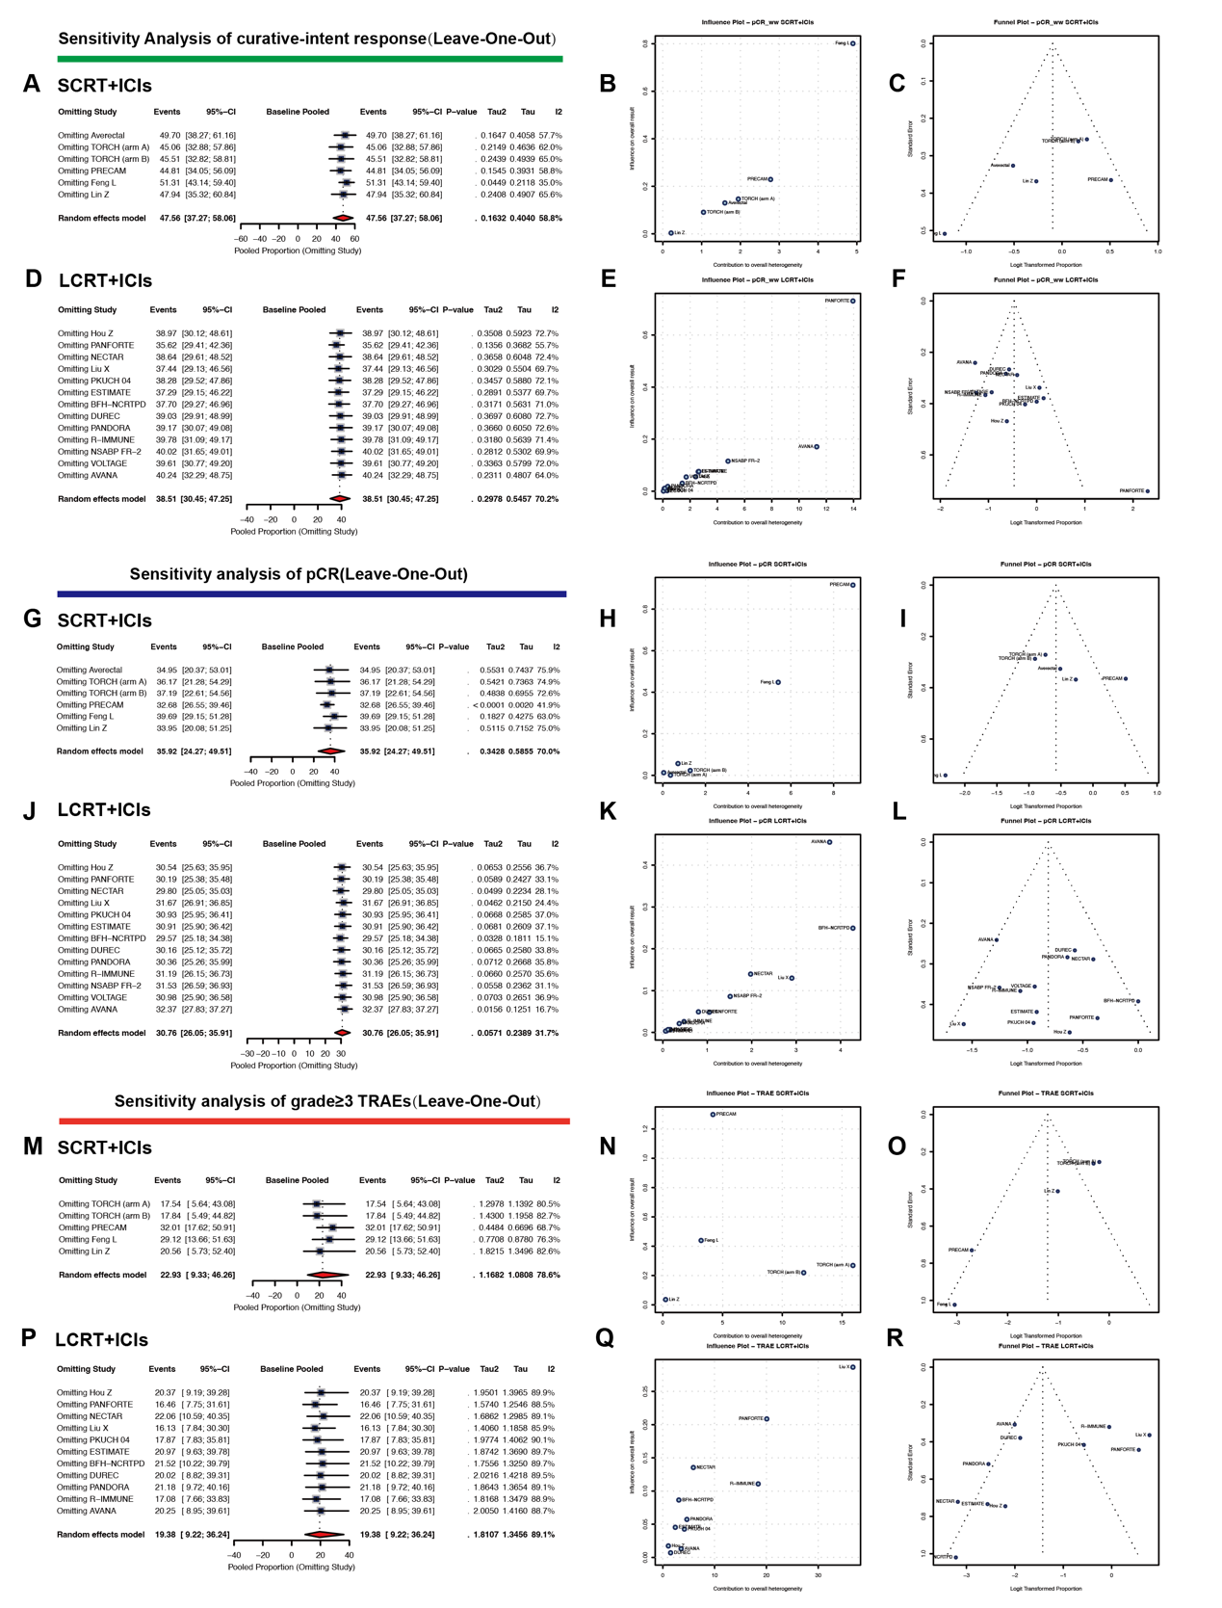
Figure S5. Robustness Assessments for Pooled Efficacy and Safety Estimates from Single-Arm Studies.
(A) Leave-one-out sensitivity analysis of the curative-intent response rate (SCRT+ICIs).
(B) Influence-Heterogeneity plot for the curative-intent response rate (SCRT+ICIs).
(C) Funnel plot for the curative-intent response rate (SCRT+ICIs).
(D) Leave-one-out sensitivity analysis of the curative-intent response rate (LCRT+ICIs).
(E) Influence-Heterogeneity plot for the curative-intent response rate (LCRT+ICIs).
(F) Funnel plot for the curative-intent response rate (LCRT+ICIs).
(G) Leave-one-out sensitivity analysis of the pCR (SCRT+ICIs).
(H) Influence-Heterogeneity plot for the pCR (SCRT+ICIs).
(I) Funnel plot for the pCR (SCRT+ICIs).
(J) Leave-one-out sensitivity analysis of the pCR (LCRT+ICIs).
(K) Influence-Heterogeneity plot for the pCR (LCRT+ICIs).
(L) Funnel plot for the pCR (LCRT+ICIs).
(M) Leave-one-out sensitivity analysis of the grade≥3 TRAEs (SCRT+ICIs).
(N) Influence-Heterogeneity plot for the grade≥3 TRAEs (SCRT+ICIs).
(O) Funnel plot for the grade≥3 TRAEs (SCRT+ICIs).
(P) Leave-one-out sensitivity analysis of the grade≥3 TRAEs (LCRT+ICIs).
(Q) Influence-Heterogeneity plot for the grade≥3 TRAEs (LCRT+ICIs).
(R) Funnel plot for the grade≥3 TRAEs (LCRT+ICIs).

