Supplementary Materials

Supplement Information 1. Technical Specifications and Implementation of Thermal Ablation (TA) Modalities
Multidisciplinary expert teams developed center-adapted clinical protocols for microwave ablation (MWA) and radiofrequency ablation (RFA), accounting for institution-specific technological preferences. Protocol parameters included: 1) antenna configuration, 2) emission frequency, 3) spatial deployment patterns, 4) ablation duration, and 5) power output optimization. This institutional variation resulted in predominant MWA utilization (n =780, 98.7% of procedures) with RFA exclusively employed at one specialized center (n=10, 1.3% of total procedures).
The MWA system consisted of:
- KY-2000 microwave generator (Kangyou Medical, China) operating at 2450 MHz with adjustable power output (1-100 W)
- Sterile single-use coaxial antennas (diameter 1.9 mm) featuring 11 mm or 5 mm active tip configurations
- Dedicated monitoring software for real-time parameter tracking
The RFA system employed:
- Cool-tip™ RF ablation system (Medtronic) utilizing impedance-modulated energy delivery
- 17-gauge internally cooled electrodes with adjustable active tip lengths (1-3 cm)
For subdiaphragmatic hepatic lesions, ultrasound-guided hydrodissection was performed between Glisson's capsule and the parietal peritoneum to prevent thermal injury. Contrast-enhanced ultrasound (CEUS) was integrated for poorly visualized metastases to enhance tumor demarcation during ablation planning.
MWA parameters were standardized as follows:
- Power delivery: 40-60 W
- Duration per application: 3-10 minutes
- Antenna configuration: Single antenna deployment for lesions <2 cm; dual-antenna simultaneous activation for lesions ≥2 cm
The ablation protocol mandated complete circumferential coverage of tumors with 5-10 mm safety margins. Antenna positioning was dynamically adjusted under image guidance to ensure confluent ablation zones, with iterative treatment cycles performed until complete radiological ablation was confirmed through post-procedural contrast-enhanced imaging.

Supplement Information 2. Hepatectomy (HT) Protocol Specifications
All patients underwent standardized preoperative assessment comprising laboratory profiling and cross-sectional imaging (CT/MRI) to evaluate surgical feasibility. Surgical strategy was individualized based on multiparametric tumor characteristics including dimensional parameters, spatial configuration, segmental location, and proximity to critical vasculature.
Hepatic resections were performed through either:
- Open approach (n=388; 71.3%)
- Laparoscopic technique (n=156; 28.7%)
The operative principle mandated complete macroscopic tumor eradication with histologically confirmed R0 margins (≥1 mm parenchymal clearance where anatomically feasible). Procedure selection followed institutional surgical oncology guidelines prioritizing oncological radicality while preserving functional hepatic reserve.

Supplemental Table 1. Specification and emulation of a target trial comparing thermal ablation vs hepatectomy using observational data.
Protocol component | Target pragmatic trial specification  (a hypothetical RCT that is ideal for answering this question) | Target trial emulation  (using observational data to best approximate the RCT comparison)
Eligibility criteria | With a specialist multidisciplinary team (sMDT) diagnosis of solitary colorectal liver metastasis that were considered to be resectable or ablatable with curative intent; solitary lesions; maximum diameter of metastasis <5cm; R0 resection for the primary tumor; non-extrahepatic metastasis at initial diagnosis on CT or MRI; Eastern Cooperative Oncology Group performance status<4; no other malignant tumors within the past 5 years; | Same as the target trial;
Treatment strategies | Individualized treatment strategies were determined by a local multidisciplinary team, which included surgeons, oncologists, gastroenterologists, radiologists, and radiotherapists, which diagnosis of solitary colorectal liver metastasis that were considered to be resectable or ablatable with curative intent. These strategies were tailored to each patient's specific condition and conformed to the preferences expressed by the patient. We categorized treatment strategies into two groups: thermal ablation versus hepatectomy; | Same as for the target trial;
Treatment assignment | Individual-level randomization without blinding; | We classify patients according to the surgery strategy that they received at time zero and emulate  randomization by propensity score matching;
Outcomes | Primary: Progression-free survival (PFS);  Secondary: Overall survival (OS), post-treatment complications, hospital stay and hospitalization cost | Same as for the target trial;
Follow-up | From treatment assignment until  the first occurrence of progressive disease, recurrent disease, death from any cause or administrative end of follow-up; | Same as for the target trial;
Casual contrasts | Intention-to-treat effect; | Intention-to-treat analysis;
Statistical analysis | Intention-to-treat analysis;  Subgroup analysis;  Sensitivity analysis; | Observational analog of the Intention-to-treat analysis;  Cox regression analysis was conducted in the propensity score matching dataset, which was calculated based on the following covariates: Sex, BMI, Plasma CEA, Plasma CA199, ECOG performance status, Comorbidity, Location of primary tumor, WHO classification, Tumor category, Lymphatic spread, Diameter of SCLM, Types of SCLM, Sequence of SCLM, and Disease-free interval;  Subgroup analysis was conducted by age, sex, ECOG status, Comorbidity, WHO classification, Tumor category, Lymphatic spread, Sequence of SCRLM, Disease-free interval, and CRS;  Sensitivity analysis was conducted by multivariable COX regression, excluding 156 patients with missing covariates, adjusted propensity score or CPSM.

Supplemental Table 2. The First-line Systemic Therapy in our study is according to 2022 NCCN guidelines of Rectal/Colon Cancer.
The First-line Systemic Therapy | All enrolled patients |  | Propensity score matched patients
The First-line Systemic Therapy | Thermal Ablation  (N=611) | Hepatectomy  (N=482) | Thermal Ablation  (N=343) | Hepatectomy  (N=388)
mFOLFOX | 283 (46.3%) | 227 (47.1%) | 162 (47.2%) | 181 (46.6%)
CAPEOX | 184 (30.1%) | 173 (35.9%) | 106 (30.9%) | 153 (39.4%)
FOLFIRI | 55 (9.0%) | 50 (10.4%) | 21 (6.1%) | 30 (7.7%)
Infusional 5-FU/LV or Capecitabine | 9 (1.4%) | 4 (0.8%) | 6 (1.7%) | 3 (0.8%)
FOLFOXIRI | 15 (2.4%) | 2 (0.4%) | 9 (2.6%) | 2 (0.5%)
FOLFOX + bevacizumab/ cetuximab | 17 (2.7%) | 4 (0.8%) | 8 (2.3%) | 4 (1.0%)
CAPEOX + bevacizumab | 40 (6.5%) | 15 (0.3%) | 26 (7.6%) | 10 (2.6%)
FOLFIRI + bevacizumab/ cetuximab | 6 (0.9%) | 7 (1.5%) | 4 (1.2%) | 5 (1.3%)
FOLFOXIRI + bevacizumab | 2 (0.3%) | 0 | 1 (0.3%) | 0
Total | 611 | 482 | 343 | 388
5-FU = fluorouracil; CAPEOX = oxaliplatin and capecitabine; FOLFIRI = irinotecan, leucovorin, and 5-FU; FOLFOXIRI = irinotecan, oxaliplatin, leucovorin, and fluorouracil; LV = leucovorin; mFOLFOX/FOLFOX = oxaliplatin, leucovorin, and 5-FU.

Supplemental Table 3. Comparative cancer-specific survival of thermal ablation versus hepatectomy in patients with SCLM.
Outcomes | All enrolled patients |  | Propensity score matched patients
Outcomes | Thermal Ablation | Hepatectomy | Thermal Ablation | Hepatectomy
Cancer-specific survival
Median survival time (95%CI) | 7.34 (6.64-9.13) | 8.67 (7.22-10.89) | 8.10 (5.89-NA) | 9.12 (8.10-NA)
Events/Patients, n/N | 175/790 | 116/544 | 90/437 | 86/437
Hazard ratio (95%CI, P value) | Reference | 0.85 (0.67-1.07, 0.17) | Reference | 0.77 (0.57-1.04, 0.08)
Note: PSM, propensity score matching; CI, confidence interval. Propensity scores were calculated according to the following covariates, including: Sex, BMI, Plasma CEA, Plasma CA199, ECOG performance status, Comorbidity, Location of primary tumor, WHO classification, Tumor category, Lymphatic spread, Diameter of SCLM, Types of SCLM, Sequence of SCLM, and Disease-free interval.

Supplemental Table 4. The Impact of Anatomical Factors: A Sensitivity Analysis of Thermal Ablation versus Hepatectomy for SCLM.
Treatment | Progression-free survival |  |  | Overall survival
Treatment | Events/Patients | Median survival (95%CI) | HR (95%CI, P value) | Events/Patients | Median survival (95%CI) | HR (95%CI, P value)
Sensitivity analysis 1: by multivariable Cox regression (N=1334)
Thermal Ablation | 457/790 | 1.90 (1.60-2.17) | Reference | 196/790 | 7.55 (6.58-9.13) | Reference
Hepatectomy | 314/544 | 1.81 (1.61-2.13) | 1.07 (0.79-1.09, 0.36) | 134/544 | 7.34 (6.43-NA) | 0.86 (0.66-1.11, 0.24)
Sensitivity analysis 2: by multivariable Cox regression after PSM (N=874)
Thermal Ablation | 243/437 | 1.98 (1.71-2.38) | Reference | 99/437 | 9.05 (5.53-NA) | Reference
Hepatectomy | 246/437 | 1.90 (1.66-2.58) | 0.94 (0.78-1.13, 0.51) | 99/437 | 8.67 (6.68-NA) | 0.80 (0.60-1.07, 0.14)
Note: HR, hazard ratio; CI, confidence interval. All HRs for sensitivity analyses 1-2 were calculated by adjusting the following covariates, including Sex, BMI, Plasma CEA, Plasma CA199, ECOG performance status, Comorbidity, Location of primary tumor, WHO classification, Tumor category, Lymphatic spread, Diameter of SCLM, Types of SCLM, Sequence of SCLM, Disease-free interval, Location of SCLM and Adjacency to major vessels.

Supplemental Table 5. Comparative effectiveness of thermal ablation versus hepatectomy in patients with SCLM after PSM.
Outcomes | Propensity score matched patients
Outcomes | Thermal Ablation | Hepatectomy
Local Tumor Progression-free survival
3-yeas survival rates (95%CI) | 87.3% (83.7%-91.1%) | 98.0% (96.5%-99.5%)
Events/Patients, n/N | 45/437 | 7/437
Hazard ratio (95%CI, P value) | Reference | 0.15 (0.07-0.34, <0.001)
New Intrahepatic Metastasis-free survival
3-yeas survival rates (95%CI) | 56.9% (52.0%-62.4%) | 53.0% (48.2%-58.4%)
Events/Patients, n/N | 164/437 | 194/437
Hazard ratio (95%CI, P value) | Reference | 1.12 (0.91-1.39, 0.26)
Extrahepatic Recurrence-free survival
3-yeas survival rates (95%CI) | 74.0% (69.4%-78.9%) | 73.6% (69.0%-78.5%)
Events/Patients, n/N | 93/437 | 97/437
Hazard ratio (95%CI, P value) | Reference | 1.02 (0.77-1.35, 0.90)

Supplemental Table 6. The first-line salvage treatments administered after progression of thermal ablation versus hepatectomy in patients with SCLM after PSM.
The first-line salvage treatments administered after progression | Thermal Ablation | Hepatectomy
Only Local Tumor Progression | 11/437 | 1/437
Repeat local therapy [ablation] | 8 | 1
Repeat local therapy [resection] | 3 | 0
Only New Intrahepatic Metastasis | 107/437 | 142/437
Repeat local therapy [ablation] | 76 | 56
Repeat local therapy [resection] | 18 | 60
Systemic therapy | 10 | 21
Radiation | 3 | 5
Only Extrahepatic Recurrence | 44/437 | 49/437
Repeat local therapy [ablation] | 2 | 0
Repeat local therapy [resection] | 4 | 6
Systemic therapy | 23 | 30
Radiation | 13 | 12
Chemoradiation/Radiation | 2 | 1
Local Tumor Progression+New Intrahepatic Metastasis | 24/437 | 6/437
Repeat local therapy [ablation] | 8 | 2
Repeat local therapy [resection] | 6 | 3
Systemic therapy | 9 | 1
Radiation | 1 | 0
Local Tumor Progression+Extrahepatic Recurrence | 16/437 | 2/437
Repeat local therapy [ablation] | 2 | 0
Repeat local therapy [resection] | 2 | 0
Systemic therapy | 7 | 1
Radiation | 5 | 1
New Intrahepatic Metastasis+Extrahepatic Recurrence | 43/437 | 48/437
Repeat local therapy [ablation] | 15 | 12
Repeat local therapy [resection] | 10 | 16
Systemic therapy | 13 | 16
Radiation | 5 | 4
Local Tumor Progression+New Intrahepatic Metastasis+Extrahepatic Recurrence | 10/437 | 2/437
Systemic therapy | 5 | 1
Chemoradiation/Radiation | 4 | 1
Best supportive care | 1 | 0

Supplemental Table 7. Outcomes between the ≤3 cm and >3 cm subgroups in patients with SCLM after PSM.
Outcomes | Tumor Size of SCLM ≤3 cm |  | P value | Tumor Size of SCLM >3 cm |  | P value
PFS | 3-yeas survival rates (95%CI) | n (%) | 0.662 | 3-yeas survival rates (95%CI) | n (%) | 0.455
TA | 41.1% (35.8%-47.2%) | 185/343 | 0.662 | 32.7% (24.0%-44.7%) | 58/94 | 0.455
HT | 42.8% (37.4%-49.0%) | 176/323 | 0.662 | 37.7% (29.4%-48.5%) | 70/114 | 0.455
OS | 3-yeas survival rates (95%CI) | n (%) | 0.846 | 3-yeas survival rates (95%CI) | n (%) | 0.039
TA | 82.1% (77.7%-86.7%) | 66/343 | 0.846 | 72.6% (63.5%-83.1%) | 33/94 | 0.039
HT | 82.6% (78.4%-87.1%) | 73/323 | 0.846 | 83.1% (76.4%-90.4%) | 26/114 | 0.039

Supplemental Figure 1. Measuring the Minimum ablation margin (MAM) requires determining the shortest distance from the tumor boundary to the ablation zone.
When tumors are situated beneath the liver capsule (within 5 mm of the edge) or near blood vessels (within 3 mm of any vessel ≥3 mm in diameter), areas where the ablation zone interfaces with the liver capsule or adjacent vessels are excluded from the MAM calculation. Illustrated here, according to the Couinaud segmentation system, are two tumors: one in segment IV (yellow) abutting the portal vein (blue) and another in segments V/VIII (yellow) touching the liver capsule (black). The ablation zone (green) is seen extending to the vessel wall and beneath the capsule. In these instances, the MAM (red) is measured away from the liver capsule and blood vessels, ensuring accurate assessment of ablation efficacy.

Supplemental Figure 2. Kaplan–Meier curves of local tumor progression-free survival, new intrahepatic metastasis-free survival, and extrahepatic recurrence-free survival in propensity score matched patients.
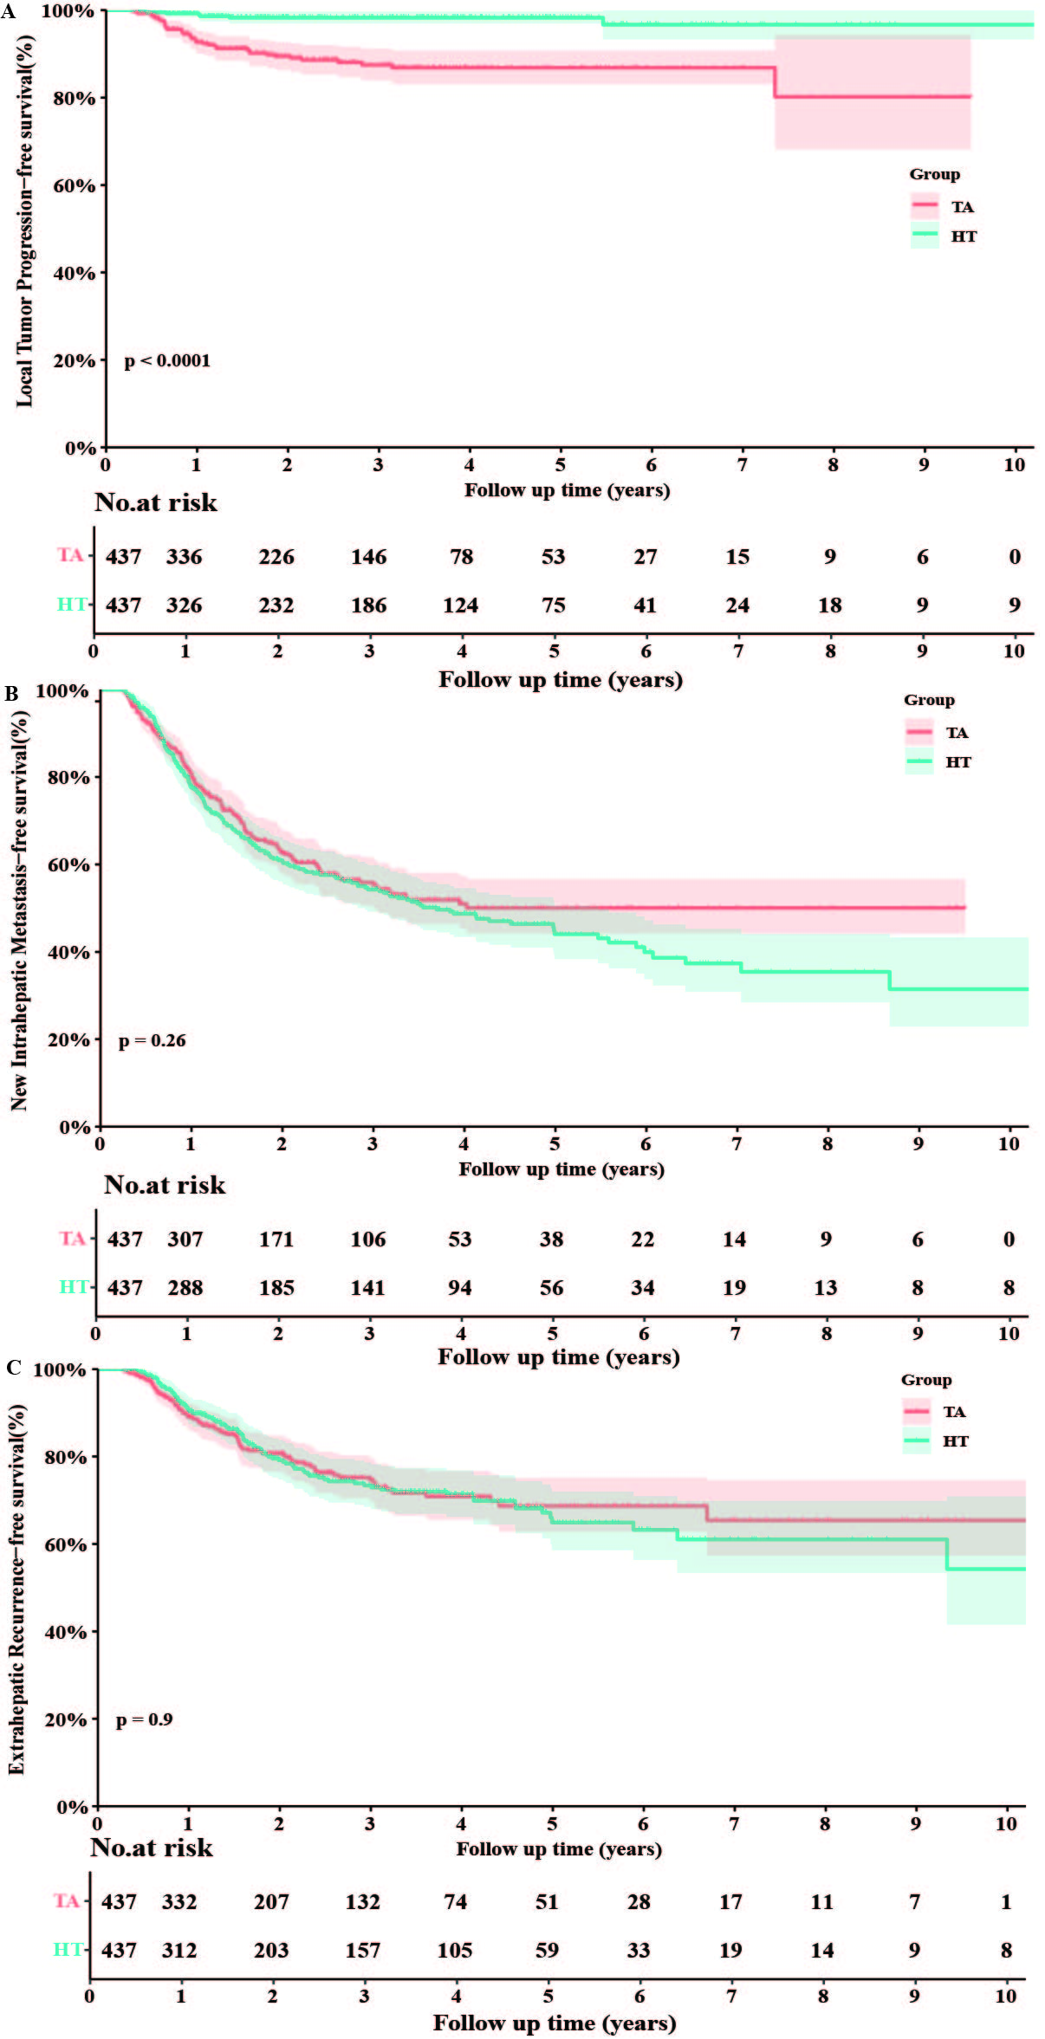
Shaded regions around curves represent 95% CIs.

