Clustering Depression Subgroups Based on Dorsolateral Prefrontal-Subgenual Anterior Cingulate Cortex Peak Functional Connectivity Reveals Different Symptom Profiles and TMS Treatment Outcomes

Supplementary methods
MRI data acquisition
Imaging data were acquired using a 3.0 T Siemens Verio MRI scanner (MRB17, Siemens AG, Erlangen, Germany) equipped with a 32-channel head coil at Shanghai Mental Health Center (SMHC) and a 3.0 T Siemens Skyra MRI scanner with a 20-channel head coil at Suzhou Suzhou Guangji Hospital (SZGJ). MRI scanning parameters were consistent between the two sites. Foam padding was placed around the subject's head to minimize head motion. 3D structural images were acquired using a T1-weighted Magnetization Prepared Rapid Gradient Echo (MPRAGE) sequence with repetition time (TR) =2300 ms, echo time (TE)=2.96 ms, flip angle=9º, field of view (FOV) =256×256 mm², voxel size=1×1×1 mm³ and 192 sagittal slices. Resting-state functional MRI (fMRI) images were acquired using an Echo Planar Imaging (EPI) sequence with TR=2500 ms, TE=30 ms, flip angle=90º, FOV=224×224 mm², number of TR=149, voxel size=3.5×3.5×3.5 mm³ and 37 axial slices. Subjects were asked to relax with eyes open during the resting-state fMRI acquisitions.
fMRI data preprocessing
All fMRI data were preprocessed using SPM12 (Wellcome Department of Cognitive Neurology, London, UK), following the procedure described in our previous study. We discarded the first four volumes and performed slice timing and rigid body correction for head motion. The images were then coregistered with individual T1 images and normalized to the MNI space using a unified segmentation algorithm. Images were resampled to 2 mm isotropic voxels and smoothed with a 6 mm full-width half-maximum Gaussian kernel. Low-pass filtering (< 0.08 Hz) and nuisance covariate (head motion, white matter, ventricular, and global signals) regression were implemented using the Data Processing & Analysis for Brain Imaging toolbox.
Reliability of MDD subgroups
We conducted reliability tests of major depressive disorder (MDD) subgroups at two levels. First, we examined the reliability of MDD subgroup clustering in different sites. We clustered MDD subgroups and performed the between-subgroup comparison independently using the SMHC and SZGJ datasets. Second, we examined the reliability of personalized peaks using different radii. We repeated the analyses with other radii (1 mm, 3 mm, 6 mm, and 12 mm) besides 9 mm. We further examined the consistency in the subgroup classification of each patient between the 9 mm radius and other radius parameters (1 mm, 3 mm, 6 mm, and 12 mm).
Subgroup validation by TMS intervention
Prior evidence suggests that the actual TMS stimulation sites are associated with treatment responses. We selected patients who received transcranial magnetic stimulation (TMS) over the anterior DLPFC, defined by a distance of less than 25 mm to the group-average DLPFC-sgACC FC peak (MNI coordinates: -42, 44, 30). Of the 120 patients with MDD included in the subgroup clustering analysis, 37 patients completed a 20-session course of 10 Hz TMS targeting anterior DLPFC and were included in the between-subgroup comparisons of TMS efficacy (Fig. S1). These patients were retrospectively selected from two distinct cohorts. The first cohort, described in detail in our previous study, received TMS targeting an MRI-guided, group-averaged DLPFC-sgACC peak (MNI coordinates: -42, 44, 30) within the anterior DLPFC. This protocol was approved by the institutional ethical board of SMHC (approval number: 2017-43). The second cohort was part of a registered clinical trial (Chinese Clinical Trial Registry: ChiCTR2000035259). This trial compared the efficacy of TMS over the DLPFC using personalized DLPFC-sgACC functional connectivity peak versus conventional “F3” electrode positioning. Since we recorded the actual TMS stimulation sites using the neuronavigational system, we were able to determine whether the actual TMS stimulation sites were within the anterior DLPFC. For the present retrospective analysis, we included patients from these two cohorts whose actual TMS targets were confirmed to be within the anterior DLPFC.
Supplementary results
Replicability using independent SMHC or SZGJ dataset
83 MDD patients were recruited from outpatients at the SMHC site and 37 MDD patients from inpatients at the SZGJ site. The demographic and clinical characteristics are summarized in Table S1. We performed the clustering analysis using the SMHC and SZGJ datasets, respectively.
MDD subgroup clustering and between-subgroup comparisons in the SMHC dataset
For the SMHC dataset, we determined the optimal number of subgroups to be two according to the largest average silhouette score (Fig. S2A). With the K-means clustering method, 74.7% of MDD patients were clustered into the anterior subgroup, whose personalized peak centroid was localized on MNI coordinates (-43, 41, 23) in the anterior dorsolateral prefrontal cortex (DLPFC, Fig. S3A). The other 25.3% of MDD patients were clustered into the posterior subgroup whose personalized peak centroid was on MNI coordinates (-37, 3, 55) in the posterior DLPFC (Fig. S3A). The personalized peaks in the anterior MDD subgroup distributed surrounding the group-average DLPFC peak with a median distance of 11.0 mm (7.0 ~19.0 mm), whereas the personalized peaks in the posterior MDD subgroup were far away with a median distance of 53.0 mm (47.0~56.0 mm, Table S2).
The anterior and posterior subgroups had comparable age, sex, years of education, illness course, and the number of depressive episodes (all p>0.05, Table S1). Regarding depressive symptoms, there were no differences in the total scores of the HAMD-17 or Montgomery-Asberg Depression Rating Scale (MADRS) between the two subgroups (all p>0.05). Regarding anxiety symptoms, the posterior subgroup exhibited a significantly higher Hamilton Anxiety Scale (HAMA) total score than the anterior subgroup (U=451.0, p=0.036, Table S1).
For the HAMD-17 factor scores, only the Anxiety/Somatization factor was higher in the posterior subgroup than the anterior subgroup (U=458.0, p=0.042). No significant between-subgroup differences were observed for the other HAMD-17 factors scores (Fig. S5A). For the HAMA factor scores, both Somatic Anxiety (U=488.0, p=0.088) and Psychic Anxiety (U=465.0, p=0.051) factors in the posterior subgroup were marginally higher than the anterior subgroup (Fig. S5B).
For the HAMD-17 item scores, significant between-subgroup differences were observed in the items of "Anxiety psychic" (U=469.0, p=0.036), which was higher in the posterior subgroup (Fig. S5C). For the HAMA item scores, the item "Respiratory Symptoms" (U=453.5, p=0.029) in the posterior subgroup was higher than the posterior subgroup (Fig. S5D). For the MADRS scale, the "Inner tension" (U=435.0, p=0.016) item scores were significantly higher in the posterior subgroup than in the anterior subgroup (Fig. S5E).
MDD subgroup clustering and between-subgroup comparisons in the SZGJ dataset
For the SZGJ dataset, we also determined the optimal number of subgroups to be two according to the largest average silhouette score (Fig. S2A). 70.3% of MDD patients were clustered into the anterior subgroup whose centroid was localized on MNI coordinates (-42, 41, 23) in the anterior DLPFC (Fig. S3A). 29.7% were clustered into the posterior subgroup and the centroid was on MNI coordinates (-37, 3, 55) (Fig. S3A). The personalized peaks of the anterior subgroup distributed surrounding the group-average peak with a median distance of 14.0 mm (9.5~22.3 mm), whereas the personalized peaks of the posterior subgroup were far away with a median distance of 38.0 mm (33.0~57.0 mm) (Table S2).
The anterior subgroup (39.2±14.8) was older than the posterior subgroup (27.3±8.1, U=213.5, p=0.020, Table S1). The sex, years of education, duration of illness, and number of depressive episodes were comparable between the two subgroups (all p>0.05). Regarding depressive symptoms, the posterior subgroup (25.7±3.3) had a higher HAMD-17 score compared to the anterior subgroup (22.4±5.0), indicating a potential statistical difference (U=84.5, p=0.053). However, there were no significant between-subgroup differences in the MADRS total scores. Regarding anxiety symptoms, the posterior subgroup (24.9±5.4) had higher HAMA total scores compared to the anterior subgroup (21.7±6.6), indicating a potential statistical difference (U=90.5, p=0.083, Table S1).
For the HAMD-17 factor scores, only the factors related to anxiety symptoms, specifically Anxiety/Somatization, were higher in the posterior subgroup than in the anterior subgroup (U=62.5, p=0.007). No statistically significant differences were observed for the remaining factor scores across the two subgroups (all p>0.05, Fig. S6A). For the HAMA factor scores, there were no significant between-subgroup differences in Somatic Anxiety and Psychic Anxiety factor scores. The mean HAMA factor scores were higher in the posterior subgroup than in the anterior subgroup (Fig. S6B).
For the HAMD-17 items, between-subgroup significant differences were observed in the items of "Anxiety psychic" (U=154.5, p=0.008) and "Guilt" (U=85.0, p=0.043), which was higher in the posterior subgroup (Fig. S6C). For the HAMA items, the "Anxious Mood" (U=73.5, p=0.018) in the posterior subgroup exhibited a significantly higher score than the anterior subgroup (Fig. S6D). For the MADRS items, the "Pessimistic Thoughts" (U=77.0, p=0.022) item scores were significantly higher in the posterior subgroup than the anterior subgroup (Fig. S6E).
Reliability of MDD subgroup clustering
When performing personalized peak clustering independently in the SMHC or SZGJ dataset, the optimal number of subgroups was determined to be 2 in the SMHC and to be 3 (the average silhouette score was similar to k=2) in the SZGJ (Figs. S2A and S3A). The proportions and centroid coordinates of each subgroup and the median distances were consistent with the results obtained from the merged data (Table S2). Additionally, the between-subgroup differences in anxiety symptoms were replicated. MDD patients in the posterior subgroup exhibited more severe anxiety symptoms than the anterior subgroup (Figs. S5 and S6).
When identifying personalized DLPFC-sgACC peaks with other radius parameters (1 mm, 3 mm, 6 mm, and 12 mm) besides 9 mm, the spatial distributions of MDD patients' personalized peaks always exhibited a bimodal distribution (Figs. S2B and S3B). Other indicators include proportions, centroid's MNI coordinates, and distances (Table S2). The consistency in the subgroup classification of each patient was 98.3% between 9 mm and 12 mm radius parameters. The consistency was 89.2% (6 mm vs. 9 mm), 85.8% (3 mm vs. 9 mm) and 84.2% (1 mm vs. 9 mm) (Fig. S4).
Clustering personalized peaks into three subgroups
According to the silhouette method, K=2 was optimal for the merged and SMHC datasets and different radius parameters of 1 mm, 3 mm, 6 mm, and 9 mm (Fig. S2). For the SZGJ dataset and the radius parameter of 12 mm, K=3 was optimal. In the case of K=2, the posterior subgroup was more widely scattered than the coherently anterior subgroup (Fig. S3). Thus, we made an additional analysis using K=3 to examine the influence of the number of subgroup clustering (Fig. S7).
The spatial distribution of the personalized peaks for patients with MDD is shown in Fig. S7A. Of the 120 patients with MDD, 64.2% clustered into the anterior subgroup, whose personalized peak centroid was localized to the MNI coordinates (-42, 43, 23) in the anterior DLPFC; 20.0% were clustered into the middle subgroup, whose personalized peak centroid was on the MNI coordinates (-52, 14, 33); and 15.8% of patients were clustered into the posterior subgroup with centroid (-31, 2, 62) in the posterior DLPFC. The median distances from personalized peaks to the group-average peak were 11.0 mm (7.0, 17.0 mm), 31.0 mm (27.8, 38.0 mm), and 55.0 mm (52.5, 57.5 mm) in the anterior, middle and posterior subgroup, respectively. The distance between subgroups was statistically different (all p < 0.001; Fig. S7B).
We compared the depressive and anxiety profiles among three subgroups. Regarding depressive symptoms, there were no significant differences among the three groups (all p>0.05). Regarding anxiety symptoms, the middle and posterior subgroups showed significantly higher anxiety/somatization factor scores in HAMD-17 and somatic anxiety factor scores in HAMA than the anterior subgroup (p < 0.05, Fig. S7), but comparable anxiety symptoms between the middle and posterior subgroups (p > 0.05).
Correlations of depressive and anxiety profiles
We assessed the relationship between the distance and symptoms in each subgroup (Fig. S8). The distances from personalized peaks to the anterior centroid and symptoms in the anterior subgroup showed no significant correlation (all p>0.05, Fig. S8A). No significant correlations were found between the distances and symptoms in the posterior subgroup (all p>0.05, Fig. S8B).

Legends for Figures and Tables
Fig. S1 The flowchart of patient recruitment. Abbreviations: MDD, major depressive disorder; MRI, magnetic resonance imaging; DLPFC, dorsolateral prefrontal cortex; TMS, transcranial magnetic stimulation.
Fig. S2 The silhouette method curve for the optimal number of subgroups (K). Abbreviations: SMHC, Shanghai Mental Health Center; SZGJ, Suzhou Guangji Hospital.
Fig. S3 The spatial distribution of personalized peaks within the left DLPFC. Abbreviations: DLPFC, dorsolateral prefrontal cortex.
Fig. S4 The variability of personalized peaks when using different radius parameters. (A) An example of a participant whose personalized peaks were similar using different radii. (B) An example of a participant whose personalized peaks varied with different radii. (C) The actual subgroup clustering for each patient when identifying personalized peaks with different radii.
Fig. S5 Comparisons of clinical features between two subgroups with MDD in the SMHC dataset. Abbreviations: MDD, major depressive disorder; SMHC, Shanghai Mental Health Center; HAMD-17, 17-item Hamilton Depression Scale; HAMA, Hamilton Anxiety Scale; MADRS, Montgomery-Asberg Depression Rating Scale; n.s., no statistical difference (p>0.05); * means p<0.05; ** means p<0.01; *** means p<0.001.
Fig. S6 Comparisons of clinical features between two subgroups with MDD in the SZGJ dataset. Abbreviations: MDD, major depressive disorder; SZGJ, Suzhou Guangji Hospital; HAMD-17, 17-item Hamilton Depression Scale; HAMA, Hamilton Anxiety Scale; MADRS, Montgomery-Asberg Depression Rating Scale; n.s., no statistical difference (p>0.05); * means p<0.05; ** means p<0.01; *** means p<0.001.
Fig. S7 Clustering personalized peaks into three subgroups. Abbreviations: HAMD-17, 17-item Hamilton Depression Scale; HAMA, Hamilton Anxiety Scale; MADRS, Montgomery-Asberg Depression Rating Scale; n.s., no significant difference (p>0.05); * means p<0.05; ** means p<0.01; *** means p<0.001.
Fig. S8 Correlation analysis between distance and symptoms. Abbreviations: HAMD-17, 17-item Hamilton Depression Scale; HAMA, Hamilton Anxiety Scale; MADRS, Montgomery-Asberg Depression Rating Scale.
Table S1 The demographic and clinical features of patients with MDD in the two independent datasets and different clinical profiles between subgroups.
Table S2 The quantified indicators of the personalized peaks' spatial distribution.
Table S3 The usage of medicines between MDD subgroups.

Fig. S1 The flowchart of patient recruitment.

Fig. S2 The silhouette method curve for the optimal number of subgroups (K).

Fig. S3 The spatial distribution of personalized peaks within the left DLPFC.

Fig. S4 The variability of personalized peaks when using different radius parameters. (A) An example of a participant whose personalized peaks were similar using different radii. (B) An example of a participant whose personalized peaks varied with different radii. (C) The actual subgroup clustering for each patient when identifying personalized peaks with different radii.

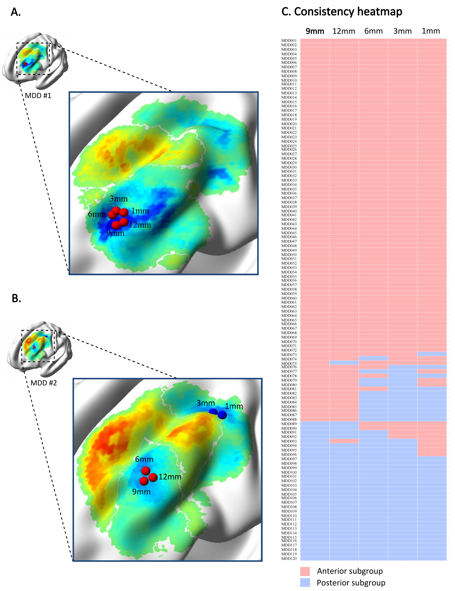

Fig. S5 Comparisons of clinical features between two subgroups with MDD in the SMHC dataset.

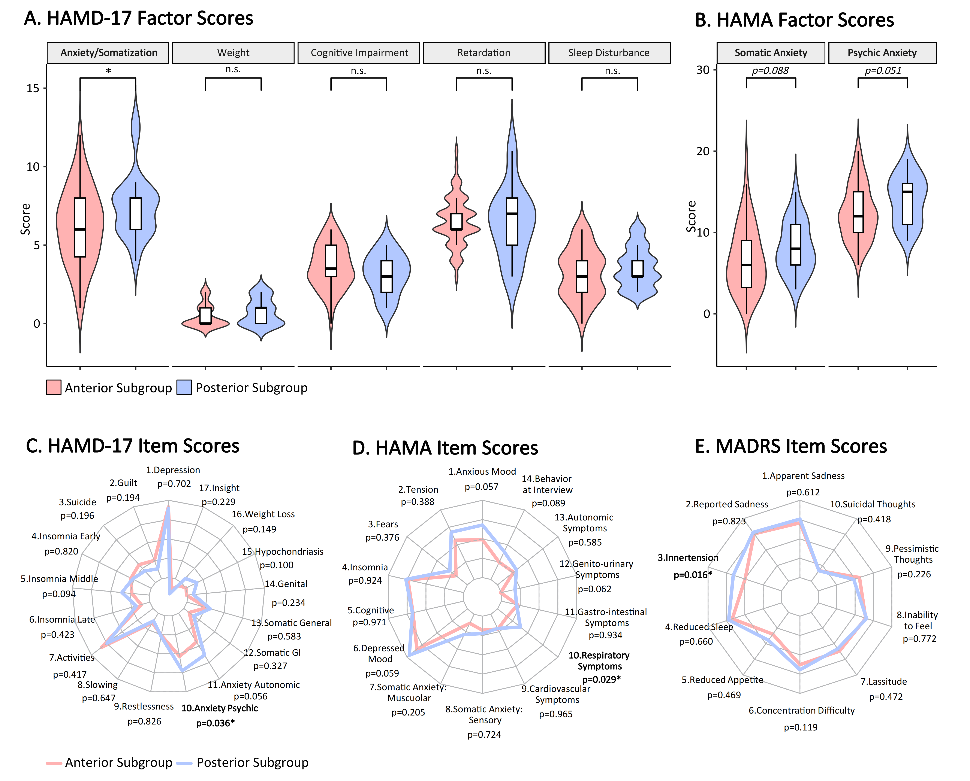

Fig. S6 Comparisons of clinical features between two subgroups with MDD in the SZGJ dataset.

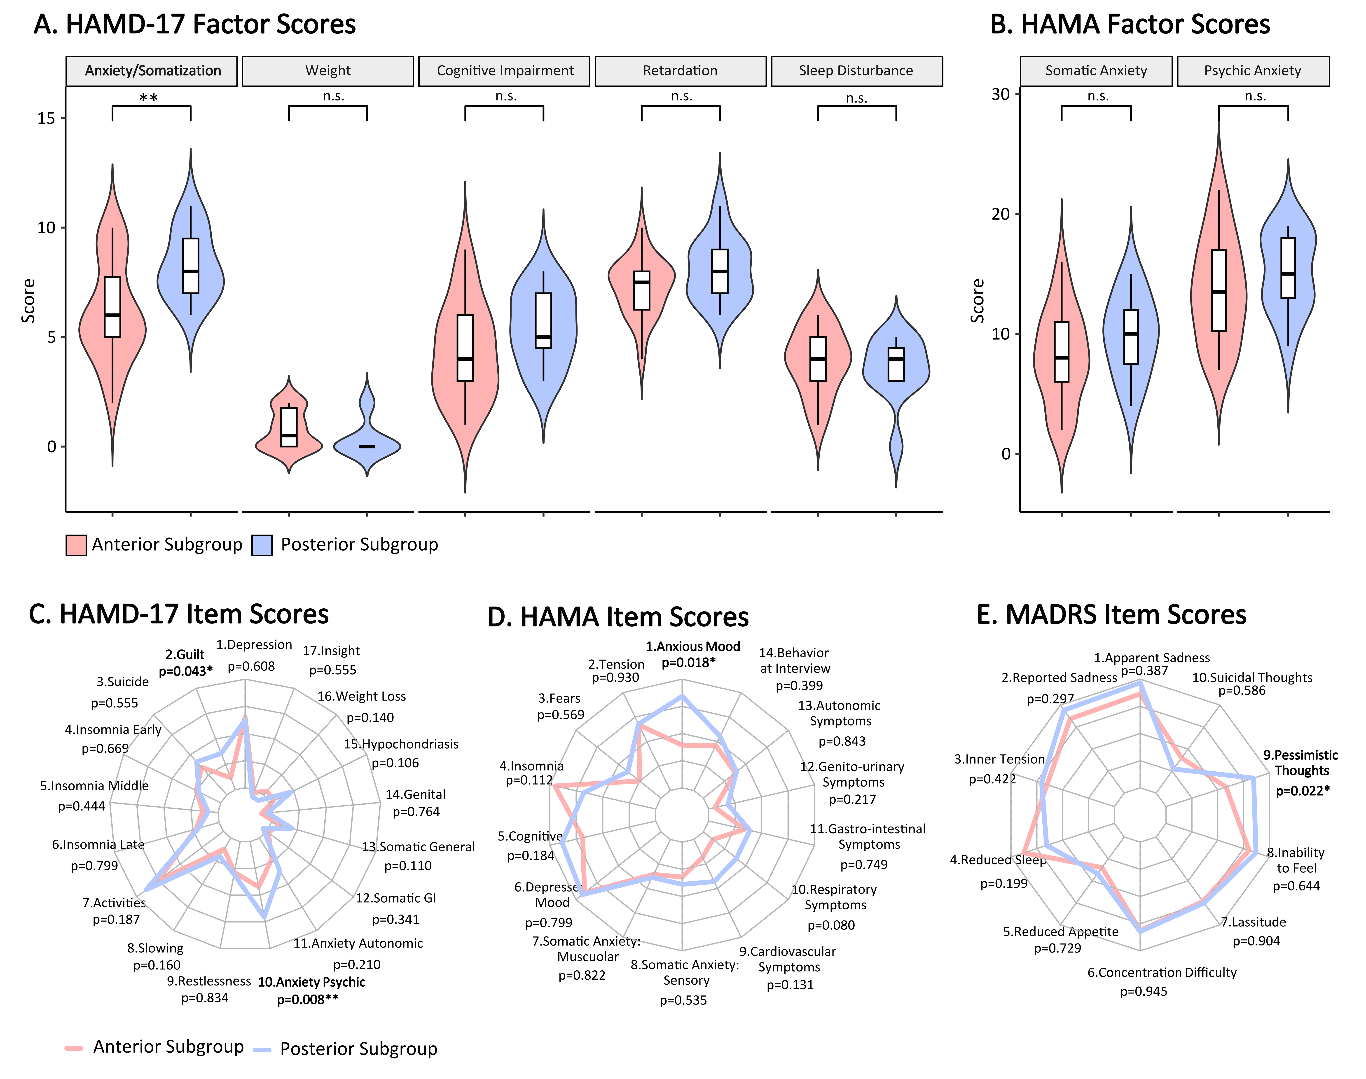

Fig. S7 Clustering personalized peaks into three subgroups.

Fig. S8 Correlation analysis between distance and symptoms.

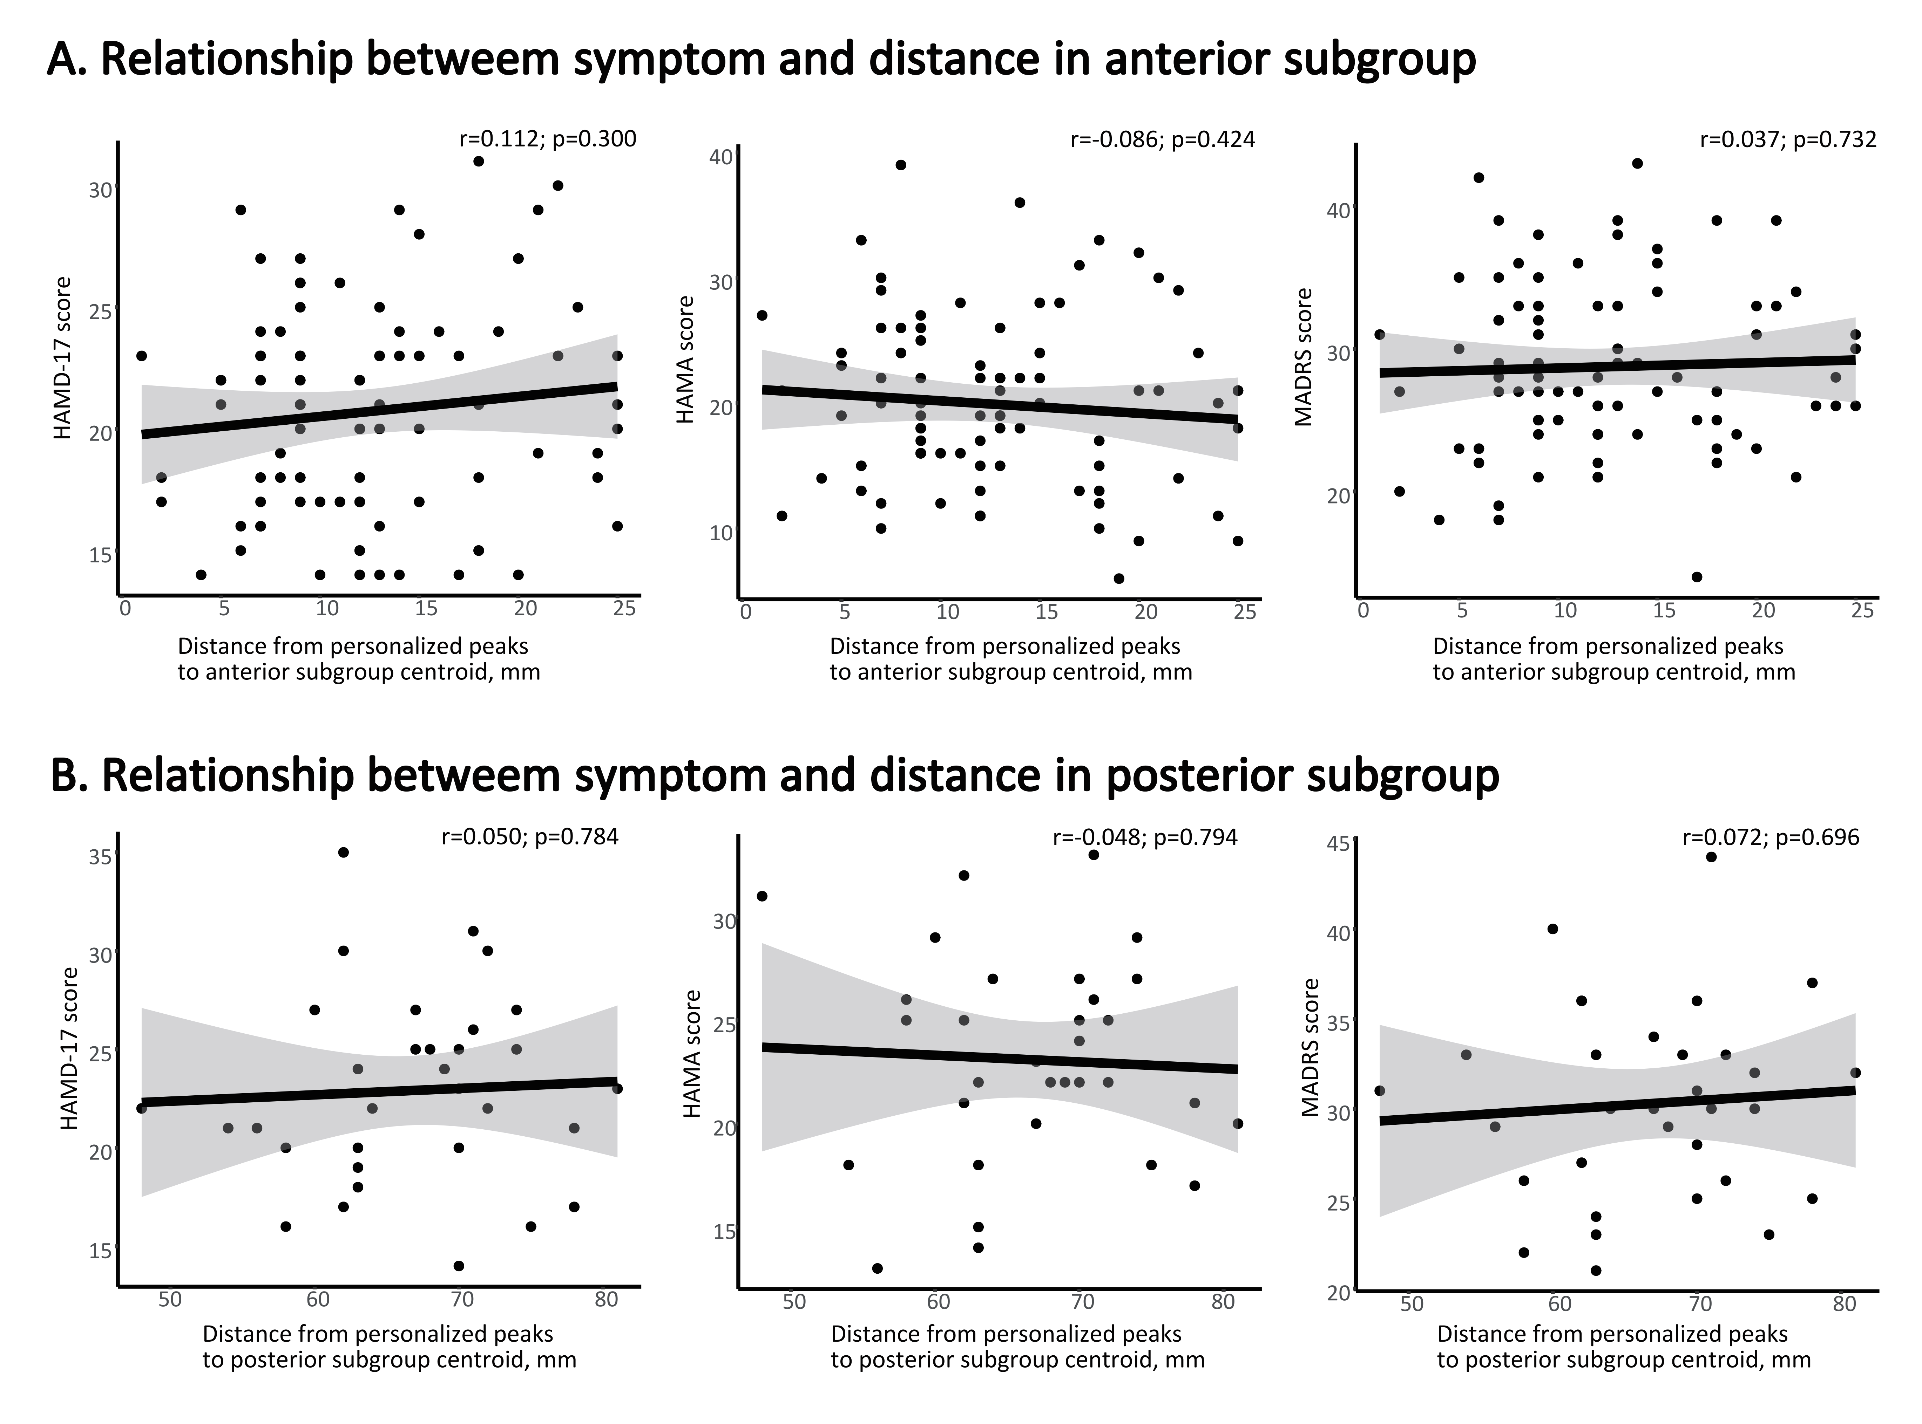

Table S1 The demographic and clinical features of patients with MDD in the two independent datasets and different clinical profiles between subgroups.
 | All Patients |  |  |  | Anterior Subgroup |  |  |  | Posterior Subgroup |  |  | Between-subgroup  Comparisons
SMHC Site | N=83 |  |  |  | N=62 |  |  |  | N=21
 | N | % |  |  | N | % |  |  | N | % |  | χ² | p
Female | 64 | 77.1 |  |  | 51 | 82.3 |  |  | 13 | 61.9 |  | 2.6 | 0.106
 | Mean | SD |  |  | Mean | SD |  |  | Mean | SD |  | U | p
Age (years) | 33.9 | 10.1 |  |  | 34.7 | 11.1 |  |  | 31.5 | 6.0 |  | 723.0 | 0.453
Education (years) | 14.8 | 2.7 |  |  | 14.1 | 2.9 |  |  | 14.7 | 2.8 |  | 521.5 | 0.156
HAMD-17 | 20.4 | 4.1 |  |  | 20.0 | 3.9 |  |  | 21.4 | 4.9 |  | 557.5 | 0.328
HAMA | 19.9 | 6.4 |  |  | 19.2 | 6.8 |  |  | 22.1 | 4.7 |  | 451.0 | 0.036*
MADRS | 27.6 | 5.0 |  |  | 27.3 | 5.0 |  |  | 28.6 | 5.0 |  | 567.5 | 0.384
 | Median | Q1 |  | Q3 | Median | Q1 |  | Q3 | Median | Q1 | Q3 | U | p
Duration of illness (months) | 39.0 | 11.0 |  | 120.8 | 39.0 | 12.0 |  | 114.0 | 66.0 | 11.0 | 144.0 | 644.5 | 0.970
Number of episodes | 2.0 | 1.0 |  | 4.0 | 2.0 | 1.0 |  | 3.0 | 2.0 | 1.5 | 4.0 | 449.0 | 0.351
SZGJ Site | N=37 |  |  |  | N=26 |  |  |  | N=11
 | N | % |  |  | N | % |  |  | N | % |  | χ² | p
Female | 19 | 51.4 |  |  | 13 | 50.0 |  |  | 6 | 54.5 |  | 2.6 | 0.106
 | Mean | SD |  |  | Mean | SD |  |  | Mean | SD |  | U | p
Age (years) | 35.6 | 14.1 |  |  | 39.2 | 14.8 |  |  | 27.3 | 8.1 |  | 723.0 | 0.453
Education (years) | 13.1 | 2.9 |  |  | 13.0 | 3.0 |  |  | 13.3 | 2.8 |  | 521.5 | 0.156
HAMD-17 | 23.4 | 4.8 |  |  | 22.4 | 5.0 |  |  | 25.7 | 3.3 |  | 557.5 | 0.328
HAMA | 22.7 | 6.3 |  |  | 21.7 | 6.6 |  |  | 24.9 | 5.4 |  | 451.0 | 0.036*
MADRS | 32.6 | 6.3 |  |  | 32.3 | 6.9 |  |  | 33.5 | 4.7 |  | 567.5 | 0.384
 | Median | Q1 |  | Q3 | Median | Q1 |  | Q3 | Median | Q1 | Q3 | U | p
Duration of illness (months) | 42.0 | 6.0 |  | 125.0 | 59.5 | 6.3 |  | 145.5 | 37.0 | 12.0 | 96.0 | 644.5 | 0.970
Number of episodes | 2.0 | 1.0 |  | 3.0 | 2.0 | 1.0 |  | 3.0 | 2.0 | 1.0 | 3.0 | 449.0 | 0.351
Abbreviations: MDD, major depressive disorder; HAMD-17, 17-item Hamilton Depression Scale; HAMA, Hamilton Anxiety Scale; MADRS, Montgomery-Asberg Depression Rating Scale; * means p<0.05; ** means p<0.01. SMHC, Shanghai Mental Health Center; SZGJ, Suzhou Guangji Hospital.

Table S2 The quantified indicators of the personalized peaks' spatial distribution.
 |  | Anterior subgroup |  |  |  |  |  |  | Posterior subgroup
 |  | Proportion (%) | Centroid's MNI coordinates |  |  | Distance  (mm) |  |  | Proportion (%) | Centroid's MNI coordinates |  |  | Distance  (mm)
 |  |  | X | Y | Z | Median | Q1 | Q3 |  | X | Y | Z | Median | Q1 | Q3
Site | Merged (N=120) | 73.3 | -43 | 40 | 23 | 12.5 | 7.0 | 19.0 | 26.7 | -39 | 5 | 53 | 50.5 | 39.0 | 56.0
Site | SMHC (N=83) | 74.7 | -43 | 41 | 23 | 11.0 | 7.0 | 19.0 | 25.3 | -37 | 3 | 55 | 53.0 | 47.0 | 56.0
Site | SZGJ (N=37) | 70.3 | -42 | 41 | 23 | 14.0 | 9.5 | 22.3 | 29.7 | -46 | 11 | 43 | 38.0 | 33.0 | 57.0
Radius | 9mm | 73.3 | -43 | 40 | 23 | 12.5 | 7.0 | 19.0 | 26.7 | -39 | 5 | 53 | 50.5 | 39.0 | 56.0
Radius | 1mm | 70.8 | -41 | 43 | 24 | 13.0 | 7.0 | 22.5 | 29.2 | -42 | 6 | 49 | 44.0 | 29.0 | 53.0
Radius | 3mm | 65.8 | -42 | 41 | 23 | 13.0 | 7.0 | 22.0 | 34.2 | -38 | 4 | 54 | 43.0 | 21.5 | 53.0
Radius | 6mm | 65.8 | -42 | 41 | 24 | 12.0 | 7.0 | 20.0 | 34.2 | -38 | 5 | 53 | 44.0 | 27.0 | 54.5
Radius | 12mm | 73.3 | -43 | 41 | 23 | 12.5 | 7.0 | 19.0 | 26.7 | -40 | 5 | 51 | 49.5 | 38.0 | 55.8
Abbreviations: SMHC, Shanghai Mental Health Center; SZGJ, Suzhou Guangji Hospital.

Table S3 The usage of medicines between MDD subgroups.
 | Anterior subgroup  (N=30) | Posterior subgroup  (N=7) | p value
antidepressants (yes/no) | 25/5 | 4/3 | 0.156
SSRIs (yes/no) | 17/13 | 1/6 | 0.090
SNRIs (yes/no) | 9/21 | 2/5 | 1.000
TCAs (yes/no) | 1/29 | 0/7 | 1.000
other (yes/no) | 13/17 | 3/4 | 1.000
BDZ (yes/no) | 6/24 | 2/5 | 0.631
Azaperone (yes/no) | 1/29 | 2/5 | 0.086
Z-drugs (yes/no) | 1/29 | 1/6 | 0.347
anticonvulsants (yes/no) | 1/29 | 2/5 | 0.086
antipsychotics (yes/no) | 7/23 | 2/5 | 1.000
mood stabilizer (yes/no) | 1/29 | 1/6 | 0.347
Abbreviations: MDD, major depressive disorder; SSRIs, selective serotonin reuptake inhibitors; SNRIs, selective serotonin and norepinephrine reuptake inhibitors; TCAs, tricyclic antidepressants; TMS, transcranial magnetic stimulation.

