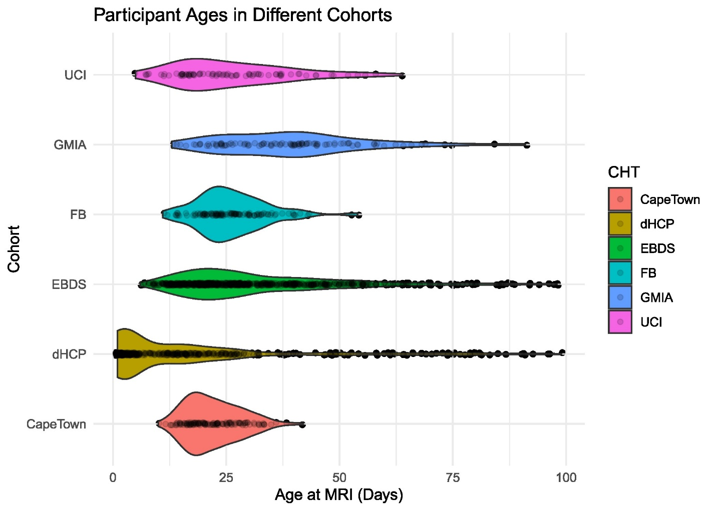

eFigure 1: Distribution of participant ages at MRI across cohorts.
Violin plots shows the distribution of neonatal ages in days at the time of MRI acquisition for each cohort. Individual observations are shown as jittered points overlaid on the violins to illustrate sample density and variability. Cohort names are shown along the y-axis.

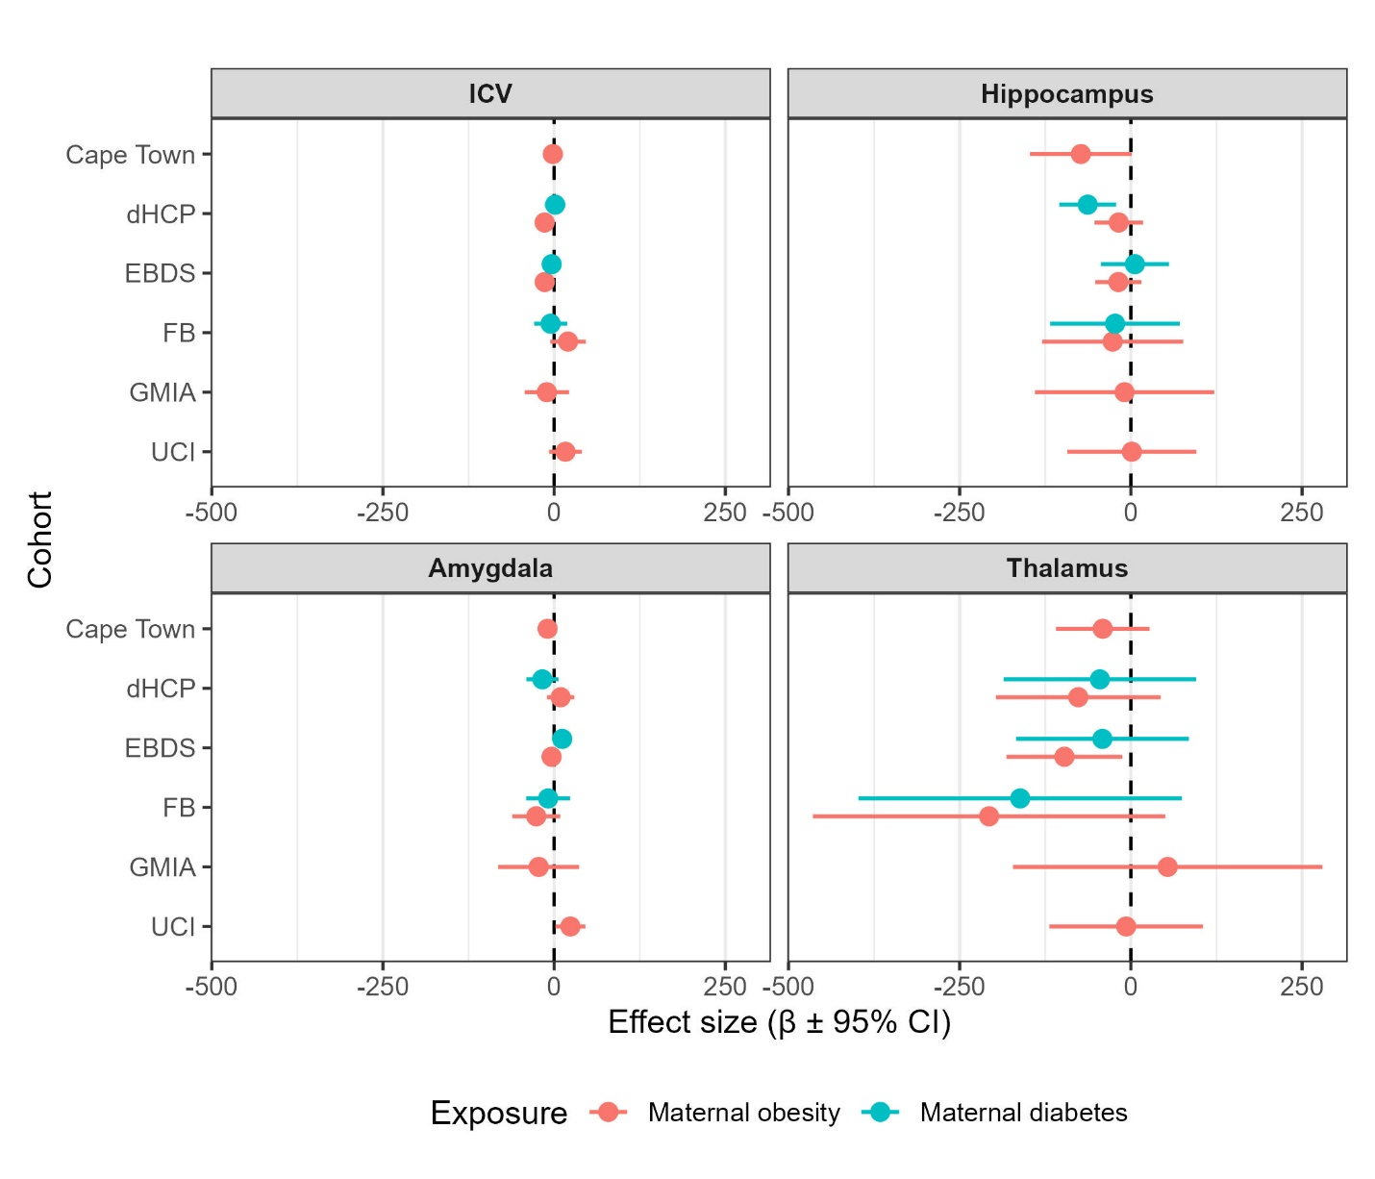

eFigure 2: Cohort-specific associations between maternal obesity and diabetes exposure and neonatal brain volumes.
Forest plots display cohort-wise regression estimates (β) and 95% confidence intervals for the associations between maternal obesity and maternal diabetes exposures and neonatal brain volumes (A) intracranial volume (ICV), (B) hippocampus, (C) amygdala, and (D) thalamus. Each point represents an exposure effect estimate from a cohort-specific linear regression model adjusted for infant age at scan, sex, gestational age at birth, low birth weight, maternal education, and intracranial volume (for non-ICV outcomes). The scanner model was included as an additional covariate in the GMIA and EBDS cohorts. Exposure variables were excluded from a model if the exposed group size was too small or had no variation within the cohort. The dashed vertical line represents the null (β = 0). Negative β values (left of the vertical dashed line) indicate lower volume associated with the maternal exposure, whereas positive β values (right of the vertical dashed line) indicate higher volume. Cohort names are shown along the y-axis, and colors distinguish maternal obesity and maternal diabetes exposures.

