Supplementary Figures and Figure Legends
Figure S1. DAG for confounder selection.
Figure S2. Sensitivity analysis of the non-linear dose-response relationships using equal knots.
Figure S3. Distribution of PRS in CKD and non-CKD participants.

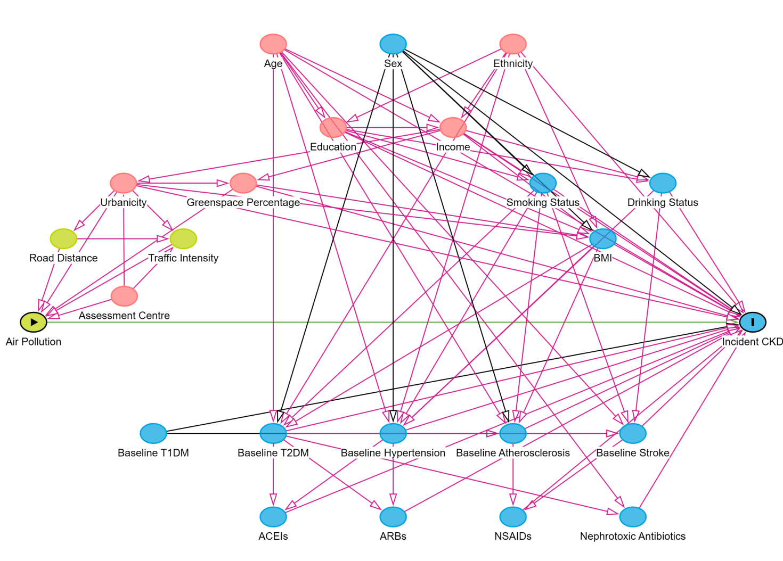
Figure S1. DAG for confounder selection.
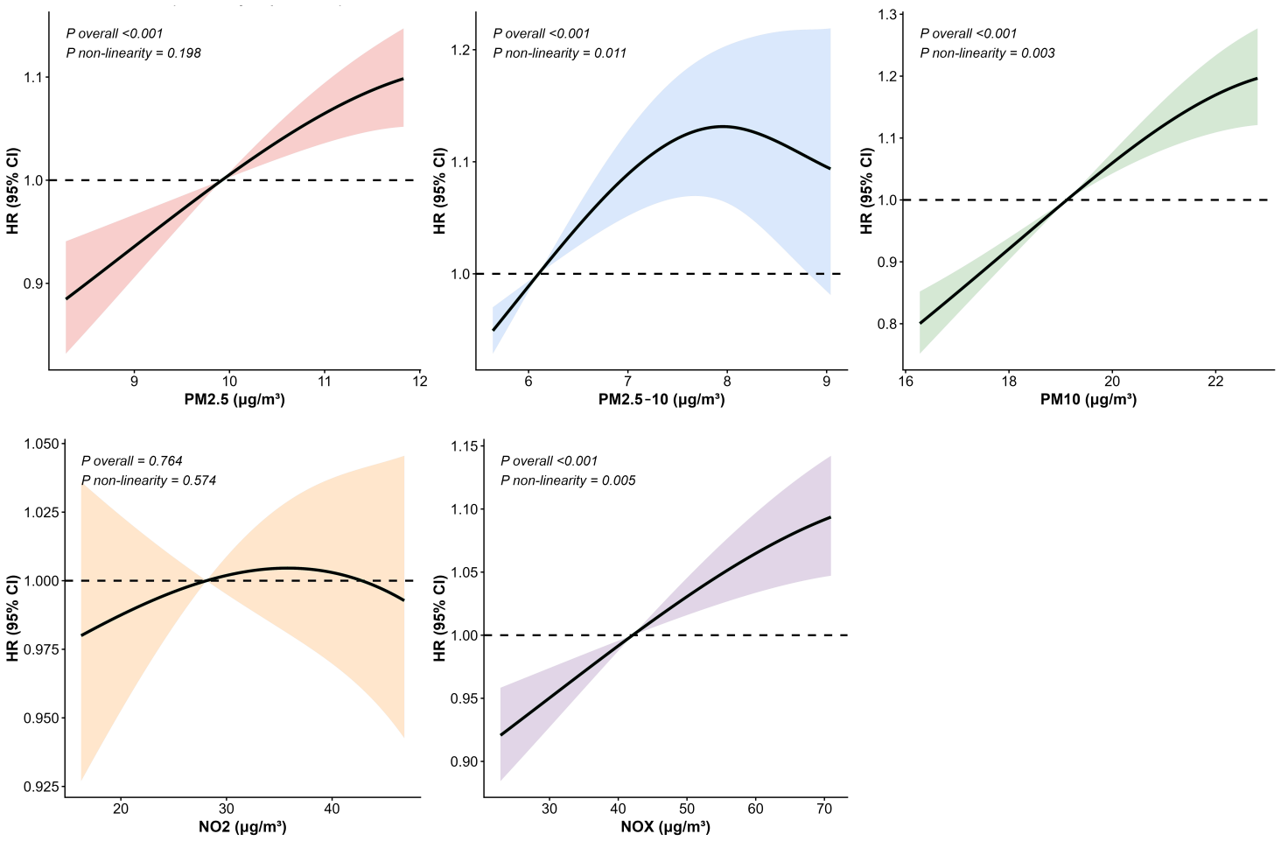
Figure S2. Sensitivity analysis of the non-linear dose-response relationships using equal knots.

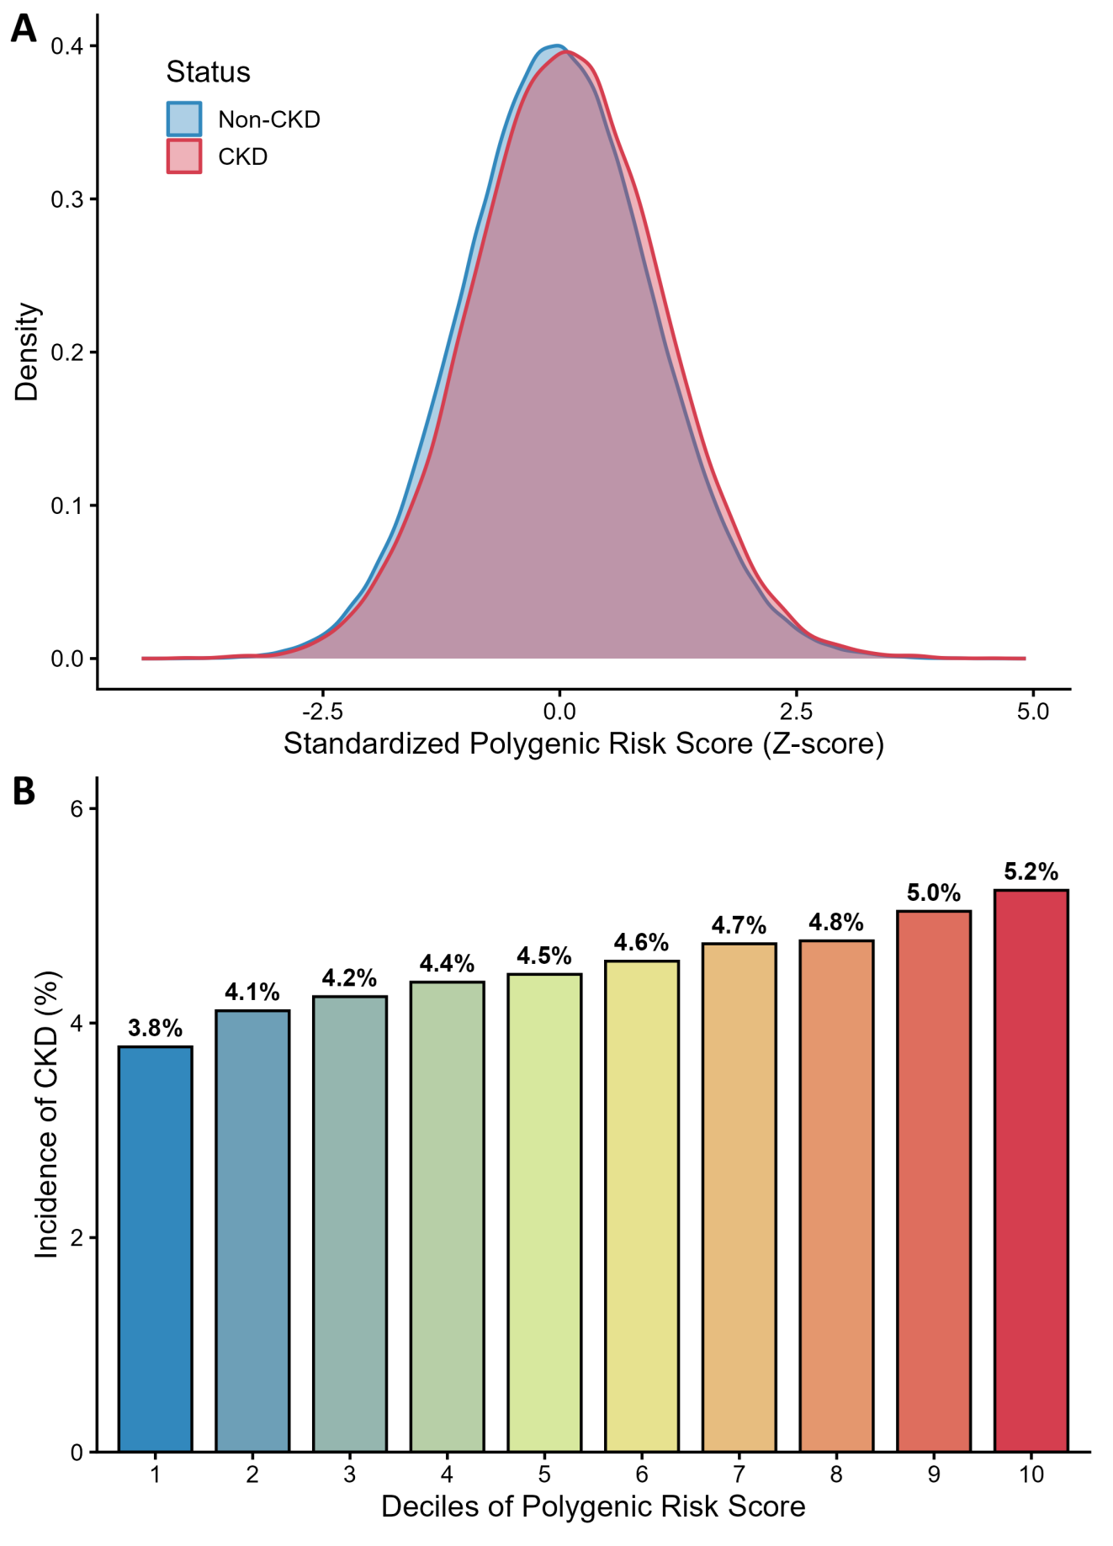

Figure S3. Distribution of PRS in CKD and non-CKD participants.

