Contents
Text S1. Definition and Measurement of Covariates 2
Text S2. Calculation of BMI Change During Follow-up in the Surgery Group 3
Table S1. New Depression Diagnoses During up to 15-Years of Follow-up 4
Table S2. New Anxiety Diagnoses During up to 15-Years of Follow-up 5
Table S3. Associations of Bariatric Surgery and Procedure Types with Risks of Depression and Anxiety After Additional Adjustment for BMI Change 6
Table S4. Baseline characteristics of the study population after excluding depression and anxiety cases occurring within the first 12 months after the index date 7
Table S5. Baseline characteristics of the full eligible cohort before matching 9
Table S6. Baseline characteristics of patients with a baseline BMI recorded within three months before the index date 11
Figure S1. Association of Bariatric Surgery with Incidence of Depression and Anxiety After Excluding Individuals with Events Within 12 Months Before the Index Date 13
Figure S2. Association of Bariatric Surgery with Incidence of Depression and Anxiety by Follow-up Durations (Years) 14
Figure S3. Association of Bariatric Surgery with Incidence of Depression and Anxiety Using the Full Unmatched Control Cohort 15
Figure S4. Association of Bariatric Surgery with Incidence of Depression and Anxiety Among Patients with a Baseline BMI Record Within 3 Months Before the Index Date 16

Text S1. Definition and Measurement of Covariates
We adjusted for the following confounders at baseline: age; sex; self-reported ethnicity (classified as White, Asian, Black, Mixed, and other ethnic groups); socioeconomic status (classified into quintiles using the Townsend score, an area-based deprivation score); marital status (classified as single, married, widowed, divorced, separated); smoking status (divided into non-smoker, ex-smoker, or current-smoker); drinking status (divided into non-drinker, ex-drinker, or current-drinker); physical activity (divided into undertaking limited/light exercise, or regular exercise); obesity-related comorbidities such as CVD, hypertension, type 2 diabetes, chronic obstructive pulmonary disease, obstructive sleep apnoea, renal failure, thyroid disease, non-diabetic hyperglycaemia, anaemia, multiple sclerosis, inflammatory bowel disease, eczema. Classifications of presence or absence of diseases were recorded through clinical codes, or if the participant had been referred to specialist services for management of any of these conditions. Missing data on any of these confounders were coded as “unknown” and entered as a separate category. Code lists for these conditions are available in supplementary materials (Codelist.xlsx).

Text S2. Calculation of BMI Change During Follow-up in the Surgery Group
BMI change during follow-up was estimated as a time-weighted average difference from baseline (index date) to the last BMI measurement before incident depression or anxiety, or to the last available follow-up in those without such events. This analysis included only individuals with at least two BMI measurements, including baseline. BMI measurements were obtained from routine primary care records between the index date and the end of follow-up (i.e., the date of outcome occurrence or censoring). The mean number of BMI measurements was 8.1 in the bariatric surgery group and 8.4 in the control group, and 18.2% of participants had only two BMI measurements during follow-up. BMI change during follow-up was calculated using the following formula:
$${BMI}_{change}=\sum{(BMI_{i}−BMI_{i−1})×(t_{i}−t_{i−1})/(t_{last}−t_{baseline})}$$
where $BMI_{i}$ represents the BMI at the current time point; $BMI_{i−1}$ represents the BMI at the previous time point; $t_{i}−t_{i−1}$ is the time interval between two consecutive BMI measurements; $t_{last}$ is the time of the last BMI measurement; $t_{baseline}$ is the time of the baseline BMI measurement. Participants were classified into quartiles (Q1–Q4) of BMI change, with approximately equal numbers in each group.

Table S1. New Depression Diagnoses During up to 15-Years of Follow-up
Year | Bariatric surgery |  |  | Behavioural control
Year | Depression diagnoses (n) | Proportion with depression (95% CI) * |  | Depression diagnoses (n) | Proportion with depression (95% CI) *
1 | 290 | 4.0% (3.5% – 4.4%) |  | 1347 | 3.9% (3.7% – 4.1%)
2 | 328 | 9.0% (8.3% – 9.6%) |  | 1124 | 7.6% (7.3% – 7.8%)
3 | 289 | 13.9% (13.1% – 14.8%) |  | 873 | 10.7% (10.4% – 11.1%)
4 | 234 | 18.6% (17.6% – 19.6%) |  | 719 | 13.8% (13.4% – 14.2%)
5 | 162 | 22.3% (21.2% – 23.4%) |  | 509 | 16.2% (15.8% – 16.7%)
6 | 132 | 25.8% (24.6% – 27.0%) |  | 425 | 18.6% (18.2% – 19.1%)
7 | 84 | 28.4% (27.1% – 29.7%) |  | 390 | 21.2% (20.7% – 21.8%)
8 | 83 | 31.4% (30.0% – 32.8%) |  | 290 | 23.5% (22.9% – 24.1%)
9 | 68 | 34.4% (32.9% – 35.9%) |  | 251 | 25.8% (25.2% – 26.4%)
10 | 43 | 36.7% (35.1% – 38.2%) |  | 167 | 27.7% (27.0% – 28.4%)
11 | 35 | 39.0% (37.3% – 40.7%) |  | 118 | 29.4% (28.7% – 30.2%)
12 | 20 | 40.8% (38.9% – 42.6%) |  | 88 | 31.1% (30.3% – 31.9%)
13 | 15 | 42.9% (40.8% – 44.9%) |  | 56 | 32.7% (31.8% – 33.6%)
14 | 14 | 45.9% (43.4% – 48.4%) |  | 30 | 34.2% (33.2% – 35.2%)
15 | 8 | 48.6% (45.5% – 51.5%) |  | 14 | 35.3% (34.1% – 36.4%)
* Cumulative proportions were estimated using the Kaplan–Meier method.

Table S2. New Anxiety Diagnoses During up to 15-Years of Follow-up
Year | Bariatric surgery |  |  | Behavioural control
Year | Anxiety diagnoses (n) | Proportion with anxiety (95% CI) * |  | Anxiety diagnoses (n) | Proportion with anxiety (95% CI) *
1 | 89 | 1.2% (1.0% – 1.5%) |  | 475 | 1.4% (1.3% – 1.5%)
2 | 97 | 2.7% (2.3% – 3.1%) |  | 382 | 2.6% (2.4% – 2.8%)
3 | 112 | 4.6% (4.1% – 5.1%) |  | 345 | 3.9% (3.7% – 4.1%)
4 | 74 | 6.1% (5.5% – 6.7%) |  | 265 | 5.0% (4.7% – 5.2%)
5 | 73 | 7.8% (7.1% – 8.5%) |  | 197 | 6.0% (5.7% – 6.2%)
6 | 52 | 9.1% (8.4% – 9.9%) |  | 244 | 7.4% (7.0% – 7.7%)
7 | 39 | 10.3% (9.5% – 11.2%) |  | 175 | 8.5% (8.1% – 8.9%)
8 | 42 | 11.9% (10.9% – 12.8%) |  | 141 | 9.6% (9.2% – 10.0%)
9 | 38 | 13.5% (12.4% – 14.6%) |  | 127 | 10.8% (10.3% – 11.2%)
10 | 22 | 14.7% (13.5% – 15.8%) |  | 71 | 11.6% (11.1% – 12.1%)
11 | 24 | 16.3% (14.9% – 17.6%) |  | 73 | 12.7% (12.1% – 13.2%)
12 | 15 | 17.6% (16.1% – 19.0%) |  | 54 | 13.7% (13.1% – 14.3%)
13 | 9 | 18.8% (17.2% – 20.4%) |  | 46 | 15.0% (14.3% – 15.7%)
14 | 7 | 20.3% (18.3% – 22.2%) |  | 14 | 15.7% (14.9% – 16.4%)
15 | 7 | 22.4% (19.9% – 24.8%) |  | 11 | 16.6% (15.6% – 17.5%)
* Cumulative proportions were estimated using the Kaplan–Meier method.

Table S3. Associations of Bariatric Surgery and Procedure Types with Risks of Depression and Anxiety After Additional Adjustment for BMI Change
 | Incidence per 1000 person-years (95%CI) |  | Adjusted Hazard Ratio (95% CI) * | Hazard Ratio further adjusted for BMI Change (95% CI) †
 | Bariatric surgery | Behavioural control | Adjusted Hazard Ratio (95% CI) * | Hazard Ratio further adjusted for BMI Change (95% CI) †
Depression
Overall | 42.4 (40.3-44.6) | 27.7 (26.9-28.5) | 1.54 (1.43-1.65) | 1.32 (1.23-1.43)
Type of procedure
Gastric bypass | 49.0 (45.2-53.0) | 27.7 (26.9-28.5) | 1.75 (1.56-1.95) | 1.48 (1.31-1.66)
Sleeve gastrectomy | 36.5 (32.2-41.2) | 27.7 (26.9-28.5) | 1.41 (1.20-1.65) | 1.15 (0.98-1.36)
Laparoscopic gastric banding | 39.1 (35.8-42.7) | 27.7 (26.9-28.5) | 1.36 (1.21-1.52) | 1.21 (1.07-1.36)
Unspecified | 42.9 (35.3-51.6) | 27.7 (26.9-28.5) | 1.91 (1.48-2.47) | 1.75 (1.35-2.27)
Anxiety
Overall | 14.4 (13.3-15.6) | 10.5 (10.0-11.0) | 1.41 (1.26-1.57) | 1.28 (1.14-1.44)
Type of procedure
Gastric bypass | 16.7 (14.6-18.9) | 10.5 (10.0-11.0) | 1.66 (1.40-1.97) | 1.48 (1.24-1.78)
Sleeve gastrectomy | 13.1 (10.7-15.9) | 10.5 (10.0-11.0) | 1.34 (1.04-1.73) | 1.19 (0.92-1.54)
Laparoscopic gastric banding | 13.0 (11.3-15.0) | 10.5 (10.0-11.0) | 1.15 (0.97-1.38) | 1.08 (0.91-1.29)
Unspecified | 13.8 (10.0-18.5) | 10.5 (10.0-11.0) | 2.12 (1.38-3.25) | 2.00 (1.30-3.07)
* Models were adjusted for matching factors, demographic and lifestyle factors, and obesity-related comorbidities.
† Additionally adjusted for BMI change during follow-up

Table S4. Baseline characteristics of the study population after excluding depression and anxiety cases occurring within the first 12 months after the index date
 | Bariatric surgery patients (n=6649) | Matched controls (n=31177)
Index year, median (IQR) | 2014 (2010 to 2017) | 2014 (2010 to 2017)
Age, median (IQR), y | 44.1 (40.7 to 47.7) | 44.4 (40.6 to 47.8)
Body mass index, median (IQR) | 44.1 (40.0 to 49.0) | 43.5 (39.7 to 47.7)
BMI category, No. (%)
35-39.9 | 231 (3.5) | 482 (1.5)
40-44.9 | 1633 (24.6) | 8256 (26.5)
45-49.9 | 2008 (30.2) | 10254 (32.9)
50-54.9 | 1572 (23.6) | 7797 (25.0)
55-59.9 | 861 (12.9) | 3317 (10.6)
60-80 | 344 (5.2) | 1071 (3.4)
Sex, No. (%)
Women | 4756 (71.5) | 22514 (72.2)
Men | 1893 (28.5) | 8663 (27.8)
Ethnicity, No. (%)
White | 4739 (71.3) | 22392 (71.8)
Asian | 309 (4.6) | 1969 (6.3)
Black | 541 (8.1) | 2943 (9.4)
Other | 129 (1.9) | 273 (0.9)
Mixed | 123 (1.8) | 524 (1.7)
Unknown | 808 (12.2) | 3076 (9.9)
Marital Status, No. (%)
Single | 231 (3.5) | 1151 (3.7)
Married | 442 (6.6) | 1979 (6.3)
Widowed | 48 (0.7) | 223 (0.7)
Divorced | 53 (0.8) | 157 (0.5)
Separated | 25 (0.4) | 101 (0.3)
Unknown | 5850 (88.0) | 27566 (88.4)
Index of Multiple Deprivation quintile, No. (%)
Quintile 1 (most affluent) | 1014 (15.3) | 4175 (13.4)
Quintile 2 | 1218 (18.3) | 4804 (15.4)
Quintile 3 | 1275 (19.2) | 5545 (17.8)
Quintile 4 | 1574 (23.7) | 7415 (23.8)
Quintile 5 (most deprived) | 1563 (23.5) | 9211 (29.5)
Unknown | 5 (0.1) | 27 (0.1)
Smoking status, No. (%)
Non-smoker | 2530 (38.1) | 12420 (39.8)
Ex-smoker | 1160 (17.4) | 4255 (13.6)
Current-smoker | 1443 (21.7) | 6629 (21.3)
Unknown | 1516 (22.8) | 7873 (25.3)
Alcohol use, No. (%)
Non-drinker | 589 (8.9) | 2932 (9.4)
Ex-drinker | 20 (0.3) | 85 (0.3)
Current-drinker | 4148 (62.4) | 18546 (59.5)
Unknown | 1892 (28.5) | 9614 (30.8)
Physical activity, No. (%)
Limited/light exercise | 1555 (23.4) | 6828 (21.9)
Regular exercise | 697 (10.5) | 3183 (10.2)
Unknown | 4397 (66.1) | 21166 (67.9)
Obesity-related comorbidity, No. (%)
Cardiovascular disease | 435 (6.5) | 1788 (5.7)
Type 2 diabetes | 1569 (23.6) | 4725 (15.2)
Hypertension | 2417 (36.4) | 10568 (33.9)
Eczema | 1349 (20.3) | 6065 (19.5)
Chronic obstructive pulmonary disease | 131 (2.0) | 637 (2.0)
Obstructive sleep apnoea | 700 (10.5) | 781 (2.5)
Inflammatory bowel disease | 352 (5.3) | 1672 (5.4)
Anaemia | 436 (6.6) | 2155 (6.9)
Non-diabetic hyperglycemia | 187 (2.8) | 778 (2.5)
Renal failure | 294 (4.4) | 943 (3.0)
Thyroid disorders | 656 (9.9) | 2302 (7.4)
Multiple sclerosis | 9 (0.1) | 50 (0.2)

Table S5. Baseline characteristics of the full eligible cohort before matching
 | Bariatric surgery patients (n=8486) | Matched controls (n=173360)
Index year, median (IQR) | 2014 (2010 to 2018) | 2015 (2010 to 2018)
Age, median (IQR), y | 44.3 (40.8 to 48.3) | 45.4 (40.5 to 48.7)
Body mass index, median (IQR) | 44.8 (40.4 to 50.4) | 38.6 (36.5 to 42.1)
BMI category, No. (%)
35-39.9 | 433 (5.1) | 1400 (0.8)
40-44.9 | 1919 (22.6) | 106561 (61.5)
45-49.9 | 2392 (28.2) | 42910 (24.8)
50-54.9 | 1909 (22.5) | 15386 (8.9)
55-59.9 | 1253 (14.8) | 5325 (3.1)
60-80 | 580 (6.8) | 1778 (1.0)
Sex, No. (%)
Women | 6139 (72.3) | 102326 (59.0)
Men | 2347 (27.7) | 71034 (41.0)
Ethnicity, No. (%)
White | 6051 (71.3) | 126012 (72.7)
Asian | 388 (4.6) | 11213 (6.5)
Black | 696 (8.2) | 13920 (8.0)
Other | 161 (1.9) | 1610 (0.9)
Mixed | 158 (1.9) | 2363 (1.4)
Unknown | 1032 (12.2) | 18242 (10.5)
Marital Status, No. (%)
Single | 331 (3.9) | 5514 (3.2)
Married | 572 (6.7) | 11692 (6.7)
Widowed | 64 (0.8) | 1581 (0.9)
Divorced | 64 (0.8) | 1133 (0.7)
Separated | 30 (0.4) | 523 (0.3)
Unknown | 7425 (87.5) | 152917 (88.2)
Index of Multiple Deprivation quintile, No. (%)
Quintile 1 (most affluent) | 1249 (14.7) | 25648 (14.8)
Quintile 2 | 1509 (17.8) | 29806 (17.2)
Quintile 3 | 1603 (18.9) | 32040 (18.5)
Quintile 4 | 2054 (24.2) | 40373 (23.3)
Quintile 5 (most deprived) | 2063 (24.3) | 45364 (26.2)
Unknown | 8 (0.1) | 129 (0.1)
Smoking status, No. (%)
Non-smoker | 3242 (38.2) | 64480 (37.2)
Ex-smoker | 1475 (17.4) | 27941 (16.1)
Current-smoker | 1872 (22.1) | 37144 (21.4)
Unknown | 1897 (22.4) | 43795 (25.3)
Alcohol use, No. (%)
Non-drinker | 752 (8.9) | 14808 (8.5)
Ex-drinker | 27 (0.3) | 437 (0.3)
Current-drinker | 5254 (61.9) | 107022 (61.7)
Unknown | 2453 (28.9) | 51093 (29.5)
Physical activity, No. (%)
Limited/light exercise | 2020 (23.8) | 38047 (21.9)
Regular exercise | 923 (10.9) | 19230 (11.1)
Unknown | 5543 (65.3) | 116083 (67.0)
Obesity-related comorbidity, No. (%)
Cardiovascular disease | 546 (6.4) | 17779 (10.3)
Type 2 diabetes | 1966 (23.2) | 32122 (18.5)
Hypertension | 3045 (35.9) | 72817 (42.0)
Eczema | 1723 (20.3) | 33514 (19.3)
Chronic obstructive pulmonary disease | 165 (1.9) | 6156 (3.6)
Obstructive sleep apnoea | 918 (10.8) | 4200 (2.4)
Inflammatory bowel disease | 449 (5.3) | 8523 (4.9)
Anaemia | 572 (6.7) | 10812 (6.2)
Non-diabetic hyperglycemia | 239 (2.8) | 4913 (2.8)
Renal failure | 358 (4.2) | 9971 (5.8)
Thyroid disorders | 837 (9.9) | 13709 (7.9)
Multiple sclerosis | 15 (0.2) | 253 (0.1)

Table S6. Baseline characteristics of patients with a baseline BMI recorded within three months before the index date
 | Bariatric surgery patients (n=3279) | Matched controls (n=15677)
Index year, median (IQR) | 2014 (2010 to 2018) | 2014 (2010 to 2018)
Age, median (IQR), y | 44.0 (40.5 to 48.3) | 44.3 (40.5 to 48.3)
Body mass index, median (IQR) | 44.3 (40.0 to 49.4) | 43.9 (39.8 to 48.4)
BMI category, No. (%)
35-39.9 | 122 (3.7) | 298 (1.9)
40-44.9 | 804 (24.5) | 4018 (25.6)
45-49.9 | 939 (28.6) | 4790 (30.6)
50-54.9 | 784 (23.9) | 3953 (25.2)
55-59.9 | 438 (13.4) | 1946 (12.4)
60-80 | 192 (5.9) | 672 (4.3)
Sex, No. (%)
Women | 2366 (72.2) | 11406 (72.8)
Men | 913 (27.8) | 4271 (27.2)
Ethnicity, No. (%)
White | 2358 (71.9) | 11133 (71.0)
Asian | 153 (4.7) | 1004 (6.4)
Black | 254 (7.7) | 1541 (9.8)
Other | 63 (1.9) | 140 (0.9)
Mixed | 60 (1.8) | 292 (1.9)
Unknown | 391 (11.9) | 1567 (10.0)
Marital Status, No. (%)
Single | 108 (3.3) | 610 (3.9)
Married | 227 (6.9) | 1039 (6.6)
Widowed | 20 (0.6) | 114 (0.7)
Divorced | 24 (0.7) | 99 (0.6)
Separated | 17 (0.5) | 62 (0.4)
Unknown | 2883 (87.9) | 13753 (87.7)
Index of Multiple Deprivation quintile, No. (%)
Quintile 1 (most affluent) | 469 (14.3) | 1985 (12.7)
Quintile 2 | 554 (16.9) | 2404 (15.3)
Quintile 3 | 617 (18.8) | 2784 (17.8)
Quintile 4 | 837 (25.5) | 3808 (24.3)
Quintile 5 (most deprived) | 800 (24.4) | 4686 (29.9)
Unknown | 2 (0.1) | 10 (0.1)
Smoking status, No. (%)
Non-smoker | 1272 (38.8) | 6311 (40.3)
Ex-smoker | 557 (17.0) | 2134 (13.6)
Current-smoker | 746 (22.8) | 3411 (21.8)
Unknown | 704 (21.5) | 3821 (24.4)
Alcohol use, No. (%)
Non-drinker | 290 (8.8) | 1447 (9.2)
Ex-drinker | 6 (0.2) | 37 (0.2)
Current-drinker | 2079 (63.4) | 9478 (60.5)
Unknown | 904 (27.6) | 4715 (30.1)
Physical activity, No. (%)
Limited/light exercise | 790 (24.1) | 3523 (22.5)
Regular exercise | 353 (10.8) | 1643 (10.5)
Unknown | 2136 (65.1) | 10511 (67.0)
Obesity-related comorbidity, No. (%)
Cardiovascular disease | 221 (6.7) | 918 (5.9)
Type 2 diabetes | 923 (28.1) | 2535 (16.2)
Hypertension | 1257 (38.3) | 5225 (33.3)
Eczema | 667 (20.3) | 3003 (19.2)
Chronic obstructive pulmonary disease | 58 (1.8) | 354 (2.3)
Obstructive sleep apnoea | 394 (12.0) | 408 (2.6)
Inflammatory bowel disease | 189 (5.8) | 815 (5.2)
Anaemia | 225 (6.9) | 1103 (7.0)
Non-diabetic hyperglycemia | 97 (3.0) | 360 (2.3)
Renal failure | 156 (4.8) | 473 (3.0)
Thyroid disorders | 328 (10.0) | 1139 (7.3)
Multiple sclerosis | 6 (0.2) | 26 (0.2)

Figure S1. Association of Bariatric Surgery with Incidence of Depression and Anxiety After Excluding Individuals with Events Within 12 Months Before the Index Date
A. Depression
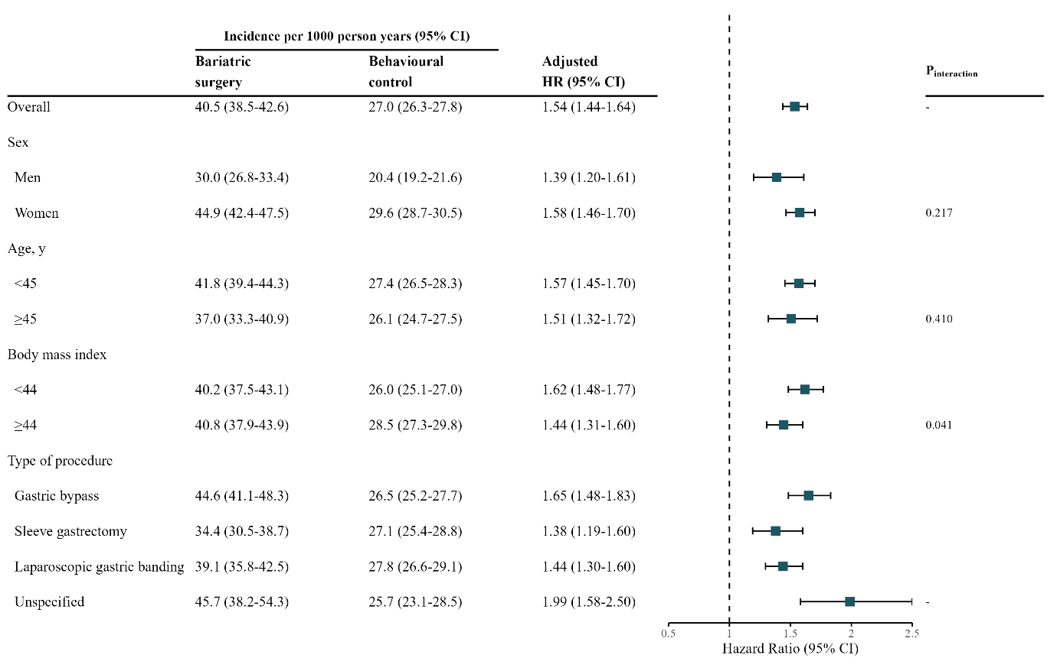
B. Anxiety
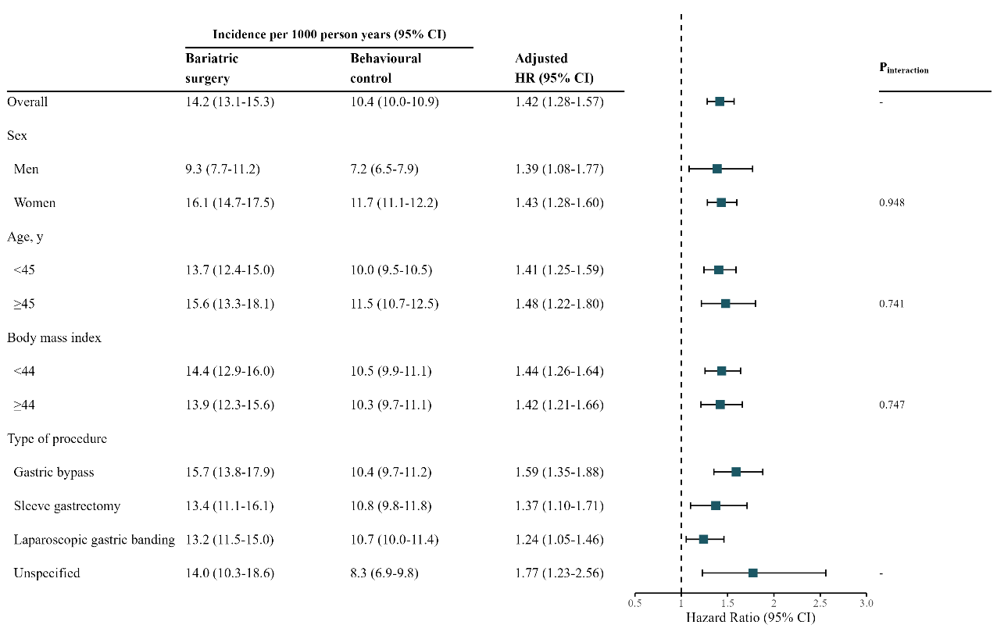
Note: Models were adjusted for matching factors, demographic and lifestyle factors, and obesity-related comorbidities. Adjusted hazard ratios (HRs) were derived by removing the original variable from the fully adjusted Cox model and replacing it with a dichotomous subgroup variable along with its interaction term with treatment. For example, the continuous age covariate was substituted with a binary version and its interaction with treatment. Age and body mass index were dichotomized using their median values. The association of surgery type (gastric bypass, sleeve gastrectomy, gastric banding, or unspecified) with the outcomes was examined in separate matched comparisons. HR: hazard ratio, CI: confidence interval

Figure S2. Association of Bariatric Surgery with Incidence of Depression and Anxiety by Follow-up Durations (Years)
A. Depression
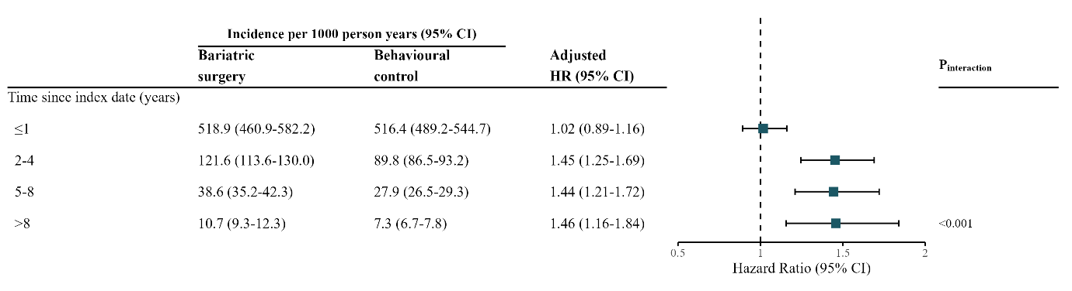
B. Anxiety
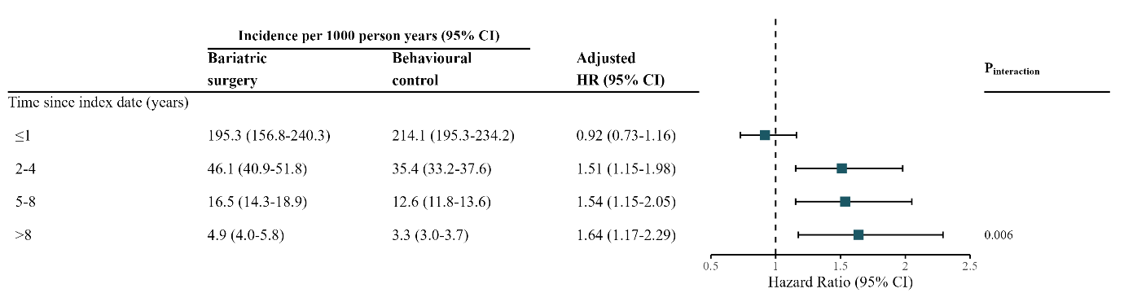
Note: Models were adjusted for matching factors, demographic and lifestyle factors, and obesity-related comorbidities. HR: hazard ratio, CI: confidence interval

Figure S3. Association of Bariatric Surgery with Incidence of Depression and Anxiety Using the Full Unmatched Control Cohort
A. Depression
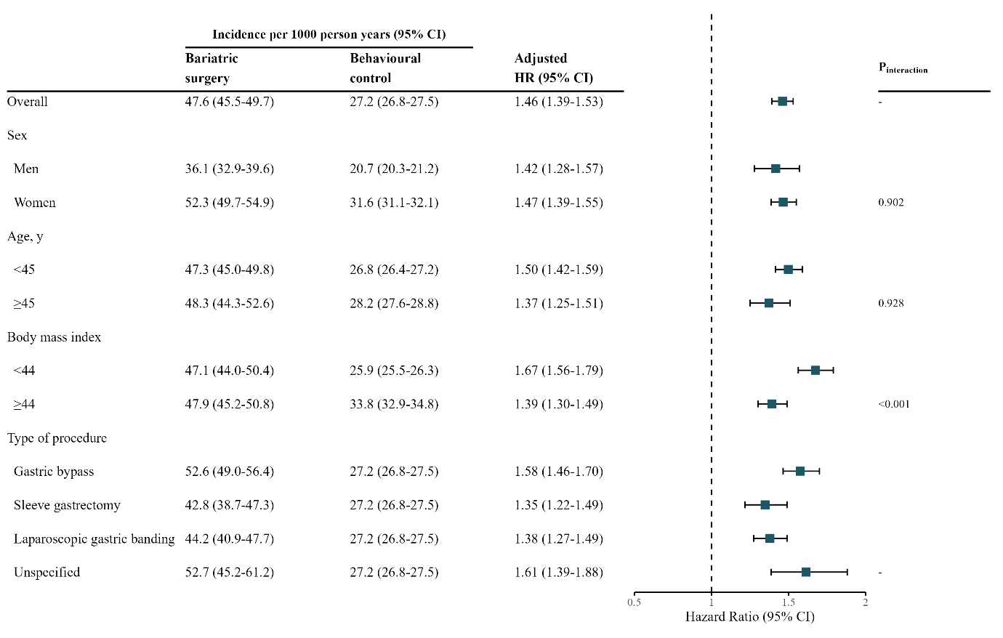
B. Anxiety
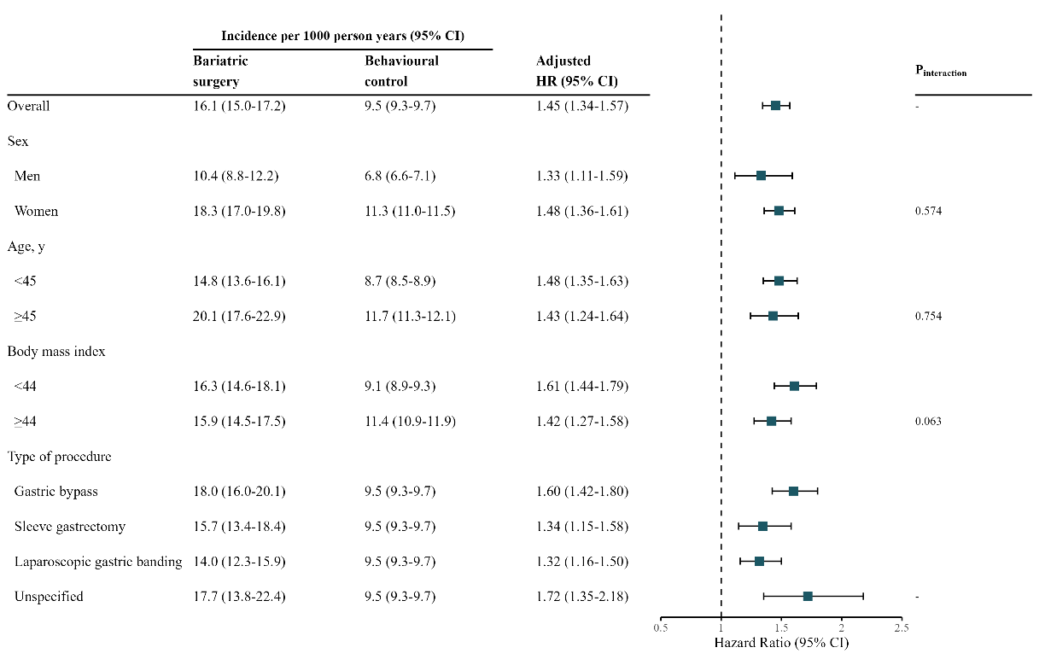
Note: Models were adjusted for matching factors, demographic and lifestyle factors, and obesity-related comorbidities. Adjusted hazard ratios (HRs) were derived by removing the original variable from the fully adjusted Cox model and replacing it with a dichotomous subgroup variable along with its interaction term with treatment. For example, the continuous age covariate was substituted with a binary version and its interaction with treatment. Age and body mass index were dichotomized using their median values. The association of surgery type (gastric bypass, sleeve gastrectomy, gastric banding, or unspecified) with the outcomes was examined in separate matched comparisons. HR: hazard ratio, CI: confidence interval

Figure S4. Association of Bariatric Surgery with Incidence of Depression and Anxiety Among Patients with a Baseline BMI Record Within 3 Months Before the Index Date
A. Depression
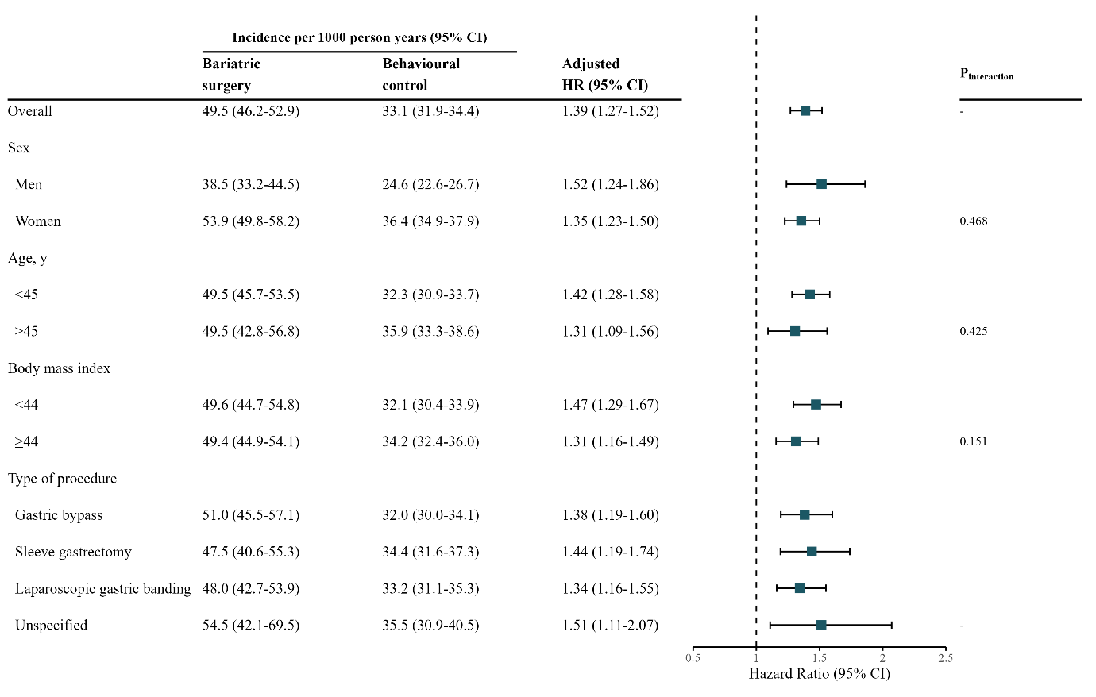
B. Anxiety
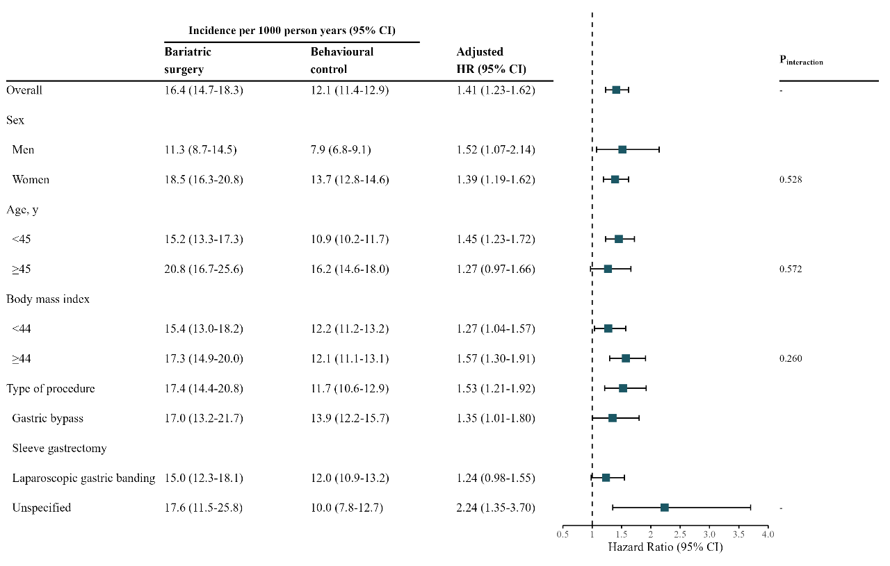
Note: Models were adjusted for matching factors, demographic and lifestyle factors, and obesity-related comorbidities. Adjusted hazard ratios (HRs) were derived by removing the original variable from the fully adjusted Cox model and replacing it with a dichotomous subgroup variable along with its interaction term with treatment. For example, the continuous age covariate was substituted with a binary version and its interaction with treatment. Age and body mass index were dichotomized using their median values. The association of surgery type (gastric bypass, sleeve gastrectomy, gastric banding, or unspecified) with the outcomes was examined in separate matched comparisons. HR: hazard ratio, CI: confidence interval

