Table S1. Comparison between included children and excluded children. Data were presented as mean (standard deviation [SD]) for continuous variables or number (percentage) for categorical variables. P values were extracted from t-test for continuous variables and chis-square test for categorical variables.
Variables | Included cases  (N = 8,981) | Excluded cases  (N = 5,661) | Statistical value | p
Socioeconomic position
Paternal occupation category at birth (= manual) | 6459 (71.9%) | 4234 (74.8%) | 14.42 | <0.01
Paternal occupation category at age 7 (= manual) | 6052 (67.4%) | 3912 (69.1%) | 4.63 | 0.03
Paternal occupation category at age 11 (= manual) | 5793 (64.5%) | 3769 (66.6%) | 6.51 | 0.01
Father unemployed at age 7 (= yes) | 196 (2.2%) | 148 (2.6%) | 2.64 | 0.10
Father unemployed at age 11 (= yes) | 279 (3.1%) | 225 (4.0%) | 7.61 | 0.01
Mother education status (= Remained after the compulsory period) | 3200 (35.6%) | 1656 (29.3%) | 63.44 | <0.01
Father education status (= Remained after the compulsory period) | 2910 (32.4%) | 1810 (32.0%) | 0.27 | 0.60
Housing tenure at age 7 (= Owned/mortgaged) | 3780 (42.1%) | 2260 (39.9%) | 6.64 | 0.01
Housing tenure at age 11 (= Owned/mortgaged) | 4135 (46.0%) | 2564 (45.3%) | 0.76 | 0.39
Number of rooms in the residence at age 7 | 4.78 (1.33) | 4.76 (1.35) | 0.70 | 0.48
Number of rooms in the residence at age 11 | 4.92 (1.32) | 4.96 (1.37) | -1.69 | 0.09
Having financial hardships at age 7 (= yes) | 740 (8.2%) | 1535 (27.1%) | 941.28 | <0.01
Having financial hardships at age 11 (= yes) | 1052 (11.7%) | 1283 (22.7%) | 309.80 | <0.01
Reported housing difficulties at age 7 (= yes) | 662 (7.4%) | 899 (15.9%) | 263.09 | <0.01
Provision of free school meals at age 11 (=yes) | 917 (10.2%) | 1106 (19.5%) | 252.88 | <0.01
Adverse childhood experiences
Parental separation or divorce (=yes) | 367 (4.1%) | 1034 (18.3%) | 805.12 | <0.01
Substance misuse by parents (=yes) | 130 (1.4%) | 1074 (19.0%) | 1410.69 | <0.01
Presence of family conflict (=yes) | 564 (6.3%) | 1403 (24.8%) | 1020.72 | <0.01
Parental death (=yes) | 150 (1.7%) | 514 (9.1%) | 438.62 | <0.01
Mental health problems among parents (=yes) | 558 (6.2%) | 1275 (22.5%) | 841.88 | <0.01
Physical neglect experienced from parents (=yes) | 567 (6.3%) | 367 (6.5%) | 0.14 | 0.71
Parental involvement in criminal activities (=yes) | 348 (3.9%) | 930 (16.4%) | 685.29 | <0.01
Environmental factors
Sex (= female) | 4429 (49.3%) | 2708 (47.8%) | 2.98 | 0.08
Having diseases at birth (= yes) | 242 (2.7%) | 196 (3.5%) | 6.79 | 0.01
Weight category at birth
Under -2 SD | 199 (2.2%) | 153 (2.7%) | 25.38 | <0.01
-2 to -1 SD | 1191 (13.3%) | 899 (15.9%) | 25.38 | <0.01
-1 to +1 SD | 6327 (70.4%) | 3806 (67.2%) | 25.38 | <0.01
+1 to +2 SD | 1020 (11.4%) | 651 (11.5%) | 25.38 | <0.01
Over +2 SD | 244 (2.7%) | 152 (2.7%) | 25.38 | <0.01
ZBMI at age 7
Under -2 SD | 182 (2.0%) | 101 (1.8%) | 5.77 | 0.22
-2 to -1 SD | 691 (7.7%) | 407 (7.2%) | 5.77 | 0.22
-1 to +1 SD | 6606 (73.6%) | 4169 (73.6%) | 5.77 | 0.22
+1 to +2 SD | 1141 (12.7%) | 775 (13.7%) | 5.77 | 0.22
Over +2 SD | 361 (4.0%) | 209 (3.7%) | 5.77 | 0.22
ZBMI at age 11
Under -2 SD | 203 (2.3%) | 114 (2.0%) | 9.24 | 0.06
-2 to -1 SD | 1169 (13.0%) | 717 (12.7%) | 9.24 | 0.06
-1 to +1 SD | 6147 (68.4%) | 3998 (70.6%) | 9.24 | 0.06
+1 to +2 SD | 1104 (12.3%) | 627 (11.1%) | 9.24 | 0.06
Over +2 SD | 358 (4.0%) | 205 (3.6%) | 9.24 | 0.06
Mother’s age at child’s birth | 27.58 (5.68) | 27.36 (5.66) | 2.20 | 0.03
Length of gestational period | 280.74 (12.91) | 280.29 (14.47) | 1.90 | 0.06
Mother’s parity | 1.30 (1.52) | 1.37 (1.62) | -2.73 | 0.01
Maternal health conditions during pregnancy (= yes) | 2093 (23.3%) | 1306 (23.1%) | 0.09 | 0.76
Mother’s marital status at child’s birth (= Married/ Twice married/Cohabiting/Stable Union ) | 8693 (96.8%) | 5443 (96.1%) | 4.13 | 0.04
Mother’s weekly smoking frequency during pregnancy
None | 6134 (68.3%) | 3733 (65.9%) | 20.87 | <0.01
1-9 | 1634 (18.2%) | 1009 (17.8%) | 20.87 | <0.01
>= 10 | 1213 (13.5%) | 919 (16.2%) | 20.87 | <0.01
Mother interested in child education at age 7 (= yes) | 7694 (85.7%) | 4537 (80.1%) | 76.66 | <0.01
Mother interested in child education at age 11 (= yes) | 7739 (86.2%) | 4622 (81.6%) | 53.70 | <0.01
Mother engaged in outdoor activities with child at age 7 (= yes) | 8840 (98.4%) | 4526 (80.0%) | 1488.22 | <0.01
Mother engaged in outdoor activities with child at age 11 (= yes) | 8370 (93.2%) | 4545 (80.3%) | 555.08 | <0.01
Mother participated in reading activities with child at age 7 (=yes) | 7535 (83.9%) | 4021 (71.0%) | 344.96 | <0.01
Father’s age at child birth | 30.65 (6.36) | 30.39 (6.44) | 2.35 | 0.02
Father interested in child education at age 7 (= yes) | 6998 (77.9%) | 4069 (71.9%) | 68.37 | <0.01
Father interested in child education at age 11 (= yes) | 6953 (77.4%) | 4133 (73.0%) | 36.50 | <0.01
Father engaged in outdoor activities with child at age 7 (= yes) | 8431 (93.9%) | 4241 (74.9%) | 1070.33 | <0.01
Father engaged in outdoor activities with child at age 11 (= yes) | 7916 (88.1%) | 4034 (71.3%) | 658.40 | <0.01
Father participated in reading activities with child at age 7 (= yes) | 6443 (71.7%) | 3283 (58.0%) | 293.62 | <0.01
Father participated in childcare at age 7 (=yes) | 7960 (88.6%) | 4268 (75.4%) | 441.02 | <0.01
Father participated in childcare at age 11 (=yes) | 8001 (89.1%) | 4143 (73.2%) | 619.50 | <0.01
Outcomes
Scores of Bristol Social Adjustment Guide (BSAG) at age 11 | 15.81 (17.01) | 18.30 (18.93) | -8.07 | <0.01
Scores of Rutter A Scale at age 11 | 6.56 (3.65) | 7.88 (4.18) | -19.45 | <0.01

Figure S1. Relative importance of predictors for childhood mental health risk based on Rutter A Scale. Data presents the relative importance of selected predictor variables in forecasting potential mental health disorders among school-aged children, based on the Rutter A Scale score at age 11. The x-axis displays the importance score, representing each variable's contribution to the model's predictive accuracy, while the y-axis lists the predictor variables in descending order of importance. The importance scores were derived using recursive feature elimination with cross-validation in the training dataset. Higher scores indicate greater predictive value for identifying potential mental health disorders.
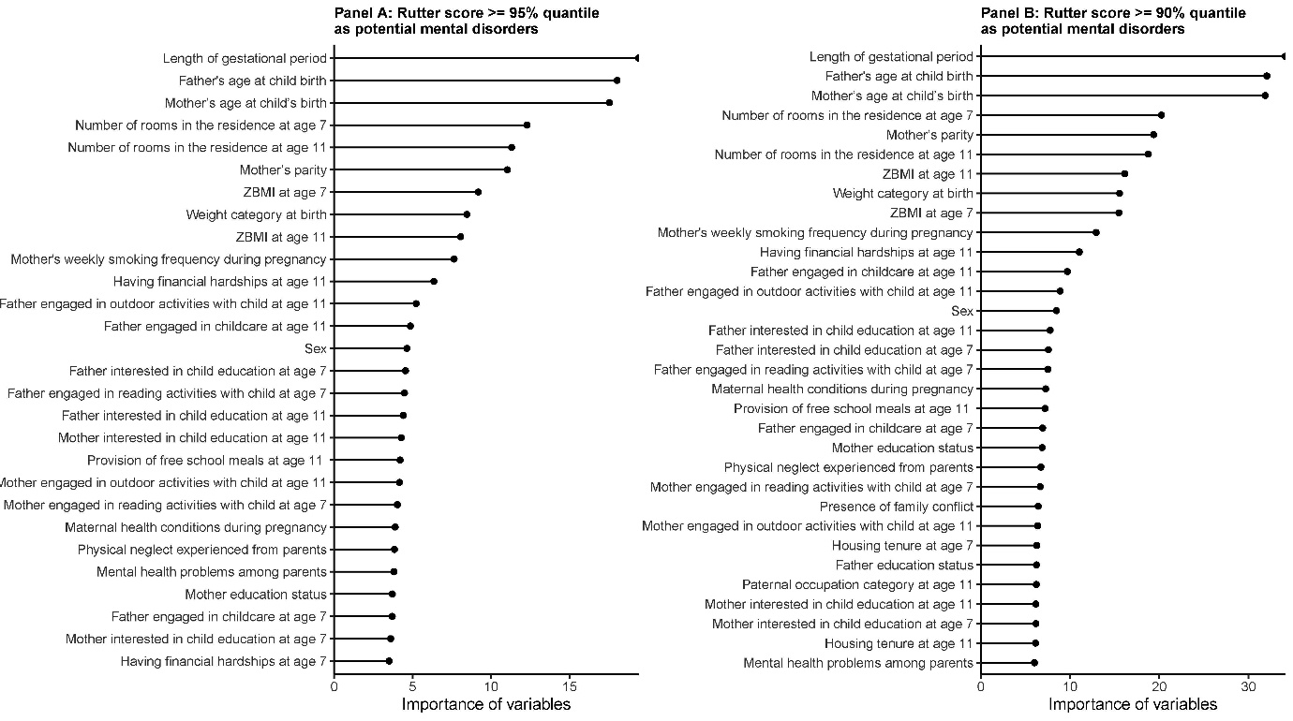

Figure S2. Receiver Operating Characteristic (ROC) curves comparing predictive performance of machine learning models for childhood mental health assessment based on Rutter A Scale. The figure presents ROC curves demonstrating the predictive performance of six different modeling approaches: stand-alone models using either all selected variables or essay features, and combined models integrating essay features with varying numbers of top selected variables (5, 10, 15, and 20). The x-axis shows the false positive rate (1-specificity), and the y-axis displays the true positive rate (sensitivity). Each curve represents the best-performing model within its respective modeling approach, as determined by the highest ROC value.
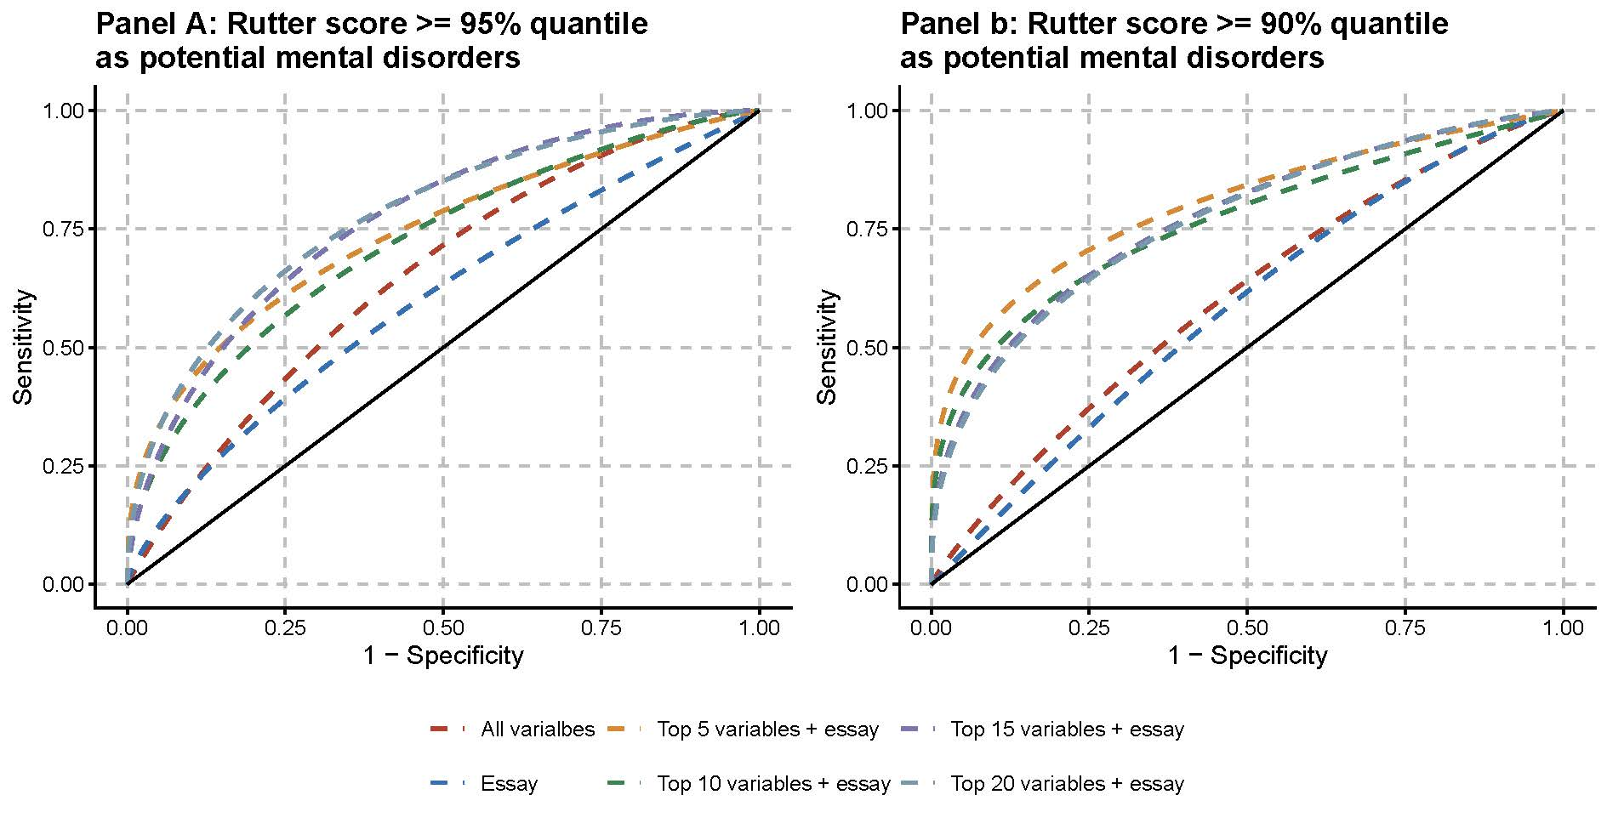
Table S2. Performance metrics of machine learning models using different predictor combinations for mental health risk detection based on Rutter A Scale. Data summarizes the performance metrics of machine learning models predicting potential mental health disorders based on based on Rutter A Scale scores at age 11, using two different thresholds (95th and 90th percentiles). The models were evaluated using different combinations of predictors: traditional variables alone, essay features alone, and varying combinations of top selected variables (5, 10, 15, or 20) with essay features. For each predictor combination shown, we selected only the best-performing model out of eight different algorithms tested (linear discriminant analysis, logistic regression, XGBoost, k-nearest neighbors, neural networks, naive Bayes, support vector machines, and random forest). The best model was determined by the highest ROC value in the test dataset.
Outcomes | predictors | Best-performing model | ROC | Sensitivity | Specificity | Accuracy | AUC | F | Kappa | Precision | Recall
Rutter scores >= 95% quantile as potential mental disorders | all selected variables | Random Forest | 0.65 (0.58, 0.71) | 0.52 (0.41, 0.64) | 0.70 (0.68, 0.72) | 0.69 (0.67, 0.71) | 0.08 (0.06, 0.11) | 0.14 (0.10, 0.18) | 0.06 (0.03, 0.10) | 0.08 (0.06, 0.11) | 0.52 (0.41, 0.64)
Rutter scores >= 95% quantile as potential mental disorders | essay | SVM | 0.60 (0.54, 0.65) | 0.60 (0.50, 0.71) | 0.58 (0.56, 0.60) | 0.58 (0.56, 0.60) | 0.06 (0.04, 0.08) | 0.12 (0.09, 0.15) | 0.04 (0.02, 0.06) | 0.07 (0.05, 0.09) | 0.60 (0.50, 0.71)
Rutter scores >= 95% quantile as potential mental disorders | top 5 selected variables + essay | XGBoost | 0.74 (0.68, 0.80) | 0.69 (0.58, 0.79) | 0.69 (0.67, 0.71) | 0.69 (0.67, 0.71) | 0.23 (0.14, 0.32) | 0.18 (0.14, 0.22) | 0.10 (0.07, 0.13) | 0.10 (0.08, 0.13) | 0.69 (0.58, 0.79)
Rutter scores >= 95% quantile as potential mental disorders | top 10 selected variables + essay | Random Forest | 0.72 (0.66, 0.78) | 0.62 (0.51, 0.72) | 0.68 (0.66, 0.71) | 0.68 (0.66, 0.70) | 0.22 (0.13, 0.31) | 0.16 (0.12, 0.19) | 0.08 (0.05, 0.11) | 0.09 (0.07, 0.11) | 0.62 (0.51, 0.72)
Rutter scores >= 95% quantile as potential mental disorders | top 15 selected variables + essay | XGBoost | 0.77 (0.72, 0.83) | 0.63 (0.52, 0.74) | 0.75 (0.73, 0.77) | 0.74 (0.72, 0.76) | 0.26 (0.18, 0.36) | 0.19 (0.15, 0.24) | 0.12 (0.08, 0.16) | 0.11 (0.08, 0.14) | 0.63 (0.52, 0.74)
Rutter scores >= 95% quantile as potential mental disorders | top 20 selected variables + essay | XGBoost | 0.78 (0.73, 0.83) | 0.63 (0.52, 0.74) | 0.75 (0.73, 0.77) | 0.74 (0.72, 0.76) | 0.22 (0.14, 0.32) | 0.19 (0.15, 0.24) | 0.12 (0.08, 0.16) | 0.11 (0.08, 0.14) | 0.63 (0.52, 0.74)
Rutter scores >= 90% quantile as potential mental disorders | all selected variables | Random Forest | 0.60 (0.55, 0.64) | 0.43 (0.35, 0.50) | 0.68 (0.65, 0.70) | 0.65 (0.63, 0.68) | 0.14 (0.11, 0.17) | 0.20 (0.16, 0.23) | 0.05 (0.01, 0.09) | 0.13 (0.10, 0.15) | 0.43 (0.35, 0.50)
Rutter scores >= 90% quantile as potential mental disorders | essay | SVM | 0.58 (0.53, 0.63) | 0.48 (0.41, 0.56) | 0.64 (0.61, 0.66) | 0.62 (0.60, 0.64) | 0.14 (0.10, 0.17) | 0.20 (0.16, 0.24) | 0.05 (0.02, 0.09) | 0.13 (0.10, 0.15) | 0.48 (0.41, 0.56)
Rutter scores >= 90% quantile as potential mental disorders | top 5 selected variables + essay | XGBoost | 0.80 (0.76, 0.83) | 0.68 (0.62, 0.75) | 0.71 (0.69, 0.73) | 0.71 (0.69, 0.73) | 0.43 (0.36, 0.50) | 0.31 (0.27, 0.36) | 0.19 (0.15, 0.23) | 0.20 (0.17, 0.24) | 0.68 (0.62, 0.75)
Rutter scores >= 90% quantile as potential mental disorders | top 10 selected variables + essay | Random Forest | 0.76 (0.72, 0.80) | 0.65 (0.58, 0.72) | 0.70 (0.68, 0.72) | 0.69 (0.67, 0.72) | 0.37 (0.30, 0.44) | 0.30 (0.25, 0.34) | 0.17 (0.13, 0.21) | 0.19 (0.16, 0.22) | 0.65 (0.58, 0.72)
Rutter scores >= 90% quantile as potential mental disorders | top 15 selected variables + essay | GLM | 0.77 (0.73, 0.80) | 0.58 (0.50, 0.65) | 0.76 (0.74, 0.79) | 0.75 (0.73, 0.77) | 0.30 (0.24, 0.37) | 0.31 (0.26, 0.35) | 0.19 (0.15, 0.24) | 0.21 (0.18, 0.25) | 0.58 (0.50, 0.65)
Rutter scores >= 90% quantile as potential mental disorders | top 20 selected variables + essay | XGBoost | 0.76 (0.72, 0.80) | 0.55 (0.48, 0.62) | 0.76 (0.74, 0.78) | 0.74 (0.72, 0.76) | 0.31 (0.25, 0.37) | 0.29 (0.25, 0.33) | 0.17 (0.13, 0.22) | 0.20 (0.16, 0.23) | 0.55 (0.48, 0.62)

