Table S1 Characteristics of studies included for mpox severity outcome
Author | Study year¹ | Country | Design | Setting | Participant | Sampling | MPXV sequencing | Risk of bias | Confirmed cases (n) | Severe/grave cases rate (%)
Breman et al. | 1970 | Liberia | Cross-sectional | Community | General population | Non-probabilistic | Not reported | Low | 4 | 0.0
Breman et al. | 1971 | Nigeria | Cross-sectional | Community | General population | Non-probabilistic | Not reported | Low | 2 | 50.0
Breman et al. | 1979 | Democratic Republic of Congo | Cross-sectional | Community | General population | Non-probabilistic | Not reported | Low | 38 | 57.9
Arita et al. | 1983 | Multinational | Cross-sectional | Community | General population | Non-probabilistic | Not reported | Low | 131 | 59.5
Jezek et al. | 1985 | Democratic Republic of Congo | Cross-sectional | Community | General population | Non-probabilistic | Not reported | Low | 282 | 39.0
Meyer et al. | 2001 | Democratic Republic of Congo | Cross-sectional | Community | General population | Non-probabilistic | Not reported | Low | 16 | 68.8
Boumandouki et al. | 2003 | Congo | Case series | Hospital | General population | Non-probabilistic | Not reported | Low | 3 | 100.0
Formenty et al. | 2005 | Sudan | Cross-sectional | Community | General population | Non-probabilistic | Clade Ia | Low | 10 | 30.0
Damon et al. | 2005 | Sudan | Case report | Community | General population | Non-probabilistic | Clade Ia | Low | 2 | 50.0
Hoff et al. | 2007 | Democratic Republic of Congo | Cross-sectional | Community | General population | Non-probabilistic | Not reported | Low | 785 | 36.7
Berthet et al. | 2010 | Central African Republic | Case report | Community | General population | Non-probabilistic | Clade Ia | Low | 2 | 0.0
Pittman et al. | 2011 | Democratic Republic of Congo | Cross-sectional | Hospital | General population | Non-probabilistic | Not reported | Moderate | 216 | 63.9
Hughes et al. | 2014 | Democratic Republic of Congo | Cross-sectional | Community | General population | Non-probabilistic | Not reported | Low | 534 | 36.5
Osadebe et al. | 2014 | Democratic Republic of Congo | Cross-sectional | Community | General population | Non-probabilistic | Not reported | Low | 333 | 28.5
Kalthan et al. | 2015 | Central African Republic | Cross-sectional | Community | General population | Non-probabilistic | Not reported | Low | 12 | 83.3
Whitehouse et al. | 2015 | Democratic Republic of Congo | Cross-sectional | Community | General population | Non-probabilistic | Not reported | Low | 1057 | 50.4
Kalthan et al. | 2016 | Central African Republic | Cross-sectional | Community | General population | Non-probabilistic | Not reported | Low | 26 | 61.5
Nakoune et al. | 2016 | Central African Republic | Cross-sectional | Community | General population and HCWs | Non-probabilistic | Not reported | Moderate | 10 | 70.0
Doshi et al. | 2017 | Congo | Case series | Community | General population | Non-probabilistic | Not reported | Moderate | 7 | 85.7
Ogoina et al. | 2017 | Nigeria | Cross-sectional | Hospital | General population | Non-probabilistic | Not reported | Low | 18 | 72.2
Vaughan et al. | 2018 | Nigeria | Case report | Hospital | General population | Non-probabilistic | Clade II | Low | 2 | 0.0
Ogoina et al. | 2018 | Nigeria | Cross-sectional | Hospital | General population | Non-probabilistic | Not reported | Low | 40 | 60.0
Echekwube et al. | 2018 | Nigeria | Case series | Hospital | General population | Non-probabilistic | Not reported | Low | 4 | 25.0
Mande et al. | 2019 | Democratic Republic of Congo | Cross-sectional | Community | General population | Non-probabilistic | Not reported | Low | 21 | 38.1
Hobson et al. | 2021 | Nigeria | Case report | Hospital | General population | Non-probabilistic | Clade II | Low | 3 | 0.0
Amao et al. | 2021 | Nigeria | Cross-sectional | Community | General population | Non-probabilistic | Not reported | Low | 3 | 0.0
Djuicy et al. | 2022 | Cameroon | Cross-sectional | Community and hospital | General population | Non-probabilistic | Clade I and II | Low | 32 | 37.5
Yadouleton et al. | 2022 | Benin | Case series | Community | General population | Non-probabilistic | Clade II | Low | 3 | 0.0
Besombes et al. | 2022 | Central African Republic | Cross-sectional | Community | General population | Non-probabilistic | Clade Ia | Low | 14 | 42.9
Kibungu et al. | 2023 | Democratic Republic of Congo | Case series | Community | General population | Non-probabilistic | Clade Ia | Low | 5 | 0.0
Mmerem et al. | 2023 | Nigeria | Cohort study | Hospital | General population | Non-probabilistic | Not reported | Low | 56 | 66.1
Nizigiyimana et al. | 2024 | Burundi | Cross-sectional | Community | General population | Non-probabilistic | Clade Ib | Low | 154 | 29.2
Brosius et al. | 2024 | Democratic Republic of Congo | Cohort study | Hospital | General population | Non-probabilistic | Clade Ib | Moderate | 431 | 24.8
Mukadi-Bamuleka et al. | 2024 | Democratic Republic of Congo | Cross-sectional | Community | General population | Non-probabilistic | Clade Ib | Low | 9 | 66.7
Kombozi et al. | 2024 | Democratic Republic of Congo | Cross-sectional | Community | General population | Probabilistic | Not reported | Low | 230 | 44.3
Vakaniaki et al. | 2024 | Democratic Republic of Congo | Cross-sectional | Community | General population | Non-probabilistic | Clade Ib | Low | 108 | 9.3
Malembi et al. | 2024 | Democratic Republic of Congo | Cross-sectional | Community | General population | Non-probabilistic | Clade Ib | Low | 814 | 48.9
1: Last year of study implementation; MPVX: monkeypox virus

Table S2 Characteristics of studies included for confirmed mpox case fatality rate
Author | Study year¹ | Country | Design | Setting | Participant | Sampling | MPXV sequencing | Risk of bias | Confirmed cases (n) | Case fatality rate (%)
Breman et al. | 1970 | Liberia | Cross-sectional | Community | General population | Non-probabilistic | Not reported | Low | 4 | 0.0
Breman et al. | 1971 | Nigeria | Cross-sectional | Community | General population | Non-probabilistic | Not reported | Low | 2 | 0.0
Breman et al. | 1979 | DRC | Cross-sectional | Community | General population | Non-probabilistic | Not reported | Low | 38 | 21.1
Arita et al. | 1983 | Multinational | Cross-sectional | Community | General population | Non-probabilistic | Not reported | Low | 131 | 13.0
Durski et al. | 1984 | CAR | Cross-sectional | Community | General population | Non-probabilistic | Not reported | Moderate | 6 | 0.0
Jezek et al. | 1985 | DRC | Cross-sectional | Community | General population | Non-probabilistic | Not reported | Low | 282 | 9.6
Jezek et al. | 1986 | DRC | Cross-sectional | Community | General population | Non-probabilistic | Not reported | Low | 276 | 2.2
Durski et al. | 1987 | Gabon | Cross-sectional | Community | General population | Non-probabilistic | Not reported | Moderate | 5 | 40.0
Meyer et al. | 2001 | DRC | Cross-sectional | Community | General population | Non-probabilistic | Not reported | Low | 16 | 31.3
Durski et al. | 2003 | Congo | Cross-sectional | Community | General population | Non-probabilistic | Not reported | Moderate | 11 | 9.1
Boumandouki et al. | 2003 | Congo | Case series | Hospital | General population | Non-probabilistic | Not reported | Low | 3 | 0.0
Formenty et al. | 2005 | Sudan | Cross-sectional | Community | General population | Non-probabilistic | Clade Ia | Low | 10 | 0.0
Damon et al. | 2005 | Sudan | Case report | Community | General population | Non-probabilistic | Clade Ia | Low | 2 | 0.0
Durski et al. | 2009 | Congo | Cross-sectional | Community | General population | Non-probabilistic | Not reported | Moderate | 2 | 0.0
Durski et al. | 2010 | CAR | Cross-sectional | Community | General population | Non-probabilistic | Not reported | Moderate | 2 | 0.0
Berthet et al. | 2010 | CAR | Case report | Community | General population | Non-probabilistic | Clade Ia | Low | 2 | 0.0
Pittman et al. | 2011 | DRC | CS | Hospital | General population | Non-probabilistic | Not reported | Moderate | 216 | 1.4
Durski et al. | 2015 | CAR | Cross-sectional | Community | General population | Non-probabilistic | Not reported | Moderate | 12 | 25.0
Kalthan et al. | 2015 | CAR | Cross-sectional | Community | General population | Non-probabilistic | Not reported | Low | 12 | 25.0
Kalthan et al. | 2016 | CAR | Cross-sectional | Community | General population | Non-probabilistic | Not reported | Low | 26 | 3.8
Nakoune et al. | 2016 | CAR | Cross-sectional | Community | General population and HCWs | Non-probabilistic | Not reported | Moderate | 10 | 20.0
Durski et al. | 2017 | CAR | Cross-sectional | Community | General population | Non-probabilistic | Not reported | Moderate | 2 | 0.0
Durski et al. | 2017 | CAR | Cross-sectional | Community | General population | Non-probabilistic | Not reported | Moderate | 6 | 0.0
Doshi et al. | 2017 | Congo | Case series | Community | General population | Non-probabilistic | Not reported | Moderate | 7 | 85.7
Durski et al. | 2017 | Liberia | Cross-sectional | Community | General population | Non-probabilistic | Not reported | Moderate | 2 | 0.0
Ogoina et al. | 2017 | Nigeria | Cross-sectional | Hospital | General population | Non-probabilistic | Not reported | Low | 18 | 0.0
Ita et al. | 2017 | Nigeria | Cross-sectional | Hospital | General population | Non-probabilistic | Not reported | Low | 6 | 0.0
Ibegu et al. | 2017 | Nigeria | Cross-sectional | Hospital | General population | Non-probabilistic | Not reported | Moderate | 11 | 0.0
Reynolds et al. | 2017 | Sierra Leone | Case series | Community | General population | Non-probabilistic | Not reported | Low | 2 | 0.0
Vaughan et al. | 2018 | Nigeria | Case report | Hospital | General population | Non-probabilistic | Clade II | Low | 2 | 0.0
Yinka-ogunleye et al. | 2018 | Nigeria | Cross-sectional | Community | General population | Non-probabilistic | Clade II | Low | 118 | 5.9
Ogoina et al. | 2018 | Nigeria | Cross-sectional | Hospital | General population | Non-probabilistic | Not reported | Low | 40 | 12.5
Echekwube et al. | 2018 | Nigeria | Case series | Hospital | General population | Non-probabilistic | Not reported | Low | 4 | 0.0
Hobson et al. | 2021 | Nigeria | Case report | Hospital | General population | Non-probabilistic | Clade II | Low | 3 | 0.0
Amao et al. | 2021 | Nigeria | Cross-sectional | Community | General population | Non-probabilistic | Not reported | Low | 3 | 0.0
Djuicy et al. | 2022 | Cameroon | Cross-sectional | Community and hospital | General population | Non-probabilistic | Clade I and II | Low | 32 | 3.1
Yadouleton et al. | 2022 | Benin | Case series | Community | General population | Non-probabilistic | Clade II | Low | 3 | 0.0
Mmerem et al. | 2023 | Nigeria | Cohort study | Hospital | General population | Non-probabilistic | Clade Ib | Low | 56 | 8.9
Kibungu et al. | 2023 | DRC | Case series | Community | General population | Non-probabilistic | Clade Ia | Low | 5 | 0.0
Nizigiyimana et al. | 2024 | Burundi | Cross-sectional | Community | General population | Non-probabilistic | Clade Ib | Low | 154 | 0.0
Brosius et al. | 2024 | DRC | Cohort study | Hospital | General population | Non-probabilistic | Clade Ib | Moderate | 431 | 0.5
Mukadi-Bamuleka et al. | 2024 | DRC | Cross-sectional | Community | General population | Non-probabilistic | Clade Ib | Low | 9 | 0.0
Malembi et al. | 2024 | DRC | Cross-sectional | Community | General population | Non-probabilistic | Clade Ib | Low | 4895 | 1,0
1: Last year that the study was conducted; MPXV: monkeypox virus; DRC: Democratic Republic of Congo; CAR: Central African Republic

Table S3 Characteristics of studies included for mpox case fatality rate outcome
Author | Study year¹ | Country | Design | Setting | Participant | Sampling | Risk of bias | Suspected cases (n) | Case fatality rate (%)
Breman et al. | 1970 | Liberia | Cross-sectional | Community | General population | Non-probabilistic | Low | 4 | 0.0
Breman et al. | 1971 | Nigeria | Cross-sectional | Community | General population | Non-probabilistic | Low | 2 | 0.0
Breman et al. | 1979 | Democratic Republic of Congo | Cross-sectional | Community | General population | Non-probabilistic | Low | 38 | 21.1
Arita et al. | 1983 | Multinational | Cross-sectional | Community | General population | Non-probabilistic | Low | 155 | 11.0
Durski et al. | 1984 | Central African Republic | Cross-sectional | Community | General population | Non-probabilistic | Moderate | 6 | 0.0
Jezek et al. | 1985 | Democratic Republic of Congo | Cross-sectional | Community | General population | Non-probabilistic | Low | 282 | 9.6
Jezek et al. | 1986 | Democratic Republic of Congo | Cross-sectional | Community | General population | Non-probabilistic | Low | 276 | 2.2
Durski et al. | 1987 | Gabon | Cross-sectional | Community | General population | Non-probabilistic | Moderate | 9 | 22.2
Mwamba et al. | 1997 | Democratic Republic of Congo | Cross-sectional | Community | General population | Non-probabilistic | Low | 92 | 3.3
Hutin et al. | 1997 | Democratic Republic of Congo | Cross-sectional | Community | General population | Non-probabilistic | Low | 88 | 0.0
Aplogan et al. | 1997 | Democratic Republic of Congo | Cross-sectional | Community | General population | Non-probabilistic | Low | 419 | 0.0
Durski et al. | 2003 | Congo | Cross-sectional | Community | General population | Non-probabilistic | Moderate | 12 | 21.1
Boumandouki et al. | 2003 | Congo | Case series | Hospital | General population | Non-probabilistic | Low | 8 | 11.0
Formenty et al. | 2005 | Sudan | Cross-sectional | Community | General population | Non-probabilistic | Low | 19 | 0.0
Damon et al. | 2005 | Sudan | Case report | Community | General population | Non-probabilistic | Low | 2 | 9.6
Durski et al. | 2010 | Central African Republic | Cross-sectional | Community | General population | Non-probabilistic | Moderate | 2 | 2.2
Berthet et al. | 2010 | Central African Republic | Case report | Community | General population | Non-probabilistic | Low | 2 | 22.2
Reynolds et al. | 2010 | Congo | Case series | Community | General population | Non-probabilistic | Low | 11 | 3.3
Pittman et al. | 2011 | Democratic Republic of Congo | Cross-sectional | Hospital | General population | Non-probabilistic | Moderate | 222 | 3.4
Durski et al. | 2015 | Central African Republic | Cross-sectional | Community | General population | Non-probabilistic | Moderate | 12 | 1.2
Kalthan et al. | 2015 | Central African Republic | Cross-sectional | Community | General population | Non-probabilistic | Low | 12 | 8.3
Kalthan et al. | 2016 | Central African Republic | Cross-sectional | Community | General population | Non-probabilistic | Low | 26 | 12.5
Nakoune et al. | 2016 | Central African Republic | Cross-sectional | Community | General population and HCWs | Non-probabilistic | Moderate | 15 | 0.0
Durski et al. | 2017 | Central African Republic | Cross-sectional | Community | General population | Non-probabilistic | Moderate | 2 | 0.0
Durski et al. | 2017 | Central African Republic | Cross-sectional | Community | General population | Non-probabilistic | Moderate | 6 | 0.0
Doshi et al. | 2017 | Congo | Case series | Community | General population | Non-probabilistic | Moderate | 88 | 100.0
Durski et al. | 2017 | Liberia | Cross-sectional | Community | General population | Non-probabilistic | Moderate | 2 | 9.1
Ogoina et al. | 2017 | Nigeria | Cross-sectional | Hospital | General population | Non-probabilistic | Low | 38 | 1.4
Ita et al. | 2017 | Nigeria | Cross-sectional | Hospital | General population | Non-probabilistic | Low | 15 | 25.0
Ibegu et al. | 2017 | Nigeria | Cross-sectional | Hospital | General population | Non-probabilistic | Moderate | 30 | 25.0
Reynolds et al. | 2017 | Sierra Leone | Cross-sectional | Community | General population | Non-probabilistic | Low | 2 | 3.8
Vaughan et al. | 2018 | Nigeria | Case report | Hospital | General population | Non-probabilistic | Low | 2 | 13.3
Yinka-ogunleye et al. | 2018 | Nigeria | Cross-sectional | Community | General population | Non-probabilistic | Low | 276 | 0.0
Ogoina et al. | 2018 | Nigeria | Cross-sectional | Hospital | General population | Non-probabilistic | Low | 51 | 0.0
Echekwube et al. | 2018 | Nigeria | Case series | Hospital | General population | Non-probabilistic | Low | 4 | 6.8
Ngbolua et al. | 2019 | Democratic Republic of Congo | Cross-sectional | Hospital | General population | Non-probabilistic | High | 3 | 0.0
Ogoina et al. | 2019 | Nigeria | Cross-sectional | Hospital | General population | Non-probabilistic | Low | 21 | 0.0
Hobson et al. | 2021 | Nigeria | Case report | Hospital | General population | Non-probabilistic | Low | 3 | 0.0
Amao et al. | 2021 | Nigeria | Cross-sectional | Community | General population | Non-probabilistic | Low | 25 | 0.0
Djuicy et al. | 2022 | Cameroon | Cross-sectional | Community and hospital | General population | Non-probabilistic | Low | 137 | 0.0
Besombes et al. | 2022 | Central African Republic | Cross-sectional | Community | General population | Non-probabilistic | Low | 11 | 0.0
Yadouleton et al. | 2022 | Benin | Case series | Community | General population | Non-probabilistic | Low | 12 | 2.5
Kibungu et al. | 2023 | Democratic Republic of Congo | Case series | Community | General population | Non-probabilistic | Low | 5 | 9.8
Nizigiyimana et al. | 2024 | Burundi | Cross-sectional | Community | General population | Non-probabilistic | Low | 607 | 0.0
Brosius et al. | 2024 | Democratic Republic of Congo | Cohort study | Hospital | General population | Non-probabilistic | Moderate | 511 | 0.0
Mukadi-Bamuleka et al. | 2024 | Democratic Republic of Congo | Cross-sectional | Community | General population | Non-probabilistic | Low | 9 | 0.0
Vakaniaki et al. | 2024 | Democratic Republic of Congo | Cross-sectional | Community | General population | Non-probabilistic | Low | 241 | 0.0
1: Last year that the study was conducted

Study year
Event rate (%)
Severity rate (%)
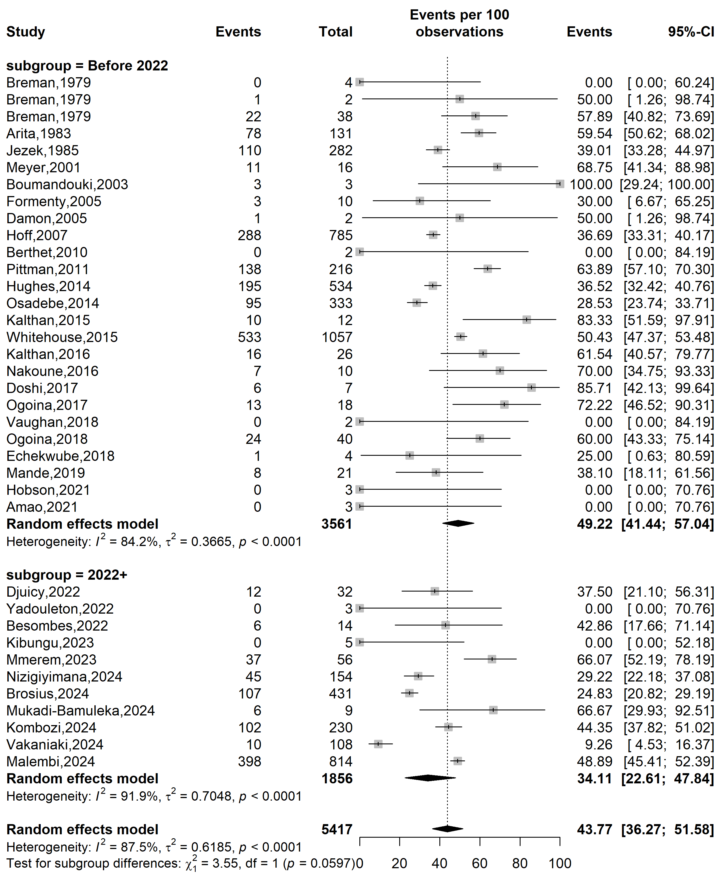
Fig. S1 Mpox disease severity rate in Africa by study periods

Country
Event rate (%)
Severity rate (%)
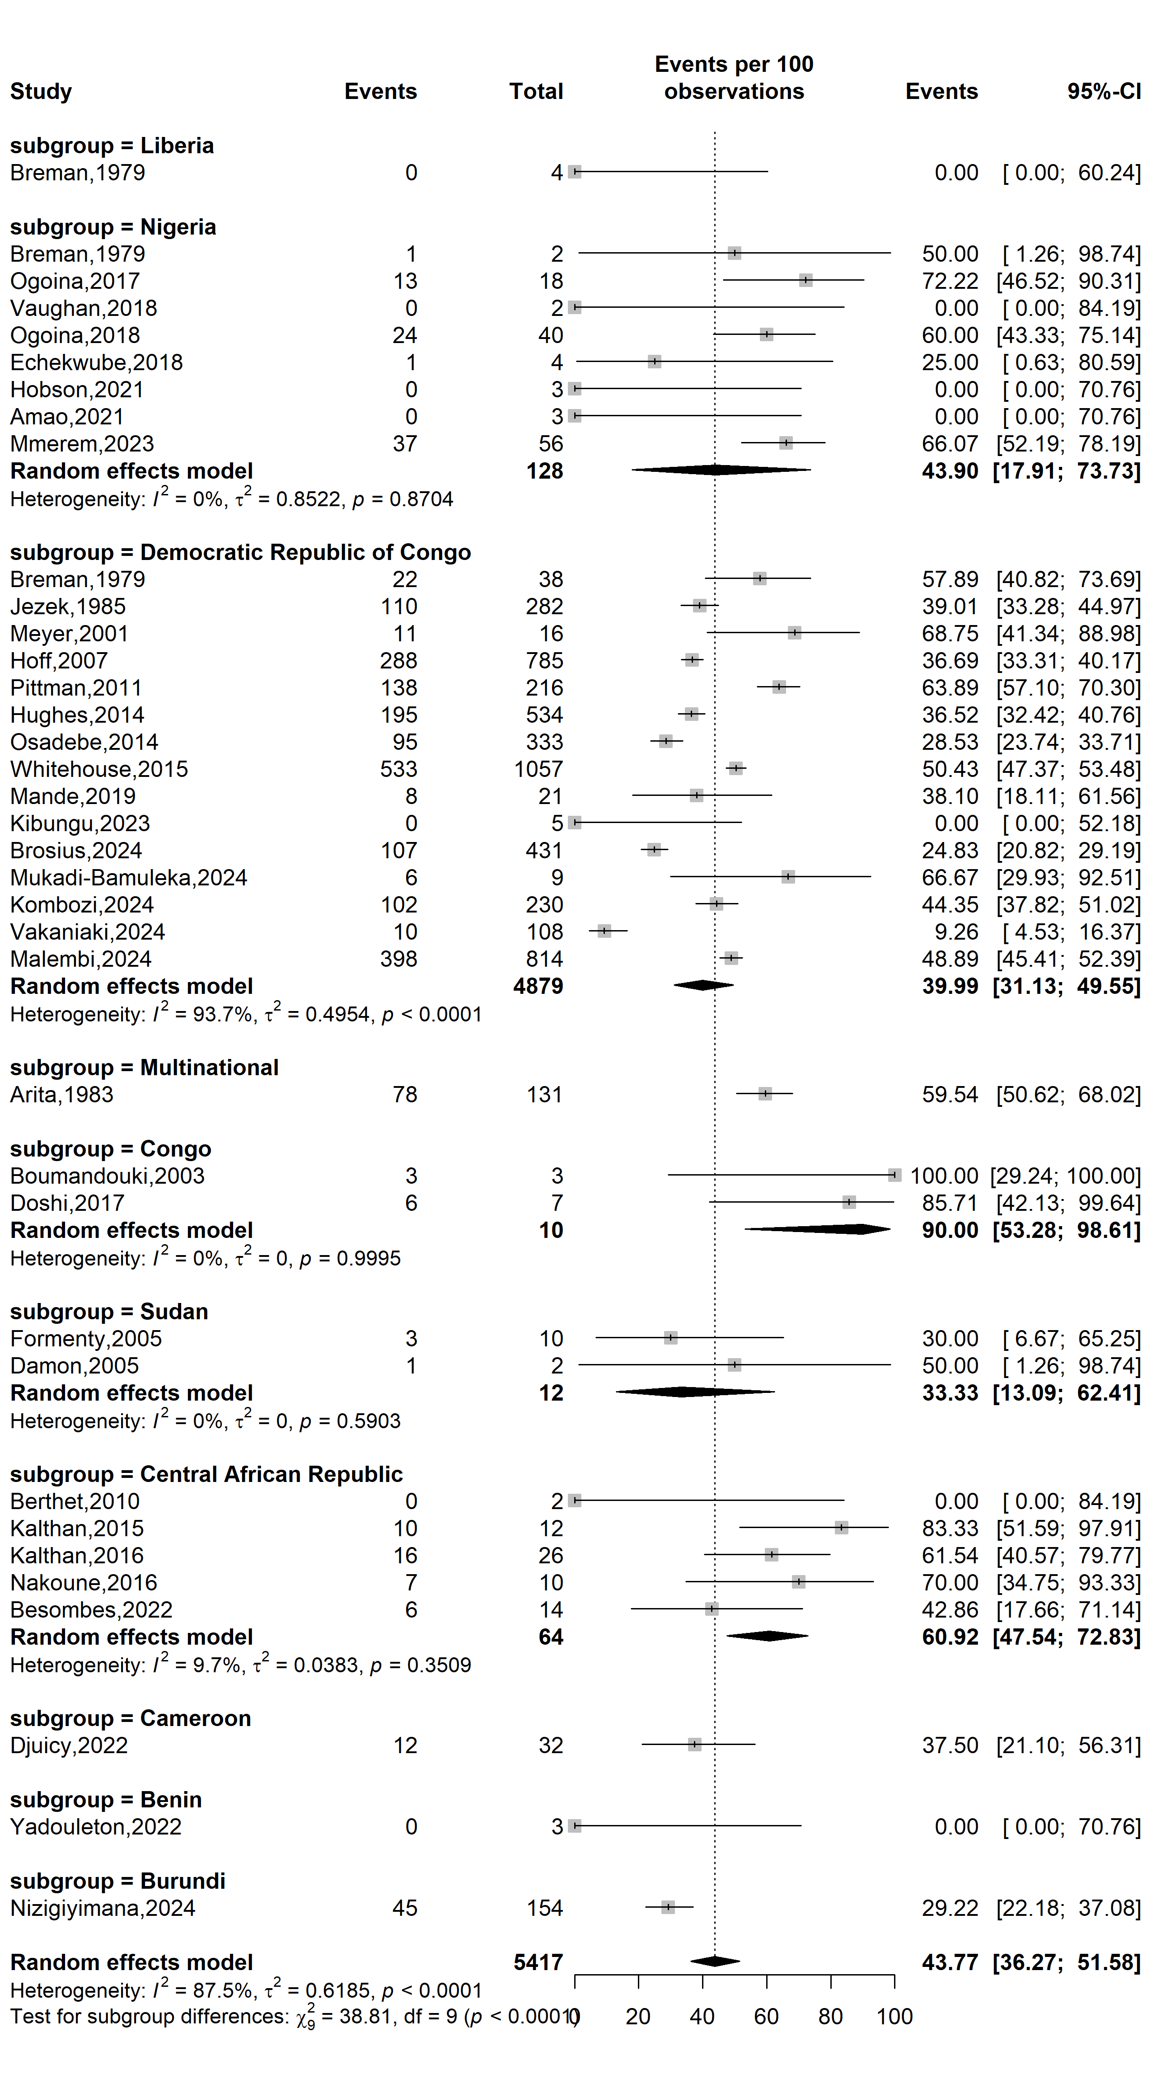
Fig. S2 Mpox disease severity rate in Africa by countries

WHO Afro region
Event rate (%)
Severity rate (%)
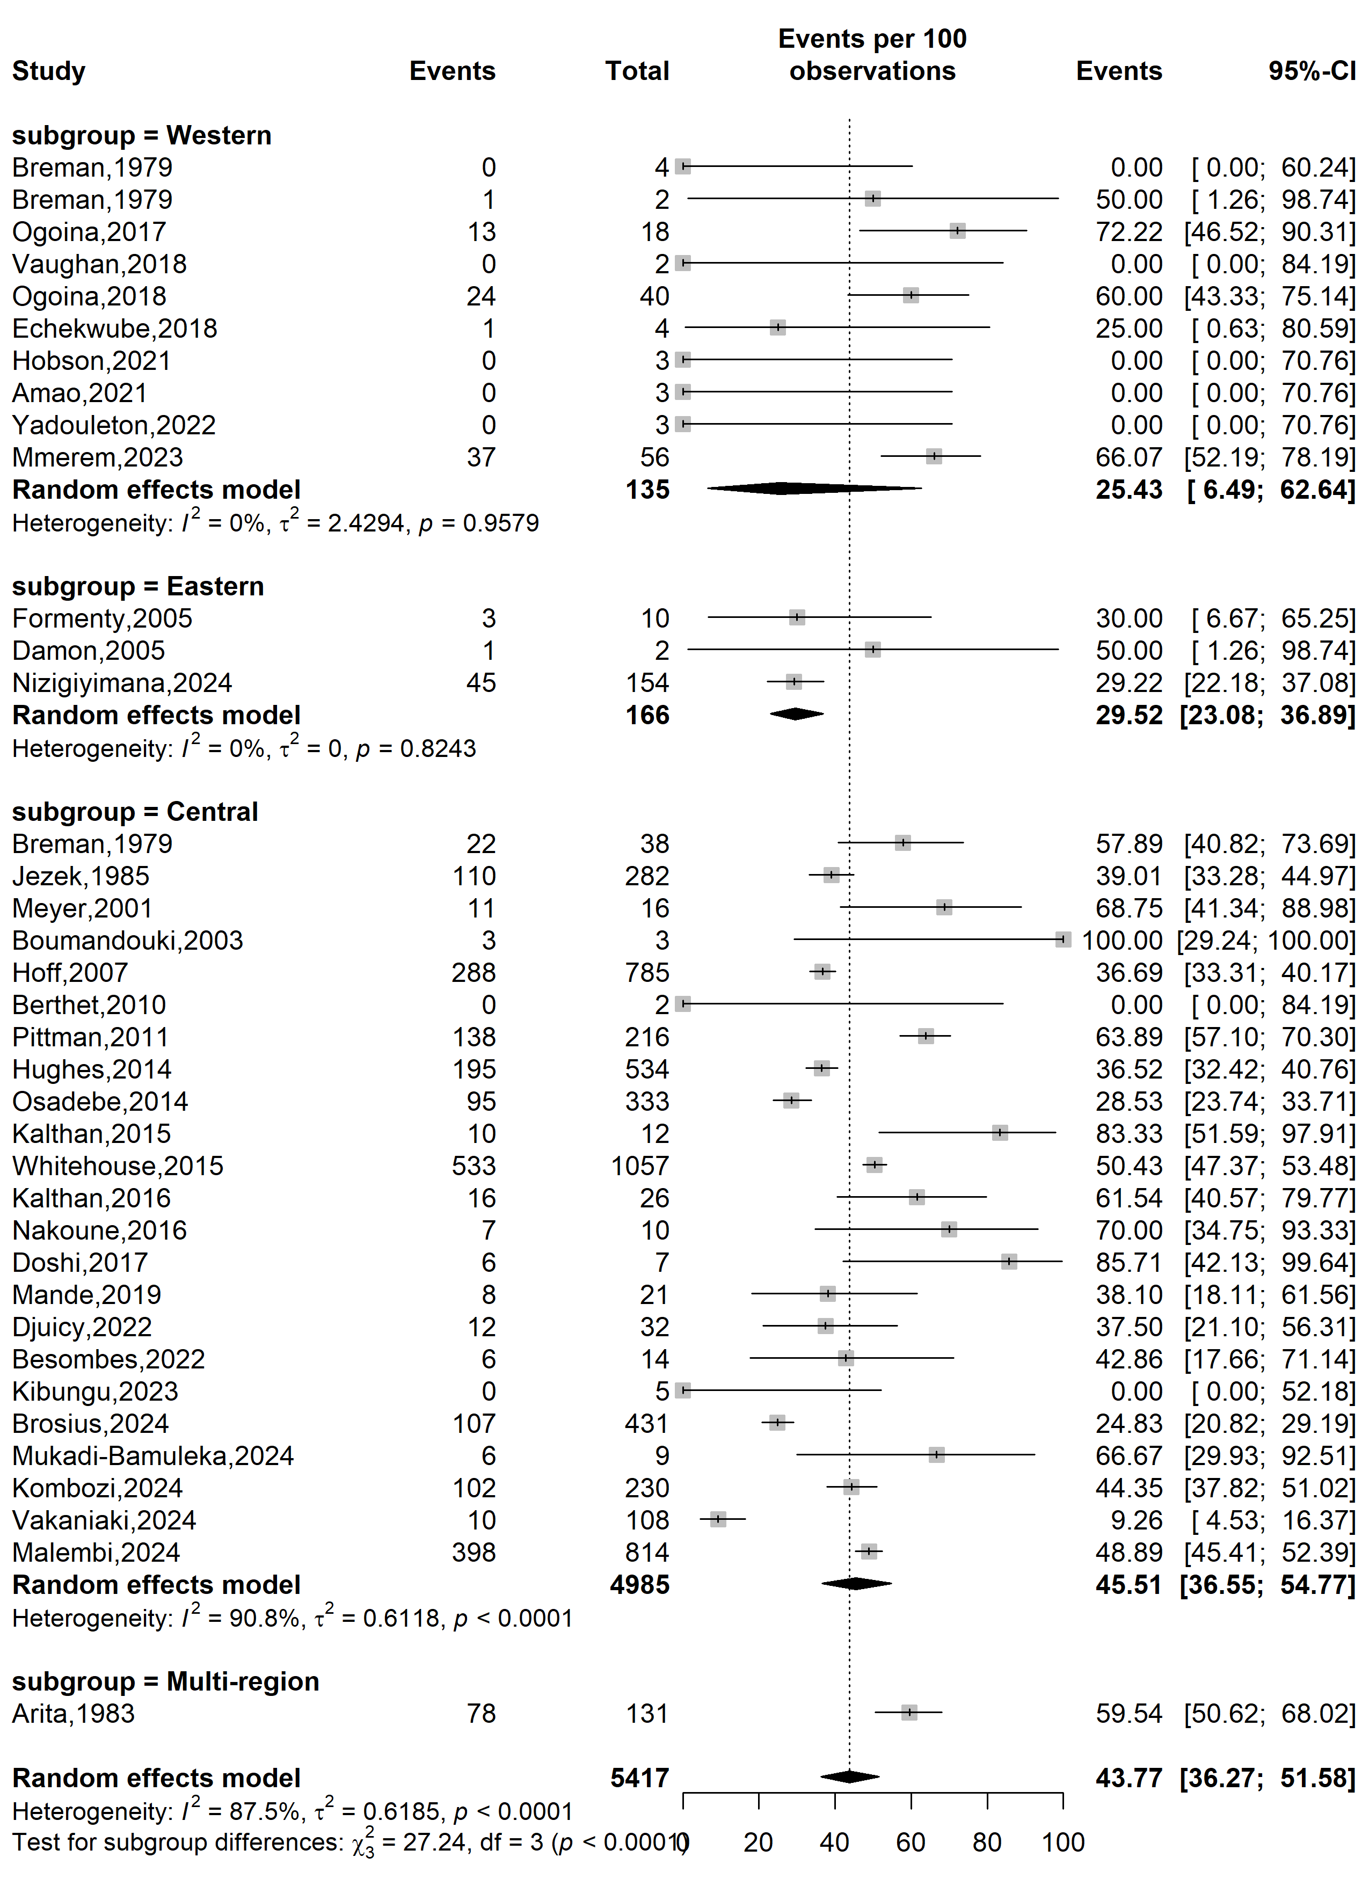
Fig. S3 Mpox disease severity rate in Africa by WHO Afro regions
Study design
Event rate (%)
Severity rate (%)
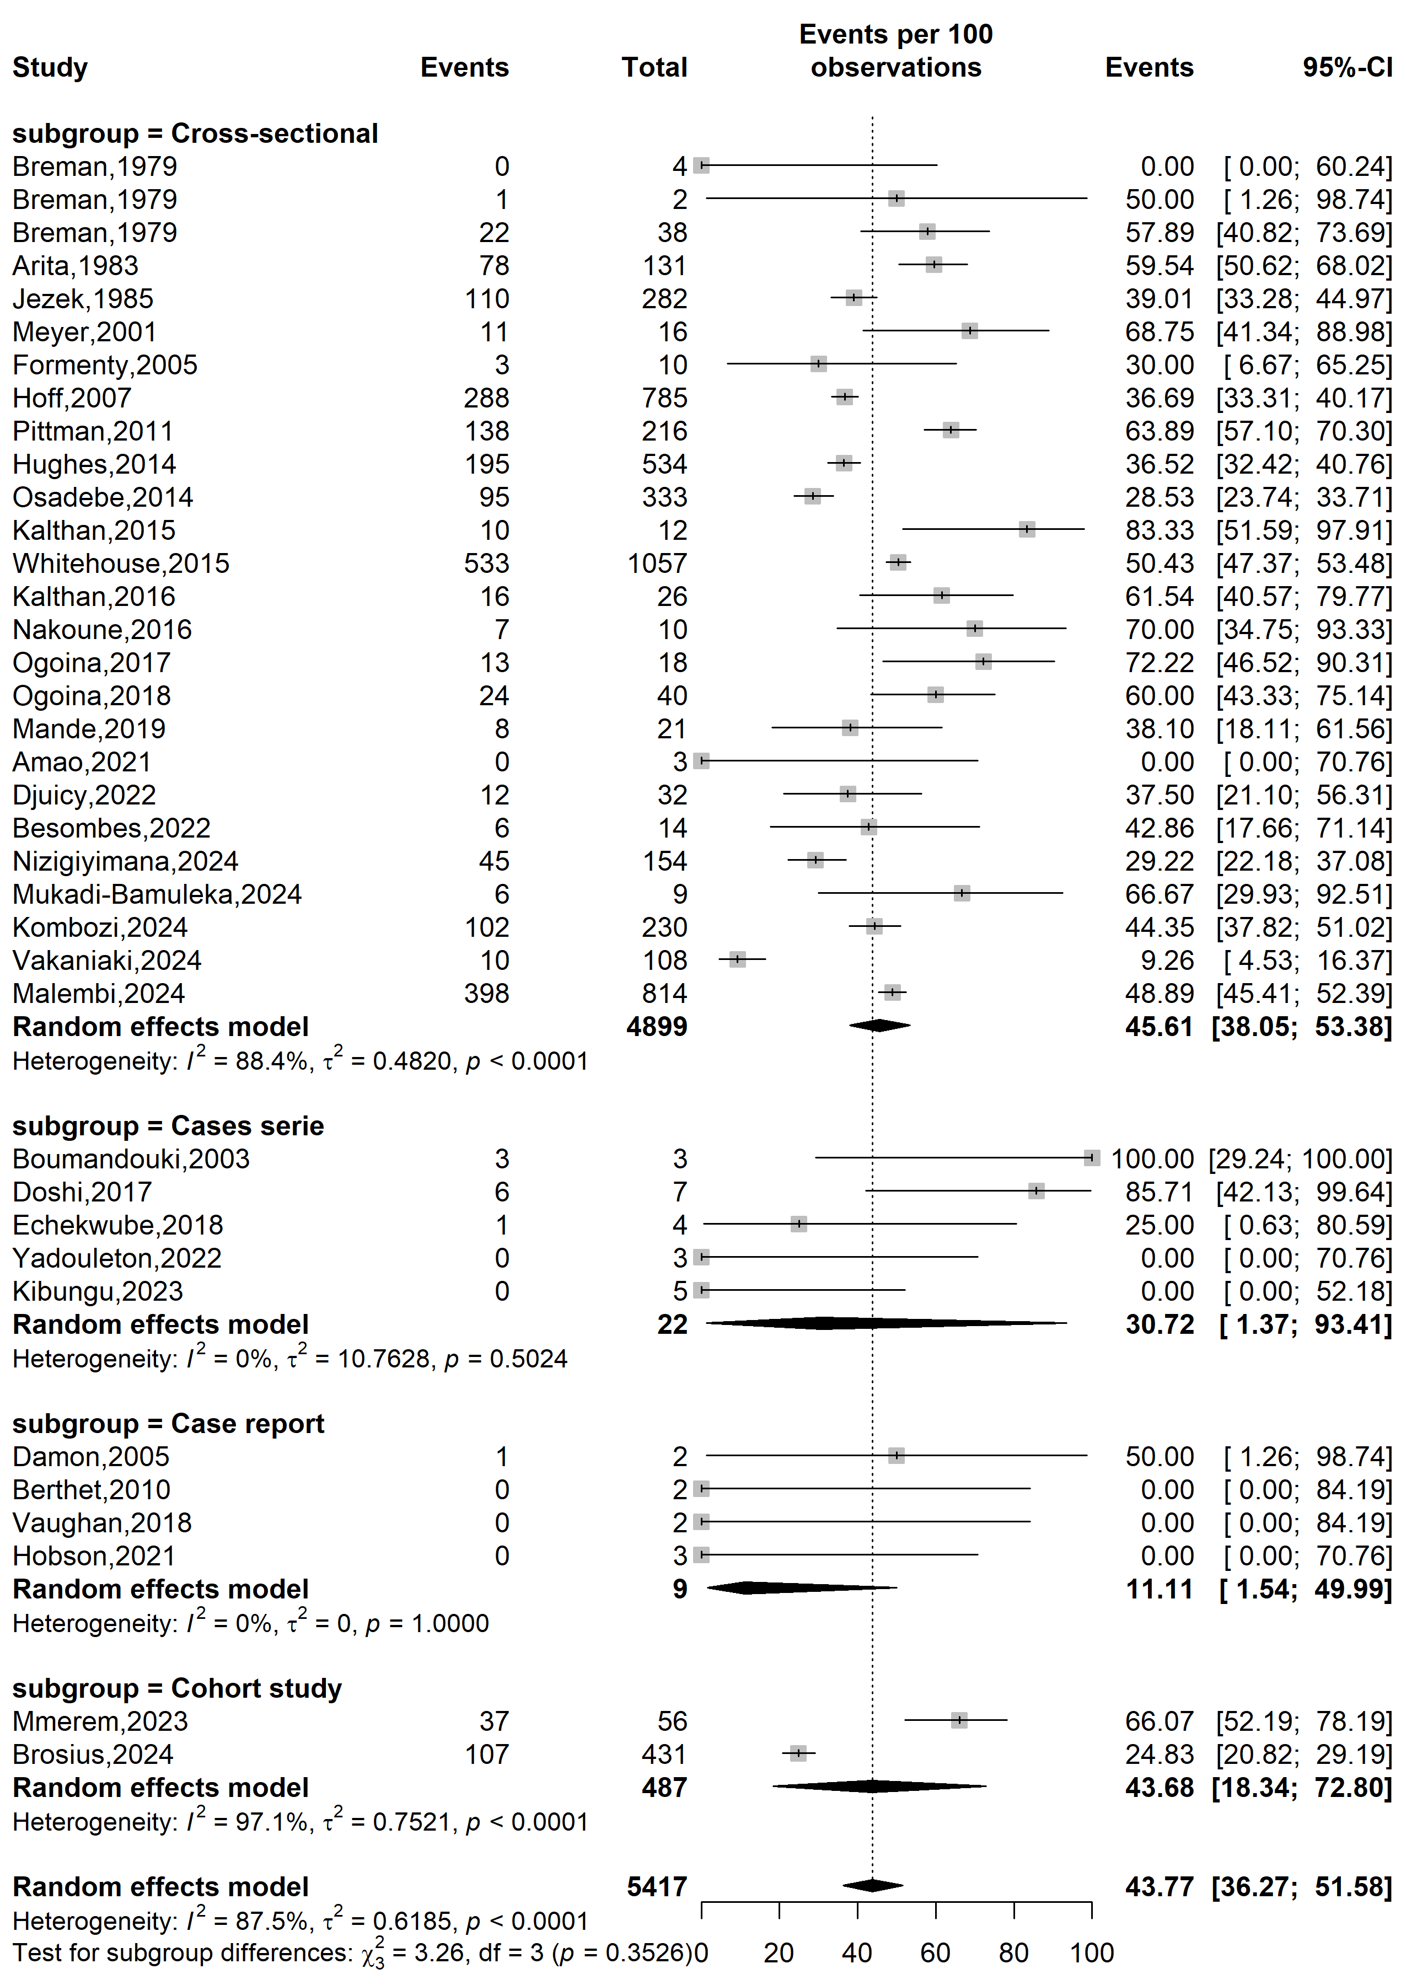
Fig. S4 Mpox severity rate in Africa by type of study designs
Study setting
Event rate (%)
Severity rate (%)
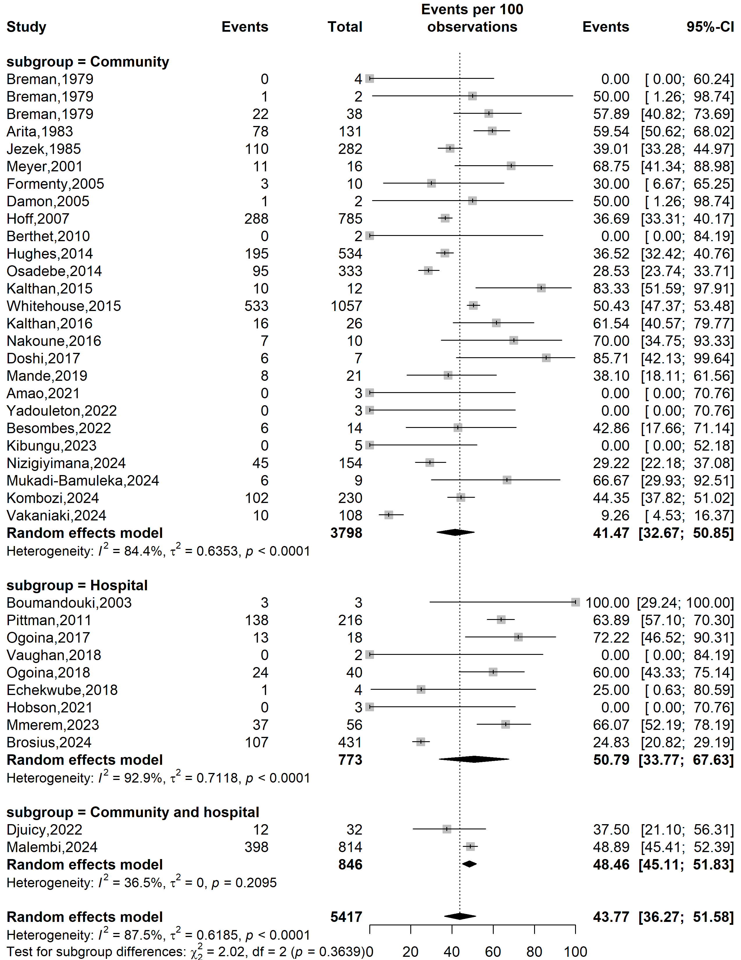
Fig. S5 Mpox severity rate in Africa by type of study settings

Mpox clade stratification
Event rate (%)
Severity rate (%)
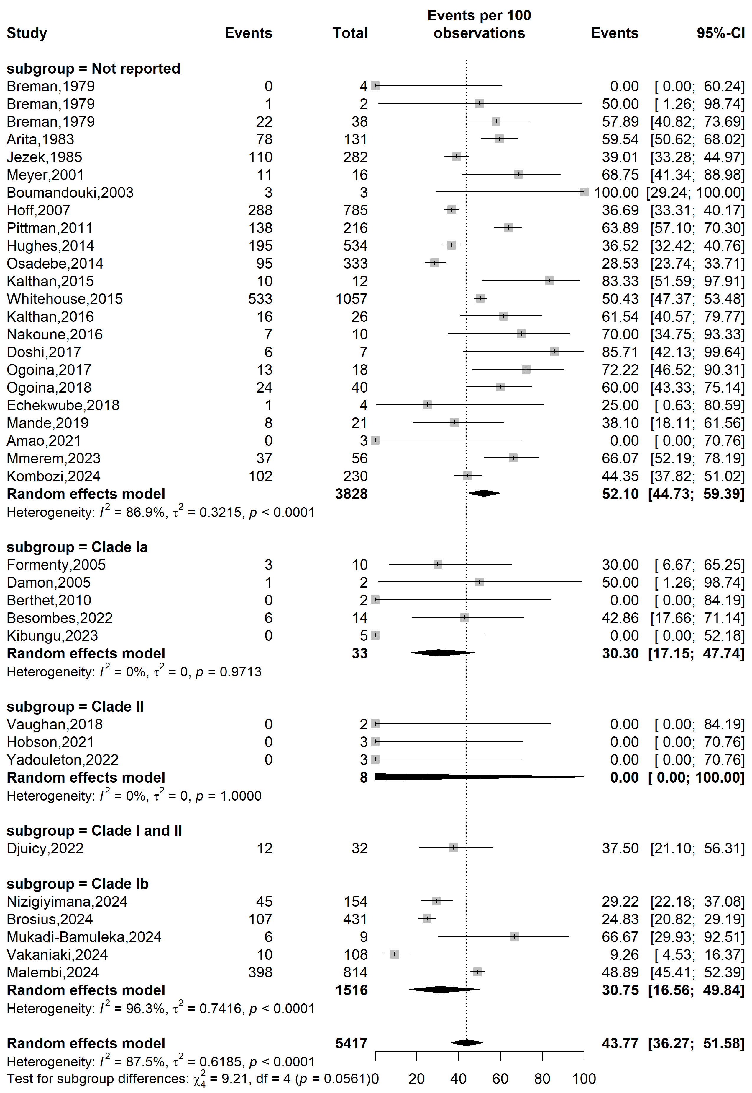
Fig. S6 Mpox severity rate in Africa by clade stratifications

Study period
Event rate (%)

Case fatality rate (%)
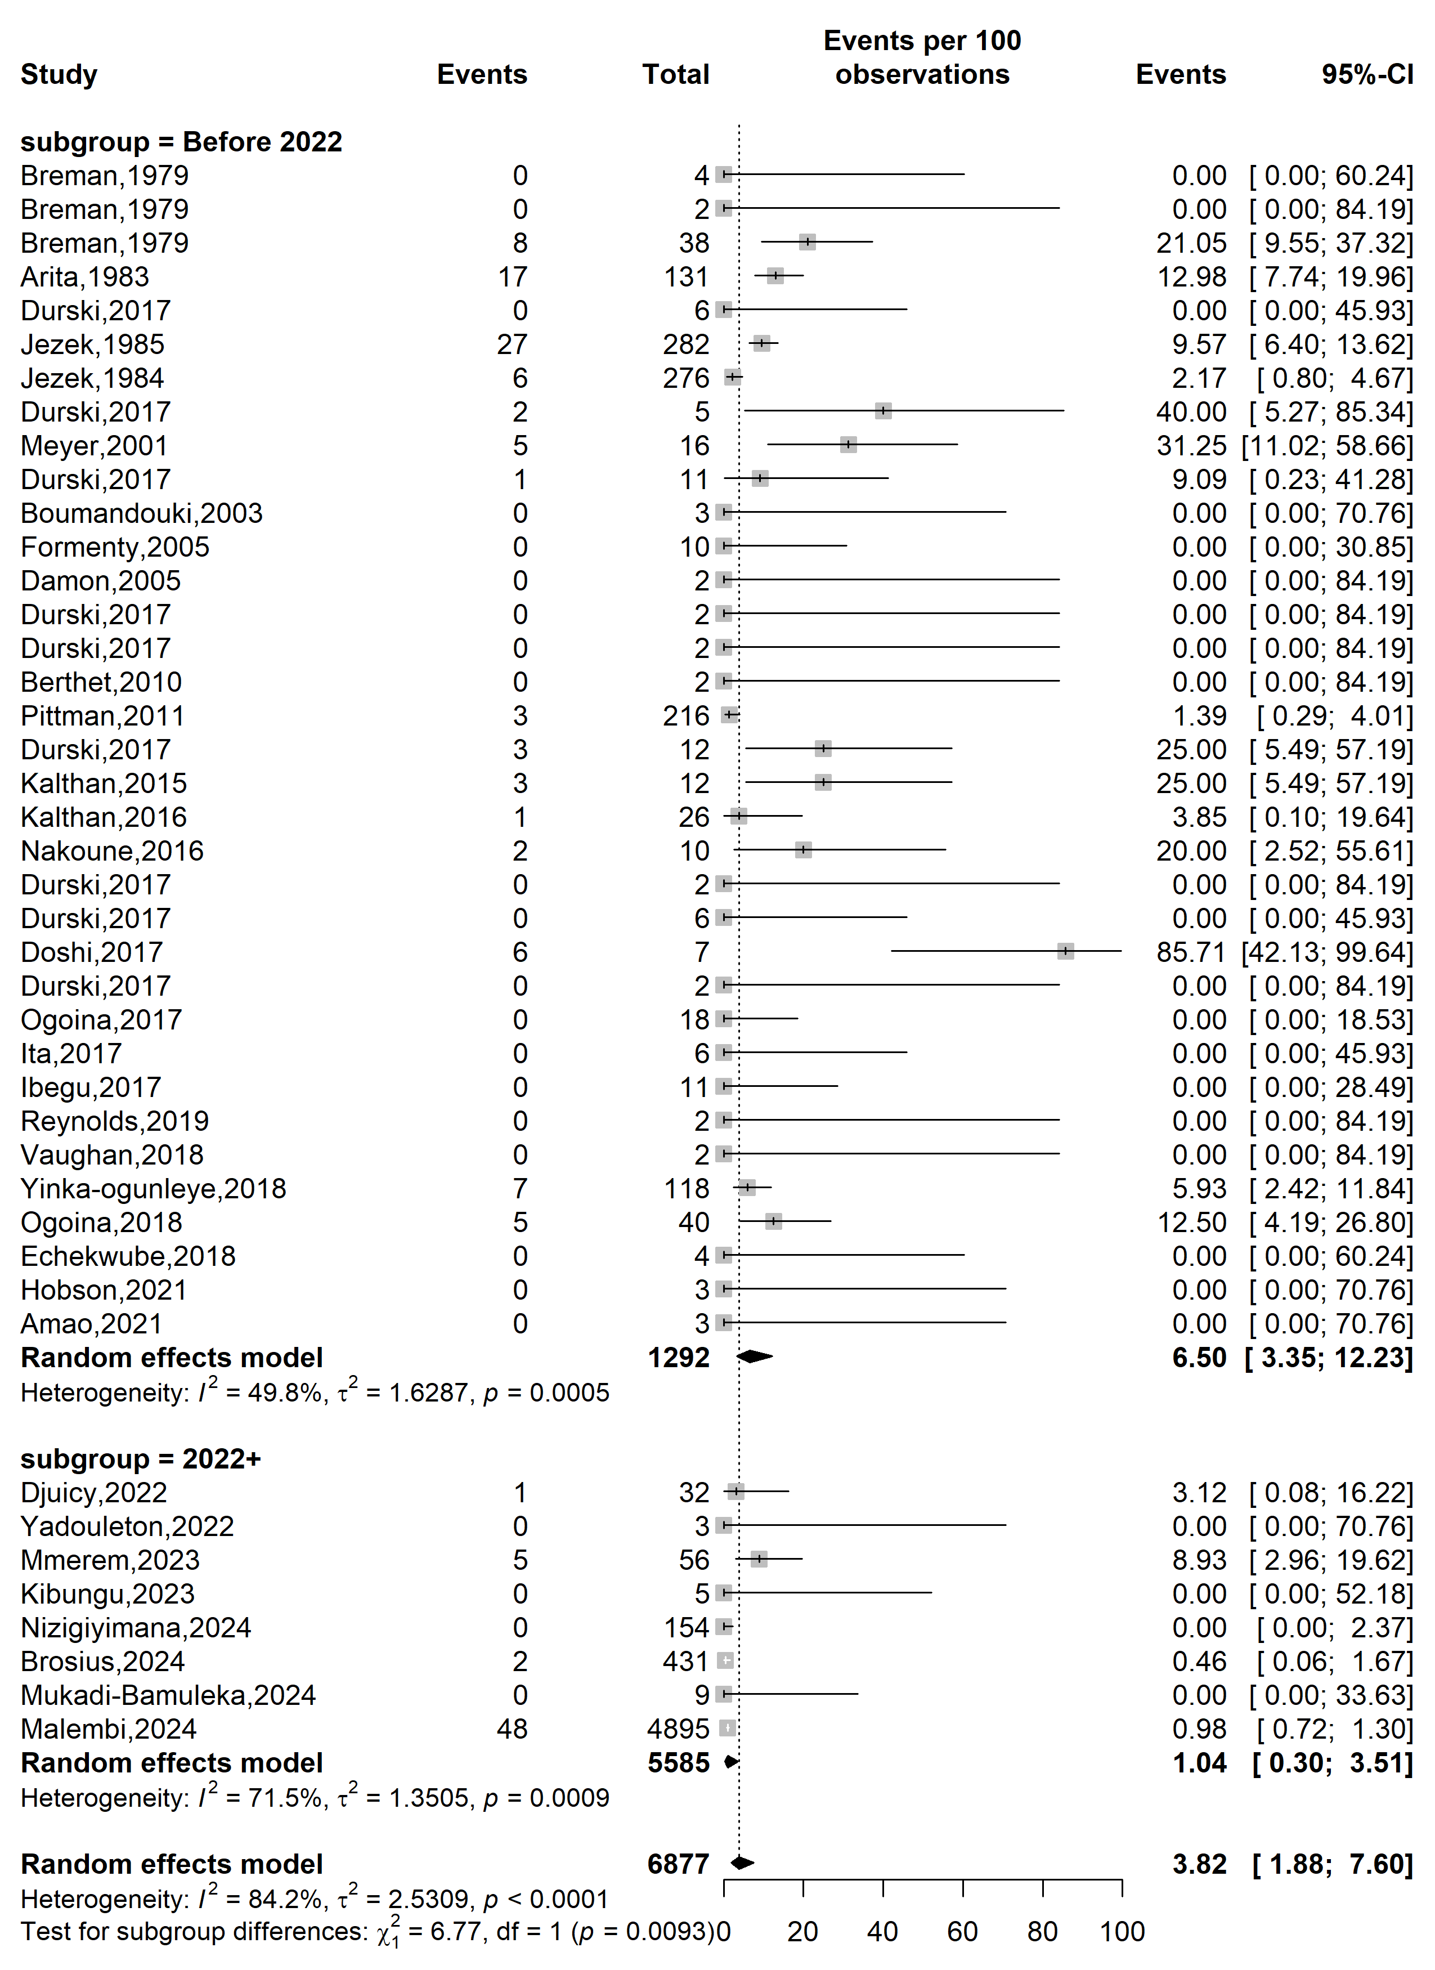
Fig. S7 Case fatality rate among confirmed mpox case in Africa by study periods

Country
Event rate (%)

Case fatality rate (%)
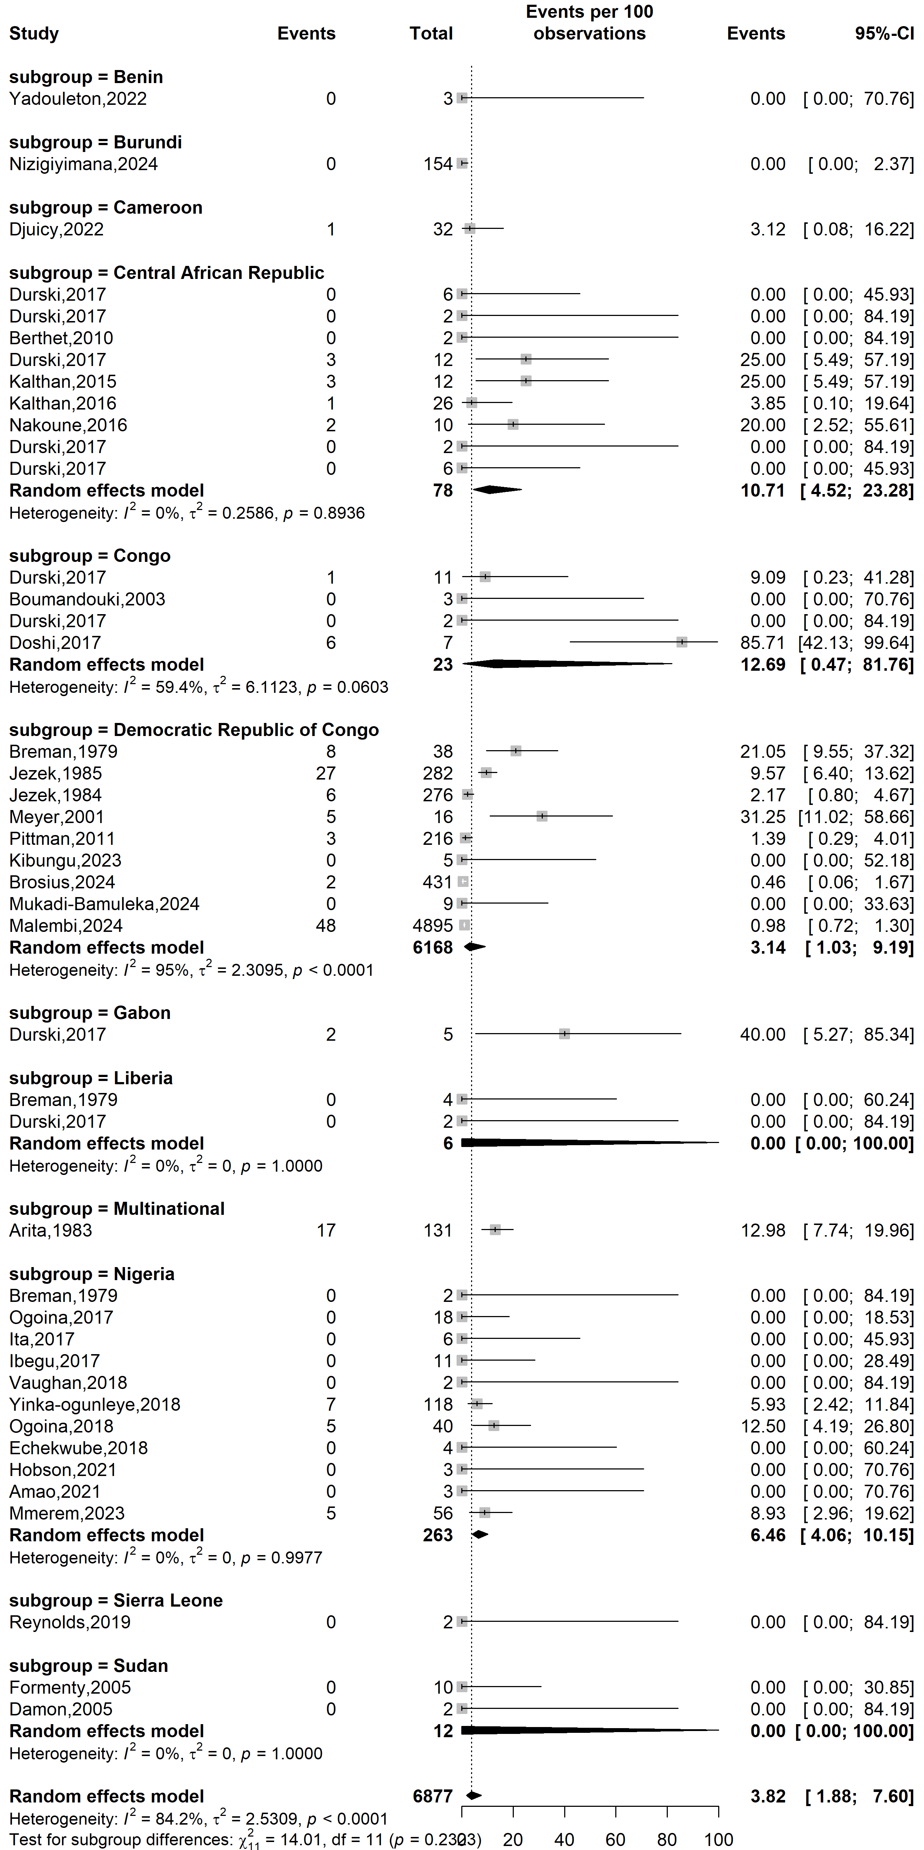
Fig. S8 Case fatality rate among confirmed mpox case by African countries
Study design
Event rate (%)

Case fatality rate (%)
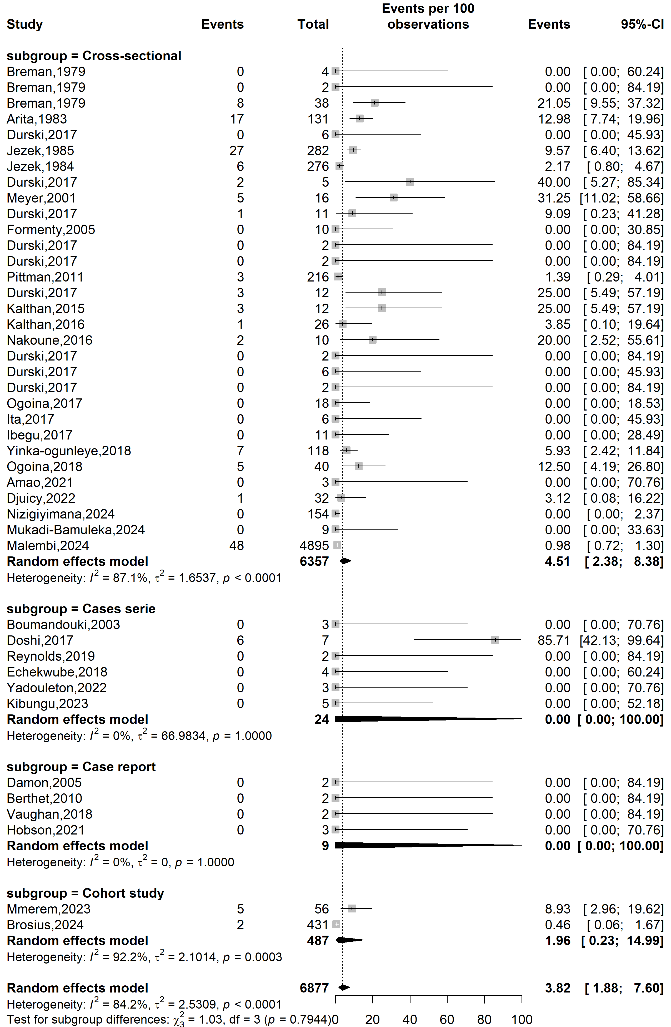
Fig. S9 Case fatality rate among confirmed mpox case in study designs
Study setting
Case fatality rate (%)
Event rate (%)

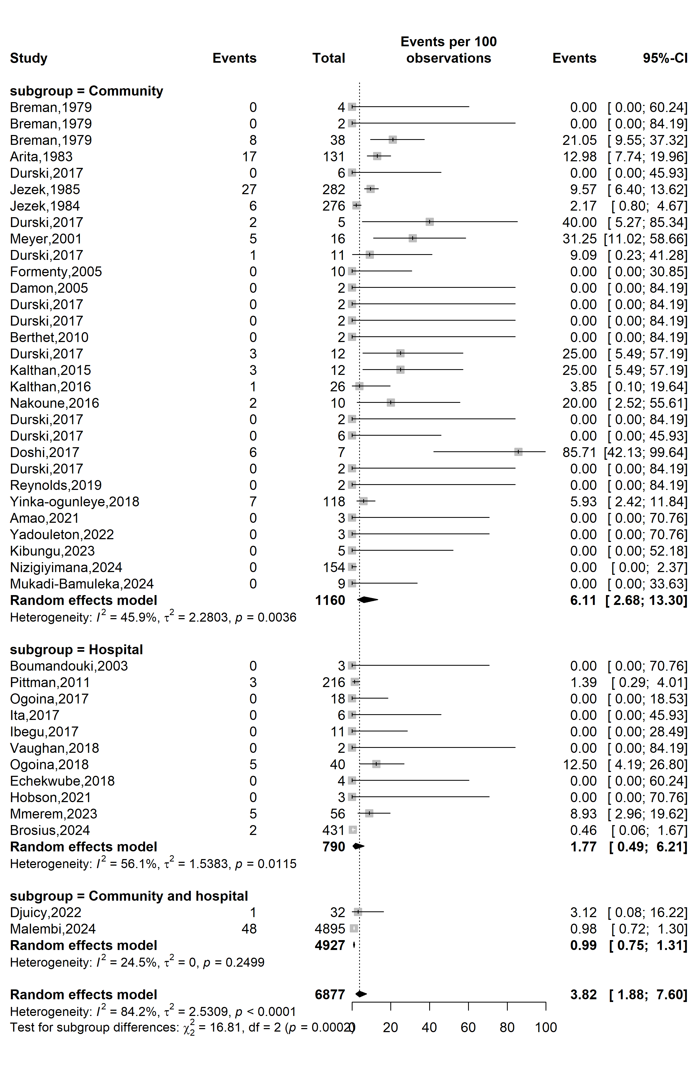
Fig. S10 Case fatality rate among confirmed mpox case in Africa by study setting
Mpox clade stratification
Event rate (%)

Case fatality rate (%)
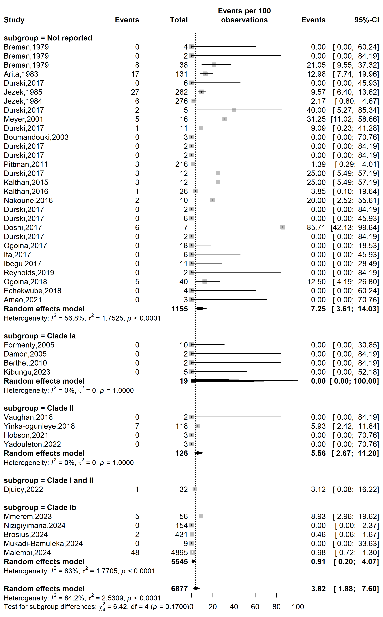
Fig. S11 Case fatality rate among confirmed mpox case in Africa by clade
WHO Afro region
Event rate (%)

Case fatality rate (%)
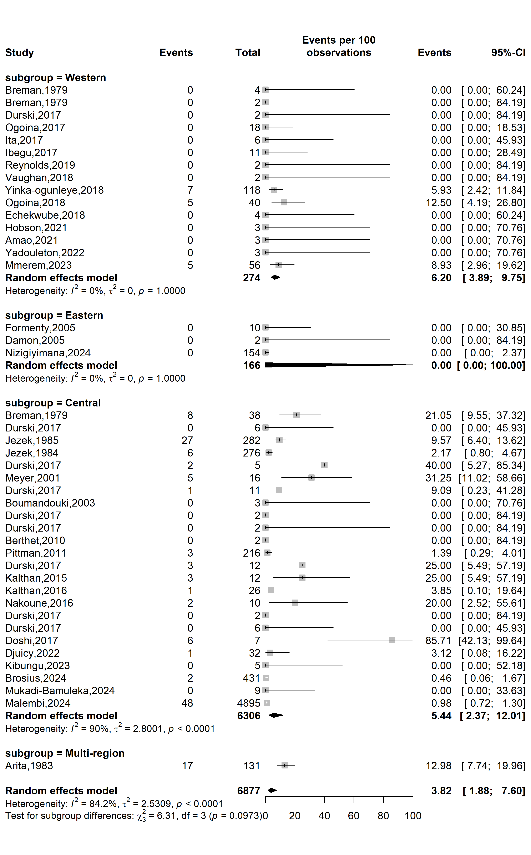
Fig. S12 Case fatality rate among confirmed mpox case by WHO Afro region
Study period
Event rate (%)

Case fatality rate (%)
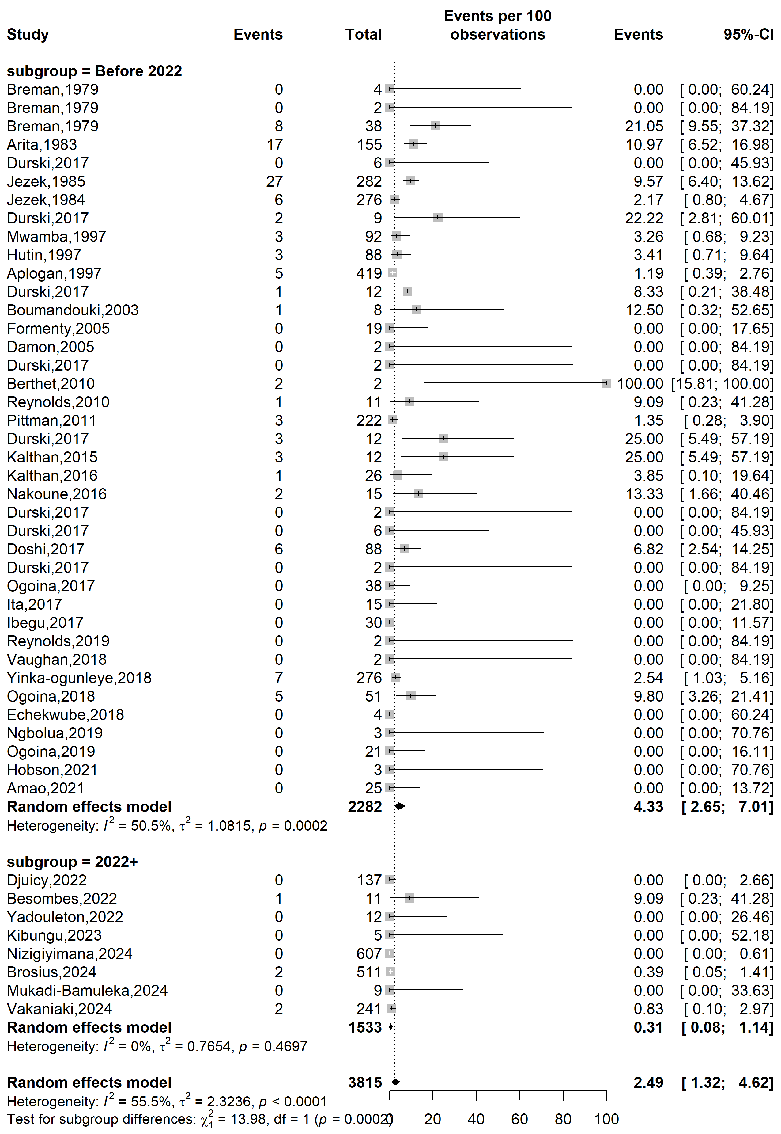
Fig. S13 Case fatality rate among suspected mpox case in Africa by study periods

Country
Event rate (%)

Case fatality rate (%)
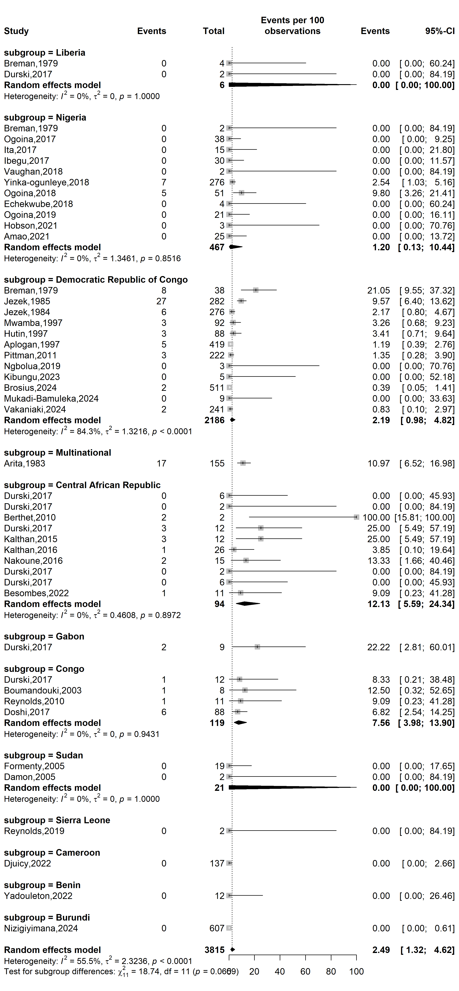
Fig. S14 Case fatality rate among suspected mpox cases across African countries

Study setting
Event rate (%)

Case fatality rate (%)
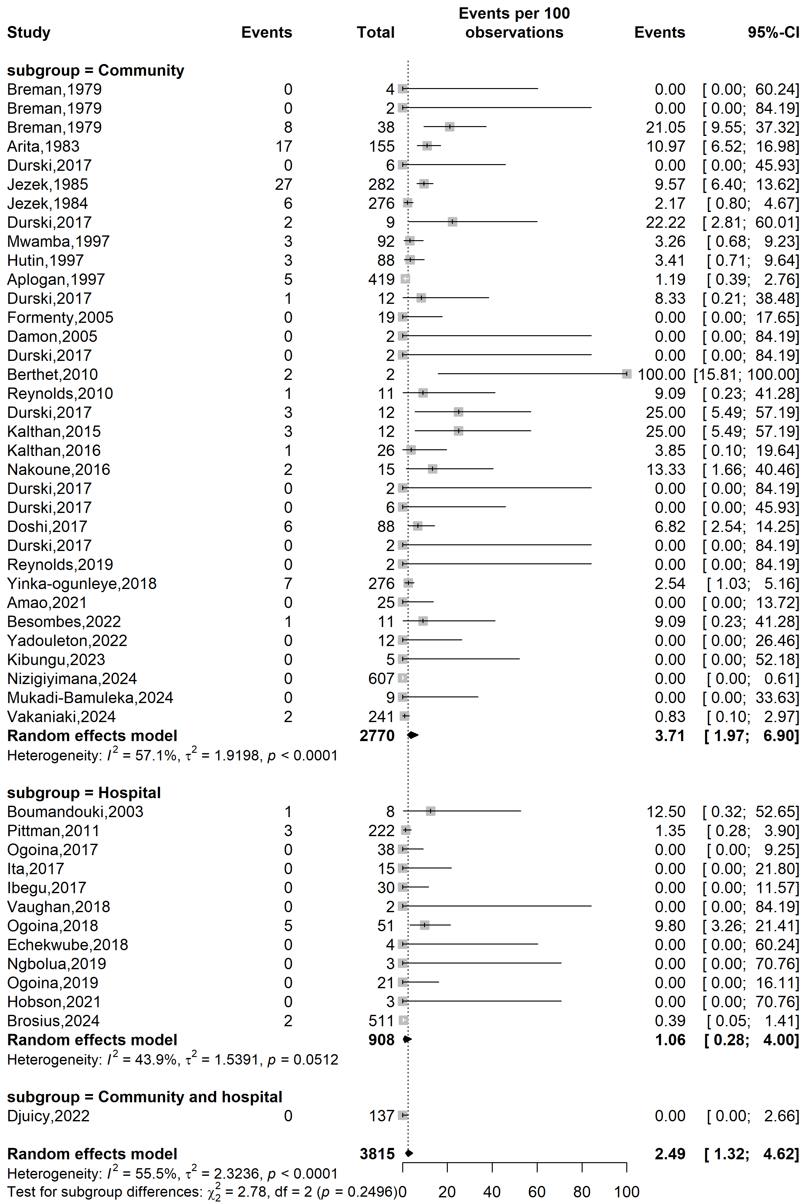
Fig. S15 Case fatality rate among suspected mpox case in Africa by study setting

Study design
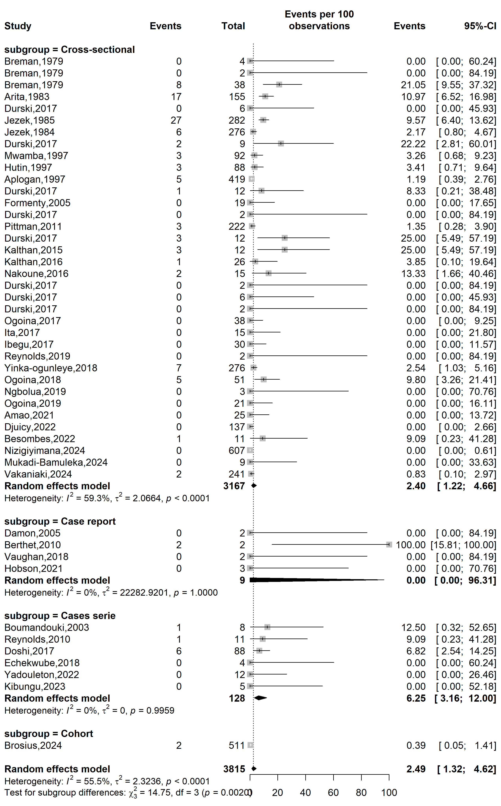
Case fatality rate (%)
Event rate (%)

Fig. S16 Case fatality rate among suspected mpox case across African by study designs

WHO Afro region
Case fatality rate (%)
Event rate (%)

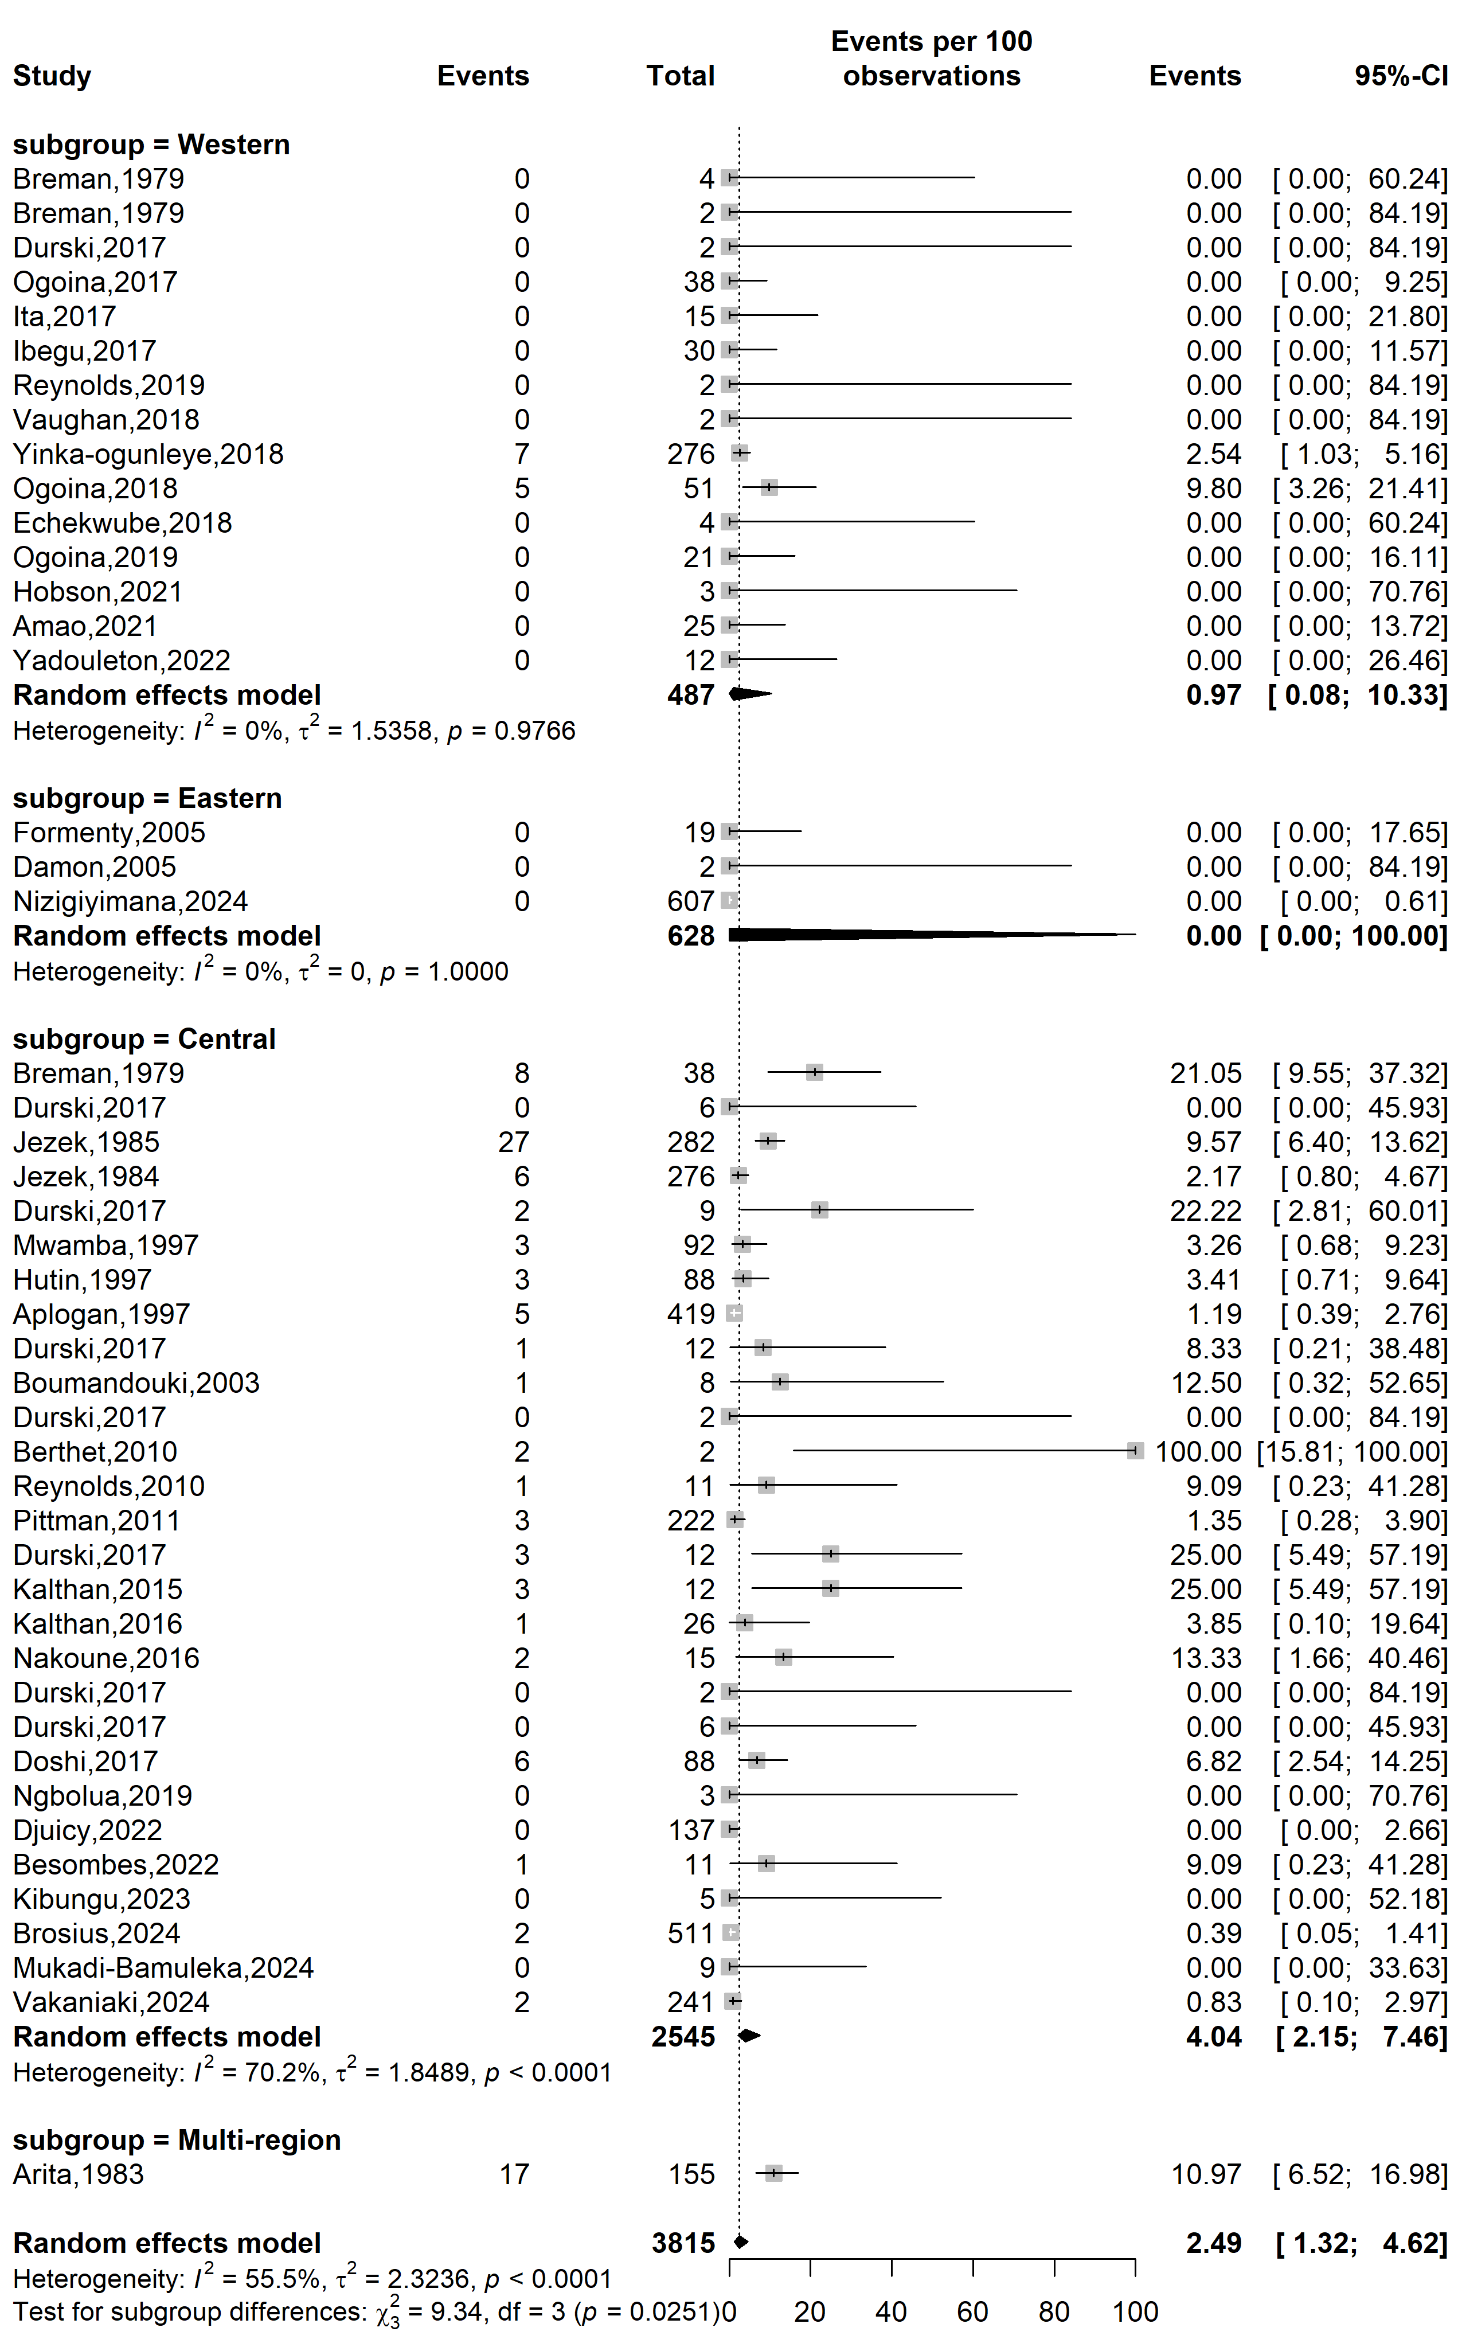
Fig. S17 Case fatality rate among suspected mpox case WHO Afro regions

Publication bias analysis
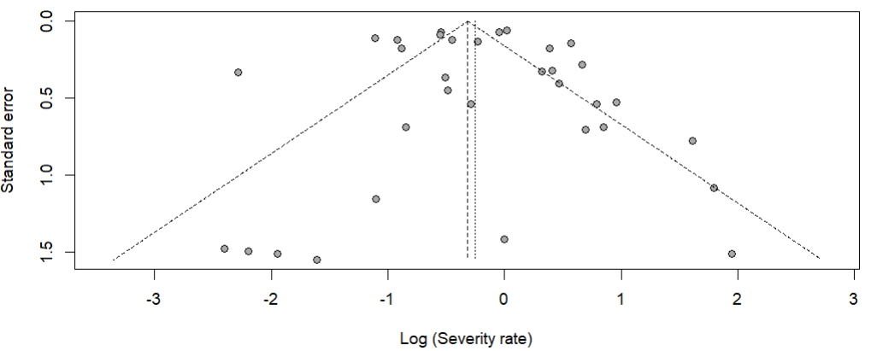
Egger’s test p-value = 0.891
Begg’s test p-value = 0.326

Fig. S18 Funnel plot displaying the pseudo 95% confidence limits and tests assessing the publication bias among studies on the mpox disease severity rate in Africa

Sensitivity analysis

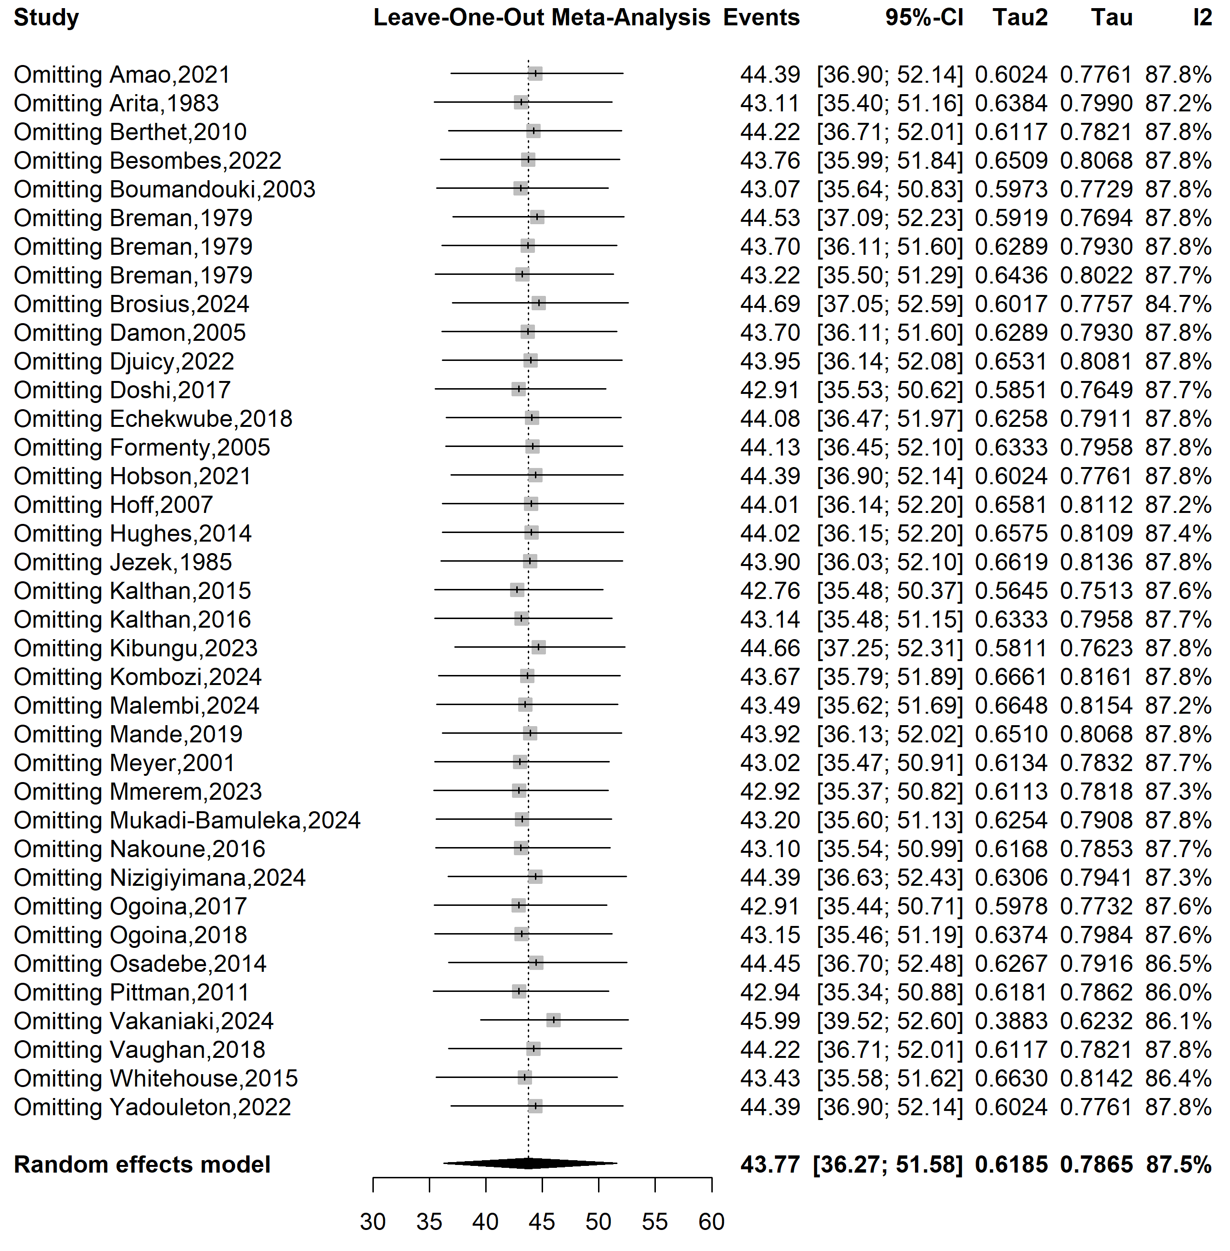
Fig. S19 Sensitivity analysis of the mpox disease severity rate in Africa

Publication bias analysis

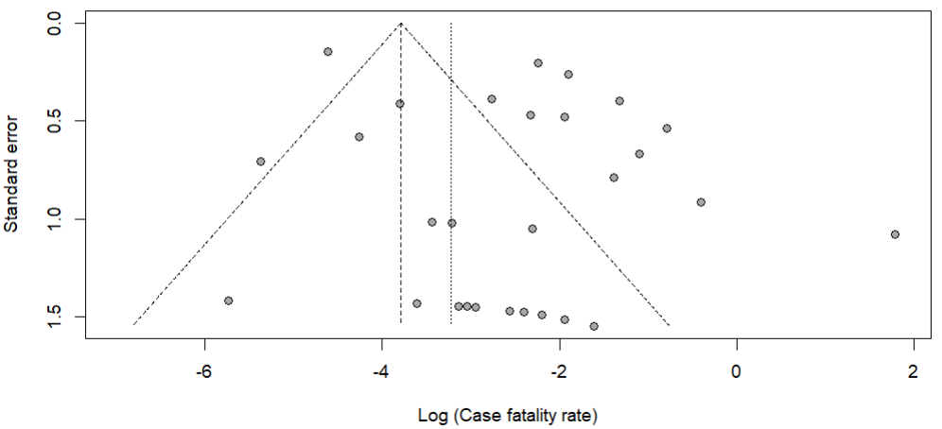
Egger’s test p-value = 0.011
Begg’s test p-value = 0.300

Fig. S20 Funnel plot displaying the pseudo 95% confidence limits and tests assessing the publication bias of studies on confirmed mpox case fatality rate in Africa

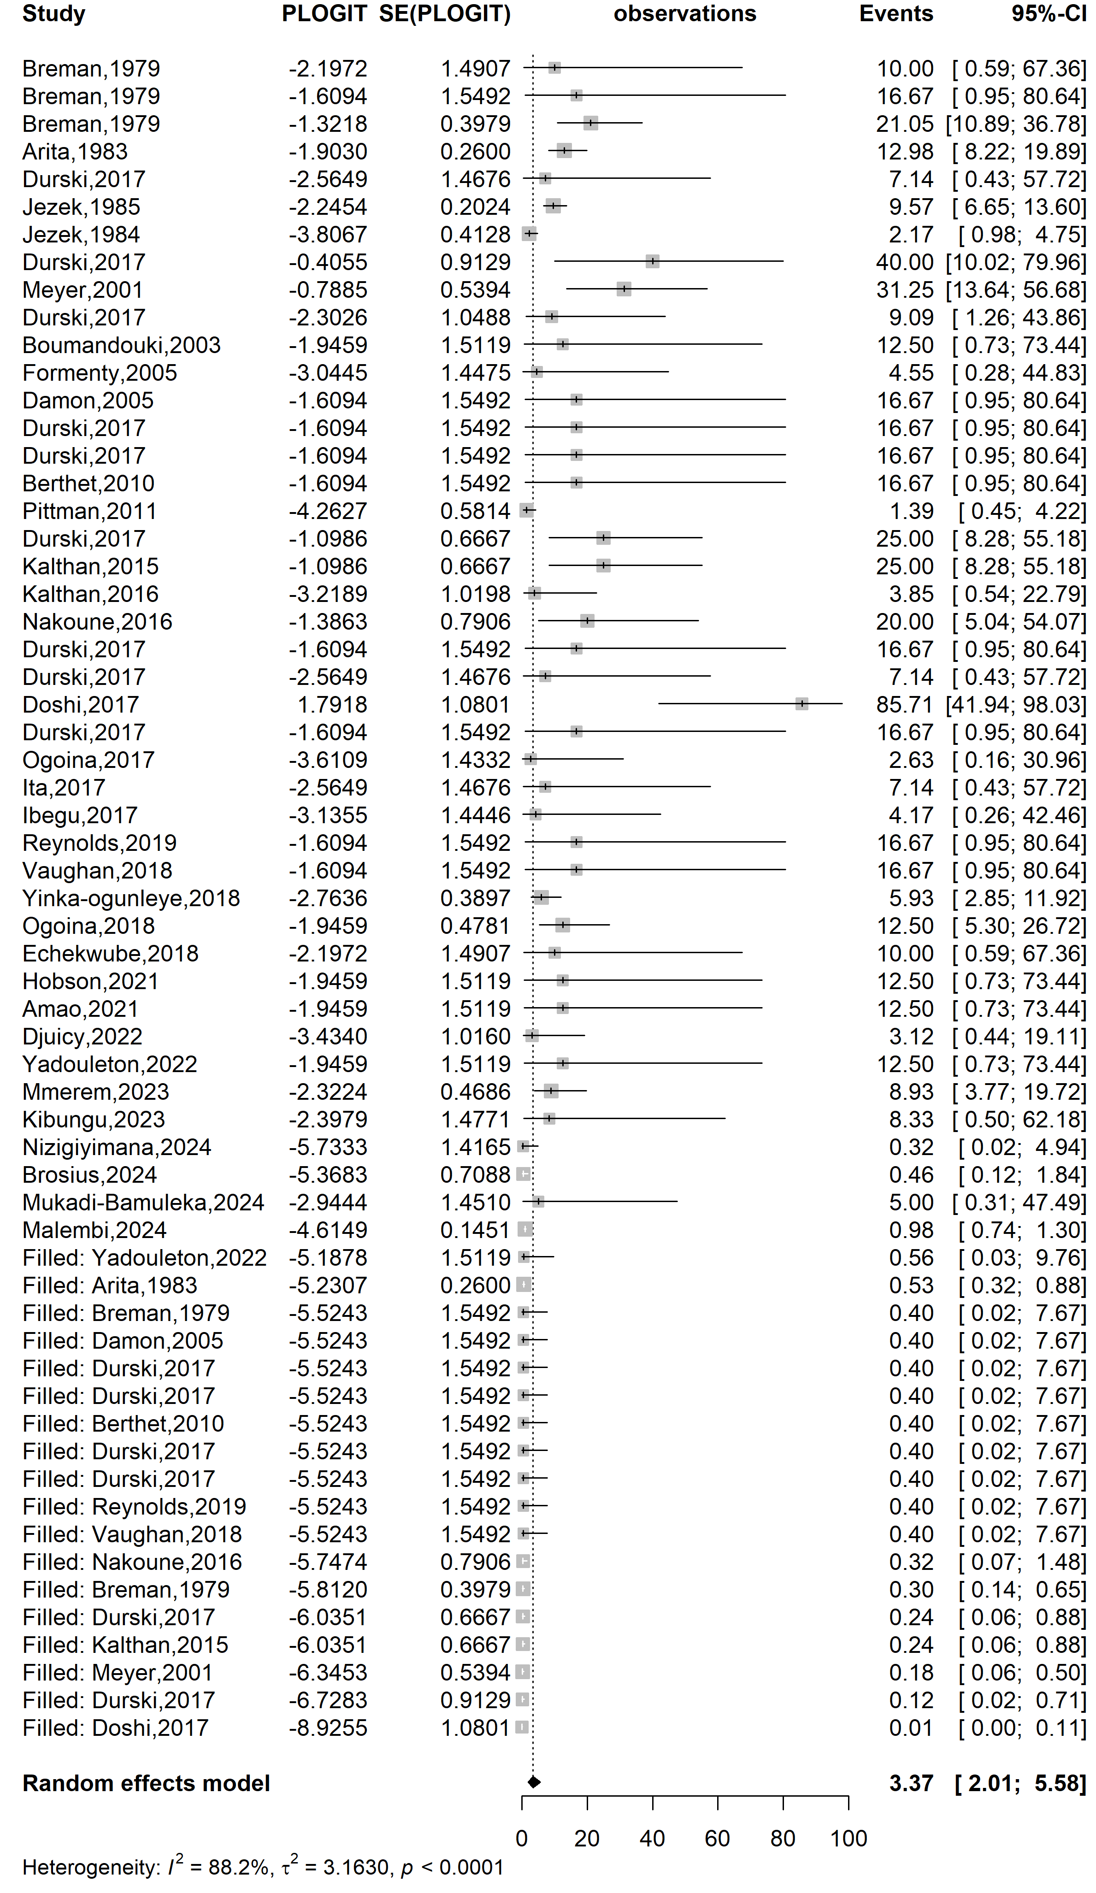
Event rate (%)

Case fatality rate (%)
Fig. S21 Trim and fill analysis of included studies on confirmed mpox case fatality rate in Africa
Sensitivity analysis
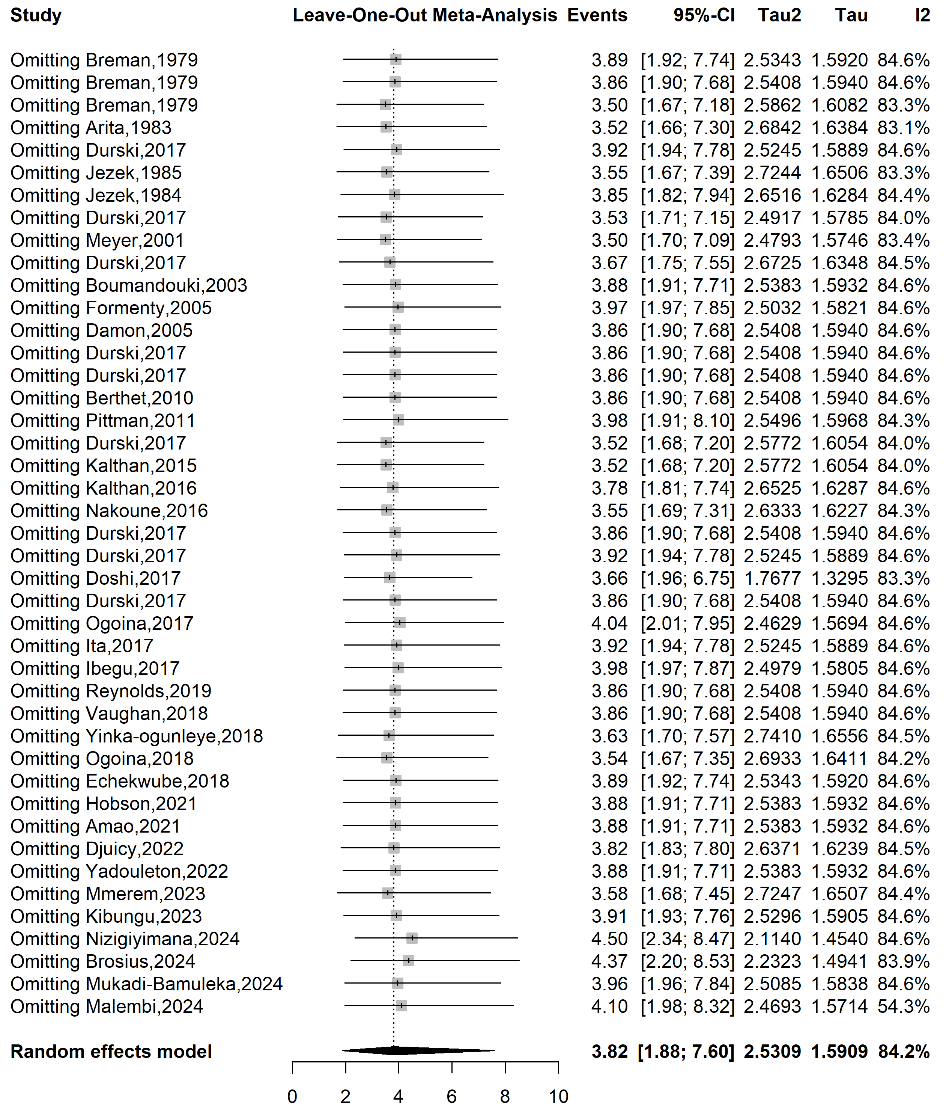
Fig. S22 Sensitivity analysis of the case fatality rate among confirmed mpox cases in Africa

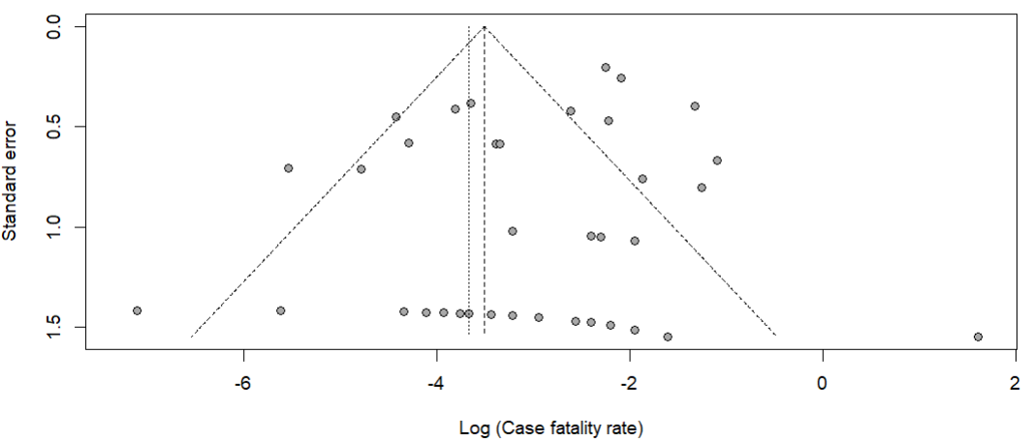
Egger’s test p-value = 0.472
Begg’s test p-value = 0.019

Fig. S23 Funnel plot displaying the pseudo 95% confidence limits and tests assessing the publication bias among studies on suspected mpox case fatality rate in Africa

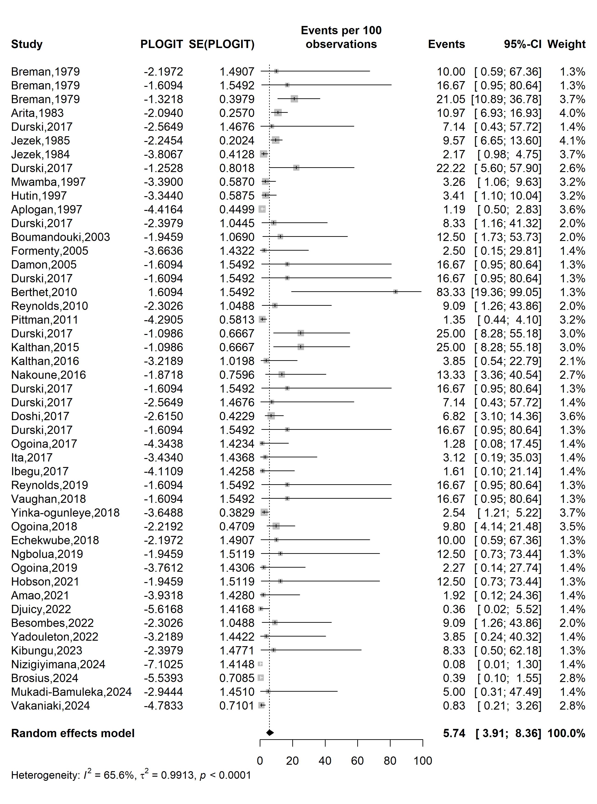
Event rate (%)

Case fatality rate (%)
Fig. S24 Trim and fill analysis of included studies assessing suspected mpox case fatality rate in Africa

Sensitivity analysis
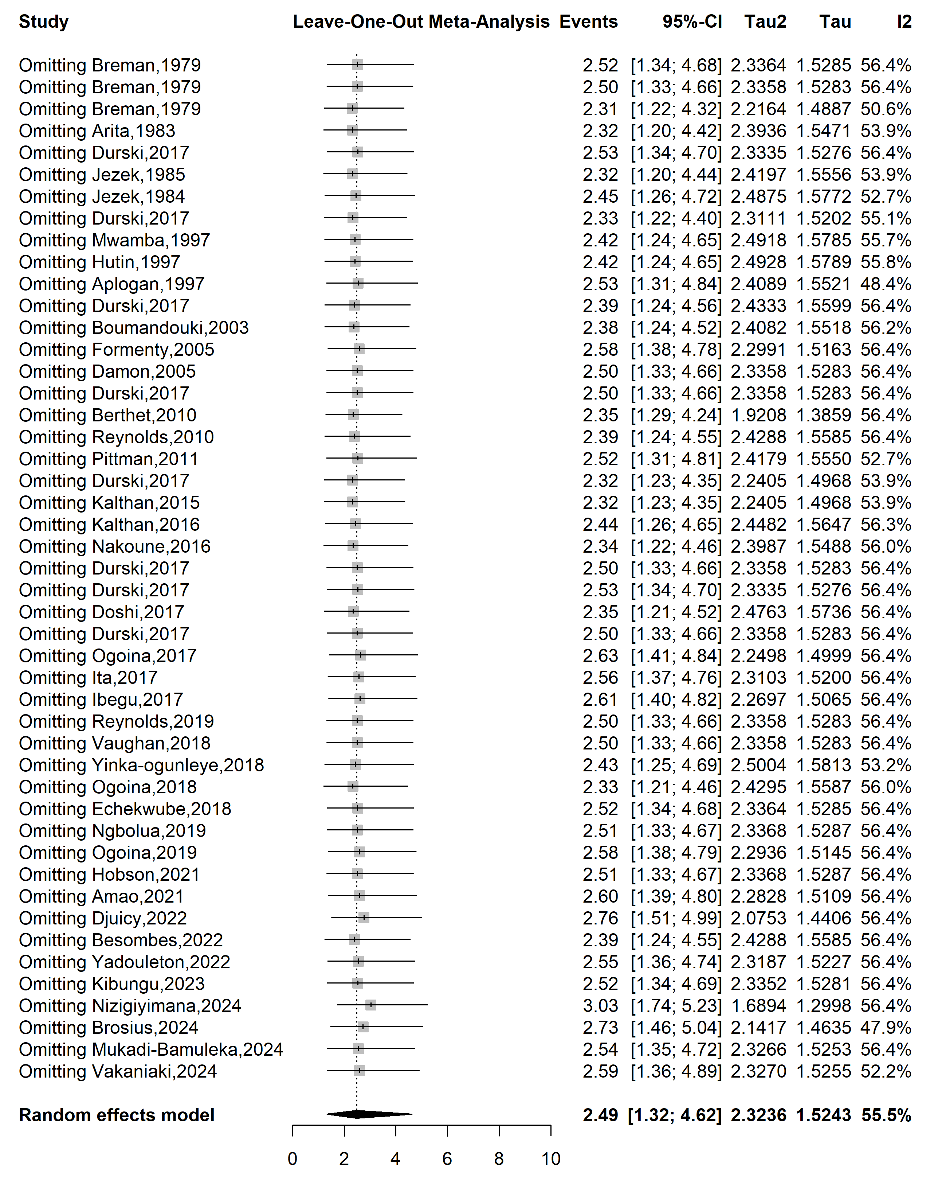
Fig. S25 Sensitivity analysis of the pooled case fatality rate among suspected mpox cases in Africa

