Additional File 2: SHIP
Cytokine Assay Characteristics (SHIP-TREND)
Main Analysis (SHIP-TREND)
Sex Stratified Analysis (SHIP-TREND)
Principal Component Analysis (SHIP-TREND)
Absolute IL6 Analysis (SHIP-START)

Cytokine Assay Characteristics

Supplemental Data Note: Detection Limits in SHIP-TREND-0 Cytokine Measurements
In the SHIP-TREND-0 cohort, a substantial proportion of measurements for certain cytokines were below the lower limit of detection (LOD) based on Olink proteomics data (Olink Target 96 Inflammation, version 3023). Specifically, the following assays exhibited high rates of missing data: IL-4: 97%, IL-13: 99%, IL-17A: 94%, and IL-6: 77%. These high rates indicate that the reported NPX (Normalized Protein eXpression) values for these cytokines are largely extrapolated, potentially impacting the reliability of downstream analyses. This should be taken into account when interpreting findings involving these markers.

Assay | Uniprot ID | OlinkID | Panel | LOD | Missing Data Frequency
IL18 | Q14116 | OID00501 | Olink Target 96 Inflammation(v.3023) | 3.06075 | 0%
TNF | P01375 | OID05548 | Olink Target 96 Inflammation(v.3023) | 3.44438 | 1%
IFN-gamma | P01579 | OID05547 | Olink Target 96 Inflammation(v.3023) | 5.37200 | 1%
IL10 | P22301 | OID00528 | Olink Target 96 Inflammation(v.3023) | 3.33541 | 6%
IL-17C | Q9P0M4 | OID00483 | Olink Target 96 Inflammation(v.3023) | 2.99904 | 22%
IL6 | P05231 | OID00482 | Olink Target 96 Inflammation(v.3023) | 4.07198 | 77%
IL-17A | Q16552 | OID00485 | Olink Target 96 Inflammation(v.3023) | 4.21954 | 94%
IL4 | P05112 | OID00546 | Olink Target 96 Inflammation(v.3023) | 3.42530 | 97%
IL13 | P35225 | OID00525 | Olink Target 96 Inflammation(v.3023) | 3.89806 | 99%
Supplementary Table S1. Summary of cytokine assay characteristics for the SHIP-TREND-0 cohort.
Table includes UniProt IDs, Olink assay identifiers, limits of detection (LOD), and the proportion of missing data based on values below the detection threshold. High frequencies of missing data are noted for IL-4, IL-13, IL-17A, and IL-6, reflecting widespread non-detectable levels for these markers.

Main Analysis

 | Male | Female | Overall
 | (N=273) | (N= 69) | (N=342)
Age
Mean (SD) | 55 (12) | 55 (12) | 55 (12)
Median [Min, Max] | 55 [23, 81] | 54 [20, 75] | 55 [20, 81]
Smoking
Never | 79 (28.9%) | 39 (56.5%) | 118 (34.5%)
Former | 134 (49.1%) | 19 (27.5%) | 153 (44.7%)
Current | 60 (22.0%) | 11 (15.9%) | 71 (20.8%)
Alcohol
Mild | 141 (51.6%) | 64 (92.8%) | 205 (59.9%)
Moderate | 77 (28.2%) | 4 (5.8%) | 81 (23.7%)
Heavy | 55 (20.1%) | 1 (1.4%) | 56 (16.4%)
BMI
Mean (SD) | 29 (4.2) | 26 (5.1) | 28 (4.5)
Median [Min, Max] | 29 [20, 42] | 26 [19, 49] | 28 [19, 49]
IL-4
Mean (SD) | 2.7 (0.30) | 2.7 (0.43) | 2.7 (0.33)
Median [Min, Max] | 2.7 [2.1, 4.3] | 2.6 [1.7, 4.5] | 2.7 [1.7, 4.5]
IL-13
Mean (SD) | 1.8 (0.32) | 1.8 (0.68) | 1.8 (0.42)
Median [Min, Max] | 1.8 [1.2, 4.1] | 1.7 [1.2, 6.4] | 1.8 [1.2, 6.4]
IL-10
Mean (SD) | 4.0 (0.77) | 3.7 (0.40) | 3.9 (0.72)
Median [Min, Max] | 3.9 [2.0, 10] | 3.6 [2.8, 5.1] | 3.8 [2.0, 10]
IL-6
Mean (SD) | 3.5 (0.81) | 3.4 (0.59) | 3.5 (0.77)
Median [Min, Max] | 3.4 [2.1, 11] | 3.2 [2.4, 5.8] | 3.4 [2.1, 11]
TNF
Mean (SD) | 4.4 (0.41) | 4.3 (0.38) | 4.4 (0.40)
Median [Min, Max] | 4.3 [3.4, 6.2] | 4.3 [3.4, 5.4] | 4.3 [3.4, 6.2]
IL-18
Mean (SD) | 9.1 (0.57) | 8.8 (0.48) | 9.0 (0.57)
Median [Min, Max] | 9.1 [6.4, 11] | 8.8 [7.7, 9.8] | 9.1 [6.4, 11]
IFN-γ
Mean (SD) | 7.1 (0.91) | 7.2 (0.94) | 7.1 (0.92)
Median [Min, Max] | 7.0 [5.1, 13] | 7.2 [5.5, 10] | 7.0 [5.1, 13]
IL-17A
Mean (SD) | 3.3 (0.52) | 3.2 (0.35) | 3.3 (0.50)
Median [Min, Max] | 3.3 [2.2, 5.6] | 3.2 [2.5, 4.0] | 3.3 [2.2, 5.6]
IL-17C
Mean (SD) | 3.6 (0.68) | 3.2 (0.60) | 3.5 (0.68)
Median [Min, Max] | 3.5 [2.1, 7.2] | 3.2 [2.2, 4.9] | 3.4 [2.1, 7.2]
Supplementary Table S2. Baseline characteristics of SHIP-TREND participants, stratified by sex. Variables include demographic and lifestyle factors (age, smoking status, alcohol consumption, BMI, and sex), as well as cytokine levels. Pro-inflammatory cytokines: IL-6, IL-18, TNF, IFN-γ, IL-17A, IL-17C; anti-inflammatory cytokines: IL-4, IL-13, IL-10. For continuous variables, means, standard deviations, medians, and ranges are presented; for categorical variables, frequencies and percentages are shown. Missing cytokine data are indicated and were excluded from respective models in the final analysis.

Cytokine Model Results
term | estimate | std.error | statistic | p.value | conf.low | conf.high | Model
(Intercept) | -0.153 | 0.402 | -0.379 | 0.705 | -0.944 | 0.639 | IL13
age | -0.001 | 0.005 | -0.266 | 0.791 | -0.011 | 0.008 | IL13
sexFemale | 0.075 | 0.154 | 0.488 | 0.626 | -0.228 | 0.378 | IL13
alcohol_consumptionModerate | 0.081 | 0.140 | 0.579 | 0.563 | -0.194 | 0.357 | IL13
alcohol_consumptionHeavy | -0.100 | 0.160 | -0.625 | 0.532 | -0.414 | 0.214 | IL13
smokingFormer | -0.042 | 0.129 | -0.328 | 0.743 | -0.295 | 0.211 | IL13
smokingCurrent | 0.058 | 0.159 | 0.367 | 0.714 | -0.255 | 0.372 | IL13
BMI (Spline 1) | -0.306 | 0.294 | -1.039 | 0.300 | -0.884 | 0.273 | IL13
BMI (Spline 2) | 0.725 | 0.753 | 0.962 | 0.337 | -0.757 | 2.206 | IL13
BMI (Spline 3) | 0.576 | 0.706 | 0.816 | 0.415 | -0.812 | 1.964 | IL13
(Intercept) | -0.152 | 0.402 | -0.377 | 0.707 | -0.943 | 0.640 | IL4
age | -0.000 | 0.005 | -0.014 | 0.989 | -0.010 | 0.010 | IL4
sexFemale | 0.116 | 0.154 | 0.755 | 0.451 | -0.186 | 0.419 | IL4
smokingFormer | -0.019 | 0.129 | -0.148 | 0.882 | -0.272 | 0.234 | IL4
smokingCurrent | 0.012 | 0.159 | 0.072 | 0.942 | -0.302 | 0.325 | IL4
alcohol_consumptionModerate | -0.105 | 0.140 | -0.751 | 0.453 | -0.381 | 0.170 | IL4
alcohol_consumptionHeavy | 0.174 | 0.160 | 1.088 | 0.277 | -0.140 | 0.488 | IL4
BMI (Spline 1) | 0.353 | 0.294 | 1.199 | 0.232 | -0.226 | 0.931 | IL4
BMI (Spline 2) | 0.119 | 0.753 | 0.158 | 0.875 | -1.362 | 1.600 | IL4
BMI (Spline 3) | -0.195 | 0.705 | -0.276 | 0.783 | -1.582 | 1.193 | IL4
(Intercept) | -0.739 | 0.393 | -1.884 | 0.060 | -1.512 | 0.033 | IL10
age | 0.012 | 0.005 | 2.547 | 0.011 | 0.003 | 0.022 | IL10
sexFemale | -0.452 | 0.150 | -3.010 | 0.003 | -0.747 | -0.157 | IL10
smokingFormer | -0.094 | 0.125 | -0.746 | 0.456 | -0.340 | 0.153 | IL10
smokingCurrent | 0.130 | 0.156 | 0.836 | 0.404 | -0.176 | 0.436 | IL10
alcohol_consumptionModerate | -0.127 | 0.137 | -0.927 | 0.355 | -0.395 | 0.142 | IL10
alcohol_consumptionHeavy | -0.082 | 0.156 | -0.528 | 0.598 | -0.389 | 0.224 | IL10
BMI (Spline 1) | -0.044 | 0.287 | -0.155 | 0.877 | -0.609 | 0.520 | IL10
BMI (Spline 2) | 0.888 | 0.735 | 1.209 | 0.228 | -0.557 | 2.333 | IL10
BMI (Spline 3) | 0.979 | 0.688 | 1.423 | 0.156 | -0.375 | 2.334 | IL10
(Intercept) | -1.011 | 0.380 | -2.662 | 0.008 | -1.758 | -0.264 | IL6
age | 0.013 | 0.005 | 2.812 | 0.005 | 0.004 | 0.022 | IL6
sexFemale | -0.138 | 0.145 | -0.949 | 0.344 | -0.423 | 0.148 | IL6
smokingFormer | 0.060 | 0.121 | 0.496 | 0.620 | -0.179 | 0.299 | IL6
smokingCurrent | 0.478 | 0.150 | 3.177 | 0.002 | 0.182 | 0.774 | IL6
alcohol_consumptionModerate | 0.024 | 0.132 | 0.181 | 0.857 | -0.236 | 0.284 | IL6
alcohol_consumptionHeavy | -0.151 | 0.151 | -1.003 | 0.317 | -0.448 | 0.145 | IL6
BMI (Spline 1) | 0.570 | 0.278 | 2.053 | 0.041 | 0.024 | 1.116 | IL6
BMI (Spline 2) | 1.178 | 0.711 | 1.658 | 0.098 | -0.220 | 2.576 | IL6
BMI (Spline 3) | 1.807 | 0.666 | 2.713 | 0.007 | 0.497 | 3.117 | IL6
(Intercept) | -0.980 | 0.448 | -2.186 | 0.030 | -1.863 | -0.098 | IL18
Age (Spline 1) | 0.487 | 0.248 | 1.964 | 0.050 | -0.001 | 0.975 | IL18
Age (Spline 2) | 2.708 | 0.797 | 3.396 | 0.001 | 1.139 | 4.276 | IL18
Age (Spline 3) | 1.099 | 0.316 | 3.475 | 0.001 | 0.477 | 1.721 | IL18
sexFemale | -0.523 | 0.142 | -3.672 | 0.000 | -0.803 | -0.243 | IL18
smokingFormer | 0.088 | 0.119 | 0.737 | 0.462 | -0.147 | 0.322 | IL18
smokingCurrent | 0.243 | 0.148 | 1.647 | 0.100 | -0.047 | 0.534 | IL18
alcohol_consumptionModerate | -0.085 | 0.130 | -0.657 | 0.512 | -0.341 | 0.170 | IL18
alcohol_consumptionHeavy | -0.196 | 0.149 | -1.312 | 0.190 | -0.489 | 0.098 | IL18
BMI (Spline 1) | 0.518 | 0.273 | 1.896 | 0.059 | -0.019 | 1.055 | IL18
BMI (Spline 2) | 0.394 | 0.697 | 0.566 | 0.572 | -0.977 | 1.765 | IL18
BMI (Spline 3) | 1.445 | 0.653 | 2.212 | 0.028 | 0.160 | 2.730 | IL18
(Intercept) | -1.529 | 0.384 | -3.987 | 0.000 | -2.284 | -0.775 | TNF
age | 0.019 | 0.005 | 4.132 | 0.000 | 0.010 | 0.029 | TNF
sexFemale | -0.148 | 0.147 | -1.006 | 0.315 | -0.436 | 0.141 | TNF
smokingFormer | 0.029 | 0.123 | 0.233 | 0.816 | -0.213 | 0.270 | TNF
smokingCurrent | 0.167 | 0.152 | 1.100 | 0.272 | -0.132 | 0.466 | TNF
alcohol_consumptionModerate | -0.190 | 0.133 | -1.423 | 0.156 | -0.453 | 0.073 | TNF
alcohol_consumptionHeavy | -0.192 | 0.152 | -1.261 | 0.208 | -0.492 | 0.107 | TNF
BMI (Spline 1) | 0.089 | 0.281 | 0.317 | 0.751 | -0.463 | 0.641 | TNF
BMI (Spline 2) | 1.969 | 0.718 | 2.742 | 0.006 | 0.556 | 3.381 | TNF
BMI (Spline 3) | 2.063 | 0.673 | 3.067 | 0.002 | 0.740 | 3.387 | TNF
(Intercept) | -0.465 | 0.398 | -1.167 | 0.244 | -1.249 | 0.319 | IL17A
age | 0.006 | 0.005 | 1.331 | 0.184 | -0.003 | 0.016 | IL17A
sexFemale | -0.224 | 0.152 | -1.472 | 0.142 | -0.524 | 0.075 | IL17A
smokingFormer | 0.008 | 0.127 | 0.062 | 0.951 | -0.243 | 0.258 | IL17A
smokingCurrent | 0.229 | 0.158 | 1.454 | 0.147 | -0.081 | 0.540 | IL17A
alcohol_consumptionModerate | 0.046 | 0.139 | 0.330 | 0.741 | -0.227 | 0.318 | IL17A
alcohol_consumptionHeavy | -0.005 | 0.158 | -0.031 | 0.975 | -0.316 | 0.306 | IL17A
BMI (Spline 1) | -0.083 | 0.291 | -0.284 | 0.777 | -0.656 | 0.490 | IL17A
BMI (Spline 2) | 0.773 | 0.745 | 1.036 | 0.301 | -0.694 | 2.239 | IL17A
BMI (Spline 3) | 1.244 | 0.699 | 1.780 | 0.076 | -0.131 | 2.618 | IL17A
(Intercept) | -0.257 | 0.464 | -0.553 | 0.581 | -1.170 | 0.656 | IL17C
Age (Spline 1) | 0.648 | 0.257 | 2.526 | 0.012 | 0.143 | 1.153 | IL17C
Age (Spline 2) | 1.192 | 0.825 | 1.445 | 0.149 | -0.431 | 2.816 | IL17C
Age (Spline 3) | 0.698 | 0.327 | 2.132 | 0.034 | 0.054 | 1.341 | IL17C
sexFemale | -0.477 | 0.147 | -3.238 | 0.001 | -0.767 | -0.187 | IL17C
smokingFormer | -0.115 | 0.123 | -0.931 | 0.353 | -0.357 | 0.128 | IL17C
smokingCurrent | 0.208 | 0.153 | 1.363 | 0.174 | -0.092 | 0.509 | IL17C
alcohol_consumptionModerate | 0.095 | 0.134 | 0.708 | 0.479 | -0.169 | 0.360 | IL17C
alcohol_consumptionHeavy | 0.036 | 0.154 | 0.234 | 0.815 | -0.268 | 0.340 | IL17C
BMI (Spline 1) | 0.137 | 0.283 | 0.485 | 0.628 | -0.419 | 0.693 | IL17C
BMI (Spline 2) | -0.016 | 0.721 | -0.022 | 0.982 | -1.435 | 1.403 | IL17C
BMI (Spline 3) | 1.076 | 0.676 | 1.591 | 0.113 | -0.254 | 2.406 | IL17C
(Intercept) | -1.109 | 0.388 | -2.854 | 0.005 | -1.873 | -0.344 | IFNy
age | 0.011 | 0.005 | 2.352 | 0.019 | 0.002 | 0.021 | IFNy
sexFemale | 0.212 | 0.149 | 1.426 | 0.155 | -0.080 | 0.504 | IFNy
smokingFormer | 0.120 | 0.124 | 0.966 | 0.335 | -0.124 | 0.364 | IFNy
smokingCurrent | -0.190 | 0.154 | -1.232 | 0.219 | -0.492 | 0.113 | IFNy
alcohol_consumptionModerate | -0.052 | 0.135 | -0.385 | 0.701 | -0.318 | 0.214 | IFNy
alcohol_consumptionHeavy | -0.243 | 0.154 | -1.573 | 0.117 | -0.546 | 0.061 | IFNy
BMI (Spline 1) | 0.572 | 0.284 | 2.013 | 0.045 | 0.013 | 1.131 | IFNy
BMI (Spline 2) | 1.089 | 0.727 | 1.498 | 0.135 | -0.341 | 2.519 | IFNy
BMI (Spline 3) | 0.469 | 0.681 | 0.689 | 0.492 | -0.871 | 1.809 | IFNy
Supplementary Table S3. Results from fully adjusted linear regression models assessing associations with pro- and anti-inflammatory cytokine levels and determinants in SHIP-TREND cohort. Models adjust for age, sex (female vs. male), smoking status (current and former vs. never), alcohol consumption (moderate and heavy vs. mild), and BMI. Natural splines with 3 degrees of freedom were used for age or BMI in select models, denoted as Spline 1–3. Cytokine levels were z-transformed; estimates reflect changes per standard deviation. Reported metrics include estimates, standard errors, test statistics, p-values, and 95% confidence intervals.

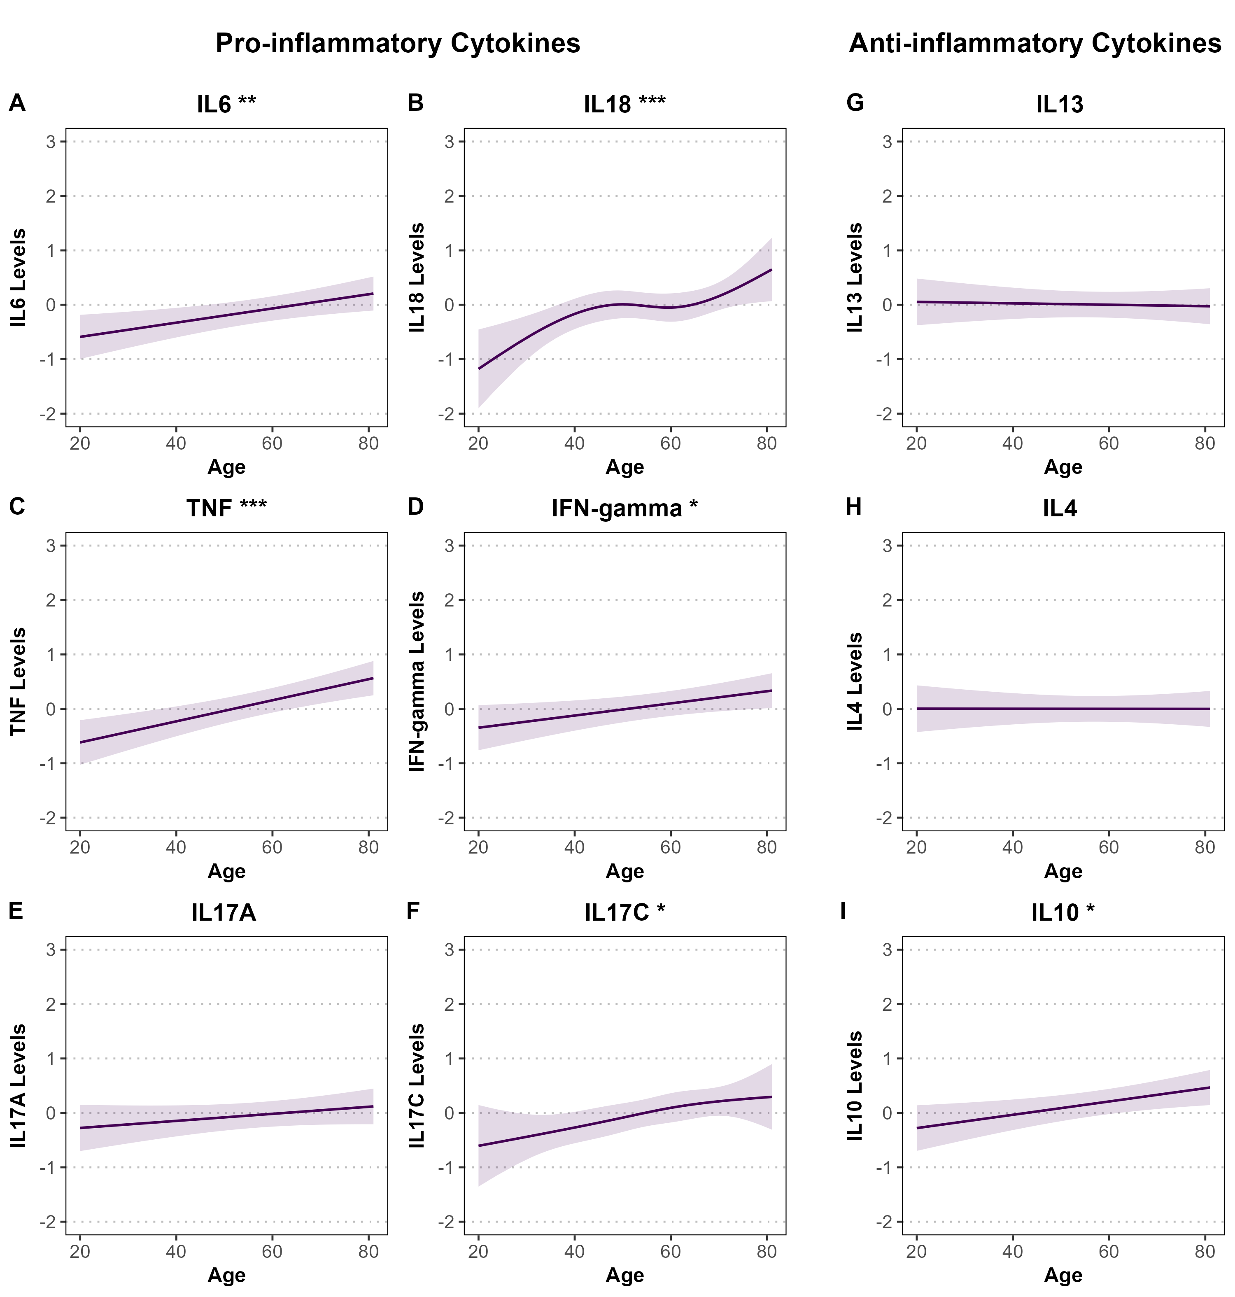
Supplementary Figure S1. Associations between age and standardized pro- and anti-inflammatory cytokine levels in SHIP-TREND cohort. Panels A–F show pro-inflammatory cytokines (IL-6, IL-18, TNF, IFN-γ, IL-17A, IL-17C), and panels G–I show anti-inflammatory cytokines (IL-13, IL-4, IL-10). Associations were estimated using linear or spline-based regression models adjusted for sex, BMI, smoking status, and alcohol consumption. Shaded areas represent 95% confidence intervals. All cytokine levels are standardized (mean = 0, SD = 1). Y-axes are standardized across all panels for comparability and range from –2 to 3 to accommodate greater variability in confidence intervals, likely due to the smaller sample size compared to the RS and PLUS cohorts. Significance is indicated by stars (*P < 0.05; **P < 0.01; ***P < 0.001).

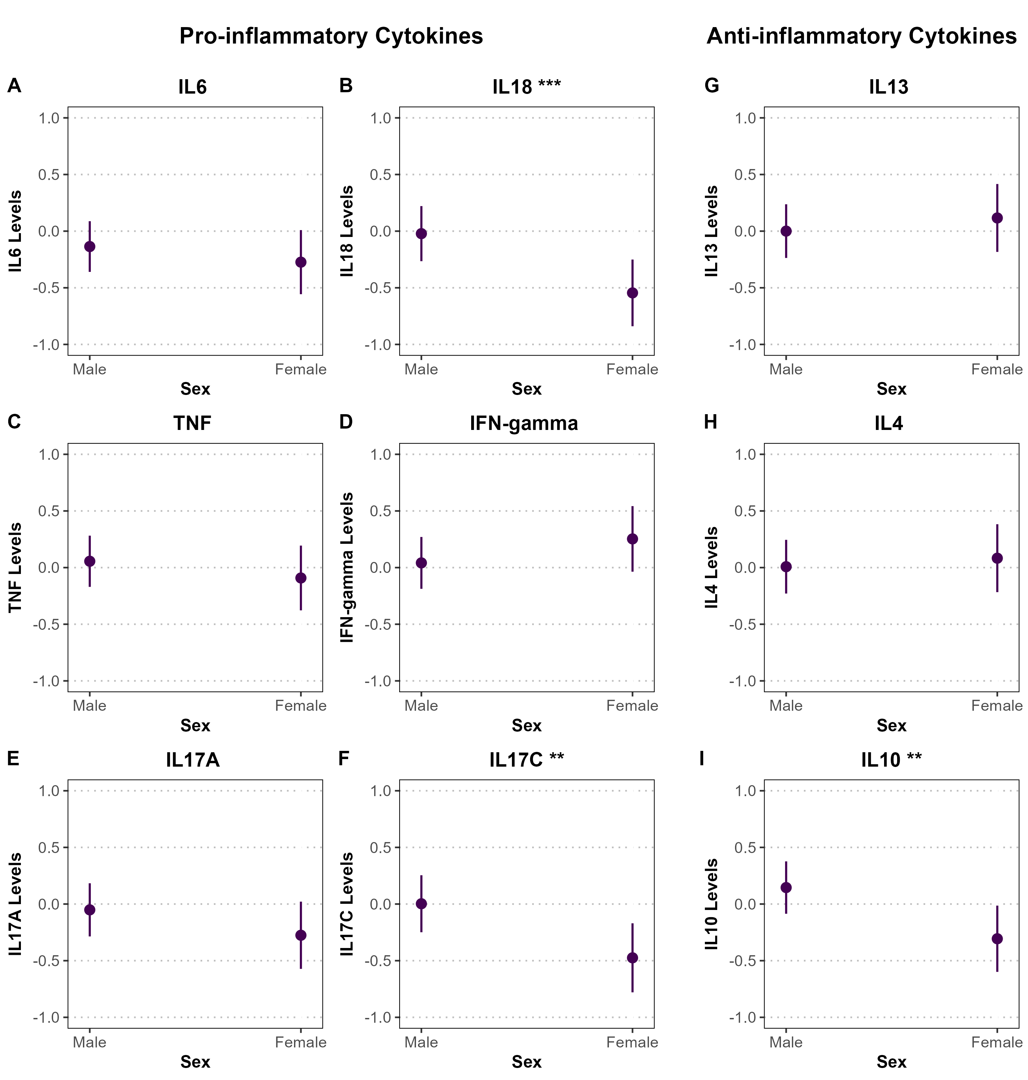
Supplementary Figure S2. Associations between sex and standardized pro- and anti-inflammatory cytokine levels in the SHIP-TREND cohort. Panels A–F show pro-inflammatory cytokines (IL-6, IL-18, TNF, IFN-γ, IL-17A, IL-17C), and panels G–I display anti-inflammatory cytokines (IL-13, IL-4, IL-10). Associations were estimated using linear regression models adjusted for age, BMI, smoking status, and alcohol consumption. Point estimates are shown with 95% confidence intervals represented as vertical error bars. Cytokine levels were z-standardized (mean = 0, SD = 1). Y-axes are fixed at –1 to 1 across all panels for comparability with other categorical analyses and to account for wider confidence intervals, likely due to the smaller sample size in SHIP-TREND. Statistical significance is indicated by asterisks (*P < 0.05; **P < 0.01; ***P < 0.001).

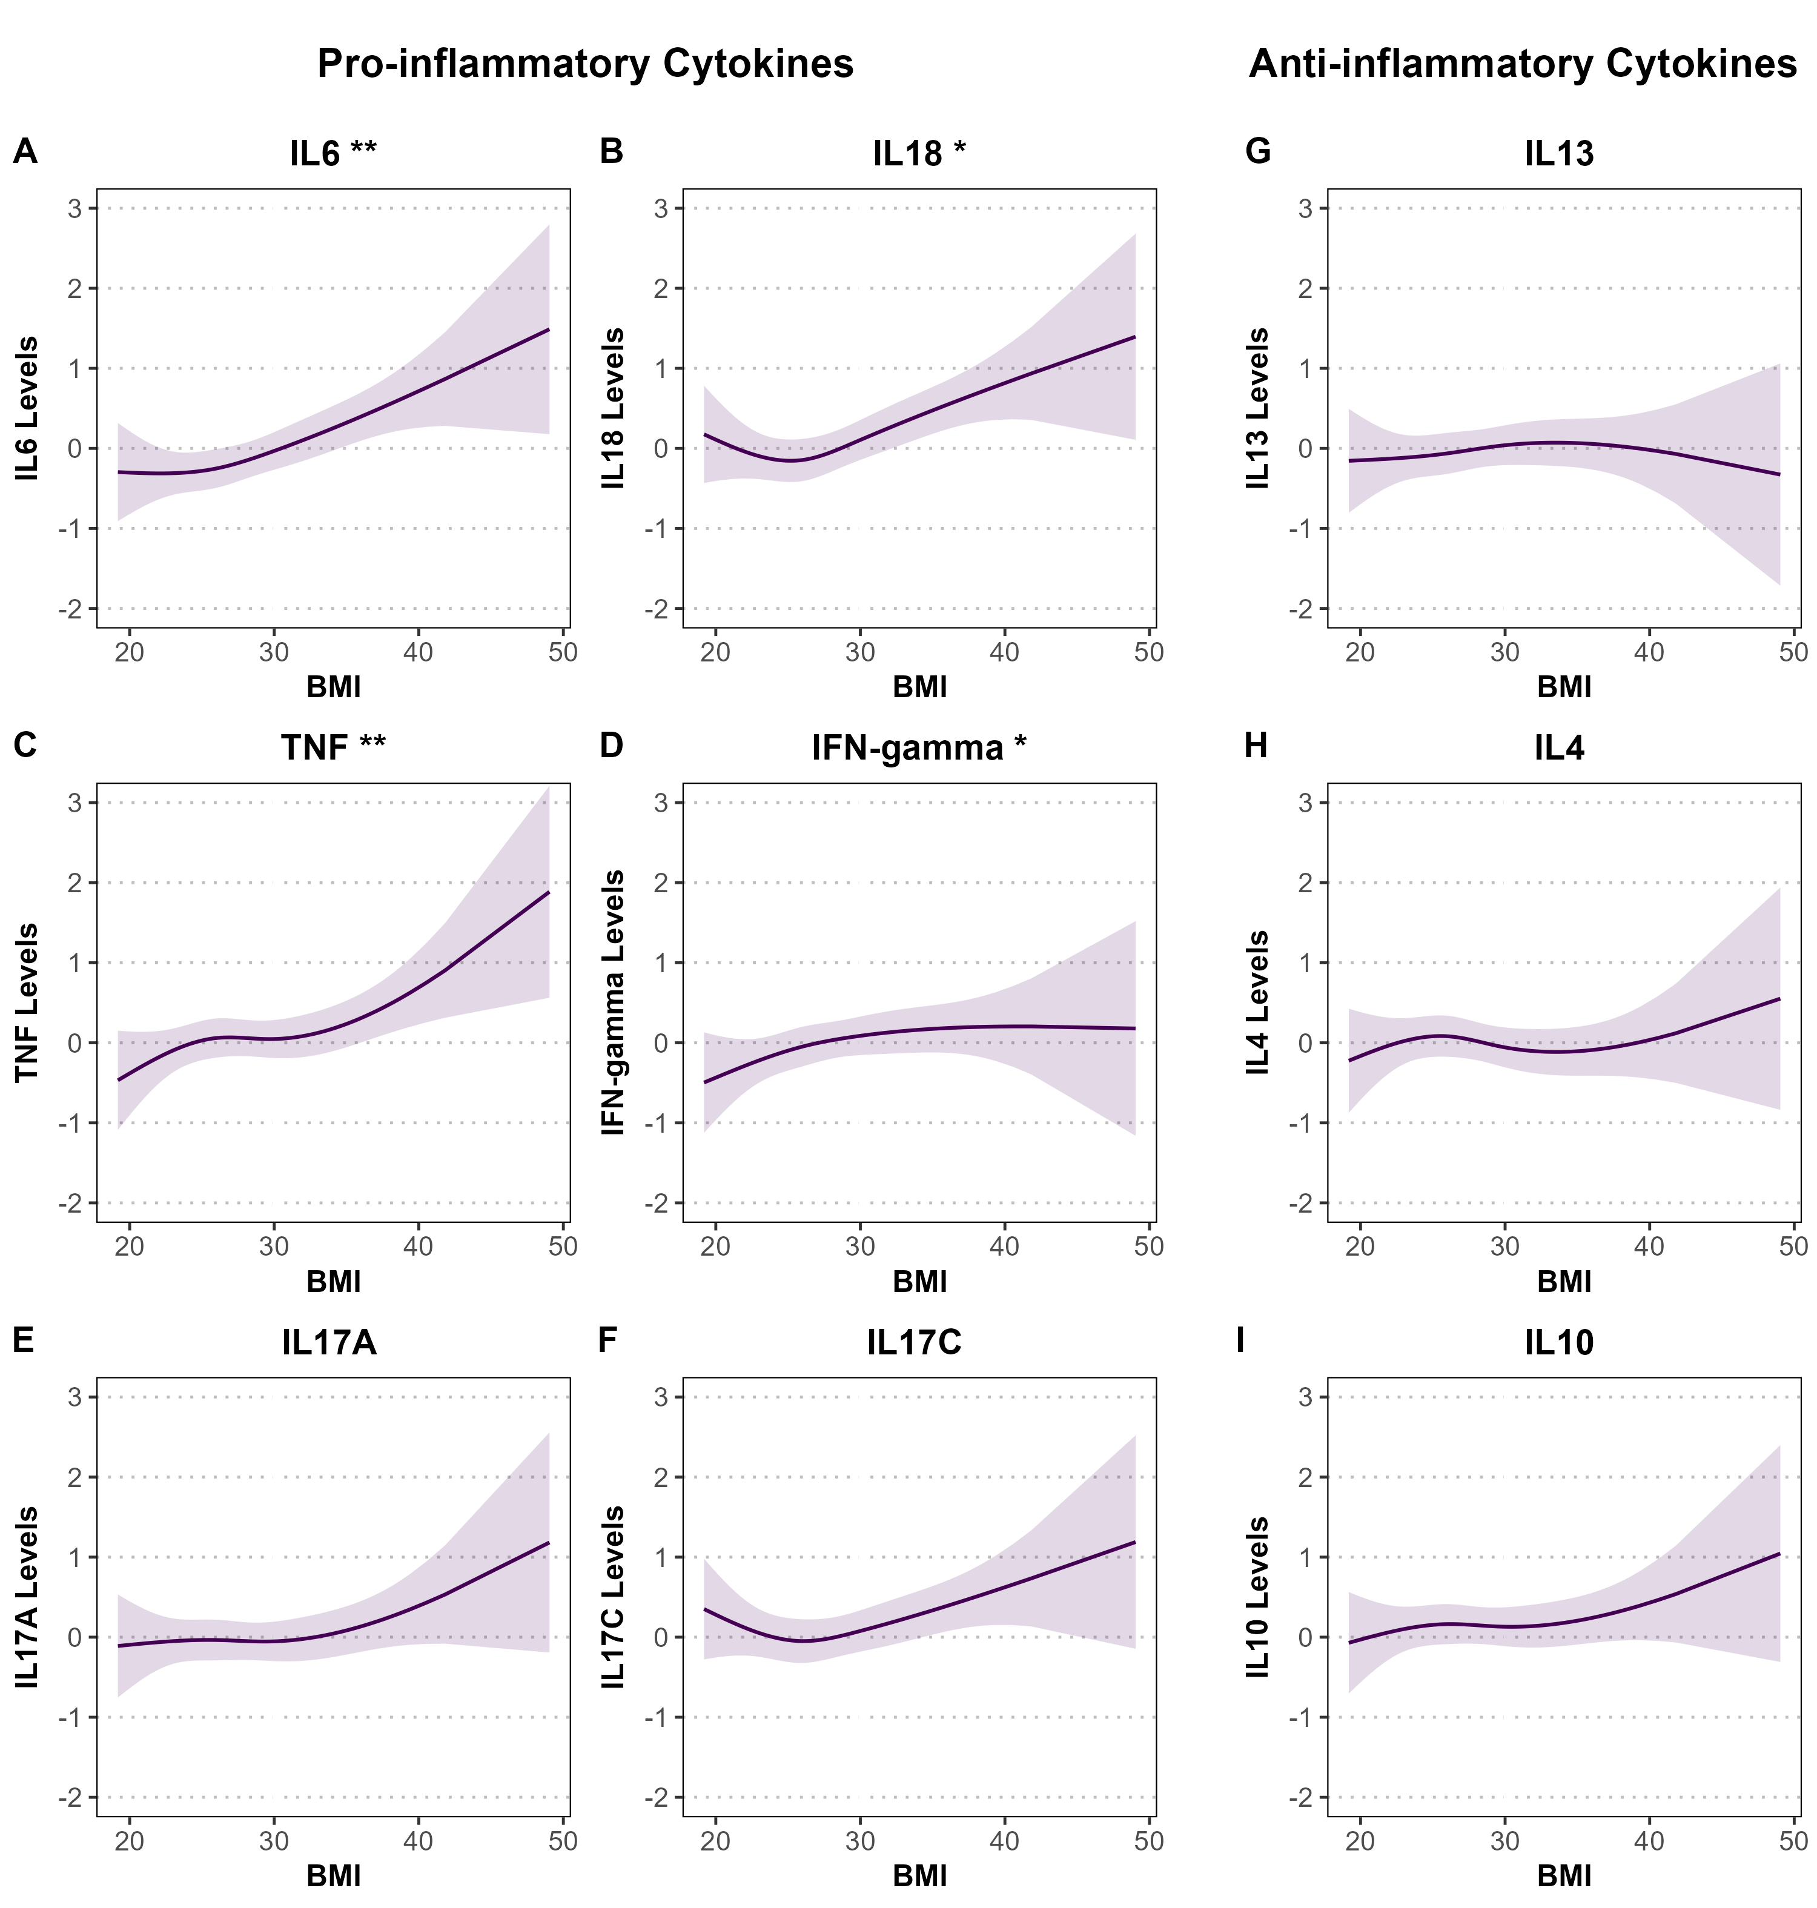
Supplementary Figure S3. Associations between BMI and standardized pro- and anti-inflammatory cytokine levels in SHIP-TREND cohort. Panels A–F show pro-inflammatory cytokines (IL-6, IL-18, TNF, IFN-γ, IL-17A, IL-17C), and panels G–I show anti-inflammatory cytokines (IL-13, IL-4, IL-10). Associations were estimated using linear or spline-based regression models adjusted for age, sex, smoking status, and alcohol consumption. Shaded areas represent 95% confidence intervals. All cytokine levels are standardized (mean = 0, SD = 1). Y-axes are standardized across all panels for comparability and range from –2 to 3 to accommodate greater variability in confidence intervals, likely due to the smaller sample size compared to the RS and PLUS cohorts. Significance is indicated by stars (*P < 0.05; **P < 0.01; ***P < 0.001).

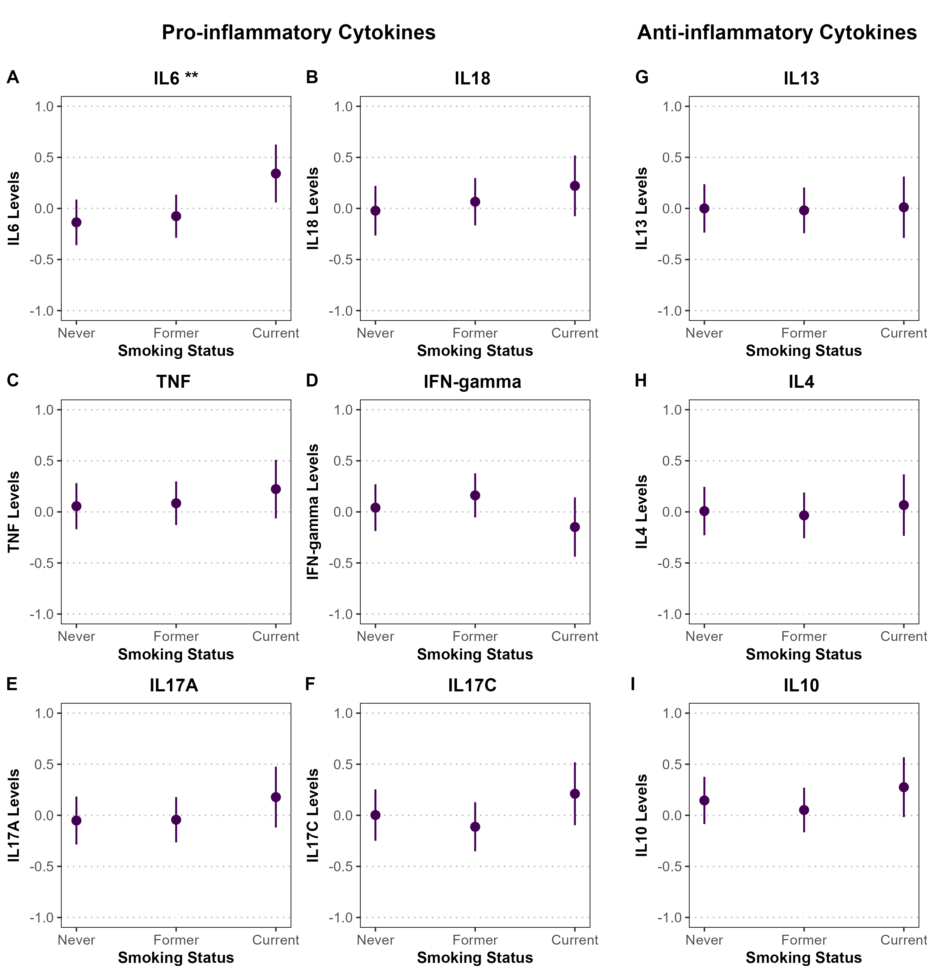
Supplementary Figure S4. Associations between smoking and standardized pro- and anti-inflammatory cytokine levels in the SHIP-TREND cohort. Panels A–F show pro-inflammatory cytokines (IL-6, IL-18, TNF, IFN-γ, IL-17A, IL-17C), and panels G–I display anti-inflammatory cytokines (IL-13, IL-4, IL-10). Associations were estimated using linear regression models adjusted for age, sex, BMI, and alcohol consumption. Point estimates are shown with 95% confidence intervals represented as vertical error bars. Cytokine levels were z-standardized (mean = 0, SD = 1). Y-axes are fixed at –1 to 1 across all panels for comparability with other categorical analyses and to account for wider confidence intervals, likely due to the smaller sample size in SHIP-TREND. Statistical significance is indicated by asterisks (*P < 0.05; **P < 0.01; ***P < 0.001).

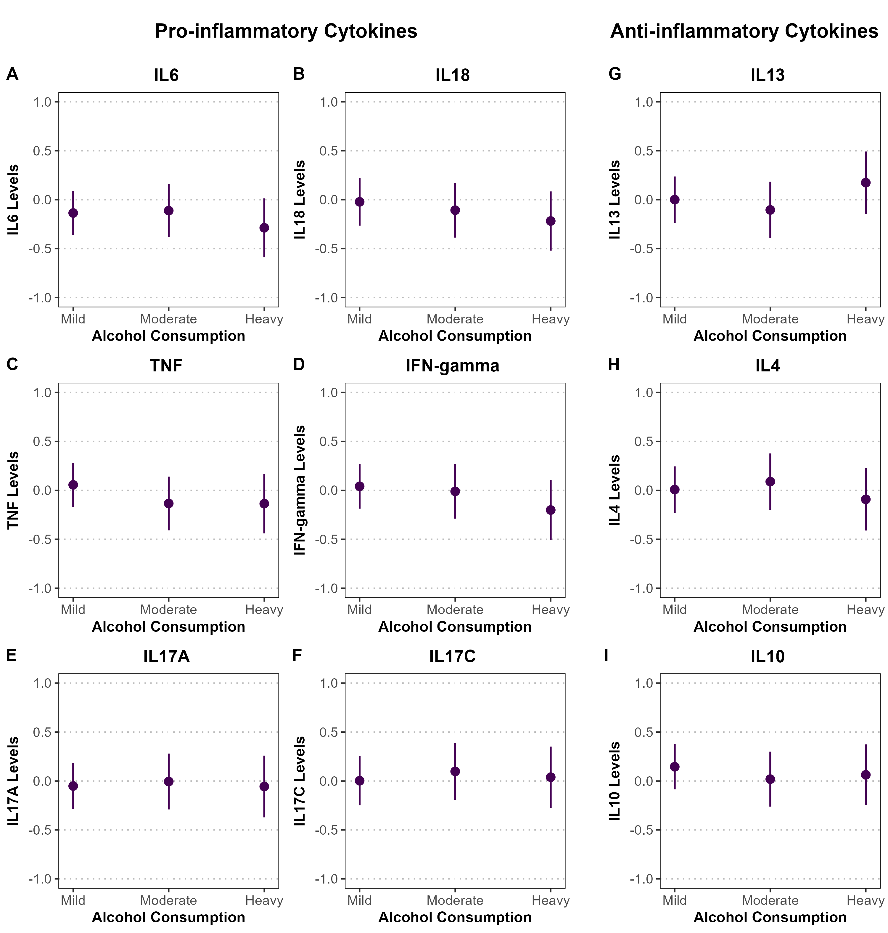
Supplementary Figure S5. Associations between alcohol consumption and standardized pro- and anti-inflammatory cytokine levels in the SHIP-TREND cohort. Panels A–F show pro-inflammatory cytokines (IL-6, IL-18, TNF, IFN-γ, IL-17A, IL-17C), and panels G–I display anti-inflammatory cytokines (IL-13, IL-4, IL-10). Associations were estimated using linear regression models adjusted for age, sex, BMI, and smoking. Point estimates are shown with 95% confidence intervals represented as vertical error bars. Cytokine levels were z-standardized (mean = 0, SD = 1). Y-axes are fixed at –1 to 1 across all panels for comparability with other categorical analyses and to account for wider confidence intervals, likely due to the smaller sample size in SHIP-TREND. Statistical significance is indicated by asterisks (*P < 0.05; **P < 0.01; ***P < 0.001).

Sex Stratified Analysis
Sex-Stratified Models (Males)
term | estimate | std.error | statistic | p.value | conf.low | conf.high | Model
(Intercept) | -0.780 | 0.475 | -1.642 | 0.102 | -1.716 | 0.155 | IL6
age | 0.013 | 0.006 | 2.373 | 0.018 | 0.002 | 0.024 | IL6
smokingFormer | 0.030 | 0.146 | 0.205 | 0.838 | -0.258 | 0.318 | IL6
smokingCurrent | 0.530 | 0.180 | 2.945 | 0.004 | 0.176 | 0.885 | IL6
alcohol_consumptionModerate | 0.047 | 0.146 | 0.321 | 0.748 | -0.241 | 0.335 | IL6
alcohol_consumptionHeavy | -0.128 | 0.163 | -0.787 | 0.432 | -0.448 | 0.192 | IL6
BMI (Spline 1) | 0.465 | 0.282 | 1.649 | 0.100 | -0.090 | 1.019 | IL6
BMI (Spline 2) | 0.217 | 0.823 | 0.264 | 0.792 | -1.404 | 1.838 | IL6
BMI (Spline 3) | 0.939 | 0.438 | 2.144 | 0.033 | 0.077 | 1.802 | IL6
(Intercept) | -1.137 | 0.502 | -2.264 | 0.024 | -2.126 | -0.148 | IL18
Age (Spline 1) | 0.399 | 0.271 | 1.471 | 0.143 | -0.135 | 0.932 | IL18
Age (Spline 2) | 2.852 | 0.780 | 3.658 | 0.000 | 1.317 | 4.387 | IL18
Age (Spline 3) | 0.962 | 0.344 | 2.800 | 0.005 | 0.286 | 1.639 | IL18
smokingFormer | 0.129 | 0.140 | 0.926 | 0.355 | -0.146 | 0.404 | IL18
smokingCurrent | 0.251 | 0.172 | 1.456 | 0.147 | -0.088 | 0.589 | IL18
alcohol_consumptionModerate | -0.109 | 0.140 | -0.779 | 0.437 | -0.384 | 0.166 | IL18
alcohol_consumptionHeavy | -0.167 | 0.157 | -1.063 | 0.289 | -0.476 | 0.142 | IL18
BMI (Spline 1) | 0.246 | 0.271 | 0.908 | 0.365 | -0.287 | 0.780 | IL18
BMI (Spline 2) | 0.370 | 0.788 | 0.470 | 0.639 | -1.182 | 1.922 | IL18
BMI (Spline 3) | 1.172 | 0.418 | 2.802 | 0.005 | 0.349 | 1.996 | IL18
(Intercept) | -1.416 | 0.466 | -3.036 | 0.003 | -2.335 | -0.498 | TNF
age | 0.019 | 0.005 | 3.433 | 0.001 | 0.008 | 0.029 | TNF
smokingFormer | -0.003 | 0.143 | -0.021 | 0.983 | -0.285 | 0.279 | TNF
smokingCurrent | 0.194 | 0.177 | 1.096 | 0.274 | -0.154 | 0.542 | TNF
alcohol_consumptionModerate | -0.231 | 0.143 | -1.611 | 0.108 | -0.514 | 0.051 | TNF
alcohol_consumptionHeavy | -0.226 | 0.160 | -1.415 | 0.158 | -0.540 | 0.088 | TNF
BMI (Spline 1) | 0.058 | 0.277 | 0.209 | 0.835 | -0.487 | 0.602 | TNF
BMI (Spline 2) | 1.409 | 0.808 | 1.743 | 0.082 | -0.183 | 3.000 | TNF
BMI (Spline 3) | 0.966 | 0.430 | 2.247 | 0.025 | 0.119 | 1.813 | TNF
(Intercept) | -0.837 | 0.463 | -1.809 | 0.072 | -1.749 | 0.074 | IFNy
age | 0.010 | 0.005 | 1.788 | 0.075 | -0.001 | 0.020 | IFNy
smokingFormer | 0.152 | 0.142 | 1.071 | 0.285 | -0.128 | 0.433 | IFNy
smokingCurrent | -0.167 | 0.175 | -0.951 | 0.343 | -0.512 | 0.179 | IFNy
alcohol_consumptionModerate | -0.040 | 0.142 | -0.279 | 0.780 | -0.320 | 0.241 | IFNy
alcohol_consumptionHeavy | -0.228 | 0.158 | -1.437 | 0.152 | -0.539 | 0.084 | IFNy
BMI (Spline 1) | 0.139 | 0.274 | 0.507 | 0.613 | -0.401 | 0.679 | IFNy
BMI (Spline 2) | 0.811 | 0.802 | 1.011 | 0.313 | -0.768 | 2.390 | IFNy
BMI (Spline 3) | 0.561 | 0.427 | 1.314 | 0.190 | -0.279 | 1.401 | IFNy
(Intercept) | -0.746 | 0.498 | -1.496 | 0.136 | -1.727 | 0.236 | IL17A
age | 0.006 | 0.006 | 0.964 | 0.336 | -0.006 | 0.017 | IL17A
smokingFormer | 0.079 | 0.153 | 0.515 | 0.607 | -0.223 | 0.381 | IL17A
smokingCurrent | 0.366 | 0.189 | 1.936 | 0.054 | -0.006 | 0.737 | IL17A
alcohol_consumptionModerate | 0.042 | 0.153 | 0.274 | 0.784 | -0.260 | 0.344 | IL17A
alcohol_consumptionHeavy | 0.004 | 0.171 | 0.023 | 0.982 | -0.332 | 0.340 | IL17A
BMI (Spline 1) | -0.248 | 0.296 | -0.840 | 0.402 | -0.830 | 0.334 | IL17A
BMI (Spline 2) | 1.256 | 0.864 | 1.454 | 0.147 | -0.445 | 2.956 | IL17A
BMI (Spline 3) | 1.065 | 0.460 | 2.318 | 0.021 | 0.161 | 1.970 | IL17A
(Intercept) | -0.066 | 0.515 | -0.127 | 0.899 | -1.080 | 0.949 | IL17C
Age (Spline 1) | 0.576 | 0.278 | 2.073 | 0.039 | 0.029 | 1.124 | IL17C
Age (Spline 2) | 0.920 | 0.800 | 1.150 | 0.251 | -0.655 | 2.496 | IL17C
Age (Spline 3) | 0.754 | 0.353 | 2.138 | 0.033 | 0.059 | 1.449 | IL17C
smokingFormer | -0.156 | 0.143 | -1.091 | 0.276 | -0.438 | 0.126 | IL17C
smokingCurrent | 0.236 | 0.177 | 1.338 | 0.182 | -0.111 | 0.584 | IL17C
alcohol_consumptionModerate | 0.147 | 0.143 | 1.025 | 0.306 | -0.135 | 0.430 | IL17C
alcohol_consumptionHeavy | 0.057 | 0.161 | 0.356 | 0.722 | -0.260 | 0.374 | IL17C
BMI (Spline 1) | 0.003 | 0.278 | 0.009 | 0.993 | -0.545 | 0.550 | IL17C
BMI (Spline 2) | -0.295 | 0.809 | -0.365 | 0.715 | -1.887 | 1.297 | IL17C
BMI (Spline 3) | 0.813 | 0.429 | 1.894 | 0.059 | -0.032 | 1.658 | IL17C
(Intercept) | -0.316 | 0.365 | -0.867 | 0.387 | -1.035 | 0.402 | IL13
age | -0.001 | 0.004 | -0.304 | 0.761 | -0.010 | 0.007 | IL13
smokingFormer | 0.006 | 0.112 | 0.056 | 0.955 | -0.214 | 0.227 | IL13
smokingCurrent | 0.128 | 0.138 | 0.929 | 0.354 | -0.144 | 0.400 | IL13
alcohol_consumptionModerate | 0.068 | 0.112 | 0.609 | 0.543 | -0.153 | 0.289 | IL13
alcohol_consumptionHeavy | -0.102 | 0.125 | -0.816 | 0.415 | -0.348 | 0.144 | IL13
BMI (Spline 1) | -0.081 | 0.216 | -0.373 | 0.709 | -0.507 | 0.345 | IL13
BMI (Spline 2) | 0.825 | 0.632 | 1.306 | 0.193 | -0.419 | 2.069 | IL13
BMI (Spline 3) | 0.231 | 0.336 | 0.688 | 0.492 | -0.431 | 0.894 | IL13
(Intercept) | -0.239 | 0.493 | -0.485 | 0.628 | -1.209 | 0.731 | IL4
Age (Spline 1) | 0.191 | 0.257 | 0.746 | 0.456 | -0.314 | 0.696 | IL4
Age (Spline 2) | 0.057 | 0.739 | 0.077 | 0.939 | -1.398 | 1.512 | IL4
Age (Spline 3) | -0.379 | 0.324 | -1.170 | 0.243 | -1.018 | 0.259 | IL4
smokingFormer | 0.056 | 0.131 | 0.427 | 0.670 | -0.202 | 0.314 | IL4
smokingCurrent | -0.039 | 0.160 | -0.241 | 0.810 | -0.354 | 0.277 | IL4
alcohol_consumptionModerate | -0.095 | 0.131 | -0.727 | 0.468 | -0.352 | 0.162 | IL4
alcohol_consumptionHeavy | 0.148 | 0.147 | 1.005 | 0.316 | -0.142 | 0.437 | IL4
BMI | 0.003 | 0.013 | 0.199 | 0.843 | -0.024 | 0.029 | IL4
(Intercept) | -0.933 | 0.505 | -1.848 | 0.066 | -1.926 | 0.061 | IL10
age | 0.012 | 0.006 | 2.076 | 0.039 | 0.001 | 0.024 | IL10
smokingFormer | -0.092 | 0.155 | -0.591 | 0.555 | -0.397 | 0.214 | IL10
smokingCurrent | 0.134 | 0.191 | 0.700 | 0.484 | -0.243 | 0.510 | IL10
alcohol_consumptionModerate | -0.174 | 0.155 | -1.123 | 0.263 | -0.480 | 0.131 | IL10
alcohol_consumptionHeavy | -0.115 | 0.173 | -0.667 | 0.505 | -0.455 | 0.225 | IL10
BMI (Spline 1) | 0.130 | 0.299 | 0.433 | 0.665 | -0.460 | 0.719 | IL10
BMI (Spline 2) | 1.039 | 0.875 | 1.188 | 0.236 | -0.683 | 2.761 | IL10
BMI (Spline 3) | 0.415 | 0.465 | 0.892 | 0.373 | -0.501 | 1.332 | IL10
Supplementary Table S4.1. Fully adjusted linear regression results for male participants, assessing associations with cytokine levels in SHIP-TREND cohort. Models adjust for age, smoking status (current and former vs. never), alcohol consumption (moderate and heavy vs. mild), and BMI. Natural splines with 3 degrees of freedom were applied to age or BMI in select models, indicated as Spline 1–3. Cytokine levels were z-transformed; estimates represent changes per standard deviation. Reported metrics include estimates, standard errors, test statistics, p-values, and 95% confidence intervals.

Sex-Stratified Models (Females)
term | estimate | std.error | statistic | p.value | conf.low | conf.high | Model
(Intercept) | -1.552 | 0.492 | -3.158 | 0.002 | -2.536 | -0.569 | IL6
age | 0.013 | 0.008 | 1.751 | 0.085 | -0.002 | 0.029 | IL6
smokingFormer | 0.213 | 0.198 | 1.072 | 0.288 | -0.184 | 0.610 | IL6
smokingCurrent | 0.103 | 0.259 | 0.397 | 0.693 | -0.416 | 0.622 | IL6
alcohol_consumptionModerate | -0.173 | 0.363 | -0.476 | 0.636 | -0.900 | 0.554 | IL6
alcohol_consumptionHeavy | -0.799 | 0.730 | -1.094 | 0.278 | -2.260 | 0.662 | IL6
BMI (Spline 1) | 0.172 | 0.440 | 0.390 | 0.698 | -0.709 | 1.052 | IL6
BMI (Spline 2) | 2.103 | 0.799 | 2.633 | 0.011 | 0.505 | 3.701 | IL6
BMI (Spline 3) | 2.179 | 0.635 | 3.432 | 0.001 | 0.909 | 3.449 | IL6
(Intercept) | -0.647 | 0.665 | -0.972 | 0.335 | -1.979 | 0.685 | IL18
Age (Spline 1) | -0.072 | 0.498 | -0.144 | 0.886 | -1.070 | 0.926 | IL18
Age (Spline 2) | -0.079 | 1.536 | -0.051 | 0.959 | -3.154 | 2.997 | IL18
Age (Spline 3) | 0.902 | 0.416 | 2.169 | 0.034 | 0.070 | 1.734 | IL18
smokingFormer | -0.020 | 0.228 | -0.086 | 0.932 | -0.476 | 0.437 | IL18
smokingCurrent | 0.622 | 0.306 | 2.036 | 0.046 | 0.010 | 1.234 | IL18
alcohol_consumptionModerate | 0.457 | 0.420 | 1.087 | 0.281 | -0.384 | 1.298 | IL18
alcohol_consumptionHeavy | -1.915 | 0.837 | -2.289 | 0.026 | -3.589 | -0.240 | IL18
BMI (Spline 1) | 0.208 | 0.511 | 0.407 | 0.686 | -0.816 | 1.231 | IL18
BMI (Spline 2) | 1.037 | 0.954 | 1.087 | 0.281 | -0.872 | 2.946 | IL18
BMI (Spline 3) | 1.332 | 0.735 | 1.812 | 0.075 | -0.139 | 2.803 | IL18
(Intercept) | -2.864 | 0.669 | -4.283 | 0.000 | -4.201 | -1.527 | TNF
age | 0.018 | 0.009 | 1.943 | 0.057 | -0.001 | 0.036 | TNF
smokingFormer | 0.257 | 0.244 | 1.056 | 0.295 | -0.230 | 0.745 | TNF
smokingCurrent | -0.013 | 0.317 | -0.042 | 0.966 | -0.648 | 0.621 | TNF
alcohol_consumptionModerate | 0.250 | 0.452 | 0.554 | 0.581 | -0.652 | 1.153 | TNF
alcohol_consumptionHeavy | 0.815 | 0.903 | 0.903 | 0.370 | -0.990 | 2.620 | TNF
BMI | 0.064 | 0.021 | 3.001 | 0.004 | 0.021 | 0.106 | TNF
(Intercept) | -0.727 | 0.683 | -1.064 | 0.292 | -2.093 | 0.640 | IFNy
age | 0.011 | 0.011 | 1.036 | 0.304 | -0.010 | 0.032 | IFNy
smokingFormer | 0.131 | 0.276 | 0.476 | 0.635 | -0.420 | 0.683 | IFNy
smokingCurrent | -0.153 | 0.360 | -0.425 | 0.672 | -0.874 | 0.568 | IFNy
alcohol_consumptionModerate | 0.056 | 0.505 | 0.112 | 0.911 | -0.954 | 1.067 | IFNy
alcohol_consumptionHeavy | 0.191 | 1.015 | 0.188 | 0.851 | -1.839 | 2.221 | IFNy
BMI (Spline 1) | 1.832 | 0.612 | 2.996 | 0.004 | 0.609 | 3.055 | IFNy
BMI (Spline 2) | 0.448 | 1.110 | 0.403 | 0.688 | -1.773 | 2.668 | IFNy
BMI (Spline 3) | 0.167 | 0.882 | 0.189 | 0.851 | -1.598 | 1.932 | IFNy
(Intercept) | -0.393 | 0.518 | -0.758 | 0.451 | -1.430 | 0.644 | IL17A
age | 0.008 | 0.008 | 1.034 | 0.305 | -0.008 | 0.025 | IL17A
smokingFormer | -0.060 | 0.209 | -0.286 | 0.776 | -0.478 | 0.359 | IL17A
smokingCurrent | -0.151 | 0.273 | -0.553 | 0.583 | -0.698 | 0.396 | IL17A
alcohol_consumptionModerate | 0.109 | 0.383 | 0.285 | 0.777 | -0.658 | 0.876 | IL17A
alcohol_consumptionHeavy | 0.182 | 0.770 | 0.236 | 0.814 | -1.359 | 1.722 | IL17A
BMI (Spline 1) | 0.010 | 0.464 | 0.023 | 0.982 | -0.918 | 0.939 | IL17A
BMI (Spline 2) | -0.235 | 0.842 | -0.279 | 0.782 | -1.920 | 1.451 | IL17A
BMI (Spline 3) | 0.502 | 0.670 | 0.750 | 0.456 | -0.837 | 1.842 | IL17A
(Intercept) | -1.363 | 0.765 | -1.783 | 0.080 | -2.894 | 0.167 | IL17C
Age (Spline 1) | 1.033 | 0.573 | 1.804 | 0.076 | -0.113 | 2.180 | IL17C
Age (Spline 2) | 2.034 | 1.766 | 1.152 | 0.254 | -1.500 | 5.569 | IL17C
Age (Spline 3) | 0.414 | 0.478 | 0.866 | 0.390 | -0.543 | 1.371 | IL17C
smokingFormer | 0.076 | 0.262 | 0.290 | 0.773 | -0.449 | 0.601 | IL17C
smokingCurrent | -0.140 | 0.351 | -0.398 | 0.692 | -0.843 | 0.563 | IL17C
alcohol_consumptionModerate | -0.450 | 0.483 | -0.933 | 0.355 | -1.417 | 0.516 | IL17C
alcohol_consumptionHeavy | 0.708 | 0.961 | 0.736 | 0.465 | -1.217 | 2.632 | IL17C
BMI (Spline 1) | 0.004 | 0.588 | 0.006 | 0.995 | -1.172 | 1.180 | IL17C
BMI (Spline 2) | 0.115 | 1.096 | 0.105 | 0.917 | -2.078 | 2.309 | IL17C
BMI (Spline 3) | 0.632 | 0.845 | 0.748 | 0.457 | -1.059 | 2.323 | IL17C
(Intercept) | -0.613 | 1.207 | -0.508 | 0.613 | -3.027 | 1.800 | IL13
age | 0.001 | 0.019 | 0.079 | 0.937 | -0.036 | 0.039 | IL13
smokingFormer | -0.270 | 0.487 | -0.554 | 0.582 | -1.244 | 0.704 | IL13
smokingCurrent | -0.265 | 0.637 | -0.416 | 0.679 | -1.538 | 1.009 | IL13
alcohol_consumptionModerate | 0.142 | 0.892 | 0.159 | 0.874 | -1.643 | 1.927 | IL13
alcohol_consumptionHeavy | -0.749 | 1.793 | -0.418 | 0.678 | -4.335 | 2.837 | IL13
BMI (Spline 1) | -1.368 | 1.080 | -1.267 | 0.210 | -3.529 | 0.793 | IL13
BMI (Spline 2) | 1.834 | 1.961 | 0.935 | 0.353 | -2.089 | 5.757 | IL13
BMI (Spline 3) | 0.813 | 1.559 | 0.521 | 0.604 | -2.305 | 3.930 | IL13
(Intercept) | -0.674 | 1.379 | -0.489 | 0.627 | -3.432 | 2.083 | IL4
Age (Spline 1) | -0.360 | 0.825 | -0.436 | 0.664 | -2.010 | 1.291 | IL4
Age (Spline 2) | 0.525 | 2.434 | 0.216 | 0.830 | -4.343 | 5.394 | IL4
Age (Spline 3) | 0.644 | 0.672 | 0.958 | 0.342 | -0.701 | 1.989 | IL4
smokingFormer | -0.302 | 0.386 | -0.780 | 0.438 | -1.075 | 0.471 | IL4
smokingCurrent | 0.363 | 0.516 | 0.704 | 0.484 | -0.669 | 1.395 | IL4
alcohol_consumptionModerate | -0.129 | 0.715 | -0.180 | 0.857 | -1.559 | 1.301 | IL4
alcohol_consumptionHeavy | 0.641 | 1.422 | 0.451 | 0.654 | -2.204 | 3.486 | IL4
BMI | 0.025 | 0.033 | 0.743 | 0.460 | -0.042 | 0.092 | IL4
(Intercept) | -1.011 | 0.386 | -2.623 | 0.011 | -1.782 | -0.240 | IL10
age | 0.013 | 0.006 | 2.213 | 0.031 | 0.001 | 0.025 | IL10
smokingFormer | -0.121 | 0.156 | -0.777 | 0.440 | -0.432 | 0.190 | IL10
smokingCurrent | 0.123 | 0.203 | 0.604 | 0.548 | -0.284 | 0.530 | IL10
alcohol_consumptionModerate | 0.230 | 0.285 | 0.806 | 0.423 | -0.341 | 0.800 | IL10
alcohol_consumptionHeavy | 0.201 | 0.573 | 0.352 | 0.726 | -0.944 | 1.347 | IL10
BMI (Spline 1) | -0.339 | 0.345 | -0.983 | 0.329 | -1.030 | 0.351 | IL10
BMI (Spline 2) | 0.444 | 0.627 | 0.709 | 0.481 | -0.809 | 1.698 | IL10
BMI (Spline 3) | 1.179 | 0.498 | 2.367 | 0.021 | 0.183 | 2.175 | IL10
Supplementary Table S4.2. Fully adjusted linear regression results for female participants, assessing associations with cytokine levels in SHIP-TREND cohort. Models adjust for age, smoking status (current and former vs. never), alcohol consumption (moderate and heavy vs. mild), and BMI. Natural splines with 3 degrees of freedom were applied to age or BMI in select models, indicated as Spline 1–3. Cytokine levels were z-transformed; estimates represent changes per standard deviation. Reported metrics include estimates, standard errors, test statistics, p-values, and 95% confidence intervals.

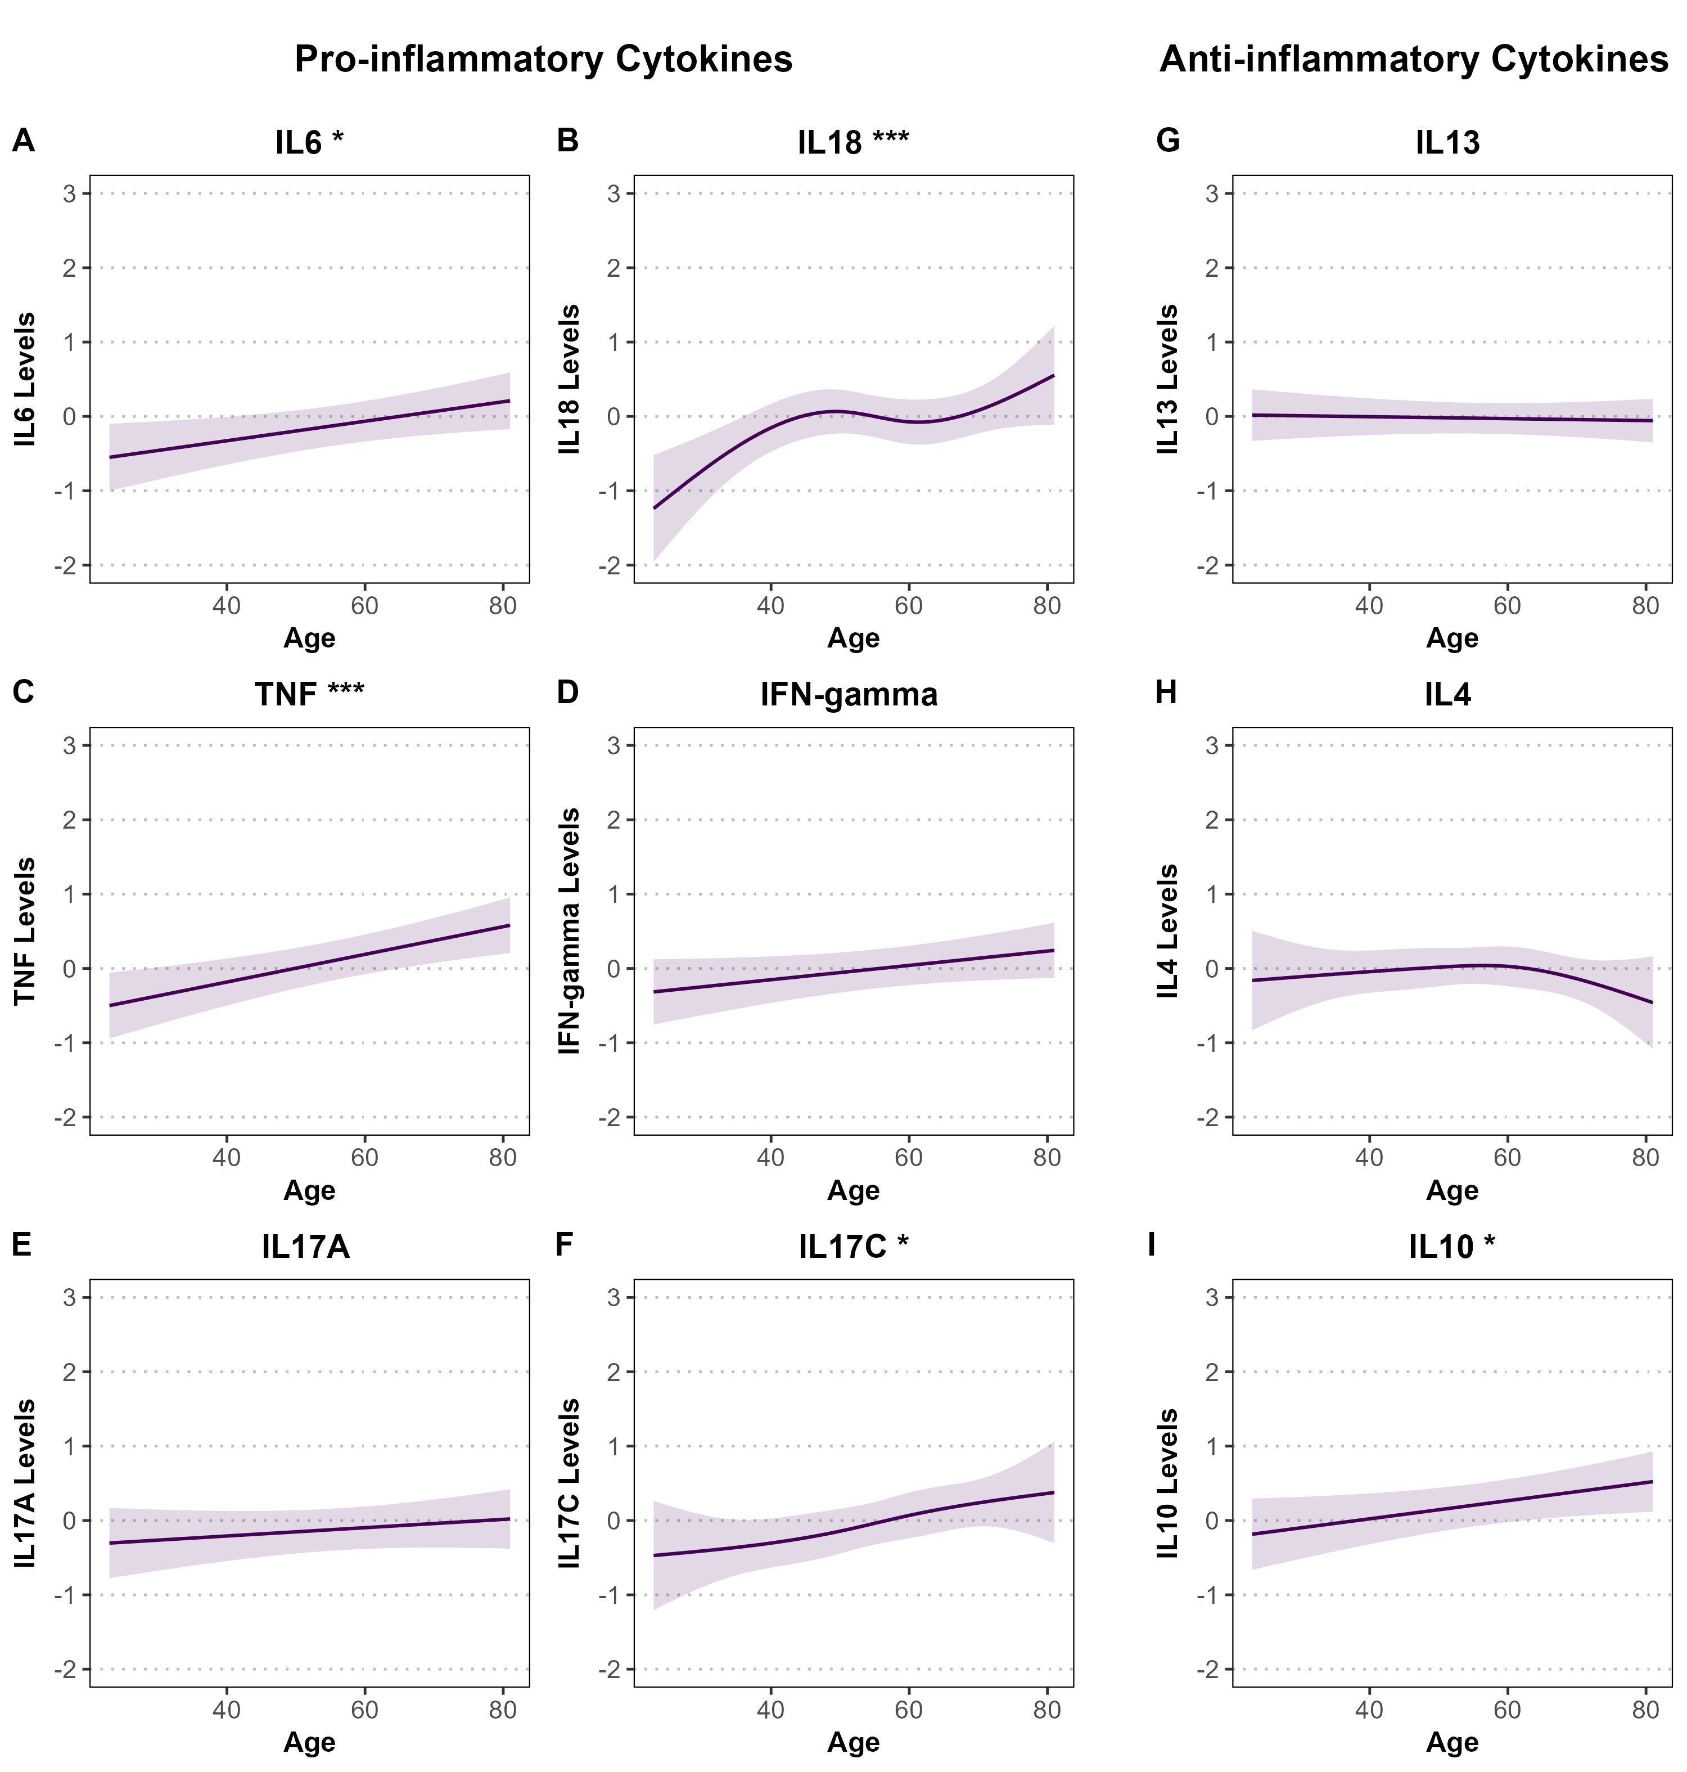
Supplementary Figure S6.1. Associations between age and standardized pro- and anti-inflammatory cytokine levels among male participants in the SHIP-TREND cohort. Panels A–F display pro-inflammatory cytokines (IL-6, IL-18, TNF, IFN-γ, IL-17A, IL-17C), and panels G–I show anti-inflammatory cytokines (IL-13, IL-4, IL-10). Associations were estimated using linear or spline-based regression models adjusted for BMI, smoking status, and alcohol consumption. Shaded areas represent 95% confidence intervals. Cytokine levels are standardized (mean = 0, SD = 1). Cytokine levels are standardized (mean = 0, SD = 1). For SHIP-TREND, y-axes are uniform across panels (range: -2 to 3) to facilitate comparability across continuous determinants. Note that this y-axis range does not match the scales used in the RS and PLUS cohorts due to their wider confidence intervals, which required broader y-axis limits. Statistical significance is denoted by asterisks (*P < 0.05; **P < 0.01; ***P < 0.001).

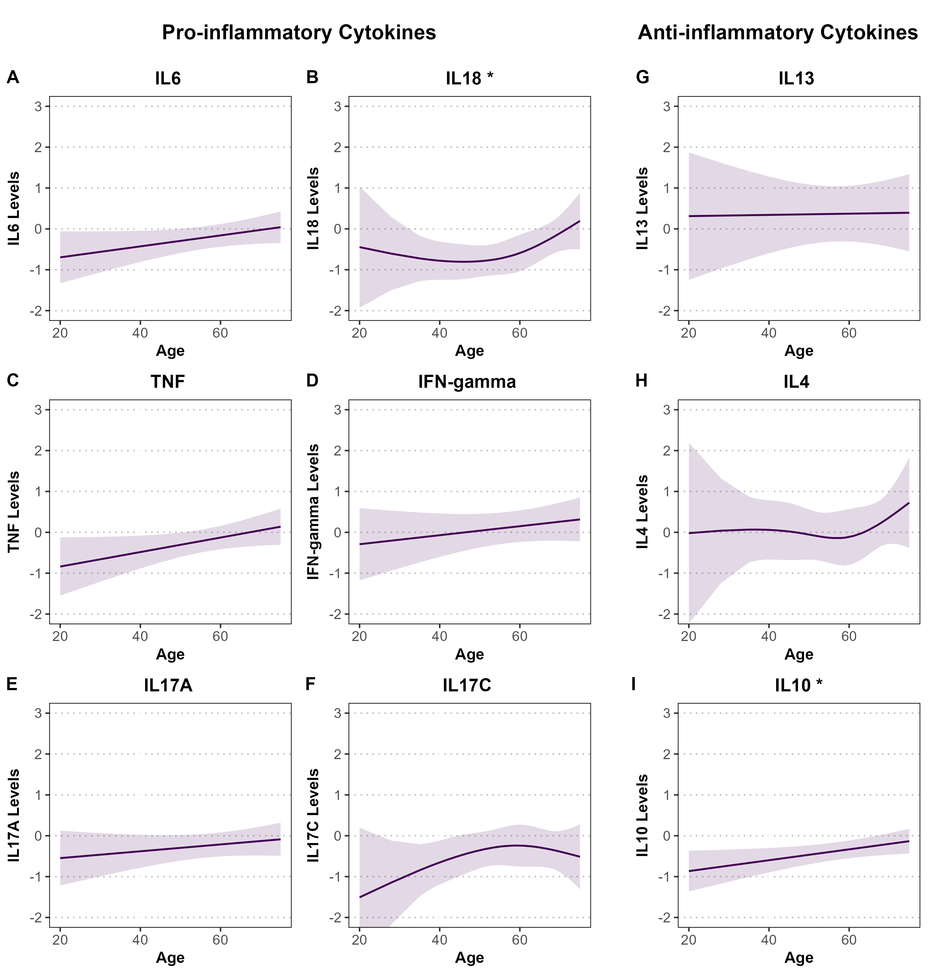
Supplementary Figure S6.2. Associations between age and standardized pro- and anti-inflammatory cytokine levels among female participants in the SHIP-TREND cohort. Panels A–F display pro-inflammatory cytokines (IL-6, IL-18, TNF, IFN-γ, IL-17A, IL-17C), and panels G–I show anti-inflammatory cytokines (IL-13, IL-4, IL-10). Associations were estimated using linear or spline-based regression models adjusted for BMI, smoking status, and alcohol consumption. Shaded areas represent 95% confidence intervals. Cytokine levels are standardized (mean = 0, SD = 1). Cytokine levels are standardized (mean = 0, SD = 1). For SHIP-TREND, y-axes are uniform across panels (range: -2 to 3) to facilitate comparability across continuous determinants. Note that this y-axis range does not match the scales used in the RS and PLUS cohorts due to their wider confidence intervals, which required broader y-axis limits. Statistical significance is denoted by asterisks (*P < 0.05; **P < 0.01; ***P < 0.001).
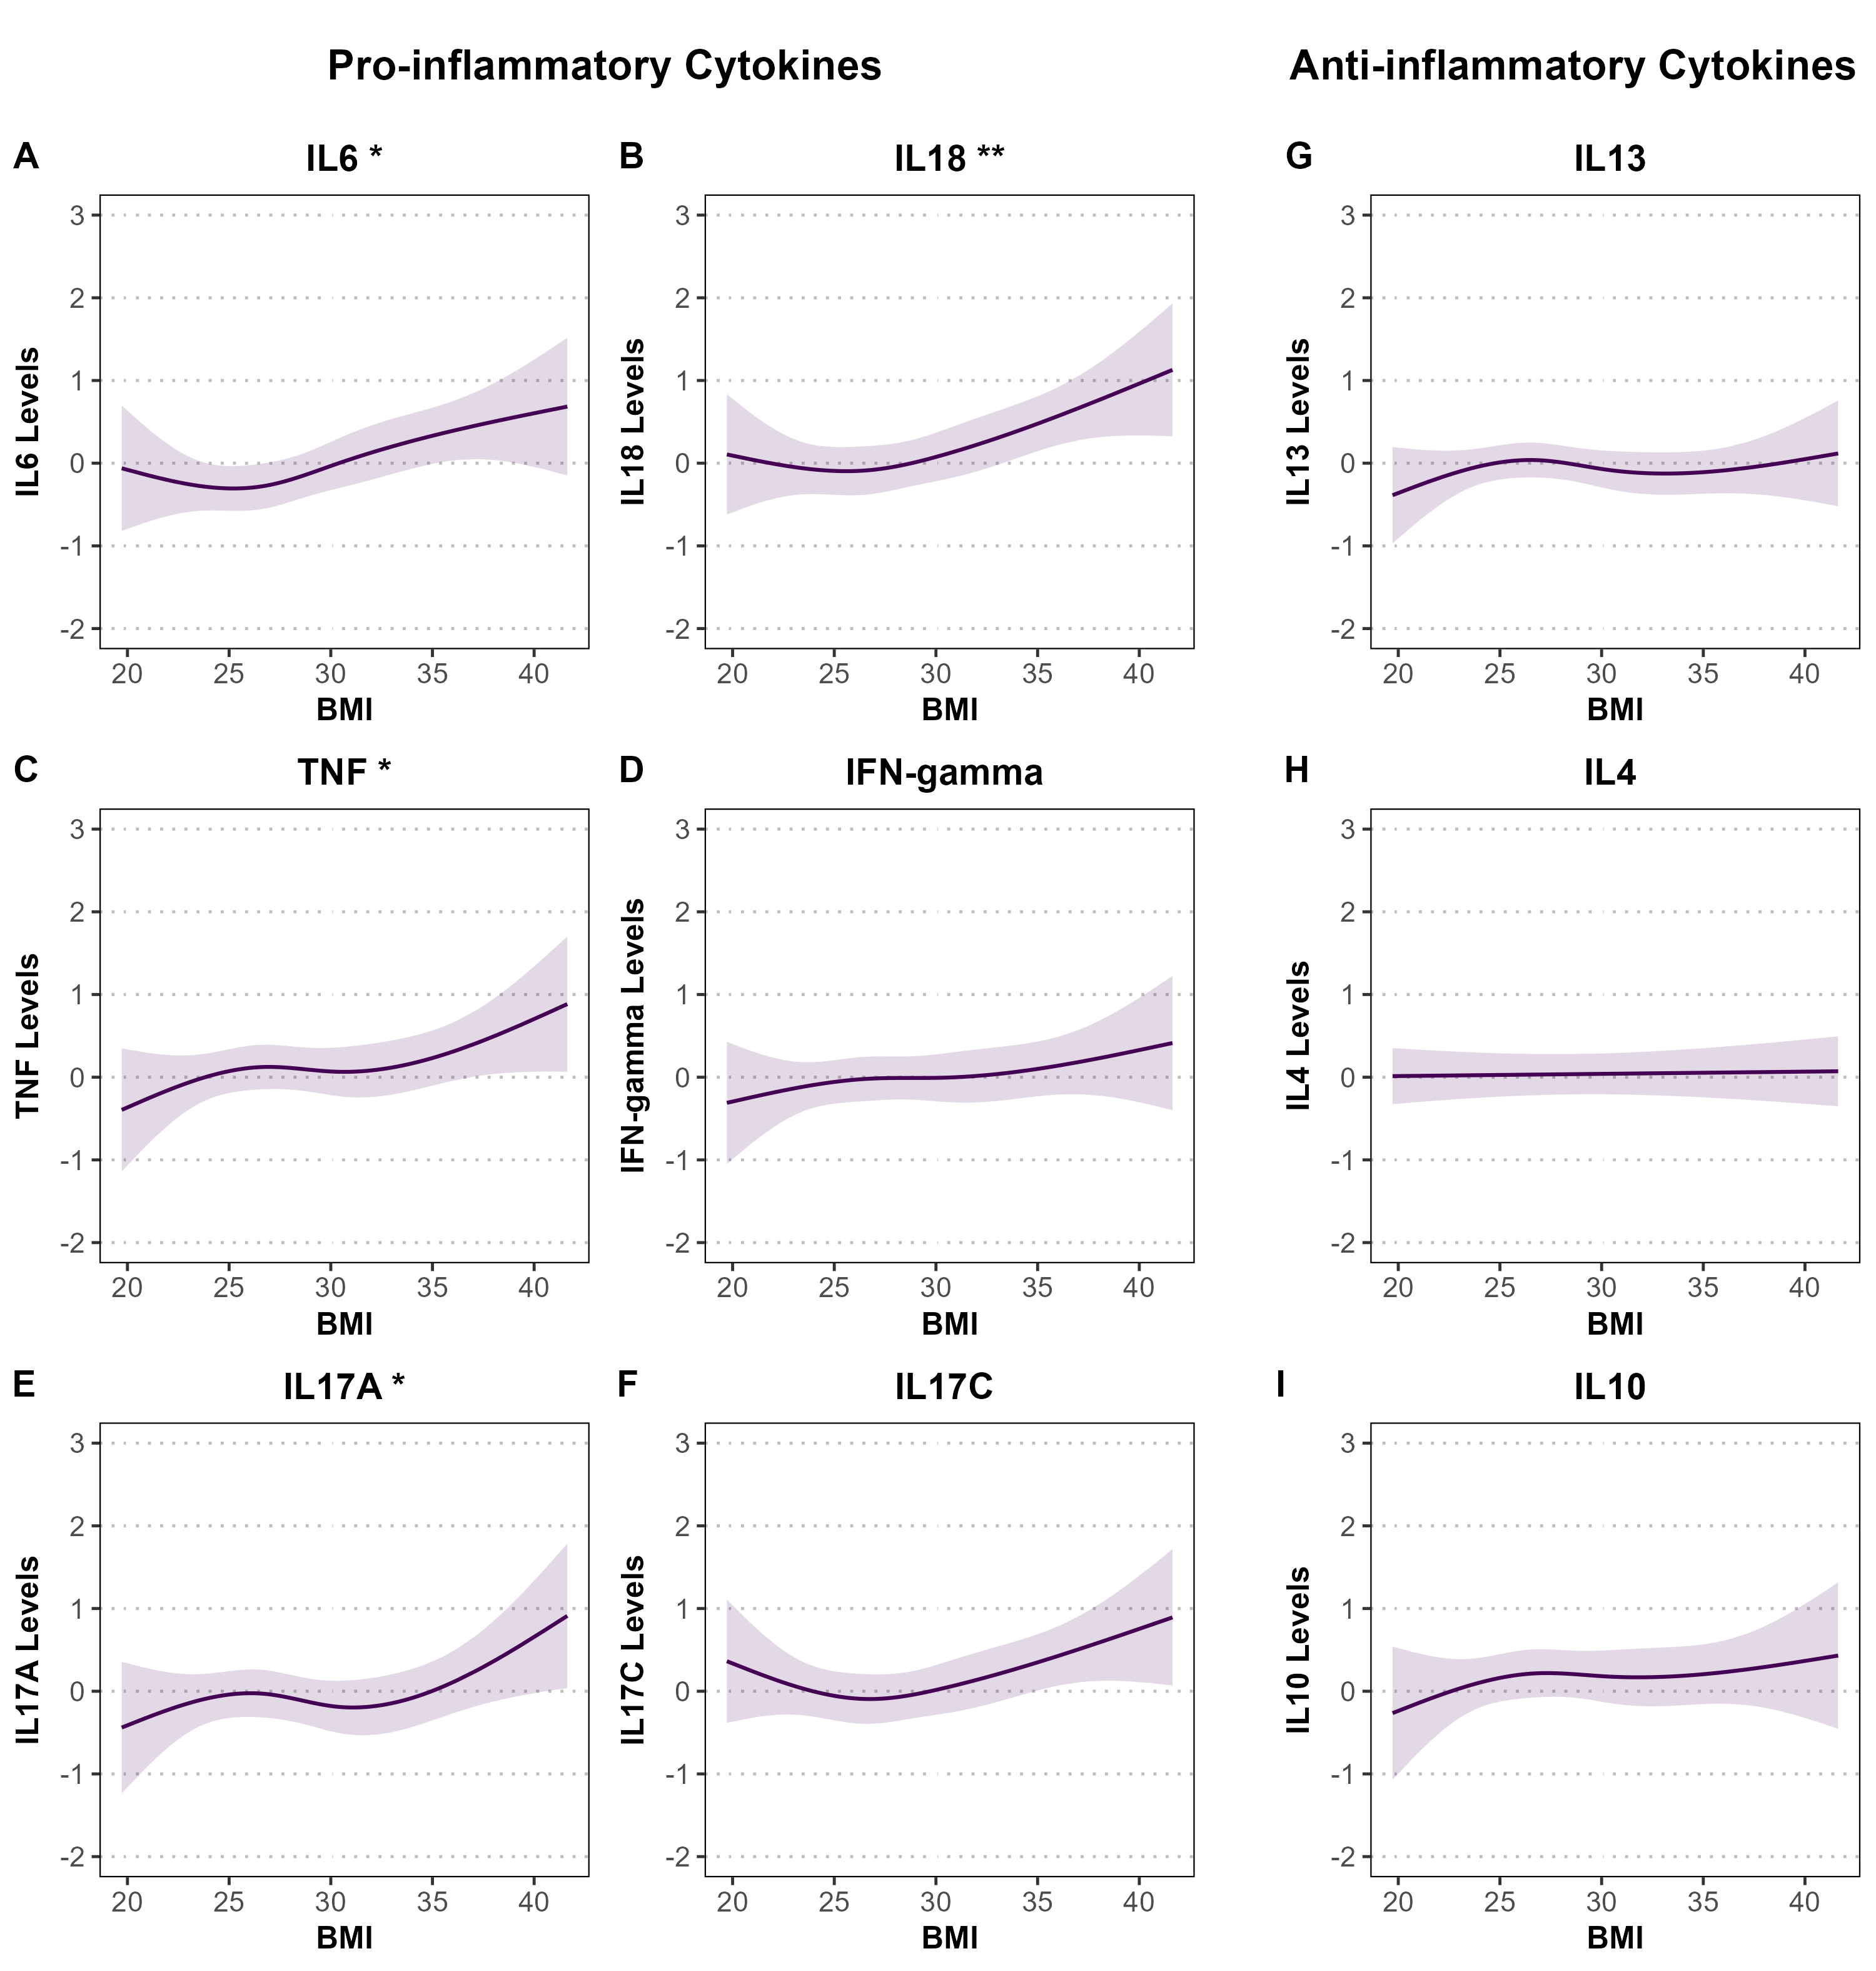
Supplementary Figure S7.1. Associations between BMI and standardized pro- and anti-inflammatory cytokine levels among male participants in the SHIP-TREND cohort. Panels A–F display pro-inflammatory cytokines (IL-6, IL-18, TNF, IFN-γ, IL-17A, IL-17C), and panels G–I show anti-inflammatory cytokines (IL-13, IL-4, IL-10). Associations were estimated using linear or spline-based regression models adjusted for age, smoking status, and alcohol consumption. Shaded areas represent 95% confidence intervals. Cytokine levels are standardized (mean = 0, SD = 1). For SHIP-TREND, y-axes are uniform across panels (range: -2 to 3) to facilitate comparability across continuous determinants. Note that this y-axis range does not match the scales used in the RS and PLUS cohorts due to their wider confidence intervals, which required broader y-axis limits. Statistical significance is denoted by asterisks (*P < 0.05; **P < 0.01; ***P < 0.001).
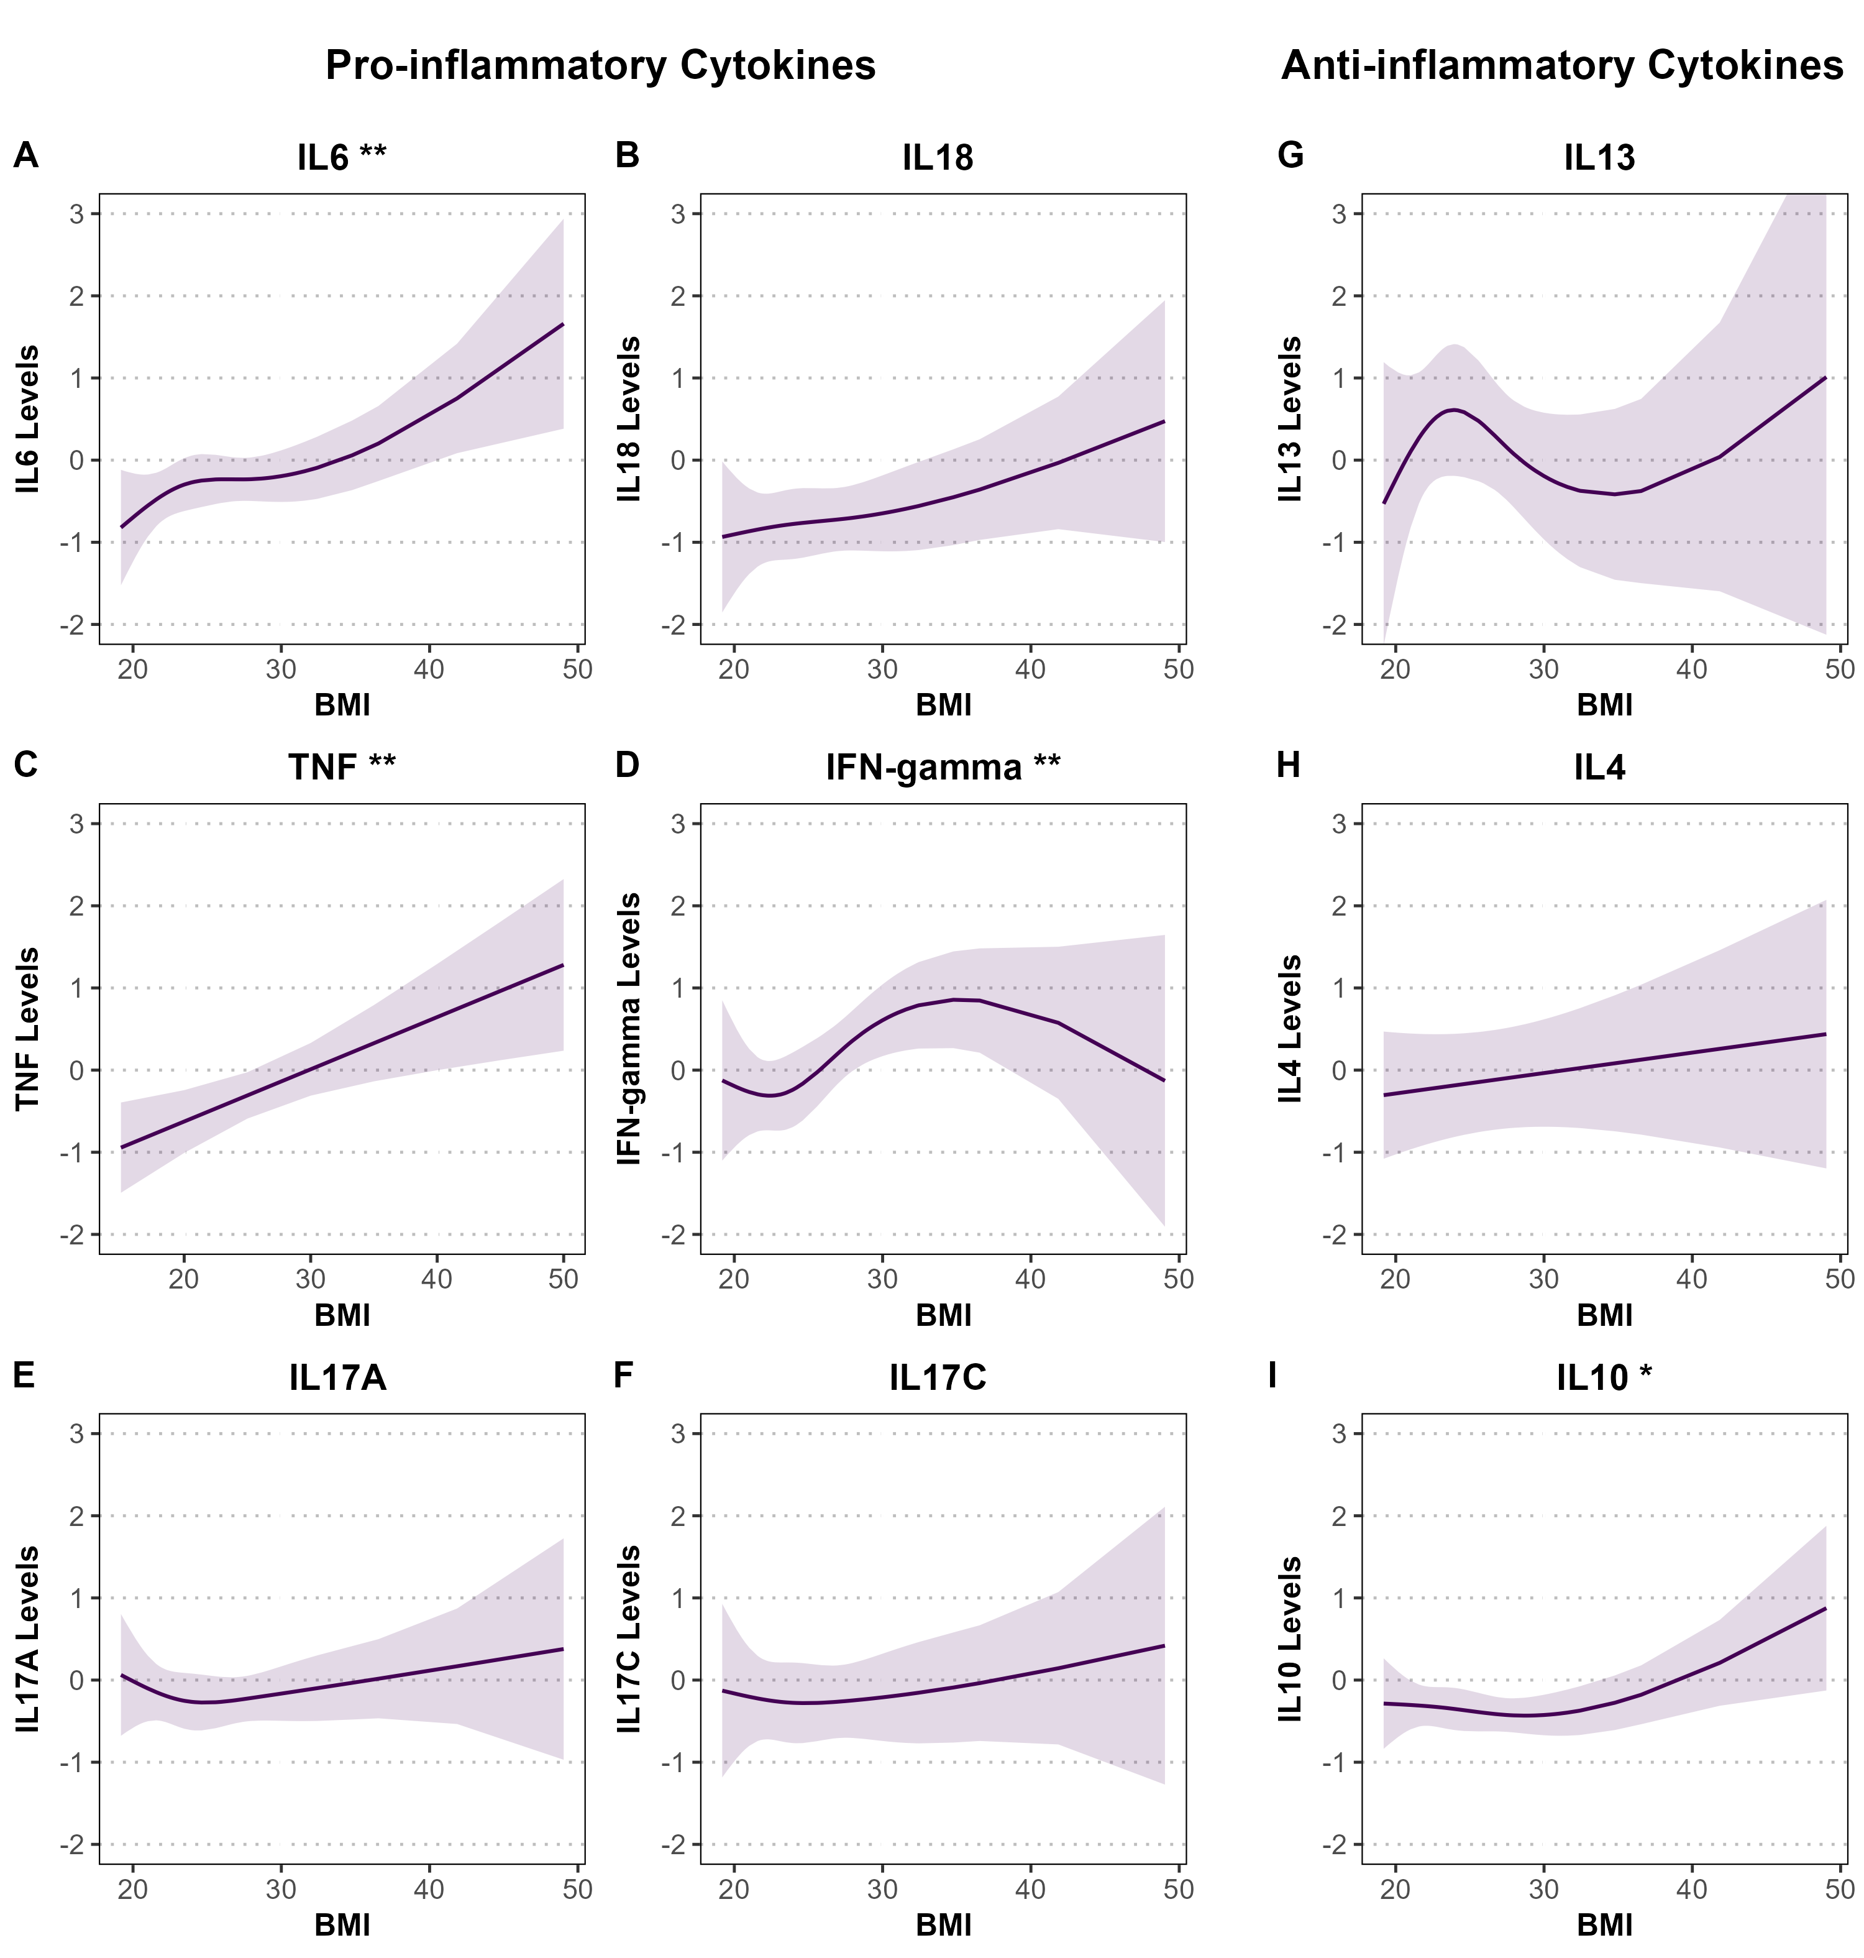
Supplementary Figure S7.2. Associations between BMI and standardized pro- and anti-inflammatory cytokine levels among female participants in the SHIP-TREND cohort. Panels A–F display pro-inflammatory cytokines (IL-6, IL-18, TNF, IFN-γ, IL-17A, IL-17C), and panels G–I show anti-inflammatory cytokines (IL-13, IL-4, IL-10). Associations were estimated using linear or spline-based regression models adjusted for age, smoking status, and alcohol consumption. Shaded areas represent 95% confidence intervals. Cytokine levels are standardized (mean = 0, SD = 1). For SHIP-TREND, y-axes are uniform across panels (range: -2 to 3) to facilitate comparability across continuous determinants. Note that this y-axis range does not match the scales used in the RS and PLUS cohorts due to their wider confidence intervals, which required broader y-axis limits. Statistical significance is denoted by asterisks (*P < 0.05; **P < 0.01; ***P < 0.001).

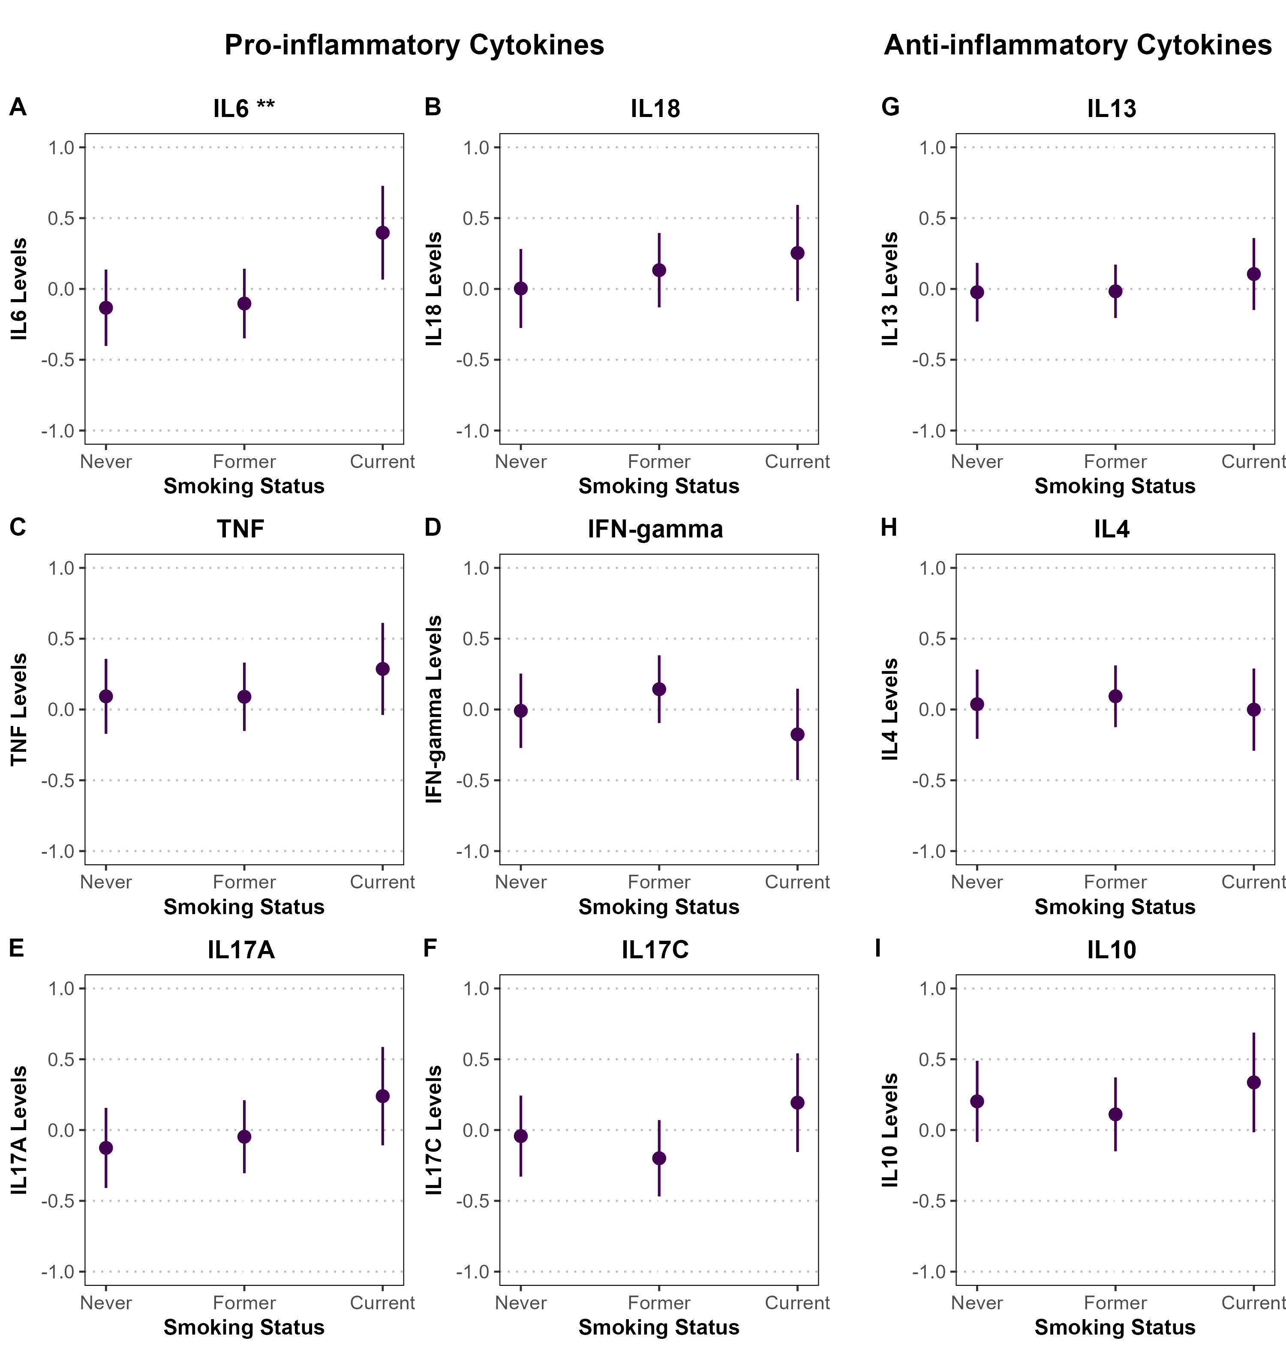
Supplementary Figure S8.1. Associations between smoking status and standardized pro- and anti-inflammatory cytokine levels among male participants in the SHIP-TREND cohort. Panels A–F display pro-inflammatory cytokines (IL-6, IL-18, TNF, IFN-γ, IL-17A, IL-17C), and panels G–I show anti-inflammatory cytokines (IL-13, IL-4, IL-10). Associations were estimated using linear or spline-based regression models adjusted for age, BMI, and alcohol consumption. Point estimates are shown with 95% confidence intervals represented as vertical error bars. Cytokine levels are standardized (mean = 0, SD = 1), and y-axes are fixed from -1 to 1 across all panels to account for wider confidence intervals in the sex-stratified analysis. Statistical significance is denoted by asterisks (*P < 0.05; **P < 0.01; ***P < 0.001).

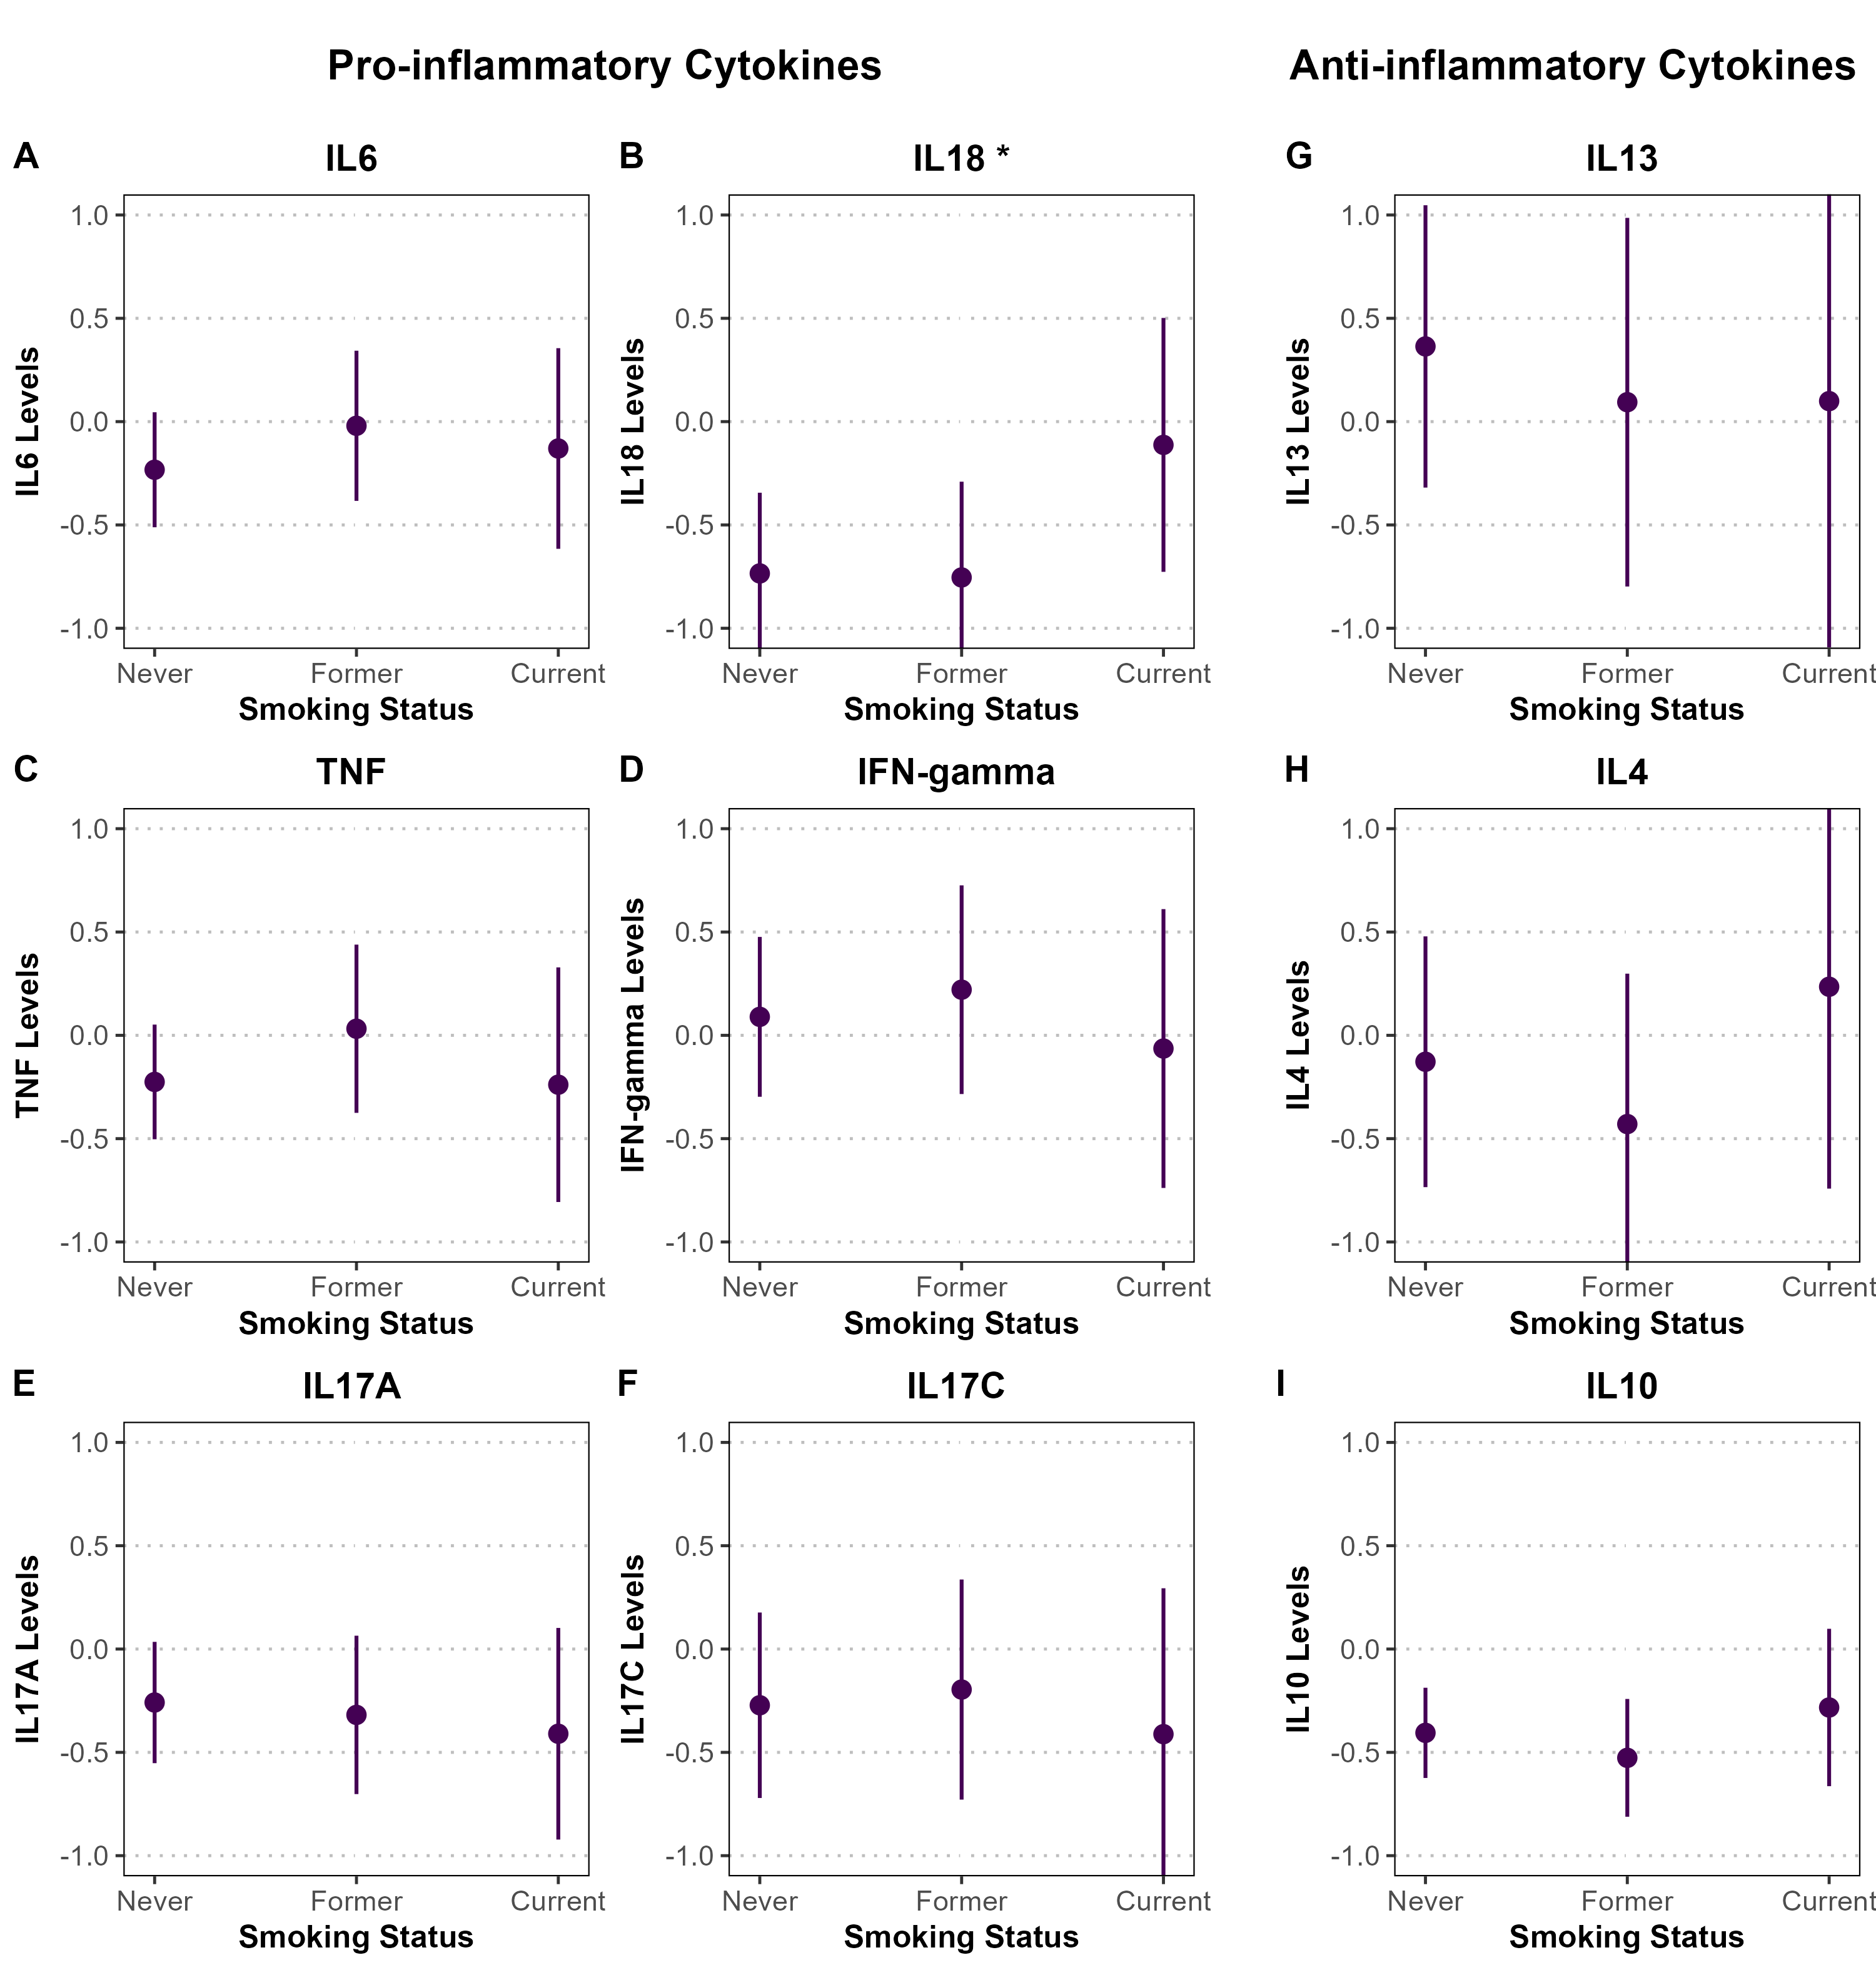
Supplementary Figure S8.2. Associations between smoking status and standardized pro- and anti-inflammatory cytokine levels among female participants in the SHIP-TREND cohort. Panels A–F display pro-inflammatory cytokines (IL-6, IL-18, TNF, IFN-γ, IL-17A, IL-17C), and panels G–I show anti-inflammatory cytokines (IL-13, IL-4, IL-10). Associations were estimated using linear or spline-based regression models adjusted for age, BMI, and alcohol consumption. Point estimates are shown with 95% confidence intervals represented as vertical error bars. Cytokine levels are standardized (mean = 0, SD = 1), and y-axes are fixed from -1 to 1 across all panels to account for wider confidence intervals in the sex-stratified analysis. Statistical significance is denoted by asterisks (*P < 0.05; **P < 0.01; ***P < 0.001).

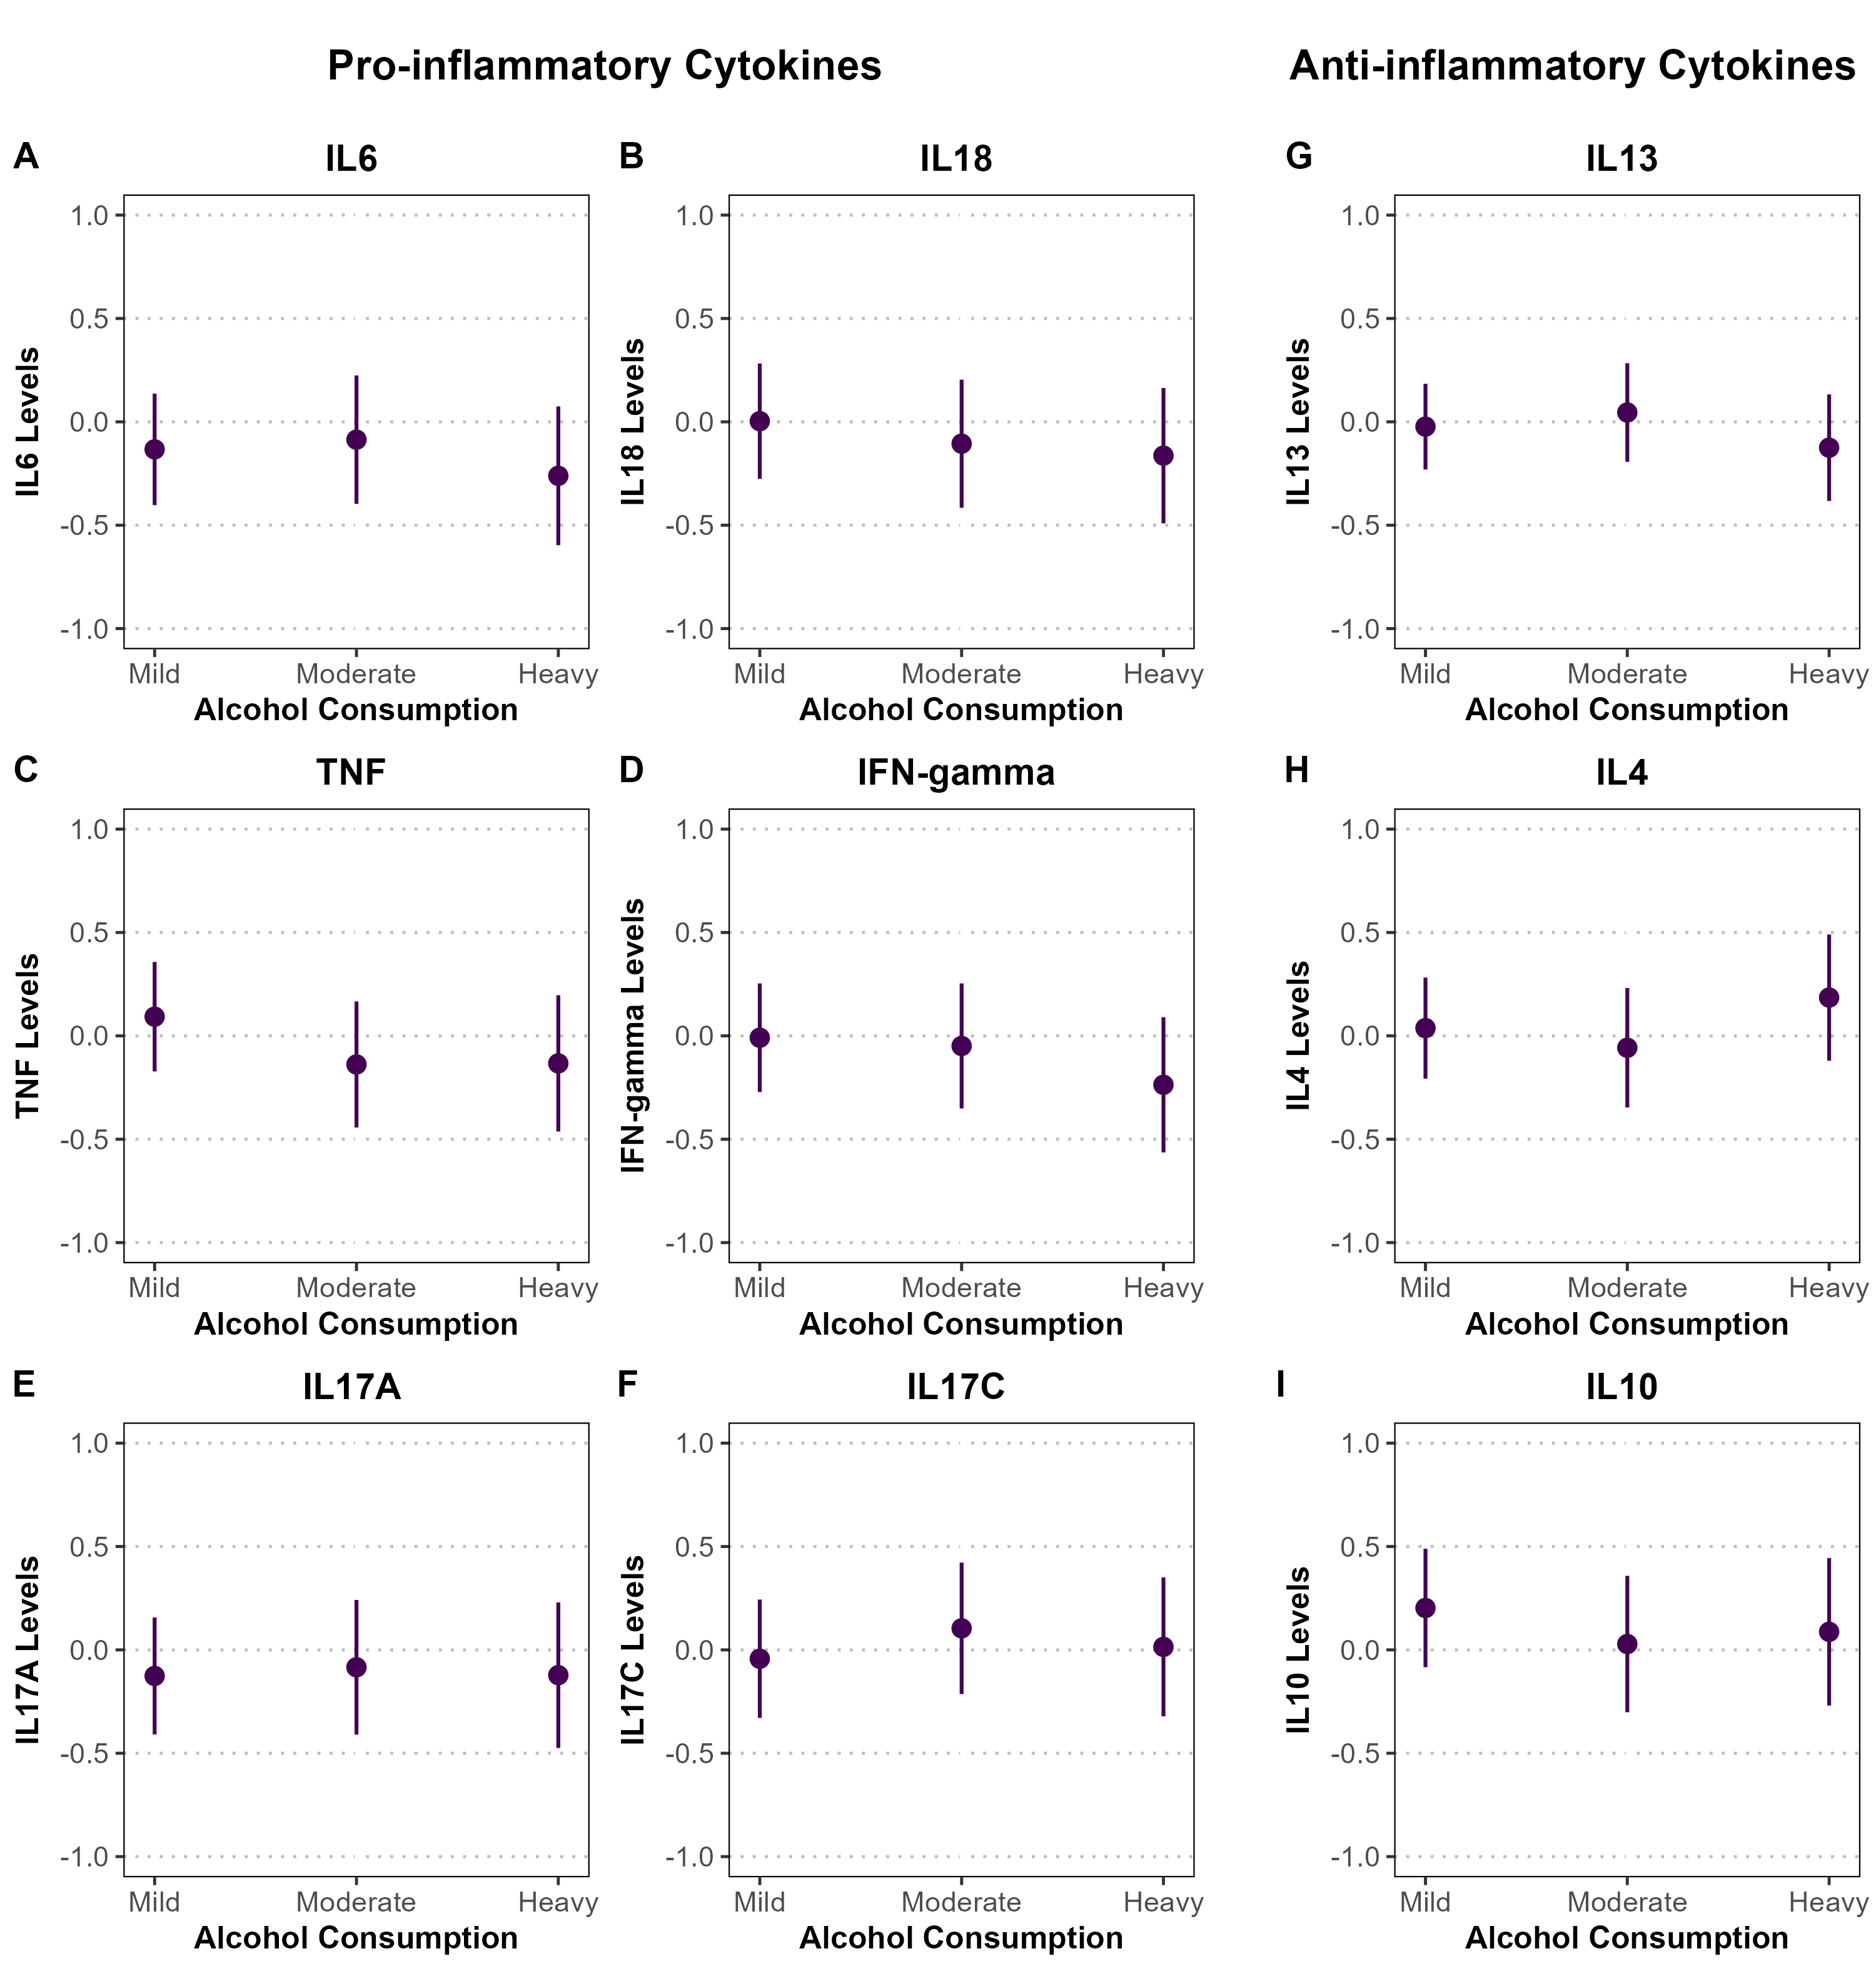
Supplementary Figure S9.1. Associations between alcohol consumption and standardized pro- and anti-inflammatory cytokine levels among male participants in the SHIP-TREND cohort. Panels A–F display pro-inflammatory cytokines (IL-6, IL-18, TNF, IFN-γ, IL-17A, IL-17C), and panels G–I show anti-inflammatory cytokines (IL-13, IL-4, IL-10). Associations were estimated using linear or spline-based regression models adjusted for age, BMI, and smoking status. Point estimates are shown with 95% confidence intervals represented as vertical error bars. Cytokine levels are standardized (mean = 0, SD = 1), and y-axes are fixed from -1 to 1 across all panels to reflect the wider confidence intervals in the sex-stratified analysis. Statistical significance is denoted by asterisks (*P < 0.05; **P < 0.01; ***P < 0.001).

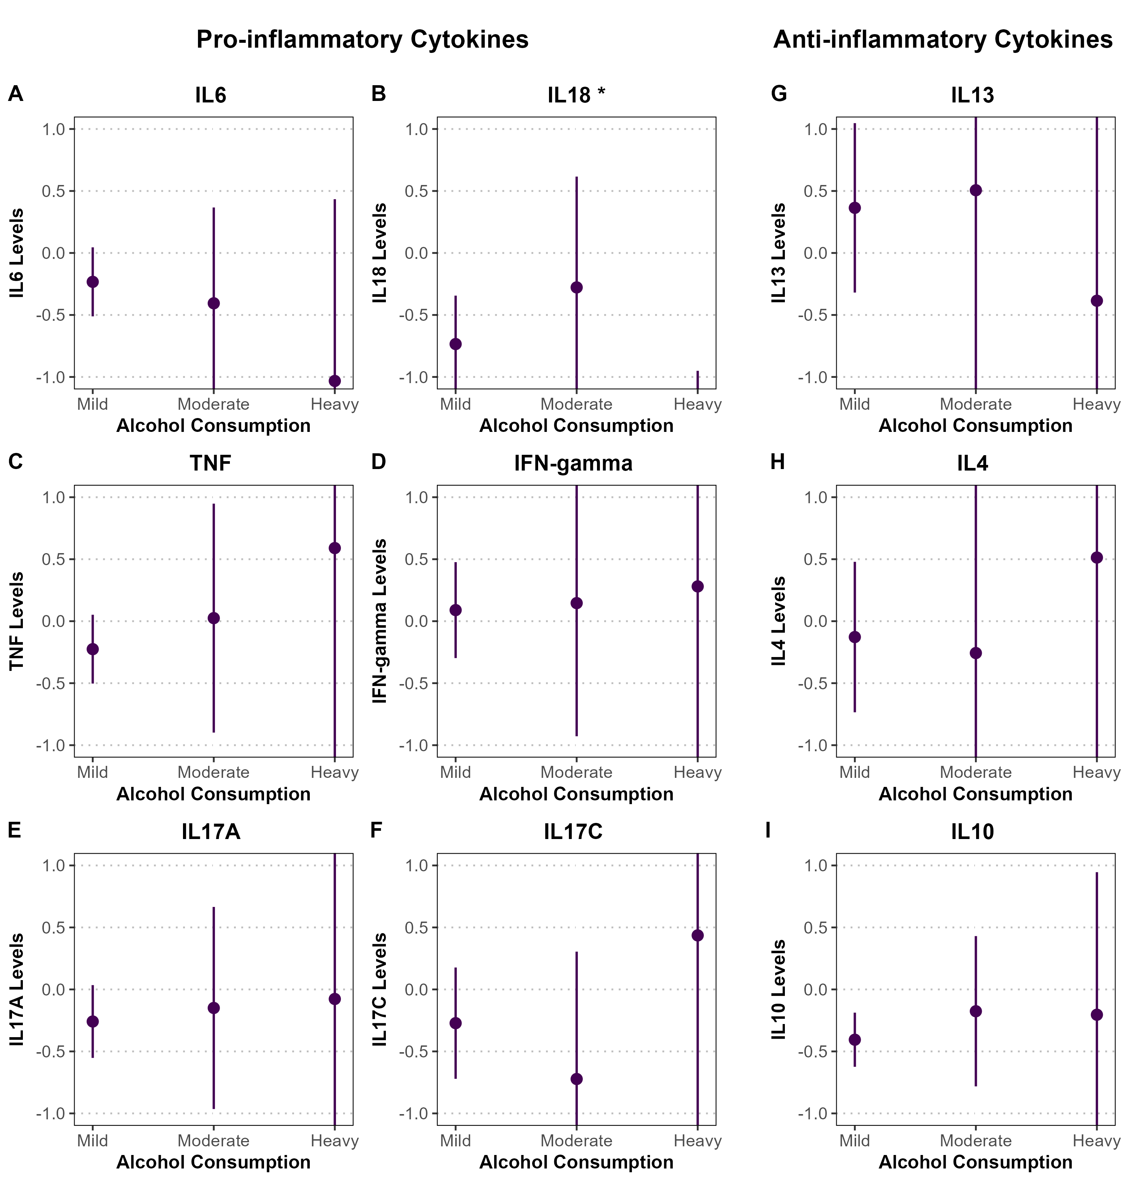
Supplementary Figure S9.2. Associations between alcohol consumption and standardized pro- and anti-inflammatory cytokine levels among female participants in the SHIP-TREND cohort. Panels A–F display pro-inflammatory cytokines (IL-6, IL-18, TNF, IFN-γ, IL-17A, IL-17C), and panels G–I show anti-inflammatory cytokines (IL-13, IL-4, IL-10). Associations were estimated using linear or spline-based regression models adjusted for age, BMI, and smoking status. Point estimates are shown with 95% confidence intervals represented as vertical error bars. Cytokine levels are standardized (mean = 0, SD = 1), and y-axes are fixed from -1 to 1 across all panels to reflect the wider confidence intervals in the sex-stratified analysis. Statistical significance is denoted by asterisks (*P < 0.05; **P < 0.01; ***P < 0.001).
*Note: Confidence intervals are very wide for female-stratified analysis for alcohol consumption, see Table S4.2 for point estimates.
Principal Component Analysis
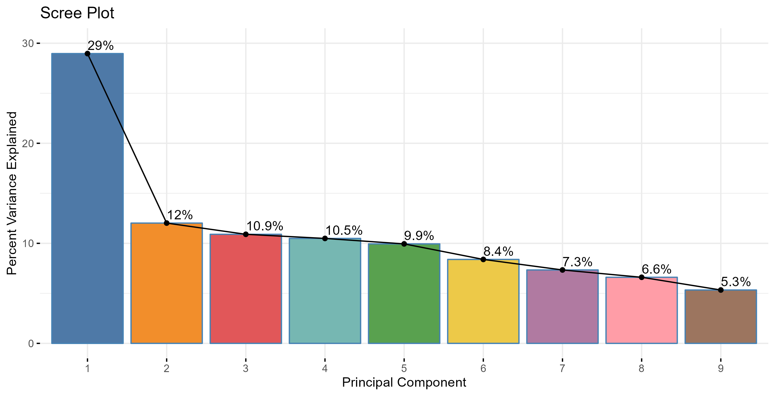
Supplementary Figure S10.1. Principal Component Analysis (PCA) of pro- and anti-inflammatory cytokine levels in SHIP-TREND cohort. The bar plot represents the percentage of variance explained by each principal component, with the first principal component capturing the largest proportion (29%). The line plot indicates the cumulative variance explained across components, illustrating the contribution of each component to the overall variability in cytokine expression.

Supplementary Figure S10.2. Principal Component Analysis (PCA) bi-plots showing the contribution of pro- and anti-inflammatory cytokines to different principal components in SHIP-TREND cohort. Each panel represents a pair of principal components (PC1 & PC2, PC3 & PC4, PC5 & PC6, and PC7 & PC8). The length and direction of the arrows indicate the influence of individual cytokines on the respective principal components, while the color scale represents their contribution magnitude. Cytokines with higher contributions are highlighted in warmer colors, indicating their stronger influence on variance in the dataset.

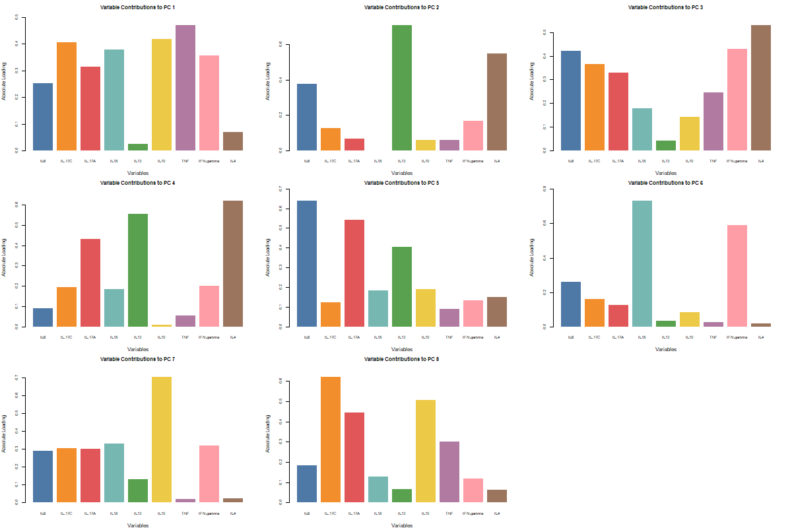
Supplementary Figure S10.3. Bar plots showing the variance contributions of individual cytokines to different principal components (PCs) from Principal Component Analysis (PCA) in SHIP-TREND cohort. Each plot represents a specific PC, with bars indicating the proportion of variance explained by each cytokine. Higher bars suggest stronger contributions to the respective PC, highlighting cytokines that drive variability in the dataset.

PC1 Model Results
term | estimate | std.error | statistic | p.value | conf.low | conf.high | Model
(Intercept) | -1.795 | 0.404 | -4.444 | 0.000 | -2.589 | -1.000 | Model 1
Age | 0.033 | 0.007 | 4.545 | 0.000 | 0.019 | 0.047 | Model 1
(Intercept) | -4.113 | 0.671 | -6.134 | 0.000 | -5.432 | -2.794 | Model 2
Age | 0.034 | 0.007 | 4.726 | 0.000 | 0.020 | 0.048 | Model 2
SexFemale | -0.600 | 0.223 | -2.691 | 0.007 | -1.038 | -0.161 | Model 2
SmokingFormer | 0.046 | 0.190 | 0.239 | 0.811 | -0.329 | 0.420 | Model 2
SmokingCurrent | 0.471 | 0.235 | 2.004 | 0.046 | 0.009 | 0.934 | Model 2
AlcoholModerate | -0.179 | 0.206 | -0.866 | 0.387 | -0.585 | 0.227 | Model 2
AlcoholHeavy | -0.343 | 0.236 | -1.455 | 0.146 | -0.807 | 0.121 | Model 2
BMI | 0.083 | 0.019 | 4.437 | 0.000 | 0.046 | 0.119 | Model 2
(Intercept) | -3.247 | 0.771 | -4.212 | 0.000 | -4.764 | -1.731 | Model 3
Age (Spline 1) | 0.975 | 0.398 | 2.449 | 0.015 | 0.192 | 1.759 | Model 3
Age (Spline 2) | 2.207 | 1.280 | 1.724 | 0.086 | -0.311 | 4.725 | Model 3
Age (Spline 3) | 1.820 | 0.504 | 3.613 | 0.000 | 0.829 | 2.810 | Model 3
SexFemale | -0.594 | 0.223 | -2.658 | 0.008 | -1.033 | -0.154 | Model 3
SmokingFormer | 0.048 | 0.191 | 0.249 | 0.803 | -0.328 | 0.423 | Model 3
SmokingCurrent | 0.473 | 0.236 | 2.007 | 0.046 | 0.009 | 0.937 | Model 3
AlcoholModerate | -0.168 | 0.207 | -0.808 | 0.419 | -0.575 | 0.240 | Model 3
AlcoholHeavy | -0.319 | 0.239 | -1.336 | 0.182 | -0.788 | 0.151 | Model 3
BMI | 0.084 | 0.019 | 4.482 | 0.000 | 0.047 | 0.121 | Model 3
Supplementary Table S5. Summary of regression models examining the association between age and the inflammaging axis (PC1) in SHIP cohort.
Model 1 includes age only (PC1 ~ age). Model 2 additionally adjusts for sex, smoking status, alcohol consumption, and body mass index (PC1 ~ age + covariates). Model 3 models age non-linearly using natural cubic splines (3 degrees of freedom) while adjusting for the same covariates. Reported metrics include estimates, standard errors, test statistics, p-values, and 95% confidence intervals.
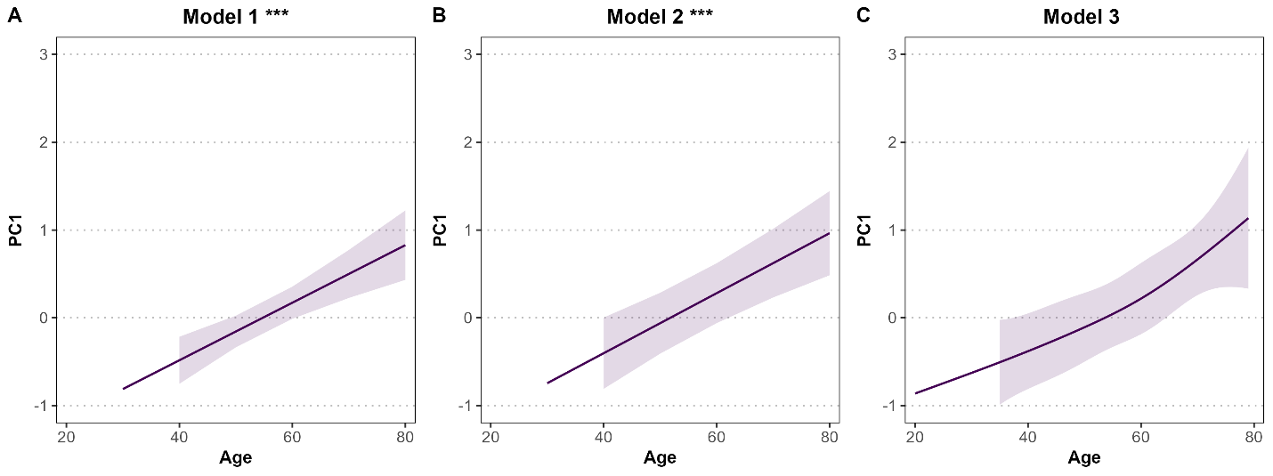
Supplementary Figure S11. Age-related changes in the inflammaging axis (PC1) in SHIP cohort.
Predicted values of the first principal component (PC1), representing a composite inflammaging cytokine axis, are shown as a function of age. Panel A (Model 1) shows the association between age and PC1 without covariate adjustment and is included as a sensitivity analysis. Panel B (Model 2) shows the age–PC1 association adjusted for sex, smoking status, alcohol consumption, and body mass index and is also included as a sensitivity analysis. Panel C (Model 3), the primary analysis, models age non-linearly using natural cubic splines (3 degrees of freedom) while adjusting for the same covariates. Solid lines indicate model-predicted values and shaded areas represent 95% confidence intervals. Asterisks denote statistical significance of the age effect (p < 0.05; p < 0.01; p < 0.001).

Absolute IL6 Analysis

 | Male | Female | Overall
 | (N=2115) | (N=2192) | (N=4307)
Age
Mean (SD) | 51 (17) | 49 (16) | 50 (16)
Median [Min, Max] | 52 [20, 81] | 49 [20, 81] | 50 [20, 81]
Smoking
Never | 442 (20.9%) | 1094 (49.9%) | 1536 (35.7%)
Former | 952 (45.0%) | 501 (22.9%) | 1453 (33.7%)
Current | 710 (33.6%) | 589 (26.9%) | 1299 (30.2%)
Missing | 11 (0.5%) | 8 (0.4%) | 19 (0.4%)
Alcohol
Mild | 932 (44.1%) | 1656 (75.5%) | 2588 (60.1%)
Moderate | 410 (19.4%) | 268 (12.2%) | 678 (15.7%)
Heavy | 607 (28.7%) | 119 (5.4%) | 726 (16.9%)
Missing | 166 (7.8%) | 149 (6.8%) | 315 (7.3%)
BMI
Mean (SD) | 28 (4.0) | 27 (5.3) | 27 (4.8)
Median [Min, Max] | 27 [18, 48] | 26 [16, 58] | 27 [16, 58]
Missing | 5 (0.2%) | 5 (0.2%) | 10 (0.2%)
IL-6
Mean (SD) | 2.9 (3.2) | 2.8 (4.1) | 2.9 (3.7)
Median [Min, Max] | 2.0 [2.0, 67] | 2.0 [2.0, 150] | 2.0 [2.0, 150]
Missing | 76 (3.6%) | 92 (4.2%) | 168 (3.9%)
Supplementary Table S6. Baseline characteristics of SHIP-START participants, stratified by sex. Variables include demographic and lifestyle factors (age, smoking status, alcohol consumption, BMI, and sex), as well as absolute IL-6 (pg/mL). For continuous variables, means, standard deviations, medians, and ranges are presented; for categorical variables, frequencies and percentages are shown. Missing IL-6 data are indicated and were excluded from respective models in the final analysis.

Term | Estimate | Std. error | Statistic | p.value
Intercept | 0.396 | 0.044 | 9.051 | < 2e-16
SexMale | 0.046 | 0.014 | -3.183 | 0.001
Age | 0.005 | 4e-4 | 11.891 | 2e-16
BMI | 0.009 | 0.001 | 6.555 | 6.32e-11
Smoking Former | -0.006 | 0.016 | -0.394 | 0.694
SmokingCurrent | 0.071 | 0.017 | 4.223 | 2.46e-05
AlcoholModerate | -0.051 | 0.018 | -2.887 | 0.004
AlcoholHeavy | -0.016 | 0.018 | -0.884 | 0.377
Supplementary Table S7. Linear regression results for log-transformed IL-6 levels (pg/mL) in the SHIP-START cohort (Sensitivity Model). The model includes sex, age, BMI, smoking status, and alcohol consumption as predictors. IL-6 levels were log-transformed to approximate normality. Reported are the regression coefficients (estimates), standard errors, test statistics, p-values, and 95% confidence intervals (conf.low, conf.high). Sex is coded as male vs. female; smoking status and alcohol consumption are categorized relative to never smokers and mild drinkers, respectively.

IL6 Model Results
term | estimate | std.error | statistic | p.value | conf.low | conf.high
Intercept | 0.589 | 0.287 | 2.050 | 0.040 | 0.026 | 1.152
SexMale | 0.223 | 0.101 | 2.197 | 0.028 | 0.024 | 0.422
Age | 0.023 | 0.003 | 7.572 | 0.000 | 0.017 | 0.029
BMI | 0.034 | 0.010 | 3.408 | 0.001 | 0.014 | 0.054
SmokingCurrent | 0.306 | 0.118 | 2.595 | 0.010 | 0.075 | 0.538
SmokingFormer | -0.049 | 0.113 | -0.431 | 0.667 | -0.271 | 0.173
AlcoholHeavy | -0.056 | 0.129 | -0.430 | 0.667 | -0.309 | 0.198
AlcoholModerate | -0.311 | 0.126 | -2.474 | 0.013 | -0.557 | -0.064
Supplementary Table S8. Linear regression results for Raw IL-6 levels (pg/mL) in the SHIP-START cohort (Main Model). The model includes sex, age, BMI, smoking status, and alcohol consumption as predictors. IL-6 levels were not log-transformed for clinical interpretation. Reported are the regression coefficients (estimates), standard errors, test statistics, p-values, and 95% confidence intervals (conf.low, conf.high). Sex is coded as male vs. female; smoking status and alcohol consumption are categorized relative to never smokers and mild drinkers, respectively.

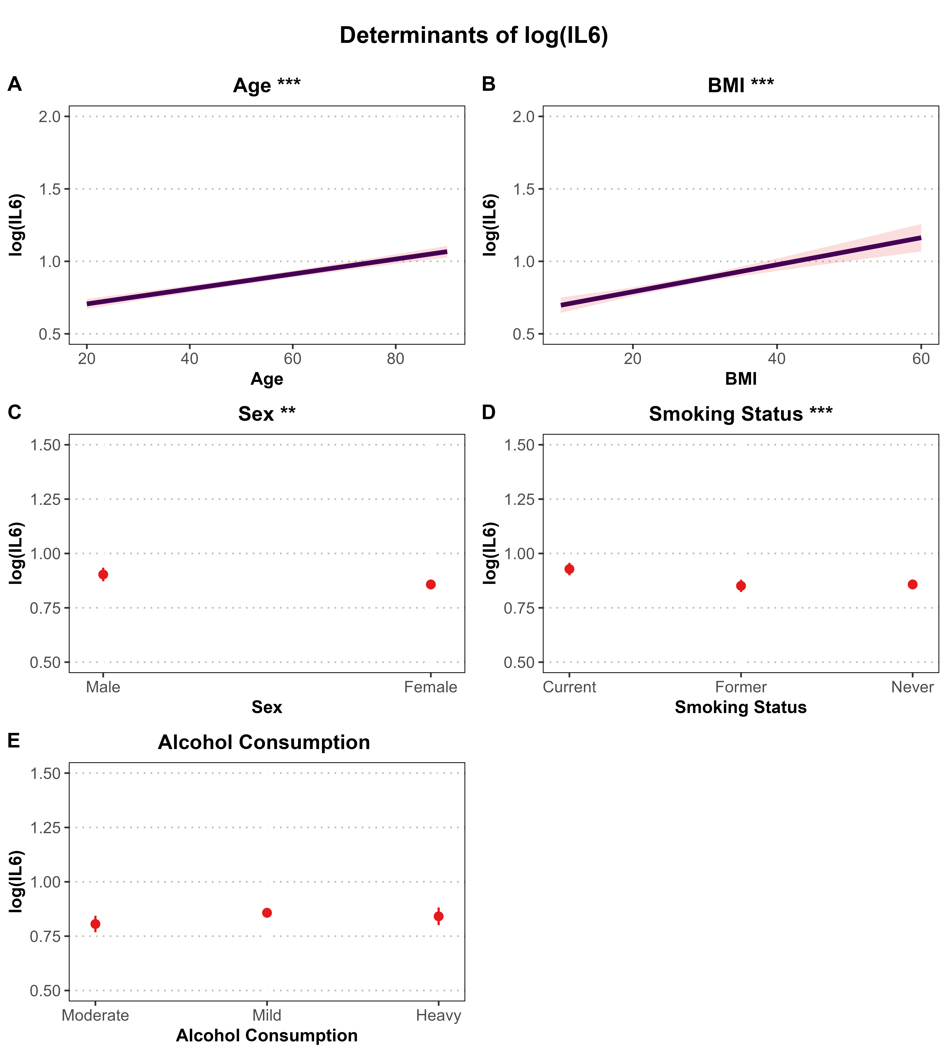
Supplementary Figure S12. Determinants of log-transformed IL-6 levels (pg/mL) in the SHIP-START cohort (Sensitivity Model). Associations are based on a multivariable linear regression model adjusted for age, sex, BMI, smoking status, and alcohol consumption. Panels A and B show continuous predictors (age and BMI) with regression lines and 95% confidence intervals (shaded areas). Panels C–E present categorical predictors (sex, smoking status, and alcohol consumption) with point estimates and 95% confidence intervals (vertical error bars). Y-axis ranges are scaled to match the PLUS IL-6 analysis: 0.5–2.0 for continuous variables (A–B) to reflect greater variability, and 0.5–1.5 for categorical variables (C–E) to enhance comparability. IL-6 levels were log-transformed prior to analysis. Asterisks indicate statistical significance (*P < 0.05; **P < 0.01).

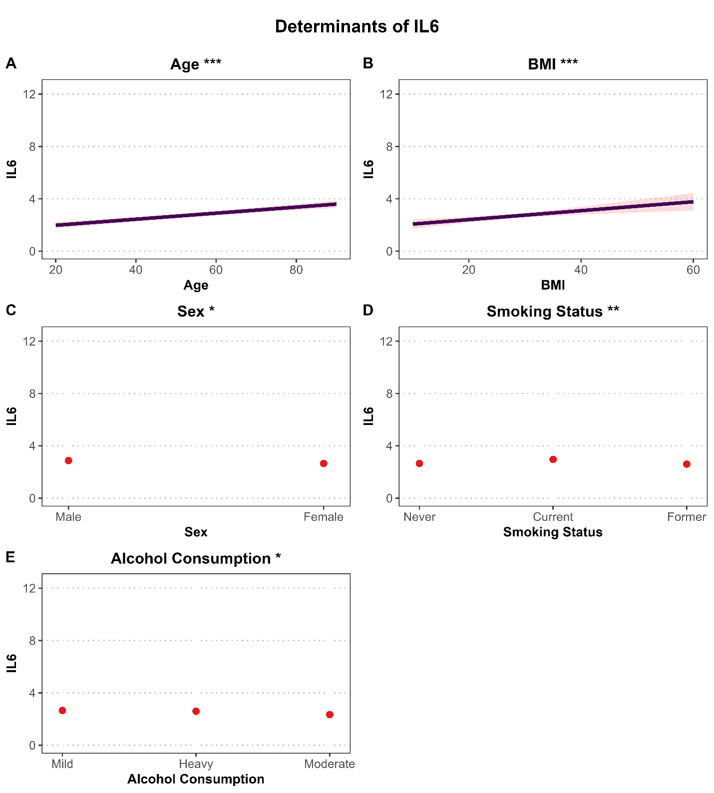
Supplementary Figure S13. Determinants of Raw IL-6 levels (pg/mL) in the SHIP-START cohort (Main Model). Associations are based on a multivariable linear regression model adjusted for age, sex, BMI, smoking status, and alcohol consumption. Panels A and B show continuous predictors (age and BMI) with regression lines and 95% confidence intervals (shaded areas). Panels C–E present categorical predictors (sex, smoking status, and alcohol consumption) with point estimates and 95% confidence intervals (vertical error bars). Y-axis ranges are scaled to match the PLUS IL-6 analysis: 0.0–12.0 for variables (A–E) to enhance comparability. IL-6 levels were not log-transformed prior to analysis to improve clinical interpretation. Asterisks indicate statistical significance (*P < 0.05; **P < 0.01).

