Additional File 3: Bialystok PLUS
Cytokine Assay Characteristics
Main Analysis
Sex Stratified Analysis
Principal Component Analysis
Absolute IL6 Analysis

Cytokine Assay Characteristics

Assay | Uniprot ID | Olink ID | Panel | LOD | Missing Data Frequency
IL6 | P05231 | OID00482 | Olink Target 96 Inflammation(v.3023) | 1.06316 | 2.4%
IL-17C | Q9P0M4 | OID00483 | Olink Target 96 Inflammation(v.3023) | 1.27953 | 0.5%
IL-17A | Q16552 | OID00485 | Olink Target 96 Inflammation(v.3023) | 1.44246 | 8.6%
IL-18 | Q14116 | OID00501 | Olink Target 96 Inflammation(v.3023) | 1.15324 | 0.3%
IL-13 | P35225 | OID00525 | Olink Target 96 Inflammation(v.3023) | 1.345 | 86.9%
IL-10 | P22301 | OID00528 | Olink Target 96 Inflammation(v.3023) | 1.80217 | 0.4%
IL-4 | P05112 | OID00546 | Olink Target 96 Inflammation(v.3023) | 0.71223 | 78.1%
IFN-gamma | P01579 | OID05547 | Olink Target 96 Inflammation(v.3023) | 4.0878 | 0.3%
TNF | P01375 | OID05548 | Olink Target 96 Inflammation(v.3023) | -0.00049 | 0.3%
Supplementary Table S1. Summary of cytokine assay characteristics for the Bialystok PLUS cohort.
Table includes UniProt IDs, Olink assay identifiers, limits of detection (LOD), and the proportion of missing data based on values below the detection threshold. High frequencies of missing data are noted for IL-13 and IL-4, reflecting widespread non-detectable levels for these markers. However, these values do not fall below LOD according to 90% cutoff criterion.

Main Analysis

 | Male | Female | Overall
 | (N=329) | (N=413) | (N=742)
Age
Mean (SD) | 47 (15) | 50 (15) | 49 (15)
Median [Min, Max] | 45 [20, 78] | 50 [20, 79] | 47 [20, 79]
Smoking
Never | 114 (34.7%) | 192 (46.5%) | 306 (41.2%)
Former | 130 (39.5%) | 148 (35.8%) | 278 (37.5%)
Current | 85 (25.8%) | 73 (17.7%) | 158 (21.3%)
Alcohol
Mild | 168 (51.1%) | 330 (79.9%) | 498 (67.1%)
Moderate | 72 (21.9%) | 64 (15.5%) | 136 (18.3%)
Heavy | 89 (27.1%) | 19 (4.6%) | 108 (14.6%)
BMI
Mean (SD) | 28 (4.3) | 26 (5.2) | 27 (4.9)
Median [Min, Max] | 27 [18, 42] | 25 [17, 47] | 26 [17, 47]
IL-4
Mean (SD) | -0.078 (0.95) | 0.062 (1.0) | 0.00 (1.0)
Median [Min, Max] | -0.19 [-2.1, 6.8] | -0.055 [-2.1, 10] | -0.12 [-2.1, 10]
IL-13
Mean (SD) | -0.0051 (0.96) | 0.0041 (1.0) | 0.00 (1.0)
Median [Min, Max] | -0.24 [-1.1, 7.9] | -0.24 [-1.3, 7.8] | -0.24 [-1.3, 7.9]
IL-10
Mean (SD) | 0.025 (0.75) | -0.020 (1.2) | 0.00 (1.0)
Median [Min, Max] | -0.069 [-2.5, 3.0] | -0.17 [-3.9, 8.8] | -0.11 [-3.9, 8.8]
IL-6
Mean (SD) | 0.014 (0.90) | -0.011 (1.1) | 0.00 (1.0)
Median [Min, Max] | -0.14 [-1.8, 7.1] | -0.17 [-2.0, 5.9] | -0.16 [-2.0, 7.1]
TNF
Mean (SD) | -0.010 (0.77) | 0.0081 (1.2) | 0.00 (1.0)
Median [Min, Max] | -0.066 [-2.2, 3.1] | -0.048 [-4.9, 9.3] | -0.058 [-4.9, 9.3]
IL-18
Mean (SD) | 0.27 (0.97) | -0.22 (0.97) | 0.00 (1.0)
Median [Min, Max] | 0.25 [-2.9, 3.3] | -0.24 [-4.7, 4.6] | 0.0084 [-4.7, 4.6]
IFN-γ
Mean (SD) | -0.052 (0.93) | 0.041 (1.0) | 0.00 (1.0)
Median [Min, Max] | -0.15 [-2.4, 3.9] | -0.10 [-2.9, 6.9] | -0.12 [-2.9, 6.9]
IL-17A
Mean (SD) | -0.079 (0.88) | 0.062 (1.1) | 0.00 (1.0)
Median [Min, Max] | -0.24 [-1.8, 5.1] | -0.13 [-2.1, 7.5] | -0.17 [-2.1, 7.5]
Missing | 4 (1.2%) | 1 (0.2%) | 5 (0.7%)
IL-17C
Mean (SD) | 0.11 (0.91) | -0.090 (1.1) | 0.00 (1.0)
Median [Min, Max] | 0.0057 [-2.2, 2.8] | -0.19 [-2.8, 6.7] | -0.12 [-2.8, 6.7]
Supplementary Table S2. Baseline characteristics of Bialystok PLUS participants, stratified by sex. Variables include demographic and lifestyle factors (age, smoking status, alcohol consumption, BMI, and sex), as well as cytokine levels. Pro-inflammatory cytokines: IL-6, IL-18, TNF, IFN-γ, IL-17A, IL-17C; anti-inflammatory cytokines: IL-4, IL-13, IL-10. For continuous variables, means, standard deviations, medians, and ranges are presented; for categorical variables, frequencies and percentages are shown. Missing cytokine data are indicated and were excluded from respective models in the final analysis.

Cytokine Model Results
term | estimate | std.error | statistic | p.value | conf.low | conf.high | Model
(Intercept) | -0.078 | 0.248 | -0.315 | 0.753 | -0.565 | 0.409 | IL13
age | -0.004 | 0.003 | -1.437 | 0.151 | -0.009 | 0.001 | IL13
sexFemale | 0.018 | 0.082 | 0.218 | 0.827 | -0.142 | 0.178 | IL13
alcohol_consumptionModerate | -0.038 | 0.101 | -0.373 | 0.709 | -0.237 | 0.161 | IL13
alcohol_consumptionHeavy | -0.132 | 0.118 | -1.113 | 0.266 | -0.364 | 0.101 | IL13
smokingFormer | 0.017 | 0.086 | 0.201 | 0.841 | -0.152 | 0.186 | IL13
smokingCurrent | 0.061 | 0.101 | 0.598 | 0.550 | -0.139 | 0.260 | IL13
BMI (Spline 1) | 0.153 | 0.201 | 0.760 | 0.447 | -0.242 | 0.549 | IL13
BMI (Spline 2) | 0.765 | 0.517 | 1.479 | 0.140 | -0.251 | 1.780 | IL13
BMI (Spline 3) | 0.591 | 0.454 | 1.301 | 0.194 | -0.301 | 1.483 | IL13
(Intercept) | -0.203 | 0.247 | -0.821 | 0.412 | -0.687 | 0.282 | IL4
age | -0.002 | 0.003 | -0.664 | 0.507 | -0.007 | 0.003 | IL4
sexFemale | 0.202 | 0.081 | 2.494 | 0.013 | 0.043 | 0.362 | IL4
smokingFormer | 0.007 | 0.086 | 0.084 | 0.933 | -0.161 | 0.175 | IL4
smokingCurrent | 0.181 | 0.101 | 1.796 | 0.073 | -0.017 | 0.379 | IL4
alcohol_consumptionModerate | 0.056 | 0.101 | 0.552 | 0.581 | -0.142 | 0.253 | IL4
alcohol_consumptionHeavy | 0.061 | 0.118 | 0.516 | 0.606 | -0.170 | 0.291 | IL4
BMI (Spline 1) | 0.331 | 0.200 | 1.652 | 0.099 | -0.062 | 0.725 | IL4
BMI (Spline 2) | 0.268 | 0.514 | 0.522 | 0.602 | -0.741 | 1.278 | IL4
BMI (Spline 3) | 0.214 | 0.452 | 0.474 | 0.635 | -0.673 | 1.102 | IL4
(Intercept) | 0.255 | 0.245 | 1.039 | 0.299 | -0.227 | 0.737 | IL10
age | 0.007 | 0.003 | 2.458 | 0.014 | 0.001 | 0.012 | IL10
sexFemale | -0.101 | 0.081 | -1.255 | 0.210 | -0.260 | 0.057 | IL10
smokingFormer | -0.100 | 0.085 | -1.176 | 0.240 | -0.267 | 0.067 | IL10
smokingCurrent | 0.138 | 0.100 | 1.374 | 0.170 | -0.059 | 0.335 | IL10
alcohol_consumptionModerate | -0.013 | 0.100 | -0.125 | 0.901 | -0.209 | 0.184 | IL10
alcohol_consumptionHeavy | 0.049 | 0.117 | 0.419 | 0.675 | -0.181 | 0.279 | IL10
BMI (Spline 1) | -0.363 | 0.199 | -1.818 | 0.069 | -0.754 | 0.029 | IL10
BMI (Spline 2) | -0.815 | 0.512 | -1.592 | 0.112 | -1.819 | 0.190 | IL10
BMI (Spline 3) | 0.300 | 0.450 | 0.667 | 0.505 | -0.583 | 1.183 | IL10
(Intercept) | -1.081 | 0.225 | -4.804 | 0.000 | -1.523 | -0.639 | IL6
age | 0.014 | 0.002 | 5.837 | 0.000 | 0.009 | 0.019 | IL6
sexFemale | 0.006 | 0.074 | 0.084 | 0.933 | -0.139 | 0.152 | IL6
smokingFormer | -0.025 | 0.078 | -0.318 | 0.750 | -0.178 | 0.128 | IL6
smokingCurrent | 0.289 | 0.092 | 3.141 | 0.002 | 0.108 | 0.470 | IL6
alcohol_consumptionModerate | -0.025 | 0.092 | -0.267 | 0.789 | -0.205 | 0.156 | IL6
alcohol_consumptionHeavy | -0.001 | 0.107 | -0.008 | 0.994 | -0.211 | 0.210 | IL6
BMI (Spline 1) | 0.601 | 0.183 | 3.286 | 0.001 | 0.242 | 0.960 | IL6
BMI (Spline 2) | 1.482 | 0.469 | 3.157 | 0.002 | 0.560 | 2.403 | IL6
BMI (Spline 3) | 2.020 | 0.412 | 4.898 | 0.000 | 1.210 | 2.830 | IL6
(Intercept) | -0.665 | 0.255 | -2.608 | 0.009 | -1.166 | -0.165 | IL18
Age (Spline 1) | 0.579 | 0.154 | 3.753 | 0.000 | 0.276 | 0.881 | IL18
Age (Spline 2) | 1.406 | 0.377 | 3.729 | 0.000 | 0.666 | 2.146 | IL18
Age (Spline 3) | 0.140 | 0.168 | 0.837 | 0.403 | -0.189 | 0.470 | IL18
sexFemale | -0.424 | 0.076 | -5.563 | 0.000 | -0.573 | -0.274 | IL18
smokingFormer | 0.026 | 0.080 | 0.318 | 0.750 | -0.132 | 0.183 | IL18
smokingCurrent | 0.314 | 0.095 | 3.321 | 0.001 | 0.129 | 0.500 | IL18
alcohol_consumptionModerate | 0.132 | 0.095 | 1.393 | 0.164 | -0.054 | 0.317 | IL18
alcohol_consumptionHeavy | 0.109 | 0.111 | 0.986 | 0.324 | -0.108 | 0.326 | IL18
BMI (Spline 1) | 0.502 | 0.188 | 2.673 | 0.008 | 0.133 | 0.871 | IL18
BMI (Spline 2) | 0.349 | 0.483 | 0.724 | 0.470 | -0.599 | 1.297 | IL18
BMI (Spline 3) | 0.427 | 0.424 | 1.006 | 0.315 | -0.406 | 1.260 | IL18
(Intercept) | -0.702 | 0.242 | -2.904 | 0.004 | -1.176 | -0.227 | TNF
age | 0.011 | 0.003 | 4.211 | 0.000 | 0.006 | 0.016 | TNF
sexFemale | 0.059 | 0.080 | 0.748 | 0.455 | -0.097 | 0.216 | TNF
smokingFormer | -0.051 | 0.084 | -0.605 | 0.546 | -0.215 | 0.114 | TNF
smokingCurrent | 0.115 | 0.099 | 1.164 | 0.245 | -0.079 | 0.309 | TNF
alcohol_consumptionModerate | 0.078 | 0.099 | 0.790 | 0.430 | -0.116 | 0.272 | TNF
alcohol_consumptionHeavy | 0.126 | 0.115 | 1.091 | 0.276 | -0.101 | 0.352 | TNF
BMI (Spline 1) | 0.454 | 0.196 | 2.312 | 0.021 | 0.068 | 0.839 | TNF
BMI (Spline 2) | 0.269 | 0.504 | 0.534 | 0.594 | -0.720 | 1.258 | TNF
BMI (Spline 3) | 0.366 | 0.443 | 0.827 | 0.409 | -0.503 | 1.235 | TNF
(Intercept) | -0.239 | 0.245 | -0.972 | 0.331 | -0.720 | 0.243 | IL17A
age | 0.008 | 0.003 | 2.884 | 0.004 | 0.002 | 0.013 | IL17A
sexFemale | 0.122 | 0.081 | 1.503 | 0.133 | -0.037 | 0.281 | IL17A
smokingFormer | 0.021 | 0.085 | 0.251 | 0.802 | -0.146 | 0.189 | IL17A
smokingCurrent | 0.266 | 0.101 | 2.646 | 0.008 | 0.069 | 0.464 | IL17A
alcohol_consumptionModerate | 0.057 | 0.101 | 0.562 | 0.574 | -0.141 | 0.254 | IL17A
alcohol_consumptionHeavy | 0.040 | 0.117 | 0.344 | 0.731 | -0.190 | 0.270 | IL17A
BMI (Spline 1) | -0.279 | 0.200 | -1.397 | 0.163 | -0.671 | 0.113 | IL17A
BMI (Spline 2) | -0.735 | 0.511 | -1.437 | 0.151 | -1.739 | 0.269 | IL17A
BMI (Spline 3) | -0.482 | 0.450 | -1.072 | 0.284 | -1.366 | 0.401 | IL17A
(Intercept) | 0.776 | 0.271 | 2.863 | 0.004 | 0.244 | 1.307 | IL17C
Age (Spline 1) | -0.327 | 0.164 | -2.000 | 0.046 | -0.649 | -0.006 | IL17C
Age (Spline 2) | -0.454 | 0.400 | -1.134 | 0.257 | -1.240 | 0.332 | IL17C
Age (Spline 3) | 0.166 | 0.178 | 0.931 | 0.352 | -0.184 | 0.515 | IL17C
sexFemale | -0.265 | 0.081 | -3.275 | 0.001 | -0.424 | -0.106 | IL17C
smokingFormer | -0.086 | 0.085 | -1.003 | 0.316 | -0.253 | 0.082 | IL17C
smokingCurrent | 0.076 | 0.100 | 0.760 | 0.448 | -0.121 | 0.274 | IL17C
alcohol_consumptionModerate | -0.181 | 0.100 | -1.802 | 0.072 | -0.378 | 0.016 | IL17C
alcohol_consumptionHeavy | -0.198 | 0.117 | -1.686 | 0.092 | -0.428 | 0.032 | IL17C
BMI (Spline 1) | 0.029 | 0.199 | 0.145 | 0.885 | -0.363 | 0.420 | IL17C
BMI (Spline 2) | -0.529 | 0.513 | -1.032 | 0.302 | -1.535 | 0.477 | IL17C
BMI (Spline 3) | 0.092 | 0.450 | 0.204 | 0.839 | -0.793 | 0.976 | IL17C
(Intercept) | -0.733 | 0.246 | -2.974 | 0.003 | -1.217 | -0.249 | IFNy
age | 0.006 | 0.003 | 2.399 | 0.017 | 0.001 | 0.012 | IFNy
sexFemale | 0.159 | 0.081 | 1.959 | 0.050 | -0.000 | 0.318 | IFNy
smokingFormer | 0.022 | 0.086 | 0.253 | 0.800 | -0.146 | 0.190 | IFNy
smokingCurrent | 0.136 | 0.101 | 1.352 | 0.177 | -0.062 | 0.334 | IFNy
alcohol_consumptionModerate | 0.151 | 0.101 | 1.496 | 0.135 | -0.047 | 0.349 | IFNy
alcohol_consumptionHeavy | 0.202 | 0.117 | 1.720 | 0.086 | -0.029 | 0.433 | IFNy
BMI (Spline 1) | 0.014 | 0.200 | 0.072 | 0.943 | -0.379 | 0.408 | IFNy
BMI (Spline 2) | 0.482 | 0.514 | 0.937 | 0.349 | -0.527 | 1.491 | IFNy
BMI (Spline 3) | 0.030 | 0.452 | 0.067 | 0.947 | -0.857 | 0.917 | IFNy
Supplementary Table S3. Results from fully adjusted linear regression models assessing associations with pro- and anti-inflammatory cytokine levels and determinants in Bialystok PLUS cohort. Models adjust for age, sex (female vs. male), smoking status (current and former vs. never), alcohol consumption (moderate and heavy vs. mild), and BMI. Natural splines with 3 degrees of freedom were used for age or BMI in select models, denoted as Spline 1–3. Cytokine levels were z-transformed; estimates reflect changes per standard deviation. Reported metrics include estimates, standard errors, test statistics, p-values, and 95% confidence intervals.

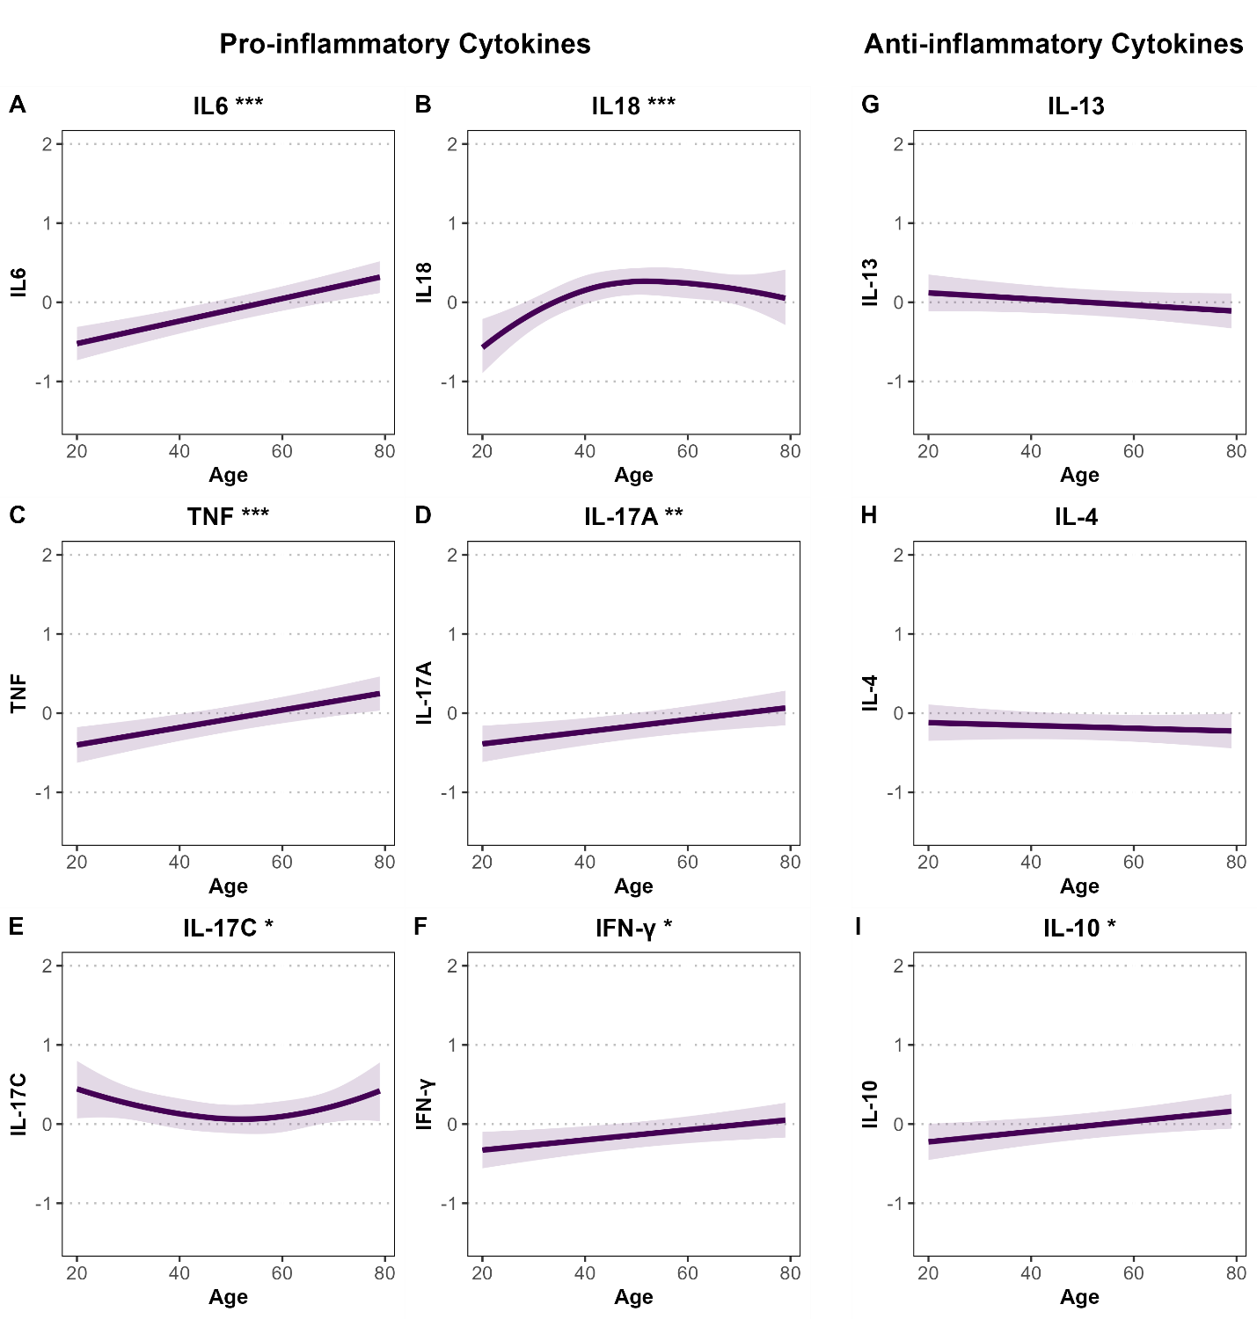Supplementary Figure S1. Associations between age and standardized pro- and anti-inflammatory cytokine levels in Bialystok PLUS cohort. Panels A–F show pro-inflammatory cytokines (IL-6, IL-18, TNF, IFN-γ, IL-17A, IL-17C), and panels G–I show anti-inflammatory cytokines (IL-13, IL-4, IL-10). Associations were estimated using linear or spline-based regression models adjusted for sex, BMI, smoking status, and alcohol consumption. Shaded areas represent 95% confidence intervals. All cytokine levels are standardized (mean = 0, SD = 1). Y-axes are standardized across all panels for comparability. Significance is indicated by stars (*P < 0.05; **P < 0.01; ***P < 0.001).

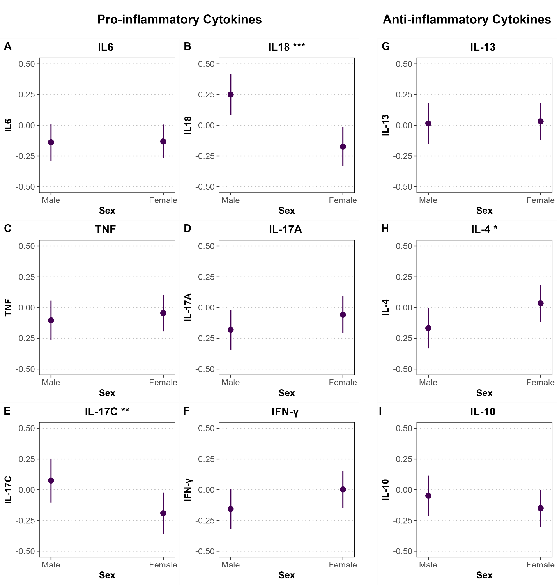Supplementary Figure S2. Associations between sex and standardized pro- and anti-inflammatory cytokine levels in Bialystok PLUS cohort. Panels A–F show pro-inflammatory cytokines (IL-6, IL-18, TNF, IFN-γ, IL-17A, IL-17C), and panels G–I show anti-inflammatory cytokines (IL-13, IL-4, IL-10). Associations were estimated using linear or spline-based regression models adjusted for age, BMI, smoking status, and alcohol consumption. Point estimates are accompanied by 95% confidence intervals displayed as vertical error bars. Y-axes are standardized across all panels for comparability. All cytokine levels are standardized (mean = 0, SD = 1). Significance is indicated by stars (*P < 0.05; **P < 0.01; ***P < 0.001).

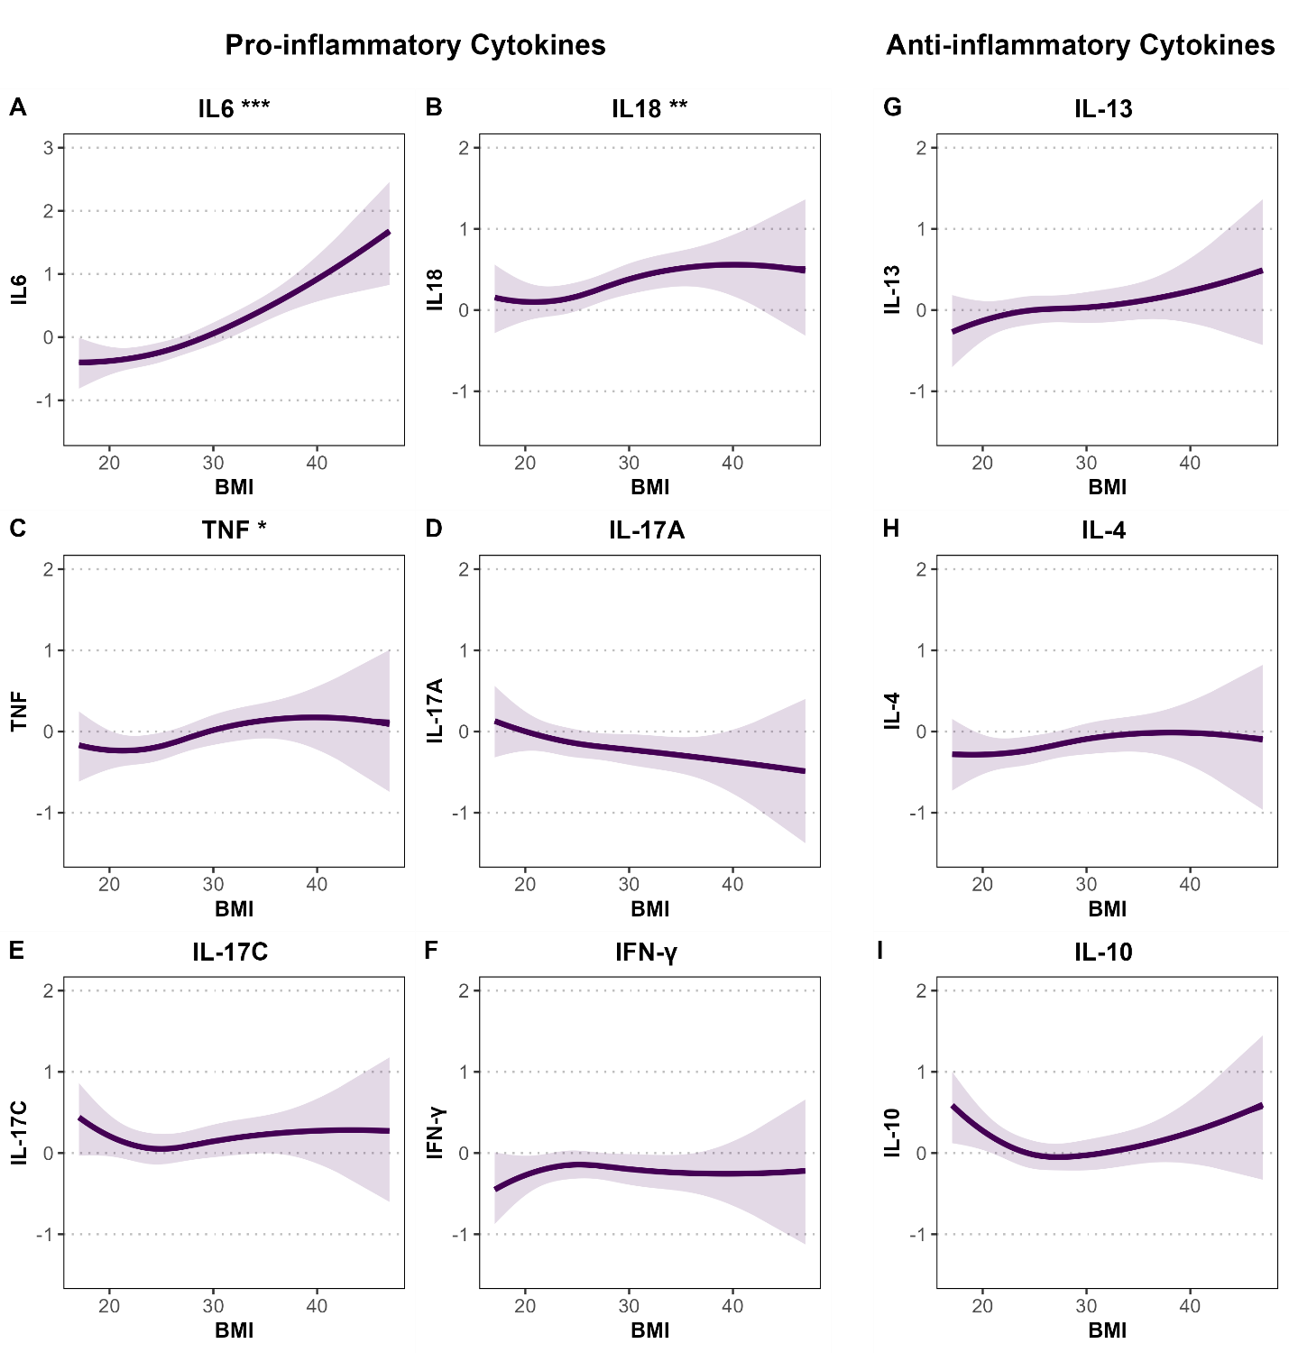
Supplementary Figure S3. Associations between BMI and standardized pro- and anti-inflammatory cytokine levels in Bialystok PLUS cohort. Panels A–F show pro-inflammatory cytokines (IL-6, IL-18, TNF, IFN-γ, IL-17A, IL-17C), and panels G–I show anti-inflammatory cytokines (IL-13, IL-4, IL-10). Associations were estimated using linear or spline-based regression models adjusted for age, sex, smoking status, and alcohol consumption. Shaded areas represent 95% confidence intervals. All cytokine levels are standardized (mean = 0, SD = 1). Y-axes are standardized across all panels for comparability, except for IL-6 (Panel A), which is displayed with a wider axis range to accommodate its greater variability. Significance is indicated by stars (*P < 0.05; **P < 0.01; ***P < 0.001).
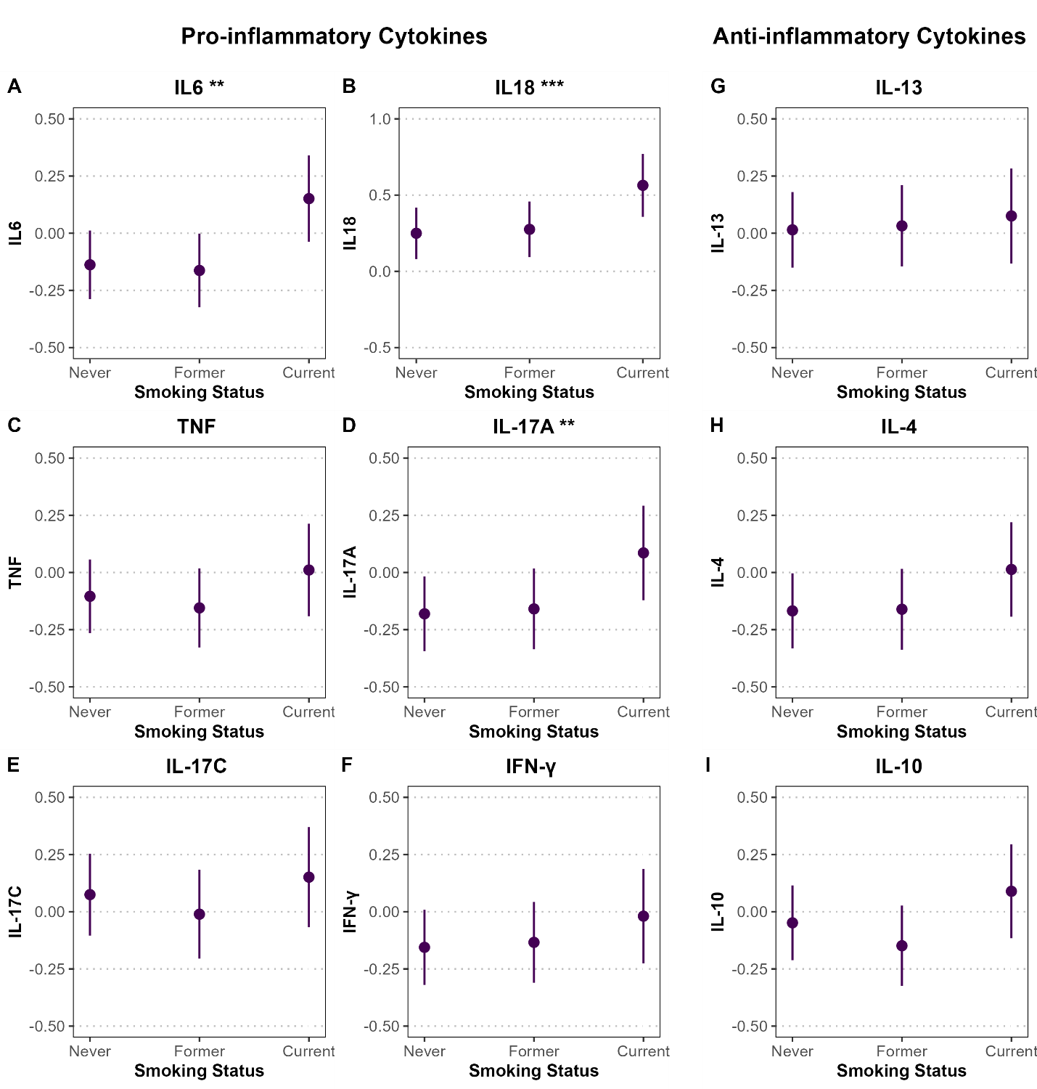
Supplementary Figure S4. Associations between smoking status and standardized pro- and anti-inflammatory cytokine levels in Bialystok PLUS cohort. Panels A–F show pro-inflammatory cytokines (IL-6, IL-18, TNF, IFN-γ, IL-17A, IL-17C), and panels G–I show anti-inflammatory cytokines (IL-13, IL-4, IL-10). Associations were estimated using linear or spline-based regression models adjusted for age, sex, BMI, and alcohol consumption. Point estimates are accompanied by 95% confidence intervals displayed as vertical error bars. Y-axes are standardized across all panels for comparability, except for IL-18, which uses a wider range (−0.5 to 1) to account for greater variability. All cytokine levels are standardized (mean = 0, SD = 1). Significance is indicated by stars (*P < 0.05; **P < 0.01; ***P < 0.001).

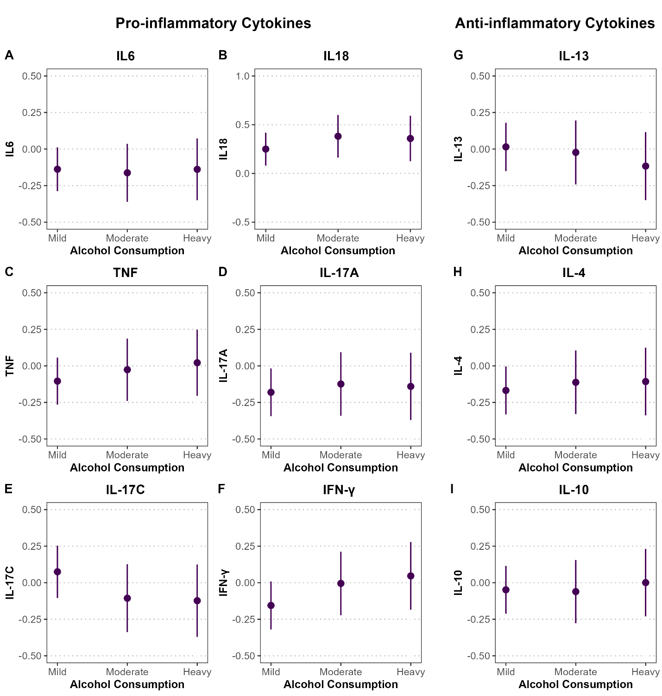
Supplementary Figure S5. Associations between alcohol consumption and standardized pro- and anti-inflammatory cytokine levels in Bialystok PLUS cohort. Panels A–F show pro-inflammatory cytokines (IL-6, IL-18, TNF, IFN-γ, IL-17A, IL-17C), and panels G–I show anti-inflammatory cytokines (IL-13, IL-4, IL-10). Associations were estimated using linear or spline-based regression models adjusted for age, sex, BMI, and smoking status. Point estimates are accompanied by 95% confidence intervals displayed as vertical error bars. Y-axes are standardized across all panels for comparability, except for IL-18, which uses a wider range (−0.5 to 1) to account for greater variability. All cytokine levels are standardized (mean = 0, SD = 1). Significance is indicated by stars (*P < 0.05; **P < 0.01; ***P < 0.001).

Sex Stratified Analysis
Sex-Stratified Models (Males)
term | estimate | std.error | statistic | p.value | conf.low | conf.high | Model
(Intercept) | -1.146 | 0.302 | -3.791 | 0.000 | -1.741 | -0.551 | IL6
age | 0.013 | 0.003 | 4.292 | 0.000 | 0.007 | 0.019 | IL6
smokingFormer | -0.079 | 0.106 | -0.747 | 0.456 | -0.287 | 0.129 | IL6
smokingCurrent | 0.452 | 0.114 | 3.963 | 0.000 | 0.228 | 0.676 | IL6
alcohol_consumptionModerate | -0.021 | 0.112 | -0.187 | 0.851 | -0.242 | 0.200 | IL6
alcohol_consumptionHeavy | 0.012 | 0.108 | 0.109 | 0.914 | -0.201 | 0.225 | IL6
BMI (Spline 1) | 0.244 | 0.205 | 1.189 | 0.235 | -0.159 | 0.646 | IL6
BMI (Spline 2) | 1.834 | 0.576 | 3.182 | 0.002 | 0.700 | 2.968 | IL6
BMI (Spline 3) | 2.277 | 0.340 | 6.701 | 0.000 | 1.608 | 2.945 | IL6
(Intercept) | -0.908 | 0.389 | -2.336 | 0.020 | -1.672 | -0.143 | IL18
Age (Spline 1) | 0.611 | 0.236 | 2.583 | 0.010 | 0.145 | 1.076 | IL18
Age (Spline 2) | 1.431 | 0.566 | 2.530 | 0.012 | 0.318 | 2.544 | IL18
Age (Spline 3) | 0.004 | 0.236 | 0.019 | 0.985 | -0.459 | 0.468 | IL18
smokingFormer | 0.015 | 0.128 | 0.120 | 0.905 | -0.236 | 0.267 | IL18
smokingCurrent | 0.216 | 0.137 | 1.576 | 0.116 | -0.054 | 0.487 | IL18
alcohol_consumptionModerate | 0.033 | 0.136 | 0.247 | 0.805 | -0.233 | 0.300 | IL18
alcohol_consumptionHeavy | 0.034 | 0.131 | 0.258 | 0.797 | -0.223 | 0.290 | IL18
BMI (Spline 1) | 0.548 | 0.248 | 2.210 | 0.028 | 0.060 | 1.035 | IL18
BMI (Spline 2) | 1.036 | 0.695 | 1.491 | 0.137 | -0.331 | 2.404 | IL18
BMI (Spline 3) | 0.806 | 0.409 | 1.970 | 0.050 | 0.001 | 1.612 | IL18
(Intercept) | -0.708 | 0.292 | -2.422 | 0.016 | -1.282 | -0.133 | TNF
age | 0.007 | 0.003 | 2.423 | 0.016 | 0.001 | 0.013 | TNF
smokingFormer | -0.109 | 0.102 | -1.067 | 0.287 | -0.310 | 0.092 | TNF
smokingCurrent | 0.118 | 0.110 | 1.074 | 0.284 | -0.098 | 0.335 | TNF
alcohol_consumptionModerate | 0.105 | 0.109 | 0.968 | 0.334 | -0.109 | 0.319 | TNF
alcohol_consumptionHeavy | 0.067 | 0.105 | 0.639 | 0.524 | -0.139 | 0.273 | TNF
BMI (Spline 1) | 0.457 | 0.198 | 2.308 | 0.022 | 0.067 | 0.846 | TNF
BMI (Spline 2) | 0.694 | 0.557 | 1.245 | 0.214 | -0.402 | 1.790 | TNF
BMI (Spline 3) | 0.331 | 0.328 | 1.007 | 0.314 | -0.315 | 0.977 | TNF
(Intercept) | 0.308 | 0.357 | 0.863 | 0.389 | -0.394 | 1.011 | IFNy
age | 0.001 | 0.004 | 0.313 | 0.754 | -0.006 | 0.008 | IFNy
smokingFormer | -0.114 | 0.125 | -0.909 | 0.364 | -0.360 | 0.132 | IFNy
smokingCurrent | 0.175 | 0.135 | 1.294 | 0.196 | -0.091 | 0.440 | IFNy
alcohol_consumptionModerate | 0.239 | 0.133 | 1.801 | 0.073 | -0.022 | 0.501 | IFNy
alcohol_consumptionHeavy | 0.163 | 0.128 | 1.275 | 0.203 | -0.089 | 0.415 | IFNy
BMI (Spline 1) | -0.104 | 0.242 | -0.428 | 0.669 | -0.580 | 0.373 | IFNy
BMI (Spline 2) | -0.924 | 0.681 | -1.356 | 0.176 | -2.265 | 0.416 | IFNy
BMI (Spline 3) | 0.212 | 0.402 | 0.527 | 0.598 | -0.578 | 1.002 | IFNy
(Intercept) | 0.446 | 0.334 | 1.336 | 0.183 | -0.211 | 1.103 | IL17A
age | 0.005 | 0.003 | 1.536 | 0.125 | -0.001 | 0.012 | IL17A
smokingFormer | 0.008 | 0.117 | 0.069 | 0.945 | -0.222 | 0.239 | IL17A
smokingCurrent | 0.244 | 0.126 | 1.930 | 0.054 | -0.005 | 0.492 | IL17A
alcohol_consumptionModerate | 0.059 | 0.125 | 0.469 | 0.640 | -0.188 | 0.305 | IL17A
alcohol_consumptionHeavy | 0.099 | 0.120 | 0.831 | 0.406 | -0.136 | 0.335 | IL17A
BMI (Spline 1) | -0.564 | 0.226 | -2.489 | 0.013 | -1.009 | -0.118 | IL17A
BMI (Spline 2) | -1.904 | 0.636 | -2.996 | 0.003 | -3.155 | -0.654 | IL17A
BMI (Spline 3) | -0.618 | 0.375 | -1.649 | 0.100 | -1.356 | 0.120 | IL17A
(Intercept) | 0.998 | 0.376 | 2.656 | 0.008 | 0.259 | 1.738 | IL17C
Age (Spline 1) | -0.426 | 0.229 | -1.863 | 0.063 | -0.876 | 0.024 | IL17C
Age (Spline 2) | -0.488 | 0.547 | -0.893 | 0.373 | -1.565 | 0.588 | IL17C
Age (Spline 3) | 0.203 | 0.228 | 0.892 | 0.373 | -0.245 | 0.652 | IL17C
smokingFormer | -0.155 | 0.124 | -1.257 | 0.210 | -0.399 | 0.088 | IL17C
smokingCurrent | 0.003 | 0.133 | 0.020 | 0.984 | -0.259 | 0.264 | IL17C
alcohol_consumptionModerate | -0.231 | 0.131 | -1.762 | 0.079 | -0.489 | 0.027 | IL17C
alcohol_consumptionHeavy | -0.172 | 0.126 | -1.364 | 0.174 | -0.420 | 0.076 | IL17C
BMI (Spline 1) | -0.083 | 0.240 | -0.348 | 0.728 | -0.555 | 0.388 | IL17C
BMI (Spline 2) | -0.920 | 0.672 | -1.369 | 0.172 | -2.243 | 0.403 | IL17C
BMI (Spline 3) | -0.127 | 0.396 | -0.321 | 0.748 | -0.906 | 0.652 | IL17C
(Intercept) | -0.491 | 0.371 | -1.323 | 0.187 | -1.221 | 0.239 | IL13
age | 0.000 | 0.004 | 0.086 | 0.932 | -0.007 | 0.008 | IL13
smokingFormer | 0.125 | 0.130 | 0.964 | 0.336 | -0.130 | 0.381 | IL13
smokingCurrent | 0.354 | 0.140 | 2.529 | 0.012 | 0.079 | 0.630 | IL13
alcohol_consumptionModerate | 0.054 | 0.138 | 0.392 | 0.695 | -0.217 | 0.326 | IL13
alcohol_consumptionHeavy | -0.019 | 0.133 | -0.139 | 0.889 | -0.280 | 0.243 | IL13
BMI (Spline 1) | 0.043 | 0.251 | 0.171 | 0.864 | -0.452 | 0.538 | IL13
BMI (Spline 2) | 0.633 | 0.708 | 0.894 | 0.372 | -0.760 | 2.025 | IL13
BMI (Spline 3) | -0.035 | 0.417 | -0.083 | 0.934 | -0.855 | 0.786 | IL13
(Intercept) | -0.510 | 0.395 | -1.292 | 0.197 | -1.286 | 0.267 | IL4
Age (Spline 1) | 0.280 | 0.236 | 1.188 | 0.236 | -0.184 | 0.745 | IL4
Age (Spline 2) | -0.280 | 0.569 | -0.492 | 0.623 | -1.399 | 0.839 | IL4
Age (Spline 3) | -0.246 | 0.237 | -1.035 | 0.301 | -0.713 | 0.221 | IL4
smokingFormer | 0.031 | 0.128 | 0.241 | 0.809 | -0.222 | 0.284 | IL4
smokingCurrent | 0.213 | 0.138 | 1.546 | 0.123 | -0.058 | 0.484 | IL4
alcohol_consumptionModerate | -0.036 | 0.136 | -0.266 | 0.790 | -0.305 | 0.232 | IL4
alcohol_consumptionHeavy | 0.066 | 0.131 | 0.504 | 0.614 | -0.192 | 0.324 | IL4
BMI | 0.015 | 0.013 | 1.099 | 0.272 | -0.011 | 0.040 | IL4
(Intercept) | 0.075 | 0.286 | 0.264 | 0.792 | -0.487 | 0.638 | IL10
age | 0.007 | 0.003 | 2.314 | 0.021 | 0.001 | 0.012 | IL10
smokingFormer | -0.206 | 0.100 | -2.059 | 0.040 | -0.403 | -0.009 | IL10
smokingCurrent | 0.080 | 0.108 | 0.743 | 0.458 | -0.132 | 0.292 | IL10
alcohol_consumptionModerate | 0.223 | 0.106 | 2.095 | 0.037 | 0.014 | 0.432 | IL10
alcohol_consumptionHeavy | 0.065 | 0.102 | 0.637 | 0.524 | -0.136 | 0.267 | IL10
BMI (Spline 1) | -0.281 | 0.194 | -1.449 | 0.148 | -0.662 | 0.100 | IL10
BMI (Spline 2) | -0.605 | 0.545 | -1.110 | 0.268 | -1.678 | 0.467 | IL10
BMI (Spline 3) | 0.188 | 0.321 | 0.585 | 0.559 | -0.444 | 0.821 | IL10
Supplementary Table S4.1. Fully adjusted linear regression results for male participants, assessing associations with cytokine levels in Bialystok PLUS cohort. Models adjust for age, smoking status (current and former vs. never), alcohol consumption (moderate and heavy vs. mild), and BMI. Natural splines with 3 degrees of freedom were applied to age or BMI in select models, indicated as Spline 1–3. Cytokine levels were z-transformed; estimates represent changes per standard deviation. Reported metrics include estimates, standard errors, test statistics, p-values, and 95% confidence intervals.

Sex-Stratified Models (Females)
term | estimate | std.error | statistic | p.value | conf.low | conf.high | Model
(Intercept) | -1.021 | 0.279 | -3.660 | 0.000 | -1.570 | -0.473 | IL6
age | 0.016 | 0.004 | 4.224 | 0.000 | 0.008 | 0.023 | IL6
smokingFormer | 0.011 | 0.111 | 0.097 | 0.922 | -0.207 | 0.228 | IL6
smokingCurrent | 0.091 | 0.144 | 0.632 | 0.528 | -0.192 | 0.374 | IL6
alcohol_consumptionModerate | 0.013 | 0.143 | 0.090 | 0.928 | -0.269 | 0.295 | IL6
alcohol_consumptionHeavy | -0.046 | 0.246 | -0.185 | 0.853 | -0.529 | 0.438 | IL6
BMI (Spline 1) | 0.816 | 0.267 | 3.062 | 0.002 | 0.292 | 1.340 | IL6
BMI (Spline 2) | 0.788 | 0.601 | 1.310 | 0.191 | -0.394 | 1.970 | IL6
BMI (Spline 3) | 1.142 | 0.546 | 2.093 | 0.037 | 0.069 | 2.215 | IL6
(Intercept) | -1.047 | 0.296 | -3.535 | 0.000 | -1.630 | -0.465 | IL18
Age (Spline 1) | 0.646 | 0.206 | 3.135 | 0.002 | 0.241 | 1.052 | IL18
Age (Spline 2) | 1.459 | 0.517 | 2.822 | 0.005 | 0.443 | 2.475 | IL18
Age (Spline 3) | 0.321 | 0.226 | 1.418 | 0.157 | -0.124 | 0.765 | IL18
smokingFormer | 0.027 | 0.105 | 0.256 | 0.798 | -0.179 | 0.232 | IL18
smokingCurrent | 0.392 | 0.136 | 2.891 | 0.004 | 0.125 | 0.659 | IL18
alcohol_consumptionModerate | 0.241 | 0.136 | 1.775 | 0.077 | -0.026 | 0.508 | IL18
alcohol_consumptionHeavy | 0.161 | 0.234 | 0.688 | 0.492 | -0.298 | 0.620 | IL18
BMI (Spline 1) | 0.312 | 0.251 | 1.243 | 0.215 | -0.182 | 0.806 | IL18
BMI (Spline 2) | 0.104 | 0.572 | 0.182 | 0.856 | -1.020 | 1.228 | IL18
BMI (Spline 3) | 0.248 | 0.517 | 0.480 | 0.631 | -0.767 | 1.263 | IL18
(Intercept) | -1.412 | 0.302 | -4.683 | 0.000 | -2.005 | -0.819 | TNF
age | 0.015 | 0.004 | 3.519 | 0.000 | 0.006 | 0.023 | TNF
smokingFormer | 0.015 | 0.125 | 0.117 | 0.907 | -0.231 | 0.260 | TNF
smokingCurrent | 0.078 | 0.163 | 0.478 | 0.633 | -0.242 | 0.397 | TNF
alcohol_consumptionModerate | 0.064 | 0.162 | 0.394 | 0.694 | -0.254 | 0.382 | TNF
alcohol_consumptionHeavy | 0.367 | 0.279 | 1.317 | 0.189 | -0.181 | 0.915 | TNF
BMI | 0.024 | 0.012 | 2.094 | 0.037 | 0.001 | 0.047 | TNF
(Intercept) | -0.978 | 0.293 | -3.342 | 0.001 | -1.553 | -0.403 | IFNy
age | 0.010 | 0.004 | 2.638 | 0.009 | 0.003 | 0.018 | IFNy
smokingFormer | 0.118 | 0.116 | 1.014 | 0.311 | -0.110 | 0.346 | IFNy
smokingCurrent | 0.022 | 0.151 | 0.143 | 0.886 | -0.275 | 0.318 | IFNy
alcohol_consumptionModerate | 0.130 | 0.150 | 0.866 | 0.387 | -0.165 | 0.425 | IFNy
alcohol_consumptionHeavy | 0.327 | 0.258 | 1.267 | 0.206 | -0.180 | 0.834 | IFNy
BMI (Spline 1) | 0.120 | 0.279 | 0.430 | 0.667 | -0.429 | 0.670 | IFNy
BMI (Spline 2) | 0.641 | 0.631 | 1.016 | 0.310 | -0.599 | 1.880 | IFNy
BMI (Spline 3) | -0.422 | 0.572 | -0.737 | 0.461 | -1.547 | 0.703 | IFNy
(Intercept) | -0.276 | 0.305 | -0.906 | 0.365 | -0.875 | 0.323 | IL17A
age | 0.009 | 0.004 | 2.128 | 0.034 | 0.001 | 0.017 | IL17A
smokingFormer | 0.046 | 0.121 | 0.383 | 0.702 | -0.191 | 0.284 | IL17A
smokingCurrent | 0.291 | 0.157 | 1.852 | 0.065 | -0.018 | 0.600 | IL17A
alcohol_consumptionModerate | 0.057 | 0.156 | 0.366 | 0.714 | -0.250 | 0.365 | IL17A
alcohol_consumptionHeavy | -0.199 | 0.269 | -0.741 | 0.459 | -0.727 | 0.329 | IL17A
BMI (Spline 1) | -0.029 | 0.292 | -0.099 | 0.921 | -0.602 | 0.544 | IL17A
BMI (Spline 2) | -0.613 | 0.657 | -0.934 | 0.351 | -1.904 | 0.678 | IL17A
BMI (Spline 3) | -0.652 | 0.596 | -1.094 | 0.275 | -1.823 | 0.520 | IL17A
(Intercept) | 0.390 | 0.336 | 1.160 | 0.247 | -0.271 | 1.052 | IL17C
Age (Spline 1) | -0.264 | 0.234 | -1.128 | 0.260 | -0.724 | 0.196 | IL17C
Age (Spline 2) | -0.415 | 0.587 | -0.708 | 0.480 | -1.569 | 0.739 | IL17C
Age (Spline 3) | 0.072 | 0.257 | 0.280 | 0.780 | -0.433 | 0.577 | IL17C
smokingFormer | -0.028 | 0.119 | -0.238 | 0.812 | -0.262 | 0.205 | IL17C
smokingCurrent | 0.142 | 0.154 | 0.924 | 0.356 | -0.160 | 0.445 | IL17C
alcohol_consumptionModerate | -0.143 | 0.154 | -0.927 | 0.355 | -0.446 | 0.160 | IL17C
alcohol_consumptionHeavy | -0.279 | 0.265 | -1.051 | 0.294 | -0.800 | 0.243 | IL17C
BMI (Spline 1) | 0.098 | 0.285 | 0.345 | 0.730 | -0.462 | 0.659 | IL17C
BMI (Spline 2) | -0.383 | 0.649 | -0.591 | 0.555 | -1.660 | 0.893 | IL17C
BMI (Spline 3) | 0.214 | 0.586 | 0.365 | 0.715 | -0.939 | 1.367 | IL17C
(Intercept) | 0.212 | 0.290 | 0.732 | 0.465 | -0.357 | 0.781 | IL13
age | -0.007 | 0.004 | -1.939 | 0.053 | -0.015 | 0.000 | IL13
smokingFormer | -0.038 | 0.115 | -0.332 | 0.740 | -0.264 | 0.188 | IL13
smokingCurrent | -0.185 | 0.149 | -1.239 | 0.216 | -0.479 | 0.108 | IL13
alcohol_consumptionModerate | -0.143 | 0.149 | -0.960 | 0.338 | -0.435 | 0.150 | IL13
alcohol_consumptionHeavy | -0.233 | 0.255 | -0.913 | 0.362 | -0.735 | 0.269 | IL13
BMI (Spline 1) | 0.252 | 0.277 | 0.911 | 0.363 | -0.292 | 0.796 | IL13
BMI (Spline 2) | 0.893 | 0.624 | 1.430 | 0.153 | -0.334 | 2.120 | IL13
BMI (Spline 3) | 0.982 | 0.566 | 1.734 | 0.084 | -0.131 | 2.095 | IL13
(Intercept) | -0.370 | 0.335 | -1.104 | 0.270 | -1.027 | 0.288 | IL4
Age (Spline 1) | 0.037 | 0.228 | 0.164 | 0.870 | -0.410 | 0.485 | IL4
Age (Spline 2) | -0.254 | 0.573 | -0.443 | 0.658 | -1.381 | 0.873 | IL4
Age (Spline 3) | -0.208 | 0.249 | -0.837 | 0.403 | -0.697 | 0.281 | IL4
smokingFormer | 0.015 | 0.116 | 0.127 | 0.899 | -0.213 | 0.243 | IL4
smokingCurrent | 0.140 | 0.151 | 0.932 | 0.352 | -0.156 | 0.437 | IL4
alcohol_consumptionModerate | 0.162 | 0.151 | 1.074 | 0.283 | -0.134 | 0.459 | IL4
alcohol_consumptionHeavy | -0.005 | 0.260 | -0.020 | 0.984 | -0.516 | 0.506 | IL4
BMI | 0.017 | 0.011 | 1.575 | 0.116 | -0.004 | 0.038 | IL4
(Intercept) | 0.276 | 0.324 | 0.850 | 0.396 | -0.362 | 0.914 | IL10
age | 0.005 | 0.004 | 1.252 | 0.211 | -0.003 | 0.014 | IL10
smokingFormer | -0.025 | 0.129 | -0.194 | 0.846 | -0.278 | 0.228 | IL10
smokingCurrent | 0.159 | 0.167 | 0.949 | 0.343 | -0.170 | 0.488 | IL10
alcohol_consumptionModerate | -0.257 | 0.167 | -1.544 | 0.123 | -0.585 | 0.070 | IL10
alcohol_consumptionHeavy | 0.248 | 0.286 | 0.867 | 0.386 | -0.314 | 0.811 | IL10
BMI (Spline 1) | -0.290 | 0.310 | -0.936 | 0.350 | -0.900 | 0.319 | IL10
BMI (Spline 2) | -0.965 | 0.699 | -1.379 | 0.169 | -2.340 | 0.410 | IL10
BMI (Spline 3) | 0.250 | 0.635 | 0.393 | 0.694 | -0.998 | 1.497 | IL10
Supplementary Table S4.2. Fully adjusted linear regression results for female participants, assessing associations with cytokine levels in Bialystok PLUS cohort. Models adjust for age, smoking status (current and former vs. never), alcohol consumption (moderate and heavy vs. mild), and BMI. Natural splines with 3 degrees of freedom were applied to age or BMI in select models, indicated as Spline 1–3. Cytokine levels were z-transformed; estimates represent changes per standard deviation. Reported metrics include estimates, standard errors, test statistics, p-values, and 95% confidence intervals.
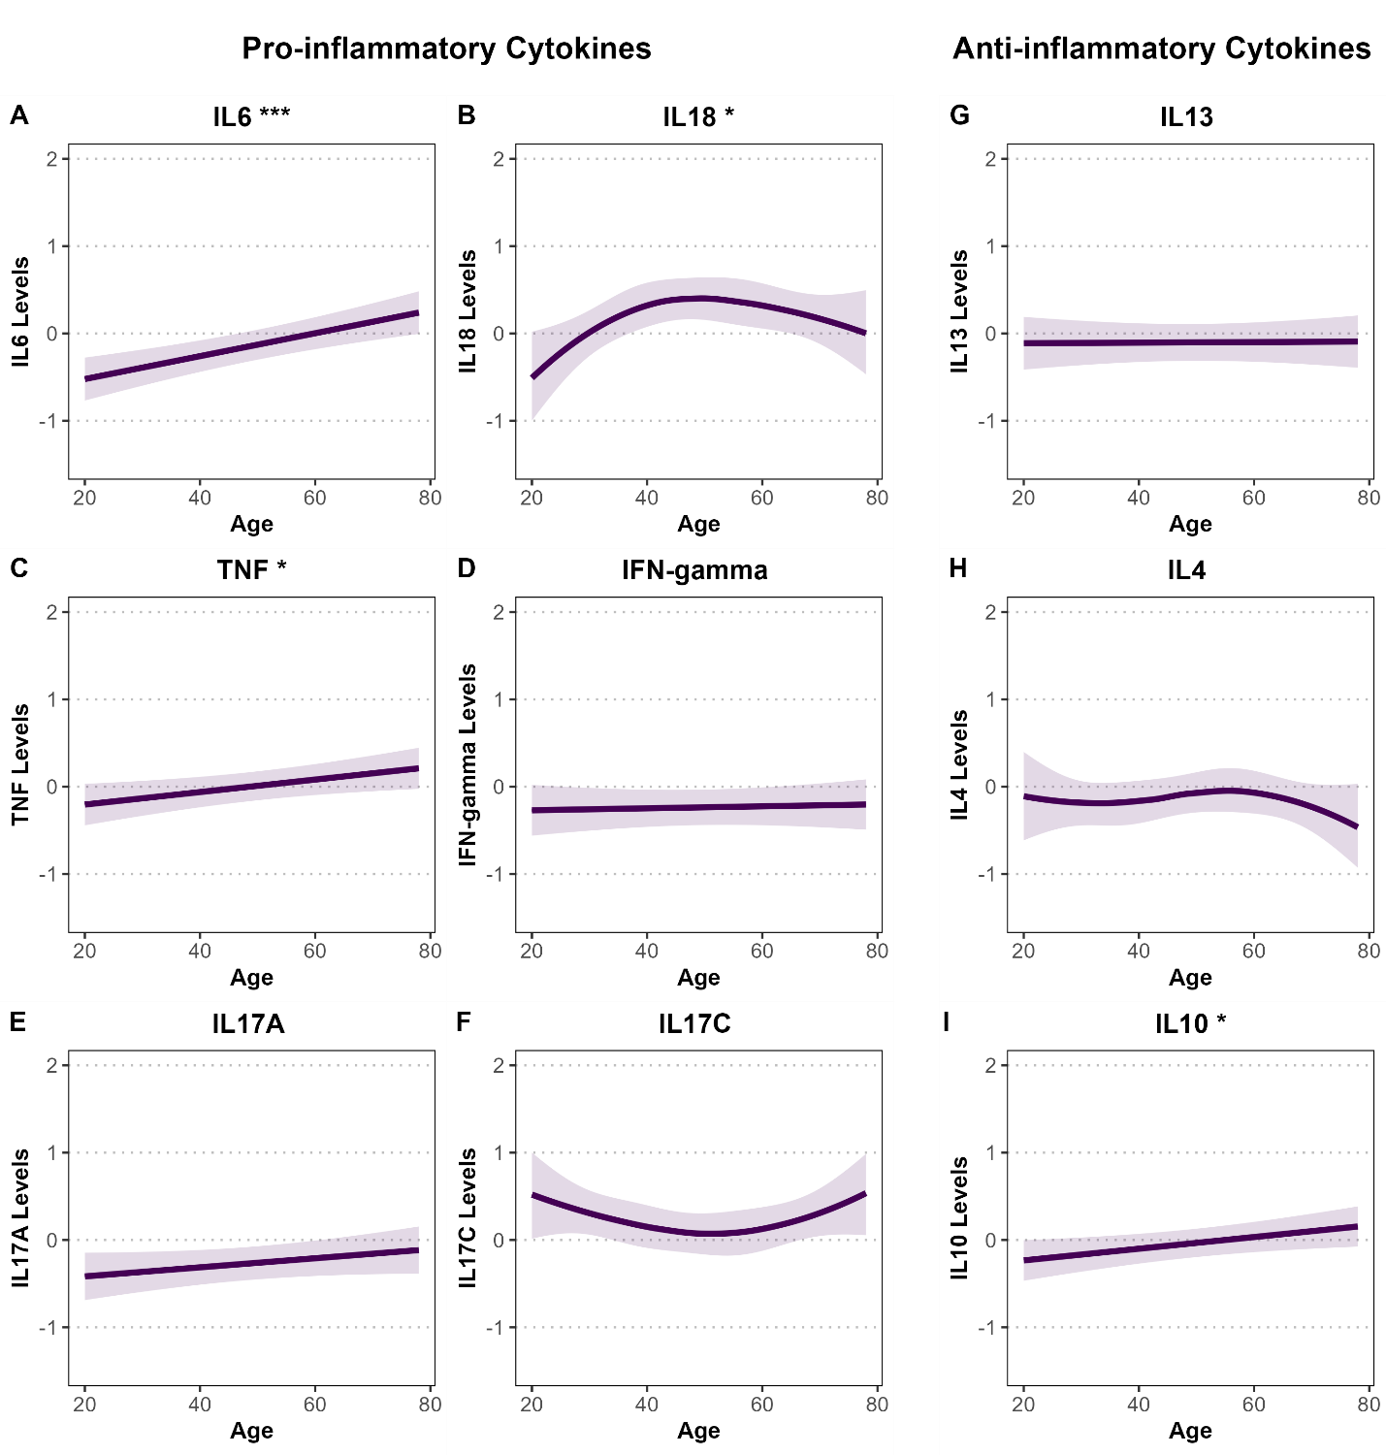Supplementary Figure S6.1. Associations between age and standardized pro- and anti-inflammatory cytokine levels among male participants in the Bialystok PLUS cohort. Panels A–F display pro-inflammatory cytokines (IL-6, IL-18, TNF, IFN-γ, IL-17A, IL-17C), and panels G–I show anti-inflammatory cytokines (IL-13, IL-4, IL-10). Associations were estimated using linear or spline-based regression models adjusted for BMI, smoking status, and alcohol consumption. Shaded areas represent 95% confidence intervals. Cytokine levels are standardized (mean = 0, SD = 1), and y-axes are uniform across panels for comparability. Statistical significance is denoted by asterisks (*P < 0.05; **P < 0.01; ***P < 0.001).

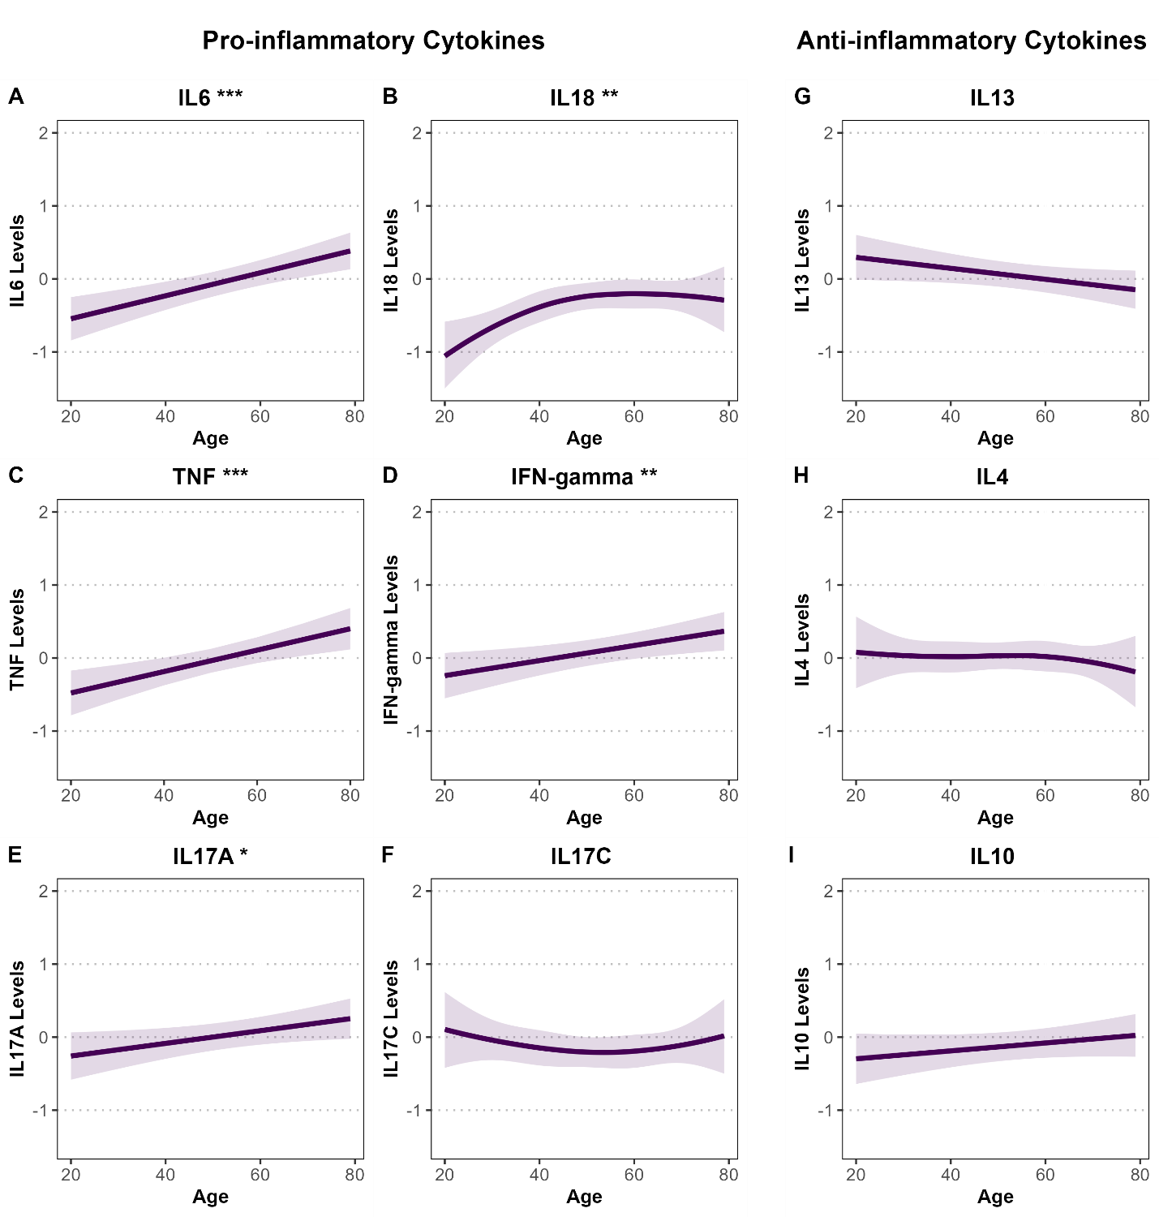Supplementary Figure S6.2. Associations between age and standardized pro- and anti-inflammatory cytokine levels among female participants in the Bialystok PLUS cohort. Panels A–F display pro-inflammatory cytokines (IL-6, IL-18, TNF, IFN-γ, IL-17A, IL-17C), and panels G–I show anti-inflammatory cytokines (IL-13, IL-4, IL-10). Associations were estimated using linear or spline-based regression models adjusted for BMI, smoking status, and alcohol consumption. Shaded areas represent 95% confidence intervals. Cytokine levels are standardized (mean = 0, SD = 1), and y-axes are uniform across panels for comparability. Statistical significance is denoted by asterisks (*P < 0.05; **P < 0.01; ***P < 0.001).

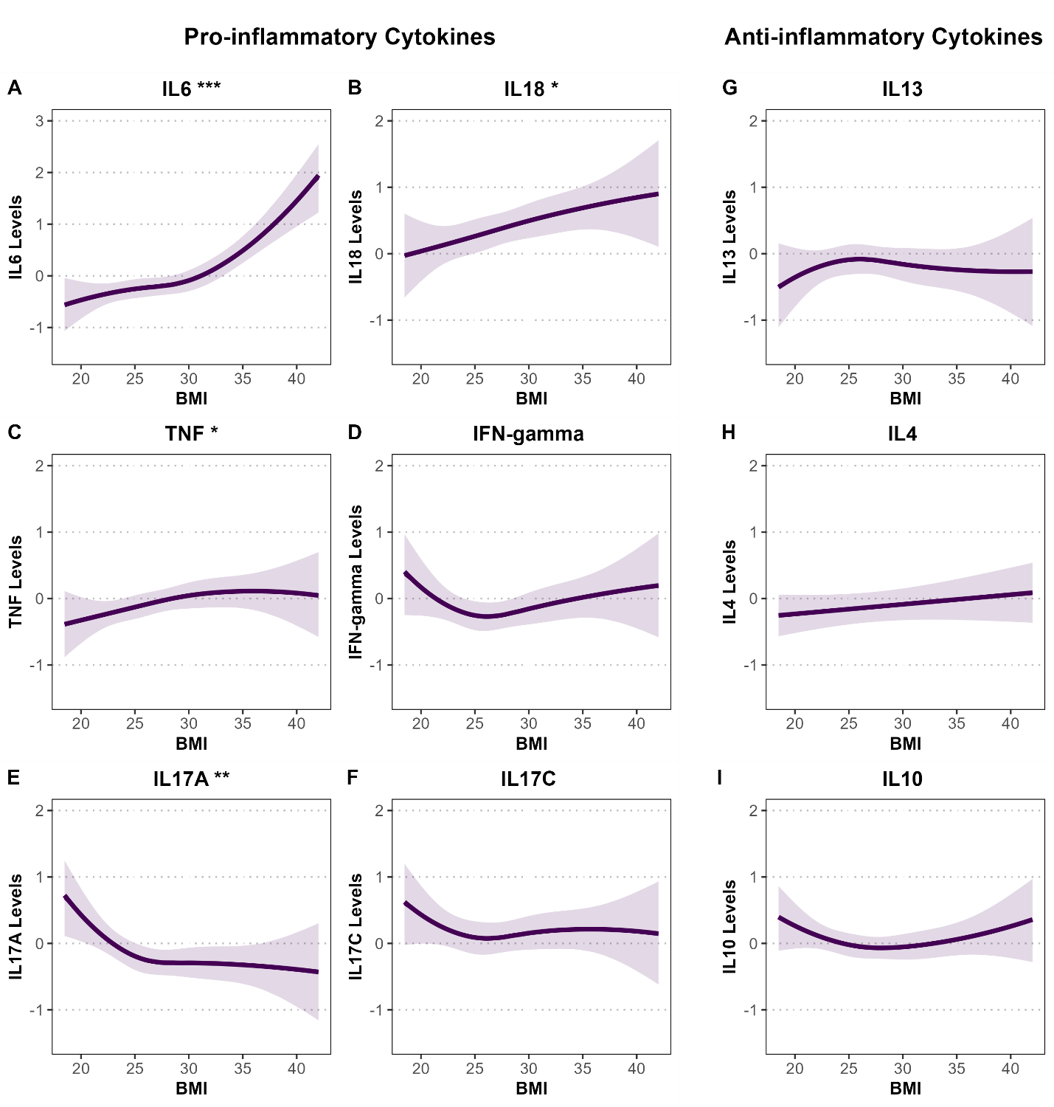Supplementary Figure S7.1. Associations between BMI and standardized pro- and anti-inflammatory cytokine levels among male participants in the Bialystok PLUS cohort. Panels A–F show pro-inflammatory cytokines (IL-6, IL-18, TNF, IFN-γ, IL-17A, IL-17C), and panels G–I show anti-inflammatory cytokines (IL-13, IL-4, IL-10). Associations were estimated using linear or spline-based regression models adjusted for age, smoking status, and alcohol consumption. Shaded areas represent 95% confidence intervals. Cytokine levels are standardized (mean = 0, SD = 1). Y-axes are standardized across all panels for comparability, except for IL-6 (Panel A), which uses a wider axis range to reflect its greater variability. Statistical significance is denoted by asterisks (*P < 0.05; **P < 0.01; ***P < 0.001).

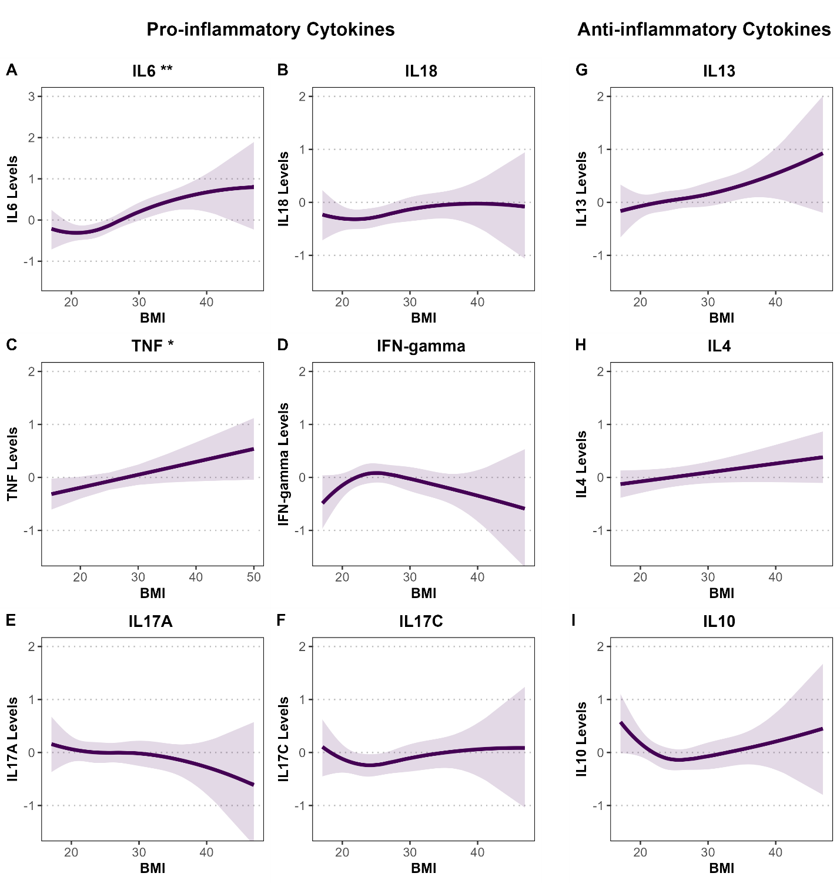Supplementary Figure S7.2. Associations between BMI and standardized pro- and anti-inflammatory cytokine levels among female participants in the Bialystok PLUS cohort. Panels A–F show pro-inflammatory cytokines (IL-6, IL-18, TNF, IFN-γ, IL-17A, IL-17C), and panels G–I show anti-inflammatory cytokines (IL-13, IL-4, IL-10). Associations were estimated using linear or spline-based regression models adjusted for age, smoking status, and alcohol consumption. Shaded areas represent 95% confidence intervals. Cytokine levels are standardized (mean = 0, SD = 1). Y-axes are standardized across all panels for comparability, except for IL-6 (Panel A), which uses a wider axis range to reflect its greater variability. Statistical significance is denoted by asterisks (*P < 0.05; **P < 0.01; ***P < 0.001).

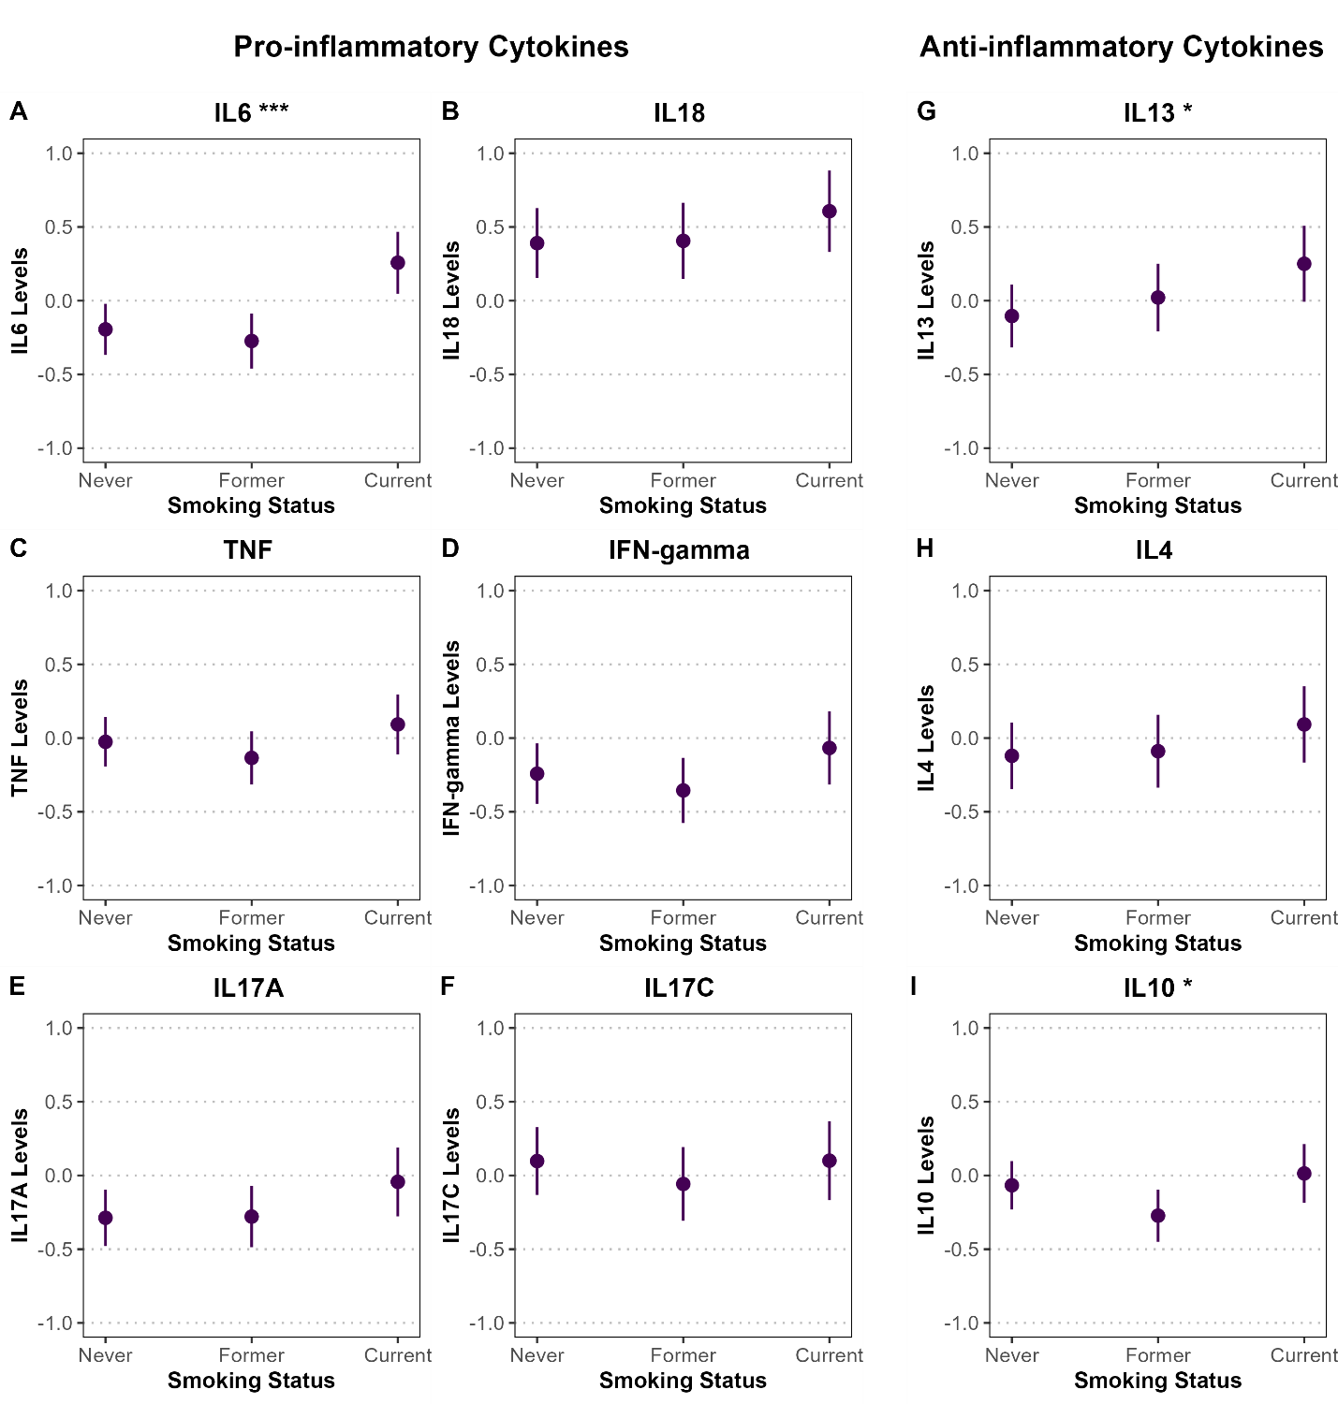Supplementary Figure S8.1. Associations between smoking status and standardized pro- and anti-inflammatory cytokine levels among male participants in the Bialystok PLUS cohort. Panels A–F display pro-inflammatory cytokines (IL-6, IL-18, TNF, IFN-γ, IL-17A, IL-17C), and panels G–I show anti-inflammatory cytokines (IL-13, IL-4, IL-10). Associations were estimated using linear or spline-based regression models adjusted for age, BMI, and alcohol consumption. Point estimates are shown with 95% confidence intervals represented as vertical error bars. Cytokine levels are standardized (mean = 0, SD = 1), and y-axes are fixed from -1 to 1 across all panels to account for wider confidence intervals in the sex-stratified analysis. Statistical significance is denoted by asterisks (*P < 0.05; **P < 0.01; ***P < 0.001).

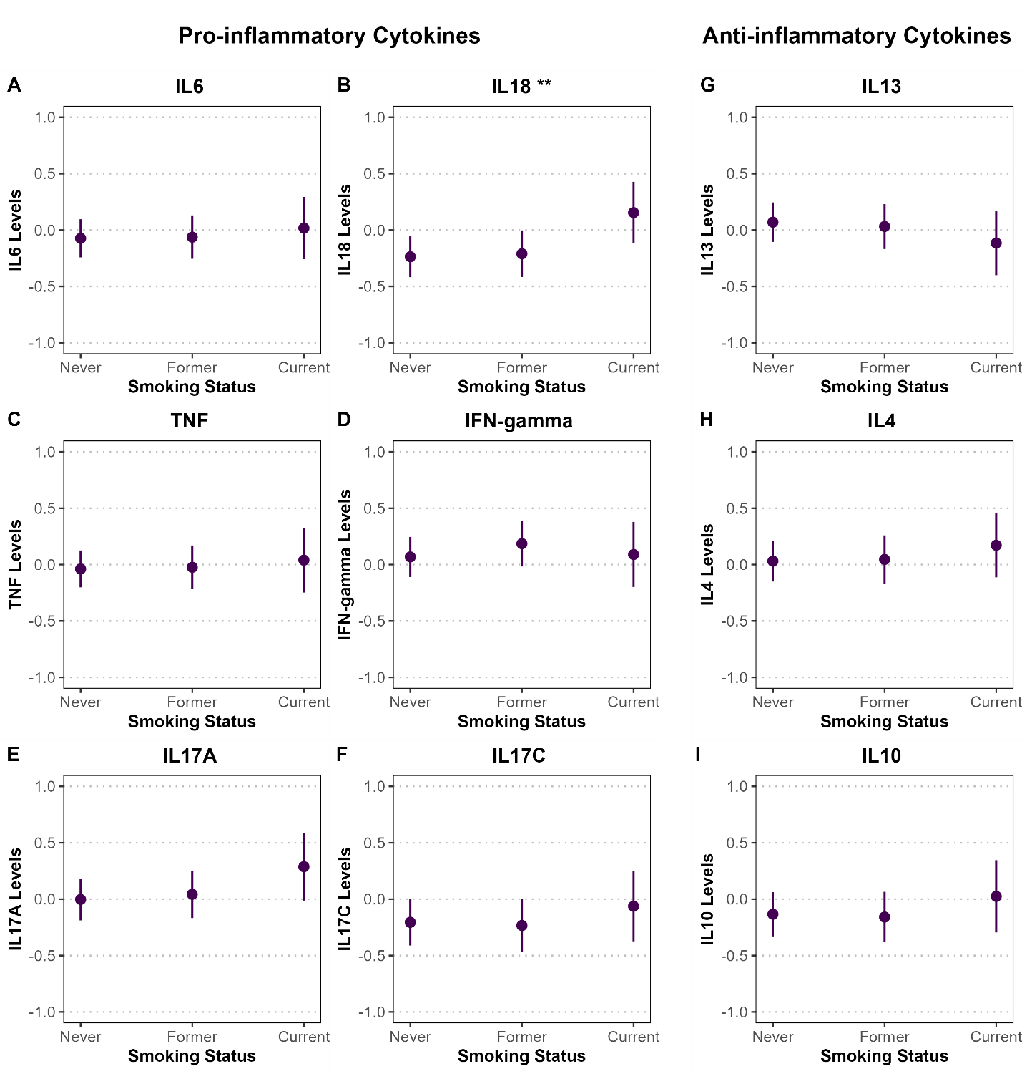Supplementary Figure S8.2. Associations between smoking status and standardized pro- and anti-inflammatory cytokine levels among female participants in the Bialystok PLUS cohort. Panels A–F display pro-inflammatory cytokines (IL-6, IL-18, TNF, IFN-γ, IL-17A, IL-17C), and panels G–I show anti-inflammatory cytokines (IL-13, IL-4, IL-10). Associations were estimated using linear or spline-based regression models adjusted for age, BMI, and alcohol consumption. Point estimates are shown with 95% confidence intervals represented as vertical error bars. Cytokine levels are standardized (mean = 0, SD = 1), and y-axes are fixed from -1 to 1 across all panels to account for wider confidence intervals in the sex-stratified analysis. Statistical significance is denoted by asterisks (*P < 0.05; **P < 0.01; ***P < 0.001).

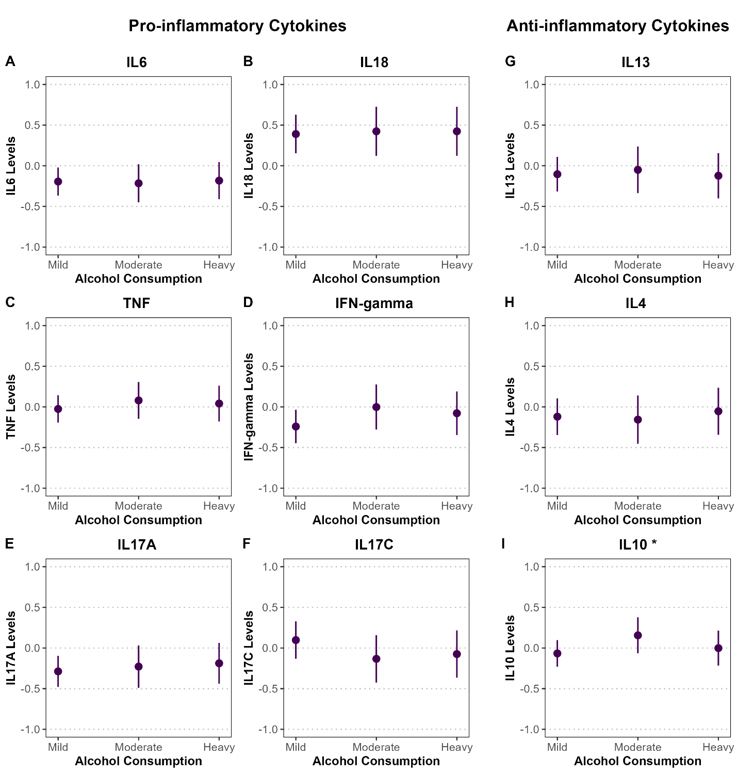
Supplementary Figure S9.1. Associations between alcohol consumption and standardized pro- and anti-inflammatory cytokine levels among male participants in the Bialystok PLUS cohort. Panels A–F display pro-inflammatory cytokines (IL-6, IL-18, TNF, IFN-γ, IL-17A, IL-17C), and panels G–I show anti-inflammatory cytokines (IL-13, IL-4, IL-10). Associations were estimated using linear or spline-based regression models adjusted for age, BMI, and smoking status. Point estimates are shown with 95% confidence intervals represented as vertical error bars. Cytokine levels are standardized (mean = 0, SD = 1), and y-axes are fixed from -1 to 1 across all panels to reflect the wider confidence intervals in the sex-stratified analysis. Statistical significance is denoted by asterisks (*P < 0.05; **P < 0.01; ***P < 0.001).
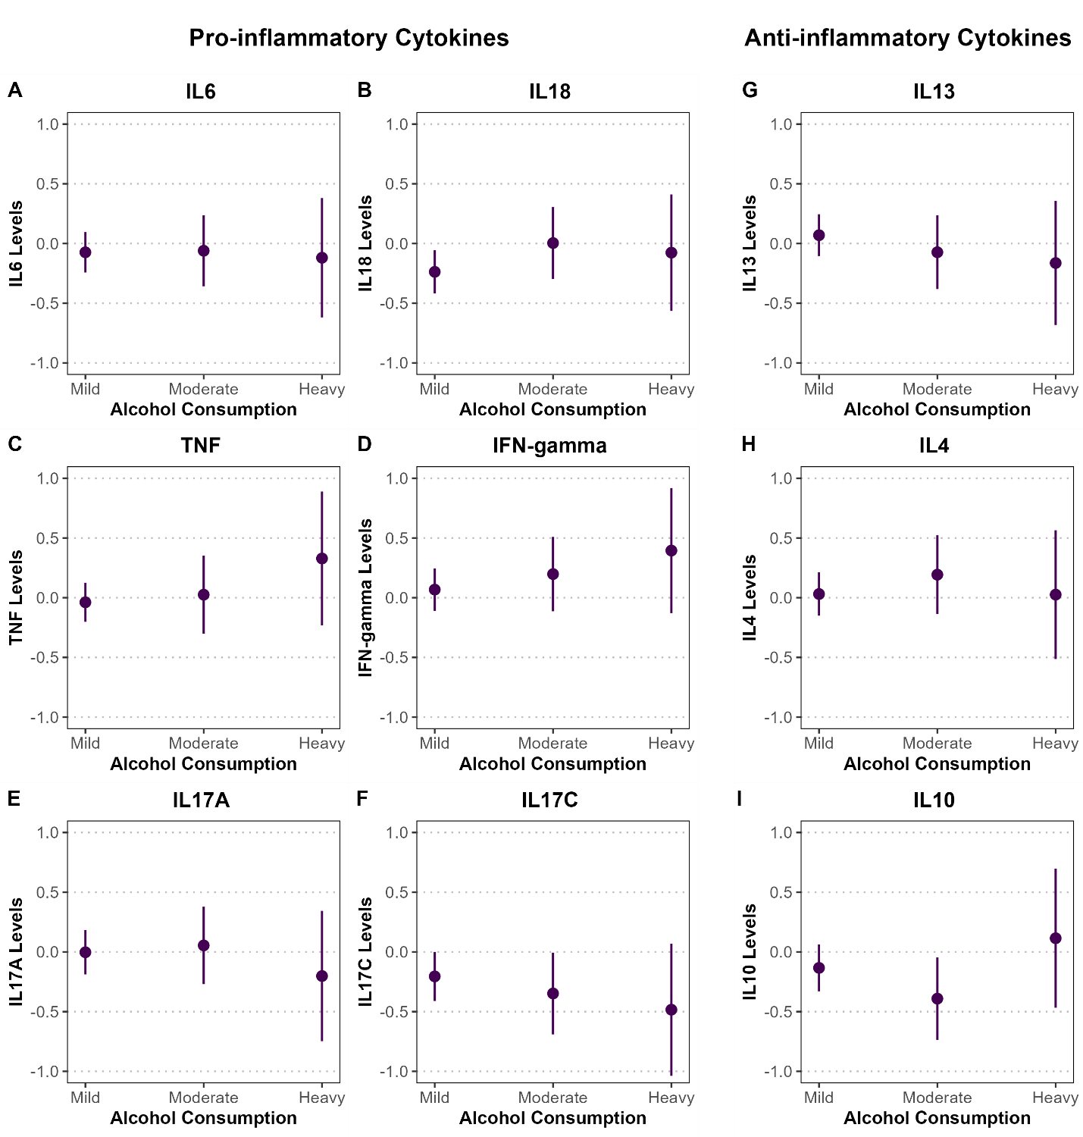
Supplementary Figure S9.2. Associations between alcohol consumption and standardized pro- and anti-inflammatory cytokine levels among female participants in the Bialystok PLUS cohort. Panels A–F display pro-inflammatory cytokines (IL-6, IL-18, TNF, IFN-γ, IL-17A, IL-17C), and panels G–I show anti-inflammatory cytokines (IL-13, IL-4, IL-10). Associations were estimated using linear or spline-based regression models adjusted for age, BMI, and smoking status. Point estimates are shown with 95% confidence intervals represented as vertical error bars. Cytokine levels are standardized (mean = 0, SD = 1), and y-axes are fixed from -1 to 1 across all panels to reflect the wider confidence intervals in the sex-stratified analysis. Statistical significance is denoted by asterisks (*P < 0.05; **P < 0.01; ***P < 0.001).

Principal Component Analysis of Cytokines
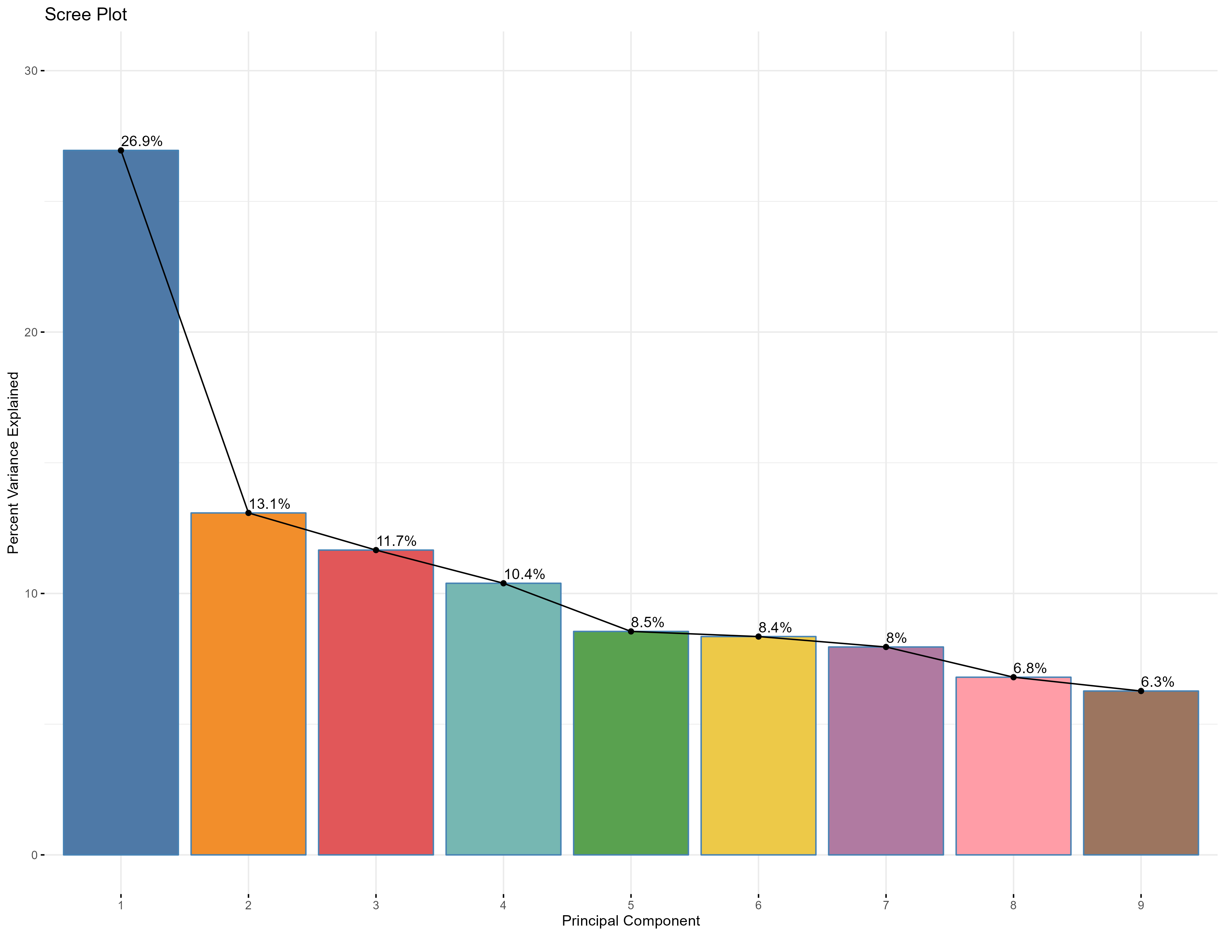Supplementary Figure S10.1. Principal Component Analysis (PCA) of pro- and anti-inflammatory cytokine levels in Bialystok PLUS cohort. The bar plot represents the percentage of variance explained by each principal component, with the first principal component capturing the largest proportion (26.9%). The line plot indicates the cumulative variance explained across components, illustrating the contribution of each component to the overall variability in cytokine expression.

Supplementary Figure S10.2. Principal Component Analysis (PCA) bi-plots showing the contribution of pro- and anti-inflammatory cytokines to different principal components in Bialystok PLUS cohort. Each panel represents a pair of principal components (PC1 & PC2, PC3 & PC4, PC5 & PC6, and PC7 & PC8). The length and direction of the arrows indicate the influence of individual cytokines on the respective principal components, while the color scale represents their contribution magnitude. Cytokines with higher contributions are highlighted in warmer colors, indicating their stronger influence on variance in the dataset.

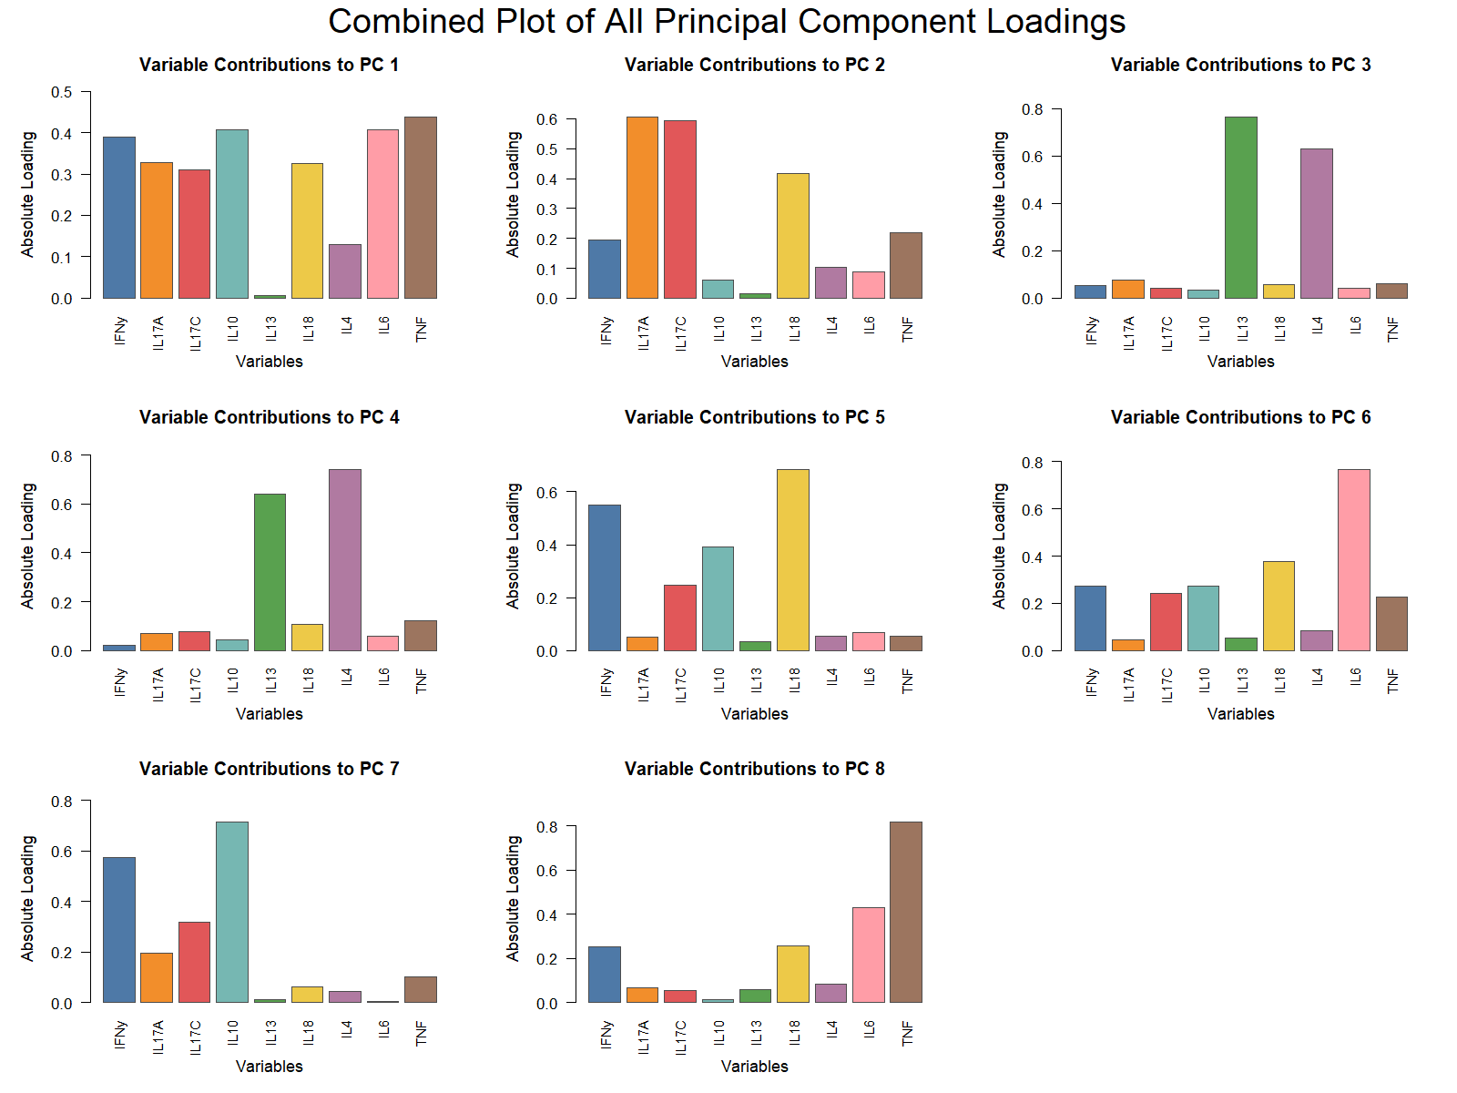Supplementary Figure S10.3. Bar plots showing the variance contributions of individual cytokines to different principal components (PCs) from Principal Component Analysis (PCA) in Bialystok PLUS cohort. Each plot represents a specific PC, with bars indicating the proportion of variance explained by each cytokine. Higher bars suggest stronger contributions to the respective PC, highlighting cytokines that drive variability in the dataset.

PC1 Model Results
term | estimate | std.error | statistic | p.value | conf.low | conf.high | Model
(Intercept) | -1.038 | 0.189 | -5.488 | 0.000 | -1.409 | -0.667 | Model 1
Age | 0.021 | 0.004 | 5.748 | 0.000 | 0.014 | 0.029 | Model 1
(Intercept) | -2.138 | 0.346 | -6.183 | 0.000 | -2.817 | -1.459 | Model 2
Age | 0.020 | 0.004 | 4.939 | 0.000 | 0.012 | 0.028 | Model 2
SexFemale | -0.075 | 0.120 | -0.628 | 0.530 | -0.310 | 0.160 | Model 2
SmokingFormer | -0.057 | 0.128 | -0.445 | 0.656 | -0.309 | 0.195 | Model 2
SmokingCurrent | 0.529 | 0.151 | 3.492 | 0.001 | 0.232 | 0.826 | Model 2
AlcoholModerate | 0.092 | 0.152 | 0.608 | 0.544 | -0.206 | 0.390 | Model 2
AlcoholHeavy | 0.137 | 0.177 | 0.778 | 0.437 | -0.210 | 0.484 | Model 2
BMI | 0.040 | 0.012 | 3.305 | 0.001 | 0.016 | 0.064 | Model 2
(Intercept) | -1.550 | 0.393 | -3.949 | 0.000 | -2.321 | -0.780 | Model 3
Age (Spline 1) | 0.454 | 0.247 | 1.837 | 0.067 | -0.031 | 0.940 | Model 3
Age (Spline 2) | 0.989 | 0.603 | 1.640 | 0.101 | -0.195 | 2.174 | Model 3
Age (Spline 3) | 1.113 | 0.268 | 4.159 | 0.000 | 0.588 | 1.638 | Model 3
SexFemale | -0.074 | 0.120 | -0.619 | 0.536 | -0.309 | 0.161 | Model 3
SmokingFormer | -0.068 | 0.129 | -0.531 | 0.596 | -0.321 | 0.184 | Model 3
SmokingCurrent | 0.529 | 0.152 | 3.490 | 0.001 | 0.231 | 0.827 | Model 3
AlcoholModerate | 0.080 | 0.152 | 0.526 | 0.599 | -0.218 | 0.378 | Model 3
AlcoholHeavy | 0.123 | 0.177 | 0.692 | 0.489 | -0.225 | 0.471 | Model 3
BMI | 0.041 | 0.012 | 3.372 | 0.001 | 0.017 | 0.065 | Model 3
Supplementary Table S5. Summary of regression models examining the association between age and the inflammaging axis (PC1) in PLUS cohort.
Model 1 includes age only (PC1 ~ age). Model 2 additionally adjusts for sex, smoking status, alcohol consumption, and body mass index (PC1 ~ age + covariates). Model 3 models age non-linearly using natural cubic splines (3 degrees of freedom) while adjusting for the same covariates. Reported metrics include estimates, standard errors, test statistics, p-values, and 95% confidence intervals.

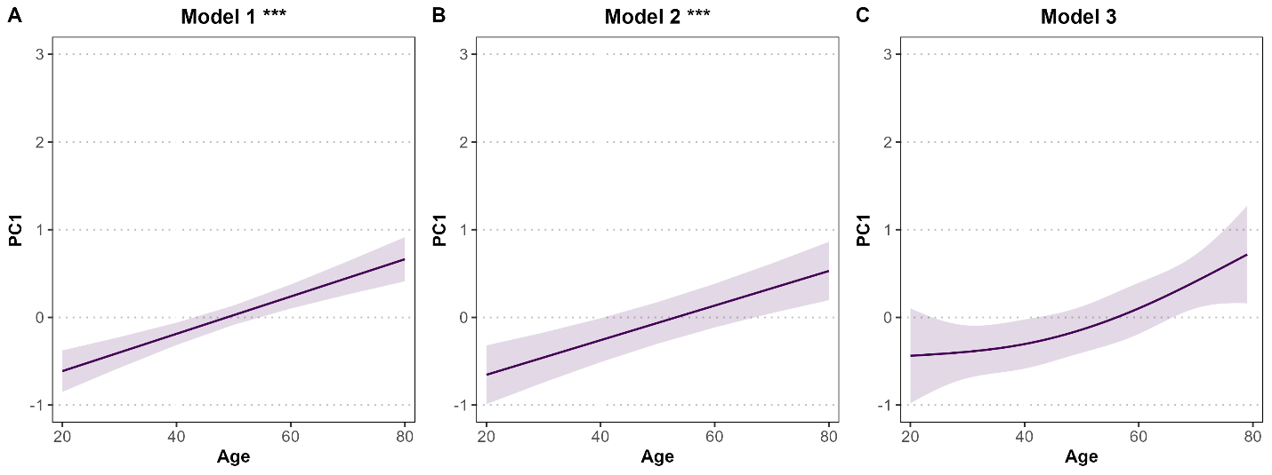
Supplementary Figure S11. Age-related changes in the inflammaging axis (PC1) in PLUS cohort.
Predicted values of the first principal component (PC1), representing a composite inflammaging cytokine axis, are shown as a function of age. Panel A (Model 1) shows the association between age and PC1 without covariate adjustment and is included as a sensitivity analysis. Panel B (Model 2) shows the age–PC1 association adjusted for sex, smoking status, alcohol consumption, and body mass index and is also included as a sensitivity analysis. Panel C (Model 3), the primary analysis, models age non-linearly using natural cubic splines (3 degrees of freedom) while adjusting for the same covariates. Solid lines indicate model-predicted values and shaded areas represent 95% confidence intervals. Asterisks denote statistical significance of the age effect (p < 0.05; p < 0.01; p < 0.001).

Absolute IL6 Analysis
 | Female | Male | Overall
 | (N=196) | (N=171) | (N=367)
Age
Mean (SD) | 55 (15) | 50 (16) | 53 (16)
Median [Min, Max] | 60 [20, 79] | 49 [20, 78] | 54 [20, 79]
Smoking
Current | 35 (17.9%) | 45 (26.3%) | 80 (21.8%)
Former | 77 (39.3%) | 68 (39.8%) | 145 (39.5%)
Never | 84 (42.9%) | 58 (33.9%) | 142 (38.7%)
Alcohol
Heavy | 5 (2.6%) | 47 (27.5%) | 52 (14.2%)
Mild | 162 (82.7%) | 84 (49.1%) | 246 (67.0%)
Moderate | 29 (14.8%) | 40 (23.4%) | 69 (18.8%)
BMI
Mean (SD) | 28 (5.5) | 28 (4.4) | 28 (5.0)
Median [Min, Max] | 27 [17, 47] | 28 [18, 42] | 28 [17, 47]
IL-6
Mean (SD) | 5.0 (9.5) | 3.5 (3.0) | 4.3 (7.2)
Median [Min, Max] | 3.0 [1.5, 100] | 2.5 [1.5, 20] | 2.8 [1.5, 100]
Supplementary Table S6. Baseline characteristics of Bialystok PLUS participants, stratified by sex. Variables include demographic and lifestyle factors (age, smoking status, alcohol consumption, BMI, and sex), as well as absolute IL-6 (pg/mL). For continuous variables, means, standard deviations, medians, and ranges are presented; for categorical variables, frequencies and percentages are shown. Missing IL-6 data were excluded from respective model in the final analysis.

IL6 Model Results
term | estimate | std.error | statistic | p.value | conf.low | conf.high
Intercept | 0.358 | 0.198 | 1.805 | 0.072 | -0.032 | 0.748
SexMale | -0.165 | 0.071 | -2.332 | 0.020 | -0.304 | -0.026
Age | 0.005 | 0.002 | 2.188 | 0.029 | 0.001 | 0.009
BMI | 0.019 | 0.007 | 2.849 | 0.005 | 0.006 | 0.033
SmokingCurrent | 0.139 | 0.090 | 1.547 | 0.123 | -0.038 | 0.315
SmokingFormer | 0.050 | 0.075 | 0.667 | 0.505 | -0.098 | 0.199
AlcoholHeavy | 0.031 | 0.108 | 0.288 | 0.773 | -0.180 | 0.243
AlcoholModerate | -0.011 | 0.089 | -0.126 | 0.900 | -0.186 | 0.164
Supplementary Table S7. Linear regression results for log-transformed IL-6 levels (pg/mL) in the Bialystok PLUS cohort (Sensitivity Model). The model includes sex, age, BMI, smoking status, and alcohol consumption as predictors. IL-6 levels were log-transformed to approximate normality. Reported are the regression coefficients (estimates), standard errors, test statistics, p-values, and 95% confidence intervals (conf.low, conf.high). Sex is coded as male vs. female; smoking status and alcohol consumption are categorized relative to never smokers and mild drinkers, respectively.

IL6 Model Results
term | estimate | std.error | statistic | p.value | conf.low | conf.high
Intercept | 2.259 | 2.324 | 0.972 | 0.332 | -2.311 | 6.829
SexMale | -1.689 | 0.828 | -2.039 | 0.042 | -3.317 | -0.060
Age | 0.016 | 0.027 | 0.602 | 0.548 | -0.036 | 0.068
BMI | 0.052 | 0.079 | 0.661 | 0.509 | -0.104 | 0.208
SmokingCurrent | 0.268 | 1.049 | 0.255 | 0.799 | -1.796 | 2.332
SmokingFormer | 0.501 | 0.884 | 0.567 | 0.571 | -1.237 | 2.238
AlcoholHeavy | 0.150 | 1.260 | 0.119 | 0.905 | -2.328 | 2.627
AlcoholModerate | 1.242 | 1.044 | 1.190 | 0.235 | -0.811 | 3.294
Supplementary Table S8. Linear regression results for Raw IL-6 levels (pg/mL) in the Bialystok PLUS cohort (Main Model). The model includes sex, age, BMI, smoking status, and alcohol consumption as predictors. IL-6 levels were not log-transformed for clinical interpretability. Reported are the regression coefficients (estimates), standard errors, test statistics, p-values, and 95% confidence intervals (conf.low, conf.high). Sex is coded as male vs. female; smoking status and alcohol consumption are categorized relative to never smokers and mild drinkers, respectively.

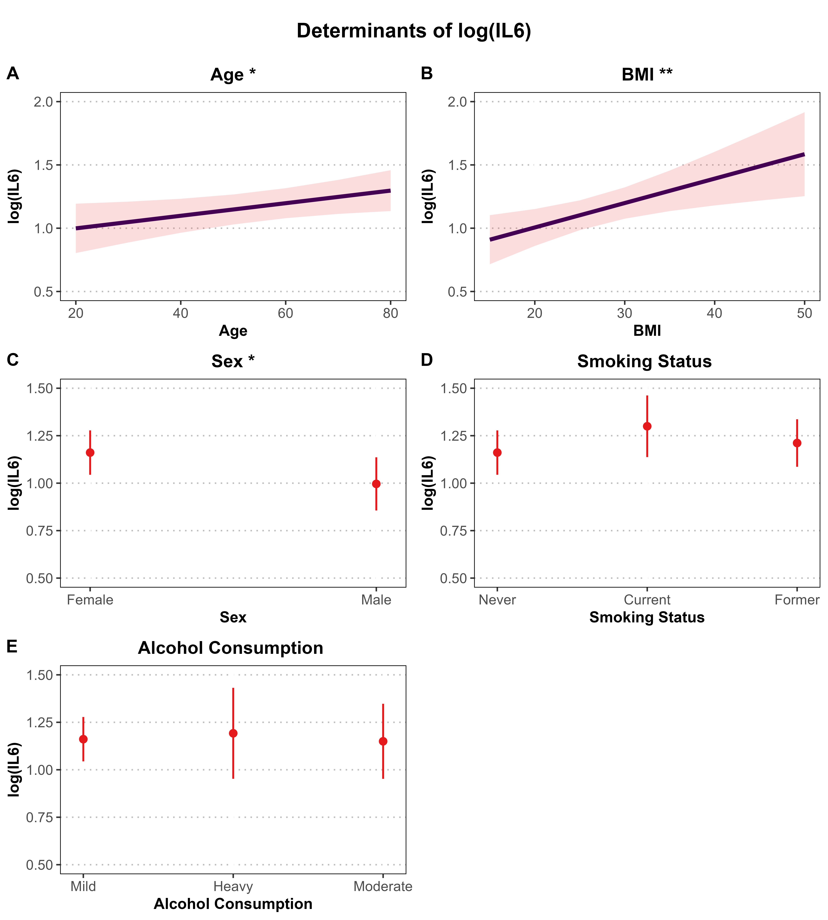
Supplementary Figure S12. Determinants of log-transformed IL-6 levels (pg/mL) in the Bialystok PLUS cohort (Sensitivity Model). Associations are based on a multivariable linear regression model adjusted for age, sex, BMI, smoking status, and alcohol consumption. Panels A and B show continuous predictors (age and BMI) with regression lines and 95% confidence intervals (shaded areas). Panels C–E present categorical predictors (sex, smoking status, and alcohol consumption) with point estimates and 95% confidence intervals (vertical error bars). Y-axis ranges are scaled to match the SHIP IL-6 analysis: 0.5–2.0 for continuous variables (A–B) to reflect greater variability, and 0.5–1.5 for categorical variables (C–E) to enhance comparability. IL-6 levels were log-transformed prior to analysis. Asterisks indicate statistical significance (*P < 0.05; **P < 0.01).

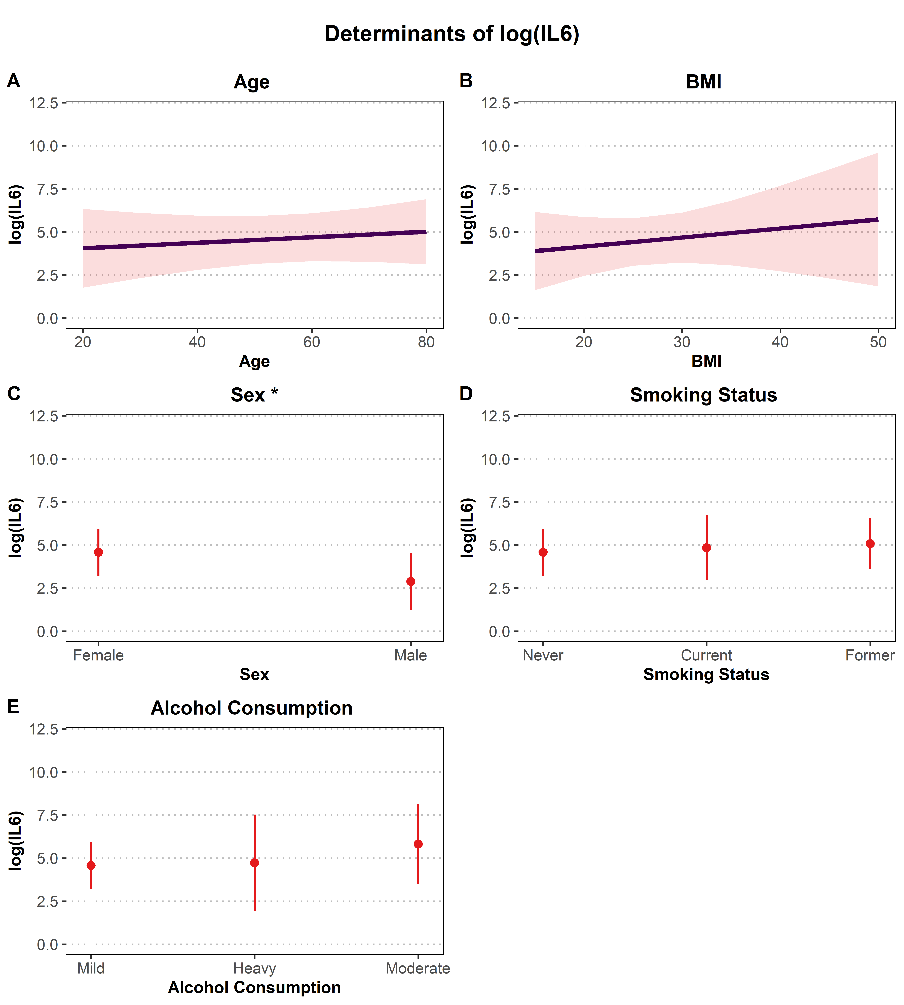
Supplementary Figure S13. Determinants of Raw IL-6 levels (pg/mL) in the Bialystok PLUS cohort (Main Model). Associations are based on a multivariable linear regression model adjusted for age, sex, BMI, smoking status, and alcohol consumption. Panels A and B show continuous predictors (age and BMI) with regression lines and 95% confidence intervals (shaded areas). Panels C–E present categorical predictors (sex, smoking status, and alcohol consumption) with point estimates and 95% confidence intervals (vertical error bars). Y-axis ranges are scaled to match the SHIP IL-6 analysis: 0.0–12.5 for variables (A–E) to enhance comparability. IL-6 levels were not log-transformed prior to analysis for clinical interpretability. Asterisks indicate statistical significance (*P < 0.05; **P < 0.01).

