Additional File 1: Rotterdam Study
Main Analysis
Sex Stratified Analysis
Principal Component Analysis

Main Analysis
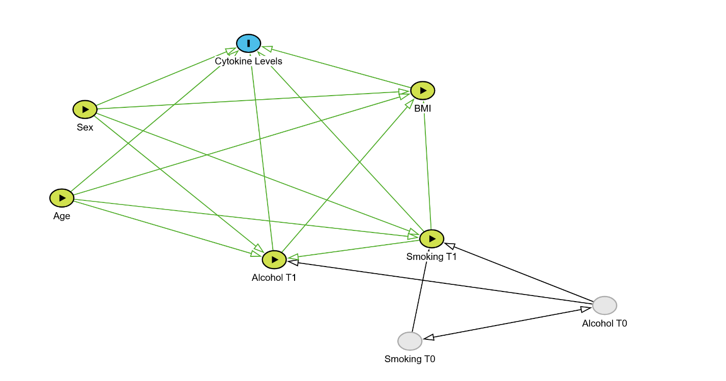
Supplementary Figure S1. Directed Acyclic Graph (DAG) illustrating the hypothesized relationships between exposures and outcome variables. The exposure variables include modifiable factors (BMI, smoking, alcohol consumption) and non-modifiable factors (sex, age). The outcome variable is cytokine levels. BMI is shown as both a potential determinant of cytokine levels and a mediator that may be influenced by smoking, alcohol consumption, and other factors. Smoking T0 and Alcohol T0 are included to represent prior exposures that could influence the measured levels of smoking and alcohol consumption. The DAG reflects the complicated relationships among exposures and their potential impact on cytokine levels.

 | Female | Male | Overall
 | (N=1950) | (N=1506) | (N=3456)
Age
Mean (SD) | 57 (6.9) | 57 (6.5) | 57 (6.8)
Median [Min, Max] | 57 [46, 97] | 57 [46, 87] | 57 [46, 97]
Smoking
Never | 692 (35.5%) | 421 (28.0%) | 1113 (32.2%)
Former | 812 (41.6%) | 732 (48.6%) | 1544 (44.7%)
Current | 446 (22.9%) | 353 (23.4%) | 799 (23.1%)
Alcohol
Mild | 1645 (84.4%) | 955 (63.4%) | 2600 (75.2%)
Moderate | 264 (13.5%) | 365 (24.2%) | 629 (18.2%)
Heavy | 41 (2.1%) | 186 (12.4%) | 227 (6.6%)
BMI
Mean (SD) | 28 (5.0) | 28 (4.0) | 28 (4.6)
Median [Min, Max] | 27 [13, 57] | 27 [18, 47] | 27 [13, 57]
IL-4
Mean (SD) | 0.0096 (0.97) | -0.013 (1.0) | 0.00 (1.0)
Median [Min, Max] | -0.20 [-2.0, 7.1] | -0.22 [-2.2, 8.0] | -0.21 [-2.2, 8.0]
IL-13
Mean (SD) | 0.0069 (1.0) | -0.0093 (0.97) | 0.00 (1.0)
Median [Min, Max] | -0.24 [-1.5, 11] | -0.22 [-1.4, 11] | -0.23 [-1.5, 11]
IL-10
Mean (SD) | -0.033 (1.0) | 0.045 (0.94) | 0.00 (1.0)
Median [Min, Max] | -0.16 [-3.8, 17] | -0.092 [-2.4, 12] | -0.14 [-3.8, 17]
IL-6
Mean (SD) | -0.0072 (0.99) | 0.010 (1.0) | 0.04 (1.0)
Median [Min, Max] | -0.15 [-2.8, 7.8] | -0.15 [-1.9, 10] | -0.15 [-2.8, 10]
TNF
Mean (SD) | 0.029 (0.98) | -0.034 (1.0) | 0.00 (1.0)
Median [Min, Max] | -0.13 [-3.3, 9.3] | -0.19 [-2.2, 11] | -0.16 [-3.3, 11]
IL-18
Mean (SD) | -0.17 (0.99) | 0.23 (0.93) | 0.00 (0.98)
Median [Min, Max] | -0.22 [-4.5, 5.0] | 0.20 [-4.0, 4.9] | -0.051 [-4.5, 5.0]
IFN-γ
Mean (SD) | 0.073 (0.99) | -0.093 (1.0) | 0.00 (1.0)
Median [Min, Max] | -0.11 [-4.2, 6.5] | -0.26 [-3.1, 7.4] | -0.16 [-4.2, 7.4]
IL-17A
Mean (SD) | 0.0048 (0.97) | -0.0060 (1.0) | 0.00 (1.0)
Median [Min, Max] | -0.19 [-2.0, 7.4] | -0.23 [-2.0, 11] | -0.21 [-2.0, 11]
IL-17C
Mean (SD) | -0.13 (0.94) | 0.17 (1.0) | 0.000021 (1.0)
Median [Min, Max] | -0.25 [-3.0, 8.5] | -0.015 [-2.3, 11] | -0.15 [-3.0, 11]
Supplementary Table S1. Baseline characteristics of Rotterdam Study participants, stratified by sex. Variables include demographic and lifestyle factors (age, smoking status, alcohol consumption, BMI, and sex), as well as cytokine levels. Pro-inflammatory cytokines: IL-6, IL-18, TNF, IFN-γ, IL-17A, IL-17C; anti-inflammatory cytokines: IL-4, IL-13, IL-10. For continuous variables, means, standard deviations, medians, and ranges are presented; for categorical variables, frequencies and percentages are shown. Missing cytokine data are indicated and were excluded from respective models in the final analysis.
Cytokine Model Results
term | estimate | std.error | statistic | p.value | conf.low | conf.high | Model
(Intercept) | 0.567 | 0.315 | 1.802 | 0.072 | -0.050 | 1.184 | IL13
age | -0.005 | 0.003 | -1.833 | 0.067 | -0.010 | 0.000 | IL13
sexFemale | 0.003 | 0.036 | 0.081 | 0.935 | -0.068 | 0.074 | IL13
alcohol_consumptionModerate | -0.028 | 0.046 | -0.621 | 0.535 | -0.118 | 0.061 | IL13
alcohol_consumptionHeavy | 0.026 | 0.072 | 0.368 | 0.713 | -0.114 | 0.167 | IL13
smokingFormer | -0.053 | 0.040 | -1.321 | 0.187 | -0.131 | 0.026 | IL13
smokingCurrent | -0.100 | 0.047 | -2.122 | 0.034 | -0.193 | -0.008 | IL13
BMI (Spline 1) | -0.137 | 0.139 | -0.990 | 0.322 | -0.409 | 0.135 | IL13
BMI (Spline 2) | -0.219 | 0.609 | -0.359 | 0.720 | -1.412 | 0.975 | IL13
BMI (Spline 3) | 0.442 | 0.391 | 1.131 | 0.258 | -0.324 | 1.209 | IL13
(Intercept) | 0.426 | 0.315 | 1.354 | 0.176 | -0.191 | 1.044 | IL4
age | -0.005 | 0.003 | -2.047 | 0.041 | -0.010 | -0.000 | IL4
sexFemale | 0.021 | 0.036 | 0.582 | 0.561 | -0.050 | 0.092 | IL4
smokingFormer | -0.027 | 0.040 | -0.674 | 0.500 | -0.105 | 0.051 | IL4
smokingCurrent | -0.070 | 0.047 | -1.484 | 0.138 | -0.163 | 0.023 | IL4
alcohol_consumptionModerate | 0.002 | 0.046 | 0.042 | 0.966 | -0.087 | 0.091 | IL4
alcohol_consumptionHeavy | 0.047 | 0.072 | 0.655 | 0.513 | -0.094 | 0.188 | IL4
BMI (Spline 1) | -0.075 | 0.139 | -0.539 | 0.590 | -0.347 | 0.197 | IL4
BMI (Spline 2) | -0.063 | 0.609 | -0.103 | 0.918 | -1.257 | 1.132 | IL4
BMI (Spline 3) | 0.280 | 0.391 | 0.716 | 0.474 | -0.487 | 1.048 | IL4
(Intercept) | 0.569 | 0.313 | 1.822 | 0.069 | -0.043 | 1.182 | IL10
age | 0.009 | 0.003 | 3.607 | 0.000 | 0.004 | 0.014 | IL10
sexFemale | -0.083 | 0.036 | -2.325 | 0.020 | -0.153 | -0.013 | IL10
smokingFormer | -0.004 | 0.040 | -0.090 | 0.928 | -0.081 | 0.074 | IL10
smokingCurrent | 0.100 | 0.047 | 2.140 | 0.032 | 0.008 | 0.192 | IL10
alcohol_consumptionModerate | 0.039 | 0.045 | 0.851 | 0.395 | -0.050 | 0.127 | IL10
alcohol_consumptionHeavy | 0.039 | 0.071 | 0.544 | 0.586 | -0.101 | 0.179 | IL10
BMI (Spline 1) | -0.118 | 0.138 | -0.856 | 0.392 | -0.388 | 0.152 | IL10
BMI (Spline 2) | -2.225 | 0.605 | -3.679 | 0.000 | -3.411 | -1.039 | IL10
BMI (Spline 3) | -0.678 | 0.388 | -1.745 | 0.081 | -1.440 | 0.084 | IL10
(Intercept) | -2.210 | 0.284 | -7.782 | 0.000 | -2.767 | -1.653 | IL6
age | 0.035 | 0.002 | 15.187 | 0.000 | 0.030 | 0.039 | IL6
sexFemale | -0.015 | 0.033 | -0.472 | 0.637 | -0.079 | 0.048 | IL6
smokingFormer | 0.053 | 0.036 | 1.474 | 0.140 | -0.018 | 0.124 | IL6
smokingCurrent | 0.536 | 0.043 | 12.566 | 0.000 | 0.452 | 0.619 | IL6
alcohol_consumptionModerate | -0.017 | 0.041 | -0.420 | 0.674 | -0.098 | 0.063 | IL6
alcohol_consumptionHeavy | 0.099 | 0.065 | 1.528 | 0.127 | -0.028 | 0.226 | IL6
BMI (Spline 1) | 0.743 | 0.125 | 5.935 | 0.000 | 0.497 | 0.988 | IL6
BMI (Spline 2) | 1.560 | 0.550 | 2.839 | 0.005 | 0.483 | 2.638 | IL6
BMI (Spline 3) | 3.099 | 0.353 | 8.779 | 0.000 | 2.407 | 3.791 | IL6
(Intercept) | -0.024 | 0.276 | -0.088 | 0.930 | -0.566 | 0.517 | IL18
Age (Spline 1) | 0.091 | 0.107 | 0.852 | 0.394 | -0.118 | 0.300 | IL18
Age (Spline 2) | 0.807 | 0.208 | 3.883 | 0.000 | 0.399 | 1.214 | IL18
Age (Spline 3) | 0.716 | 0.261 | 2.742 | 0.006 | 0.204 | 1.228 | IL18
sexFemale | -0.412 | 0.034 | -12.024 | 0.000 | -0.479 | -0.345 | IL18
smokingFormer | 0.001 | 0.038 | 0.021 | 0.984 | -0.074 | 0.075 | IL18
smokingCurrent | 0.210 | 0.045 | 4.678 | 0.000 | 0.122 | 0.298 | IL18
alcohol_consumptionModerate | -0.052 | 0.043 | -1.212 | 0.226 | -0.137 | 0.032 | IL18
alcohol_consumptionHeavy | -0.047 | 0.068 | -0.685 | 0.494 | -0.181 | 0.087 | IL18
BMI (Spline 1) | 0.188 | 0.132 | 1.428 | 0.153 | -0.070 | 0.447 | IL18
BMI (Spline 2) | 0.571 | 0.579 | 0.987 | 0.324 | -0.563 | 1.706 | IL18
BMI (Spline 3) | 1.299 | 0.372 | 3.493 | 0.000 | 0.570 | 2.028 | IL18
(Intercept) | -1.466 | 0.309 | -4.751 | 0.000 | -2.071 | -0.861 | TNF
age | 0.024 | 0.002 | 9.618 | 0.000 | 0.019 | 0.029 | TNF
sexFemale | 0.046 | 0.035 | 1.289 | 0.198 | -0.024 | 0.115 | TNF
smokingFormer | 0.039 | 0.039 | 1.006 | 0.315 | -0.037 | 0.116 | TNF
smokingCurrent | -0.026 | 0.046 | -0.567 | 0.571 | -0.117 | 0.065 | TNF
alcohol_consumptionModerate | -0.018 | 0.045 | -0.393 | 0.694 | -0.105 | 0.070 | TNF
alcohol_consumptionHeavy | -0.086 | 0.070 | -1.227 | 0.220 | -0.224 | 0.052 | TNF
BMI (Spline 1) | 0.121 | 0.136 | 0.893 | 0.372 | -0.145 | 0.388 | TNF
BMI (Spline 2) | 0.619 | 0.597 | 1.036 | 0.300 | -0.552 | 1.789 | TNF
BMI (Spline 3) | 1.033 | 0.384 | 2.693 | 0.007 | 0.281 | 1.785 | TNF
(Intercept) | -0.127 | 0.313 | -0.404 | 0.686 | -0.740 | 0.487 | IL17A
age | 0.016 | 0.003 | 6.158 | 0.000 | 0.011 | 0.020 | IL17A
sexFemale | -0.018 | 0.036 | -0.490 | 0.624 | -0.088 | 0.053 | IL17A
smokingFormer | -0.022 | 0.040 | -0.561 | 0.575 | -0.100 | 0.056 | IL17A
smokingCurrent | 0.026 | 0.047 | 0.560 | 0.576 | -0.066 | 0.118 | IL17A
alcohol_consumptionModerate | -0.036 | 0.045 | -0.791 | 0.429 | -0.125 | 0.053 | IL17A
alcohol_consumptionHeavy | -0.075 | 0.071 | -1.049 | 0.294 | -0.215 | 0.065 | IL17A
BMI (Spline 1) | -0.167 | 0.138 | -1.213 | 0.225 | -0.437 | 0.103 | IL17A
BMI (Spline 2) | -1.378 | 0.606 | -2.276 | 0.023 | -2.566 | -0.191 | IL17A
BMI (Spline 3) | -0.188 | 0.389 | -0.482 | 0.630 | -0.950 | 0.575 | IL17A
(Intercept) | 0.609 | 0.284 | 2.145 | 0.032 | 0.052 | 1.166 | IL17C
Age (Spline 1) | 0.009 | 0.110 | 0.078 | 0.937 | -0.206 | 0.224 | IL17C
Age (Spline 2) | 0.913 | 0.214 | 4.276 | 0.000 | 0.495 | 1.332 | IL17C
Age (Spline 3) | 1.583 | 0.269 | 5.895 | 0.000 | 1.056 | 2.110 | IL17C
sexFemale | -0.322 | 0.035 | -9.137 | 0.000 | -0.391 | -0.253 | IL17C
smokingFormer | -0.100 | 0.039 | -2.554 | 0.011 | -0.176 | -0.023 | IL17C
smokingCurrent | 0.108 | 0.046 | 2.338 | 0.019 | 0.017 | 0.198 | IL17C
alcohol_consumptionModerate | 0.040 | 0.045 | 0.892 | 0.373 | -0.048 | 0.127 | IL17C
alcohol_consumptionHeavy | 0.047 | 0.070 | 0.665 | 0.506 | -0.091 | 0.184 | IL17C
BMI (Spline 1) | 0.031 | 0.136 | 0.230 | 0.818 | -0.235 | 0.297 | IL17C
BMI (Spline 2) | -0.697 | 0.595 | -1.171 | 0.242 | -1.864 | 0.470 | IL17C
BMI (Spline 3) | 0.389 | 0.382 | 1.016 | 0.310 | -0.361 | 1.138 | IL17C
(Intercept) | -0.840 | 0.311 | -2.703 | 0.007 | -1.449 | -0.231 | IFNy
age | 0.018 | 0.003 | 7.181 | 0.000 | 0.013 | 0.023 | IFNy
sexFemale | 0.174 | 0.036 | 4.887 | 0.000 | 0.104 | 0.244 | IFNy
smokingFormer | -0.033 | 0.039 | -0.830 | 0.407 | -0.110 | 0.045 | IFNy
smokingCurrent | -0.152 | 0.047 | -3.258 | 0.001 | -0.243 | -0.061 | IFNy
alcohol_consumptionModerate | 0.077 | 0.045 | 1.711 | 0.087 | -0.011 | 0.165 | IFNy
alcohol_consumptionHeavy | 0.141 | 0.071 | 1.994 | 0.046 | 0.002 | 0.280 | IFNy
BMI (Spline 1) | -0.138 | 0.137 | -1.005 | 0.315 | -0.406 | 0.131 | IFNy
BMI (Spline 2) | -0.352 | 0.601 | -0.585 | 0.558 | -1.531 | 0.827 | IFNy
BMI (Spline 3) | 0.181 | 0.386 | 0.470 | 0.638 | -0.576 | 0.939 | IFNy
Supplementary Table S2. Fully adjusted linear regression results for all participants, assessing associations with cytokine levels in the Rotterdam Study. Models adjust for age, smoking status (current and former vs. never), alcohol consumption (moderate and heavy vs. mild), and BMI. Natural splines with 3 degrees of freedom were applied to age or BMI in select models, indicated as Spline 1–3. Cytokine levels were z-transformed; estimates represent changes per standard deviation. Reported metrics include estimates, standard errors, test statistics, p-values, and 95% confidence intervals.

Cytokine Model Results: Unadjusted vs FDR-Adjusted P-values
Model | Term | Unadjusted  p_value | Adjusted  p_value | Significant  FDR | Change in Significance
IL13 | age | 0.067 | 0.156 | FALSE | No Change
IL13 | alcohol_consumptionHeavy | 0.713 | 0.761 | FALSE | No Change
IL13 | alcohol_consumptionModerate | 0.535 | 0.697 | FALSE | No Change
IL13 | sexFemale | 0.935 | 0.966 | FALSE | No Change
IL13 | smokingCurrent | 0.034 | 0.089 | FALSE | Significant to Non-Significant
IL13 | smokingFormer | 0.187 | 0.356 | FALSE | No Change
IL13 | Overall BMI Spline | 0.129 | 0.271 | FALSE | No Change
IL4 | age | 0.041 | 0.103 | FALSE | Significant to Non-Significant
IL4 | alcohol_consumptionHeavy | 0.513 | 0.687 | FALSE | No Change
IL4 | alcohol_consumptionModerate | 0.966 | 0.982 | FALSE | No Change
IL4 | sexFemale | 0.561 | 0.697 | FALSE | No Change
IL4 | smokingCurrent | 0.138 | 0.277 | FALSE | No Change
IL4 | smokingFormer | 0.500 | 0.687 | FALSE | No Change
IL4 | Overall BMI Spline | 0.630 | 0.716 | FALSE | No Change
IL10 | age | <0.001 | 0.001 | TRUE | No Change
IL10 | alcohol_consumptionHeavy | 0.586 | 0.697 | FALSE | No Change
IL10 | alcohol_consumptionModerate | 0.395 | 0.622 | FALSE | No Change
IL10 | sexFemale | 0.020 | 0.058 | FALSE | Significant to Non-Significant
IL10 | smokingCurrent | 0.032 | 0.089 | FALSE | Significant to Non-Significant
IL10 | smokingFormer | 0.928 | 0.966 | FALSE | No Change
IL10 | Overall BMI Spline | <0.001 | <0.001 | TRUE | No Change
IL6 | age | <0.001 | <0.001 | TRUE | No Change
IL6 | alcohol_consumptionHeavy | 0.127 | 0.271 | FALSE | No Change
IL6 | alcohol_consumptionModerate | 0.674 | 0.745 | FALSE | No Change
IL6 | sexFemale | 0.637 | 0.716 | FALSE | No Change
IL6 | smokingCurrent | <0.001 | <0.001 | TRUE | No Change
IL6 | smokingFormer | 0.140 | 0.277 | FALSE | No Change
IL6 | Overall BMI Spline | <0.001 | <0.001 | TRUE | No Change
IL18 | alcohol_consumptionHeavy | 0.494 | 0.687 | FALSE | No Change
IL18 | alcohol_consumptionModerate | 0.226 | 0.395 | FALSE | No Change
IL18 | sexFemale | <0.001 | <0.001 | TRUE | No Change
IL18 | smokingCurrent | <0.001 | <0.001 | TRUE | No Change
IL18 | smokingFormer | 0.984 | 0.984 | FALSE | No Change
IL18 | Overall Age Spline | 0.001 | 0.004 | TRUE | No Change
IL18 | Overall BMI Spline | <0.001 | <0.001 | TRUE | No Change
TNF | age | <0.001 | <0.001 | TRUE | No Change
TNF | alcohol_consumptionHeavy | 0.220 | 0.395 | FALSE | No Change
TNF | alcohol_consumptionModerate | 0.694 | 0.754 | FALSE | No Change
TNF | sexFemale | 0.198 | 0.366 | FALSE | No Change
TNF | smokingCurrent | 0.571 | 0.697 | FALSE | No Change
TNF | smokingFormer | 0.315 | 0.522 | FALSE | No Change
TNF | Overall BMI Spline | <0.001 | <0.001 | TRUE | No Change
IL17A | age | <0.001 | <0.001 | TRUE | No Change
IL17A | alcohol_consumptionHeavy | 0.294 | 0.501 | FALSE | No Change
IL17A | alcohol_consumptionModerate | 0.429 | 0.644 | FALSE | No Change
IL17A | sexFemale | 0.624 | 0.716 | FALSE | No Change
IL17A | smokingCurrent | 0.576 | 0.697 | FALSE | No Change
IL17A | smokingFormer | 0.575 | 0.697 | FALSE | No Change
IL17A | Overall BMI Spline | 0.005 | 0.016 | TRUE | No Change
IL17C | alcohol_consumptionHeavy | 0.506 | 0.687 | FALSE | No Change
IL17C | alcohol_consumptionModerate | 0.373 | 0.602 | FALSE | No Change
IL17C | sexFemale | <0.001 | <0.001 | TRUE | No Change
IL17C | smokingCurrent | 0.019 | 0.058 | FALSE | Significant to Non-Significant
IL17C | smokingFormer | 0.011 | 0.034 | TRUE | No Change
IL17C | Overall Age Spline | <0.001 | <0.001 | TRUE | No Change
IL17C | Overall BMI Spline | <0.001 | <0.001 | TRUE | No Change
IFNy | age | <0.001 | <0.001 | TRUE | No Change
IFNy | alcohol_consumptionHeavy | 0.046 | 0.112 | FALSE | Significant to Non-Significant
IFNy | alcohol_consumptionModerate | 0.087 | 0.196 | FALSE | No Change
IFNy | sexFemale | <0.001 | <0.001 | TRUE | No Change
IFNy | smokingCurrent | 0.001 | 0.004 | TRUE | No Change
IFNy | smokingFormer | 0.407 | 0.625 | FALSE | No Change
IFNy | Overall BMI Spline | 0.478 | 0.687 | FALSE | No Change
Supplementary Table S3. Comparison of fully adjusted model with and without FDR multiple testing correction. This table presents the unadjusted and FDR-adjusted p-values for each determinant (age, sex, BMI, smoking, and alcohol) along with the changes in significance. FDR correction was applied to the association between each determinant and the given cytokine, with the correction specifically applied to the overall spline p-values for the non-linear determinants (BMI and age) and excluding the intercept. The main cytokine findings remain consistent before and after adjustment, with key cytokines (IL-6, IL-18, IFN-γ, IL-17C, and IL-10) continuing to show significant associations across the determinants.

Sex Stratified Analysis
Sex-Stratified Models (Males)
term | estimate | std.error | statistic | p.value | conf.low | conf.high | Model
(Intercept) | -2.930 | 0.283 | -10.361 | 0.000 | -3.485 | -2.375 | IL6
age | 0.042 | 0.004 | 11.474 | 0.000 | 0.035 | 0.050 | IL6
smokingFormer | 0.124 | 0.057 | 2.168 | 0.030 | 0.012 | 0.237 | IL6
smokingCurrent | 0.661 | 0.067 | 9.804 | 0.000 | 0.528 | 0.793 | IL6
alcohol_consumptionModerate | 0.001 | 0.057 | 0.021 | 0.983 | -0.111 | 0.113 | IL6
alcohol_consumptionHeavy | 0.140 | 0.075 | 1.881 | 0.060 | -0.006 | 0.287 | IL6
BMI (Spline 1) | 0.427 | 0.131 | 3.266 | 0.001 | 0.171 | 0.684 | IL6
BMI (Spline 2) | 1.397 | 0.422 | 3.307 | 0.001 | 0.568 | 2.226 | IL6
BMI (Spline 3) | 1.940 | 0.294 | 6.600 | 0.000 | 1.363 | 2.516 | IL6
(Intercept) | -0.567 | 0.218 | -2.606 | 0.009 | -0.994 | -0.140 | IL18
Age (Spline 1) | 0.093 | 0.130 | 0.713 | 0.476 | -0.162 | 0.347 | IL18
Age (Spline 2) | 0.833 | 0.265 | 3.149 | 0.002 | 0.314 | 1.352 | IL18
Age (Spline 3) | 0.695 | 0.251 | 2.768 | 0.006 | 0.202 | 1.187 | IL18
smokingFormer | 0.025 | 0.058 | 0.437 | 0.662 | -0.088 | 0.138 | IL18
smokingCurrent | 0.106 | 0.068 | 1.564 | 0.118 | -0.027 | 0.238 | IL18
alcohol_consumptionModerate | 0.015 | 0.057 | 0.256 | 0.798 | -0.098 | 0.127 | IL18
alcohol_consumptionHeavy | 0.055 | 0.075 | 0.731 | 0.465 | -0.093 | 0.202 | IL18
BMI (Spline 1) | 0.347 | 0.131 | 2.637 | 0.008 | 0.089 | 0.605 | IL18
BMI (Spline 2) | 1.346 | 0.425 | 3.169 | 0.002 | 0.513 | 2.180 | IL18
BMI (Spline 3) | 1.063 | 0.295 | 3.604 | 0.000 | 0.484 | 1.642 | IL18
(Intercept) | -1.248 | 0.309 | -4.042 | 0.000 | -1.853 | -0.642 | TNF
age | 0.020 | 0.004 | 4.915 | 0.000 | 0.012 | 0.028 | TNF
smokingFormer | 0.096 | 0.063 | 1.527 | 0.127 | -0.027 | 0.219 | TNF
smokingCurrent | -0.052 | 0.074 | -0.706 | 0.480 | -0.196 | 0.092 | TNF
alcohol_consumptionModerate | -0.034 | 0.062 | -0.543 | 0.587 | -0.156 | 0.088 | TNF
alcohol_consumptionHeavy | -0.075 | 0.082 | -0.919 | 0.358 | -0.235 | 0.085 | TNF
BMI (Spline 1) | -0.109 | 0.143 | -0.766 | 0.444 | -0.390 | 0.171 | TNF
BMI (Spline 2) | 0.607 | 0.461 | 1.317 | 0.188 | -0.297 | 1.512 | TNF
BMI (Spline 3) | 0.990 | 0.321 | 3.084 | 0.002 | 0.360 | 1.619 | TNF
(Intercept) | -0.708 | 0.305 | -2.324 | 0.020 | -1.306 | -0.110 | IFNy
age | 0.020 | 0.004 | 5.119 | 0.000 | 0.013 | 0.028 | IFNy
smokingFormer | -0.067 | 0.062 | -1.091 | 0.275 | -0.189 | 0.054 | IFNy
smokingCurrent | -0.160 | 0.073 | -2.206 | 0.028 | -0.303 | -0.018 | IFNy
alcohol_consumptionModerate | 0.026 | 0.061 | 0.421 | 0.674 | -0.095 | 0.146 | IFNy
alcohol_consumptionHeavy | 0.140 | 0.080 | 1.735 | 0.083 | -0.018 | 0.297 | IFNy
BMI (Spline 1) | -0.132 | 0.141 | -0.934 | 0.351 | -0.408 | 0.145 | IFNy
BMI (Spline 2) | -1.125 | 0.455 | -2.472 | 0.014 | -2.018 | -0.232 | IFNy
BMI (Spline 3) | -0.471 | 0.317 | -1.486 | 0.137 | -1.092 | 0.150 | IFNy
(Intercept) | -0.650 | 0.319 | -2.039 | 0.042 | -1.276 | -0.025 | IL17A
age | 0.018 | 0.004 | 4.211 | 0.000 | 0.009 | 0.026 | IL17A
smokingFormer | -0.055 | 0.065 | -0.857 | 0.392 | -0.182 | 0.071 | IL17A
smokingCurrent | 0.071 | 0.076 | 0.937 | 0.349 | -0.078 | 0.220 | IL17A
alcohol_consumptionModerate | -0.001 | 0.064 | -0.009 | 0.993 | -0.127 | 0.126 | IL17A
alcohol_consumptionHeavy | -0.057 | 0.084 | -0.675 | 0.500 | -0.222 | 0.108 | IL17A
BMI (Spline 1) | -0.008 | 0.148 | -0.055 | 0.956 | -0.297 | 0.281 | IL17A
BMI (Spline 2) | -0.774 | 0.476 | -1.625 | 0.104 | -1.709 | 0.160 | IL17A
BMI (Spline 3) | -0.322 | 0.331 | -0.972 | 0.331 | -0.972 | 0.328 | IL17A
(Intercept) | 0.209 | 0.246 | 0.847 | 0.397 | -0.275 | 0.692 | IL17C
Age (Spline 1) | 0.054 | 0.147 | 0.365 | 0.715 | -0.234 | 0.342 | IL17C
Age (Spline 2) | 0.679 | 0.299 | 2.267 | 0.024 | 0.092 | 1.266 | IL17C
Age (Spline 3) | 0.997 | 0.284 | 3.508 | 0.000 | 0.440 | 1.554 | IL17C
smokingFormer | -0.087 | 0.065 | -1.332 | 0.183 | -0.215 | 0.041 | IL17C
smokingCurrent | 0.117 | 0.076 | 1.535 | 0.125 | -0.033 | 0.267 | IL17C
alcohol_consumptionModerate | 0.022 | 0.065 | 0.344 | 0.731 | -0.105 | 0.149 | IL17C
alcohol_consumptionHeavy | 0.080 | 0.085 | 0.935 | 0.350 | -0.087 | 0.247 | IL17C
BMI (Spline 1) | 0.003 | 0.149 | 0.017 | 0.986 | -0.289 | 0.295 | IL17C
BMI (Spline 2) | -0.169 | 0.481 | -0.352 | 0.725 | -1.113 | 0.774 | IL17C
BMI (Spline 3) | 0.214 | 0.334 | 0.641 | 0.521 | -0.441 | 0.869 | IL17C
(Intercept) | 0.978 | 0.300 | 3.265 | 0.001 | 0.391 | 1.566 | IL13
age | -0.011 | 0.004 | -2.837 | 0.005 | -0.019 | -0.003 | IL13
smokingFormer | 0.031 | 0.061 | 0.502 | 0.616 | -0.089 | 0.150 | IL13
smokingCurrent | -0.119 | 0.071 | -1.664 | 0.096 | -0.259 | 0.021 | IL13
alcohol_consumptionModerate | -0.076 | 0.060 | -1.250 | 0.212 | -0.194 | 0.043 | IL13
alcohol_consumptionHeavy | -0.018 | 0.079 | -0.224 | 0.823 | -0.173 | 0.137 | IL13
BMI (Spline 1) | -0.051 | 0.139 | -0.366 | 0.714 | -0.323 | 0.221 | IL13
BMI (Spline 2) | -0.582 | 0.448 | -1.300 | 0.194 | -1.460 | 0.296 | IL13
BMI (Spline 3) | 0.031 | 0.311 | 0.099 | 0.921 | -0.580 | 0.642 | IL13
(Intercept) | 0.132 | 0.224 | 0.589 | 0.556 | -0.307 | 0.571 | IL4
Age (Spline 1) | 0.012 | 0.147 | 0.082 | 0.934 | -0.276 | 0.300 | IL4
Age (Spline 2) | -0.493 | 0.299 | -1.647 | 0.100 | -1.081 | 0.094 | IL4
Age (Spline 3) | -0.151 | 0.284 | -0.533 | 0.594 | -0.709 | 0.406 | IL4
smokingFormer | -0.060 | 0.065 | -0.918 | 0.359 | -0.188 | 0.068 | IL4
smokingCurrent | -0.035 | 0.076 | -0.464 | 0.643 | -0.185 | 0.115 | IL4
alcohol_consumptionModerate | 0.063 | 0.065 | 0.967 | 0.334 | -0.064 | 0.190 | IL4
alcohol_consumptionHeavy | 0.111 | 0.085 | 1.301 | 0.194 | -0.056 | 0.278 | IL4
BMI | 0.003 | 0.007 | 0.419 | 0.675 | -0.010 | 0.016 | IL4
(Intercept) | -0.342 | 0.290 | -1.177 | 0.239 | -0.911 | 0.228 | IL10
age | 0.008 | 0.004 | 2.232 | 0.026 | 0.001 | 0.016 | IL10
smokingFormer | 0.151 | 0.059 | 2.572 | 0.010 | 0.036 | 0.267 | IL10
smokingCurrent | 0.215 | 0.069 | 3.107 | 0.002 | 0.079 | 0.351 | IL10
alcohol_consumptionModerate | 0.023 | 0.059 | 0.390 | 0.697 | -0.092 | 0.138 | IL10
alcohol_consumptionHeavy | 0.020 | 0.077 | 0.255 | 0.799 | -0.131 | 0.170 | IL10
BMI (Spline 1) | 0.105 | 0.134 | 0.785 | 0.432 | -0.158 | 0.369 | IL10
BMI (Spline 2) | -0.508 | 0.434 | -1.171 | 0.242 | -1.358 | 0.343 | IL10
BMI (Spline 3) | -0.149 | 0.302 | -0.493 | 0.622 | -0.741 | 0.443 | IL10
Supplementary Table S4. Fully adjusted linear regression results for female participants, assessing associations with cytokine levels in the Rotterdam Study. Models adjust for age, smoking status (current and former vs. never), alcohol consumption (moderate and heavy vs. mild), and BMI. Natural splines with 3 degrees of freedom were applied to age or BMI in select models, indicated as Spline 1–3. Cytokine levels were z-transformed; estimates represent changes per standard deviation. Reported metrics include estimates, standard errors, test statistics, p-values, and 95% confidence intervals.
Sex-Stratified Models (Females)
term | estimate | std.error | statistic | p.value | conf.low | conf.high | Model
(Intercept) | -1.678 | 0.334 | -5.030 | 0.000 | -2.332 | -1.024 | IL6
age | 0.029 | 0.003 | 9.966 | 0.000 | 0.023 | 0.035 | IL6
smokingFormer | -0.003 | 0.046 | -0.060 | 0.952 | -0.094 | 0.088 | IL6
smokingCurrent | 0.449 | 0.055 | 8.166 | 0.000 | 0.341 | 0.557 | IL6
alcohol_consumptionModerate | -0.032 | 0.060 | -0.534 | 0.593 | -0.149 | 0.085 | IL6
alcohol_consumptionHeavy | -0.063 | 0.141 | -0.448 | 0.654 | -0.340 | 0.214 | IL6
BMI (Spline 1) | 0.793 | 0.150 | 5.284 | 0.000 | 0.499 | 1.087 | IL6
BMI (Spline 2) | 1.126 | 0.634 | 1.777 | 0.076 | -0.116 | 2.369 | IL6
BMI (Spline 3) | 2.885 | 0.390 | 7.390 | 0.000 | 2.119 | 3.651 | IL6
(Intercept) | -0.157 | 0.332 | -0.474 | 0.635 | -0.808 | 0.494 | IL18
Age (Spline 1) | 0.072 | 0.142 | 0.509 | 0.611 | -0.207 | 0.352 | IL18
Age (Spline 2) | 0.698 | 0.264 | 2.647 | 0.008 | 0.181 | 1.215 | IL18
Age (Spline 3) | 0.575 | 0.319 | 1.805 | 0.071 | -0.050 | 1.200 | IL18
smokingFormer | -0.031 | 0.051 | -0.610 | 0.542 | -0.130 | 0.069 | IL18
smokingCurrent | 0.293 | 0.060 | 4.878 | 0.000 | 0.175 | 0.411 | IL18
alcohol_consumptionModerate | -0.133 | 0.065 | -2.036 | 0.042 | -0.260 | -0.005 | IL18
alcohol_consumptionHeavy | -0.305 | 0.154 | -1.978 | 0.048 | -0.608 | -0.003 | IL18
BMI (Spline 1) | 0.002 | 0.164 | 0.010 | 0.992 | -0.320 | 0.323 | IL18
BMI (Spline 2) | 0.103 | 0.692 | 0.148 | 0.882 | -1.255 | 1.460 | IL18
BMI (Spline 3) | 1.198 | 0.427 | 2.807 | 0.005 | 0.361 | 2.035 | IL18
(Intercept) | -1.918 | 0.217 | -8.834 | 0.000 | -2.344 | -1.492 | TNF
age | 0.026 | 0.003 | 8.300 | 0.000 | 0.020 | 0.032 | TNF
smokingFormer | 0.002 | 0.050 | 0.047 | 0.963 | -0.097 | 0.101 | TNF
smokingCurrent | 0.005 | 0.060 | 0.084 | 0.933 | -0.112 | 0.122 | TNF
alcohol_consumptionModerate | 0.005 | 0.065 | 0.075 | 0.940 | -0.122 | 0.132 | TNF
alcohol_consumptionHeavy | -0.133 | 0.153 | -0.869 | 0.385 | -0.434 | 0.168 | TNF
BMI | 0.016 | 0.004 | 3.720 | 0.000 | 0.008 | 0.025 | TNF
(Intercept) | -0.875 | 0.370 | -2.363 | 0.018 | -1.602 | -0.149 | IFNy
age | 0.016 | 0.003 | 5.072 | 0.000 | 0.010 | 0.023 | IFNy
smokingFormer | -0.013 | 0.052 | -0.250 | 0.803 | -0.114 | 0.088 | IFNy
smokingCurrent | -0.153 | 0.061 | -2.509 | 0.012 | -0.273 | -0.033 | IFNy
alcohol_consumptionModerate | 0.147 | 0.066 | 2.226 | 0.026 | 0.018 | 0.277 | IFNy
alcohol_consumptionHeavy | 0.094 | 0.157 | 0.599 | 0.549 | -0.214 | 0.401 | IFNy
BMI (Spline 1) | 0.010 | 0.167 | 0.058 | 0.954 | -0.317 | 0.336 | IFNy
BMI (Spline 2) | 0.297 | 0.703 | 0.422 | 0.673 | -1.083 | 1.676 | IFNy
BMI (Spline 3) | 0.517 | 0.433 | 1.193 | 0.233 | -0.333 | 1.367 | IFNy
(Intercept) | -0.047 | 0.362 | -0.131 | 0.896 | -0.757 | 0.662 | IL17A
age | 0.014 | 0.003 | 4.512 | 0.000 | 0.008 | 0.021 | IL17A
smokingFormer | 0.005 | 0.050 | 0.107 | 0.915 | -0.093 | 0.104 | IL17A
smokingCurrent | -0.008 | 0.060 | -0.127 | 0.899 | -0.125 | 0.109 | IL17A
alcohol_consumptionModerate | -0.071 | 0.065 | -1.098 | 0.272 | -0.198 | 0.056 | IL17A
alcohol_consumptionHeavy | -0.119 | 0.153 | -0.780 | 0.436 | -0.420 | 0.181 | IL17A
BMI (Spline 1) | -0.138 | 0.163 | -0.845 | 0.398 | -0.457 | 0.182 | IL17A
BMI (Spline 2) | -1.345 | 0.687 | -1.958 | 0.050 | -2.693 | 0.002 | IL17A
BMI (Spline 3) | -0.029 | 0.423 | -0.068 | 0.945 | -0.859 | 0.801 | IL17A
(Intercept) | 0.425 | 0.317 | 1.341 | 0.180 | -0.197 | 1.046 | IL17C
Age (Spline 1) | -0.038 | 0.136 | -0.281 | 0.779 | -0.305 | 0.228 | IL17C
Age (Spline 2) | 0.863 | 0.252 | 3.430 | 0.001 | 0.369 | 1.356 | IL17C
Age (Spline 3) | 1.577 | 0.304 | 5.187 | 0.000 | 0.981 | 2.173 | IL17C
smokingFormer | -0.110 | 0.048 | -2.265 | 0.024 | -0.205 | -0.015 | IL17C
smokingCurrent | 0.106 | 0.057 | 1.850 | 0.064 | -0.006 | 0.219 | IL17C
alcohol_consumptionModerate | 0.069 | 0.062 | 1.104 | 0.270 | -0.053 | 0.191 | IL17C
alcohol_consumptionHeavy | -0.083 | 0.147 | -0.566 | 0.572 | -0.372 | 0.205 | IL17C
BMI (Spline 1) | 0.110 | 0.157 | 0.704 | 0.482 | -0.197 | 0.417 | IL17C
BMI (Spline 2) | -0.933 | 0.661 | -1.411 | 0.158 | -2.228 | 0.363 | IL17C
BMI (Spline 3) | 0.329 | 0.407 | 0.809 | 0.419 | -0.469 | 1.128 | IL17C
(Intercept) | 0.139 | 0.383 | 0.362 | 0.717 | -0.613 | 0.890 | IL13
age | -0.001 | 0.003 | -0.270 | 0.787 | -0.007 | 0.006 | IL13
smokingFormer | -0.107 | 0.053 | -2.014 | 0.044 | -0.212 | -0.003 | IL13
smokingCurrent | -0.079 | 0.063 | -1.253 | 0.210 | -0.203 | 0.045 | IL13
alcohol_consumptionModerate | 0.026 | 0.068 | 0.382 | 0.702 | -0.108 | 0.160 | IL13
alcohol_consumptionHeavy | 0.140 | 0.162 | 0.862 | 0.389 | -0.178 | 0.458 | IL13
BMI (Spline 1) | -0.088 | 0.172 | -0.510 | 0.610 | -0.426 | 0.250 | IL13
BMI (Spline 2) | 0.283 | 0.728 | 0.389 | 0.697 | -1.144 | 1.710 | IL13
BMI (Spline 3) | 0.654 | 0.448 | 1.457 | 0.145 | -0.226 | 1.533 | IL13
(Intercept) | -0.082 | 0.159 | -0.517 | 0.605 | -0.393 | 0.229 | IL4
Age (Spline 1) | -0.269 | 0.142 | -1.900 | 0.058 | -0.547 | 0.009 | IL4
Age (Spline 2) | 0.036 | 0.262 | 0.138 | 0.890 | -0.478 | 0.551 | IL4
Age (Spline 3) | -0.150 | 0.318 | -0.473 | 0.636 | -0.773 | 0.473 | IL4
smokingFormer | -0.003 | 0.051 | -0.066 | 0.947 | -0.103 | 0.096 | IL4
smokingCurrent | -0.096 | 0.060 | -1.605 | 0.109 | -0.213 | 0.021 | IL4
alcohol_consumptionModerate | -0.064 | 0.065 | -0.979 | 0.328 | -0.191 | 0.064 | IL4
alcohol_consumptionHeavy | -0.133 | 0.154 | -0.865 | 0.387 | -0.435 | 0.169 | IL4
BMI | 0.002 | 0.004 | 0.532 | 0.595 | -0.006 | 0.011 | IL4
(Intercept) | 0.755 | 0.387 | 1.952 | 0.051 | -0.004 | 1.514 | IL10
age | 0.008 | 0.003 | 2.495 | 0.013 | 0.002 | 0.015 | IL10
smokingFormer | -0.110 | 0.054 | -2.048 | 0.041 | -0.216 | -0.005 | IL10
smokingCurrent | 0.032 | 0.064 | 0.504 | 0.614 | -0.093 | 0.157 | IL10
alcohol_consumptionModerate | 0.055 | 0.069 | 0.799 | 0.424 | -0.080 | 0.191 | IL10
alcohol_consumptionHeavy | 0.080 | 0.164 | 0.490 | 0.624 | -0.241 | 0.402 | IL10
BMI (Spline 1) | -0.131 | 0.174 | -0.750 | 0.453 | -0.472 | 0.211 | IL10
BMI (Spline 2) | -2.542 | 0.735 | -3.458 | 0.001 | -3.983 | -1.100 | IL10
BMI (Spline 3) | -0.687 | 0.453 | -1.517 | 0.130 | -1.575 | 0.201 | IL10
Supplementary Table S5. Fully adjusted linear regression results for female participants, assessing associations with cytokine levels in the Rotterdam Study. Models adjust for age, smoking status (current and former vs. never), alcohol consumption (moderate and heavy vs. mild), and BMI. Natural splines with 3 degrees of freedom were applied to age or BMI in select models, indicated as Spline 1–3. Cytokine levels were z-transformed; estimates represent changes per standard deviation. Reported metrics include estimates, standard errors, test statistics, p-values, and 95% confidence intervals.

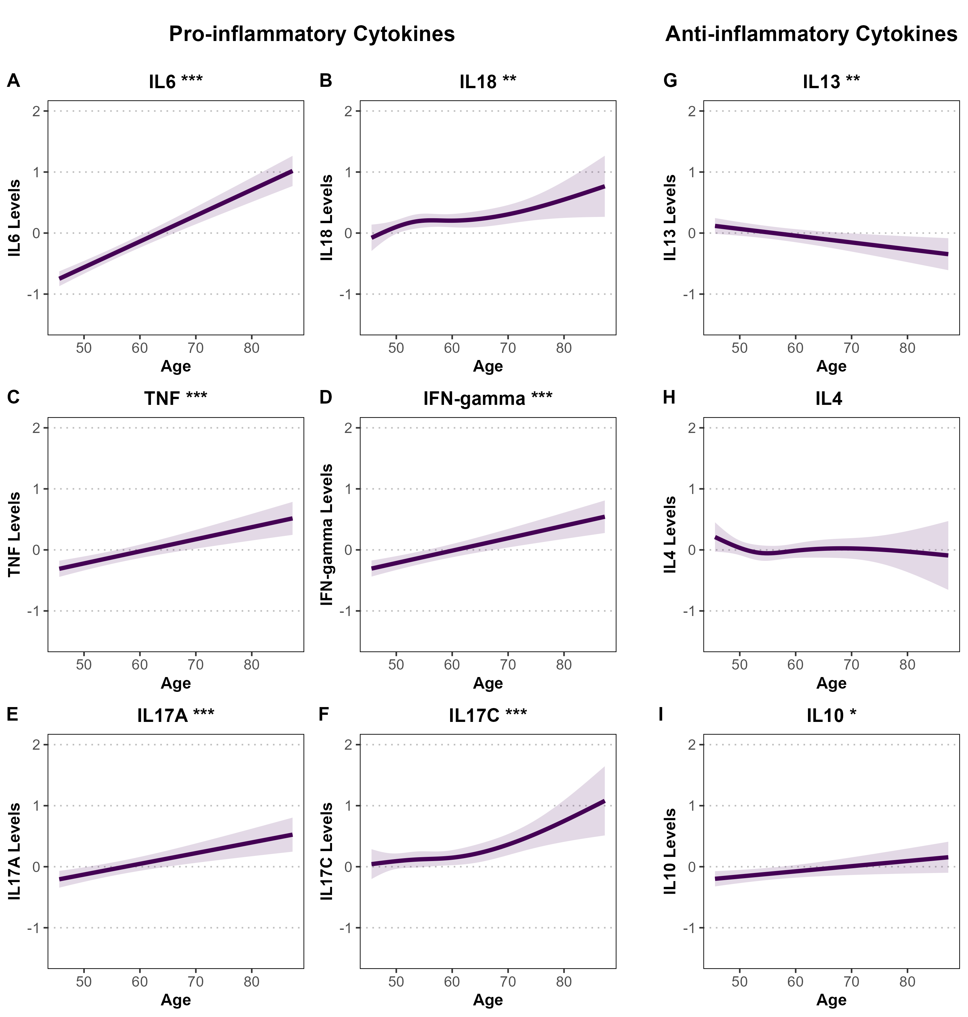
Supplementary Figure S2.1. Associations between age and standardized pro- and anti-inflammatory cytokine levels among male participants in the Rotterdam Study. Panels A–F display pro-inflammatory cytokines (IL-6, IL-18, TNF, IFN-γ, IL-17A, IL-17C), and panels G–I show anti-inflammatory cytokines (IL-13, IL-4, IL-10). Associations were estimated using linear or spline-based regression models adjusted for BMI, smoking status, and alcohol consumption. Shaded areas represent 95% confidence intervals. Cytokine levels are standardized (mean = 0, SD = 1), and y-axes are uniform across panels for comparability. Statistical significance is denoted by asterisks (*P < 0.05; **P < 0.01; ***P < 0.001).

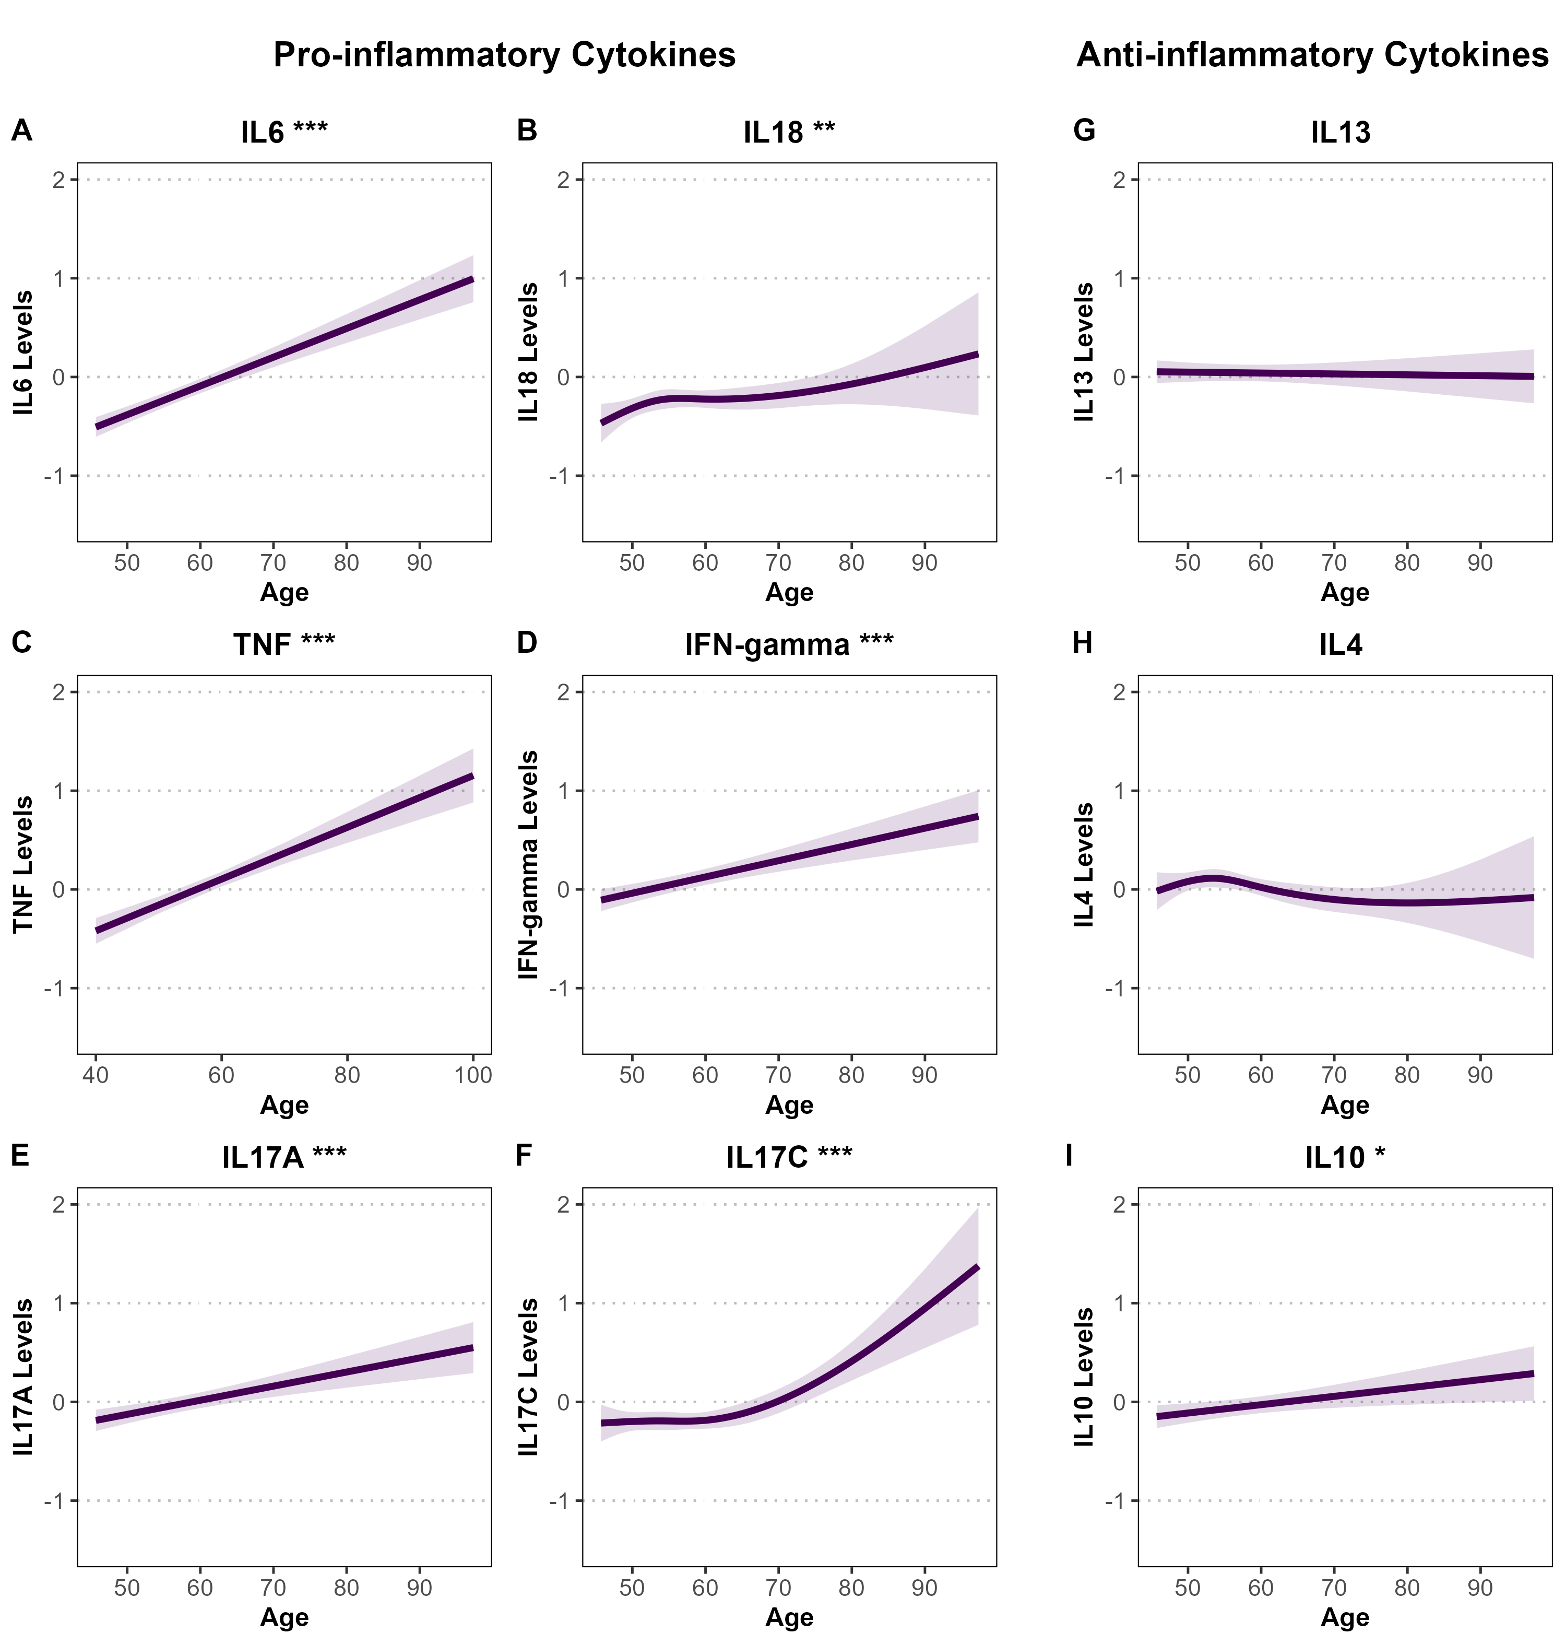
Supplementary Figure S2.2. Associations between age and standardized pro- and anti-inflammatory cytokine levels among female participants in the Rotterdam Study. Panels A–F display pro-inflammatory cytokines (IL-6, IL-18, TNF, IFN-γ, IL-17A, IL-17C), and panels G–I show anti-inflammatory cytokines (IL-13, IL-4, IL-10). Associations were estimated using linear or spline-based regression models adjusted for BMI, smoking status, and alcohol consumption. Shaded areas represent 95% confidence intervals. Cytokine levels are standardized (mean = 0, SD = 1), and y-axes are uniform across panels for comparability. Statistical significance is denoted by asterisks (*P < 0.05; **P < 0.01; ***P < 0.001).

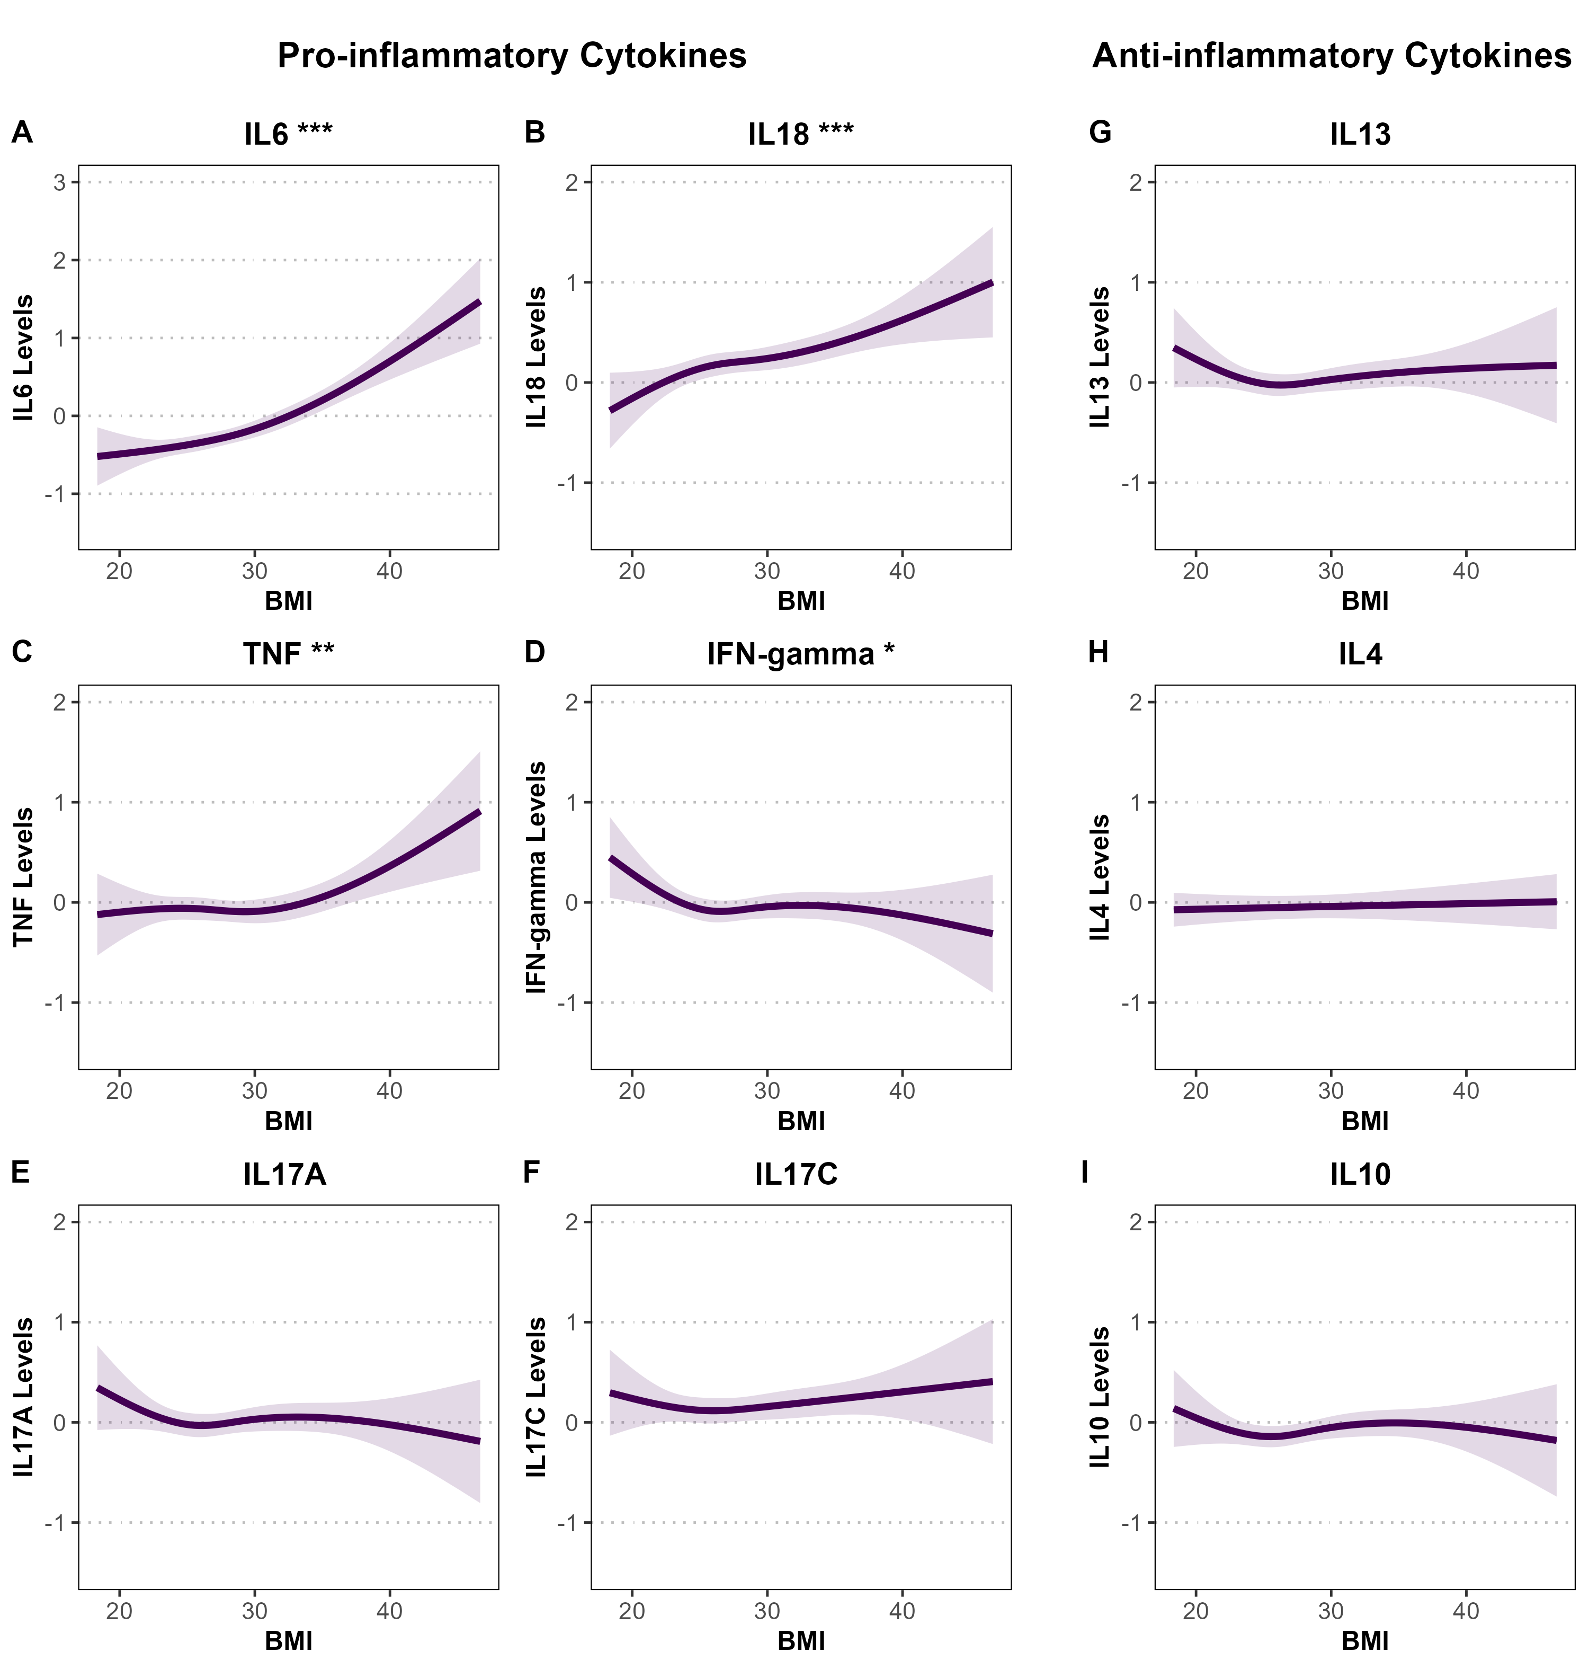
Supplementary Figure S3.1.Associations between BMI and standardized pro- and anti-inflammatory cytokine levels among female participants in the Rotterdam Study. Panels A–F show pro-inflammatory cytokines (IL-6, IL-18, TNF, IFN-γ, IL-17A, IL-17C), and panels G–I show anti-inflammatory cytokines (IL-13, IL-4, IL-10). Associations were estimated using linear or spline-based regression models adjusted for age, smoking status, and alcohol consumption. Shaded areas represent 95% confidence intervals. Cytokine levels are standardized (mean = 0, SD = 1). Y-axes are standardized across all panels for comparability, except for IL-6 (Panel A), which uses a wider axis range to reflect its greater variability. Statistical significance is denoted by asterisks (*P < 0.05; **P < 0.01; ***P < 0.001).

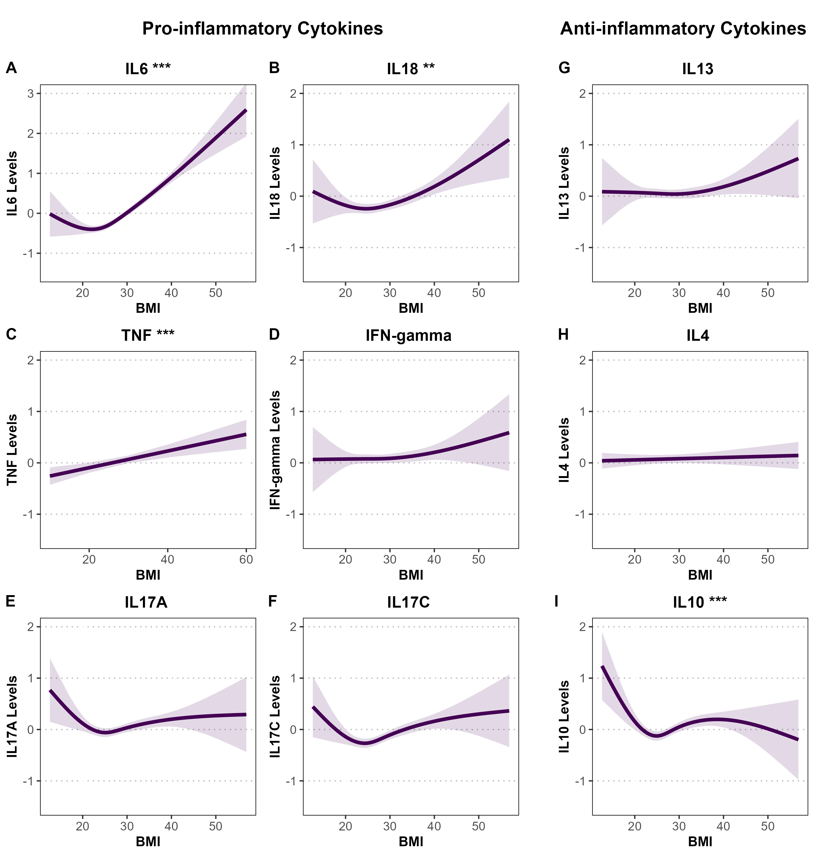
Supplementary Figure S3.2. Associations between BMI and standardized pro- and anti-inflammatory cytokine levels among female participants in the Rotterdam Study. Panels A–F show pro-inflammatory cytokines (IL-6, IL-18, TNF, IFN-γ, IL-17A, IL-17C), and panels G–I show anti-inflammatory cytokines (IL-13, IL-4, IL-10). Associations were estimated using linear or spline-based regression models adjusted for age, smoking status, and alcohol consumption. Shaded areas represent 95% confidence intervals. Cytokine levels are standardized (mean = 0, SD = 1). Y-axes are standardized across all panels for comparability, except for IL-6 (Panel A), which uses a wider axis range to reflect its greater variability. Statistical significance is denoted by asterisks (*P < 0.05; **P < 0.01; ***P < 0.001).

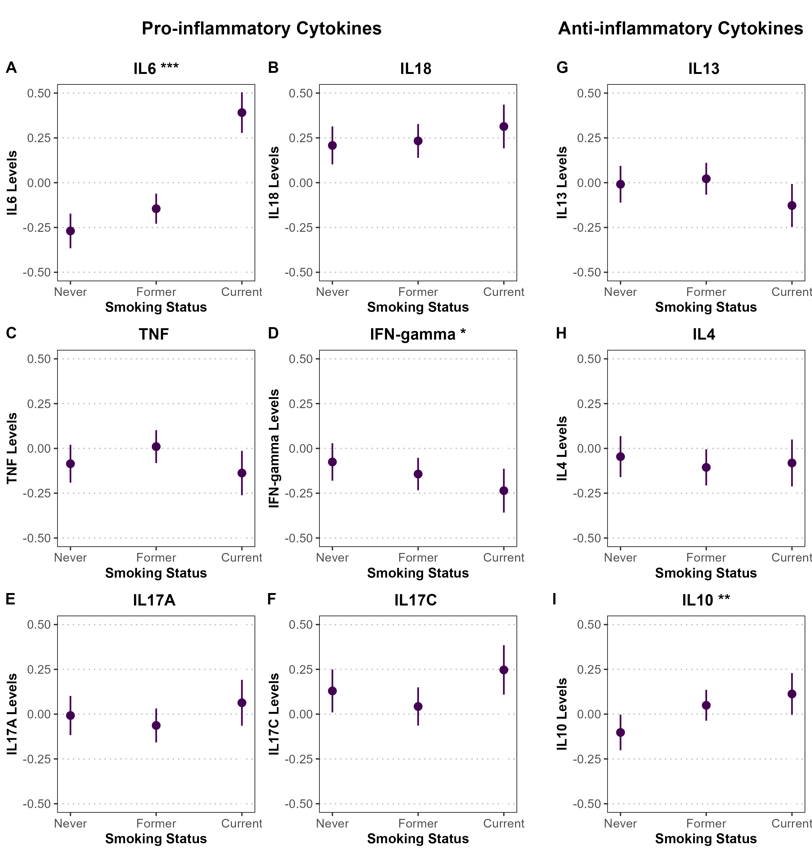
Supplementary Figure S4.1. Associations between smoking status and standardized pro- and anti-inflammatory cytokine levels among male participants in the Rotterdam Study. Panels A–F display pro-inflammatory cytokines (IL-6, IL-18, TNF, IFN-γ, IL-17A, IL-17C), and panels G–I show anti-inflammatory cytokines (IL-13, IL-4, IL-10). Associations were estimated using linear or spline-based regression models adjusted for age, BMI, and alcohol consumption. Point estimates are shown with 95% confidence intervals represented as vertical error bars. Cytokine levels are standardized (mean = 0, SD = 1), and y-axes are fixed from -0.50 to 0.50 across all panels. Statistical significance is denoted by asterisks (*P < 0.05; **P < 0.01; ***P < 0.001).

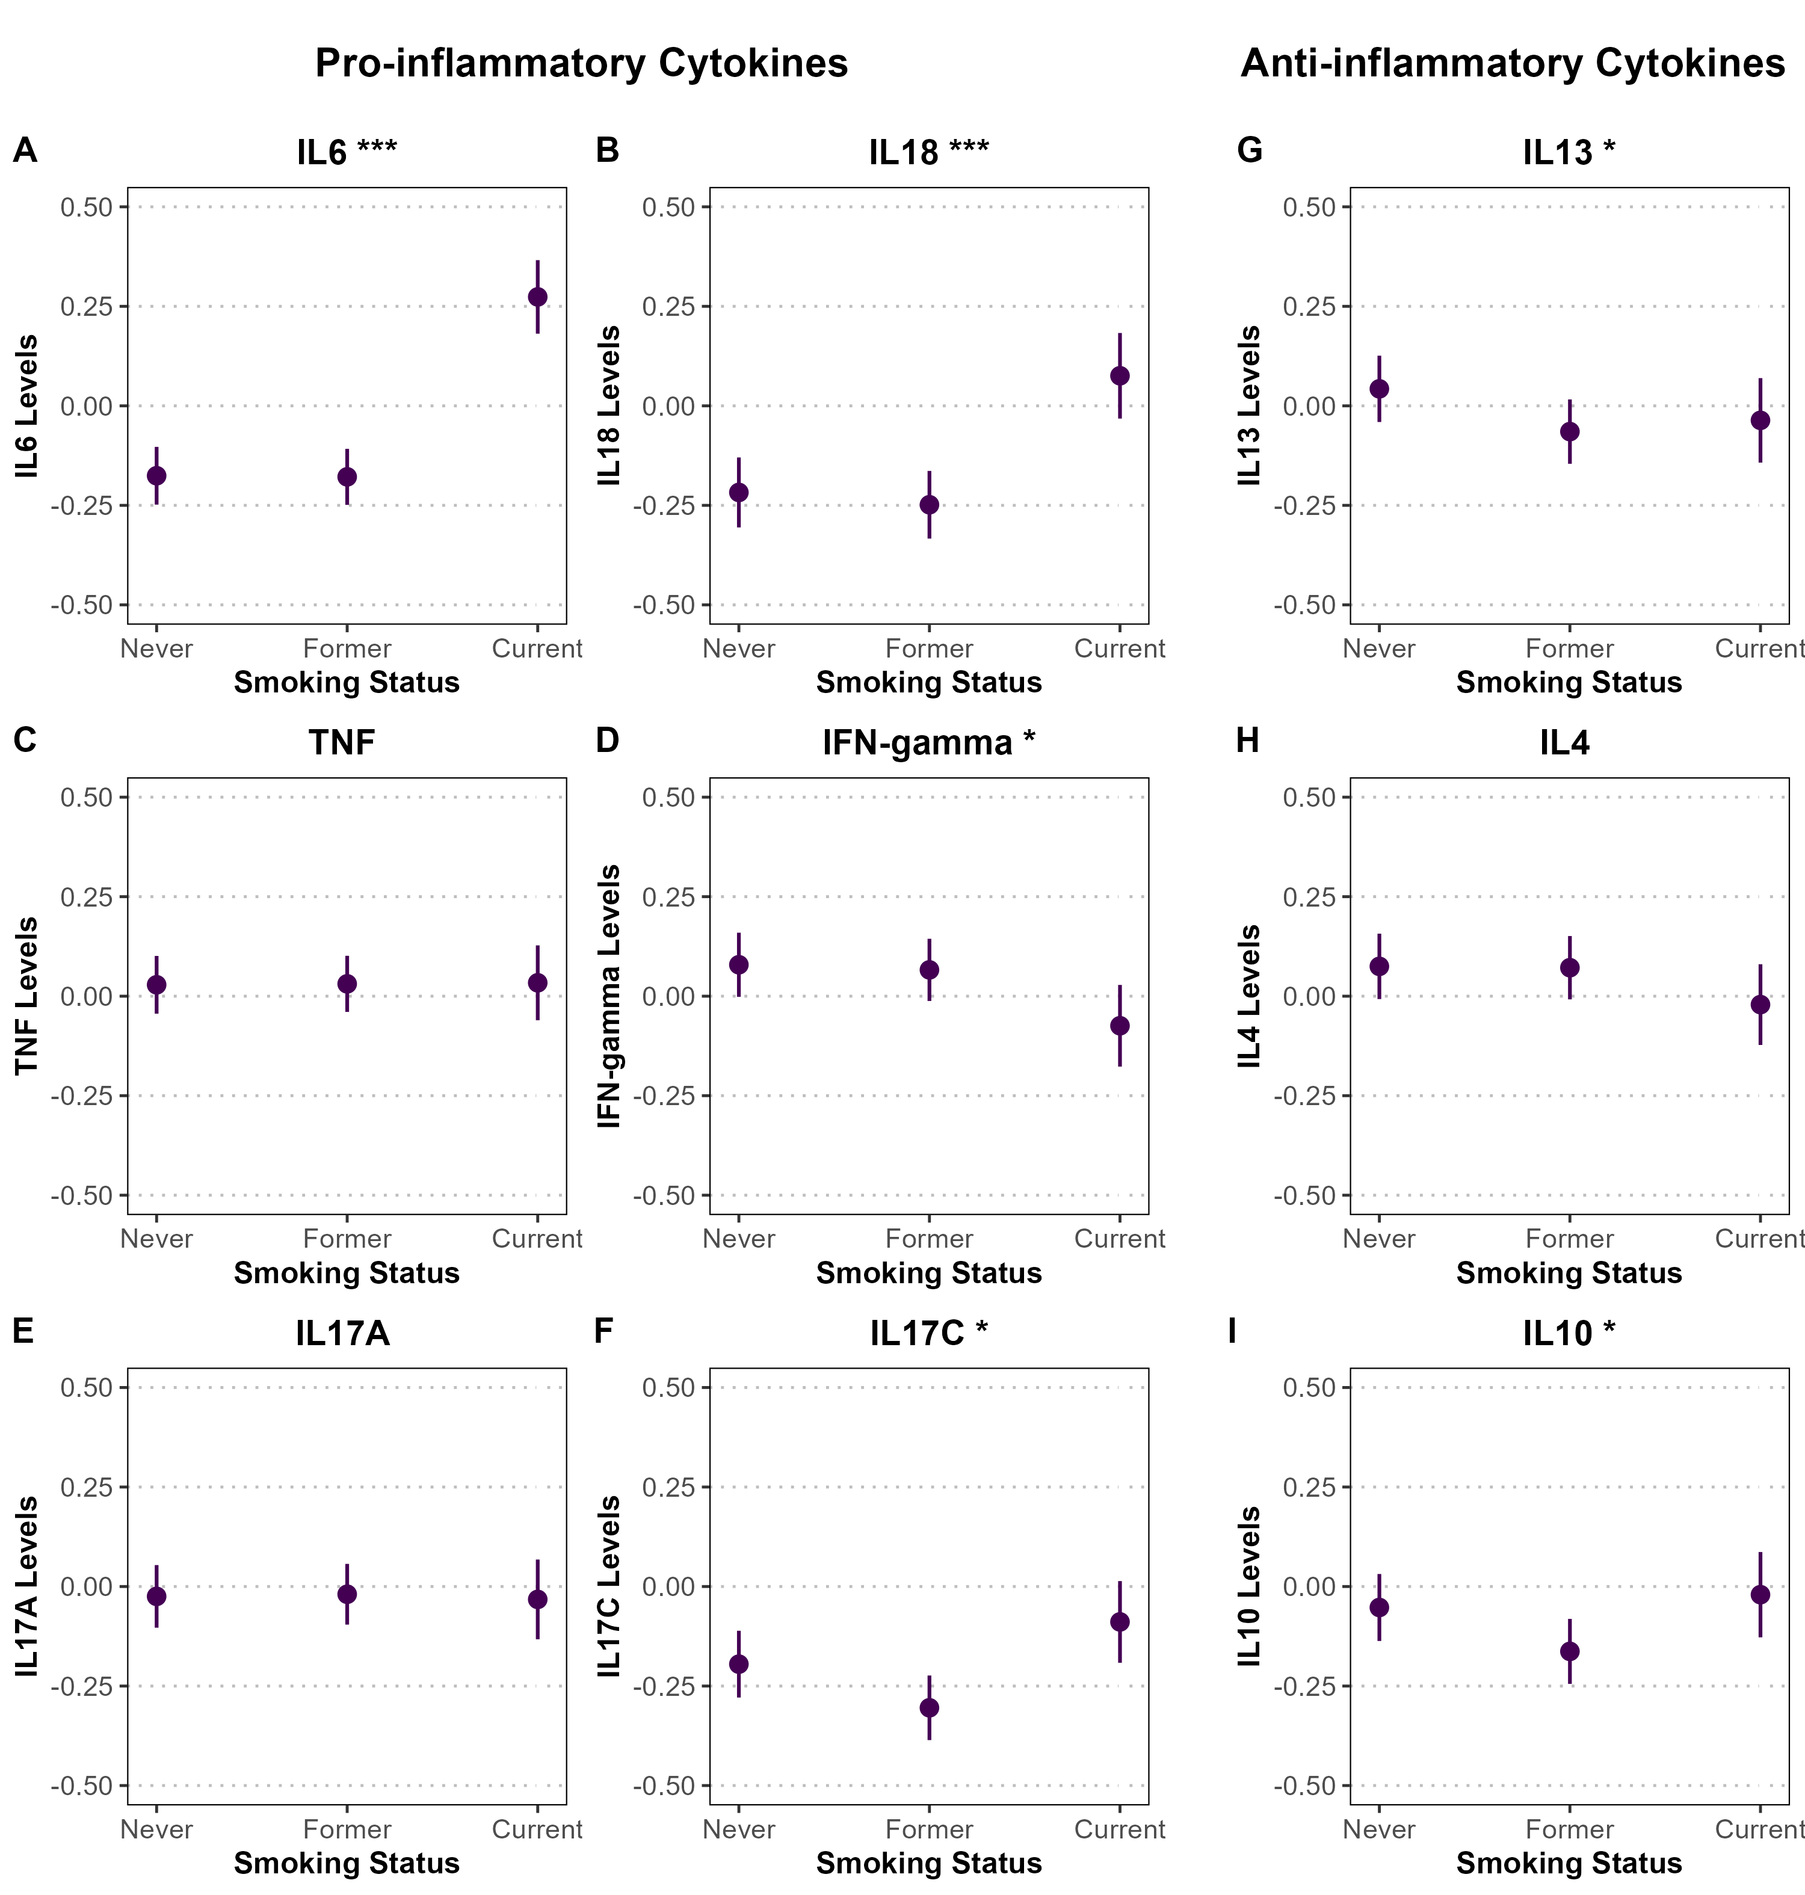
Supplementary Figure S4.2 Associations between smoking status and standardized pro- and anti-inflammatory cytokine levels among female participants in the Rotterdam Study. Panels A–F display pro-inflammatory cytokines (IL-6, IL-18, TNF, IFN-γ, IL-17A, IL-17C), and panels G–I show anti-inflammatory cytokines (IL-13, IL-4, IL-10). Associations were estimated using linear or spline-based regression models adjusted for age, BMI, and alcohol consumption. Point estimates are shown with 95% confidence intervals represented as vertical error bars. Cytokine levels are standardized (mean = 0, SD = 1), and y-axes are fixed from -0.50 to 0.50 across all panels. Statistical significance is denoted by asterisks (*P < 0.05; **P < 0.01; ***P < 0.001).

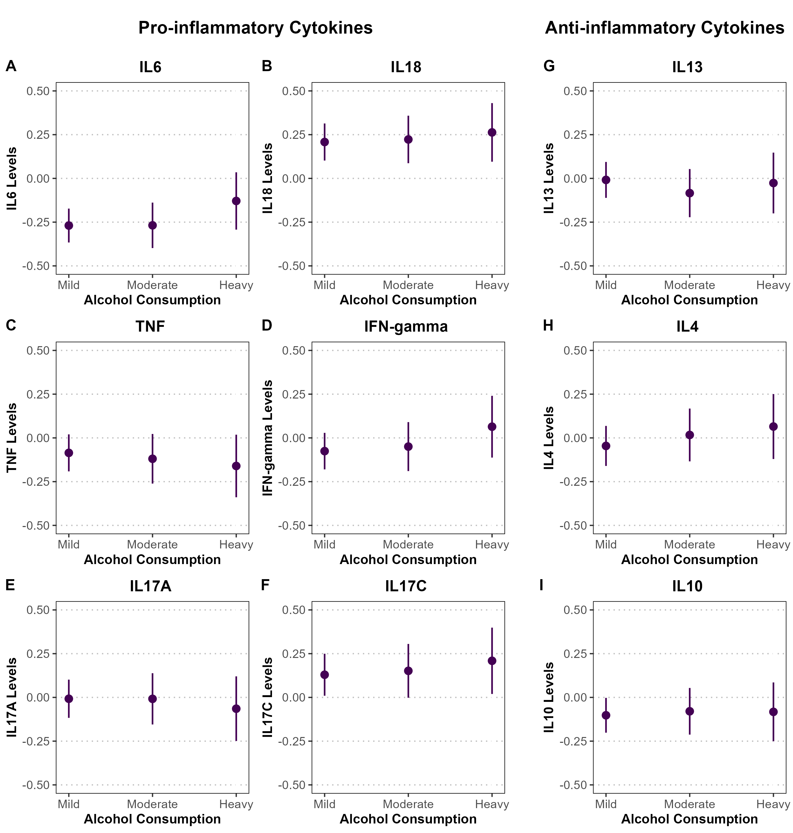
Supplementary Figure S5.1. Associations between alcohol consumption and standardized pro- and anti-inflammatory cytokine levels among male participants in the Rotterdam Study. Panels A–F display pro-inflammatory cytokines (IL-6, IL-18, TNF, IFN-γ, IL-17A, IL-17C), and panels G–I show anti-inflammatory cytokines (IL-13, IL-4, IL-10). Associations were estimated using linear or spline-based regression models adjusted for age, BMI, and smoking status. Point estimates are shown with 95% confidence intervals represented as vertical error bars. Cytokine levels are standardized (mean = 0, SD = 1), and y-axes are fixed from -1 to 1 across all panels to reflect the wider confidence intervals in the male-stratified analysis. Statistical significance is denoted by asterisks (*P < 0.05; **P < 0.01; ***P < 0.001).

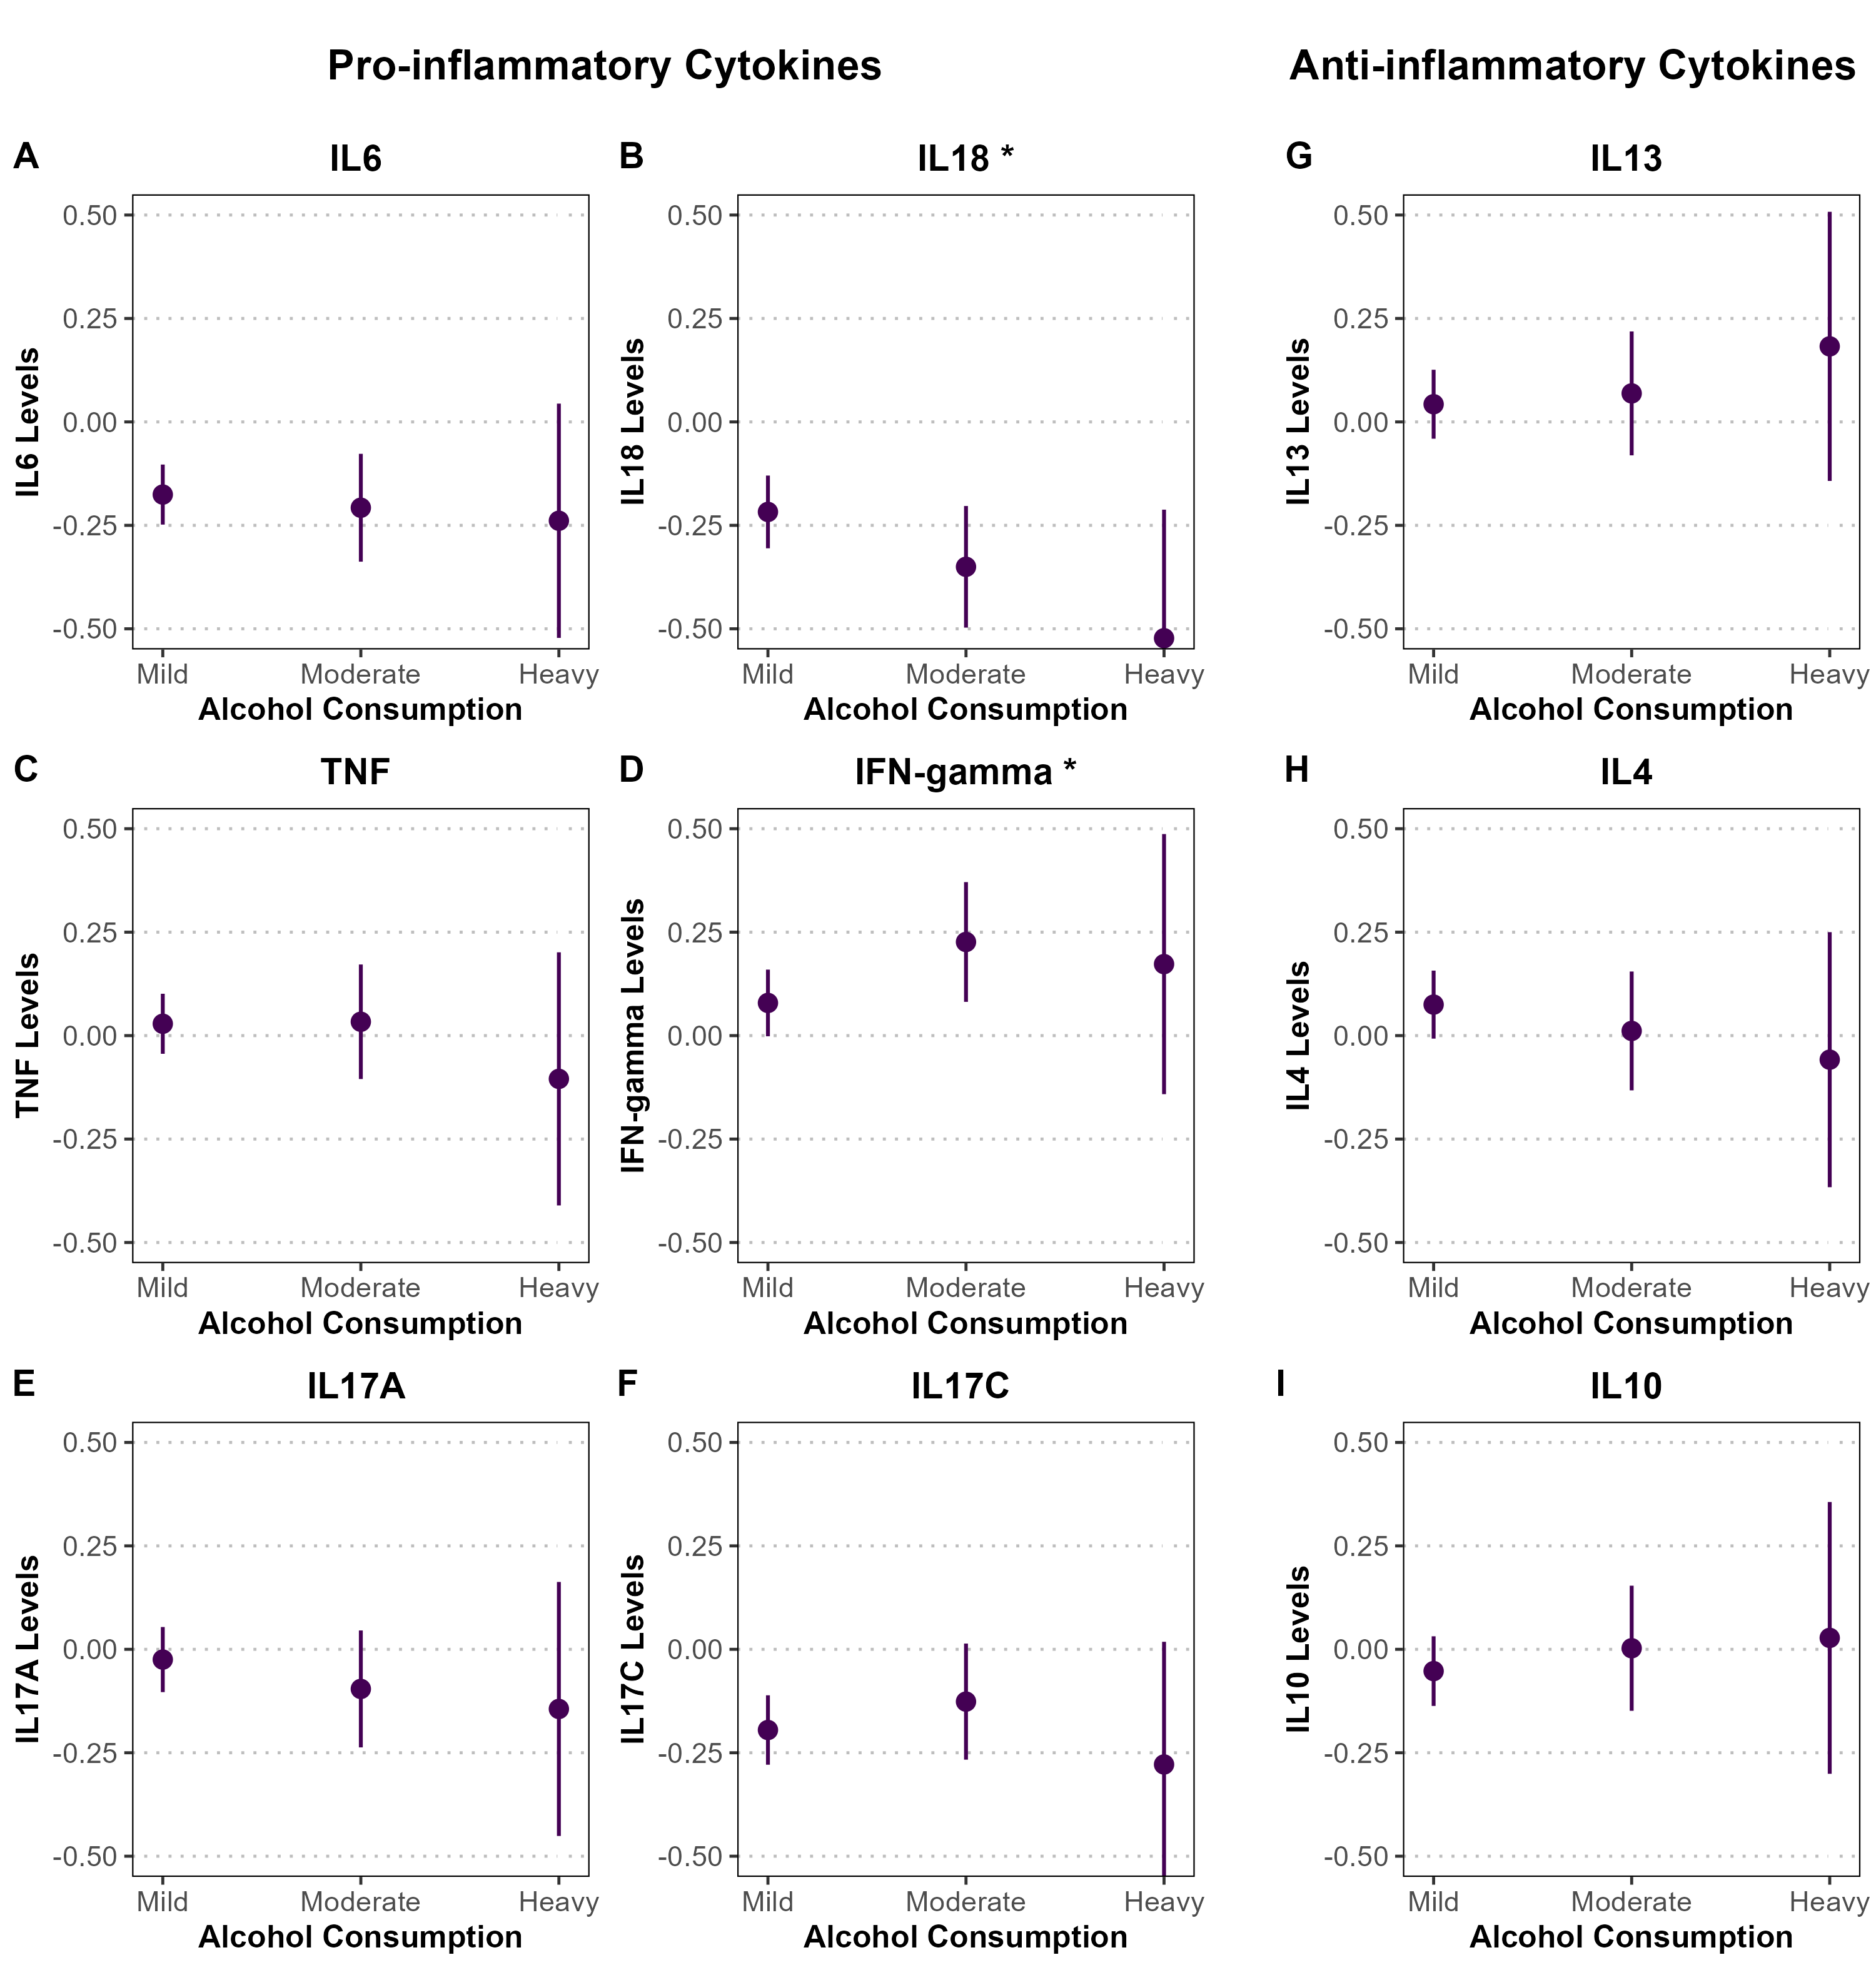
Supplementary Figure S5.2. Associations between alcohol consumption and standardized pro- and anti-inflammatory cytokine levels among female participants in the Rotterdam Study. Panels A–F display pro-inflammatory cytokines (IL-6, IL-18, TNF, IFN-γ, IL-17A, IL-17C), and panels G–I show anti-inflammatory cytokines (IL-13, IL-4, IL-10). Associations were estimated using linear or spline-based regression models adjusted for age, BMI, and smoking status. Point estimates are shown with 95% confidence intervals represented as vertical error bars. Cytokine levels are standardized (mean = 0, SD = 1), and y-axes are fixed from -1 to 1 across all panels to reflect the wider confidence intervals in the male-stratified analysis. Statistical significance is denoted by asterisks (*P < 0.05; **P < 0.01; ***P < 0.001).

Principal Component Analysis:
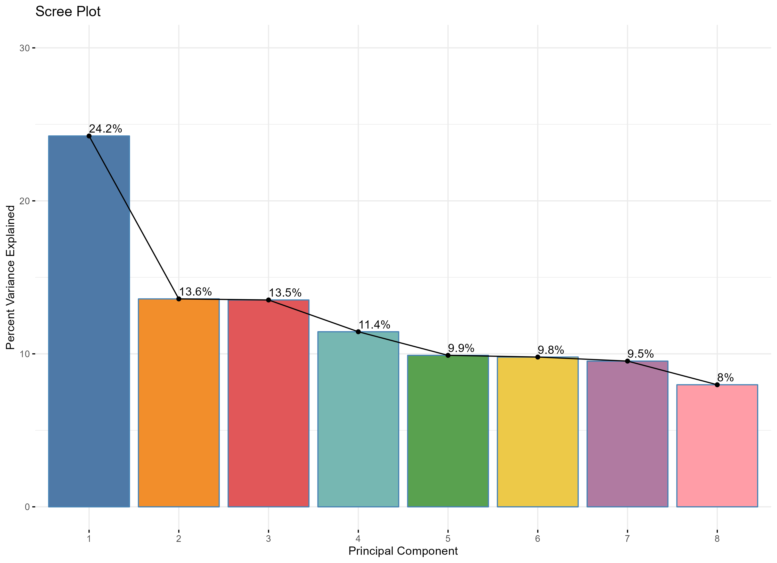
Supplementary Figure S6.1. Principal Component Analysis (PCA) of pro- and anti-inflammatory cytokine levels in the Rotterdam Study. The bar plot represents the percentage of variance explained by each principal component, with the first principal component capturing the largest proportion (24.2%). The line plot indicates the cumulative variance explained across components, illustrating the contribution of each component to the overall variability in cytokine expression.

Supplementary Figure S6.2. Principal Component Analysis (PCA) bi-plots showing the contribution of pro- and anti-inflammatory cytokines to different principal components in the Rotterdam Study. Each panel represents a pair of principal components (PC1 & PC2, PC3 & PC4, PC5 & PC6, and PC7 & PC8). The length and direction of the arrows indicate the influence of individual cytokines on the respective principal components, while the color scale represents their contribution magnitude. Cytokines with higher contributions are highlighted in warmer colors, indicating their stronger influence on variance in the dataset.

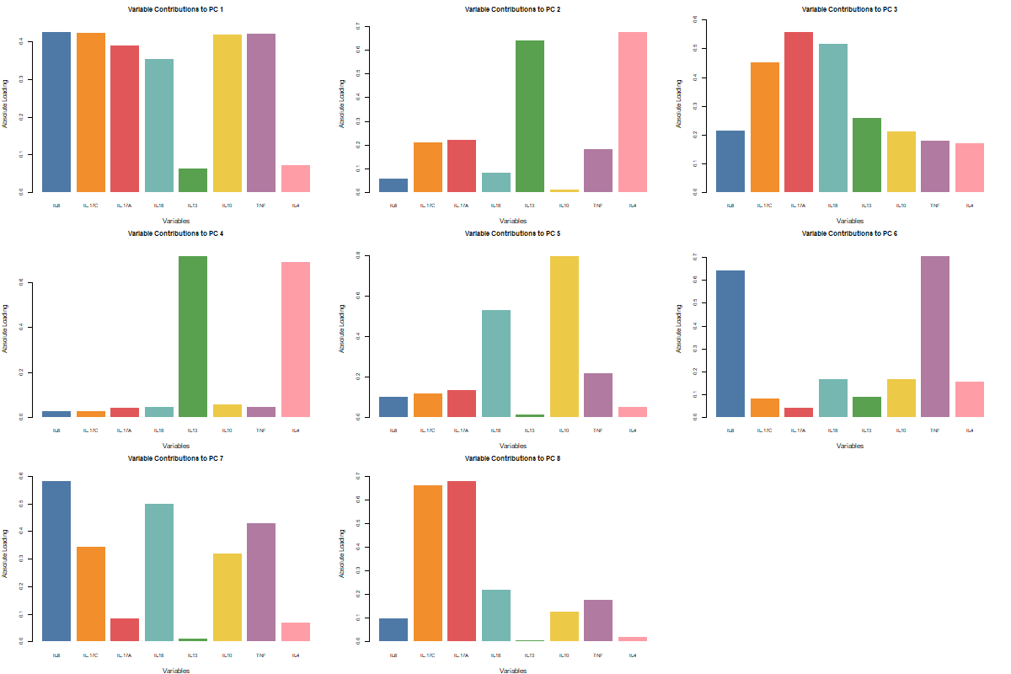
Supplementary Figure S6.3. Bar plots showing the variance contributions of individual cytokines to different principal components (PCs) from Principal Component Analysis (PCA) in the Rotterdam Study. Each plot represents a specific PC, with bars indicating the proportion of variance explained by each cytokine. Higher bars suggest stronger contributions to the respective PC, highlighting cytokines that drive variability in the dataset.

PC1 Model Results
term | estimate | std.error | statistic | p.value | conf.low | conf.high | Model
(Intercept) | -2.425 | 0.197 | -12.326 | < 0.001 | -2.810 | -2.039 | Model 1
age | 0.043 | 0.003 | 12.413 | < 0.001 | 0.036 | 0.049 | Model 1
(Intercept) | -3.966 | 0.235 | -16.854 | < 0.001 | -4.428 | -3.505 | Model 2
age | 0.043 | 0.003 | 12.925 | < 0.001 | 0.037 | 0.050 | Model 2
sexFemale | -0.270 | 0.047 | -5.730 | < 0.001 | -0.363 | -0.178 | Model 2
smokingFormer | -0.020 | 0.053 | -0.377 | 0.706 | -0.124 | 0.084 | Model 2
smokingCurrent | 0.394 | 0.062 | 6.311 | < 0.001 | 0.272 | 0.517 | Model 2
alcohol_consumptionModerate | -0.027 | 0.060 | -0.451 | 0.652 | -0.145 | 0.091 | Model 2
alcohol_consumptionHeavy | 0.005 | 0.095 | 0.050 | 0.960 | -0.181 | 0.191 | Model 2
BMI | 0.057 | 0.005 | 11.556 | < 0.001 | 0.047 | 0.066 | Model 2
(Intercept) | -2.013 | 0.175 | -11.497 | < 0.001 | -2.356 | -1.670 | Model 3
Age (Spline 1) | 0.529 | 0.148 | 3.572 | < 0.001 | 0.239 | 0.820 | Model 3
Age (Spline 2) | 2.483 | 0.289 | 8.594 | < 0.001 | 1.916 | 3.049 | Model 3
Age (Spline 3) | 3.168 | 0.363 | 8.716 | < 0.001 | 2.456 | 3.881 | Model 3
sexFemale | -0.272 | 0.047 | -5.776 | < 0.001 | -0.364 | -0.180 | Model 3
smokingFormer | -0.019 | 0.053 | -0.365 | 0.715 | -0.123 | 0.084 | Model 3
smokingCurrent | 0.396 | 0.062 | 6.342 | < 0.001 | 0.273 | 0.518 | Model 3
alcohol_consumptionModerate | -0.020 | 0.060 | -0.326 | 0.745 | -0.138 | 0.099 | Model 3
alcohol_consumptionHeavy | 0.017 | 0.095 | 0.181 | 0.856 | -0.169 | 0.204 | Model 3
BMI | 0.057 | 0.005 | 11.691 | < 0.001 | 0.048 | 0.067 | Model 3
Supplementary Table S6. Summary of regression models examining the association between age and the inflammaging axis (PC1).
Model 1 includes age only (PC1 ~ age). Model 2 additionally adjusts for sex, smoking status, alcohol consumption, and body mass index (PC1 ~ age + covariates). Model 3 models age non-linearly using natural cubic splines (3 degrees of freedom) while adjusting for the same covariates. Reported metrics include estimates, standard errors, test statistics, p-values, and 95% confidence intervals.

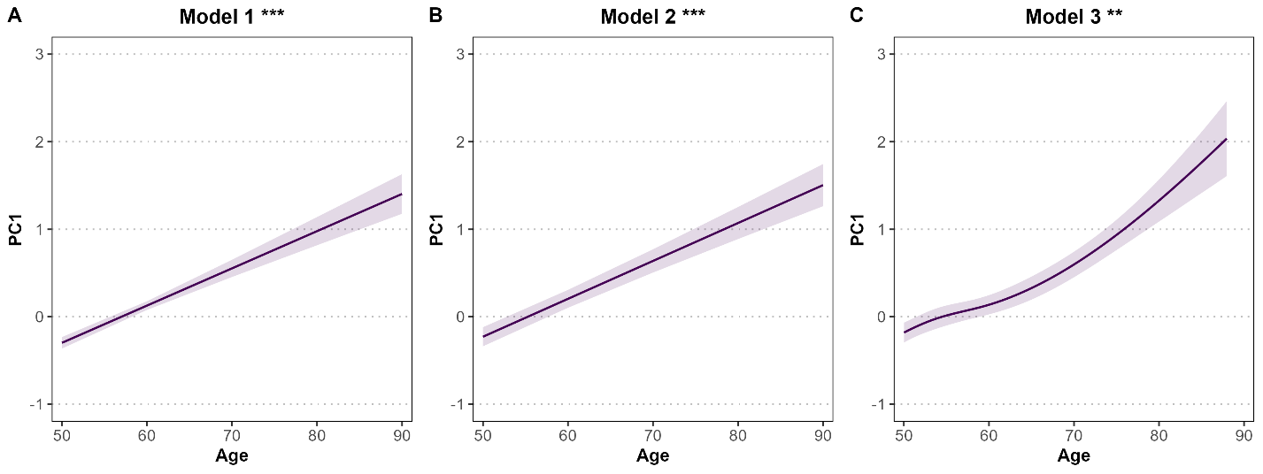
Supplementary Figure S7. Age-related changes in the inflammaging axis (PC1).
Predicted values of the first principal component (PC1), representing a composite inflammaging cytokine axis, are shown as a function of age. Panel A (Model 1) shows the association between age and PC1 without covariate adjustment and is included as a sensitivity analysis. Panel B (Model 2) shows the age–PC1 association adjusted for sex, smoking status, alcohol consumption, and body mass index and is also included as a sensitivity analysis. Panel C (Model 3), the primary analysis, models age non-linearly using natural cubic splines (3 degrees of freedom) while adjusting for the same covariates. Solid lines indicate model-predicted values and shaded areas represent 95% confidence intervals. Asterisks denote statistical significance of the age effect (p < 0.05; p < 0.01; p < 0.001).

