Additional File 2

Figure S1. Treatment algorithm for type 2 diabetes management provided by community health workers
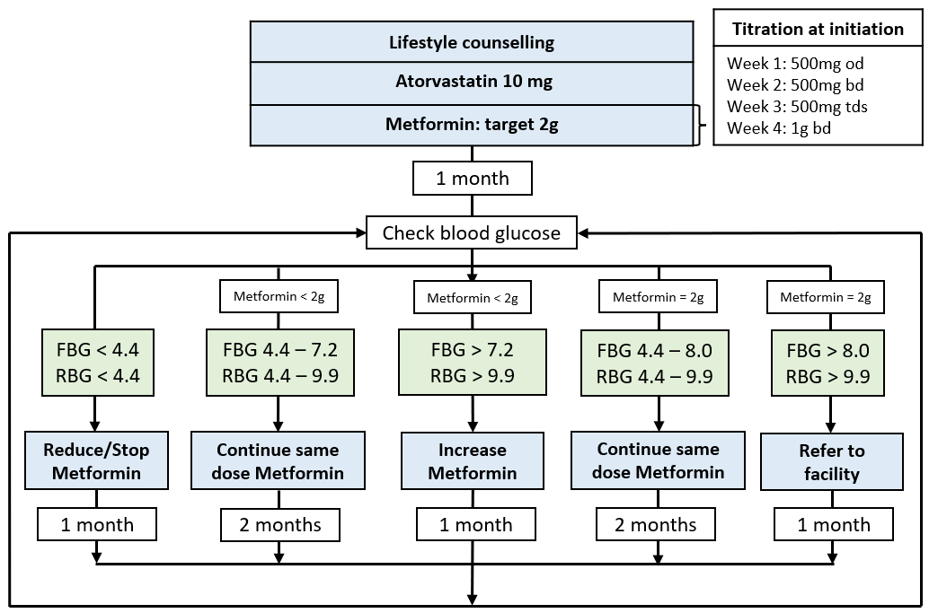
Figure S1 legend
FBG: fasting blood glucose; RBG: random blood glucose

