Additional File 3

Figure S2. Forestplot of potential effect modifiers on primary endpoint
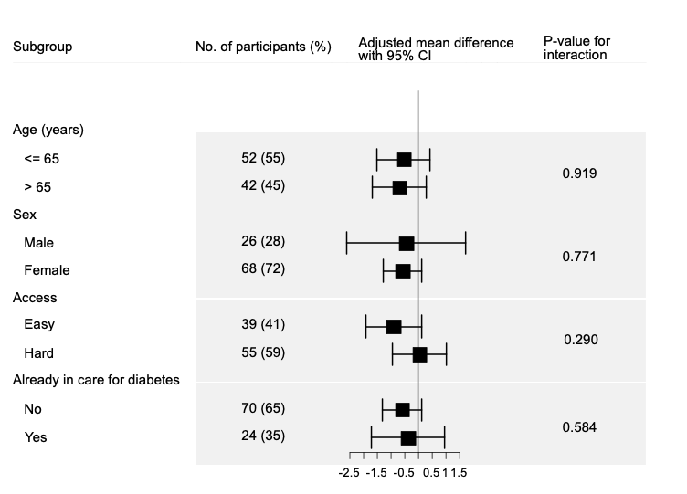
Figure S2 legend
Age was analysed as continuous interaction, assuming linearity

