Effectiveness of Bullying Prevention-Associated Interventions among Children and Adolescents: An Umbrella Review of Systematic Review and Meta-analysis

Zi-Wei Li, PhD¹; Li Lu, PhD^{1,2*}; Xiao-Dong Qin, MD¹; Rong Li, MD¹; Zhongliang Zhou, PhD¹; Shou Liu, PhD³; Qi Liu, PhD⁴; Sha Lai, PhD¹; Qing Shen, PhD^{5,6,7}

Additional file 1

Supplemental Information
Fig. S1 | The relationship between bullying prevention intervention and related outcome
Fig. S2 | The efficacy by prevention intervention subgroups in studies with RCTs only
Fig. S3 | The efficacy by outcome subgroups in studies with RCTs only
Fig. S4 | The effectiveness by prevention intervention subgroups in studies with high or moderate AMSTAR-2 quality rating
Fig. S5 | The effectiveness by prevention intervention subgroups in studies with low or critically low AMSTAR-2 quality rating
Fig. S6 | The effectiveness by outcome subgroups in studies with high or moderate AMSTAR-2 quality rating
Fig. S7 | The effectiveness by outcome subgroups in studies with low or critically low AMSTAR-2 quality rating
Fig. S8 | The effectiveness by prevention intervention subgroups in studies with high AMSTAR-2 rating
Fig. S9 | The effectiveness by prevention intervention subgroups in studies with moderate AMSTAR-2 rating
Fig. S10 | The effectiveness by prevention intervention subgroups in studies with low AMSTAR-2 rating
Fig. S11 | The effectiveness by prevention intervention subgroups in studies with critically low AMSTAR-2 rating
Fig. S12 | The effectiveness by outcome subgroups in studies with high AMSTAR-2 rating
Fig. S13 | The effectiveness by outcome subgroups in studies with moderate AMSTAR-2 rating
Fig. S14 | The effectiveness by outcome subgroups in studies with low AMSTAR-2 rating
Fig. S15 | The effectiveness by outcome subgroups in studies with critically low AMSTAR-2 rating
Table S1 | PRISMA checklist
Table S2 | Modifications or new additions to the original protocol
Table S3 | Search strategy
Table S4 | Examples of excluded meta-analyses
Table S5 | Examples of details of one excluded and one included meta-analysis
Table S6 | Specific characteristics of included meta-analyses
Table S7 | Original effect sizes and related values of included meta-analyses
Table S8 | 16-items of AMSTAR-2
Table S9 | Results of AMSTAR-2 quality assessment
Table S10 | GRADE assessment of the credibility of evidence
Table S11 | Classifications of bullying prevention interventions and outcomes
Table S12 | The original effect measures without transformation by prevention interventions
Table S13 | The original effect measures without transformation by outcomes
Table S14a | Cohen's d by prevention intervention subgroup (Complete version)
Table S14b | Cohen's d by prevention intervention subgroup (Simplified version, consistent with forest plot)
Table S15a | Cohen's d by outcome subgroup (Complete version)
Table S15b | Cohen's d by outcome subgroup (Simplified version, consistent with forest plot)

Fig. S1. The relationship between bullying prevention interventions and related outcomes

Fig. S2. The efficacy by prevention intervention subgroups in studies with RCTs only

Fig. S3. The efficacy by outcome subgroups in studies with RCTs only

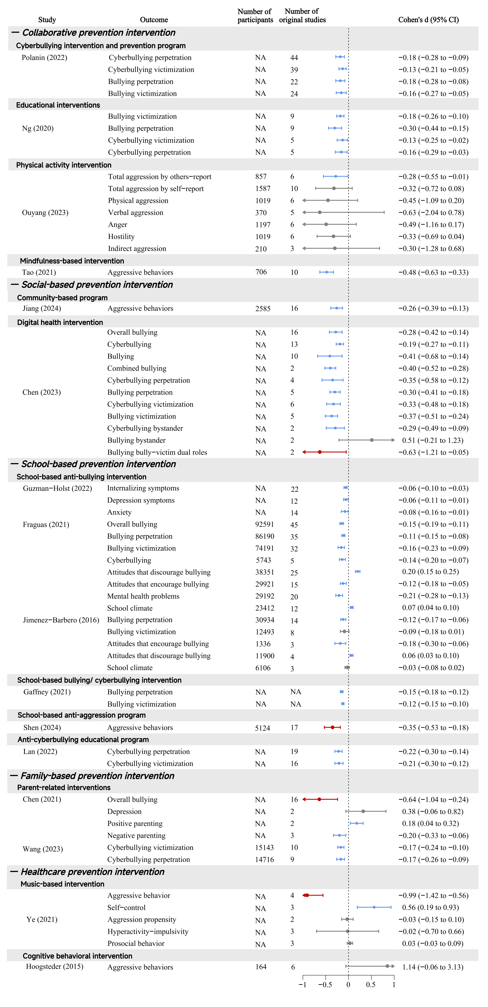

Fig. S4. The effectiveness by prevention intervention subgroups in studies with high or moderate AMSTAR-2 quality rating

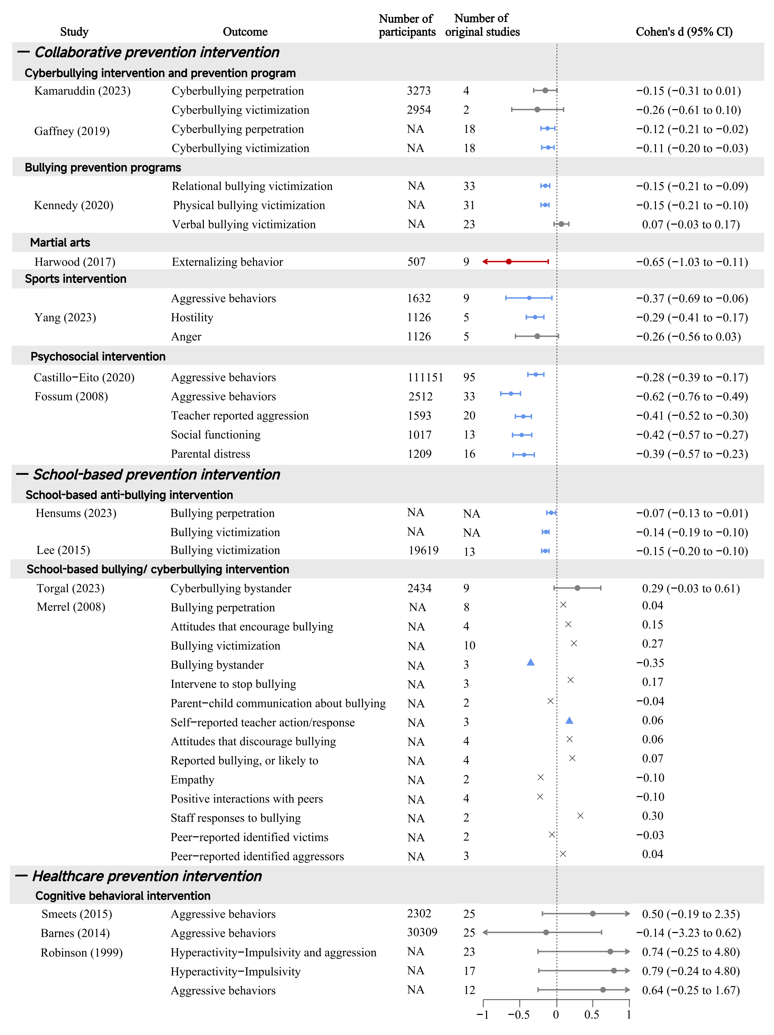

Fig. S5. The effectiveness by prevention intervention subgroups in studies with low or critically low AMSTAR-2 quality rating

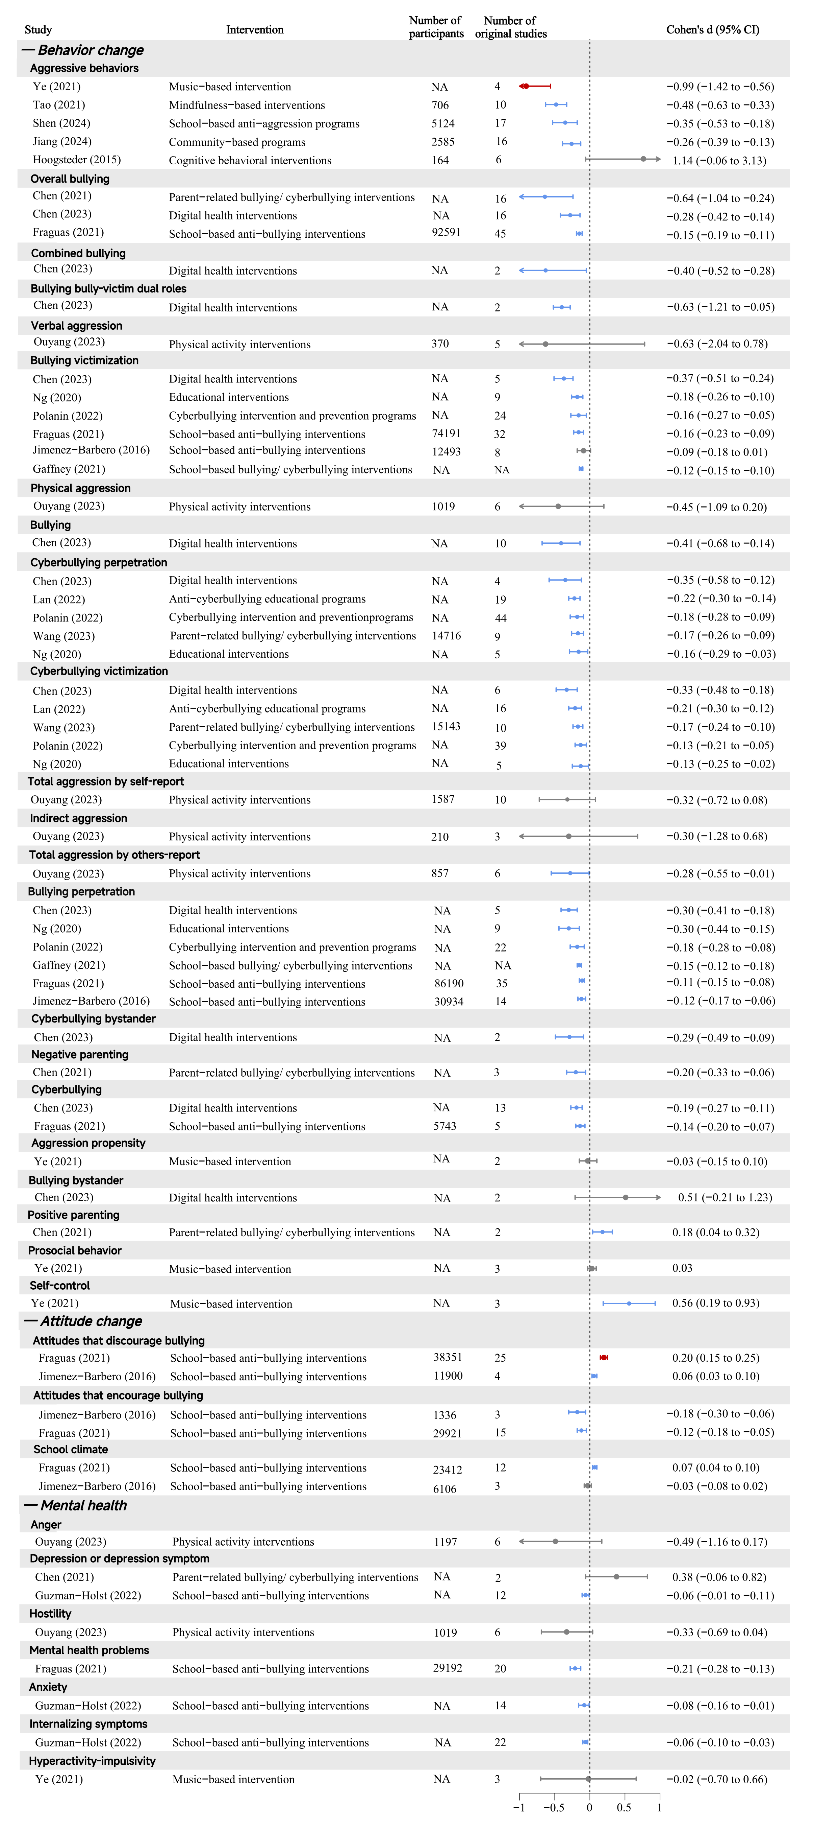

Fig. S6. The effectiveness by outcome subgroups in studies with high or moderate AMSTAR-2 quality rating
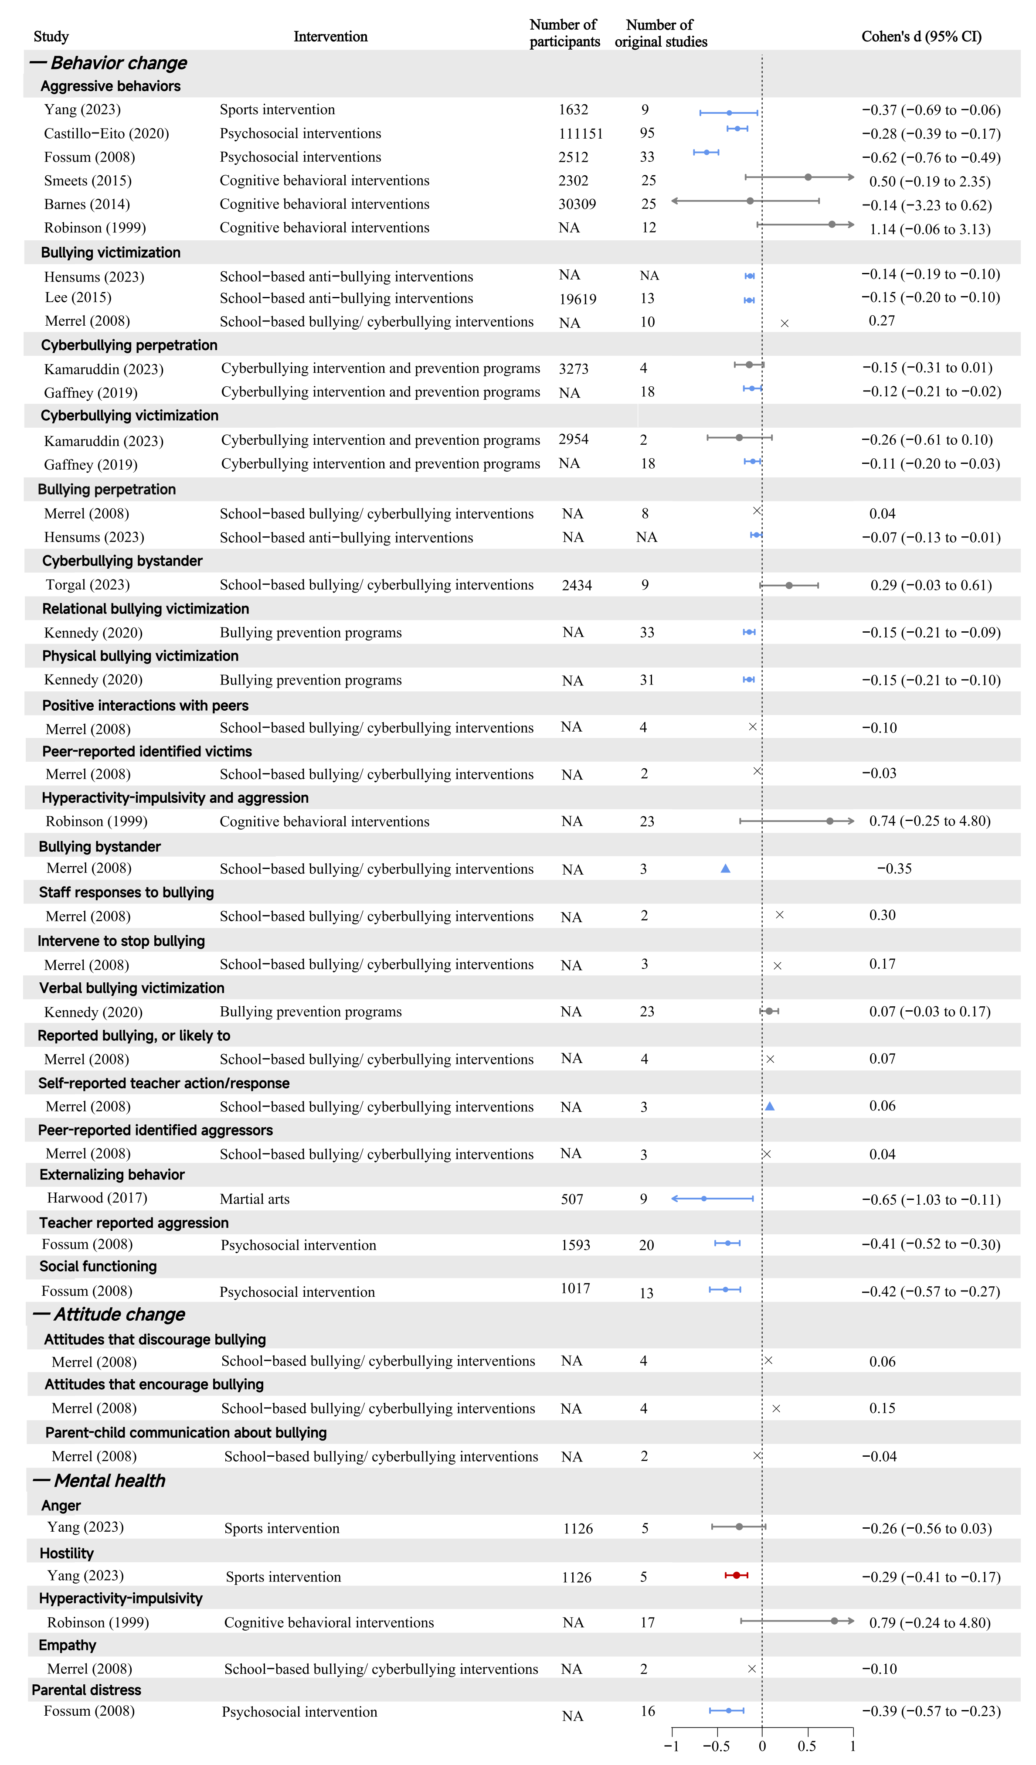

Fig. S7. The effectiveness by outcome subgroups in studies with low or critically low AMSTAR-2 quality rating
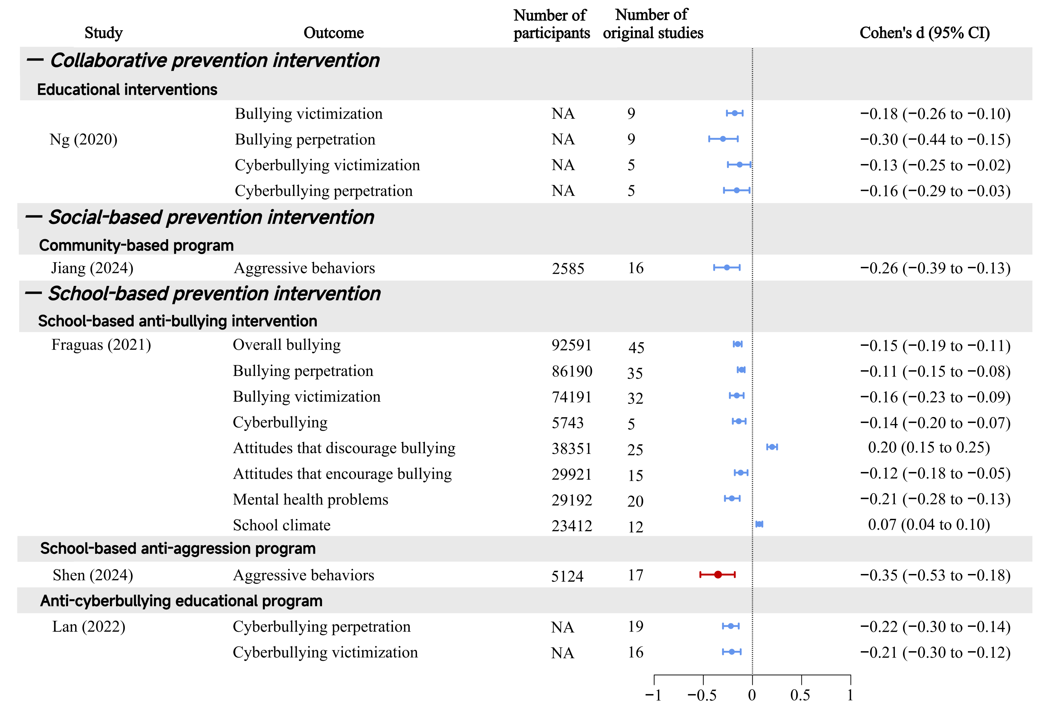

Fig. S8. The effectiveness by prevention intervention subgroups in studies with high AMSTAR-2 rating

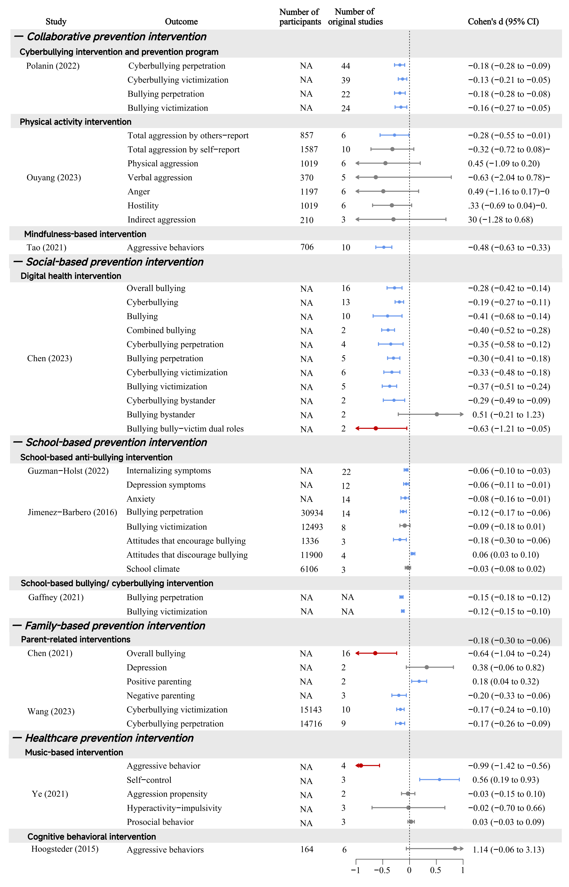

Fig. S9. The effectiveness by prevention intervention subgroups in studies with moderate AMSTAR-2 rating

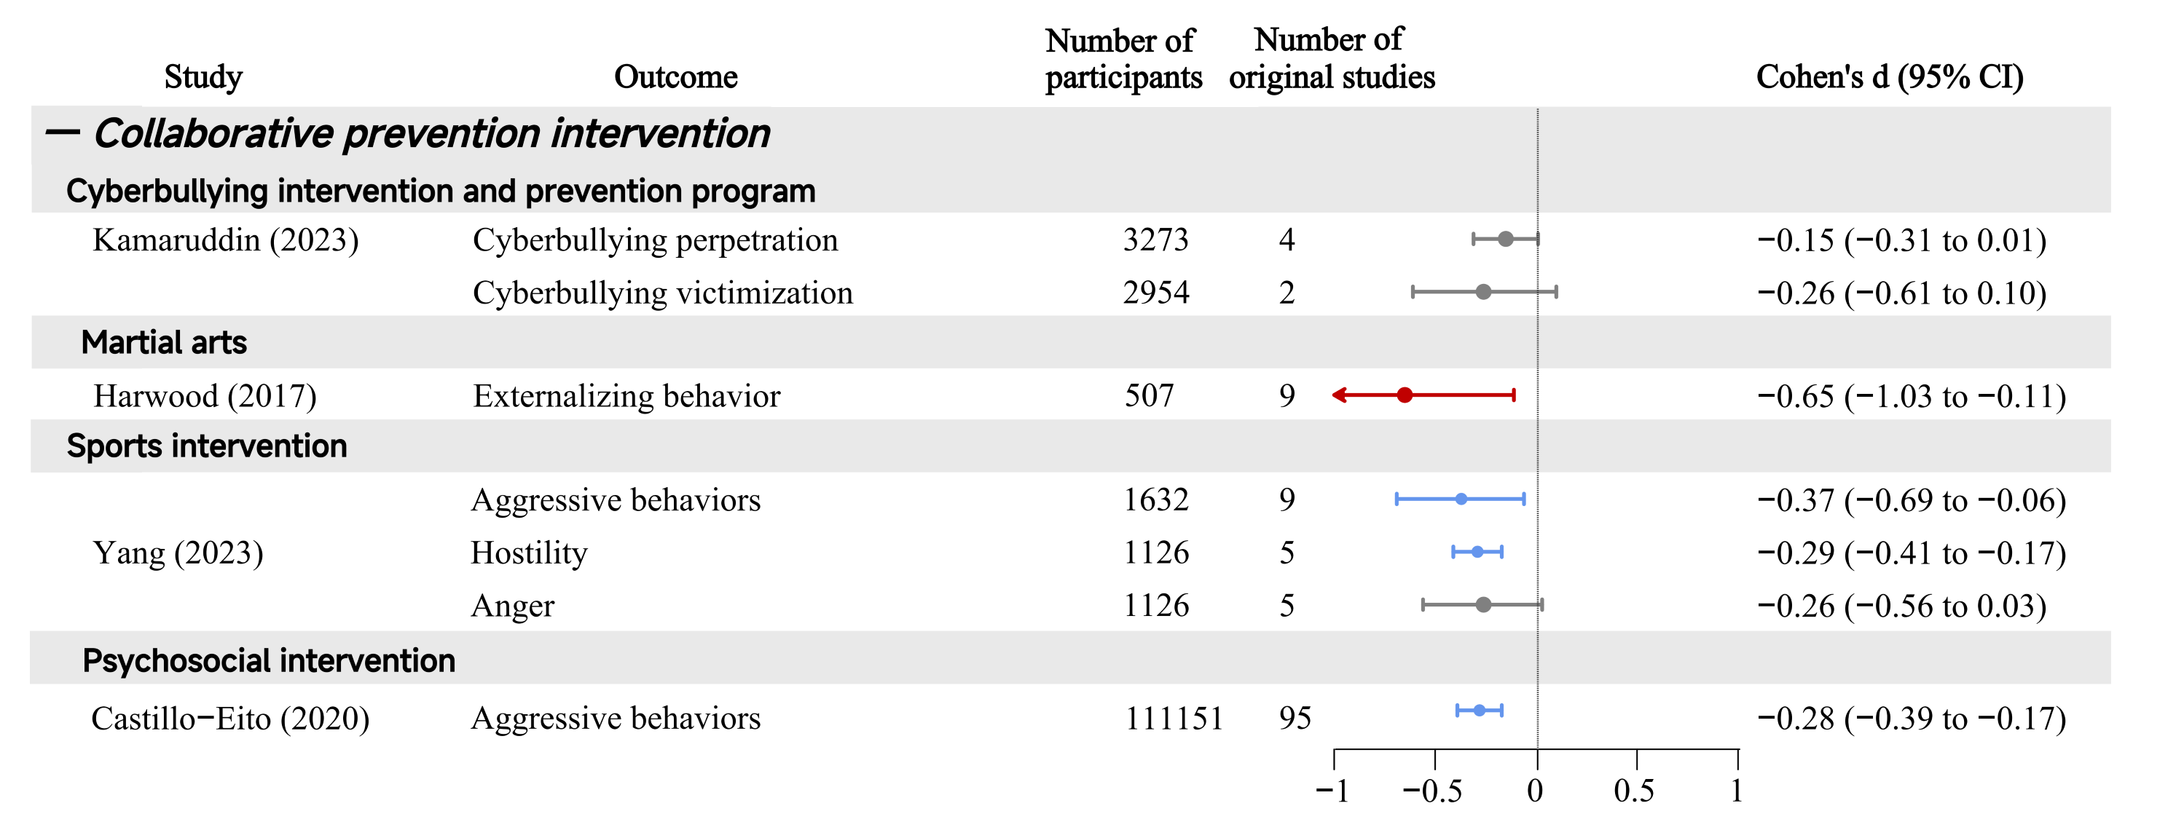

Fig. S10. The effectiveness by prevention intervention subgroups in studies with low AMSTAR-2 rating
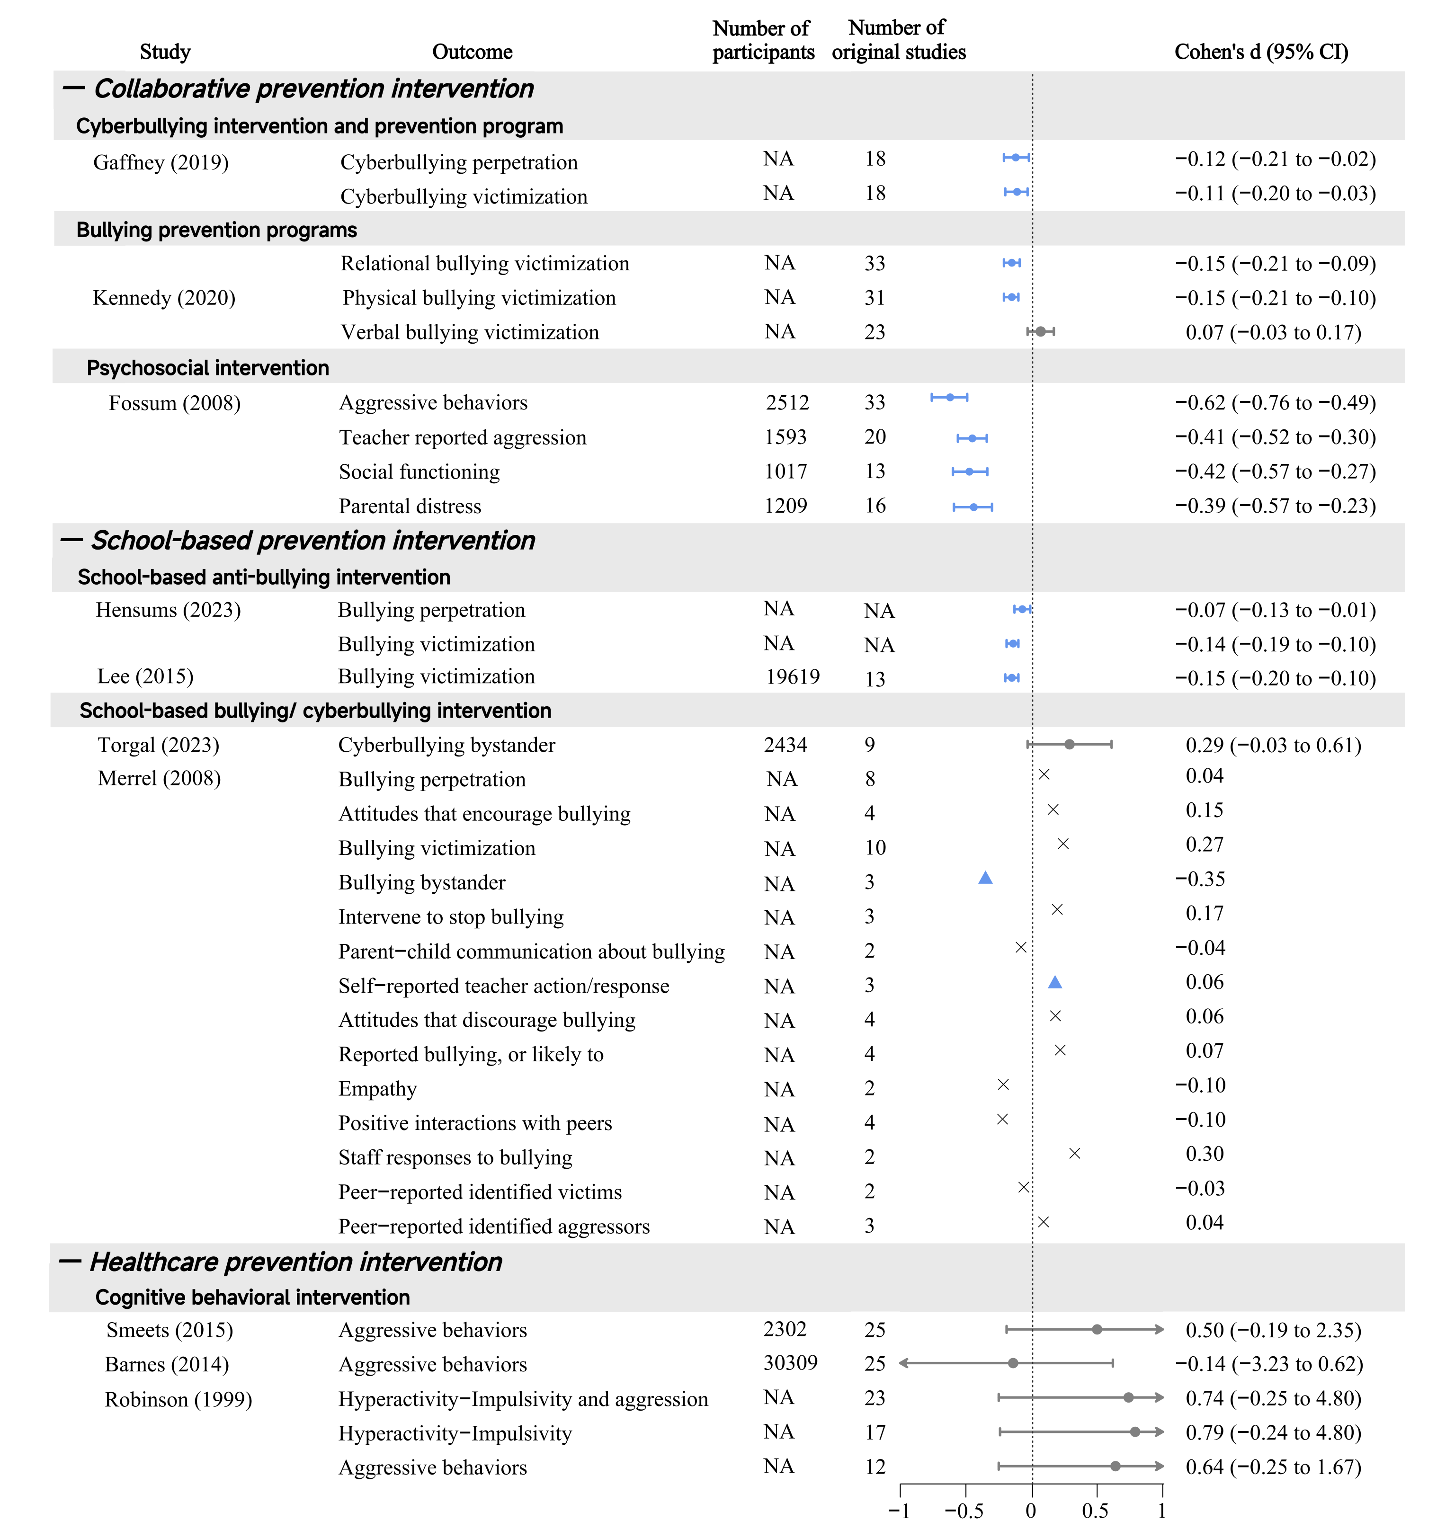

Fig. S11. The effectiveness by prevention intervention subgroups in studies with critically low AMSTAR-2 rating
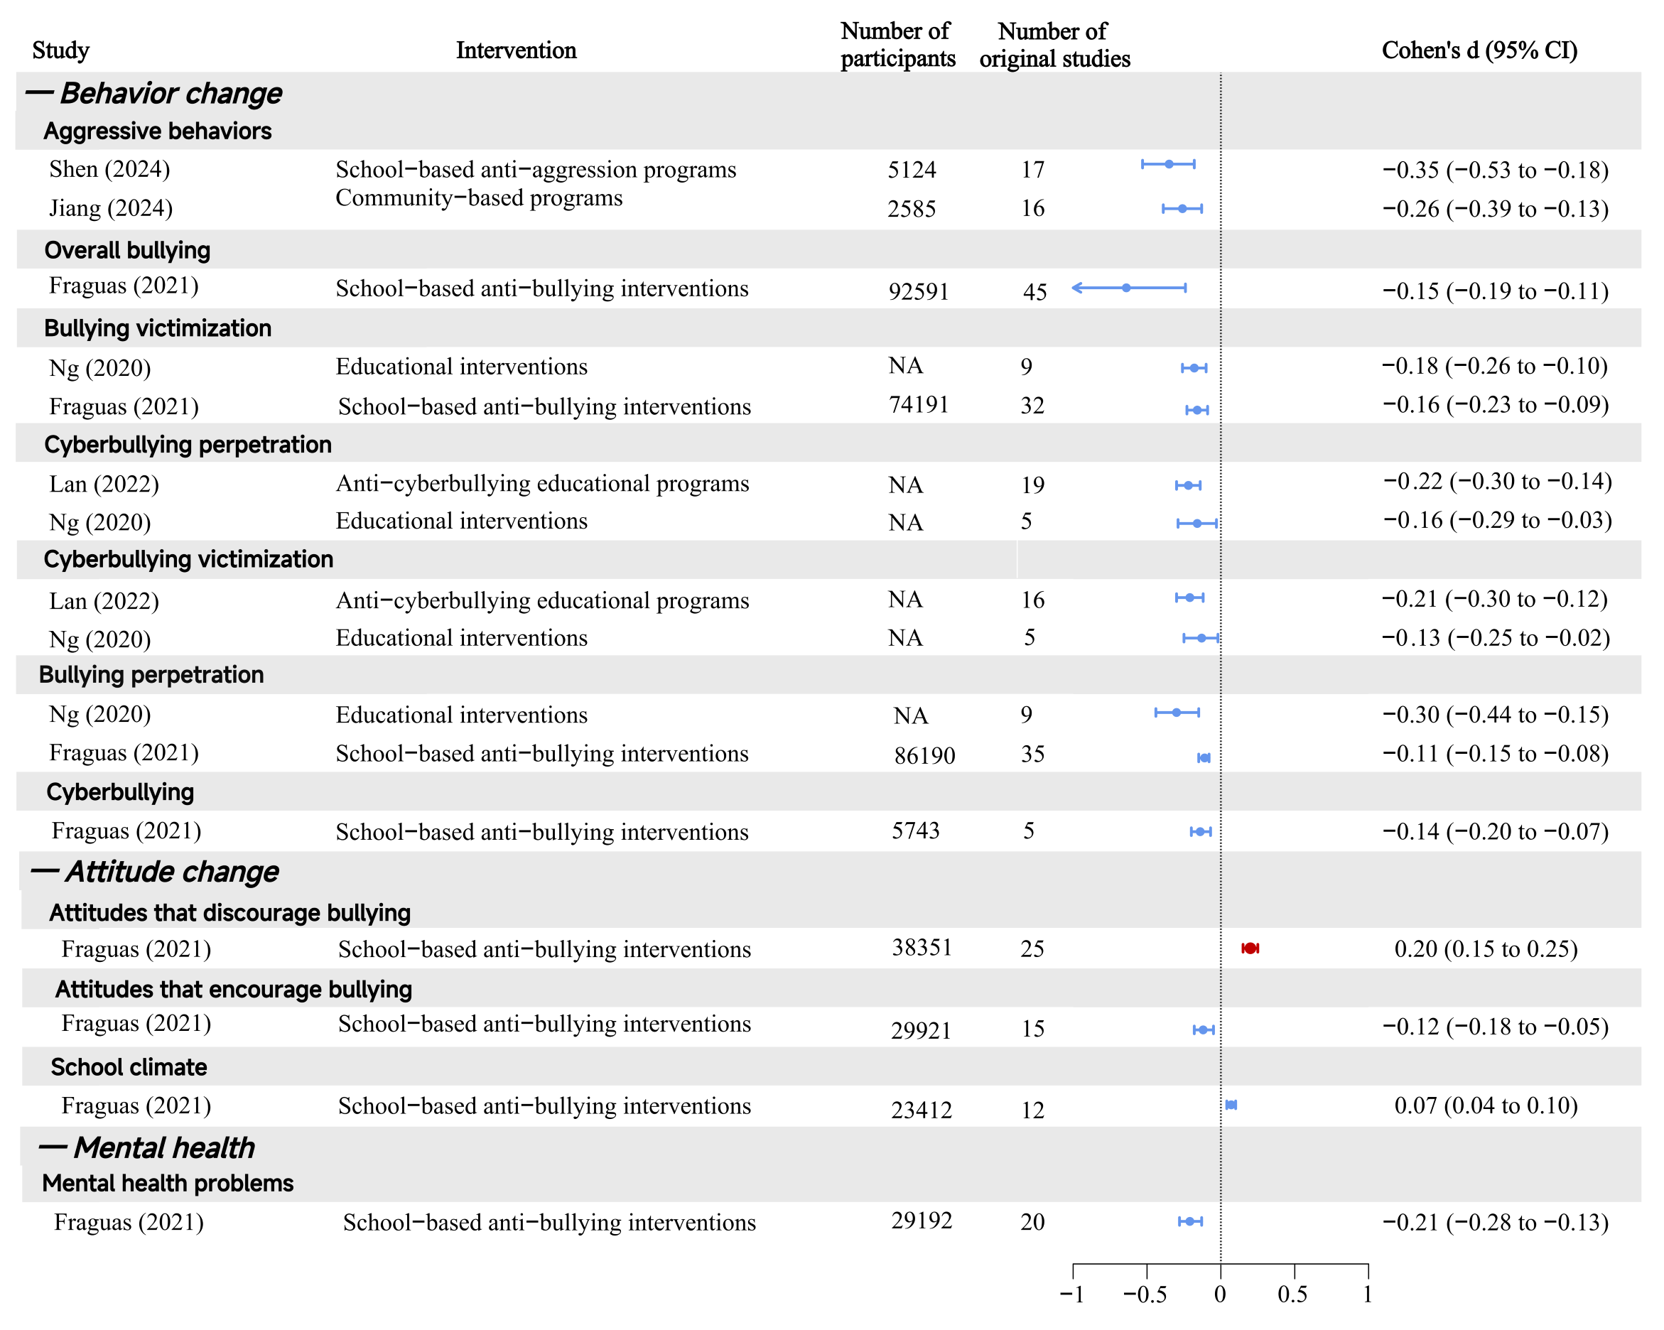

Fig. S12. The effectiveness by outcome subgroups in studies with high AMSTAR-2 rating
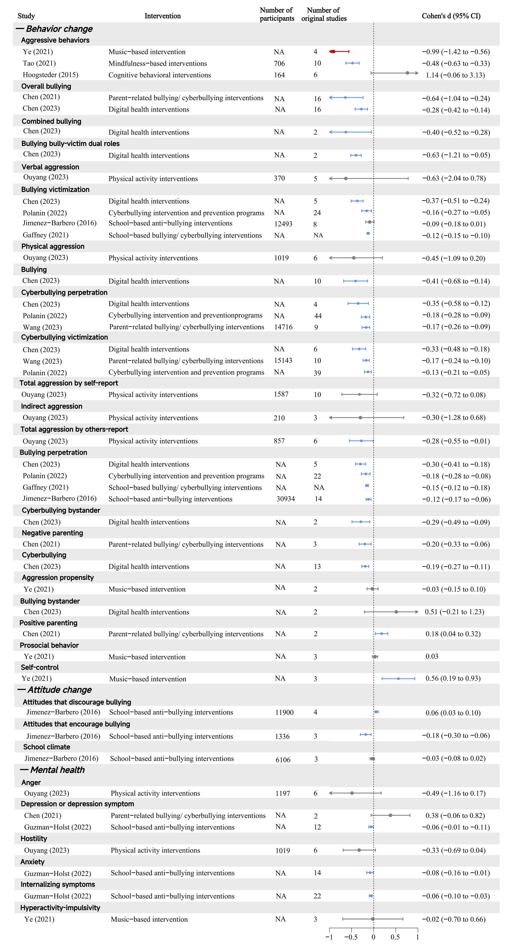

Fig. S13. The effectiveness by outcome subgroups in studies with moderate AMSTAR-2 rating
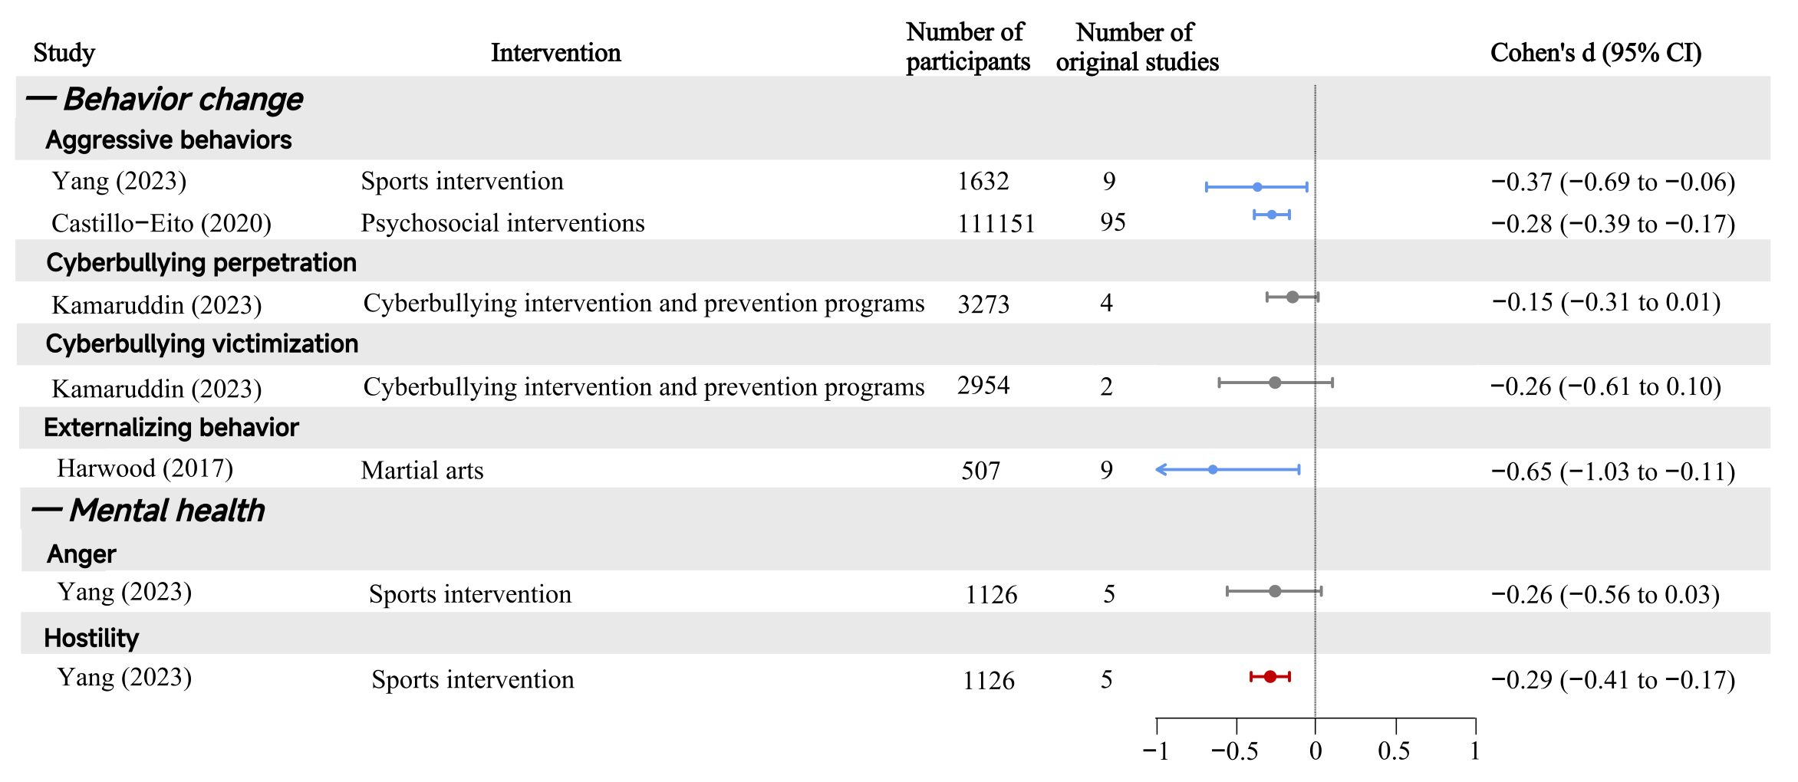

Fig. S14. The effectiveness by outcome subgroups in studies with low AMSTAR-2 rating

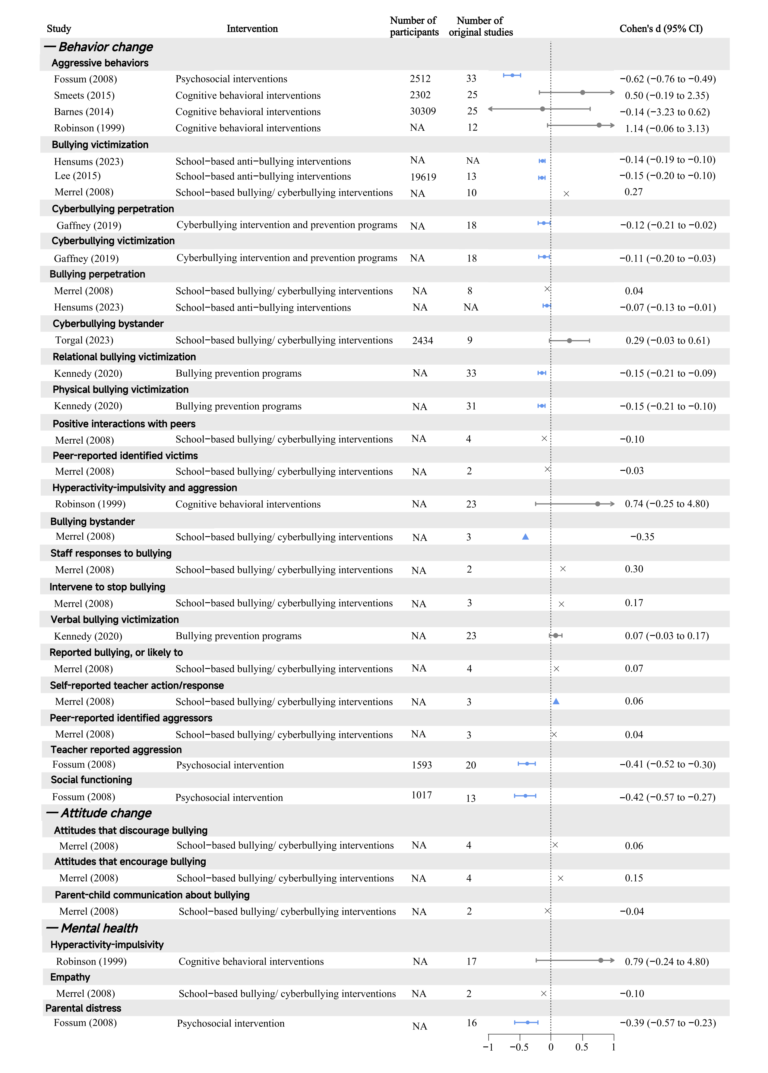

Fig. S15. The effectiveness by outcome subgroups in studies with critically low AMSTAR-2 rating

Table S1. PRISMA checklist
Section and Topic | Item # | Checklist item | Location where item is reported
TITLE
Title | 1 | Identify the report as a systematic review. | 1
ABSTRACT
Abstract | 2 | See the PRISMA 2020 for Abstracts checklist. | 2
INTRODUCTION
Rationale | 3 | Describe the rationale for the review in the context of existing knowledge. | 3-5
Objectives | 4 | Provide an explicit statement of the objective(s) or question(s) the review addresses. | 5
METHODS
Eligibility criteria | 5 | Specify the inclusion and exclusion criteria for the review and how studies were grouped for the syntheses. | 6-7, 9
Information sources | 6 | Specify all databases, registers, websites, organisations, reference lists and other sources searched or consulted to identify studies. Specify the date when each source was last searched or consulted. | 6
Search strategy | 7 | Present the full search strategies for all databases, registers and websites, including any filters and limits used. | 6, Table S3
Selection process | 8 | Specify the methods used to decide whether a study met the inclusion criteria of the review, including how many reviewers screened each record and each report retrieved, whether they worked independently, and if applicable, details of automation tools used in the process. | 6-8, Table S4 & S5
Data collection process | 9 | Specify the methods used to collect data from reports, including how many reviewers collected data from each report, whether they worked independently, any processes for obtaining or confirming data from study investigators, and if applicable, details of automation tools used in the process. | 8
Data items | 10a | List and define all outcomes for which data were sought. Specify whether all results that were compatible with each outcome domain in each study were sought (e.g. for all measures, time points, analyses), and if not, the methods used to decide which results to collect. | 8, Table S6 & S7
Data items | 10b | List and define all other variables for which data were sought (e.g. participant and intervention characteristics, funding sources). Describe any assumptions made about any missing or unclear information. | 8, Table S6 & S7
Study risk of bias assessment | 11 | Specify the methods used to assess risk of bias in the included studies, including details of the tool(s) used, how many reviewers assessed each study and whether they worked independently, and if applicable, details of automation tools used in the process. | 8-9, Table S8
Effect measures | 12 | Specify for each outcome the effect measure(s) (e.g. risk ratio, mean difference) used in the synthesis or presentation of results. | 10
Synthesis methods | 13a | Describe the processes used to decide which studies were eligible for each synthesis (e.g. tabulating the study intervention characteristics and comparing against the planned groups for each synthesis (item #5)). | 11, Table S6 & S7
Synthesis methods | 13b | Describe any methods required to prepare the data for presentation or synthesis, such as handling of missing summary statistics, or data conversions. | 10-11
Synthesis methods | 13c | Describe any methods used to tabulate or visually display results of individual studies and syntheses. | 11
Synthesis methods | 13d | Describe any methods used to synthesize results and provide a rationale for the choice(s). If meta-analysis was performed, describe the model(s), method(s) to identify the presence and extent of statistical heterogeneity, and software package(s) used. | 10-11
Synthesis methods | 13e | Describe any methods used to explore possible causes of heterogeneity among study results (e.g. subgroup analysis, meta-regression). | 11
Synthesis methods | 13f | Describe any sensitivity analyses conducted to assess robustness of the synthesized results. | 11
Reporting bias assessment | 14 | Describe any methods used to assess risk of bias due to missing results in a synthesis (arising from reporting biases). | 8, Table S8
Certainty assessment | 15 | Describe any methods used to assess certainty (or confidence) in the body of evidence for an outcome. | 9-10
RESULTS
Study selection | 16a | Describe the results of the search and selection process, from the number of records identified in the search to the number of studies included in the review, ideally using a flow diagram. | 11-12, Figure 1
Study selection | 16b | Cite studies that might appear to meet the inclusion criteria, but which were excluded, and explain why they were excluded. | 7, Table S4 & S5
Study characteristics | 17 | Cite each included study and present its characteristics. | 11-12, Table 1 & Table S5
Risk of bias in studies | 18 | Present assessments of risk of bias for each included study. | 12-13, Figure 2
Results of individual studies | 19 | For all outcomes, present, for each study: (a) summary statistics for each group (where appropriate) and (b) an effect estimate and its precision (e.g. confidence/credible interval), ideally using structured tables or plots. | 13-16, Figure 3 & 4; Fig. S1, Table S12-S15
Results of syntheses | 20a | For each synthesis, briefly summarise the characteristics and risk of bias among contributing studies. | 12-13, Figure 2
Results of syntheses | 20b | Present results of all statistical syntheses conducted. If meta-analysis was done, present for each the summary estimate and its precision (e.g. confidence/credible interval) and measures of statistical heterogeneity. If comparing groups, describe the direction of the effect. | 13-16, Figure 3 & 4; Fig. S1, Table S12-S15
Results of syntheses | 20c | Present results of all investigations of possible causes of heterogeneity among study results. | 13-17
Results of syntheses | 20d | Present results of all sensitivity analyses conducted to assess the robustness of the synthesized results. | 17, Fig. S4 & S5
Reporting biases | 21 | Present assessments of risk of bias due to missing results (arising from reporting biases) for each synthesis assessed. | Table S6
Certainty of evidence | 22 | Present assessments of certainty (or confidence) in the body of evidence for each outcome assessed. | 12-13, Table S10
DISCUSSION
Discussion | 23a | Provide a general interpretation of the results in the context of other evidence. | 18-22
Discussion | 23b | Discuss any limitations of the evidence included in the review. | 22-23
Discussion | 23c | Discuss any limitations of the review processes used. | 23
Discussion | 23d | Discuss implications of the results for practice, policy, and future research. | 23-24
OTHER INFORMATION
Registration and protocol | 24a | Provide registration information for the review, including register name and registration number, or state that the review was not registered. | 5
Registration and protocol | 24b | Indicate where the review protocol can be accessed, or state that a protocol was not prepared. | 5
Registration and protocol | 24c | Describe and explain any amendments to information provided at registration or in the protocol. | 5, Table S2
Support | 25 | Describe sources of financial or non-financial support for the review, and the role of the funders or sponsors in the review. | 26
Competing interests | 26 | Declare any competing interests of review authors. | 27
Availability of data, code and other materials | 27 | Report which of the following are publicly available and where they can be found: template data collection forms; data extracted from included studies; data used for all analyses; analytic code; any other materials used in the review. | 26
Notes: NA: Not applicable; Source of the table (32).

Table S2. Modifications or new additions to the original protocol
Section | Original protocol | Modifications or new addition | Rationale
Study selection | 2.Studies involving children and adolescents aged 24 years or younger. | Studies involving bullying behaviors in children (<18 years) and adolescents, the latter was defined as individuals aged 10-24 years since it was noted that this age range aligns more closely with adolescent growth and popular understandings of this life phase, which could facilitate extended investments across diverse contexts (36). Children were defined as individuals aged <18 years (37). | For accurate characterisation of the research endpoint, we restricted the population to bullying behaviours occurring in children (<18 years) and adolescents (10-24 years).
Study selection | 6.Articles providing odds ratios (OR) or metrics convertible to ORs (e.g., mean, standard deviation (SD), standardized mean difference (SMD), or Cohen's d) will be included. | (f) providing Cohen's d or other measures [e.g., mean difference (MD), relative risk (RR), odds ratios (OR), Hedges' g, standardized mean difference (SMD)] that can be converted to Cohen's d, since it was widely reported in existing reviews (15, 38) | Drawing on established high-impact studies (15, 38), all non-Cohen’s d effect sizes were converted to this standardized metric. This approach was implemented to facilitate cross-study comparisons and minimize potential biases arising from the transformation of heterogeneous effect size metrics.
Analysis of the degree of overlap in studies | NR | The degree of overlap among primary studies was calculated using the Corrected Covered Area (CCA).  To further assess overlap and identify reviews pairs with high overlap (39), we calculated the proportion of primary studies from one review that were present in another review and excluded those with primary study overlap exceeding 40%. | To avoid double-counting and overestimation of evidence
Data summary | NR | Three authors (ZWL, RL, and XDQ) assessed the credibility of evidence for effect estimate reported in the meta-analysis by applying the GRADE criteria (Grading of Recommendations, Assessment, Development, and Evaluations). | To rate the confidence of effect estimates
Data summary | NR | Sensitivity analyses were conducted by stratifying the AMSTAR-2 quality ratings (High & Moderate VS. Low & Critically Low; and four groups separately), to evaluate the robustness of the primary findings. | To enhance the robustness of results
References
15. Fraguas D, Díaz-Caneja CM, Ayora M, Durán-Cutilla M, Abregú-Crespo R, Ezquiaga-Bravo I, et al. Assessment of School Anti-Bullying Interventions: A Meta-analysis of Randomized Clinical Trials. JAMA Pediatr. 2021;175(1):44-55.
36. Sawyer SM, Azzopardi PS, Wickremarathne D, Patton GC. The age of adolescence. Lancet Child Adolesc Health. 2018;2(3):223-8.
37. UNICEF. Convention on the Rights of the Child General Assembly resolution 44/25; 1989.
38. Baldwin JR, Wang B, Karwatowska L, Schoeler T, Tsaligopoulou A, Munafò MR, et al. Childhood Maltreatment and Mental Health Problems: A Systematic Review and Meta-Analysis of Quasi-Experimental Studies. Am J Psychiatry. 2023;180(2):117-26.
Notes: NR: Not reported.

Table S3. Search strategy
Database | Search Strategy
PubMed | Total: 2739 913 (ZWL); 913 (RL); 913 (XDQ) After duplicate removal: 912  (child*[Title/Abstract] OR adolescent[Title/Abstract] OR teen*[Title/Abstract] OR youth[Title/Abstract]) AND (bullying[Title/Abstract] OR anti-bullying[Title/Abstract] OR "school bullying"[Title/Abstract] OR cyberbullying[Title/Abstract] OR victimization[Title/Abstract] OR "bullying victimization"[Title/Abstract] OR cyber-victimization[Title/Abstract] OR abuse[Title/Abstract] OR violence[Title/Abstract] OR aggression[Title/Abstract]) AND (intervention[Title/Abstract] OR prevention[Title/Abstract] OR treatment[Title/Abstract] OR therapy[Title/Abstract] OR curriculum[Title/Abstract]) AND ("systematic review"[Title/Abstract] OR meta-analysis[Title/Abstract])
Embase | Total: 2841 947 (ZWL); 947 (RL); 947 (XDQ) After duplicate removal: 935  (child*:ab,ti OR adolescent:ab,ti OR teen*:ab,ti OR youth:ab,ti) AND (bullying:ab,ti OR 'anti bullying':ab,ti OR 'school bullying':ab,ti OR cyberbullying:ab,ti OR victimization:ab,ti OR 'bullying victimization':ab,ti OR 'cyber victimization':ab,ti OR abuse:ab,ti OR violence:ab,ti OR aggression:ab,ti) AND (intervention:ab,ti OR prevention:ab,ti OR treatment:ab,ti OR therapy:ab,ti OR curriculum:ab,ti) AND ('systematic review':ab,ti OR 'meta analysis':ab,ti)
Web of science | Total: 4530 1510 (ZWL); 1510 (RL); 1510 (XDQ) After duplicate removal: 1495  AB=((child* OR adolescent OR teen* OR youth) AND (bullying OR anti-bullying OR “school bullying” OR cyberbullying OR victimization OR “bullying victimization” OR cyber-victimization OR abuse OR violence OR aggression) AND (intervention OR prevention OR treatment OR therapy OR curriculum) AND (“systematic review” OR meta-analysis))
EBSCO # | Total: 4801 1488 (ZWL); 1557 (RL); 1756 (XDQ) After duplicate removal: 1398  AB=((child* OR adolescent OR teen* OR youth) AND (bullying OR anti-bullying OR “school bullying” OR cyberbullying OR victimization OR “bullying victimization” OR cyber-victimization OR abuse OR violence OR aggression) AND (intervention OR prevention OR treatment OR therapy OR curriculum) AND (“systematic review” OR meta-analysis))
Notes: # The EBSCO database has a function of “exact duplicates removed from the results”. Thus, the number of studies searched out by the three authors was inconsistent.

Table S4. Examples of excluded meta-analyses
No | Year | Authors | Title | Journal
1 | 2009 | Farrington D P, Ttofi M M | School-Based Programs to Reduce Bullying and Victimization | Campbell systematic reviews
2 | 2007 | Ferguson C J, Miguel C S, Kilburn Jr J C,  Sanchez, P | The Effectiveness of School-Based Anti-Bullying Programs: A Meta-Analytic Review | Criminal Justice Review
3 | 2019 | Gaffney H,  Ttofi M M,  Farrington D P | Evaluating the effectiveness of school-bullying prevention programs: An updated meta-analytical review | Aggression and violent behavior
4 | 2019 | Huang Y,  Espelage D L, Polanin J R,  Hong, J. S | A meta-analytic review of school-based anti-bullying programs with a parent component | International journal of bullying prevention
5 | 2011 | Ttofi M M, Farrington D P | Effectiveness of school-based programs to reduce bullying: A systematic and meta-analytic review | Journal of experimental criminology
6 | 2021 | Gaffney H,  Ttofi M M, Farrington D P | What works in anti-bullying programs? Analysis of effective intervention components | Journal of school psychology
7 | 2019 | Gaffney H,  Farrington D P,  Ttofi M M | Examining the effectiveness of school-bullying intervention programs globally: A meta-analysis | International Journal of Bullying Prevention
Reasons for exclusion
- Five articles from the same team ¹⁻⁵, two of which are updated versions ²⁻³ of previous articles ^{1,5}, one ⁴ used the data from ³. Thus, we included the newest meta-analyses [40].
- No list of articles reporting specific incorporation ⁷.
- 15 of 22 included studies ⁷ were included in Gaffney et al (2021) [40].
References
- Farrington DP and Ttofi MM (2009) School-based programs to reduce bullying and victimization. Campbell systematic reviews 5(1), i-148.
- Gaffney H, Farrington DP and Ttofi MM (2019) Examining the effectiveness of school-bullying intervention programs globally: A meta-analysis. International Journal of Bullying Prevention 1, 14-31.
- Gaffney H, Ttofi MM and Farrington DP (2019) Evaluating the effectiveness of school-bullying prevention programs: An updated meta-analytical review. Aggression and Violent Behavior 45, 111-133.
- Gaffney H, Ttofi MM and Farrington DP (2021) What works in anti-bullying programs? Analysis of effective intervention components. Journal of school psychology 85, 37-56.
- Ttofi MM and Farrington DP (2011) Effectiveness of school-based programs to reduce bullying: A systematic and meta-analytic review. Journal of experimental criminology 7, 27-56.
- Ferguson CJ, Miguel CS, Kilburn Jr JC and Sanchez P (2007) The effectiveness of school-based anti-bullying programs: A meta-analytic review. Criminal Justice Review 32(4), 401-414.
- Huang Y, Espelage DL, Polanin JR and Hong JS (2019) A meta-analytic review of school-based anti-bullying programs with a parent component. International Journal of Bullying Prevention 1, 32-44.

Table S5. Examples of details of one excluded and one included meta-analysis
Reference List
Excluded | Included in the current study
Huang et al. (2019) (41) | Gaffney et al (2021) (40)
- Alsaker, F. D., & Valkanover, S. (2012). The Bernese program against victimization in kindergarten and elementary school. New Directions for Youth Development, 2012(133), 15-28.  - Bauer, N. S., Lozano, P., & Rivara, F. P. (2007). The effectiveness of the Olweus Bullying Prevention Program in public middle schools: a controlled trial. Journal of Adolescent Health, 40(3), 266-274.  - Beran, T. N., Tutty, L., & Steinrath, G. (2004). An evaluation of a bullying prevention program for elementary schools. Canadian Journal of School Psychology, 19(1-2), 99-116.  - Berry, K., & Hunt, C. J. (2009). Evaluation of an intervention program for anxious adolescent boys who are bullied at school. Journal of Adolescent Health, 45(4), 376-382.  - Crean, H. F., & Johnson, D. B. (2013). Promoting alternative thinking strategies (PATHS) and elementary school aged children's aggression: Results from a cluster randomized trial. American Journal of Community Psychology, 52(1/2), 56-72.  - Cross, D., Shaw, T., Hadwen, K., Cardoso, P., Slee, P., Roberts, C., Thomas L. & Barnes, A. (2016). Longitudinal impact of the cyber friendly schools program on adolescents' cyberbullying behavior. Aggressive Behavior, 42(2), 166-180.  - Cross, D., Waters, S., Pearce, N., Shaw, T., Hall, M., Erceg, E., . . . Hamilton, G. (2012). The friendly schools friendly families programme: three-year bullying behaviour outcomes in primary school children. International Journal of Educational Research, 53, 394- 406.  - Domino, M. B. (2011). The Impact of Take the LEAD on School Bullying Among Middle School Youth (unpublished doctoral dissertation). Walden University.  - Evers, K. E., Prochaska, J. O., Van Marter, D. F., Johnson, J. L., & Prochaska, J. M. (2007). Transtheoretical-based bullying prevention effectiveness trials in middle schools and high schools. Educational Research, 49(4), 397-414.  - Fekkes, M., Pijpers, F.I.M., & Verloove-Vanhorick, S.P. (2006). Effects of antibullying school program on bullying and health complaints. Archives of Pediatrics and Adolescent Medicine, 160, 638-644.  - Frey, K., Hirschstein, M.K., Snell, J. L., van Schoiack Edstrom, L., MacKenzie, E.P., & Broderick, C.J. (2005). Reducing playground bullying and supporting beliefs: an experimental trial of the steps to respect program. Developmental Psychology, 41, 479-491.  - Hunt, C. (2007). The effect of an education program on attitudes and beliefs about bullying and bullying behaviour in junior secondary school students. Child and Adolescent Mental Health, 12(1), 21-26.  - Joronen, K., Konu, A., Rankin, H. S., & Åstedt-Kurki, P. (2011). An evaluation of a drama program to enhance social relationships and anti-bullying at elementary school: a controlled study. Health Promotion International, 27(1), 5-14.  - Kärnä, A., Voeten, M., Little, T. D., Alanen, E., Poskiparta, E., & Salmivalli, C. (2013). Effectiveness of the KiVa Antibullying program: grades 1-3 and 7-9. Journal of Educational Psychology, 105(2), 535, 551.  - Kärnä, A., Voeten, M., Little, T. D., Poskiparta, E., Alanen, E., & Salmivalli, C. (2011). Going to scale: a nonrandomized nationwide trial of the KiVa antibullying program for grades 1-9. Journal of Consulting and Clinical Psychology, 79(6), 796-805.  - Lewis, K. M., Schure, M. B., Bavarian, N., DuBois, D. L., Day, J., Ji, P., Silverthorn, N., Acock, A., Vuchinich, S., & Flay, B. R. (2013). Problem behavior and urban, low-income youth: A randomized controlled trial of Positive Action in Chicago. American Journal of Preventive Medicine, 44(6), 622-630.  - Leadbeater, B., & Sukhawathanakul, P. (2011). Multicomponent programs for reducing peer victimization in early elementary school: a longitudinal evaluation of the WITS primary program. Journal of Community Psychology, 39(5), 606-620.  - Pepler, D.J., Craig, W.M., O'Connell, P., Atlas, R. & Charach, A. (2004). Making a difference in bullying: evaluation of a systemic school-based program in Canada. In P.K. Smith, D. Pepler, & K. Rigby (Eds.), Bullying in schools: how successful can interventions be? (pp. 125-140). Cambridge: Cambridge University Press.  - Raskauskas, J. (2007). Evaluation of the Kia Kaha anti-bullying programme for students in years 5-8. Final Report to the New Zealand Police. Wellington: New Zealand Police.  - Salmivalli, C., Kaukiainen, A., & Voeten, M. (2005). Anti-bullying intervention: Implementation and outcome. British Journal of Educational Psychology, 75(3), 465-487.  - Stevens, V., De Bourdeaudhuij, I., & Van Oost, P. (2000). Bullying in Flemish schools: an evaluation of anti-bullying intervention in primary and secondary schools. British Journal of Educational Psychology, 70(2), 195-210.  - Wong, D. S., Cheng, C. H., Ngan, R. M., & Ma, S. K. (2011). Program effectiveness of a restorative whole-school approach for tackling school bullying in Hong Kong. International Journal of Offender Therapy and Comparative Criminology, 55(6), 846-862. | Selected References:  - Alsaker, F. D. (2004). Bernese program against victimization to kindergarten and elementary schools. In P. K. Smith, D. Pepler & K. Rigby (Eds.), Bullying in schools: How successful can interventions be? (pp. 289-306). Cambridge University Press.  - Alsaker, F. D., & Valkanover, S. (2001). Early diagnosis and prevention of victimization in kindergarten. In J. Juvonen & S. Graham (Eds.), Peer harassment in school (pp. 175-195). Guilford.  .......  - Bauer, N. S., Lozano, P., & Rivara, F. P. (2007). The effectiveness of the Olweus bullying prevention program in public middle schools: A controlled trial. Journal of Adolescent Health, 40, 266-274.  - Beran, T., & Shapiro, B. (2005). Evaluation of an anti-bullying program: Student reports of knowledge and confidence to manage bullying. Canadian Journal of Education, 28(4), 700-717.  - Beran, T., Tutty, L., & Steinrath, G. (2004). An evaluation of a bullying prevention program for elementary schools. Canadian Journal of School Psychology, 19(1/2), 99-116.  - Berry, K., & Hunt, C. J. (2009). Evaluation of an intervention program for anxious adolescent boys who are bullied at school. Journal of Adolescent Health, 45, 376-382.  ...........  - Domino, M. (2011). The impact of Take the LEAD on school bullying among middle school youth (Doctoral Dissertation). Available from ProQuest Dissertation and Theses database (UMI No. 3434870).  - Domino, M. (2013). Measuring the impact of an alternative approach to school bullying. Journal of School Health, 83(6), 430-437.  ...........  - Evers, K. E., Poskiparta, J. O., van Marter, D. F., Johnson, J. L., & Prochaska, J. M. (2007). Transtheoretical-based bullying prevention effectiveness trials in middle schools and high schools. Educational Research, 49, 397-414.  ...........  - Fekkes, M., Pijpers, F. I. M., & Verloove-Vanhorick, P. (2006). Effects of antibullying school program on bullying and health complaints Archives of Pediatrics and Adolescent Medicine, 160(6), 638-644  - Fekkes, M., van de Sande, M. C. E., Gravesteijn, J. C., Pannebakker, F. D., Buijs, G. J., Diekstra, R. F. W., & Kocken, P. L. (2016). Effects of the Dutch Skills for Life program on the health behaviour, bullying, and suicidal ideation of secondary school students. Health Education, 116(1), 2-15.  ...........  - Frey, K., Hirschstein, M. K., Snell, J. L., van Schoiack Edstrom, L., MacKenzie, E. P., & Broderick, C. J. (2005). Reducing playground bullying and supporting beliefs: An experimental trial of the Steps to Respect program. Developmental Psychology, 41, 479-491.  ...........  - Hunt, C. (2007). The effect of an education program on attitudes and beliefs about bullying and bullying behaviour in junior secondary school students. Child and Adolescent Mental Health, 12(1), 21-26.  ...........  - Joronen, K., Konu, A., Rankin, H. S., & Astedt-Kurki, P. (2011). An evaluation of a drama program to enhance social relationships and anti-bullying at elementary school: A controlled study. Health Promotion International, 27(1), 5-14.  ...........  - Kärnä, A., Voeten, M., Little, T. D., Alanen, E., Poskiparta, E., & Salmivalli, C. (2013). Effectiveness of the KiVa Antibullying Program: Grades 1-3 and 7-9. Journal of Educational Psychology, 105(2), 535-551.  - Kärnä, A., Voeten, M., Little, T. D., Poskiparta, E., Alanen, E., & Salmivalli, C. (2011a). Going to scale: A nonrandomized nationwide trial of the KiVa antibullying Program for Grades 1-9. Journal of Consulting and Clinical Psychology, 79(6), 796-805.  - Kärnä, A., Voeten, M., Little, T. D., Poskiparta, E., Kaljonen, A., & Salmivalli, C. (2011b). A large-scale evaluation of the KiVa antibullying program: Grades 4-6. Child Development, 82(1), 311-330.  ...........  - Lewis, K. M., Schure, M. B., Bavarian, N., DuBois, D. L., Day, J., Ji, P., Silverthorn, N., Acock, A., Vuchinich, S., & Flay, B. R. (2013). Problem behavior and urban, low-income youth: A randomized controlled trial of Positive Action in Chicago. American Journal of Preventive Medicine, 44(6), 622-630.  ...........  - Pepler, D. J., Craig, W. M., O'Connell, P., Atlas, R., & Charach, A. (2004). Making a difference in bullying: Evaluation of a systemic school-based program in Canada. In P. K. Smith, D. Pepler & K. Rigby (Eds.), Bullying in schools: How successful can interventions be? (pp. 125-140). Cambridge University Press.  - Polanin, M.K. (2015). Effects of cultural awareness training in conjunction with an established bullying prevention program (Doctoral Dissertation). Loyola University Chicago.  ...........  - Salmivalli, C., Kaukiainen, A., & Voeten, M. (2005). Anti-bullying intervention: Implementation and outcome. British Journal of Educational Psychology, 75, 465-487.  ...........  - Wong, D. S. W., Cheng, C. H. K., Ngan, R. M. H., & Ma, S. K. (2011). Program effectiveness of a restorative whole-school approach for tackling school bullying in Hong Kong. International Journal of Offender Therapy and Comparative Criminology, 55(6), 846-862.  ...........
Notes: The bold references indicate that the same studies were included in the two separate meta-analyses. n=number of original studies.

Table S6. Specific characteristics of included meta-analyses
No. | First author (year) | Name of intervention | Model synthesizing data | Publication bias | Study design | Sample of participants | Sample of group |  | N | Year of studies | Journal | Name of outcome variable | Age
 |  |  |  |  |  |  | Intervention | Control
1 | Jiménez-Barbero (2016) | Anti-bullying school programs | Random effects model | Funnel-plot; Presence of publication bias in victimization and school climate; NA | RCT | 30934 | 16243 | 14691 | 14 | 2000.01.01  —2015.05.31 | Children and Youth Services Review | Bullying or school violence frequency | 7-16
 |  |  |  |  |  | 14293 | 7683 | 6610 | 14 | 2000.01.01  —2015.05.31 | Children and Youth Services Review | Victimization frequency | 7-16
 |  |  |  |  |  | 1336 | 660 | 676 | 14 | 2000.01.01  —2015.05.31 | Children and Youth Services Review | Attitudes favoring bullying or school violence | 7-16
 |  |  |  |  |  | 11900 | 5929 | 5971 | 14 | 2000.01.01  —2015.05.31 | Children and Youth Services Review | Attitudes against bullying or school violence | 7-16
 |  |  |  |  |  | 6106 | 2806 | 3300 | 14 | 2000.01.01  —2015.05.31 | Children and Youth Services Review | School climate | 7-16
2 | Chen (2021) | Parenting programs | Random effects model | Funnel plot, Begg–Mazumdar rank correlation, Egger's correlation tests; No publication bias; Trim and Fill test | RCT and pre-posttest | 46361 | - | - | 16 | —2019.3 | Trauma, Violence, & Abuse | Overall bullying | 4-15
 |  |  |  |  |  |  | - | - | 16 | —2019.3 | Trauma, Violence, & Abuse | Children's depression | 4-15
 |  |  |  |  |  |  | - | - | 16 | —2019.3 | Trauma, Violence, & Abuse | Positive parenting | 4-15
 |  |  |  |  |  |  | - | - | 16 | —2019.3 | Trauma, Violence, & Abuse | Negative parenting | 4-15
3 | Fraguas (2021) | School anti-bullying interventions | Random effects model | Funnel Plot, fail-safe N, Egger's regression; Presence of publication bias in Overall bullying, Bullying perpetration, Attitudes that discourage bullying, Mental health problems, School climate; NA | RCT | 111659 | 46847 | 45744 | 69 | 2020.2 | JAMA Pediatrics | Overall bullying (E) | 4-17
 |  |  |  |  |  |  | 11020 | 11977 | 69 | 2020.2 | JAMA Pediatrics | Overall bullying (F) | 4-17
 |  |  |  |  |  |  | 43199 | 42991 | 69 | 2020.2 | JAMA Pediatrics | Bullying perpetration (E) | 4-17
 |  |  |  |  |  |  | 7889 | 7993 | 69 | 2020.2 | JAMA Pediatrics | Bullying perpetration (F) | 4-17
 |  |  |  |  |  |  | 37190 | 37001 | 69 | 2020.2 | JAMA Pediatrics | Bullying exposure (E) | 4-17
 |  |  |  |  |  |  | 6971 | 7629 | 69 | 2020.2 | JAMA Pediatrics | Bullying exposure (F) | 4-17
 |  |  |  |  |  |  | 3271 | 2472 | 69 | 2020.2 | JAMA Pediatrics | Cyberbullying (E) | 4-17
 |  |  |  |  |  |  | - | - | 69 | 2020.2 | JAMA Pediatrics | Cyberbullying (F) | 4-17
 |  |  |  |  |  |  | 20537 | 17778 | 69 | 2020.2 | JAMA Pediatrics | Attitudes that discourage bullying (E) | 4-17
 |  |  |  |  |  |  | 5517 | 4596 | 69 | 2020.2 | JAMA Pediatrics | Attitudes that discourage bullying (F) | 4-17
 |  |  |  |  |  |  | 15884 | 14037 | 69 | 2020.2 | JAMA Pediatrics | Attitudes that encourage bullying (E) | 4-17
 |  |  |  |  |  |  | 3329 | 3299 | 69 | 2020.2 | JAMA Pediatrics | Attitudes that encourage bullying (F) | 4-17
 |  |  |  |  |  |  | 14543 | 14649 | 69 | 2020.2 | JAMA Pediatrics | Mental health problems (E) | 4-17
 |  |  |  |  |  |  | 1605 | 1621 | 69 | 2020.2 | JAMA Pediatrics | Mental health problems (F) | 4-17
 |  |  |  |  |  |  | 11417 | 11995 | 69 | 2020.2 | JAMA Pediatrics | School climate (E) | 4-17
 |  |  |  |  |  |  | 2647 | 2978 | 69 | 2020.2 | JAMA Pediatrics | School climate (F) | 4-17
4 | Guzman- Holst (2022) | Antibullying interventions | Random effects model | Funnel Plot; No publication bias; Duval and Tweedie trim-and-fill procedure | Randomized experiments, experimental-control comparisons with pre- and postmeasures, and other experimental-control comparisons. | 58091 | - | - | 22 | 2011-2020 | Journal of Child Psychology and Psychiatry | Overall internalizing symptoms | 4-19（10.5）
 |  |  |  |  |  |  | - | - | 22 | 2011-2020 | Journal of Child Psychology and Psychiatry | Depression | 4-19（10.5）
 |  |  |  |  |  |  | - | - | 22 | 2011-2020 | Journal of Child Psychology and Psychiatry | Anxiety | 4-19（10.5）
5 | Hensums (2023) | School-based anti-bullying interventions | Fitting multilevel regression models | Year of publication, Location of study (by continent), Design, Reported effects; No publication bias; NA | RCT, quasi-experimental, measure before and after interventions | 39793 | - | - | 10 | —2019.1 | Prevention Science | Bullying victimization | 12.58±2.34
 |  |  |  |  |  |  | - | - | 10 | —2019.1 | Prevention Science | Bullying perpetration | 12.58±2.34
6 | Kamaruddin (2023) | Game-based, skill-building, school-based, and whole-school interventions | Random-effects model with  robust variance estimation | Searched for relevant information including published and unpublished research reports and available data sets; NA; NA | RCT, quasi-experimental studies, and studies that may have assigned groups in a randomized or non-randomized way to conditions without any exclusion based on the level of assignment | 3273 | 1802 | 1471 | 4 | 1995—2022 | Frontiers in Psychiatry | Cyberbullying perpetration frequency | 8-23
 |  |  |  |  |  | 2954 | 1623 | 1331 | 4 | 1995—2022 | Frontiers in Psychiatry | Cyberbullying victimization frequency | 8-23
7 | Kennedy (2020) | Bullying prevention programs | Random effects model | This search included all types of scholarly articles; NA; NA | Experimental, quasi-experimental, non-experimental | - | - | - | 33 | 1990—2018 | Aggression and Violent Behavior | Relational bullying victimization | Under the age of 18
 |  |  |  |  |  | - | - | - | 33 | 1990—2018 | Aggression and Violent Behavior | Physical bullying victimization | Under the age of 18
 |  |  |  |  |  | - | - | - | 33 | 1990—2018 | Aggression and Violent Behavior | Verbal bullying victimization | Under the age of 18
8 | Lan (2022) | Anti-cyberbullying educational programs | Random effects model | Funnel plot, Rosenthal's fail-safe number, fail-safe N; No publication bias; NA | Quasi-experimental and RCTs | 31924 | - | - | 19 | —2020.3.31 | Computers in Human Behavior | Cyber aggression (S) | 11.3-16.8
 |  |  |  |  |  |  | - | - | 19 | —2020.3.31 | Computers in Human Behavior | Cyber aggression (L) | 11.3-16.8
 |  |  |  |  |  |  | - | - | 19 | —2020.3.31 | Computers in Human Behavior | Cyber victimization (S) | 11.3-16.8
 |  |  |  |  |  |  | - | - | 19 | —2020.3.31 | Computers in Human Behavior | Cyber victimization (L) | 11.3-16.8
9 | Ng (2022) | Educational interventions | Random effects model | Funnel plots; Presence of publication bias in bullying victimization and perpetration; NA | RCTs | 35694 | - | - | 15 | —2019.6.30 | Trauma, Violence, & Abuse | Bullying victimization frequency | 10-18
 |  |  |  |  |  |  | - | - | 15 | —2019.6.30 | Trauma, Violence, & Abuse | Bullying victimization frequency | 10-18
 |  |  |  |  |  |  | - | - | 15 | —2019.6.30 | Trauma, Violence, & Abuse | Bullying perpetration frequency | 10-18
 |  |  |  |  |  |  | - | - | 15 | —2019.6.30 | Trauma, Violence, & Abuse | Bullying perpetration frequency | 10-18
 |  |  |  |  |  |  | - | - | 15 | —2019.6.30 | Trauma, Violence, & Abuse | Cyberbullying victimization frequency | 10-18
 |  |  |  |  |  |  | - | - | 15 | —2019.6.30 | Trauma, Violence, & Abuse | Cyberbullying perpetration frequency | 10-18
10 | Torgal (2023) | School-based cyberbullying prevention programs | Random effects model with robust variance estimation | Not assessed | Quasi-experimental and RCTs | 2434 | - | - | 9 | —2019.8 | School Psychology Review | Cyber-bystander behavior | 10-18
11 | Wang (2023) | Parent-related interventions | Random effects model | Funnel plot, Egger's test; Presence of publication bias; Duval and Tweedie's trim and fill method | Quasi-experimental and RCTs | 15143 | 8503 | 6640 | 11 | —2021.5.27 | Trauma, Violence, & Abuse | Cyberbullying victimization frequency (E) | 10-19
 |  |  |  |  |  |  | 1819 | 1518 | 11 | —2021.5.27 | Trauma, Violence, & Abuse | Cyberbullying victimization frequency (F) | 10-19
 |  |  |  |  |  | 14716 | 7100 | 7616 | 11 | —2021.5.27 | Trauma, Violence, & Abuse | Cyberbullying perpetration frequency (E) | 10-19
 |  |  |  |  |  |  | 1794 | 1488 | 11 | —2021.5.27 | Trauma, Violence, & Abuse | Cyberbullying perpetration frequency (F) | 10-19
12 | Polanin (2022) | Cyberbullying prevention and intervention programming | Multilevel, random-effects  model with robust variance estimation | Egger's test, funnel plots; No publication bias; Duval and Tweedie's trim and fill method | NR | 45371 | - | - | 50 | —2019.8.5 | Prevention Science | Cyberbullying perpetration | 13±1.73
 |  |  |  |  |  |  | - | - | 50 | —2019.8.5 | Prevention Science | Cyberbullying victimization | 13±1.73
 |  |  |  |  |  |  | - | - | 50 | —2019.8.5 | Prevention Science | Bullying perpetration frequency | 13±1.73
 |  |  |  |  |  |  | - | - | 50 | —2019.8.5 | Prevention Science | Bullying victimization | 13±1.73
13 | Barnes (2014) | Cognitive behavioral interventions | Fixed effects model | Rosenthal's formula; No publication bias; NA | Experimental or quasi-experimental | 30309 | - | - | 25 | 1992—2012 | Aggression and Violent Behavior | Aggressive behaviors | 10-17.99
14 | Castillo-Eito (2020) | Psychosocial interventions | Three-level random-effects meta-analysis | Located grey literature; NA; NA | RCTs | 111151 | 57742 | 53409 | 95 | —2019.1 | Clinical Psychology Review | Aggression | 13.36 (mean age)
15 | Harwood (2017) | Martial arts | Not assessed | Funnel Plot; No publication bias; NA | NR | 507 | - | - | 9 | 1980—2015.11 | Aggression and Violent Behavior | Problematic externalizing behavior | 6-18
16 | Hoogsteder (2015) | Individually oriented cognitive behavioral treatment | Multilevel random effects model | Fail-safe number; No publication bias; NA | Quasi-experimental | 164 | - | - | 6 | 1980—2011 | The Journal of Forensic Psychiatry & Psychology | Overall several aggressive problems | 12-18 (15.8)
17 | Ouyang (2023) | Physical activity interventions | Random effects model | Egger's tests and funnel plots; No publication bias; NA | Quasi-experimental and RCTs | 2003 | 444 | 413 | 15 | —2020.6 | Aggression and Violent Behavior | Total aggression by others-report | Under the age of 18
 |  |  |  |  |  |  | 807 | 780 | 15 | —2020.6 | Aggression and Violent Behavior | Total aggression by self-report | Under the age of 18
 |  |  |  |  |  |  | 517 | 502 | 15 | —2020.6 | Aggression and Violent Behavior | Physical aggression | Under the age of 18
 |  |  |  |  |  |  | 187 | 183 | 15 | —2020.6 | Aggression and Violent Behavior | Verbal aggression | Under the age of 18
 |  |  |  |  |  |  | 641 | 556 | 15 | —2020.6 | Aggression and Violent Behavior | Anger | Under the age of 18
 |  |  |  |  |  |  | 516 | 503 | 15 | —2020.6 | Aggression and Violent Behavior | Hostility | Under the age of 18
 |  |  |  |  |  |  | 105 | 105 | 15 | —2020.6 | Aggression and Violent Behavior | Indirect aggression | Under the age of 18
18 | Yang (2023) | Sports intervention | DerSimonian-Laird random effects model or fixed effects  model | Not assessed | Quasi-experimental and RCTs | 1632 | 833 | 799 | 15 | —2022.10.12 | Peer J | Overall aggression | 7-16
 |  |  |  |  |  | 1126 | 571 | 555 | 15 | —2022.10.12 | Peer J | Hostility | 7-16
 |  |  |  |  |  | 1126 | 571 | 555 | 15 | —2022.10.12 | Peer J | Anger | 7-16
19 | Ye (2021) | Music-based intervention | Random effects model | Funnel plot, Egger linear regression test; Presence of publication bias in aggressive behavior; NA | Quasi-RCT and RCT | 3465 | - | - | 10 | —2020.3 | Medicine | Aggressive behavior | 8-13
 |  |  |  |  |  |  | - | - | 10 | —2020.3 | Medicine | Self-control | 8-13
 |  |  |  |  |  |  | - | - | 10 | —2020.3 | Medicine | Aggression propensity | 8-13
 |  |  |  |  |  |  | - | - | 10 | —2020.3 | Medicine | Hyperactivity-impulsivity | 8-13
 |  |  |  |  |  |  | - | - | 10 | —2020.3 | Medicine | Prosocial behavior | 8-13
20 | Jiang (2024) | Community-based programs | Random effects model | Egger's correlation tests, Begg-Mazumdar rank correlation, funnel plots; No  publication bias; NA | Quasi-experimental and RCTs | 2585 | 1386 | 1199 | 16 | 2023.7.7 | Trauma, Violence, & Abuse | Aggression | 2-18
21 | Shen (2024) | School-based  anti-aggression programs | Random effects model | Funnel plots, Egger's test; No publication bias; Trim and Fill tests | Quasi-experimental and RCTs | 5124 | 3565 | 2564 | 17 | 2022.10.14 | Research on Social Work Practice | Aggressive behaviors | 3-19
22 | Chen (2023) | Digital health interventions (DHIs) | Random effects model | Funnel plots; No publication bias; Trim and fill tests | Quasi-experimental and RCTs | 55473 | - | - | 16 | 2021.1.31 | Trauma, Violence, & Abuse | Overall bullying | 7-23
 |  |  |  |  |  |  | - | - | 16 | 2021.1.31 | Trauma, Violence, & Abuse | Cyberbullying | 7-23
 |  |  |  |  |  |  | - | - | 16 | 2021.1.31 | Trauma, Violence, & Abuse | Bullying | 7-23
 |  |  |  |  |  |  | - | - | 16 | 2021.1.31 | Trauma, Violence, & Abuse | Combined bullying | 7-23
 |  |  |  |  |  |  | - | - | 16 | 2021.1.31 | Trauma, Violence, & Abuse | Cyberbullying perpetration | 7-23
 |  |  |  |  |  |  | - | - | 16 | 2021.1.31 | Trauma, Violence, & Abuse | Bullying perpetration | 7-23
 |  |  |  |  |  |  | - | - | 16 | 2021.1.31 | Trauma, Violence, & Abuse | Cyberbullying victimization | 7-23
 |  |  |  |  |  |  | - | - | 16 | 2021.1.31 | Trauma, Violence, & Abuse | Bullying victimization | 7-23
 |  |  |  |  |  |  | - | - | 16 | 2021.1.31 | Trauma, Violence, & Abuse | Cyberbullying bystander | 7-23
 |  |  |  |  |  |  | - | - | 16 | 2021.1.31 | Trauma, Violence, & Abuse | Bullying bystander | 7-23
 |  |  |  |  |  |  | - | - | 16 | 2021.1.31 | Trauma, Violence, & Abuse | Bullying bully–victim dual roles | 7-23
23 | Gaffney (2021) | School‐based programs | Multivariance adjustment model and random effects model | Funnel plot; No publication bias; Duval and Tweedie's trim | Quasi-experimental and RCTs | - | - | - | 100 | 2009—2016.12 | Campbell Systematic Reviews | Bullying perpetration | 4-18
 |  |  |  |  |  |  | - | - | 100 | 2009—2016.12 | Campbell Systematic Reviews | Bullying victimization | 4-18
24 | Gaffney (2019) | Cyberbullying intervention and prevention programs | Random effects model | Funnel plot, Rosenthal's Fail-Safe N; Presence of publication bias; Duval and Tweedie's trim | Quasi-experimental and RCTs | 36708 | - | - | 18 | —2017.12 | Aggression and Violent Behavior | Cyberbullying perpetration | 11-19
 |  |  |  |  |  |  | - | - | 18 | —2017.12 | Aggression and Violent Behavior | Cyberbullying victimization | 11-19
25 | Merrel (2008) | School bullying intervention programs | Multiplicative variance adjustment model | Gray literature; NA; NA | RCT or quasi-experimental, age cohort | 15386 | - | - | 16 | 1980—2004 | School Psychology Quarterly | Bullying others | 5-16
 |  |  |  |  |  |  | - | - | 16 | 1980—2004 | School Psychology Quarterly | Positive attitude toward bullying | 5-16
 |  |  |  |  |  |  | - | - | 16 | 1980—2004 | School Psychology Quarterly | Being bullied | 5-16
 |  |  |  |  |  |  | - | - | 16 | 1980—2004 | School Psychology Quarterly | Witnessed bullying | 5-16
 |  |  |  |  |  |  | - | - | 16 | 1980—2004 | School Psychology Quarterly | Intervene to stop bullying | 5-16
 |  |  |  |  |  |  | - | - | 16 | 1980—2004 | School Psychology Quarterly | Bullies were talked to by adult | 5-16
 |  |  |  |  |  |  | - | - | 16 | 1980—2004 | School Psychology Quarterly | Teacher action/response | 5-16
 |  |  |  |  |  |  | - | - | 16 | 1980—2004 | School Psychology Quarterly | Ignore/refuse to join bullying | 5-16
 |  |  |  |  |  |  | - | - | 16 | 1980—2004 | School Psychology Quarterly | Reported bullying, or likely to | 5-16
 |  |  |  |  |  |  | - | - | 16 | 1980—2004 | School Psychology Quarterly | Sympathy for victims | 5-16
 |  |  |  |  |  |  | - | - | 16 | 1980—2004 | School Psychology Quarterly | Positive interactions with peers | 5-16
 |  |  |  |  |  |  | - | - | 16 | 1980—2004 | School Psychology Quarterly | Staff appropriate responses to bullying | 5-16
 |  |  |  |  |  |  | - | - | 16 | 1980—2004 | School Psychology Quarterly | Peer report Identified victims | 5-16
 |  |  |  |  |  |  | - | - | 16 | 1980—2004 | School Psychology Quarterly | Peer report Identified aggressors | 5-16
26 | Lee (2015) | School-based anti-bullying programs | Random effects model | Not assessed | Longitudinal cohort, RCT, controlled trial, posttest only RCT | 19619 | - | - | 13 | 1990.1—2010.1 | Journal of Child Health Care | Bullying victimization | 9-16
27 | Fossum (2008) | Psychosocial interventions | Random effects model | Not assessed | No control condition | 2512 | - | - | 65 | 1987—2005.8 | European Child & Adolescent Psychiatry | Aggressive behaviours (ES1) | 4-16
 |  |  |  |  |  | 2459 | - | - | 65 | 1987—2005.8 | European Child & Adolescent Psychiatry | Aggressive behaviours (ES2) | 4-16
 |  |  |  |  |  | 1593 | - | - | 65 | 1987—2005.8 | European Child & Adolescent Psychiatry | Teacher reported aggression (ES1) | 4-16
 |  |  |  |  |  | 653 | - | - | 65 | 1987—2005.8 | European Child & Adolescent Psychiatry | Teacher reported aggression (ES2) | 4-16
 |  |  |  |  |  | 1017 | - | - | 65 | 1987—2005.8 | European Child & Adolescent Psychiatry | Social functioning (ES1) | 4-16
 |  |  |  |  |  | 670 | - | - | 65 | 1987—2005.8 | European Child & Adolescent Psychiatry | Social functioning (ES2) | 4-16
 |  |  |  |  |  | 1209 | - | - | 65 | 1987—2005.8 | European Child & Adolescent Psychiatry | Parental distress (ES1) | 4-16
 |  |  |  |  |  | 1169 | - | - | 65 | 1987—2005.8 | European Child & Adolescent Psychiatry | Parental distress (ES2) | 4-16
28 | Robinson (1999) | Cognitive behavior modification | Multiple measures | Rosenthal's formula; No publication bias; NA | Experimental or quasi-experimental | 1132 | - | - | 23 | 1967—1995 | Journal of Educational Psychology | Hyperactivity-Impulsivity and aggression | 5-13
 |  |  |  |  |  |  | - | - | 23 | 1967—1995 | Journal of Educational Psychology | Hyperactivity-Impulsivity | 5-13
 |  |  |  |  |  |  | - | - | 23 | 1967—1995 | Journal of Educational Psychology | Aggression | 5-13
29 | Smeets (2015) | Cognitive behavior therapy | Random effects model | Not assessed | RCT | 2302 | - | - | 25 | 2000.1—2013.4 | European Child & Adolescent Psychiatry | Aggressive behaviors | 10.78
30 | Tao (2021) | Mindfulness-based interventions | Random effects model | Funnel plot, Egger's regression test;No publication bias; Trim and Fill method | RCT, quasi-experiment, or single subject | 706 | - | - | 10 | —2020.6.23 | Mindfulness | Aggression | 9.85
Notes: E: End of intervention; F: Follow-up; S: Short term; L: Long term; ES1: Studies involving an untreated control; ES2: Studies involving either a treated control or no control; N: Total number of articles; NR: Not reported; NA: Not applicable.

Table S7. Original effect sizes and related values of included meta-analyses
No. | First author (year) | Name of intervention |  | Name of outcome variable | n | Original effect size | Cohen's d (95% CI) | Largest effect size | Smallest effect size | I² | Q
1 | Jiménez-Barbero (2016) | Anti-bullying school programs | － | Bullying or school violence frequency | 14 | SMD | -0.12 (-0.17 to -0.06) | 0.01 (-0.23 to 0.25) | -0.80 (-1.40 to -0.20) | 65 | <0.001
1 | Jiménez-Barbero (2016) | Anti-bullying school programs | 🚫 | Victimization frequency | 8 | SMD | -0.09 (-0.18 to 0.01) | 0.04 (-0.22 to 0.29) | -0.80 (-1.40 to -0.20) | 74 | <0.001
1 | Jiménez-Barbero (2016) | Anti-bullying school programs | － | Attitudes favoring bullying or school violence | 3 | SMD | -0.18 (-0.30 to -0.06) | -0.14 (-0.25 to -0.02) | -0.37 (-0.67 to -0.08) | 4 | 2.09
1 | Jiménez-Barbero (2016) | Anti-bullying school programs | ＋ | Attitudes against bullying or school violence | 4 | SMD | 0.06 (0.03 to 0.10) | 0.15 (-0.05 to 0.36) | 0.00 (-0.22 to 0.22) | 0 | 1.5
1 | Jiménez-Barbero (2016) | Anti-bullying school programs | 🚫 | School climate | 3 | SMD | -0.03 (-0.08 to 0.02) | 0.00 (-0.07 to 0.08) | -0.09 (-0.29 to 0.11) | 0 | 1.36
2 | Chen (2021) | Parenting programs | － | Overall bullying | 16 | Cohen's d | 0.640 (0.239 to 1.041) | 2.613 (1.946 to 3.280) | 0.030 (-0.326 to 0.386) | 99.628 | <0.001
2 | Chen (2021) | Parenting programs | 🚫 | Children's depression | 2 | Cohen's d | -0.381 (-0.060 to 0.821)* | - | - | 53.607 | 0.142
2 | Chen (2021) | Parenting programs | ＋ | Positive parenting | 2 | Cohen's d | 0.180 (0.036 to 0.323) | - | - | 0 | 0.389
2 | Chen (2021) | Parenting programs | － | Negative parenting | 3 | Cohen's d | -0.195 (0.061 to 0.329)* | - | - | 0 | 0.521
3 | Fraguas (2021) | School anti-bullying interventions | － | Overall bullying (E) | 45 | Cohen's d | -0.150 (-0.191 to -0.109) | -0.013 (-0.060 to 0.034) | -0.807 (-1.324 to -0.291) | 85.3 | <0.001
3 | Fraguas (2021) | School anti-bullying interventions | － | Overall bullying (F) | 21 | Cohen's d | -0.171 (-0.243 to -0.099) | - | - | 80 | <0.001
3 | Fraguas (2021) | School anti-bullying interventions | － | Bullying perpetration (E) | 35 | Cohen's d | -0.111 (-0.146 to -0.077) | - | - | 78.8 | <0.001
3 | Fraguas (2021) | School anti-bullying interventions | － | Bullying perpetration (F) | 17 | Cohen's d | -0.175 (-0.276 to -0.073) | - | - | 85.9 | <0.001
3 | Fraguas (2021) | School anti-bullying interventions | － | Bullying exposure (E) | 32 | Cohen's d | -0.158 (-0.225 to -0.092) | - | - | 94.1 | <0.001
3 | Fraguas (2021) | School anti-bullying interventions | － | Bullying exposure (F) | 13 | Cohen's d | -0.122 (-0.173 to -0.071) | - | - | 41.3 | 0.06
3 | Fraguas (2021) | School anti-bullying interventions | － | Cyberbullying (E) | 5 | Cohen's d | -0.135 (-0.201 to -0.069) | - | - | 19.7 | 0.29
3 | Fraguas (2021) | School anti-bullying interventions | 🚫 | Cyberbullying (F) | 1 | Cohen's d | NA | - | - | - | -
3 | Fraguas (2021) | School anti-bullying interventions | ＋ | Attitudes that discourage bullying (E) | 25 | Cohen's d | 0.195 (0.145 to 0.245) | - | - | 78.4 | <0.001
3 | Fraguas (2021) | School anti-bullying interventions | ＋ | Attitudes that discourage bullying (F) | 14 | Cohen's d | 0.143 (0.083 to 0.202) | - | - | 52.5 | 0.011
3 | Fraguas (2021) | School anti-bullying interventions | － | Attitudes that encourage bullying (E) | 15 | Cohen's d | -0.115 (-0.184 to -0.046) | - | - | 85.2 | <0.001
3 | Fraguas (2021) | School anti-bullying interventions | － | Attitudes that encourage bullying (F) | 7 | Cohen's d | -0.123 (-0.197 to -0.048) | - | - | 48.6 | 0.07
3 | Fraguas (2021) | School anti-bullying interventions | － | Mental health problems (E) | 20 | Cohen's d | -0.205 (-0.277 to -0.133) | -0.014 (-0.097 to 0.069) | -1.410 (-2.063 to -0.757) | 83.7 | <0.001
3 | Fraguas (2021) | School anti-bullying interventions | － | Mental health problems (F) | 6 | Cohen's d | -0.202 (-0.347 to -0.056) | - | - | 65.7 | 0.012
3 | Fraguas (2021) | School anti-bullying interventions | ＋ | School climate (E) | 12 | Cohen's d | 0.070 (0.044 to 0.096) | - | - | 0 | 0.7
3 | Fraguas (2021) | School anti-bullying interventions | ＋ | School climate (F) | 5 | Cohen's d | 0.135 (0.037 to 0.233) | - | - | 72 | 0.006
4 | Guzman- Holst (2022) | Antibullying interventions | － | Overall internalizing symptoms | 22 | Hedge's g | 0.06 (0.028 to 0.101) | 0.54 (0.00 to 1.08) | -0.29 (-0.74 to 0.16) | 2.2 | 0.43
4 | Guzman- Holst (2022) | Antibullying interventions | － | Depression | 12 | Hedge's g | 0.06 (0.014 to 0.107) | - | - | 0 | 0.011
4 | Guzman- Holst (2022) | Antibullying interventions | － | Anxiety | 14 | Hedge's g | 0.08 (0.011 to 0.158) | - | - | 44 | 0.024
5 | Hensums (2023) | School-based anti-bullying interventions | － | Bullying victimization | - | OR | -0.144 (-0.189 to -0.100) | - | - | - | -
5 | Hensums (2023) | School-based anti-bullying interventions | － | Bullying perpetration | - | OR | -0.071 (-0.13 to -0.011) | - | - | - | -
6 | Kamaruddin (2023) | Game-based, skill-building, school-based, and whole-school interventions | 🚫 | Cyberbullying perpetration frequency | 4 | MD | -0.154 (-0.312 to 0.005) | 0.00 (-0.02 to 0.02) | -0.14 (-0.42 to 0.14) | 41 | -
6 | Kamaruddin (2023) |  | 🚫 | Cyberbullying victimization frequency | 2 | MD | -0.258 (-0.614 to 0.099) | -0.03 (-0.06 to 0.00) | -0.26 (-0.48 to -0.04) | 76 | -
7 | Kennedy (2020) | Bullying prevention programs | － | Relational bullying victimization | 33 | OR | 0.153 (0.091 to 0.212) | 1.386 (0.408 to 2.364) | -0.713 (-1.496 to 0.070) | 89.65 | <0.001
7 | Kennedy (2020) | Bullying prevention programs | － | Physical bullying victimization | 31 | OR | 0.153 (0.096 to 0.212) | 1.742 (1.023 to 2.461) | -0.817 (-1.276 to -0.359) | 88.46 | <0.001
7 | Kennedy (2020) | Bullying prevention programs | 🚫 | Verbal bullying victimization | 23 | OR | 0.072 (-0.034 to 0.174) | 0.951 (0.795 to 1.107) | -0.359 (-0.678 to -0.040) | 94.83 | <0.001
8 | Lan (2022) | Anti-cyberbullying educational programs | － | Cyber aggression (S) | 19 | SMD | -0.220 (-0.299 to -0.140) | 0.03 (-0.09 to 0.14) | -0.98 (-1.68 to -0.28) | 81.59 | <0.001
8 | Lan (2022) | Anti-cyberbullying educational programs | － | Cyber aggression (L) | 3 | SMD | -0.162 (-0.397 to 0.074) | 0.00 (-0.08 to 0.08) | -0.37 (-0.70 to -0.05) | 71.79 | 0.029
8 | Lan (2022) | Anti-cyberbullying educational programs | － | Cyber victimization (S) | 16 | SMD | -0.213 (-0.303 to -0.123) | 0.09 (0.03 to 0.14) | -0.58 (-0.79 to -0.36) | 86.454 | <0.001
8 | Lan (2022) | Anti-cyberbullying educational programs | － | Cyber victimization (L) | 3 | SMD | -0.178 (-0.360 to 0.003) | -0.08 (-0.15 to -0.002) | -0.35 (-0.62 to -0.09) | 55.05 | 0.11
9 | Ng (2022) | Educational interventions | － | Bullying victimization frequency | 9 | SMD | -0.18 (-0.26 to -0.10) | -0.03 (-0.38 to 0.33) | -0.46 (-0.69 to -0.24) | 29 | 0.81
9 | Ng (2022) | Educational interventions | 🚫 | Bullying victimization frequency | 2 | RR | -0.014 (-0.036 to 0.008) | 0.99 (0.91 to 1.08) | 0.98 (0.92 to 1.04) | 0 | 0.19
9 | Ng (2022) | Educational interventions | － | Bullying perpetration frequency | 9 | SMD | -0.30 (-0.44 to -0.15) | -0.08 (-0.24 to 0.09) | -0.81 (-1.03 to -0.58) | 75 | 0.19
9 | Ng (2022) | Educational interventions | 🚫 | Bullying perpetration frequency | 2 | RR | -0.012 (-0.078 to 0.055) | 1.03 (0.92 to 1.16) | 0.94 (0.85 to 1.03) | 41 | <0.001
9 | Ng (2022) | Educational interventions | － | Cyberbullying victimization frequency | 5 | SMD | -0.13 (-0.25 to -0.02) | -0.03 (-0.10 to 0.04) | -0.50 (-0.83 to -0.18) | 73 | 0.005
9 | Ng (2022) | Educational interventions | － | Cyberbullying perpetration frequency | 5 | SMD | -0.16 (-0.29 to -0.03) | 0.00 (-0.07 to 0.07) | -0.58 (-0.91 to -0.25) | 80 | <0.001
10 | Torgal (2023) | School-based cyberbullying prevention programs | 🚫 | Cyber-bystander behavior | 9 | Hedge's g | 0.29 (-0.03 to 0.61) | - | - | 79.76 | -
11 | Wang (2023) | Parent-related interventions | － | Cyberbullying victimization frequency (E) | 10 | SMD | -0.17 (-0.24 to -0.10) | -0.03 (-0.10 to 0.04) | -0.54 (-0.84 to -0.23) | 68 | <0.001
11 | Wang (2023) | Parent-related interventions | － | Cyberbullying victimization frequency (F) | 2 | SMD | -0.09 (-0.16 to -0.02) | -0.08(-0.15 to -0.00) | -0.15 (-0.32 to -0.03) | 0 | 0.46
11 | Wang (2023) | Parent-related interventions | － | Cyberbullying perpetration frequency (E) | 9 | SMD | -0.17 (-0.26 to -0.09) | 0.00 (-0.07 to 0.07) | -0.53 (-0.84 to -0.23) | 80 | <0.001
11 | Wang (2023) | Parent-related interventions | 🚫 | Cyberbullying perpetration frequency (F) | 2 | SMD | -0.10 (-0.31 to 0.12) | 0.00 (-0.07 to 0.07) | -0.22 (-0.40 to -0.05) | 81 | 0.02
12 | Polanin (2022) | Cyberbullying prevention and intervention  programming | － | Cyberbullying perpetration | 44 | Hedge's g | -0.18 (-0.28 to -0.09) | - | - | 79.71 | -
12 | Polanin (2022) | Cyberbullying prevention and intervention  programming | － | Cyberbullying victimization | 39 | Hedge's g | -0.13 (-0.21 to -0.05) | - | - | 34.9 | -
12 | Polanin (2022) | Cyberbullying prevention and intervention  programming | － | Bullying perpetration frequency | 22 | Hedge's g | -0.18 (-0.28 to -0.08) | - | - | 55.2 | -
12 | Polanin (2022) | Cyberbullying prevention and intervention  programming | － | Bullying victimization | 24 | Hedge's g | -0.16 (-0.27 to -0.05) | - | - | 63.21 | -
13 | Barnes (2014) | Cognitive behavioral interventions | 🚫 | Aggressive behaviors | 25 | Cohen's d | -0.14 (-3.23 to 0.62) | - | - | - | >0.05
14 | Castillo-Eito (2020) | Psychosocial interventions | － | Aggression | 95 | Cohen's d | 0.28 (0.17 to 0.39) | - | - | 91.17 | -
15 | Harwood (2017) | Martial arts | － | Problematic externalizing behavior | 9 | Cohen's d | 0.65 (0.11 to 1.03) | - | - | 41.99 | >0.05
16 | Hoogsteder (2015) | Individually oriented cognitive behavioral Treatment | 🚫 | Overall several aggressive problems | 6 | Cohen's d | 1.139 (-0.06 to 3.13) | 3.13 | -0.06 | - | >0.05
17 | Ouyang (2023) | Physical activity interventions | － | Total aggression by others-report | 6 | Hedge's g | -0.28 (-0.55 to - 0.01) | 0.09 (-0.34 to 0.53) | -0.58 (-1.48 to 0.32) | 45.8 | 0.1
17 | Ouyang (2023) | Physical activity interventions | 🚫 | Total aggression by self-report | 10 | Hedge's g | -0.32 ( -0.72 to 0.08) | 0.32 (-0.04 to 0.67) | -1.72 (-2.30 to -1.13) | 91.9 | <0.001
17 | Ouyang (2023) | Physical activity interventions | 🚫 | Physical aggression | 6 | Hedge's g | -0.45 ( -1.09 to 0.20) | 0.25 (-0.11 to 0.61) | -1.98 (-2.59 to -1.36) | 94.2 | <0.001
17 | Ouyang (2023) | Physical activity interventions | 🚫 | Verbal aggression | 5 | Hedge's g | -0.63 ( -2.04 to 0.78) | 0.36 (-0.17 to 0.88) | -3.58 (-4.39 to -2.77) | 97.48 | <0.001
17 | Ouyang (2023) | Physical activity interventions | 🚫 | Anger | 6 | Hedge's g | -0.49 ( -1.16 to 0.17) | 0.19 (-0.34 to 0.71) | -2.23 (-2.87 to -1.59) | 95.92 | <0.001
17 | Ouyang (2023) | Physical activity interventions | 🚫 | Hostility | 6 | Hedge's g | -0.33 ( -0.69 to 0.04) | 0.06 (-0.30 to 0.41) | -1.24 (-1.79 to -0.69) | 81.55 | <0.001
17 | Ouyang (2023) | Physical activity interventions | 🚫 | Indirect aggression | 3 | Hedge's g | -0.30 ( -1.28 to 0.68) | 0.30 (-0.06 to 0.65) | -1.28 (-1.83 to -0.73) | 90.52 | <0.001
18 | Yang (2023) | Sports intervention | － | Overall aggression | 9 | SMD | -0.37 (-0.69 to -0.06) | 0.53 (-0.01 to 1.07) | -3.57 (-4.77 to -2.36) | 88 | -
18 | Yang (2023) | Sports intervention | － | Hostility | 5 | SMD | -0.29 (-0.41 to -0.17) | 0.13 (-0.40 to 0.66) | -0.36 (-0.64 to -0.09) | 0 | -
18 | Yang (2023) | Sports intervention | 🚫 | Anger | 5 | SMD | -0.26 (-0.56 to 0.03) | 0.75 (0.20 to 1.30) | -0.52 (-0.91 to -0.13) | 78 | -
19 | Ye (2021) | Music-based intervention | － | Aggressive behavior | 4 | SMD | -0.99 (-1.42 to -0.56) | 0.11 (-1.04 to 1.25) | -3.22 (-4.08 to -2.35) | 94.4 | <0.001
19 | Ye (2021) | Music-based intervention | ＋ | Self-control | 3 | SMD | 0.56 (0.19 to 0.93) | 2.31 (1.84 to 2.79) | 0.04 (-0.04 to 0.11) | 96.5 | <0.001
19 | Ye (2021) | Music-based intervention | 🚫 | Aggression propensity | 2 | SMD | -0.03 (-0.15 to 0.10) | -0.01 (-0.09 to 0.07) | -0.31 (-0.87 to 0.25) | 6.3 | 0.302
19 | Ye (2021) | Music-based intervention | 🚫 | Hyperactivity-impulsivity | 3 | SMD | -0.02 (-0.70 to 0.66) | 1.34 (0.09 to 2.59) | -1.76 (-3.09 to -0.42) | 82.5 | <0.001
19 | Ye (2021) | Music-based intervention | 🚫 | Prosocial behavior | 3 | SMD | 0.03 (-0.03 to 0.09) | 0.28 (-0.15 to 0.71) | -0.05 (-0.49 to 0.38) | 2.8 | 0.379
20 | Jiang (2024) | Community-based programs | － | Aggression | 16 | SMD | -0.26 (-0.39 to -0.13) | 0.16 (-0.05 to 0.38) | -0.68 (-1.03 to -0.32) | 58 | 0.002
21 | Shen (2024) | School-based anti-aggression programs | － | Aggressive behaviors | 17 | SMD | -0.35 (-0.53 to -0.18) | 1.30 (0.70 to 1.90) | -1.94 (-2.56 to -1.32) | 89 | <0.001
22 | Chen (2023) | Digital health interventions (DHIs) | － | Overall bullying | 16 | Cohen's d | 0.28 (0.14 to 0.42) | 1.62 (1.38 to 1.86) | 0.02 (-0.28 to 0.33) | 97.81 | <0.001
22 | Chen (2023) | Digital health interventions (DHIs) | － | Cyberbullying | 13 | Cohen's d | 0.19 (0.11 to 0.27) | - | - | 72.95 | <0.001
22 | Chen (2023) | Digital health interventions (DHIs) | － | Bullying | 10 | Cohen's d | 0.41 (0.14 to 0.68) | - | - | 97.65 | <0.001
22 | Chen (2023) | Digital health interventions (DHIs) | － | Combined bullying | 2 | Cohen's d | 0.40 (0.28 to 0.52) | - | - | 0 | 0.796
22 | Chen (2023) | Digital health interventions (DHIs) | － | Cyberbullying perpetration | 4 | Cohen's d | 0.35 (0.12 to 0.58) | - | - | 74.3 | 0.003
22 | Chen (2023) | Digital health interventions (DHIs) | － | Bullying perpetration | 5 | Cohen's d | 0.30 (0.18 to 0.41) | - | - | 2.51 | 0.392
22 | Chen (2023) | Digital health interventions (DHIs) | － | Cyberbullying victimization | 6 | Cohen's d | 0.33 (0.18 to 0.48) | - | - | 64.99 | 0.014
22 | Chen (2023) | Digital health interventions (DHIs) | － | Bullying victimization | 5 | Cohen's d | 0.37 (0.24 to 0.51) | - | - | 29.71 | 0.223
22 | Chen (2023) | Digital health interventions (DHIs) | － | Cyberbullying bystander | 2 | Cohen's d | 0.29 (0.09 to 0.49) | - | - | 0 | 0.962
22 | Chen (2023) | Digital health interventions (DHIs) | 🚫 | Bullying bystander | 2 | Cohen's d | 0.51 (-0.21 to 1.23) | - | - | 85.24 | 0.009
22 | Chen (2023) | Digital health interventions (DHIs) | － | Bullying bully–victim dual roles | 2 | Cohen's d | 0.63 (0.05 to 1.21) | - | - | 63.48 | 0.098
23 | Gaffney (2021) | School‐based programs | － | Bullying perpetration | - | OR | 0.149 (0.119 to 0.178) | - | - | 73.716 | <0.001
23 | Gaffney (2021) | School‐based programs | － | Bullying victimization | - | OR | 0.120 (0.096 to 0.149) | - | - | 77.534 | <0.001
24 | Gaffney (2019) | Cyberbullying intervention and prevention programs | － | Cyberbullying perpetration | 18 | OR | 0.116 (0.022 to 0.209) | - | - | 74.81 | <0.001
24 | Gaffney (2019) | Cyberbullying intervention and prevention programs | － | Cyberbullying victimization | 18 | OR | 0.113 (0.027 to 0.201) | - | - | 72.44 | <0.001
25 | Merrel (2008) | School Bullying Intervention Programs | 🚫 | Bullying others | 8 | Cohen's d | 0.04 | - | - | - | -
25 | Merrel (2008) | School Bullying Intervention Programs | 🚫 | Positive attitude toward bullying | 4 | Cohen's d | 0.15 | - | - | - | -
25 | Merrel (2008) | School Bullying Intervention Programs | 🚫 | Being bullied | 10 | Cohen's d | 0.27 | - | - | - | -
25 | Merrel (2008) | School Bullying Intervention Programs | 🚫 | Witnessed bullying | 3 | Cohen's d | 0.35 | - | - | - | -
25 | Merrel (2008) | School Bullying Intervention Programs | 🚫 | Intervene to stop bullying | 3 | Cohen's d | 0.17 | - | - | - | -
25 | Merrel (2008) | School Bullying Intervention Programs | 🚫 | Bullies were talked to by adult | 2 | Cohen's d | -0.04 | - | - | - | -
25 | Merrel (2008) | School Bullying Intervention Programs | 🚫 | Teacher action/response | 3 | Cohen's d | 0.06 | - | - | - | -
25 | Merrel (2008) | School Bullying Intervention Programs | 🚫 | Ignore/refuse to join bullying | 4 | Cohen's d | 0.06 | - | - | - | -
25 | Merrel (2008) | School Bullying Intervention Programs | 🚫 | Reported bullying, or likely to | 4 | Cohen's d | 0.07 | - | - | - | -
25 | Merrel (2008) | School Bullying Intervention Programs | 🚫 | Sympathy for victims | 2 | Cohen's d | -0.10 | - | - | - | -
25 | Merrel (2008) | School Bullying Intervention Programs | 🚫 | Positive interactions with peers | 4 | Cohen's d | -0.10 | - | - | - | -
25 | Merrel (2008) | School Bullying Intervention Programs | 🚫 | Staff appropriate responses to bullying | 2 | Cohen's d | 0.30 | - | - | - | -
25 | Merrel (2008) | School Bullying Intervention Programs | 🚫 | Peer report Identified victims | 2 | Cohen's d | -0.03 | - | - | - | -
25 | Merrel (2008) | School Bullying Intervention Programs | 🚫 | Peer report Identified aggressors | 3 | Cohen's d | 0.04 | - | - | - | -
26 | Lee (2015) | School-based anti-bullying programs | － | Bullying victimization | 13 | Cohen's d | -0.151 (-0.201 to -0.101) | - | - | 69.7 | <0.001
27 | Fossum (2008) | Psychosocial interventions | － | Aggressive behaviors (ES1) | 33 | Cohen's d | 0.62 (0.49 to 0.76) | - | - | - | <0.001
27 | Fossum (2008) | Psychosocial interventions | － | Aggressive behaviors (ES2) | 32 | Cohen's d | 0.95 (0.77 to 1.14) | - | - | - | <0.001
27 | Fossum (2008) | Psychosocial interventions | － | Teacher reported aggression (ES1) | 20 | Cohen's d | 0.41 (0.30 to 0.52) | - | - | - | -
27 | Fossum (2008) | Psychosocial interventions | － | Teacher reported aggression (ES2) | 7 | Cohen's d | 0.63 (0.39 to 0.86) | - | - | - | -
27 | Fossum (2008) | Psychosocial interventions | － | Social functioning (ES1) | 13 | Cohen's d | 0.42 (0.27 to 0.57) | - | - | - | -
27 | Fossum (2008) | Psychosocial interventions | － | Social functioning (ES2) | 10 | Cohen's d | 0.49 (0.24 to 0.73) | - | - | - | -
27 | Fossum (2008) | Psychosocial interventions | － | Parental distress (ES1) | 16 | Cohen's d | 0.39 (0.23 to 0.57) | - | - | - | -
27 | Fossum (2008) | Psychosocial interventions | － | Parental distress (ES2) | 17 | Cohen's d | 0.47 (0.36 to 0.59) | - | - | - | -
28 | Robinson (1999) | Cognitive behavior modification | 🚫 | Hyperactivity-Impulsivity and aggression | 23 | Cohen's d | 0.74 (-0.25 to 4.80) | - | - | - | >0.05
28 | Robinson (1999) | Cognitive behavior modification | 🚫 | Hyperactivity-Impulsivity | 17 | Cohen's d | 0.79 (-0.24 to 4.80) | - | - | - | -
28 | Robinson (1999) | Cognitive behavior modification | 🚫 | Aggression | 12 | Cohen's d | 0.64 (-0.25 to 1.67) | - | - | - | -
29 | Smeets (2015) | Cognitive behavior therapy | 🚫 | Aggressive behaviors | - | Cohen's d | 0.5 (-0.19 to 2.35) | - | - | 76 | <0.001
30 | Tao (2021) | Mindfulness-based interventions | － | Aggression | 10 | Hedge's g | 0.48 (0.33 to 0.63) | - | - | 6.71 | <0.001
Notes: E: End of intervention; F: Follow-up; S: Short term; L: Long term; ES1: Studies involving an untreated control; ES2: Studies involving either a treated control or no control; n: Specific number of articles of each outcome; 95% CI: 95% Confidence Interval.
－(including －)indicates that the effect was significantly beneficial.
－: The Cohen's d was multiplied by -1 in the forest plot showing in main text.
🚫: The effect was not statistically significant.
* The original values were -0.381 [-0.060, 0.821] and -0.195 [0.061 to 0.329] and were adjusted to 0.381 [-0.060, 0.821] and -0.195 [-0.329 to -0.061] throughout the study, respectively, which was checked with the first author via email.

Table S8. 16-items of AMSTAR-2
Item | Question
1 | Did the research questions and inclusion criteria for the review include the components of PICO?
2 | Did the report of the review contain an explicit statement that the review methods were established prior to the conduct of the review and did the report justify any significant deviations from the protocol?
3 | Did the review authors explain their selection of the study designs for inclusion in the review?
4 | Did the review authors use a comprehensive literature search strategy?
5 | Did the review authors perform study selection in duplicate?
6 | Did the review authors perform data extraction in duplicate?
7 | Did the review authors provide a list of excluded studies and justify the exclusions?
8 | Did the review authors describe the included studies in adequate detail?
9 | Did the review authors use a satisfactory technique for assessing the risk of bias (RoB) in individual studies that were included in the review?
10 | Did the review authors report on the sources of funding for the studies included in the review?
11 | If meta-analysis was performed, did the review authors use appropriate methods for statistical combination of results?
12 | If meta-analysis was performed, did the review authors assess the potential impact of RoB in individual studies on the results of the meta-analysis or other evidence synthesis?
13 | Did the review authors account for RoB in primary studies when interpreting/discussing the results of the review?
14 | Did the review authors provide a satisfactory explanation for, and discussion of, any heterogeneity observed in the results of the review?
15 | If they performed quantitative synthesis did the review authors carry out an adequate investigation of publication bias (small study bias) and discuss its likely impact on the results of the review?
16 | Did the review authors report any potential sources of conflict of interest, including any funding they received for conducting the review?
Critical domains*
Item 2, Item 4, Item 7, Item 9, Item 11, Item 13, Item 15
Rating overall confidence in the results of the review
High
- No or one non-critical weakness: the systematic review provides an accurate and comprehensive summary of the results of the available studies that address the question of interest.
Moderate
- More than one non-critical weakness: the systematic review has more than one weakness but no critical flaws. It may provide an accurate summary of the results of the available studies that were included in the review.
Low
- One critical flaw with or without non-critical weaknesses: the review has a critical flaw and may not provide an accurate and comprehensive summary of the available studies that address the question of interest.
Critically low
- More than one critical flaw with or without non-critical weaknesses: the review has more than one critical flaw and should not be relied on to provide an accurate and comprehensive summary of the available studies.
Notes: Multiple non-critical weaknesses may diminish confidence in the review (45).

Table S9. Results of AMSTAR-2 quality assessment
No. | First author (year) | 1 | 2 | 3 | 4 | 5 | 6 | 7 | 8 | 9 | 10 | 11 | 12 | 13 | 14 | 15 | 16 | Breakdown by critical items
1 | Jiménez- Barbero (2016) | Y | P | Y | Y | Y | Y | Y | Y | Y | N | Y | Y | Y | Y | Y | N | Moderate
2 | Chen (2021) | Y | P | N | Y | Y | Y | Y | Y | Y | N | Y | Y | Y | Y | Y | Y | Moderate
3 | Fraguas (2021) | Y | P | Y | Y | Y | Y | Y | Y | Y | N | Y | Y | Y | Y | Y | Y | High
4 | Guzman- Holst (2022) | Y | P | N | Y | Y | Y | Y | Y | Y | N | Y | Y | Y | Y | Y | Y | Moderate
5 | Hensums (2023) | Y | P | N | P | N | N | N | P | N | N | Y | Y | Y | Y | Y | Y | Critically low
6 | Kamaruddin (2023) | Y | P | Y | Y | N | N | Y | P | Y | N | Y | Y | Y | Y | N | Y | Low
7 | Kennedy (2020) | Y | P | N | Y | N | N | P | P | Y | N | Y | N | N | Y | N | N | Critically low
8 | Lan (2022) | Y | P | Y | Y | Y | Y | Y | Y | Y | N | Y | Y | Y | Y | Y | Y | High
9 | Ng (2022) | Y | P | Y | Y | Y | Y | Y | Y | Y | N | Y | Y | Y | Y | Y | Y | High
10 | Torgal (2023) | Y | P | Y | Y | N | N | Y | P | N | N | Y | N | N | Y | N | N | Critically low
11 | Wang (2023) | Y | P | N | Y | Y | Y | Y | Y | Y | N | Y | Y | Y | Y | Y | Y | Moderate
12 | Polanin (2022) | Y | P | N | Y | N | N | Y | P | Y | Y | Y | Y | Y | Y | Y | Y | Moderate
13 | Barnes (2014) | Y | P | N | Y | N | N | N | P | N | N | Y | N | N | Y | N | N | Critically low
14 | Castillo-Eito (2020) | Y | P | Y | Y | Y | Y | Y | P | Y | N | Y | Y | Y | Y | N | Y | Low
15 | Harwood (2017) | Y | P | N | P | Y | Y | N | P | Y | N | Y | Y | Y | Y | Y | Y | Low
16 | Hoogsteder (2015) | Y | P | N | Y | N | N | Y | Y | Y | N | Y | Y | Y | Y | Y | N | Moderate
17 | Ouyang (2023) | Y | P | N | P | Y | N | Y | Y | Y | N | Y | Y | Y | Y | Y | Y | Moderate
18 | Yang (2023) | Y | P | N | P | Y | N | Y | Y | Y | N | Y | Y | Y | Y | N | Y | Low
19 | Ye (2021) | Y | P | N | P | Y | Y | Y | Y | Y | N | Y | Y | Y | Y | Y | N | Moderate
20 | Jiang (2024) | Y | P | Y | Y | Y | Y | Y | Y | Y | N | Y | Y | Y | Y | Y | Y | High
21 | Shen (2024) | Y | P | Y | P | Y | Y | Y | Y | Y | N | Y | Y | Y | Y | Y | Y | High
22 | Chen (2023) | Y | P | N | Y | Y | Y | Y | Y | Y | N | Y | Y | Y | Y | Y | Y | Moderate
23 | Gaffney (2021) | Y | P | Y | Y | Y | Y | Y | Y | Y | N | Y | Y | Y | Y | Y | N | Moderate
24 | Gaffney (2019) | Y | P | Y | Y | N | N | Y | Y | N | N | Y | N | N | Y | Y | N | Critically low
25 | Merrel (2008) | Y | P | N | Y | N | N | N | P | N | N | Y | N | N | N | N | N | Critically low
26 | Lee (2015) | Y | P | N | P | Y | N | Y | Y | N | N | Y | N | N | Y | N | N | Critically low
27 | Fossum (2008) | Y | P | Y | N | N | N | P | P | N | N | Y | N | N | N | N | N | Critically low
28 | Robinson (1999) | Y | P | N | P | N | N | N | Y | N | N | Y | N | N | Y | N | N | Critically low
29 | Smeets (2015) | Y | P | Y | Y | N | N | N | Y | Y | N | Y | Y | Y | Y | N | Y | Critically low
30 | Tao (2021) | Y | P | N | Y | Y | Y | Y | Y | Y | N | Y | Y | Y | Y | Y | N | Moderate
Notes: Purple indicates yes, yellow indicates partial yes, pink indicates no; red indicates critical items.

Table S10. GRADE assessment of the credibility of evidence
First author (year) | Outcome | Risk of bias | Inconsistency | Indirectness | Imprecision | Publication bias | Other considerations | Certainty
Intervention: Collaborative prevention intervention
Cyberbullying intervention and prevention programs
Kamaruddin (2023) | Cyberbullying perpetration | Not Serious | Not Serious | Not Serious | Serious | Serious |  | Very low
Kamaruddin (2023) | Cyberbullying victimization | Not Serious | Serious | Not Serious | Serious | Serious |  | Very low
Polanin (2022) | Cyberbullying perpetration | Serious | Serious | Not Serious | Not Serious | Not Serious |  | Very low
Polanin (2022) | Cyberbullying victimization | Serious | Not Serious | Not Serious | Not Serious | Not Serious |  | Very low
Polanin (2022) | Bullying perpetration | Serious | Serious | Not Serious | Not Serious | Not Serious |  | Very low
Polanin (2022) | Bullying victimization | Serious | Serious | Not Serious | Not Serious | Not Serious |  | Very low
Gaffney (2019) | Cyberbullying perpetration | Serious | Serious | Serious | Serious | Serious |  | Very low
Gaffney (2019) | Cyberbullying victimization | Serious | Serious | Serious | Serious | Serious |  | Very low
Bullying prevention programs
Kennedy (2020) | Relational bullying victimization | Serious | Serious | Not Serious | Not Serious | Serious |  | Very low
Kennedy (2020) | Physical bullying victimization | Serious | Serious | Not Serious | Not Serious | Serious |  | Very low
Kennedy (2020) | Verbal bullying victimization | Serious | Serious | Not Serious | Serious | Serious |  | Very low
Educational interventions
Ng (2022) | Bullying victimization | Serious | Not Serious | Not Serious | Not Serious | Serious |  | Low
Ng (2022) | Bullying perpetration | Serious | Serious | Not Serious | Not Serious | Serious |  | Very low
Ng (2022) | Cyberbullying victimization | Serious | Serious | Not Serious | Not Serious | Not Serious |  | Low
Ng (2022) | Cyberbullying perpetration | Serious | Serious | Not Serious | Not Serious | Not Serious |  | Low
Martial arts
Harwood (2017) | Externalizing behavior | Serious | Not Serious | Not Serious | Not Serious | Not Serious | Substantial effect size | Low
Physical activity interventions
Ouyang (2023) | Total aggression by others-report | Not Serious | Serious | Not Serious | Not Serious | Not Serious |  | Low
Ouyang (2023) | Total aggression by self-report | Not Serious | Not Serious | Not Serious | Not Serious | Not Serious |  | Moderate
Ouyang (2023) | Physical aggression | Not Serious | Serious | Not Serious | Serious | Not Serious |  | Very low
Ouyang (2023) | Verbal aggression | Not Serious | Serious | Not Serious | Serious | Not Serious |  | Very low
Ouyang (2023) | Anger | Not Serious | Serious | Not Serious | Serious | Not Serious |  | Very low
Ouyang (2023) | Hostility | Not Serious | Serious | Not Serious | Serious | Not Serious |  | Very low
Ouyang (2023) | Indirect aggression | Not Serious | Serious | Not Serious | Serious | Not Serious |  | Very low
Sports intervention
Yang (2023) | Aggressive behaviors | Not Serious | Serious | Not Serious | Not Serious | Serious |  | Very low
Yang (2023) | Hostility | Not Serious | Not Serious | Not Serious | Not Serious | Serious |  | Low
Yang (2023) | Anger | Not Serious | Serious | Not Serious | Serious | Serious |  | Very low
Psychosocial interventions
Castillo Eito (2020) | Aggressive behaviors | Serious | Serious | Serious | Serious | Serious | Dose-response relation | Very low
Fossum (2008) | Aggressive behaviors | Serious | Serious | Not Serious | Not Serious | Serious | Substantial effect size | Very low
Fossum (2008) | Teacher reported aggression | Serious | Serious | Not Serious | Not Serious | Serious |  | Very low
Fossum (2008) | Social functioning | Serious | Serious | Not Serious | Not Serious | Serious |  | Very low
Fossum (2008) | Parental distress | Serious | Serious | Not Serious | Not Serious | Serious |  | Very low
Mindfulness-based interventions
Tao (2021) | Aggressive behaviors | Not Serious | Not Serious | Not Serious | Not Serious | Not Serious |  | Moderate
Intervention: Community-based prevention intervention
Community-based programs
Jiang (2024) | Aggressive behaviors | Not Serious | Serious | Not Serious | Not Serious | Not Serious |  | Low
Digital health interventions
Chen (2023) | Overall bullying | Not Serious | Serious | Not Serious | Not Serious | Not Serious |  | Low
Chen (2023) | Cyberbullying | Not Serious | Serious | Not Serious | Not Serious | Not Serious | Dose-response relation | Moderate
Chen (2023) | Bullying | Not Serious | Serious | Not Serious | Not Serious | Not Serious |  | Low
Chen (2023) | Combined bullying | Not Serious | Not Serious | Not Serious | Not Serious | Not Serious |  | Moderate
Chen (2023) | Cyberbullying perpetration | Not Serious | Serious | Not Serious | Not Serious | Not Serious |  | Low
Chen (2023) | Bullying perpetration | Not Serious | Not Serious | Not Serious | Not Serious | Not Serious |  | Moderate
Chen (2023) | Cyberbullying victimization | Not Serious | Serious | Not Serious | Not Serious | Not Serious |  | Low
Chen (2023) | Bullying victimization | Not Serious | Not Serious | Not Serious | Not Serious | Not Serious |  | Moderate
Chen (2023) | Cyberbullying bystander | Not Serious | Not Serious | Not Serious | Not Serious | Not Serious |  | Moderate
Chen (2023) | Bullying bystander | Not Serious | Serious | Not Serious | Serious | Not Serious |  | Low
Chen (2023) | Bullying bully-victim dual roles | Not Serious | Serious | Not Serious | Not Serious | Not Serious | Substantial effect size | Moderate
Intervention: School-based intervention
School-based anti-bullying interventions
Hensums (2023) | Bullying perpetration | Not Serious | Serious | Not Serious | Not Serious | Not Serious | Dose-response relation | Moderate
Hensums (2023) | Bullying victimization | Not Serious | Serious | Not Serious | Not Serious | Not Serious |  | Low
Guzman-Holst (2022) | Internalizing symptoms | Not Serious | Not Serious | Not Serious | Not Serious | Not Serious |  | Low
Guzman-Holst (2022) | Depression symptoms | Not Serious | Not Serious | Not Serious | Not Serious | Not Serious |  | Low
Guzman-Holst (2022) | Anxiety | Not Serious | Not Serious | Not Serious | Not Serious | Not Serious |  | Low
Fraguas (2021) | Overall bullying | Not Serious | Serious | Not Serious | Not Serious | Serious |  | Low
Fraguas (2021) | Bullying perpetration | Not Serious | Serious | Not Serious | Not Serious | Serious |  | Low
Fraguas (2021) | Bullying victimization | Not Serious | Serious | Not Serious | Not Serious | Not Serious |  | Moderate
Fraguas (2021) | Cyberbullying | Not Serious | Not Serious | Not Serious | Not Serious | Not Serious |  | High
Fraguas (2021) | Attitudes that discourage bullying | Not Serious | Serious | Not Serious | Not Serious | Serious |  | Low
Fraguas (2021) | Attitudes that encourage bullying | Not Serious | Serious | Not Serious | Not Serious | Not Serious |  | Moderate
Fraguas (2021) | Mental health problems | Not Serious | Serious | Not Serious | Not Serious | Serious |  | Low
Fraguas (2021) | School climate | Not Serious | Not Serious | Not Serious | Not Serious | Serious |  | Moderate
Jiménez-Barbero (2016) | Bullying perpetration | Not Serious | Serious | Not Serious | Not Serious | Not Serious |  | Moderate
Jiménez-Barbero (2016) | Bullying victimization | Not Serious | Serious | Not Serious | Serious | Serious |  | Very low
Jiménez-Barbero (2016) | Attitudes that encourage bullying | Not Serious | Not Serious | Not Serious | Not Serious | Not Serious |  | High
Jiménez-Barbero (2016) | Attitudes that discourage bullying | Not Serious | Not Serious | Not Serious | Not Serious | Not Serious |  | High
Jiménez-Barbero (2016) | School climate | Not Serious | Not Serious | Not Serious | Serious | Serious |  | Low
Lee (2015) | Bullying victimization | Serious | Serious | Serious | Serious | Serious |  | Very low
School-based bullying/ cyberbullying interventions
Torgal (2023) | Cyberbullying bystander | Serious | Serious | Serious | Serious | Serious |  | Very low
Gaffney (2021) | Bullying perpetration | Not Serious | Serious | Not Serious | Not Serious | Not Serious |  | Low
Gaffney (2021) | Bullying victimization | Not Serious | Serious | Not Serious | Not Serious | Not Serious |  | Low
Merrel (2008) | Bullying perpetration | Serious | Serious | Not Serious | Serious | Serious |  | Very low
Merrel (2008) | Attitudes that encourage bullying | Serious | Serious | Not Serious | Serious | Serious |  | Very low
Merrel (2008) | Bullying victimization | Serious | Serious | Not Serious | Serious | Serious |  | Very low
Merrel (2008) | Bullying bystander | Serious | Serious | Not Serious | Not Serious | Serious |  | Very low
Merrel (2008) | Intervene to stop bullying | Serious | Serious | Not Serious | Serious | Serious |  | Very low
Merrel (2008) | Parent-child communication about bullying | Serious | Serious | Not Serious | Serious | Serious |  | Very low
Merrel (2008) | Self-reported teacher action/response | Serious | Serious | Not Serious | Not Serious | Serious |  | Very low
Merrel (2008) | Attitudes that discourage bullying | Serious | Serious | Not Serious | Serious | Serious |  | Very low
Merrel (2008) | Reported bullying, or likely to | Serious | Serious | Not Serious | Serious | Serious |  | Very low
Merrel (2008) | Empathy | Serious | Serious | Not Serious | Serious | Serious |  | Very low
Merrel (2008) | Positive interactions with peers | Serious | Serious | Not Serious | Serious | Serious |  | Very low
Merrel (2008) | Staff responses to bullying | Serious | Serious | Not Serious | Serious | Serious |  | Very low
Merrel (2008) | Peer-reported identified victims | Serious | Serious | Not Serious | Serious | Serious |  | Very low
Merrel (2008) | Peer-reported identified aggressors | Serious | Serious | Not Serious | Serious | Serious |  | Very low
School-based anti-aggression programs
Shen (2024) | Aggressive behaviors | Not Serious | Serious | Not Serious | Not Serious | Not Serious |  | Low
Anti-cyberbullying educational programs
Lan (2022) | Cyberbullying perpetration | Serious | Serious | Not Serious | Not Serious | Not Serious |  | Very low
Lan (2022) | Cyberbullying victimization | Serious | Serious | Not Serious | Not Serious | Not Serious |  | Very low
Intervention: Family-based intervention
Parent-related interventions
Chen (2021) | Overall bullying | Not Serious | Serious | Not Serious | Not Serious | Not Serious | Substantial effect size | Moderate
Chen (2021) | Depression* | Not Serious | Serious | Not Serious | Serious | Not Serious |  | Very low
Chen (2021) | Positive parenting | Not Serious | Not Serious | Not Serious | Not Serious | Not Serious |  | Moderate
Chen (2021) | Negative parenting* | Not Serious | Not Serious | Not Serious | Not Serious | Not Serious |  | Moderate
Wang (2023) | Cyberbullying victimization | Serious | Serious | Not Serious | Not Serious | Serious |  | Very low
Wang (2023) | Cyberbullying perpetration | Serious | Serious | Not Serious | Not Serious | Serious |  | Very low
Intervention: Healthcare intervention
Music-based intervention
Ye (2021) | Aggressive behavior | Not Serious | Serious | Not Serious | Not Serious | Serious |  | Low
Ye (2021) | Self-control | Not Serious | Serious | Not Serious | Not Serious | Not Serious | Substantial effect size | Moderate
Ye (2021) | Aggression propensity | Not Serious | Not Serious | Not Serious | Serious | Not Serious |  | Low
Ye (2021) | Hyperactivity-impulsivity | Not Serious | Serious | Not Serious | Serious | Not Serious |  | Very low
Ye (2021) | Prosocial behavior | Not Serious | Not Serious | Not Serious | Serious | Not Serious |  | Low
Cognitive behavioral interventions
Smeets (2015) | Aggressive behaviors | Serious | Serious | Not Serious | Serious | Serious |  | Very low
Hoogsteder (2015) | Aggressive behaviors | Serious | Serious | Not Serious | Serious | Not Serious |  | Very low
Barnes (2014) | Aggressive behaviors | Serious | Serious | Not Serious | Serious | Not Serious |  | Very low
Robinson (1999) | Hyperactivity-Impulsivity and aggression | Serious | Serious | Not Serious | Serious | Not Serious | Dose-response relation | Very low
Robinson (1999) | Hyperactivity-Impulsivity | Serious | Serious | Not Serious | Serious | Not Serious |  | Very low
Robinson (1999) | Aggressive behaviors | Serious | Serious | Not Serious | Serious | Not Serious |  | Very low

Table S11. Classifications of bullying prevention interventions and outcomes
No. | First author (year) | Name of primary prevention intervention | Prevention intervention | Sub-prevention intervention | Name of primary outcome | Name of current outcome
 |  |  |  |  |  | Outcome | Sub-outcome
1 | Jiménez-Barbero (2016) | Anti-bullying school programs | School-based prevention intervention | School-based anti-bullying interventions | Bullying or school violence frequency | Behavior change | Bullying perpetration
 |  |  |  |  | Victimization frequency | Behavior change | Bullying victimization
 |  |  |  |  | Attitudes favoring bullying or school violence | Attitude change | Attitudes that encourage bullying
 |  |  |  |  | Attitudes against bullying or school violence | Attitude change | Attitudes that discourage bullying
 |  |  |  |  | School climate | Attitude change | School climate
2 | Chen (2021) | Parenting programs | Family-based prevention intervention | Parent-related bullying/ cyberbullying interventions | Overall bullying | Behavior change | Overall bullying
 |  |  |  |  | Children's depression | Mental health | Depression
 |  |  |  |  | Positive parenting | Behavior change | Positive parenting
 |  |  |  |  | Negative parenting | Behavior change | Negative parenting
3 | Fraguas (2021) | School anti-bullying interventions | School-based prevention intervention | School-based anti-bullying interventions | Overall bullying | Behavior change | Overall bullying
 |  |  |  |  | Bullying perpetration | Behavior change | Bullying perpetration
 |  |  |  |  | Bullying exposure | Behavior change | Bullying victimization
 |  |  |  |  | Cyberbullying (both perpetration and exposure) | Behavior change | Cyberbullying
 |  |  |  |  | Attitudes that discourage bullying | Attitude change | Attitudes that discourage bullying
 |  |  |  |  | Attitudes that encourage bullying | Attitude change | Attitudes that encourage bullying
 |  |  |  |  | Mental health problems | Mental health | Mental health problems
 |  |  |  |  | School climate | Attitude change | School climate
4 | Guzman- Holst (2022) | Antibullying interventions | School-based prevention intervention | School-based anti-bullying interventions | Overall internalizing symptoms (Depression and anxiety) | Mental health | Internalizing symptoms
 |  |  |  |  | Depression | Mental health | Depression
 |  |  |  |  | Anxiety | Mental health | Anxiety
5 | Hensums (2023) | School-based anti-bullying interventions | School-based prevention intervention | School-based anti-bullying interventions | Bullying victimization | Behavior change | Bullying victimization
 |  |  |  |  | Bullying perpetration | Behavior change | Bullying perpetration
6 | Kamaruddin (2023) | Game based, skill-building, school-based, and whole-school interventions | Collaborative prevention intervention | Cyberbullying intervention and prevention programs | Cyberbullying perpetration frequency | Behavior change | Cyberbullying perpetration
 |  |  |  |  | Cyberbullying victimization frequency | Behavior change | Cyberbullying victimization
7 | Kennedy (2020) | Bullying prevention programs | Collaborative prevention intervention | Bullying prevention programs | Relational bullying victimization | Behavior change | Relational bullying victimization
 |  |  |  |  | Physical bullying victimization | Behavior change | Physical bullying victimization
 |  |  |  |  | Verbal bullying victimization | Behavior change | Verbal bullying victimization
8 | Lan (2022) | Anti-cyberbullying educational programs | School-based prevention intervention | Anti-cyberbullying educational programs | Cyber aggression | Behavior change | Cyberbullying perpetration
 |  |  |  |  | Cyber victimization | Behavior change | Cyberbullying victimization
9 | Ng (2022) | Educational interventions | Collaborative prevention intervention | Educational interventions | Bullying victimization frequency | Behavior change | Bullying victimization
 |  |  |  |  | Bullying perpetration frequency | Behavior change | Bullying perpetration
 |  |  |  |  | Cyberbullying victimization frequency | Behavior change | Cyberbullying victimization
 |  |  |  |  | Cyberbullying perpetration frequency | Behavior change | Cyberbullying perpetration
10 | Torgal (2023) | School-based cyberbullying  prevention programs | School-based prevention intervention | School-based bullying/ cyberbullying interventions | Cyber-bystander behavior | Behavior change | Cyberbullying bystander
11 | Wang (2023) | Parent-related  interventions | Family-based prevention intervention | Parent-related bullying/ cyberbullying interventions | Cyberbullying victimization frequency | Behavior change | Cyberbullying victimization
 |  |  |  |  | Cyberbullying perpetration frequency | Behavior change | Cyberbullying perpetration
12 | Polanin (2022) | Cyberbullying prevention and intervention  programming | Collaborative prevention intervention | Cyberbullying intervention and prevention programs | Cyberbullying perpetration | Behavior change | Cyberbullying perpetration
 |  |  |  |  | Cyberbullying victimization | Behavior change | Cyberbullying victimization
 |  |  |  |  | Bullying perpetration frequency | Behavior change | Bullying perpetration
 |  |  |  |  | Bullying victimization | Behavior change | Bullying victimization
13 | Barnes (2014) | Cognitive  behavioral interventions | Healthcare prevention intervention | Cognitive behavioral interventions | Aggressive behaviors | Behavior change | Aggressive behaviors
14 | Castillo-Eito (2020) | Psychosocial interventions | Collaborative prevention intervention | Psychosocial interventions | Aggression | Behavior change | Aggressive behaviors
15 | Harwood (2017) | Martial arts | Collaborative prevention intervention | Martial arts | Problematic externalizing behavior (aggression, anger, and violence) | Behavior change | Externalizing behavior
16 | Hoogsteder (2015) | Individually  oriented Cognitive Behavioral Treatment | Healthcare prevention intervention | Cognitive behavioral interventions | Overall several aggressive problems | Behavior change | Aggressive behaviors
17 | Ouyang (2023) | Physical activity interventions | Collaborative prevention intervention | Physical activity interventions | Total aggression by others-report | Behavior change | Total aggression by others-report
 |  |  |  |  | Total aggression by self-report | Behavior change | Total aggression by self-report
 |  |  |  |  | Physical aggression | Behavior change | Physical aggression
 |  |  |  |  | Verbal aggression | Behavior change | Verbal aggression
 |  |  |  |  | Anger | Mental health | Anger
 |  |  |  |  | Hostility | Mental health | Hostility
 |  |  |  |  | Indirect aggression | Behavior change | Indirect aggression
18 | Yang (2023) | Sports intervention | Collaborative prevention intervention | Sports intervention | Overall aggression | Behavior change | Aggressive behaviors
 |  |  |  |  | Hostility | Mental health | Hostility
 |  |  |  |  | Anger | Mental health | Anger
19 | Ye (2021) | Music-based intervention | Healthcare prevention intervention | Music-based intervention | Aggressive behavior | Behavior change | Aggressive behaviors
 |  |  |  |  | Self-control | Behavior change | Self-control
 |  |  |  |  | Aggression propensity | Behavior change | Aggression propensity
 |  |  |  |  | Hyperactivity-impulsivity | Mental health | Hyperactivity-impulsivity
 |  |  |  |  | Prosocial behavior | Behavior change | Prosocial behavior
20 | Jiang (2024) | Community-based programs | Community-based prevention intervention | Community-based programs | Aggression | Behavior change | Aggressive behaviors
21 | Shen (2024) | School-based programs | School-based prevention intervention | School-based anti-aggression programs | Aggressive behaviors | Behavior change | Aggressive behaviors
22 | Chen (2023) | Digital health interventions (DHIs) | Community-based prevention intervention | Digital health interventions | Overall bullying | Behavior change | Overall bullying
 |  |  |  |  | Cyberbullying | Behavior change | Cyberbullying
 |  |  |  |  | Bullying | Behavior change | Bullying
 |  |  |  |  | Combined bullying | Behavior change | Combined bullying
 |  |  |  |  | Cyberbullying perpetration | Behavior change | Cyberbullying perpetration
 |  |  |  |  | Bullying perpetration | Behavior change | Bullying perpetration
 |  |  |  |  | Cyberbullying victimization | Behavior change | Cyberbullying victimization
 |  |  |  |  | Bullying victimization | Behavior change | Bullying victimization
 |  |  |  |  | Cyberbullying bystander | Behavior change | Cyberbullying bystander
 |  |  |  |  | Bullying bystander | Behavior change | Bullying bystander
 |  |  |  |  | Bullying bully–victim dual roles | Behavior change | Bullying bully–victim dual roles
23 | Gaffney (2021) | School‐based programs | School-based prevention intervention | School-based bullying/ cyberbullying interventions | Bullying perpetration | Behavior change | Bullying perpetration
 |  |  |  |  | Bullying victimization | Behavior change | Bullying victimization
24 | Gaffney (2019) | Cyberbullying intervention and prevention programs | Collaborative prevention intervention | Cyberbullying intervention and prevention programs | Cyberbullying perpetration | Behavior change | Cyberbullying perpetration
 |  |  |  |  | Cyberbullying victimization | Behavior change | Cyberbullying victimization
25 | Merrel (2008) | School Bullying Intervention Programs | School-based prevention intervention | School-based bullying/ cyberbullying interventions | Bullying others | Behavior change | Bullying perpetration
 |  |  |  |  | Positive attitude toward bullying | Attitude change | Attitudes that encourage bullying
 |  |  |  |  | Being bullied | Behavior change | Bullying victimization
 |  |  |  |  | Witnessed bullying | Behavior change | Bullying bystander
 |  |  |  |  | Intervene to stop bullying | Behavior change | Intervene to stop bullying
 |  |  |  |  | Bullies were talked to by adult | Attitude change | Parent-child communication about bullying
 |  |  |  |  | Teacher action/response | Behavior change | Self-reported teacher action/response
 |  |  |  |  | Ignore/refuse to join bullying | Attitude change | Attitudes that discourage bullying
 |  |  |  |  | Reported bullying, or likely to | Behavior change | Reported bullying, or likely to
 |  |  |  |  | Sympathy for victims | Mental health | Empathy
 |  |  |  |  | Positive interactions with peers | Behavior change | Positive interactions with peers
 |  |  |  |  | Staff appropriate responses to bullying | Behavior change | Staff responses to bullying
 |  |  |  |  | Identified victims | Behavior change | Peer-reported identified victims
 |  |  |  |  | Identified aggressors | Behavior change | Peer-reported identified aggressors
26 | Lee (2015) | school-based anti-bullying programs | School-based prevention intervention | School-based anti-bullying interventions | Bullying victimization | Behavior change | Bullying victimization
27 | Fossum (2008) | Psychosocial interventions | Collaborative prevention intervention | Psychosocial interventions | Aggressive behaviours | Behavior change | Aggressive behaviors
 |  |  |  |  | Teacher reported aggression | Behavior change | Teacher reported aggression
 |  |  |  |  | Social functioning | Behavior change | Social functioning
 |  |  |  |  | Parental distress | Mental health | Parental distress
28 | Robinson (1999) | Cognitive behavior modification | Healthcare prevention intervention | Cognitive behavioral interventions | Hyperactivity-Impulsivity and aggression | Behavior change | Hyperactivity-Impulsivity and aggression
 |  |  |  |  | Hyperactivity-Impulsivity | Mental health | Hyperactivity-Impulsivity
 |  |  |  |  | Aggression | Behavior change | Aggressive behaviors
29 | Smeets (2015) | Cognitive behavior therapy | Healthcare prevention intervention | Cognitive behavioral interventions | Aggressive behaviors | Behavior change | Aggressive behaviors
30 | Tao (2021) | Mindfulness-based interventions | Collaborative prevention intervention | Mindfulness-based interventions | Aggression | Behavior change | Aggressive behaviors

Table S12. The original effect measures without transformation by prevention interventions
First author (year) | Outcome | Number of participants | Number of original studies | Name of original effect size | Original effect size (95% CI)
Prevention intervention: Collaborative
Cyberbullying intervention and prevention programs
Kamaruddin (2023) | Cyberbullying perpetration | 3273 | 4 | MD | -0.04(-0.10 to 0.03)
Kamaruddin (2023) | Cyberbullying victimization | 2954 | 2 | MD | -0.12 (-0.34 to 0.10)
Polanin (2022) | Cyberbullying perpetration | NA | 44 | SMD | -0.220 (-0.299 to -0.140)
Polanin (2022) | Cyberbullying victimization | NA | 39 | SMD | -0.162 (-0.397 to 0.074)
Polanin (2022) | Bullying perpetration | NA | 22 | SMD | -0.213 (-0.303 to -0.123)
Polanin (2022) | Bullying victimization | NA | 24 | SMD | -0.178 (-0.360 to 0.003)
Gaffney (2019) | Cyberbullying perpetration | NA | 18 | OR | 1.233 (1.04-1.46)
Gaffney (2019) | Cyberbullying victimization | NA | 18 | OR | 1.144 (0.99-1.33)
Bullying prevention programs
Kennedy (2020) | Relational bullying victimization | NA | 33 | OR | 1.32 (1.18 to 1.47)
Kennedy (2020) | Physical bullying victimization | NA | 31 | OR | 1.14 (0.94 to 1.37)
Kennedy (2020) | Verbal bullying victimization | NA | 23 | OR | 1.32 (1.19 to 1.47)
Educational interventions
Ng (2020) | Bullying victimization | NA | 9 | SMD | -0.18 (-0.26 to -0.10)
Ng (2020) | Bullying perpetration | NA | 9 | SMD | -0.30 (-0.44 to -0.15)
Ng (2020) | Cyberbullying victimization | NA | 5 | SMD | -0.13 (-0.25 to -0.02)
Ng (2020) | Cyberbullying perpetration | NA | 5 | SMD | -0.16 (-0.29 to -0.03)
Martial arts
Harwood (2017) | Externalizing behavior | 507 | 9 | Cohen's d | 0.65 (0.11 to 1.03)
Physical activity interventions
Ouyang (2023) | Total aggression by others-report | 857 | 6 | Hedges' g | -0.28 (-0.55 to -0.01)
Ouyang (2023) | Total aggression by self-report | 1587 | 10 | Hedges' g | -0.32 (-0.72 to 0.08)
Ouyang (2023) | Physical aggression | 1019 | 6 | Hedges' g | -0.45 (-1.09 to 0.20)
Ouyang (2023) | Verbal aggression | 370 | 5 | Hedges' g | -0.63 (-2.04 to 0.78)
Ouyang (2023) | Anger | 1197 | 6 | Hedges' g | -0.49 (-1.16 to 0.17)
Ouyang (2023) | Hostility | 1019 | 6 | Hedges' g | -0.33 (-0.69 to 0.04)
Ouyang (2023) | Indirect aggression | 210 | 3 | Hedges' g | -0.30 (-1.28 to 0.68)
Sports intervention
Yang (2023) | Aggressive behaviors | 1632 | 9 | SMD | -0.37 (-0.69 to -0.06)
Yang (2023) | Hostility | 1126 | 5 | SMD | -0.29 (-0.41 to 0.17)
Yang (2023) | Anger | 1126 | 5 | SMD | -0.26 (-0.56 to 0.03)
Psychosocial interventions
Castillo Eito (2020) | Aggressive behaviors | 111151 | 95 | Cohen's d | 0.28 (0.17 to 0.39)
Fossum (2008) | Aggressive behaviors | 2512 | 33 | Cohen's d | 0.62 (0.49-0.76)
Fossum (2008) | Teacher reported aggression | 1593 | 20 | Cohen's d | 0.41 (0.3-0.52)
Fossum (2008) | Social functioning | 1017 | 13 | Cohen's d | 0.42 (0.27-0.57)
Fossum (2008) | Parental distress | 1209 | 16 | Cohen's d | 0.39 (0.23-0.57)
Mindfulness-based interventions
Tao (2021) | Aggressive behaviors | 706 | 10 | Hedges' g | 0.48 (0.33-0.63)
Prevention intervention:Community-based
Community-based programs
Jiang (2024) | Aggressive behaviors | 2585 | 16 | SMD | -0.26 (-0.39 to -0.13)
Digital health interventions
Chen (2023) | Overall bullying | NA | 16 | Cohen's d | 0.28 (0.14 to 0.42)
Chen (2023) | Cyberbullying | NA | 13 | Cohen's d | 0.19 (0.11 to 0.27)
Chen (2023) | Bullying | NA | 10 | Cohen's d | 0.41 (0.14 to 0.68)
Chen (2023) | Combined bullying | NA | 2 | Cohen's d | 0.40 (0.28 to 0.52)
Chen (2023) | Cyberbullying perpetration | NA | 4 | Cohen's d | 0.35 (0.12 to 0.58)
Chen (2023) | Bullying perpetration | NA | 5 | Cohen's d | 0.30 (0.18 to 0.41)
Chen (2023) | Cyberbullying victimization | NA | 6 | Cohen's d | 0.33 (0.18 to 0.48)
Chen (2023) | Bullying victimization | NA | 5 | Cohen's d | 0.37 (0.24 to 0.51)
Chen (2023) | Cyberbullying bystander | NA | 2 | Cohen's d | 0.29 (0.09 to 0.49)
Chen (2023) | Bullying bystander | NA | 2 | Cohen's d | 0.51 (-0.21 to 1.23)
Chen (2023) | Bullying bully-victim dual roles | NA | 2 | Cohen's d | 0.63 (0.05 to 1.21)
Prevention intervention: School-based
School-based anti-bullying interventions
Hensums (2023) | Bullying perpetration | NA | NA | OR | 0.77 (0.71 to 0.83)
Hensums (2023) | Bullying victimization | NA | NA | OR | 0.88 (0.79 to 0.98)
Guzman-Holst (2022) | Internalizing symptoms | NA | 22 | Hedges' g | 0.06 (0.0284 to 0.1005)
Guzman-Holst (2022) | Depression symptoms | NA | 12 | Hedges' g | 0.06 (0.014-0.107)
Guzman-Holst (2022) | Anxiety | NA | 14 | Hedges' g | 0.08 (0.11 to 0.158)
Fraguas (2021) | Overall bullying | 92591 | 45 | Cohen's d | -0.150 (-0.191 to -0.109)
Fraguas (2021) | Bullying perpetration | 86190 | 35 | Cohen's d | -0.111 (-0.146 to -0.077)
Fraguas (2021) | Bullying victimization | 74191 | 32 | Cohen's d | -0.158 (-0.225 to -0.092)
Fraguas (2021) | Cyberbullying | 5743 | 5 | Cohen's d | -0.135 (-0.201 to -0.069)
Fraguas (2021) | Attitudes that discourage bullying | 38351 | 25 | Cohen's d | 0.195 (0.145 to 0.245)
Fraguas (2021) | Attitudes that encourage bullying | 29921 | 15 | Cohen's d | -0.115 (-0.184 to -0.046)
Fraguas (2021) | Mental health problems | 29192 | 20 | Cohen's d | -0.205 (-0.277 to -0.133)
Fraguas (2021) | School climate | 23412 | 12 | Cohen's d | 0.070 (0.044 to 0.096)
Jiménez-Barbero (2016) | Bullying perpetration | 30934 | 14 | SMD | -0.12 (-0.17 to -0.06)
Jiménez-Barbero (2016) | Bullying victimization | 12493 | 8 | SMD | -0.09 (-0.17 to 0.00)
Jiménez-Barbero (2016) | Attitudes that encourage bullying | 1336 | 3 | SMD | -0.18 (-0.30 to -0.06)
Jiménez-Barbero (2016) | Attitudes that discourage bullying | 11900 | 4 | SMD | 0.06 (0.03 to 0.10)
Jiménez-Barbero (2016) | School climate | 6106 | 3 | SMD | -0.03 (-0.08 to 0.02)
Lee (2015) | Bullying victimization | 19619 | 13 | Cohen's d | -0.151 (-0.201 to -0.101)
School-based bullying/ cyberbullying interventions
Torgal (2023) | Cyberbullying bystander | 2434 | 9 | Hedges' g | 0.29 (-0.03 to 0.61)
Gaffney (2021) | Bullying perpetration | NA | NA | OR | 1.308 (1.239-1.380)
Gaffney (2021) | Bullying victimization | NA | NA | OR | 1.244 (1.19-1.31)
Merrel (2008) | Bullying perpetration | NA | 8 | Cohen's d | 0.04
Merrel (2008) | Attitudes that encourage bullying | NA | 4 | Cohen's d | 0.15
Merrel (2008) | Bullying victimization | NA | 10 | Cohen's d | 0.27
Merrel (2008) | Bullying bystander | NA | 3 | Cohen's d | 0.35
Merrel (2008) | Intervene to stop bullying | NA | 3 | Cohen's d | 0.17
Merrel (2008) | Parent-child communication about bullying | NA | 2 | Cohen's d | -0.04
Merrel (2008) | Self-reported teacher action/response | NA | 3 | Cohen's d | 0.06
Merrel (2008) | Attitudes that discourage bullying | NA | 4 | Cohen's d | 0.06
Merrel (2008) | Reported bullying, or likely to | NA | 4 | Cohen's d | 0.07
Merrel (2008) | Empathy | NA | 2 | Cohen's d | -0.10
Merrel (2008) | Positive interactions with peers | NA | 4 | Cohen's d | -0.10
Merrel (2008) | Staff responses to bullying | NA | 2 | Cohen's d | 0.30
Merrel (2008) | Peer-reported identified victims | NA | 2 | Cohen's d | -0.03
Merrel (2008) | Peer-reported identified aggressors | NA | 3 | Cohen's d | 0.04
School-based anti-aggression programs
Shen (2024) | Aggressive behaviors | 5124 | 17 | SMD | -0.35 (-0.53 to -0.18)
Anti-cyberbullying educational programs
Lan (2022) | Cyberbullying perpetration | NA | 19 | SMD | -0.220 (-0.299 to -0.140)
Lan (2022) | Cyberbullying victimization | NA | 16 | SMD | -0.213 (-0.303 to -0.123)
Prevention intervention: Family-based
Parent-related interventions
Chen (2021) | Overall bullying | NA | 16 | Cohen's d | 0.64 (0.239 to 1.041)
Chen (2021) | Depression* | NA | 2 | Cohen's d | -0.381 (-0.060 to 0.821)
Chen (2021) | Positive parenting | NA | 2 | Cohen's d | 0.180 (0.036 to 0.323)
Chen (2021) | Negative parenting* | NA | 3 | Cohen's d | -0.195 (-0.061 to -0.329)
Wang (2023) | Cyberbullying victimization | 15143 | 10 | SMD | -0.17 (-0.24 to -0.10)
Wang (2023) | Cyberbullying perpetration | 14716 | 9 | SMD | -0.17 (-0.26 to -0.09)
Prevention intervention: Healthcare
Music-based intervention
Ye (2021) | Aggressive behavior | NA | 4 | SMD | -0.05 (-0.19 to 0.09)
Ye (2021) | Self-control | NA | 3 | SMD | 0.56 (0.19 to 0.93)
Ye (2021) | Aggression propensity | NA | 2 | SMD | -0.03 (-0.15 to 0.10)
Ye (2021) | Hyperactivity-impulsivity | NA | 3 | SMD | -0.02 (-0.70 to 0.66)
Ye (2021) | Prosocial behavior | NA | 3 | SMD | 0.03 (-0.03 to 0.09)
Cognitive behavioral interventions
Smeets (2015) | Aggressive behaviors | 2302 | 25 | SMD | 0.50 (-0.19 to 2.35)
Hoogsteder (2015) | Aggressive behaviors | 164 | 6 | Cohen's d | 1.139 (-0.06 to 3.13)
Barnes (2014) | Aggressive behaviors | 30309 | 25 | Cohen's d | -0.14 (-3.23 to 0.62)
Robinson (1999) | Hyperactivity-Impulsivity and aggression | NA | 23 | Cohen's d | 0.74 (-0.25 to 4.8)
Robinson (1999) | Hyperactivity-Impulsivity | NA | 17 | Cohen's d | 0.79 (-0.24 to 4.80)
Robinson (1999) | Aggressive behaviors | NA | 12 | Cohen's d | 0.64 (-0.25 to 1.67)
Notes: 95% CI: 95% Confidence Interval.

Table S13. The original effect measures without transformation by outcomes
First author (year) | Intervention | Number of participants | Number of original studies | Name of original effect size | Original effect size (95% CI)
Outcome: Behavior change
Aggressive behaviors
Ye (2021) | Music-based intervention | NA | 4 | SMD | -0.05 (-0.19 to 0.09)
Tao (2021) | Mindfulness-based interventions | 706 | 10 | Hedges' g | 0.48 (0.33-0.63)
Yang (2023) | Sports intervention | 1632 | 9 | SMD | -0.37 (-0.69 to -0.06)
Shen (2024) | School-based anti-aggression programs | 5124 | 17 | SMD | -0.35 (-0.53 to -0.18)
Castillo-Eito (2020) | Psychosocial interventions | 111151 | 95 | Cohen's d | 0.28 (0.17 to 0.39)
Fossum (2008) | Psychosocial interventions | 2512 | 33 | Cohen's d | 0.62 (0.49-0.76)
Jiang (2024) | Community-based programs | 2585 | 16 | SMD | -0.26 (-0.39 to -0.13)
Smeets (2015) | Cognitive behavioral interventions | 2302 | 25 | SMD | 0.50 (-0.19 to 2.35)
Barnes (2014) | Cognitive behavioral interventions | 30309 | 25 | Cohen's d | -0.14 (-3.23 to 0.62)
Hoogsteder (2015) | Cognitive behavioral interventions | 164 | 6 | Cohen's d | 1.139 (-0.06 to 3.13)
Robinson (1999) | Cognitive behavioral interventions | NA | 12 | Cohen's d | 0.64 (-0.25 to 1.67)
Overall bullying
Chen (2021) | Parent-related bullying/ cyberbullying interventions | NA | 16 | Cohen's d | 0.64 (0.239 to 1.041)
Chen (2023) | Digital health interventions | NA | 16 | Cohen's d | 0.28 (0.14 to 0.42)
Fraguas (2021) | School-based anti-bullying interventions | 92591 | 45 | Cohen's d | -0.150 (-0.191 to -0.109)
Combined bullying
Chen (2023) | Digital health interventions | NA | 2 | Cohen's d | 0.40 (0.28 to 0.52)
Bullying bully–victim dual roles
Chen (2023) | Digital health interventions | NA | 2 | Cohen's d | 0.63 (0.05 to 1.21)
Verbal aggression
Ouyang (2023) | Physical activity interventions | 370 | 5 | Hedges' g | -0.63 (-2.04 to 0.78)
Bullying victimization
Chen (2023) | Digital health interventions | NA | 5 | Cohen's d | 0.37 (0.24 to 0.51)
Ng (2020) | Educational interventions | NA | 9 | SMD | -0.18 (-0.26 to -0.10)
Polanin (2022) | Cyberbullying intervention and prevention programs | NA | 24 | SMD | -0.178 (-0.360 to 0.003)
Hensums (2023) | School-based anti-bullying interventions | NA | NA | OR | 0.88 (0.79 to 0.98)
Fraguas (2021) | School-based anti-bullying interventions | 74191 | 32 | Cohen's d | -0.158 (-0.225 to -0.092)
Jiménez-Barbero (2016) | School-based anti-bullying interventions | 12493 | 8 | SMD | -0.09 (-0.17 to 0.00)
Lee (2015) | School-based anti-bullying interventions | 19619 | 13 | Cohen's d | -0.151 (-0.201 to -0.101)
Gaffney (2021) | School-based bullying/ cyberbullying interventions | NA | NA | OR | 1.244 (1.19-1.31)
Merrel (2009) | School-based bullying/ cyberbullying interventions | NA | 10 | Cohen's d | 0.27
Physical aggression
Ouyang (2023) | Physical activity interventions | 1019 | 6 | Hedges' g | -0.45 (-1.09 to 0.20)
Bullying
Chen (2023) | Digital health interventions | NA | 10 | Cohen's d | 0.41 (0.14 to 0.68)
Cyberbullying perpetration
Chen (2023) | Digital health interventions | NA | 4 | Cohen's d | 0.35 (0.12 to 0.58)
Lan (2022) | Anti-cyberbullying educational programs | NA | 19 | SMD | -0.220 (-0.299 to -0.140)
Polanin (2022) | Cyberbullying intervention and prevention programs | NA | 44 | SMD | -0.220 (-0.299 to -0.140)
Kamaruddin (2023) | Cyberbullying intervention and prevention programs | 3273 | 4 | MD | -0.04(-0.10 to 0.03)
Gaffney (2019) | Cyberbullying intervention and prevention programs | NA | 18 | OR | 1.233 (1.04-1.46)
Wang (2023) | Parent-related bullying/ cyberbullying interventions | 14716 | 9 | SMD | -0.17 (-0.26 to -0.09)
Ng (2020) | Educational interventions | NA | 5 | SMD | -0.16 (-0.29 to -0.03)
Cyberbullying victimization
Chen (2023) | Digital health interventions | NA | 6 | Cohen's d | 0.33 (0.18 to 0.48)
Lan (2022) | Anti-cyberbullying educational programs | NA | 16 | SMD | -0.213 (-0.303 to -0.123)
Wang (2023) | Parent-related bullying/ cyberbullying interventions | 15143 | 10 | SMD | -0.17 (-0.24 to -0.10)
Polanin (2022) | Cyberbullying intervention and prevention programs | NA | 39 | SMD | -0.162 (-0.397 to 0.074)
Kamaruddin (2023) | Cyberbullying intervention and prevention programs | 2954 | 2 | MD | -0.12 (-0.34 to 0.10)
Gaffney (2019) | Cyberbullying intervention and prevention programs | NA | 18 | OR | 1.144 (0.99-1.33)
Ng (2020) | Educational interventions | NA | 5 | SMD | -0.13 (-0.25 to -0.02)
Total aggression by self-report
Ouyang (2023) | Physical activity interventions | 1587 | 10 | Hedges' g | -0.32 (-0.72 to 0.08)
Indirect aggression
Ouyang (2023) | Physical activity interventions | 210 | 3 | Hedges' g | -0.30 (-1.28 to 0.68)
Total aggression by others-report
Ouyang (2023) | Physical activity interventions | 857 | 6 | Hedges' g | -0.28 (-0.55 to -0.01)
Bullying perpetration
Chen (2023) | Digital health interventions | NA | 5 | Cohen's d | 0.30 (0.18 to 0.41)
Ng (2020) | Educational interventions | NA | 9 | SMD | -0.30 (-0.44 to -0.15)
Polanin (2022) | Cyberbullying intervention and prevention programs | NA | 22 | SMD | -0.213 (-0.303 to -0.123)
Gaffney (2021) | School-based bullying/ cyberbullying interventions | NA | NA | OR | 1.308 (1.239-1.380)
Merrel (2008) | School-based bullying/ cyberbullying interventions | NA | 8 | Cohen's d | 0.04
Hensums (2023) | School-based anti-bullying interventions | NA | NA | OR | 0.77 (0.71 to 0.83)
Fraguas (2021) | School-based anti-bullying interventions | 86190 | 35 | Cohen's d | -0.111 (-0.146 to -0.077)
Jiménez-Barbero (2016) | School-based anti-bullying interventions | 30934 | 14 | SMD | -0.12 (-0.17 to -0.06)
Cyberbullying bystander
Chen (2023) | Digital health interventions | NA | 2 | Cohen's d | 0.29 (0.09 to 0.49)
Torgal (2023) | School-based bullying/ cyberbullying interventions | 2434 | 9 | Hedges' g | 0.29 (-0.03 to 0.61)
Negative parenting
Chen (2021) | Parent-related bullying/ cyberbullying interventions * | NA | 3 | Cohen's d | -0.195 (-0.061 to -0.329)
Relational bullying victimization
Kennedy (2020) | Bullying prevention programs | NA | 33 | OR | 1.32 (1.18 to 1.47)
Physical bullying victimization
Kennedy (2020) | Bullying prevention programs | NA | 31 | OR | 1.14 (0.94 to 1.37)
Cyberbullying
Chen (2023) | Digital health interventions | NA | 13 | Cohen's d | 0.19 (0.11 to 0.27)
Fraguas (2021) | School-based anti-bullying interventions | 5743 | 5 | Cohen's d | -0.135 (-0.201 to -0.069)
Positive interactions with peers
Merrel (2008) | School-based bullying/ cyberbullying interventions | NA | 4 | Cohen's d | -0.10
Aggression propensity
Ye (2021) | Music-based intervention | NA | 2 | SMD | -0.03 (-0.15 to 0.10)
Peer-reported identified victims
Merrel (2008) | School-based bullying/ cyberbullying interventions | NA | 2 | Cohen's d | -0.03
Hyperactivity-impulsivity and aggression
Robinson (1999) | Cognitive behavioral interventions | NA | 23 | Cohen's d | 0.74 (-0.25 to 4.8)
Bullying bystander
Chen (2023) | Digital health interventions | NA | 2 | Cohen's d | 0.51 (-0.21 to 1.23)
Merrel (2008) | School-based bullying/ cyberbullying interventions | NA | 3 | Cohen's d | 0.35
Staff responses to bullying
Merrel (2008) | School-based bullying/ cyberbullying interventions | NA | 2 | Cohen's d | 0.30
Positive parenting
Chen (2021) | Parent-related bullying/ cyberbullying interventions | NA | 2 | Cohen's d | 0.180 (0.036 to 0.323)
Intervene to stop bullying
Merrel (2008) | School-based bullying/ cyberbullying interventions | NA | 3 | Cohen's d | 0.17
Verbal bullying victimization
Kennedy (2020) | Bullying prevention programs | NA | 23 | OR | 1.32 (1.19 to 1.47)
Reported bullying, or likely to
Merrel (2008) | School-based bullying/ cyberbullying interventions | NA | 4 | Cohen's d | 0.07
Self-reported teacher action/response
Merrel (2008) | School-based bullying/ cyberbullying interventions | NA | 3 | Cohen's d | 0.06
Peer-reported identified aggressors
Merrel (2008) | School-based bullying/ cyberbullying interventions | NA | 3 | Cohen's d | 0.04
Prosocial behavior
Ye (2021) | Music-based intervention | NA | 3 | SMD | 0.03 (-0.03 to 0.09)
Externalizing behavior
Harwood (2017) | Martial arts | 507 | 9 | Cohen's d | 0.65 (0.11 to 1.03)
Self-control
Ye (2021) | Music-based intervention | NA | 3 | SMD | 0.56 (0.19 to 0.93)
Teacher reported aggression
Fossum (2008) | Psychosocial interventions | 1593 | 20 | Cohen's d | 0.41 (0.3-0.52)
Social functioning
Fossum (2008) | Psychosocial interventions | 1017 | 13 | Cohen's d | 0.42 (0.27-0.57)
Outcome: Attitude change
Attitudes that discourage bullying
Fraguas (2021) | School-based anti-bullying interventions | 38351 | 25 | Cohen's d | 0.195 (0.145 to 0.245)
Jiménez-Barbero (2016) | School-based anti-bullying interventions | 11900 | 4 | SMD | 0.06 (0.03 to 0.10)
Merrel (2008) | School-based bullying/ cyberbullying interventions | NA | 4 | Cohen's d | 0.06
Attitudes that encourage bullying
Merrel (2008) | School-based bullying/ cyberbullying interventions | NA | 4 | Cohen's d | 0.15
Jiménez-Barbero (2016) | School-based anti-bullying interventions | 1336 | 3 | SMD | -0.18 (-0.30 to -0.06)
Fraguas (2021) | School-based anti-bullying interventions | 29921 | 15 | Cohen's d | -0.115 (-0.184 to -0.046)
School climate
Fraguas (2021) | School-based anti-bullying interventions | 23412 | 12 | Cohen's d | 0.070 (0.044 to 0.096)
Jiménez-Barbero (2016) | School-based anti-bullying interventions | 6106 | 3 | SMD | -0.03 (-0.08 to 0.02)
Parent-child communication about bullying
Merrel (2008) | School-based bullying/ cyberbullying interventions | NA | 2 | Cohen's d | -0.04
Outcome: Mental health
Anger
Ouyang (2023) | Physical activity interventions | 1197 | 6 | Hedges' g | -0.49 (-1.16 to 0.17)
Yang (2023) | Sports intervention | 1126 | 5 | SMD | -0.26 (-0.56 to 0.03)
Depression or depression symptom
Chen (2021) | Parent-related bullying/ cyberbullying interventions * | NA | 2 | Cohen's d | -0.381 (-0.060 to 0.821)
Guzman-Holst (2022) | School-based anti-bullying interventions | NA | 12 | Hedges' g | 0.06 (0.014-0.107)
Hostility
Ouyang (2023) | Physical activity interventions | 1019 | 6 | Hedges' g | -0.33 (-0.69 to 0.04)
Yang (2023) | Sports intervention | 1126 | 5 | SMD | -0.29 (-0.41 to 0.17)
Mental health problems
Fraguas (2021) | School-based anti-bullying interventions | 29192 | 20 | Cohen's d | -0.205 (-0.277 to -0.133)
Anxiety
Guzman-Holst (2022) | School-based anti-bullying interventions | NA | 14 | Hedges' g | 0.08 (0.11 to 0.158)
Internalizing symptoms
Guzman-Holst (2022) | School-based anti-bullying interventions | NA | 22 | Hedges' g | 0.06 (0.0284 to 0.1005)
Hyperactivity-impulsivity
Ye (2021) | Music-based intervention | NA | 3 | SMD | -0.02 (-0.70 to 0.66)
Robinson (1999) | Cognitive behavioral interventions | NA | 17 | Cohen's d | 0.79 (-0.24 to 4.80)
Empathy
Merrel (2008) | School-based bullying/ cyberbullying interventions | NA | 2 | Cohen's d | -0.10
Parental distress
Fossum (2008) | Psychosocial interventions | 1209 | 16 | Cohen's d | 0.39 (0.23-0.57)
Notes: 95% CI: 95% Confidence Interval.

Table S14a. Cohen's d by prevention intervention subgroup (Complete version)
First author (year) | Outcome | n | Cohen's d | 95% CI
 |  |  |  | Lower | Higher
Prevention intervention: Collaborative
Cyberbullying intervention and prevention programs
Kamaruddin (2023) | Cyberbullying perpetration | 4 | -0.15 | -0.31 | 0.01
Kamaruddin (2023) | Cyberbullying victimization | 2 | -0.26 | -0.61 | 0.10
Polanin (2022) | Cyberbullying perpetration | 44 | -0.18 | -0.28 | -0.09
Polanin (2022) | Cyberbullying victimization | 39 | -0.13 | -0.21 | -0.05
Polanin (2022) | Bullying perpetration | 22 | -0.18 | -0.28 | -0.08
Polanin (2022) | Bullying victimization | 24 | -0.16 | -0.27 | -0.05
Gaffney (2019) | Cyberbullying perpetration | 18 | -0.12 | -0.21 | -0.02
Gaffney (2019) | Cyberbullying victimization | 18 | -0.11 | -0.20 | -0.03
Bullying prevention programs
Kennedy (2020) | Relational bullying victimization | 33 | -0.15 | -0.21 | -0.09
Kennedy (2020) | Physical bullying victimization | 31 | -0.15 | -0.21 | -0.10
Kennedy (2020) | Verbal bullying victimization | 23 | 0.07 | -0.03 | 0.17
Educational interventions
Ng (2020) | Bullying victimization | 9 | -0.18 | -0.26 | -0.10
Ng (2020) | Bullying perpetration | 9 | -0.30 | -0.44 | -0.15
Ng (2020) | Cyberbullying victimization | 5 | -0.13 | -0.25 | -0.02
Ng (2020) | Cyberbullying perpetration | 5 | -0.16 | -0.29 | -0.03
Martial arts
Harwood (2017) | Externalizing behavior | 9 | -0.65 | -1.03 | -0.11
Physical activity interventions
Ouyang (2023) | Total aggression by others-report | 6 | -0.28 | -0.55 | -0.01
Ouyang (2023) | Total aggression by self-report | 10 | -0.32 | -0.72 | 0.08
Ouyang (2023) | Physical aggression | 6 | -0.45 | -1.09 | 0.20
Ouyang (2023) | Verbal aggression | 5 | -0.63 | -2.04 | 0.78
Ouyang (2023) | Anger | 6 | -0.49 | -1.16 | 0.17
Ouyang (2023) | Hostility | 6 | -0.33 | -0.69 | 0.04
Ouyang (2023) | Indirect aggression | 3 | -0.3 | -1.28 | 0.68
Sports intervention
Yang (2023) | Aggressive behaviors | 9 | -0.37 | -0.69 | -0.06
Yang (2023) | Hostility | 5 | -0.29 | -0.41 | -0.17
Yang (2023) | Anger | 5 | -0.26 | -0.56 | 0.03
Psychosocial interventions
Castillo Eito (2020) | Aggressive behaviors | 95 | -0.28 | -0.39 | -0.17
Fossum (2008) | Aggressive behaviors (ES1) | 33 | -0.62 | -0.76 | -0.49
Fossum (2008) | Aggressive behaviors (ES2) | 32 | -0.95 | -1.14 | -0.77
Fossum (2008) | Teacher reported aggression (ES1) | 20 | -0.41 | -0.52 | -0.30
Fossum (2008) | Teacher reported aggression (ES2) | 7 | -0.63 | -0.86 | -0.39
Fossum (2008) | Social functioning (ES1) | 13 | -0.42 | -0.57 | -0.27
Fossum (2008) | Social functioning (ES2) | 10 | -0.49 | -0.73 | -0.24
Fossum (2008) | Parental distress (ES1) | 16 | -0.39 | -0.57 | -0.23
Fossum (2008) | Parental distress (ES2) | 17 | -0.47 | -0.59 | -0.36
Mindfulness-based interventions
Tao (2021) | Aggressive behaviors | 10 | -0.48 | -0.63 | -0.33
Prevention intervention: Community-based
Community-based programs
Jiang (2024) | Aggressive behaviors | 16 | -0.26 | -0.39 | -0.13
Digital health interventions
Chen (2023) | Overall bullying | 16 | -0.28 | -0.42 | -0.14
Chen (2023) | Cyberbullying | 13 | -0.19 | -0.27 | -0.11
Chen (2023) | Bullying | 10 | -0.41 | -0.68 | -0.14
Chen (2023) | Combined bullying | 2 | -0.4 | -0.52 | -0.28
Chen (2023) | Cyberbullying perpetration | 4 | -0.35 | -0.58 | -0.12
Chen (2023) | Bullying perpetration | 5 | -0.30 | -0.41 | -0.18
Chen (2023) | Cyberbullying victimization | 6 | -0.33 | -0.48 | -0.18
Chen (2023) | Bullying victimization | 5 | -0.37 | -0.51 | -0.24
Chen (2023) | Cyberbullying bystander | 2 | -0.29 | -0.49 | -0.09
Chen (2023) | Bullying bystander | 2 | 0.51 | -0.21 | 1.23
Chen (2023) | Bullying bully-victim dual roles | 2 | -0.63 | -1.21 | -0.05
Prevention intervention: School-based
School-based anti-bullying interventions
Hensums (2023) | Bullying perpetration | NA | -0.07 | -0.13 | -0.01
Hensums (2023) | Bullying victimization | NA | -0.14 | -0.19 | -0.10
Guzman-Holst (2022) | Internalizing symptoms | 22 | -0.06 | -0.10 | -0.03
Guzman-Holst (2022) | Depression symptoms | 12 | -0.06 | -0.11 | -0.01
Guzman-Holst (2022) | Anxiety | 14 | -0.08 | -0.16 | -0.01
Fraguas (2021) | Overall bullying (E) | 45 | -0.15 | -0.19 | -0.11
Fraguas (2021) | Overall bullying (F) | 21 | -0.17 | -0.24 | -0.10
Fraguas (2021) | Bullying perpetration (E) | 35 | -0.11 | -0.15 | -0.08
Fraguas (2021) | Bullying perpetration (F) | 17 | -0.18 | -0.28 | -0.07
Fraguas (2021) | Bullying victimization (E) | 32 | -0.16 | -0.23 | -0.09
Fraguas (2021) | Bullying victimization (F) | 13 | -0.12 | -0.17 | -0.07
Fraguas (2021) | Cyberbullying | 5 | -0.14 | -0.20 | -0.07
Fraguas (2021) | Attitudes that discourage bullying (E) | 25 | 0.20 | 0.15 | 0.25
Fraguas (2021) | Attitudes that discourage bullying (F) | 14 | 0.14 | 0.08 | 0.20
Fraguas (2021) | Attitudes that encourage bullying (E) | 15 | -0.12 | -0.18 | -0.05
Fraguas (2021) | Attitudes that encourage bullying (F) | 7 | -0.12 | -0.20 | -0.05
Fraguas (2021) | Mental health problems (E) | 20 | -0.21 | -0.28 | -0.13
Fraguas (2021) | Mental health problems (F) | 6 | -0.20 | -0.35 | -0.06
Fraguas (2021) | School climate (E) | 12 | 0.07 | 0.04 | 0.10
Fraguas (2021) | School climate (F) | 5 | 0.14 | 0.04 | 0.23
Jiménez-Barbero (2016) | Bullying perpetration | 14 | -0.12 | -0.17 | -0.06
Jiménez-Barbero (2016) | Bullying victimization | 8 | -0.09 | -0.18 | 0.01
Jiménez-Barbero (2016) | Attitudes that encourage bullying | 3 | -0.18 | -0.30 | -0.06
Jiménez-Barbero (2016) | Attitudes that discourage bullying | 4 | 0.06 | 0.03 | 0.10
Jiménez-Barbero (2016) | School climate | 3 | -0.03 | -0.08 | 0.02
Lee (2015) | Bullying victimization | 13 | -0.15 | -0.20 | -0.10
School-based bullying/ cyberbullying interventions
Torgal (2023) | Cyberbullying bystander | 9 | 0.29 | -0.03 | 0.61
Gaffney (2021) | Bullying perpetration | NA | -0.15 | -0.18 | -0.12
Gaffney (2021) | Bullying victimization | NA | -0.12 | -0.15 | -0.10
Merrel (2008) | Bullying perpetration | 8 | 0.04 | NA | NA
Merrel (2008) | Attitudes that encourage bullying | 4 | 0.15 | NA | NA
Merrel (2008) | Bullying victimization | 10 | 0.27 | NA | NA
Merrel (2008) | Bullying bystander | 3 | -0.35 | NA | NA
Merrel (2008) | Intervene to stop bullying | 3 | 0.17 | NA | NA
Merrel (2008) | Parent-child communication about bullying | 2 | -0.04 | NA | NA
Merrel (2008) | Self-reported teacher action/response | 3 | 0.06 | NA | NA
Merrel (2008) | Attitudes that discourage bullying | 4 | 0.06 | NA | NA
Merrel (2008) | Reported bullying, or likely to | 4 | 0.07 | NA | NA
Merrel (2008) | Empathy | 2 | -0.1 | NA | NA
Merrel (2008) | Positive interactions with peers | 4 | -0.1 | NA | NA
Merrel (2008) | Staff responses to bullying | 2 | 0.3 | NA | NA
Merrel (2008) | Peer-reported identified victims | 2 | -0.03 | NA | NA
Merrel (2008) | Peer-reported identified aggressors | 3 | 0.04 | NA | NA
School-based anti-aggression programs
Shen (2024) | Aggressive behaviors | 17 | -0.35 | -0.53 | -0.18
Anti-cyberbullying educational programs
Lan (2022) | Cyberbullying perpetration (S) | 19 | -0.22 | -0.30 | -0.14
Lan (2022) | Cyberbullying perpetration (L) | 3 | -0.16 | -0.40 | 0.07
Lan (2022) | Cyberbullying victimization (S) | 16 | -0.21 | -0.30 | -0.12
Lan (2022) | Cyberbullying victimization (L) | 3 | -0.18 | -0.36 | 0.003
Prevention intervention: Family-based
Parent-related interventions
Chen (2021) | Overall bullying | 16 | -0.64 | -1.04 | -0.24
Chen (2021) | Depression* | 2 | 0.38 | -0.06 | 0.82
Chen (2021) | Positive parenting | 2 | 0.18 | 0.04 | 0.32
Chen (2021) | Negative parenting* | 3 | -0.20 | -0.33 | -0.06
Wang (2023) | Cyberbullying victimization (E) | 10 | -0.17 | -0.24 | -0.10
Wang (2023) | Cyberbullying victimization (F) | 2 | -0.09 | -0.16 | -0.02
Wang (2023) | Cyberbullying perpetration (E) | 9 | -0.17 | -0.26 | -0.09
Wang (2023) | Cyberbullying perpetration (F) | 2 | -0.10 | -0.31 | 0.12
Prevention intervention: Healthcare
Music-based intervention
Ye (2021) | Aggressive behavior | 4 | -0.99 | -1.42 | -0.56
Ye (2021) | Self-control | 3 | 0.56 | 0.19 | 0.93
Ye (2021) | Aggression propensity | 2 | -0.03 | -0.15 | 0.10
Ye (2021) | Hyperactivity-impulsivity | 3 | -0.02 | -0.70 | 0.66
Ye (2021) | Prosocial behavior | 3 | 0.03 | -0.03 | 0.09
Cognitive behavioral interventions
Smeets (2015) | Aggressive behaviors | 25 | 0.50 | -0.19 | 2.35
Hoogsteder (2015) | Aggressive behaviors | 6 | 1.139 | -0.06 | 3.13
Barnes (2014) | Aggressive behaviors | 25 | -0.14 | -3.23 | 0.62
Robinson (1999) | Hyperactivity-Impulsivity and aggression | 23 | 0.74 | -0.25 | 4.80
Robinson (1999) | Hyperactivity-Impulsivity | 17 | 0.79 | -0.24 | 4.80
Robinson (1999) | Aggressive behaviors | 12 | 0.64 | -0.25 | 1.67
Notes: To ensure consistency, the effect sizes of the following studies were multiplied by -1, where the prevention intervention was verified as preventive and beneficial, and the original effect size values were reported as greater than 0 (54, 55): Chen (2021) (20), Guzman- Holst (2022) (61), Kennedy (2020) (62), Castillo-Eito (2020) (28), Harwood (2017) (14), Chen (2023) (63), Gaffney (2021) (40), Gaffney (2019) (64), Fossum (2008) (27), and Tao (2021) (65).
E: End of intervention; F: Follow-up; S: Short term; L: Long term; ES1: Studies involving an untreated control; ES2: Studies involving either a treated control or no control; n: Specific number of articles of each outcome; 95% CI: 95% Confidence Interval.
* The original values were -0.381 [-0.060, 0.821] and -0.195 [0.061 to 0.329] and were adjusted to 0.381 [-0.060, 0.821] and -0.195 [-0.329 to -0.061] throughout the study, respectively, which was checked with the first author via email.

Table S14b. Cohen's d by prevention intervention subgroup (Simplified version, consistent with forest plot)
First author (year) | Outcome | n | Cohen's d | 95% CI
 |  |  |  | Lower | Higher
Intervention: Collaborative prevention intervention
Cyberbullying intervention and prevention programs
Kamaruddin (2023) | Cyberbullying perpetration | 4 | -0.15 | -0.31 | 0.01
Kamaruddin (2023) | Cyberbullying victimization | 2 | -0.26 | -0.61 | 0.10
Polanin (2022) | Cyberbullying perpetration | 44 | -0.18 | -0.28 | -0.09
Polanin (2022) | Cyberbullying victimization | 39 | -0.13 | -0.21 | -0.05
Polanin (2022) | Bullying perpetration | 22 | -0.18 | -0.28 | -0.08
Polanin (2022) | Bullying victimization | 24 | -0.16 | -0.27 | -0.05
Gaffney (2019) | Cyberbullying perpetration | 18 | -0.12 | -0.21 | -0.02
Gaffney (2019) | Cyberbullying victimization | 18 | -0.11 | -0.20 | -0.03
Bullying prevention programs
Kennedy (2020) | Relational bullying victimization | 33 | -0.15 | -0.21 | -0.09
Kennedy (2020) | Physical bullying victimization | 31 | -0.15 | -0.21 | -0.10
Kennedy (2020) | Verbal bullying victimization | 23 | 0.07 | -0.03 | 0.17
Educational interventions
Ng (2020) | Bullying victimization | 9 | -0.18 | -0.26 | -0.10
Ng (2020) | Bullying perpetration | 9 | -0.30 | -0.44 | -0.15
Ng (2020) | Cyberbullying victimization | 5 | -0.13 | -0.25 | -0.02
Ng (2020) | Cyberbullying perpetration | 5 | -0.16 | -0.29 | -0.03
Martial arts
Harwood (2017) | Externalizing behavior | 9 | -0.65 | -1.03 | -0.11
Physical activity interventions
Ouyang (2023) | Total aggression by others-report | 6 | -0.28 | -0.55 | -0.01
Ouyang (2023) | Total aggression by self-report | 10 | -0.32 | -0.72 | 0.08
Ouyang (2023) | Physical aggression | 6 | -0.45 | -1.09 | 0.20
Ouyang (2023) | Verbal aggression | 5 | -0.63 | -2.04 | 0.78
Ouyang (2023) | Anger | 6 | -0.49 | -1.16 | 0.17
Ouyang (2023) | Hostility | 6 | -0.33 | -0.69 | 0.04
Ouyang (2023) | Indirect aggression | 3 | -0.30 | -1.28 | 0.68
Sports intervention
Yang (2023) | Aggressive behaviors | 9 | -0.37 | -0.69 | -0.06
Yang (2023) | Hostility | 5 | -0.29 | -0.41 | -0.17
Yang (2023) | Anger | 5 | -0.26 | -0.56 | 0.03
Psychosocial interventions
Castillo Eito (2020) | Aggressive behaviors | 95 | -0.28 | -0.39 | -0.17
Fossum (2008) | Aggressive behaviors | 33 | -0.62 | -0.76 | -0.49
Fossum (2008) | Teacher reported aggression | 20 | -0.41 | -0.52 | -0.30
Fossum (2008) | Social functioning | 13 | -0.42 | -0.57 | -0.27
Fossum (2008) | Parental distress | 16 | -0.39 | -0.57 | -0.23
Mindfulness-based interventions
Tao (2021) | Aggressive behaviors | 10 | -0.48 | -0.63 | -0.33
Intervention: Community-based prevention intervention
Community-based programs
Jiang (2024) | Aggressive behaviors | 16 | -0.26 | -0.39 | -0.13
Digital health interventions
Chen (2023) | Overall bullying | 16 | -0.28 | -0.42 | -0.14
Chen (2023) | Cyberbullying | 13 | -0.19 | -0.27 | -0.11
Chen (2023) | Bullying | 10 | -0.41 | -0.68 | -0.14
Chen (2023) | Combined bullying | 2 | -0.40 | -0.52 | -0.28
Chen (2023) | Cyberbullying perpetration | 4 | -0.35 | -0.58 | -0.12
Chen (2023) | Bullying perpetration | 5 | -0.30 | -0.41 | -0.18
Chen (2023) | Cyberbullying victimization | 6 | -0.33 | -0.48 | -0.18
Chen (2023) | Bullying victimization | 5 | -0.37 | -0.51 | -0.24
Chen (2023) | Cyberbullying bystander | 2 | -0.29 | -0.49 | -0.09
Chen (2023) | Bullying bystander | 2 | 0.51 | -0.21 | 1.23
Chen (2023) | Bullying bully-victim dual roles | 2 | -0.63 | -1.21 | -0.05
Intervention: School-based intervention
School-based anti-bullying interventions
Hensums (2023) | Bullying perpetration | NA | -0.07 | -0.13 | -0.01
Hensums (2023) | Bullying victimization | NA | -0.14 | -0.19 | -0.10
Guzman-Holst (2022) | Internalizing symptoms | 22 | -0.06 | -0.10 | -0.03
Guzman-Holst (2022) | Depression symptoms | 12 | -0.06 | -0.11 | -0.01
Guzman-Holst (2022) | Anxiety | 14 | -0.08 | -0.16 | -0.01
Fraguas (2021) | Overall bullying | 45 | -0.15 | -0.19 | -0.11
Fraguas (2021) | Bullying perpetration | 35 | -0.11 | -0.15 | -0.08
Fraguas (2021) | Bullying victimization | 32 | -0.16 | -0.23 | -0.09
Fraguas (2021) | Cyberbullying | 5 | -0.14 | -0.20 | -0.07
Fraguas (2021) | Attitudes that discourage bullying | 25 | 0.20 | 0.15 | 0.25
Fraguas (2021) | Attitudes that encourage bullying | 15 | -0.12 | -0.18 | -0.05
Fraguas (2021) | Mental health problems | 20 | -0.21 | -0.28 | -0.13
Fraguas (2021) | School climate | 12 | 0.07 | 0.04 | 0.10
Jiménez-Barbero (2016) | Bullying perpetration | 14 | -0.12 | -0.17 | -0.06
Jiménez-Barbero (2016) | Bullying victimization | 8 | -0.09 | -0.18 | 0.01
Jiménez-Barbero (2016) | Attitudes that encourage bullying | 3 | -0.18 | -0.30 | -0.06
Jiménez-Barbero (2016) | Attitudes that discourage bullying | 4 | 0.06 | 0.03 | 0.10
Jiménez-Barbero (2016) | School climate | 3 | -0.03 | -0.08 | 0.02
Lee (2015) | Bullying victimization | 13 | -0.15 | -0.20 | -0.10
School-based bullying/ cyberbullying interventions
Torgal (2023) | Cyberbullying bystander | 9 | 0.29 | -0.03 | 0.61
Gaffney (2021) | Bullying perpetration | NA | -0.15 | -0.18 | -0.12
Gaffney (2021) | Bullying victimization | NA | -0.12 | -0.15 | -0.10
Merrel (2008) | Bullying perpetration | 8 | 0.04 | NA | NA
Merrel (2008) | Attitudes that encourage bullying | 4 | 0.15 | NA | NA
Merrel (2008) | Bullying victimization | 10 | 0.27 | NA | NA
Merrel (2008) | Bullying bystander | 3 | -0.35 | NA | NA
Merrel (2008) | Intervene to stop bullying | 3 | 0.17 | NA | NA
Merrel (2008) | Parent-child communication about bullying | 2 | -0.04 | NA | NA
Merrel (2008) | Self-reported teacher action/response | 3 | 0.06 | NA | NA
Merrel (2008) | Attitudes that discourage bullying | 4 | 0.06 | NA | NA
Merrel (2008) | Reported bullying, or likely to | 4 | 0.07 | NA | NA
Merrel (2008) | Empathy | 2 | -0.10 | NA | NA
Merrel (2008) | Positive interactions with peers | 4 | -0.10 | NA | NA
Merrel (2008) | Staff responses to bullying | 2 | 0.30 | NA | NA
Merrel (2008) | Peer-reported identified victims | 2 | -0.03 | NA | NA
Merrel (2008) | Peer-reported identified aggressors | 3 | 0.04 | NA | NA
School-based anti-aggression programs
Shen (2024) | Aggressive behaviors | 17 | -0.35 | -0.53 | -0.18
Anti-cyberbullying educational programs
Lan (2022) | Cyberbullying perpetration | 19 | -0.22 | -0.30 | -0.14
Lan (2022) | Cyberbullying victimization | 16 | -0.21 | -0.30 | -0.12
Intervention: Family-based intervention
Parent-related interventions
Chen (2021) | Overall bullying | 16 | -0.64 | -1.04 | -0.24
Chen (2021) | Depression* | 2 | 0.38 | -0.06 | 0.82
Chen (2021) | Positive parenting | 2 | 0.18 | 0.04 | 0.32
Chen (2021) | Negative parenting* | 3 | -0.20 | -0.33 | -0.06
Wang (2023) | Cyberbullying victimization | 10 | -0.17 | -0.24 | -0.10
Wang (2023) | Cyberbullying perpetration | 9 | -0.17 | -0.26 | -0.09
Intervention: Healthcare intervention
Music-based intervention
Ye (2021) | Aggressive behavior | 4 | -0.99 | -1.42 | -0.56
Ye (2021) | Self-control | 3 | 0.56 | 0.19 | 0.93
Ye (2021) | Aggression propensity | 2 | -0.03 | -0.15 | 0.10
Ye (2021) | Hyperactivity-impulsivity | 3 | -0.02 | -0.70 | 0.66
Ye (2021) | Prosocial behavior | 3 | 0.03 | -0.03 | 0.09
Cognitive behavioral interventions
Smeets (2015) | Aggressive behaviors | 25 | 0.50 | -0.19 | 2.35
Hoogsteder (2015) | Aggressive behaviors | 6 | 1.14 | -0.06 | 3.13
Barnes (2014) | Aggressive behaviors | 25 | -0.14 | -3.23 | 0.62
Robinson (1999) | Hyperactivity-Impulsivity and aggression | 23 | 0.74 | -0.25 | 4.80
Robinson (1999) | Hyperactivity-Impulsivity | 17 | 0.79 | -0.24 | 4.80
Robinson (1999) | Aggressive behaviors | 12 | 0.64 | -0.25 | 1.67
Notes: n: Specific number of articles of each outcome; 95% CI: 95% Confidence Interval.
* The original values were -0.381 [-0.060, 0.821] and -0.195 [0.061 to 0.329] and were adjusted to 0.381 [-0.060, 0.821] and -0.195 [-0.329 to -0.061] throughout the study, respectively, which was checked with the first author via email.
To ensure consistency, the effect sizes of the following studies were multiplied by -1, where the prevention intervention was verified as preventive and beneficial, and the original effect size values were reported as greater than 0 (54, 55): Chen (2021) (20), Guzman- Holst (2022) (61), Kennedy (2020) (62), Castillo-Eito (2020) (28), Harwood (2017) (14), Chen (2023) (63), Gaffney (2021) (40), Gaffney (2019) (64), Fossum (2008) (27), and Tao (2021) (65).

Table S15a. Cohen's d by outcome subgroup (Complete version)
First author (year) | Intervention | n | Cohen's d | 95% CI
 |  |  |  | Lower | Higher
Outcome: Behavior change
Aggressive behaviors
Ye (2021) | Music-based intervention | 4 | -0.99 | -1.42 | -0.56
Tao (2021) | Mindfulness-based interventions | 10 | -0.48 | -0.63 | -0.33
Yang (2023) | Sports intervention | 9 | -0.37 | -0.69 | -0.06
Shen (2024) | School-based anti-aggression programs | 17 | -0.35 | -0.53 | -0.18
Castillo-Eito (2020) | Psychosocial interventions | 95 | -0.28 | -0.39 | -0.17
Fossum (2008) (ES1) | Psychosocial interventions | 33 | -0.62 | -0.76 | -0.49
Fossum (2008) (ES2) | Psychosocial interventions | 32 | -0.95 | -1.14 | -0.77
Jiang (2024) | Community-based programs | 16 | -0.26 | -0.39 | -0.13
Smeets (2015) | Cognitive behavioral interventions | 25 | 0.50 | -0.19 | 2.35
Barnes (2014) | Cognitive behavioral interventions | 25 | -0.14 | -3.23 | 0.62
Hoogsteder (2015) | Cognitive behavioral interventions | 6 | 1.139 | -0.06 | 3.13
Robinson (1999) | Cognitive behavioral interventions | 12 | 0.64 | -0.25 | 1.67
Overall bullying
Chen (2021) | Parent-related bullying/ cyberbullying interventions | 16 | -0.64 | -1.04 | -0.24
Chen (2023) | Digital health interventions | 16 | -0.28 | -0.42 | -0.14
Fraguas (2021) (E) | School-based anti-bullying interventions | 45 | -0.15 | -0.19 | -0.11
Fraguas (2021) (F) | School-based anti-bullying interventions | 21 | -0.17 | -0.24 | -0.10
Combined bullying
Chen (2023) | Digital health interventions | 2 | -0.4 | -0.52 | -0.28
Bullying bully–victim dual roles
Chen (2023) | Digital health interventions | 2 | -0.63 | -1.21 | -0.05
Combined bullying
Chen (2023) | Digital health interventions | 2 | -0.4 | -0.52 | -0.28
Verbal aggression
Ouyang (2023) | Physical activity interventions | 5 | -0.63 | -2.04 | 0.78
Bullying victimization
Chen (2023) | Digital health interventions | 5 | -0.37 | -0.51 | -0.24
Ng (2020) | Educational interventions | 9 | -0.18 | -0.26 | -0.10
Polanin (2022) | Cyberbullying intervention and prevention programs | 24 | -0.16 | -0.27 | -0.05
Hensums (2023) | School-based anti-bullying interventions | NA | -0.14 | -0.19 | -0.10
Fraguas (2021) (E) | School-based anti-bullying interventions | 32 | -0.16 | -0.23 | -0.09
Fraguas (2021) (F) | School-based anti-bullying interventions | 13 | -0.12 | -0.17 | -0.07
Jiménez-Barbero (2016) | School-based anti-bullying interventions | 8 | -0.09 | -0.18 | 0.01
Lee (2015) | School-based anti-bullying interventions | 13 | -0.15 | -0.20 | -0.10
Gaffney (2021) | School-based bullying/ cyberbullying interventions | NA | -0.12 | -0.10 | -0.15
Merrel (2009) | School-based bullying/ cyberbullying interventions | 10 | 0.27 | NA | NA
Physical aggression
Ouyang (2023) | Physical activity interventions | 6 | -0.45 | -1.09 | 0.20
Bullying
Chen (2023) | Digital health interventions | 10 | -0.41 | -0.68 | -0.14
Cyberbullying perpetration
Chen (2023) | Digital health interventions | 4 | -0.35 | -0.58 | -0.12
Lan (2022) (S) | Anti-cyberbullying educational programs | 19 | -0.22 | -0.30 | -0.14
Lan (2022) (L) | Anti-cyberbullying educational programs | 3 | -0.16 | -0.40 | 0.07
Polanin (2022) | Cyberbullying intervention and prevention programs | 44 | -0.18 | -0.28 | -0.09
Kamaruddin (2023) | Cyberbullying intervention and prevention programs | 4 | -0.15 | -0.31 | 0.01
Gaffney (2019) | Cyberbullying intervention and prevention programs | 18 | -0.12 | -0.21 | -0.02
Wang (2023) (E) | Parent-related bullying/ cyberbullying interventions | 9 | -0.17 | -0.26 | -0.09
Wang (2023) (F) | Parent-related bullying/ cyberbullying interventions | 2 | -0.10 | -0.31 | 0.12
Ng (2020) | Educational interventions | 5 | -0.16 | -0.29 | -0.03
Cyberbullying victimization
Chen (2023) | Digital health interventions | 6 | -0.33 | -0.48 | -0.18
Lan (2022) (S) | Anti-cyberbullying educational programs | 16 | -0.21 | -0.30 | -0.12
Lan (2022) (L) | Anti-cyberbullying educational programs | 3 | -0.18 | -0.36 | 0.003
Wang (2023) (E) | Parent-related bullying/ cyberbullying interventions | 10 | -0.17 | -0.24 | -0.10
Wang (2023) (F) | Parent-related bullying/ cyberbullying interventions | 2 | -0.09 | -0.16 | -0.02
Polanin (2022) | Cyberbullying intervention and prevention programs | 39 | -0.13 | -0.21 | -0.05
Kamaruddin (2023) | Cyberbullying intervention and prevention programs | 2 | -0.26 | -0.61 | 0.10
Gaffney (2019) | Cyberbullying intervention and prevention programs | 18 | -0.11 | -0.20 | -0.03
Ng (2020) | Educational interventions | 5 | -0.13 | -0.25 | -0.02
Total aggression by self-report
Ouyang (2023) | Physical activity interventions | 10 | -0.32 | -0.72 | 0.08
Indirect aggression
Ouyang (2023) | Physical activity interventions | 3 | -0.30 | -1.28 | 0.68
Total aggression by others-report
Ouyang (2023) | Physical activity interventions | 6 | -0.28 | -0.55 | -0.01
Bullying perpetration
Chen (2023) | Digital health interventions | 5 | -0.3 | -0.41 | -0.18
Ng (2020) | Educational interventions | 9 | -0.3 | -0.44 | -0.15
Polanin (2022) | Cyberbullying intervention and prevention programs | 22 | -0.18 | -0.28 | -0.08
Gaffney (2021) | School-based bullying/ cyberbullying interventions | NA | -0.15 | -0.12 | -0.18
Merrel (2008) | School-based bullying/ cyberbullying interventions | 8 | 0.04 | NA | NA
Hensums (2023) | School-based anti-bullying interventions | NA | -0.07 | -0.13 | -0.01
Fraguas (2021) (E) | School-based anti-bullying interventions | 35 | -0.11 | -0.15 | -0.08
Fraguas (2021) (F) | School-based anti-bullying interventions | 17 | -0.18 | -0.28 | -0.07
Jiménez-Barbero (2016) | School-based anti-bullying interventions | 14 | -0.12 | -0.17 | -0.06
Cyberbullying bystander
Chen (2023) | Digital health interventions | 2 | -0.29 | -0.49 | -0.09
Torgal (2023) | School-based bullying/ cyberbullying interventions | 9 | 0.29 | -0.03 | 0.61
Negative parenting
Chen (2021) | Parent-related bullying/ cyberbullying interventions* | 3 | -0.20 | -0.33 | -0.06
Relational bullying victimization
Kennedy (2020) | Bullying prevention programs | 33 | -0.15 | -0.21 | -0.09
Physical bullying victimization
Kennedy (2020) | Bullying prevention programs | 31 | -0.15 | -0.21 | -0.10
Cyberbullying
Chen (2023) | Digital health interventions | 13 | -0.19 | -0.27 | -0.11
Fraguas (2021) | School-based anti-bullying interventions | 5 | -0.14 | -0.20 | -0.07
Positive interactions with peers
Merrel (2008) | School-based bullying/ cyberbullying interventions | 4 | -0.10 | NA | NA
Aggression propensity
Ye (2021) | Music-based intervention | 2 | -0.03 | -0.15 | 0.10
Peer-reported identified victims
Merrel (2008) | School-based bullying/ cyberbullying interventions | 2 | -0.03 | NA | NA
Hyperactivity-impulsivity and aggression
Robinson (1999) | Cognitive behavioral interventions | 23 | 0.74 | -0.25 | 4.80
Bullying bystander
Chen (2023) | Digital health interventions | 2 | 0.51 | -0.21 | 1.23
Merrel (2008) | School-based bullying/ cyberbullying interventions | 3 | -0.35 | NA | NA
Staff responses to bullying
Merrel (2008) | School-based bullying/ cyberbullying interventions | 2 | 0.30 | NA | NA
Positive parenting
Chen (2021) | Parent-related bullying/ cyberbullying interventions | 2 | 0.18 | 0.04 | 0.32
Intervene to stop bullying
Merrel (2008) | School-based bullying/ cyberbullying interventions | 3 | 0.17 | NA | NA
Verbal bullying victimization
Kennedy (2020) | Bullying prevention programs | 23 | 0.07 | -0.03 | 0.17
Reported bullying, or likely to
Merrel (2008) | School-based bullying/ cyberbullying interventions | 4 | 0.07 | NA | NA
Self-reported teacher action/response
Merrel (2008) | School-based bullying/ cyberbullying interventions | 3 | 0.06 | NA | NA
Peer-reported identified aggressors
Merrel (2008) | School-based bullying/ cyberbullying interventions | 3 | 0.04 | NA | NA
Prosocial behavior
Ye (2021) | Music-based intervention | 3 | 0.03 | -0.03 | 0.09
Externalizing behavior
Harwood (2017) | Martial arts | 9 | -0.65 | -1.03 | -0.11
Self-control
Ye (2021) | Music-based intervention | 3 | 0.56 | 0.19 | 0.93
Teacher reported aggression
Fossum (2008) (ES1) | Psychosocial interventions | 20 | -0.41 | -0.52 | -0.30
Fossum (2008) (ES2) | Psychosocial interventions | 7 | -0.63 | -0.86 | -0.39
Social functioning
Fossum (2008) (ES1) | Psychosocial interventions | 13 | -0.42 | -0.57 | -0.27
Fossum (2008) (ES2) | Psychosocial interventions | 10 | -0.49 | -0.73 | -0.24
Outcome: Attitude change
Attitudes that discourage bullying
Fraguas (2021) (E) | School-based anti-bullying interventions | 25 | 0.20 | 0.15 | 0.25
Fraguas (2021) (F) | School-based anti-bullying interventions | 14 | 0.14 | 0.08 | 0.20
Jiménez-Barbero (2016) | School-based anti-bullying interventions | 4 | 0.06 | 0.03 | 0.10
Merrel (2008) | School-based bullying/ cyberbullying interventions | 4 | 0.06 | NA | NA
Attitudes that encourage bullying
Merrel (2008) | School-based bullying/ cyberbullying interventions | 4 | 0.15 | NA | NA
Jiménez-Barbero (2016) | School-based anti-bullying interventions | 3 | -0.18 | -0.30 | -0.06
Fraguas (2021) (E) | School-based anti-bullying interventions | 15 | -0.12 | -0.18 | -0.05
Fraguas (2021) (F) | School-based anti-bullying interventions | 7 | -0.12 | -0.20 | -0.05
School climate
Fraguas (2021) (E) | School-based anti-bullying interventions | 12 | 0.07 | 0.04 | 0.10
Fraguas (2021) (F) | School-based anti-bullying interventions | 5 | 0.14 | 0.04 | 0.23
Jiménez-Barbero (2016) | School-based anti-bullying interventions | 3 | -0.03 | -0.08 | 0.02
Parent-child communication about bullying
Merrel (2008) | School-based bullying/ cyberbullying interventions | 2 | -0.04 | NA | NA
Outcome: Mental health
Anger
Ouyang (2023) | Physical activity interventions | 6 | -0.49 | -1.16 | 0.17
Yang (2023) | Sports intervention | 5 | -0.26 | -0.56 | 0.03
Depression or depression symptom
Chen (2021) | Parent-related bullying/ cyberbullying interventions * | 2 | 0.38 | -0.06 | 0.82
Guzman-Holst (2022) | School-based anti-bullying interventions | 12 | -0.06 | -0.01 | -0.11
Hostility
Ouyang (2023) | Physical activity interventions | 6 | -0.33 | -0.69 | 0.04
Yang (2023) | Sports intervention | 5 | -0.29 | -0.41 | -0.17
Mental health problems
Fraguas (2021) (E) | School-based anti-bullying interventions | 20 | -0.21 | -0.28 | -0.13
Fraguas (2021) (F) | School-based anti-bullying interventions | 6 | -0.20 | -0.35 | -0.06
Anxiety
Guzman-Holst (2022) | School-based anti-bullying interventions | 14 | -0.08 | -0.16 | -0.01
Internalizing symptoms
Guzman-Holst (2022) | School-based anti-bullying interventions | 22 | -0.06 | -0.10 | -0.03
Hyperactivity-impulsivity
Ye (2021) | Music-based intervention | 3 | -0.02 | -0.70 | 0.66
Robinson (1999) | Cognitive behavioral interventions | 17 | 0.79 | -0.24 | 4.80
Empathy
Merrel (2008) | School-based bullying/ cyberbullying interventions | 2 | -0.10 | NA | NA
Parental distress
Fossum (2008) (ES1) | Psychosocial interventions | 16 | -0.39 | -0.57 | -0.23
Fossum (2008) (ES2) | Psychosocial interventions | 17 | -0.47 | -0.59 | -0.36
Notes: E: End of intervention; F: Follow-up; S: Short term; L: Long term; ES1: Studies involving an untreated control; ES2: Studies involving either a treated control or no control; n: Specific number of articles of each outcome; 95% CI: 95% Confidence Interval.
* The original values were -0.381 [-0.060, 0.821] and -0.195 [0.061 to 0.329] and were adjusted to 0.381 [-0.060, 0.821] and -0.195 [-0.329 to -0.061] throughout the study, respectively, which was checked with the first author via email.
To ensure consistency, the effect sizes of the following studies were multiplied by -1, where the prevention intervention was verified as preventive and beneficial, and the original effect size values were reported as greater than 0 (54, 55): Chen (2021) (20), Guzman- Holst (2022) (61), Kennedy (2020) (62), Castillo-Eito (2020) (28), Harwood (2017) (14), Chen (2023) (63), Gaffney (2021) (40), Gaffney (2019) (64), Fossum (2008) (27), and Tao (2021) (65).

Table S15b. Cohen's d by outcome subgroup (Simplified version, consistent with forest plot)
First author (year) | Intervention | n | Cohen's d | 95% CI
 |  |  |  | Lower | Higher
Outcome: Behavior change
Aggressive behaviors
Ye (2021) | Music-based intervention | 4 | -0.99 | -1.42 | -0.56
Tao (2021) | Mindfulness-based interventions | 10 | -0.48 | -0.63 | -0.33
Yang (2023) | Sports intervention | 9 | -0.37 | -0.69 | -0.06
Shen (2024) | School-based anti-aggression programs | 17 | -0.35 | -0.53 | -0.18
Castillo-Eito (2020) | Psychosocial interventions | 95 | -0.28 | -0.39 | -0.17
Fossum (2008) | Psychosocial interventions | 33 | -0.62 | -0.76 | -0.49
Jiang (2024) | Community-based programs | 16 | -0.26 | -0.39 | -0.13
Smeets (2015) | Cognitive behavioral interventions | 25 | 0.50 | -0.19 | 2.35
Barnes (2014) | Cognitive behavioral interventions | 25 | -0.14 | -3.23 | 0.62
Hoogsteder (2015) | Cognitive behavioral interventions | 6 | 1.139 | -0.06 | 3.13
Robinson (1999) | Cognitive behavioral interventions | 12 | 0.64 | -0.25 | 1.67
Overall bullying
Chen (2021) | Parent-related bullying/ cyberbullying interventions | 16 | -0.64 | -1.04 | -0.24
Chen (2023) | Digital health interventions | 16 | -0.28 | -0.42 | -0.14
Fraguas (2021) | School-based anti-bullying interventions | 45 | -0.15 | -0.19 | -0.11
Combined bullying
Chen (2023) | Digital health interventions | 2 | -0.40 | -0.52 | -0.28
Bullying bully–victim dual roles
Chen (2023) | Digital health interventions | 2 | -0.63 | -1.21 | -0.05
Verbal aggression
Ouyang (2023) | Physical activity interventions | 5 | -0.63 | -2.04 | 0.78
Bullying victimization
Chen (2023) | Digital health interventions | 5 | -0.37 | -0.51 | -0.24
Ng (2020) | Educational interventions | 9 | -0.18 | -0.26 | -0.10
Polanin (2022) | Cyberbullying intervention and prevention programs | 24 | -0.16 | -0.27 | -0.05
Hensums (2023) | School-based anti-bullying interventions | NA | -0.14 | -0.19 | -0.10
Fraguas (2021) | School-based anti-bullying interventions | 32 | -0.16 | -0.23 | -0.09
Jiménez-Barbero (2016) | School-based anti-bullying interventions | 8 | -0.09 | -0.18 | 0.01
Lee (2015) | School-based anti-bullying interventions | 13 | -0.15 | -0.20 | -0.10
Gaffney (2021) | School-based bullying/ cyberbullying interventions | NA | -0.12 | -0.10 | -0.15
Merrel (2009) | School-based bullying/ cyberbullying interventions | 10 | 0.27 | NA | NA
Physical aggression
Ouyang (2023) | Physical activity interventions | 6 | -0.45 | -1.09 | 0.20
Bullying
Chen (2023) | Digital health interventions | 10 | -0.41 | -0.68 | -0.14
Cyberbullying perpetration
Chen (2023) | Digital health interventions | 4 | -0.35 | -0.58 | -0.12
Lan (2022) | Anti-cyberbullying educational programs | 19 | -0.22 | -0.30 | -0.14
Polanin (2022) | Cyberbullying intervention and prevention programs | 44 | -0.18 | -0.28 | -0.09
Kamaruddin (2023) | Cyberbullying intervention and prevention programs | 4 | -0.15 | -0.31 | 0.01
Gaffney (2019) | Cyberbullying intervention and prevention programs | 18 | -0.12 | -0.21 | -0.02
Wang (2023) | Parent-related bullying/ cyberbullying interventions | 9 | -0.17 | -0.26 | -0.09
Ng (2020) | Educational interventions | 5 | -0.16 | -0.29 | -0.03
Cyberbullying victimization
Chen (2023) | Digital health interventions | 6 | -0.33 | -0.48 | -0.18
Lan (2022) | Anti-cyberbullying educational programs | 16 | -0.21 | -0.30 | -0.12
Wang (2023) | Parent-related bullying/ cyberbullying interventions | 10 | -0.17 | -0.24 | -0.10
Polanin (2022) | Cyberbullying intervention and prevention programs | 39 | -0.13 | -0.21 | -0.05
Kamaruddin (2023) | Cyberbullying intervention and prevention programs | 2 | -0.26 | -0.61 | 0.10
Gaffney (2019) | Cyberbullying intervention and prevention programs | 18 | -0.11 | -0.20 | -0.03
Ng (2020) | Educational interventions | 5 | -0.13 | -0.25 | -0.02
Total aggression by self-report
Ouyang (2023) | Physical activity interventions | 10 | -0.32 | -0.72 | 0.08
Indirect aggression
Ouyang (2023) | Physical activity interventions | 3 | -0.30 | -1.28 | 0.68
Total aggression by others-report
Ouyang (2023) | Physical activity interventions | 6 | -0.28 | -0.55 | -0.01
Bullying perpetration
Chen (2023) | Digital health interventions | 5 | -0.30 | -0.41 | -0.18
Ng (2020) | Educational interventions | 9 | -0.30 | -0.44 | -0.15
Polanin (2022) | Cyberbullying intervention and prevention programs | 22 | -0.18 | -0.28 | -0.08
Gaffney (2021) | School-based bullying/ cyberbullying interventions | NA | -0.15 | -0.12 | -0.18
Merrel (2008) | School-based bullying/ cyberbullying interventions | 8 | 0.04 | NA | NA
Hensums (2023) | School-based anti-bullying interventions | NA | -0.07 | -0.13 | -0.01
Fraguas (2021) | School-based anti-bullying interventions | 35 | -0.11 | -0.15 | -0.08
Jiménez-Barbero (2016) | School-based anti-bullying interventions | 14 | -0.12 | -0.17 | -0.06
Cyberbullying bystander
Chen (2023) | Digital health interventions | 2 | -0.29 | -0.49 | -0.09
Torgal (2023) | School-based bullying/ cyberbullying interventions | 9 | 0.29 | -0.03 | 0.61
Negative parenting
Chen (2021) | Parent-related bullying/ cyberbullying interventions * | 3 | -0.20 | -0.33 | -0.06
Relational bullying victimization
Kennedy (2020) | Bullying prevention programs | 33 | -0.15 | -0.21 | -0.09
Physical bullying victimization
Kennedy (2020) | Bullying prevention programs | 31 | -0.15 | -0.21 | -0.10
Cyberbullying
Chen (2023) | Digital health interventions | 13 | -0.19 | -0.27 | -0.11
Fraguas (2021) | School-based anti-bullying interventions | 5 | -0.14 | -0.20 | -0.07
Positive interactions with peers
Merrel (2008) | School-based bullying/ cyberbullying interventions | 4 | -0.10 | NA | NA
Aggression propensity
Ye (2021) | Music-based intervention | 2 | -0.03 | -0.15 | 0.10
Peer-reported identified victims
Merrel (2008) | School-based bullying/ cyberbullying interventions | 2 | -0.03 | NA | NA
Hyperactivity-impulsivity and aggression
Robinson (1999) | Cognitive behavioral interventions | 23 | 0.74 | -0.25 | 4.80
Bullying bystander
Chen (2023) | Digital health interventions | 2 | 0.51 | -0.21 | 1.23
Merrel (2008) | School-based bullying/ cyberbullying interventions | 3 | -0.35 | NA | NA
Staff responses to bullying
Merrel (2008) | School-based bullying/ cyberbullying interventions | 2 | 0.30 | NA | NA
Positive parenting
Chen (2021) | Parent-related bullying/ cyberbullying interventions | 2 | 0.18 | 0.04 | 0.32
Intervene to stop bullying
Merrel (2008) | School-based bullying/ cyberbullying interventions | 3 | 0.17 | NA | NA
Verbal bullying victimization
Kennedy (2020) | Bullying prevention programs | 23 | 0.07 | -0.03 | 0.17
Reported bullying, or likely to
Merrel (2008) | School-based bullying/ cyberbullying interventions | 4 | 0.07 | NA | NA
Self-reported teacher action/response
Merrel (2008) | School-based bullying/ cyberbullying interventions | 3 | 0.06 | NA | NA
Peer-reported identified aggressors
Merrel (2008) | School-based bullying/ cyberbullying interventions | 3 | 0.04 | NA | NA
Prosocial behavior
Ye (2021) | Music-based intervention | 3 | 0.03 | -0.03 | 0.09
Externalizing behavior
Harwood (2017) | Martial arts | 9 | -0.65 | -1.03 | -0.11
Self-control
Ye (2021) | Music-based intervention | 3 | 0.56 | 0.19 | 0.93
Teacher reported aggression
Fossum (2008) | Psychosocial interventions | 20 | -0.41 | -0.52 | -0.30
Social functioning
Fossum (2008) | Psychosocial interventions | 13 | -0.42 | -0.57 | -0.27
Outcome: Attitude change
Attitudes that discourage bullying
Fraguas (2021) | School-based anti-bullying interventions | 25 | 0.20 | 0.15 | 0.25
Jiménez-Barbero (2016) | School-based anti-bullying interventions | 4 | 0.06 | 0.03 | 0.10
Merrel (2008) | School-based bullying/ cyberbullying interventions | 4 | 0.06 | NA | NA
Attitudes that encourage bullying
Merrel (2008) | School-based bullying/ cyberbullying interventions | 4 | 0.15 | NA | NA
Jiménez-Barbero (2016) | School-based anti-bullying interventions | 3 | -0.18 | -0.30 | -0.06
Fraguas (2021) | School-based anti-bullying interventions | 15 | -0.12 | -0.18 | -0.05
School climate
Fraguas (2021) | School-based anti-bullying interventions | 12 | 0.07 | 0.04 | 0.10
Jiménez-Barbero (2016) | School-based anti-bullying interventions | 3 | -0.03 | -0.08 | 0.02
Parent-child communication about bullying
Merrel (2008) | School-based bullying/ cyberbullying interventions | 2 | -0.04 | NA | NA
Outcome: Mental health
Anger
Ouyang (2023) | Physical activity interventions | 6 | -0.49 | -1.16 | 0.17
Yang (2023) | Sports intervention | 5 | -0.26 | -0.56 | 0.03
Depression or depression symptom
Chen (2021) | Parent-related bullying/ cyberbullying interventions * | 2 | 0.38 | -0.06 | 0.82
Guzman-Holst (2022) | School-based anti-bullying interventions | 12 | -0.06 | -0.01 | -0.11
Hostility
Ouyang (2023) | Physical activity interventions | 6 | -0.33 | -0.69 | 0.04
Yang (2023) | Sports intervention | 5 | -0.29 | -0.41 | -0.17
Mental health problems
Fraguas (2021) | School-based anti-bullying interventions | 20 | -0.21 | -0.28 | -0.13
Anxiety
Guzman-Holst (2022) | School-based anti-bullying interventions | 14 | -0.08 | -0.16 | -0.01
Internalizing symptoms
Guzman-Holst (2022) | School-based anti-bullying interventions | 22 | -0.06 | -0.10 | -0.03
Hyperactivity-impulsivity
Ye (2021) | Music-based intervention | 3 | -0.02 | -0.70 | 0.66
Robinson (1999) | Cognitive behavioral interventions | 17 | 0.79 | -0.24 | 4.80
Empathy
Merrel (2008) | School-based bullying/ cyberbullying interventions | 2 | -0.10 | NA | NA
Parental distress
Fossum (2008) | Psychosocial interventions | 16 | -0.39 | -0.57 | -0.23
Notes: n: Specific number of articles of each outcome; 95% CI: 95% Confidence Interval.
* The original values were -0.381 [-0.060, 0.821] and -0.195 [0.061 to 0.329] and were adjusted to 0.381 [-0.060, 0.821] and -0.195 [-0.329 to -0.061] throughout the study, respectively, which was checked with the first author via email.
To ensure consistency, the effect sizes of the following studies were multiplied by -1, where the prevention intervention was verified as preventive and beneficial, and the original effect size values were reported as greater than 0 (54, 55): Chen (2021) (20), Guzman- Holst (2022) (61), Kennedy (2020) (62), Castillo-Eito (2020) (28), Harwood (2017) (14), Chen (2023) (63), Gaffney (2021) (40), Gaffney (2019) (64), Fossum (2008) (27), and Tao (2021) (65).

