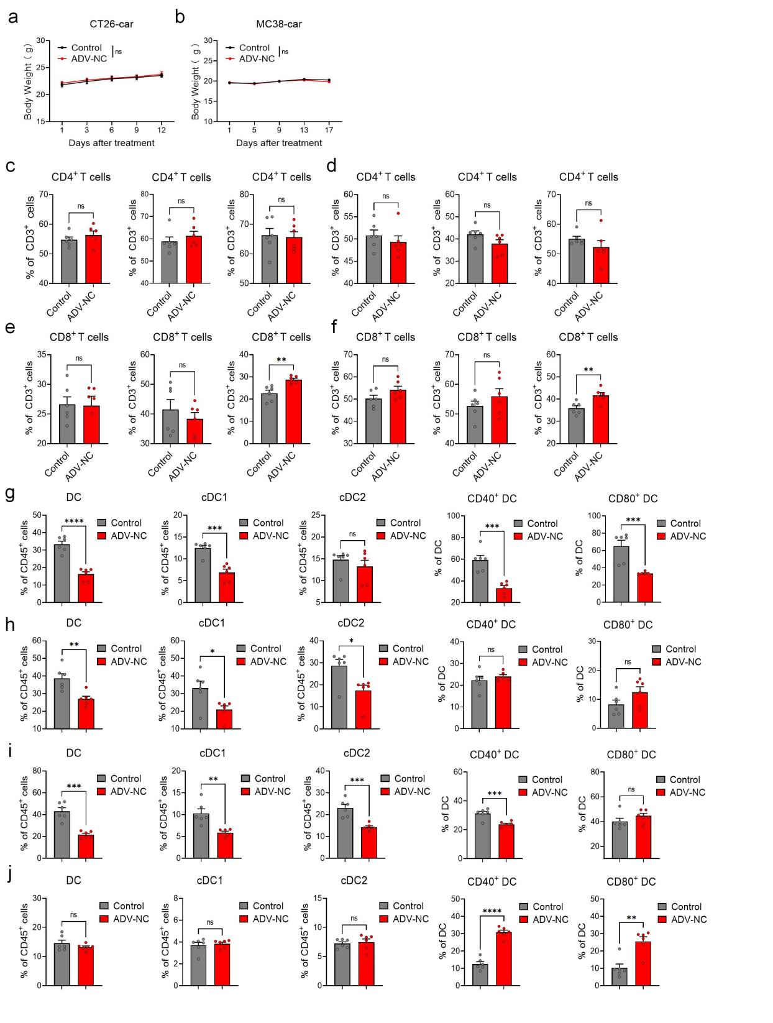
Figure S1
ADV-NC treatment significantly reduces the number of DCs in the TME without significant tissue toxicity
(a) Changes in mouse body weight during the treatment period in the subcutaneous CT26 model (n = 6 mice per group). (b) Changes in mouse body weight during the treatment period in the subcutaneous MC38 model (n = 6 mice per group). (c) Changes in CD4⁺ T cell counts in the spleen, peripheral blood, and lymph nodes of CT26 mouse models following ADV-NC treatment assessed by flow cytometry (n = 6 mice per group). (d) Changes in CD4⁺ T cell counts in the spleen, peripheral blood, and lymph nodes of MC38 mouse models following ADV-NC treatment assessed by flow cytometry (n = 6 mice per group). (e) Changes in CD8⁺ T cell counts in the spleen, peripheral blood, and lymph nodes of CT26 mouse models following ADV-NC treatment assessed by flow cytometry (n = 6 mice per group). (f) Changes in CD8⁺ T cell counts in the spleen, peripheral blood, and lymph nodes of MC38 mouse models following ADV-NC treatment assessed by flow cytometry (n = 6 mice per group). (g) Quantities and activation status of DCs in tumor tissues of CT26 mouse models following ADV-NC treatment assessed by flow cytometry (n = 6 mice per group). (h) Changes in the quantity and activation status of DCs in the lymph nodes of CT26 mouse models following ADV-NC treatment assessed by flow cytometry (n=6 mice per group). (j) Quantities and activation status of DCs in tumor tissues of MC38 mouse models following ADV-NC treatment assessed by flow cytometry (n =6 mice per group). (i) Changes in the quantity and activation status of DCs in the lymph nodes of MC38 mouse models following ADV-NC treatment assessed by flow cytometry (n = 6 mice per group).
The data are presented as the means ± SEMs. NS, no significant difference; ∗p<0.05, ∗∗p<0.01, ∗∗∗p<0.001, ∗∗∗∗p<0.0001
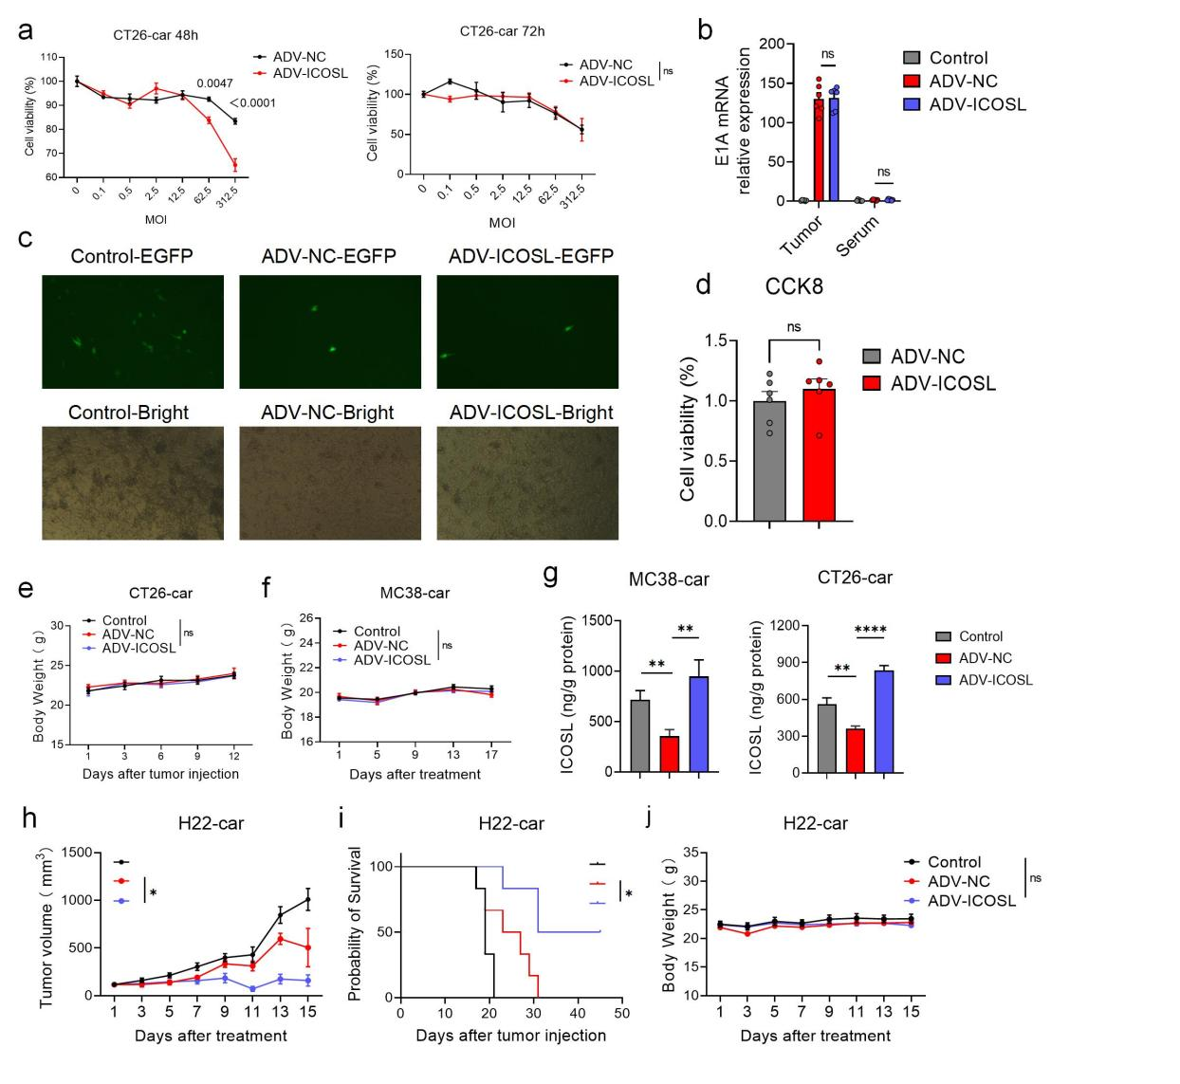
Figure S2
ADV-ICOSL shows antitumor efficacy in H22 model without affecting ADV-NC basic functions
(a) CT26-car cells were infected with ADV-NC or ADV-ICOSL at different MOIs, and cell viability was measured at 48 hours, 72 hours, and later by a CCK-8 assay (n = 3 biological replicates). (b) Viral replication levels in mouse tumor tissues and serum were detected by qPCR assay on the second day after three rounds of oncolytic virus treatment (n = 6 biological replicates). (c) Brightfield and fluorescence images of MC38-car tumor cells cultured with mouse serum from different treatment groups mixed with ADV-NC virus (MOI = 5) for 48 hours (20× objective). (d) Cytotoxicity against MC38-car tumor cells assessed by CCK8 assay after incubation with mouse serum from different treatment groups mixed with ADV-NC (n = 6 biological replicates). (e) Changes in mouse body weight during the treatment period in the subcutaneous CT26 model (n = 6 mice per group). (f) Changes in mouse body weight during the treatment period in the subcutaneous MC38 model (n = 6 mice per group). (g) ICOSL levels were measured by ELISA on day 7 after the first ADV-ICOSL treatment (n = 6 biological replicates). (h) Changes in subcutaneous tumor volume in the H22 tumor model following treatment with ADV-NC or ADV-ICOSL (n = 6 mice per group). (i) Survival curves of the mice in the different treatment groups (n = 6 mice per group). (j) Changes in mouse body weight during the treatment period in the subcutaneous H22 model (n = 6 mice per group).
The data are presented as the means ± SEMs. NS, no significant difference; ∗p<0.05, ∗∗p<0.01, ∗∗∗∗p<0.0001

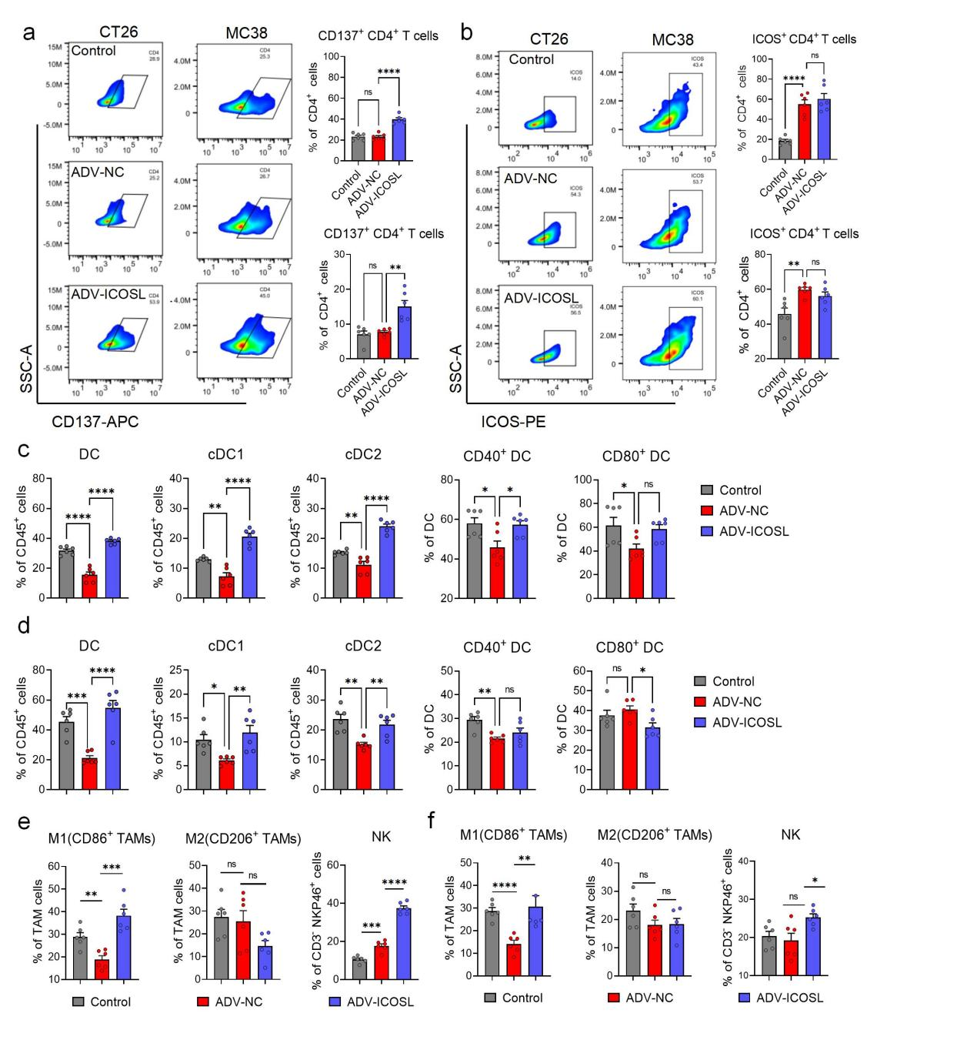
Figure S3
ADV-ICOSL activates CD4⁺ T cells and increases DCs in the TME
- Changes in the activation status of CD137⁺ CD4⁺ T cells in tumor tissues of CT26 and MC38 mouse models following ADV-ICOSL treatment assessed by flow cytometry (n = 6 mice per group). (b) Changes in the activation status of ICOS⁺ CD4⁺ T cells in tumor tissues of CT26 and MC38 mouse models following ADV-ICOSL treatment assessed by flow cytometry (n = 6 mice per group). (c) Quantities and activation status of DCs in tumor tissues of CT26 mouse models following ADV-ICOSL treatment assessed by flow cytometry (n = 6 mice per group). (d) Quantities and activation status of DCs in tumor tissues of MC38 mouse models following ADV-ICOSL treatment assessed by flow cytometry (n = 6 mice per group). (e) Changes in other immune cell populations in CT26 mouse models following ADV-ICOSL treatment assessed by flow cytometry (n = 6 mice per group). (f) Changes in other immune cell populations in MC38 mouse models following ADV-ICOSL treatment assessed by flow cytometry (n = 6 mice per group).
The data are presented as the means ± SEMs. NS, no significant difference; ∗p<0.05, ∗∗p<0.01, ∗∗∗p<0.001, ∗∗∗∗p<0.0001

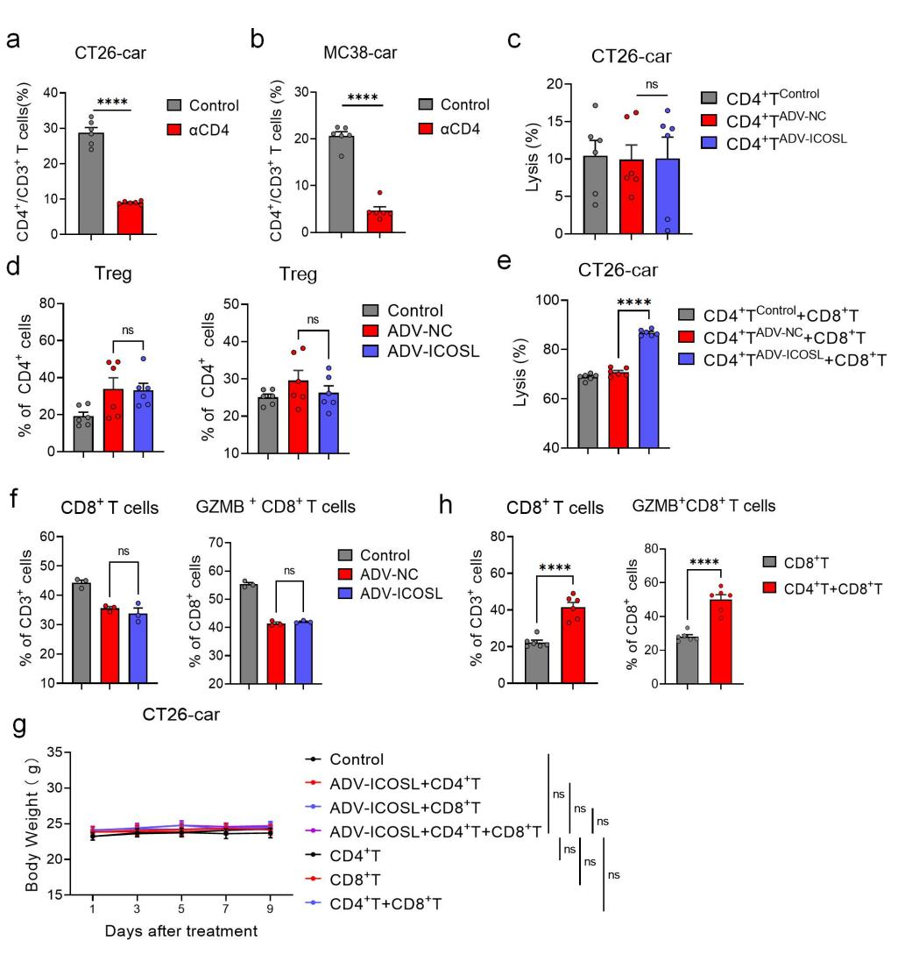

Figure S4
ADV-ICOSL indirectly affects CD8⁺ T cell cytotoxicity in a CD4⁺ T cell-dependent manner
- Percentages of infiltrating CD4⁺ T cells in the tumor microenvironment of subcutaneous CT26 tumors on day 2 after anti-CD4 mAb treatment (n=6 mice per group). (b) Percentages of infiltrating CD4⁺ T cells in the tumor microenvironment of subcutaneous MC38 tumors on day 2 after anti-CD4 mAb treatment (n=6 mice per group). (c) The cytotoxic efficiency of CD4⁺ T cells from different treatment groups against CT26-luc tumor cells. (d) Percentage of infiltrating Tregs in the tumor microenvironment of subcutaneous tumors on day 7 after the first ADV-ICOSL treatment (n=6 mice per group). (e) CD4⁺ T cells from different treatment groups were co-cultured with splenic-isolated CD8⁺ T cells and CT26-car tumor cells, and the cytotoxic efficiency against tumor cells was assessed. (f) Effects of supernatants from MC38-car tumor cells infected with different ADVs on the quantity and proliferation of CD8⁺ T cell. (g) Changes in mouse body weight during the treatment period (n=6 mice per group). (h) Percentages of infiltrating CD8⁺ T and GZMB⁺ CD8⁺ T immune cells in TME of nude subcutaneous CT26 tumors on day 7 after the first ADV-ICOSL treatment (n=6 mice per group).
The data are presented as the means ± SEMs. NS, no significant difference; ∗∗∗∗p<0.0001

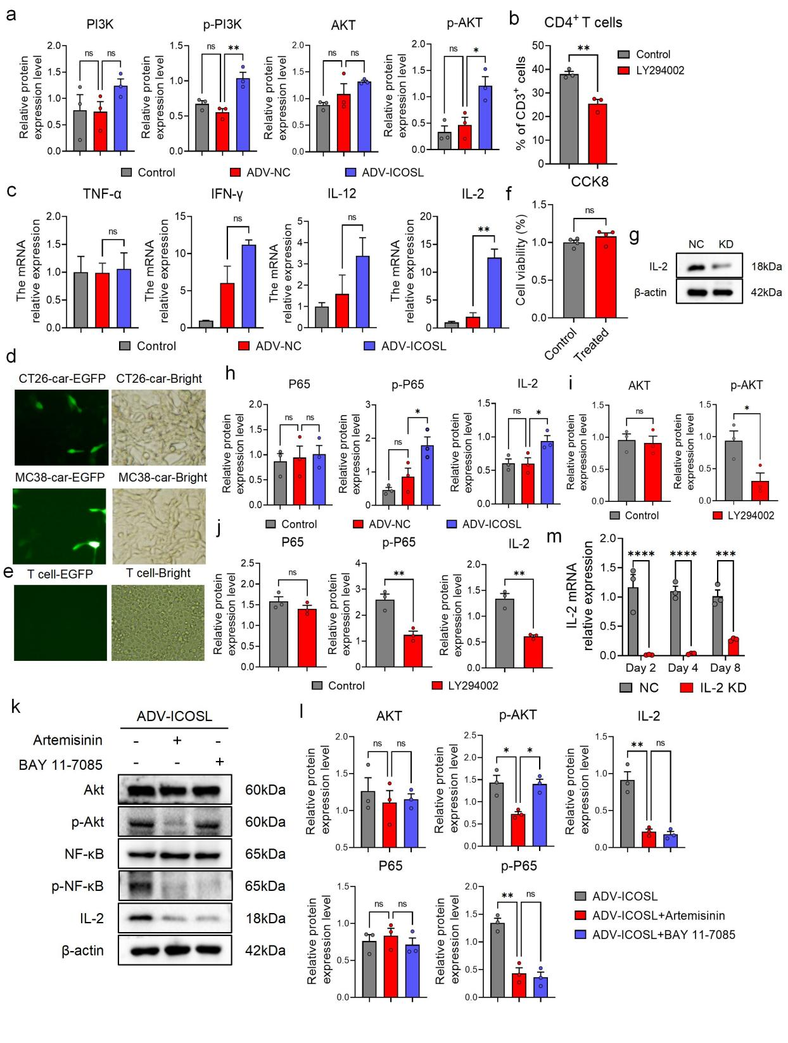

Figure S5
During ADV-ICOSL treatment, Akt regulates IL-2 secretion as an upstream mediator of NF-κB
- Quantitative densitometric analysis of the PI3K/Akt signaling pathway by Western blot (n = 3 per group). (b) Effect of PI3K inhibitor treatment on the proliferation of CD4⁺ T cells. The timeline of the entire experiment is as follows: CD4⁺ T cells were activated with anti-CD3/CD28 for 2 days, then stimulated with supernatant from ADV-ICOSL-infected tumor cells for 48 hours with or without LY294002. Proliferation was assessed by flow cytometry. (c) The expression of multiple cytokines in CD4⁺ T cells from different treatment groups of tumor tissues. (d) Brightfield and fluorescence images of tumor cells collected from the supernatant of virus-infected tumor cells and subsequently infected for 48 hours (20× objective). (e) Brightfield and fluorescence images of T cells infected with the supernatant collected from virus-infected tumor cells for 48 hours (20× objective). (f) Cytotoxicity of the supernatant collected from virus-infected tumor cells against T cells assessed by CCK8 assay (n = 4 per group). (g) Validation of IL2 knockdown efficiency in CD4⁺ T cells by siRNA assessed by Western blot. (h) Quantitative densitometric analysis of the NF-κB signaling pathway by Western blot (n = 3 per group). (i) Quantitative densitometric analysis of Akt protein expression following LY294002 treatment by Western blot (n = 3 per group). (j) Quantitative densitometric analysis of NF-κB signaling pathway-related protein expression levels following LY294002 treatment by Western blot (n = 3 per group). (k) Effects of artemisinin and BAY 11-7085 treatment on downstream signaling pathway protein expression in CD4⁺ T cells assessed by Western blot. (l) Densitometric quantification of signaling pathway protein expression in CD4⁺ T cells following artemisinin and BAY 11-7085 treatment by Western blot (n = 3 per group). (m) Duration of IL2 knockdown in CD4⁺ T cells by siRNA assessed by qPCR (n = 3 per group).
The data are presented as the means ± SEMs. NS, no significant difference; ∗p<0.05, ∗∗p<0.01 , ∗∗∗p<0.001, ∗∗∗∗p<0.0001

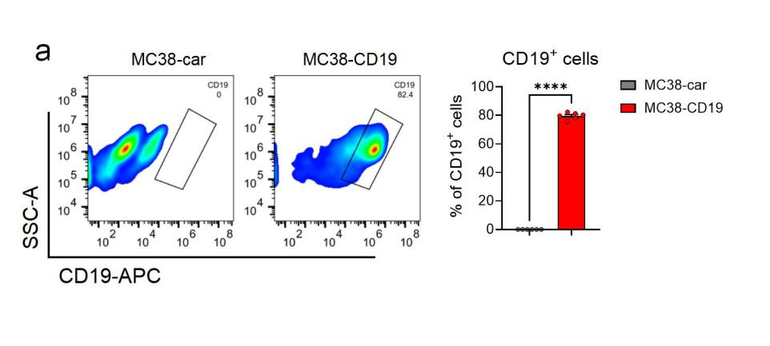
Figure S6
MC38-CD19 cells exhibit high expression of CD19 on their surface
- Expression of CD19 protein on the surface of MC38-CD19 cells detected by flow cytometry (n = 6 mice per group).
The data are presented as the means ± SEMs. ∗∗∗∗p<0.0001

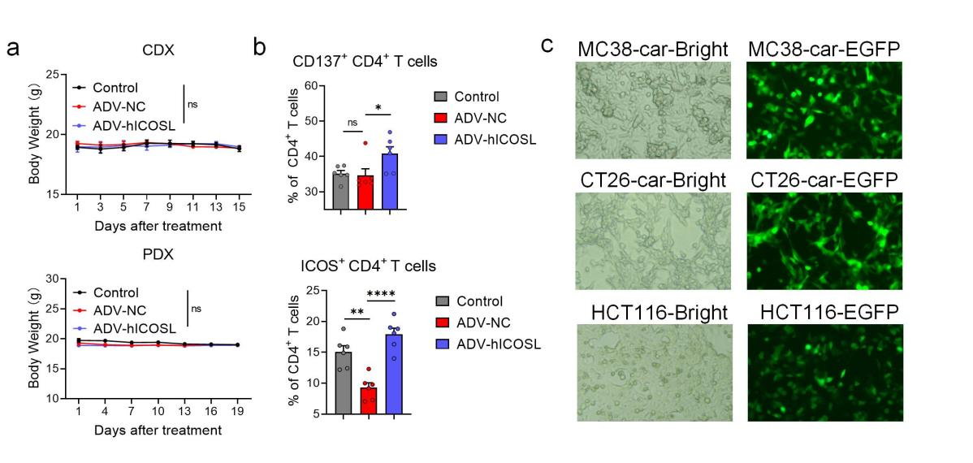
Figure S7
ADV-hICOSL significantly activates CD4⁺ T cells in the TME and efficiently infects tumor cells
(a) Changes in mouse body weight during the treatment period in the CDX and PDX model (n = 6 mice per group). (b) Activation status of CD4⁺ T cells following ADV-hICOSL treatment in the CDX model assessed by flow cytometry (n = 6 mice per group). (c) Brightfield and fluorescence images of CT26-car and MC38-car cells infected with ADV-ICOSL and HCT116 cells infected with ADV-hICOSL (20× objective).
The data are presented as the means ± SEMs. NS, no significant difference; ∗p<0.05, ∗∗p<0.01, ∗∗∗∗p<0.0001

