Single-cell profiling of gastric cancer ascites reveals an epithelial-immune dual phenotype signature predictive for anti-PD-1 immunotherapy responses

Figure S1. Experimental workflow illustrating collection of MA and PBMC samples from 10 GC patients followed by single-cell RNA sequencing (scRNA-seq) and BCR/TCR sequencing (scBCR/TCR-seq). This figure was created using Figdraw (ID: TIWYUbb104).

Figure S2. Quality control of single-cell transcriptome profiles. (A) Violin plots for different quality metrics in tissue samples before quality control. (B) Violin plots for different quality metrics in tissue samples after quality control.
Figure S3. scRNA-seq profiling of of MA and PBMCs in GC. (A) UMAP plots of total cells of MA and PBMC, colored by cluster number, sample id, tissue type and patient. (B) UMAP visualization of 190,392 QC-passed cells colored by cell type. (C) Violin plots depicting expression distributions of canonical markers defining the 8 major cell types.
Figure S4. Marker gene expression and cross-study overlap analysis of CD4⁺ and CD8⁺ T cell subclusters. (A) The heatmap illustrates the expression patterns of T cell subclusters marker gene. (B-G) Dot plots of the overlap between marker genes for CDT and CD8T subclusters in previous studies and the cluster markers used in the present study. The size of the dots corresponds to the overlap between the cluster gene sets, while the color of the dots shown was determined by the Benjamini-Hochberg adjusted -log₁₀(pvalues).
Figure S5. T cell subclusters functional score analyses. (A) Heatmap showing the expression of 8 curated gene signatures in the CD8 T cell subclusters. (B) UMAP plots showing the expression of 8 curated gene signatures in the CD8 T cell subclusters.
Figure S6. T cell analyses based on integrated expression and TCR clonality. (A) UMAP plot highlighting the recovery of VDJ information. (B) UMAP plots comparing the clonal of T cells of MA and PBMC. (C) Stack plot of the number and relative proportion of cells by T subclusters assigned into specific frequency ranges. (D) The TCR repertoire overlap among MA and PBMC tissues from the same patients. The value is Morisita’s overlap index. (E) Migration potential of T cell subclusters across different tissues quantified by pairwise STARTRAC-migr indices. Data were presented as mean value. *p < 0.05; **p < 0.01; ***p < 0.001; permutation test (exact p values were provided in source data). (F) pSTARTRAC-tran indices of T01_CD8T, T02_CD8T, T03_CD8T and T04_CD8T cells for each patient with matched tissue samples, depicted by dots. Center line indicates the median value, lower and upper hinges represent the 25th and 75th percentiles, respectively, and whiskers denote 1.5× interquartile range. *p < 0.05, **p < 0.01, ***p < 0.001, Kruskal-Wallis test.
Figure S7. Subclustering and marker gene expression profiling of B cells in MA and PBMC. (A) UMAP plots of B cell subclusters in MA and PBMC. (B) Dot plot of subcluster-specific marker expression; dot size proportional to expression frequency, color indicates average expression.
Figure S8. B cell analyses based on integrated expression and BCR clonality. (A) UMAP plot highlighting the recovery of VDJ information. (B) UMAP plots comparing the clonal of B cells of MA and PBMC. (C) Stack plot of the number of cells assigned to specific frequency ranges for MA and PBMC. (D) Stack plot of the proportion of cells assigned to specific frequency ranges for MA and PBMC. (E) Bar plot showing the percentage of different antibody isotypes in MA and PBMC. (F) Bar plot showing the percentage of different antibody isotypes in B cell subclusters. (G) Box plots show comparisons of the percentage of antibody isotypes in AtM B subcluster. Center line indicates the median value, lower and upper hinges represent the 25th and 75th percentiles, respectively, and whiskers denote 1.5× interquartile range. *p < 0.05, **p < 0.01, ***p < 0.001, Kruskal-Wallis test.
Figure S9. scRNA-seq profiling and marker gene expression in myeloid cell subclusters. (A) UMAP plots of myeloid cell subclusters in MA and PBMC. (B) UMAP plots showing the expression of curated genes in the myeloid cell subclusters. (C-D) Dot plots of the overlap between marker genes for DC and macrophage subclusters in previous studies and the cluster markers used in the present study. The size of the dots corresponds to the overlap between the cluster gene sets, while the color of the dots shown was determined by the Benjamini-Hochberg adjusted -log₁₀(pvalues).
Figure S10. Comprehensive characterization of macrophage polarization and tumor-associated functional programs across four distinct macrophage subsets. (A) Violin plots of M1/M2 signature scores in macrophage subclusters. (B) Heatmap of M1 and M2 marker expression in macrophages. (C) Violin plots of tumor-promoting pathway signature scores.
Figure S11. EIDPCs enrichment and inter-sample heterogeneity in epithelial populations. (A) Pie chart depicting the overall fraction of EIDPCs among all epithelial cells across the cohort. (B) Bar plot showing the proportion of EIDPCs within epithelial cells (Epi and EIDPCs) for each sample. Values are indicated for each sample.

Figure S12. Dual detection of epithelial immune phenotype cells and other cells. (A-B) Scatter plot of doublet scores against unique molecular identifier (UMI) counts and gene counts. Doublet scores were calculated by the R package DoubletFinder. (C-D) Violin plot of umi counts and gene counts between different cell types.
Figure S13. Heatmaps of allele-specific CNV events across patient.
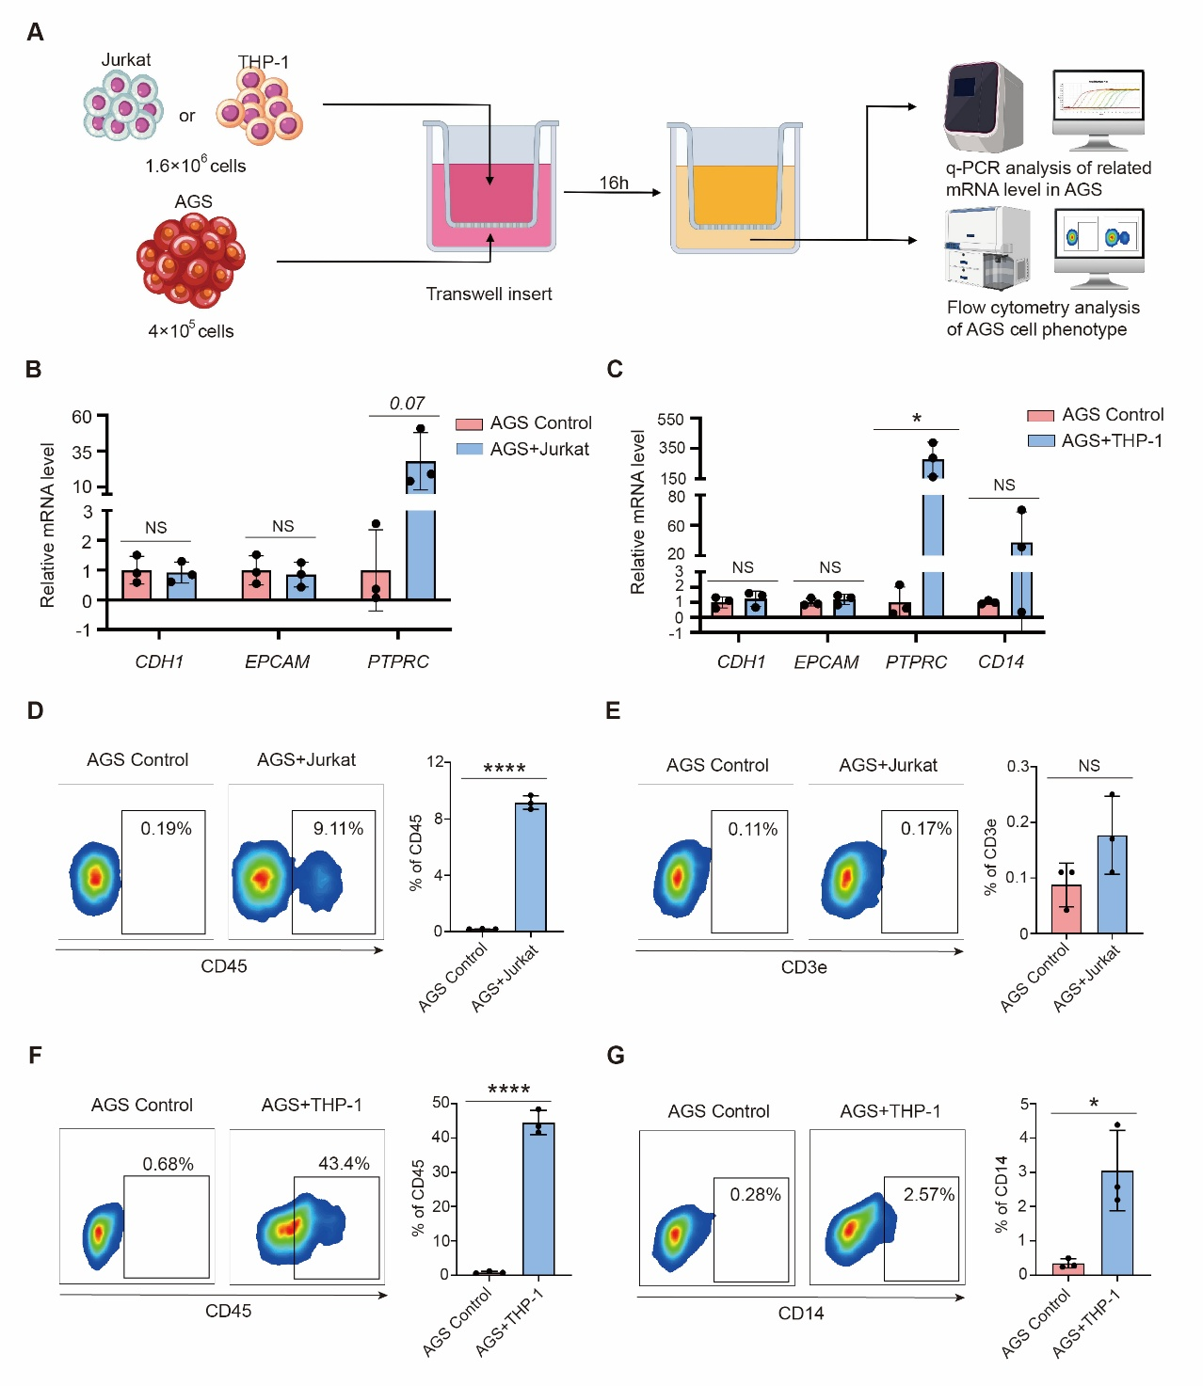
Figure S14. GC tumor cells of epithelial origin can acquire mRNA associated with immune cell phenotypes from immune cells and express the corresponding phenotypes. (A) Schematic of the experiment involving co-culture of immune cell lines with epithelial-origin GC tumor cells (AGS cell line). The relative mRNA expression levels in AGS cells following incubation with Jurkat (B) or THP-1 (C) cells were measured. Flow cytometry was used to detect the expression of CD45 (D) and CD3e (E) in AGS cells co-cultured with Jurkat cells, as well as the expression of CD45 (F) and CD14 (G) in AGS cells co-cultured with THP-1 cells.
Figure S15. Evaluation of IRS-EIDPC features independent of DEG screening. (A) Expression profiles of 10 core genes selected independently of the DEG screening. (B-D) ROC curve showing the predictive performance of IRS-EIDPC for anti-PD-1 therapy efficacy, independent of the DEG screening.

