Additional file 2 Content

Table S1. Search Strategy
Table S2. Data extracted from included systematic reviews
Table S3. General characteristics of the selected primary outcome
Table S4. Additional analyses
Table S5. Changes in methodological characteristics of systematic reviews including RCTs and NRSIs published up to 2022 and after 2022
Table S6. Statistical significance and reasonableness of conclusions when separate meta-analyses of RCTs and NRSIs yielded quantitatively disagree results
Table S7. Certainty of evidence when separate meta-analyses of RCTs and NRSIs showed qualitative disagreement
Table S8. Qualitative agreement between effect estimates from RCT-only meta-analyses and meta-analyses combining RCTs and NRSIs

Fig. S1. Summary of types of non-randomized studies of interventions (NRSIs)
Fig. S2. Risk of bias assessment tools used for RCTs and NRSIs

Table S1. Search Strategy
No. | PubMed (From 2017 to 2024) Result: 42341
1 | - "Randomized Controlled Trials as Topic"[Mesh] OR randomi* [tiab] OR RCT [tiab]  - "Controlled Clinical Trials as Topic"[Mesh] OR "controlled trial*"[tiab]  - "Clinical Trials as Topic"[MeSH] OR "clinical trial*"[tiab]  - #1 OR #2 OR #3
2 | - "Non-Randomized Controlled Trials as Topic"[Mesh] OR Non randomi* [tiab] OR Nonrandomi* [tiab] OR Non-RCT* [tiab] OR NRCT* [tiab]  - Quasi randomi* [tiab] OR Quazi randomi* [tiab] OR Quasi experiment [tiab] OR Quazi experiment [tiab]  - "Cohort Studies"[Mesh] OR Cohort stud* [tiab]  - "Case-Control Studies"[Mesh] OR Case control [tiab]  - "Controlled Before-After Studies"[Mesh] OR Controlled before and after [tiab] OR Controlled before after [tiab] OR CBA [tiab]  - Pre post [tiab] OR pre and post [tiab]  - "Observational Studies as Topic"[Mesh] OR "Observation"[Mesh] OR Observation* [tiab]  - "Prospective Studies" [Mesh] OR "prospective" [tiab]  - "Retrospective Studies" [Mesh] OR "retrospective" [tiab]  - #5 OR #6 OR #7 OR #8 OR #9 OR #10 OR #11 OR #12 OR #13
3 | - "Systematic Reviews as Topic"[Mesh] OR "Systematic Review"[pt] OR "systematic review"[Filter] OR Systematic Review [tiab]  - "Meta-Analysis as Topic"[Mesh] OR "Meta-Analysis"[pt] OR meta [tiab]  - Evidence synthesis [tiab]  - #15 OR #16 OR #17
4 | - "Safety"[Mesh] OR safety [tiab] OR safe [tiab]  - harm [tiab]  - "Poisoning"[Mesh] OR poisoning [tiab]  - toxicity [tiab]  - tolerability [tiab] OR tolerance [tiab] OR tolerate [tiab]  - complication [tiab]  - adverse event [tiab]  - adverse outcome [tiab]  - untoward effect [tiab]  - side effect [tiab]  - "Drug-Related Side Effects and Adverse Reactions"[Mesh] OR adverse reaction [tiab]  - adverse effect [tiab]  - "Risk"[Mesh] OR risk [tiab]  - undesirable effect [tiab]  - treatment emergent [tiab]  - hazard [tiab]  - #19 OR #20 OR #21 OR #22 OR #23 OR #24 OR #25 OR #26 OR #27 OR #28 OR #29 OR #30 OR #31 OR #32 OR #33 OR #34
5 | - #4 AND #14 AND #18 AND #35

Table S2. Data extracted from the source systematic reviews
Variable | Description
Country of the first author | Country of the first author, categorized according to WHO region: Europe, Western Pacific, Americas, Eastern Mediterranean, South-East Asia, or Africa.
Publication year | Publication year reported in the source systematic review.
Registration platform | Registration platform reported in the source systematic review.
Protocol available | Whether a protocol was available, as reported in the source systematic review or identified in supplementary materials, published articles, or registry platforms.
Reporting guidelines | Reporting guidelines used, based on cited references or explicit statements in the systematic review.
Disease area | Primary clinical area addressed by the review, classified into predefined medical or surgical specialties.  - Medical specialties included endocrinology, hematology, neurology, cardiology, respiratory medicine, gastroenterology, nephrology/renal medicine, rheumatology, infectious diseases, oncology, obstetrics/gynecology, pediatrics, dermatology/venereology, ophthalmology, stomatology, emergency medicine, intensive care, psychiatry/psychosis, sleep-wake disorders, nursing, and other.  - Surgical specialties included general surgery, cardiac surgery, vascular surgery, neurosurgery, otorhinolaryngology, thoracic surgery, urology, orthopedics, plastic surgery, surgical oncology, obstetrics/gynecology, pediatrics, dermatology/venereology, ophthalmology, stomatology, and other.
Type of NRSIs | As specified in eligible criteria and in the results. The definition of each type of NRSIs is as below:  - Quasi-randomized trial/Quasi-experiment study: Allocation to groups was based on a quasi-random method (e.g. date of birth, social insurance number).  - Non-randomized controlled trial: Participants were assigned to intervention or control group in a clinical trial according to the investigator’s or physician’s preference, without any procedures to ensure random or quasi-random allocation.  - Cohort study: Participants who received an intervention are compared with those who did not receive the intervention, typically in a prospective or retrospective observational design.  - Case-control study: Retrospective studies in which participants are selected based on their outcome status and compared with controls without the outcome.  - Controlled before-and-after study: The effects of an intervention are tested by collecting data both before and after the intervention is introduced, and the results for the control and intervention groups are then compared.
Type of control | Type of control based on information provided in source evidence:  - Active control: The control group receives a treatment already known to be effective.  - Placebo/no treatment: Placebo refers to a “dummy” treatment that closely mimics the test intervention in physical characteristics (e.g. color, weight, taste, smell) but does not contain the active component. No treatment refers to the absence of the study intervention in the control group, which may include usual care provided to both groups or the use of a waiting list control, where participants are withheld from receiving the intervention during the study and are scheduled to receive it after the trial or at a predefined later time.
Type of outcome | Type of control based on information provided in source evidence, if the primary outcome is a composite-endpoint, we checked all that apply:  - Mortality: All-cause mortality; Disease specific mortality  - Morbidity: Cardiovascular major morbid events; Other major morbid events (e.g. loss of vision, seizures, fracture, revascularization); Onset/recurrence/relapse/remission of cancer and other chronic diseases (e.g. COPD exacerbation, new onset of diabetes); Renal failure requiring dialysis; Hospitalization, medical and surgical procedures (e.g. placement of a pacemaker, and cardioversion); Infections (e.g. pneumonia, gastroenteritis); Dermatological (e.g. skin necrosis, Stevens–Johnson syndrome and toxic epidermal necrolysis); Rheumatologic disorders such as exacerbation of a rheumatologic disease (e.g. Behcet's Disease, rheumatoid arthritis); Preterm birth  - Symptoms/Functional status (e.g. failure to become pregnant, successful nursing/breastfeeding, depression, work disability)  - Surrogate outcomes (e.g. diagnosis of TB, viral load, physical activity, weight loss*, post-operative atrial fibrillation, cognitive function, negative conversion time of COVID-19)
Source of funding | Source of funding for the systematic review: private for-profit, private or public not-for-profit, government, not funded, or not reported.
Sample size | Total sample size of RCTs and NRSIs included for the selected outcome.
Number of studies | Number of RCTs and NRSIs included for the selected outcome.
Risk of bias assessment | Risk-of-bias tools used for RCTs and NRSIs, and methods used to address bias in NRSIs.
Effect measure | Effect measure used for the reported effect estimate, as presented in the source systematic review.
Effect estimates | Effect estimate reported in the source systematic review.
Synthesis approach | Approach used to synthesize RCTs and NRSIs:  - Qualitative synthesis of NRSIs with meta-analysis of RCTs;  - Qualitative synthesis of RCTs with meta-analysis of NRSIs;  - Combined meta-analysis of RCTs and NRSIs;  - Qualitative synthesis of both RCTs and NRSIs, including reasons for not conducting meta-analysis.
Whether the PI/ECO similarity between RCTs and NRSIs were considered | Assessment of whether similarity in populations, interventions/exposures, comparisons, and outcomes (PI/ECO) between RCTs and NRSIs was considered. Definitions of the options were as follows:  - Yes: The systematic review authors explicitly stated that PI/ECO similarity was assessed.  - Probably yes: Subgroup analyses or sensitivity analyses were performed based on the PI/ECO elements (either as planned or as conducted)  - No: PICO similarity was not mentioned, or no relevant information was provided.
Source of heterogeneity identified | Assess based on the descriptions in the article. Definitions of the options are as follows:  - Clinical: Differences in the study population, intervention/exposure, comparator, or outcomes (PI/ECO) assessed.  - Study design-related: Heterogeneity due to differences in study design (e.g., cohort studies vs. RCTs).  - Quality-related: Heterogeneity related to risk of bias, such as differences in the extent of adjustment for key confounding domains.
Statistical methods | Statistical methods used for meta-analysis (e.g., Mantel-Haenszel, Peto odds ratio, inverse variance, Bayesian methods).
Statistical model | Statistical model used for meta-analysis (fixed-effect model or random-effects model).
Subgroup analyses | Factors prespecified or used for subgroup analyses.
Sensitivity analyses | Factors examined in sensitivity analyses and whether the results differed from the main analysis.
Publication bias | Methods used to assess publication bias for RCTs and NRSIs, whether publication bias was detected, and whether it was addressed.
Certainty of evidence | Methods used to assess certainty of evidence and the reported certainty ratings/results.

Table S3. General characteristics of the selected primary outcome
Characteristics | Systematic reviews, No. (%)
Characteristics | Overall (N=195) | Q1 journal (n=118) | Non-Q1 journal (n=77) | P value
Disease area |  |  |  | 0.253ª
Cardiology | 14 (7.2) | 7 (5.9) | 7 (9.1)
Endocrinology | 24 (12.3) | 11 (9.3) | 13 (16.9)
Obstetrics/Gynecology | 30 (15.4) | 18 (15.3) | 12 (15.6)
Oncology | 15 (7.7) | 9 (7.6) | 6 (7.8)
Pediatrics | 9 (4.6) | 8 (6.8) | 1 (1.3)
Other disease | 51 (26.2) | 33 (28.0) | 18 (23.4)
No restriction | 45 (23.1) | 27 (22.9) | 18 (23.4)
Type(s) of primary outcome^{b} |  |  |  | 0.871ª
Mortality | 19 (9.7) | 13 (68.6) | 6 (7.8)
Morbidity | 134 (68.7) | 81 (68.6) | 53 (68.8)
Surrogate outcome | 20 (9.7) | 12 (11.0) | 8 (10.4)
Symptoms/Functional status | 19 (9.7) | 10 (10.2) | 9 (11.7)
Adverse event/effect^{c} | 6 (3.1) | 3 (2.5) | 3 (3.9)
Type(s) of NRSIs included in primary outcome |  |  |  | 0.226
Quasi-randomized controlled trial only | 2 (1.0) | 1 (0.8) | 1 (1.3)
Non-randomized controlled trial only | 2 (1.0) | 1 (0.8) | 1 (1.3)
Cohort only | 102 (52.3) | 56 (47.5) | 46 (59.7)
Case-control only | 5 (2.6) | 5 (4.2) | 0 (0.0)
Multiple types of NRSIs^{c} | 84 (43.1) | 55 (46.6) | 29 (37.7)

IQR=interquartile range
ªFisher exact test
^{b}For composite primary outcomes, each component was classified under the relevant category.
^{c}The types of adverse events were not specified in detail.
^{d}Distribution of NRSI types included under the primary outcome (see Supplementary eFig 2).

Table S4. Additional analyses
Characteristics |  | Systematic reviews, No. (%) |  |  | P value
 |  | Overall (N=146) | Q1 journal (n=87) | Non-Q1 journal (n=59) | P value
Subgroup analyses | Whether subgroup analysis planned in the Method section |  |  |  | 0.886
Subgroup analyses | Yes, types of subgroup analysis planned | 79 (54.1) | 48 (55.2) | 31 (52.5)
Subgroup analyses | PI/ECO characteristics (e.g., type of population) | 63 (79.7) | 37 (77.1) | 26 (83.9)
Subgroup analyses | Study design (e.g., RCTs vs. NRSIs) | 35 (44.3) | 20 (41.7) | 15 (48.4)
Subgroup analyses | Risk of bias (e.g., high quality vs. low or moderate quality) | 10 (12.7) | 6 (12.5) | 4 (12.9)
Subgroup analyses | Region | 11 (13.9) | 3 (6.3) | 8 (25.8)
Subgroup analyses | Otherª | 11 (13.9) | 2 (4.2) | 9 (29.0)
Subgroup analyses | No | 67 (45.9) | 39 (44.8) | 28 (47.5)
Subgroup analyses | Whether subgroup analysis conducted |  |  |  | 0.902
Subgroup analyses | Yes, whether subgroup analysis predefined | 82 (56.2) | 48 (55.2) | 34 (57.6)
Subgroup analyses | All predefined | 57 (69.5) | 32 (66.7) | 25 (73.5)
Subgroup analyses | All post hoc | 19 (23.2) | 11 (22.9) | 8 (23.5)
Subgroup analyses | Combined predefined and post hoc | 6 (7.3) | 5 (10.4) | 1 (2.9)
Subgroup analyses | Yes, the credibility of subgroup analyses assessed | 1 (0.7) | 1 (1.1) | 0 (0.0)
Subgroup analyses | Yes, the subgroup effect or interaction reported | 57 (39.0) | 36 (41.4) | 21 (35.6)
Subgroup analyses | No | 64 (43.8) | 39 (44.8) | 25 (42.4)
Sensitivity analysis | Whether sensitivity analysis planned in the Method section |  |  |  | 0.937
Sensitivity analysis | Yes, types of sensitivity analysis planned^{b} | 65 (44.5) | 38 (43.7) | 27 (45.8)
Sensitivity analysis | PI/ECO characteristics (e.g., type of population) | 22 (33.8) | 13 (34.2) | 9 (33.3)
Sensitivity analysis | Risk of bias (e.g., exclude high risk of bias studies) | 16 (23.5) | 12 (31.6) | 4 (14.8)
Sensitivity analysis | Leave-one-out analysis | 12 (18.5) | 4 (10.5) | 8 (29.6)
Sensitivity analysis | Model parameters or assumptions | 11 (16.9) | 7 (18.4) | 4 (14.8)
Sensitivity analysis | Other^{c} | 11 (16.9) | 7 (18.4) | 4 (14.8)
Sensitivity analysis | No | 81 (55.5) | 49 (56.3) | 32 (54.2)
Sensitivity analysis | Was the sensitivity analysis conducted^{b} |  |  |  | 0.546
Sensitivity analysis | Yes, types of sensitivity analysis conducted | 76 (52.1) | 43 (49.4) | 33 (55.9)
Sensitivity analysis | Leave-one-out analysis | 27 (35.5) | 14 (32.6) | 13 (39.4)
Sensitivity analysis | PI/ECO characteristics (e.g., type of population) | 22 (28.9) | 11 (25.6) | 11 (33.3)
Sensitivity analysis | Risk of bias | 16 (21.1) | 10 (23.3) | 6 (18.2)
Sensitivity analysis | Study design | 13 (17.1) | 3 (7.0) | 10 (30.3)
Sensitivity analysis | Model parameters or assumptions | 9 (11.8) | 6 (13.9) | 3 (9.1)
Sensitivity analysis | Other^{d} | 18 (23.7) | 11 (25.6) | 7 (21.2)
Sensitivity analysis | No | 70 (47.9) | 44 (50.6) | 26 (44.1)
Publication bias | Whether publication bias assessed for the outcome |  |  |  | 0.645
 | Yes, how was publication bias assessed | 87 (59.6) | 50 (57.5) | 37 (62.7)
 | RCTs and NRSIs assessed together | 65 (74.7) | 38 (76.0) | 27 (73.0)
 | RCTs and NRSIs assessed separately | 12 (13.8) | 6 (12.0) | 6 (16.2)
 | Only assessed publication bias of RCTs or NRSIs | 8 (9.2) | 5 (10.0) | 3 (8.1)
 | RCTs and NRSIs assessed both together and separately | 2 (2.3) | 1 (2.0) | 1 (2.7)
 | No, reason for not assessed | 59 (40.4) | 37 (42.5) | 22 (37.3)
 | Fewer than 10 studies within the outcome | 24 (16.4) | 13 (14.9) | 11 (18.6)
 | Not reported | 34 (23.3) | 23 (26.4) | 11 (18.6)
 | Methods used to assess publication bias^{e}
 | Standard funnel plot | 83 (95.4) | 47 (94.0) | 36 (97.3)
 | Begg’s test | 26 (29.9) | 15 (30.0) | 11 (29.7)
 | Egger’s test | 49 (56.3) | 27 (54.0) | 22 (59.5)
 | Other (e.g., Harbord’s test, Mazumdar’s test) | 5 (5.7) | 3 (6.0) | 1 (2.7)
 | Whether publication bias exist^{e} |  |  |  | 0.705
 | Yes, how was publication bias addressed | 17 (19.5) | 9 (18.0) | 8 (21.6)
 | Trim and fill method | 2 (11.8) | 1 (11.1) | 1 (12.5)
 | Not addressed | 15 (88.2) | 8 (88.9) | 7 (87.5)
 | No | 62 (71.3) | 36 (72.0) | 26 (70.3)
 | Not applicable, the result of funnel plot was not interpreted | 7 (8.0) | 5 (10.0) | 2 (5.4)
ªEffect measure, estimates (adjusted vs unadjusted), sample size.
^{b}If a study conducted multiple sensitivity analyses, we listed each under the relevant category.
^{c}Study design, funding source, estimates (e.g., exclude unadjusted estimates), sample size, effect measure.
^{d}Funding source, estimates (e.g., exclude unadjusted estimates), sample size, effect measure, adding studies with statistical significance.
^{e}The sample size is 87, if a study used multiple publication bias methods, we listed each under the relevant category.

Table S5. Changes in methodological characteristics of systematic reviews including RCTs and NRSIs published up to 2022 and after 2022
Characteristics | Systematic reviews, No. (%)
Characteristics | 2022 and before (N=142) | 2023 and after (n=53) | P value
Registration | 72 (50.7) | 42 (79.2) | 0.001
Protocol available (Yes) | 74 (52.1) | 42 (79.2) | 0.001
Registry platform | 69 (48.6) | 42 (79.2)
Supplementary material | 3 (2.1) | 0 (0.0)
Published article | 2 (1.4) | 0 (0.0)
Reporting guideline endorsement |  |  | 0.001ª
PRISMA | 106 (74.6) | 44 (83.0)
MOOSE | 7 (4.9) | 0 (0.0)
PRISMA and MOOSE | 6 (4.2) | 8 (15.1)
Other | 1 (0.7) | 1 (1.9)
Not reported | 22 (15.5) | 1 (1.9)
NRSI types included in systematic reviews as planned |  |  | 0.143
Single type of NRSIs | 24 (16.9) | 7 (13.2)
Multiple type of NRSIs | 69 (48.6) | 27 (50.9)
Not specified types of NRSIs (e.g., observational) | 37 (26.1) | 9 (17.0)
No restriction | 12 (8.5) | 10 (18.9)
NRSI types included in systematic reviews as conducted |  |  | 0.665
Single type of NRSIs | 63 (44.4) | 21 (39.6)
Multiple type of NRSIs | 79 (55.6) | 32 (60.4)
Source of funding |  |  | 0.895ª
Private not for profit | 29 (24.6) | 16 (20.8)
Private for profit | 2 (1.7) | 2 (2.6)
Government | 21 (17.8) | 11 (14.3)
No funded | 47 (39.8) | 34 (44.2)
Funding not reported | 26 (22.0) | 17 (22.1)
Risk of bias tools used for RCTs |  |  | <0.001
Cochrane RoB tool | 78 (54.9) | 18 (34.0)
Cochrane RoB2 tool | 26 (18.3) | 26 (49.1)
Other | 32 (22.5) | 9 (17.0)
Not report | 6 (4.2) | 0 (0.0)
Risk of bias tools used for NRSIs |  |  | 0.039
NOS | 80 (56.3) | 37 (69.8)
ROBINS-I | 22 (15.5) | 11 (20.8)
Other | 44 (31.0) | 7 (13.2)
Method of combing RCTs and NRSIsª |  |  | 0.138
Qualitative synthesis of RCTs and NRSIs | 41 (28.9) | 8 (15.1)
Qualitative synthesis of RCTs and meta-analysis of NRSIs | 4 (2.8) | 3 (5.7)
Qualitative synthesis of NRSIs and meta-analysis of RCTs | 9 (6.3) | 2 (3.8)
RCTs and NRSIs combined in separate meta-analysis | 27 (19.0) | 10 (18.9)
RCTs and NRSIs combined in a single meta-analysis | 61 (42.9) | 30 (56.6)
With subgroup analysis by study design^{b} | 26 (42.6) | 16 (53.3)
Without subgroup analysis by study design^{b} | 35 (57.4) | 14 (46.7)
Whether the PI/ECO similarity of RCTs and NRSIs considered^{c} |  |  | 0.168
Probably yes | 43 (70.5) | 16 (53.3)
No | 18 (29.5) | 14 (46.7)
Heterogeneity of RCTs or NRSIs assessed before combined both study types (Yes)^{b} | 8 (13.1) | 4 (13.3) | 1.000
Risk of bias of NRSIs considered in the meta-analysis (Yes)^{c} | 10 (16.4) | 6 (20.0) | 0.895
NRSIs with moderate or high risk of bias included in the meta-analysis^{d} | 42 (68.9) | 24 (80.0) | 0.288
Types of NRSI estimates^{c} |  |  | 0.620
Adjust estimates | 13 (21.3) | 4 (13.3)
Unadjusted (crude) estimates | 31 (50.8) | 14 (46.7)
Partial adjusted and partial unadjusted estimates | 8 (13.1) | 5 (16.7)
Not specified | 9 (14.8) | 7 (23.3)
ªFisher exact test
^{b}A total of 61 studies were included in subcategory analysis.
^{c}These characteristics were assessed only in synthesis scenarios where RCTs and NRSIs were combined in a single meta-analysis.
^{d}Risk of bias results were unavailable for four articles.

Table S6. Statistical significance and reasonableness of conclusions when separate meta-analyses of RCTs and NRSIs yielded quantitatively disagree results
Author, year | Qualitatively agreement between RCTs and NRSIs | Source of conclusion | Reasonableness of conclusion
Chen et al, 2017 | Neither RCTs nor NRSIs were statistically significant, and point estimates were in opposite directions | Only based on NRSIs | Unreasonable
Wong et al, 2017 | RCTs were not statistically significant, whereas NRSIs were statistically significant and showed effects in the opposite direction | Only based on NRSIs | Unreasonable
Yu et al, 2017 | RCTs were not statistically significant, whereas NRSIs were statistically significant and showed effects in the opposite direction | Only based on RCTs | Reasonable
Alqudah et al, 2018 | Neither RCTs nor NRSIs were statistically significant, and point estimates were in opposite directions | Based both on RCTs and NRSIs | Reasonable
Batchelor et al, 2018 | RCTs were not statistically significant, whereas NRSIs were statistically significant and showed effects in the opposite direction | Only based on RCTs | Reasonable
Overbeek et al, 2018 | Neither RCTs nor NRSIs were statistically significant, and point estimates were in opposite directions | Based both on RCTs and NRSIs | Reasonable
Zhao et al, 2018 | Neither RCTs nor NRSIs were statistically significant, and point estimates were in opposite directions | Based both on RCTs and NRSIs | Reasonable
Engeda et al, 2019 | RCTs were not statistically significant, whereas NRSIs were statistically significant in the same direction, but the NRSI point estimate lay outside the 95% CI of the RCTs | Only based on NRSIs | Unreasonable
Fan et al, 2019 | Neither RCTs nor NRSIs were statistically significant, and point estimates were in opposite directions | From RCTs and NRSIs separately | Reasonable
Mudhune et al, 2019 | RCTs were statistically significant, whereas NRSIs were not statistically significant | Only based on RCTs | Reasonable
Salim et al, 2019 | Neither RCTs nor NRSIs were statistically significant, and point estimates were in opposite directions | From RCTs and NRSIs separately | Reasonable
Hamada et al, 2020 | Both RCTs and NRSIs were statistically significant, and point estimates were in opposite directions | Based both on RCTs and NRSIs | Reasonable
Khorasani et al, 2020 | Neither RCTs nor NRSIs were statistically significant, and point estimates were in opposite directions | Only based on RCTs | Reasonable
Nasser et al, 2020 | Neither RCTs nor NRSIs were statistically significant, and point estimates were in opposite directions | Based both on RCTs and NRSIs | Reasonable
Nicolas et al, 2020 | Neither RCTs nor NRSIs were statistically significant, and point estimates were in opposite directions | Based both on RCTs and NRSIs | Reasonable
Pujade et al, 2020 | RCTs were statistically significant, whereas NRSIs were not statistically significant | Only based on RCTs | Reasonable
Cannarella et al, 2024 | RCTs were not statistically significant, whereas NRSIs were statistically significant and showed effects in the opposite direction | Only based on RCTs | Reasonable
Deng et al, 2024 | RCTs were not statistically significant, whereas NRSIs were statistically significant and showed effects in the opposite direction | Only based on NRSIs | Unreasonable
Symvoulidis et al, 2023 | Neither RCTs nor NRSIs were statistically significant, and point estimates were in opposite directions | Based both on RCTs and NRSIs | Reasonable
Rafati et al, 2023 | RCTs were statistically significant, whereas NRSIs were not statistically significant | Only based on RCTs | Reasonable
Padhi et al, 2024 | RCTs were not statistically significant, whereas NRSIs were statistically significant in the same direction, but the NRSI point estimate lay outside the 95% CI of the RCTs | From RCTs and NRSIs separately | Reasonable
Mechelen et al, 2024 | Neither RCTs nor NRSIs were statistically significant, and point estimates were in opposite directions | From RCTs and NRSIs separately | Reasonable
Abolhassani et al, 2023 | Neither RCTs nor NRSIs were statistically significant, and point estimates were in opposite directions | From RCTs and NRSIs separately | Reasonable
Liao et al, 2022 | Neither RCTs nor NRSIs were statistically significant, and point estimates were in opposite directions | From RCTs and NRSIs separately | Reasonable
Pundir et al, 2021 | RCTs were not statistically significant, whereas NRSIs were statistically significant and showed effects in the opposite direction | Only based on RCTs | Unreasonable

Table S7. Certainty of evidence when separate meta-analyses of RCTs and NRSIs show qualitative disagreement
First author, year | Study design | No. of studies included | No. of patients included | Estimates (95% CI) | I²/$τ^{2}$ | Imprecision | Inconsistency | RoB | Indirectness | Publication  bias | Upgrade | GRADE
Patient or population: T2DM patients; Intervention: sulfonylureas; Comparison: other active agents; Outcome: cancer
Chen et al, 2017 | RCT | 33 | 25499 | 0.96  (0.78, 1.18) | 26%/NA | Seriousª | Not serious | Not serious | Not serious | Not serious | Not serious | Moderate
Chen et al, 2017 | Cohort | 15 | NA | 1.05  (0.95, 1.15) | 96%/NA | Seriousª | Seriousª | Not serious | Not serious | Not serious | Not serious | Very low
Chen et al, 2017 | Case-control | 11 | NA | 1.13  (0.93, 1.37) | 76%/NA | Seriousª | Seriousª | Not serious | Not serious | Not serious | Not serious | Very low
Patient or population: Adult patients who aged ≥18; Intervention: Use of macrolides; Comparison: Non-use of macrolides for observational studies/placebo for RCTs; Outcome: risk of mortality outcomes or composite cardiovascular outcomes
Wong et al, 2017 | RCT | 5 | 5457 | 0.99  (0.74, 1.34) | 0%/0.00 | Not serious | Not serious | Seriousª | Not serious | Not serious | Not serious | Moderate
Wong et al, 2017 | Cohort | 10 | NA | 1.24  (1.04, 1.49) | 90%/0.06 | Not serious | Seriousª | Not serious | Not serious | Not serious | Not serious | Very low
Wong et al, 2017 | Case-control | 5 | NA | 1.72  (1.09, 2.73) | 0%/0.00 | Not serious | Not serious | Not serious | Not serious | Not serious | Not serious | Low
Patient or population: No limitation; Intervention: Use of statin; Comparison: Non–statin users; Outcome: cataract incidence or cataract surgery
Yu et al,  2017 | RCT | 5 | 35702 | 0.89  (0.72, 1.10) | 30.5%/NA | Not serious | Not serious | Seriousª | Not serious | Not serious | Not serious | Moderate
Yu et al,  2017 | Cohort | 6 | 1434590 | 1.13  (1.01, 1.25) | 90.5%/NA | Not serious | Seriousª | Seriousª | Not serious | Not serious | Not serious | Very low
Yu et al,  2017 | Case-control | 6 | 2127763 | 1.10  (0.99, 1.23) | 95.9%/NA | Not serious | Seriousª | Seriousª | Not serious | Not serious | Not serious | Very low
Patient or population: women; Intervention: Metformin; Comparison: non-metformin; Outcome: risk of pre-eclampsia
Alqudah et al, 2018 | RCT | 5 | 1220 | 0.86  (0.33, 2.26) | 66%/0.78 | Seriousª | Seriousª | Not serious | Not serious | Not serious | Not serious | Low
Alqudah et al, 2018 | NRSI | 4 | 1402 | 1.21  (0.56, 2.61) | 30%/0.19 | Seriousª | Not serious | Seriousª | Not serious | Not serious | Not serious | Very low
Patient or population: Patients who aged ≥18; Intervention: Proton pump inhibitors; Comparison: Placebo; Outcome: risk of major adverse cardiovascular events
Batchelor et al,  2018 | RCT | 8 | 4124 | 0.89  (0.34, 2.33) | 0%/0 | Seriousª | Not serious | Not serious | Seriousª | Not serious | Not serious | Low
Batchelor et al,  2018 | NRSI | 8 | NA | 1.25  (1.11, 1.42) | 81%/0.02 | Not serious | Seriousª | Not serious | Not serious | Not serious | Not serious | Very low
Patient or population: no restriction; Intervention: dipeptidyl peptidase‐4 inhibitor use; Comparison: either placebo or active antidiabetic drugs; Outcome: colorectal cancer
Overbeek et al, 2018 | RCT | 4 | 18012 | 0.89 (0.34, 2.33) | 0%/0 | Seriousª | Not serious | Seriousª | Not serious | Not serious | Not serious | Low
Overbeek et al, 2018 | NRSI | 1 | 193394 | 1.25 (1.11, 1.42) | NA | Not serious | Not serious | Not serious | Not serious | Not serious | Not serious | Low
Patient or population: patients underwent coronary artery bypass graft; Intervention: dual antiplatelet therapy; Comparison: single antiplatelet therapy; Outcome: any bleeding
Zhao et al, 2018 | RCT | 5 | 2803 | 0.58  (0.33, 1.02) | 0% | Seriousª | Not serious | Serious^{b} | Not serious | Not serious | Not serious | Very low
Zhao et al, 2018 | NRSI | 8 | 20788 | 1.13  (0.98, 1.31) | 0% | Seriousª | Not serious | Not serious | Not serious | Not serious | Not serious | Very low
Patient or population: adult participants older than 30 years old; Intervention: statins use; Comparison: non-statins use; Outcome: type 2 diabetes
Engeda et al, 2019 | RCT | 8 | NA | 1.55  (1.39, 1.74) | 27%/NA | Not serious | Not serious | Not serious | Seriousª | Not serious | Not serious | Moderate
Engeda et al, 2019 | NRSI | 15 | NA | 1.11  (1.00, 1.22) | 97.6%/NA | Not serious | Seriousª | Not serious | Seriousª | Seriousª | Not serious | Very low
Patient or population: fetuses or children whose mothers were prescribed macrolide antibiotics during pregnancy; Intervention: macrolide antibiotics; Comparison: alternative antibiotics; Outcome: stillbirth
Fan et al, 2019 | RCT | 2 | 4684 | 1.11  (1.00, 1.22) | 0% | Seriousª | Not serious | Not serious | Not serious | Not serious | Not serious | Moderate^{c}
Fan et al, 2019 | NRSI | 1 | 323 | 1.55  (1.39, 1.74) | NA | Not serious | Not serious | Seriousª | Not serious | Not serious | Not serious | Moderate^{c}
Patient or population: Breast cancer survivors diagnosed at a postmenopausal age (population mean age ≥ 50); Intervention: Conventional oestrogen-based therapies and the non-conventional tibolone treatment; Comparison: No treatment, acupuncture or placebo; Outcome: cataract incidence or cataract surgery
Mudhune et al, 2019 | RCT | 4 | 4018 | 1.46  (1.20, 1.77) | 18%/0.01 | Not serious | Not serious | Not serious | Seriousª | Not serious | Not serious | Moderate
Mudhune et al, 2019 | NRSI | 5 | 11984 | 0.80  (0.53, 1.19) | 66%/0.12 | Seriousª | Seriousª | Seriousª | Seriousª | Not serious | Not serious | Very low
Patient or population: no restriction; Intervention: high-dose IV iron; Comparison: low-dose iron, no iron, and oral iron; Outcome: mortality
Salim et al, 2019 | RCT | 6 | 2670 | 0.83  (0.69, 1.01) | 0% | Seriousª | Not serious | Seriousª | Not serious | Not serious | Not serious | Low
Salim et al, 2019 | NRSI | 9 | 267353 | 1.10  (1.00, 1.22) | 83% | Not serious | Seriousª | Seriousª | Not serious | Not serious | Not serious | Very low
Patient or population: Pregnant or postpartum women (defined as within 12 months of delivery) regardless of HIV status; Intervention: Preventive treatment with daily isoniazid alone for 6 months or longer; Comparison: Another preventive treatment regimen or no preventive treatment (including deferred provision until postpartum in a comparison group); Outcome: Composite pregnancy outcomes (low birth weight, preterm delivery, spontaneous abortion, stillbirth, or congenital anomaly)
Hamada et al,  2020 | RCT | 1 | 909 | 1.51  (1.09, 2.10) | NA | Seriousª | Not serious | Not serious | Not serious | Not serious | Not serious | Moderate
Hamada et al,  2020 | NRSI | 2 | 347 | 0.47  (0.20, 0.74) | NA | Seriousª | Serious^{b} | Not serious | Not serious | Not serious | Not serious | Very low^{c}
Patient or population: adult patients who underwent colorectal surgery; Intervention: nonabsorbable oral; Comparison: no nonabsorbable oral; Outcome: postoperative Clostridium difficile infection
Khorasani et al, 2020 | RCT | 4 | 794 | 4.46  (0.96, 20.66) | 0% | Seriousª | Not serious | Seriousª | Not serious | Not serious | Not serious | Low
Khorasani et al, 2020 | NRSI | 6 | 59538 | 0.88  (0.51, 1.52) | 84.7% | Seriousª | Seriousª | Seriousª | Not serious | Not serious | Not serious | Very low
Patient or population: pregnant women; Intervention: Influenza vaccine; Comparison: placebo; Outcome: stillbirth
Nasser et al, 2020 | RCT | 2 | 6003 | 1.15  (0.38, 3.43) | 10% | Seriousª | Not serious | Seriousª | Not serious | Not serious | Not serious | Low
Nasser et al, 2020 | NRSI | 1 | 18612 | 0.70  (0.57, 1.03) | NA | Seriousª | Not serious | Not serious | Not serious | Not serious | Not serious | Very low
Patient or population: pregnancy; Intervention: Ivermectin-exposed; Comparison: no exposure; Outcome: Spontaneous abortions and stillbirths
Nicolas et al, 2020 | RCT | 1 | 837 | 0.62  (0.18, 2.14) | NA | Seriousª | Not serious | Seriousª | Not serious | Not serious | Not serious | Low
Nicolas et al, 2020 | NRSI | 4 | 3049 | 1.15  (0.75, 1.78) | 0% | Seriousª | Not serious | Seriousª | Not serious | Not serious | Not serious | Very low
Patient or population: Adult patients with an indication for antiplatelet treatment; Intervention: Ticagrelor used at approved daily doses in clinical practice (between 60 mg/BID and 180 mg loading dose); Comparison: Placebo, non-users or active comparators as clopidogrel, prasugrel or aspirin; Outcome: Bradyarrhythmia
Pujade et al,  2020 | RCT | 15 | NA | 1.15  (1.05, 1.26) | 0%/NA | Seriousª | Not serious | Seriousª | Not serious | Not serious | Not serious | Low
Pujade et al,  2020 | NRSI | 1 | 700 | 1.06  (0.65, 2.21) | NA | Seriousª | Not serious | Seriousª | Not serious | Not serious | Not serious | Very low
Patient or population: Patients with serum total T (TT) levels T <12 nmol l⁻¹; Intervention: Testosterone replacement therapy; Comparison: Hypogonadal controls on placebo or no prasugrel or no treatment; Outcome: Risk of arterial thrombotic events
Cannarella et al,  2024 | RCT | 8 | 1309 | 1.21  (0.47, 3.43) | 28%/0.57 | Seriousª | Not serious | Not serious | Seriousª | Not serious | Not serious | Low
Cannarella et al,  2024 | NRSI | 5 | 329536 | 0.56  (0.50, 0.63) | 61%/0.01 | Not serious | Seriousª | Seriousª | Not serious | Not serious | Not serious | Very low
Patient or population: Adult patients (>18 years) among Asian populations with a diagnosis of hyperuricemia with or without gout; Intervention: Febuxostat; Comparison: Allopurinol; Outcome: Acute decompensated heart failure
Deng et al,  2024 | RCT | 2 | 1333 | 0.73  (0.35, 1.53) | 0%/NA | Seriousª | Not serious | Seriousª | Not serious | Not serious | Not serious | Low
Deng et al,  2024 | NRSI | 5 | 618876 | 1.15  (1.02, 1.31) | 82%/0.01 | Not serious | Seriousª | Seriousª | Not serious | Not serious | Not serious | Very low
Patient or population: adults (≥18 years old); Intervention: statins; Comparison: placebos or their equivalent; Outcome: bladder cancer risk
Symvoulidis et al, 2023 | RCT | 4 | 27849 | 0.89  (0.68, 1.16) | 0% | Seriousª | Not serious | Not serious | Not serious | Not serious | Not serious | Moderate
Symvoulidis et al, 2023 | NRSI | 6 | 1166668 | 1.32  (0.76, 2.30) | 98% | Seriousª | Seriousª | Not serious | Not serious | Not serious | Not serious | Very low
Patient or population: Individuals who had undergone SARS-CoV-2 vaccination with all widely administered vaccine platforms (mRNA, viral vector, inactivated, protein subunit); Intervention: SARS-CoV-2 vaccination; Comparison: Individuals receiving saline placebo or other vaccines (in RCTs) or unvaccinated individuals (in observational studies); Outcome: Bell's palsy (BP) occurring as an adverse event in the time frame after vaccination (or corresponding time frame in control groups)
Rafati et al,  2024 | RCT | 2 | 68052 | 3.57  (1.09, 11.67) | 0%/NA | Seriousª | Not serious | Not serious | Seriousª | Not serious | Not serious | Low
Rafati et al,  2024 | NRSI | 8 | 27028727 | 0.70  (0.42, 1.16) | 54%/NA | Not serious | Seriousª | Not serious | Not serious | Not serious | Not serious | Very low
Patient or population: Adult participants (18 years and older) who had undergone percutaneous coronary intervention; Intervention: Using proton pump inhibitors post-procedure; Comparison: Not using PPIs post-PCI or those assessed for baseline cardiovascular risk before PPI use; Outcome: Any cardiovascular diseases
Padhi et al,  2024 | RCT | 6 | 7400 | 1.02  (0.88, 1.18) | 30%/0.005 | Seriousª | Not serious | Serious^{b} | Not serious | Not serious | Not serious | Very low
Padhi et al,  2024 | NRSI | 16 | NA | 1.20  (1.09, 1.31) | 49%/0.02 | Not serious | Seriousª | Seriousª | Not serious | Not serious | Not serious | Very low
Patient or population: Preterm infants, defined as infants with a gestational age of less than 37 weeks; Intervention: Antenatal antibiotic exposure; Comparison: Preterm infants not exposed to antenatal antibiotics; Outcome: Oxygen requirement during the first 28 days of life or at postnatal day 28
Mechelen et al, 2024 | RCT | 6 | 12715 | 0.65  (0.69, 1.25) | NA | Seriousª | Not serious | Seriousª | Not serious | Not serious | Not serious | Low
Mechelen et al, 2024 | NRSI | 10 | 107576 | 1.19  (0.82, 1.92) | NA | Seriousª | Not serious | Not serious | Not serious | Not serious | Not serious | Very low
Patient or population: Pregnant women with polycystic ovary syndrome; Intervention: Metformin; Comparison: group without metformin exposure; Outcome: major congenital malformation
Abolhassani et al, 2023 | RCT | 2 | 109 | 0.93  (0.09, 9.21) | 0%/0 | Seriousª | Not serious | Not serious | Not serious | Not serious | Not serious | Moderate
Abolhassani et al, 2023 | NRSI | 5 | 2364 | 1.35  (0.37, 4.90) | 65%/1.19 | Seriousª | Seriousª | Not serious | Not serious | Not serious | Not serious | Very low
Patient or population: COVID-19 patients; Intervention: Hydroxychloroquine; Comparison: placebo; Outcome: Acute kidney injury
Liao et al, 2022 | RCT | 4 | 1164 | 1.19  (0.86, 1.64) | 0%/NA | Seriousª | Not serious | Seriousª | Not serious | Not serious | Not serious | Low^{c}
Liao et al, 2022 | NRSI | 2 | 296 | 0.48  (0.16, 1.46) | NA | Seriousª | Not serious | Seriousª | Not serious | Not serious | Not serious | Low^{c}
Patient or population: No limitation; Intervention: Letrozole; Comparison: clomiphene, placebo, gonadotrophins, metformin, natural conception or other agents; Outcome: Congenital malformations
Pundir et al, 2021 | RCT | 14 | 867 | 1.19  (0.22, 6.43) | 0%/NA | Serious^{b} | Not serious | Not serious | Not serious | Not serious | Not serious | Low
Pundir et al, 2021 | NRSI | 11 | 2453 | 0.54  (0.36, 0.81) | 17%/NA | Not serious | Not serious | Not serious | Not serious | Not serious | Not serious | Low
ªDowngrade one level
^{b}Downgrade two level
^{c}Because the risk of bias of NRSIs was evaluated using ROBINS-I, the certainty of evidence was downgraded from high.

Table S8. Qualitative agreement between effect estimates from RCT-only meta-analyses and meta-analyses combining RCTs and NRSIs
Characteristics | Systematic reviews, No. (%)ª
Characteristics | Overall (N=89) | Q1 journal (n=49)ª | Non-Q1 journal (n=40)
Qualitatively agree
RCTs were non-significant, whereas pooled RCTs and NRSIs were significant; effect estimates were in the same direction, and the pooled estimate lay within the 95% CI of the RCTs. | 23 (25.8) | 13 (26.5) | 10 (25.0)
Both were statistically significant, with effect estimates in the same direction and a difference between estimates of <50%^{b} | 9 (10.1) | 7 (14.3) | 2 (5.0)
Both were non-significant, with effect estimates in the same direction. | 18 (20.2) | 11 (22.4) | 7 (17.5)
Qualitatively disagree
RCTs were non-significant, whereas pooled RCTs and NRSIs were significant; effect estimates were in the same direction, but the pooled estimate lay outside the 95% CI of the RCTs. | 2 (2.2) | 1 (2.0) | 1 (2.5)
RCTs were non-significant, whereas pooled RCTs and NRSIs were significant, with effect estimates in opposite directions. | 5 (5.6) | 3 (6.1) | 2 (5.0)
RCTs were significant, whereas pooled RCTs and NRSIs were non-significant. | 10 (11.2) | 3 (6.1) | 7 (17.5)
Both were non-significant, with effect estimates in opposite directions. | 18 (20.2) | 8 (16.3) | 10 (25.0)
Both were statistically significant, with effect estimates in the same direction and a difference between estimates of >50%^{b} | 4 (4.5) | 3 (6.1) | 1 (2.5)
ªOf the 91 total studies, two studies (both JCR Q1) did not report effect estimates and were excluded from the qualitative agreement evaluation.
^{b}Difference in effect calculated by: ($θ_{pooled}$-$θ_{RCT}$)$÷θ_{RCT} ×100\%$, where$θ$is the estimated pooled effects
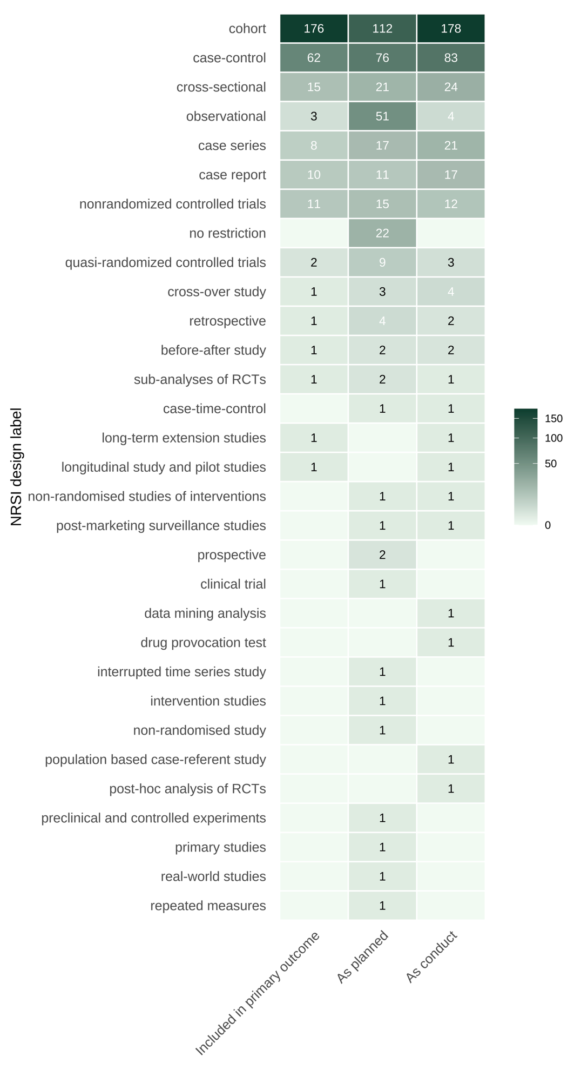
Fig. S1. Summary of types of non-randomized studies of interventions (NRSIs)

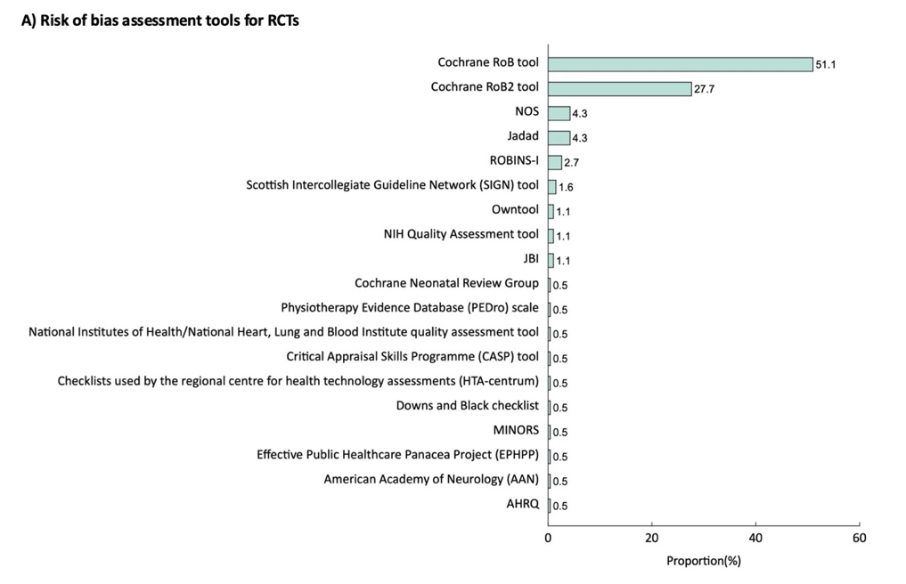
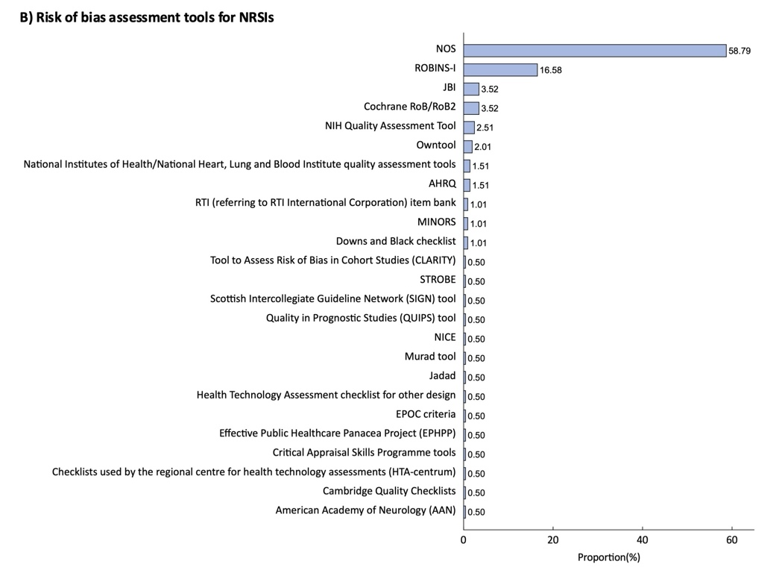
Fig. S2. Risk of bias tools used for RCTs and NRSIs
NOS=Newcastle Ottawa Scale, ROBINS-I=Risk Of Bias In Non-randomized Studies of Interventions, NIH=National Institutes of Health, JBI=Joanna Briggs Institute, MINORS=Methodological index for non‐randomized studies, AHRQ=Agency for Healthcare Research and Quality, STROBE=Strengthening the Reporting of Observational studies in Epidemiology, NICE=National Institute for Health and Care Excellence, EPOC=Cochrane Effective Practice and Organisation of Care Group Risk of Bias Criteria. Owntool refer to tools that the authors themselves have formulated.

