Supplementary Materials
Supplement to: Chunming Wang, Lei Cai, Yongguang Yang, et al.
Liquid Biopsy-Based Multi-Omics Approach for Early Detection of Hepatocellular Carcinoma (ASCEND-Hep): A Multiphase Prospective Development and Validation Study

CONTENTS
Supplementary Figures 2
Supplementary Tables 9

Supplementary Figures
Figure S1. Heatmap of DMBs in cancer vs. non-cancer control tissues. This heatmap illustrates the differentially methylated blocks (DMBs) between 19 cancer and 52 non-cancer control tissue samples (including adjacent, cirrhotic, and normal tissues)

Figure S2. Cell free DNA (cfDNA) methylation scores in HCC cases and controls. In the training set (n = 378), cfDNA methylation scores demonstrated a progressive increase from normal controls and other chronic liver disease (CLD) to liver cirrhosis, and then to HCC. HCC cases showed a significantly higher score compared to all control groups (indicated by brackets). P < 0.001 for all indicated comparisons. Other CLD included hepatitis B virus (HBV) infection, hepatitis C virus (HCV) infection, alcoholic liver disease (ALD), and nonalcoholic fatty liver disease (NAFLD), as determined by comprehensive imaging and/or pathological examination.

Figure S3. Performance of three single-omics models in the training and validation sets. (A, C) Sensitivity for overall HCC detection and according to Barcelona Clinic Liver Cancer (BCLC) stage 0, A, B, and C. (B, D) Specificity for overall non-HCC detection, including normal and chronic liver disease (CLD). CLD samples comprised liver cirrhosis, hepatitis B virus (HBV) infection, hepatitis C virus (HCV) infection, alcoholic liver disease (ALD), and nonalcoholic fatty liver disease (NAFLD).

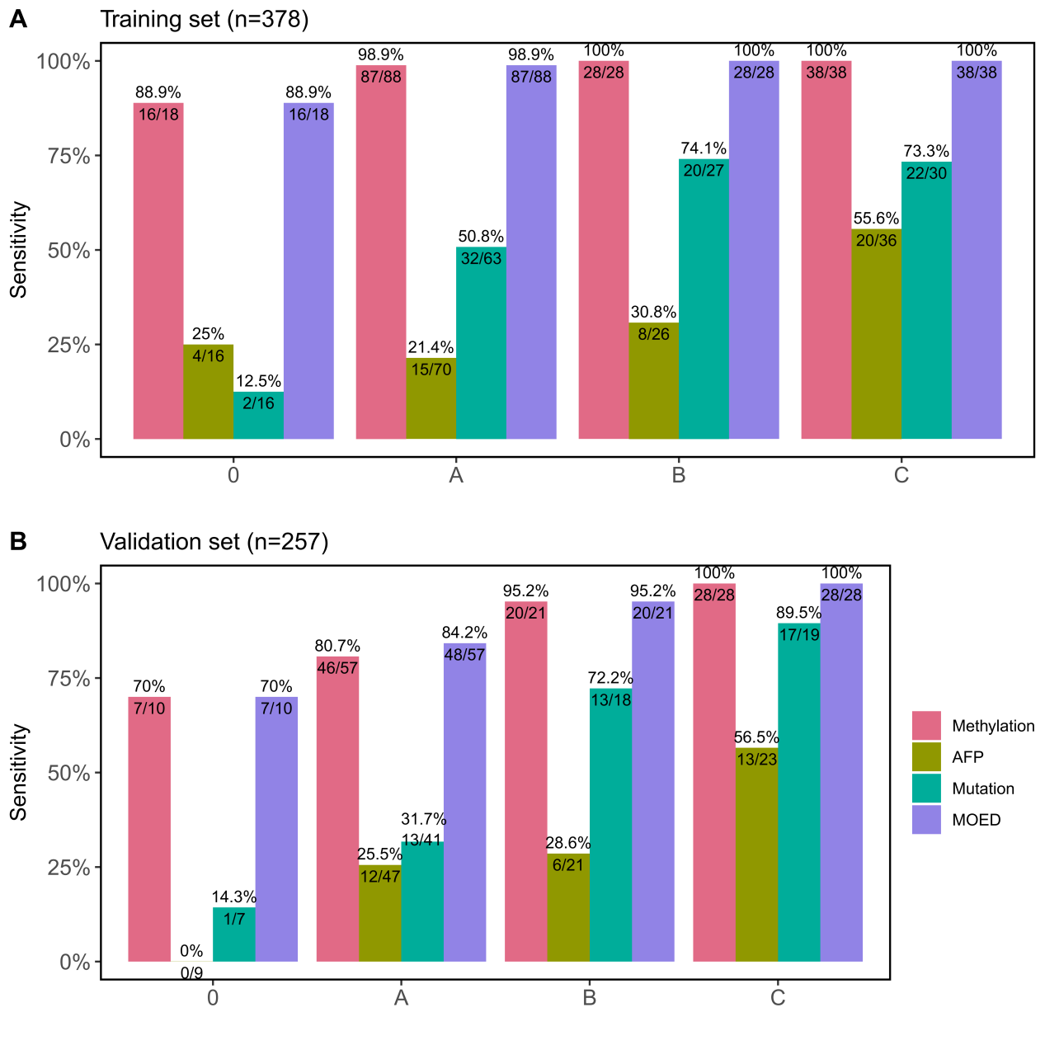
Figure S4. Sensitivity of different models across BCLC stages. The sensitivity of the methylation-, AFP-, mutation-based and MOED models at different Barcelona Clinic Liver Cancer (BCLC) stages in the training set (A) and validation set (B), respectively.
Figure S5. Methylation scores in HCC with or without cirrhosis. Methylation score comparison in HCC with (Yes) and without (No) liver cirrhosis across training set (Left) and validation set (Right).

Figure S6. Performance of the MOED model in the independent validation set (n = 797). (A) Sensitivity of the MOED model in the detection of different Barcelona Clinic Liver Cancer (BCLC) stages of HCC. (B) Specificity of the MOED model in the detection of non-HCC, including normal and chronic liver disease (CLD). CLD samples comprised liver cirrhosis, hepatitis B virus (HBV) infection, hepatitis C virus (HCV) infection, alcoholic liver disease (ALD), and nonalcoholic fatty liver disease (NAFLD). (C) UpSet plot illustrating the diagnostic intersection across distinct models in the independent validation set. The horizontal bars on the left represent the total number of subjects predicted as positive by each individual model (Methylation and AFP). On the right is the intersection matrix, where vertical lines connecting the points represent overlapping cases identified by two models, while isolated points indicate cases uniquely identified by a single model. The vertical bars at the top right represent the counts of cases predicted as positive by: (1) Methylation only; (2) both Methylation and AFP; and (3) AFP only. The red numbers above the vertical bars indicate the false positive (FP) counts for each model, while the blue numbers indicate the true positive (TP) counts. The AFP-based model (labeled "protein") independently identified 6 true positive cases.

Figure S7. Comparison of alanine transaminase (ALT) and aspartate aminotransferase (AST) levels between MOED-positive and MOED-negative non-HCC cases in the prospective cohort. (A) ALT levels in 41 MOED-positive non-HCC cases versus 397 MOED-negative non-HCC cases. (B) AST levels in 41 MOED-positive non-HCC cases versus 397 MOED-negative non-HCC cases.

Supplementary Tables
Table S1. Clinical characteristics of the tissue samples.
 | No. (%)
Characteristics | Tumor, N = 19 | Control, N = 52 | P-value
Age, mean (IQR) | 55 (52, 64) | 48 (42, 56) | 0.03ª
Sex, n (%)
Female | 6 (31.6%) | 9 (17.3%) | 0.02^{b}
Male | 13 (68.4%) | 29 (55.8%) | 0.02^{b}
Unknown | 0 (0%) | 14 (26.9%) | 0.02^{b}
Sample type, n (%)
Cancer | 19 (100.0%) |  | NA
Adjacent | NA | 19 (36.5%) | NA
Cirrhosis | NA | 19 (36.5%) | NA
Normal | NA | 14 (26.9%) | NA
BCLC stage, n (%)
A | 10 (52.6%) | NA | NA
B | 3 (15.8%) | NA | NA
C | 6 (31.6%) | NA | NA
ªP value is based on the Wilcoxon rank sum test.
^{b}P value is based on the Fisher's exact test.

Table S2. Genomic annotations of the 101 differentially methylated blocks (DMBs).
Block ID | Associated Gene | Gene Type
Block1 | FGF19 | protein-coding
Block2 | GNA11 | protein-coding
Block3 | PPM1N | protein-coding
Block4 | CXXC5 | protein-coding
Block5 | TBX2 | protein-coding
Block6 | LDHB | protein-coding
Block7 | GATA4 | protein-coding
Block8 | PRR16 | protein-coding
Block9 | HOXC10 | protein-coding
Block10 | LINC01798 | ncRNA
Block11 | TFR2 | protein-coding
Block12 | KDM7A-DT | ncRNA
Block13 | FRMD4B | protein-coding
Block14 | LHX2 | protein-coding
Block15 | PLEKHA6 | protein-coding
Block16 | LIN28B-AS1 | ncRNA
Block17 | TLR5 | protein-coding
Block18 | CACNA1C-AS1 | ncRNA
Block19 | ADORA2A | protein-coding
Block20 | NDRG4 | protein-coding
Block21 | LOC100128242 | protein-coding
Block22 | DPP6 | protein-coding
Block23 | RGS1 | protein-coding
Block24 | RUBCN | protein-coding
Block25 | HOTTIP | ncRNA
Block26 | BEST4 | protein-coding
Block27 | ASGR2 | protein-coding
Block28 | ZFP64 | protein-coding
Block29 | LRRC7 | protein-coding
Block30 | GIMAP6 | protein-coding
Block31 | TRIM40 | protein-coding
Block32 | FIGN | protein-coding
Block33 | LRRFIP1 | protein-coding
Block34 | DUOXA2 | protein-coding
Block35 | MROH6 | protein-coding
Block36 | SWSAP1 | protein-coding
Block37 | CHRM3-AS2 | ncRNA
Block38 | SPINK2 | protein-coding
Block39 | HOXA6 | protein-coding
Block40 | CDKN2A-DT | ncRNA
Block41 | MECOM | protein-coding
Block42 | MEIOC | protein-coding
Block43 | NPBWR1 | protein-coding
Block44 | KLHL6 | protein-coding
Block45 | EXOC3-AS1 | ncRNA
Block46 | CDH2 | protein-coding
Block47 | C1QL1 | protein-coding
Block48 | UBD | protein-coding
Block49 | EGR3 | protein-coding
Block50 | HIST3H2A | protein-coding
Block51 | CPAMD8 | protein-coding
Block52 | ADGRB2 | protein-coding
Block53 | NCR2 | protein-coding
Block54 | LBH | protein-coding
Block55 | ANP32B | protein-coding
Block56 | MREG | protein-coding
Block57 | OR1F1 | protein-coding
Block58 | AGRN | protein-coding
Block59 | LOC375196 | ncRNA
Block60 | DGKZ | protein-coding
Block61 | CORO6 | protein-coding
Block62 | GNB4 | protein-coding
Block63 | HIST1H2BH | protein-coding
Block64 | FOXC1 | protein-coding
Block65 | PPP1R21 | protein-coding
Block66 | PSTPIP1 | protein-coding
Block67 | F2RL3 | protein-coding
Block68 | SEPT9 | protein-coding
Block69 | TJP2 | protein-coding
Block70 | MIR194-2HG | ncRNA
Block71 | ANKRD60 | protein-coding
Block72 | HHEX | protein-coding
Block73 | LINC01271 | ncRNA
Block74 | NAT8L | protein-coding
Block75 | BCL2L11 | protein-coding
Block76 | CERS1 | protein-coding
Block77 | TBX2 | protein-coding
Block78 | TNIK | protein-coding
Block79 | CYP2F1 | protein-coding
Block80 | SATB2 | protein-coding
Block81 | CR1 | protein-coding
Block82 | CCDC61 | protein-coding
Block83 | PTGER4 | protein-coding
Block84 | GATA4 | protein-coding
Block85 | NDUFB9 | protein-coding
Block86 | MIR155HG | ncRNA
Block87 | HIST1H4F | protein-coding
Block88 | CD276 | protein-coding
Block89 | DNM3 | protein-coding
Block90 | OTX1 | protein-coding
Block91 | FLJ32255 | ncRNA
Block92 | MIR5087 | ncRNA
Block93 | HMGB2 | protein-coding
Block94 | LINC02035 | ncRNA
Block95 | TLX1 | protein-coding
Block96 | HOXA9 | protein-coding
Block97 | GALNT13 | protein-coding
Block98 | LINC02140 | ncRNA
Block99 | AJAP1 | protein-coding
Block100 | MIR2277 | ncRNA
Block101 | LOC90768 | ncRNA

Table S3. Sensitivity of the MOED model across clinical subgroups in HCC from the training and validation sets.
Characteristics | HCC | P-valueª
Age
<60 | 94.9% | 0.86
≥60 | 93.7% | 0.86
Sex
Female | 95.0% | 1.00
Male | 94.4% | 1.00
BMI
<30 | 94.6% | 1.00
>=30 | 91.7% | 1.00
Tumor size
≤2 | 81.2% | 0.002
(2,5] | 94.2% | 0.002
>5 | 97.4% | 0.002
HBV infection
No | 89.3% | 0.41
Yes | 95.0% | 0.41
With cirrhosis
No | 92.5% | 0.54
Yes | 95.2% | 0.54
Child-Pugh
A | 93.7% | 0.60
B | 96.8% | 0.60
C | 100.0% | 0.60
ªP value is based on the Pearson's Chi-squared Test.
Table S4. Clinical characteristics of etiology-matched HCC and controls from the training and validation sets.
Characteristic | HCC, N = 59 | CLD, N = 59
Age, Median (IQR) | 56 (46, 61) | 54 (49, 58)
Sex, n (%)
Female | 20 (34%) | 19 (32%)
Male | 39 (66%) | 40 (68%)
Etiology, n (%)
HBV | 32 (54%) | 28 (47%)
HCV | 3 (5.1%) | 2 (3.4%)
ALD | 5 (8.5%) | 3 (5.1%)
NAFLD | 19 (32%) | 26 (44%)
AFP, Median (IQR) (ng/mL) | 35 (7, 1,200) | 3 (2, 4)
BCLC stage, n (%)
0 | 4 (6.8%) | 0 (0%)
A | 31 (53%) | 0 (0%)
B | 9 (15%) | 0 (0%)
C | 15 (25%) | 0 (0%)
HBV: hepatitis B virus, HCV: hepatitis C virus, ALD: alcoholic liver disease, NAFLD: nonalcoholic fatty liver disease. CLD: chronic liver disease.
Table S5. Performance of MOED in etiology-matched HCC and controls from the training and validation sets.

 | AUC (95% CI)
Etiology-matched subgroup | MOED model | AFP model | P-value
All BCLC stages | 0.932 (0.881-0.975) | 0.823 (0.733-0.895) | 0.02
BCLC stage 0-A | 0.923 (0.861-0.967) | 0.748 (0.629-0.853) | 0.01

Table S6. Clinical characteristics of the non-HCC cases in the prospective cohort.
Characteristics | No. (%) |  | P-value
Characteristics | MOED-positive | MOED-negative | P-value
Total number | 41 | 397
AFP, mean (SD), ng/mL | 3.37 (2.0) | 3.03 (2.8) | 0.18
ALT, U/L |  |  | 0.007ª
>40 | 7 (17.1) | 23 (5.8)
≤40 | 34 (82.9) | 374 (94.2)
AST, U/L |  |  | <0.001ª
>40 | 7 (17.1) | 16 (4.0)
≤40 | 34 (82.9) | 381 (96.0)
Cirrhosis | 4 (9.8) | 27 (6.8) | 0.44
HBV positive | 38 (92.7) | 372 (93.7) | 0.80
ALT: alanine aminotransferase, AST: aspartate aminotransferase.
ªP value is based on the Chi-Squar test.

