Supplementary Appendix

Appendix Tables

Table S1. The flowchart of sample selection

Sample selection steps | Remained | Dropped
Raw sample, no missing value on the name, sex and age of surgeon and surgery name | 1,600,535 | 0
Excluded records from surgical categories with <10,000 cases | 660,941 | 939,594
Excluded records from hospitals with <1,000 total surgeries | 608,224 | 52,717
Excluded records above the 99th percentile of LOS | 602,608 | 5,616

Table S2. Demographic description and hospitalization characteristics of patients
Characteristics | Overall  N = 602,608 | Male  N = 238,949 | Female  N = 363,659
Age (yr), mean (SD) | 52.5(17.9) | 58.8(16.0) | 48.4(17.9)
Payment Type, n (%)
Employee Insurance | 179,233.0 (29.7%) | 82,088.0 (34.4%) | 97,145.0 (26.7%)
Resident Insurance | 249,285.0 (41.4%) | 95,896.0 (40.1%) | 153,389.0 (42.2%)
Poverty Alleviation | 3,973.0 (0.7%) | 1,952.0 (0.8%) | 2,021.0 (0.6%)
Commercial Health Insurance | 93.0 (0.0%) | 37.0 (0.0%) | 56.0 (0.0%)
Public Expenses | 282.0 (0.0%) | 136.0 (0.1%) | 146.0 (0.0%)
Self - payment | 65,931.0 (10.9%) | 18,952.0 (7.9%) | 46,979.0 (12.9%)
Social Insurances | 2,646.0 (0.4%) | 955.0 (0.4%) | 1,691.0 (0.5%)
Other | 101,165.0 (16.8%) | 38,933.0 (16.3%) | 62,232.0 (17.1%)
Admission Type, n (%)
Emergency Department | 129,896.0 (21.6%) | 58,680.0 (24.6%) | 71,216.0 (19.6%)
Outpatient | 441,482.0 (73.3%) | 167,389.0 (70.1%) | 274,093.0 (75.4%)
External Referrals | 787.0 (0.1%) | 370.0 (0.2%) | 417.0 (0.1%)
Other | 30,443.0 (5.1%) | 12,510.0 (5.2%) | 17,933.0 (4.9%)
Four Types of Surgical Operations, n (%)
Diagnostic Operations | 108,320.0 (18.0%) | 60,612.0 (25.4%) | 47,708.0 (13.1%)
Intervention | 19,780.0 (3.3%) | 14,779.0 (6.2%) | 5,001.0 (1.4%)
Standard Surgery | 239,860.0 (39.8%) | 49,483.0 (20.7%) | 190,377.0 (52.4%)
Therapeutic Operations | 234,648.0 (38.9%) | 114,075.0 (47.7%) | 120,573.0 (33.2%)
No. of Surgeries at Once Admission, mean (SD) | 1.9 (1.3) | 2.0 (1.4) | 1.8 (1.2)
Surgeries Performed at Same Day, n (%)
No | 72,478.0 (12.0%) | 30,467.0 (12.8%) | 42,011.0 (11.6%)
Yes | 530,130.0 (88.0%) | 208,482.0 (87.2%) | 321,648.0 (88.4%)
Quality of Hospital, n (%)
Secondary | 119,813.0 (19.9%) | 42,278.0 (17.7%) | 77,535.0 (21.3%)
Tertiary | 482,795.0 (80.1%) | 196,671.0 (82.3%) | 286,124.0 (78.7%)
Note: SD = Standard Deviation

Table S3. Demographic description of surgeons
Characteristics | Overall  N = 11,994 | Male  N = 4,952 | Female  N = 7,042 | p-value
Age (yr), mean (SD) | 37.9 (7.8) | 40.0 (8.0) | 36.5 (7.3) | <0.001
Year of Working, mean (SD) | 13.0 (8.6) | 14.5 (9.2) | 11.9 (8.0) | <0.001
Education Levels, n (%) |  |  |  | <0.001
Doctoral degree | 3,350.0 (27.7%) | 1,465.0 (29.4%) | 1,885.0 (26.6%)
Master’s degree | 6,609.0 (54.7%) | 3,008.0 (60.3%) | 3,601.0 (50.8%)
Bachelor’s degree | 1,878.0 (15.6%) | 465.0 (9.3%) | 1,413.0 (19.9%)
College diploma or lower | 238.0 (2.0%) | 53.0 (1.1%) | 185.0 (2.6%)
Birth Cohort, n (%) |  |  |  | <0.001
1956 ~ 1965 | 235.0 (2.0%) | 149.0 (3.0%) | 86.0 (1.2%)
1966 ~ 1975 | 1,365.0 (11.4%) | 781.0 (15.8%) | 584.0 (8.3%)
1976 ~ 1985 | 4,041.0 (33.7%) | 1,997.0 (40.3%) | 2,044.0 (29.0%)
1986 ~ 1995 | 5,813.0 (48.5%) | 1,920.0 (38.8%) | 3,893.0 (55.3%)
1996 ~ 2005 | 540.0 (4.5%) | 105.0 (2.1%) | 435.0 (6.2%)
Note: SD = Standard Deviation; Two Sample t-test and Pearson's Chi-squared test were used to calculate the p-value.

Table S4. Poisson estimate of coefficients for length of stay after surgery using full analysis sample and three subsamples
Variables | Full Sample | Subsample
Variables | Full Sample | Top 10 of surgical operation | Excluding Maternal and Child Health Hospitals | Selected surgical operation
Surgeon’s sex (Ref: Male) | -0.017** | 0.008 | -0.020** | -0.011
 | (0.008) | (0.009) | (0.008) | (0.009)
No. of Surgeries at Once Admission | 0.073*** | 0.076*** | 0.074*** | 0.087***
 | (0.003) | (0.004) | (0.003) | (0.004)
Surgeon’s Age | 0.000 | -0.000 | -0.000 | -0.001
 | (0.000) | (0.001) | (0.000) | (0.001)
Surgeries Performed at Same Day | -0.252*** | -0.361*** | -0.251*** | -0.290***
 | (0.009) | (0.017) | (0.009) | (0.011)
Resident Insurance (Ref: Employee Insurance) | 0.020*** | 0.035*** | 0.020*** | 0.015**
 | (0.005) | (0.006) | (0.005) | (0.006)
Poverty Alleviation | 0.104*** | 0.088*** | 0.102*** | 0.111***
 | (0.015) | (0.020) | (0.016) | (0.021)
Commercial Health Insurance | 0.076 | 0.211 | 0.080 | 0.126
 | (0.104) | (0.169) | (0.107) | (0.193)
Public Expenses | 0.001 | -0.103 | 0.006 | -0.022
 | (0.060) | (0.079) | (0.066) | (0.071)
Self - payment | -0.023 | -0.042** | -0.031* | -0.081**
 | (0.018) | (0.021) | (0.019) | (0.032)
Social Insurances | 0.027 | 0.054*** | 0.027 | 0.013
 | (0.017) | (0.018) | (0.017) | (0.025)
Other | -0.080*** | -0.122*** | -0.088*** | -0.124***
 | (0.025) | (0.031) | (0.026) | (0.046)
Outpatient (Ref = ED) | -0.067*** | -0.048*** | -0.070*** | -0.067***
 | (0.007) | (0.007) | (0.007) | (0.010)
External Referrals | 0.063** | 0.190*** | 0.062* | 0.017
 | (0.031) | (0.044) | (0.032) | (0.044)
Other | -0.093*** | -0.080* | -0.096*** | -0.067*
 | (0.025) | (0.043) | (0.025) | (0.035)
Patient’ Age | 0.002*** | 0.000 | 0.002*** | 0.001***
 | (0.000) | (0.000) | (0.000) | (0.000)
Num.Obs. | 602608 | 396861 | 585678 | 374728
AIC | 2592324.0 | 1554735.4 | 2528771.8 | 1695412.3
BIC | 2608360.2 | 1569994.2 | 2543741.1 | 1710276.5
RMSE | 2.74 | 2.35 | 2.77 | 3.14
FE: Surgeon’s Education | X | X | X | X
FE: Hospital | X | X | X | X
FE: Hospital^Month | X | X | X | X
FE: Surgical Code | X | X | X | X
FE: Surgical Category | X | X | X | X
Note: * p < 0.1, ** p < 0.05, *** p < 0.01. Std. Errors are included in brackets. Std. Errors are clustered at hospital and month level. ED = Emergency Department.
The ICD-10 surgical codes of selected surgical operation are 99.92, 99.28, 99.25, 93.90, 93.35, 45.43, 45.42, 45.13, 44.13, 43.41, 39.95, 36.07, 33.24, 14.79, 13.41. The ICD-10 surgical codes of top 10 Surgeries are 13.41, 14.79, 33.24, 45.43, 51.23, 74.1x, 75.69, 88.55, 99.25, 99.28.

Table S5. Negative Binomial estimate of coefficients for length of stay after surgery using full analysis sample and three subsamples
Variables | Full Sample | Subsample
Variables | Full Sample | Top 10 of surgical operation | Excluding Maternal and Child Health Hospitals | Selected surgical operation
Surgeon’s sex (Ref: Male) | -0.018** | 0.003 | -0.020** | -0.005
 | (0.009) | (0.010) | (0.009) | (0.010)
No. of Surgeries at Once Admission | 0.076*** | 0.081*** | 0.078*** | 0.101***
 | (0.004) | (0.005) | (0.004) | (0.006)
Surgeon’s Age | 0.000 | -0.001 | -0.000 | -0.000
 | (0.000) | (0.001) | (0.000) | (0.001)
Surgeries Performed at Same Day | -0.305*** | -0.404*** | -0.305*** | -0.386***
 | (0.013) | (0.023) | (0.014) | (0.018)
Resident Insurance (Ref: Employee Insurance) | 0.026*** | 0.037*** | 0.027*** | 0.030***
 | (0.005) | (0.006) | (0.005) | (0.006)
Poverty Alleviation | 0.109*** | 0.096*** | 0.107*** | 0.108***
 | (0.017) | (0.022) | (0.018) | (0.027)
Commercial Health Insurance | 0.105 | 0.227 | 0.112 | 0.184
 | (0.115) | (0.189) | (0.118) | (0.223)
Public Expenses | 0.005 | -0.086 | 0.012 | -0.015
 | (0.057) | (0.077) | (0.065) | (0.072)
Self - payment | -0.034* | -0.056** | -0.043** | -0.123***
 | (0.020) | (0.024) | (0.020) | (0.038)
Social Insurances | 0.036** | 0.056*** | 0.036** | 0.032
 | (0.018) | (0.020) | (0.018) | (0.027)
Other | -0.118*** | -0.165*** | -0.130*** | -0.241***
 | (0.032) | (0.037) | (0.035) | (0.072)
Outpatient (Ref = ED) | -0.071*** | -0.050*** | -0.074*** | -0.077***
 | (0.007) | (0.008) | (0.007) | (0.012)
External Referrals | 0.066** | 0.163*** | 0.065** | 0.019
 | (0.030) | (0.041) | (0.030) | (0.043)
Other | -0.107*** | -0.107*** | -0.110*** | -0.075**
 | (0.025) | (0.041) | (0.025) | (0.036)
Patient’ Age | 0.002*** | 0.000 | 0.002*** | 0.001***
 | (0.000) | (0.000) | (0.000) | (0.000)
Num.Obs. | 602608 | 396861 | 585678 | 374728
AIC | 2488106.0 | 1513413.5 | 2419595.9 | 1550471.1
BIC | 2504142.2 | 1528672.3 | 2434565.2 | 1565335.3
RMSE | 2.79 | 2.37 | 2.82 | 3.28
FE: Surgeon’s Education | X | X | X | X
FE: Hospital | X | X | X | X
FE: Hospital^Month | X | X | X | X
FE: Surgical Code | X | X | X | X
FE: Surgical Category | X | X | X | X
Note: * p < 0.1, ** p < 0.05, *** p < 0.01. Std. Errors are included in brackets. Std. Errors are clustered at hospital and month level. ED = Emergency Department.
The ICD-10 surgical codes of selected surgical operation are 99.92, 99.28, 99.25, 93.90, 93.35, 45.43, 45.42, 45.13, 44.13, 43.41, 39.95, 36.07, 33.24, 14.79, 13.41. The ICD-10 surgical codes of top 10 Surgeries are 13.41, 14.79, 33.24, 45.43, 51.23, 74.1x, 75.69, 88.55, 99.25, 99.28.

Table S6. Post-hoc estimate for length of stay after surgery of interaction effect (Poisson)
Interaction Variable | Sex of Surgeon | LOSAS | SE | Lower 95% CI | Upper 95% CI
Male Patient | Male Surgeon | 4.72 | 0.130 | 4.47 | 4.98
 | Female Surgeon | 4.70 | 0.144 | 4.42 | 4.99
Female Patient | Male Surgeon | 4.56 | 0.129 | 4.31 | 4.81
 | Female Surgeon | 4.43 | 0.143 | 4.15 | 4.72
Male Assistant | Male Surgeon | 5.04 | 0.172 | 4.72 | 5.39
 | Female Surgeon | 4.86 | 0.196 | 4.49 | 5.26
Female Assistant | Male Surgeon | 5.04 | 0.183 | 4.69 | 5.41
 | Female Surgeon | 4.73 | 0.194 | 4.37 | 5.13
Birth Cohort: 1956 ~ 1965 | Male Surgeon | 4.44 | 0.103 | 4.24 | 4.65
 | Female Surgeon | 4.69 | 0.180 | 4.35 | 5.05
Birth Cohort: 1966 ~ 1975 | Male Surgeon | 4.69 | 0.123 | 4.45 | 4.93
 | Female Surgeon | 4.52 | 0.136 | 4.26 | 4.79
Birth Cohort: 1976 ~ 1985 | Male Surgeon | 4.62 | 0.122 | 4.39 | 4.87
 | Female Surgeon | 4.47 | 0.127 | 4.23 | 4.73
Birth Cohort: 1986 ~ 1995 | Male Surgeon | 4.58 | 0.126 | 4.34 | 4.83
 | Female Surgeon | 4.60 | 0.124 | 4.36 | 4.85
Birth Cohort: 1996 ~ 2005 | Male Surgeon | 5.13 | 0.203 | 4.75 | 5.55
 | Female Surgeon | 4.50 | 0.140 | 4.23 | 4.78

Appendix Figures

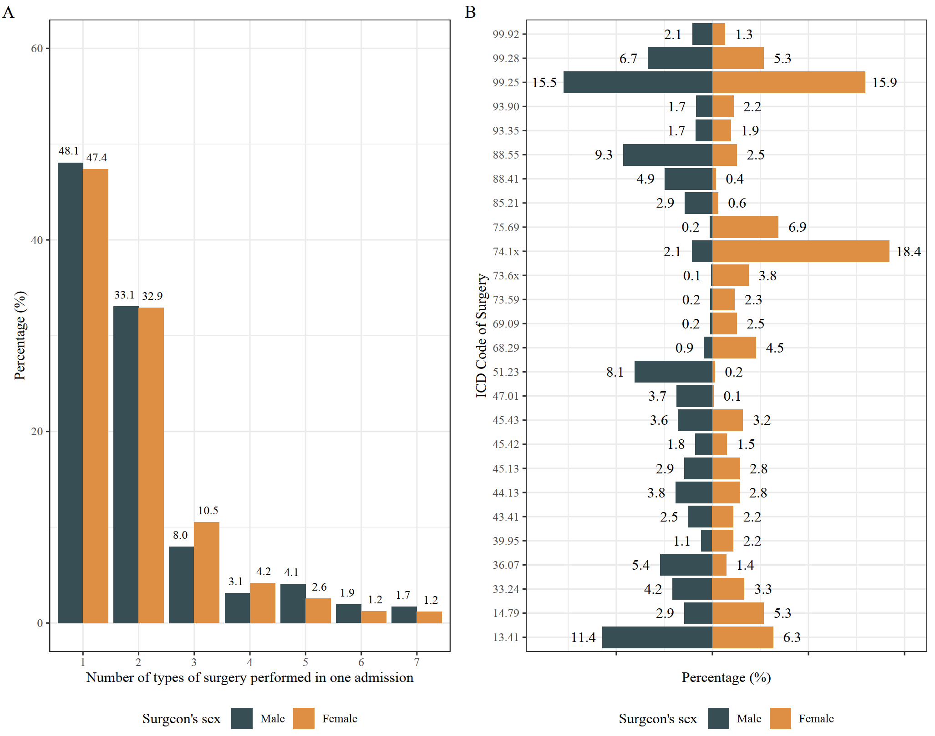

Fig S1. Distribution of number of surgeries, by surgeon’s sex
Note: The surgical name can be found in the in brackets. 99.92 (Injection or infusion of other therapeutic or prophylactic substance), 99.28 (Injection or infusion of anti-tumor drugs as a biological response modifier [BRM]), 99.25 (Injection or infusion of cancer chemotherapeutic substance), 93.90 (Non-invasive mechanical ventilation), 93.35 (Thermotherapy), 88.55 (Single-catheter technique for coronary angiography), 88.41 (Cerebral angiography), 85.21 (Local excision of breast lesion), 75.69 (Repair of other obstetric lacerations), 74.1x (Low cervical cesarean section), 73.6x (Episiotomy), 73.59 (Other manipulation-assisted delivery), 69.09 (Other Dilation and Curettage (D&C)), 68.29 (Other excision or destruction of uterus lesion), 51.23 (Laparoscopic cholecystectomy), 47.01 (Laparoscopic appendectomy), 45.43 (Other endoscopic destruction or excision of large intestine lesion), 45.42 (Endoscopic polypectomy of sigmoid colon), 45.13 (Other endoscopy of small intestine), 44.13 (Other Gastroscopy), 43.41 (Endoscopic Excision or Destruction of Gastric Lesion or Tissue), 39.95 (Hemodialysis), 36.07 (Drug-eluting coronary-artery stent Placement), 33.24 (Bronchoscopy with biopsy), 14.79 (Other vitreous surgery), 13.41 (Phacoemulsification and Aspiration of Cataract).

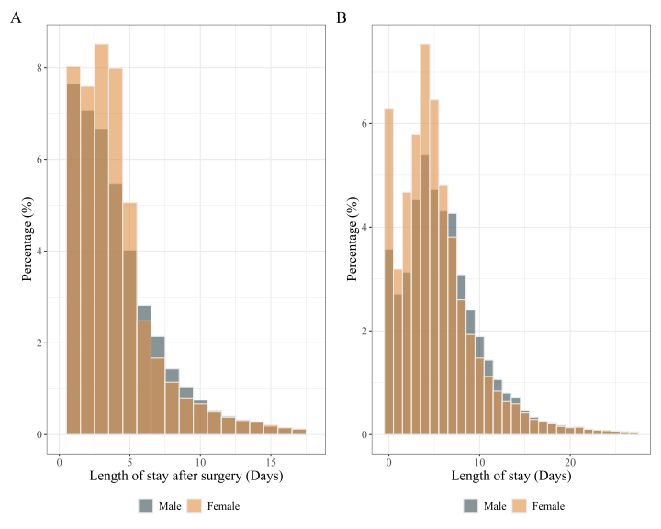

Fig S2. Distribution of Length of Stay After Surgery (LOSAS) and LOS, by surgeon’s sex

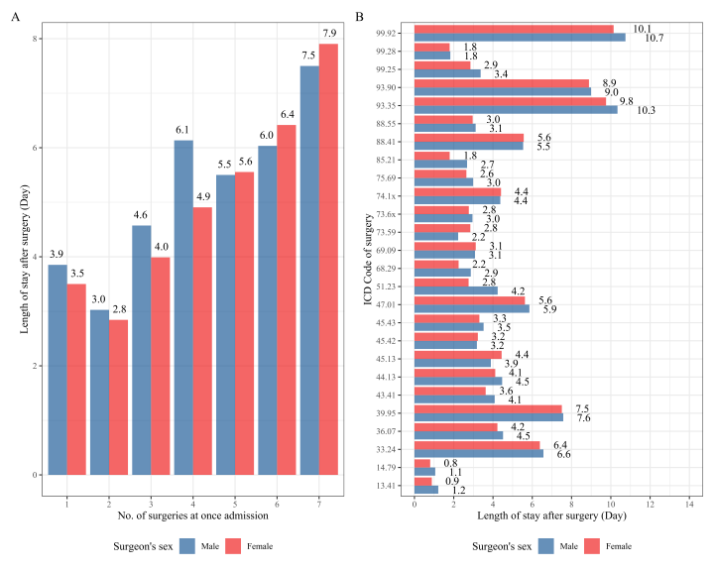

Fig S3. Distribution of Length of Stay After Surgery (LOSAS) between No. of surgeries and surgery code, by surgeon’s sex
Note: The surgical name can be found in the in brackets. 99.92 (Injection or infusion of other therapeutic or prophylactic substance), 99.28 (Injection or infusion of anti-tumor drugs as a biological response modifier [BRM]), 99.25 (Injection or infusion of cancer chemotherapeutic substance), 93.90 (Non-invasive mechanical ventilation), 93.35 (Thermotherapy), 88.55 (Single-catheter technique for coronary angiography), 88.41 (Cerebral angiography), 85.21 (Local excision of breast lesion), 75.69 (Repair of other obstetric lacerations), 74.1x (Low cervical cesarean section), 73.6x (Episiotomy), 73.59 (Other manipulation-assisted delivery), 69.09 (Other Dilation and Curettage (D&C)), 68.29 (Other excision or destruction of uterus lesion), 51.23 (Laparoscopic cholecystectomy), 47.01 (Laparoscopic appendectomy), 45.43 (Other endoscopic destruction or excision of large intestine lesion), 45.42 (Endoscopic polypectomy of sigmoid colon), 45.13 (Other endoscopy of small intestine), 44.13 (Other Gastroscopy), 43.41 (Endoscopic Excision or Destruction of Gastric Lesion or Tissue), 39.95 (Hemodialysis), 36.07 (Drug-eluting coronary-artery stent Placement), 33.24 (Bronchoscopy with biopsy), 14.79 (Other vitreous surgery), 13.41 (Phacoemulsification and Aspiration of Cataract).

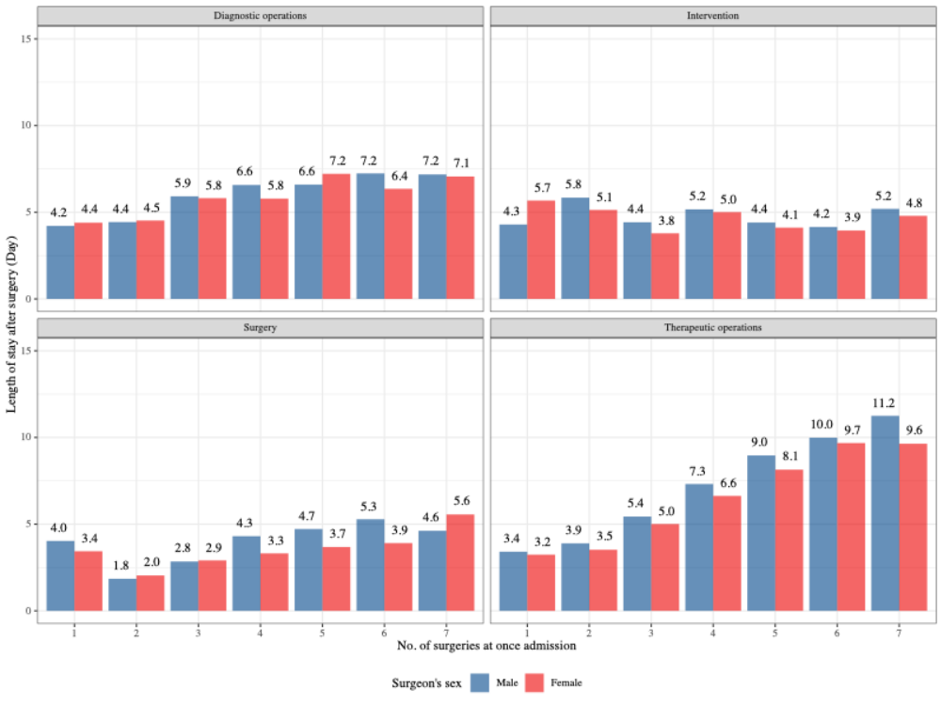

Fig S4. Distribution of Length of Stay After Surgery (LOSAS) by times facet with surgery category

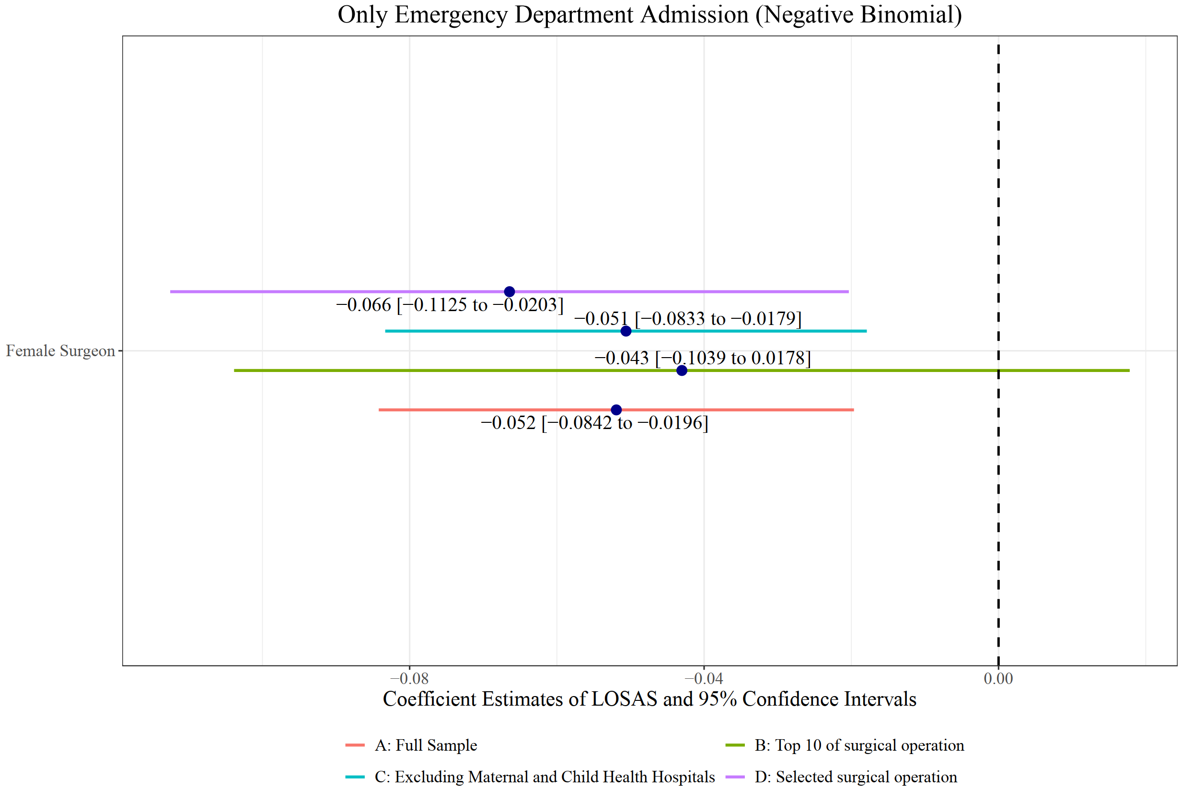

Fig S5. Coefficients for length of stay after surgery using full analysis sample and three subsamples from emergency department

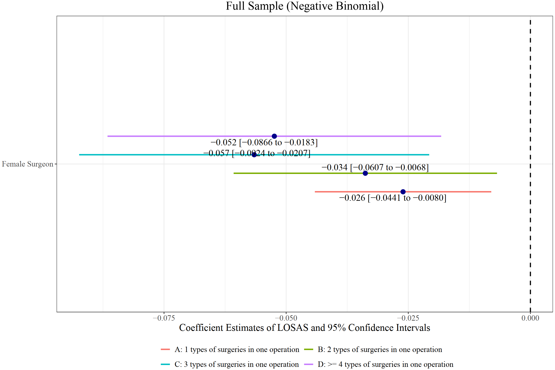

Fig S6. Coefficients for length of stay after surgery using full analysis sample, group by types of surgeries in one operation

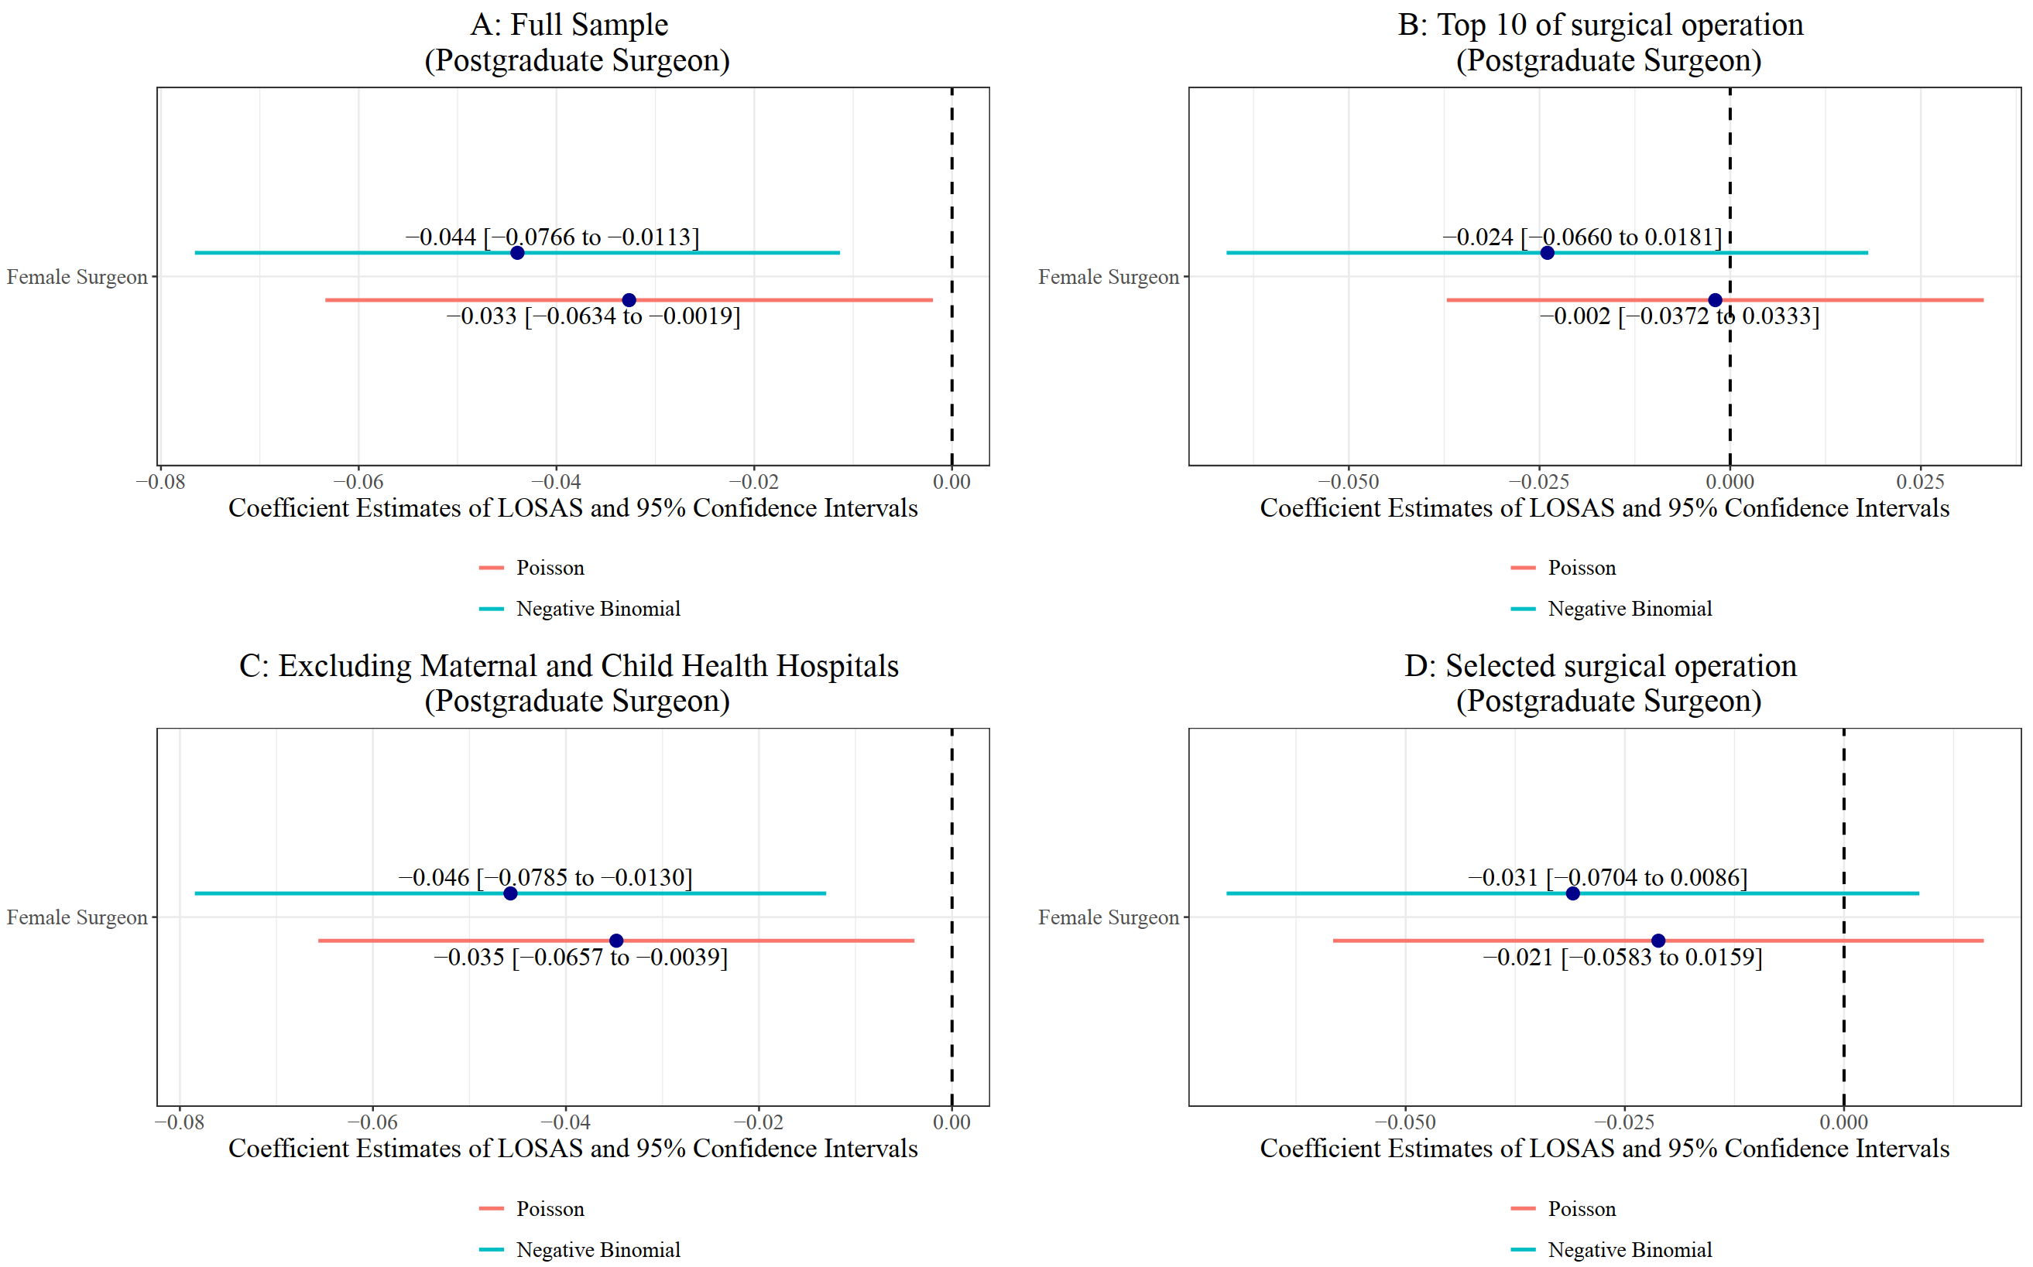

Fig S7. Coefficients for length of stay after surgery using sample from postgraduate surgeon

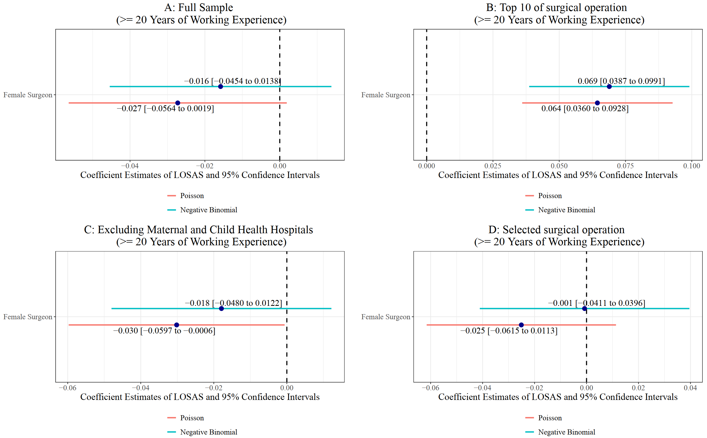

Fig S8. Coefficients for length of stay after surgery using full analysis sample and three subsamples filtered by year of working experience

Post-hoc of Main regression (Corresponding to the Figure 1)
Sex of Physician | Day | SE | 95% CI LCL | 95% CI UCL | Sample
Male | 4.620097 | 0.1269719 | 4.377820 | 4.875782 | A: Full Sample
Female | 4.540231 | 0.1408089 | 4.272471 | 4.824772 | A: Full Sample
Male | 3.969284 | 0.1778760 | 3.635526 | 4.333684 | B: Top 10 of surgical operation
Female | 4.001478 | 0.1966447 | 3.634041 | 4.406067 | B: Top 10 of surgical operation
Male | 4.617187 | 0.1299708 | 4.369349 | 4.879083 | C: Excluding Maternal and Child Health Hospitals
Female | 4.525138 | 0.1439718 | 4.251576 | 4.816301 | C: Excluding Maternal and Child Health Hospitals
Male | 4.844211 | 0.1889401 | 4.487695 | 5.229048 | D: Selected surgical operation
Female | 4.788876 | 0.2044709 | 4.404431 | 5.206878 | D: Selected surgical operation

Post-hoc of ED regression (Corresponding to the Figure 2)
Sex of Physician | Day | SE | 95% CI LCL | 95% CI UCL | Sample
Male | 4.793874 | 0.2799344 | 4.275446 | 5.375166 | A: Full Sample
Female | 4.521141 | 0.3158312 | 3.942630 | 5.184538 | A: Full Sample
Male | 4.065638 | 0.3973901 | 3.356829 | 4.924115 | B: Top 10 of surgical operation
Female | 3.999794 | 0.4545519 | 3.201133 | 4.997714 | B: Top 10 of surgical operation
Male | 4.770328 | 0.2822092 | 4.248071 | 5.356791 | C: Excluding Maternal and Child Health Hospitals
Female | 4.503125 | 0.3186198 | 3.920008 | 5.172982 | C: Excluding Maternal and Child Health Hospitals
Male | 5.072907 | 0.3984216 | 4.349149 | 5.917108 | D: Selected surgical operation
Female | 4.716822 | 0.4361698 | 3.934939 | 5.654069 | D: Selected surgical operation

Post-hoc of types of surgeries in one admission (Corresponding to the Figure 3)
Sex of Physician | Day | SE | 95% CI LCL | 95% CI UCL | Sample
Male | 4.078970 | 0.1436216 | 3.806970 | 4.370404 | A: 1 types of surgeries in one operation
Female | 3.989737 | 0.1499668 | 3.706373 | 4.294764 | A: 1 types of surgeries in one operation
Male | 4.263130 | 0.1973491 | 3.893361 | 4.668017 | B: 2 types of surgeries in one operation
Female | 4.145615 | 0.2156490 | 3.743783 | 4.590577 | B: 2 types of surgeries in one operation
Male | 4.632675 | 0.3235330 | 4.040046 | 5.312236 | C: 3 types of surgeries in one operation
Female | 4.393624 | 0.3285925 | 3.794572 | 5.087249 | C: 3 types of surgeries in one operation
Male | 5.172010 | 0.3948365 | 4.453257 | 6.006769 | D: ≥ 4 types of surgeries in one operation
Female | 4.825187 | 0.4190126 | 4.070024 | 5.720465 | D: ≥ 4 types of surgeries in one operation

