Figure 2A
GAPDH:
TGM2:
Figure 2B
GAPDH:

TGM2:
Figure 3I
GAPDH:
TGM2:
Figure 3J
GAPDH:
TGM2:
Figure 5E
GAPDH:

CLDN5:
Figure 5F
GAPDH:
TGM2:
Figure 7E
GAPDH:
H3:
TGM2-nuclear proteins:
TGM2-whole proteins:
RelA-nuclear proteins:
RelA-whole proteins:
CLDN5-nuclear proteins:

CLDN5-whole proteins:
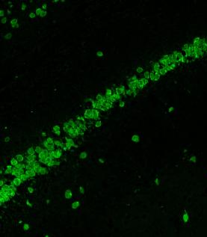
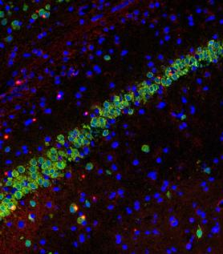
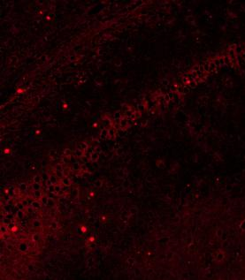
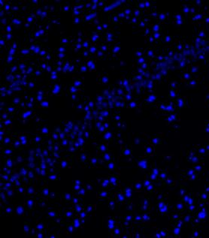
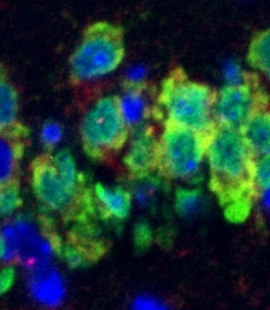
Conol
Epilepsy

