Supplementary appendix for Polygenicity shapes distinct brain patterns and clinical profiles of bipolar disorder
Supplementary Methods
Supplementary Figures
Fig. S1. Q-Q plots of meta-analysis results for EAS-BD.
Fig. S2. Results of GNOVA analysis for traits with significant genetic correlations.
Fig. S3. Manhattan plot of MTAG results for 24 pairs of BD-IDPs identified with shared SNVs.
Fig. S4. MESuSiE analysis within a 500 kb window surrounding rs7941324.
Fig. S5. Gene enrichment analysis for genes near shared SNVs.
Fig. S6. Enrichment analysis of SNVs performed using snpXplorer.
Fig. S7. Synaptic functional enrichment analysis of shared genes between BD and IDPs using SynGo.
Fig. S8. Developmental trajectories of gene expression for BD and IDPs across nine time windows and brain regions.
Fig. S9. Identification of shared proteins between BD and IDPs using SMR and BLISS.
Fig. S10. Protein-protein interaction (PPI) analysis of shared proteins using STRING.
Fig. S11. Statistical mediation of clinical features between BD-IDP PRS and suicide risk.
Supplementary Method.
Quality Control for genotyped data
Quality control (QC) analyses were conducted at both the individual and genetic marker levels using PLINK v1.9 for two cohorts, the Li et al. cohort and the CLASS-BD cohort, which were collectively referred to as the Chinese BD (CN-BD) cohort. Individuals were excluded from further analyses if they had inconsistent sex information, a genotyping failure rate exceeding 5%, heterozygosity rates over 6 standard deviations, related identity by descent (IBD) with other participants (IBD>0.1875), or a significant deviation from the East Asian cluster of the 1,000 Genomes Project Phase 3 or the majority of examined participants (over 6 standard deviations from the mean on any top 20 principal components (PCs) based on principal component analysis (PCA)). The PCA was performed in EIGENSTRAT software according to genotype results of LD-pruned SNPs (--indep-pairwise 50 5 0.2) extracted by PLINK v1.9. After filtering out SNPs with a minor allele frequency (MAF) less than 1% across the entire genome and SNPs located in regions with extended high linkage disequilibrium (LD), such as the major histocompatibility complex (MHC) region, SNPs with a call rate less than 95%, or deviation from Hardy-Weinberg equilibrium (HWE) with a P value less than 1.00×10 in either cases or controls were excluded at genetic marker level from further analyses.
For the CN-BD cohort, we obtained 930,677 SNPs in 1,323 cases with BD and 2,597 controls before QC. Initial QC steps involved filtering out SNPs with a missingness rate > 0.05, resulting in 467,368 SNPs remaining. Further filtering based on MAF < 0.01 left 364,464 SNPs. After applying the HWE test with a threshold of 1.00×105, 352,427 SNPs were retained. Subject-level QC involved excluding participants with a missingness rate > 0.05, resulting in 1,315 cases and 2,547 controls. Additionally, participants with IBD > 0.1875 were excluded, leaving 1,282 cases and 2,444 controls for subsequent analysis. After imputation, a total of 5,933,750 SNPs were obtained. Following final QC procedures, 5,348,556 SNPs were retained for analysis, covering 1,269 cases and 2,438 controls, including 1,484 males and 2,223 females.
Local genetic correlation
To investigate whether specific regions influence the traits that showed positive results in genome-wide genetic correlations, we conducted further evaluations using local analysis of covariate annotation (LAVA). LAVA provides evidence for local genetic correlations and indicates the direction of these associations. It is an integrated framework for local genetic correlation analyses that assesses local heritability and analyzes conditional genetic relationships between multiple phenotypes using partial correlation and multiple regression. This method also tests standard bivariate local genetic correlations between two phenotypes. According to the scheme described in the original text, we partitioned the East Asian genome into 2,197 regions (including the MHC region), with an average size of 1 Mb. We performed bivariate analysis only on the loci with a univariate signal of P < 0.05/2197 for the two phenotypes.
Cross-trait analysis
To identify pleiotropic loci shared between traits, we performed a cross-trait meta-analysis of GWAS summary statistics using Multi-Trait Analysis of GWAS (MTAG). MTAG applies generalized inverse-variance-weighted meta-analysis for multiple traits. In addition, it accommodates potential sample overlap between GWAS. Its key assumption is that all SNVs share the same variance-covariance matrix of effect sizes among traits. As initially described, MTAG is a consistent estimator whose effect estimates have a lower genome-wide mean squared error than the corresponding single-trait GWAS estimates. In addition, association statistics from MTAG also yield stronger statistical power and little inflation of the FDR for each analyzed trait with high correlation.
Given that the assumptions in MTAG—namely, equal SNV heritability for each trait and the same genetic covariance between traits—could be violated, we performed a cross-phenotype association analysis (CPASSOC) as a sensitivity check. CPASSOC combines GWAS summary statistics from multiple traits to detect shared variants while accounting for population structure and cryptic relatedness. It provides two test statistics, SHom and SHet. SHom, based on a fixed-effect meta-analysis, represents the maximum weighted sum of trait-specific genetic effects and is less effective in between-study heterogeneity, which is common when meta-analyzing multiple traits. SHet, an extension of SHom, offers improved power by allowing for heterogeneous effects due to different study designs, environmental factors, populations, and phenotypes, which is more reflective of real-world conditions. Consequently, we adopted SHet in our analysis.
We prioritized SNVs that were genome-wide significant (P < 5 × 10⁻⁸) in both MTAG and CPASSOC analyses. Furthermore, we used PLINK to identify independent genome-wide significant pleiotropic loci through LD clustering (r² < 0.2 within a 500kb window).
Clinical measures
In the CLASS-BD cohort, according to the Diagnostic and Statistical Manual of Mental Disorders, 4th/5th Edition (DSM-IV/V) criteria for BD type I and BD type II, the diagnosis was confirmed by two trained psychiatrists fulfilling the Chinese version of the Chinese version of the Mini International Neuropsychiatric Interview (MINI) through a structured clinical interview. Participants with BD diagnosis underwent comprehensive evaluations conducted by qualified psychiatrists with a series of standardized assessment scales when enrolled: the Hamilton Anxiety Rating Scale (HAMA), the Hamilton Depression Rating Scale 24-item scale (HAMD), the Young Mania Rating Scale (YAMARS), and the Montgomery-Åsberg Depression Rating Scale (MADRS). Additionally, the participants with BD also went through self-report scales: the Generalized Anxiety Disorder 7-item scale (GAD-7), the Patient Health Questionnaire 9-item scale (PHQ-9), and the Clinically Useful Depression Outcome Scale supplemented with questions for the DSM-5 Mixed subtype (CUDOS). Each of these scales served a distinct purpose in assessing various aspects of mental health. GAD-7 and HAMA are designed to measure the severity of anxious symptoms. PHQ-9, HAMD, and MADRS are tailored to evaluate the severity of depressive symptoms. YAMARS is developed to assess manic symptoms. CUDOS assesses the mixed features of bipolar depression. Of note, suicide risk was evaluated by the M.I.N.I. Suicide Subscale was divided into 4 classes including none (0 point), low (1-5 points), moderate (6-9 points), and high (>9 points) risks. Additionally, the age of onset and duration of the disease were self-reported by the participants and recorded by the psychiatrists.

Fig. S1. Q-Q plots of meta-analysis results for EAS-BD.
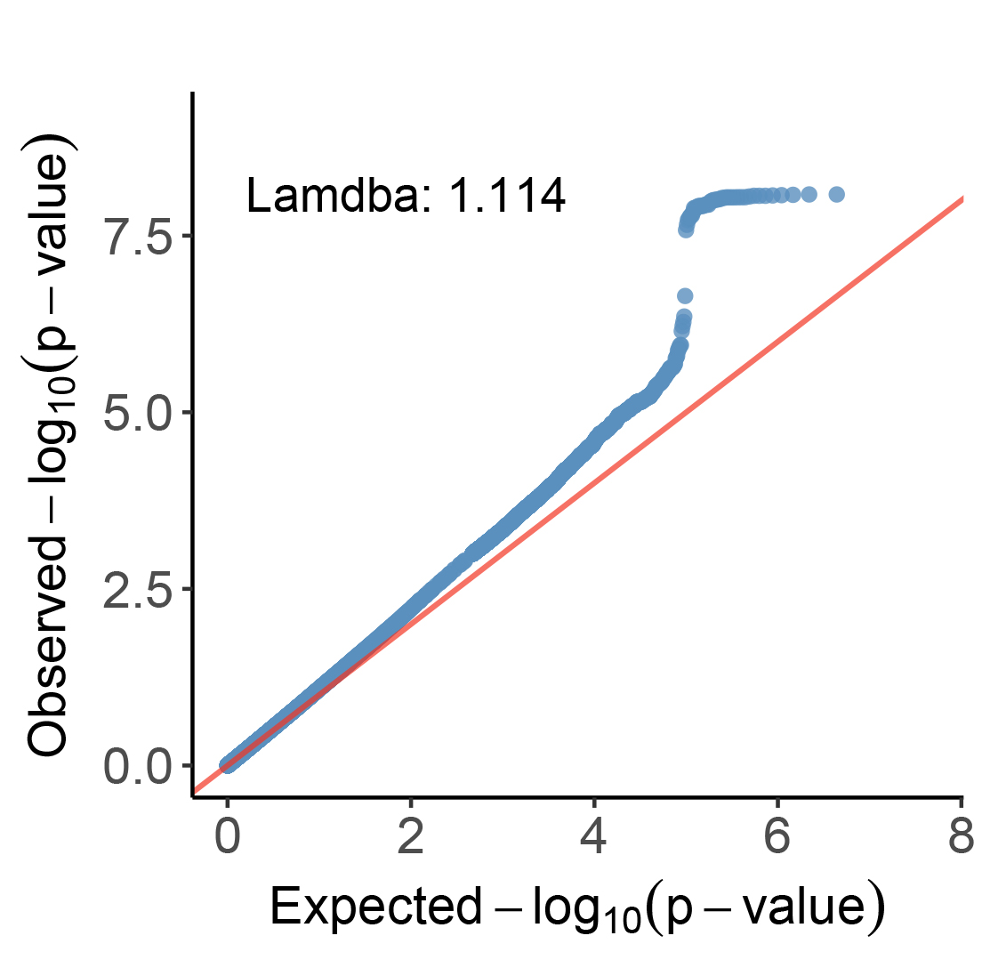
Q-Q plots depict expected -log10 P-values (x-axis) against observed -log10 P-values (y-axis).

Fig. S2. Results of GNOVA analysis for traits with significant genetic correlations.
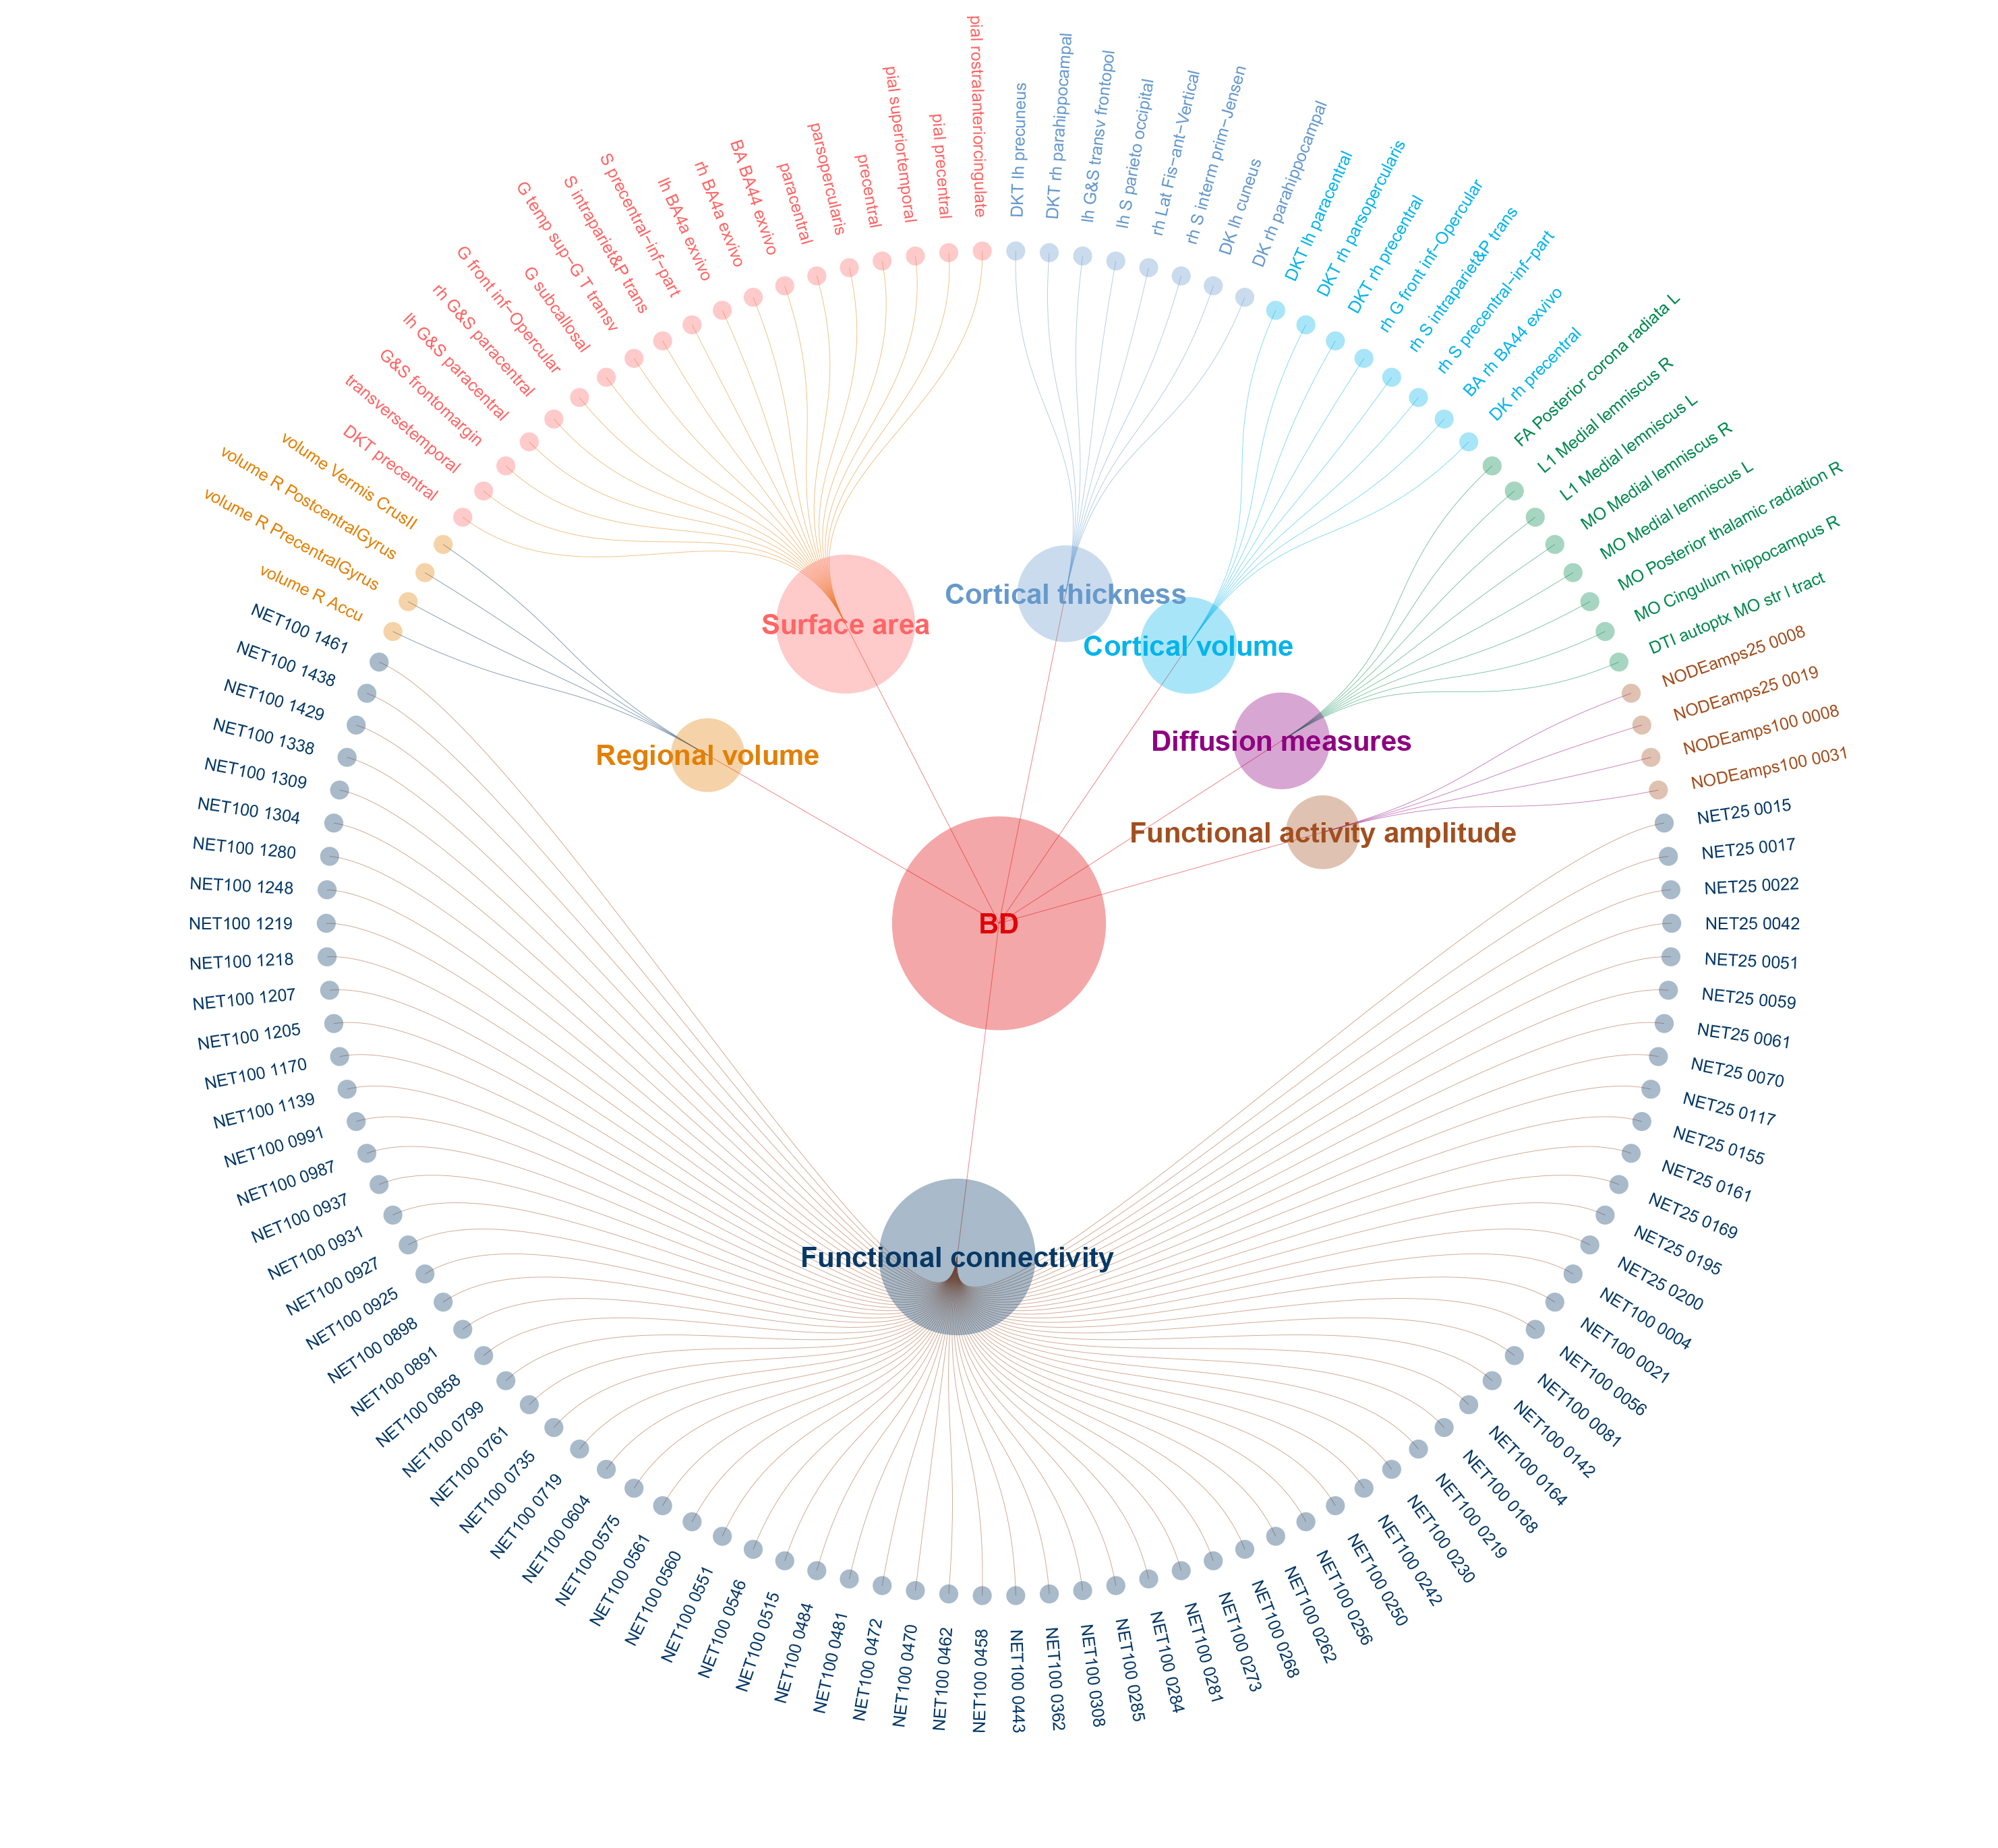
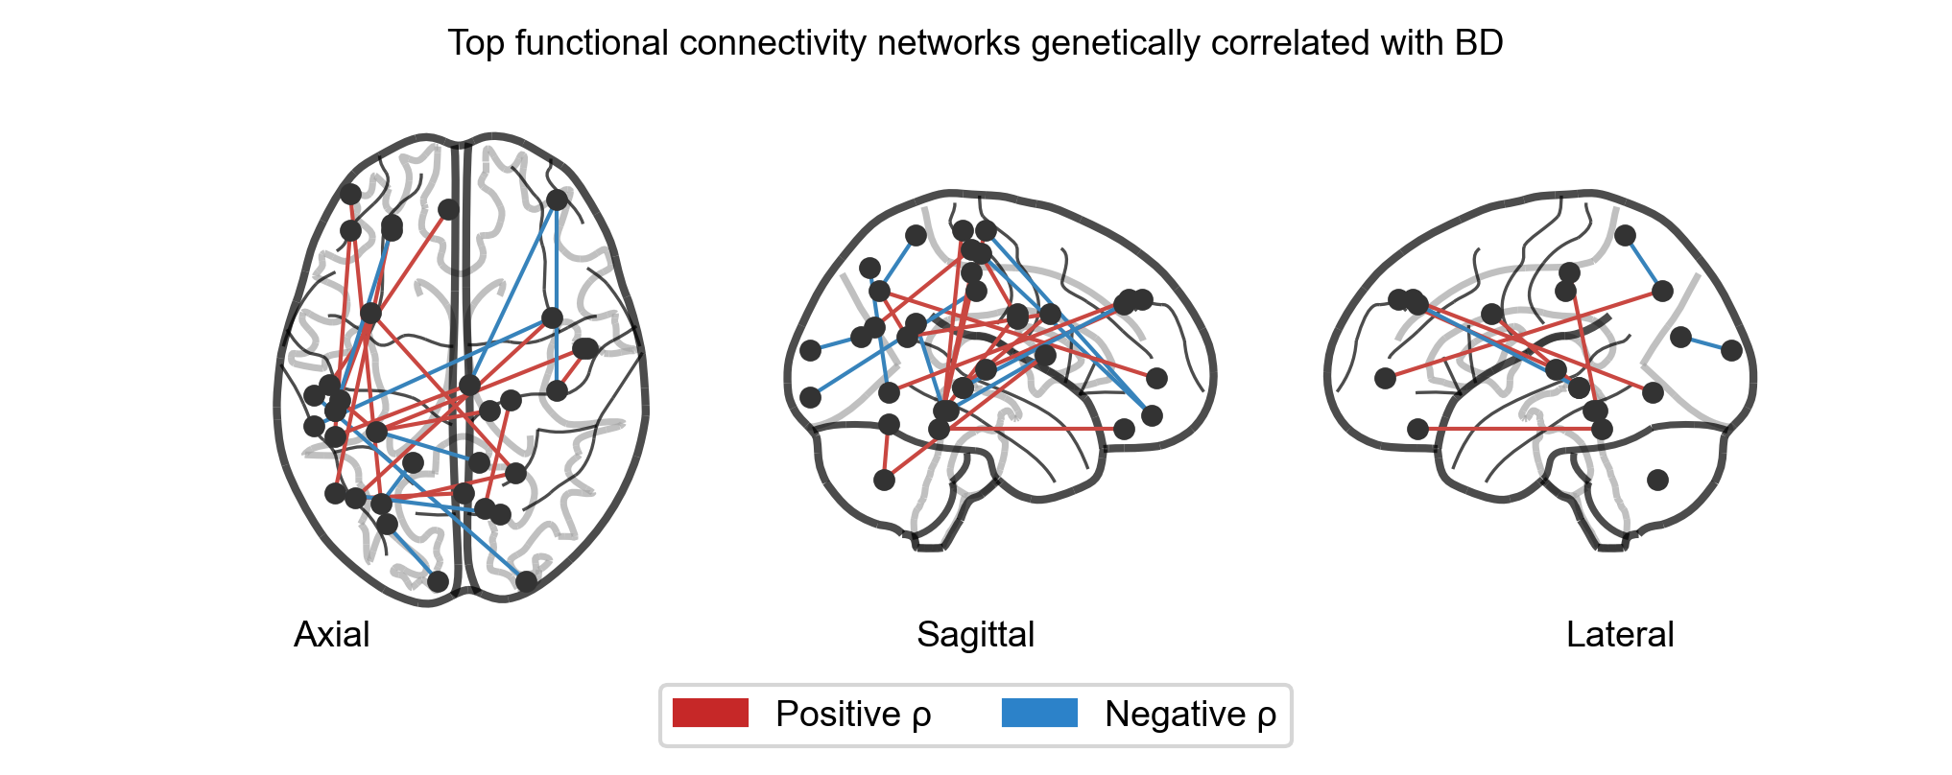
A network diagram of 126 BD-IDPs identified in GNOVA after Bonferroni correction (Top). Three-dimensional glass brain projections showing the top 24 FC edges with significant genetic correlations with BD (down). Each node represents the peak coordinate of a group-ICA component from the UK Biobank resting-state fMRI decomposition (ICA-d25: 21 good components; ICA-d100: 55 good components). Edges connect pairs of ICA components whose functional connectivity strength is genetically correlated with BD. Red edges indicate positive genetic correlations; blue edges indicate negative genetic correlations. Node pair assignments were decoded from upper-triangle edge indices using the column-major vectorization convention. Group-ICA spatial maps were obtained from the FMRIB UK Biobank resource (https://www.fmrib.ox.ac.uk/ukbiobank/).
Fig. S3. Manhattan plot of MTAG results for 24 pairs of BD-IDPs identified with shared SNVs.
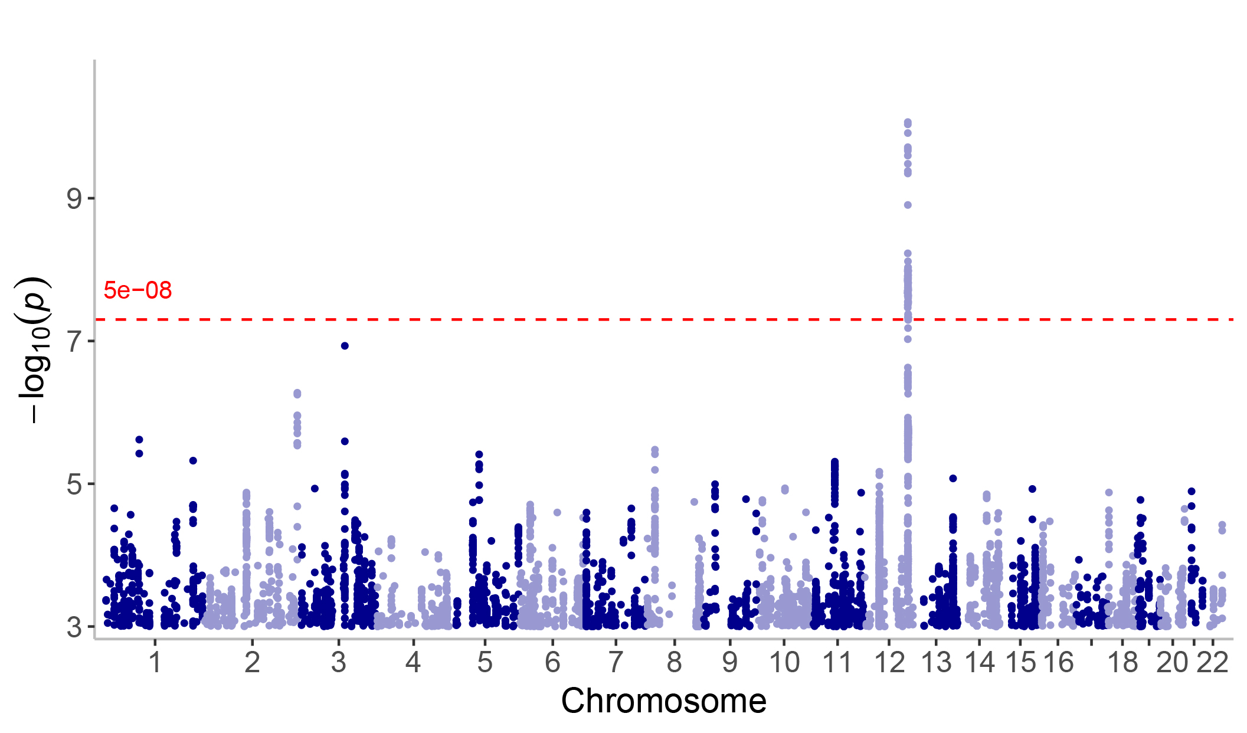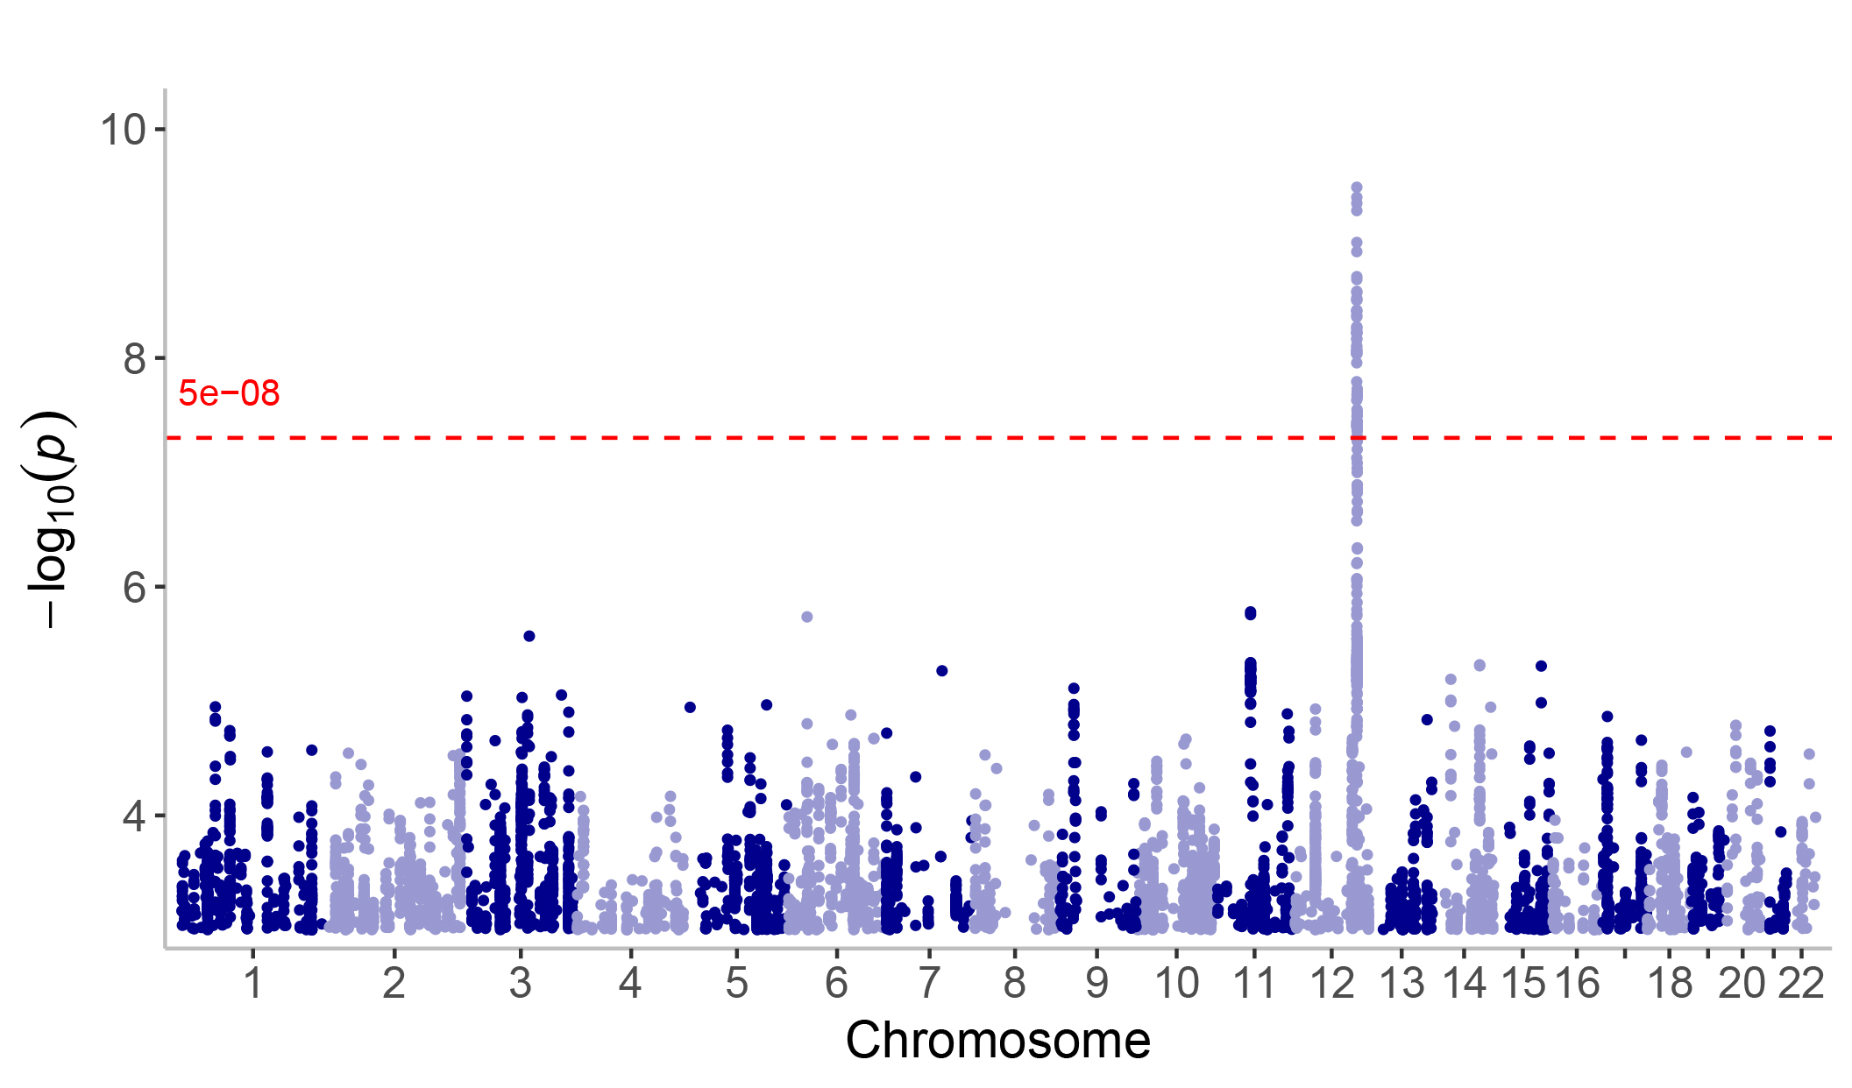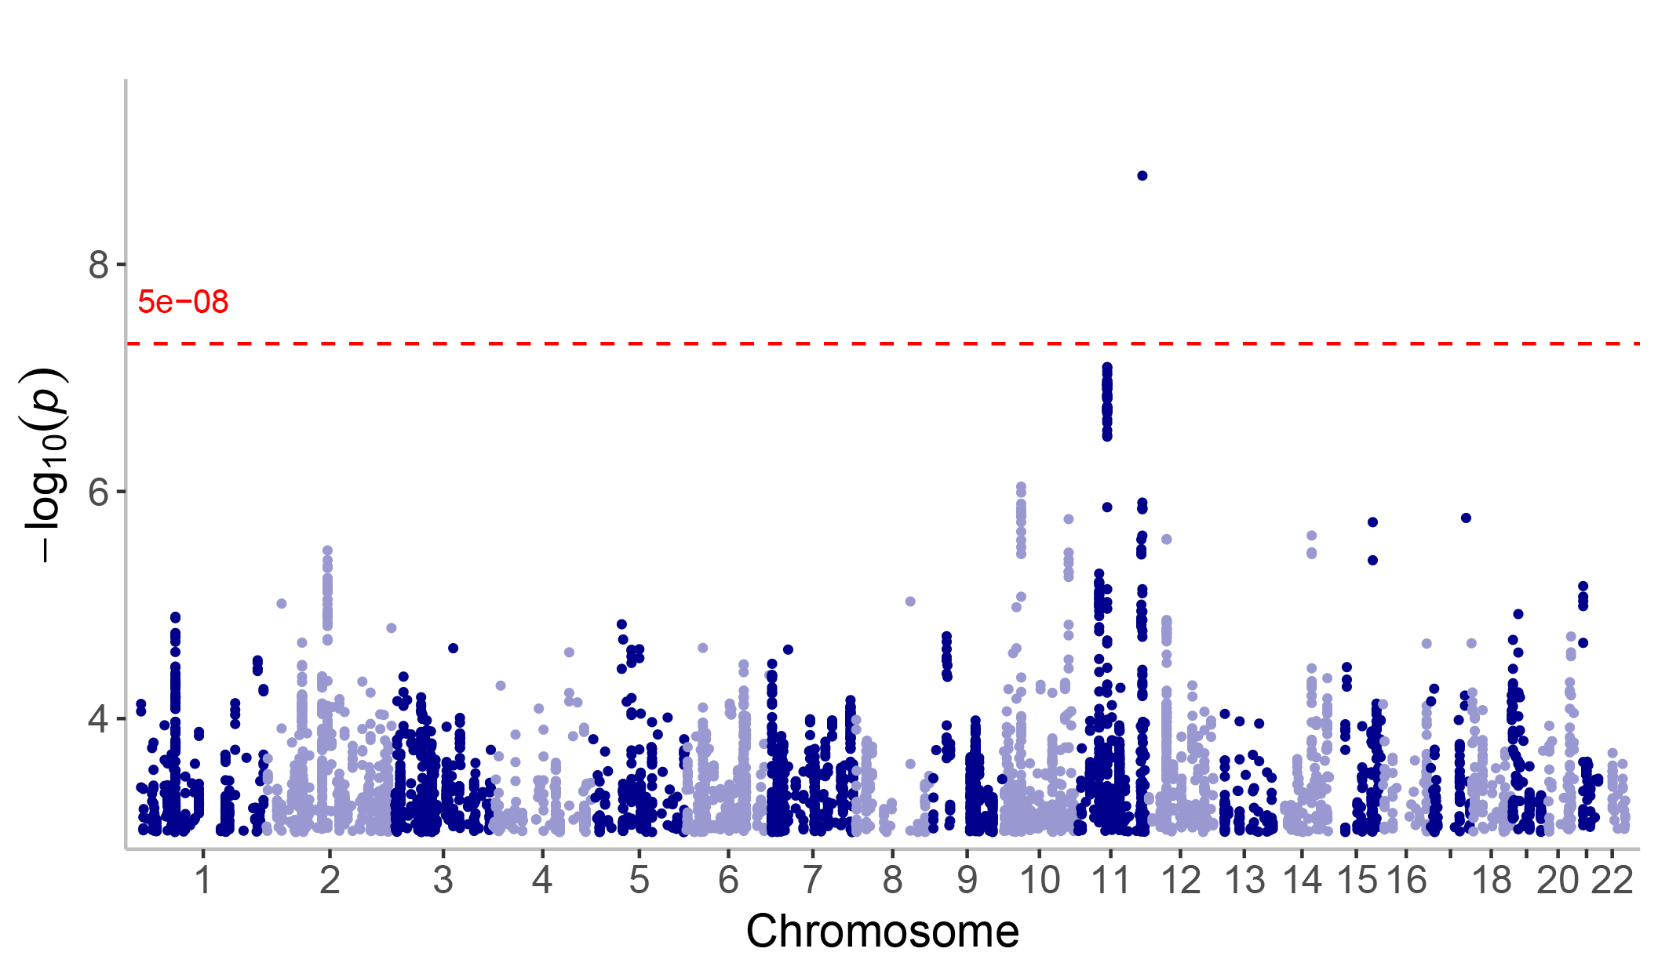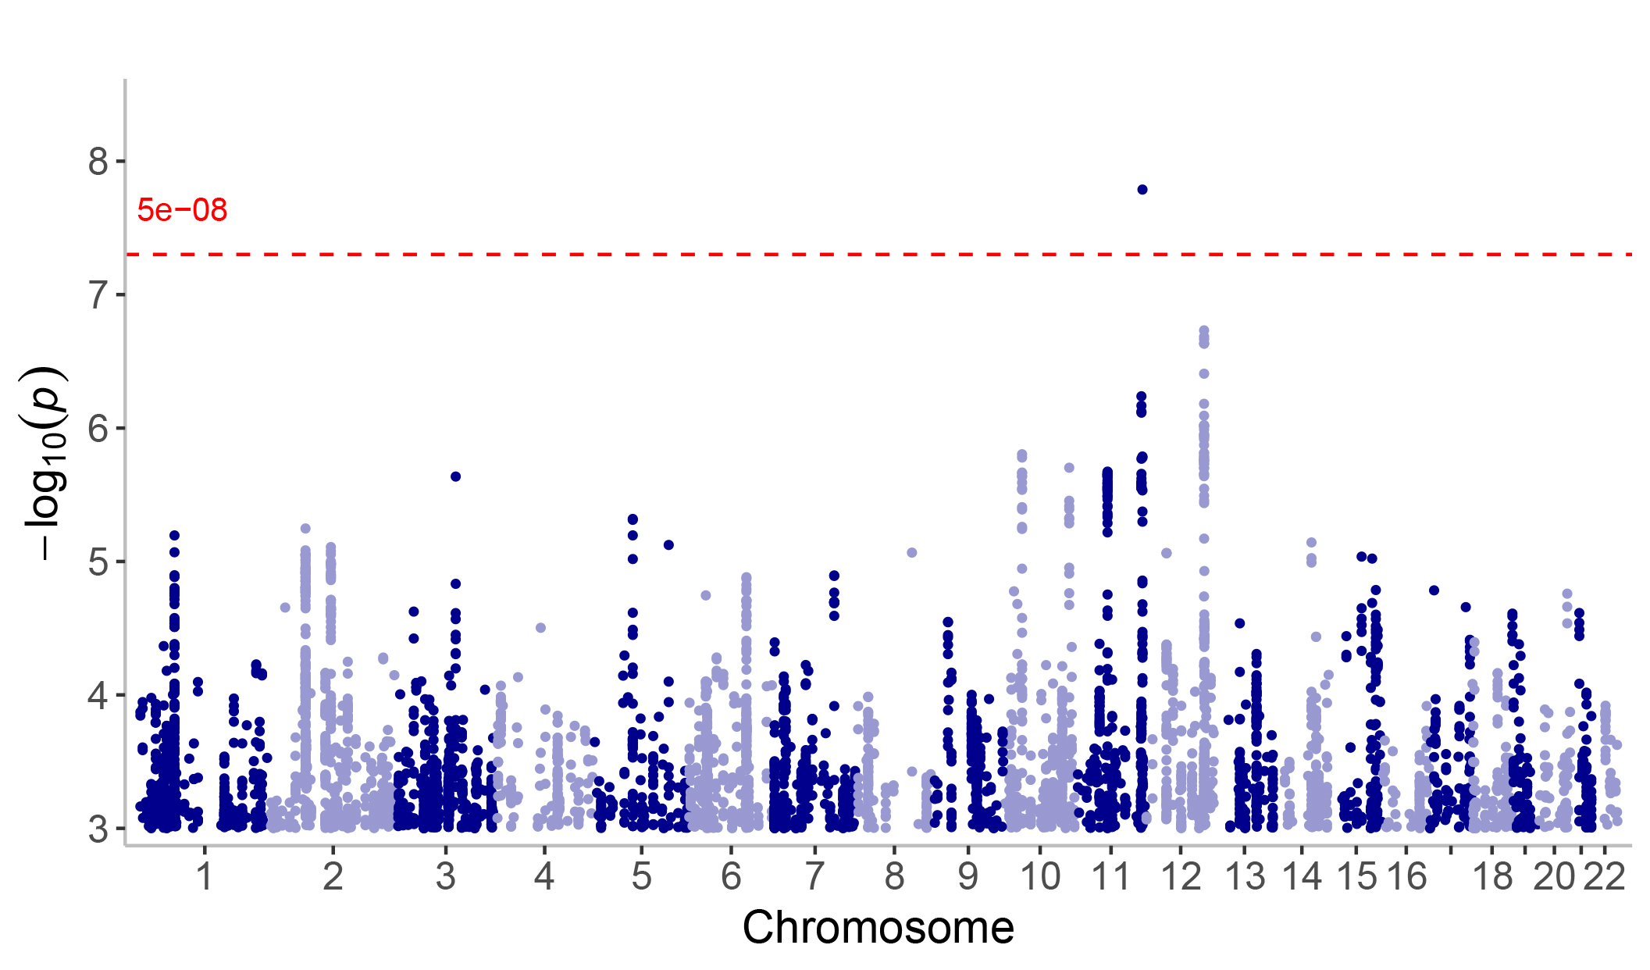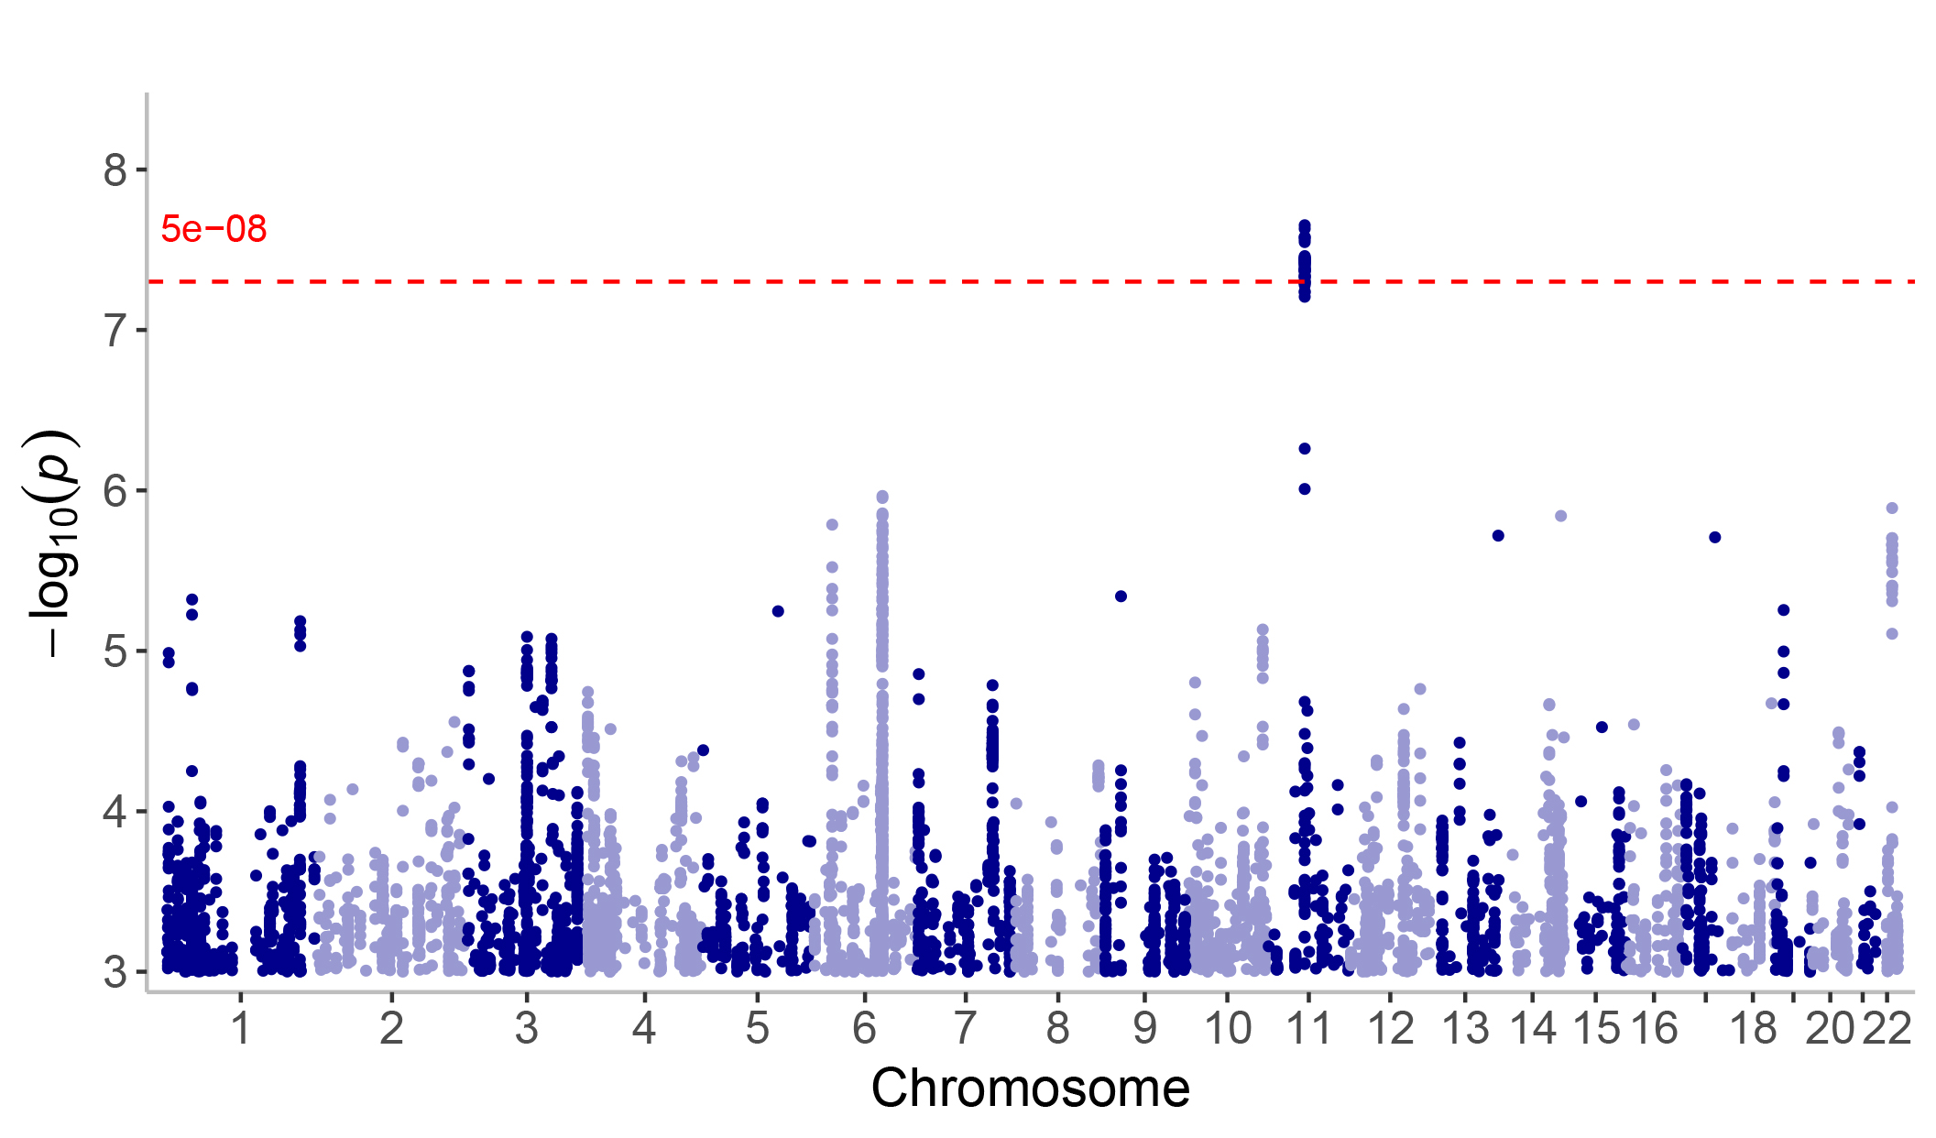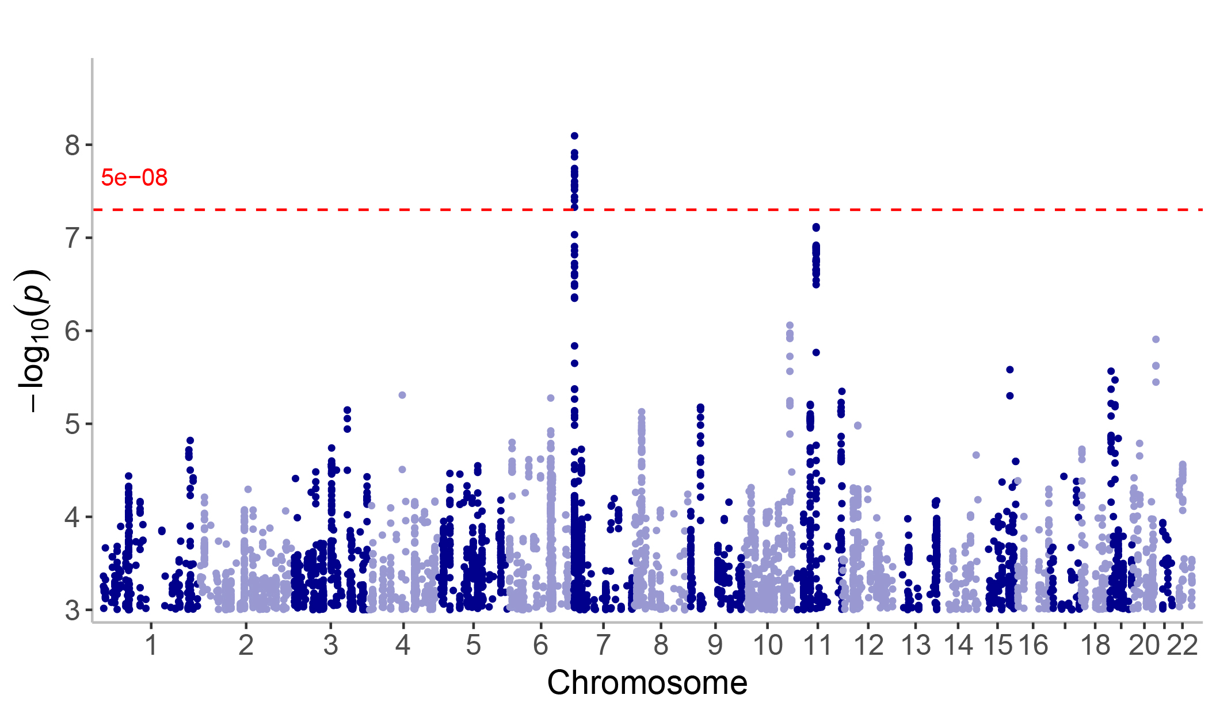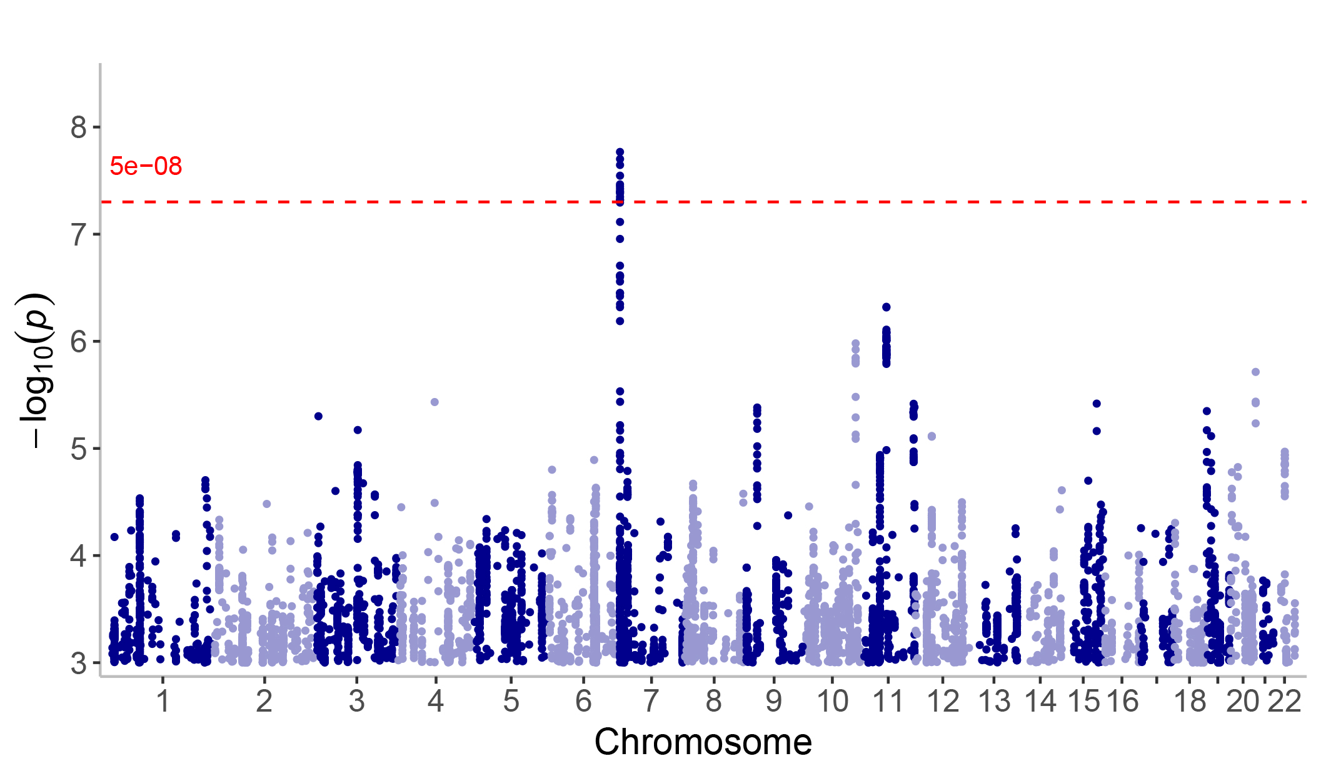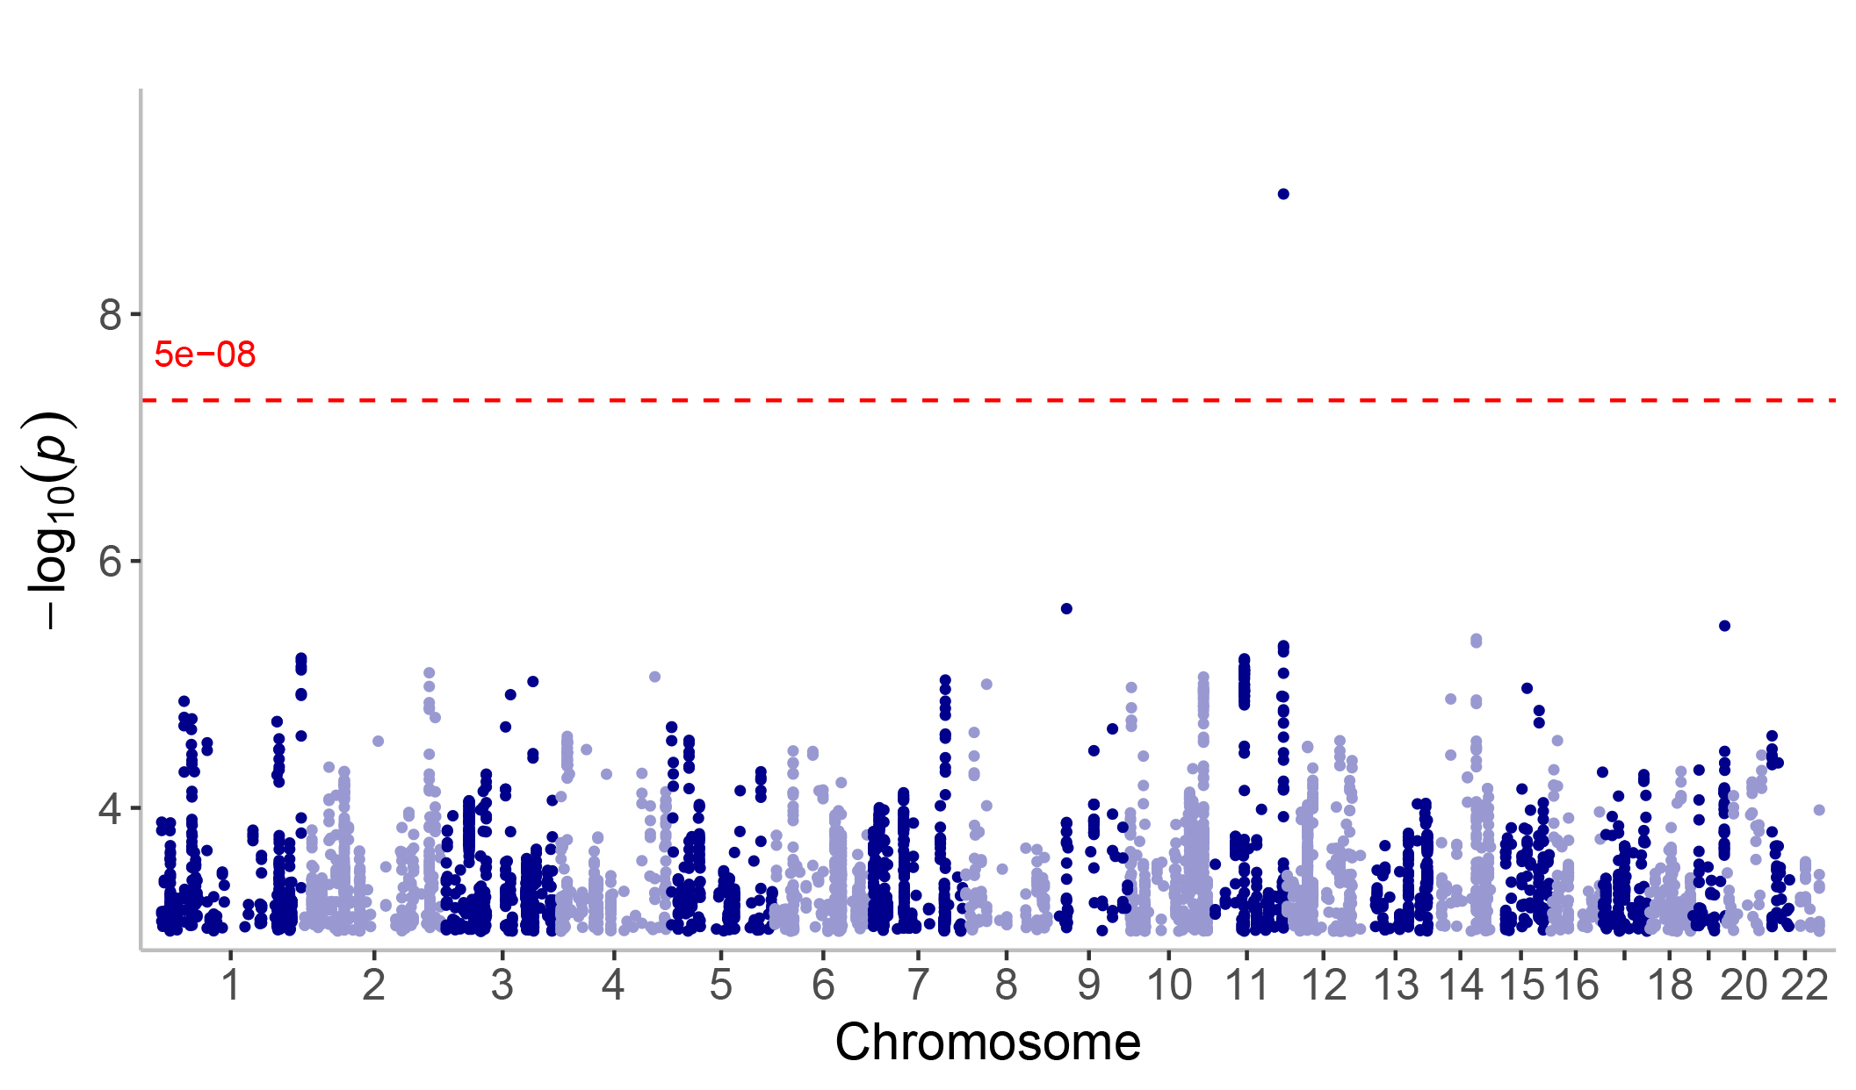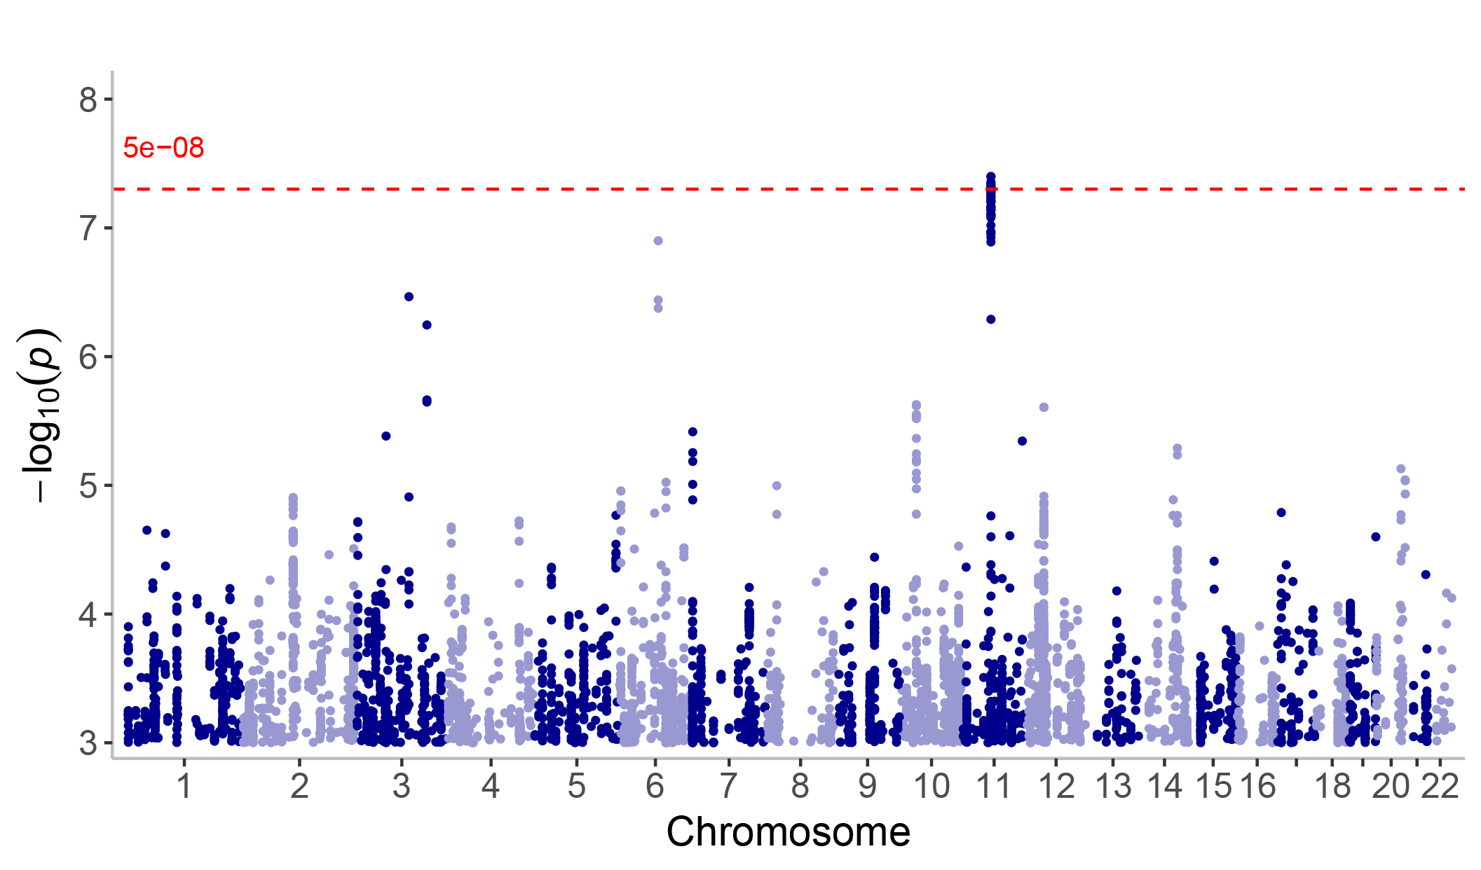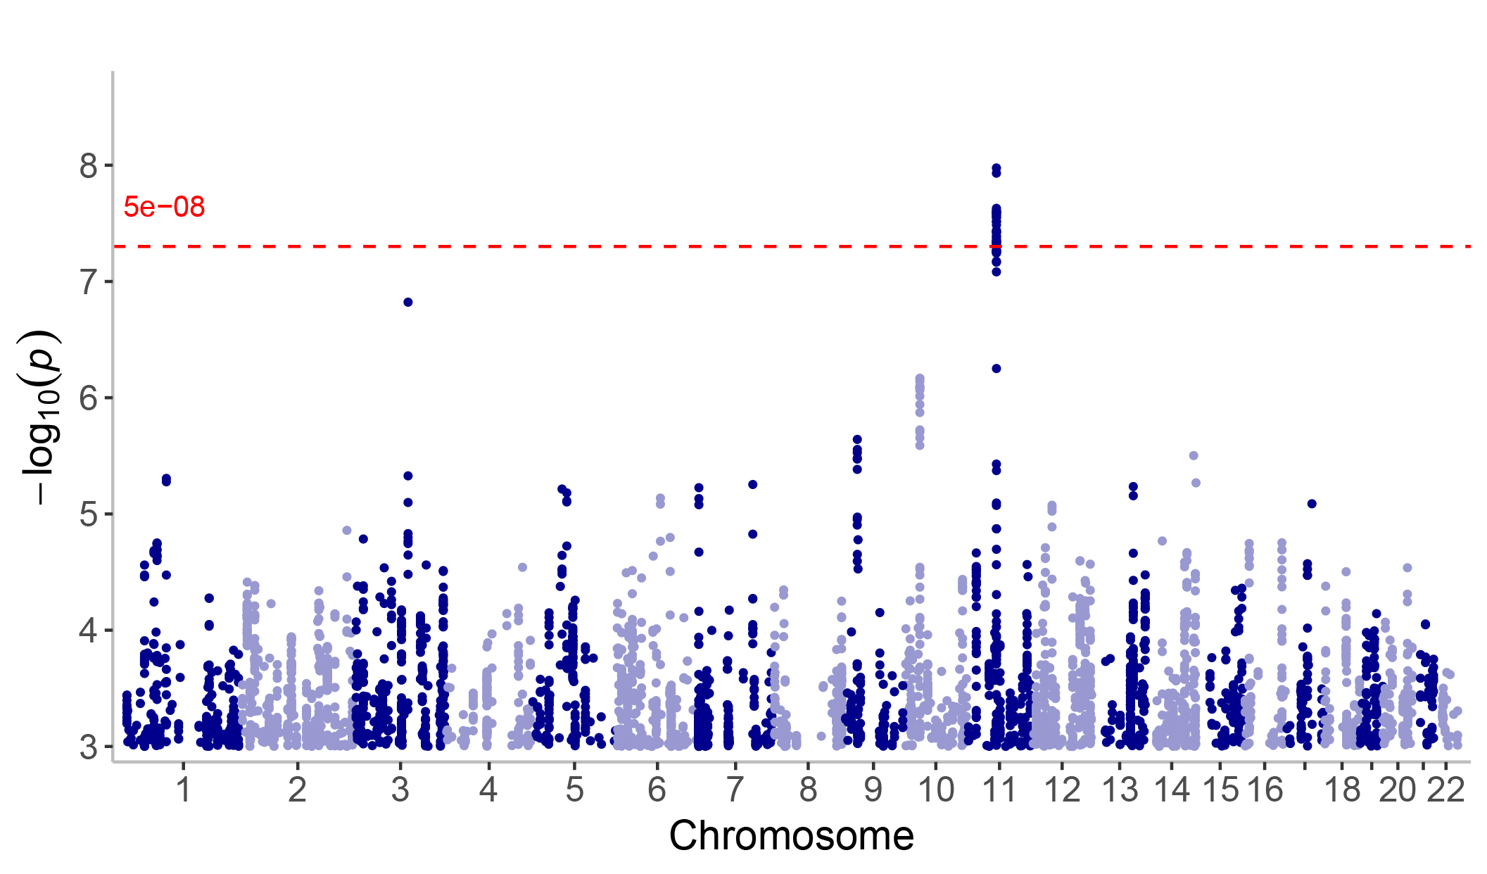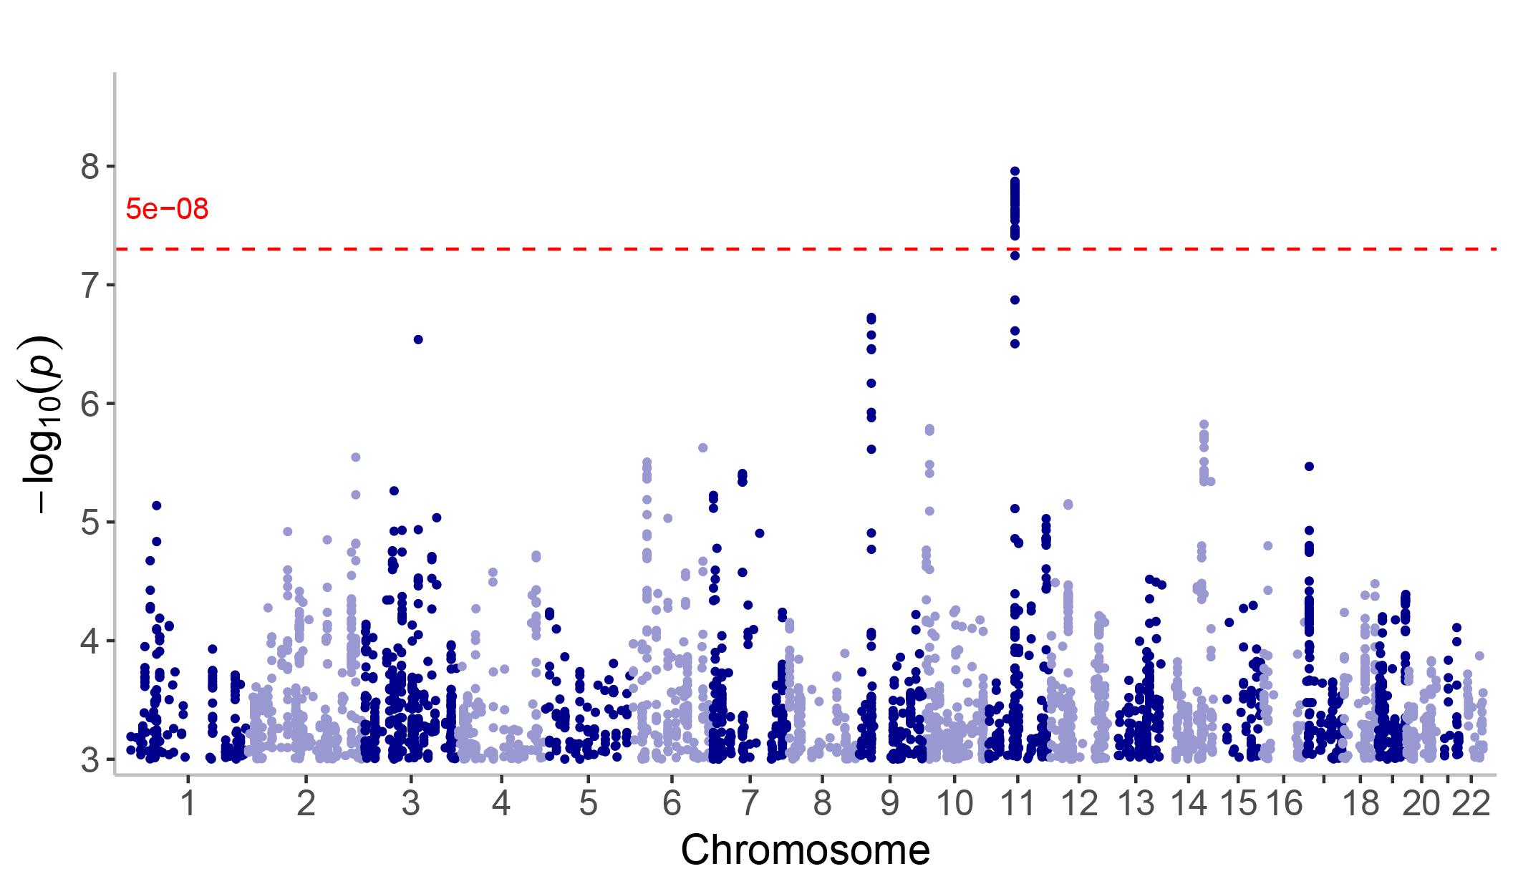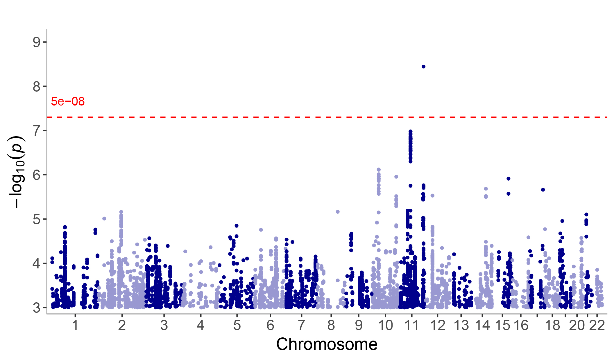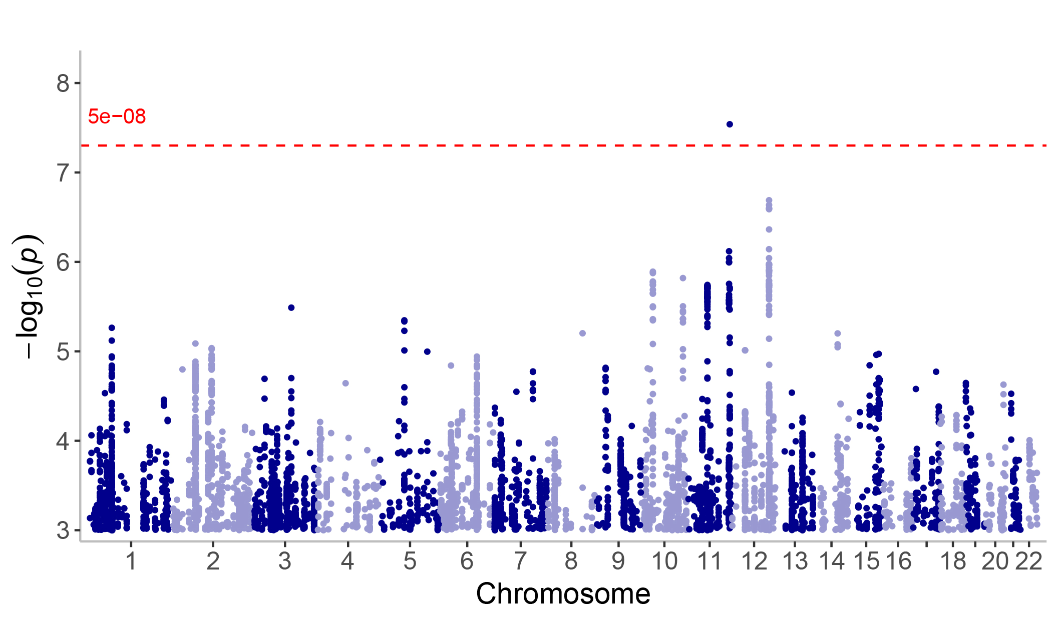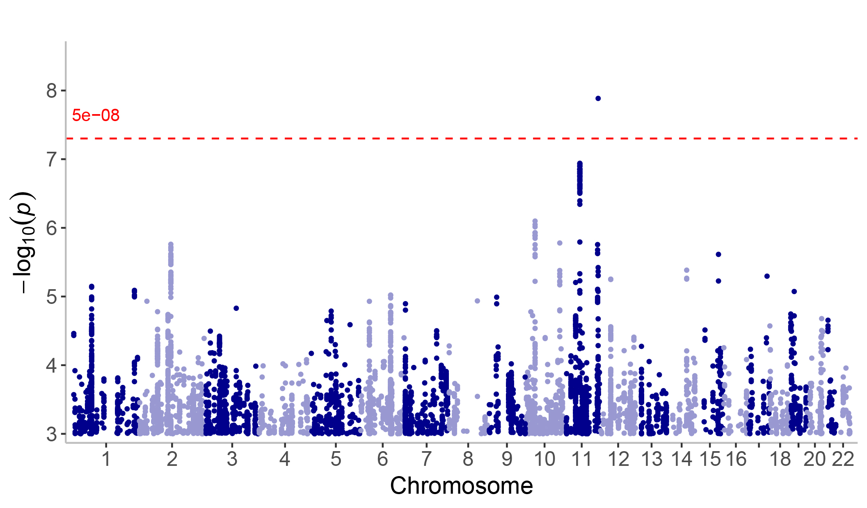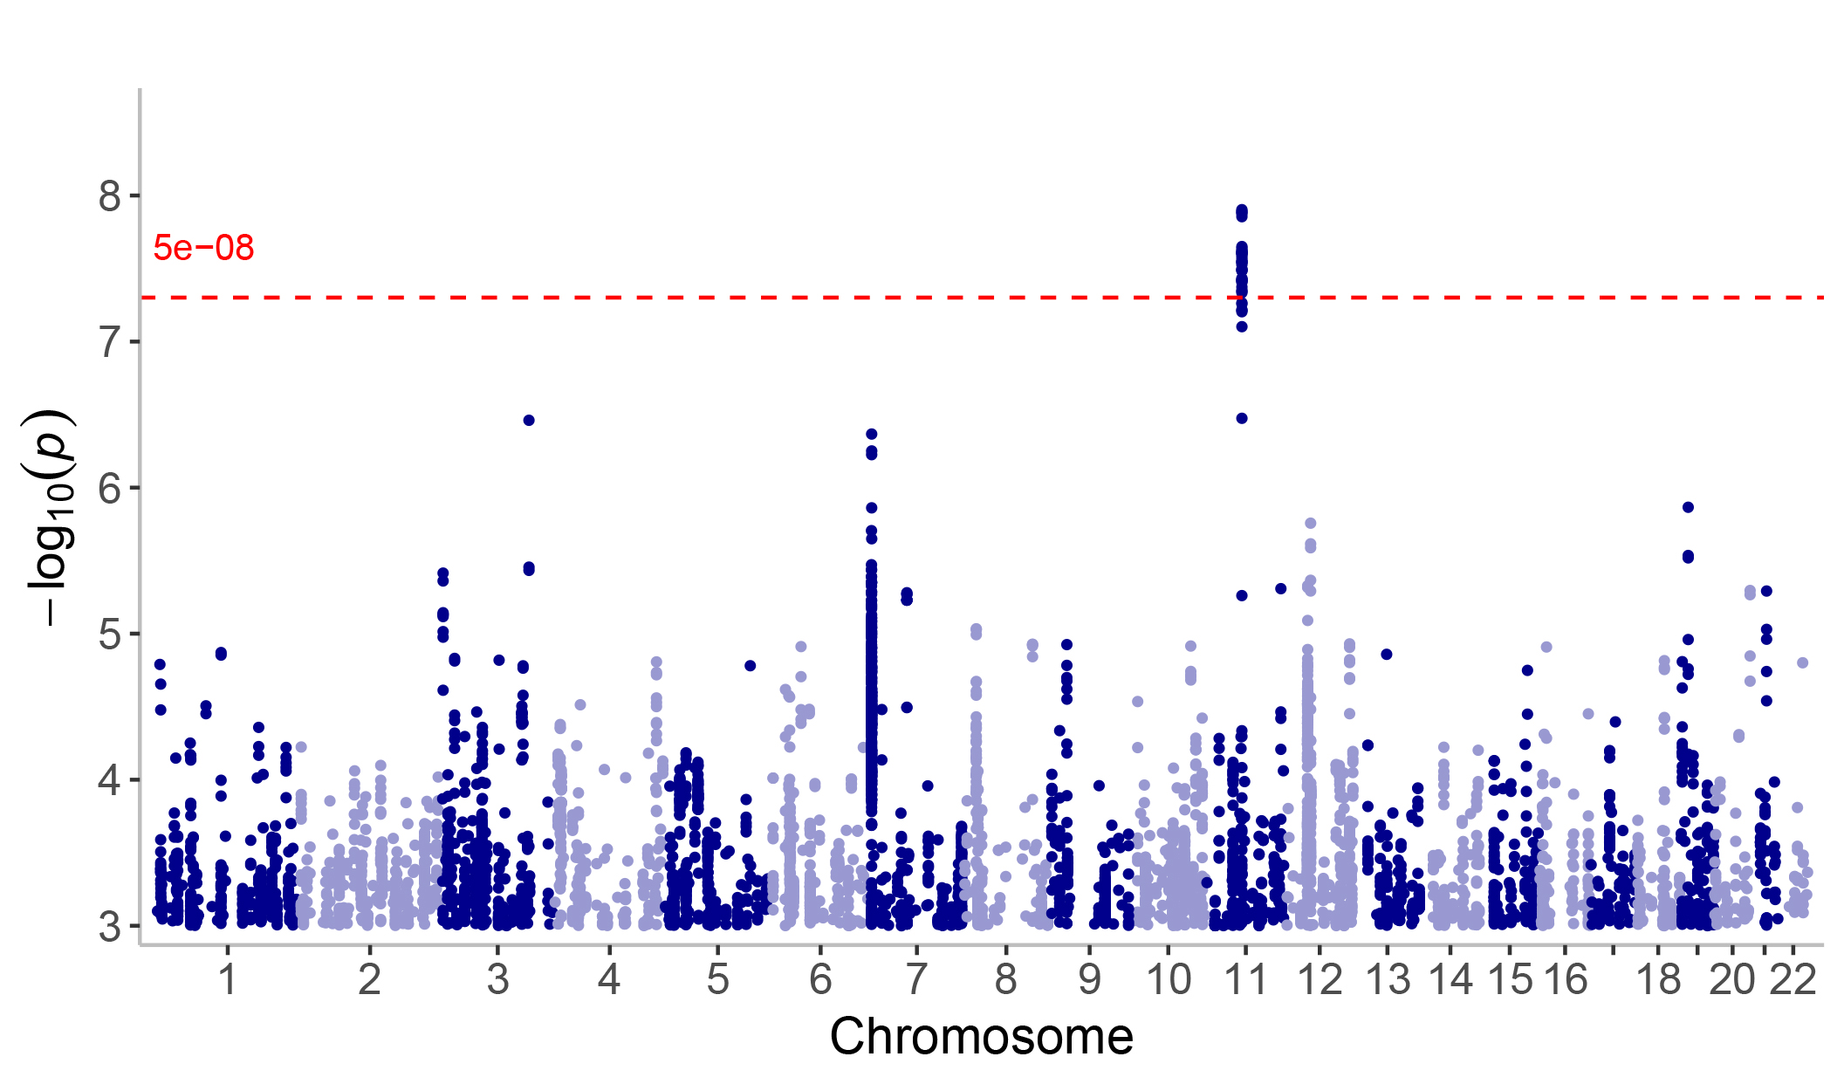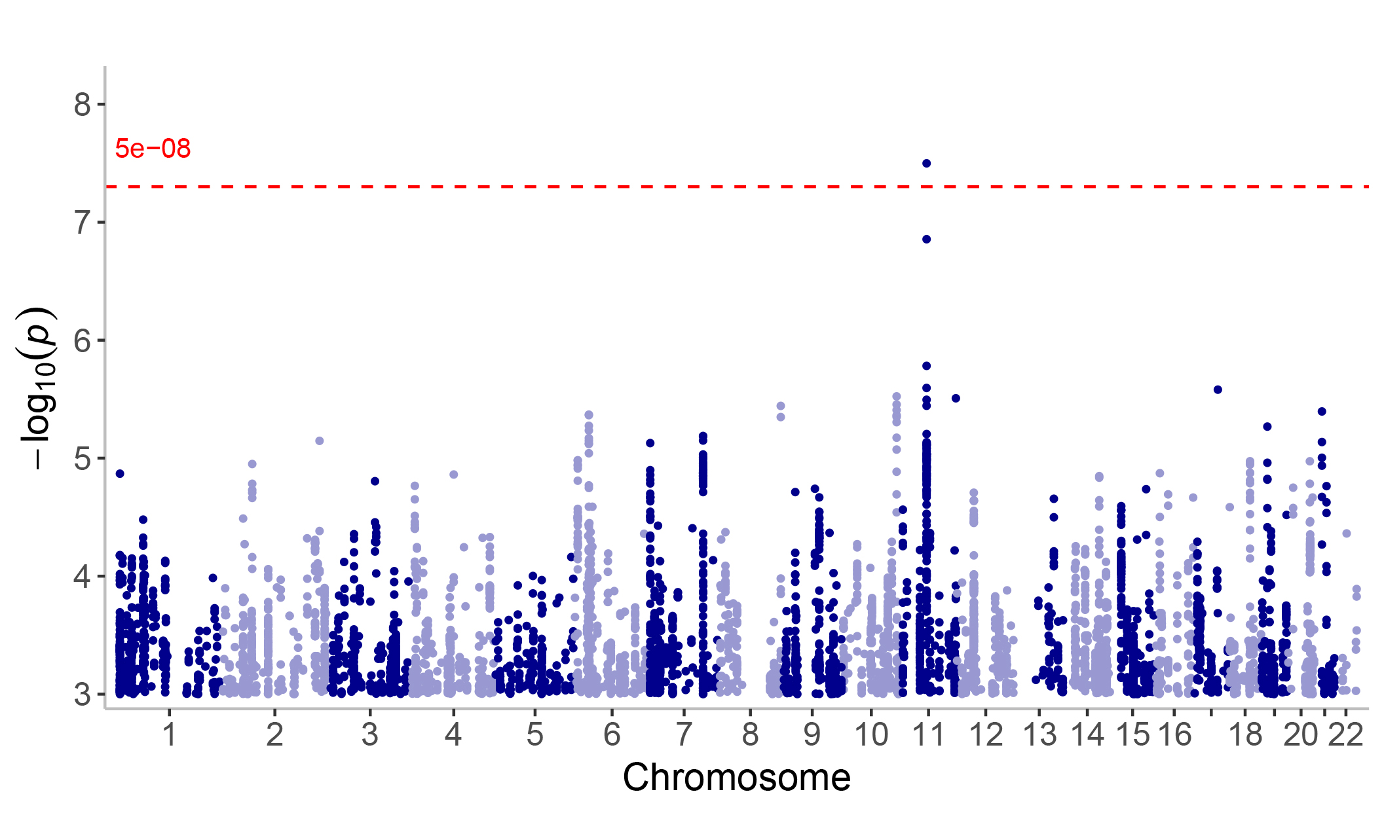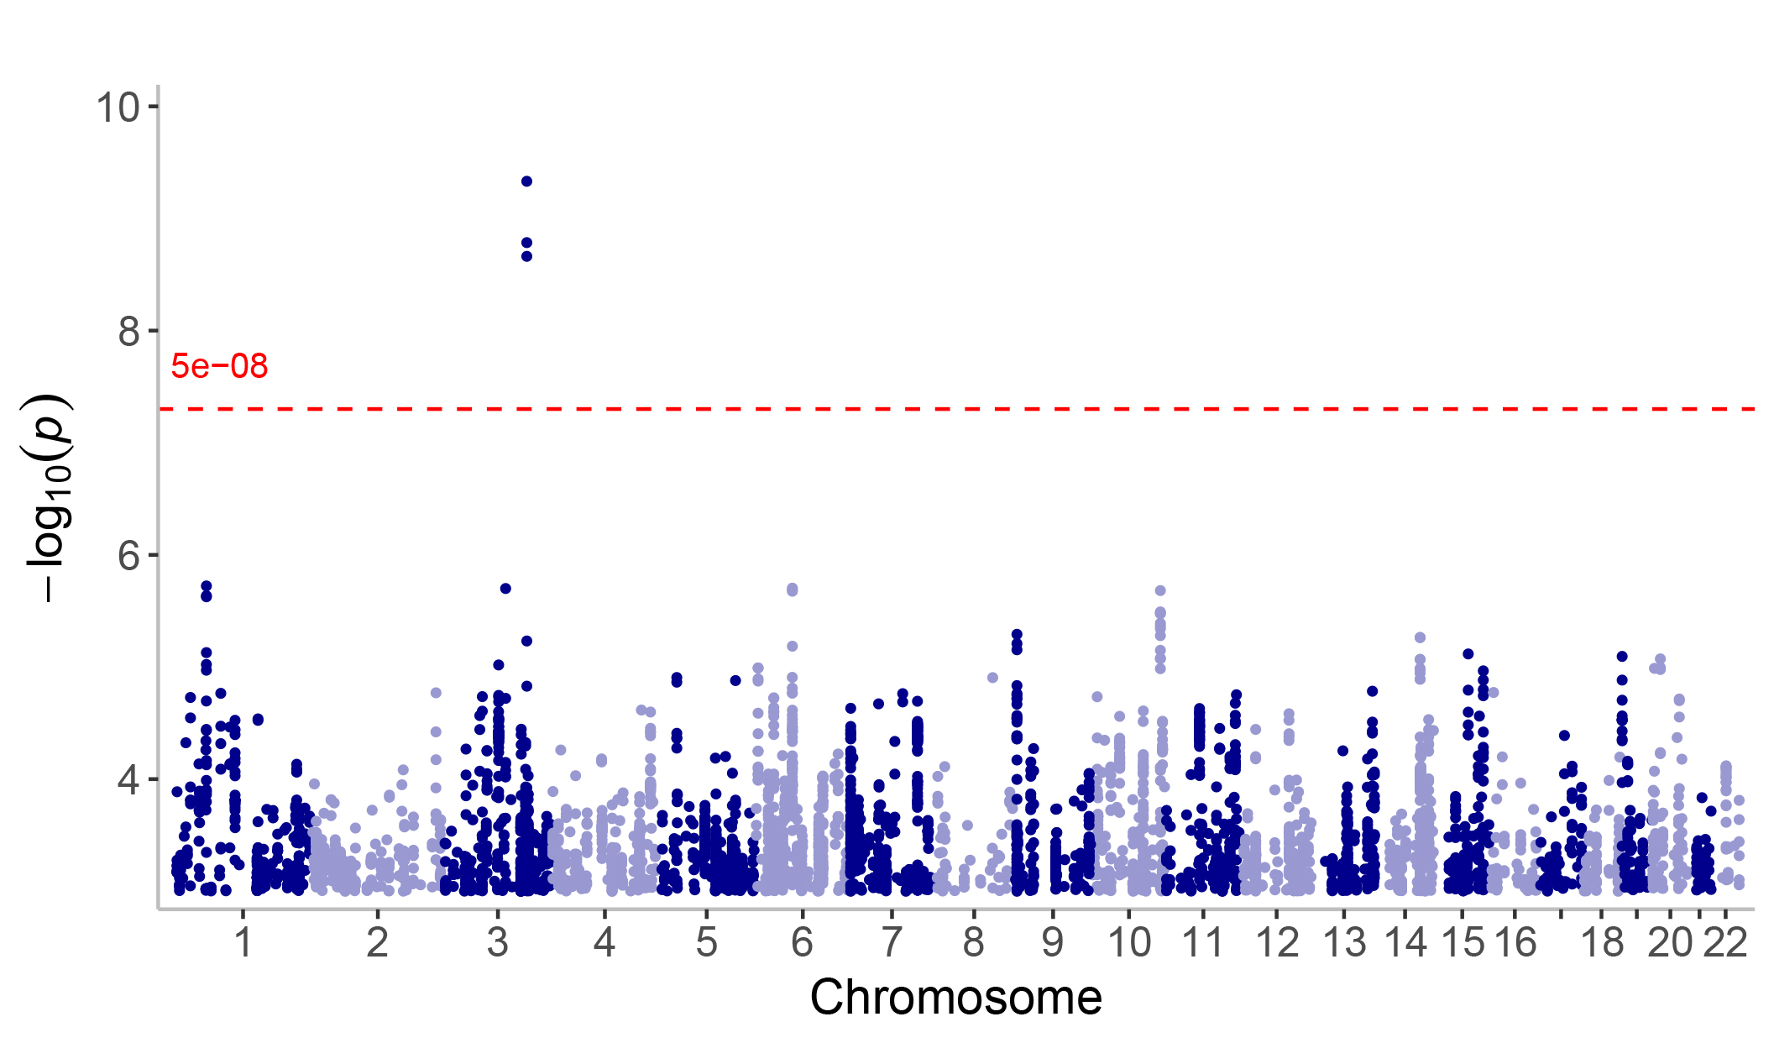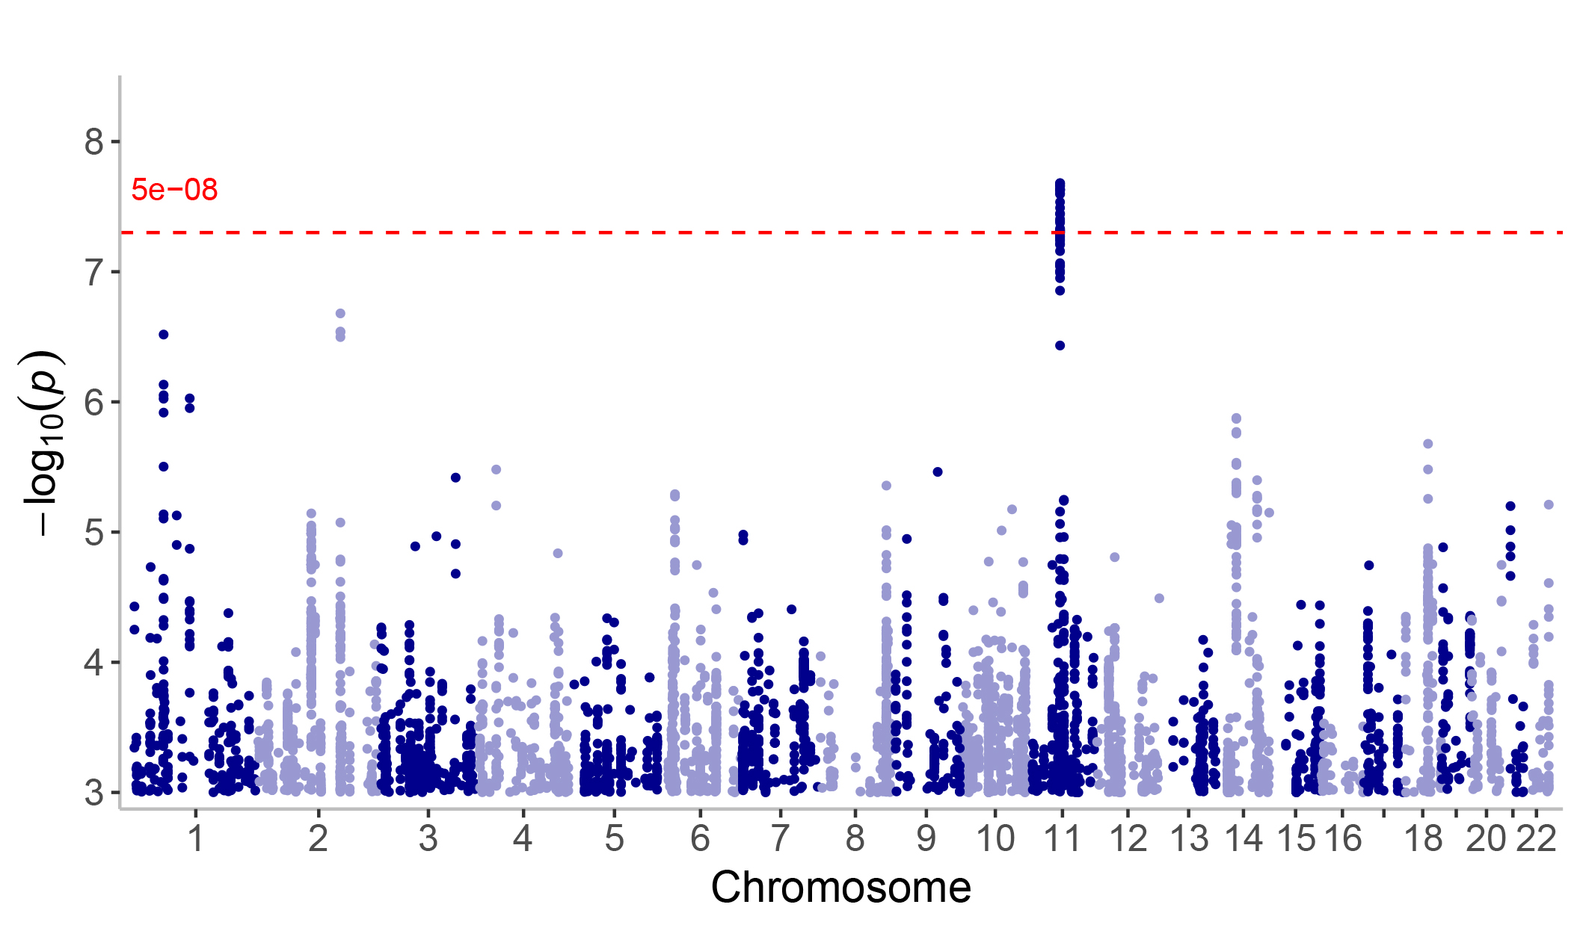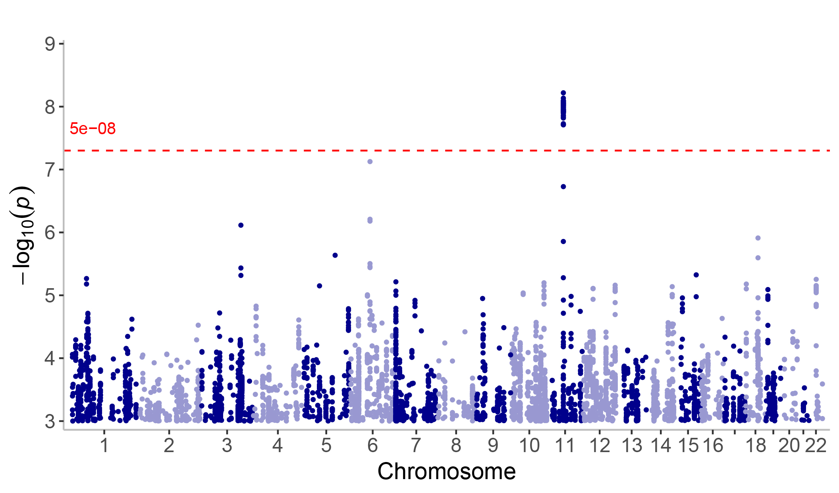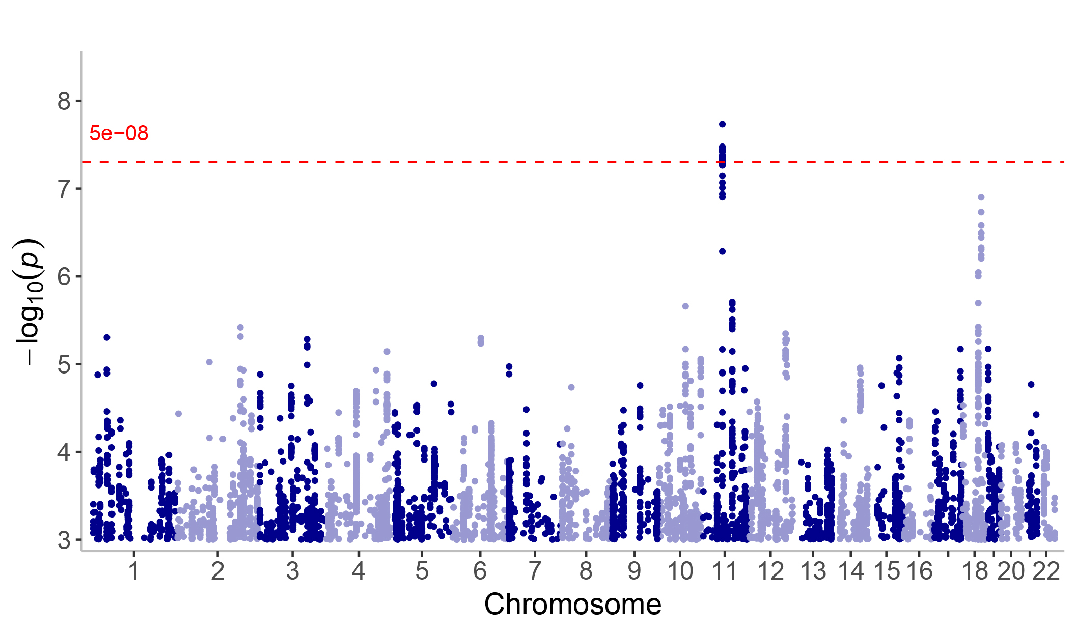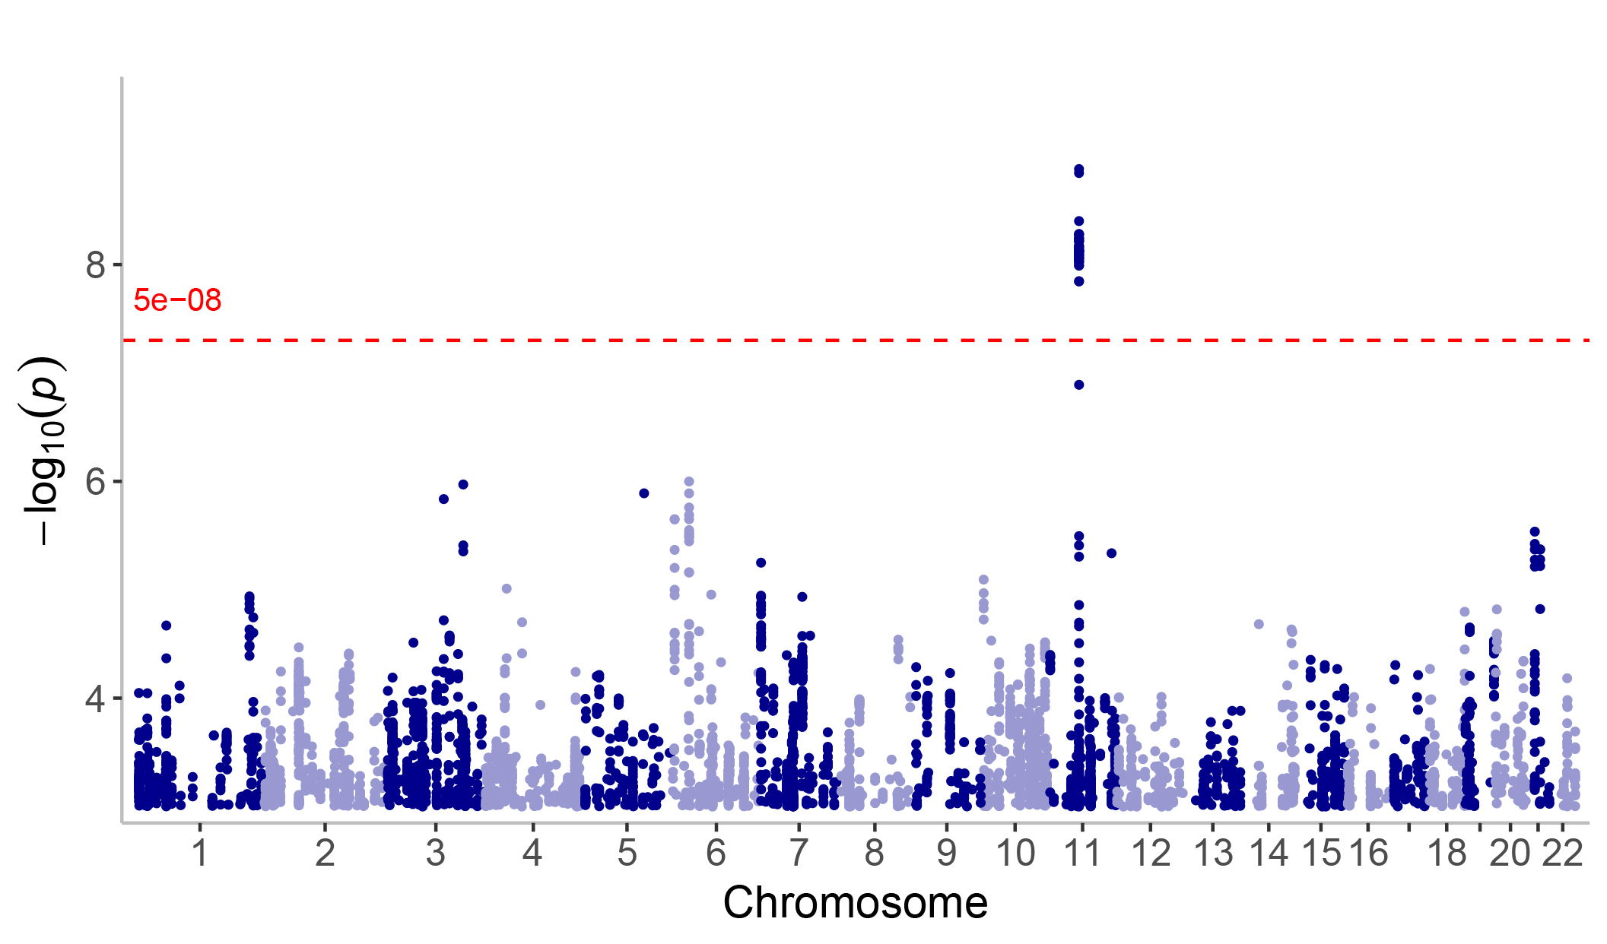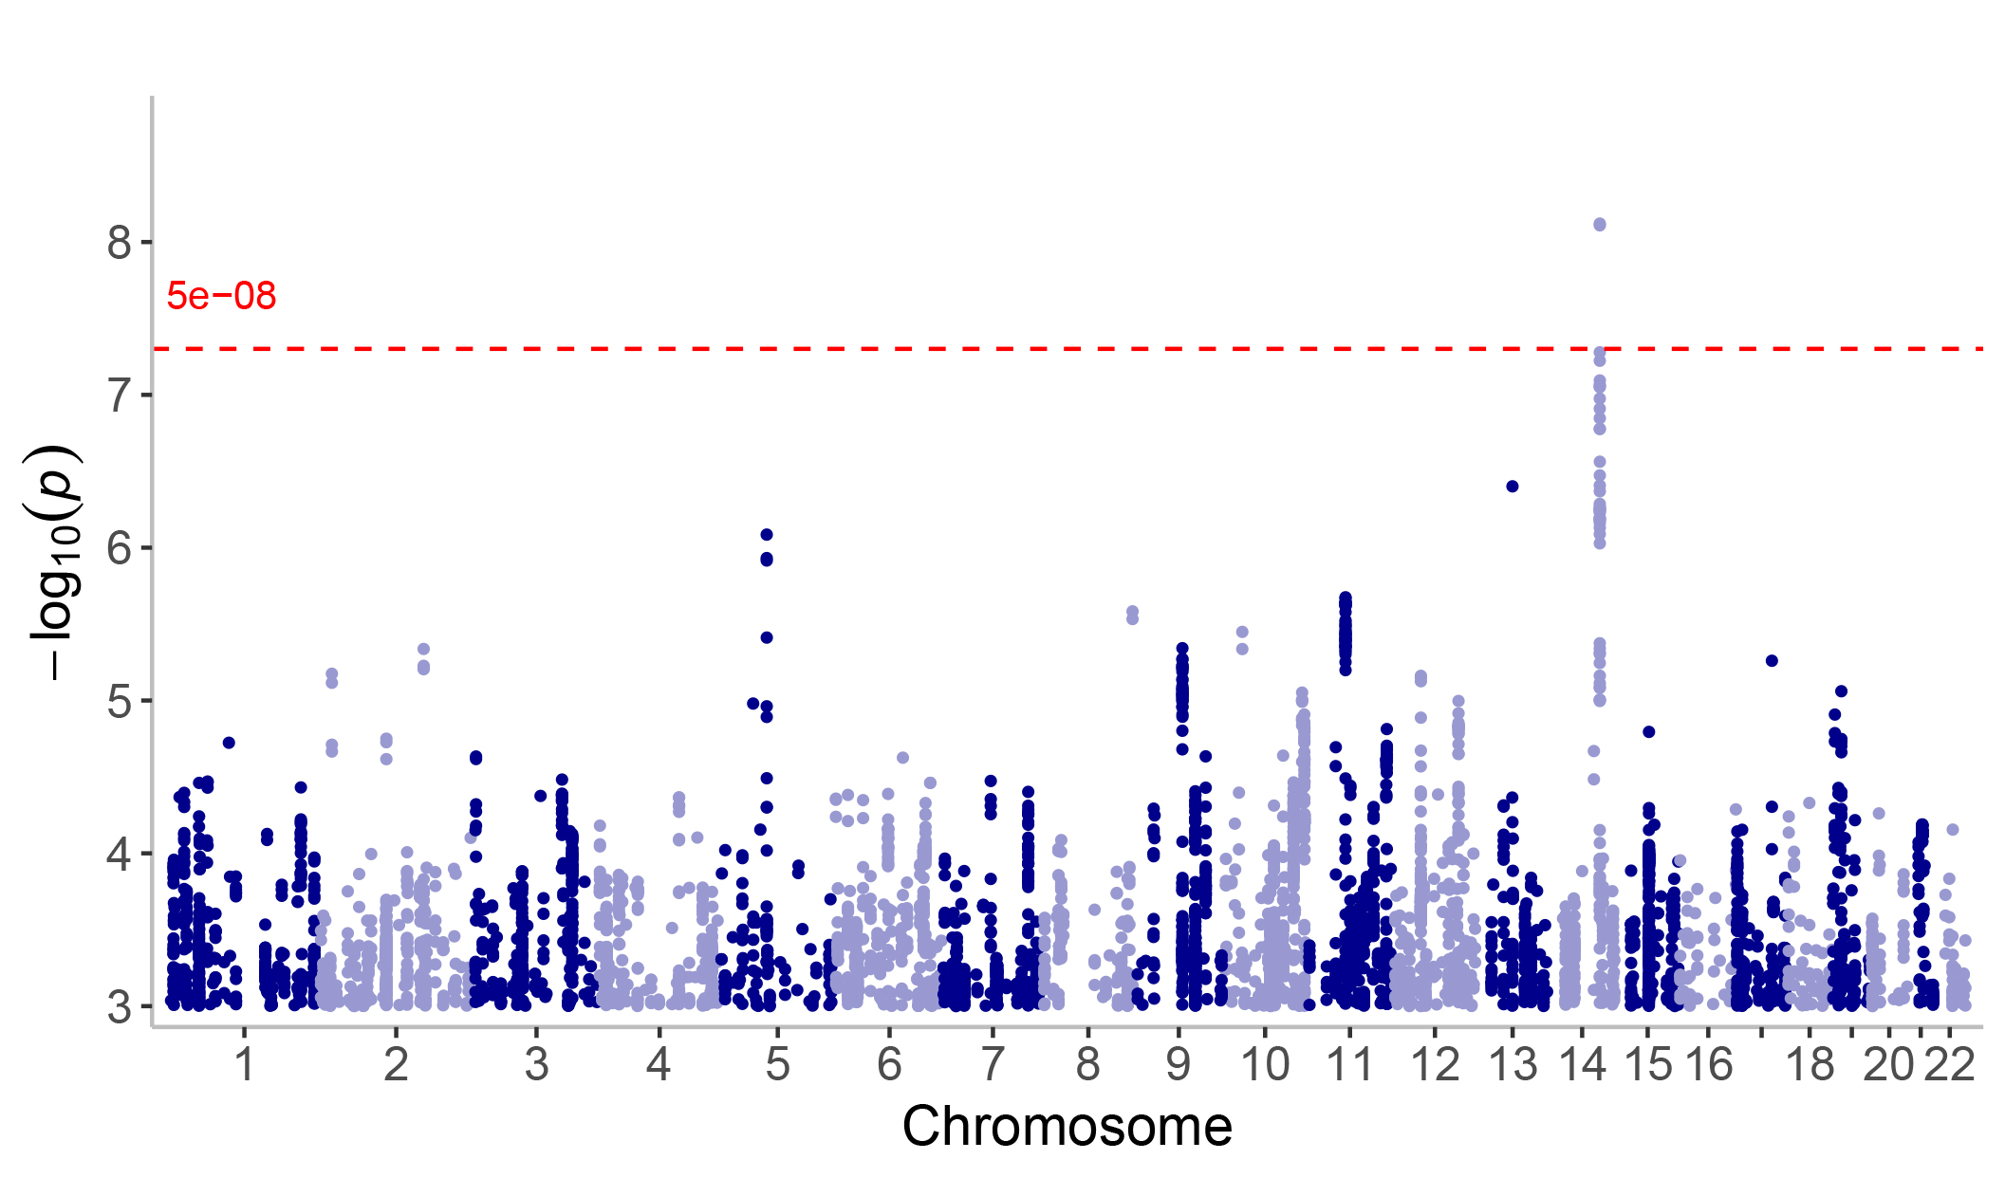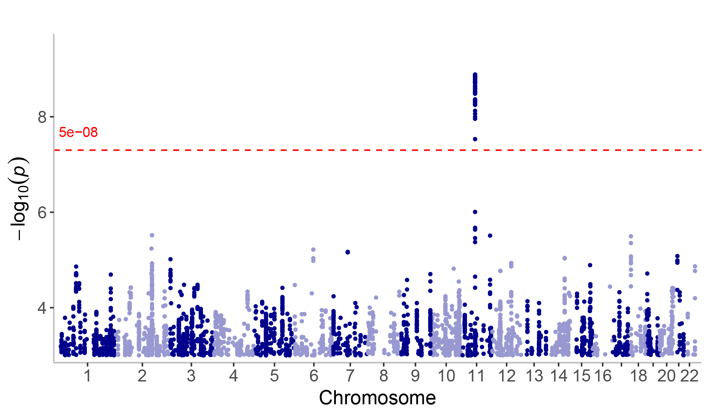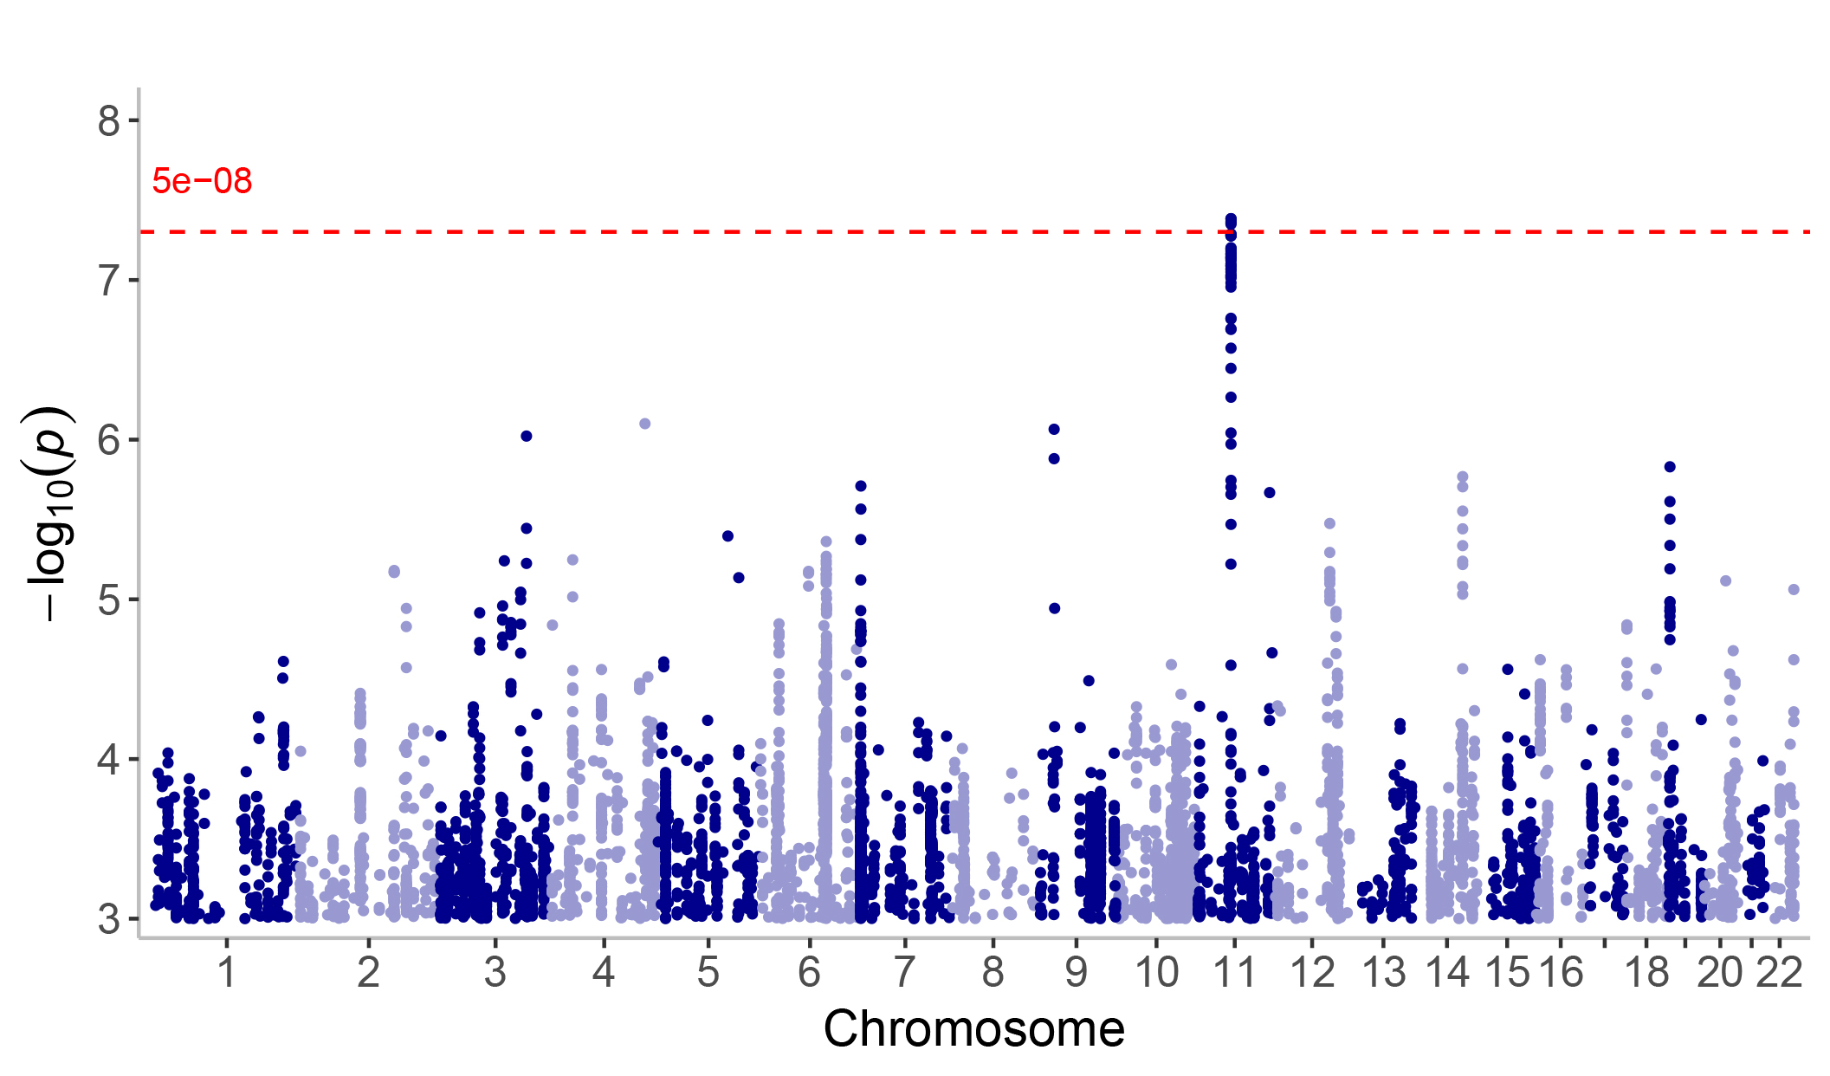

Fig. S4. MESuSiE analysis within a 500 kb window surrounding rs7941324.

Fig. S5. Gene enrichment analysis for genes near shared SNVs.
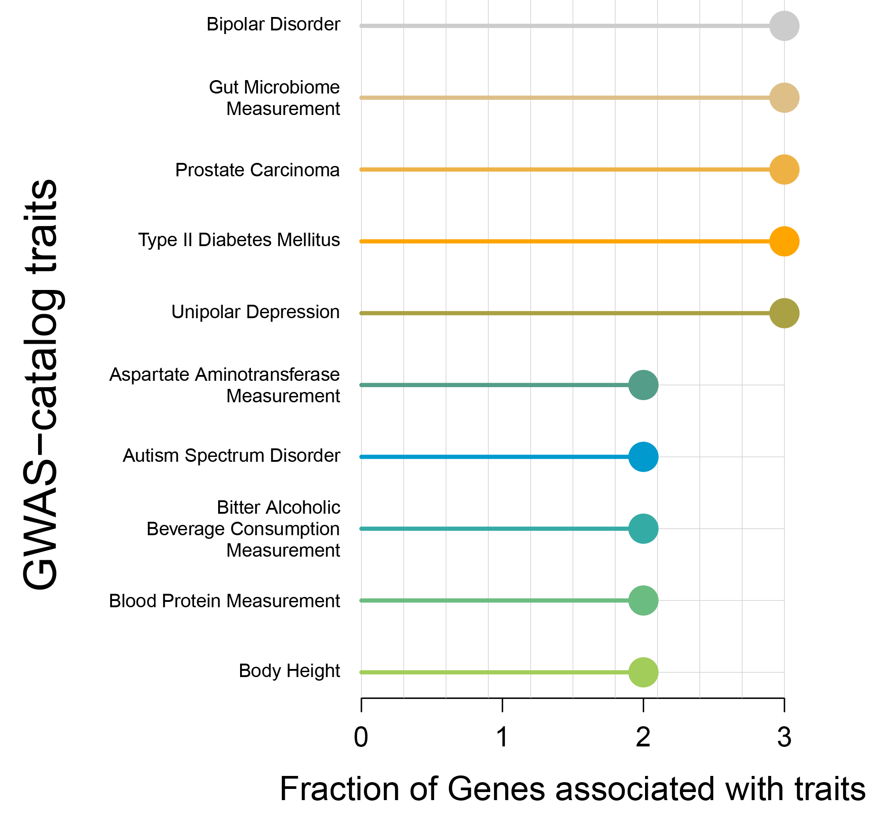
Fig. S6. Enrichment analysis of SNVs performed using snpXplorer.
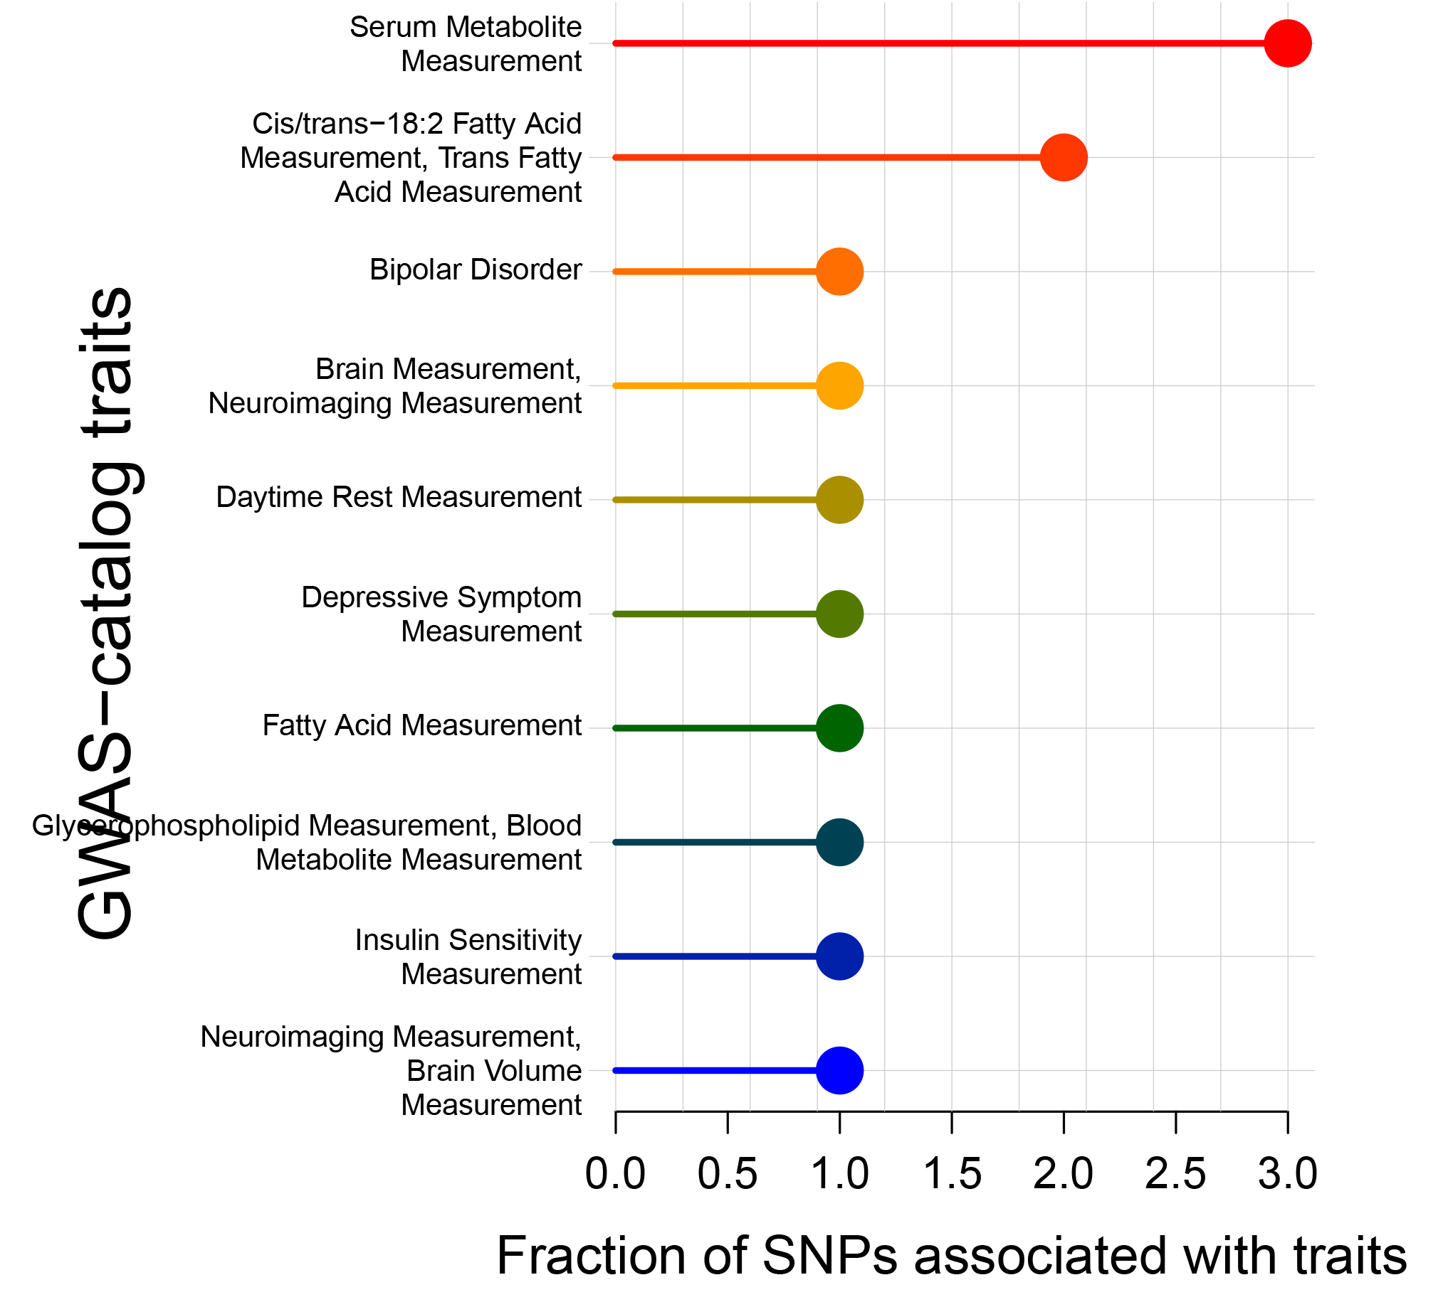
Fig. S7. Synaptic functional enrichment analysis of shared genes between BD and IDPs using SynGo.
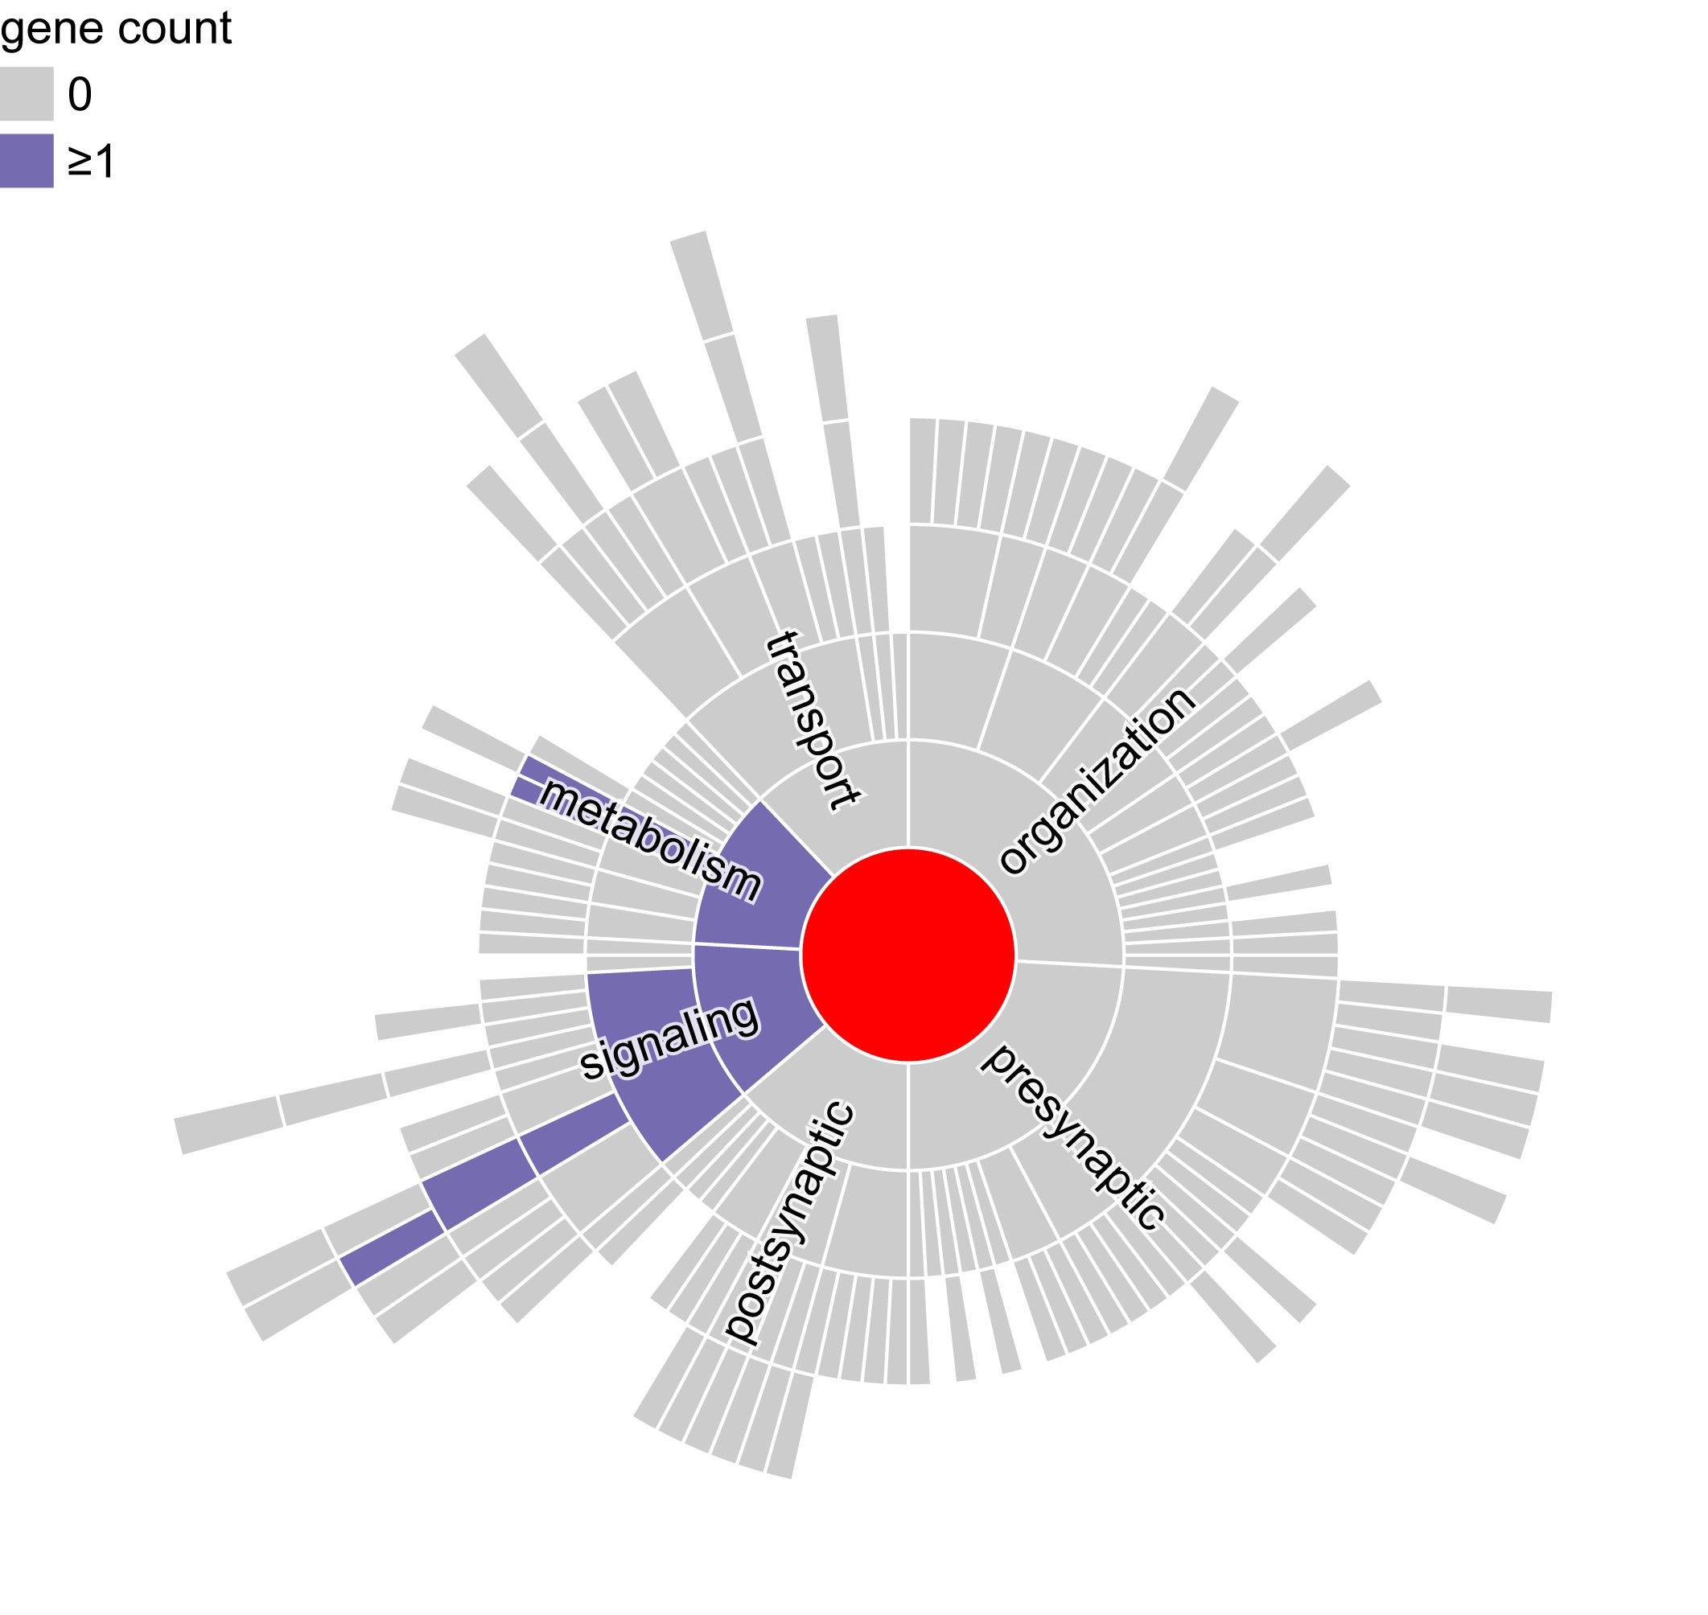

Fig. S8. Developmental trajectories of gene expression for BD and IDPs across nine time windows and brain regions.
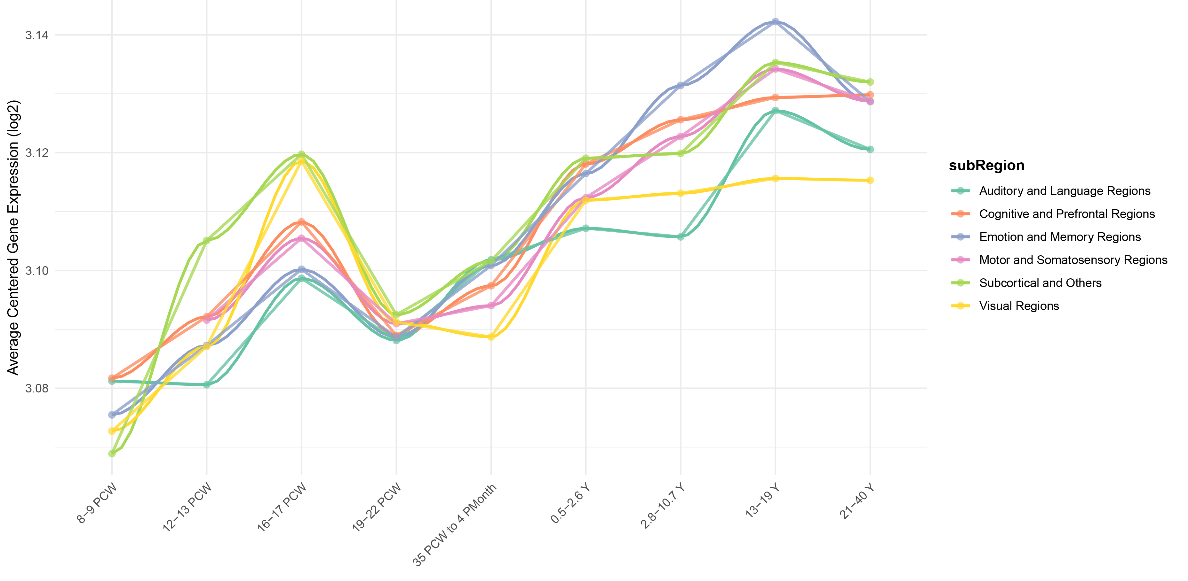

Fig. S9. Identification of shared proteins between BD and IDPs using SMR and BLISS.
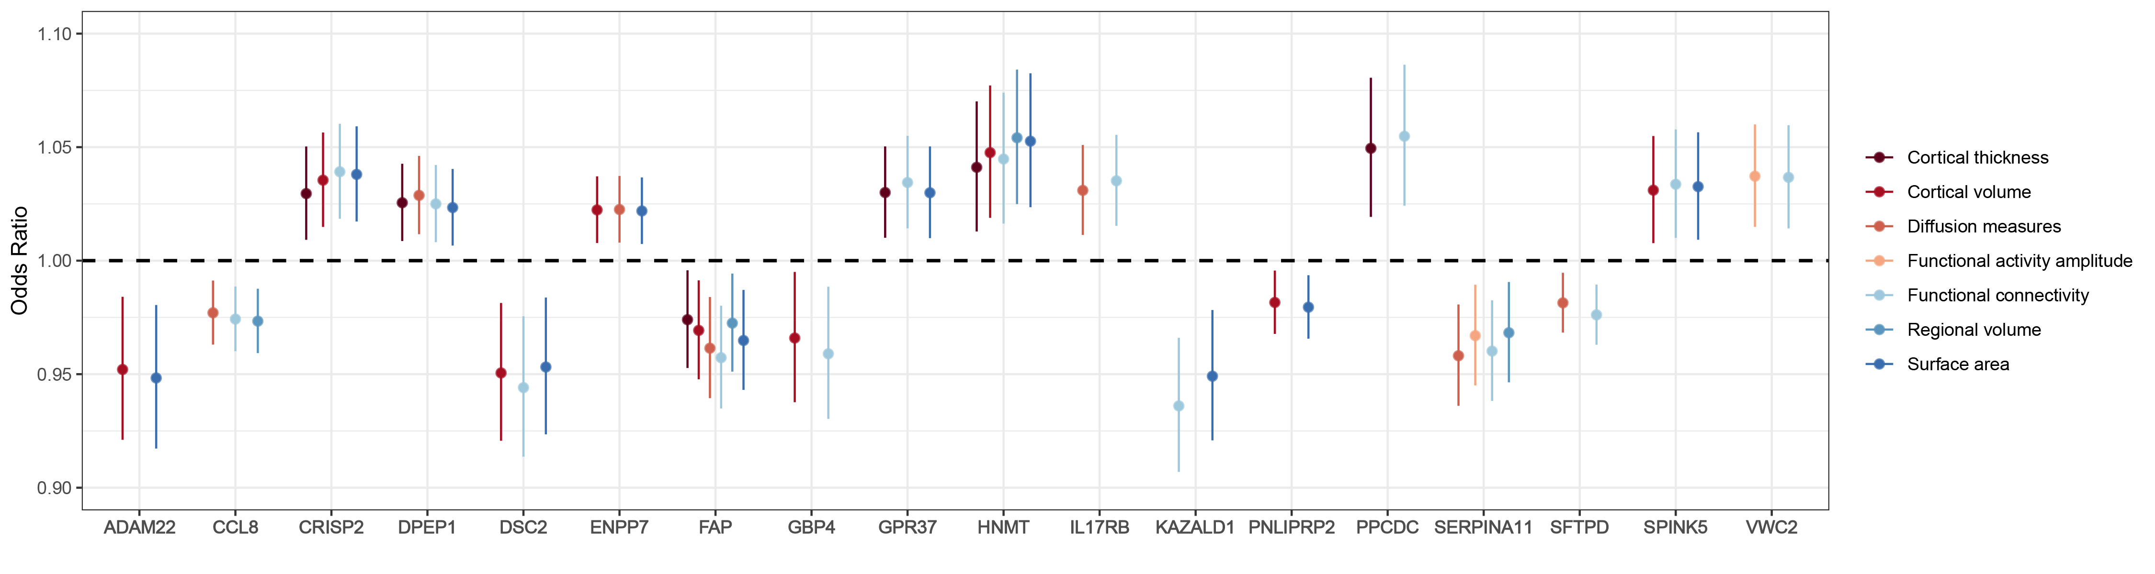
Fig. S10. Protein-protein interaction (PPI) analysis of shared proteins using STRING.
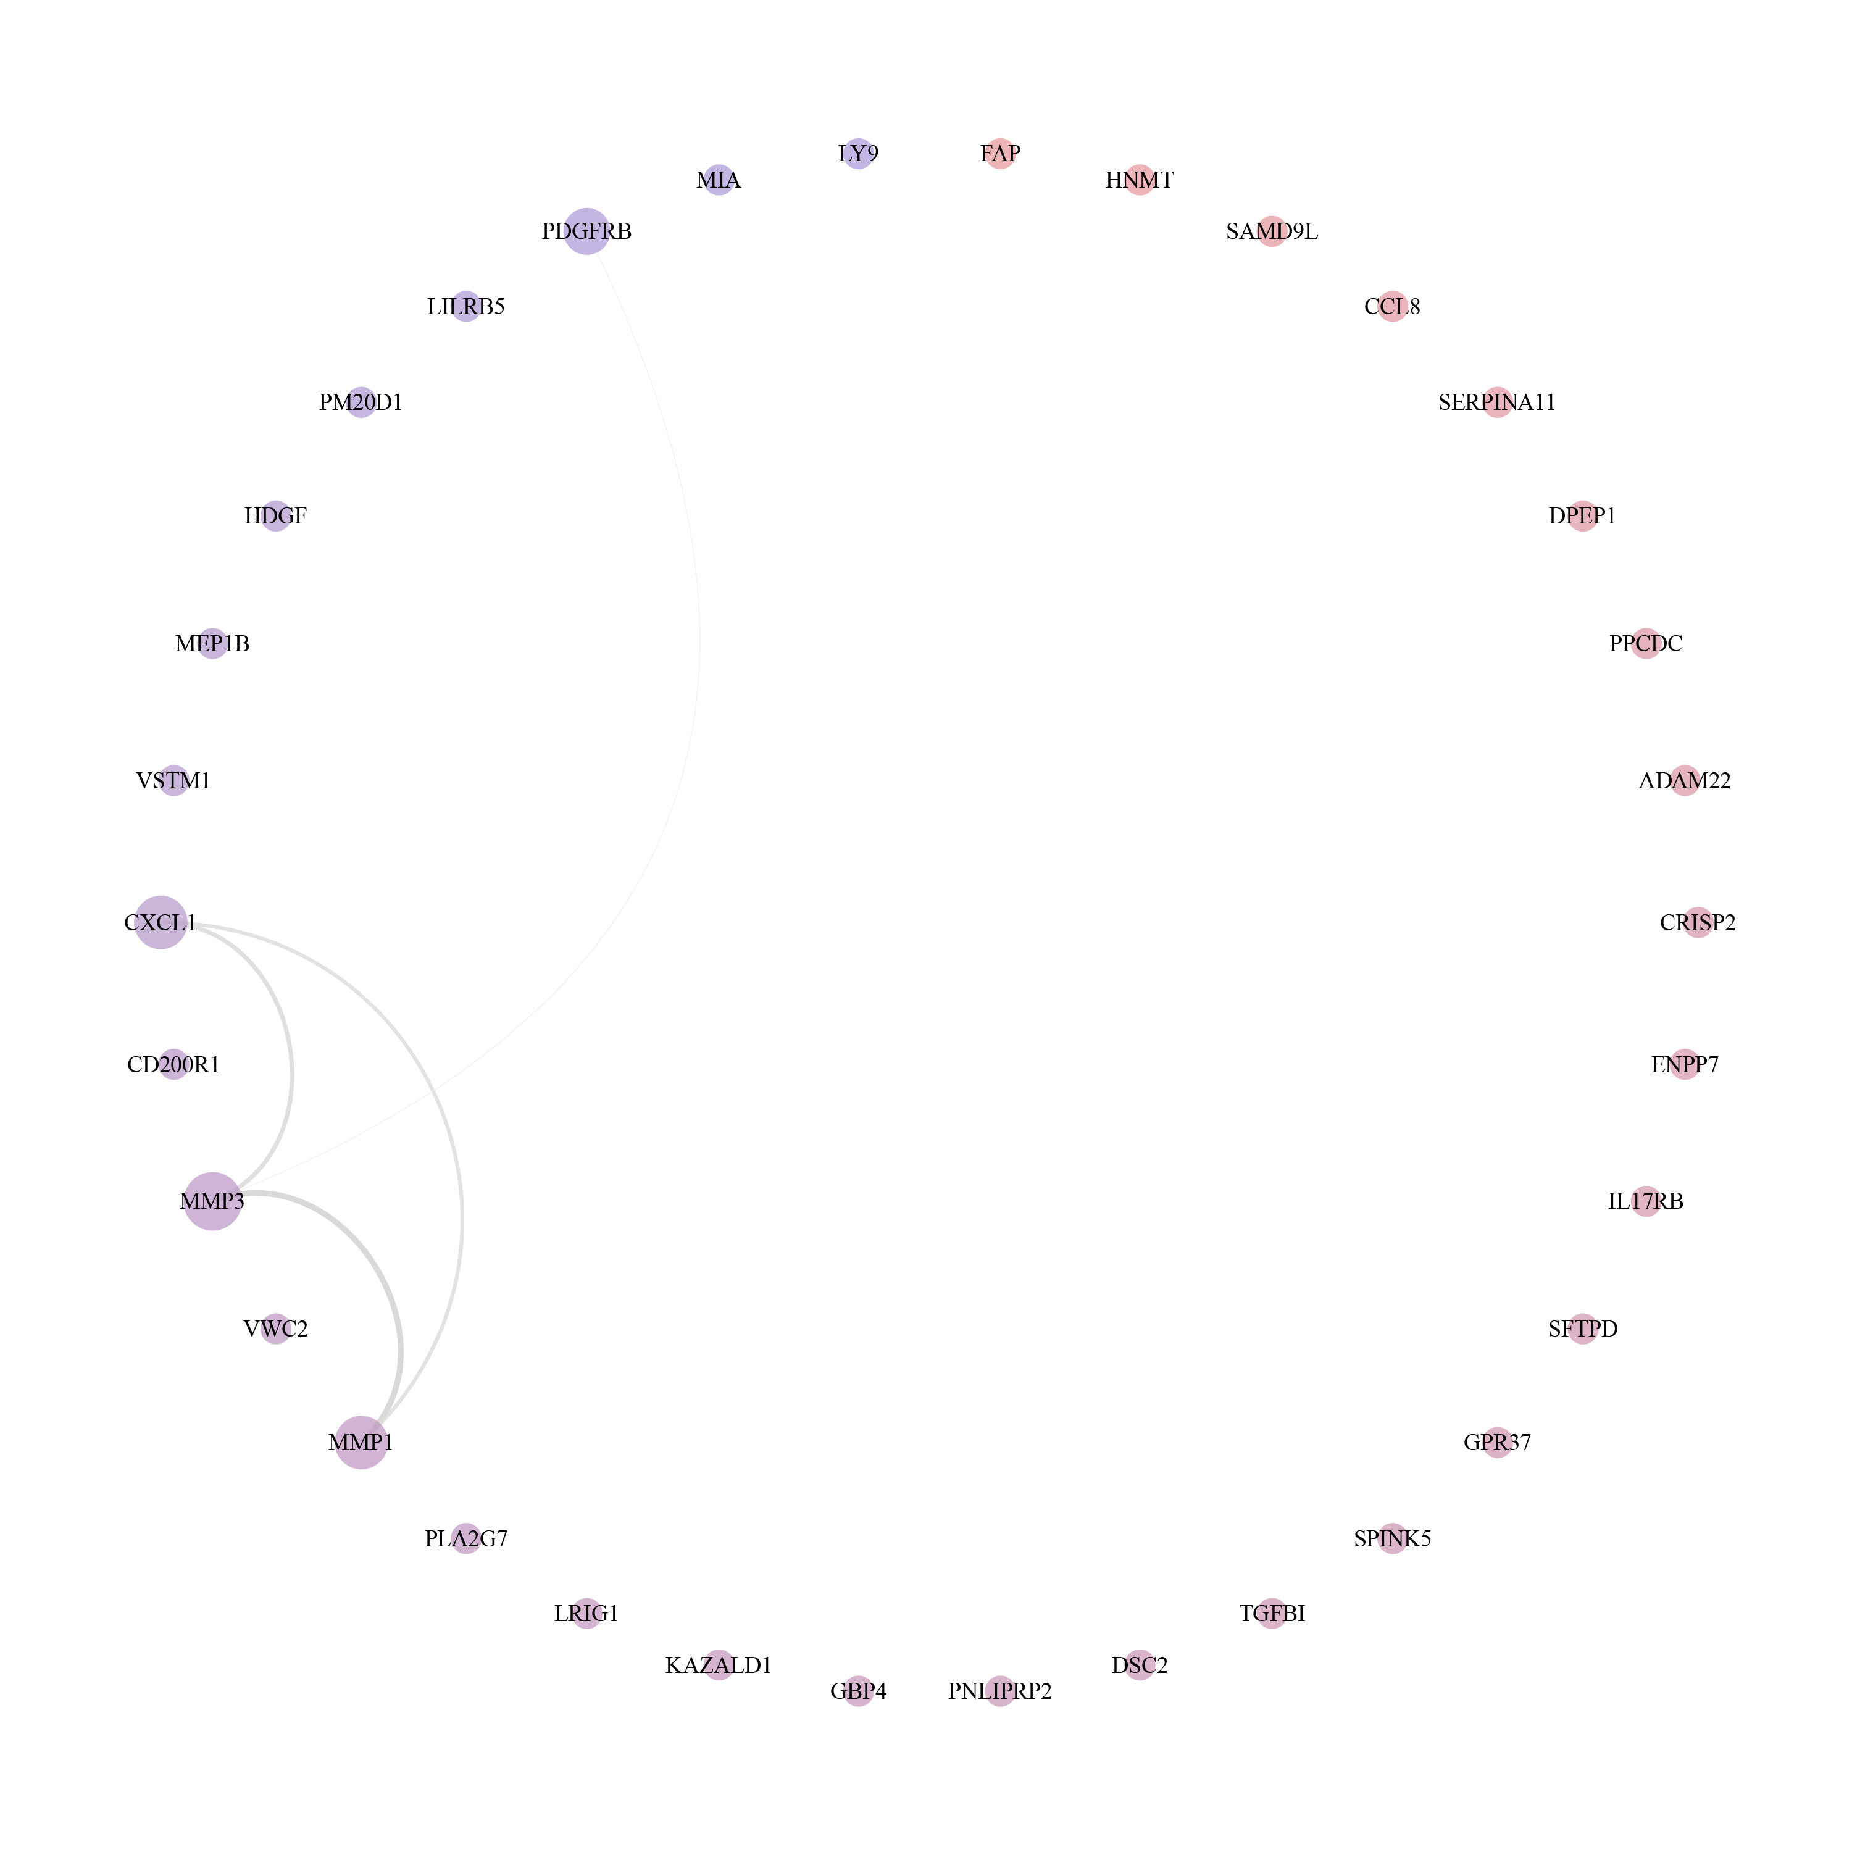
Fig. S11. Statistical mediation of clinical features between BD-IDP PRS and suicide risk.
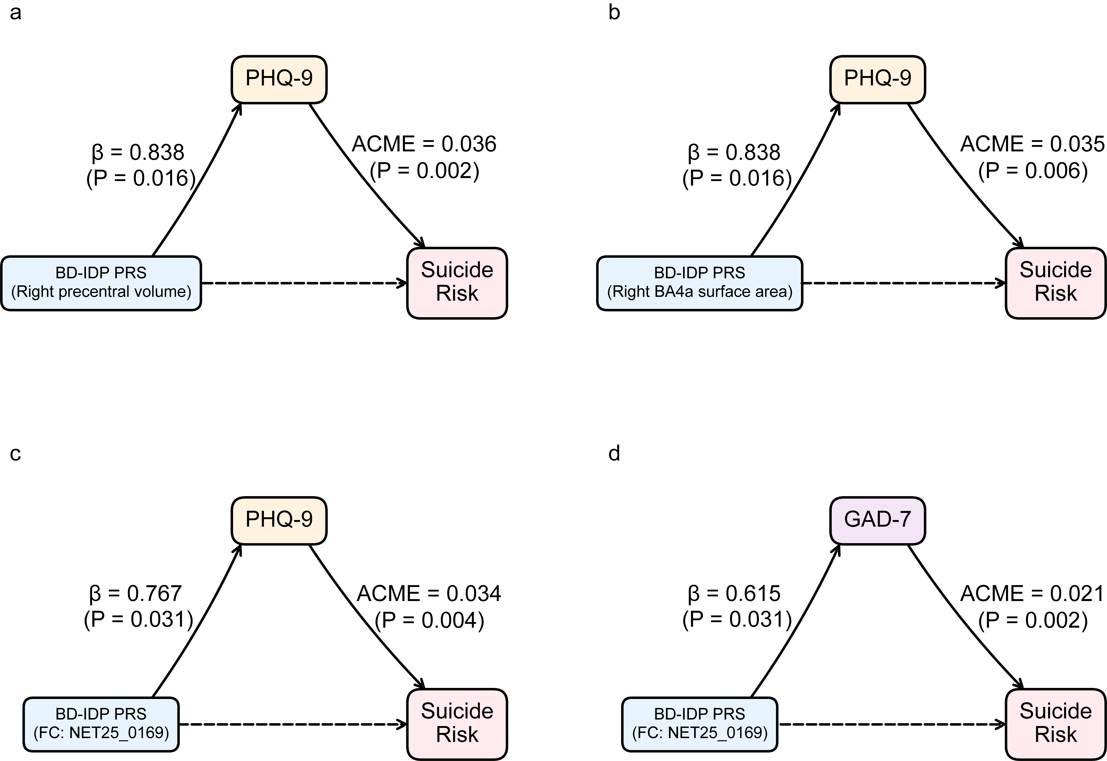
Mediation path diagrams for four significant mediation pathways linking BD-IDP PRS to suicide risk through clinical features. Each panel shows the standard mediation triangle: left path represents the association between BD-IDP PRS and the mediator (Additional file 1: Table S21); right path represents the association between the mediator and suicide risk controlling for PRS (Additional file 1: Table S22).

