Supplementary Figure 1. Odds ratios (OR) and confidence intervals (95% CI) for each metabolite that discriminates TNBC from ER+PR+ tumours and breast cancer risk by breast cancer subtype − EPIC study¹
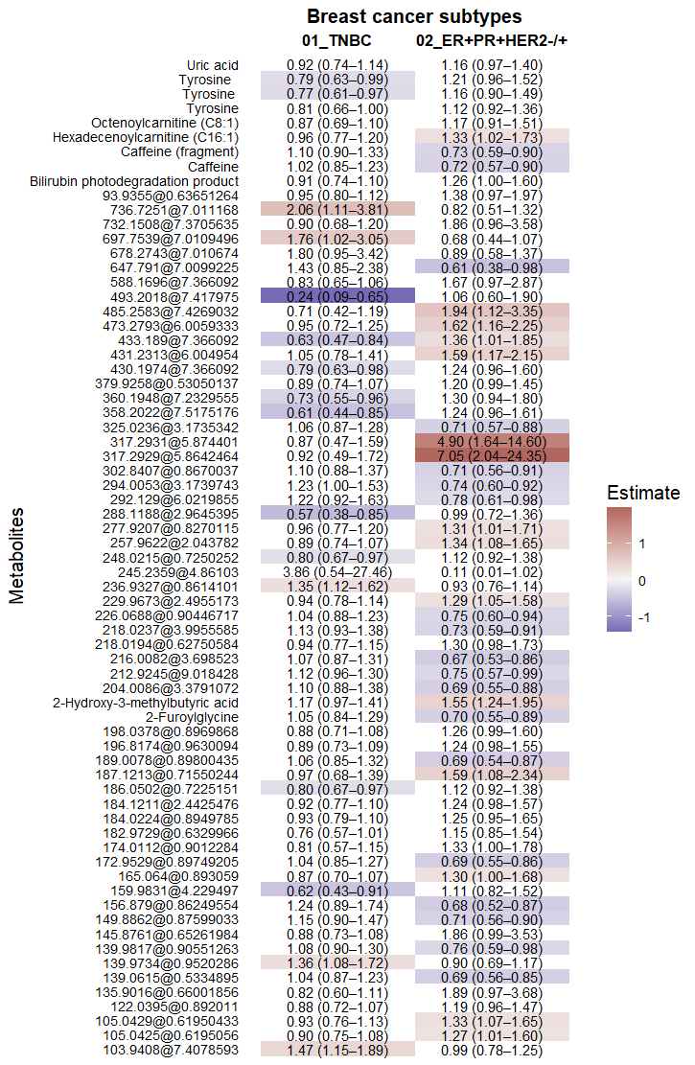

Note ER-PR-HER2-, Triple negative breast cancer; and ER+PR+HER2-/+, hormone receptor positive breast cancer
¹Models were adjusted on matching factors, with additional adjustment for age at menarche, age at first full term pregnancy and parity, breastfeeding, ever use of contraceptive pills, ever use of menopausal hormonal therapy, physical activity index, alcohol consumption, smoking status, and educational level. This plot shows the OR and 95% CI for each identified and unannotated metabolite. Highlighted results in blue indicate negative associations, and those in orange indicate positive associations, while white indicates no significant association.
Supplementary Figure 2. Partial Pearson correlations between 69 features that discriminated two breast cancer subtypes, adjusted for study center and batch − EPIC cohort¹
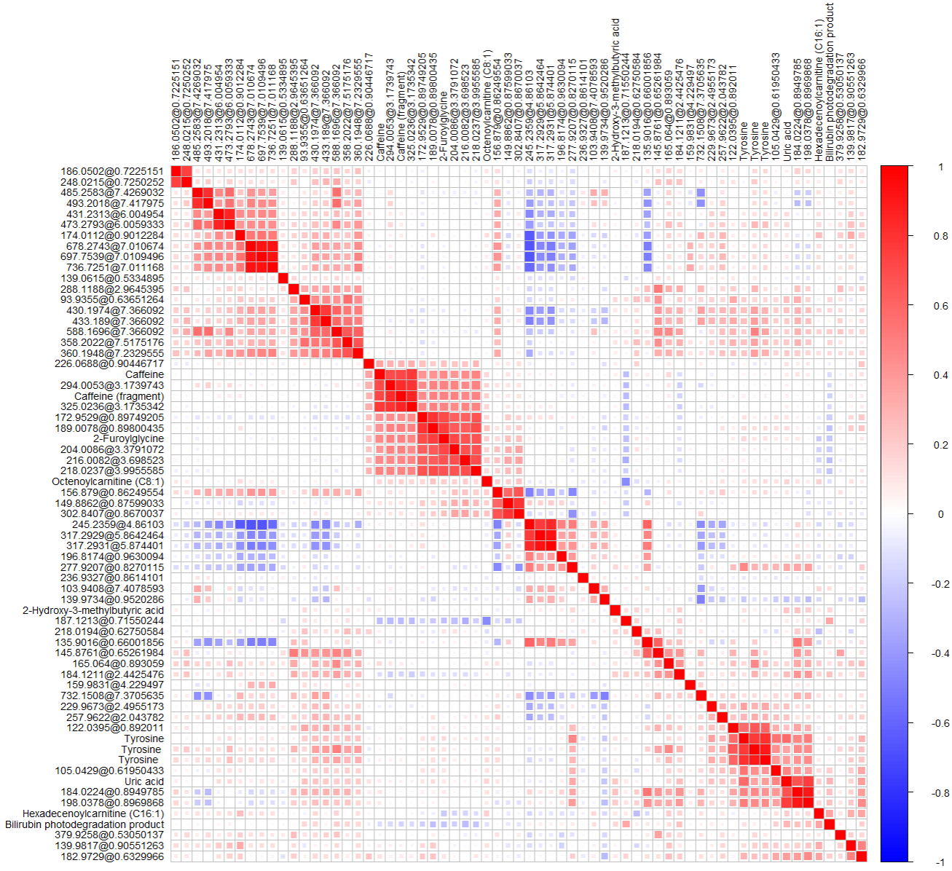
¹All associations were corrected for centre of recruitment and batch. This heatmap shows the correlation coefficients for each identified and unannotated metabolite that discriminate TNBC from ER+PR+ tumours. Highlighted results in blue indicate negative associations, those in orange indicate positive associations, and white indicates no significant association.
Supplementary Figure 3. Heatmap of the associations between identified and unannotated metabolites that discriminates TNBC from ER+PR+ tumours and their association with lifestyle factors − EPIC study¹
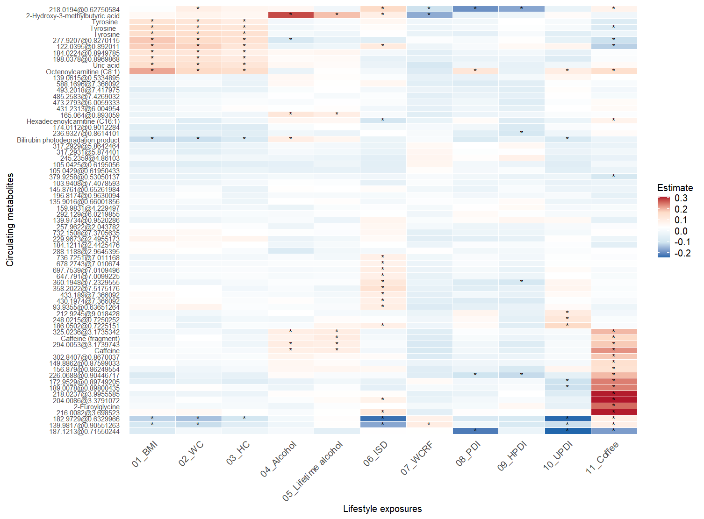
Note BMI, Body Mass Index; WC, Waist Circumference; HC, Hip Circumference; ISD, Inflammatory potential of diet; WCRF, Adherence to the World Cancer Research Fund Recommendations; PDI, Plant-Based Diet Index; uPDI, Unhealthy plant-based diet; hPDI, Healthy plant-based diet.
¹All associations were adjusted for centre of recruitment, batch, age at blood collection, menopausal status, smoking, duration of the menstrual cycle, and fasting status at blood collection. This heatmap shows the estimates of the associations between each identified and unannotated metabolite and lifestyle factors after correction for multiple testing. Highlighted results in blue indicate negative associations, those in orange indicate positive associations, and white indicates no significant association.

