Supplemental Content
Table S1. TACE Treatment in Safety Analysis Set.
Table S2. Treatment Exposure for Cadonilimab and Lenvatinib
Table S3. Treatment Modifications for Cadonilimab and Lenvatinib
Table S4. Summary of Incidences of AEs in the Safety Analysis Set
Table S5. Case Summaries of the Four Treatment-Related Deaths
Table S6. Summary of Incidences of AEs in the Vp3/Vp4 subgroup
Table S7. Cross-tabulation of CTCAE grade for Hyperbilirubinemia from Baseline to Worst Post-Baseline
Table S8. Cross-tabulation of CTCAE grade for Hypoalbuminemia from Baseline to Worst Post-Baseline
Table S9. Cross-tabulation of CTCAE grade for activated partial thromboplastin time (aPTT)
Fig. S1. Flow Diagram of Patient Enrollment
Fig. S2. Waterfall Plots for Best Percent Change from Baseline for Target Lesion
Fig. S3. Swimmer Plot for Duration of Response
Fig. S4. Spider Plot Percent Change from Baseline in Target Lesion

Table S1. TACE Treatment in Safety Analysis Set
 | BCLC Stage B  (N=19) | BCLC Stage C  (N=43)
Treatment times
1 | 9 (47.4) | 16 (37.2)
2 | 4 (21.1) | 11 (25.6)
3 | 4 (21.1) | 10 (23.3)
4 | 2 (10.5) | 6 (14.0)
Interval (days) between second and first treatment
n | 10 | 27
Mean (SD) | 109.7 (67.82) | 108.1 (92.14)
Median | 93.0 | 67.0
Min, Max | 57, 288 | 45, 369
Interval (days) between third and second treatment
n | 6 | 16
Mean (SD) | 175.2 (122.47) | 119.1 (108.65)
Median | 136.0 | 86.5
Min，Max | 64, 373 | 42, 453
Interval (days) between fourth and third treatment
n | 2 | 6
Mean (SD) | 57.5 (28.99) | 80.0 (58.50)
Median | 57.5 | 58.0
Min，Max | 37, 78 | 30, 188

Table S2. Treatment Exposure for Cadonilimab and Lenvatinib
Cadonilimab + lenvatinib + TACE
(N=62)
Cadonilimab (N=61)*
Duration of treatment
Median (range), cycle | 13.1 (1, 35)
Median (range), day | 307.0 (5, 751 )
≥3 months, n (%) | 46 (74.2)
≥6 months, n (%) | 37 (59.7)
≥12 months, n (%) | 20 (32.3)
≥18 months, n (%) | 11 (17.7)
≥24 months, n (%) | 9 (14.5)
Relative dose intensity
Median (range), % | 98.35 (50.0, 100 )
Lenvatinib (N=61)*
Duration of treatment
Median (range), day | 385.6 (4, 762)
≥3 months, n (%) | 52 (83.9)
≥6 months, n (%) | 43 (69.4)
≥12 months, n (%) | 29 (46.8)
≥18 months, n (%) | 19 (30.6)
≥24 months, n (%) | 11 (17.7)
Treatment adherence
Median (range), % | 99.97 (98.1, 100.7 )
**One patient who underwent transarterial chemoembolization didn’t receive cadonilimab and lenvatinib due to COVID-19 infection

Table S3. Treatment Modifications for Cadonilimab and Lenvatinib
Treatment modifications | Cadonilimab + lenvatinib + TACE  (N=62)
Cadonilimab (N=61)*
At least one dose delay, n (%) | 47 (75.8)
Adverse events | 38 (61.3)
Others | 22 (35.5)
At least one infusion interruption, n (%) | 10 (16.1)
Adverse events | 10 (16.1)
Others | 0
Lenvatinib (N=61)*
At least one dose modification, n (%) | 53 (85.5)
Adverse events | 45 (72.6)
Others | 25 (40.3)
**One patient who underwent transarterial chemoembolization didn’t receive cadonilimab and lenvatinib due to COVID-19 infection

Table S4. Summary of Incidences of AEs in the Safety Analysis Set
Cadonilimab + lenvatinib + TACE
(N=62)
Treatment-emergent Adverse Events (TEAE) | 62 (100)
Grade ≥3 TEAE | 56 (90.3)
Treatment-related Adverse Events (TRAE)* | 62 (100)
Grade ≥3 TRAE | 54 (87.1)
TRSAE | 28 (45.2)
Grade ≥3 TRSAE | 24 (38.7)
TRAE leading to permanent discontinuation of cadonilimab | 13 (21.0)
TRAE leading to death | 4 (6.5)
Cadonilimab-related TRAE | 55 (88.7)
Grade ≥3 cadonilimab-related TRAE | 36 (58.1)
Cadonilimab-related TRAE leading to death | 3 (4.8)
Lenvatinib-related TRAE | 60 (96.8)
Grade ≥3 Lenvatinib-related TRAE | 44 (71.0)
Lenvatinib-related TRAE leading to death | 3 (4.8)
TACE-related TRAE | 61 (98.4)
Grade ≥3 TACE-related TRAE | 32 (51.6)
TACE-related TRAE leading to death | 1 (1.6)
Immune-related AE (irAE) | 26 (41.9)
Grade ≥3 irAE | 15 (24.2)
irAE leading to death | 0
*TRAE including adverse events related to any treatment (cadonilimab, lenvatinib, or TACE) in study.

Table S5. Case Summaries of the Four Treatment-Related Deaths
Case summaries
Patient 1, a 49y-male, was diagnosed as HCC on March 2023. The patient had a history of liver cirrhosis and portal hypertension.The patient was enrolled on 2023-03-14 and received first TACE on the same day. The procedure went smoothly, and the post-operative laboratory tests indicated that the patient was able to tolerate following treatment. The patient received cadonilimab (690mg) and lenvatinib (12mg) since 2023-03-21.The patient reported experiencing symptoms of fatigue, nausea, vomiting and diarrhea starting from 2023-03-22 and investigator instructed the patient to take Montmorillonite powder and Ondansetron. At 1:00 am 2023-03-25, his family reported the patient began to experience blood in the phlegm after defecating that night.The investigator advised the patient to seek treatment at the local hospital as soon as possible. During the journey to the hospital, the patient experienced hematemesis. Despite efforts at the local hospital, the patient's condition did not improve and he passed away on 2023-03-25. The local hospital recorded this as acute gastrointestinal bleeding.Taking into account the patient's symptoms and the history of liver cirrhosis and portal hypertension, the possible cause of death was considered to be rupture and bleeding of esophageal and gastric fundus varices. It was considered to be not related to cadonilimab, possibly related to lenvatinib, possibly related to TACE, and related to the disease.
Patient 2, a 64y-male, was diagonsed as HCC on 2023-04-17. The patient had a history of hepatitis B and liver cirrhosis. The patient was enrolled on 2023-4-20 and received first TACE. The cadonilimab(595mg) and lenvatinib (8mg) were given since 2023-4-26 and continued to be used according to protocol. The cadonilimab was discontinued after 2023-06 due to abnormal myocardial markers. The patient started taking Methylprednisolone 16mg qd since 2023-06-27.The patient reported experiencing diarrhea and anal ulceration since 2023-07-uk.The patient also experienced mild fever.The lab test on 2023-07-04 showed White blood cell count: 8.2 x 10^9/L, absolute neutrophil count: 7.5 x 10^9/L, platelet count: 50 x 10^9/L.C-reactive protein: 92.62 mg/L. Procalcitonin: 0.30 ng/ml.The investigator instructed the patient to take Avatrombopag, Montmorillonite powder and Berberine hydrochloride and stop taking lenvatinib on 2023-07-04.On 2023-07-05 the patient had diarrhea 6-7 times, with general fatigue, profuse sweating all over the body, cold and clammy limbs, and rapid breathing. The patient was sent to the emergency department.The lab test showed White blood cell count: 0.9 x 10^9/L, absolute neutrophil count: 0.5 x 10^9/L, platelets: 18 x 10^9/L, hypersensitive C-reactive protein: 226.23 mg/L, procalcitonin: > 100.00 ng/ml.The patient was urgently admitted to the hospital for treatment. Vital signs were measured as follows: Temperature: 37.3℃, Pulse: 130 beats per minute, Respiration: 22 breaths per minute, Blood pressure: 82/50 mmHg. Norepinephrine injection was used to raise blood pressure. Imipenem and Cilastatin Sodium and tigecycline was used for anti-infection.But the patient's condition deteriorated further, presenting with nodding respiration, decreased blood pressure, and reduced blood oxygen saturation. The patient passed away on early morning 2023-07-06. Based on patient’s symptoms and lab test results, the possible cause of death was considered to be septic shock. It was considered to be possibly related to cadonilimab, possibly related to lenvatinib, not related to TACE.
Patient 3, a 54y-female,was diagnosed as HCC on 2022-09-05. The patient was enrolled on 2022-09-12 and received first TACE. The cadonilimab (720mg) and lenvatinib(12mg) were given since 2022-09-20 and continued to be used according to protocol.The disease progression occurred on 2023-06-02. The study treatment was ended. The follow-up treatment was not given and the patient died on 2023-07-07 due to disease progression. Considering the death occurred closely to last dose of study treatment. It was considered to be possibly related to cadonilimab, possibly related to lenvatinib, not related to TACE.
Patient 4, a 69y-male, was diagnosed as HCC on 2022-09-13. The patient was enrolled on 2022-10-13 and received first TACE. The cadonilimab (600mg) and lenvatinib (8mg) were given since 2022-10-21 and continued to be used according to protocol. On 2022-12-28,the patient was was hospitalized due to Grade 3 Rash. After treatment with 5mg of dexamethasone, the rash improved significantly. On 2022-12-31,the patient had fever and COVID-2019 test was possitive.Anti-infection treatment was given. During the hospitalization, the patient also had a decrease in platelet count. After receiving blood transfusion, recombinant human thrombopoietin and avacaritabap treatment, it was improved. When the patient was discharged on 2023-01-19, the rash and thrombocytopenia had significantly improved. The imaging examination showed a significant improvement in liver cancer. But patient reported unexplainable general incomfort and there was a sudden cessation of breathing and heartbeat, followed by death on 2023-1-22.No more detail could be offered. Taking into account the patient's symptoms and medical history, the explosive myocarditis caused by COVID-2019, pulmonary embolism, acute coronary syndrome and cerebrovascular accident cannot be ruled out. It was considered to be possibly related to cadonilimab, unlikely related to lenvatinib, not related to TACE.

Table S6. Summary of Incidences of AEs in the Vp3/Vp4 Subgroup
Cadonilimab + lenvatinib + TACE
(N=13)
Treatment-emergent Adverse Events (TEAE) | 13 (100)
Grade≥3 TEAE | 11 (84.6)
Treatment-related Adverse Events (TRAE)* | 13 (100)
Grade≥3 TRAE | 11 (84.6)
TRSAE | 8 (61.5)
Grade≥3 TRSAE | 7 (53.8)
TRAE leading to permanent discontinuation of cadonilimab | 3 (23.1)
TRAE leading to death | 1 (7.7)
Cadonilimab-related TRAE | 9 (69.2)
Grade≥3 cadonilimab-related TRAE | 5 (38.5)
Cadonilimab-related TRAE leading to death | 0
Lenvatinib-related TRAE | 13 (100)
Grade≥3 Lenvatinib-related TRAE | 8 (61.5)
Lenvatinib-related TRAE leading to death | 1 (7.7)
TACE-related TRAE | 13 (100)
Grade≥3 TACE-related TRAE | 10 (76.9)
TACE-related TRAE leading to death | 1 (7.7)
Immune-related AE (irAE) | 5 (38.5%)
Grade≥3 irAE | 1 (7.7)
irAE leading to death | 0

Table S7. Cross-tabulation of CTCAE grade for Hyperbilirubinemia from Baseline to Worst Post-Baseline
Baseline CTCAE grade for hyperbilirubinemia,  n (%) | Worst post-baseline CTCAE grade for hyperbilirubinemia, n (%)
Baseline CTCAE grade for hyperbilirubinemia,  n (%) | 0 | 1 | 2 | 3 | 4 | Not detected | Total
0 | 11 (17.7) | 17 (27.4) | 21 (33.9) | 1 (1.6) | 0 | 0 | 50 (80.6)
1 | 0 | 2 (3.2) | 6 (9.7) | 1 (1.6) | 0 | 0 | 9 (14.5)
2 | 0 | 0 | 3 (4.8) | 0 | 0 | 0 | 3 (4.8)
3 | 0 | 0 | 0 | 0 | 0 | 0 | 0
4 | 0 | 0 | 0 | 0 | 0 | 0 | 0
Total | 11 (17.7) | 19 (30.6) | 30 (48.4) | 2 (3.2) | 0 | 0 | 62 (100.0)
Note: Note: Baseline CTCAE grade was the last available measurement prior to the first TACE treatment. Worst post-baseline grade was the maximum CTCAE grade recorded from baseline until the initiation of subsequent anti-tumor therapy or last follow-up, whichever occurred first.

Table S8. Cross-tabulation of CTCAE grade for Hypoalbuminemia from Baseline to Worst Post-Baseline
Baseline CTCAE grade for hypoalbuminemia,  n (%) | Worst post-baseline CTCAE grade for hypoalbuminemia, n (%)
Baseline CTCAE grade for hypoalbuminemia,  n (%) | 0 | 1 | 2 | 3 | 4 | Not detected | Total
0 | 1(1.6) | 21 (33.9) | 10 (16.1) | 0 | 0 | 0 | 32 (51.6)
1 | 0 | 17 (27.4) | 13 (21.0) | 0 | 0 | 0 | 30 (48.4)
2 | 0 | 0 | 0 | 0 | 0 | 0 | 0
3 | 0 | 0 | 0 | 0 | 0 | 0 | 0
4 | 0 | 0 | 0 | 0 | 0 | 0 | 0
Total | 1(1.6) | 38 (61.3) | 23 (37.1) | 0 | 0 | 0 | 62 (100.0)
Note: Baseline CTCAE grade was the last available measurement prior to the first TACE treatment. Worst post-baseline grade was the maximum CTCAE grade recorded from baseline until the initiation of subsequent anti-tumor therapy or last follow-up, whichever occurred first.

Table S9. Cross-tabulation of CTCAE grade for activated partial thromboplastin time (aPTT) prolongation
Baseline CTCAE grade for aPTT, n (%) | Worst post-baseline CTCAE grade for aPTT, n (%)
Baseline CTCAE grade for aPTT, n (%) | 0 | 1 | 2 | 3 | 4 | Not detected | Total
0 | 41 (66.1) | 16 (25.8) | 0 | 0 | 0 | 1 (1.6) | 58 (93.5)
1 | 0 | 4 (6.5) | 0 | 0 | 0 | 0 | 4 (6.5)
2 | 0 | 0 | 0 | 0 | 0 | 0 | 0
3 | 0 | 0 | 0 | 0 | 0 | 0 | 0
4 | 0 | 0 | 0 | 0 | 0 | 0 | 0
Total | 41 (66.1) | 20 (32.3) | 0 | 0 | 0 | 1 (1.6) | 62 (100.0)
Note: Baseline CTCAE grade was the last available measurement prior to the first TACE treatment. Worst post-baseline grade was the maximum CTCAE grade recorded from baseline until the initiation of subsequent anti-tumor therapy or last follow-up, whichever occurred first.

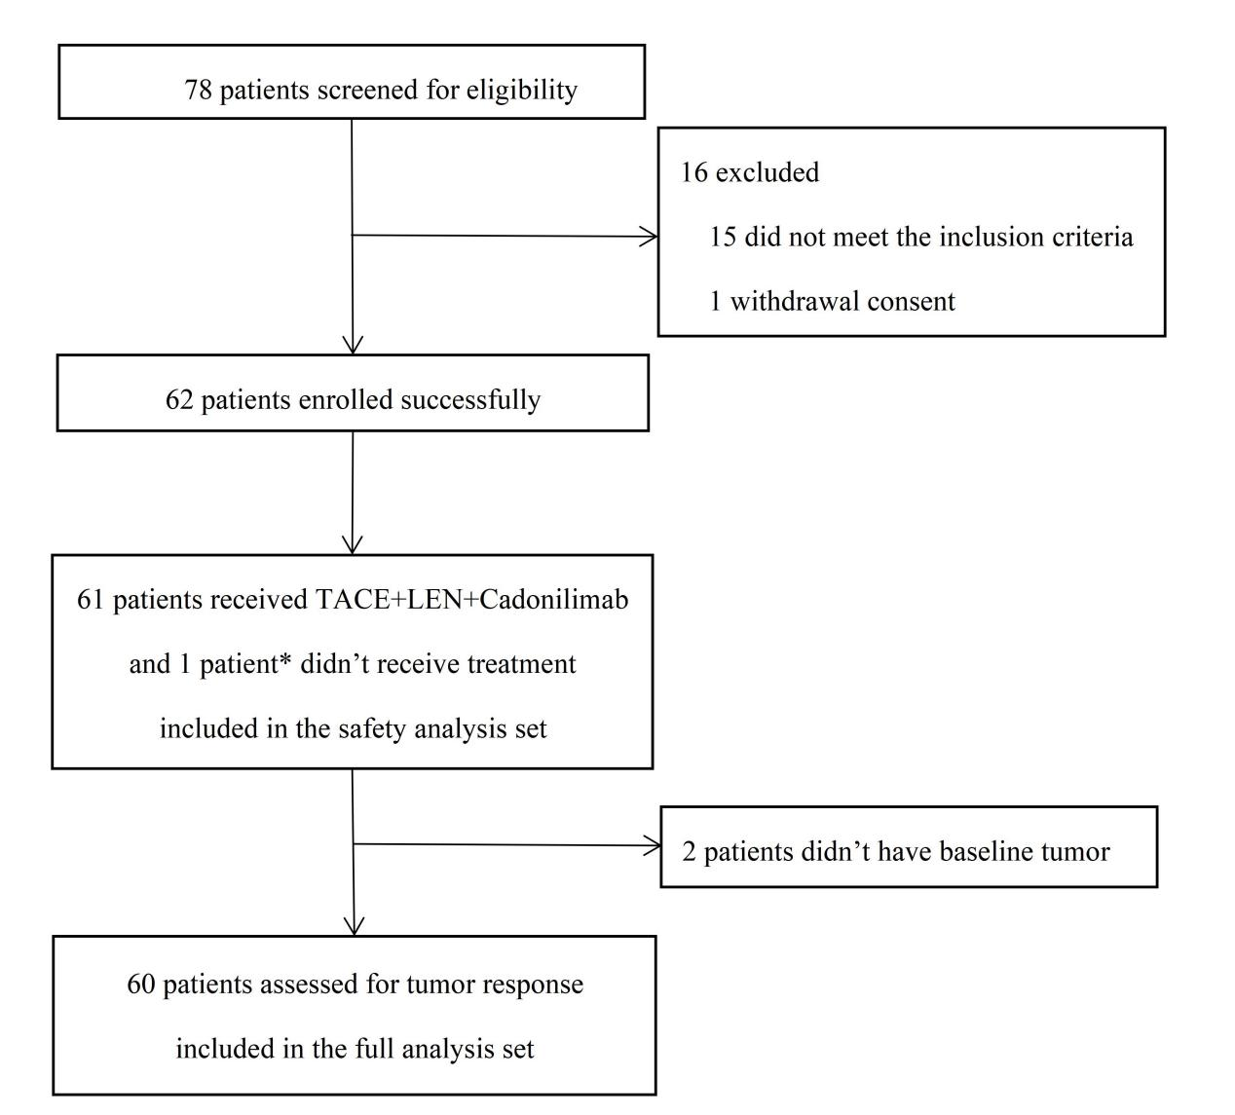
Fig. S1. Flow Diagram of Patient Enrollment
*One patient who underwent transarterial chemoembolization didn’t receive cadonilimab and lenvatinib due to COVID-19 infection

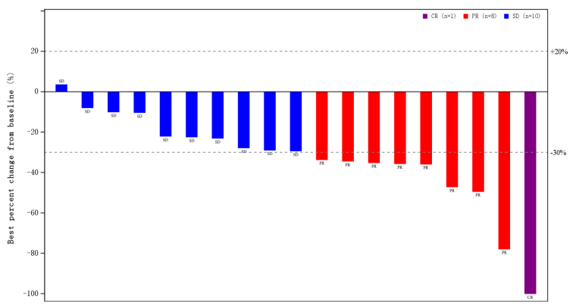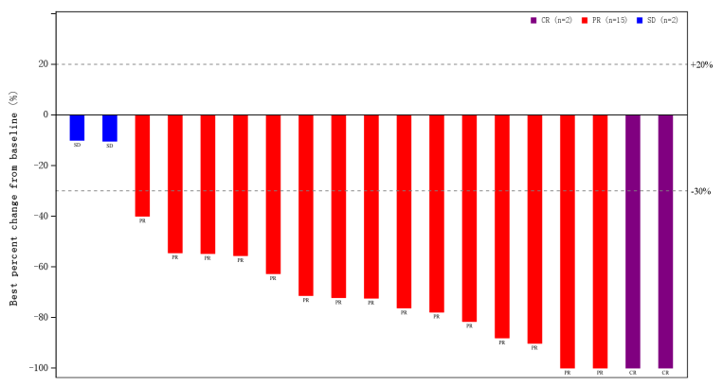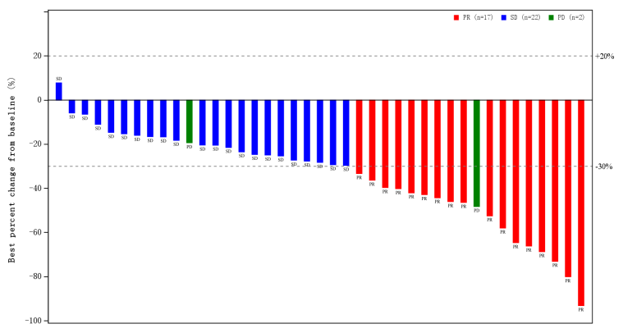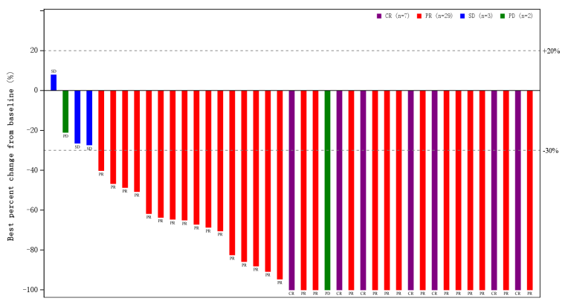
A. BCLC B (RECIST)
C. BCLC C (RECIST)
B. BCLC B (mRECIST)
D. BCLC C (mRECIST)
Fig. S2. Waterfall Plots for Best Percent Change from Baseline for Target Lesion. (A) Patients with BCLC stage B HCC (per RECIST v1.1); (B)Patients with BCLC stage B HCC (per mRECIST ); (C) Patients with BCLC stage C HCC (per RECIST v1.1); (D) Patients with BCLC stage C HCC (per mRECIST).
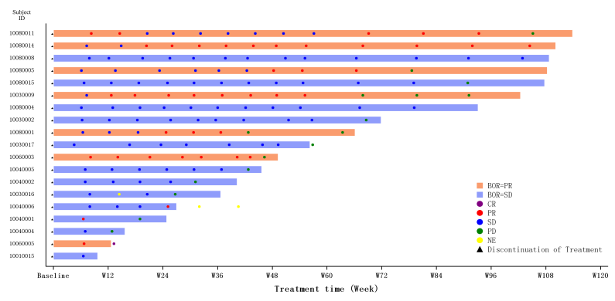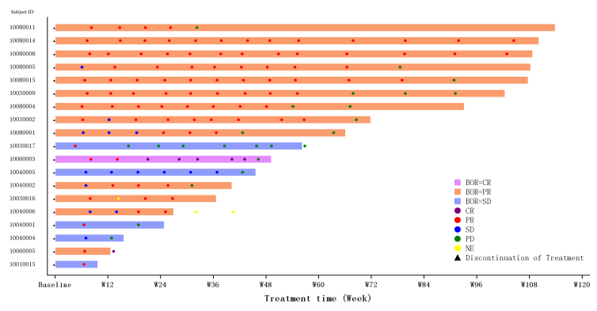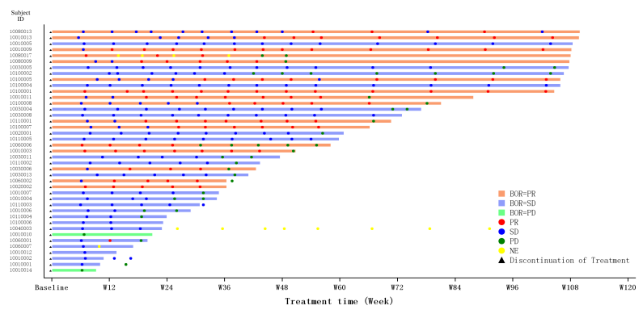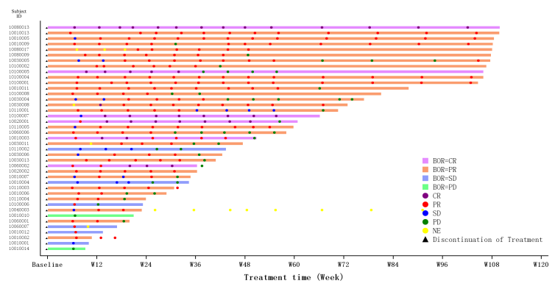
A. BCLC B (RECIST)
C. BCLC C (RECIST)
B. BCLC B (mRECIST)
D. BCLC C (mRECIST)
Fig. S3. Swimmer Plot for Duration of Response. (A) Patients with BCLC stage B HCC (per RECIST v1.1); (B) Patients with BCLC stage B HCC (per mRECIST ); (C) Patients with BCLC stage C HCC (per RECIST v1.1); (D) Patients with BCLC stage C HCC (per mRECIST).
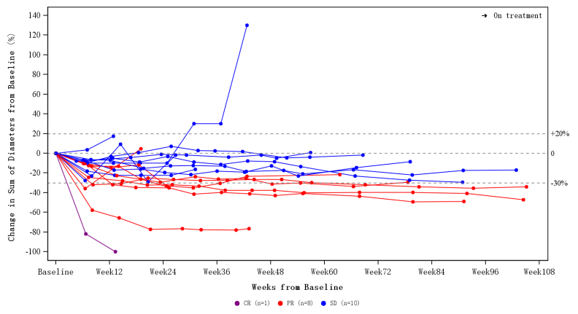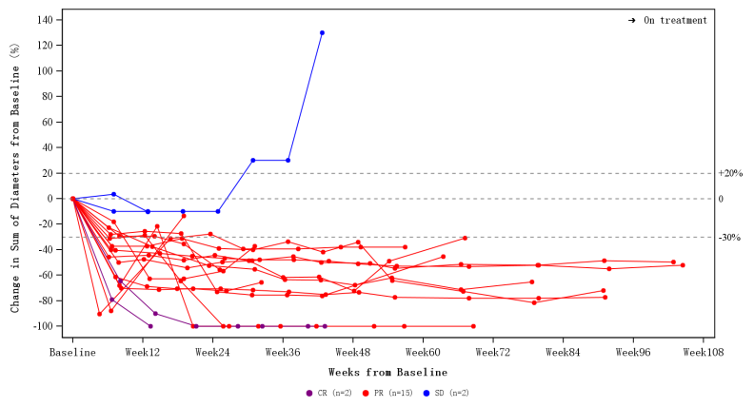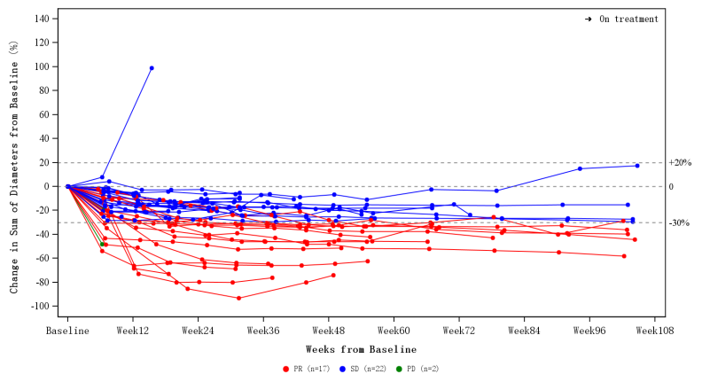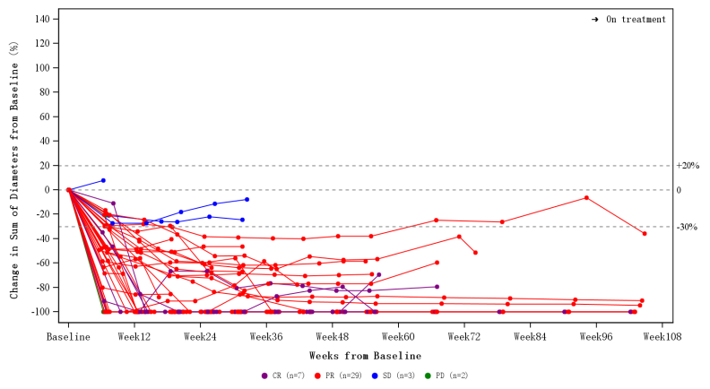
A. BCLC B (RECIST)
C. BCLC C (RECIST)
B. BCLC B (mRECIST)
D. BCLC C (mRECIST)
Fig. S4. Spider Plot Percent Change from Baseline in Target Lesion. (A) Patients with BCLC stage B HCC (per RECIST v1.1); (B) Patients with BCLC stage B HCC (per mRECIST ); (C) Patients with BCLC stage C HCC (per RECIST v1.1); (D) Patients with BCLC stage C HCC (per mRECIST).

