Table of Contents

Additional Methods 3
Additional Method1 – Method for dietary data collection and the identification of under-reporters of energy intake 3
Additional Method2 – Detailed qualitative and quantitative assessment of food additive exposure 3
Additional Method3 – Detailed description of statistical analyses 4
Additional Method4 – Non-negative matrix factorisation 5
Additional Method5 – Quantile-based g-computation 6
Additional Figures 7
Additional Figure1 – Flowchart, NutriNet-Santé, 2009-2024 7
Additional Figure2 – Baseline distribution of the 75 food additives consumed by at least of 5% the participants, NutriNet-Santé cohort, 2009-2024 (n= 112,050). 8
Additional Figure3 – Dose-response associations between exposure to food additive mixtures and incidence of hypertension (n=103,052) and cardiovascular diseases (n=110,021), Restricted Cubic Splines, NutriNet-Santé cohort, 2009-2024 11
Additional Figure4 – Kernel density distribution of food additives mixtures scores, NutriNet-Santé cohort, n= 112,050, 2009-2024 ª 21
Additional Tables 22
Additional Table1 – Daily food additive intakes among study participants from the NutriNet-Santé cohort, 2009-2024ª 22
Additional Table2 – Spearman correlation matrix between food additive intakes and NMF components identified by Lee and Sung algorithm (main model), NutriNet-Santé cohort, 2009-2024ª 25
Additional Table3 – Consensus map for rank number determination and sensitivity analyses using other decomposition algorithms in the NMF procedure 27
3. a. Rank selection in NMF (consensus map) 27
3. b. Spearman correlation matrix between food additive intakes and NMF components identified by the Brunet algorithm (sensitivity analysis), NutriNet-Santé cohort, 2009-2024ª 28
3. c. Spearman correlation matrix between food additive intakes and NMF components identified by non-smooth non-negative matrix factorisation (nsNMF) (sensitivity analysis), NutriNet-Santé cohort, 2009-2024ª 30
3. d. Stability of NMF food additive mixtures across time, NutriNet-Santé cohort, 2009-2024 32
Additional Table4 – Standardised coefficient matrix derived from the NMF procedure, Lee and Sung algorithm (main model), NutriNet-Santé cohort, 2009-2024 36
Additional Table5 – Spearman correlations between the five NMF food additive mixtures at baseline, NutriNet-Santé cohort, 2009-2024ª 38
Additional Table6 – Spearman correlations between NMF food additive mixtures and food group intakes among participants from the NutriNet-Santé cohort, 2009-2024 39
Additional Table7 – Cut-offs for sex-specific tertiles of food additive mixtures, per sex and period of follow-up, NutriNet-Santé cohort, 2009-2024 40
Additional Table8 – Associations between exposure to food additive mixtures and incidence of hypertension (n=103,052) and cardiovascular diseases (n=110,021), NutriNet-Santé cohort, 2009-2024- main modelª 41
Additional Table9 – Associations between exposure to food additive mixtures and incidence of hypertension (n=103,052) and cardiovascular diseases (n=110,021), NutriNet-Santé cohort, 2009-2024 – sensitivity analysesª 44
Additional Table10 – Associations between exposure to food additive mixtures and cerebrovascular disease incidence (n=110,021, 1,142 incident cases), NutriNet-Santé cohort, 2009-2024 – sensitivity analyses using a median-based categorisation ª 52
Additional Table11 – Interaction tests between food additive mixtures and potential effect modifiers on the incidence of hypertension (n=103,052) and cardiovascular diseases (n=110,021), NutriNet-Santé cohort, 2009-2024 ª 53
Additional Table12 – Quantile-based g-Computation estimating the joint effect of food additive mixtures on hypertension (n=103,052) and cardiovascular diseases (n=110,021) incidence, NutriNet-Santé cohort, 2009-2024 56
12.a. Hypertension 56
12.b. Cardiovascular Diseases 58
Additional Table13 – Quantile-based g-computation estimating the joint effect of NMF-derived mixtures on hypertension and cardiovascular outcomes, NutriNet-Santé cohort, 2009-2024 (n=110,021) ª 60
13.a. Hypertension 60
13.b. Cardiovascular Diseases 60
Additional Table14 – Mediation by hypertension of the associations between food additive mixtures and cardiovascular outcomes, NutriNet-Santé cohort, 2009-2024 (n=110,021) ª 61
Additional Table15 – Two-by-two interactions between the food additives most emblematic to each mixture, NutriNet-Santé cohort, 2009-2024 62
15.a. Hypertension 62
15.b. Cardiovascular diseases 66
15.c. Coronary Heart Disease 67

Additional Methods

Additional Method1 – Method for dietary data collection and the identification of under-reporters of energy intake
At inclusion, and every six months thereafter, participants were invited to fill out three non-consecutive days of 24-hour dietary records, randomly assigned over two weeks, including two weekdays and one weekend day (to account for variability in the diet across the week and the seasons). At all times throughout their assigned dietary record period, participants had access to a dedicated interface on the study website to declare all foods and beverages consumed during 24 hours: three main meals (breakfast, lunch, dinner) and any other eating occasion. Participants were asked to estimate portion sizes either by directly entering the weight consumed in the platform or by using validated photographs or usual containers. A French food composition database (>3,500 items) was used to estimate mean daily energy, alcohol, macro- and micro-nutrient intakes. These estimates included contributions from composite dishes using French recipes validated by food and nutrition professionals. The web-based questionnaires used in the study have been tested and validated against both in-person interviews by trained dietitians, and urinary and blood markers. In this analysis, we included participants having at least two 24-hour-dietary records during the first two years of follow-up. Participants who underreported their energy intake were excluded from the analyses and were identified using the method from Black, based on the original method developed by Goldberg et al. This method relies on the hypothesis that the maintenance of a stable body weight requires a balance between energy intake and expenditure. The equations developed by Black account for the reported dietary energy intake, basal metabolic rate (calculated using Schofield’s equations), sex, age, height, weight, number of dietary records, physical activity level (PAL), and intra/inter-individual variability. As recommended by Black, the intra-individual coefficients of variations for BMR and PAL were fixed at 8.5 % and 15%, respectively. In addition, a PAL of 1.55 was used to reflect a “light” physical activity which is assumed to be attained by healthy, normally active individuals living a sedentary lifestyle. Finally, some individuals identified as under-reporters of energy intakes using Black’s method were not excluded, if they also reported recent weight variations, adherence to weight-loss restrictive diets, or declared the consumptions entered in their dietary records as unusually low compared to their habitual diets.
In this study, 23,205 participants (corresponding to 17.1% of the subjects) were considered as under-energy reporters and were excluded from the study. This proportion of under-reporters is common, for instance in the nationally representative INCA 3 study conducted in 2016 by the French Food Safety Agency 18% of adult participants were identified as under-reporters using the Black method.
Several quality control operations were performed to account for over-reporting. Limitations in the online tool were set when participants reported the quantities of food consumed, aiming to alert them that the number they were about to enter was potentially an outlier, thereby encouraging double check and correction. Later on, during the data cleaning process, limitations were set per food category within one eating episode and per record for quantities; for instance, limitations for fruits were set for 3000 grams/day, 1500 grams/day for fish, 2000 grams/day for yoghurts, etc. If more than 10% of reported food items had outliers, then the full record was excluded. This led to the exclusion of 55 participants for the present study. Otherwise, values were corrected to the maximum authorised values or standardised.

Additional Method2 – Detailed qualitative and quantitative assessment of food additive exposure
The detailed methodology for food additive exposure assessment has been described previously and is the same as the one used in the NutriNet-Santé cohort (mutualized dietary data collection tools). The strength of our methodology relies in the precise qualitative assessment of additive exposure, i.e., presence/absence of a specific additive in the food consumed. This unique level of detail is permitted by the fact that commercial names/brands of industrial product consumed were collected and matched with three databases providing the ingredient list and thus, presence of the specific additive, at the time when the product was consumed: OQALI, a national database managed by the National Research Institute for Agriculture, Food and Environment (INRAe) and the French food safety authority (ANSES), Open Food Facts (an open collaborative global database), and Mintel Global New Products Database (GNPD), a global database of innovative products. Dynamic matching was applied, meaning that products were matched date-to-date: the date of consumption of each food or beverage declared by each participant was used to match the product to the closest composition data available, thus accounting for potential reformulations. Potential inconsistencies across the three food composition databases were handled as follows: priority was given to the information from OQALI (the national reference database, which includes detailed historical composition data), followed by Open Food Facts, and finally the GNPD, where ingredients are listed in English, potentially leading to less accurate additive detection. Thus, we only attributed a non-null dose of a specific additive to a given product declared by a participant if this specific product contained this specific additive.
Then, since manufacturers are not required to disclose additive quantities on packaging, a three-step method was applied to determine the quantitative content in food additives. The priority was given to laboratory assays conducted by certified laboratories (Eurofins, Mérieux, and the Direction Générale de la Consommation, de la Concurrence et de la Répression des Fraudes DGCCRF) either as part of the ADDITIVES project or provided by the consumer association UFC Que Choisir, covering 2,677 food item – food additive pairs. “Pairs” (i.e. a specific additive in a specific food vector) selected for laboratory assays corresponded to the most frequently consumed and most emblematic commercial food/beverage items for a given additive. When laboratory data were unavailable (not in the catalogue of contacted laboratories), additive doses from EFSA corresponding to generic food items were used, with the requirement that the specific food item did actually contain the specific food additive in the ingredients list. EFSA provided us with data aggregated at the level of food items or groups, and did not include brand-specific usage levels due to confidentiality constraints. EFSA data can be obtained upon request through their "Public Access to Documents" procedure (https://www.efsa.europa.eu/sites/default/files/2023-08/pad-guidance-for-applicants.pdf). If EFSA data were also unavailable, generic doses from the Codex General Standard for Food Additives (GSFA) were applied (published here: https://www.fao.org/gsfaonline/additives/results.html).

Additional Method3 – Detailed description of statistical analyses
Cause-specific Cox models with time-dependent variables were used, so that death during follow-up was handled as a competing risk. The proportional hazard assumption was tested using the Schoenfeld residual method implemented in the survival R package. The non-linear dose-response associations were explored using restricted cubic splines with three knots covering each food additive mixture distribution: 27.5th, 72.5th and 95th percentiles (Additional file 1: Figure2).
The time-to-event data structure was used with time-dependent dietary variables updated every two years. Exposure during one period was computed using a weighted average of the most recent 2-year period and prior periods. Each period contained averaged food additive intakes from the available dietary records within each 2-year period. The maximum number of 2-year periods was 8, to cover the maximum follow-up period of 16 years (2009-2024 for the first included participants). We used a cumulative exponential decay weighting scheme to attribute lower weights to recent periods and higher weights to more ancient ones, given the fact that physio-pathological mechanisms underlying potential causal associations between additive intake and cardiovascular disease onset are expected to take several years (food additive intake consumed the month before diagnosis is less likely to have caused cardiovascular disease or hypertension onset than more ancient usual exposures). Thus, for instance, intake during period 3 (years 5-6 of follow-up) = [intake during period 1 (years 1-2) + intake during period 2 (years 3-4) / 2 + intake during period 3 (years 5-6) / 4] / (1+1/2+1/4). All dietary data were handled similarly.
Missing values for covariates were handled by a multiple imputation approach using additive regression, followed by bootstrapping, and predictive mean matching (n=20 imputed dataset) as implemented in the Hmisc R package. Specifically, the imputation model included a comprehensive set of predictors deemed relevant to the missing covariates. Variables were incorporated to capture the underlying relationships and patterns. The choice of predictors (i.e., age, sex, family history of CVD or hypertension, physical activity, incident CVD or hypertension, educational level, socio-professional category, geographical region, smoking status, BMI, energy intake, and alcohol intake) was guided by their known or hypothesized associations with the variables containing missing values. Missing values were imputed for the following variables: physical activity level, BMI, smoking status, number of smoked cigarettes in pack years, educational level, socio-professional category and family history of cardiovascular disease or hypertension.
Sensitivity analyses were tested based on the main model: additional mutual adjustment for the other NMF food additive mixtures (model 1); additional adjustment for prevalent metabolic disorders, i.e. hypertriglyceridemia, type 2 diabetes, cardiovascular disease (for hypertension models) or hypertension (for CVD models) (model 2); for monthly income per household unit (<1200 €/month; 1200–1800 €/month; 1800–2700 €/month) (model 3); adjustment for fish intake (continuous, g/day) (model 4); adjustment for nuts intake (continuous, g/day) (model 5); exclusion of the prevalent cases during the first year of follow-up, to challenge reverse causality (model 6); adjustment for ultra-processed food intake (continuous, % weight) (model 7).

Additional Method4 – Non-negative matrix factorisation
The aim of Nonnegative Matrix Factorisation (NMF) is the factorisation of a matrix, allowing to approximate its original information as precisely as possible, but with a reduced number of components. Compared to other factorisation methods such as principal component analysis (PCA), its particularity is the constraint of nonnegative values (both for the original data and for the outputted components), and that no independence constraints are imposed to the components. It is particularly adapted for sparse matrices such as ours, where individuals are described by a lot of food additives variables with many zeroes, and its prerequisite of nonnegative data is not problematic in the case of food consumption data. Also, compared with other factorisation methods, the absence of independence of components is interesting for food data approximation as an individual can combine several components generated by the NMF, which better considers the diversity of consumption behaviors within a population.

Given a nonnegative matrix A, NMF seeks to produce rank-k matrices W and H such as:
$$A ≈W H$$
With W and H nonnegative and:
$$k ≪ rank(A)$$
Each column of X is thus approximated by a non-negative linear combination of the columns of W (the basis components), where the coefficients are given by the corresponding column of H (the mixture coefficients).

The NMF algorithms estimates W and H as a local minimum of the following optimization problem:
$$\min_{W, H≥0}\left[D(X, WH) + R(W, H)\right]$$

With D a loss function that measures the approximation quality, and R an optional penalization function designed to improve desirable properties on matrices W and H. D can be a least squares criterion (Frobenius norm) or the Kullback-Leibler divergence. The generated matrices W and H extracted from the NMF were used to compute the correlation matrix.

The algorithms used and the number of ranks k can be determined after evaluation of several parameters, such as the quality of estimation (e.g. residuals, part of explained variance and sparseness) or the stability after multiple runs (e.g. cophenetic correlation coefficient). We chose the Lee and Sung algorithm for the main model according to those parameters. The number of ranks r was determined according to the method proposed by Brunet et al., using the smallest value of r for which the cophenetic coefficient starts decreasing, as visualized on the consensus map (Additional file 1: Table 3.a.). We conducted sensitivity analyses by testing different NMF algorithms (instead of Lee and Sung), including Brunet and a modified version of Lee and Sung’s algorithm (i.e. non-smooth non-negative matrix factorisation, with the “nsNMF” option in the NMF package). The identified mixtures and food additives that composed them were similar, regardless the chosen algorithm (shown in Additional file 1: Table 3.b. and 3.c). We also checked the stability of food additive mixture intakes over time by performing NMF analysis on two periods of 8 years each (corresponding to the median follow-up: period 1= 2009-2016; period 2=2017-2024, Additional file 1: Table 3.d.).

Additional Method5 – Quantile-based g-computation

As a sensitivity analysis, quantile-based g-computation was applied to the joint “effect” of (i) an “overall mixture” of the 75 food additives of interest, and (ii) the additives most emblematic of each NMF mixture (i.e. those presented in Table 1) on hypertension and CVD outcomes. G-comp estimates how a tertile increase in the mixture concentration is associated with an outcome, accounting for correlations among mixture components and integrating both positive and negative associations. The qgcomp.cox.noboot function from the qgcomp R package was used, with Cox proportional hazards models as the underlying survival model. Analyses were conducted on each of the 20 multiply imputed datasets, and results were pooled using Rubin's rules. Individual additive weights (positive and negative) were averaged across imputations. All models were adjusted for the same covariates as the main analyses.

Additional Figures

Additional Figure1 – Flowchart, NutriNet-Santé, 2009-2024

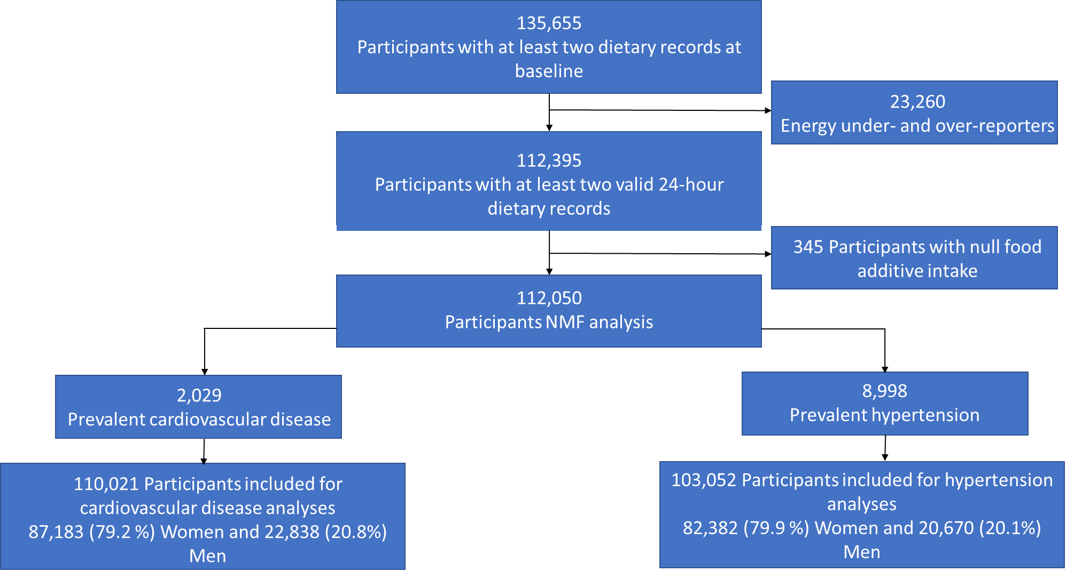

Additional Figure2 – Baseline distribution of the 75 food additives consumed by at least of 5% the participants, NutriNet-Santé cohort, 2009-2024 (n= 112,050).
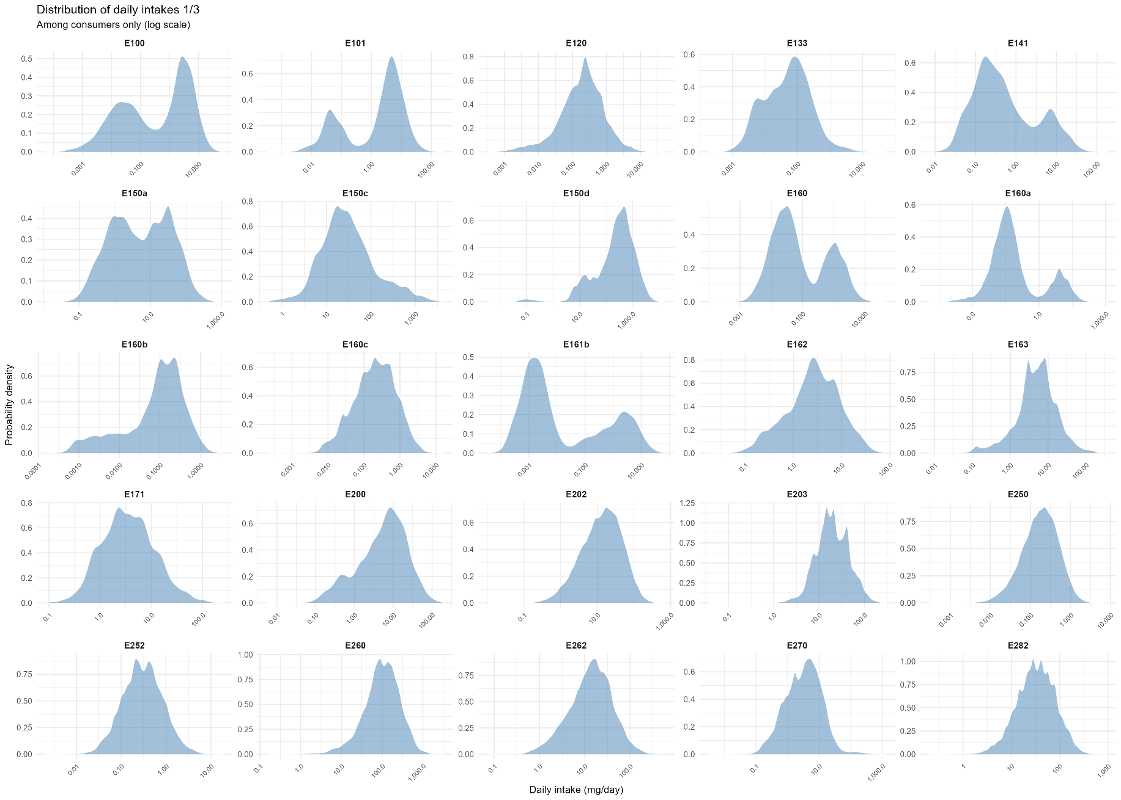
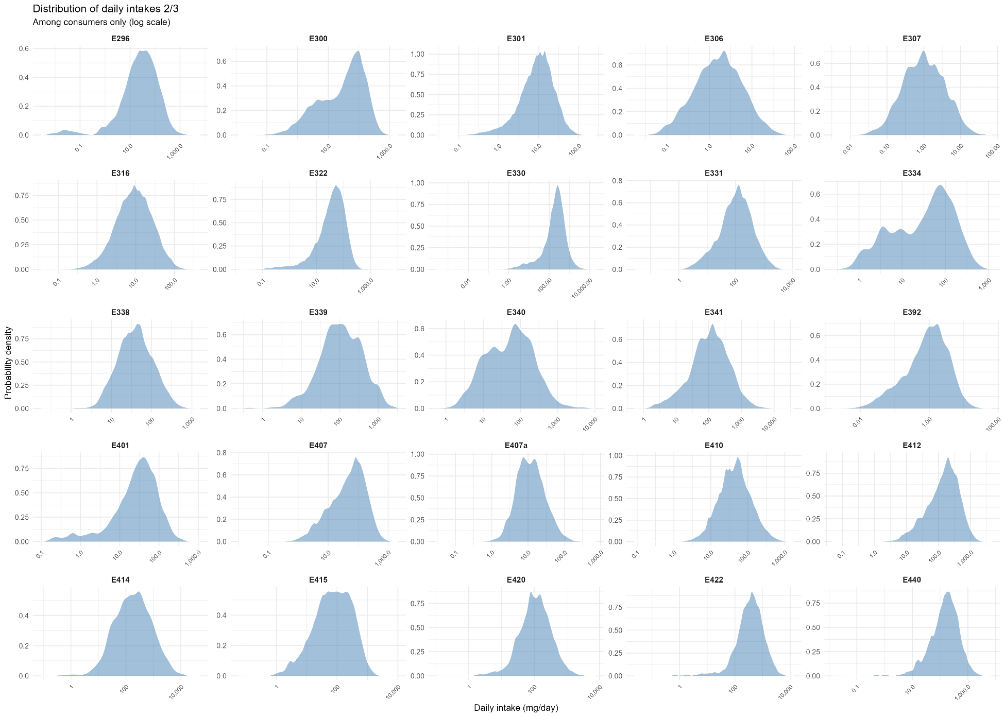
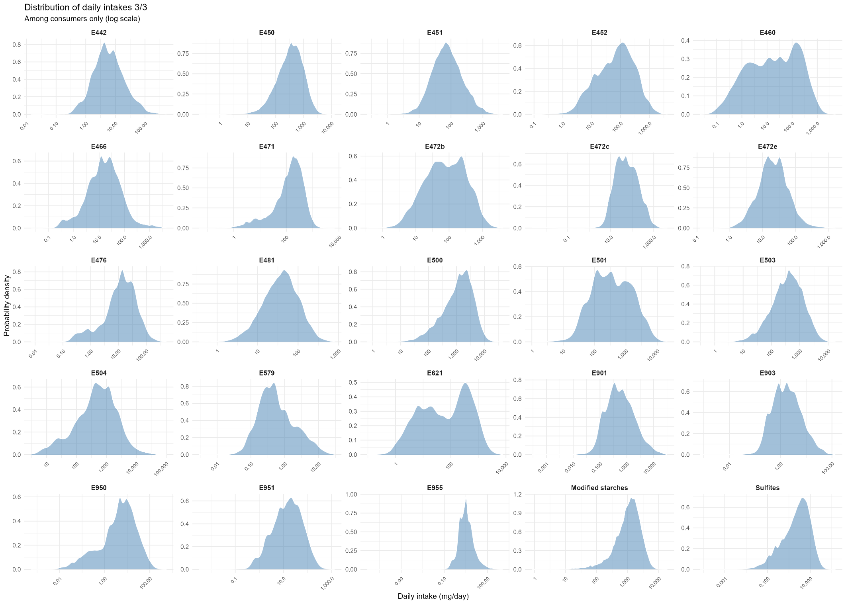

Additional Figure3 – Dose-response associations between exposure to food additive mixtures and incidence of hypertension (n=103,052) and cardiovascular diseases (n=110,021), Restricted Cubic Splines, NutriNet-Santé cohort, 2009-2024

A: Mixture 1. B: Mixture 2. C: Mixture 3. D: Mixture 4. E: Mixture 5.
A1: Association between Mixture 1 and hypertension  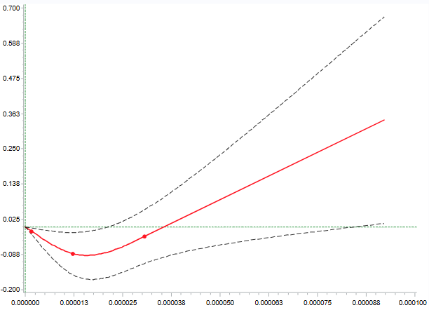  P for non-linearity = 0.004 | A2: Association between Mixture 1 and cardiovascular diseases  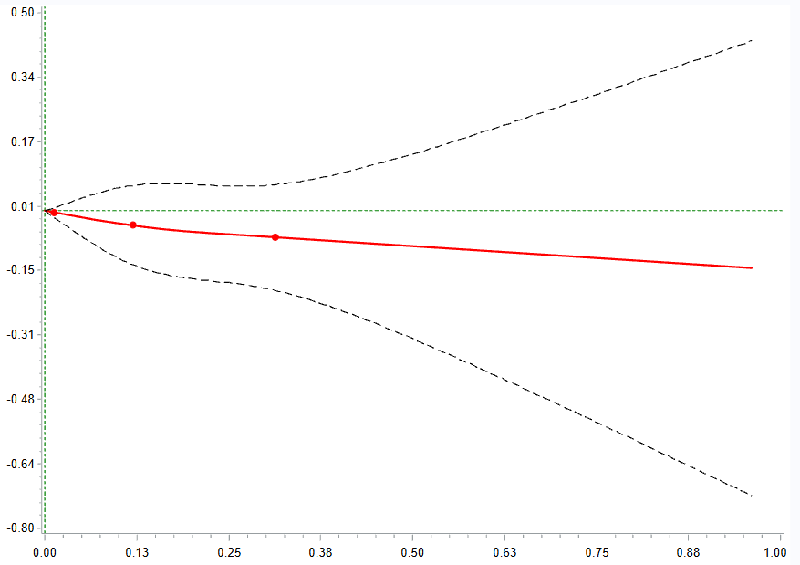  P for non-linearity = 0.801
A3: Association between Mixture 1 and coronary heart disease  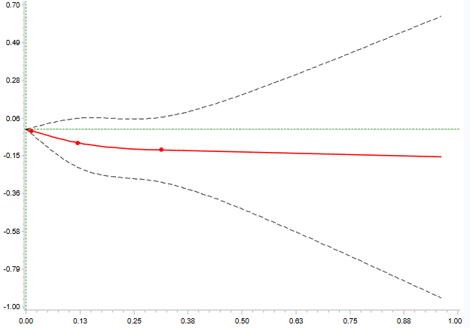  P for non-linearity = 0.555 | A4: Association between Mixture 1 and cerebrovascular accident  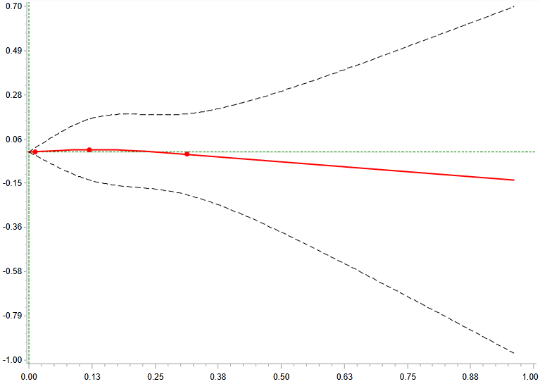  P for non-linearity = 0.779

B1: Association between Mixture 2 and hypertension  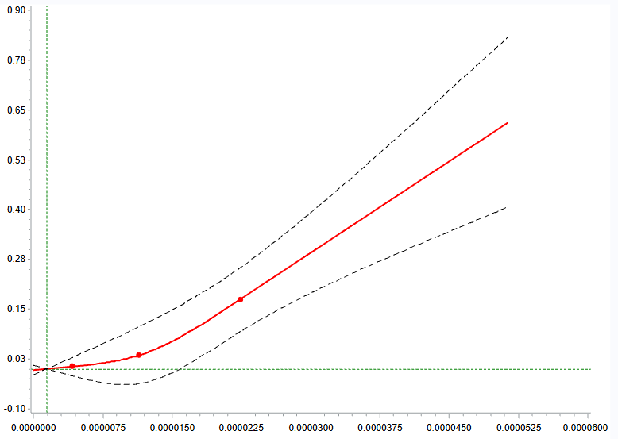  P for non-linearity = 0.042 | B2: Association between Mixture 2 and cardiovascular diseases  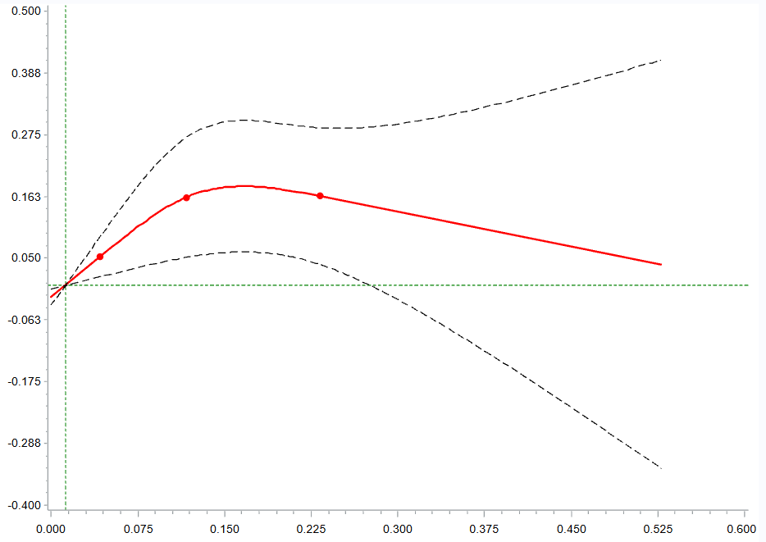  P for non-linearity = 0.035
B3: Association between Mixture 2 intake and coronary heart disease  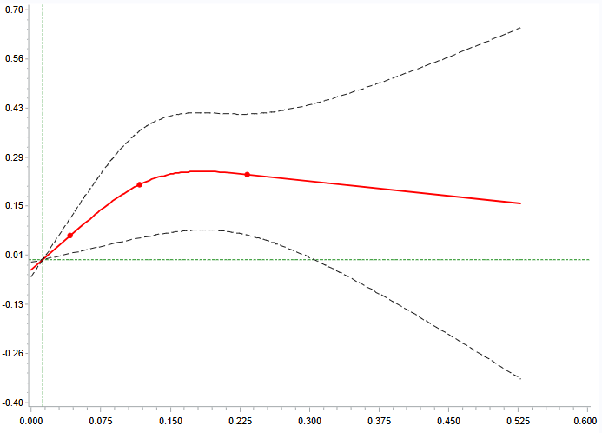  P for non-linearity = 0.068 | B4: Association between Mixture 2 and cerebrovascular accident  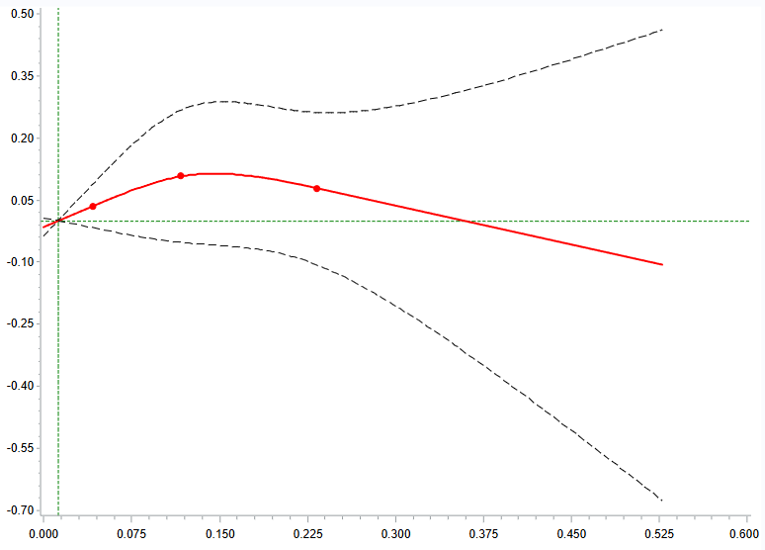  P for non-linearity = 0.233

C1: Association between Mixture 3 and hypertension  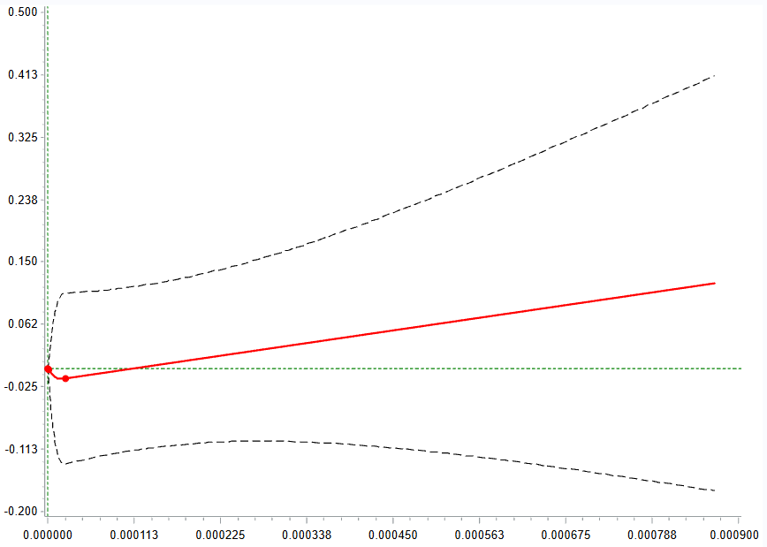  P for non-linearity = 0.785 | C2: Association between Mixture 3 and cardiovascular diseases  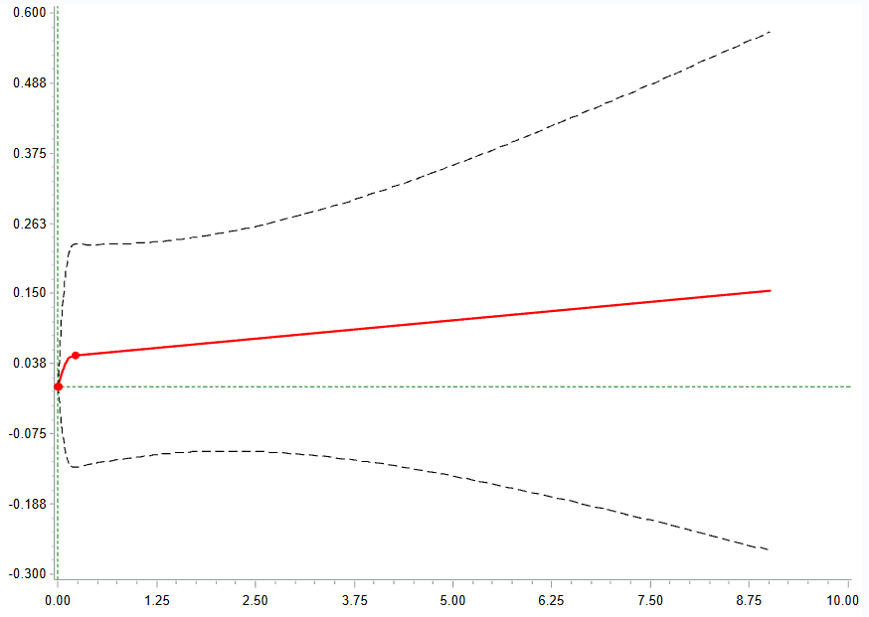  P for non-linearity = 0.609
C3: Association between Mixture 3 and coronary heart disease  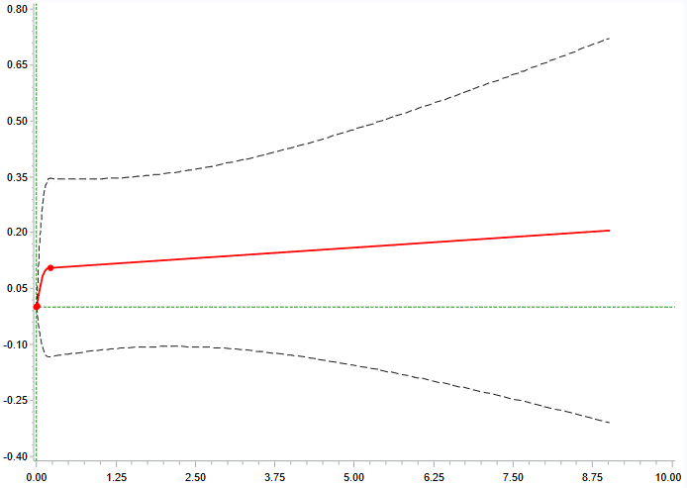  P for non-linearity = 0.404 |  | C4: Association between Mixture 3 and cerebrovascular accident  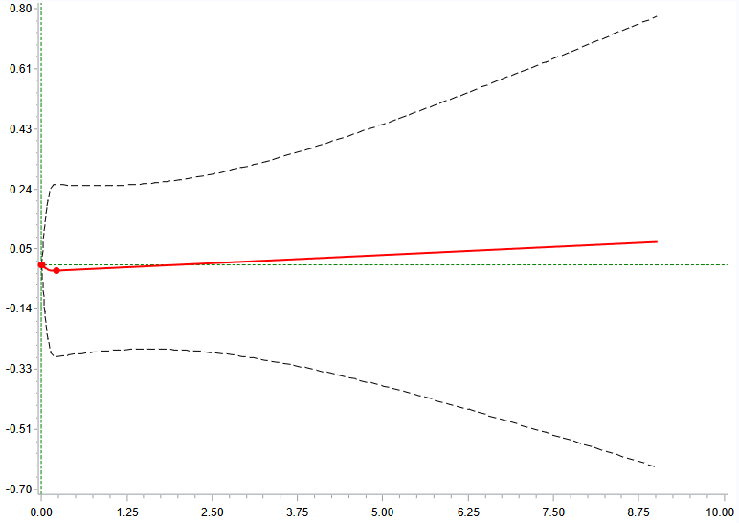  P for non-linearity = 0.888

D1: Association between Mixture 4 and hypertension  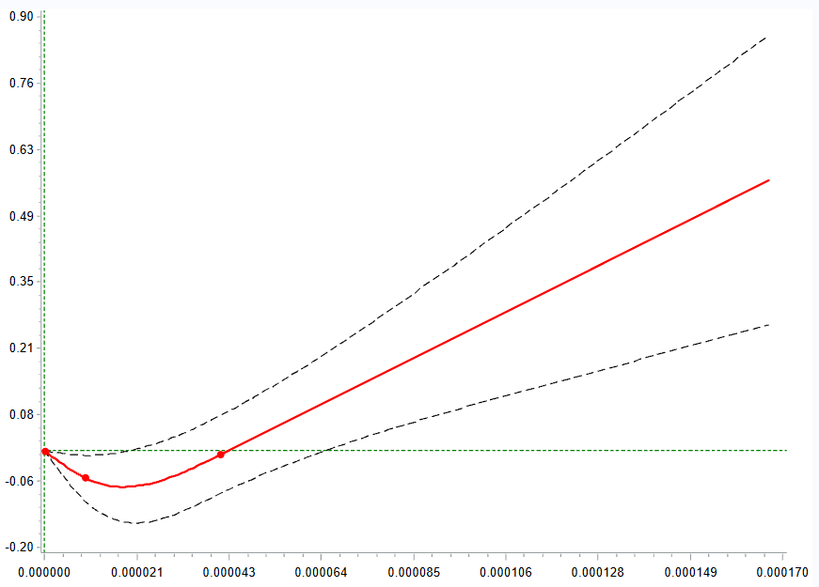  P for non-linearity = 0.001 | D2: Association between Mixture 4 and cardiovascular diseases  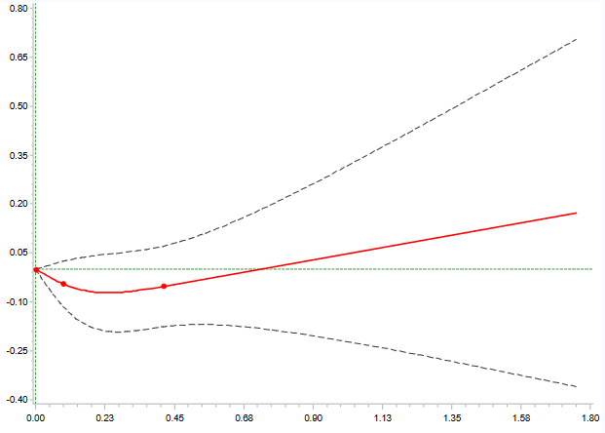  P for non-linearity = 0.197
D3: Association between Mixture 4 and coronary heart disease  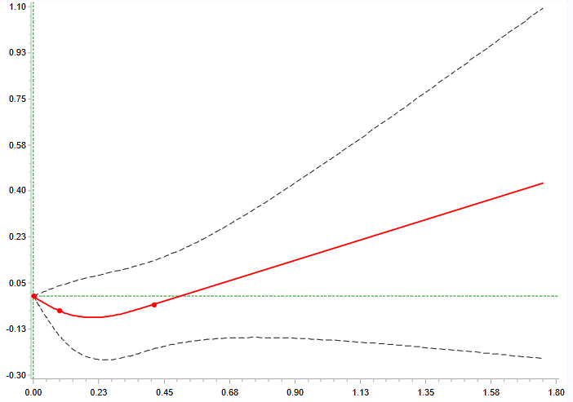  P for non-linearity = 0.163 | D4: Association between Mixture 4 and cerebrovascular accident  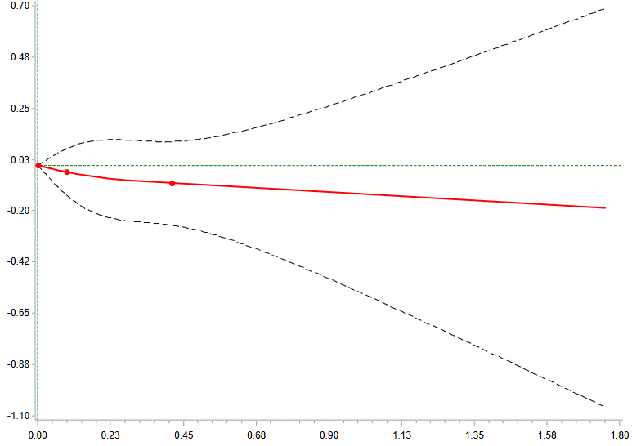  P for non-linearity = 0.746

E1: Association between Mixture 5 and hypertension  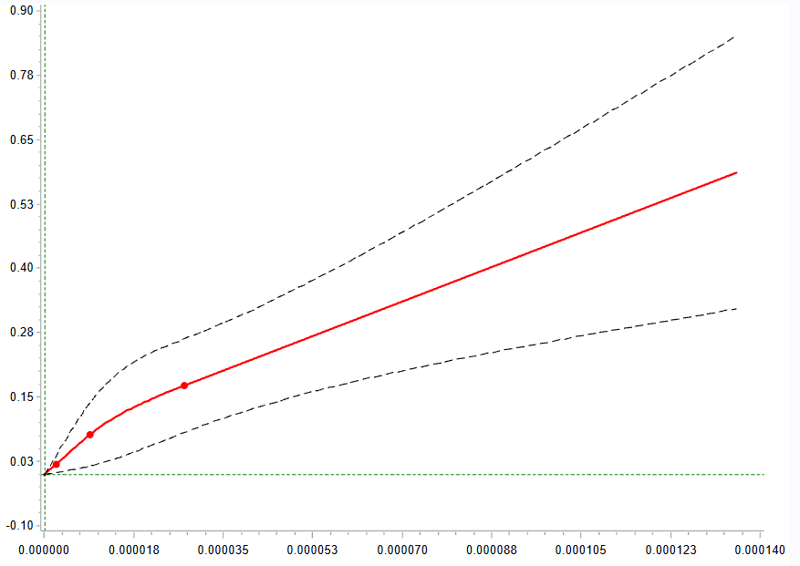  P for non-linearity = 0.226 | E2: Association between Mixture 5 and cardiovascular diseases  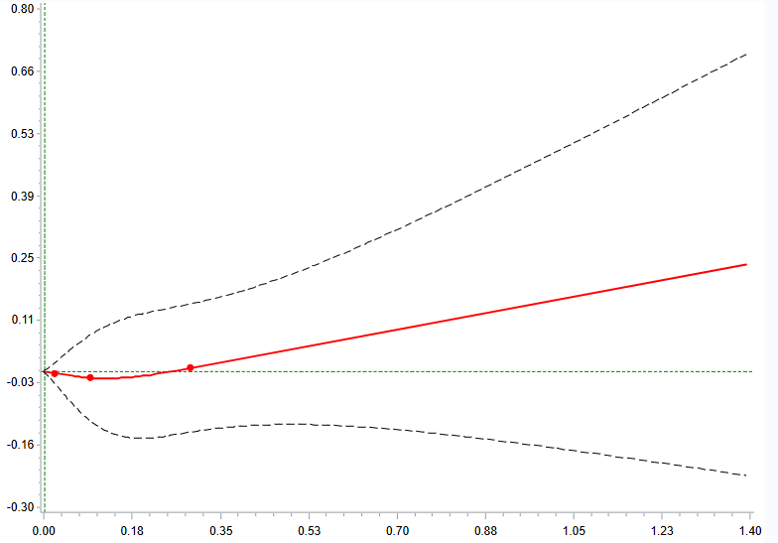  P for non-linearity = 0.559
E3: Association between Mixture 5 and coronary heart disease  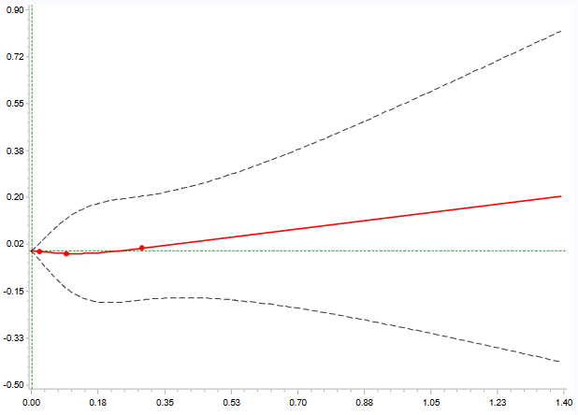  P for non-linearity = 0.747 | E4: Association between Mixture 5 and cerebrovascular accident  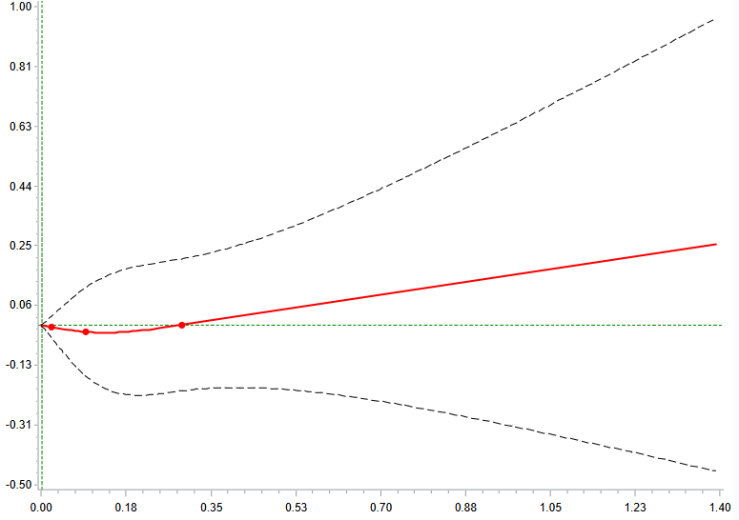  P for non-linearity = 0.630

Additional Figure4 – Kernel density distribution of food additives mixtures scores, NutriNet-Santé cohort, n= 112,050, 2009-2024 ª
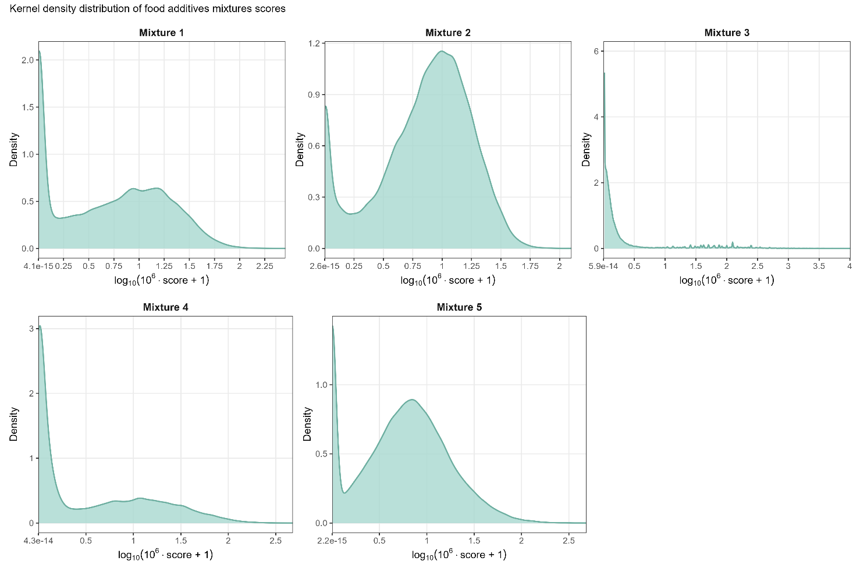

Additional Tables

Additional Table1 – Daily food additive intakes among study participants from the NutriNet-Santé cohort, 2009-2024ª

Food additive name | European code | Mean in mg/d/kg of body weight, all participants (SD) | Median in mg/d/kg of body weight, all participants [25th–75th percentiles] | Mean in mg/d, all participants (SD) | Median in mg/d, all participants [25th–75th percentiles] | Mean in mg/d, in consumers only (SD) | Median in mg/d, in consumers only [25th-75th percentiles] | Proportion of consumers (%)
Citric acid | E330 | 4.94 (8.23) | 3.04 [1.08-5.95] | 319.46 (534.90) | 197.27 [70.05-383.32] | 349.00 (549.79) | 221.63 [102.98-408.76] | 0.92
E14xx (E1404–E1452) | Modifed starches | 20.09 (18.41) | 15.93 [7.02-28.11] | 1294.39 (1169.09) | 1030.59 [446.43-1813.83] | 1423.74 (1148.56) | 1153.12 [610.11-1915.86] | 0.91
Lecithins | E322 | 0.87 (2.31) | 0.52 [0.14-1.12] | 55.87 (151.04) | 33.78 [9.20-72.09] | 64.47 (160.52) | 41.78 [18.56-79.86] | 0.87
Food additive sulphites | Total Sulphites | 0.06 (0.09) | 0.03 [0.00-0.08] | 3.97 (5.72) | 1.87 [0.24-5.42] | 4.74 (5.95) | 2.74 [0.83-6.43] | 0.84
Ascorbic acid | E300 | 0.94 (1.42) | 0.37 [0.03-1.33] | 59.78 (87.99) | 24.05 [2.09-85.70] | 71.85 (91.86) | 40.69 [7.70-102.28] | 0.83
Xanthan gum | E415 | 2.05 (3.43) | 0.72 [0.10-2.60] | 133.27 (221.86) | 46.19 [6.70-167.98] | 165.88 (236.34) | 76.68 [26.76-216.11] | 0.80
Pectins | E440 | 3.19 (4.70) | 1.77 [0.30-4.16] | 205.74 (301.59) | 114.09 [18.84-266.40] | 256.28 (316.77) | 161.75 [72.02-320.71] | 0.80
Mono- and diglycerides of fatty acids | E471 | 2.70 (3.44) | 1.63 [0.11-3.90] | 174.99 (224.14) | 104.98 [7.33-253.26] | 220.08 (230.78) | 157.48 [64.63-302.66] | 0.80
Carrageenan | E407 | 1.06 (1.65) | 0.43 [0.01-1.46] | 68.70 (106.06) | 27.89 [0.52-94.24] | 91.28 (113.52) | 54.65 [17.86-121.05] | 0.75
Sodium nitrite | E250 | 0.00 (0.00) | 0.00 [0.00-0.00] | 0.21 (0.29) | 0.11 [0.00-0.28] | 0.28 (0.31) | 0.18 [0.09-0.36] | 0.74
Sodium carbonates | E500 | 22.52 (32.78) | 10.29 [0.00-32.01] | 1436.45 (2064.05) | 660.50 [0.00-2051.67] | 1993.46 (2191.33) | 1300.00 [500.00-2696.53] | 0.72
Guar gum | E412 | 2.50 (3.50) | 1.24 [0.00-3.57] | 162.92 (230.58) | 79.09 [0.00-228.57] | 231.86 (244.30) | 161.66 [67.32-309.34] | 0.70
Diphosphates | E450 | 5.72 (8.18) | 2.83 [0.00-8.01] | 366.01 (518.03) | 180.95 [0.00-514.29] | 525.61 (549.08) | 357.14 [165.47-700.00] | 0.70
Potassium sorbate | E202 | 0.26 (0.45) | 0.08 [0.00-0.32] | 16.61 (29.33) | 5.25 [0.00-21.04] | 25.37 (33.04) | 14.19 [5.50-32.66] | 0.65
Sodium erythorbate | E316 | 0.13 (0.25) | 0.02 [0.00-0.15] | 8.16 (16.07) | 1.38 [0.00-9.82] | 15.51 (19.41) | 8.99 [4.32-19.05] | 0.53
Sodium ascorbate | E301 | 0.10 (0.17) | 0.00 [0.00-0.15] | 6.66 (11.27) | 0.00 [0.00-9.86] | 13.34 (12.86) | 9.88 [4.96-17.14] | 0.50
Paprika extract, capsanthin, capsorubin | E160c | 0.00 (0.01) | 0.00 [0.00-0.00] | 0.21 (0.49) | 0.00 [0.00-0.20] | 0.43 (0.64) | 0.21 [0.08-0.53] | 0.48
Sodium citrates | E331 | 1.59 (4.06) | 0.00 [0.00-1.51] | 104.34 (268.48) | 0.00 [0.00-100.00] | 221.99 (356.72) | 107.14 [43.71-250.19] | 0.47
Ammonium carbonates | E503 | 5.23 (11.84) | 0.00 [0.00-5.34] | 332.36 (746.22) | 0.00 [0.00-342.00] | 722.65 (963.69) | 400.00 [160.00-900.00] | 0.46
Locust bean gum | E410 | 0.51 (1.13) | 0.00 [0.00-0.60] | 33.16 (73.10) | 0.00 [0.00-39.19] | 73.47 (94.22) | 44.27 [22.32-85.38] | 0.45
Carotenes | E160a | 0.02 (0.13) | 0.00 [0.00-0.00] | 1.33 (8.17) | 0.00 [0.00-0.03] | 3.13 (12.31) | 0.05 [0.02-0.21] | 0.43
Lactic acid | E270 | 0.05 (0.26) | 0.00 [0.00-0.03] | 3.09 (16.81) | 0.00 [0.00-1.71] | 8.22 (26.63) | 3.41 [1.28-7.96] | 0.38
Carotenoids | E160 | 0.00 (0.01) | 0.00 [0.00-0.00] | 0.20 (0.83) | 0.00 [0.00-0.02] | 0.55 (1.30) | 0.05 [0.02-0.59] | 0.37
Acesulfame K | E950 | 0.06 (0.21) | 0.00 [0.00-0.02] | 4.23 (13.78) | 0.00 [0.00-1.53] | 12.59 (21.45) | 5.04 [1.45-14.26] | 0.34
Potassium nitrate | E252 | 0.00 (0.01) | 0.00 [0.00-0.00] | 0.16 (0.44) | 0.00 [0.00-0.14] | 0.50 (0.66) | 0.30 [0.15-0.61] | 0.32
Lutein | E161b | 0.01 (0.03) | 0.00 [0.00-0.00] | 0.34 (1.85) | 0.00 [0.00-0.00] | 1.20 (3.31) | 0.00 [0.00-0.60] | 0.28
Sorbitol | E420 | 0.86 (2.97) | 0.00 [0.00-0.40] | 54.51 (183.72) | 0.00 [0.00-25.76] | 197.39 (306.65) | 109.89 [53.98-224.82] | 0.28
Aspartame | E951 | 0.14 (0.49) | 0.00 [0.00-0.03] | 9.15 (31.06) | 0.00 [0.00-1.81] | 33.25 (52.00) | 15.53 [5.32-40.09] | 0.28
Carminic acid, Carmines | E120 | 0.00 (0.01) | 0.00 [0.00-0.00] | 0.13 (0.61) | 0.00 [0.00-0.02] | 0.48 (1.09) | 0.22 [0.08-0.48] | 0.27
Sulphite ammonia caramel | E150d | 2.17 (7.23) | 0.00 [0.00-0.09] | 143.06 (473.87) | 0.00 [0.00-5.95] | 550.82 (800.00) | 282.86 [88.39-662.95] | 0.26
Glycerol | E422 | 2.40 (6.96) | 0.00 [0.00-0.31] | 152.32 (438.56) | 0.00 [0.00-18.21] | 589.81 (697.64) | 388.61 [184.44-746.03] | 0.26
Curcumin | E100 | 0.01 (0.03) | 0.00 [0.00-0.00] | 0.60 (2.25) | 0.00 [0.00-0.00] | 2.41 (4.00) | 0.69 [0.03-3.35] | 0.25
Calcium propionate | E282 | 0.19 (0.49) | 0.00 [0.00-0.00] | 11.95 (31.45) | 0.00 [0.00-0.00] | 47.82 (47.36) | 33.57 [17.86-60.48] | 0.25
Triphosphates | E451 | 0.50 (1.79) | 0.00 [0.00-0.00] | 32.41 (116.14) | 0.00 [0.00-0.00] | 139.12 (207.51) | 72.79 [35.93-152.96] | 0.23
Plain caramel | E150a | 0.08 (0.35) | 0.00 [0.00-0.00] | 5.15 (22.76) | 0.00 [0.00-0.00] | 22.20 (43.08) | 5.36 [1.07-26.79] | 0.23
Extracts of rosemary | E392 | 0.01 (0.02) | 0.00 [0.00-0.00] | 0.41 (1.46) | 0.00 [0.00-0.00] | 1.85 (2.65) | 0.99 [0.36-2.28] | 0.22
Polyphosphates | E452 | 0.54 (2.08) | 0.00 [0.00-0.00] | 35.15 (134.46) | 0.00 [0.00-0.00] | 163.69 (251.29) | 77.14 [21.91-199.80] | 0.21
Phosphoric acid | E338 | 0.20 (0.68) | 0.00 [0.00-0.00] | 13.31 (44.49) | 0.00 [0.00-0.00] | 65.09 (79.45) | 40.06 [19.76-79.03] | 0.20
Monosodium glutamate | E621 | 0.82 (3.65) | 0.00 [0.00-0.00] | 51.63 (225.23) | 0.00 [0.00-0.00] | 268.51 (453.42) | 70.09 [10.57-357.14] | 0.19
Calcium phosphates | E341 | 0.74 (4.24) | 0.00 [0.00-0.00] | 47.03 (262.78) | 0.00 [0.00-0.00] | 252.46 (564.67) | 113.57 [44.64-267.86] | 0.19
Annatto, bixin, norbixin | E160b | 0.00 (0.00) | 0.00 [0.00-0.00] | 0.03 (0.12) | 0.00 [0.00-0.00] | 0.18 (0.24) | 0.11 [0.03-0.24] | 0.17
Polyglycerol polyricinoleate | E476 | 0.05 (0.22) | 0.00 [0.00-0.00] | 3.44 (14.25) | 0.00 [0.00-0.00] | 22.52 (30.03) | 13.14 [5.59-28.57] | 0.15
Sucralose | E955 | 0.02 (0.19) | 0.00 [0.00-0.00] | 1.27 (11.29) | 0.00 [0.00-0.00] | 8.47 (28.07) | 3.17 [1.43-6.61] | 0.15
Sodium alginate | E401 | 0.10 (0.40) | 0.00 [0.00-0.00] | 6.58 (26.17) | 0.00 [0.00-0.00] | 47.22 (54.75) | 31.42 [13.47-61.73] | 0.14
Diacetyltartaric acid esters of mono- and diglycerides of fatty acids | E472e | 0.08 (0.43) | 0.00 [0.00-0.00] | 5.16 (27.21) | 0.00 [0.00-0.00] | 37.34 (64.47) | 20.94 [10.63-41.85] | 0.14
Anthocyanins | E163 | 0.02 (0.12) | 0.00 [0.00-0.00] | 1.31 (7.20) | 0.00 [0.00-0.00] | 9.89 (17.48) | 5.25 [2.43-10.12] | 0.13
Tocopherol-rich extract | E306 | 0.01 (0.04) | 0.00 [0.00-0.00] | 0.46 (2.32) | 0.00 [0.00-0.00] | 3.50 (5.48) | 1.73 [0.64-4.05] | 0.13
Alpha-tocopherol | E307 | 0.00 (0.02) | 0.00 [0.00-0.00] | 0.28 (1.51) | 0.00 [0.00-0.00] | 2.22 (3.69) | 0.96 [0.39-2.38] | 0.13
Malic acid | E296 | 0.13 (0.84) | 0.00 [0.00-0.00] | 8.14 (54.66) | 0.00 [0.00-0.00] | 68.74 (145.18) | 27.86 [9.91-76.13] | 0.12
Sodium carboxy methyl cellulose | E466 | 0.10 (1.06) | 0.00 [0.00-0.00] | 6.42 (68.80) | 0.00 [0.00-0.00] | 57.45 (198.50) | 16.28 [6.30-42.24] | 0.11
Lactic acid esters of mono- and diglycerides of fatty acids | E472b | 0.31 (1.60) | 0.00 [0.00-0.00] | 19.78 (103.29) | 0.00 [0.00-0.00] | 180.22 (261.37) | 76.19 [28.57-238.10] | 0.11
Carnauba wax | E903 | 0.01 (0.04) | 0.00 [0.00-0.00] | 0.43 (2.77) | 0.00 [0.00-0.00] | 4.07 (7.54) | 1.75 [0.71-4.17] | 0.11
Gum arabic (Acacia gum) | E414 | 0.92 (6.95) | 0.00 [0.00-0.00] | 58.57 (454.55) | 0.00 [0.00-0.00] | 552.26 (1294.50) | 186.83 [60.90-522.94] | 0.11
Cellulose | E460 | 0.18 (1.18) | 0.00 [0.00-0.00] | 11.28 (75.81) | 0.00 [0.00-0.00] | 106.60 (210.19) | 19.05 [2.64-121.43] | 0.11
Sodium acetates | E262 | 0.04 (0.18) | 0.00 [0.00-0.00] | 2.35 (11.74) | 0.00 [0.00-0.00] | 22.95 (29.61) | 14.16 [7.08-28.32] | 0.10
Acetic acid | E260 | 0.23 (1.06) | 0.00 [0.00-0.00] | 15.12 (68.06) | 0.00 [0.00-0.00] | 151.60 (160.48) | 104.17 [53.57-190.48] | 0.10
Ammonium phosphatides | E442 | 0.02 (0.14) | 0.00 [0.00-0.00] | 1.25 (8.91) | 0.00 [0.00-0.00] | 13.06 (25.91) | 5.36 [2.68-12.86] | 0.10
Beetroot Red, betanin | E162 | 0.01 (0.04) | 0.00 [0.00-0.00] | 0.46 (2.47) | 0.00 [0.00-0.00] | 5.03 (6.65) | 2.86 [1.14-6.29] | 0.09
Sodium stearoyl-2-lactylate | E481 | 0.08 (0.40) | 0.00 [0.00-0.00] | 5.01 (25.03) | 0.00 [0.00-0.00] | 58.52 (64.74) | 38.53 [19.05-71.80] | 0.09
Processed eucheuma seaweed | E407a | 0.02 (0.13) | 0.00 [0.00-0.00] | 1.45 (8.27) | 0.00 [0.00-0.00] | 18.30 (23.62) | 11.39 [6.10-21.41] | 0.08
Ferrous gluconate | E579 | 0.00 (0.01) | 0.00 [0.00-0.00] | 0.10 (0.72) | 0.00 [0.00-0.00] | 1.33 (2.35) | 0.47 [0.23-1.17] | 0.07
Citric acid esters of mono- and diglycerides of fatty acids | E472c | 0.13 (0.88) | 0.00 [0.00-0.00] | 8.17 (57.13) | 0.00 [0.00-0.00] | 114.15 (182.98) | 53.93 [21.57-137.02] | 0.07
Magnesium carbonates | E504 | 1.39 (13.60) | 0.00 [0.00-0.00] | 88.40 (872.32) | 0.00 [0.00-0.00] | 1277.32 (3078.48) | 500.00 [166.67-1250.00] | 0.07
Titanium dioxide | E171 | 0.01 (0.07) | 0.00 [0.00-0.00] | 0.52 (4.23) | 0.00 [0.00-0.00] | 7.57 (14.33) | 3.43 [1.53-7.68] | 0.07
Calcium sorbate | E203 | 0.03 (0.15) | 0.00 [0.00-0.00] | 1.84 (9.43) | 0.00 [0.00-0.00] | 27.21 (24.96) | 20.00 [11.43-34.29] | 0.07
Riboflavins | E101 | 0.01 (0.04) | 0.00 [0.00-0.00] | 0.34 (2.61) | 0.00 [0.00-0.00] | 5.28 (8.96) | 3.21 [0.12-6.46] | 0.06
Tartaric acid | E334 | 0.07 (0.46) | 0.00 [0.00-0.00] | 4.82 (30.84) | 0.00 [0.00-0.00] | 75.40 (97.72) | 44.64 [8.57-104.17] | 0.06
Potassium carbonates | E501 | 0.83 (6.38) | 0.00 [0.00-0.00] | 54.11 (414.03) | 0.00 [0.00-0.00] | 914.82 (1452.89) | 350.00 [125.00-1125.00] | 0.06
Sorbic acid | E200 | 0.01 (0.08) | 0.00 [0.00-0.00] | 0.68 (4.69) | 0.00 [0.00-0.00] | 11.47 (15.79) | 6.41 [2.11-14.38] | 0.06
Brilliant Blue FCF | E133 | 0.00 (0.00) | 0.00 [0.00-0.00] | 0.01 (0.23) | 0.00 [0.00-0.00] | 0.19 (0.95) | 0.05 [0.01-0.15] | 0.06
Sodium phosphates | E339 | 0.18 (1.32) | 0.00 [0.00-0.00] | 11.78 (85.46) | 0.00 [0.00-0.00] | 215.31 (299.48) | 107.14 [46.92-276.79] | 0.05
Beeswax | E901 | 0.00 (0.01) | 0.00 [0.00-0.00] | 0.07 (0.58) | 0.00 [0.00-0.00] | 1.22 (2.17) | 0.54 [0.24-1.29] | 0.05
Ammonia caramel | E150c | 0.08 (1.01) | 0.00 [0.00-0.00] | 5.35 (63.26) | 0.00 [0.00-0.00] | 100.05 (255.69) | 26.79 [11.90-65.55] | 0.05
Copper complexes of chlorophylls and chlorophyllins | E141 | 0.00 (0.03) | 0.00 [0.00-0.00] | 0.14 (1.66) | 0.00 [0.00-0.00] | 2.63 (6.76) | 0.35 [0.14-1.63] | 0.05
Potassium phosphates | E340 | 0.12 (1.63) | 0.00 [0.00-0.00] | 7.50 (99.31) | 0.00 [0.00-0.00] | 147.84 (416.65) | 58.29 [16.66-145.71] | 0.05

Abbreviations: BMI: Body Mass Index; hPDI: healthy Plant-based Diet Index.
ª All food additive intake data in this table are calculated as the mean intake during the first 2 years of participation in the study.

Additional Table2 – Spearman correlation matrix between food additive intakes and NMF components identified by Lee and Sung algorithm (main model), NutriNet-Santé cohort, 2009-2024ª

Food additives | Mixtures
Food additives | 1 | 2 | 3 | 4 | 5
E100 Curcumin | 0.01 | 0.16 | 0.00 | 0.01 | 0.07
E101 Riboflavin | 0.07 | 0.02 | 0.53 | 0.01 | 0.05
E120 Cochineal, Carminic acid, Carmines | 0.02 | 0.09 | 0.00 | 0.01 | 0.09
E133 Brilliant blue FCF | 0.01 | 0.00 | 0.02 | 0.00 | 0.03
E141 Copper complexes of chlorophyllis and chlorophyllins | 0.01 | 0.02 | 0.00 | 0.01 | 0.04
E150a Plain caramel | 0.02 | 0.08 | 0.10 | 0.02 | 0.05
E150c Ammonia caramel | 0.00 | 0.10 | 0.02 | 0.01 | 0.03
E150d Sulphite ammonia caramel | 0.03 | -0.01 | 0.03 | 0.03 | 0.59
E160 Carotene | 0.02 | 0.01 | 0.02 | 0.02 | 0.08
E160a Carotenes | 0.01 | 0.03 | 0.00 | 0.01 | 0.11
E160b Annatto, Bixin, Norbixin | 0.04 | 0.09 | 0.00 | 0.04 | 0.05
E160c Paprika extract, capsanthin, capsorubin | 0.05 | 0.11 | 0.00 | 0.02 | 0.17
E161b Lutein | 0.02 | 0.13 | 0.00 | 0.01 | 0.14
E162 Beetroot Red, betanin | 0.02 | 0.05 | 0.00 | 0.01 | 0.07
E163 Anthocyanins | 0.02 | 0.06 | 0.01 | 0.02 | 0.15
E171 Titanium dioxide | 0.02 | 0.01 | 0.00 | 0.04 | 0.10
E200 Sorbic acid | 0.05 | 0.02 | 0.00 | 0.05 | 0.01
E202 Potassium sorbate | 0.06 | 0.17 | 0.01 | 0.03 | 0.09
E203 Calcium sorbate | -0.01 | 0.01 | 0.00 | 0.00 | 0.00
E250 Sodium nitrite | 0.05 | 0.10 | 0.01 | 0.02 | 0.10
E252 Potassium nitrate | 0.03 | -0.02 | 0.01 | 0.01 | 0.05
E260 Acetic acid | 0.02 | 0.10 | 0.00 | 0.01 | 0.04
E262 Sodium acetate | 0.02 | 0.05 | 0.00 | 0.01 | 0.02
E270 Lactic acid | 0.01 | 0.04 | 0.00 | 0.00 | 0.06
E282 Calcium propionate | 0.04 | 0.05 | 0.00 | 0.02 | 0.07
E296 Malic acid | 0.08 | 0.01 | 0.01 | 0.03 | 0.19
E300 Ascorbic acid | 0.11 | 0.06 | 0.00 | 0.03 | 0.06
E301 Sodium ascorbate | 0.06 | 0.04 | 0.01 | 0.02 | 0.06
E306 Tocopherols | 0.03 | 0.04 | 0.02 | 0.04 | 0.05
E307 Alpha-tocopherol | 0.11 | 0.04 | 0.24 | 0.28 | 0.02
E316 Sodium erythorbate | 0.05 | 0.10 | 0.00 | 0.01 | 0.06
E322 Lecithins | 0.11 | 0.04 | 0.09 | 0.15 | 0.08
E330 Citric acid | 0.13 | 0.09 | 0.10 | 0.04 | 0.83
E331 Sodium citrates | 0.04 | 0.10 | 0.12 | 0.03 | 0.63
E334 Tartaric acid | 0.01 | 0.06 | 0.00 | 0.00 | 0.01
E338 Phosphoric acid | 0.03 | -0.01 | 0.03 | 0.03 | 0.59
E339 Sodium phosphates | 0.02 | 0.08 | 0.01 | 0.01 | 0.03
E340 Potassium phosphates | 0.02 | 0.02 | 0.00 | 0.00 | 0.03
E341 Calcium phosphates | 0.07 | 0.07 | 0.05 | 0.08 | 0.02
E392 Carnosic acid (Extracts of rosemary) | 0.01 | 0.02 | 0.00 | 0.02 | 0.04
E401 Sodium alginate | 0.08 | 0.04 | 0.01 | 0.02 | 0.04
E407 Carrageenan | 0.06 | 0.24 | 0.01 | 0.04 | 0.08
E407a Processed euchema seaweed | 0.01 | 0.04 | 0.00 | 0.01 | 0.04
E410 Locust bean gum | 0.04 | 0.02 | 0.01 | 0.02 | 0.07
E412 Guar gum | 0.03 | 0.26 | 0.01 | 0.01 | 0.15
E414 Arabic gum | 0.02 | 0.00 | 0.01 | 0.03 | 0.23
E415 Xanthan gum | 0.05 | 0.16 | 0.01 | 0.02 | 0.11
E420 Sorbitols | 0.16 | 0.02 | 0.01 | 0.08 | 0.09
E422 Glycerol | 0.37 | 0.05 | 0.01 | 0.10 | 0.08
E440 Pectins | 0.13 | 0.31 | 0.00 | 0.02 | 0.15
E442 Ammonium phosphatides | 0.01 | -0.01 | 0.00 | 0.01 | 0.03
E450 Diphosphates | 0.78 | 0.07 | 0.07 | 0.3 | 0.08
E451 Triphosphates | 0.03 | 0.12 | 0.00 | 0.01 | 0.05
E452 Polyphosphates | 0.01 | 0.21 | 0.00 | 0.00 | 0.06
E460 Cellulose (microcrystalline cellulose) | 0.06 | 0.06 | 0.01 | 0.08 | 0.04
E466 Carboxy methyl cellulose | 0.02 | 0.04 | 0.03 | 0.02 | 0.04
E471 Mono- and diglycerides of fatty acids | 0.10 | 0.13 | 0.00 | 0.08 | 0.13
E472b Lactic acid esters of mono- and diglycerides of fatty acids | 0.03 | 0.05 | 0.01 | 0.03 | 0.03
E472c Citric acid esters of mono- and diglycerides of fatty acids | 0.01 | 0.11 | 0.01 | 0.00 | 0.02
E472e Mono and diacetyl tartaric acid esters of mono and diglycerides of fatty acids | 0.07 | 0.01 | 0.11 | 0.18 | 0.04
E476 Polyglycerol polyricinoleate | 0.03 | 0.05 | 0.00 | 0.09 | 0.03
E481 Sodium stearoyl-2-lactylate | 0.02 | 0.01 | 0.00 | 0.02 | 0.04
E500 Sodium carbonates | 0.99 | 0.03 | 0.14 | 0.35 | 0.05
E501 Potassium carbonates | 0.17 | 0.00 | 0.00 | 0.00 | 0.00
E503 Ammonium carbonates | 0.35 | 0.01 | 0.17 | 0.99 | 0.01
E504 Magnesium carbonates | 0.14 | -0.01 | 0.99 | 0.17 | 0.04
E579 Ferrous gluconate | 0.02 | 0.02 | 0.00 | 0.01 | 0.02
E621 Monosodium glutamate | 0.01 | 0.12 | 0.00 | -0.01 | 0.04
E901 Beeswax | 0.02 | 0.00 | 0.00 | 0.02 | 0.09
E903 Carnauba wax | 0.03 | 0.00 | 0.01 | 0.03 | 0.18
E950 Acesulfame K | 0.02 | 0.08 | 0.04 | 0.02 | 0.56
E951 Aspartame | 0.00 | 0.06 | 0.02 | 0.00 | 0.41
E955 Sucralose | 0.01 | 0.01 | 0.03 | 0.00 | 0.25
Food additive sulphites | 0.01 | -0.01 | -0.01 | -0.02 | -0.02
Modified starches | 0.05 | 0.99 | 0.00 | 0.01 | 0.03
ª Non-negative Matrix Factorisation (NMF) was conducted on the 75 food additives that were consumed by at least 5% of the study population. Five main NMF components (i.e. the five food additive mixtures) were identified. This table provides the correlation matrix (Spearman) between each NMF component and each food additive intake. Food additives with correlation coefficients ≥│0.15│were considered as the most emblematic of each mixture for description purposes, though all additives contributed to the mixture score calculation. NMF was performed on the population sample common between hypertension and cardiovascular disease analyses, i.e. before excluding specific prevalent cases (n=112,050). The variance explained by this model was 89.3% of the total variance, as calculated by determining the reconstruction error of the original matrix.

Additional Table3 – Consensus map for rank number determination and sensitivity analyses using other decomposition algorithms in the NMF procedure

3. a. Rank selection in NMF (consensus map)

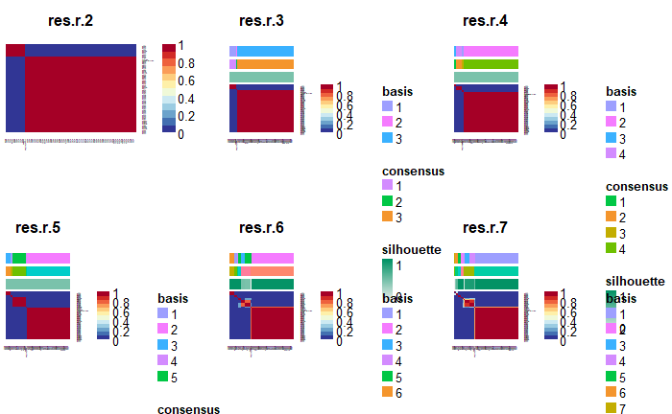

The consensus map provides a visual summary of the NMF analysis results, highlighting the stability of components across multiple iterations of the process, using the Lee algorithm³. The heatmap represents the pairwise homogeneity of samples within the same component, with values ranging from 0 (indicating that the samples are never grouped together) to 1 (indicating that the samples are always grouped together). Red squares denote strong agreement among samples, whereas blue squares signify weak or no agreement.
Components assignments are depicted by the accompanying colour bar, with each colour representing a distinct component. The consensus values quantify component stability, where higher values indicate more robust and well-defined components. Additionally, the silhouette metric evaluates clustering quality by assessing the separation between components and minimizing overlap.

3. b. Spearman correlation matrix between food additive intakes and NMF components identified by the Brunet algorithm (sensitivity analysis), NutriNet-Santé cohort, 2009-2024ª

Food additives | Mixtures
Food additives | 1 | 2 | 3 | 4 | 5
E100 Curcumin | 0.01 | 0.20 | 0.00 | 0.02 | 0.05
E101 Riboflavin | 0.05 | 0.04 | 0.52 | 0.01 | 0.05
E120 Cochineal, Carminic acid, Carmines | 0.03 | 0.11 | 0.00 | 0.01 | 0.07
E133 Brilliant blue FCF | 0.00 | 0.00 | 0.02 | 0.00 | 0.06
E141 Copper complexes of chlorophyllis and chlorophyllins | 0.00 | 0.03 | 0.00 | 0.01 | 0.05
E150a Plain caramel | 0.03 | 0.09 | 0.09 | 0.03 | 0.05
E150c Ammonia caramel | 0.01 | 0.12 | 0.02 | 0.03 | 0.11
E150d Sulphite ammonia caramel | 0.02 | -0.02 | 0.03 | 0.03 | 0.72
E160 Carotene | 0.03 | 0.05 | 0.02 | 0.02 | 0.10
E160a Carotenes | 0.02 | 0.07 | 0.01 | 0.01 | 0.09
E160b Annatto, Bixin, Norbixin | 0.04 | 0.11 | 0.00 | 0.03 | 0.03
E160c Paprika extract, capsanthin, capsorubin | 0.05 | 0.17 | 0.00 | 0.02 | 0.17
E161b Lutein | 0.01 | 0.17 | 0.00 | 0.02 | 0.12
E162 Beetroot Red, betanin | 0.03 | 0.11 | 0.00 | 0.02 | 0.02
E163 Anthocyanins | 0.02 | 0.08 | 0.01 | 0.02 | 0.15
E171 Titanium dioxide | 0.03 | 0.01 | 0.00 | 0.04 | 0.22
E200 Sorbic acid | 0.06 | 0.02 | 0.00 | 0.05 | 0.01
E202 Potassium sorbate | 0.07 | 0.32 | 0.01 | 0.03 | 0.07
E203 Calcium sorbate | -0.01 | 0.01 | 0.00 | 0.00 | 0.00
E250 Sodium nitrite | 0.04 | 0.18 | 0.01 | 0.02 | 0.07
E252 Potassium nitrate | 0.03 | 0.00 | 0.01 | 0.01 | 0.04
E260 Acetic acid | 0.02 | 0.16 | 0.00 | 0.01 | 0.04
E262 Sodium acetate | 0.02 | 0.08 | 0.00 | 0.00 | 0.03
E270 Lactic acid | 0.01 | 0.09 | 0.01 | 0.00 | 0.05
E282 Calcium propionate | 0.05 | 0.13 | 0.00 | 0.02 | 0.06
E296 Malic acid | 0.09 | 0.02 | 0.01 | 0.03 | 0.20
E300 Ascorbic acid | 0.12 | 0.12 | 0.00 | 0.04 | 0.05
E301 Sodium ascorbate | 0.05 | 0.07 | 0.01 | 0.02 | 0.05
E306 Tocopherols | 0.03 | 0.08 | 0.02 | 0.06 | 0.11
E307 Alpha-tocopherol | 0.10 | 0.04 | 0.24 | 0.28 | 0.04
E316 Sodium erythorbate | 0.04 | 0.15 | 0.00 | 0.01 | 0.03
E322 Lecithins | 0.11 | 0.07 | 0.09 | 0.15 | 0.21
E330 Citric acid | 0.14 | 0.15 | 0.10 | 0.05 | 0.51
E331 Sodium citrates | 0.04 | 0.13 | 0.13 | 0.04 | 0.70
E334 Tartaric acid | 0.01 | 0.10 | 0.00 | 0.00 | 0.00
E338 Phosphoric acid | 0.03 | -0.02 | 0.03 | 0.03 | 0.72
E339 Sodium phosphates | 0.03 | 0.16 | 0.01 | 0.03 | 0.04
E340 Potassium phosphates | 0.01 | 0.02 | 0.01 | 0.00 | 0.11
E341 Calcium phosphates | 0.07 | 0.07 | 0.04 | 0.38 | 0.01
E392 Carnosic acid (Extracts of rosemary) | 0.01 | 0.05 | 0.00 | 0.02 | 0.03
E401 Sodium alginate | 0.09 | 0.07 | 0.01 | 0.04 | 0.04
E407 Carrageenan | 0.06 | 0.32 | 0.01 | 0.05 | 0.07
E407a Processed euchema seaweed | 0.01 | 0.09 | 0.00 | 0.01 | 0.05
E410 Locust bean gum | 0.05 | 0.13 | 0.01 | 0.02 | 0.05
E412 Guar gum | 0.03 | 0.47 | 0.01 | 0.01 | 0.07
E414 Arabic gum | 0.02 | -0.01 | 0.00 | 0.02 | 0.48
E415 Xanthan gum | 0.06 | 0.35 | 0.01 | 0.02 | 0.05
E420 Sorbitols | 0.19 | 0.03 | 0.02 | 0.07 | 0.20
E422 Glycerol | 0.49 | 0.04 | 0.00 | 0.12 | 0.04
E440 Pectins | 0.13 | 0.44 | 0.00 | 0.03 | 0.06
E442 Ammonium phosphatides | 0.02 | 0.01 | 0.00 | 0.01 | 0.03
E450 Diphosphates | 0.82 | 0.11 | 0.07 | 0.30 | 0.04
E451 Triphosphates | 0.03 | 0.28 | 0.01 | 0.01 | 0.03
E452 Polyphosphates | 0.02 | 0.35 | 0.00 | 0.02 | 0.02
E460 Cellulose (microcrystalline cellulose) | 0.06 | 0.11 | 0.01 | 0.08 | 0.07
E466 Carboxy methyl cellulose | 0.03 | 0.06 | 0.04 | 0.03 | 0.17
E471 Mono- and diglycerides of fatty acids | 0.12 | 0.28 | 0.00 | 0.08 | 0.08
E472b Lactic acid esters of mono- and diglycerides of fatty acids | 0.03 | 0.10 | 0.01 | 0.04 | 0.04
E472c Citric acid esters of mono- and diglycerides of fatty acids | 0.01 | 0.18 | 0.01 | 0.03 | 0.04
E472e Mono and diacetyl tartaric acid esters of mono and diglycerides of fatty acids | 0.07 | 0.04 | 0.12 | 0.18 | 0.04
E476 Polyglycerol polyricinoleate | 0.03 | 0.07 | 0.00 | 0.16 | 0.02
E481 Sodium stearoyl-2-lactylate | 0.03 | 0.05 | 0.00 | 0.03 | 0.03
E500 Sodium carbonates | 0.97 | 0.02 | 0.12 | 0.35 | 0.02
E501 Potassium carbonates | 0.28 | 0.00 | 0.00 | 0.00 | 0.00
E503 Ammonium carbonates | 0.33 | 0.00 | 0.17 | 0.95 | 0.03
E504 Magnesium carbonates | 0.10 | -0.01 | 1.00 | 0.17 | 0.04
E579 Ferrous gluconate | 0.02 | 0.06 | 0.00 | 0.01 | 0.01
E621 Monosodium glutamate | 0.01 | 0.24 | 0.00 | -0.01 | -0.01
E901 Beeswax | 0.02 | 0.00 | 0.00 | 0.02 | 0.09
E903 Carnauba wax | 0.03 | 0.00 | 0.01 | 0.03 | 0.26
E950 Acesulfame K | 0.02 | 0.09 | 0.04 | 0.02 | 0.66
E951 Aspartame | 0.00 | 0.07 | 0.02 | 0.00 | 0.49
E955 Sucralose | 0.01 | 0.05 | 0.03 | 0.01 | 0.19
Food additive sulphites | 0.01 | 0.03 | 0.00 | -0.02 | -0.04
Modified starches | 0.05 | 0.89 | 0.00 | 0.03 | 0.00

ª NMF was performed on the 75 food additives that were consumed by at least 5% of the study population. Five main NMF components (i.e. the five food additive mixtures) were identified. This table provides the correlation matrix (Spearman) between each NMF component and each food additive intake. Food additives with correlation coefficients ≥│0.15│were considered as the most emblematic of each mixture for description purposes, though all additives contributed to the mixture score calculation. The variance explained by this model was 85.1% of the total variance, as calculated by determining the reconstruction error of the original matrix.

3. c. Spearman correlation matrix between food additive intakes and NMF components identified by non-smooth non-negative matrix factorisation (nsNMF) (sensitivity analysis), NutriNet-Santé cohort, 2009-2024ª

 | Mixtures
Food additives | 1 | 2 | 3 | 4 | 5
E100 Curcumin | 0.00 | 0.16 | 0.02 | 0.01 | 0.05
E101 Riboflavin | 0.00 | -0.01 | 0.35 | 0.00 | 0.03
E120 Cochineal, Carminic acid, Carmines | 0.01 | 0.07 | 0.02 | 0.01 | 0.07
E133 Brilliant blue FCF | 0.00 | -0.01 | 0.01 | 0.00 | 0.05
E141 Copper complexes of chlorophyllis and chlorophyllins | 0.00 | 0.01 | 0.01 | 0.00 | 0.05
E150a Plain caramel | 0.01 | 0.05 | 0.08 | 0.02 | 0.05
E150c Ammonia caramel | 0.00 | 0.11 | 0.04 | 0.01 | 0.05
E150d Sulphite ammonia caramel | -0.04 | -0.11 | 0.03 | 0.00 | 0.67
E160 Carotene | 0.01 | 0.01 | 0.04 | 0.01 | 0.09
E160a Carotenes | 0.00 | 0.03 | 0.02 | 0.01 | 0.09
E160b Annatto, Bixin, Norbixin | 0.03 | 0.07 | 0.02 | 0.03 | 0.04
E160c Paprika extract, capsanthin, capsorubin | 0.02 | 0.10 | 0.02 | 0.01 | 0.17
E161b Lutein | 0.00 | 0.13 | 0.01 | 0.01 | 0.12
E162 Beetroot Red, betanin | 0.01 | 0.06 | 0.02 | 0.01 | 0.04
E163 Anthocyanins | 0.00 | 0.03 | 0.02 | 0.01 | 0.15
E171 Titanium dioxide | 0.00 | -0.02 | 0.01 | 0.04 | 0.19
E200 Sorbic acid | 0.04 | 0.00 | 0.00 | 0.06 | 0.01
E202 Potassium sorbate | 0.05 | 0.21 | 0.05 | 0.03 | 0.09
E203 Calcium sorbate | -0.01 | 0.01 | 0.00 | 0.00 | 0.00
E250 Sodium nitrite | 0.03 | 0.11 | 0.03 | 0.02 | 0.08
E252 Potassium nitrate | 0.03 | -0.02 | 0.01 | 0.01 | 0.04
E260 Acetic acid | 0.01 | 0.11 | 0.02 | 0.01 | 0.04
E262 Sodium acetate | 0.02 | 0.05 | 0.01 | 0.00 | 0.03
E270 Lactic acid | 0.00 | 0.06 | 0.02 | 0.00 | 0.06
E282 Calcium propionate | 0.04 | 0.07 | 0.02 | 0.01 | 0.07
E296 Malic acid | 0.06 | -0.04 | 0.02 | 0.02 | 0.20
E300 Ascorbic acid | 0.10 | 0.05 | 0.03 | 0.03 | 0.06
E301 Sodium ascorbate | 0.04 | 0.03 | 0.02 | 0.02 | 0.05
E306 Tocopherols | 0.01 | 0.04 | 0.04 | 0.05 | 0.09
E307 Alpha-tocopherol | -0.03 | -0.03 | 0.37 | 0.13 | 0.00
E316 Sodium erythorbate | 0.03 | 0.10 | 0.02 | 0.01 | 0.04
E322 Lecithins | 0.05 | 0.00 | 0.12 | 0.12 | 0.15
E330 Citric acid | 0.07 | 0.00 | 0.10 | 0.01 | 0.53
E331 Sodium citrates | -0.03 | -0.01 | 0.10 | 0.00 | 0.66
E334 Tartaric acid | 0.01 | 0.07 | 0.01 | 0.00 | 0.00
E338 Phosphoric acid | -0.04 | -0.11 | 0.03 | 0.00 | 0.67
E339 Sodium phosphates | 0.02 | 0.11 | 0.04 | 0.01 | 0.04
E340 Potassium phosphates | 0.01 | 0.02 | 0.01 | 0.00 | 0.07
E341 Calcium phosphates | 0.05 | 0.01 | 0.08 | 0.19 | 0.01
E392 Carnosic acid (Extracts of rosemary) | 0.00 | 0.02 | 0.01 | 0.02 | 0.04
E401 Sodium alginate | 0.08 | 0.02 | 0.03 | 0.02 | 0.05
E407 Carrageenan | 0.03 | 0.22 | 0.05 | 0.04 | 0.07
E407a Processed euchema seaweed | 0.00 | 0.05 | 0.02 | 0.01 | 0.06
E410 Locust bean gum | 0.03 | 0.06 | 0.04 | 0.01 | 0.06
E412 Guar gum | 0.01 | 0.35 | 0.05 | 0.01 | 0.09
E414 Arabic gum | -0.02 | -0.05 | 0.01 | 0.00 | 0.42
E415 Xanthan gum | 0.04 | 0.24 | 0.04 | 0.02 | 0.07
E420 Sorbitols | 0.15 | -0.04 | 0.04 | 0.07 | 0.18
E422 Glycerol | 0.46 | -0.08 | 0.03 | 0.09 | 0.06
E440 Pectins | 0.11 | 0.33 | 0.04 | 0.02 | 0.07
E442 Ammonium phosphatides | 0.01 | -0.01 | 0.01 | 0.01 | 0.03
E450 Diphosphates | 0.74 | -0.14 | 0.16 | 0.22 | 0.06
E451 Triphosphates | 0.02 | 0.19 | 0.04 | 0.01 | 0.04
E452 Polyphosphates | 0.01 | 0.27 | 0.03 | 0.01 | 0.03
E460 Cellulose (microcrystalline cellulose) | 0.03 | 0.05 | 0.02 | 0.09 | 0.06
E466 Carboxy methyl cellulose | 0.01 | 0.03 | 0.04 | 0.02 | 0.13
E471 Mono- and diglycerides of fatty acids | 0.08 | 0.15 | 0.05 | 0.07 | 0.12
E472b Lactic acid esters of mono- and diglycerides of fatty acids | 0.02 | 0.05 | 0.03 | 0.03 | 0.05
E472c Citric acid esters of mono- and diglycerides of fatty acids | 0.01 | 0.14 | 0.04 | 0.00 | 0.03
E472e Mono and diacetyl tartaric acid esters of mono and diglycerides of fatty acids | -0.01 | -0.02 | 0.20 | 0.10 | 0.03
E476 Polyglycerol polyricinoleate | -0.01 | 0.03 | 0.02 | 0.16 | 0.02
E481 Sodium stearoyl-2-lactylate | 0.01 | 0.01 | 0.02 | 0.02 | 0.04
E500 Sodium carbonates | 0.88 | -0.25 | 0.18 | 0.29 | 0.03
E501 Potassium carbonates | 0.28 | -0.05 | 0.00 | -0.01 | 0.00
E503 Ammonium carbonates | 0.04 | -0.22 | 0.35 | 0.91 | -0.04
E504 Magnesium carbonates | -0.04 | -0.08 | 0.77 | 0.05 | -0.03
E579 Ferrous gluconate | 0.01 | 0.03 | 0.01 | 0.01 | 0.01
E621 Monosodium glutamate | 0.01 | 0.19 | 0.01 | 0.00 | 0.00
E901 Beeswax | 0.01 | -0.02 | 0.01 | 0.02 | 0.09
E903 Carnauba wax | 0.00 | -0.05 | 0.01 | 0.02 | 0.25
E950 Acesulfame K | -0.04 | -0.01 | 0.04 | -0.01 | 0.62
E951 Aspartame | -0.04 | 0.00 | 0.02 | -0.02 | 0.45
E955 Sucralose | -0.01 | 0.00 | 0.02 | 0.00 | 0.20
Food additive sulphites | 0.01 | 0.03 | -0.01 | -0.01 | -0.03
Modified starches | 0.02 | 0.78 | 0.05 | 0.02 | -0.02

ª Food additive mixtures were identified using a non-smooth nonnegative matrix factorisation (nsNMF), which optimizes a clear cost function designed to explicitly represent sparsity⁴. NMF was performed on the 75 food additives that were consumed by at least 5% of the study population. Five main NMF components (i.e. the five food additive mixtures) were identified. This table provides the correlation matrix (Spearman) between each NMF component and each food additive intake. Food additives with correlation coefficients ≥│0.15│were considered as the most emblematic of each mixture for description purposes, though all additives contributed to the mixture score calculation. The variance explained by this model was 62.5% of the total variance, as calculated by determining the reconstruction error of the original matrix.

3. d. Stability of NMF food additive mixtures across time, NutriNet-Santé cohort, 2009-2024

- NMF performed on mean daily food additive intakes in the 2009-2016 period
 | Mixtures
Food additives | 1 | 2 | 3 | 4 | 5
E100 Curcumin | 0.02 | 0.16 | 0.00 | 0.01 | 0.07
E101 Riboflavin | 0.08 | 0.02 | 0.57 | 0.01 | 0.05
E120 Cochineal, Carminic acid, Carmines | 0.02 | 0.09 | 0.00 | 0.01 | 0.08
E133 Brilliant blue FCF | 0.00 | 0.00 | 0.02 | 0.00 | 0.03
Modified starches | 0.05 | 1.00 | 0.00 | 0.02 | 0.01
E141 Copper complexes of chlorophyllis and chlorophyllins | 0.00 | 0.02 | 0.00 | 0.01 | 0.04
E150a Plain caramel | 0.03 | 0.07 | 0.09 | 0.03 | 0.04
E150c Ammonia caramel | 0.00 | 0.10 | 0.03 | 0.01 | 0.03
E150d Sulphite ammonia caramel | 0.03 | -0.01 | 0.03 | 0.03 | 0.66
E160 Carotene | 0.03 | 0.01 | 0.02 | 0.02 | 0.08
E160a Carotenes | 0.02 | 0.04 | 0.00 | 0.01 | 0.10
E160b Annatto, Bixin, Norbixin | 0.05 | 0.08 | 0.01 | 0.04 | 0.05
E160c Paprika extract, capsanthin, capsorubin | 0.05 | 0.11 | 0.00 | 0.02 | 0.17
E161b Lutein | 0.02 | 0.12 | 0.00 | 0.01 | 0.13
E162 Beetroot Red, betanin | 0.02 | 0.05 | 0.00 | 0.01 | 0.06
E163 Anthocyanins | 0.03 | 0.06 | 0.01 | 0.02 | 0.15
E171 Titanium dioxide | 0.02 | 0.01 | 0.00 | 0.04 | 0.11
E200 Sorbic acid | 0.06 | 0.02 | 0.00 | 0.05 | 0.01
E202 Potassium sorbate | 0.07 | 0.18 | 0.01 | 0.03 | 0.09
E203 Calcium sorbate | -0.01 | 0.01 | 0.00 | -0.01 | 0.00
Food additive sulphites | 0.00 | -0.01 | 0.00 | -0.02 | -0.03
E250 Sodium nitrite | 0.05 | 0.10 | 0.01 | 0.02 | 0.10
E252 Potassium nitrate | 0.03 | -0.02 | 0.01 | 0.01 | 0.05
E260 Acetic acid | 0.02 | 0.09 | 0.00 | 0.01 | 0.04
E262 Sodium acetate | 0.02 | 0.05 | 0.00 | 0.01 | 0.02
E270 Lactic acid | 0.01 | 0.04 | 0.00 | 0.00 | 0.06
E282 Calcium propionate | 0.04 | 0.04 | 0.00 | 0.02 | 0.07
E296 Malic acid | 0.08 | 0.01 | 0.01 | 0.03 | 0.18
E300 Ascorbic acid | 0.11 | 0.06 | 0.00 | 0.03 | 0.06
E301 Sodium ascorbate | 0.06 | 0.04 | 0.01 | 0.02 | 0.06
E306 Tocopherols | 0.03 | 0.04 | 0.02 | 0.04 | 0.05
E307 Alpha-tocopherol | 0.11 | 0.03 | 0.25 | 0.27 | 0.02
E316 Sodium erythorbate | 0.05 | 0.10 | 0.01 | 0.01 | 0.06
E322 Lecithins | 0.12 | 0.04 | 0.09 | 0.15 | 0.08
E330 Citric acid | 0.13 | 0.09 | 0.09 | 0.04 | 0.78
E331 Sodium citrates | 0.05 | 0.09 | 0.11 | 0.03 | 0.67
E334 Tartaric acid | 0.01 | 0.05 | 0.00 | 0.01 | 0.01
E338 Phosphoric acid | 0.03 | -0.01 | 0.03 | 0.03 | 0.66
E339 Sodium phosphates | 0.02 | 0.08 | 0.01 | 0.01 | 0.02
E340 Potassium phosphates | 0.02 | 0.01 | 0.01 | 0.00 | 0.03
E341 Calcium phosphates | 0.07 | 0.07 | 0.05 | 0.08 | 0.02
E392 Carnosic acid (Extract of rosemary) | 0.01 | 0.02 | 0.00 | 0.02 | 0.04
E401 Sodium alginate | 0.08 | 0.04 | 0.01 | 0.02 | 0.04
E407 Carrageenan | 0.07 | 0.26 | 0.01 | 0.04 | 0.07
E407a Processed euchema seaweed | 0.01 | 0.04 | 0.00 | 0.01 | 0.05
E410 Locust bean gum | 0.05 | 0.03 | 0.01 | 0.02 | 0.06
E412 Guar gum | 0.03 | 0.27 | 0.01 | 0.01 | 0.14
E414 Arabic gum | 0.03 | 0.00 | 0.01 | 0.03 | 0.24
E415 Xanthan gum | 0.05 | 0.16 | 0.01 | 0.03 | 0.11
E420 Sorbitols | 0.17 | 0.02 | 0.01 | 0.08 | 0.09
E422 Glycerol | 0.37 | 0.05 | 0.01 | 0.11 | 0.07
E440 Pectins | 0.12 | 0.33 | 0.00 | 0.02 | 0.13
E442 Ammonium phosphatides | 0.02 | -0.01 | 0.00 | 0.01 | 0.03
E450 Diphosphates | 0.79 | 0.07 | 0.08 | 0.31 | 0.07
E451 Triphosphates | 0.03 | 0.12 | 0.00 | 0.02 | 0.06
E452 Polyphosphates | 0.02 | 0.20 | 0.01 | 0.01 | 0.06
E460 Cellulose (microcrystalline cellulose) | 0.05 | 0.06 | 0.01 | 0.08 | 0.04
E466 Carboxy methyl cellulose | 0.02 | 0.04 | 0.03 | 0.02 | 0.04
E471 Mono- and diglycerides of fatty acids | 0.10 | 0.14 | 0.00 | 0.08 | 0.12
E472b Lactic acid esters of mono- and diglycerides of fatty acids | 0.04 | 0.06 | 0.01 | 0.03 | 0.03
E472c Citric acid esters of mono- and diglycerides of fatty acids | 0.01 | 0.10 | 0.01 | 0.00 | 0.02
E472e Mono and diacetyl tartaric acid esters of mono and diglycerides of fatty acids | 0.08 | 0.01 | 0.11 | 0.18 | 0.05
E476 Polyglycerol polyricinoleate | 0.04 | 0.07 | 0.00 | 0.10 | 0.02
E481 Sodium stearoyl-2-lactylate | 0.02 | 0.01 | 0.00 | 0.02 | 0.04
E500 Sodium carbonates | 1.00 | 0.03 | 0.15 | 0.36 | 0.04
E501 Potassium carbonates | 0.17 | 0.01 | 0.00 | 0.00 | 0.00
E503 Ammonium carbonates | 0.36 | 0.01 | 0.17 | 1.00 | 0.02
E504 Magnesium carbonates | 0.15 | -0.01 | 1.00 | 0.17 | 0.04
E579 Ferrous gluconate | 0.02 | 0.02 | 0.00 | 0.01 | 0.01
E621 Monosodium glutamate | 0.01 | 0.12 | 0.00 | -0.01 | 0.04
E901 Beeswax | 0.02 | 0.00 | 0.01 | 0.02 | 0.09
E903 Carnauba wax | 0.04 | 0.00 | 0.01 | 0.03 | 0.18
E950 Acesulfame K | 0.02 | 0.08 | 0.04 | 0.02 | 0.60
E951 Aspartame | 0.00 | 0.07 | 0.02 | 0.00 | 0.45
E955 Sucralose | 0.01 | 0.02 | 0.02 | 0.00 | 0.24

NMF performed on mean daily food additive intakes in the 2017-2024 period
 | Mixtures
Food additives | 1 | 2 | 3 | 4 | 5
E100 Curcumin | 0.02 | 0.14 | 0.02 | 0.07 | 0.00
E101 Riboflavin | 0.02 | 0.03 | 0.00 | 0.04 | 0.33
E120 Cochineal, Carminic acid, Carmines | 0.03 | 0.09 | 0.02 | 0.09 | 0.00
E133 Brilliant blue FCF | 0.01 | 0.01 | 0.01 | 0.02 | 0.03
Modified starches | 0.06 | 1.00 | 0.04 | 0.14 | 0.01
E141 Copper complexes of chlorophyllis and chlorophyllins | 0.01 | 0.05 | 0.02 | 0.05 | 0.01
E150a Plain caramel | 0.02 | 0.07 | 0.03 | 0.05 | 0.01
E150c Ammonia caramel | 0.02 | 0.06 | 0.02 | 0.02 | 0.00
E150d Sulphite ammonia caramel | 0.03 | 0.02 | 0.01 | 0.25 | 0.08
E160 Carotene | 0.03 | 0.03 | 0.02 | 0.06 | 0.01
E160a Carotenes | 0.01 | 0.05 | 0.02 | 0.10 | 0.01
E160b Annatto, Bixin, Norbixin | 0.04 | 0.11 | 0.03 | 0.07 | 0.00
E160c Paprika extract, capsanthin, capsorubin | 0.06 | 0.10 | 0.02 | 0.13 | 0.00
E161b Lutein | 0.02 | 0.10 | 0.00 | 0.10 | 0.01
E162 Beetroot Red, betanin | 0.01 | 0.04 | 0.01 | 0.08 | 0.00
E163 Anthocyanins | 0.02 | 0.06 | 0.01 | 0.14 | 0.08
E171 Titanium dioxide | 0.01 | 0.02 | 0.02 | 0.06 | 0.01
E200 Sorbic acid | 0.08 | 0.01 | 0.01 | 0.02 | 0.02
E202 Potassium sorbate | 0.08 | 0.23 | 0.03 | 0.18 | 0.01
E203 Calcium sorbate | -0.02 | 0.02 | -0.01 | 0.00 | 0.00
Food additive sulphites | 0.02 | 0.03 | 0.00 | 0.03 | 0.00
E250 Sodium nitrite | 0.08 | 0.16 | 0.03 | 0.13 | 0.00
E252 Potassium nitrate | 0.07 | 0.03 | 0.01 | 0.06 | 0.01
E260 Acetic acid | 0.02 | 0.10 | 0.00 | 0.04 | 0.00
E262 Sodium acetate | 0.04 | 0.11 | 0.02 | 0.06 | 0.00
E270 Lactic acid | 0.04 | 0.06 | 0.00 | 0.09 | 0.00
E282 Calcium propionate | 0.07 | 0.07 | 0.03 | 0.11 | 0.01
E296 Malic acid | 0.14 | 0.02 | 0.05 | 0.20 | 0.02
E300 Ascorbic acid | 0.09 | 0.10 | 0.06 | 0.13 | 0.00
E301 Sodium ascorbate | 0.04 | 0.09 | 0.02 | 0.07 | 0.00
E306 Tocopherols | 0.03 | 0.02 | 0.02 | 0.07 | 0.04
E307 Alpha-tocopherol | 0.01 | 0.06 | 0.03 | 0.03 | 0.09
E316 Sodium erythorbate | 0.11 | 0.18 | 0.02 | 0.11 | 0.00
E322 Lecithins | 0.12 | 0.05 | 0.13 | 0.10 | 0.06
E330 Citric acid | 0.14 | 0.15 | 0.04 | 0.95 | 0.07
E331 Sodium citrates | 0.06 | 0.12 | 0.03 | 0.38 | 0.17
E334 Tartaric acid | 0.03 | 0.08 | 0.00 | 0.02 | 0.00
E338 Phosphoric acid | 0.03 | 0.02 | 0.01 | 0.26 | 0.08
E339 Sodium phosphates | 0.01 | 0.07 | 0.01 | 0.05 | 0.02
E340 Potassium phosphates | 0.02 | 0.01 | 0.00 | 0.04 | 0.00
E341 Calcium phosphates | 0.07 | 0.05 | 0.06 | 0.10 | 0.00
E392 Carnosic acid (Extracts of rosemary) | 0.02 | 0.05 | 0.03 | 0.07 | 0.01
E401 Sodium alginate | 0.07 | 0.04 | 0.02 | 0.09 | 0.00
E407 Carrageenan | 0.08 | 0.28 | 0.05 | 0.10 | 0.00
E407a Processed euchema seaweed | 0.02 | 0.06 | 0.01 | 0.05 | 0.00
E410 Locust bean gum | 0.07 | 0.06 | 0.02 | 0.10 | 0.01
E412 Guar gum | 0.03 | 0.22 | 0.01 | 0.19 | 0.00
E414 Arabic gum | 0.03 | 0.00 | 0.05 | 0.15 | 0.00
E415 Xanthan gum | 0.05 | 0.20 | 0.01 | 0.29 | 0.00
E420 Sorbitols | 0.14 | 0.04 | 0.06 | 0.09 | 0.02
E422 Glycerol | 0.37 | 0.05 | 0.13 | 0.24 | 0.01
E440 Pectins | 0.14 | 0.24 | 0.03 | 0.18 | 0.00
E442 Ammonium phosphatides | 0.02 | 0.00 | 0.01 | 0.02 | 0.00
E450 Diphosphates | 0.70 | 0.13 | 0.25 | 0.24 | 0.01
E451 Triphosphates | 0.02 | 0.15 | 0.02 | 0.11 | 0.01
E452 Polyphosphates | 0.01 | 0.24 | 0.01 | 0.17 | 0.00
E460 Cellulose (microcrystalline cellulose) | 0.04 | 0.07 | 0.04 | 0.03 | 0.01
E466 Carboxy methyl cellulose | 0.05 | 0.02 | 0.02 | 0.05 | 0.01
E471 Mono- and diglycerides of fatty acids | 0.13 | 0.20 | 0.10 | 0.21 | 0.00
E472b Lactic acid esters of mono- and diglycerides of fatty acids | 0.02 | 0.05 | 0.03 | 0.02 | 0.00
E472c Citric acid esters of mono- and diglycerides of fatty acids | 0.00 | 0.09 | 0.01 | 0.04 | 0.02
E472e Mono and diacetyl tartaric acid esters of mono and diglycerides of fatty acids | 0.04 | 0.02 | 0.07 | 0.07 | 0.00
E476 Polyglycerol polyricinoleate | 0.02 | 0.09 | 0.05 | 0.05 | 0.01
E481 Sodium stearoyl-2-lactylate | 0.02 | 0.04 | 0.03 | 0.06 | 0.00
E500 Sodium carbonates | 1.00 | 0.05 | 0.28 | 0.15 | 0.02
E501 Potassium carbonates | 0.13 | -0.01 | 0.01 | -0.01 | 0.00
E503 Ammonium carbonates | 0.27 | 0.04 | 1.00 | 0.03 | 0.01
E504 Magnesium carbonates | 0.02 | 0.00 | 0.01 | 0.01 | 1.00
E579 Ferrous gluconate | 0.02 | 0.04 | 0.00 | 0.03 | 0.00
E621 Monosodium glutamate | 0.00 | 0.14 | 0.00 | 0.18 | 0.01
E901 Beeswax | 0.02 | 0.00 | 0.01 | 0.09 | 0.02
E903 Carnauba wax | 0.02 | 0.00 | 0.02 | 0.14 | 0.02
E950 Acesulfame K | 0.02 | 0.07 | 0.00 | 0.35 | 0.06
E951 Aspartame | 0.02 | 0.05 | 0.01 | 0.25 | 0.05
E955 Sucralose | 0.00 | 0.01 | 0.00 | 0.38 | 0.01

Only a few additives were not consistent (e.g. E307 and E472e found in period 1 and not in period 2 and conversely for E621), which can be attributed to market evolutions and reformulations, but most of the additives and their grouping in the five mixtures were identical.

Additional Table4 – Standardised coefficient matrix derived from the NMF procedure, Lee and Sung algorithm (main model), NutriNet-Santé cohort, 2009-2024

Food additives | Mixture 1 | Mixture 2 | Mixture 3 | Mixture 4 | Mixture 5
E100 - Curcumin | 0.00 | 0.02 | 0.00 | 0.00 | 0.01
E101 - Riboflavin | 0.00 | 0.00 | 0.14 | 0.00 | 0.01
E120 - Cochineal, Carminic acid, Carmines | 0.00 | 0.00 | 0.00 | 0.00 | 0.00
E133 - Brilliant blue FCF | 0.00 | 0.00 | 0.00 | 0.00 | 0.00
E141 - Copper complexes of chlorophyllis and chlorophyllins | 0.00 | 0.00 | 0.00 | 0.00 | 0.01
E150a - Plain caramel | 0.02 | 0.13 | 0.20 | 0.03 | 0.11
E150c - Ammonia caramel | 0.00 | 0.29 | 0.13 | 0.00 | 0.03
E150d - Sulphite ammonia caramel | 0.00 | 0.00 | 0.30 | 0.16 | 18.62
E160 - Carotene | 0.00 | 0.00 | 0.00 | 0.00 | 0.01
E160a - Carotenes | 0.01 | 0.02 | 0.00 | 0.01 | 0.06
E160b - Annatto, Bixin, Norbixin | 0.00 | 0.00 | 0.00 | 0.00 | 0.00
E160c - Paprika extract, capsanthin, capsorubin | 0.00 | 0.00 | 0.00 | 0.00 | 0.01
E161b - Lutein | 0.00 | 0.01 | 0.00 | 0.00 | 0.02
E162 - Beetroot Red, betanin | 0.00 | 0.01 | 0.00 | 0.00 | 0.01
E163 - Anthocyanins | 0.00 | 0.02 | 0.00 | 0.01 | 0.08
E171 - Titanium dioxide | 0.00 | 0.00 | 0.00 | 0.02 | 0.03
E200 - Sorbic acid | 0.01 | 0.01 | 0.00 | 0.02 | 0.01
E202 - Potassium sorbate | 0.10 | 0.43 | 0.00 | 0.10 | 0.29
E203 - Calcium sorbate | 0.01 | 0.04 | 0.00 | 0.02 | 0.02
E250 - Sodium nitrite | 0.00 | 0.00 | 0.00 | 0.00 | 0.00
E252 - Potassium nitrate | 0.00 | 0.00 | 0.00 | 0.00 | 0.00
E260 - Acetic acid | 0.06 | 0.46 | 0.00 | 0.11 | 0.24
E262 - Sodium acetate | 0.02 | 0.06 | 0.00 | 0.01 | 0.04
E270 - Lactic acid | 0.02 | 0.07 | 0.01 | 0.01 | 0.08
E282 - Calcium propionate | 0.09 | 0.24 | 0.00 | 0.08 | 0.25
E296 - Malic acid | 0.12 | 0.00 | 0.00 | 0.00 | 0.68
E300 - Ascorbic acid | 0.57 | 1.14 | 0.00 | 0.36 | 0.93
E301 - Sodium ascorbate | 0.05 | 0.13 | 0.00 | 0.05 | 0.11
E306 - Tocopherols | 0.00 | 0.01 | 0.00 | 0.01 | 0.01
E307 - Alpha-tocopherol | 0.00 | 0.00 | 0.03 | 0.04 | 0.00
E316 - Sodium erythorbate | 0.06 | 0.19 | 0.00 | 0.04 | 0.14
E322 - Lecithins | 0.44 | 0.85 | 0.84 | 2.17 | 1.18
E330 - Citric acid | 1.30 | 1.51 | 3.40 | 0.00 | 30.67
E331 - Sodium citrates | 0.00 | 0.68 | 2.97 | 0.00 | 11.19
E334 - Tartaric acid | 0.02 | 0.14 | 0.00 | 0.02 | 0.05
E338 - Phosphoric acid | 0.00 | 0.00 | 0.03 | 0.01 | 1.75
E339 - Sodium phosphates | 0.05 | 0.40 | 0.04 | 0.08 | 0.16
E340 - Potassium phosphates | 0.07 | 0.15 | 0.02 | 0.00 | 0.21
E341 - Calcium phosphates | 0.44 | 1.11 | 0.75 | 1.79 | 0.46
E392 - Carnosic acid (Extracts of rosemary) | 0.00 | 0.01 | 0.00 | 0.01 | 0.01
E401 - Sodium alginate | 0.09 | 0.13 | 0.00 | 0.00 | 0.11
E407 - Carrageenan | 0.34 | 1.99 | 0.00 | 0.54 | 0.91
E407a - Processed euchema seaweed | 0.01 | 0.03 | 0.00 | 0.01 | 0.03
E410 - Locust bean gum | 0.25 | 0.59 | 0.01 | 0.28 | 0.67
E412 - Guar gum | 0.55 | 4.56 | 0.00 | 0.88 | 3.28
E414 - Arabic gum | 0.00 | 0.00 | 0.00 | 0.16 | 8.16
E415 - Xanthan gum | 0.74 | 3.28 | 0.00 | 0.83 | 2.63
E420 - Sorbitols | 1.02 | 0.60 | 0.00 | 0.72 | 1.28
E422 - Glycerol | 5.33 | 1.05 | 0.00 | 0.00 | 2.07
E440 - Pectins | 1.58 | 6.01 | 0.00 | 0.00 | 3.45
E442 - Ammonium phosphatides | 0.01 | 0.02 | 0.00 | 0.02 | 0.03
E450 - Diphosphates | 13.45 | 2.08 | 0.00 | 2.01 | 2.09
E451 - Triphosphates | 0.14 | 0.98 | 0.01 | 0.22 | 0.51
E452 - Polyphosphates | 0.02 | 1.46 | 0.02 | 0.00 | 0.55
E460 - Cellulose (microcrystalline cellulose) | 0.09 | 0.25 | 0.00 | 0.59 | 0.16
E466 - Carboxy methyl cellulose | 0.04 | 0.14 | 0.21 | 0.09 | 0.23
E471 - Mono- and diglycerides of fatty acids | 1.18 | 3.69 | 0.00 | 2.37 | 3.28
E472b - Lactic acid esters of mono- and diglycerides of fatty acids | 0.12 | 0.45 | 0.01 | 0.38 | 0.35
E472c - Citric acid esters of mono- and diglycerides of fatty acids | 0.01 | 0.34 | 0.03 | 0.00 | 0.07
E472e - Mono and diacetyl tartaric acid esters of mono and diglycerides of fatty acids | 0.02 | 0.06 | 0.23 | 0.53 | 0.08
E476 - Polyglycerol polyricinoleate | 0.01 | 0.07 | 0.00 | 0.18 | 0.04
E481 - Sodium stearoyl-2-lactylate | 0.03 | 0.08 | 0.00 | 0.09 | 0.11
E500 - Sodium carbonates | 68.05 | 0.00 | 0.00 | 0.00 | 0.00
E501 - Potassium carbonates | 2.43 | 0.00 | 0.00 | 0.00 | 0.00
E503 - Ammonium carbonates | 0.03 | 0.00 | 0.05 | 84.89 | 0.00
E504 - Magnesium carbonates | 0.00 | 0.00 | 90.48 | 0.00 | 0.00
E579 - Ferrous gluconate | 0.00 | 0.00 | 0.00 | 0.00 | 0.00
E621 - Monosodium glutamate | 0.18 | 1.70 | 0.00 | 0.00 | 0.76
E901 - Beeswax | 0.00 | 0.00 | 0.00 | 0.00 | 0.00
E903 - Carnauba wax | 0.00 | 0.00 | 0.00 | 0.01 | 0.04
E950 - Acesulfame K | 0.00 | 0.02 | 0.03 | 0.00 | 0.51
E951 - Aspartame | 0.00 | 0.08 | 0.03 | 0.00 | 0.88
E955 - Sucralose | 0.00 | 0.00 | 0.02 | 0.00 | 0.19
E14xx - Modified starches | 0.79 | 62.12 | 0.00 | 0.00 | 0.00
Food additive sulphites | 0.03 | 0.08 | 0.00 | 0.02 | 0.04

To facilitate interpretation and comparability across additives, the coefficient matrix was standardised by dividing each loading by the column sum and multiplying by 100, so that values within each mixture component sum to 100 and can be interpreted as the relative contribution of each additive to that mixture. Unlike some other mixture methods, NMF does not constrain raw loadings to sum to 1 or 100%: standardisation was therefore applied post-hoc for presentational purposes only and does not affect the mixture structure or the analytical results. A coefficient = 00.0 in this table does not mean that the additive did not contribute at all to the mixture, but its contribution was below 00.0, thus, very limited.

Additional Table5 – Spearman correlations between the five NMF food additive mixtures at baseline, NutriNet-Santé cohort, 2009-2024ª

 | Mixture 1 | Mixture 2 | Mixture 3 | Mixture 4 | Mixture 5
Mixture 1 | 1.00
Mixture 2 | 0.02 | 1.00
Mixture 3 | 0.12 | -0.004 | 1.00
Mixture 4 | 0.35 | 0.006 | 0.17 | 1.00
Mixture 5 | 0.05 | 0.03 | 0.04 | 0.02 | 1.00

Additional Table6 – Spearman correlations between NMF food additive mixtures and food group intakes among participants from the NutriNet-Santé cohort, 2009-2024

Food groups | Mixture 1 | Mixture 2 | Mixture 3 | Mixture 4 | Mixture 5
Fruits and vegetables | -0.03 | 0.06 | 0.04 | -0.06 | -0.09
Brothª | -0.01 | 0.40 | 0.05 | -0.04 | -0.14
Potatoes and tubers | 0.02 | 0.14 | -0.01 | 0.02 | -0.02
Refined grains and cereals | 0.03 | 0.04 | -0.03 | 0.03 | 0.03
Whole grains and cereals | -0.02 | -0.01 | 0.02 | -0.02 | -0.09
Pulses and legumes | 0.03 | 0.02 | 0.02 | 0.03 | -0.06
Nuts, seeds and dried fruits | 0.12 | -0.01 | 0.00 | 0.09 | 0.02
Dairy products | 0.06 | 0.09 | 0.01 | 0.05 | 0.06
Dairy desserts | 0.09 | 0.22 | 0.03 | 0.09 | 0.07
Red meat and offals | 0.00 | 0.06 | -0.02 | -0.01 | 0.07
Poultry | 0.02 | 0.07 | -0.01 | 0.00 | 0.07
Processed meat | 0.02 | 0.07 | -0.01 | 0.00 | 0.07
Eggs | 0.05 | 0.03 | 0.01 | 0.02 | 0.02
Fish and seafood | -0.01 | 0.04 | -0.01 | 0.00 | -0.03
Processed fish and seafood | 0.06 | 0.05 | 0.00 | 0.05 | 0.06
Fats and sauces | 0.08 | 0.21 | -0.05 | 0.05 | 0.10
Other seasonings | 0.02 | -0.04 | 0.00 | 0.01 | 0.02
Breakfast cereals | 0.07 | 0.00 | 0.02 | 0.08 | 0.06
Confectionery | 0.09 | 0.05 | -0.01 | 0.07 | 0.04
Cakes and biscuits | 0.35 | 0.09 | -0.02 | 0.18 | 0.06
Pastries | 0.13 | 0.03 | -0.03 | 0.14 | 0.11
Artificially sweetened drinks | 0.03 | 0.04 | -0.14 | 0.01 | 0.41
Tea, coffee, water | 0.05 | 0.02 | 0.04 | 0.04 | -0.04
Sugary drinks | 0.13 | 0.00 | -0.01 | 0.09 | 0.37
Alcoholic drinks | 0.05 | -0.01 | 0.00 | 0.02 | -0.03
Meal replacements | 0.01 | 0.04 | 0.04 | 0.01 | 0.04
Savoury snacks | 0.18 | 0.01 | 0.00 | 0.19 | 0.10
ª “Broth” refers to a food item called "bouillon" in French, which is a clarified soup or seasoned liquid typically made by simmering meat, vegetables, and seasonings in water. It can be consumed as a standalone dish.

Additional Table7 – Cut-offs for sex-specific tertiles of food additive mixtures, per sex and period of follow-up, NutriNet-Santé cohort, 2009-2024
 |  |  |  | Cardiovascular disease sample (n = 110,021) |  |  |  |  |  | Hypertension sample (n = 103,052)
 |  |  | Mixture 1 | Mixture 2 | Mixture 3 | Mixture 4 | Mixture 5 |  | Mixture 1 | Mixture 2 | Mixture 3 | Mixture 4 | Mixture 5
Period No.1 | Cut-off(s) for Men |  | 0.613 - 9.704 | 4.649 - 11.033 | 0.000 - 0.104 | 0.046 - 3.899 | 2.443 - 7.928 |  | 0.708 - 10.069 | 4.603 - 10.975 | 0.000 - 0.110 | 0.047 - 4.146 | 2.474 - 8.065
Period No.1 | Cut-off(s) for Women |  | 1.116 - 8.996 | 4.386 - 10.163 | 0.000 - 0.129 | 0.080 - 5.133 | 2.537 - 7.980 |  | 1.155 - 9.135 | 4.333 - 10.051 | 0.000 - 0.129 | 0.082 - 5.194 | 2.559 - 8.056
Period No.2 | Cut-off(s) for Men |  | 1.483 - 10.071 | 5.276 - 11.206 | 0.000 - 0.118 | 0.139 - 5.165 | 2.688 - 7.681 |  | 2.982 - 11.332 | 5.875 - 11.162 | 0.000 - 0.139 | 0.365 - 7.263 | 2.991 - 7.295
Period No.2 | Cut-off(s) for Women |  | 1.900 - 9.463 | 4.921 - 10.307 | 0.000 - 0.141 | 0.183 - 6.041 | 2.784 - 7.806 |  | 3.364 - 10.400 | 5.307 - 10.011 | 0.000 - 0.157 | 0.720 - 7.749 | 3.107 - 7.388
Period No.3 | Cut-off(s) for Men |  | 1.781 - 10.180 | 5.507 - 11.300 | 0.000 - 0.125 | 0.18 - 5.501 | 2.763 - 7.616 |  | 3.328 - 11.308 | 5.955 - 11.083 | 0.000 - 0.146 | 0.588 - 7.460 | 3.052 - 7.051
Period No.3 | Cut-off(s) for Women |  | 2.214 - 9.593 | 5.126 - 10.365 | 0.000 - 0.146 | 0.234 - 6.470 | 2.855 - 7.715 |  | 3.532 - 10.301 | 5.380 - 9.968 | 0.000 - 0.156 | 1.019 - 7.820 | 3.072 - 6.998
Period No.4 | Cut-off(s) for Men |  | 2.053 - 10.420 | 5.623 - 11.260 | 0.000 - 0.132 | 0.226 - 5.945 | 2.861 - 7.648 |  | 3.273 - 11.084 | 5.911 - 11.009 | 0.000 - 0.144 | 0.587 - 7.302 | 3.035 - 6.961
Period No.4 | Cut-off(s) for Women |  | 2.429 - 9.761 | 5.228 - 10.330 | 0.000 - 0.154 | 0.291 - 6.819 | 2.977 - 7.768 |  | 3.589 - 10.324 | 5.354 - 9.837 | 0.000 - 0.149 | 1.027 - 7.700 | 3.059 - 6.942
Period No.5 | Cut-off(s) for Men |  | 2.256 - 10.597 | 5.636 - 11.126 | 0.000 - 0.134 | 0.260 - 6.207 | 2.943 - 7.668 |  | 3.337 - 11.258 | 6.008 - 11.089 | 0.000 - 0.142 | 0.602 - 7.235 | 3.001 - 6.872
Period No.5 | Cut-off(s) for Women |  | 2.658 - 9.866 | 5.250 - 10.230 | 0.000 - 0.155 | 0.350 - 6.980 | 3.049 - 7.714 |  | 3.623 - 10.292 | 5.457 - 10.002 | 0.000 - 0.153 | 1.011 - 7.699 | 3.070 - 6.960
Period No.6 | Cut-off(s) for Men |  | 2.478 - 10.815 | 5.715 - 11.072 | 0.000 - 0.130 | 0.311 - 6.503 | 2.953 - 7.523 |  | 3.540 - 11.456 | 6.022 - 10.951 | 0.000 - 0.143 | 0.650 - 7.402 | 3.042 - 7.107
Period No.6 | Cut-off(s) for Women |  | 2.912 - 9.936 | 5.343 - 10.207 | 0.000 - 0.152 | 0.448 - 7.124 | 3.050 - 7.476 |  | 3.768 - 10.541 | 5.399 - 9.877 | 0.000 - 0.157 | 1.106 - 7.908 | 3.089 - 6.991
Period No.7 | Cut-off(s) for Men |  | 2.748 - 11.057 | 5.781 - 10.976 | 0.000 - 0.138 | 0.367 - 6.991 | 3.014 - 7.578 |  | 3.603 - 11.913 | 5.891 - 10.867 | 0.000 - 0.152 | 0.797 - 7.792 | 3.077 - 7.133
Period No.7 | Cut-off(s) for Women |  | 3.051 - 10.036 | 5.382 - 10.135 | 0.000 - 0.154 | 0.544 - 7.272 | 3.115 - 7.462 |  | 3.982 - 10.610 | 5.389 - 9.774 | 0.000 - 0.165 | 1.211 - 7.965 | 3.104 - 7.061
Period No.8 | Cut-off(s) for Men |  | 3.494 - 12.233 | 5.710 - 10.439 | 0.000 - 0.160 | 0.925 - 7.842 | 3.279 - 7.613 |  | 3.591 - 12.419 | 5.601 - 10.227 | 0.000 - 0.161 | 0.906 - 7.492 | 3.223 - 7.699
Period No.8 | Cut-off(s) for Women |  | 4.056 - 10.708 | 5.247 - 9.269 | 0.000 - 0.164 | 1.329 - 7.713 | 3.236 - 7.035 |  | 4.134 - 10.948 | 5.103 - 9.118 | 0.000 - 0.174 | 1.329 - 7.789 | 3.220 - 7.099

Additional Table8 – Associations between exposure to food additive mixtures and incidence of hypertension (n=103,052) and cardiovascular diseases (n=110,021), NutriNet-Santé cohort, 2009-2024- main modelª

Food Additive mixtures ^{bc} |  | Lower  consumers | Medium consumers | Higher  consumers | P-value ^{b,c,d}
Hypertension
Mixture 1 | Cases / Participants | 1,987 / 40,042 | 1,903 / 37,091 | 1,653 / 34,655 | <0.001§
Mixture 1 | HR (95%CI) | 1 | 1.13 (1.06 -1.21) | 1.14 (1.07 -1.22)
Mixture 2 | Cases / Participants | 1,628 / 37,213 | 1,798 / 35,550 | 2,117 / 35,466 | 0.001§
Mixture 2 | HR (95%CI) | 1 | 1.13 (1.06 -1.21) | 1.12 (1.05 -1.19)
Mixture 3 | Cases / Participants | 1,823 / 38,002 | 1,889 / 38,362 | 1,831 / 35,512 | 0.624*
Mixture 3 | HR (95%CI) | 1 | 0.92 (0.86 -0.98) | 1.02 (0.95 -1.09)
Mixture 4 | Cases / Participants | 1,959 / 40,612 | 1,829 / 39,634 | 1,755 / 34,843 | <0.001§
Mixture 4 | HR (95%CI) | 1 | 1.09 (1.02 -1.16) | 1.16 (1.08 -1.24)
Mixture 5 | Cases / Participants | 1,854 / 36,548 | 1,966 / 35,015 | 1,723 / 36,288 | <0.001*
Mixture 5 | HR (95%CI) | 1 | 1.14 (1.07 -1.22) | 1.19 (1.11 -1.28)
Cardiovascular diseases
Mixture 1 | Cases / Participants | 803 / 43,949 | 949 / 41,000 | 698 / 37,399 | 0.029*
Mixture 1 | HR (95%CI) | 1 | 1.21 (1.10 - 1.33) | 1.12 (1.00 - 1.24)
Mixture 2 | Cases / Participants | 703 / 40,753 | 844 / 39,435 | 903 / 38,210 | 0.001§
Mixture 2 | HR (95%CI) | 1 | 1.21 (1.09 - 1.34) | 1.18 (1.07 - 1.31)
Mixture 3 | Cases / Participants | 763 / 41,823 | 892 / 42,571 | 795 / 38,421 | 0.749*
Mixture 3 | HR (95%CI) | 1 | 0.96 (0.87 - 1.06) | 1.02 (0.92 - 1.12)
Mixture 4 | Cases / Participants | 767 / 46,107 | 921 / 44,594 | 762 / 37,699 | 0.015*
Mixture 4 | HR (95%CI) | 1 | 1.23 (1.12 - 1.36) | 1.13 (1.02 - 1.26)
Mixture 5 | Cases / Participants | 872 / 40,122 | 908 / 38,644 | 670 / 38,492 | 0.159*
Mixture 5 | HR (95%CI) | 1 | 1.10 (1.00 - 1.21) | 1.07 (0.96 - 1.19)
Cerebrovascular disease
Mixture 1 | Cases / Participants | 367 / 43,949 | 438 / 41,000 | 337 / 37,399 | 0.061*
Mixture 1 | HR (95%CI) | 1 | 1.22 (1.05 - 1.40) | 1.15 (0.98 - 1.35)
Mixture 2 | Cases / Participants | 331 / 40,753 | 414 / 39,435 | 397 / 38,210 | 0.247*
Mixture 2 | HR (95%CI) | 1 | 1.27 (1.09 - 1.47) | 1.10 (0.95 - 1.28)
Mixture 3 | Cases / Participants | 366 / 41,823 | 404 / 42,571 | 372 / 38,421 | 0.915*
Mixture 3 | HR (95%CI) | 1 | 0.90 (0.78 - 1.04) | 0.99 (0.86 - 1.15)
Mixture 4 | Cases / Participants | 360 / 46,107 | 429 / 44,594 | 353 / 37,699 | 0.199*
Mixture 4 | HR (95%CI) | 1 | 1.21 (1.05 - 1.40) | 1.10 (0.94 - 1.29)
Mixture 5 | Cases / Participants | 411 / 40,122 | 421 / 38,644 | 310 / 38,492 | 0.397*
Mixture 5 | HR (95%CI) | 1 | 1.09 (0.95 - 1.25) | 1.06 (0.91 - 1.24)
Coronary heart disease
Mixture 1 | Cases / Participants | 436 / 43,949 | 511 / 41,000 | 361 / 37,399 | 0.215*
Mixture 1 | HR (95%CI) | 1 | 1.21 (1.06 - 1.37) | 1.08 (0.93 - 1.26)
Mixture 2 | Cases / Participants | 372 / 40,753 | 430 / 39,435 | 506 / 38,210 | 0.001*
Mixture 2 | HR (95%CI) | 1 | 1.16 (1.01 - 1.34) | 1.26 (1.10 - 1.45)
Mixture 3 | Cases / Participants | 397 / 41,823 | 488 / 42,571 | 423 / 38,421 | 0.585*
Mixture 3 | HR (95%CI) | 1 | 1.01 (0.88 - 1.15) | 1.04 (0.91 - 1.19)
Mixture 4 | Cases / Participants | 407 / 46,107 | 492 / 44,594 | 409 / 37,699 | 0.029*
Mixture 4 | HR (95%CI) | 1 | 1.25 (1.09 - 1.42) | 1.16 (1.01 - 1.34)
Mixture 5 | Cases / Participants | 461 / 40,122 | 487 / 38,644 | 360 / 38,492 | 0.246*
Mixture 5 | HR (95%CI) | 1 | 1.12 (0.98 - 1.27) | 1.08 (0.93 - 1.25)

Abbreviations: HR: Hazard ratio, CI: Confidence interval

ª The most emblematic food additives of each NMF mixture were as follows (detailed in Table 1). Mixture 1 was mainly characterized by sodium carbonates, diphosphates, glycerol, ammonium carbonates, potassium carbonates, and sorbitol. Mixture 2 was characterized by modified starches, pectin, guar gum, carrageenan, polyphosphates, potassium sorbates, xanthan gum, and curcumin. The additives that contributed most to mixture 3 were magnesium carbonates, riboflavin, alpha-tocopherol, and ammonium carbonates. Main contributors to mixture 4 were ammonium carbonates, sodium carbonates, diphosphates, alpha-tocopherol, mono and diacetyl tartaric acid esters of mono and diglycerides of fatty acids, magnesium carbonates, and lecithins. Finally, the main food additives in mixture 5 were citric acid, sodium citrates, sulphite ammonia caramel, phosphoric acid, acesulfame-K, aspartame, sucralose, arabic gum, malic acid, carnauba wax, paprika extract, anthocyanins, pectin, and guar gum.

A total of 5,543 hypertension, 2,450 cardiovascular diseases, 1,142 cerebrovascular disease and 1,308 coronary heart disease incident cases were detected during follow-up.

Intakes of food additive mixtures were handled as categorical cumulative time-dependent variables, using a time-varying exposure model per two years of follow-up, each containing averaged food additive mixtures intakes from the available dietary records within each two-year period. The maximum number of two-year periods was eight, to cover the maximum follow-up period of 16 years (Additional file 1: Method3). The three categories were defined as sex-specific tertiles of food additive mixture NMF scores (lower, medium and higher consumers of each mixture). Cut-offs were re-calculated for each period and are available in Additional file 1: Table 7.

^{b}Based on the linearity test from Restricted Cubic Splines presented in Additional file 1: Figure 2, the p-value displayed in the present table is either the p-trend marked with * (when p for non-linearity was ≥ 0.05) or the overall p-value marked with § (when p for non-linearity was <0.05).

^{c}Multivariable Cox proportional hazard models adjusted for age (time-scale), sex, BMI (continuous, kg/m²), physical activity (categorical IPAQ variable: high, moderate, low), smoking status (never smoked, former smoker, current smoker), number of smoked cigarettes in pack-years (continuous), educational level (did not complete secondary education, up to two years of university studies, bachelor degree or higher), socio-professional categories (farmer, craftsman/shopkeeper/entrepreneur, managerial staff/intellectual profession, intermediate profession, employee, manual worker, retired, unemployed, student, other without professional activity), geographical region (10 French regions), family history of cardiovascular diseases or hypertension (yes/no), number of dietary records (continuous), daily intakes of energy without alcohol (continuous, kcal/d), alcohol (continuous, g/d), saturated fats (continuous, g/d), sodium (continuous, mg/d), dietary fibre (continuous, g/d), sugars (continuous, g/d), fruits and vegetables (continuous, g/d), dairy products (continuous, g/d), red and processed meats (continuous, g/d).

^{d}Since the Proportional Hazards Assumption was not satisfied in the hypertension analyses, the Cox models were stratified by age. Stratification was performed using eight age categories, each spanning a 10-year interval.
In the hypertension models, 1.97% of participants were censored due to death, 12.19% due to cohort drop out, and 80.46% for no event (no incident hypertension, death or drop out) before the end of this specific study on 31 December 2024. In the CVD models, 2.29% of participants were censored due to death, 12.41% due to cohort drop out, and 83.06% for no event (no incident CVD, death or drop out) before the end of this specific study on 31 December 2024.

Corresponding p-values after FDR adjustment: hypertension: p for Mixture 1= 0.10, p for Mixture 2= 0.01, p for Mixture 3=0.82, p for Mixture 4= 0.05, p for Mixture 5 <0.001; cardiovascular diseases: p for Mixture 1=0.07, p for Mixture 2= 0.002, p for Mixture 3=0.8, p for Mixture 4=0.04, p for Mixture 5 =0.29; cerebrovascular diseases: p for Mixture 1=0.12, p for Mixture 2= 0.33, p for Mixture 3=0.91, p for Mixture 4=0.33, p for Mixture 5 =0.49; coronary heart diseases: p for Mixture 1=0.33, p for Mixture 2= 0.009, p for Mixture 3=0.69, p for Mixture 4=0.07, p for Mixture 5 =0.33.

Additional Table9 – Associations between exposure to food additive mixtures and incidence of hypertension (n=103,052) and cardiovascular diseases (n=110,021), NutriNet-Santé cohort, 2009-2024 – sensitivity analysesª

Food additive mixtures |  |  | Lower | Medium | Higher | P-value^{b,c}
Hypertension |  |  | consumers | consumers | consumers | P-value^{b,c}
Mixture 1 | Model 1 | Cases / Participants | 1,987 / 40,042 | 1,903 / 37,091 | 1,653 / 34,655 | <0.001§
Mixture 1 |  | HR (95%CI) | 1 | 1.13 (1.06 - 1.21) | 1.14 (1.06 - 1.22) | <0.001§
Mixture 1 | Model 2 | Cases / Participants | 1,987 / 40,042 | 1,903 / 37,091 | 1,653 / 34,655 | <0.001§
Mixture 1 |  | HR (95%CI) | 1 | 1.13 (1.06 -1.21) | 1.14 (1.07 -1.23) | <0.001§
Mixture 1 | Model 3 | Cases / Participants | 1,987 / 40,042 | 1,903 / 37,091 | 1,653 / 34,655 | <0.001§
Mixture 1 |  | HR (95%CI) | 1 | 1.13 (1.06 -1.21) | 1.14 (1.07 -1.22)
Mixture 1 | Model 4 | Cases / Participants | 1,987 / 40,042 | 1,903 / 37,091 | 1,653 / 34,655 | <0.001§
Mixture 1 |  | HR (95%CI) | 1 | 1.14 (1.07 -1.22) | 1.15 (1.07 -1.24)
Mixture 1 | Model 5 | Cases / Participants | 1,987 / 40,042 | 1,903 / 37,091 | 1,653 / 34,655 | <0.001§
Mixture 1 |  | HR (95%CI) | 1 | 1.14 (1.07 -1.22) | 1.15 (1.07 -1.23)
Mixture 1 | Model 6 | Cases / Participants | 1,420 / 34,153 | 1,883 / 34,091 | 1,569 / 34,137 | 0.200§
Mixture 1 |  | HR (95%CI) | 1 | 1.05 (0.97 -1.14) | 1.05 (0.96 -1.15)
Mixture 1 | Model 7 | Cases / Participants | 1,987 / 40,042 | 1,903 / 37,091 | 1,653 / 34,655 | <0.001§
Mixture 1 |  | HR (95%CI) | 1 | 1.15 (1.07 -1.22) | 1.15 (1.07 -1.23) | <0.001§
Mixture 2 | Model 1 | Cases / Participants | 1,628 / 37,213 | 1,798 / 35,550 | 2,117 / 35,466 | <0.001§
Mixture 2 |  | HR (95%CI) | 1 | 1.13 (1.06 - 1.21) | 1.12 (1.05 - 1.19) | <0.001§
Mixture 2 | Model 2 | Cases / Participants | 1,628 / 37,213 | 1,798 / 35,550 | 2,117 / 35,466 | 0.002§
Mixture 2 |  | HR (95%CI) | 1 | 1.12 (1.05 -1.20) | 1.09 (1.02 -1.17) | 0.002§
Mixture 2 | Model 3 | Cases / Participants | 1,628 / 37,213 | 1,798 / 35,550 | 2,117 / 35,466 | <0.001§
Mixture 2 |  | HR (95%CI) | 1 | 1.14 (1.06 -1.21) | 1.12 (1.05 -1.20) | <0.001§
Mixture 2 | Model 4 | Cases / Participants | 1,628 / 37,213 | 1,798 / 35,550 | 2,117 / 35,466 | <0.001§
Mixture 2 |  | HR (95%CI) | 1 | 1.14 (1.07 -1.22) | 1.13 (1.06 -1.21) | <0.001§
Mixture 2 | Model 5 | Cases / Participants | 1,628 / 37,213 | 1,798 / 35,550 | 2,117 / 35,466 | <0.001§
Mixture 2 |  | HR (95%CI) | 1 | 1.14 (1.06 -1.22) | 1.12 (1.05 -1.20) | <0.001§
Mixture 2 | Model 6 | Cases / Participants | 1,326 / 34,186 | 1,711 / 34,097 | 1,835 / 34,098 | 0.033§
Mixture 2 |  | HR (95%CI) | 1 | 1.10 (1.01 -1.20) | 1.15 (1.05 -1.25) | 0.033§
Mixture 2 | Model 7 | Cases / Participants | 1,628 / 37,213 | 1,798 / 35,550 | 2,117 / 35,466 | 0.010§
Mixture 2 |  | HR (95%CI) | 1 | 1.13 (1.06 -1.21) | 1.10 (1.02 -1.18) | 0.010§
Mixture 3 | Model 1 | Cases / Participants | 1,823 / 38,002 | 1,889 / 38,362 | 1,831 / 35,512 | 0.912*
Mixture 3 |  | HR (95%CI) | 1 | 0.93 (0.87 -1.00) | 1.00 (0.94 -1.07) | 0.912*
Mixture 3 | Model 2 | Cases / Participants | 1,823 / 38,002 | 1,889 / 38,362 | 1,831 / 35,512 | 0.673*
Mixture 3 |  | HR (95%CI) | 1 | 0.93 (0.87 -0.99) | 1.01 (0.95 -1.08) | 0.673*
Mixture 3 | Model 3 | Cases / Participants | 1,823 / 38,002 | 1,889 / 38,362 | 1,831 / 35,512 | 0.632*
Mixture 3 |  | HR (95%CI) | 1 | 0.92 (0.86 -0.98) | 1.02 (0.95 -1.08) | 0.632*
Mixture 3 | Model 4 | Cases / Participants | 1,823 / 38,002 | 1,889 / 38,362 | 1,831 / 35,512 | 0.595*
Mixture 3 |  | HR (95%CI) | 1 | 0.93 (0.87 -0.99) | 1.02 (0.95 -1.09) | 0.595*
Mixture 3 | Model 5 | Cases / Participants | 1,823 / 38,002 | 1,889 / 38,362 | 1,831 / 35,512 | 0.592*
Mixture 3 |  | HR (95%CI) | 1 | 0.93 (0.87 -0.99) | 1.02 (0.95 -1.09) | 0.592*
Mixture 3 | Model 6 | Cases / Participants | 1,581 / 34,153 | 1,661 / 34,123 | 1,630 / 34,105 | 0.827*
Mixture 3 |  | HR (95%CI) | 1 | 0.93 (0.85 -1.01) | 0.99 (0.91 -1.08) | 0.827*
Mixture 3 | Model 7 | Cases / Participants | 1,823 / 38,002 | 1,889 / 38,362 | 1,831 / 35,512 | 0.690*
Mixture 3 |  | HR (95%CI) | 1 | 0.94 (0.88 -1.00) | 1.01 (0.95 -1.09) | 0.690*
Mixture 4 | Model 1 | Cases / Participants | 1,959 / 40,612 | 1,829 / 39,634 | 1,755 / 34,843 | <0.001§
Mixture 4 |  | HR (95%CI) | 1 | 1.09 (1.02 - 1.16) | 1.16 (1.08 - 1.24) | <0.001§
Mixture 4 | Model 2 | Cases / Participants | 1,959 / 40,612 | 1,829 / 39,634 | 1,755 / 34,843 | <0.001§
Mixture 4 |  | HR (95%CI) | 1 | 1.09 (1.03 -1.17) | 1.16 (1.08 -1.24) | <0.001§
Mixture 4 | Model 3 | Cases / Participants | 1,959 / 40,612 | 1,829 / 39,634 | 1,755 / 34,843 | <0.001§
Mixture 4 |  | HR (95%CI) | 1 | 1.09 (1.02 -1.16) | 1.16 (1.09 -1.24) | <0.001§
Mixture 4 | Model 4 | Cases / Participants | 1,959 / 40,612 | 1,829 / 39,634 | 1,755 / 34,843 | <0.001§
Mixture 4 |  | HR (95%CI) | 1 | 1.10 (1.03 -1.17) | 1.17 (1.10 -1.26) | <0.001§
Mixture 4 | Model 5 | Cases / Participants | 1,959 / 40,612 | 1,829 / 39,634 | 1,755 / 34,843 | <0.001§
Mixture 4 |  | HR (95%CI) | 1 | 1.10 (1.03 -1.17) | 1.17 (1.09 -1.25) | <0.001§
Mixture 4 | Model 6 | Cases / Participants | 1,486 / 34,140 | 1,662 / 34,129 | 1,724 / 34,112 | 0.013§
Mixture 4 |  | HR (95%CI) | 1 | 1.03 (0.95 -1.12) | 1.12 (1.02 -1.22) | 0.013§
Mixture 4 | Model 7 | Cases / Participants | 1,959 / 40,612 | 1,829 / 39,634 | 1,755 / 34,843 | <0.001§
Mixture 4 |  | HR (95%CI) | 1 | 1.10 (1.03 -1.18) | 1.17 (1.09 -1.25) | <0.001§
Mixture 5 | Model 1 | Cases / Participants | 1,854 / 36,548 | 1,966 / 35,015 | 1,723 / 36,288 | <0.001*
Mixture 5 |  | HR (95%CI) | 1 | 1.14 (1.07 - 1.22) | 1.19 (1.11 - 1.28) | <0.001*
Mixture 5 | Model 2 | Cases / Participants | 1,854 / 36,548 | 1,966 / 35,015 | 1,723 / 36,288 | <0.001*
Mixture 5 |  | HR (95%CI) | 1 | 1.14 (1.07 -1.22) | 1.17 (1.09 -1.25) | <0.001*
Mixture 5 | Model 3 | Cases / Participants | 1,854 / 36,548 | 1,966 / 35,015 | 1,723 / 36,288 | <0.001*
Mixture 5 |  | HR (95%CI) | 1 | 1.14 (1.07 -1.22) | 1.19 (1.11 -1.28) | <0.001*
Mixture 5 | Model 4 | Cases / Participants | 1,854 / 36,548 | 1,966 / 35,015 | 1,723 / 36,288 | <0.001*
Mixture 5 |  | HR (95%CI) | 1 | 1.15 (1.07 -1.23) | 1.18 (1.10 -1.26) | <0.001*
Mixture 5 | Model 5 | Cases / Participants | 1,854 / 36,548 | 1,966 / 35,015 | 1,723 / 36,288 | <0.001*
Mixture 5 |  | HR (95%CI) | 1 | 1.15 (1.07 -1.22) | 1.18 (1.10 -1.26) | <0.001*
Mixture 5 | Model 6 | Cases / Participants | 1,576 / 34,154 | 1,885 / 34,081 | 1,411 / 34,146 | 0.001*
Mixture 5 |  | HR (95%CI) | 1 | 1.09 (1.01 -1.19) | 1.17 (1.07 -1.28) | 0.001*
Mixture 5 | Model 7 | Cases / Participants | 1,854 / 36,548 | 1,966 / 35,015 | 1,723 / 36,288 | <0.001*
Mixture 5 |  | HR (95%CI) | 1 | 1.15 (1.08 -1.23) | 1.15 (1.07 -1.24) | <0.001*
Cardiovascular diseases
Mixture 1 | Model 1 | Cases / Participants | 803 / 43,949 | 949 / 41,000 | 698 / 37,399 | 0.034*
Mixture 1 |  | HR (95%CI) | 1 | 1.21 (1.10 - 1.33) | 1.11 (0.99 - 1.23) | 0.034*
Mixture 1 | Model 2 | Cases / Participants | 803 / 43,949 | 949 / 41,000 | 698 / 37,399 | 0.034*
Mixture 1 |  | HR (95%CI) | 1 | 1.21 (1.10 -1.33) | 1.11 (1.00 -1.24) | 0.034*
Mixture 1 | Model 3 | Cases / Participants | 803 / 43,949 | 949 / 41,000 | 698 / 37,399 | 0.002*
Mixture 1 |  | HR (95%CI) | 1 | 1.21 (1.10 -1.33) | 1.11 (0.99 -1.24) | 0.002*
Mixture 1 | Model 4 | Cases / Participants | 803 / 43,949 | 949 / 41,000 | 698 / 37,399 | 0.031*
Mixture 1 |  | HR (95%CI) | 1 | 1.21 (1.10 -1.33) | 1.11 (1.00 -1.24) | 0.031*
Mixture 1 | Model 5 | Cases / Participants | 803 / 43,949 | 949 / 41,000 | 698 / 37,399 | 0.037*
Mixture 1 |  | HR (95%CI) | 1 | 1.21 (1.10 -1.33) | 1.11 (1.00 -1.24) | 0.037*
Mixture 1 | Model 6 | Cases / Participants | 648 / 36,598 | 892 / 36,588 | 674 / 36,599 | 0.195*
Mixture 1 |  | HR (95%CI) | 1 | 1.17 (1.05 -1.29) | 1.07 (0.95 -1.20) | 0.195*
Mixture 1 | Model 7 | Cases / Participants | 803 / 43,949 | 949 / 41,000 | 698 / 37,399 | 0.034*
Mixture 1 |  | HR (95%CI) | 1 | 1.21 (1.10 -1.34) | 1.11 (1.00 -1.24) | 0.034*
Mixture 2 | Model 1 | Cases / Participants | 703 / 40,753 | 844 / 39,435 | 903 / 38,210 | <0.001§
Mixture 2 |  | HR (95%CI) | 1 | 1.21 (1.09 - 1.34) | 1.18 (1.07 - 1.31) | <0.001§
Mixture 2 | Model 2 | Cases / Participants | 703 / 40,753 | 844 / 39,435 | 903 / 38,210 | 0.001§
Mixture 2 |  | HR (95%CI) | 1 | 1.20 (1.08 -1.33) | 1.18 (1.06 -1.30) | 0.001§
Mixture 2 | Model 3 | Cases / Participants | 703 / 40,753 | 844 / 39,435 | 903 / 38,210 | <0.001§
Mixture 2 |  | HR (95%CI) | 1 | 1.21 (1.09 -1.34) | 1.18 (1.07 -1.31) | <0.001§
Mixture 2 | Model 4 | Cases / Participants | 703 / 40,753 | 844 / 39,435 | 903 / 38,210 | 0.001§
Mixture 2 |  | HR (95%CI) |  | 1.21 (1.09 -1.34) | 1.18 (1.07 -1.31) | 0.001§
Mixture 2 | Model 5 | Cases / Participants | 703 / 40,753 | 844 / 39,435 | 903 / 38,210 | 0.001§
Mixture 2 |  | HR (95%CI) | 1 | 1.21 (1.09 -1.34) | 1.19 (1.07 -1.31) | 0.001§
Mixture 2 | Model 6 | Cases / Participants | 598 / 36,610 | 788 / 36,587 | 828 / 36,588 | 0.003§
Mixture 2 |  | HR (95%CI) | 1 | 1.18 (1.06 -1.31) | 1.18 (1.06 -1.32) | 0.003§
Mixture 2 | Model 7 | Cases / Participants | 703 / 40,753 | 844 / 39,435 | 903 / 38,210 | 0.002§
Mixture 2 |  | HR (95%CI) | 1 | 1.21 (1.09 -1.34) | 1.18 (1.06 -1.31) | 0.002§
Mixture 3 | Model 1 | Cases / Participants | 763 / 41,823 | 892 / 42,571 | 795 / 38,421 | 0.827*
Mixture 3 |  | HR (95%CI) | 1 | 0.96 (0.87 -1.06) | 1.01 (0.92 -1.12) | 0.827*
Mixture 3 | Model 2 | Cases / Participants | 763 / 41,823 | 892 / 42,571 | 795 / 38,421 | 0.680*
Mixture 3 |  | HR (95%CI) | 1 | 0.97 (0.88 -1.07) | 1.02 (0.92 -1.13) | 0.680*
Mixture 3 | Model 3 | Cases / Participants | 763 / 41,823 | 892 / 42,571 | 795 / 38,421 | 0.748*
Mixture 3 |  | HR (95%CI) | 1 | 0.96 (0.87 -1.06) | 1.02 (0.92 -1.12) | 0.748*
Mixture 3 | Model 4 | Cases / Participants | 763 / 41,823 | 892 / 42,571 | 795 / 38,421 | 0.742*
Mixture 3 |  | HR (95%CI) | 1 | 0.96 (0.87 -1.06) | 1.02 (0.92 -1.12) | 0.742*
Mixture 3 | Model 5 | Cases / Participants | 763 / 41,823 | 892 / 42,571 | 795 / 38,421 | 0.737*
Mixture 3 |  | HR (95%CI) | 1 | 0.96 (0.87 -1.06) | 1.02 (0.92 -1.12) | 0.737*
Mixture 3 | Model 6 | Cases / Participants | 680 / 36,590 | 807 / 36,594 | 727 / 36,601 | 0.584*
Mixture 3 |  | HR (95%CI) | 1 | 0.97 (0.87 -1.07) | 1.03 (0.93 -1.14) | 0.584*
Mixture 3 | Model 7 | Cases / Participants | 763 / 41,823 | 892 / 42,571 | 795 / 38,421 | 0.763*
Mixture 3 |  | HR (95%CI) | 1 | 0.97 (0.88 -1.07) | 1.02 (0.92 -1.12) | 0.763*
Mixture 4 | Model 1 | Cases / Participants | 767 / 46,107 | 921 / 44,594 | 762 / 37,699 | 0.016*
Mixture 4 |  | HR (95%CI) | 1 | 1.23 (1.12 - 1.36) | 1.13 (1.02 - 1.26) | 0.016*
Mixture 4 | Model 2 | Cases / Participants | 767 / 46,107 | 921 / 44,594 | 762 / 37,699 | 0.022*
Mixture 4 |  | HR (95%CI) | 1 | 1.22 (1.11 - 1.35) | 1.13 (1.01 - 1.25) | 0.022*
Mixture 4 | Model 3 | Cases / Participants | 767 / 46,107 | 921 / 44,594 | 762 / 37,699 | 0.016*
Mixture 4 |  | HR (95%CI) | 1 | 1.23 (1.11 - 1.36) | 1.13 (1.02 -1.26) | 0.016*
Mixture 4 | Model 4 | Cases / Participants | 767 / 46,107 | 921 / 44,594 | 762 / 37,699 | 0.017*
Mixture 4 |  | HR (95%CI) | 1 | 1.23 (1.11 -1.35) | 1.13 (1.02 -1.26) | 0.017*
Mixture 4 | Model 5 | Cases / Participants | 767 / 46,107 | 921 / 44,594 | 762 / 37,699 | 0.020*
Mixture 4 |  | HR (95%CI) | 1 | 1.23 (1.11 -1.35) | 1.13 (1.01 -1.25) | 0.020*
Mixture 4 | Model 6 | Cases / Participants | 696 / 36,595 | 753 / 36,596 | 765 / 36,594 | 0.105*
Mixture 4 |  | HR (95%CI) | 1 | 1.21 (1.09 -1.34) | 1.09 (0.98 -1.22) | 0.105*
Mixture 4 | Model 7 | Cases / Participants | 767 / 46,107 | 921 / 44,594 | 762 / 37,699 | 0.014*
Mixture 4 |  | HR (95%CI) | 1 | 1.23 (1.12 -1.36) | 1.13 (1.02 -1.26) | 0.014*
Mixture 5 | Model 1 | Cases / Participants | 872 / 40,122 | 908 / 38,644 | 670 / 38,492 | 0.159*
Mixture 5 |  | HR (95%CI) | 1 | 1.10 (1.00 - 1.21) | 1.07 (0.96 - 1.19) | 0.159*
Mixture 5 | Model 2 | Cases / Participants | 872 / 40,122 | 908 / 38,644 | 670 / 38,492 | 0.235*
Mixture 5 |  | HR (95%CI) | 1 | 1.10 (1.00 - 1.20) | 1.06 (0.95 - 1.18) | 0.235*
Mixture 5 | Model 3 | Cases / Participants | 872 / 40,122 | 908 / 38,644 | 670 / 38,492 | 0.160*
Mixture 5 |  | HR (95%CI) | 1 | 1.10 (1.00 - 1.21) | 1.07 (0.96 - 1.19) | 0.160*
Mixture 5 | Model 4 | Cases / Participants | 872 / 40,122 | 908 / 38,644 | 670 / 38,492 | 0.163*
Mixture 5 |  | HR (95%CI) | 1 | 1.10 (1.00 -1.21) | 1.07 (0.96 -1.19) | 0.163*
Mixture 5 | Model 5 | Cases / Participants | 872 / 40,122 | 908 / 38,644 | 670 / 38,492 | 0.182*
Mixture 5 |  | HR (95%CI) | 1 | 1.10 (1.00 -1.21) | 1.07 (0.96 -1.19) | 0.182*
Mixture 5 | Model 6 | Cases / Participants | 779 / 36,598 | 848 / 36,576 | 587 / 36,611 | 0.195*
Mixture 5 |  | HR (95%CI) | 1 | 1.06 (0.96 -1.17) | 1.07 (0.96 -1.20) | 0.195*
Mixture 5 | Model 7 | Cases / Participants | 872 / 40,122 | 908 / 38,644 | 670 / 38,492 | 0.284*
Mixture 5 |  | HR (95%CI) | 1 | 1.10 (1.00 -1.21) | 1.05 (0.94 -1.17) | 0.284*
Cerebrovascular disease
Mixture 1 | Model 1 | Cases / Participants | 367 / 43,949 | 438 / 41,000 | 337 / 37,399 | 0.061*
Mixture 1 |  | HR (95%CI) | 1 | 1.22 (1.05 -1.40) | 1.15 (0.98 -1.35) | 0.061*
Mixture 1 | Model 2 | Cases / Participants | 367 / 43,949 | 438 / 41,000 | 337 / 37,399 | 0.065*
Mixture 1 |  | HR (95%CI) | 1 | 1.22 (1.05 - 1.40) | 1.15 (0.98 - 1.35) | 0.065*
Mixture 1 | Model 3 | Cases / Participants | 367 / 43,949 | 438 / 41,000 | 337 / 37,399 | 0.065*
Mixture 1 |  | HR (95%CI) | 1 | 1.21 (1.05 - 1.40) | 1.15 (0.98 - 1.35) | 0.065*
Mixture 1 | Model 4 | Cases / Participants | 367 / 43,949 | 438 / 41,000 | 337 / 37,399 | 0.061*
Mixture 1 |  | HR (95%CI) | 1 | 1.21 (1.05 - 1.40) | 1.15 (0.98 -1.35) | 0.061*
Mixture 1 | Model 5 | Cases / Participants | 367 / 43,949 | 438 / 41,000 | 337 / 37,399 | 0.079*
Mixture 1 |  | HR (95%CI) | 1 | 1.21 (1.05 -1.40) | 1.14 (0.97 -1.34) | 0.079*
Mixture 1 | Model 6 | Cases / Participants | 299 / 36,645 | 432 / 36,640 | 313 / 36,638 | 0.209*
Mixture 1 |  | HR (95%CI) | 1 | 1.19 (1.03 -1.38) | 1.10 (0.93 -1.30) | 0.209*
Mixture 1 | Model 7 | Cases / Participants | 367 / 43,949 | 438 / 41,000 | 337 / 37,399 | 0.066*
Mixture 1 |  | HR (95%CI) | 1 | 1.22 (1.05 -1.40) | 1.15 (0.98 -1.35) | 0.066*
Mixture 2 | Model 1 | Cases / Participants | 331 / 40,753 | 414 / 39,435 | 397 / 38,210 | 0.248*
Mixture 2 |  | HR (95%CI) | 1 | 1.27 (1.09 - 1.47) | 1.10 (0.95 - 1.28) | 0.248*
Mixture 2 | Model 2 | Cases / Participants | 331 / 40,753 | 414 / 39,435 | 397 / 38,210 | 0.270*
Mixture 2 |  | HR (95%CI) | 1 | 1.26 (1.09 - 1.46) | 1.10 (0.94 - 1.27) | 0.270*
Mixture 2 | Model 3 | Cases / Participants | 331 / 40,753 | 414 / 39,435 | 397 / 38,210 | 0.248*
Mixture 2 |  | HR (95%CI) | 1 | 1.26 (1.09 - 1.47) | 1.10 (0.95 - 1.28) | 0.248*
Mixture 2 | Model 4 | Cases / Participants | 331 / 40,753 | 414 / 39,435 | 397 / 38,210 | 0.260*
Mixture 2 |  | HR (95%CI) | 1 | 1.26 (1.09 -1.46) | 1.10 (0.94 -1.28) | 0.260*
Mixture 2 | Model 5 | Cases / Participants | 331 / 40,753 | 414 / 39,435 | 397 / 38,210 | 0.233*
Mixture 2 |  | HR (95%CI) | 1 | 1.26 (1.09 -1.46) | 1.10 (0.95 -1.28) | 0.233*
Mixture 2 | Model 6 | Cases / Participants | 285 / 36,647 | 407 / 36,644 | 352 / 36,632 | 0.347*
Mixture 2 |  | HR (95%CI) | 1 | 1.28 (1.09 -1.49) | 1.09 (0.93 -1.27) | 0.347*
Mixture 2 | Model 7 | Cases / Participants | 331 / 40,753 | 414 / 39,435 | 397 / 38,210 | 0.264*
Mixture 2 |  | HR (95%CI) | 1 | 1.26 (1.09 -1.47) | 1.10 (0.94 -1.28) | 0.264*
Mixture 3 | Model 1 | Cases / Participants | 366 / 41,823 | 404 / 42,571 | 372 / 38,421 | 0.913*
Mixture 3 |  | HR (95%CI) | 1 | 0.90 (0.78 - 1.04) | 0.99 (0.86 - 1.15) | 0.913*
Mixture 3 | Model 2 | Cases / Participants | 366 / 41,823 | 404 / 42,571 | 372 / 38,421 | 0.941*
Mixture 3 |  | HR (95%CI) | 1 | 0.91 (0.79 - 1.05) | 0.99 (0.86 - 1.15) | 0.941*
Mixture 3 | Model 3 | Cases / Participants | 366 / 41,823 | 404 / 42,571 | 372 / 38,421 | 0.908*
Mixture 3 |  | HR (95%CI) | 1 | 0.90 (0.78 - 1.04) | 0.99 (0.86 - 1.15) | 0.908*
Mixture 3 | Model 4 | Cases / Participants | 366 / 41,823 | 404 / 42,571 | 372 / 38,421 | 0.928*
Mixture 3 |  | HR (95%CI) | 1 | 0.91 (0.79 -1.04) | 0.99 (0.86 -1.15) | 0.928*
Mixture 3 | Model 5 | Cases / Participants | 366 / 41,823 | 404 / 42,571 | 372 / 38,421 | 0.942*
Mixture 3 |  | HR (95%CI) | 1 | 0.91 (0.79 -1.05) | 0.99 (0.86 -1.15) | 0.942*
Mixture 3 | Model 6 | Cases / Participants | 324 / 36,636, | 371 / 36,635 | 349 / 36,652 | 0.636*
Mixture 3 |  | HR (95%CI) | 1 | 0.90 (0.77 -1.04) | 1.04 (0.89 -1.21) | 0.636*
Mixture 3 | Model 7 | Cases / Participants | 366 / 41,823 | 404 / 42,571 | 372 / 38,421 | 0.918*
Mixture 3 |  | HR (95%CI) | 1 | 0.91 (0.79 -1.05) | 0.99 (0.86 -1.15) | 0.918*
Mixture 4 | Model 1 | Cases / Participants | 360 / 46,107 | 429 / 44,594 | 353 / 37,699 | 0.202*
Mixture 4 |  | HR (95%CI) | 1 | 1.22 (1.05 - 1.40) | 1.10 (0.94 - 1.28) | 0.202*
Mixture 4 | Model 2 | Cases / Participants | 360 / 46,107 | 429 / 44,594 | 353 / 37,699 | 0.220*
Mixture 4 |  | HR (95%CI) | 1 | 1.21 (1.05 - 1.40) | 1.10 (0.94 - 1.28) | 0.220*
Mixture 4 | Model 3 | Cases / Participants | 360 / 46,107 | 429 / 44,594 | 353 / 37,699 | 0.209*
Mixture 4 |  | HR (95%CI) | 1 | 1.21 (1.05 - 1.40) | 1.10 (0.94 - 1.28) | 0.209*
Mixture 4 | Model 4 | Cases / Participants | 360 / 46,107 | 429 / 44,594 | 353 / 37,699 | 0.209*
Mixture 4 |  | HR (95%CI) | 1 | 1.21 (1.05 -1.40) | 1.10 (0.94 -1.28) | 0.209*
Mixture 4 | Model 5 | Cases / Participants | 360 / 46,107 | 429 / 44,594 | 353 / 37,699 | 0.251*
Mixture 4 |  | HR (95%CI) | 1 | 1.21 (1.05 -1.39) | 1.09 (0.93 -1.27) | 0.251*
Mixture 4 | Model 6 | Cases / Participants | 339 / 36,641 | 348 / 36,647 | 357 / 36,635 | 0.477*
Mixture 4 |  | HR (95%CI) | 1 | 1.23 (1.05 -1.42) | 1.06 (0.90 -1.25) | 0.477*
Mixture 4 | Model 7 | Cases / Participants | 360 / 46,107 | 429 / 44,594 | 353 / 37,699 | 0.208*
Mixture 4 |  | HR (95%CI) | 1 | 1.21 (1.05 -1.40) | 1.10 (0.94 -1.28) | 0.208*
Mixture 5 | Model 1 | Cases / Participants | 411 / 40,122 | 421 / 38,644 | 310 / 38,492 | 0.398*
Mixture 5 |  | HR (95%CI) | 1 | 1.09 (0.95 - 1.25) | 1.06 (0.91 - 1.24) | 0.398*
Mixture 5 | Model 2 | Cases / Participants | 411 / 40,122 | 421 / 38,644 | 310 / 38,492 | 0.442*
Mixture 5 |  | HR (95%CI) | 1 | 1.09 (0.95 - 1.25) | 1.05 (0.90 - 1.24) | 0.442*
Mixture 5 | Model 3 | Cases / Participants | 411 / 40,122 | 421 / 38,644 | 310 / 38,492 | 0.400*
Mixture 5 |  | HR (95%CI) | 1 | 1.09 (0.95 - 1.25) | 1.06 (0.91 - 1.24) | 0.400*
Mixture 5 | Model 4 | Cases / Participants | 411 / 40,122 | 421 / 38,644 | 310 / 38,492 | 0.417*
Mixture 5 |  | HR (95%CI) | 1 | 1.09 (0.95 -1.25) | 1.06 (0.90 -1.24) | 0.417*
Mixture 5 | Model 5 | Cases / Participants | 411 / 40,122 | 421 / 38,644 | 310 / 38,492 | 0.462*
Mixture 5 |  | HR (95%CI) | 1 | 1.08 (0.94 -1.24) | 1.05 (0.90 -1.23) | 0.462*
Mixture 5 | Model 6 | Cases / Participants | 363 / 36,631 | 397 / 36,638 | 284 / 36,654 | 0.106*
Mixture 5 |  | HR (95%CI) | 1 | 1.11 (0.96 -1.28) | 1.14 (0.97 -1.34) | 0.106*
Mixture 5 | Model 7 | Cases / Participants | 411 / 40,122 | 421 / 38,644 | 310 / 38,492 | 0.446*
Mixture 5 |  | HR (95%CI) | 1 | 1.09 (0.95 -1.25) | 1.05 (0.90 -1.23) | 0.446*
Coronary heart disease
Mixture 1 | Model 1 | Cases / Participants | 436 / 43,949 | 511 / 41,000 | 361 / 37,399 | 0.241*
Mixture 1 |  | HR (95%CI) | 1 | 1.20 (1.06 - 1.37) | 1.08 (0.93 - 1.25) | 0.241*
Mixture 1 | Model 2 | Cases / Participants | 436 / 43,949 | 511 / 41,000 | 361 / 37,399 | 0.231*
Mixture 1 |  | HR (95%CI) | 1 | 1.20 (1.05 - 1.37) | 1.08 (0.93 - 1.26) | 0.231*
Mixture 1 | Model 3 | Cases / Participants | 436 / 43,949 | 511 / 41,000 | 361 / 37,399 | 0.219*
Mixture 1 |  | HR (95%CI) | 1 | 1.20 (1.06 - 1.37) | 1.08 (0.93 - 1.26) | 0.219*
Mixture 1 | Model 4 | Cases / Participants | 436 / 43,949 | 511 / 41,000 | 361 / 37,399 | 0.222*
Mixture 1 |  | HR (95%CI) | 1 | 1.20 (1.06 -1.37) | 1.08 (0.93 -1.26) | 0.222*
Mixture 1 | Model 5 | Cases / Participants | 436 / 43,949 | 511 / 41,000 | 361 / 37,399 | 0.214*
Mixture 1 |  | HR (95%CI) | 1 | 1.20 (1.06 -1.37) | 1.08 (0.93 -1.26) | 0.214*
Mixture 1 | Model 6 | Cases / Participants | 349 / 36,627 | 460 / 36,621 | 361 / 36,635 | 0.543*
Mixture 1 |  | HR (95%CI) | 1 | 1.15 (1.00 -1.32) | 1.04 (0.89 -1.22) | 0.543*
Mixture 1 | Model 7 | Cases / Participants | 436 / 43,949 | 511 / 41,000 | 361 / 37,399 | 0.232*
Mixture 1 |  | HR (95%CI) | 1 | 1.21 (1.06 -1.38) | 1.08 (0.93 -1.25) | 0.232*
Mixture 2 | Model 1 | Cases / Participants | 372 / 40,753 | 430 / 39,435 | 506 / 38,210 | 0.001*
Mixture 2 |  | HR (95%CI) | 1 | 1.16 (1.01 - 1.34) | 1.26 (1.10 - 1.45) | 0.001*
Mixture 2 | Model 2 | Cases / Participants | 372 / 40,753 | 430 / 39,435 | 506 / 38,210 | 0.001*
Mixture 2 |  | HR (95%CI) | 1 | 1.15 (1.00 - 1.32) | 1.25 (1.09 -1.44) | 0.001*
Mixture 2 | Model 3 | Cases / Participants | 372 / 40,753 | 430 / 39,435 | 506 / 38,210 | 0.001*
Mixture 2 |  | HR (95%CI) | 1 | 1.16 (1.01 - 1.33) | 1.26 (1.10 - 1.45) | 0.001*
Mixture 2 | Model 4 | Cases / Participants | 372 / 40,753 | 430 / 39,435 | 506 / 38,210 | <0.001*
Mixture 2 |  | HR (95%CI) | 1 | 1.16 (1.01 -1.33) | 1.26 (1.10 -1.45) | <0.001*
Mixture 2 | Model 5 | Cases / Participants | 372 / 40,753 | 430 / 39,435 | 506 / 38,210 | <0.001*
Mixture 2 |  | HR (95%CI) | 1 | 1.16 (1.01 -1.33) | 1.26 (1.10 -1.45) | <0.001*
Mixture 2 | Model 6 | Cases / Participants | 313 / 36,637 | 381 / 36,616 | 476 / 36,630 | 0.001*
Mixture 2 |  | HR (95%CI) | 1 | 1.09 (0.94 -1.27) | 1.27 (1.10 -1.47) | 0.001*
Mixture 2 | Model 7 | Cases / Participants | 372 / 40,753 | 430 / 39,435 | 506 / 38,210 | 0.001*
Mixture 2 |  | HR (95%CI) | 1 | 1.16 (1.01 -1.34) | 1.26 (1.09 -1.45) | 0.001*
Mixture 3 | Model 1 | Cases / Participants | 397 / 41,823 | 488 / 42,571 | 423 / 38,421 | 0.682*
Mixture 3 |  | HR (95%CI) | 1 | 1.02 (0.89 - 1.16) | 1.03 (0.90 - 1.18) | 0.682*
Mixture 3 | Model 2 | Cases / Participants | 397 / 41,823 | 488 / 42,571 | 423 / 38,421 | 0.516*
Mixture 3 |  | HR (95%CI) | 1 | 1.02 (0.89 - 1.17) | 1.05 (0.91 - 1.20) | 0.516*
Mixture 3 | Model 3 | Cases / Participants | 397 / 41,823 | 488 / 42,571 | 423 / 38,421 | 0.585*
Mixture 3 |  | HR (95%CI) | 1 | 1.01 (0.88 -1.15) | 1.04 (0.90 - 1.19) | 0.585*
Mixture 3 | Model 4 | Cases / Participants | 397 / 41,823 | 488 / 42,571 | 423 / 38,421 | 0.587*
Mixture 3 |  | HR (95%CI) | 1 | 1.01 (0.88 -1.15) | 1.04 (0.90 -1.19) | 0.587*
Mixture 3 | Model 5 | Cases / Participants | 397 / 41,823 | 488 / 42,571 | 423 / 38,421 | 0.590*
Mixture 3 |  | HR (95%CI) | 1 | 1.01 (0.88 -1.15) | 1.04 (0.90 -1.19) | 0.590*
Mixture 3 | Model 6 | Cases / Participants | 356 / 36,628 | 436 / 36,632 | 378 / 36,623 | 0.769
Mixture 3 |  | HR (95%CI) | 1 | 1.03 (0.90 -1.19) | 1.02 (0.88 -1.18) | 0.769
Mixture 3 | Model 7 | Cases / Participants | 397 / 41,823 | 488 / 42,571 | 423 / 38,421 | 0.610*
Mixture 3 |  | HR (95%CI) | 1 | 1.02 (0.89 -1.17) | 1.04 (0.90 -1.19) | 0.610*
Mixture 4 | Model 1 | Cases / Participants | 407 / 46,107 | 492 / 44,594 | 409 / 37,699 | 0.031*
Mixture 4 |  | HR (95%CI) | 1 | 1.25 (1.09 - 1.43) | 1.16 (1.01 - 1.34) | 0.031*
Mixture 4 | Model 2 | Cases / Participants | 407 / 46,107 | 492 / 44,594 | 409 / 37,699 | 0.043*
Mixture 4 |  | HR (95%CI) | 1 | 1.23 (1.08 - 1.41) | 1.15 (1.00 - 1.33) | 0.043*
Mixture 4 | Model 3 | Cases / Participants | 407 / 46,107 | 492 / 44,594 | 409 / 37,699 | 0.031*
Mixture 4 |  | HR (95%CI) | 1 | 1.24 (1.09 - 1.42) | 1.16 (1.01 - 1.34) | 0.031*
Mixture 4 | Model 4 | Cases / Participants | 407 / 46,107 | 492 / 44,594 | 409 / 37,699 | 0.032*
Mixture 4 |  | HR (95%CI) | 1 | 1.24 (1.09 -1.42) | 1.16 (1.01 -1.34) | 0.032*
Mixture 4 | Model 5 | Cases / Participants | 407 / 46,107 | 492 / 44,594 | 409 / 37,699 | 0.031*
Mixture 4 |  | HR (95%CI) | 1 | 1.24 (1.09 -1.42) | 1.16 (1.01 -1.34) | 0.031*
Mixture 4 | Model 6 | Cases / Participants | 357 / 36,628 | 405 / 36,622 | 408 / 36,633 | 0.114*
Mixture 4 |  | HR (95%CI) | 1 | 1.20 (1.04 -1.39) | 1.13 (0.97 -1.31) | 0.114*
Mixture 4 | Model 7 | Cases / Participants | 407 / 46,107 | 492 / 44,594 | 409 / 37,699 | 0.027*
Mixture 4 |  | HR (95%CI) | 1 | 1.25 (1.10 -1.43) | 1.17 (1.01 -1.35) | 0.027*
Mixture 5 | Model 1 | Cases / Participants | 461 / 40,122 | 487 / 38,644 | 360 / 38,492 | 0.247*
Mixture 5 |  | HR (95%CI) | 1 | 1.12 (0.98 - 1.27) | 1.08 (0.93 - 1.25) | 0.247*
Mixture 5 | Model 2 | Cases / Participants | 461 / 40,122 | 487 / 38,644 | 360 / 38,492 | 0.358*
Mixture 5 |  | HR (95%CI) | 1 | 1.11 (0.97 - 1.26) | 1.06 (0.92 - 1.23) | 0.358*
Mixture 5 | Model 3 | Cases / Participants | 461 / 40,122 | 487 / 38,644 | 360 / 38,492 | 0.247*
Mixture 5 |  | HR (95%CI) | 1 | 1.12 (0.98 - 1.27) | 1.08 (0.93 - 1.25) | 0.247*
Mixture 5 | Model 4 | Cases / Participants | 461 / 40,122 | 487 / 38,644 | 360 / 38,492 | 0.240*
Mixture 5 |  | HR (95%CI) | 1 | 1.12 (0.98 -1.27) | 1.08 (0.93 -1.25) | 0.240*
Mixture 5 | Model 5 | Cases / Participants | 461 / 40,122 | 487 / 38,644 | 360 / 38,492 | 0.241*
Mixture 5 |  | HR (95%CI) | 1 | 1.12 (0.98 -1.27) | 1.08 (0.93 -1.25) | 0.241*
Mixture 5 | Model 6 | Cases / Participants | 416 / 36,641 | 451 / 36,611 | 303 / 36,631 | 0.774*
Mixture 5 |  | HR (95%CI) | 1 | 1.02 (0.89 -1.17) | 1.02 (0.87 -1.19) | 0.774*
Mixture 5 | Model 7 | Cases / Participants | 461 / 40,122 | 487 / 38,644 | 360 / 38,492 | 0.436*
Mixture 5 |  | HR (95%CI) | 1 | 1.12 (0.98 -1.27) | 1.05 (0.90 -1.21) | 0.436*

Abbreviations: HR: Hazard ratio, CI: Confidence Interval

ª The most emblematic food additives of each NMF mixture were as follows (detailed in Table 1). Mixture 1 was mainly characterized by sodium carbonates, diphosphates, glycerol, ammonium carbonates, potassium carbonates, and sorbitol. Mixture 2 was characterized by modified starches, pectin, guar gum, carrageenan, polyphosphates, potassium sorbates, xanthan gum, and curcumin. The additives that contributed most to mixture 3 were magnesium carbonates, riboflavin, alpha-tocopherol, and ammonium carbonates. Main contributors to mixture 4 were ammonium carbonates, sodium carbonates, diphosphates, alpha-tocopherol, mono and diacetyl tartaric acid esters of mono and diglycerides of fatty acids, magnesium carbonates, and lecithins. Finally, the main food additives in mixture 5 were citric acid, sodium citrates, sulphite ammonia caramel, phosphoric acid, acesulfame-K, aspartame, sucralose, arabic gum, malic acid, carnauba wax, paprika extract, anthocyanins, pectin, and guar gum.

A total of 5,543 hypertension, 2,450 cardiovascular diseases 1,142 cerebrovascular diseases and 1,308 coronary heart disease incident cases were detected during follow-up.
Intakes of food additive mixtures were handled as categorical cumulative time-dependent variables, using a time-varying exposure model per two years of follow-up (Additional file 1: Method3). Categories of exposure were defined as sex-specific tertiles of food additive mixture NMF scores (Cut-offs provided in Additional file 1: Table 5).

^{b} The detail of all investigated associations between food additive mixtures and cardiovascular diseases and hypertension incidence with corresponding HRs, 95% CIs and number of cases/participants per category is provided in Additional file 1: Table 6. Based on the linearity test from Restricted Cubic Splines presented in Additional file 1: Figure 2, the p-value displayed in the present table is either the p-trend marked with * (when p for non-linearity was ≥ 0.05) or the overall p-value marked with § (when p for non-linearity was <0.05).

^{c} Multivariable Cox proportional hazard models adjusted for age (time-scale), sex, BMI (continuous, kg/m²), physical activity (categorical IPAQ variable: high, moderate, low), smoking status (never smoked, former smoker, current smoker), number of smoked cigarettes in pack-years (continuous), educational level (did not complete secondary education, up to two years of university studies, bachelor degree or higher), socio-professional categories (farmer, craftsman/shopkeeper/entrepreneur, managerial staff/intellectual profession, intermediate profession, employee, manual worker, retired, unemployed, student, other without professional activity), geographical region (10 French regions), family history of cardiovascular diseases or hypertension (yes/no), number of dietary records (continuous), daily intakes of energy without alcohol (continuous, kcal/d), alcohol (continuous, g/d), saturated fats (continuous, g/d), sodium (continuous, mg/d), dietary fibre (continuous, g/d), sugars (continuous, g/d), fruits and vegetables (continuous, g/d), dairy products (continuous, g/d), red and processed meats (continuous, g/d). Model 1: Main model + mutual adjustment for the other NMF food additive mixtures (continuous). Model 2: Main model + adjustment for prevalent metabolic disorders, i.e. cardiovascular disease or arterial hypertension (according to the outcome studied), hypertriglyceridemia and type 2 diabetes. Model 3: Main model + adjustment for monthly income per household unit (<1200 €/month; 1200–1800 €/month; 1800–2700 €/month; >2700 €/month). Model 4: Main model + adjustment for fish intake (continuous, g/day). Model 5: Main model + adjustment for nuts intake (continuous, g/day). Model 6: exclusion of incident cases occurring during the first year of follow-up, to challenge reverse causality. Model 7: adjustment for ultra-processed food intake (continuous, % weight).

Additional Table10 – Associations between exposure to food additive mixtures and cerebrovascular disease incidence (n=110,021, 1,142 incident cases), NutriNet-Santé cohort, 2009-2024 – sensitivity analyses using a median-based categorisation ª

Mixture | HR (95%CI) | p-value*
Mixture 1 | 1.08 (0.95–1.22) | 0.23
Mixture 2 | 1.01 (0.89–1.14) | 0.90
Mixture 3 | 0.97 (0.87–1.10) | 0.66
Mixture 4 | 1.08 (0.95–1.22) | 0.24
Mixture 5 | 0.97 (0.85–1.09) | 0.60

Abbreviations: HR: Hazard ratio, CI: Confidence Interval

ª The most emblematic food additives of each NMF mixture were as follows (detailed in Table 1). Mixture 1 was mainly characterized by sodium carbonates, diphosphates, glycerol, ammonium carbonates, potassium carbonates, and sorbitol. Mixture 2 was characterized by modified starches, pectin, guar gum, carrageenan, polyphosphates, potassium sorbates, xanthan gum, and curcumin. The additives that contributed most to mixture 3 were magnesium carbonates, riboflavin, alpha-tocopherol, and ammonium carbonates. Main contributors to mixture 4 were ammonium carbonates, sodium carbonates, diphosphates, alpha-tocopherol, mono and diacetyl tartaric acid esters of mono and diglycerides of fatty acids, magnesium carbonates, and lecithins. Finally, the main food additives in mixture 5 were citric acid, sodium citrates, sulphite ammonia caramel, phosphoric acid, acesulfame-K, aspartame, sucralose, arabic gum, malic acid, carnauba wax, paprika extract, anthocyanins, pectin, and guar gum.

A total of 1,142 cerebrovascular diseases incident cases were detected during follow-up. Intakes of food additive mixtures were handled as categorical cumulative time-dependent variables, using a time-varying exposure model per two years of follow-up (Additional file 1: Method3). Categories of exposure were defined as ≤ versus > to the sex-specific median of food additive mixture NMF scores. Cut-offs: Mixture 1: period 1: 4.21, period 2: 5.00, period 3: 5.29, period 4: 5.53, period 5: 5.73, period 6: 5.93, period 7: 6.05, period 8: 7.06; Mixture 2: period 1: 7.11, period 2: 7.48, period 3: 7.63, period 4: 7.68, period 5: 7.66, period 6: 7.68, period 7: 7.66, period 8: 7.30; Mixture 3: period 1: 0.00, period 2: 0.01, period 3: 0.02, period 4: 0.03, period 5: 0.03, period 6: 0.03, period 7: 0.03, period 8: 0.05; Mixture 4: period 1: 0.45, period 2: 1.23, period 3: 1.63, period 4: 2.00, period 5: 2.26, period 6: 2.50, period 7: 2.73, period 8: 3.45; Mixture 5: period 1: 4.79, period 2: 4.87, period 3: 4.90, period 4: 4.98, period 5: 5.02, period 6: 4.94, period 7: 4.96, period 8: 4.92.

^{b} Multivariable Cox proportional hazard models adjusted for age (time-scale), sex, BMI (continuous, kg/m²), physical activity (categorical IPAQ variable: high, moderate, low), smoking status (never smoked, former smoker, current smoker), number of smoked cigarettes in pack-years (continuous), educational level (did not complete secondary education, up to two years of university studies, bachelor degree or higher), socio-professional categories (farmer, craftsman/shopkeeper/entrepreneur, managerial staff/intellectual profession, intermediate profession, employee, manual worker, retired, unemployed, student, other without professional activity), geographical region (10 French regions), family history of cardiovascular diseases or hypertension (yes/no), number of dietary records (continuous), daily intakes of energy without alcohol (continuous, kcal/d), alcohol (continuous, g/d), saturated fats (continuous, g/d), sodium (continuous, mg/d), dietary fibre (continuous, g/d), sugars (continuous, g/d), fruits and vegetables (continuous, g/d), dairy products (continuous, g/d), red and processed meats (continuous, g/d).

Additional Table11 – Interaction tests between food additive mixtures and potential effect modifiers on the incidence of hypertension (n=103,052) and cardiovascular diseases (n=110,021), NutriNet-Santé cohort, 2009-2024 ª

Hypertension | Potential effect modifier | P interaction^{b}
Mixture 1 | Sex | 0.991
Mixture 1 | Smoking status | 0.991
Mixture 1 | Ultra-processed food consumption | 0.788
Mixture 1 | BMI | 0.788
Mixture 1 | hPDI | 0.788
Mixture 2 | Sex | 0.788
Mixture 2 | Smoking status | 0.718
Mixture 2 | Ultra-processed food consumption | 0.883
Mixture 2 | BMI | 0.788
Mixture 2 | hPDI | 0.718
Mixture 3 | Sex | 0.788
Mixture 3 | Smoking status | 0.966
Mixture 3 | Ultra-processed food consumption | 0.931
Mixture 3 | BMI | 0.788
Mixture 3 | hPDI | 0.931
Mixture 4 | Sex | 0.788
Mixture 4 | Smoking status | 0.931
Mixture 4 | Ultra-processed food consumption | 0.788
Mixture 4 | BMI | 0.788
Mixture 4 | hPDI | 0.931
Mixture 5 | Sex | 0.788
Mixture 5 | Smoking status | 0.788
Mixture 5 | Ultra-processed food consumption | 0.788
Mixture 5 | BMI | 0.760
Mixture 5 | hPDI | 0.979
Cardiovascular diseases
Mixture 1 | Sex | 0.794
Mixture 1 | Smoking status | 0.814
Mixture 1 | Ultra-processed food consumption | 0.890
Mixture 1 | BMI | 0.814
Mixture 1 | hPDI | 0.674
Mixture 2 | Sex | 0.674
Mixture 2 | Smoking status | 0.890
Mixture 2 | Ultra-processed food consumption | 0.674
Mixture 2 | BMI | 0.637
Mixture 2 | hPDI | 0.295
Mixture 3 | Sex | 0.814
Mixture 3 | Smoking status | 0.890
Mixture 3 | Ultra-processed food consumption | 0.554
Mixture 3 | BMI | 0.814
Mixture 3 | hPDI | 0.637
Mixture 4 | Sex | 0.890
Mixture 4 | Smoking status | 0.910
Mixture 4 | Ultra-processed food consumption | 0.890
Mixture 4 | BMI | 0.910
Mixture 4 | hPDI | 0.637
Mixture 5 | Sex | 0.637
Mixture 5 | Smoking status | 0.554
Mixture 5 | Ultra-processed food consumption | 0.637
Mixture 5 | BMI | 0.814
Mixture 5 | hPDI | 0.890
Cerebrovascular disease
Mixture 1 | Sex | 0.824
Mixture 1 | Smoking status | 0.362
Mixture 1 | Ultra-processed food consumption | 0.641
Mixture 1 | BMI | 0.785
Mixture 1 | hPDI | 0.379
Mixture 2 | Sex | 0.643
Mixture 2 | Smoking status | 0.735
Mixture 2 | Ultra-processed food consumption | 0.641
Mixture 2 | BMI | 0.584
Mixture 2 | hPDI | 0.063
Mixture 3 | Sex | 0.641
Mixture 3 | Smoking status | 0.643
Mixture 3 | Ultra-processed food consumption | 0.362
Mixture 3 | BMI | 0.824
Mixture 3 | hPDI | 0.379
Mixture 4 | Sex | 0.362
Mixture 4 | Smoking status | 0.584
Mixture 4 | Ultra-processed food consumption | 0.362
Mixture 4 | BMI | 0.584
Mixture 4 | hPDI | 0.643
Mixture 5 | Sex | 0.423
Mixture 5 | Smoking status | 0.180
Mixture 5 | Ultra-processed food consumption | 0.643
Mixture 5 | BMI | 0.641
Mixture 5 | hPDI | 0.641
Coronary heart disease
Mixture 1 | Sex | 0.846
Mixture 1 | Smoking status | 0.695
Mixture 1 | Ultra-processed food consumption | 0.846
Mixture 1 | BMI | 0.846
Mixture 1 | hPDI | 0.909
Mixture 2 | Sex | 0.846
Mixture 2 | Smoking status | 0.846
Mixture 2 | Ultra-processed food consumption | 0.846
Mixture 2 | BMI | 0.846
Mixture 2 | hPDI | 0.846
Mixture 3 | Sex | 0.695
Mixture 3 | Smoking status | 0.846
Mixture 3 | Ultra-processed food consumption | 0.695
Mixture 3 | BMI | 0.846
Mixture 3 | hPDI | 0.846
Mixture 4 | Sex | 0.846
Mixture 4 | Smoking status | 0.846
Mixture 4 | Ultra-processed food consumption | 0.814
Mixture 4 | BMI | 0.862
Mixture 4 | hPDI | 0.175
Mixture 5 | Sex | 0.846
Mixture 5 | Smoking status | 0.884
Mixture 5 | Ultra-processed food consumption | 0.695
Mixture 5 | BMI | 0.695
Mixture 5 | hPDI | 0.695

Abbreviations: BMI: Body Mass Index; hPDI: healthy Plant-based Diet Index.

ª Models were adjusted for age (time-scale), sex, BMI (continuous, kg/m²), physical activity (categorical IPAQ variable: high, moderate, low), smoking status (never smoked, former smoker, current smoker), number of smoked cigarettes in pack-years (continuous), educational level (did not complete secondary education, up to two years of university studies, bachelor degree or higher), socio-professional categories (farmer, craftsman/shopkeeper/entrepreneur, managerial staff/intellectual profession, intermediate profession, employee, manual worker, retired, unemployed, student, other without professional activity), geographical region (10 French regions), family history of cardiovascular diseases or hypertension (yes/no), number of dietary records (continuous), daily intakes of energy without alcohol (continuous, kcal/d), alcohol (continuous, g/d), saturated fats (continuous, g/d), sodium (continuous, mg/d), dietary fibre (continuous, g/d), sugars (continuous, g/d), fruits and vegetables (continuous, g/d), dairy products (continuous, g/d), red and processed meats (continuous, g/d).

^{b} Interactions were tested by entering into the models the product of each mixture score (3 categories) with sex (female/male), smoking status (never smoked, former smoker, current smoker), ultra-processed food consumption (continuous, % weight), BMI (continuous, kg/m²), and hPDI (continuous, score). False Discovery Rate (FDR) correction using the Benjamini-Hochberg procedure was applied, outcome-wise.

Additional Table12 – Quantile-based g-Computation estimating the joint effect of food additive mixtures on hypertension (n=103,052) and cardiovascular diseases (n=110,021) incidence, NutriNet-Santé cohort, 2009-2024

12.a. Hypertension

Food additives | Weights | Direction
E100 - Curcumin | 0.0352 | Positive
E101 - Riboflavin | 0.0149 | Positive
E120 - Cochineal, Carminic acid, Carmines | 0.0009 | Positive
E133 - Brilliant blue FCF | 0.0338 | Positive
E141 - Copper complexes of chlorophyllis and chlorophyllins | 0.1023 | Negative
E150a - Plain caramel | 0.0108 | Positive
E150c - Ammonia caramel | 0.0041 | Negative
E150d - Sulphite ammonia caramel | 0.0982 | Positive
E160 - Carotene | 0.0029 | Negative
E160a - Carotenes | 0.0029 | Positive
E160b - Annatto, Bixin, Norbixin | 0.0273 | Negative
E160c - Paprika extract, capsanthin, capsorubin | 0.0068 | Negative
E161b - Lutein | 0.0067 | Positive
E162 - Beetroot Red, betanin | 0.0417 | Negative
E163 - Anthocyanins | 0.0034 | Negative
E171 - Titanium dioxide | 0.0252 | Positive
E200 - Sorbic acid | 0.035 | Negative
E202 - Potassium sorbate | 0.0242 | Positive
E203 - Calcium sorbate | 0.0126 | Negative
E250 - Sodium nitrite | 0.0144 | Negative
E252 - Potassium nitrate | 0.0007 | Negative
E260 - Acetic acid | 0.017 | Positive
E262 - Sodium acetate | 0.0329 | Negative
E270 - Lactic acid | 0.0246 | Positive
E282 - Calcium propionate | 0.0023 | Negative
E296 - Malic acid | 0.0076 | Negative
E300 - Ascorbic acid | 0.0235 | Positive
E301 - Sodium ascorbate | 0.0308 | Positive
E306 - Tocopherols | 0.0238 | Positive
E307 - Alpha-tocopherol | 0.0553 | Positive
E316 - Sodium erythorbate | 0.0137 | Positive
E322 - Lecithins | 0.0491 | Negative
E330 - Citric acid | 0.05 | Positive
E331 - Sodium citrates | 0.0234 | Negative
E334 - Tartaric acid | 0.0095 | Negative
E338 - Phosphoric acid | 0.1199 | Negative
E339 - Sodium phosphates | 0.0321 | Negative
E340 - Potassium phosphates | 0.0308 | Negative
E341 - Calcium phosphates | 0.0012 | Positive
E392 - Carnosic acid (Extracts of rosemary) | 0.0133 | Negative
E401 - Sodium alginate | 0.0457 | Negative
E407 - Carrageenan | 0.0143 | Positive
E407a - Processed euchema seaweed | 0.0122 | Positive
E410 - Locust bean gum | 0.0092 | Positive
E412 - Guar gum | 0.0058 | Positive
E414 - Arabic gum | 0.0647 | Positive
E415 - Xanthan gum | 0.0176 | Positive
E420 - Sorbitols | 0.0526 | Negative
E422 - Glycerol | 0.0162 | Negative
E440 - Pectins | 0.0129 | Positive
E442 - Ammonium phosphatides | 0.01 | Positive
E450 - Diphosphates | 0.0346 | Positive
E451 - Triphosphates | 0.002 | Positive
E452 - Polyphosphates | 0.0958 | Negative
E460 - Cellulose (microcrystalline cellulose) | 0.0259 | Negative
E466 - Carboxy methyl cellulose | 0.0535 | Positive
E471 - Mono- and diglycerides of fatty acids | 0.0229 | Positive
E472b - Lactic acid esters of mono- and diglycerides of fatty acids | 0.0083 | Negative
E472c - Citric acid esters of mono- and diglycerides of fatty acids | 0.0074 | Positive
E472e - Mono and diacetyl tartaric acid esters of mono and diglycerides of fatty acids | 0.0202 | Positive
E476 - Polyglycerol polyricinoleate | 0.0115 | Positive
E481 - Sodium stearoyl-2-lactylate | 0.0161 | Positive
E500 - Sodium carbonates | 0.0138 | Negative
E501 - Potassium carbonates | 0.0016 | Positive
E503 - Ammonium carbonates | 0.0279 | Positive
E504 - Magnesium carbonates | 0.0051 | Negative
E579 - Ferrous gluconate | 0.0358 | Positive
E621 - Monosodium glutamate | 0.0104 | Positive
E901 - Beeswax | 0.0061 | Negative
E903 - Carnauba wax | 0.111 | Negative
E950 - Acesulfame K | 0.0616 | Negative
E951 - Aspartame | 0.0824 | Positive
E955 - Sucralose | 0.0541 | Positive
E14xx - Modified starches | 0.0227 | Negative
Food additive sulphites | 0.0572 | Negative

Relative weights of individual food additives within the mixture and their direction of association with hypertension incidence, estimated by quantile-based g-computation (qgcomp). Weights represent the proportional contribution of each additive to the overall mixture effect. A positive direction indicates that the additive contributes to an increased hypertension incidence, whereas a negative direction indicates a contribution to a decreased incidence.

Outcome | Ψ (psi)ª | p-value | HR | 95% CI
Hypertension | 0.59 | 0.008 | 1.80 | [1.16 ; 2.79]

ª ψ (psi): overall mixture effect estimated on the log-HR scale, representing the change associated with a simultaneous one-tertile increase in all food additive mixture components

12.b. Cardiovascular Diseases

Food additives | Weights | Direction
E100 – Curcumin | 0.06458 | Positive
E101 – Riboflavin | 0.02803 | Negative
E120 – Cochineal / Carminic acid | 0.01868 | Negative
E133 – Brilliant Blue FCF | 0.52165 | Negative
E141 – Copper complexes of chlorophylls | 0.05063 | Positive
E150a – Plain caramel | 0.00066 | Negative
E150c – Ammonia caramel | 0.00042 | Negative
E150d – Sulphite ammonia caramel | 0.00912 | Positive
E160 – Carotenoids | 0.04349 | Negative
E160a – Beta-carotene | 0.00214 | Negative
E160b – Annatto / Bixin / Norbixin | 0.11232 | Negative
E160c – Paprika extract | 0.51994 | Positive
E161b – Lutein | 0.00565 | Negative
E162 – Beetroot red / Betanin | 0.00497 | Negative
E163 – Anthocyanins | 0.00344 | Negative
E171 – Titanium dioxide | 0.01711 | Negative
E200 – Sorbic acid | 0.02361 | Positive
E202 – Potassium sorbate | 0.00392 | Positive
E203 – Calcium sorbate | 0.04532 | Positive
E250 – Sodium nitrite | 0.07143 | Negative
E252 – Potassium nitrate | 0.06115 | Negative
E260 – Acetic acid | 0.00154 | Positive
E262 – Sodium acetates | 0.00390 | Negative
E270 – Lactic acid | 0.00263 | Positive
E282 – Calcium propionate | 0.00040 | Negative
E296 – Malic acid | 0.00098 | Negative
E300 – Ascorbic acid | 0.00134 | Positive
E301 – Sodium ascorbate | 0.00900 | Positive
E306 – Tocopherol-rich extract | 0.00398 | Negative
E307 – Alpha-tocopherol | 0.02337 | Negative
E316 – Sodium erythorbate | 0.01975 | Positive
E322 – Lecithins | 0.00014 | Negative
E330 – Citric acid | 0.00007 | Positive
E331 – Sodium citrates | 0.00048 | Positive
E334 – Tartaric acid | 0.00002 | Negative
E338 – Phosphoric acid | 0.00933 | Negative
E339 – Sodium phosphates | 0.00043 | Negative
E340 – Potassium phosphates | 0.00081 | Positive
E341 – Calcium phosphates | 0.00010 | Negative
E392 – Rosemary extracts | 0.00809 | Negative
E401 – Sodium alginate | 0.00009 | Negative
E407 – Carrageenan | 0.00035 | Negative
E407a – Processed Eucheuma seaweed | 0.02741 | Positive
E410 – Locust bean gum | 0.00007 | Negative
E412 – Guar gum | 0.00105 | Positive
E414 – Acacia gum / Gum arabic | 0.00003 | Positive
E415 – Xanthan gum | 0.00003 | Negative
E420 – Sorbitols | 0.00086 | Positive
E422 – Glycerol | 0.00046 | Positive
E440 – Pectins | 0.00001 | Negative
E442 – Ammonium phosphatides | 0.00379 | Negative
E450 – Diphosphates | 0.00005 | Negative
E451 – Triphosphates | 0.00009 | Negative
E452 – Polyphosphates | 0.00010 | Negative
E460 – Cellulose | 0.00468 | Positive
E466 – Carboxymethyl cellulose | 0.00056 | Negative
E471 – Mono- and diglycerides of fatty acids | 0.00163 | Positive
E472b – Lactic acid esters of mono- and diglycerides | 0.00160 | Positive
E472c – Citric acid esters of mono- and diglycerides | 0.00754 | Positive
E472e – Diacetyl tartaric acid esters of mono- and diglycerides | 0.00982 | Positive
E476 – Polyglycerol polyricinoleate | 0.02205 | Positive
E481 – Sodium stearoyl-2-lactylate | 0.00128 | Negative
E500 – Sodium carbonates | 0.00013 | Positive
E501 – Potassium carbonates | 0.00030 | Negative
E503 – Ammonium carbonates | 0.00001 | Negative
E504 – Magnesium carbonates | 0.00001 | Negative
E579 – Ferrous gluconate | 0.01054 | Negative
E621 – Monosodium glutamate | 0.00115 | Positive
E901 – Beeswax | 0.04061 | Negative
E903 – Carnauba wax | 0.15118 | Positive
E950 – Acesulfame K | 0.01105 | Positive
E951 – Aspartame | 0.00226 | Positive
E955 – Sucralose | 0.00021 | Negative
Modified starches | 0.00015 | Positive
Food additive sulphites | 0.00420 | Positive

Relative weights of individual food additives within the mixture and their direction of association with cardiovascular diseases incidence, estimated by quantile-based g-computation (qgcomp). Weights represent the proportional contribution of each additive to the overall mixture effect. A positive direction indicates that the additive contributes to an increased cardiovascular diseases incidence, whereas a negative direction indicates a contribution to a decreased incidence.

Outcome | Ψ (psi)ª | p-value | HR | 95% CI
Cardiovascular disease | 0.02 | 0.965 | 1.02 | [0.41 ; 2.53]

ª ψ (psi): overall mixture effect estimated on the log-HR scale, representing the change associated with a simultaneous one-tertile increase in all food additive mixture components

Additional Table13 – Quantile-based g-computation estimating the joint effect of NMF-derived mixtures on hypertension and cardiovascular outcomes, NutriNet-Santé cohort, 2009-2024 (n=110,021) ª

13.a. Hypertension

Exposure | Ψ (psi)^{b} | p-value | HR | 95% CI
Mixture 1 | 0.09 | 0.198 | 1.09 | [0.96 ; 1.24]
Mixture 2 | 0.36 | < 0.001 | 1.43 | [1.28 ; 1.60]
Mixture 3 | 0.27 | < 0.001 | 1.31 | [1.14 ; 1.51]
Mixture 4 | 0.26 | < 0.001 | 1.30 | [1.15 ; 1.46]
Mixture 5 | 0.40 | < 0.001 | 1.49 | [1.25 ; 1.77]

ª The most emblematic food additives of each NMF mixture were as follows (detailed in Table 1). Mixture 1 was mainly characterized by sodium carbonates, diphosphates, glycerol, ammonium carbonates, potassium carbonates, and sorbitol. Mixture 2 was characterized by modified starches, pectin, guar gum, carrageenan, polyphosphates, potassium sorbates, xanthan gum, and curcumin. The additives that contributed most to mixture 3 were magnesium carbonates, riboflavin, alpha-tocopherol, and ammonium carbonates. Main contributors to mixture 4 were ammonium carbonates, sodium carbonates, diphosphates, alpha-tocopherol, mono and diacetyl tartaric acid esters of mono and diglycerides of fatty acids, magnesium carbonates, and lecithins. Finally, the main food additives in mixture 5 were citric acid, sodium citrates, sulphite ammonia caramel, phosphoric acid, acesulfame-K, aspartame, sucralose, arabic gum, malic acid, carnauba wax, paprika extract, anthocyanins, pectin, and guar gum.

^{b}ψ (psi): mixture effect of the most emblematic additives of NMF components estimated on the log-HR scale, representing the change in log-hazard associated with a simultaneous one-tertile increase in all food additive mixture components

13.b. Cardiovascular Diseases

Exposure | Ψ (psi)^{b} | p-value | HR | 95% CI
Mixture 1 | -0.26 | 0.094 | 0.77 | [0.57 ; 1.05]
Mixture 2 | 0.14 | 0.244 | 1.15 | [0.91 ; 1.44]
Mixture 3 | -0.31 | 0.070 | 0.73 | [0.52 ; 1.03]
Mixture 4 | -0.11 | 0.443 | 0.89 | [0.67 ; 1.19]
Mixture 5 | 0.34 | 0.061 | 1.41 | [0.99 ; 2.00]
ª The most emblematic food additives of each NMF mixture were as follows (detailed in Table 1). Mixture 1 was mainly characterized by sodium carbonates, diphosphates, glycerol, ammonium carbonates, potassium carbonates, and sorbitol. Mixture 2 was characterized by modified starches, pectin, guar gum, carrageenan, polyphosphates, potassium sorbates, xanthan gum, and curcumin. The additives that contributed most to mixture 3 were magnesium carbonates, riboflavin, alpha-tocopherol, and ammonium carbonates. Main contributors to mixture 4 were ammonium carbonates, sodium carbonates, diphosphates, alpha-tocopherol, mono and diacetyl tartaric acid esters of mono and diglycerides of fatty acids, magnesium carbonates, and lecithins. Finally, the main food additives in mixture 5 were citric acid, sodium citrates, sulphite ammonia caramel, phosphoric acid, acesulfame-K, aspartame, sucralose, arabic gum, malic acid, carnauba wax, paprika extract, anthocyanins, pectin, and guar gum.

^{b}ψ (psi): mixture effect of the most emblematic additives of NMF components estimated on the log-HR scale, representing the change in log-hazard associated with a simultaneous one-tertile increase in all food additive mixture components

Additional Table14 – Mediation by hypertension of the associations between food additive mixtures and cardiovascular outcomes, NutriNet-Santé cohort, 2009-2024 (n=110,021) ª

Mixture | Outcome | Proportion of the association mediated by hypertension | 95%CI of the proportion mediated | P-value
Mixture 1 | Cardiovascular diseases | 10.5% | -50.4; 68.7 | 0.166
Mixture 2 | Cardiovascular diseases | 8.9% | 4.6; 19.9 | 0.002
Mixture 2 | Coronary heart disease | 6.9% | 3.8; 17.1 | <0.001
Mixture 4 | Cardiovascular diseases | 11.7% | -53.4;141.4 | 0.090
Mixture 4 | Coronary heart disease | 10.6% | -61.9; 76.5 | 0.152
Abbreviations: 95% CI: 95% confidence interval.

Mediation analyses were performed using the CMAVERSE R package for each statistically significant association detected in Figure 1/ Additional file 1: Table 6 between a given food additive mixture and a cardiovascular outcome.
Multivariable Cox proportional hazard models adjusted for age (time-scale), sex, BMI (continuous, kg/m²), physical activity (categorical IPAQ variable: high, moderate, low), smoking status (never smoked, former smoker, current smoker), number of smoked cigarettes in pack-years (continuous), educational level (did not complete secondary education, up to two years of university studies, bachelor degree or higher), socio-professional categories (farmer, craftsman/shopkeeper/entrepreneur, managerial staff/intellectual profession, intermediate profession, employee, manual worker, retired, unemployed, student, other without professional activity), geographical region (10 French regions), family history of cardiovascular diseases or hypertension (yes/no), number of dietary records (continuous), daily intakes of energy without alcohol (continuous, kcal/d), alcohol (continuous, g/d), saturated fats (continuous, g/d), sodium (continuous, mg/d), dietary fibre (continuous, g/d), sugars (continuous, g/d), fruits and vegetables (continuous, g/d), dairy products (continuous, g/d), red and processed meats (continuous, g/d).

Additional Table15 – Two-by-two interactions between the food additives most emblematic to each mixture, NutriNet-Santé cohort, 2009-2024

15.a. Hypertension

Mixture 1
Food additives interactions | Regression coefficient beta | 95%CI HR | P-value | Corrected FDR p-value
E500:E450 | 0.011 | 0.005 ; 0.017 | 0.001 | 0.002
E500:E422 | -0.019 | -0.047 ; 0.009 | 0.185 | 0.396
E500:E503 | 0.013 | -0.007 ; 0.033 | 0.206 | 0.401
E500:E501 | 0.003 | -0.014 ; 0.019 | 0.765 | 0.860
E500:E420 | -0.001 | -0.042 ; 0.040 | 0.949 | 0.949
E450:E422 | 0.015 | -0.009 ; 0.039 | 0.215 | 0.401
E450:E503 | -0.002 | -0.023 ; 0.019 | 0.855 | 0.923
E450:E501 | -0.001 | -0.033 ; 0.030 | 0.927 | 0.944
E450:E420 | -0.003 | -0.038 ; 0.033 | 0.883 | 0.935
E422:E503 | -0.009 | -0.035 ; 0.016 | 0.481 | 0.721
E422:E501 | 0.011 | -0.026 ; 0.048 | 0.567 | 0.779
E422:E420 | 0.008 | -0.007 ; 0.023 | 0.280 | 0.488
E503:E501 | 0.014 | -0.024 ; 0.052 | 0.471 | 0.721
E503:E420 | -0.003 | -0.025 ; 0.018 | 0.755 | 0.860
E501:E420 | 0.004 | -0.013 ; 0.021 | 0.666 | 0.836

Mixture 2
Food additives interactions | Regression coefficient beta | 95%CI HR | P-value | Corrected FDR p-value
Modified starches:E440 | 0.000 | -0.026 ; 0.025 | 0.974 | 0.974
Modified starches:E412 | -0.001 | -0.033 ; 0.031 | 0.946 | 0.974
Modified starches:E407 | 0.010 | -0.005 ; 0.025 | 0.206 | 0.471
Modified starches:E452 | -0.002 | -0.023 ; 0.020 | 0.866 | 0.940
Modified starches:E202 | 0.014 | -0.013 ; 0.041 | 0.306 | 0.652
Modified starches:E100 | 0.007 | -0.020 ; 0.033 | 0.627 | 0.805
Modified starches:E415 | -0.005 | -0.033 ; 0.023 | 0.726 | 0.876
E440:E412 | 0.006 | -0.007 ; 0.020 | 0.360 | 0.721
E440:E407 | -0.001 | -0.027 ; 0.026 | 0.965 | 0.974
E440:E452 | 0.007 | -0.021 ; 0.034 | 0.628 | 0.805
E440:E202 | -0.029 | -0.057 ; -0.002 | 0.039 | 0.124
E440:E100 | 0.005 | -0.010 ; 0.019 | 0.514 | 0.805
E440:E415 | -0.003 | -0.029 ; 0.023 | 0.821 | 0.931
E412:E407 | 0.004 | -0.021 ; 0.029 | 0.754 | 0.877
E412:E452 | -0.010 | -0.045 ; 0.025 | 0.587 | 0.805
E412:E202 | 0.016 | -0.005 ; 0.037 | 0.130 | 0.363
E412:E100 | -0.010 | -0.027 ; 0.007 | 0.259 | 0.572
E412:E415 | 0.009 | 0.002 ; 0.016 | 0.012 | 0.045
E407:E452 | -0.001 | -0.026 ; 0.025 | 0.963 | 0.974
E407:E202 | 0.006 | -0.018 ; 0.031 | 0.623 | 0.805
E407:E100 | -0.002 | -0.015 ; 0.012 | 0.829 | 0.931
E407:E415 | -0.005 | -0.034 ; 0.025 | 0.754 | 0.877
E452:E202 | 0.002 | -0.004 ; 0.007 | 0.576 | 0.805
E452:E100 | -0.016 | -0.057 ; 0.025 | 0.444 | 0.769
E452:E415 | 0.010 | -0.026 ; 0.046 | 0.595 | 0.805
E202:E100 | -0.008 | -0.026 ; 0.011 | 0.405 | 0.742
E202:E415 | -0.004 | -0.022 ; 0.014 | 0.654 | 0.805
E100:E415 | 0.013 | -0.004 ; 0.030 | 0.138 | 0.367

Mixture 4
Food additives interactions | Regression coefficient beta | 95%CI HR | P-value | Corrected FDR p-value
E503:E500 | 0.001 | -0.019 ; 0.022 | 0.888 | 0.904
E503:E450 | 0.006 | -0.017 ; 0.029 | 0.612 | 0.764
E503:E307 | -0.013 | -0.032 ; 0.006 | 0.169 | 0.332
E503:E472e | 0.024 | 0.001 ; 0.046 | 0.040 | 0.092
E503:E504 | -0.002 | -0.023 ; 0.019 | 0.844 | 0.898
E503:E322 | 0.016 | -0.021 ; 0.053 | 0.399 | 0.632
E500:E450 | 0.008 | 0.004 ; 0.012 | 0.000 | 0.001
E500:E307 | 0.059 | 0.018 ; 0.100 | 0.005 | 0.014
E500:E472e | -0.042 | -0.105 ; 0.022 | 0.199 | 0.346
E500:E504 | -0.004 | -0.024 ; 0.016 | 0.727 | 0.814
E500:E322 | -0.062 | -0.094 ; -0.029 | 0.000 | 0.001
E450:E307 | -0.027 | -0.067 ; 0.012 | 0.178 | 0.339
E450:E472e | -0.012 | -0.062 ; 0.038 | 0.630 | 0.764
E450:E504 | 0.015 | -0.025 ; 0.055 | 0.462 | 0.690
E450:E322 | 0.044 | 0.020 ; 0.068 | 0.000 | 0.001
E307:E472e | -0.003 | -0.033 ; 0.027 | 0.866 | 0.898
E307:E504 | -0.002 | -0.013 ; 0.010 | 0.757 | 0.830
E307:E322 | 0.000 | -0.002 ; 0.003 | 0.675 | 0.801
E472e:E504 | 0.024 | 0.003 ; 0.044 | 0.025 | 0.064
E472e:E322 | -0.046 | -0.105 ; 0.012 | 0.122 | 0.258
E504:E322 | -0.003 | -0.014 ; 0.008 | 0.602 | 0.764

Mixture 5
Food additives interactions | Regression coefficient beta | 95%CI HR | P-value | Corrected FDR p-value
E330:E331 | -0.094 | -0.146 ; -0.041 | <0.001 | 0.001
E330:E338 | -7.964 | -8.367 ; -7.560 | <0.001 | <0.001
E330:E150d | 0.781 | 0.743 ; 0.819 | <0.001 | <0.001
E330:E950 | 0.111 | -0.879 ; 1.101 | 0.826 | 0.880
E330:E951 | 1.170 | 0.733 ; 1.607 | <0.001 | <0.001
E330:E414 | 0.088 | 0.069 ; 0.107 | <0.001 | <0.001
E330:E955 | 1.057 | 0.644 ; 1.470 | <0.001 | <0.001
E330:E903 | 1.138 | -6.083 ; 8.359 | 0.757 | 0.822
E330:E296 | -1.054 | -1.318 ; -0.791 | <0.001 | <0.001
E330:E160c | 40.465 | -4.847 ; 85.777 | 0.080 | 0.110
E330:E163 | 0.921 | -0.646 ; 2.488 | 0.249 | 0.312
E330:E412 | 0.129 | 0.037 ; 0.221 | 0.006 | 0.010
E331:E338 | -21.745 | -22.029 ; -21.462 | <0.001 | <0.001
E331:E150d | 2.054 | 2.027 ; 2.080 | <0.001 | <0.001
E331:E950 | 5.985 | 5.187 ; 6.783 | <0.001 | <0.001
E331:E951 | -2.973 | -3.453 ; -2.492 | <0.001 | <0.001
E331:E414 | 0.000 | -0.058 ; 0.057 | 0.989 | 0.997
E331:E955 | -4.968 | -12.445 ; 2.510 | 0.193 | 0.247
E331:E903 | -3.800 | -22.812 ; 15.213 | 0.695 | 0.770
E331:E296 | 1.650 | 0.974 ; 2.326 | <0.001 | <0.001
E331:E160c | -82.010 | -163.831 ; -0.189 | 0.049 | 0.070
E331:E163 | -17.848 | -22.064 ; -13.632 | <0.001 | <0.001
E331:E412 | 0.375 | 0.232 ; 0.517 | <0.001 | <0.001
E338:E150d | 0.230 | 0.116 ; 0.345 | <0.001 | <0.001
E338:E950 | 42.303 | 37.808 ; 46.797 | <0.001 | <0.001
E338:E951 | 26.014 | 24.206 ; 27.822 | <0.001 | <0.001
E338:E414 | 10.371 | 9.435 ; 11.307 | <0.001 | <0.001
E338:E955 | 293.713 | 276.000 ; 311.427 | <0.001 | <0.001
E338:E903 | -838.960 | -1012.396 ; -665.523 | <0.001 | <0.001
E338:E296 | 49.515 | 43.039 ; 55.992 | <0.001 | <0.001
E338:E160c | 890.266 | 290.496 ; 1490.036 | 0.004 | 0.006
E338:E163 | 21.983 | -43.096 ; 87.063 | 0.508 | 0.579
E338:E412 | 55.097 | 53.962 ; 56.231 | <0.001 | <0.001
E150d:E950 | -8.044 | -8.463 ; -7.625 | <0.001 | <0.001
E150d:E951 | -1.575 | -1.744 ; -1.407 | <0.001 | <0.001
E150d:E414 | -0.905 | -0.992 ; -0.818 | <0.001 | <0.001
E150d:E955 | -30.873 | -32.525 ; -29.220 | <0.001 | <0.001
E150d:E903 | 106.546 | 90.327 ; 122.764 | <0.001 | <0.001
E150d:E296 | -3.616 | -4.228 ; -3.005 | <0.001 | <0.001
E150d:E160c | -5.241 | -61.154 ; 50.671 | 0.854 | 0.881
E150d:E163 | -17.208 | -23.285 ; -11.130 | <0.001 | <0.001
E150d:E412 | -4.971 | -5.078 ; -4.865 | <0.001 | <0.001
E950:E951 | 14.028 | 7.313 ; 20.743 | <0.001 | <0.001
E950:E414 | 1.126 | -0.938 ; 3.189 | 0.285 | 0.342
E950:E955 | -25.794 | -55.563 ; 3.974 | 0.089 | 0.120
E950:E903 | -604.519 | -1035.450 ; -173.588 | 0.006 | 0.010
E950:E296 | -21.382 | -42.358 ; -0.407 | 0.046 | 0.065
E950:E160c | 123.778 | -1228.019 ; 1475.575 | 0.858 | 0.881
E950:E163 | 348.347 | 191.394 ; 505.299 | <0.001 | <0.001
E950:E412 | -3.107 | -5.901 ; -0.313 | 0.029 | 0.043
E951:E414 | 0.048 | -0.861 ; 0.956 | 0.918 | 0.934
E951:E955 | 42.284 | 21.227 ; 63.342 | <0.001 | <0.001
E951:E903 | -173.887 | -363.687 ; 15.912 | 0.073 | 0.101
E951:E296 | 4.161 | -2.951 ; 11.273 | 0.251 | 0.312
E951:E160c | 1067.052 | 387.276 ; 1746.827 | 0.002 | 0.004
E951:E163 | 92.884 | 3.287 ; 182.481 | 0.042 | 0.061
E951:E412 | -0.544 | -1.937 ; 0.850 | 0.444 | 0.517
E414:E955 | -3.678 | -6.951 ; -0.405 | 0.028 | 0.041
E414:E903 | -5.086 | -7.922 ; -2.250 | <0.001 | 0.001
E414:E296 | -0.636 | -1.004 ; -0.269 | 0.001 | 0.001
E414:E160c | -50.546 | -71.446 ; -29.647 | <0.001 | <0.001
E414:E163 | 5.522 | 4.872 ; 6.172 | <0.001 | <0.001
E414:E412 | 0.134 | 0.038 ; 0.229 | 0.006 | 0.010
E955:E903 | 1782.345 | 754.611 ; 2810.079 | 0.001 | 0.001
E955:E296 | 6.129 | -57.939 ; 70.198 | 0.851 | 0.881
E955:E160c | -7807.520 | -12666.312 ; -2948.728 | 0.002 | 0.003
E955:E163 | -110.275 | -607.873 ; 387.322 | 0.664 | 0.742
E955:E412 | 11.960 | 5.732 ; 18.189 | <0.001 | <0.001
E903:E296 | 272.870 | 223.140 ; 322.600 | <0.001 | <0.001
E903:E160c | -1419.864 | -16007.447 ; 13167.720 | 0.849 | 0.881
E903:E163 | -59.115 | -187.686 ; 69.456 | 0.367 | 0.436
E903:E412 | -4.159 | -35.835 ; 27.516 | 0.797 | 0.857
E296:E160c | 133.652 | -702.930 ; 970.235 | 0.754 | 0.822
E296:E163 | -104.711 | -128.474 ; -80.949 | <0.001 | <0.001
E296:E412 | 2.830 | 1.992 ; 3.667 | <0.001 | <0.001
E160c:E163 | 4397.314 | 1409.768 ; 7384.861 | 0.004 | 0.007
E160c:E412 | -52.557 | -146.306 ; 41.191 | 0.272 | 0.330
E163:E412 | -3.685 | -9.554 ; 2.183 | 0.218 | 0.277

15.b. Cardiovascular diseases
Mixture 1
Food additives interactions | Regression coefficient beta | 95%CI HR | P-value | Corrected FDR p-value
E500:E450 | 0.010 | -0.004 ; 0.025 | 0.167 | 0.391
E500:E422 | 0.000 | 0.000 ; 0.000 | 0.962 | 0.990
E500:E503 | 0.004 | -0.036 ; 0.045 | 0.834 | 0.990
E500:E501 | 0.000 | 0.000 ; 0.000 | 0.496 | 0.837
E500:E420 | 0.000 | -0.001 ; 0.001 | 0.932 | 0.990
E450:E422 | 0.000 | 0.000 ; 0.000 | 0.653 | 0.980
E450:E503 | 0.001 | -0.035 ; 0.036 | 0.959 | 0.990
E450:E501 | 0.000 | 0.000 ; 0.000 | 0.990 | 0.990
E450:E420 | 0.000 | -0.001 ; 0.000 | 0.591 | 0.938
E422:E503 | 0.000 | 0.000 ; 0.000 | 0.725 | 0.990
E422:E501 | 0.000 | 0.000 ; 0.000 | 0.577 | 0.938
E422:E420 | 0.000 | 0.000 ; 0.000 | 0.775 | 0.990
E503:E501 | 0.000 | 0.000 ; 0.000 | 0.335 | 0.625
E503:E420 | 0.000 | 0.000 ; 0.000 | 0.952 | 0.990
E501:E420 | 0.000 | 0.000 ; 0.000 | 0.302 | 0.603

Mixture 2
Food additives interactions | Regression coefficient beta | 95%CI HR | P-value | Corrected FDR p-value
Modified starches:E440 | -0.048 | -0.092 ; -0.005 | 0.030 | 0.149
Modified starches:E412 | 0.021 | -0.026 ; 0.069 | 0.381 | 0.677
Modified starches:E407 | 0.013 | -0.007 ; 0.032 | 0.206 | 0.480
Modified starches:E452 | -0.011 | -0.050 ; 0.029 | 0.601 | 0.889
Modified starches:E202 | 0.026 | -0.015 ; 0.066 | 0.210 | 0.480
Modified starches:E100 | -0.002 | -0.040 ; 0.035 | 0.898 | 0.979
Modified starches:E415 | -0.012 | -0.057 ; 0.033 | 0.599 | 0.889
E440:E412 | 0.015 | -0.008 ; 0.037 | 0.199 | 0.480
E440:E407 | -0.038 | -0.085 ; 0.009 | 0.117 | 0.394
E440:E452 | 0.003 | -0.068 ; 0.073 | 0.943 | 0.979
E440:E202 | -0.039 | -0.095 ; 0.018 | 0.180 | 0.480
E440:E100 | 0.014 | -0.015 ; 0.042 | 0.343 | 0.627
E440:E415 | 0.014 | -0.024 ; 0.053 | 0.470 | 0.791
E412:E407 | 0.007 | -0.036 ; 0.050 | 0.740 | 0.979
E412:E452 | -0.018 | -0.095 ; 0.059 | 0.651 | 0.906
E412:E202 | -0.019 | -0.057 ; 0.018 | 0.310 | 0.621
E412:E100 | -0.016 | -0.059 ; 0.026 | 0.454 | 0.785
E412:E415 | 0.010 | -0.002 ; 0.022 | 0.099 | 0.370
E407:E452 | -0.001 | -0.056 ; 0.055 | 0.979 | 0.979
E407:E202 | -0.014 | -0.069 ; 0.041 | 0.611 | 0.889
E407:E100 | 0.007 | -0.003 ; 0.017 | 0.181 | 0.480
E407:E415 | -0.028 | -0.079 ; 0.024 | 0.294 | 0.607
E452:E202 | -0.001 | -0.017 ; 0.015 | 0.911 | 0.979
E452:E100 | 0.007 | -0.043 ; 0.056 | 0.797 | 0.979
E452:E415 | -0.009 | -0.085 ; 0.067 | 0.816 | 0.979
E202:E100 | 0.005 | -0.040 ; 0.050 | 0.825 | 0.979
E202:E415 | 0.005 | -0.011 ; 0.021 | 0.527 | 0.843
E100:E415 | 0.022 | -0.018 ; 0.062 | 0.285 | 0.607

Mixture 4
Food additives interactions | Regression coefficient beta | 95%CI HR | P-value | Corrected FDR p-value
E503:E500 | 0.008 | -0.026 ; 0.043 | 0.634 | 0.914
E503:E450 | -0.006 | -0.047 ; 0.034 | 0.765 | 0.927
E503:E307 | -0.016 | -0.057 ; 0.025 | 0.442 | 0.763
E503:E472e | -0.008 | -0.059 ; 0.043 | 0.755 | 0.927
E503:E504 | 0.007 | -0.018 ; 0.033 | 0.560 | 0.887
E503:E322 | 0.015 | -0.020 ; 0.050 | 0.406 | 0.723
E500:E450 | 0.007 | 0.000 ; 0.015 | 0.058 | 0.221
E500:E307 | 0.059 | -0.005 ; 0.122 | 0.069 | 0.231
E500:E472e | 0.012 | -0.053 ; 0.076 | 0.721 | 0.914
E500:E504 | -0.008 | -0.054 ; 0.037 | 0.722 | 0.914
E500:E322 | -0.033 | -0.087 ; 0.021 | 0.228 | 0.480
E450:E307 | -0.054 | -0.131 ; 0.022 | 0.163 | 0.387
E450:E472e | -0.016 | -0.101 ; 0.069 | 0.711 | 0.914
E450:E504 | 0.014 | -0.043 ; 0.071 | 0.627 | 0.914
E450:E322 | 0.032 | -0.009 ; 0.072 | 0.125 | 0.340
E307:E472e | 0.038 | 0.015 ; 0.061 | 0.001 | 0.007
E307:E504 | -0.016 | -0.051 ; 0.020 | 0.391 | 0.720
E307:E322 | 0.001 | -0.003 ; 0.005 | 0.692 | 0.914
E472e:E504 | 0.024 | -0.007 ; 0.055 | 0.136 | 0.352
E472e:E322 | -0.042 | -0.158 ; 0.073 | 0.473 | 0.793
E504:E322 | 0.000 | -0.014 ; 0.014 | 0.999 | 0.999

15.c. Coronary Heart Disease

Mixture 2
Food additives interactions | Regression coefficient beta | 95%CI HR | P-value | Corrected FDR p-value
Modified starches:E440 | -0.033 | -0.091 ; 0.026 | 0.275 | 0.838
Modified starches:E412 | 0.029 | -0.036 ; 0.094 | 0.382 | 0.906
Modified starches:E407 | 0.014 | -0.014 ; 0.041 | 0.333 | 0.865
Modified starches:E452 | -0.005 | -0.055 ; 0.045 | 0.841 | 0.981
Modified starches:E202 | -0.004 | -0.069 ; 0.062 | 0.915 | 0.981
Modified starches:E100 | -0.013 | -0.066 ; 0.041 | 0.647 | 0.981
Modified starches:E415 | -0.018 | -0.081 ; 0.045 | 0.571 | 0.981
E440:E412 | 0.007 | -0.024 ; 0.038 | 0.669 | 0.981
E440:E407 | -0.028 | -0.085 ; 0.029 | 0.338 | 0.865
E440:E452 | 0.019 | -0.060 ; 0.097 | 0.644 | 0.981
E440:E202 | -0.032 | -0.107 ; 0.044 | 0.413 | 0.939
E440:E100 | 0.041 | 0.009 ; 0.073 | 0.013 | 0.076
E440:E415 | -0.018 | -0.085 ; 0.049 | 0.599 | 0.981
E412:E407 | 0.018 | -0.022 ; 0.058 | 0.375 | 0.906
E412:E452 | -0.017 | -0.106 ; 0.072 | 0.706 | 0.981
E412:E202 | -0.003 | -0.042 ; 0.035 | 0.864 | 0.981
E412:E100 | -0.061 | -0.111 ; -0.010 | 0.018 | 0.098
E412:E415 | 0.008 | -0.008 ; 0.024 | 0.336 | 0.865
E407:E452 | 0.009 | -0.047 ; 0.065 | 0.750 | 0.981
E407:E202 | 0.010 | -0.050 ; 0.070 | 0.739 | 0.981
E407:E100 | 0.013 | -0.003 ; 0.029 | 0.101 | 0.463
E407:E415 | -0.037 | -0.101 ; 0.026 | 0.251 | 0.838
E452:E202 | 0.003 | -0.013 ; 0.020 | 0.687 | 0.981
E452:E100 | 0.002 | -0.063 ; 0.068 | 0.950 | 0.981
E452:E415 | 0.005 | -0.085 ; 0.095 | 0.908 | 0.981
E202:E100 | 0.012 | -0.046 ; 0.071 | 0.683 | 0.981
E202:E415 | 0.005 | -0.011 ; 0.021 | 0.544 | 0.981
E100:E415 | -0.021 | -0.094 ; 0.051 | 0.567 | 0.981

Mixture 4
Food additives interactions | Regression coefficient beta | 95%CI HR | P-value | Corrected FDR p-value
E503:E500 | 0.027 | 0.014 ; 0.039 | <0.001 | <0.001
E503:E450 | -0.009 | -0.021 ; 0.003 | 0.149 | 0.213
E503:E307 | -0.013 | -0.017 ; -0.010 | <0.001 | <0.001
E503:E472e | -0.018 | -0.027 ; -0.010 | <0.001 | <0.001
E503:E504 | 0.006 | 0.000 ; 0.011 | 0.048 | 0.081
E503:E322 | -0.006 | -0.024 ; 0.012 | 0.527 | 0.601
E500:E450 | 0.008 | -0.001 ; 0.016 | 0.091 | 0.143
E500:E307 | 0.029 | 0.019 ; 0.039 | <0.001 | <0.001
E500:E472e | 0.014 | -0.008 ; 0.035 | 0.208 | 0.275
E500:E504 | -0.003 | -0.017 ; 0.010 | 0.631 | 0.692
E500:E322 | -0.026 | -0.053 ; 0.002 | 0.069 | 0.112
E450:E307 | -0.058 | -0.066 ; -0.050 | <0.001 | <0.001
E450:E472e | 0.000 | -0.018 ; 0.019 | 0.959 | 0.976
E450:E504 | 0.013 | 0.000 ; 0.025 | 0.042 | 0.073
E450:E322 | 0.040 | 0.019 ; 0.062 | <0.001 | <0.001
E307:E472e | 0.036 | 0.031 ; 0.041 | <0.001 | <0.001
E307:E504 | -0.001 | -0.005 ; 0.002 | 0.462 | 0.560
E307:E322 | -0.003 | -0.012 ; 0.006 | 0.517 | 0.601
E472e:E504 | 0.006 | -0.002 ; 0.014 | 0.163 | 0.227
E472e:E322 | 0.005 | -0.021 ; 0.031 | 0.715 | 0.755
E504:E322 | 0.001 | -0.009 ; 0.010 | 0.860 | 0.891
For a given model, the two individual food additive variables (intake in mg/d, continuous variable) as well as the product of the two corresponding variables (i.e. interaction term) were simultaneously introduced into Cox models. Each food additive has been standardized to have a mean of 0 and a standard deviation of 1, enhancing interpretability. Multivariable Cox proportional hazard models adjusted for age (time-scale), sex, BMI (continuous, kg/m²), physical activity (categorical IPAQ variable: high, moderate, low), smoking status (never smoked, former smoker, current smoker), number of smoked cigarettes in pack-years (continuous), educational level (did not complete secondary education, up to two years of university studies, bachelor degree or higher), socio-professional categories (farmer, craftsman/shopkeeper/entrepreneur, managerial staff/intellectual profession, intermediate profession, employee, manual worker, retired, unemployed, student, other without professional activity), geographical region (10 French regions), family history of cardiovascular diseases or hypertension (yes/no), number of dietary records (continuous), daily intakes of energy without alcohol (continuous, kcal/d), alcohol (continuous, g/d), saturated fats (continuous, g/d), sodium (continuous, mg/d), dietary fibre (continuous, g/d), sugars (continuous, g/d), fruits and vegetables (continuous, g/d), dairy products (continuous, g/d), red and processed meats (continuous, g/d).

