Appendix A：
Appendix A1. Items in smart health monitoring equipment packages:
- Electronic Blood Pressure Gauge
- Routine Blood Tester (Blood Oxygen and Blood Glucose Meters)
- Infrared forehead thermometer
- Hand-operated fetal heart rate monitor
- EKG
- Routine Urine Tester
- Health Management bag
- ID card readers
- Tablets that had already downloaded the telemedicine platform.

Images of the digital health equipment packages and their included items:
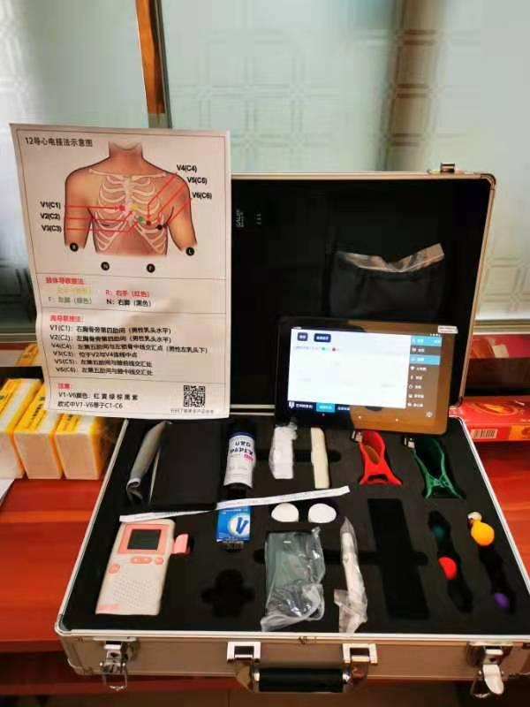
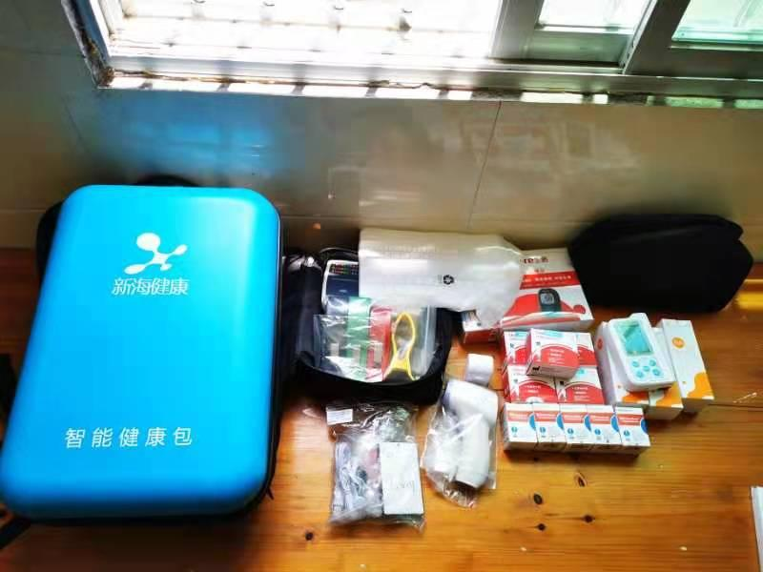

Appendix A2. Functions of the Dingbei Primary Care Doctor Platform:
- Patient Files Creation and Management: Through the portal of the platform, the village doctors can create patient files which include patient name, gender, age, ethnicity, marital status, drug allergies, disease history description, etc.

- One-click Consultation: Village doctors can directly conduct the online consultation with the doctors at GD2H by test messages or audio calls. This function is used when the patients request the online contact with doctors from upper-level hospitals during their visits to the village clinics. After the consultation, doctors at GD2H will provide suggestions on the following referrals or treatments for the patients.

- Referral Consultation: Village doctors will use the referral consultation when they find themselves unable or unsure how to deal with patients. By using this function through test messages or audio calls, doctors at GD2H will provide suggestions on the following referrals or treatments for the patients.

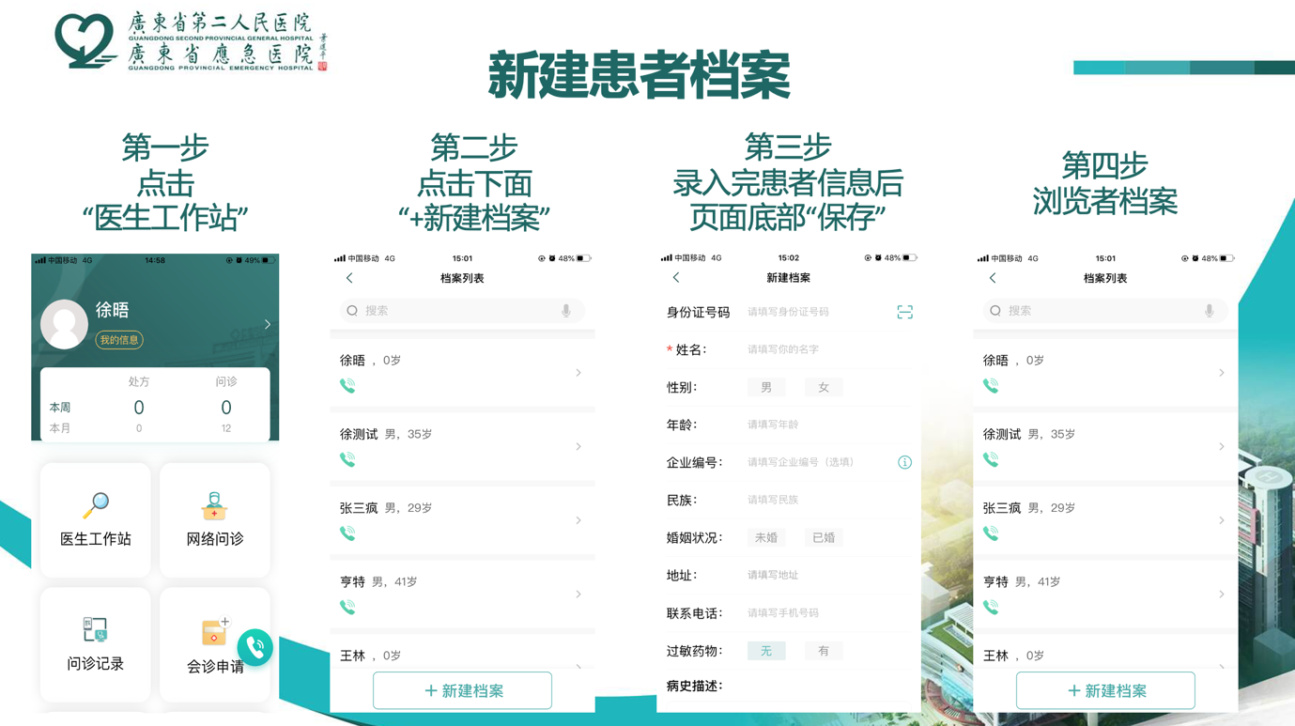
Appendix A3. The interface and steps of creating and managing patient new files on the telemedicine platform:
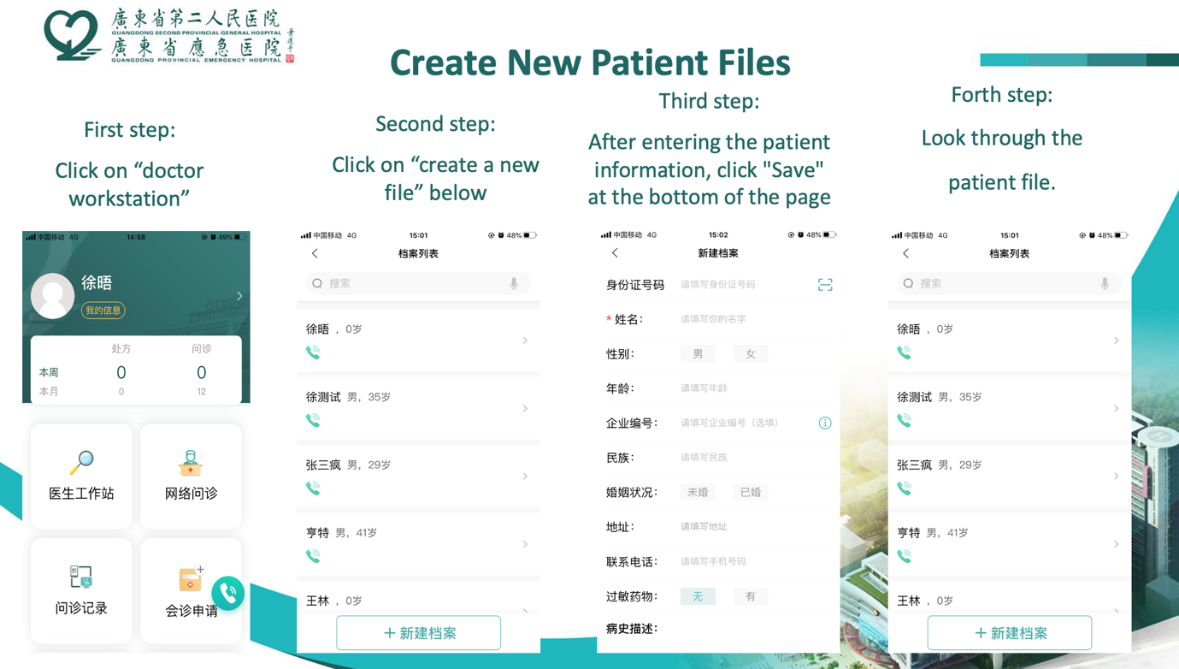
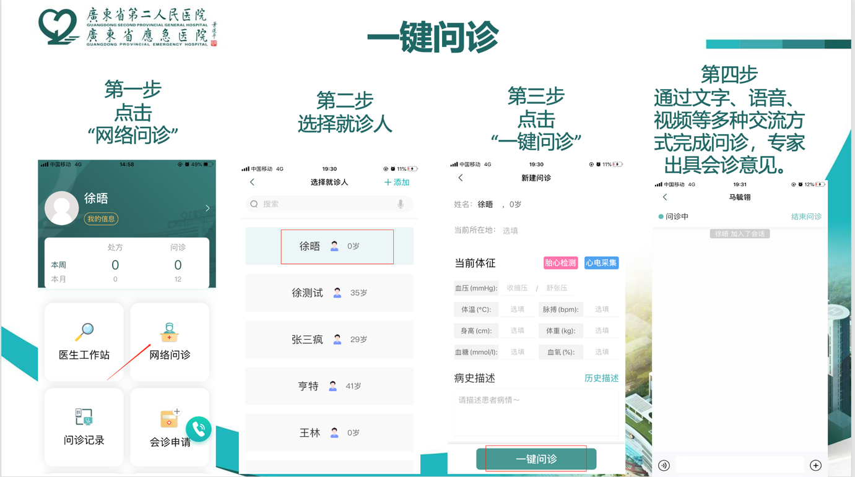
Appendix A4. The interface and steps of usage of the one-click consultation on the telemedicine platform:
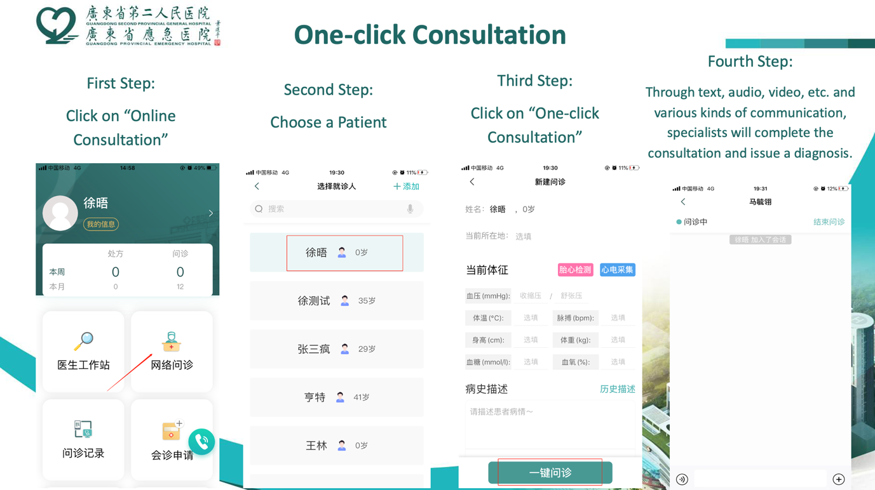

Appendix A5. The interface and steps of usage of consultation for referral on the telemedicine platform:
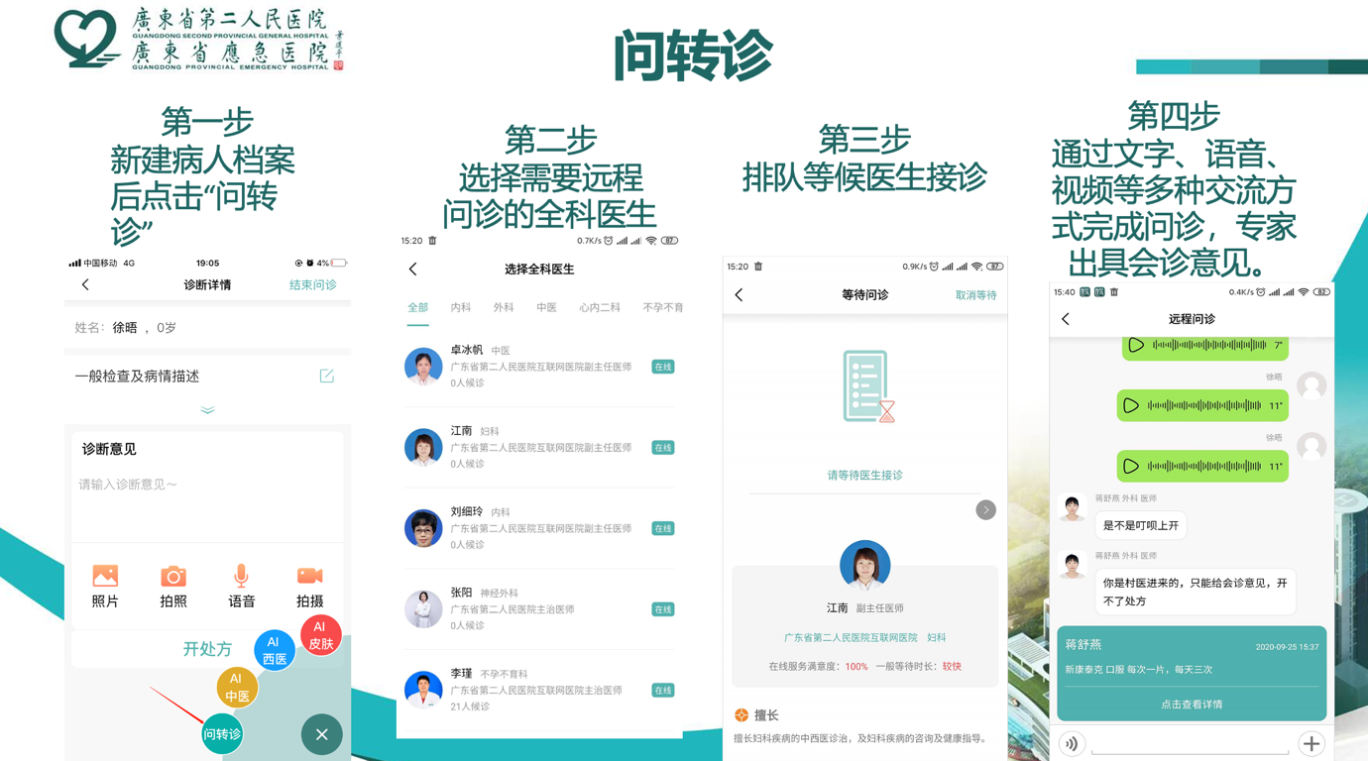
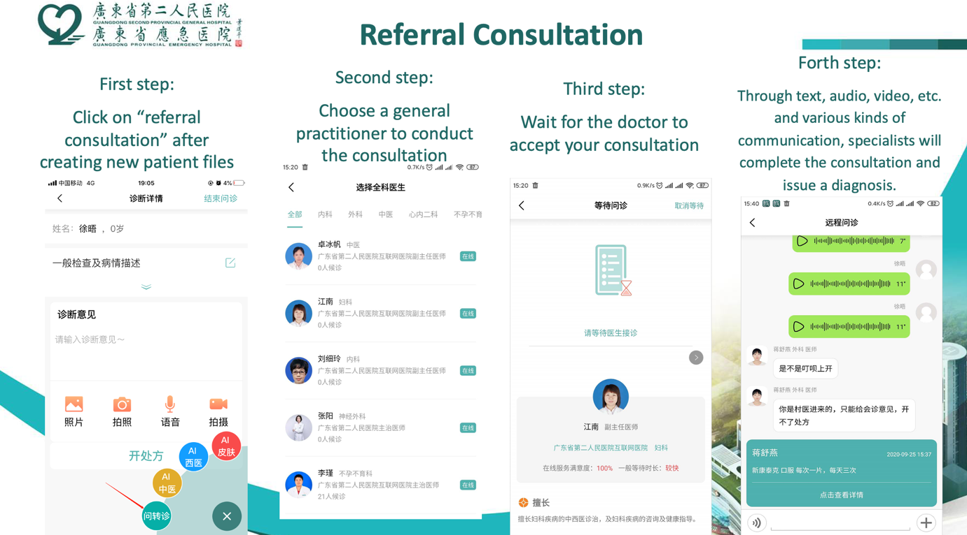

Appendix A6. Demand-side marketing materials of the Telemedicine Kiosk Program

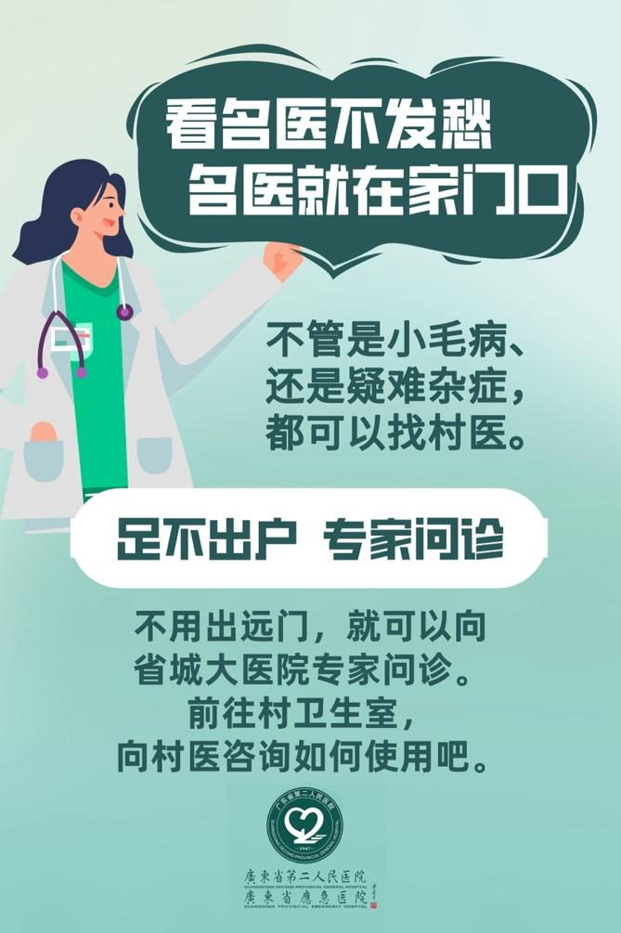
Social Marketing Campaign Poster:
Don’t worry about seeing a great doctor. Great doctors are right at your doorstep!

It doesn’t matter if it’s a small illness or complicated case, there’s a village doctor for every problem.

Stay close to home for specialist consultations!
You don’t have to travel far to get a consultation from a specialist from the Provincial hospital. First, go to your village clinic, and ask your village doctor how to use (Dingbei)!

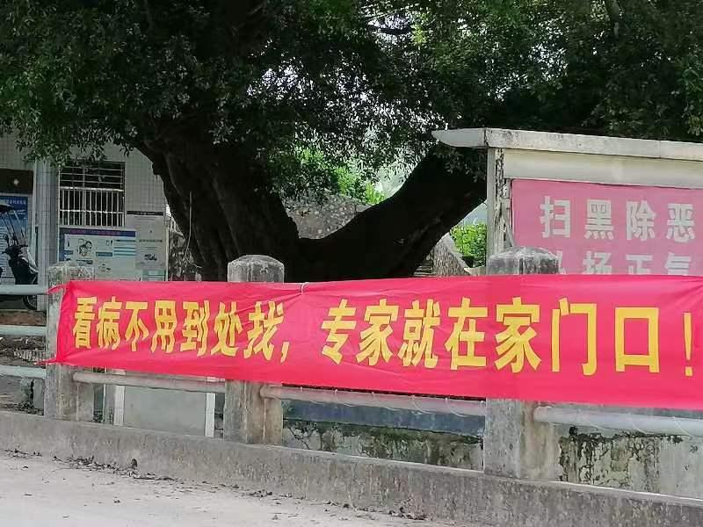
Social Marketing Campaign Banner:
No need to go around seeing a doctor, the specialists are right at your doorstep!

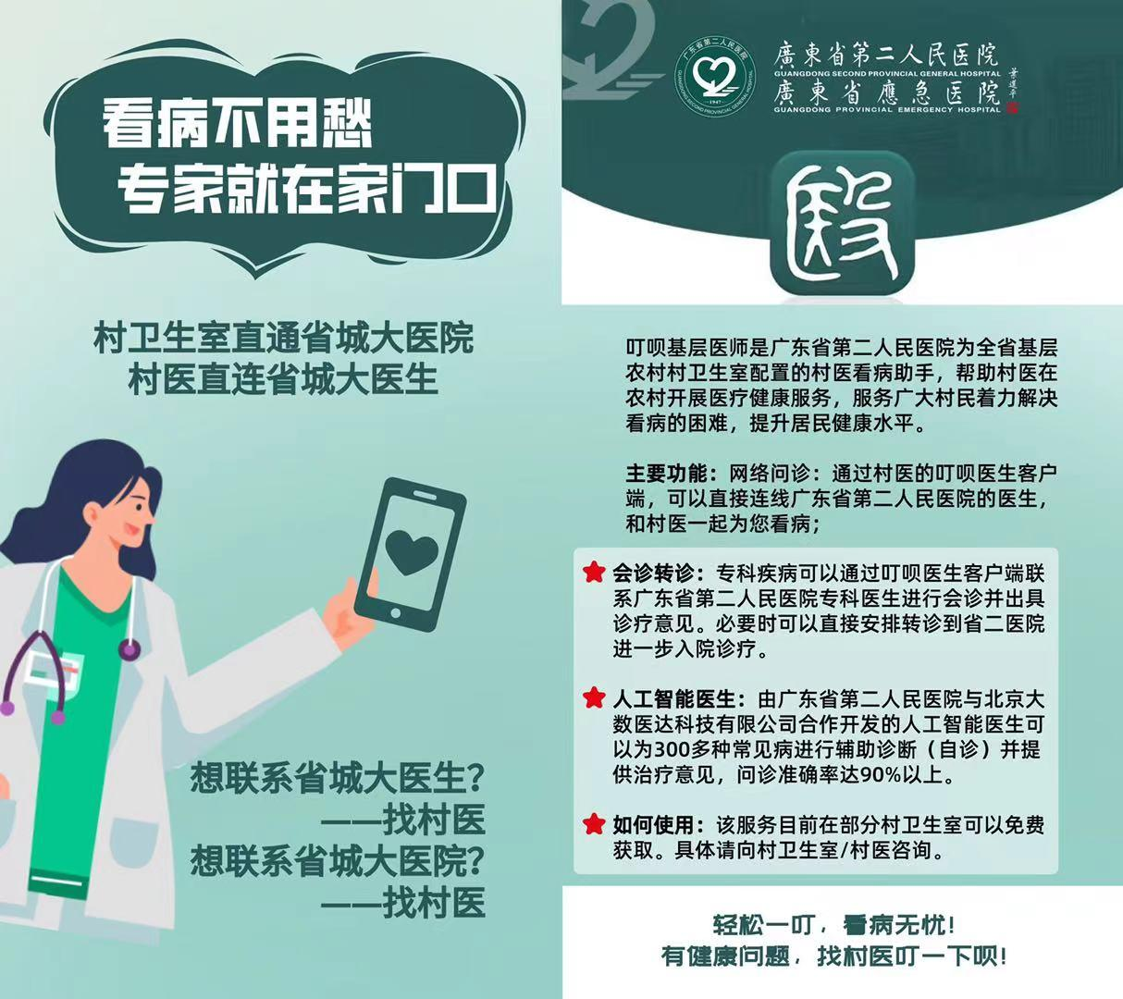
Social Marketing Campaign Flyer:
Don’t worry about seeing a great doctor. Great doctors are right at your doorstep!
The village clinic is directly connected to the general provincial hospital. The Village doctors are directly connected to provincial experts.

Want to contact provincial experts? - Find a village doctor
Want to contact the general provincial hospital? - Find a village doctor

Dingbei app is a diagnosis and treatment aid provided for village doctors in the village clinic by GD2H to assist with delivering healthcare services, overcoming barriers to seeing a doctor, and improving the health of rural residents.
Main Function: Online consultations: Through the Dingbei portal, you can directly contact the doctors at Guangdong Second Provincial General Hospital and they will work together with the village doctors to assist the consultation.

Specialist consultations and Transfers: For specialized diseases, patients can contact the specialists of the Second People's Hospital of Guangdong Province for consultation and diagnosis and treatment through the Dingbei Doctor portal. If necessary, patients can directly arrange a referral to GD2H for further diagnosis and treatment.
Artificial Intelligence Doctor: The artificial intelligence doctor commissioned by the Second People's Hospital of Guangdong Province and developed by Beijing Dashu Yida Technology Co., Ltd. can assist in diagnosis (self-diagnosis) and provide treatment opinions for 300 common diseases and has a reported consultation accuracy rate of over 90%.
How to use: The service is currently available free of charge in some village clinics. For details, please consult your village clinic/village doctor

You can see a doctor in just one easy click！If you have a health problem, find a village doctor to use Dingbei!

Appendix B:

Table B1. Effect of the demand-side marketing and monetary incentive treatments on the village doctors’ telemedicine usage.
Telemedicine Usage among Village Doctors ª |  | Negative Binomial Model
 |  | Coefficient ^{c} (95% CI) | P-value
Platform login
 | + Demand-side marketing (N=24) | -0.13 (-0.86, 0.55) | 0.708
 | + Monetary incentives (N=22) | -0.94 (-2.11, 0.24) | 0.118
 | + Demand-side marketing and monetary incentives (N=23) | 0.71 (-0.02, 1.44) | 0.056*
Patient profile creation
 | + Demand-side marketing (N=24) | 1.80 (-1.09, 4.68) | 0.222
 | + Monetary incentives (N=22) | 1.36 (-1.16, 3.88) | 0.292
 | + Demand-side marketing and monetary incentives (N=23) | 3.15 (-0.47, 6.77) | 0.088*
One-click consultation
 | + Demand-side marketing (N=24) | -0.64 (-5.16, 3.88) | 0.782
 | + Monetary incentives (N=22) | -1.92 (-4.95,1.11) | 0.214
 | + Demand-side marketing and monetary incentives (N=23) | 0.14 (-4.01, 4.29) | 0.948
Referral consultation
 | + Demand-side marketing (N=24) | -0.93 (-2.87, 1.00) | 0.345
 | + Monetary incentives (N=22) | -1.58 (-3.61, 0.45) | 0.126
 | + Demand-side marketing and monetary incentives (N=23) | 1.31 (-0.57, 3.20) | 0.171
a: control arm refers to the arm with telemedicine access and training only (N=25).
c: coefficients were adjusted for county fixed effects and were adjusted for confounding including village doctors’ age, gender, education level, working hours, baseline personal salary, whether are native to the village, self-perceived respect scale, public health service scale, clinic income, monthly patient volume, distance to the township healthcare centers, distance to the county hospitals, whether used telemedicine platforms at the baseline, whether recommended telemedicine platforms to patients, whether have WeChat groups with doctors from county hospitals and township healthcare centers.
The main text reports the coefficients in this Table.
*p < 0.1; **p < 0.05; ***p < 0.01

Telemedicine Usage among Village Doctors ª |  | Negative Binomial Model
 |  | Average Treatment Effect ^{c} (95% CI) | P-value
Platform login
 | + Demand-side marketing (N=24) | -0.41 (-2.57, 0.55) | 0.708
 | + Monetary incentives (N=22) | -2.06 (-4.27, 0.15) | 0.068*
 | + Demand-side marketing and monetary incentives (N=23) | 3.51 (-0.92, 7.94) | 0.121
Patient profile creation
 | + Demand-side marketing (N=24) | 366.82 (-1773.663, 2507.3) | 0.737
 | + Monetary incentives (N=22) | 209.54 (-957.02, 1376.09) | 0.725
 | + Demand-side marketing and monetary incentives (N=23) | 1625.48 (-8174.60, 11425.55) | 0.745
One-click consultation
 | + Demand-side marketing (N=24) | -0.23 (-2.11, 1.66) | 0.813
 | + Monetary incentives (N=22) | -0.41 (-2.04, 1.22) | 0.621
 | + Demand-side marketing and monetary incentives (N=23) | 0.07 (-2.01, 2.15) | 0.946
Referral consultation
 | + Demand-side marketing (N=24) | -2.49 (-14.94, 9.94) | 0.694
 | + Monetary incentives (N=22) | -3.67 (-18.26, 11.72) | 0.126
 | + Demand-side marketing and monetary incentives (N=23) | 11.20 (-39.43, 61.82) | 0.665
a: control arm refers to the arm with telemedicine access and training only (N=25).
c: average treatment effects were adjusted for county fixed effects and were adjusted for confounding including village doctors’ age, gender, education level, working hours, baseline personal salary, whether are native to the village, self-perceived respect scale, public health service scale, clinic income, monthly patient volume, distance to the township healthcare centers, distance to the county hospitals, whether used telemedicine platforms at the baseline, whether recommended telemedicine platforms to patients, whether have WeChat groups with doctors from county hospitals and township healthcare centers
*p < 0.1; **p < 0.05; ***p < 0.01

Table B2. Effect of the Telemedicine Kiosk treatments on primary care utilization of the village clinics
Primary Care Utilization  of the Village Clinics |  | Compared to control arm without access and training |  | Compared to Telemedicine access and training only arm
 |  | Coefficient  (95% CI) | P-value | Coefficient  (95% CI) | P-value
Average monthly patient number from inside the village
 | Telemedicine access and training only (N=25) | -0.40 (-0.73, -0.07) | 0.018** | N/A | N/A
 | + Demand-side marketing (N=24) | 0.37 (-0.30, 1.05) | 0.277 | 0.78 (0.02, 1.53) | 0.044**
 | + Monetary incentives (N=22) | 0.50 (-0.34, 1.35) | 0.239 | 0.91 (-0.07, 1.88) | 0.070*
 | + Demand-side marketing and monetary incentives (N=23) | 0.10 (-0.64, 0.84) | 0.796 | 0.50 (-0.30, 1.30) | 0.222
Average monthly patient number from outside the village
 | Telemedicine access and training only (N=25) | -0.74 (-2.09, 0.61) | 0.284 | N/A | N/A
 | + Demand-side marketing (N=24) | -0.27 (-1.80, 1.26) | 0.729 | 0.47 (-0.32, 1.26) | 0.245
 | + Monetary incentives (N=22) | 1.00 (-0.06, 2.04) | 0.065* | 1.73 (0.77, 2.69) | <0.001***
 | + Demand-side marketing and monetary incentives (N=23) | 0.04 (-1.46, 1.53) | 0.960 | 0.78 (-0.05, 1.61) | 0.067*
Total patient number in the last month
 | Telemedicine access and training only (N=25) | -0.52 (-0.96, -0.07) | 0.024** | N/A | N/A
 | + Demand-side marketing (N=24) | 0.32 (-0.48, 1.12) | 0.437 | 0.83 (0.17, 1.50) | 0.014**
 | + Monetary incentives (N=22) | 0.69 (-0.05, 1.43) | 0.069* | 1.20 (0.32, 2.08) | 0.007**
 | + Demand-side marketing and monetary incentives (N=23) | -0.12 (-0.99, 0.76) | 0.796 | 0.40 (-0.39, 1.19) | 0.324
Number of intramuscular injections in the last month
 | Telemedicine access and training only (N=25) | 0.38 (-0.63, 1.39) | 0.460 | N/A | N/A
 | + Demand-side marketing (N=24) | 0.34 (-0.54, 1.22) | 0.455 | -0.04 (-1.03, 0.94) | 0.929
 | + Monetary incentives (N=22) | 0.49 (-0.43, 1.42) | 0.296 | 0.11 (-1.25, 1.47) | 0.871
 | + Demand-side marketing and monetary incentives (N=23) | -0.11 (-1.02, 0.81) | 0.818 | -0.49 (-1.66, 0.69) | 0.416
*p < 0.1; **p < 0.05; ***p < 0.01
The main text reports the coefficients in this Table.

Primary Care Utilization  of the Village Clinics |  | Compared to control arm without access and training |  | Compared to Telemedicine access and training only arm
 |  | Average Treatment Effect  (95% CI) | P-value | Average Treatment Effect  (95% CI) | P-value
Average monthly patient number from inside the village
 | Telemedicine access and training only (N=25) | -23.89(-42.99, -4.82) | 0.014** | N/A | N/A
 | + Demand-side marketing (N=24) | 32.89(-29.68, 95.47) | 0.303 | 56.78 (-3.46, 117.02) | 0.065*
 | + Monetary incentives (N=22) | 47.51(-37.98, 132.99) | 0.276 | 71.39 (-13.88,156.67) | 0.101
 | + Demand-side marketing and monetary incentives (N=23) | 7.42 (-49.25, 64.09) | 0.797 | 31.31 (-20.45, 83.07) | 0. 236
Average monthly patient number from outside the village
 | Telemedicine access and training only (N=25) | -18.67 (-46.62, 9.28) | 0.191 | N/A | N/A
 | + Demand-side marketing (N=24) | -8.48 (-49.15, 32.18) | 0.683 | 10.19 (-19.17, 39.54) | 0.496
 | + Monetary incentives (N=22) | 60.37(-78.09, 198.84) | 0.393 | 79.04 (-63.22,221.30) | 0.276
 | + Demand-side marketing and monetary incentives (N=23) | 1.40 (-54.52, 57.31) | 0.961 | 20.07 (-28.56, 68.69) | 0.419
Total patient number in the last month
 | Telemedicine access and training only (N=25) | -40.68(-93.39, 12.03) | 0.130 | N/A | N/A
 | + Demand-side marketing (N=24) | 37.90(-56.64,132.43) | 0.432 | 78.58 (-1.85, 159.00) | 0.055*
 | + Monetary incentives (N=22) | 100.20 (-21.13,221.53) | 0.106 | 140.88 (0.59, 281.17) | 0.049**
 | + Demand-side marketing and monetary incentives (N=23) | -11.06 (-96.10, 73.98) | 0.799 | 29.62 (-33.43, 92.67) | 0.357
Number of intramuscular injections in the last month
 | Telemedicine access and training only (N=25) | 17.43 (-32.66, 67.52) | 0.495 | N/A | N/A
 | + Demand-side marketing (N=24) | 15.04 (-24.92, 54.99) | 0.461 | -2.39 (-55.81, 51.02) | 0.930
 | + Monetary incentives (N=22) | 24.02 (-33.45, 81.49) | 0.413 | 6.59 (-74.13, 87.30) | 0.873
 | + Demand-side marketing and monetary incentives (N=23) | -3.83 (-36.99, 29.32) | 0.821 | -21.27 (-77.92, 35.39) | 0.462
*p < 0.1; **p < 0.05; ***p < 0.01

Table B3. Effect of the Telemedicine Kiosk treatments on village clinic revenue (Tobit Regression).
Village Clinic Revenue (per thousand yuan) |  | Compared to control arm without access and training |  | Compared to Telemedicine access and training only arm
 |  | Average Treatment Effect  (95% CI) | P-value | Average Treatment Effect  (95% CI) | P-value
Annual net medical income of the clinic
 | Telemedicine access and training only (N=25) | -13.37(-20.73, -6.02) | 0.001** | N/A | N/A
 | + Demand-side marketing (N=24) | -0.74 (-13.00, 11.52) | 0.904 | 12.63 (1.83, 23.43) | 0.022**
 | + Monetary incentives (N=22) | -0.84 (-10.14, 8.46) | 0.858 | 12.53 (3.17, 21.90) | 0.009**
 | + Demand-side marketing and monetary incentives (N=23) | -0.46 (-7.10, 6.18) | 0.890 | 12.91 (6.32, 19.49) | <0.001***
Subsidy received for public health service
 | Telemedicine access and training only (N=25) | -1.11 (-5.71, 3.48) | 0.632 | N/A | N/A
 | + Demand-side marketing (N=24) | -2.98 (-6.93, 0.97) | 0.138 | -1.87 (-4.97, 1.23) | 0.234
 | + Monetary incentives (N=22) | -1.10 (-5.84, 3.65) | 0.647 | 0.01 (-4.34, 4.37) | 0.995
 | + Demand-side marketing and monetary incentives (N=23) | -4.06 (-7.96, -0.15) | 0.042** | -2.94 (-9.38, 3.50) | 0.366
Annual net income from non-zero rate medications
 | Telemedicine access and training only (N=25) | 2.27 (-0.89, 5.43) | 0.157 | N/A | N/A
 | + Demand-side marketing (N=24) | 0.29 (-5.59, 6.18) | 0.921 | -1.97 (-8.87, 4.92) | 0.571
 | + Monetary incentives (N=22) | 3.68 (-1.44, 8.80) | 0.157 | 1.41 (-3.89, 6.70) | 0.598
 | + Demand-side marketing and monetary incentives (N=23) | 1.80 (-3.65, 7.25) | 0.513 | -0.47 (-6.83, 5.90) | 0.884
Subsidy received based on zero rate medications
 | Telemedicine access and training only (N=25) | 0.33 (-1.68, 2.34) | 0.744 | N/A | N/A
 | + Demand-side marketing (N=24) | -1.41 (-4.40, 1.58) | 0.350 | -1.74 (-3.31, -0.18) | 0.030**
 | + Monetary incentives (N=22) | 0.40 (-3.07, 3.87) | 0.818 | 0.07 (-2.19, 2.34) | 0.950
 | + Demand-side marketing and monetary incentives (N=23) | 0.40 (-3.07, 3.87) | 0.238m | -2.28 (-4.33, -0.22) | 0.030**
Annual salary of all clinic staff
 | Telemedicine access and training only (N=25) | 4.12 (-18.11, 26.36) | 0.714 | N/A | N/A
 | + Demand-side marketing (N=24) | -12.01 (-26.48, 2.46) | 0.103 | -16.13 (39.16,6.91) | 0.168
 | + Monetary incentives (N=22) | 14.92 (-5.36, 35.21) | 0.147 | 10.81(-13.51,35.13) | 0.380
 | + Demand-side marketing and monetary incentives (N=23) | 0.32 (-20.77, 21.40) | 0.976 | -3.80(-21.38,13.78) | 0.668
*p < 0.1; **p < 0.05; ***p < 0.01

Appendix C:

Table 1C. Heterogeneity of the Telemedicine Kiosk program treatment effects on the village doctors’ telemedicine usage index, rural primary care utilization index, and village clinic revenue index stratified by patient volume.
Variables |  | Stratified by patient volume of the village clinic |  | p-value
 |  | Low volume  (< 30 patients per month) | High volume  (≥ 30 patients per month) | p-value
Panel A: Telemedicine usage index
+ Demand-side marketing (N=24)
 | Average treatment effectª (95% CI) | 0.03 (-0.23, 0.29) | -1.09 (-2.27, 0.08)
 | P-value | 0.800 | 0.068* | 0.197
+ Monetary incentives (N=22)
 | Average treatment effectª (95% CI) | 0.04 (-0.20, 0.29) | 0.49 (-2.03, 3.01) | 0.425
 | P-value | 0.719 | 0.702
+ Demand-side marketing and monetary incentives (N=23)
 | Average treatment effectª (95% CI) | -0.01 (-0.14, 0.12) | 1.54 (-0.79, 3.86) | 0.128
 | P-value | 0.895 | 0.196
Panel B: Primary care utilization index
Telemedicine access and training only (N=25)
 | Average treatment effect^{b} (95% CI) | -0.32 (-.60, -0.03) | -1.75 (-2.98, -0.52) | 0.645
 | P-value | 0.028** | 0.005**
+ Demand-side marketing (N=24)
 | Average treatment effect^{b} (95% CI) | 0.16 (-0.15, 0.48) | -1.03 (-2.20, 0.13) | 0.426
 | P-value | 0.306 | 0.082*
+ Monetary incentives (N=22)
 | Average treatment effect^{b} (95% CI) | -0.18 (-0.44, 0.08) | -1.21 (-2.42, -0.001) | 0.982
 | P-value | 0.183 | 0.050*
+ Demand-side marketing and monetary incentives (N=23)
 | Average treatment effect^{b} (95% CI) | 0.36 (-0.04, 0.77) | -0.64 (-1.65, 0.37)
 | P-value | 0.080* | 0.214 | 0.648
Panel C: Clinic revenue index
Telemedicine access and training only (N=25)
 | Average treatment effect^{c} (95% CI) | -0.10 (-0.48, 0.29) | -0.37 (-1.26, 0.51) | 0.485
 | P-value | 0.624 | 0.407
+ Demand-side marketing (N=24)
 | Average treatment effect^{c} (95% CI) | -0.15 (-0.75, 0.45) | 0.20 (-0.69, 1.09) | 0.059*
 | P-value | 0.632 | 0.407
+ Monetary incentives (N=22)
 | Average treatment effect^{c} (95% CI) | -0.09 (-0.48, 0.31) | 1.96 (0.04, 3.88) | 0.341
 | P-value | 0.670 | 0.046**
+ Demand-side marketing, and monetary incentives (N=23)
 | Average treatment effect^{c} (95% CI) | -0.34 (-0.76, 0.06) | -0.01 (-0.89, 0.87) | 0.480
 | P-value | 0.095* | 0.986
a: inverse covariance index of telemedicine usage generated from a list of binary variables representing village doctors’ behaviors on the telemedicine platform, including logging in, creating patient profiles, using one-click consultation, and referral consultation
b: Telemedicine access and training provision only showed a significant effect on reducing the overall primary care utilization.
c: inverse covariance index of clinic revenue generated from annual net medical income of the clinic, subsidy received for public health service, annual net income from non-zero rate medications, subsidy received based on zero rate medications.
*p < 0.1; **p < 0.05; ***p < 0.01

Table 2C. Heterogeneity of the Telemedicine Kiosk program treatment effects on the village doctors’ telemedicine usage index, rural primary care utilization index and village clinic revenue index stratified by village doctors’ age.
Variables |  | Stratified by village doctors’ age |  | p-value
 |  | Young  (< 50 years old) | Old  (≥ 50 years old) | p-value
Panel A: Telemedicine usage index
+ Demand-side marketing (N=24)
 | Average treatment effectª (95% CI) | 0.11 (-0.51, 0.72) | 1.55 (1.12, 1.97) | 0.018**
 | P-value | 0.735 | <0.001***
+ Monetary incentives (N=22)
 | Average treatment effectª (95% CI) | -0.32 (-1.08, 0.44) | 0.28 (0.14, 0.42) | 0.004**
 | P-value | 0.410 | <0.001***
+ Demand-side marketing and monetary incentives (N=23)
 | Average treatment effectª (95% CI) | 0.31 (-0.34, 0.96) | 1.19 (0.91, 1.46) | 0.061**
 | P-value | 0.347 | <0.001***
Panel B: Primary care utilization index
Telemedicine access and training only (N=25)
 | Average treatment effect^{b} (95% CI) | -0.57 (-0.94, -0.21) | -1.83(-2.65, -1.02) | 0.363
 | P-value | 0.002** | <0.001***
+ Demand-side marketing (N=24)
 | Average treatment effect^{b} (95% CI) | -0.19 (-0.53, 0.14) | 3.45 (0.95, 5.94) | 0.092*
 | P-value | 0.262 | 0.007**
+ Monetary incentives (N=22)
 | Average treatment effect^{b} (95% CI) | -0.52 (-1.01, -0.03) | -0.83 (-1.50, -0.15) | 0.982
 | P-value | 0.039** | 0.016**
+ Demand-side marketing and monetary incentives (N=23)
 | Average treatment effect^{b} (95% CI) | 0.13 (-0.28, 0.54) | -0.39 (-1.13, 0.35) | 0.811
 | P-value | 0.532 | 0.297
Panel C: Clinic revenue index
Telemedicine access and training only (N=25)
 | Average treatment effect^{c} (95% CI) | -0.15 (-0.68, 0.38) | -0.07 (-0.87, 0.73) | 0.674
 | P-value | 0.587 | 0.864
 | + Demand-side marketing (N=24)
 | Average treatment effect^{c} (95% CI) | -0.44 (-1.03, 0.14) | 0.03 (-3.26, 3.32) | 0.985
 | P-value | 0.139 | 0.986
+ Monetary incentives (N=22)
 | Average treatment effect^{c} (95% CI) | -0.65 (-1.12, -0.19) | 0.78 (-0.18, 1.74) | 0.034**
 | P-value | 0.006** | 0.111
+ Demand-side marketing, and monetary incentives (N=23)
 | Average treatment effect^{c} (95% CI) | -0.61 (-1.14, -0.08) | 0.02 (-0.90, 0.94) | 0.150
 | P-value | 0.024** | 0.962
a: inverse covariance index of telemedicine usage generated from a list of binary variables representing village doctors’ behaviors on the telemedicine platform, including logging in, creating patient profiles, using one-click consultation, and referral consultation
b: Telemedicine access and training provision only showed a significant effect on reducing the overall primary care utilization.
c: inverse covariance index of clinic revenue generated from annual net medical income of the clinic, subsidy received for public health service, annual net income from non-zero rate medications, subsidy received based on zero rate medications.
*p < 0.1; **p < 0.05; ***p < 0.01

Table 3C. Heterogeneity of the Telemedicine Kiosk program treatment effects on the village doctors’ telemedicine usage index, rural primary care utilization index, and village clinic revenue index stratified by village doctors’ WeChat consultation engagement.
Variables |  | Village doctors’ WeChat consultation engagement |  | p-value
 |  | Low | High | p-value
Panel A: Telemedicine usage index
+ Demand-side marketing (N=24)
 | Average treatment effectª (95% CI) | 0.62 (-0.72, 1.96) | -0.67 (-1.13, -0.21) | 0.928
 | P-value | 0.366 | 0.005**
+ Monetary incentives (N=22)
 | Average treatment effectª (95% CI) | -0.29 (-1.34, 0.76) | -0.37 (-.77, 0.04) | 0.184
 | P-value | 0.588 | 0.075*
+ Demand-side marketing and monetary incentives (N=23)
 | Average treatment effectª (95% CI) | 0.68 (-0.19, 1.55) | 0.41 (-0.15, 0.97) | 0.170
 | P-value | 0.124 | 0.156
Panel B: Primary care utilization index
Telemedicine access and training only (N=25)
 | Average treatment effect^{b} (95% CI) | -0.82 (-1.46, -0.18) | -1.23 (-1.98, -0.49) | 0.122
 | P-value | 0.012** | 0.001**
+ Demand-side marketing (N=24)
 | Average treatment effect^{b} (95% CI) | 0.33 (-0.41, 1.08) | -0.37 (-1.16, 0.42) | 0.422
 | P-value | 0.381 | 0.360
+ Monetary incentives (N=22)
 | Average treatment effect^{b} (95% CI) | -0.71 (-1.15, -0.27) | -0.97 (-1.62, -0.33) | 0.044**
 | P-value | 0.002** | 0.003
+ Demand-side marketing and monetary incentives (N=23)
 | Average treatment effect^{b} (95% CI) | 0.62 (0.24, 1.01) | 0.23 (-0.88, 1.35) | 0.112
 | P-value | 0.001** | 0.683
Panel C: Clinic revenue index
Telemedicine access and training only (N=25)
 | Average treatment effect^{c} (95% CI) | 0.49 (0.01, 0.97) | -0.62 (-1.24, 0.001) | 0.034**
 | P-value | 0.047** | 0.050*
 | + Demand-side marketing (N=24)
 | Average treatment effect^{c} (95% CI) | -1.28 (-2.05, -0.50) | 0.26 (-0.43, 0.94) | 0.422
 | P-value | 0.001** | 0.467
+ Monetary incentives (N=22)
 | Average treatment effect^{c} (95% CI) | -0.27 (-0.82, 0.28) | 0.72 (-0.02, 1.47) | 0.044**
 | P-value | 0.334 | 0.057*
+ Demand-side marketing, and monetary incentives (N=23)
 | Average treatment effect^{c} (95% CI) | -0.42 (-0.95, 0.12) | -0.07 (-0.85, 0.70) | 0.112
 | P-value | 0.129 | 0.845

a: inverse covariance index of telemedicine usage generated from a list of binary variables representing village doctors’ behaviors on the telemedicine platform, including logging in, creating patient profiles, using one-click consultation, and referral consultation
b: Telemedicine access and training provision only showed a significant effect on reducing the overall primary care utilization.
c: inverse covariance index of clinic revenue generated from annual net medical income of the clinic, subsidy received for public health service, annual net income from non-zero rate medications, subsidy received based on zero rate medications.
*p < 0.1; **p < 0.05; ***p < 0.01

Appendix D:
Table 1D. Characteristics of village doctors attend interviews (N=20).
Participant No. | Intervention Group | City | Gender | Age | Highest Education | Highest Qualification
P1 | +Incentive only | Heyuan | Female | 46 | Secondary Vocational College | Village Doctor
P2 | Telemedicine access and training | Meizhou | Male | 45 | Secondary Vocational College | Practicing Assistant Physician
P3 | +Incentive only | Meizhou | Male | 44 | Secondary Vocational College | Village Doctor
P4 | Telemedicine access and training | Meizhou | Male | 48 | Higher Vocational College | Practicing Assistant Physician
P5 | +Incentive & Marketing | Heyuan | Male | 47 | Higher Vocational College | Practicing Assistant Physician
P6 | +Marketing only | Heyuan | Male | 52 | Higher Vocational College | Practicing Physician
P7 | +Marketing only | Heyuan | Male | 57 | Higher Vocational College | Practicing Assistant Physician
P8 | Telemedicine access and training | Heyuan | Male | 65 | Secondary Vocational College | Village Doctor
P9 | +Marketing only | Meizhou | Female | 42 | Higher Vocational College | Practicing Pharmacist
P10 | +Marketing only | Heyuan | Male | 46 | Secondary Vocational College | N/A
P11 | +Incentive & Marketing | Heyuan | Male | 40 | Secondary Vocational College | Village Doctor
P12 | Telemedicine access and training | Heyuan | Female | 59 | Secondary Vocational College | Village Doctor
P13 | +Incentive & Marketing | Meizhou | Male | 43 | Secondary Vocational College | Village Doctor
P14 | +Incentive only | Heyuan | Male | 48 | Secondary Vocational College | Village Doctor
P15 | +Incentive only | Heyuan | Male | 54 | Secondary Vocational College | Village Doctor
P16 | +Incentive & Marketing | Meizhou | Male | 49 | Higher Vocational College | Village Doctor
P17 | +Incentive & Marketing | Meizhou | Female | 39 | Higher Vocational College | Practicing Assistant Physician
P18 | +Incentive only | Meizhou | Female | 40 | Higher Vocational College | Practicing Assistant Physician
P19 | +Marketing only | Meizhou | Male | 49 | Higher Vocational College | Village Doctor
P20 | Telemedicine access and training | Meizhou | Male | 51 | Secondary Vocational College | Village Doctor

Table 2D. Characteristic distribution of village doctors attended interviews.
Village Doctor Characteristics | n(%)
N | 20
Sex, n(%)
Male | 15(75)
Female | 5(25)
Age in years, mean (min–max) | 48(39-65)
Years in practice, mean (min–max) | 24(14-37)
Highest Education, n(%)
Higher Vocational College | 9(45)
Secondary Vocational College | 11(55)
Highest Qualification, n(%)
Village Doctor | 11(55)
Practicing Physician | 1(5)
Practicing Assistant Physician | 6(30)
Practicing Pharmacist | 1(5)
Other | 1(5)
Intervention Group, n(%)
Telemedicine access & training | 5(25)
+ Incentive | 5(25)
+ Demand-side marketing | 5(25)
+ Incentive & demand-side marketing | 5(25)

Appendix E
Table 1E. Constructs of Inner Setting Theme in CFIR Framework
CFIR Constructs | Operational Definitions | Key Topics Explored with Village Doctors
Structural Characteristics | Physical infrastructure or tangible material features support the functional performance of the telemedicine kiosk program in rural primary care. | Availability of network connections, electronic equipment
Relational Connections | The quality of formal and informal relationships, networks, and teams within and across rural primary care systems. | Communications between village doctors, communications between village doctors and doctors form township healthcare centers or county hospitals
Compatibility | How the telemedicine kiosk program fits with individuals’ values, perceived needs, and existing workflows and systems. | Perception on the telemedicine, fitness with local health systems or referral processes
Leadership Engagement | The commitment, engagement and responsibility of the leader, management, or even administrative power input to support the implementation and/or delivery of the telemedicine kiosk program. | Role of local health administration, job promotion and professional title evaluation under the influence of telemedicine engagement
Mission Alignment | How does implementing and delivering the telemedicine kiosk program influence the overarching commitment, purpose, or goals in the village primary care system. | Perceived values and inconvenience of using telemedicine, influence of using telemedicine on work efficiency
Relative Priority | The importance of engaging in telemedicine kiosk programs compared to other alternatives, actions, or initiatives. | Other alternatives of telemedicine platforms to communicate with doctors in upper-level hospitals, other prioritized initiatives, other than telemedicine engagement

