Supplementary methods
Supplementary Methods: Detailed bioinformatics pipeline
(1) Sequencing Platform and Target Region: Sequencing was performed on the Ion Torrent platform. The target panel comprised 325 hematologic tumor-related genes. The complete gene list is provided in Additional file 1: Table S1.
(2) Raw Data Preprocessing and Alignment: Quality Control: Raw sequencing reads (FASTQ files) were assessed for quality metrics using FastQC (version 0.11.9). Trimming: Adapter sequences and low-quality bases (Phred score < 20) were trimmed using Trimmomatic (version 0.39) with the following parameters: ILLUMINACLIP:adapters.fa:2:30:10 LEADING:3 TRAILING:3 SLIDINGWINDOW:4:15 MINLEN:36. Alignment: Clean reads were aligned to the human reference genome (GRCh37.p13) using the BWA-MEM algorithm (version 0.7.17) with default parameters. Post-alignment Processing: Aligned reads in BAM format were sorted, and duplicate reads were marked using Picard (version 2.26.0) MarkDuplicates tool to avoid PCR duplication bias.
(3) Variant Calling: Germline Variants: Germline single nucleotide variants (SNVs) and small insertions/deletions (indels) were identified using GATK HaplotypeCaller (version 4.2.0) in accordance with GATK Best Practices. Somatic Variants: Somatic variants were called by comparing tumor (if available) against a matched normal sample using GATK Mutect2 (version 4.2.0). For samples without a matched normal, a panel of normals (PON) was used to filter out recurrent artifacts.
(4) Variant Annotation and Filtering:Annotation: All called variants were annotated using ANNOVAR (version 2020-06-08) and SnpEff (version 5.0). Annotation sources included population frequencies (dbSNP v155, 1000 Genomes), cancer mutation databases (COSMIC v96), and clinical significance databases (ClinVar 2024 release). Germline Filtering: Germline variants were subjected to variant quality score recalibration (VQSR) using GATK VariantRecalibrator to achieve a high-confidence call set. Somatic Filtering: For final analysis, we retained somatic variants that met the following stringent criteria: sequencing depth ≥ 2000×, variant allele frequency (VAF) ≥ 2%, and present in at least 5 variant reads.
(5) Final Variant Prioritization: The final list of prioritized variants for clinical and statistical analysis included those classified as: Pathogenic/Likely Pathogenic in the ClinVar database. Driver mutations as annotated in the COSMIC Cancer Gene Census. Variants meeting the American College of Medical Genetics and Genomics (ACMG) guidelines for pathogenicity.
Echocardiographic assessment
Measurement method: left atrial diameter (LAD) was measured using transthoracic echocardiography, strictly following the guidelines of the American Society of Echocardiography (ASE). Measurements were obtained in the parasternal long‑axis view at end‑systole. All examinations were performed by experienced echocardiographers.
Timing of measurement: To establish a clear temporal sequence, we reviewed medical records and confirmed that all LAD measurements were obtained before the first occurrence of AF. For some patients, LAD was measured at baseline (at the time of hematologic malignancy diagnosis); for others, it was measured during routine follow‑up echocardiographic examinations, but always before AF onset.
Quality control: All echocardiographic data were independently reviewed by two investigators; discrepancies were resolved through consensus.
Extended CHIP gene analysis
To address the suggestion to expand the analysis to the 58‑gene CHIP list (PubMed ID: 36652671), we performed the following additional analyses in the discovery cohort (to maintain the independence of the validation cohort).
All 58 genes were screened for mutation frequency. The coverage of these genes in our 325‑gene panel, mutation counts, and atrial fibrillation (AF) events among mutation carriers are presented in Additional file 1: Table S8. Genes are grouped into three categories: (i) CHIP genes covered in our panel (n=54), for which complete data are available; (ii) CHIP genes not covered in our panel (n=4), for which no data are available; and (iii) additional high‑frequency mutations (>2%) not in the CHIP list (n=8), identified from our panel and presented for completeness.
Among the 54 covered CHIP genes, those with at least one AF event among carriers and sufficient mutation frequency were considered suitable for exploratory analysis. For these genes (n=20), we performed univariable Fine‑Gray competing risk analyses (adjusted for age and sex) to estimate their association with AF risk, with death as the competing event. To control for multiple testing, we applied Benjamini‑Hochberg false discovery rate (FDR) correction; a q‑value < 0.05 was considered statistically significant.
Genes with zero AF events among carriers or extremely low mutation frequency were considered too rare for reliable regression analysis and are reported descriptively only (mutation counts and AF events).
The complete results—including mutation counts, AF events, univariable sHRs with 95% confidence intervals, raw P‑values, and FDR‑adjusted q‑values for all genes analyzed, as well as descriptive data for all other genes—are presented in Additional file 1: Table S8.
Clonal complexity analysis
To evaluate the impact of multiple spliceosome gene mutations (clonal complexity), patients with spliceosome mutations were stratified into two groups: Single‑mutation group: patients carrying exactly one spliceosome gene mutation (SF3B1, SRSF2, U2AF1, or ZRSR2); Multiple‑mutation group: patients carrying two or more spliceosome gene mutations. Gray’s test was used to compare the cumulative incidence of AF (with death as a competing event) between these two groups. Due to the limited sample size of the multiple‑mutation group (n = 12), this analysis was considered exploratory, and results are presented descriptively in Additional file 1: Table S6.
Detection of cytokine levels
Peripheral blood (PB) samples were collected at the time of the first visit to the Department of Hematology, the Second Hospital of Tianjin Medical University, and tested within 2 hours. Several inflammatory biomarkers, including interleukin (IL) - 1β, IL - 2, IL - 4, IL - 5, IL - 6, IL - 8, IL - 10, IL - 12, IL - 17A, IL - 17F, IL - 22, tumor necrosis factor (TNF) - α, TNF - β, and interferon (IFN) - γ, were captured by microspheres of known volume and fluorescence intensity using liquid chip multifactor flow detection technology. The corresponding fluorescence was detected by flow cytometry, and the content of corresponding cytokines of the sample to be tested was obtained based on the fluorescence intensity. All flow cytometry analyses were performed using a Beckman CytoFLEX LX flow cytometer.
Monocyte isolation
Fresh peripheral blood samples were collected from patients with spliceosome gene mutations (detailed patient information is provided in the Additional file 1: Table S10). Peripheral blood mononuclear cells (PBMCs) were isolated by density gradient centrifugation. PBMCs were resuspended in phosphate-buffered saline (PBS) containing 2% fetal bovine serum (FBS) at a concentration of 1×10⁶–5×10⁶ cells/mL. Cells were stained with anti-human CD45‑FITC and anti-human CD14‑PE antibodies and incubated at 4°C for 20 minutes in the dark. After washing, CD45⁺CD14⁺ monocytes were sorted using a BD FACSAria flow cytometer.
Co-culture model
Human atrial fibroblasts (purchased from Yuchun Biology, Cat. No. BH3533) were cultured in Fibroblast Medium (Cat. No. CC1338) according to the manufacturer’s instructions. Co-culture experiments were performed using 6-well Trans-well plates (Corning, 0.4 μm pore size): Monocytes were seeded in the lower chamber at a density of 1×10⁵ cells per well;Atrial fibroblasts were seeded in the upper chamber at a density of 1×10⁵ cells per well. After 48 hours of co-culture, fibroblasts were harvested for Western blot analysis. All experiments were performed in triplicate, and monocyte numbers were standardized across groups to avoid confounding bias due to variations in cell counts.
IL‑6 neutralization experiments
An IL‑6 neutralizing antibody (10 μg/mL, R&D Systems, Cat. No. MAB2061) was added to the lower chamber at the start of co‑culture and replenished every 24 hours. After 48 hours, fibroblasts were harvested for Western blot analysis.
Western blot analysis
Fibroblasts were lysed in RIPA buffer (containing protease and phosphatase inhibitors) on ice. Protein samples (30 μg per lane) were separated by 12.5% SDS‑PAGE and transferred to PVDF membranes overnight at 4°C. Membranes were blocked with 5% BSA in TBST for 1 hour at room temperature, then incubated overnight at 4°C with primary antibodies against COL1A1, COL3A1, α-SMA, and GAPDH. Detailed antibody information is provided in Additional file 1: Table S11. After washing, membranes were incubated with HRP‑conjugated secondary antibodies for 2 hours at room temperature. Protein bands were visualized using an enhanced chemiluminescence (ECL) system, and densitometric analysis was performed using ImageJ software.
The analysis code, including R code for all core analyses (data preprocessing, time-dependent covariate construction, competing risk models, interaction analysis, MDS exclusion, and bootstrap validation), is provided as Supplementary Code in the Additional file 3.

Supplementary Table S1. List of 325 Genes Included in the Next-Generation Sequencing Panel

ABCB1 | ABL1 | AKT1 | AKT3 | ALK | AMER1 | ANKRD26 | APC | ARAF | ARC
ARID1A | ARID1B | ARID2 | ASXL1 | ASXL2 | ATG2B | ATM | ATRX | B2M | BCL2
BCL6 | BCOR | BCORL1 | BCR | BIRC3 | BLM | BLNK | BRAF | BRCA1 | BRCA2
BRCC3 | BRINP3 | BTG1 | BTG2 | BTK | CACNA1E | CALR | CARD11 | CASP8 | CBFB
CBL | CBLB | CBLC | CCND1 | CCND2 | CCND3 | CCR4 | CD274 | CD28 | CD58
CD79A | CD79B | CDC25C | CDKN1A | CDKN1B | CDKN2A | CDKN2B | CDKN2C | CEBPA | CHD8
CIITA | CNOT3 | COL12A1 | CRBN | CREBBP | CRLF2 | CROCC | CSF1R | CSF3R | CSMD1
CSNK1A1 | CTCF | CTLA4 | CUL4B | CUX1 | CXCR4 | CXCR5 | CYLD | DDR2 | DDX11
DDX3X | DDX41 | DHX15 | DIS3 | DKC1 | DNAH9 | DNM2 | DNMT3A | DNMT3B | DOT1L
DPYD | DUSP22 | EBF1 | ECT2L | EED | EGFR | EGR1 | EGR2 | EIF2A | ELANE
EP300 | EPCAM | EPHA7 | EPOR | EPPK1 | ERBB2 | ERBB3 | ERBB4 | ERG | ETNK1
ETV6 | EZH2 | FAM46C | FAS | FAT1 | FBXW7 | FGFR1 | FGFR2 | FGFR3 | FLT3
FOXO1 | FOXO3 | GATA1 | GATA2 | GATA3 | GFI1 | GNA13 | GNAS | GSKIP | GSTM1
GSTP1 | HAX1 | HRAS | ID3 | IDH1 | IDH2 | IFNLR1 | IGLL5 | IKZF1 | IKZF3
IL7R | INPP5D | IRF4 | IRF8 | ITK | JAK1 | JAK2 | JAK3 | KDM5A | KDM6A
KIT | KLF2 | KLHL6 | KMT2A | KMT2B | KMT2C | KMT2D | KRAS | LMO2 | LTB
LYN | LYST | MAF | MAFA | MAFB | MALT1 | MAP2K1 | MAP2K4 | MAPK1 | MAX
MDM2 | MECOM | MED12 | MEF2B | MET | MIR142 | MLH1 | MPL | MS4A1 | MSH2
MSH6 | MTHFR | MTOR | MTRR | MUC16 | MUM1 | MYBBP1A | MYC | MYD88 | MYH11
MYOM2 | NARS | NCOR1 | NCOR2 | NF1 | NF2 | NFKB1 | NFKB2 | NFKBIE | NOTCH1
NOTCH2 | NPM1 | NQO1 | NRAS | NT5C2 | NTRK1 | NTRK2 | NTRK3 | NUDT15 | P2RY8
PAX5 | PBRM1 | PBX1 | PCLO | PDCD1LG2 | PDGFRA | PDGFRB | PHF6 | PIGA | PIK3CA
PIM1 | PLCG1 | PLCG2 | PML | PMS2 | POT1 | PPM1D | PRDM1 | PRKCB | PRPF40B
PRPF8 | PRPS1 | PTEN | PTK2B | PTPN1 | PTPN11 | PTPRD | PTPRT | RAD21 | RAF1
RARA | RB1 | RBBP6 | REL | RELN | RET | RHOA | ROBO1 | ROBO2 | ROS1
RPL10 | RPS15 | RPS6KB1 | RUNX1 | SAMD9 | SAMD9L | SAMHD1 | SETBP1 | SETD2 | SF1
SF3A1 | SF3B1 | SGK1 | SH2B3 | SLCO1B1 | SMAD4 | SMARCA2 | SMARCA4 | SMARCB1 | SMC1A
SMC1B | SMC2 | SMC3 | SMN1 | SMO | SOCS1 | SOD2 | SOS1 | SPEN | SRP72
SRSF2 | STAG2 | STAT1 | STAT2 | STAT3 | STAT4 | STAT5A | STAT5B | STAT6 | SUFU
SUZ12 | SYK | TAL1 | TBL1XR1 | TCF3 | TERC | TERT | TET1 | TET2 | TNFAIP3
TNFRSF14 | TP53 | TP63 | TP73 | TPMT | TRAF2 | TRAF3 | TSC1 | TTN | TYK2
U2AF1 | U2AF2 | UNC13D | USP7 | VEGFA | VPREB1 | WAC | WHSC1 | WT1 | XPO1
ZAP70 | ZBTB7A | ZMYM3 | ZNF292 | ZRSR2

Supplementary Table S2. Cumulative incidence of AF in the entire cohort

Follow-up time (years) | Entire cohort (N=1572) |  | Discovery cohort (n=1160) | Validation cohort (n=412)
 | At risk | Cumulative AF (%) | At risk | At risk
0 | 1572 | - | 1160 | 412
1 | 1419 | 4.6 | 1026 | 393
5 | 600 | 10.7 | 325 | 275
10 | 117 | 18.3 | 86 | 31
15 | 32 | 25.7 | 25 | 7
20 | 10 | 37.3 | 10 | 0

AF, atrial fibrillation
Supplementary Table S3. Baseline characteristics of hematologic malignancy patients stratified by CHIP-related gene mutation status
 | CHIP (n=646) | no-CHIP (n=926) | P-value
Follow-up time, y media (range) | 4 (1-26) | 4 (1-29) | 0.682
Age, media (range) | 65 (10-92) | 58.5 (3-88) | <0.001***
Age, years, n (%) |  |  | <0.001***
≤40 | 45 (7.0%) | 185 (20.3%)
41-50 | 47 (7.3%) | 108 (11.8%)
51-60 | 125 (19.5%) | 212 (23.2%)
61-70 | 232 (36.2%) | 258 (28.3%)
＞70 | 192 (30.0%) | 149 (16.3%)
Male, n (%) | 376 (58.2%) | 471 (50.9%) | 0.005**
Diagnosis, N
Ph⁻MPN, n, (n/N) | 183 (28.3%) | 289 (31.2%)
CML, n, (n/N) | 12 (1.9%) | 32 (3.5%)
AML, n, (n/N) | 133 (20.6%) | 163 (17.6%)
MDS, n, (n/N) | 195 (30.2%) | 159 (17.2%)
MDS/MPN, n, (n/N) | 27 (4.2%) | 12 (1.3%)
Lymphoid Malignancy, n, (n/N) | 96 (14.9%) | 271 (29.3%)
At the time of diagnosis
HB, g/L media (range) | 92.0 (26-237) | 115 (21-261) | <0.001***
WBC, ×10⁹/L media (range) | 5.92 (0.01-498.7) | 6.99 (0.01-300) | 0.690
Monocytes, ×10⁹/L media (range) | 0.35 (0.01-21.56) | 0.36 (0.01-75.8) | 0.871
PLT, ×10⁹/L media (range) | 156.5 (1-1559) | 204.5 (1-2433) | 0.017*
Anthracycline drug exposure, n (%) | 106 (16.2%) | 138 (14.8%) | 0.438
Hypertension, n (%) | 228 (35.3%) | 276 (29.8%) | 0.024*
Hyperlipidemia, n (%) | 36 (5.6%) | 61 (6.1%) | 0.456
Diabetes, n (%) | 115 (17.8%) | 127 (13.7%) | 0.028*
Smoking | 140 (21.7%) | 150 (16.2%) | 0.007**
History of cardiovascular and cerebrovascular diseases, n (%) | 234 (36.2%) | 245 (26.5%) | <0.001***
LVEF, % media (range) | 62.0 (24.0-74.0) | 63.0 (17.0-74.0) | 0.109
LAD, mm media (range) | 38.9 (23.7-62.8) | 37.1 (23.0-61.3) | <0.001***
LVEDD, mm media (range) | 47.3 (36.6-73.6) | 45.8 (36.3-63.5) | <0.001***
CHIP, Clonal hematopoiesis of indeterminate potential; CHIP refers to mutations in DTA, spliceosome, or DNA damage repair-related genes. Ph⁻ MPN, Philadelphia negative myeloproliferative neoplasm; CML, chronic myeloid leukemia; AML, acute myeloid leukemia; MDS, myelodysplastic syndrome; HB, hemoglobin; WBC, white blood cell; PLT, platelet count; LVEF, left ventricular ejection fraction; LAD, left atrial diameter; LVEDD, left ventricular end-diastolic diameter; AF, atrial fibrillation. * P < 0.05; ** P < 0.01; *** P < 0.001.

Supplementary Table S4. Distribution of CHIP-related mutations, anthracycline treatment patterns, and atrial fibrillation events by hematologic malignancy subtype

Characteristic | Total (N=1572) | MDS (n=354) | AML (n=296) | Lymphoid Malignancy (n=367) | Ph⁻MPN (n=472) | MDS/MPN (n=39) | CML (n=44)
CHIP-related mutations, n (%)
-Any CHIP mutation | 646 (41.1%) | 195 (55.1%) | 133 (44.9%) | 96 (26.2%) | 183 (38.8%) | 27 (69.2%) | 12 (27.3%)
-DTA genes | 447 (28.5%) | 106 (30%) | 98 (33.1%) | 63 (17.2%) | 146 (30.9%) | 22 (56.4%) | 12 (27.3%)
-Spliceosome genes | 251 (16.0%) | 110 (31.1%) | 45 (15.2%) | 33 (9.0%) | 48 (10.2%) | 15 (38.5%) | 0 (0%)
-DNA damage repair genes | 109 (6.9%) | 46 (13.0%) | 18 (6.1%) | 19 (5.2%) | 23 (4.9%) | 3 (7.7%) | 0 (0%)
Anthracycline treatment
-Exposed, n (%) | 230 (14.6%) | 6 (1.7%) | 97 (32.8%) | 121 (33.0%) | 4 (0.8%) | 2 (5.1%) | 0 (0%)
-Cumulative dose,  mg/m², median (IQR) | 216 (108-300) | 216 (216-216) | 216 (108-216) | 200 (100-300) | 297 (257-324) | 216 (216-216) | 0
-Number of cycles，  median (IQR) | 2 (2-4) | 2 (2-2) | 2 (1-2) | 4 (2-6) | 3 (2.8-3.2) | 2 (2-2) | 0
AF, n (%) | 156 (9.9%) | 23 (6.5%) | 18 (6.1%) | 42 (11.4%) | 67 (14.2%) | 5 (12.8%) | 1 (2.3%)

Data are presented as n (%) for categorical variables, and as median (interquartile range) for cumulative dose and number of cycles. Cumulative anthracycline doses are expressed as doxorubicin-equivalent mg/m². CHIP, clonal hematopoiesis of indeterminate potential; DTA, DNMT3A, TET2, ASXL1; MDS, myelodysplastic syndromes; AML, acute myeloid leukemia; Ph-MPN, Philadelphia‑negative myeloproliferative neoplasms; CML, chronic myeloid leukemia; IQR, interquartile range.
Supplementary Table S5. Baseline characteristics stratified by spliceosome gene mutation status after PSM
 | PSM 1 (sex, age, hypertension, smoking, diabetes and hyperlipidemia) |  |  | PSM 2 (sex, age, hypertension, smoking, diabetes, hyperlipidemia, and exposure to anthracycline drugs)
 | Spliceosome (n=147) | no-spliceosome (n=147) | P-value | Spliceosome (n=142) | no-spliceosome (n=142) | P-value
Age, media (range) | 68 (20-91) | 69 (15-89) | 0.919 | 68 (20-91) | 68 (15-89) | 0.705
Male, n (%) | 96 (65.3%) | 100 (68.0%) | 0.711 | 92 (64.8%) | 95 (66.9%) | 0.802
Anthracycline drug exposure, n (%) | 21 (14.3%) | 19 (12.9%) | 0.865 | 21 (14.8%) | 16 (11.3%) | 0.481
Hypertension, n (%) | 58 (39.5%) | 58 (39.5%) | 1.000 | 57 (40.1%) | 56 (39.4%) | 1.000
Hyperlipidemia, n (%) | 1 (0.7%) | 2 (1.4%) | 1.000 | 1 (0.7%) | 1 (0.7%) | 1.000
Diabetes, n (%) | 30 (20.4%) | 22 (15.0%) | 0.285 | 28 (19.7%) | 20 (14.1%) | 0.268
Smoking | 40 (27.2%) | 46 (31.3%) | 0.522 | 40 (28.2%) | 49 (34.5%) | 0.306
ACS, n (%) | 22 (15.0%) | 24 (16.3%) | 0.873 | 22 (15.5%) | 20 (14.1%) | 0.867

PSM, propensity score matching; ACS, acute coronary syndrome.

Supplementary Table S6. Clonal complexity analysis: single vs. multiple spliceosome mutations
Group | N | AF events, n (%) | Competing events (death), n (%) | Censored,  n (%) | Gray's test P-value
Single mutation | 139 | 33 (23.7%) | 31 (22.3%) | 75 (54%) | 0.708
Multiple mutations (≥2) | 12 | 4 (33.3%) | 1 (8.3%) | 7 (58.3%)
Clonal complexity was defined as the number of spliceosome gene mutations per patient (SF3B1, SRSF2, U2AF1, ZRSR2). Cumulative incidence of atrial fibrillation (AF) was compared between patients with a single mutation and those with two or more mutations using Gray's test, accounting for death as a competing event. No statistically significant difference was observed between the two groups (P = 0.708). Due to the small sample size in the multiple mutation group (n=12), these results should be interpreted with caution.

Supplementary Table S7. Proportional hazards assumption test results for core variables in the discovery cohort
Model | Variable | Assumption satisfied | Evidence
Cox model  (Schoenfeld residuals) | CHIP | Yes | P = 0.090
 | DTA genes | Yes | P = 0.132
 | Spliceosome genes | Yes | P = 0.150
 | DNA damage repair genes | Yes | P = 0.757
Fine‑Gray model  (cumulative residuals) | CHIP | Yes | Assumption satisfied*
 | DTA genes | Yes | Assumption satisfied*
 | Spliceosome genes | Yes | Assumption satisfied*
 | DNA damage repair genes | Yes | Assumption satisfied*
*For the Fine‑Gray model, the proportional subdistribution hazards assumption was assessed using cumulative residuals tests. The test results indicated that the assumption was satisfied for all core variables (no significant time‑varying effects detected). Due to the nature of this testing method, exact P‑values are not provided; the qualitative conclusion is reported instead. Only core variables of interest are presented. Other covariates (age, sex, anthracycline exposure) also satisfied the proportional hazards assumption. For Cox models, P>0.05 indicates no violation of the proportional hazards assumption. Detailed test outputs are available from the corresponding author upon request.

Supplementary Table S8. Extended analysis of 58 CHIP-related genes and additional high-frequency mutations in the discovery cohort

Gene | Mutations,  n (%) | AF events in  mutation carriers, n (%) | sHR (95% CI)* | Raw P | FDR q-value
CHIP genes covered in our panel (n=54)
DNMT3A | 95 (8.2%) | 9 (9.5%) | 0.640 (0.331 - 1.239) | 0.190 | 0.592
TET2 | 159 (13.7%) | 31 (19.5%) | 1.536 (1.027 - 2.299) | 0.037 | 0.287
ASXL1 | 146 (12.6%) | 25 (17.1%) | 1.323 (0.865 - 2.024) | 0.200 | 0.592
SF3B1 | 56 (4.8%) | 15 (26.8%) | 1.703 (0.990 - 2.930) | 0.055 | 0.341
SRSF2 | 37 (3.2%) | 7 (18.9%) | 1.121 (0.569 - 2.208) | 0.740 | 0.960
U2AF1 | 46 (4.0%) | 15 (32.6%) | 2.595 (1.499 - 4.493) | 0.001 | 0.007
ZRSR2 | 25 (2.2%) | 5 (20.0%) | 1.382 (0.584 - 3.274) | 0.460 | 0.816
TP53 | 73 (6.3%) | 12 (16.4%) | 1.031 (0.540 - 1.970) | 0.930 | 0.960
PPM1D | 11 (0.9%) | 2 (18.2%) | 0.817 (0.205 - 3.262) | 0.770 | 0.960
BCOR | 34 (2.9%) | 5 (14.7%) | 1.038 (0.409 - 2.638) | 0.940 | 0.960
CREBBP | 38 (3.3%) | 3 (7.9%) | 0.678 (0.226 - 2.032) | 0.490 | 0.816
CUX1 | 27 (2.3%) | 3 (11.1%) | 0.872 (0.273 - 2.783) | 0.820 | 0.960
EP300 | 30 (2.6%) | 7 (23.3%) | 1.893 (0.921 - 3.891) | 0.082 | 0.424
EZH2 | 27 (2.3%) | 8 (29.6%) | 1.701 (0.781 - 3.705) | 0.180 | 0.592
FLT3 | 42 (3.6%) | 1 (2.4%) | 0.312 (0.043 - 2.241) | 0.250 | 0.596
IDH1 | 39 (3.4%) | 6 (15.4%) | 1.134 (0.519 - 2.476) | 0.750 | 0.960
JAK2 | 336 (29%) | 65 (19.3%) | 2.323 (1.662 - 3.247) | <0.001 | <0.001
MPL | 35 (3.0%) | 6 (17.1%) | 0.926 (0.414 - 2.068) | 0.850 | 0.960
NRAS | 45 (3.9%) | 6 (13.3%) | 1.515 (0.719 - 3.191) | 0.270 | 0.598
RUNX1 | 64 (5.5%) | 9 (14.1%) | 0.849 (0.440 - 1.639) | 0.630 | 0.960
SETBP1 | 21 (1.8%) | 0 | - | - | -
ASXL2 | 14 (1.3%) | 0 | - | - | -
BCORL1 | 16 (1.4%) | 0 | - | - | -
BRAF | 16 (1.4%) | 0 | - | - | -
BRCC3 | 1 (0.1%) | 0 | - | - | -
CBL | 20 (1.7%) | 0 | - | - | -
CBLB | 2 (0.2%) | 0 | - | - | -
CEBPA | 21 (1.8%) | 0 | - | - | -
CSF3R | 10 (0.9%) | 0 | - | - | -
CTCF | 2 (0.1%) | 0 | - | - | -
EED | 3 (0.1%) | 0 | - | - | -
ETNK1 | 4 (0.3%) | 0 | - | - | -
ETV6 | 14 (1.2%) | 0 | - | - | -
GATA2 | 20 (1.7%) | 0 | - | - | -
GNAS | 6 (0.5%) | 0 | - | - | -
IDH2 | 21 (1.8%) | 0 | - | - | -
IKZF1 | 8 (0.7%) | 0 | - | - | -
KDM6A | 4 (0.3%) | 0 | - | - | -
KIT | 12 (10%) | 0 | - | - | -
KRAS | 29 (2.5%) | 0 | - | - | -
NF1 | 21 (1.8%) | 0 | - | - | -
NPM1 | 20 (1.7%) | 0 | - | - | -
PHF6 | 10 (0.9%) | 0 | - | - | -
PRPF40B | 5 (0.4%) | 0 | - | - | -
PRPF8 | 2 (0.2%) | 0 | - | - | -
PTPN11 | 16 (1.4%) | 0 | - | - | -
RAD21 | 3 (0.3%) | 0 | - | - | -
SETD2 | 15 (1.3%) | 0 | - | - | -
SMC1A | 6 (0.5%) | 0 | - | - | -
SMC3 | 3 (0.3%) | 0 | - | - | -
STAG2 | 20 (1.7%) | 0 | - | - | -
SUZ12 | 3 (0.3%) | 0 | - | - | -
U2AF2 | 0 | - | - | - | -
WT1 | 14 (1.2%) | 0 | - | - | -
CHIP genes not covered in our panel (n=4)
GNB1 | - | - | - | - | -
PDS5B | - | - | - | - | -
PHIP | - | - | - | - | -
SETDB1 | - | - | - | - | -
Additional high-frequency mutations (>2%) not in CHIP list (n=8)
ATM | 38 (3.3%) | 5 (13.2%) | 0.975 (0.381 - 2.493) | 0.960 | 0.960
ARID1A | 26 (2.2%) | 3 (11.5%) | 0.935 (0.281 - 3.115) | 0.910 | 0.960
CALR | 52 (4.5%) | 6 (11.5%) | 1.043 (0.483 - 2.255) | 0.910 | 0.960
FAT1 | 61 (5.3%) | 6 (9.8%) | 0.760 (0.343 - 1.686) | 0.500 | 0.816
KMT2D | 71 (6.1%) | 5 (7.0%) | 0.597 (0.256 - 1.392) | 0.230 | 0.594
NOTCH1 | 38 (3.3%) | 3 (7.9%) | 0.594 (0.181 - 1.947) | 0.390 | 0.806
RELN | 29 (2.5%) | 3 (10.3%) | 0.671 (0.214 - 2.103) | 0.490 | 0.816
SH2B3 | 28 (2.4%) | 2 (7.1%) | 0.418 (0.132 - 1.320) | 0.140 | 0.592
CHIP, clonal hematopoiesis of indeterminate potential; CI, confidence interval; FDR, false discovery rate; sHR, subdistribution hazard ratio.

Supplementary Table S9. Causal mediation analysis of LAD in spliceosome gene-associated AF risk
Effect Type | Group | Estimate | 95% CI (Lower ~ Upper) | P-value
ACME  (Average Causal Mediation Effect) | No-spliceosome gene mutation | 0.011 | 0.002 ~ 0.020 | 0.006**
ACME  (Average Causal Mediation Effect) | spliceosome gene mutation | 0.013 | 0.003 ~ 0.030 | 0.006**
ACME  (Average Causal Mediation Effect) | Average | 0.012 | 0.003 ~ 0.020 | 0.006**
ADE  (Average Direct Effect) | No-spliceosome gene mutation | 0.036 | -0.023 ~ 0.100 | 0.214
ADE  (Average Direct Effect) | spliceosome gene mutation | 0.038 | -0.024 ~ 0.110 | 0.214
ADE  (Average Direct Effect) | Average | 0.037 | -0.023 ~ 0.100 | 0.214
Total Effect | - | 0.049 | -0.012~ 0.120 | 0.106
Proportion Mediated | No-spliceosome gene mutation | 0.219 | -0.868~ 1.890 | 0.112
Proportion Mediated | spliceosome gene mutation | 0.266 | -0.747 ~ 1.800 | 0.112
Proportion Mediated | Average | 0.242 | -0.807 ~ 1.850 | 0.112
AF, atrial fibrillation. *P<0.05, ** P<0.01.

Supplementary Table S10. Clinical characteristics of patients whose peripheral blood monocytes were used for co‑culture experiments

Patient ID | Age (years) | Sex | Disease subtype | Spliceosome mutation gene | VAF (%)
Spliceosome mutation group
P01 | 56 | Male | AML | SRSF2 | 17.5
P02 | 43 | Female | DLBCL | SF3B1 | 19.5
P03 | 81 | Male | MDS | U2AF1 | 41.4
P04 | 68 | Male | AML | U2AF1 | 38.0
No-Spliceosome mutation group
C01 | 72 | Male | DLBCL
C02 | 62 | Female | AML
C03 | 74 | Female | AML
C04 | 77 | Male | AML

VAF: variant allele frequency. AML, Acute Myeloid Leukemia; DLBCL, Diffuse Large B‑Cell Lymphoma; MDS, Myelodysplastic Syndromes. Detailed information for all patients is available upon request.

Supplementary Table S11. Antibodies used for Western blot analysis

Antibody | Molecular weight (kDa) | Source (Cat. No.) | Dilution | Secondary antibody (Cat. No.) | Secondary dilution
GAPDH | 36 | Rabbit (Affinity, AF7021) | 1:3000 | HRP‑goat anti‑rabbit (CST, #7074S) | 1:3000
COL1A1 | 130–180 | Rabbit (GeneTex, GTX82721) | 1:1000 | HRP‑goat anti‑rabbit (CST, #7074S) | 1:3000
COL3A1 | 130–180 | Rabbit (Novus, NBP1-71410) | 1:1000 | HRP‑goat anti‑rabbit (CST, #7074S) | 1:3000
α-SMA | 42 | Rabbit (Abcam, ab5694) | 1:1000 | HRP‑goat anti‑rabbit (CST, #7074S) | 1:3000

α-SMA, α-smooth muscle actin
Supplementary Table S12. Summary of spliceosome gene mutations identified in the entire cohort
Gene | Exon | Nucleotide Change | Amino Acid Change
U2AF1 | exon2 | c.101C>A | p.(Ser34Tyr)
U2AF1 | exon2 | c.101C>T | p.(Ser34Phe)
U2AF1 | exon2 | c.C101A | p.S34Y
U2AF1 | exon2 | c.C101T | p.S34F
U2AF1 | exon2 | c.G104T | p.R35L
U2AF1 | exon6 | c.467G>A | p.(Arg156His)
U2AF1 | exon6 | c.470A>C | p.(Gln157Pro)
U2AF1 | exon6 | c.470A>G | p.(Gln157Arg)
U2AF1 | exon6 | c.477_478insTATGAG | p.E159_M160insYE
U2AF1 | exon6 | c.A470C | p.Q157P
U2AF1 | exon6 | c.A470G | p.Q157R
U2AF1 | exon6 | c.G467A | p.R156H
U2AF1 | exon8 | c.653_654insCGGTGG | p.G223_R224insGG
U2AF1 | exon8 | c.657_659del | p.G223del
SF3B1 | exon6 | c.A590C | p.K197T
SF3B1 | exon7 | c.844_845insCGACACCAGGCCATG | p.H281_G282insATPGH
SF3B1 | exon14 | c.1986C>G | p.(His662Gln)
SF3B1 | exon14 | c.1997A>C | p.(Lys666Thr)
SF3B1 | exon14 | c.1998G>C | p.(Lys666Asn)
SF3B1 | exon14 | c.A1996G | p.K666E
SF3B1 | exon14 | c.A1997C | p.K666T
SF3B1 | exon14 | c.A1997T | p.K666M
SF3B1 | exon14 | c.C1873T | p.R625C
SF3B1 | exon14 | c.C1986G | p.H662Q
SF3B1 | exon14 | c.G1861A | p.D621N
SF3B1 | exon14 | c.G1874A | p.R625H
SF3B1 | exon14 | c.G1998T | p.K666N
SF3B1 | exon15 | c.2098A>G | p.(Lys700Glu)
SF3B1 | exon15 | c.A2098G | p.K700E
SF3B1 | exon16 | c.G2225A | p.G742D
SRSF2 | exon1 | c.283_291del | p.P95_D97del
SRSF2 | exon1 | c.283_291del | p.(Pro95_Asp97del)
SRSF2 | exon1 | c.283C>T | p.(Pro95Ser)
SRSF2 | exon1 | c.284_307del | p.(Pro95_Arg102del)
SRSF2 | exon1 | c.284_307del | p.95_103del
SRSF2 | exon1 | c.284_307del | p.P95_R102del
SRSF2 | exon1 | c.284C>A | p.(Pro95His)
SRSF2 | exon1 | c.284C>G | p.(Pro95Arg)
SRSF2 | exon1 | c.284C>T | p.(Pro95Leu)
SRSF2 | exon1 | c.C283G | p.P95A
SRSF2 | exon1 | c.C284A | p.P95H
SRSF2 | exon1 | c.C284G | p.P95R
SRSF2 | exon1 | c.C284T | p.P95L
ZRSR2 | exon10 | c.883C>T | p.(Arg295*)
ZRSR2 | exon10 | c.C883T | p.R295X
ZRSR2 | exon11 | c.1043_1044del | p.(Leu348Phefs*36)
ZRSR2 | exon11 | c.1043_1044del | p.L348Ffs*36
ZRSR2 | exon11 | c.1279_1290del | p.(Asp432_Arg435del)
ZRSR2 | exon11 | c.1306_1307insGCCGGGGCAGCCGGA | p.R442_S443insGSRSR
ZRSR2 | exon11 | c.1314_1315insAGACGGAGCCGG | p.(G438_S439insRRSR)
ZRSR2 | exon11 | c.1314_1315insAGCCGG | p.(Arg448_Arg449insSerArg)
ZRSR2 | exon11 | c.1314_1315insAGCCGG | p.R448_R449insSR
ZRSR2 | exon11 | c.1315_1326del | p.439_442del
ZRSR2 | exon11 | c.1326_1327insGGC | p.R442_S443insG
ZRSR2 | exon11 | c.1338_1339ins  AGCCGC | p.R448_R449insSR
ZRSR2 | exon11 | c.952C>T | p.Q318*
ZRSR2 | exon11 | c.A1027G | p.N343D
ZRSR2 | exon11 | c.C1038G | p.I346M
ZRSR2 | exon11 | c.G1319A | p.R440Q
ZRSR2 | exon2 | c.73G>T | p.(Glu25*)
ZRSR2 | exon5 | c.388delA | p.E131Kfs*34
ZRSR2 | exon5 | c.C370T | p.Q124X
ZRSR2 | exon7 | c.536G>T | p.(Gly179Val)
ZRSR2 | exon7 | c.C505T | p.R169X
ZRSR2 | exon7 | c.G536T | p.G179V
ZRSR2 | exon8 | c.698A>G | p.(Tyr233Cys)
ZRSR2 | exon8 | c.705_706 insTTCC | p.D238Pfs*5
ZRSR2 | exon8 | c.764A>C | p.(Gln255Pro)
ZRSR2 | exon8 | c.C642A | p.C214X

Supplementary Figure S1. Patient flow diagram

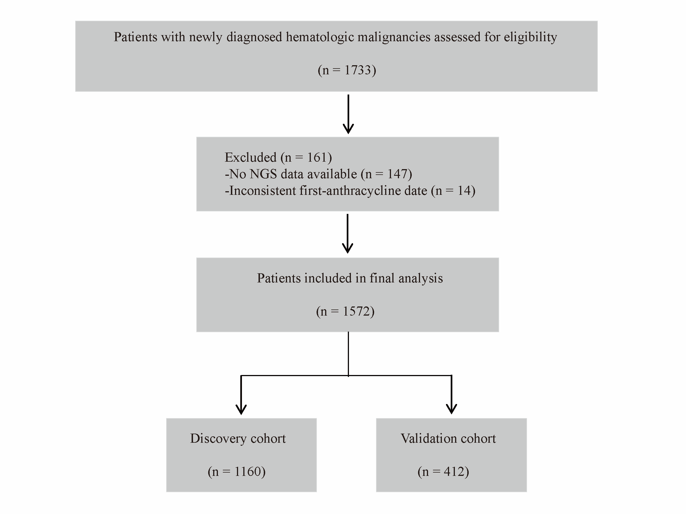
Supplementary Figure S2. Sensitivity analyses: excluding patients with atrial fibrillation within 1 year, and VAF thresholds of 5% and 10%
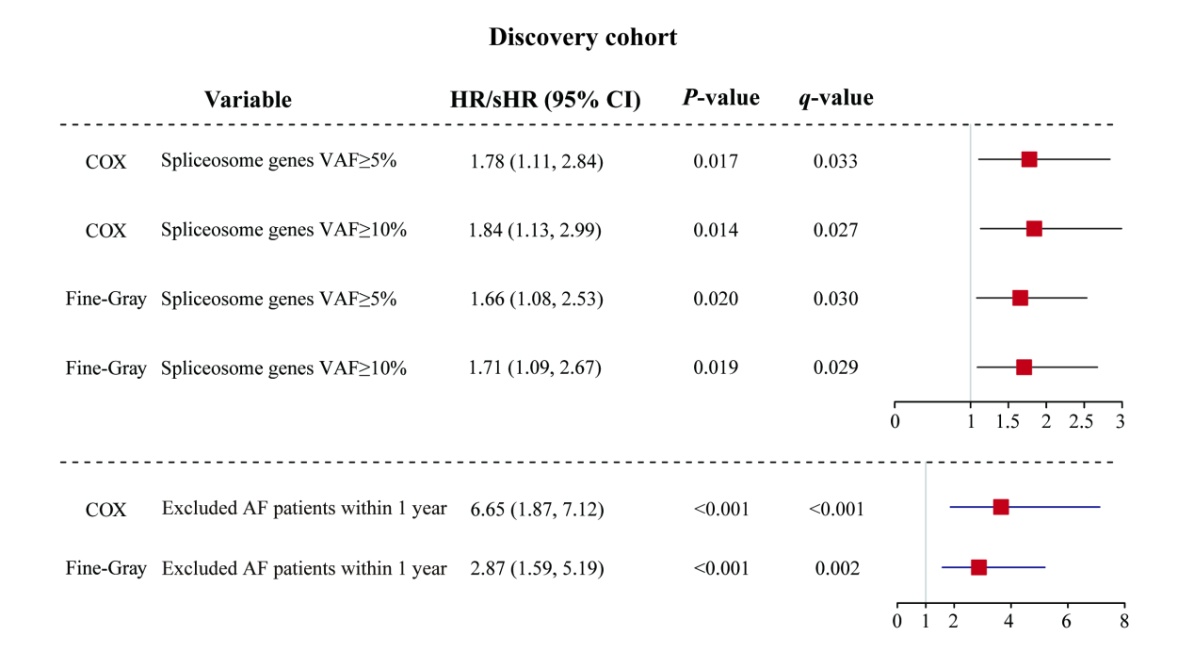
Association between spliceosome gene mutations and AF risk. All models were adjusted for covariates including sex, age, cardiovascular risk factors, anthracycline exposure, and history of cardiovascular and cerebrovascular disease. Data are presented as HR or sHR with 95% confidence intervals (CI) and raw P values. FDR‑adjusted q values are shown in parentheses; q < 0.05 was considered statistically significant. HR: Hazard Ratio; sHR: Subdistribution Hazard Ratio; FDR: False Discovery Rate.
Supplementary Figure S3. VAF distribution of spliceosome gene mutations (waterfall plot)
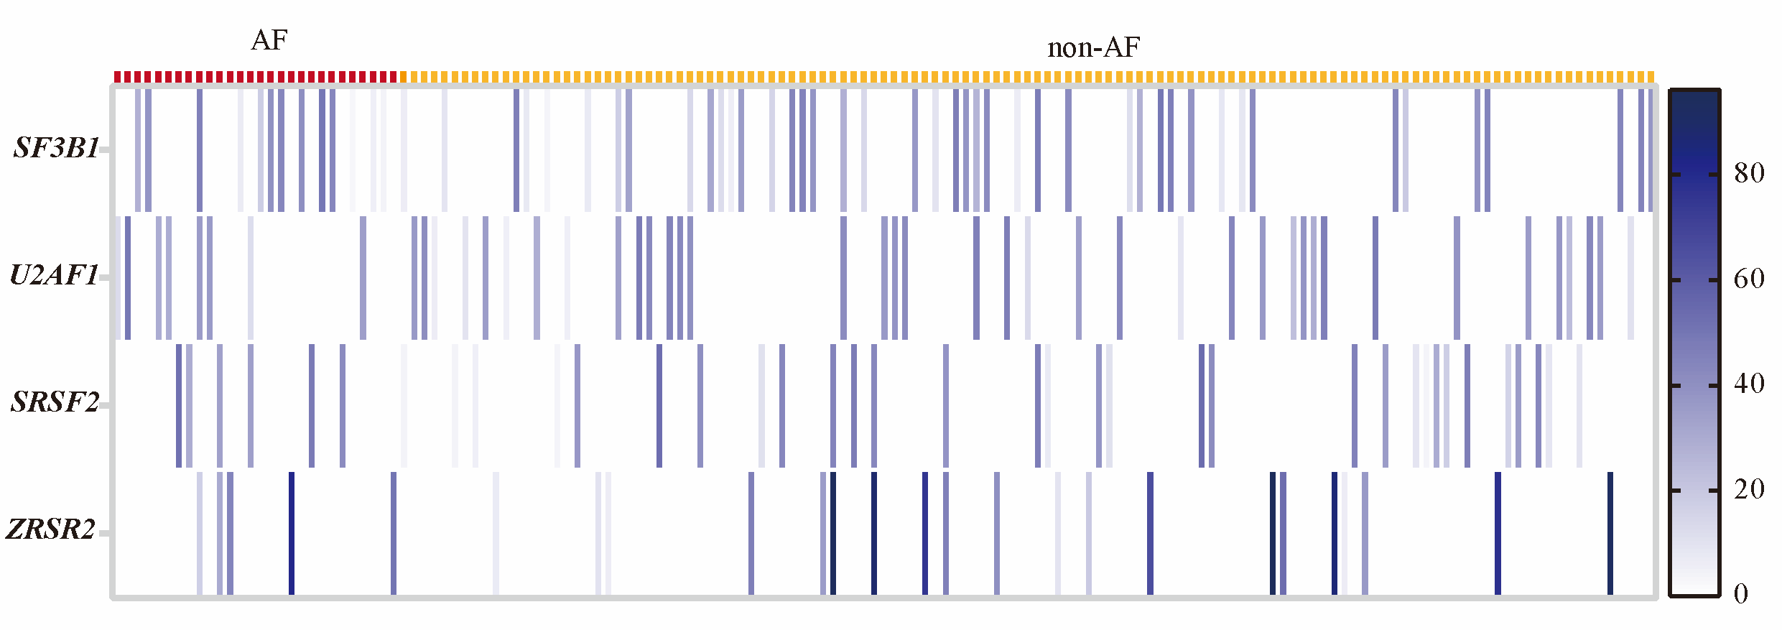
In the waterfall plot, each mutation is represented by a color gradient indicating variant allele frequency (VAF), ranging from 0 (white) to 100 (dark blue), with darker colors reflecting higher mutational burden. The x‑axis displays individual patients, and the y‑axis lists the spliceosome genes. Patients who developed AF are marked in red, while those who remained event‑free are shown in yellow. AF, atrial fibrillation.

Supplementary Figure S4. Sensitivity analysis: spliceosome-anthracycline interaction in the AML and lymphoid malignancy subgroups
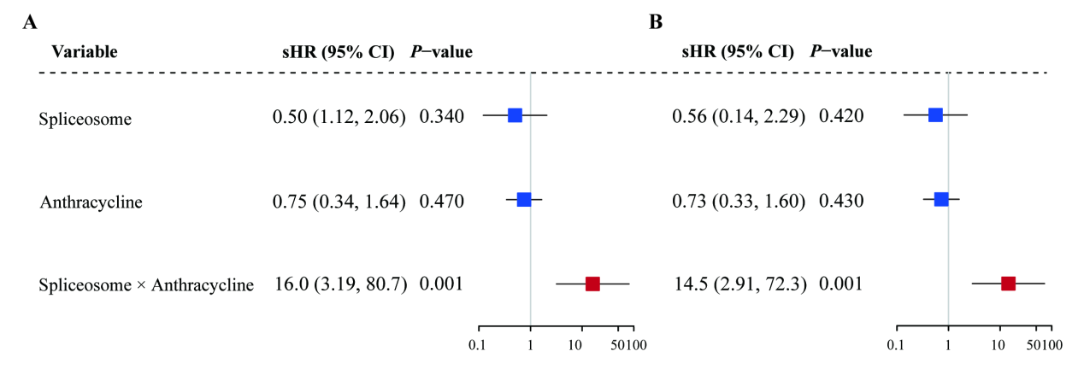
Forest plots showing the interaction between spliceosome mutations and time‑dependent anthracycline exposure in patients with acute myeloid leukemia (AML) and lymphoid malignancies. (A) Adjusted for age and sex. (B) Additionally adjusted for disease subtype. All models used Fine‑Gray competing risk regression with death as competing event. Wide confidence intervals reflect limited sample size of the double‑positive subgroup. sHR, subdistribution hazard ratio; CI, confidence interval.
Supplementary Figure S5. Cardiac structural changes by spliceosome gene mutations and AF status in patients with hematologic malignancies
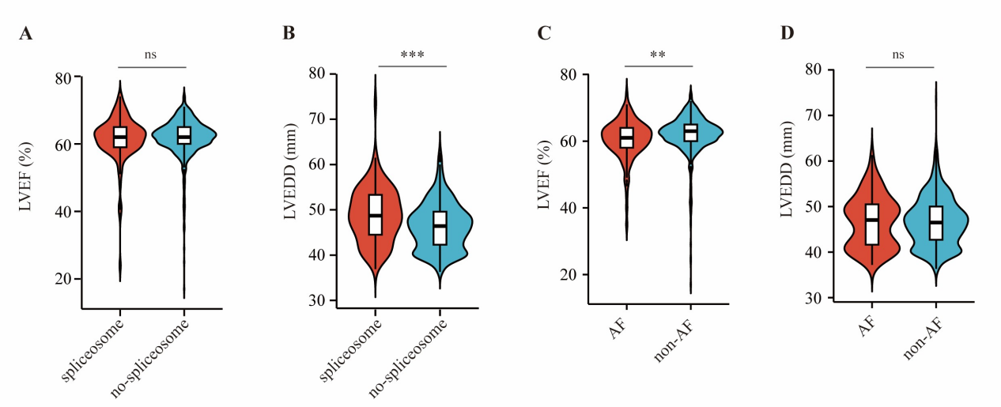(A-B) Comparison of LVEF and LVEDD between patients with spliceosome gene mutations and those without. (C-D) Comparison of LVEF and LVEDD between the AF group and the non-AF group. LVEF, left ventricular ejection fraction; LVEDD, Left ventricular end-diastolic diameter; AF, atrial fibrillation. ** P < 0.01; *** P < 0.001.

Supplementary Figure S6. Representative western blots showing COL3A1 expression in atrial fibroblasts co‑cultured with monocytes from spliceosome mutation carriers versus non‑carriers.
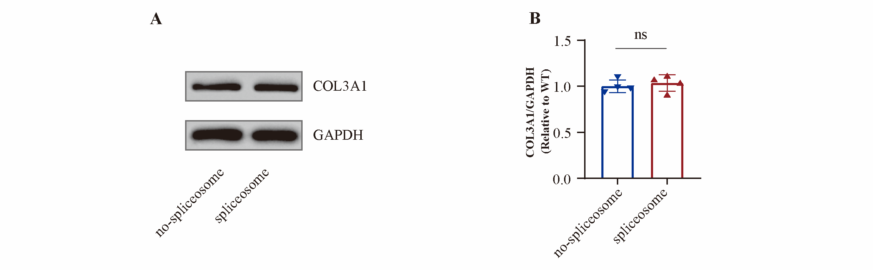
(A) Representative Western blots of COL3A1 in atrial fibroblasts after co‑culture with monocytes from spliceosome‑mutant patients or wild‑type controls. (B) Quantitative analysis of COL3A1 expression. Data are shown as mean ± SD (n = 4 per group); Mann‑Whitney U test. *P < 0.05, **P < 0.01, ***P < 0.001.

