Additional file

Research strategy
PUBMED
(("Neoplasms"[MeSH] OR neoplasm* OR tumor* OR carcinoma*) AND ("Antidepressive Agents"[MeSH] OR "Antidepressive Agent"[Title/Abstract] OR "Antipsychotic Agents"[MeSH] OR "Antipsychotic Agent"[Title/Abstract] OR "Tranquilizing Agents"[MeSH])) AND humans[Filter] AND English [Filter]

EMBASE
(('neoplasm'/exp OR 'neoplasm' OR neoplasm:ti,ab,kw OR 'neoplasm'/de) AND 'antidepressant agent':ti,ab,kw OR 'antidepressant agent'/de OR 'neuroleptic agent':ti,ab,kw OR 'neuroleptic agent'/de OR 'tranquilizer':ti,ab,kw) AND 'tranquilizer'/de AND english:la AND 'human'/de NOT editorial:it NOT 'conference abstract':it NOT letter:it

SCOPUS
TITLE-ABS-KEY ( cancer* OR neoplasm* OR malignant* OR tumour* OR tumor* OR carcinoma* OR adenocarcinoma* ) AND TITLE-ABS-KEY ( antidepressant AND agent OR neuroleptic AND agent OR antipsychotic AND agent OR tranquilizing AND agent ) AND ( LIMIT-TO ( EXACTKEYWORD , "Human" ) ) AND ( LIMIT-TO ( LANGUAGE , "English" ) ) AND ( LIMIT-TO ( DOCTYPE , "ar" ) OR LIMIT-TO ( DOCTYPE , "re" ) )

Statistical methods
To formally compare pooled effect estimates across exposure categories, pooled estimates were compared on the natural logarithmic scale. For each comparison, the difference between pooled effects ${(D}_{ij})$was calculated as:
$$D_{ij}=\ln\left({PE}_{i}\right)-\ln\left({PE}_{j}\right)$$
equivalently,
$$D_{ij}=\ln\left(\frac{{PE}_{i}}{{PE}_{j}}\right)$$
where (${PE}_{i}$) and (${PE}_{j}$) denote the pooled effect estimates obtained from the corresponding random-effects meta-analyses.
The standard error of the difference (${SE}_{D}$) was estimated assuming independence between pooled estimates:
$${SE}_{D}=\sqrt{{SE}_{i}^{2}+{SE}_{j}^{2}}$$
where the standard error ${SE}_{i}j$of each pooled estimate was derived from the corresponding 95% confidence interval:
$${SE}_{i}=\frac{\ln\left(U_{i}\right)-\ln\left(L_{i}\right)}{2×1.96}$$
with ($U_{i}$) and ($L_{i}$) representing the upper and lower confidence limits of each estimate, respectively.
Statistical significance of the difference between pooled estimates was assessed using a Wald z-test:
$$Z=\frac{D}{{SE}_{D}}$$
and corresponding two-sided p-values were obtained from the standard normal distribution. The confidence intervals at 95% (${CI}_{95\%}$) for the difference were calculated as:
$${CI}_{95\%}\left(D\right)=D±1.96×{SE}_{D}$$
For ease of interpretation, results were exponentiated and reported as ratios of pooled estimates:
$$Ratio=\exp\left(D\right)=\frac{{PE}_{i}}{{PE}_{j}}$$
where values greater than 1 indicate a higher pooled effect estimate in the numerator subgroup and values lower than 1 indicate a lower pooled effect estimate.
For each comparison, the difference between pooled effects ${(D}_{ij})$was calculated as:
$$D_{ij}=\ln\left({PE}_{i}\right)-\ln\left({PE}_{j}\right)$$
equivalently,
$$D_{ij}=\ln\left(\frac{{PE}_{i}}{{PE}_{j}}\right)$$
where (${PE}_{i}$) and (${PE}_{j}$) denote the pooled effect estimates obtained from the corresponding random-effects meta-analyses.
The standard error of the difference (${SE}_{D}$) was estimated assuming independence between pooled estimates:
$${SE}_{D}=\sqrt{{SE}_{i}^{2}+{SE}_{j}^{2}}$$
where the standard error ${SE}_{i}j$of each pooled estimate was derived from the corresponding 95% confidence interval:
$${SE}_{i}=\frac{\ln\left(U_{i}\right)-\ln\left(L_{i}\right)}{2×1.96}$$
with ($U_{i}$) and ($L_{i}$) representing the upper and lower confidence limits of each estimate, respectively.
Statistical significance of the difference between pooled estimates was assessed using a Wald z-test:
$$Z=\frac{D}{{SE}_{D}}$$
and corresponding two-sided p-values were obtained from the standard normal distribution. The confidence intervals at 95% (${CI}_{95\%}$) for the difference were calculated as:
$${CI}_{95\%}\left(D\right)=D±1.96×{SE}_{D}$$
For ease of interpretation, results were exponentiated and reported as ratios of pooled estimates:
$$Ratio=\exp\left(D\right)=\frac{{PE}_{i}}{{PE}_{j}}$$
where values greater than 1 indicate a higher pooled effect estimate in the numerator subgroup and values lower than 1 indicate a lower pooled effect estimate.

Table 1 Quality assessment for studies using the Newcastle–Ottawa Quality Assessment Scale: cohort studies and case-control studies
 | Selection |  |  |  | Comparability | Outcome
Author | Representativeness | Selection | Selection of controls | Definition of controls | Variables(s) | Ascertainment of exposure | Same method of ascertainment for cases and controls | Non-response rate | Overall
Ashbury et al. | * | * | * |  | ** | * |  |  | 6
Azoulay et al. | * | * | * |  | * |  | * |  | 5
Boursi et al. | * | * | * | * | * |  |  | * | 6
Brown et al. | * | * |  | * | ** | * | * |  | 7
Chien et al. | * | * | * | * | * | * |  |  | 6
Chubak et al. | * | * | * |  | * |  | * |  | 5
Coogan et al. 2005 | * | * |  | * | ** | * |  |  | 6
Coogan et al. 2008 | * | * |  | * | ** |  | * |  | 6
Cotterchio et al. | * | * | * |  | ** | * |  |  | 6
Fulton-Kehoe et al. | * | * | * |  | ** | * |  |  | 6
González-Pérez et al. | * | * | * | * | ** | * |  |  | 7
Haque et al. | * | * | * | * | * | * | * |  | 7
Haukka et al. | * | * | * | * | * | * |  |  | 6
Kato et al. | * | * |  | * | ** | * | * |  | 7
Lash et al. | * | * | * |  | * | * | * |  | 6
Mansi et al. | * | * | * |  | * | * | * |  | 6
Moorman et al. | * | * | * |  | * | * |  |  | 5
Sharpe et al. | * | * | * |  | * | * | * |  | 6
Steingart et al. | * | * | * | * | ** | * |  |  | 7
Tamim et al. | * | * | * | * | * | * |  |  | 6
Wang et al. | * | * | * | * | ** | * |  |  | 7
Weiss et al. | * | * | * |  | * | * | * |  | 6
Wernli et al. | * | * | * |  | ** |  | * |  | 6

NOTE: For each study, a maximum of one star for each numbered item within the Selection and Exposure categories was awarded. A maximum of two stars was given for Comparability. The total number of stars earned (maximum score of 9) was a measure of study quality.
The Newcastle–Ottawa Scale (NOS) was used to assess the quality of the included studies. For case–control studies, stars are awarded within the Selection domain when the case definition is adequately validated, cases are representative, community controls are used, and controls have no history of the outcome. In the Comparability domain, one star is given if analyses are adjusted for breast cancer and an additional star if further confounders are controlled. In the Exposure domain, stars are assigned for secure ascertainment of exposure (e.g., medical or surgical records), blinded interviews, consistent methods of exposure assessment between cases and controls, and similar response rates. For cohort studies, the Selection domain awards stars when the exposed cohort is representative of the average population, the nonexposed cohort is drawn from the same community, exposure is ascertained from secure records or structured interviews, and the outcome is absent at baseline. In the Comparability domain, one star is given if analyses adjust for breast cancer and an additional star if further confounders are included. In the Outcome domain, stars are awarded for independent or record-based outcome assessment, sufficient length of follow-up, and adequate follow-up of the cohort. Higher numbers of stars indicate better methodological quality.

Analyses

CURRENT SSRIs USERS GROUP 1
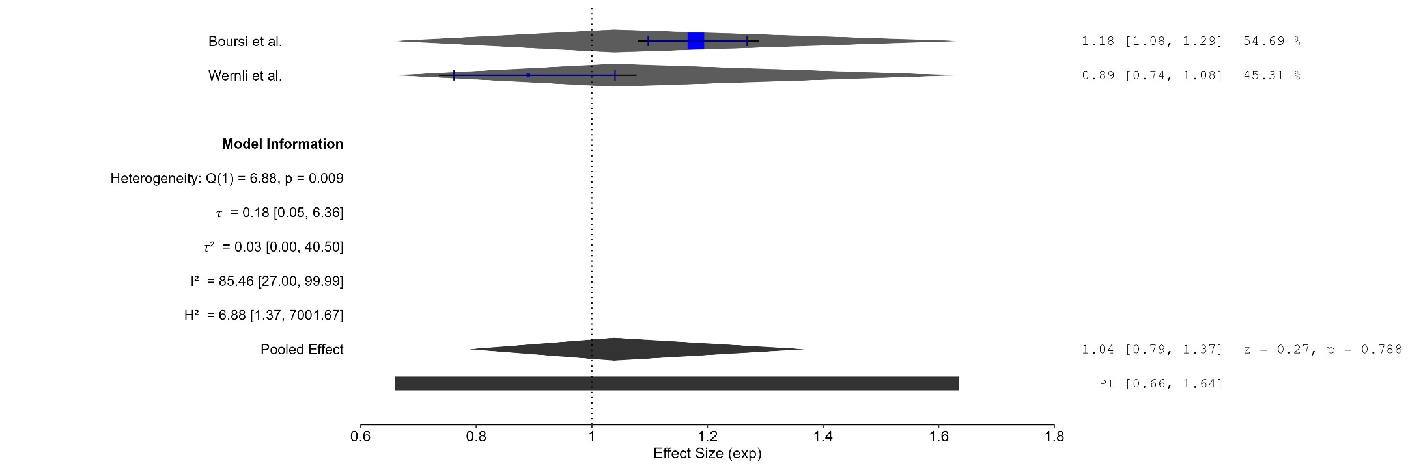
Figure 1. Current SSRIs Users Group 1
The area of each square is proportional to the sample size of the respective study, with horizontal lines through the squares representing the 95% confidence interval (C.I.) for that study. In the pooled analysis, the diamond symbol represents the pooled estimate, with the right and left points of the diamond indicating the 95% C.I. for the overall analysis
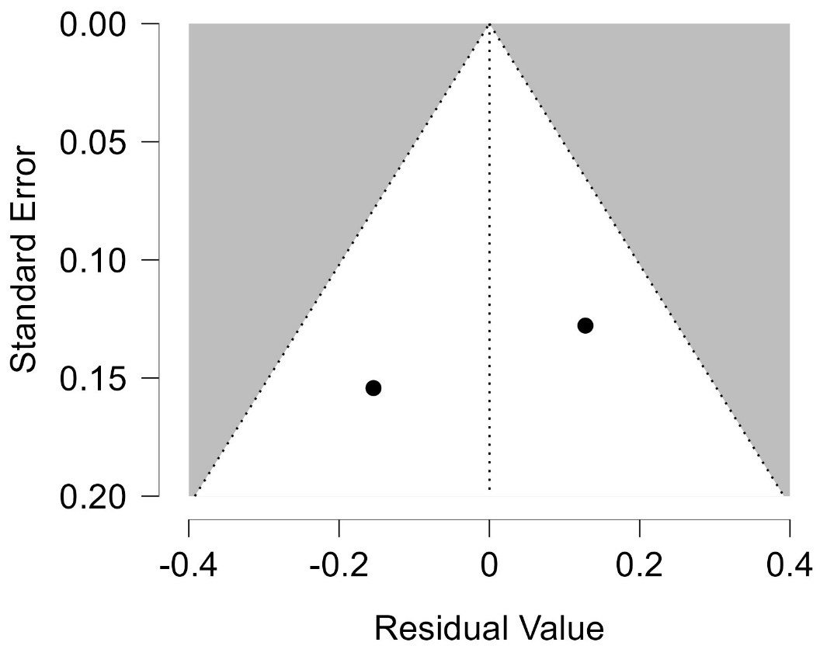
Figure 2. Funnel plot - Current SSRIs Users Group 1
Each blue dot represents a single study, plotted with its effect size on the x-axis and its standard error on the y-axis. The vertical red line represents the overall effect estimate derived from the random-effects model using restricted maximum likelihood (REML). The pseudo 95% confidence interval region, shown as gray diagonal lines, outlines the expected spread of studies in the absence of bias or between-study heterogeneity.
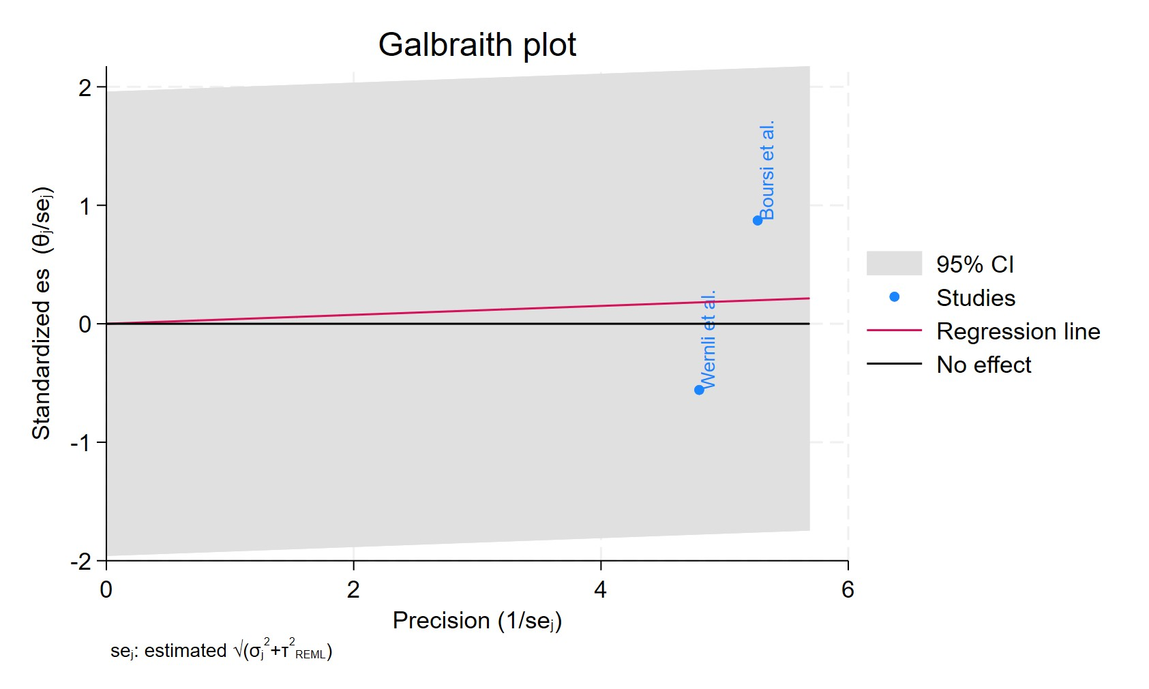
Figure 3 Galbraith plot - Current SSRIs Users Group 1
Each study is represented as a point, where the x-axis denotes the precision (defined as the inverse of the standard error), and the y-axis indicates the standardized effect size. The red regression line represents the overall summary effect estimated from the random-effects model, and the gray shaded area corresponds to the confidence interval at 95% around regression line. The horizontal black ––line at y = 0 corresponds to the line of no effect, serving as a reference.
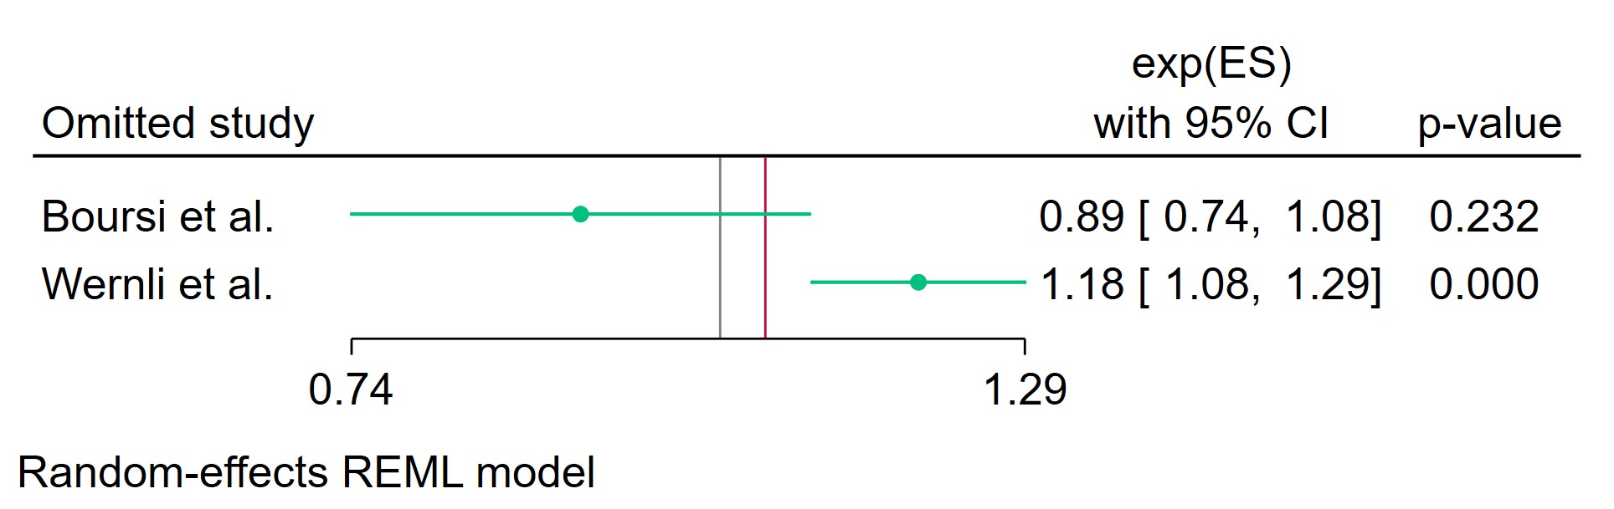
Figure 4 Leave-one-out - Current SSRIs Users Group 1
Leave-one-out (LOO) analysis assesses meta-analysis robustness by iteratively excluding one study at a time and refitting the model to observe shifts in the pooled effect size, confidence interval, and heterogeneity
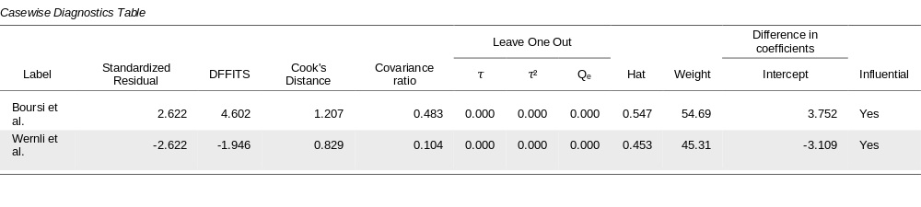
Figure 5 Casewise diagnostics - Current SSRIs Users Group 1
Casewise diagnostics evaluate individual study influence in meta-analysis by computing standardized residuals, leverage (Hat values), and global influence measures like DFFITS, Cook's distance, and covariance ratios.​
Leave-one-out (LOO) analyses refit the model after sequentially omitting each study, quantifying changes in key parameters (e.g., $τ$, $τ^{2}$, $Q_{e}$, pooled effect) to assess sensitivity to individual observations.​
Studies exceeding conventional thresholds (e.g., Cook's distance >1, |DFFITS| >1, |standardized residual| >2) are flagged as influential, guiding decisions on robustness or exclusion.
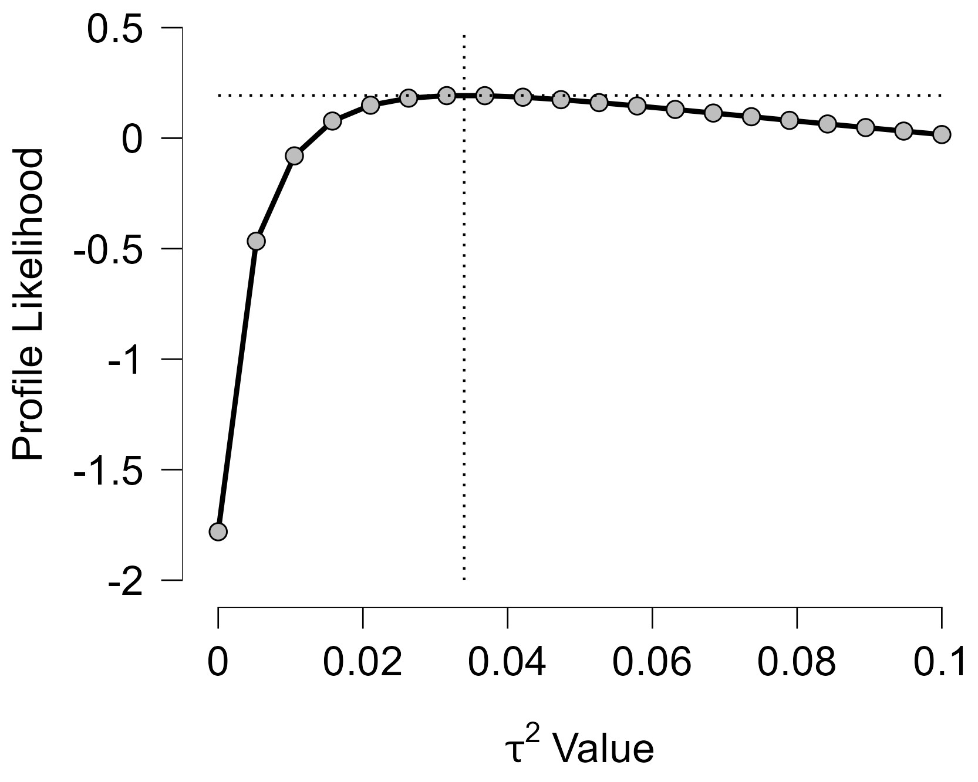
Figure 6 Profile Likelihood - Current SSRIs Users Group 1
The x-axis shows candidate values of the heterogeneity variance $τ^{2}$, and the y-axis shows the corresponding standardized profile likelihood, which has been scaled so that the maximum value equals 1 at $τ^{2}=0$.
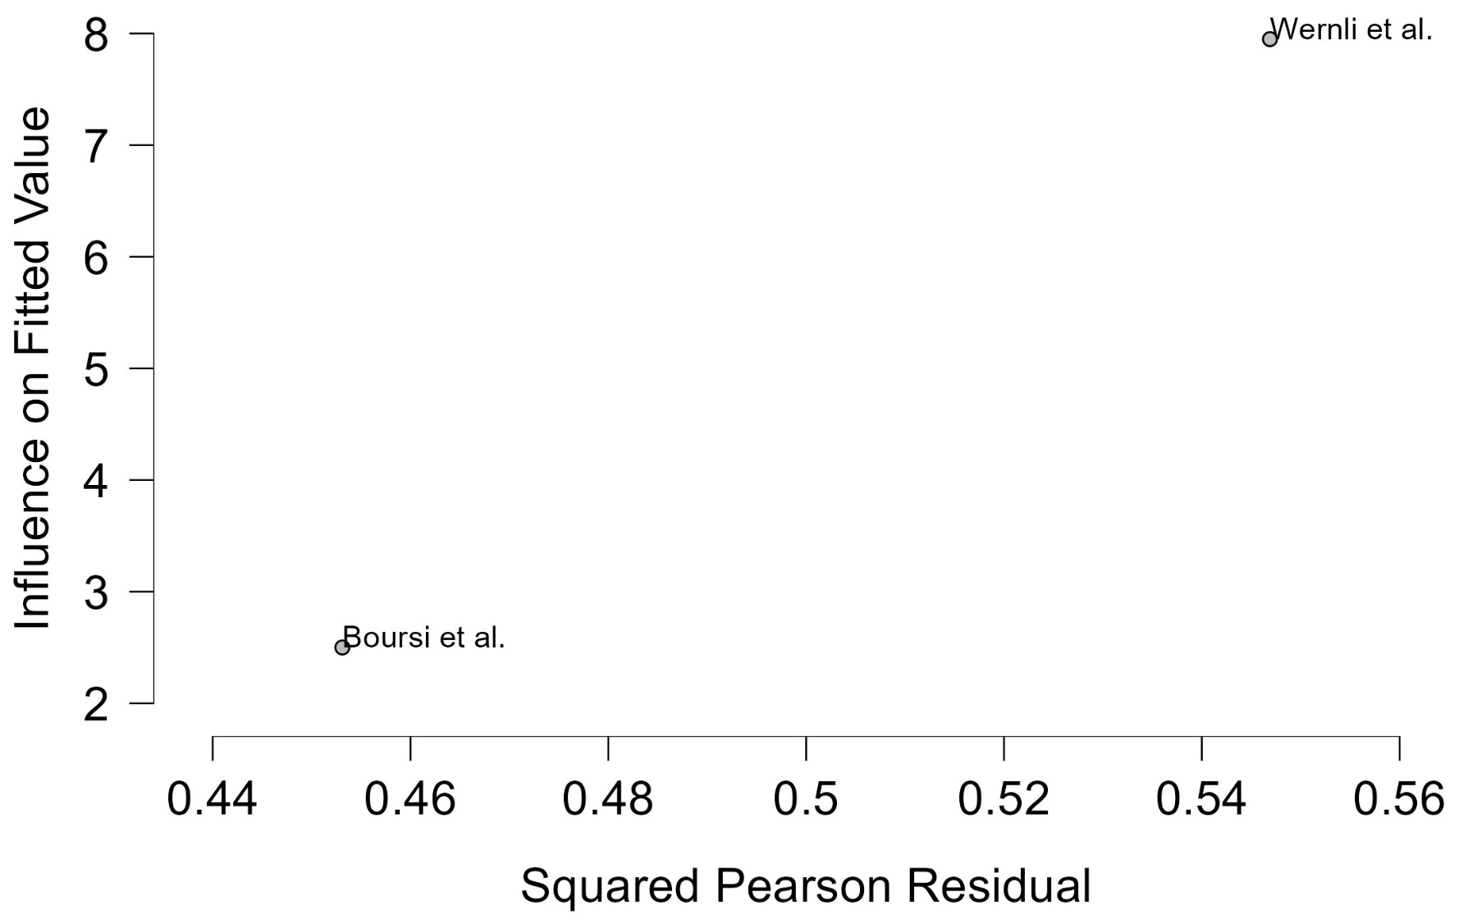
Figure 7 Baujat plot - Current SSRIs Users Group 1
The Baujat plot visualises each study's contribution to the Q-statistic for heterogeneity on the x-axis (squared Pearson residual) against its influence on the pooled effect on the y-axis (standardized squared difference in fixed-effects estimates with/without the study). Studies in the top-right quadrant drive both heterogeneity and effect variation, signalling candidates for sensitivity analysis; bottom-left points have minimal impact.

Former SSRIs Users Group 1
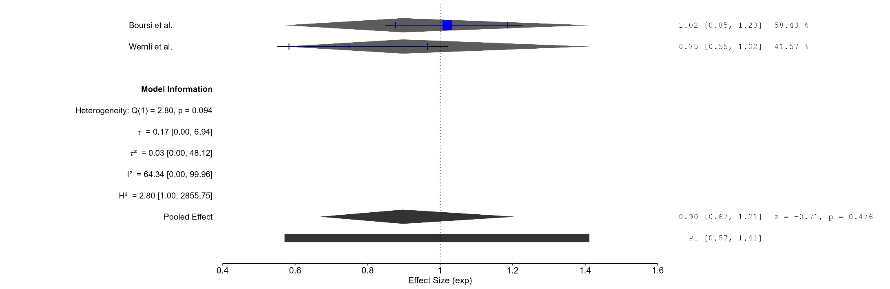
Figure 8 Forest plot - Former SSRIs Users Group 1

The area of each square is proportional to the sample size of the respective study, with horizontal lines through the squares representing the 95% confidence interval (C.I.) for that study. In the pooled analysis, the diamond symbol represents the pooled estimate, with the right and left points of the diamond indicating the 95% C.I. for the overall analysis
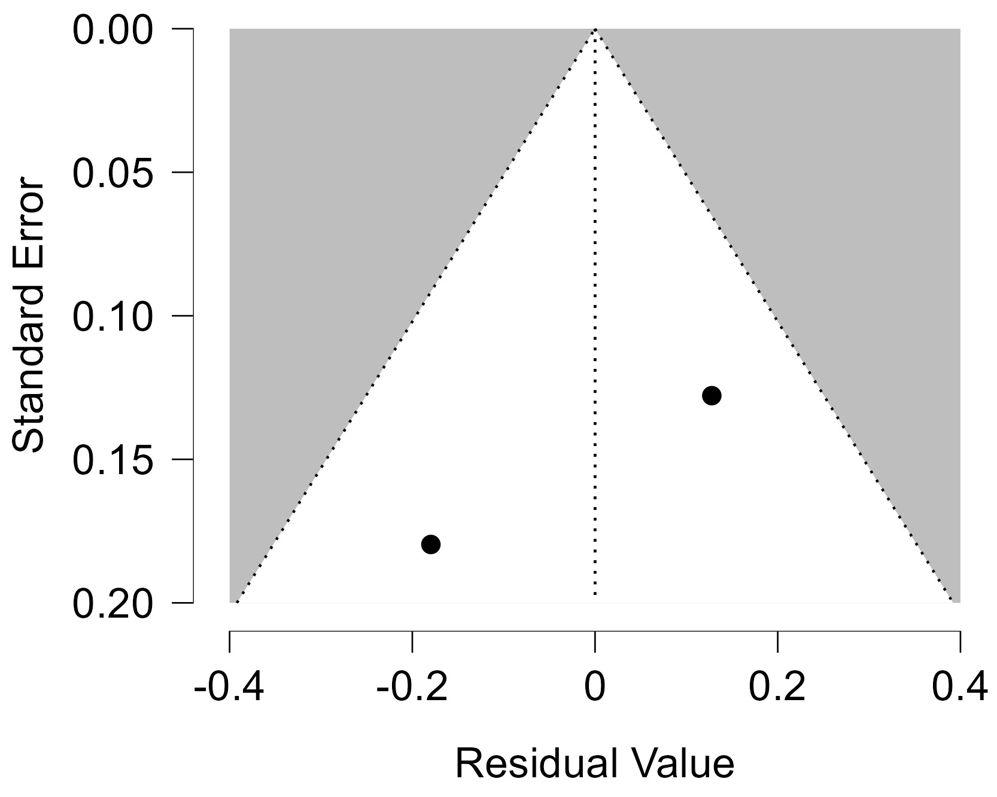
Figure 9 Funnel plot - Former SSRIs Users Group 1
Each blue dot represents a single study, plotted with its effect size on the x-axis and its standard error on the y-axis. The vertical red line represents the overall effect estimate derived from the random-effects model using restricted maximum likelihood (REML). The pseudo 95% confidence interval region, shown as gray diagonal lines, outlines the expected spread of studies in the absence of bias or between-study heterogeneity.
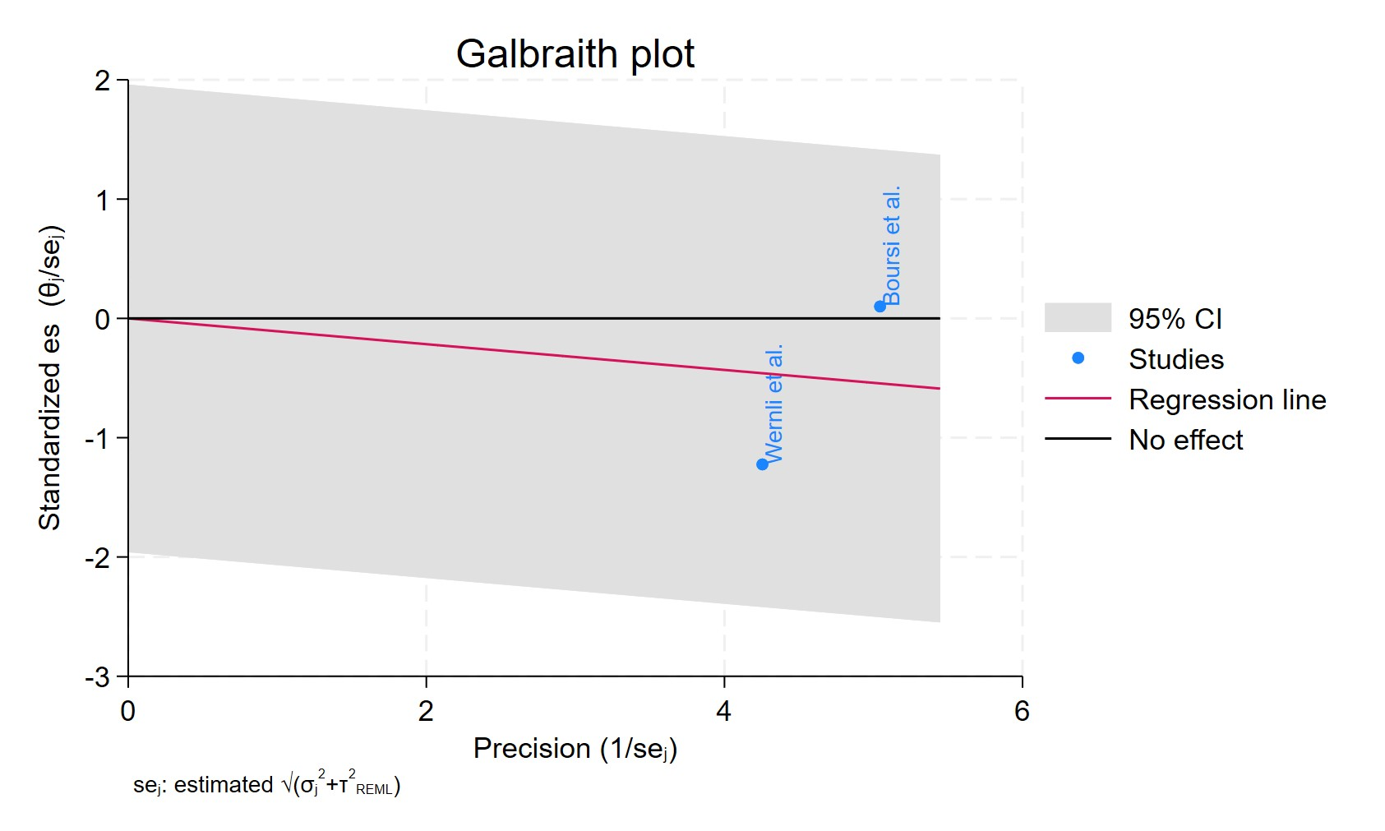
Figure 10 Galbraith plot - Former SSRIs Users Group 1

Each study is represented as a point, where the x-axis denotes the precision (defined as the inverse of the standard error), and the y-axis indicates the standardized effect size. The red regression line represents the overall summary effect estimated from the random-effects model, and the gray shaded area corresponds to the confidence interval at 95% around regression line. The horizontal black ––line at y = 0 corresponds to the line of no effect, serving as a reference.
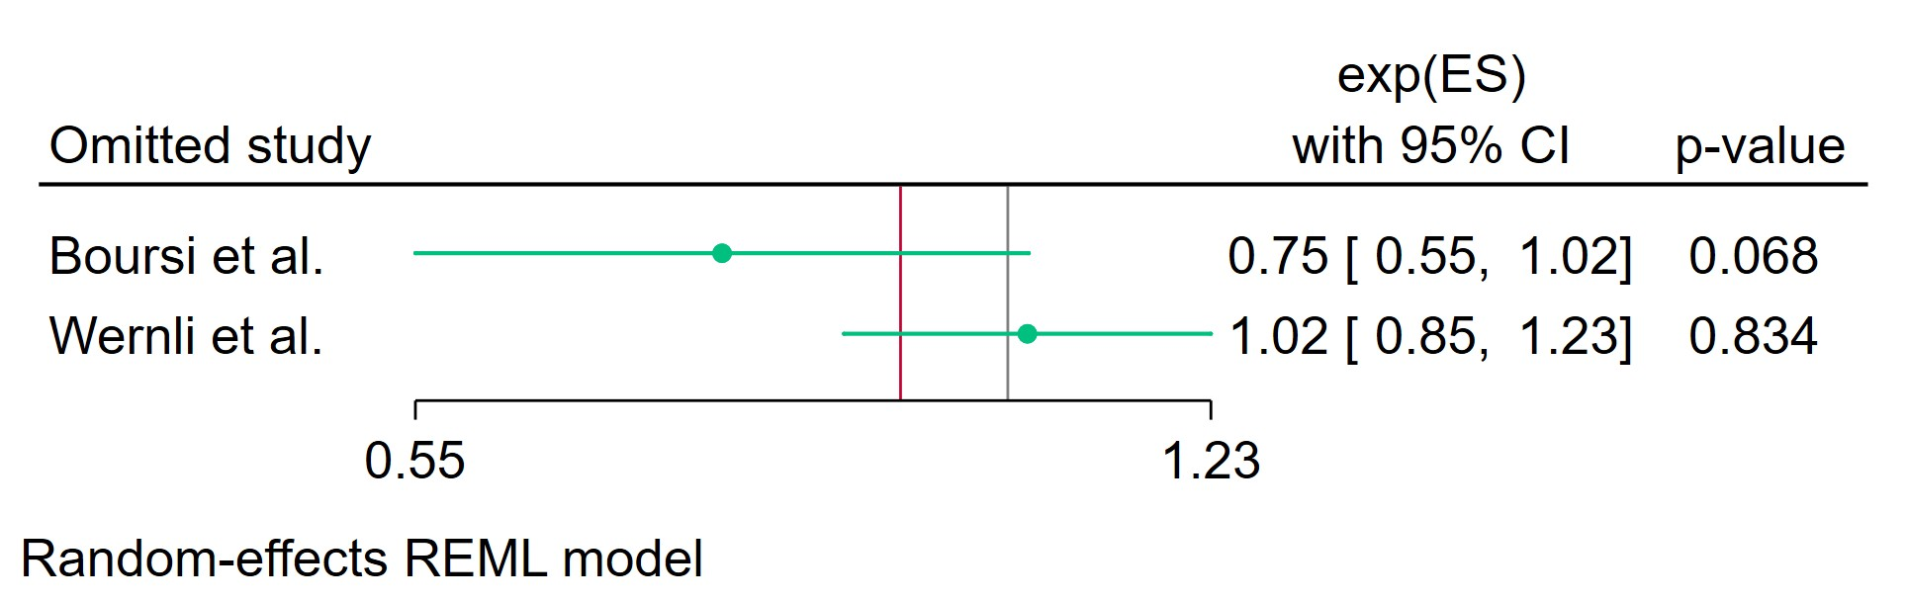
Figure 11 Leave-one-out - Former SSRIs Users Group 1

Leave-one-out (LOO) analysis assesses meta-analysis robustness by iteratively excluding one study at a time and refitting the model to observe shifts in the pooled effect size, confidence interval, and heterogeneity

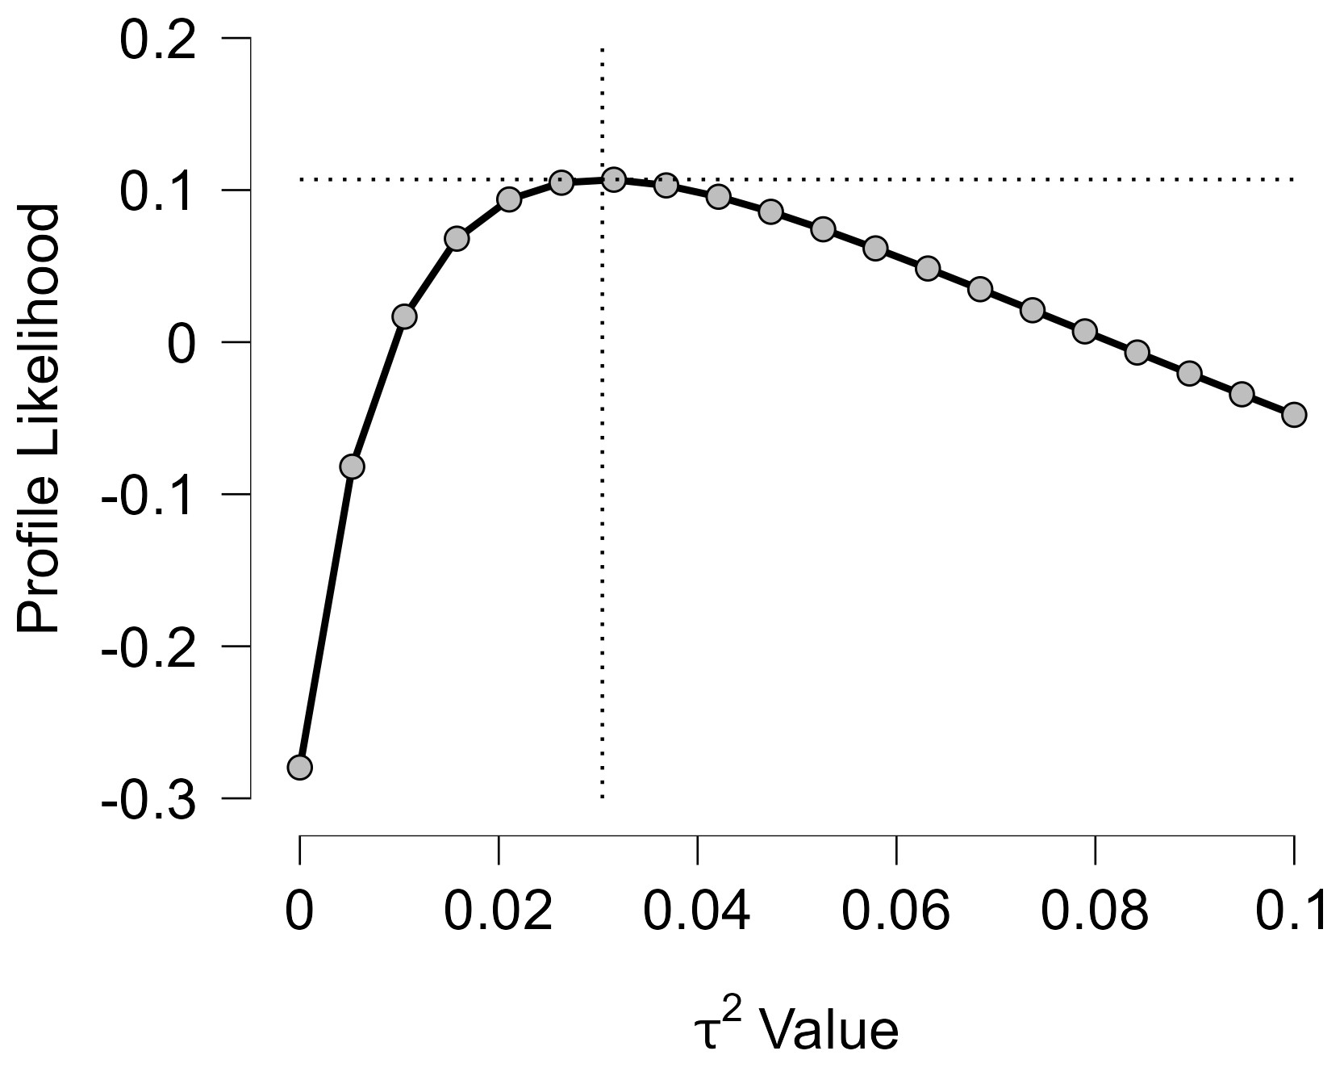
Figure 12 Profile Likelihood - Former SSRIs Users Group 1
The x-axis shows candidate values of the heterogeneity variance $τ^{2}$, and the y-axis shows the corresponding standardized profile likelihood, which has been scaled so that the maximum value equals 1 at $τ^{2}=0$.
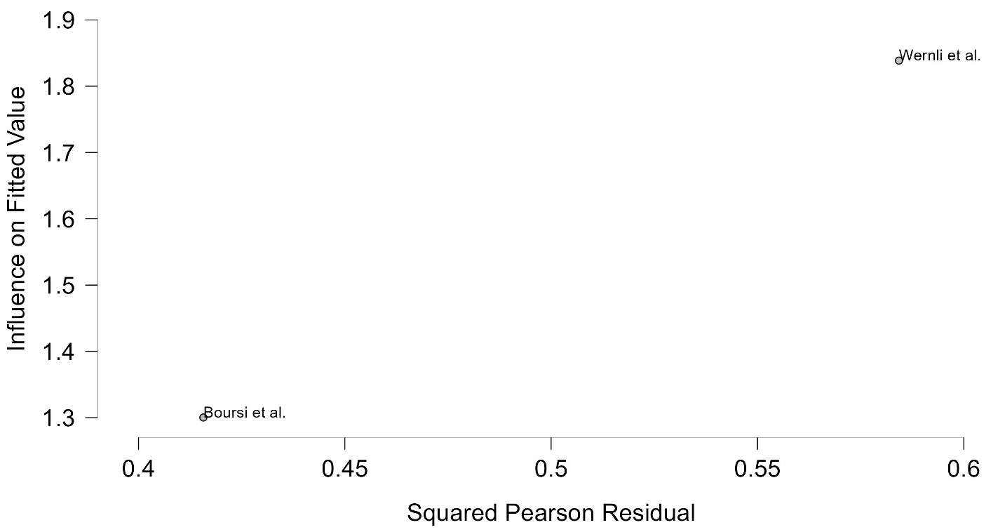
Figure 13 Baujat plot - Former SSRIs Users Group 1
The Baujat plot visualises each study's contribution to the Q-statistic for heterogeneity on the x-axis (squared Pearson residual) against its influence on the pooled effect on the y-axis (standardized squared difference in fixed-effects estimates with/without the study). Studies in the top-right quadrant drive both heterogeneity and effect variation, signalling candidates for sensitivity analysis; bottom-left points have minimal impact.

Current SSRIs Users Group 2
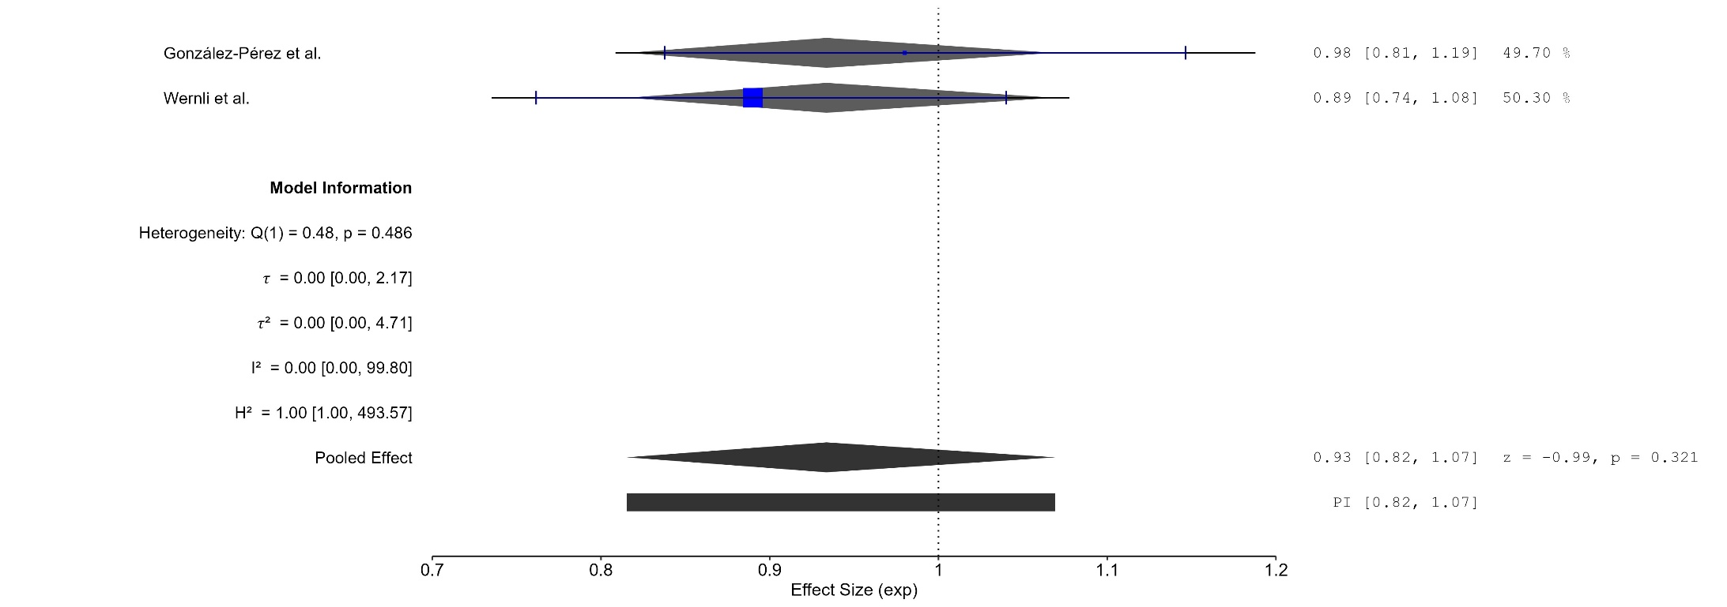
Figure 14 Forest plot - Current SSRIs Users Group 2

The area of each square is proportional to the sample size of the respective study, with horizontal lines through the squares representing the 95% confidence interval (C.I.) for that study. In the pooled analysis, the diamond symbol represents the pooled estimate, with the right and left points of the diamond indicating the 95% C.I. for the overall analysis
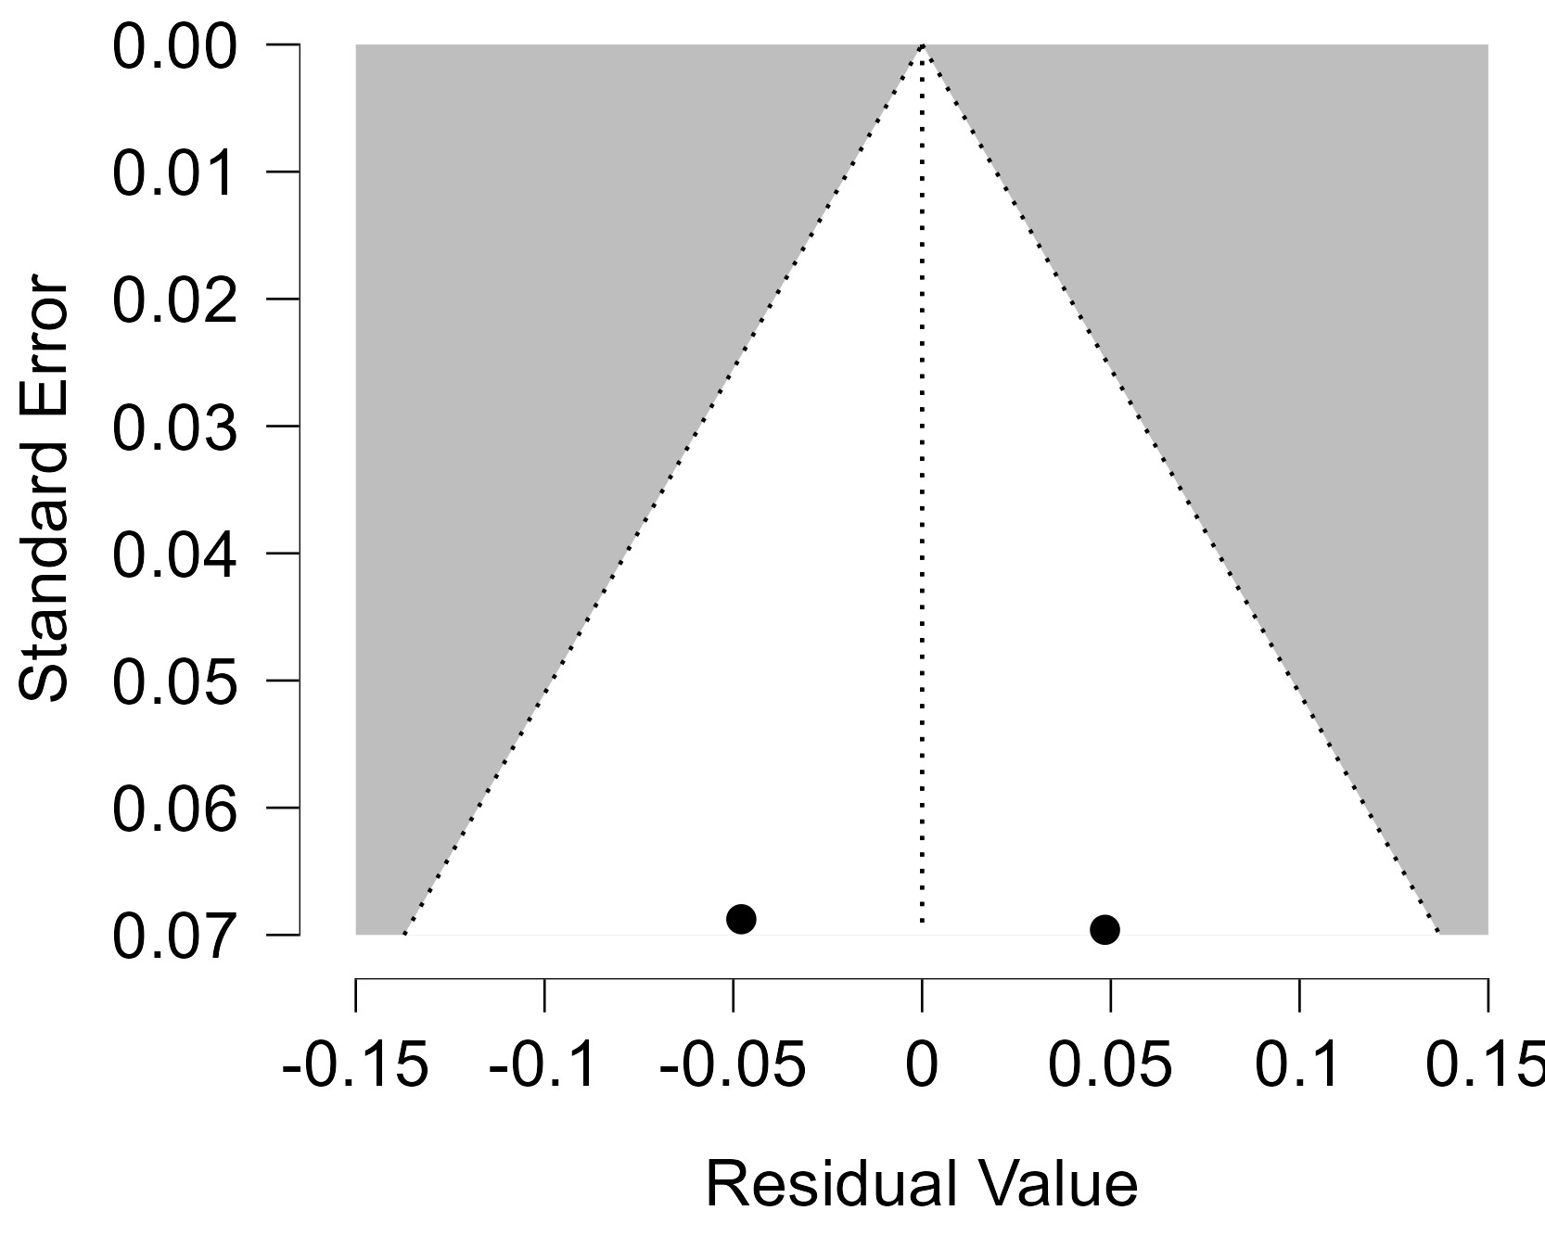
Figure 15 Funnel plot - Current SSRIs Users Group 2

Each blue dot represents a single study, plotted with its effect size on the x-axis and its standard error on the y-axis. The vertical red line represents the overall effect estimate derived from the random-effects model using restricted maximum likelihood (REML). The pseudo 95% confidence interval region, shown as gray diagonal lines, outlines the expected spread of studies in the absence of bias or between-study heterogeneity.
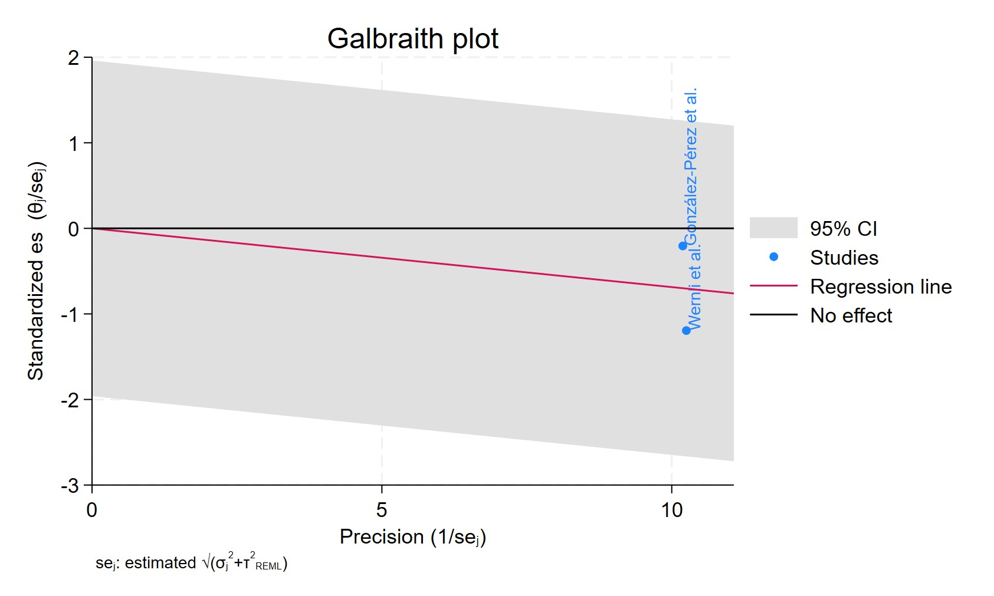
Figure 16 Galbraith plot - Current SSRIs Users Group 2

Each study is represented as a point, where the x-axis denotes the precision (defined as the inverse of the standard error), and the y-axis indicates the standardized effect size. The red regression line represents the overall summary effect estimated from the random-effects model, and the gray shaded area corresponds to the confidence interval at 95% around regression line. The horizontal black ––line at y = 0 corresponds to the line of no effect, serving as a reference.
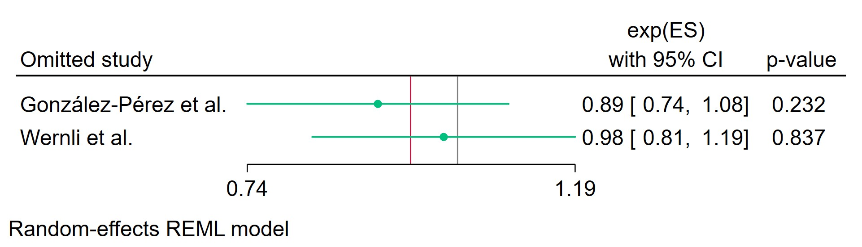
Figure 17 Leave-one-out - Current SSRIs Users Group 2
Leave-one-out (LOO) analysis assesses meta-analysis robustness by iteratively excluding one study at a time and refitting the model to observe shifts in the pooled effect size, confidence interval, and heterogeneity
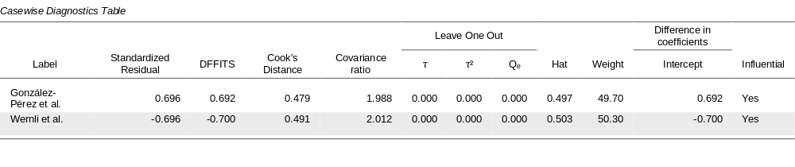
Figure 18 Casewise diagnostics - Current SSRIs Users Group 2

Casewise diagnostics evaluate individual study influence in meta-analysis by computing standardized residuals, leverage (Hat values), and global influence measures like DFFITS, Cook's distance, and covariance ratios.​
Leave-one-out (LOO) analyses refit the model after sequentially omitting each study, quantifying changes in key parameters (e.g., $τ$, $τ^{2}$, $Q_{e}$, pooled effect) to assess sensitivity to individual observations.​
Studies exceeding conventional thresholds (e.g., Cook's distance >1, |DFFITS| >1, |standardized residual| >2) are flagged as influential, guiding decisions on robustness or exclusion.
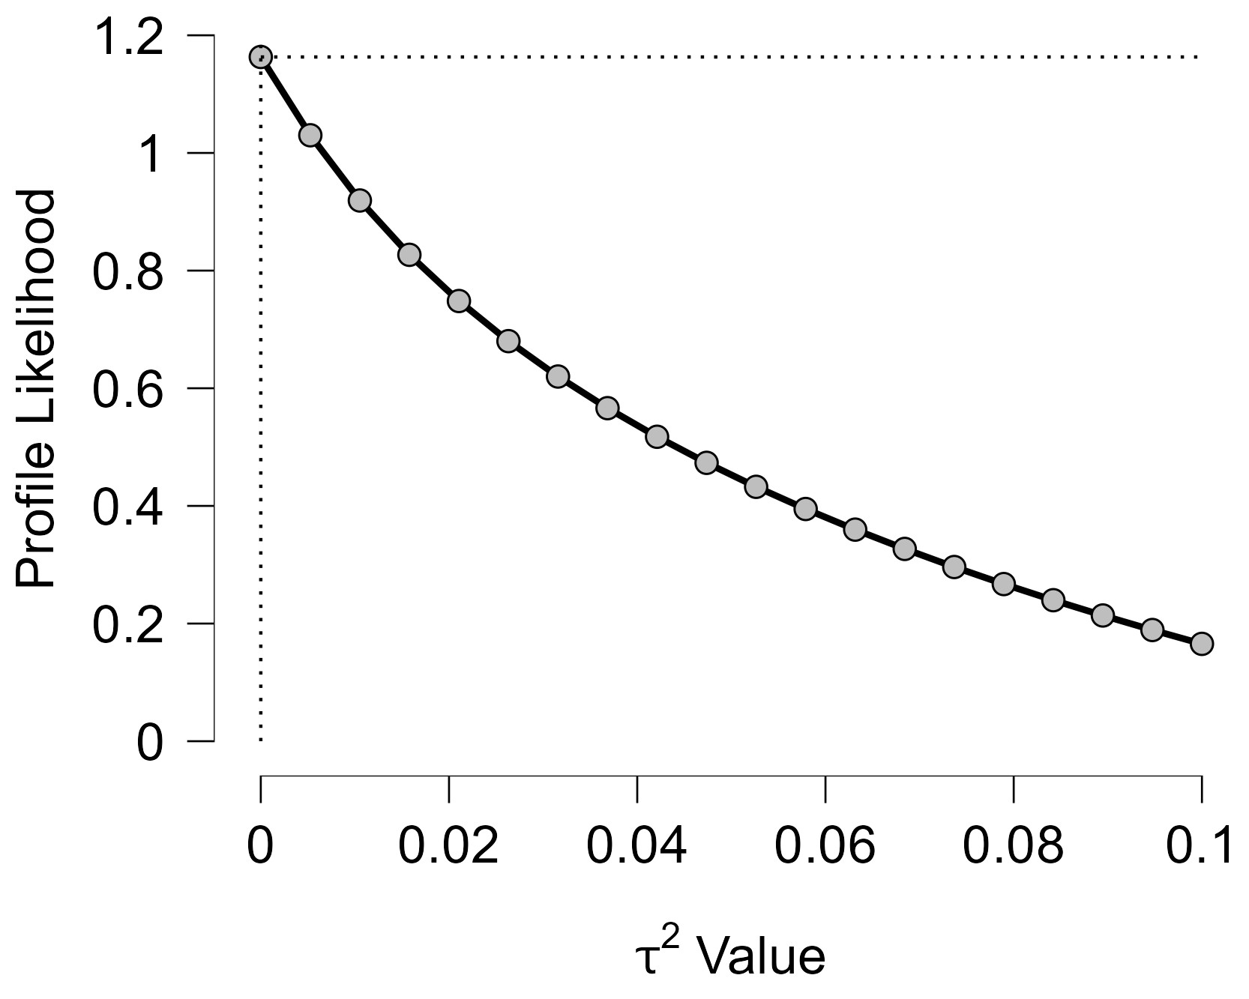
Figure 19 Profile Likelihood - Current SSRIs Users Group 2

The x-axis shows candidate values of the heterogeneity variance $τ^{2}$, and the y-axis shows the corresponding standardized profile likelihood, which has been scaled so that the maximum value equals 1 at $τ^{2}=0$.
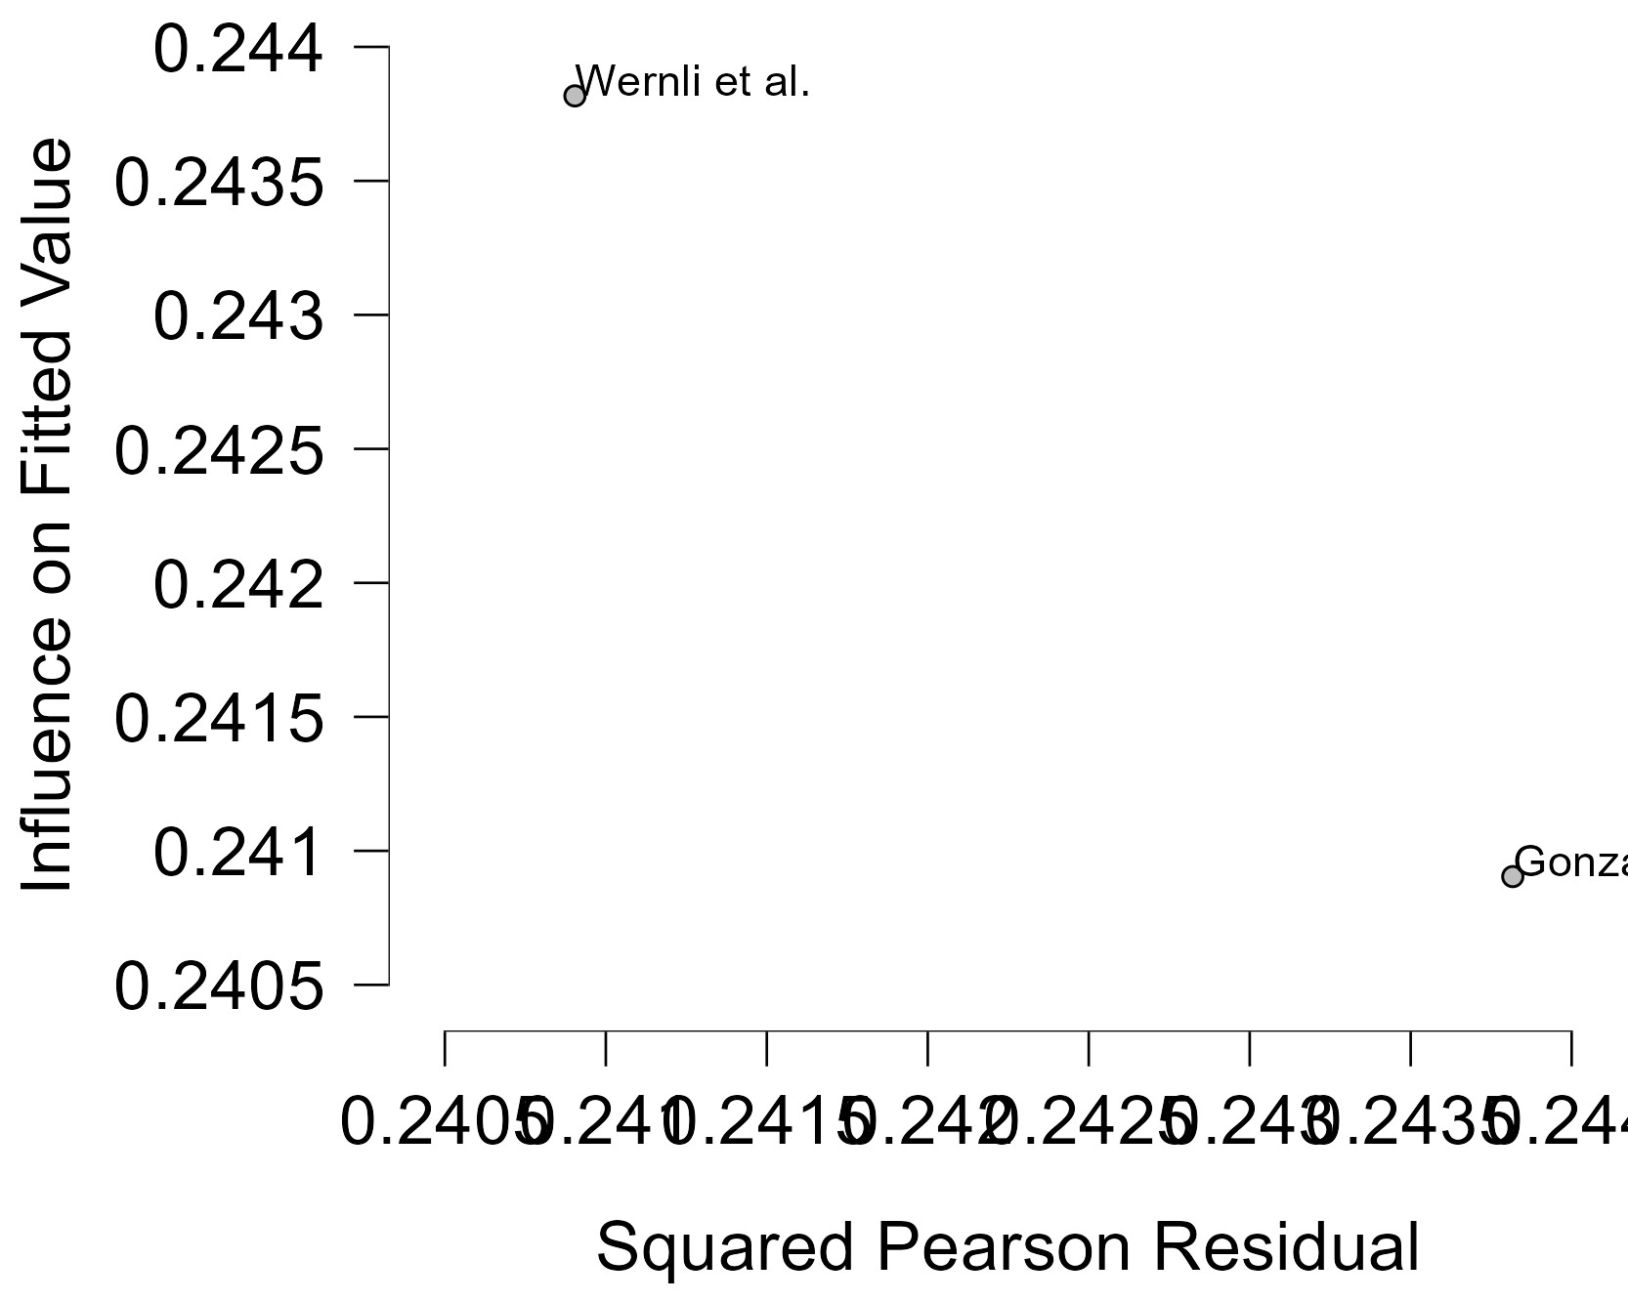
Figure 20 Baujat plot - Current SSRIs Users Group 2

The Baujat plot visualises each study's contribution to the Q-statistic for heterogeneity on the x-axis (squared Pearson residual) against its influence on the pooled effect on the y-axis (standardized squared difference in fixed-effects estimates with/without the study). Studies in the top-right quadrant drive both heterogeneity and effect variation, signalling candidates for sensitivity analysis; bottom-left points have minimal impact.

Former SSRIs Users Group 2
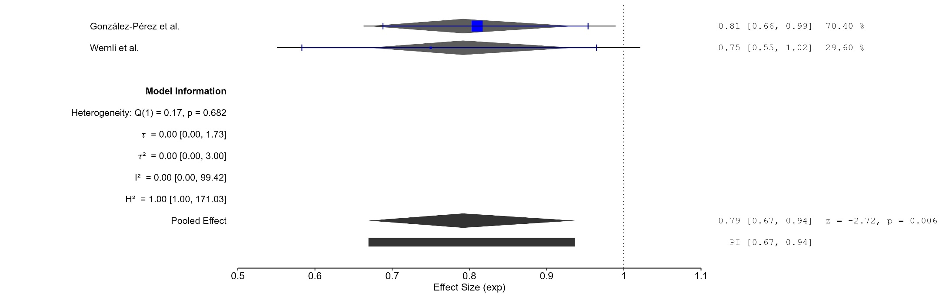
Figure 21 Forest plot - Former SSRIs Users Group 2

The area of each square is proportional to the sample size of the respective study, with horizontal lines through the squares representing the 95% confidence interval (C.I.) for that study. In the pooled analysis, the diamond symbol represents the pooled estimate, with the right and left points of the diamond indicating the 95% C.I. for the overall analysis
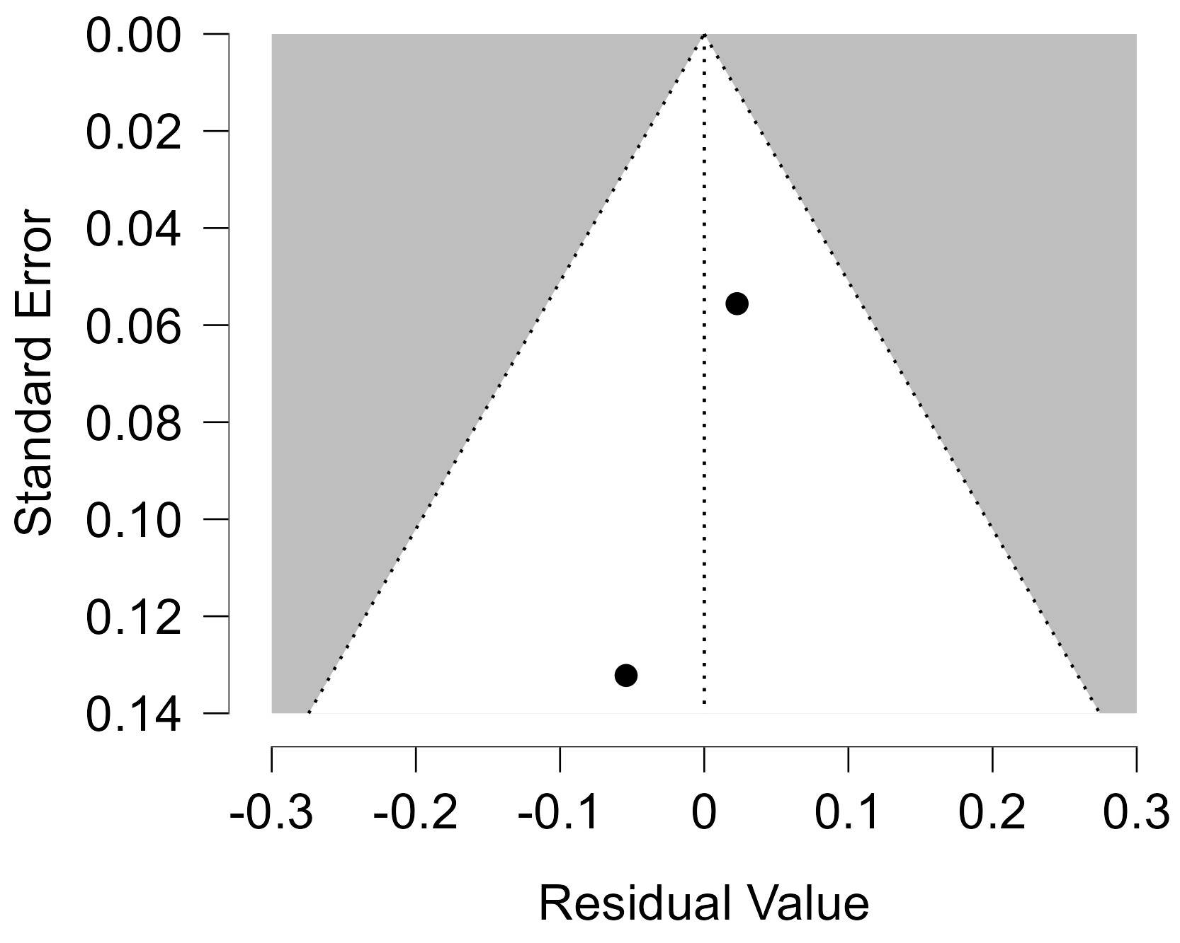
Figure 22 Funnel plot - Former SSRIs Users Group 2

Each blue dot represents a single study, plotted with its effect size on the x-axis and its standard error on the y-axis. The vertical red line represents the overall effect estimate derived from the random-effects model using restricted maximum likelihood (REML). The pseudo 95% confidence interval region, shown as gray diagonal lines, outlines the expected spread of studies in the absence of bias or between-study heterogeneity.
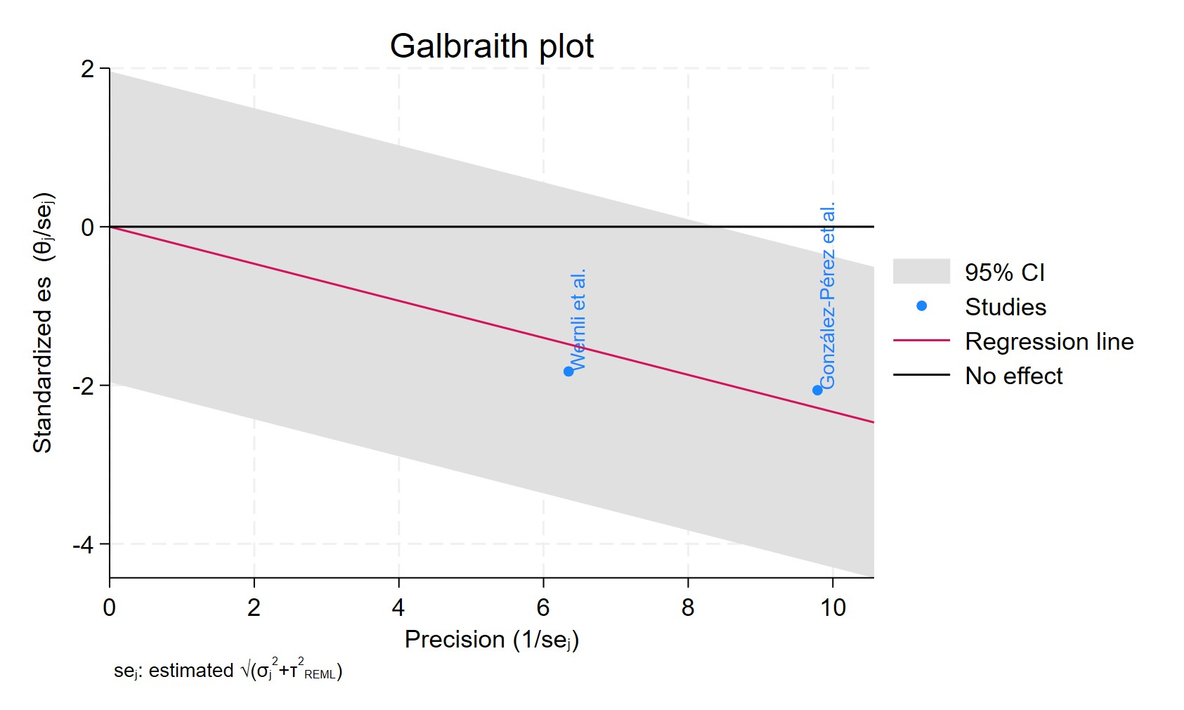
Figure 23 Galbraith plot - Former SSRIs Users Group 2

Each study is represented as a point, where the x-axis denotes the precision (defined as the inverse of the standard error), and the y-axis indicates the standardized effect size. The red regression line represents the overall summary effect estimated from the random-effects model, and the gray shaded area corresponds to the confidence interval at 95% around regression line. The horizontal black ––line at y = 0 corresponds to the line of no effect, serving as a reference.
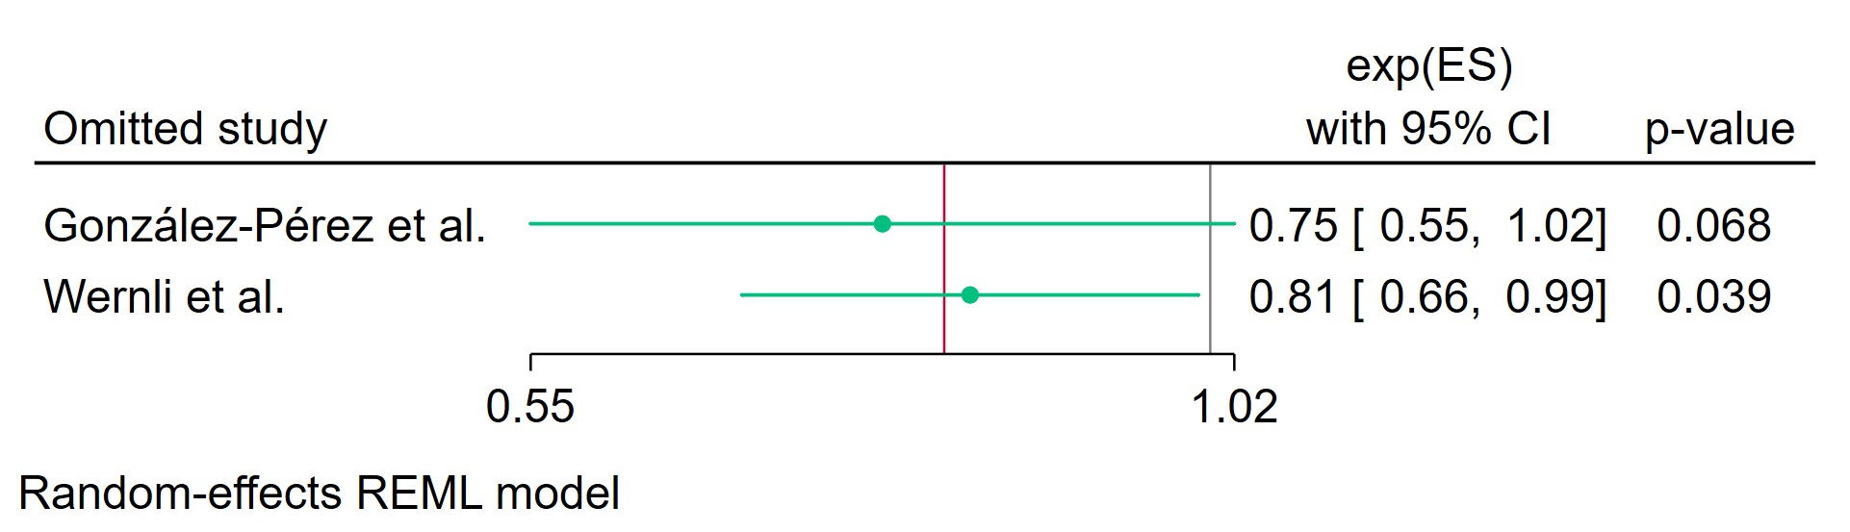
Figure 24 Leave-one-out - Former SSRIs Users Group 2

Leave-one-out (LOO) analysis assesses meta-analysis robustness by iteratively excluding one study at a time and refitting the model to observe shifts in the pooled effect size, confidence interval, and heterogeneity

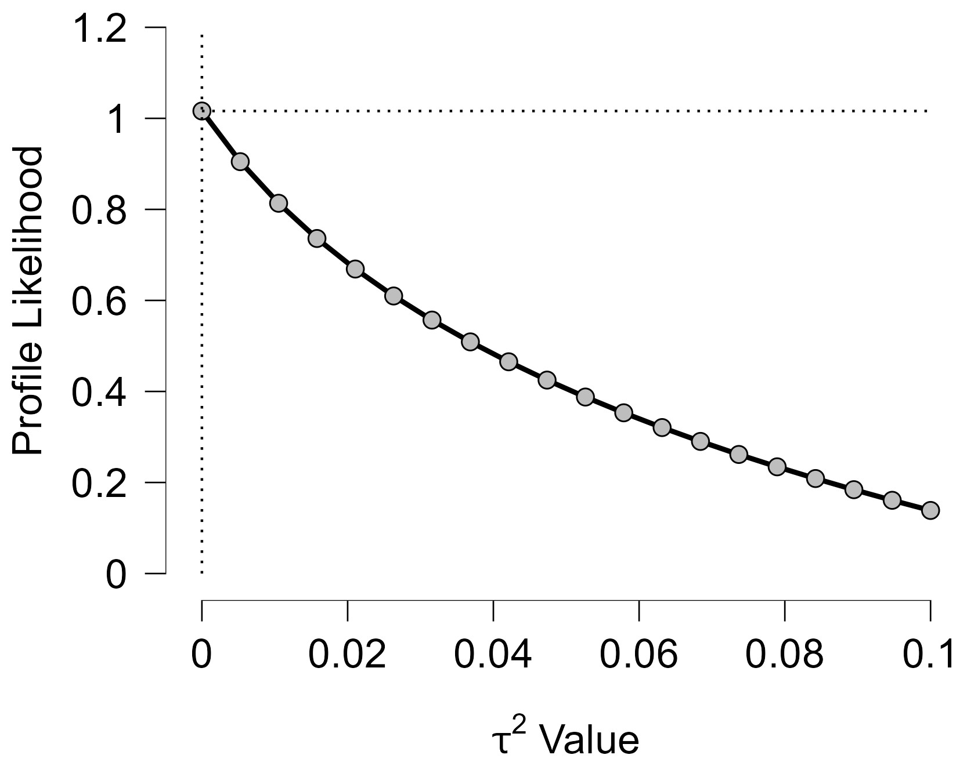
Figure 25 Profile Likelihood - Former SSRIs Users Group 2
The x-axis shows candidate values of the heterogeneity variance $τ^{2}$, and the y-axis shows the corresponding standardized profile likelihood, which has been scaled so that the maximum value equals 1 at $τ^{2}=0$.
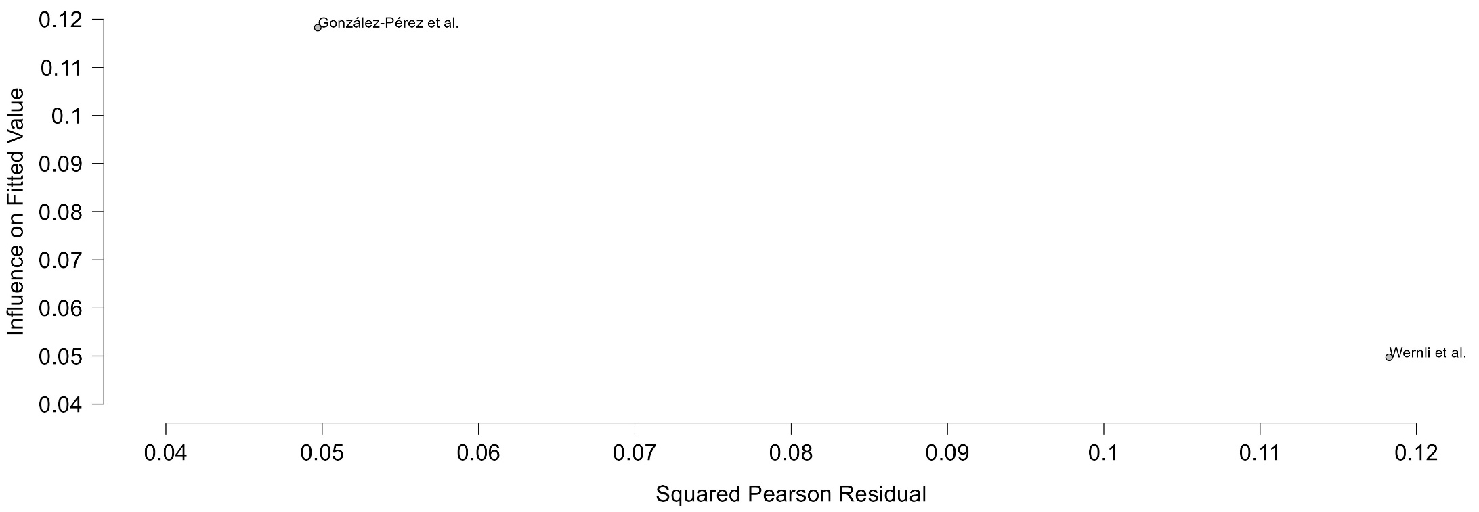
Figure 26 Baujat plot - Former SSRIs Users Group 2

The Baujat plot visualises each study's contribution to the Q-statistic for heterogeneity on the x-axis (squared Pearson residual) against its influence on the pooled effect on the y-axis (standardized squared difference in fixed-effects estimates with/without the study). Studies in the top-right quadrant drive both heterogeneity and effect variation, signalling candidates for sensitivity analysis; bottom-left points have minimal impact.

Cumulative Duration SSRIs Treatment Less Than 2 Years
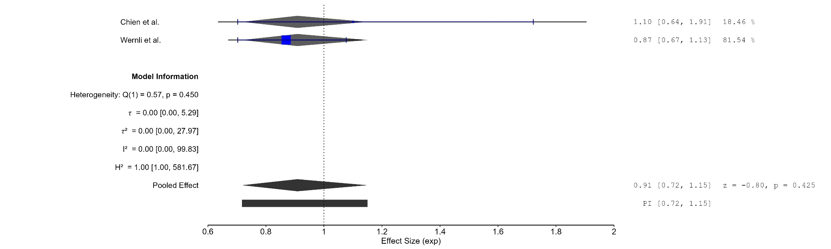
Figure 27 Forest plot - Cumulative Duration SSRIs Treatment Less Than 2 Years

The area of each square is proportional to the sample size of the respective study, with horizontal lines through the squares representing the 95% confidence interval (C.I.) for that study. In the pooled analysis, the diamond symbol represents the pooled estimate, with the right and left points of the diamond indicating the 95% C.I. for the overall analysis
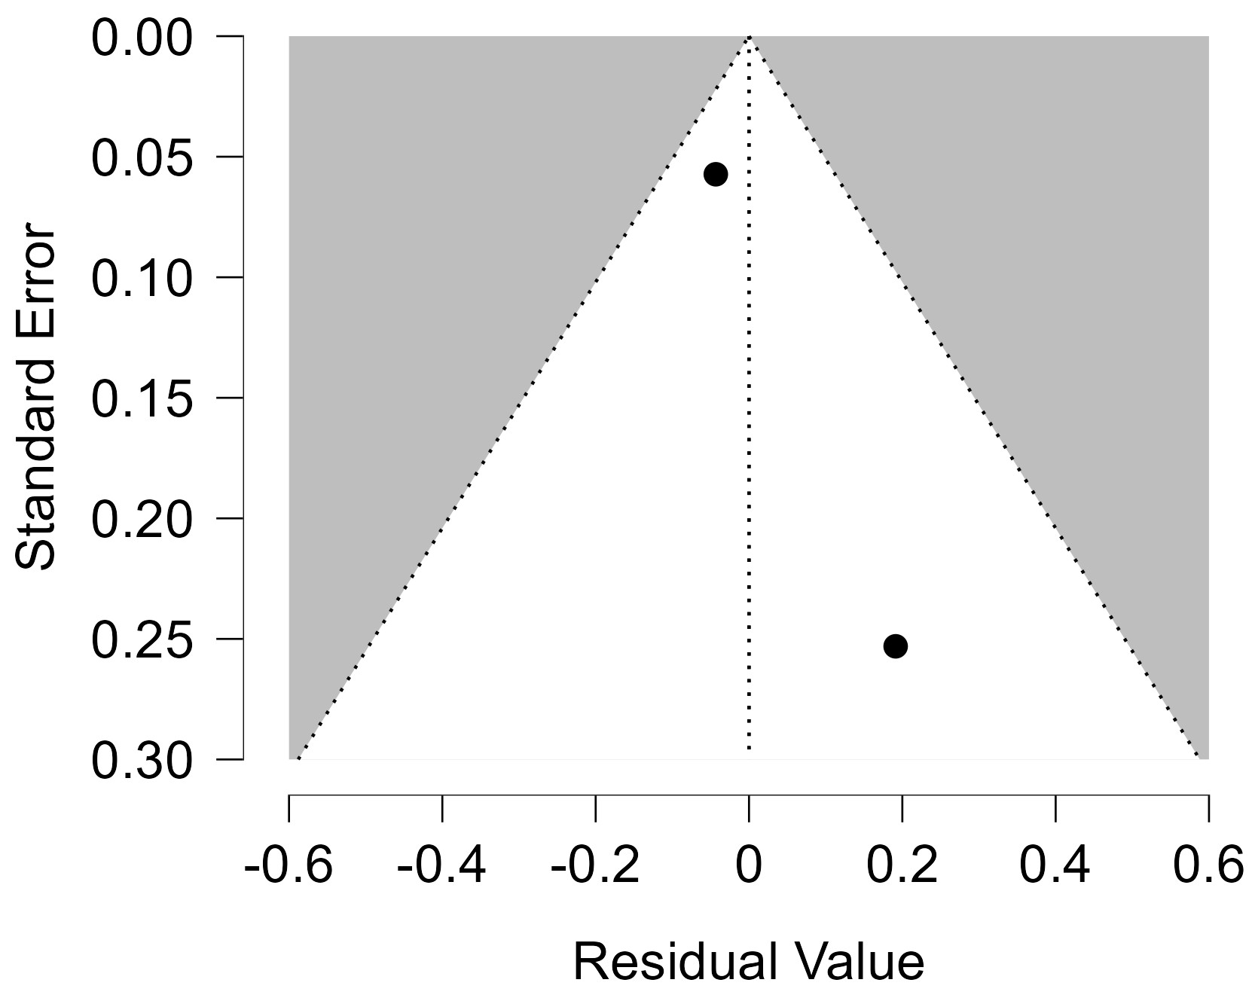
Figure 28 Funnel plot - Cumulative Duration SSRIs Treatment Less Than 2 Years

Each blue dot represents a single study, plotted with its effect size on the x-axis and its standard error on the y-axis. The vertical red line represents the overall effect estimate derived from the random-effects model using restricted maximum likelihood (REML). The pseudo 95% confidence interval region, shown as gray diagonal lines, outlines the expected spread of studies in the absence of bias or between-study heterogeneity.
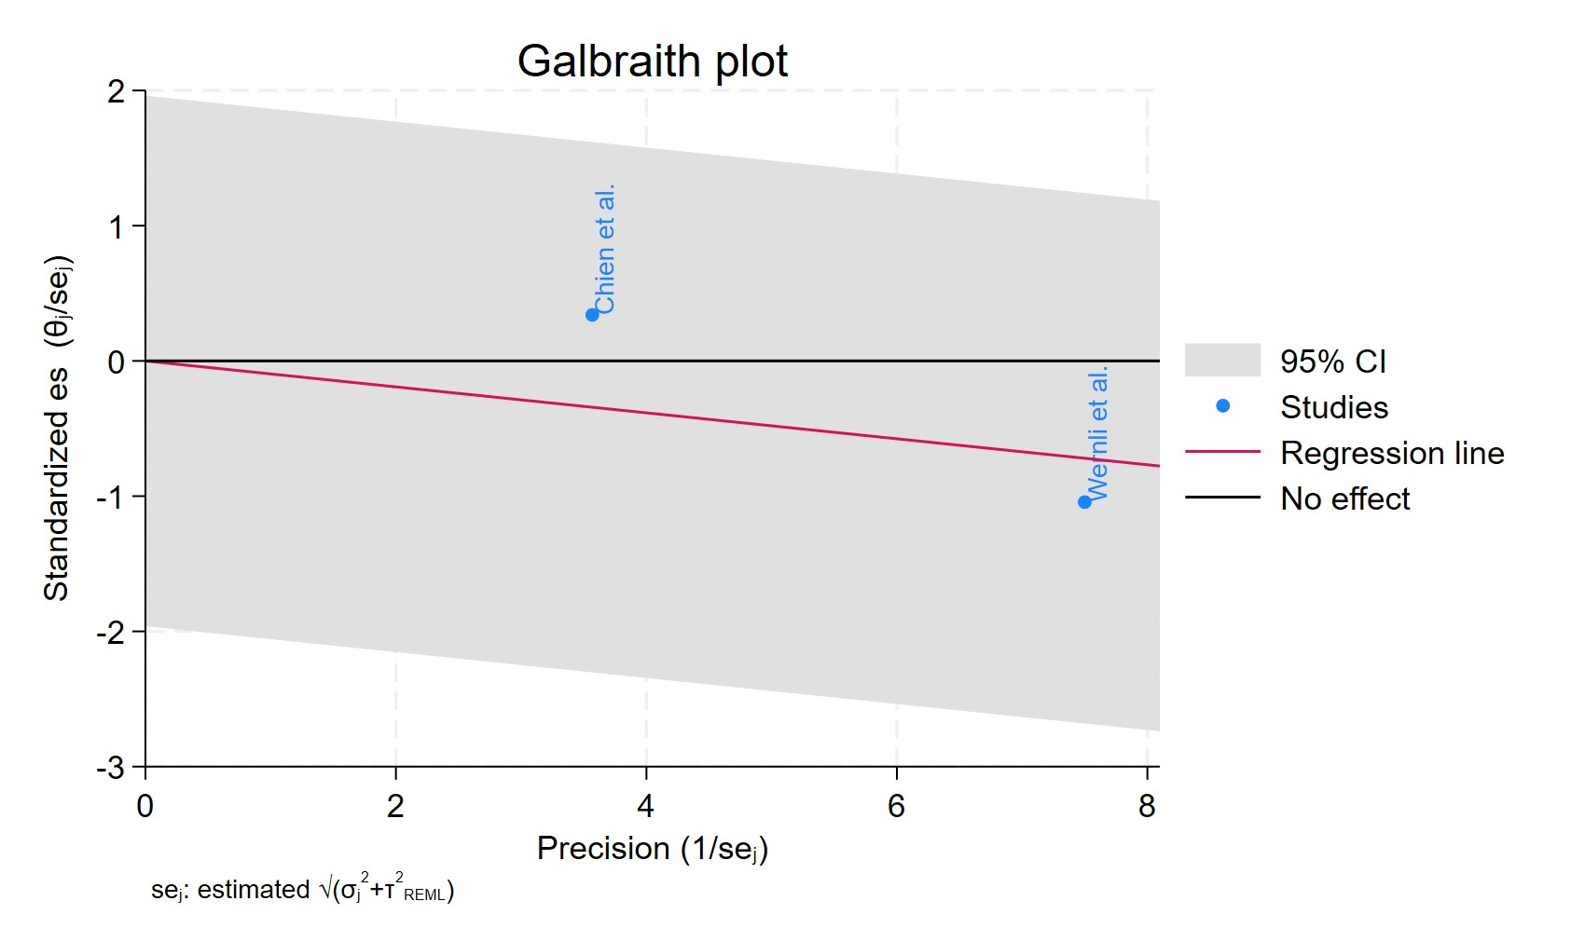
Figure 29 Galbraith plot - Cumulative Duration SSRIs Treatment Less Than 2 Years

Each study is represented as a point, where the x-axis denotes the precision (defined as the inverse of the standard error), and the y-axis indicates the standardized effect size. The red regression line represents the overall summary effect estimated from the random-effects model, and the gray shaded area corresponds to the confidence interval at 95% around regression line. The horizontal black ––line at y = 0 corresponds to the line of no effect, serving as a reference.
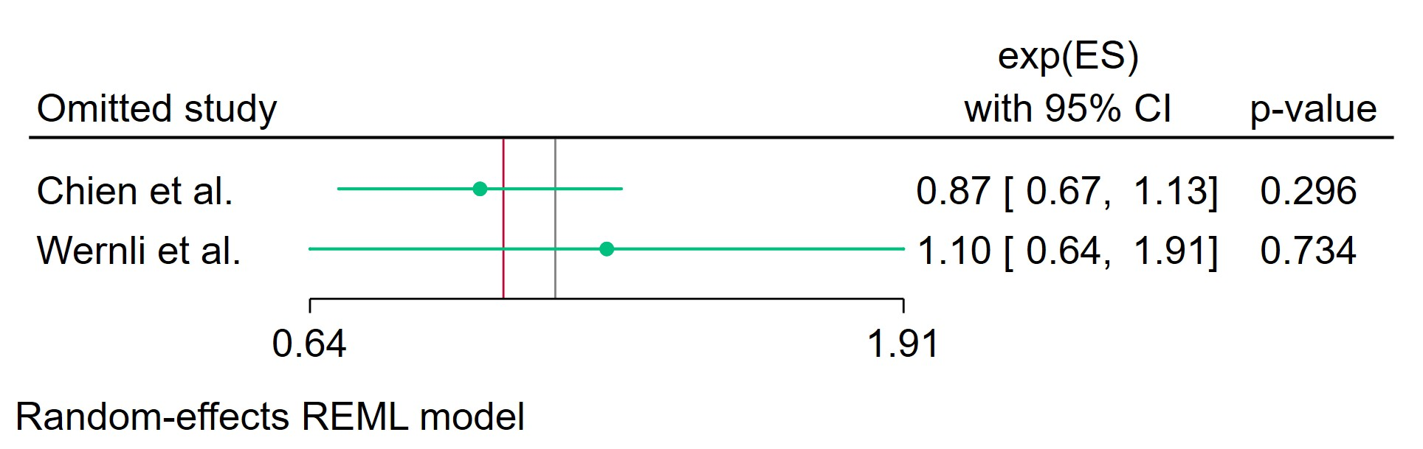
Figure 30 Leave-one-out - Cumulative Duration SSRIs Treatment Less Than 2 Years

Leave-one-out (LOO) analysis assesses meta-analysis robustness by iteratively excluding one study at a time and refitting the model to observe shifts in the pooled effect size, confidence interval, and heterogeneity
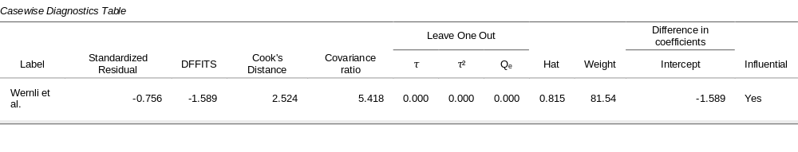
Figure 31 Casewise diagnostics - Cumulative Duration SSRIs Treatment Less Than 2 Years

Casewise diagnostics evaluate individual study influence in meta-analysis by computing standardized residuals, leverage (Hat values), and global influence measures like DFFITS, Cook's distance, and covariance ratios.​
Leave-one-out (LOO) analyses refit the model after sequentially omitting each study, quantifying changes in key parameters (e.g., $τ$, $τ^{2}$, $Q_{e}$, pooled effect) to assess sensitivity to individual observations.​
Studies exceeding conventional thresholds (e.g., Cook's distance >1, |DFFITS| >1, |standardized residual| >2) are flagged as influential, guiding decisions on robustness or exclusion.
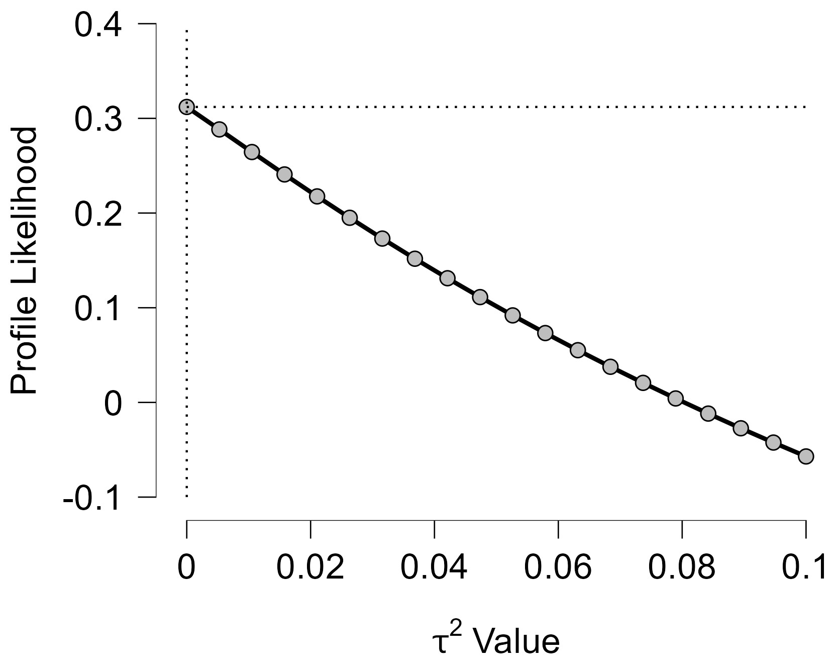
Figure 32 Profile Likelihood- Cumulative Duration SSRIs Treatment Less Than 2 Years

The x-axis shows candidate values of the heterogeneity variance $τ^{2}$, and the y-axis shows the corresponding standardized profile likelihood, which has been scaled so that the maximum value equals 1 at $τ^{2}=0$.
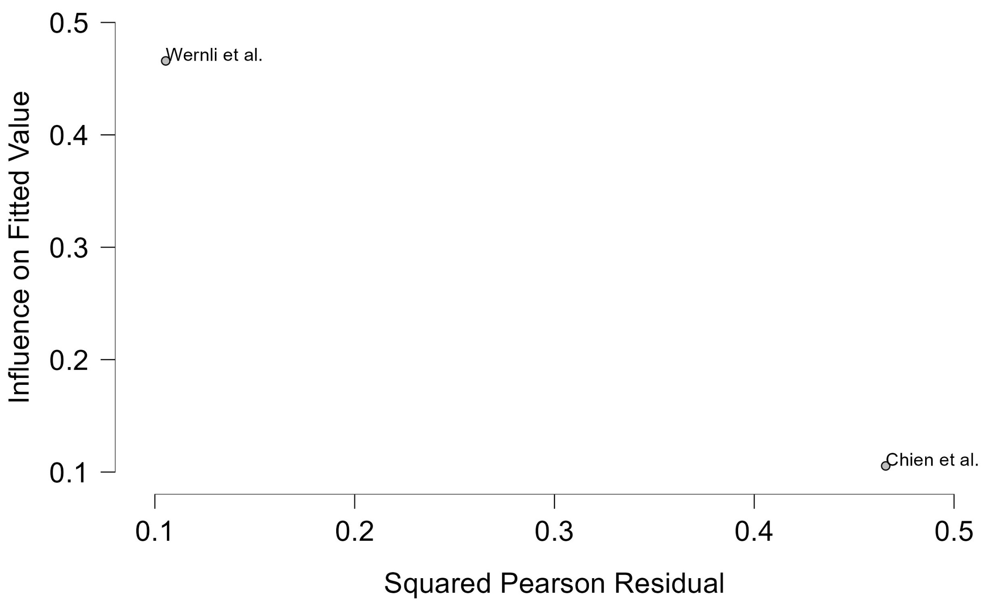
Figure 33 Baujat plot - Cumulative Duration SSRIs Treatment Less Than 2 Years
The Baujat plot visualises each study's contribution to the Q-statistic for heterogeneity on the x-axis (squared Pearson residual) against its influence on the pooled effect on the y-axis (standardized squared difference in fixed-effects estimates with/without the study). Studies in the top-right quadrant drive both heterogeneity and effect variation, signalling candidates for sensitivity analysis; bottom-left points have minimal impact.

Cumulative Duration SSRIs Treatment 2-4 Years
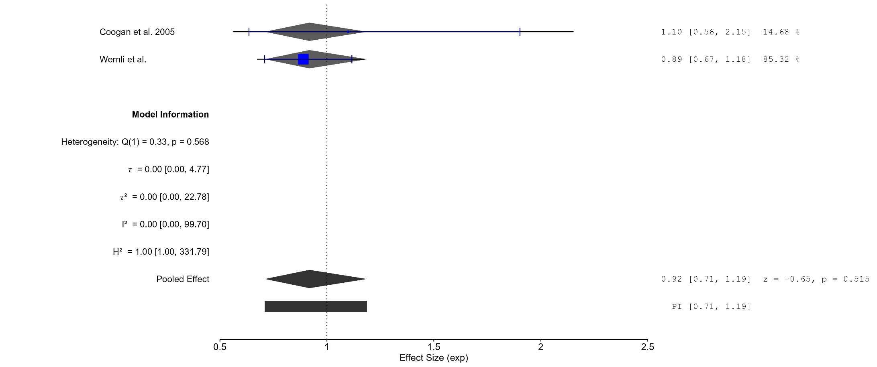
Figure 34 Forest plot - Cumulative Duration SSRIs Treatment 2-4 Years
The area of each square is proportional to the sample size of the respective study, with horizontal lines through the squares representing the 95% confidence interval (C.I.) for that study. In the pooled analysis, the diamond symbol represents the pooled estimate, with the right and left points of the diamond indicating the 95% C.I. for the overall analysis
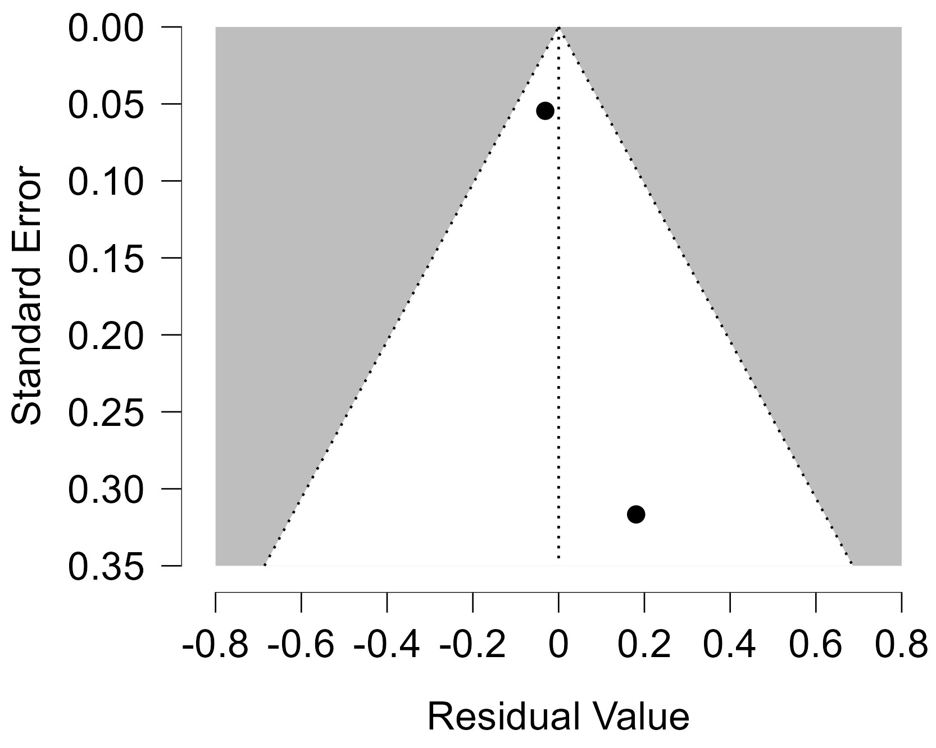
Figure 35 Funnel plot - Cumulative Duration SSRIs Treatment 2-4 Years

Each blue dot represents a single study, plotted with its effect size on the x-axis and its standard error on the y-axis. The vertical red line represents the overall effect estimate derived from the random-effects model using restricted maximum likelihood (REML). The pseudo 95% confidence interval region, shown as gray diagonal lines, outlines the expected spread of studies in the absence of bias or between-study heterogeneity.
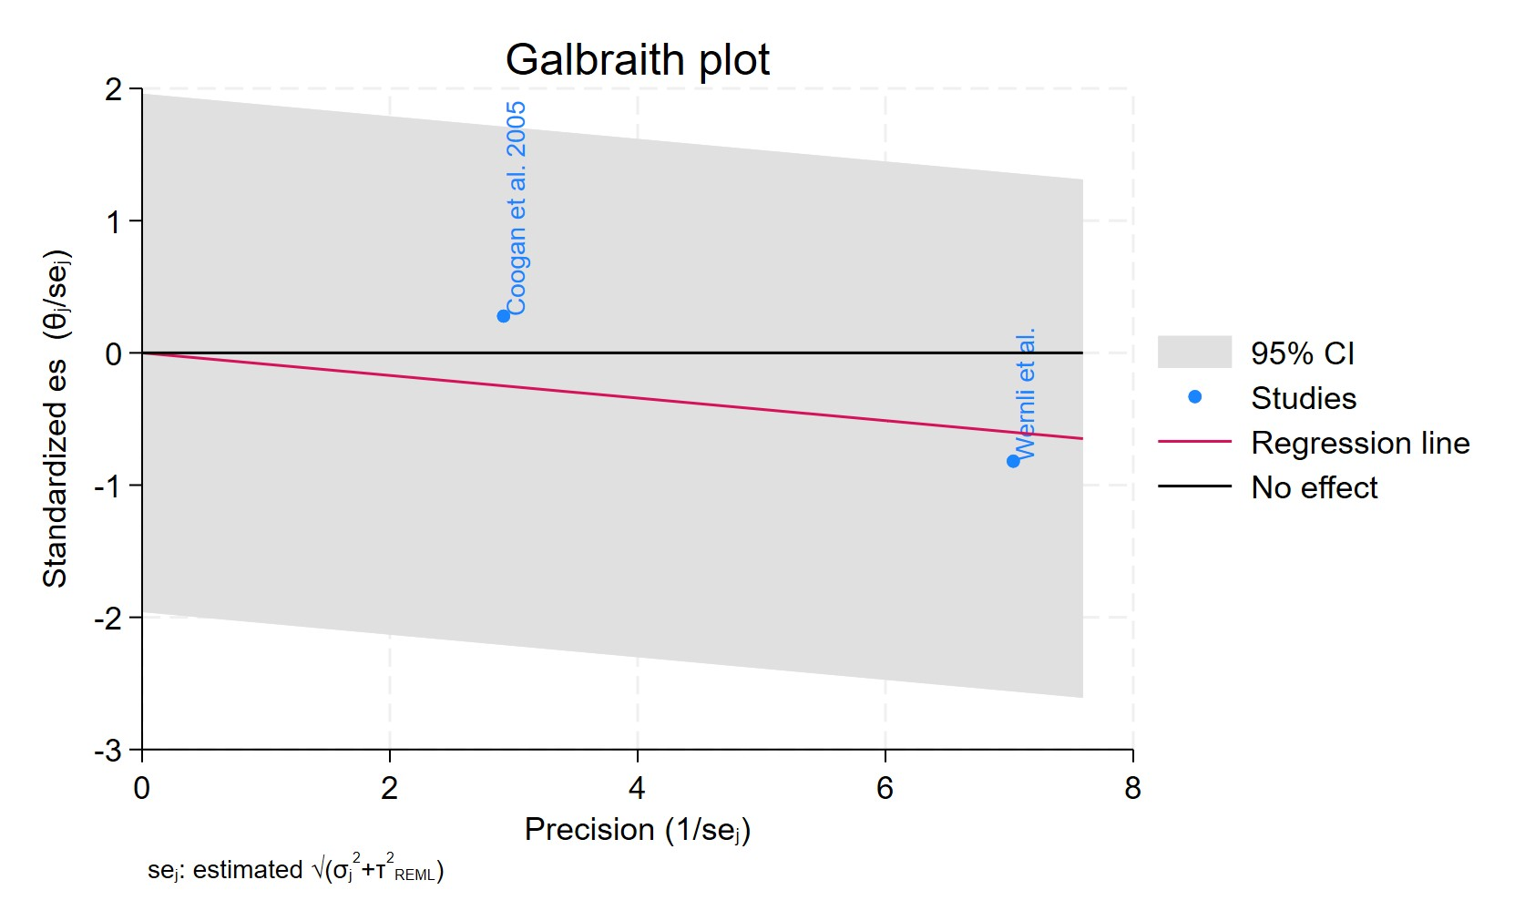
Figure 36 Galbraith plot - Cumulative Duration SSRIs Treatment 2-4 Years

Each study is represented as a point, where the x-axis denotes the precision (defined as the inverse of the standard error), and the y-axis indicates the standardized effect size. The red regression line represents the overall summary effect estimated from the random-effects model, and the gray shaded area corresponds to the confidence interval at 95% around regression line. The horizontal black ––line at y = 0 corresponds to the line of no effect, serving as a reference.
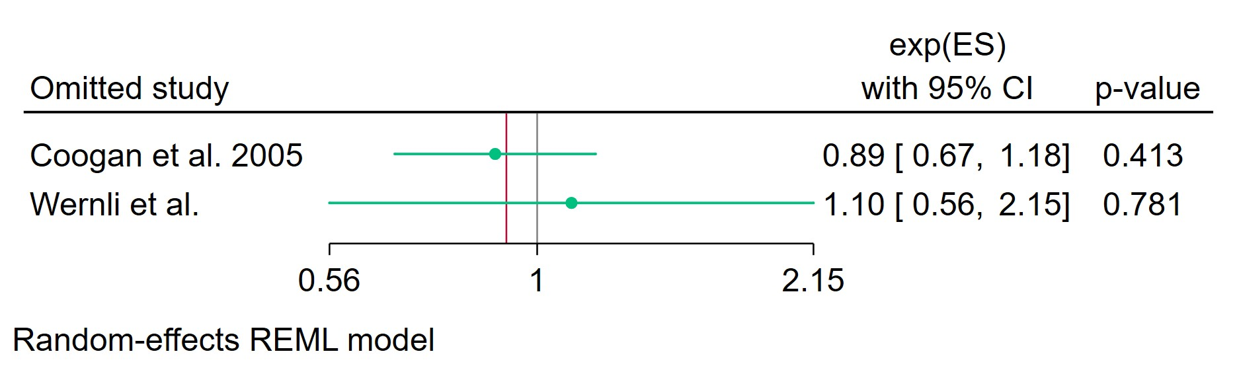
Figure 37 Leave-one-out - Cumulative Duration SSRIs Treatment 2-4 Years

Leave-one-out (LOO) analysis assesses meta-analysis robustness by iteratively excluding one study at a time and refitting the model to observe shifts in the pooled effect size, confidence interval, and heterogeneity
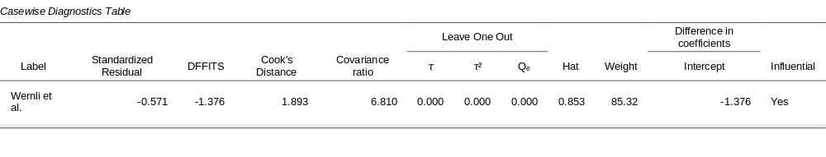
Figure 38 Casewise diagnostics - Cumulative Duration SSRIs Treatment 2-4 Years

Casewise diagnostics evaluate individual study influence in meta-analysis by computing standardized residuals, leverage (Hat values), and global influence measures like DFFITS, Cook's distance, and covariance ratios.​
Leave-one-out (LOO) analyses refit the model after sequentially omitting each study, quantifying changes in key parameters (e.g., $τ$, $τ^{2}$, $Q_{e}$, pooled effect) to assess sensitivity to individual observations.​
Studies exceeding conventional thresholds (e.g., Cook's distance >1, |DFFITS| >1, |standardized residual| >2) are flagged as influential, guiding decisions on robustness or exclusion.
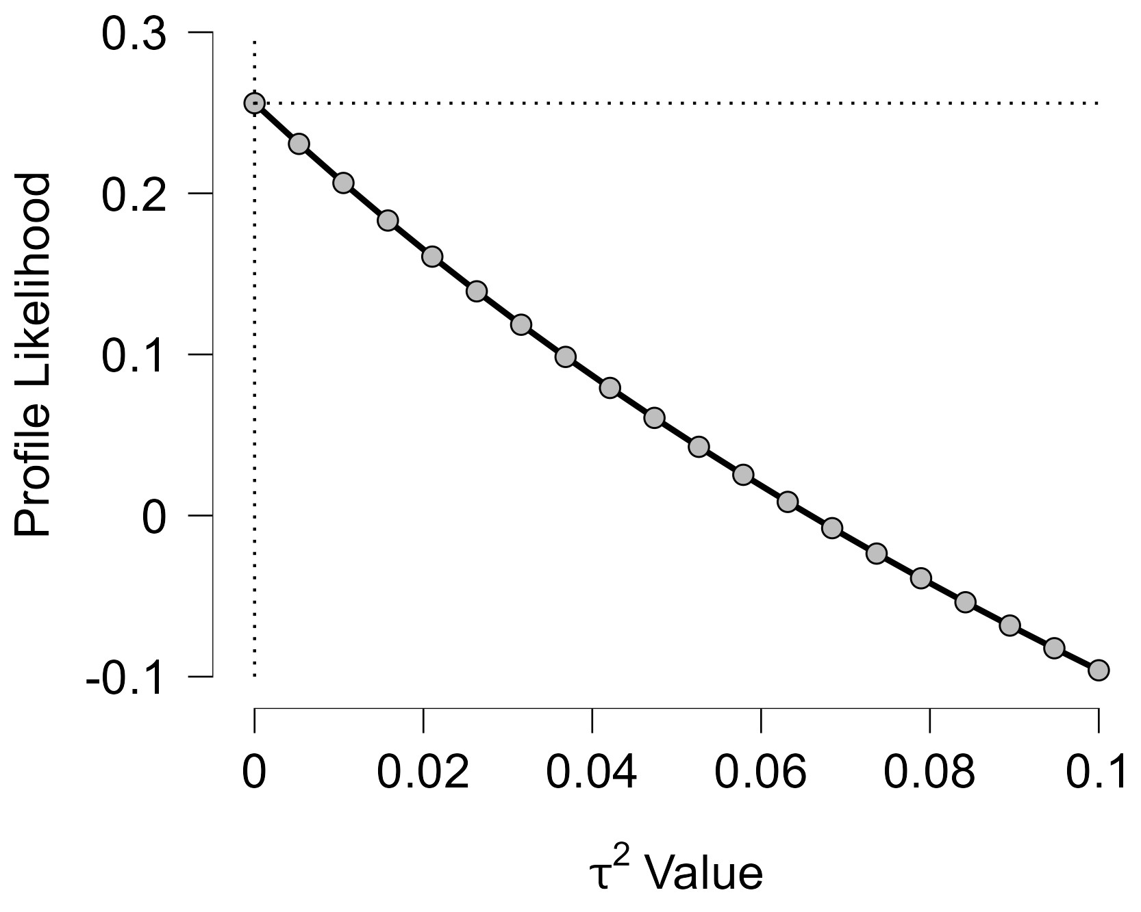
Figure 39 Profile Likelihood- Cumulative Duration SSRIs Treatment 2-4 Years

The x-axis shows candidate values of the heterogeneity variance $τ^{2}$, and the y-axis shows the corresponding standardized profile likelihood, which has been scaled so that the maximum value equals 1 at $τ^{2}=0$.
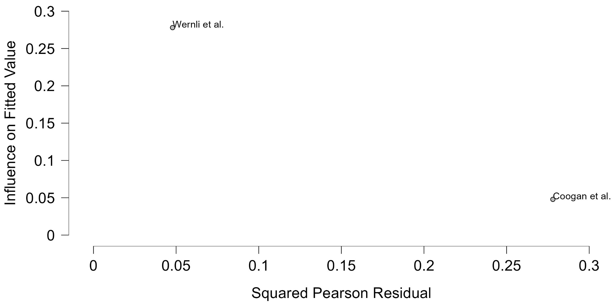
Figure 40 Baujat plot - Cumulative Duration SSRIs Treatment 2-4 Years

The Baujat plot visualises each study's contribution to the Q-statistic for heterogeneity on the x-axis (squared Pearson residual) against its influence on the pooled effect on the y-axis (standardized squared difference in fixed-effects estimates with/without the study). Studies in the top-right quadrant drive both heterogeneity and effect variation, signalling candidates for sensitivity analysis; bottom-left points have minimal impact.

Cumulative Duration SSRIs Treatment 0-1 Year
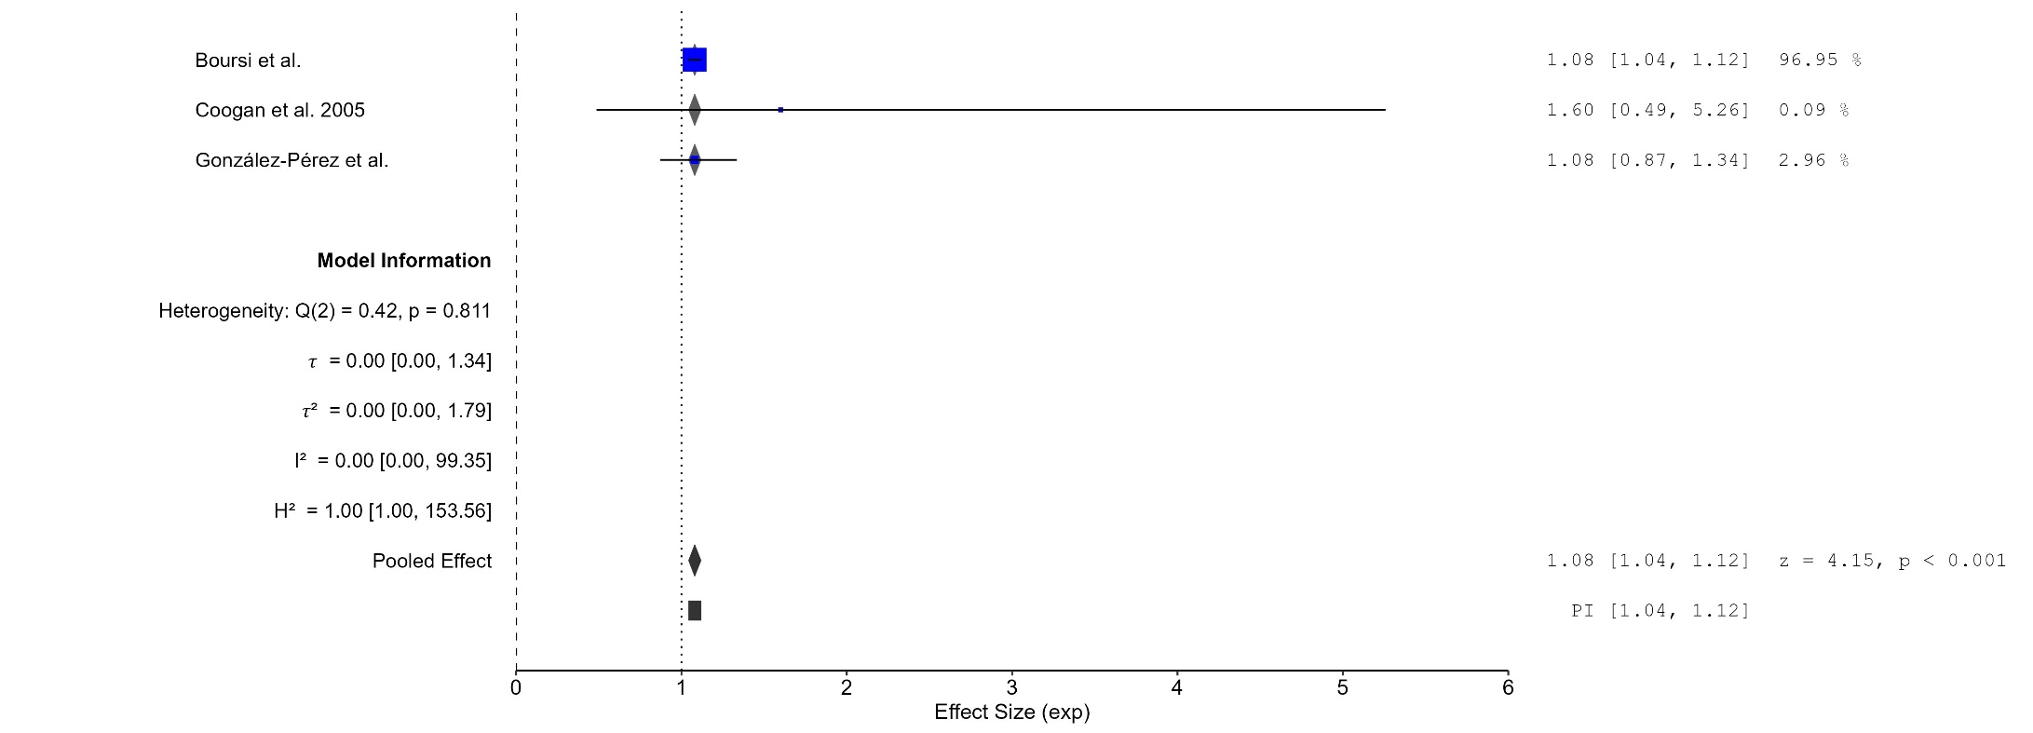
Figure 41 Forest plot - Cumulative Duration SSRIs Treatment 0-1 Year

The area of each square is proportional to the sample size of the respective study, with horizontal lines through the squares representing the 95% confidence interval (C.I.) for that study. In the pooled analysis, the diamond symbol represents the pooled estimate, with the right and left points of the diamond indicating the 95% C.I. for the overall analysis
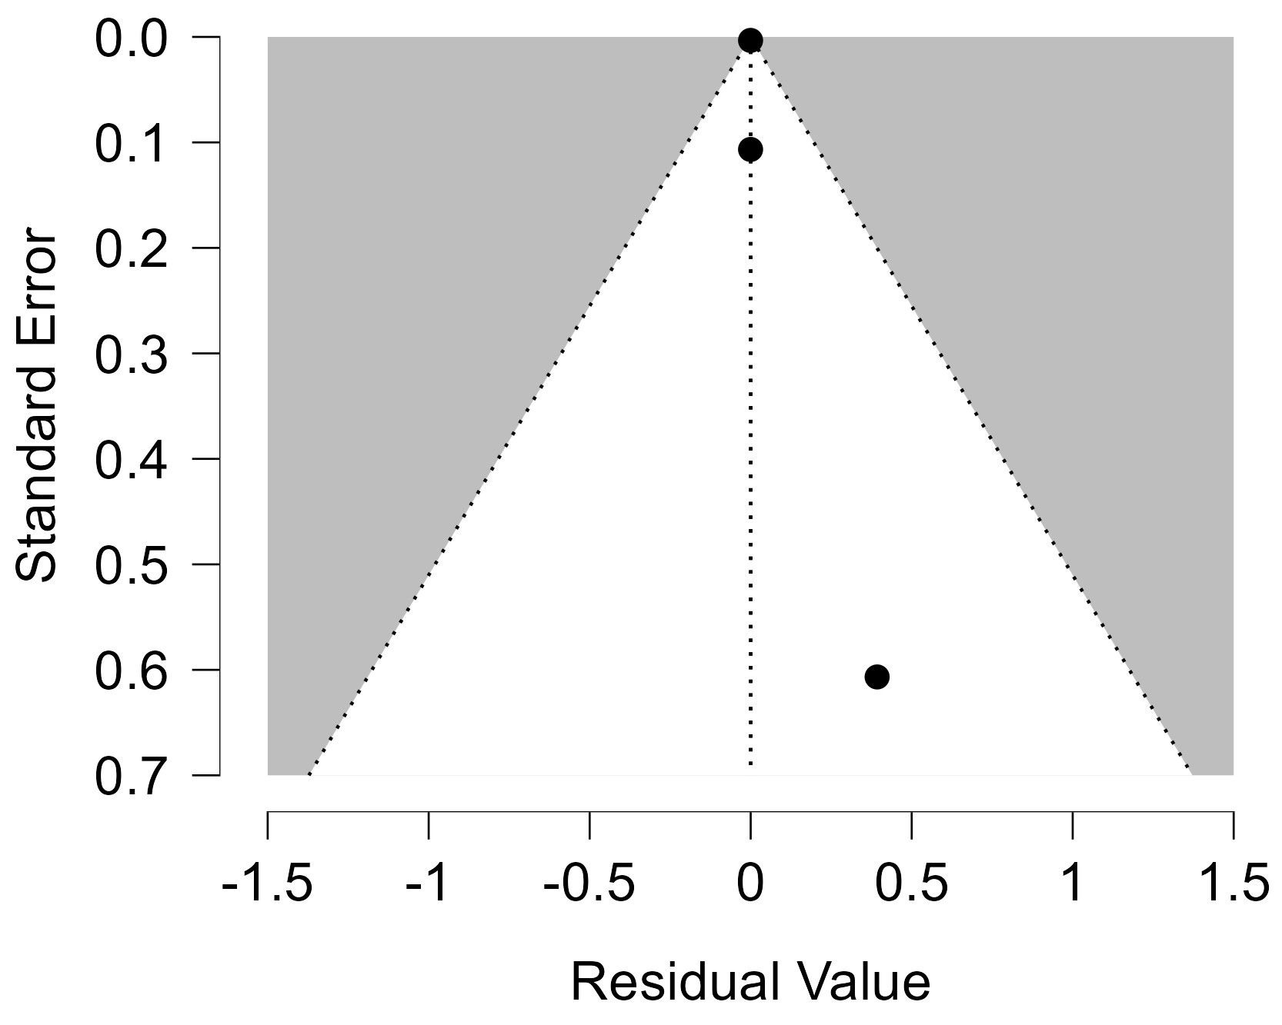
Figure 42 Funnel plot - Cumulative Duration SSRIs Treatment 0-1 Year

Each blue dot represents a single study, plotted with its effect size on the x-axis and its standard error on the y-axis. The vertical red line represents the overall effect estimate derived from the random-effects model using restricted maximum likelihood (REML). The pseudo 95% confidence interval region, shown as gray diagonal lines, outlines the expected spread of studies in the absence of bias or between-study heterogeneity.
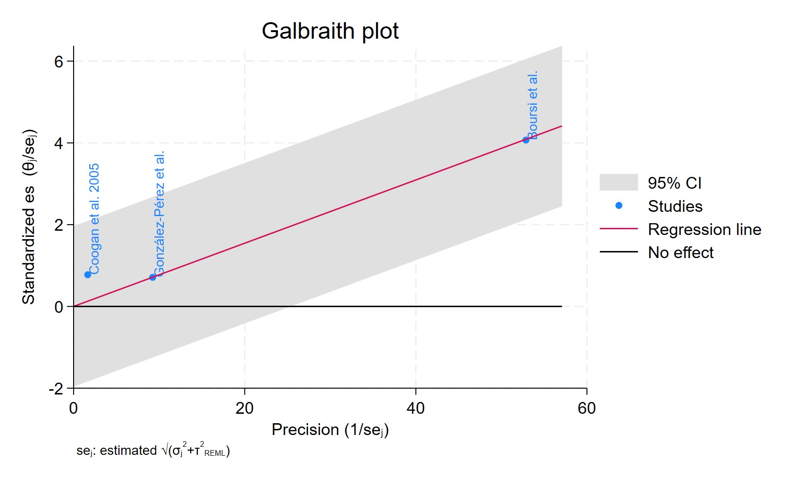
Figure 43 Galbraith plot - Cumulative Duration SSRIs Treatment 0-1 Year

Each study is represented as a point, where the x-axis denotes the precision (defined as the inverse of the standard error), and the y-axis indicates the standardized effect size. The red regression line represents the overall summary effect estimated from the random-effects model, and the gray shaded area corresponds to the confidence interval at 95% around regression line. The horizontal black ––line at y = 0 corresponds to the line of no effect, serving as a reference.
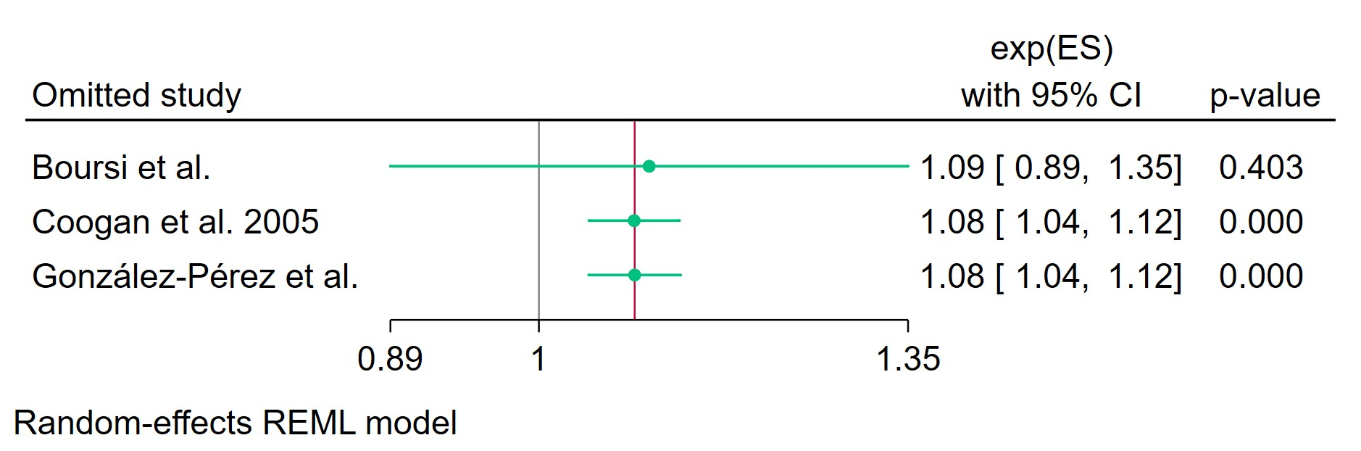
Figure 44 Leave-one-out - Cumulative Duration SSRIs Treatment 0-1 Year

Leave-one-out (LOO) analysis assesses meta-analysis robustness by iteratively excluding one study at a time and refitting the model to observe shifts in the pooled effect size, confidence interval, and heterogeneity

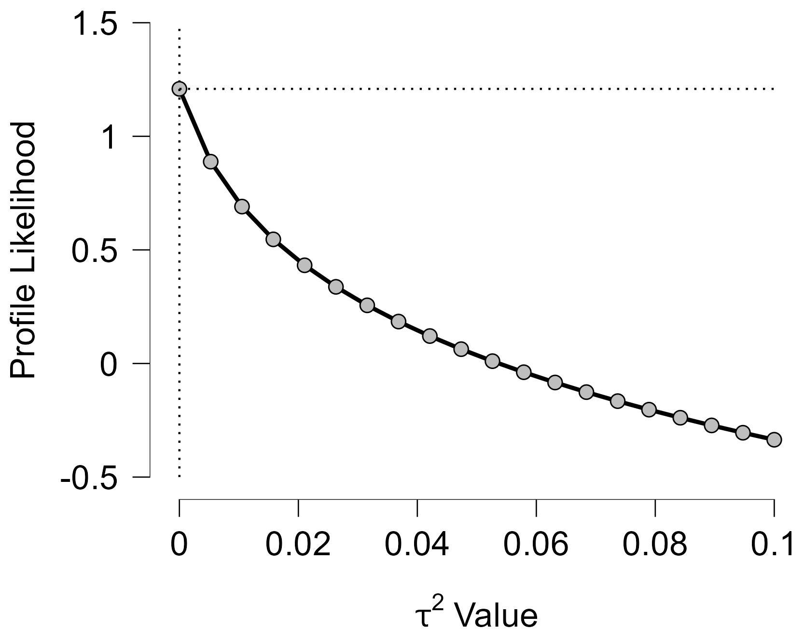
Figure 45 Profile Likelihood- Cumulative Duration SSRIs Treatment 0-1 Year

The x-axis shows candidate values of the heterogeneity variance $τ^{2}$, and the y-axis shows the corresponding standardized profile likelihood, which has been scaled so that the maximum value equals 1 at $τ^{2}=0$.
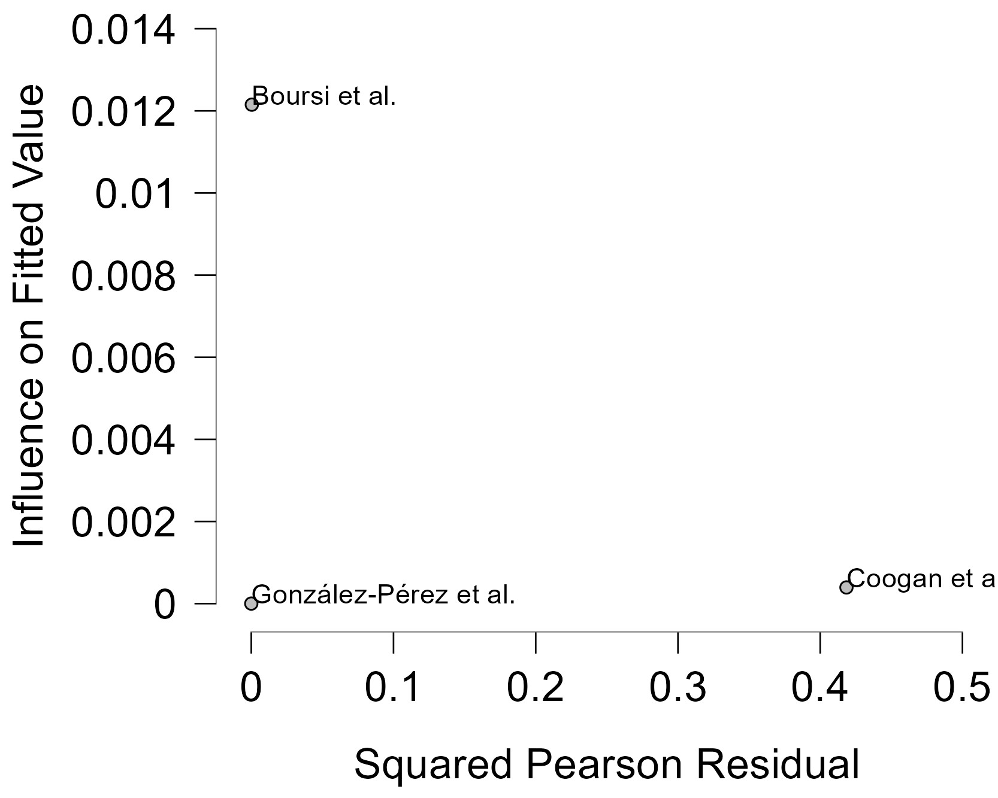
Figure 46 Baujat plot - Cumulative Duration SSRIs Treatment 0-1 Year
The Baujat plot visualises each study's contribution to the Q-statistic for heterogeneity on the x-axis (squared Pearson residual) against its influence on the pooled effect on the y-axis (standardized squared difference in fixed-effects estimates with/without the study). Studies in the top-right quadrant drive both heterogeneity and effect variation, signalling candidates for sensitivity analysis; bottom-left points have minimal impact.
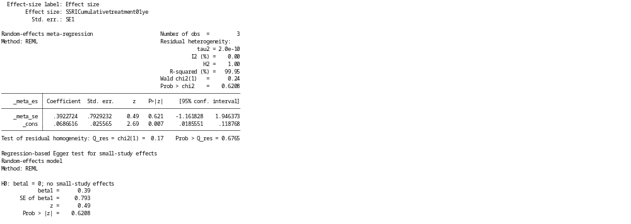
Figure 47 Regression-based Egger's test for small-study effects with REML model- Cumulative Duration SSRIs Treatment 0-1 Year

Egger's regression test detects small-study effects (e.g., publication bias) by regressing standardized study effects (${\hat{θ}}_{j}/SE({\hat{θ}}_{j})$) on precision ($1/SE({\hat{θ}}_{j})$), testing if the intercept ($β_{0}$) equals zero under $H_{0}$. Random-effects versions adjust for between-study variance $τ^{2}$, using marginal variances to mitigate bias in sparse data; p < 0.05 (or 0.10) suggests effects like selective reporting inflating smaller/precise studies. It complements funnel plots and potential inflation with high heterogeneity or ORs away from 1.

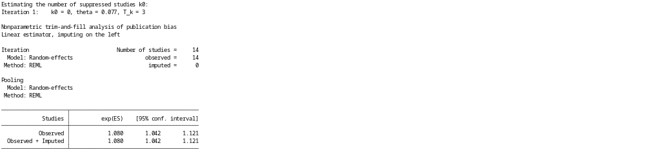
Figure 48 Nonparametric trim-and-fill analysis for publication bias adjustment (random-effects REML model, linear estimator)- Cumulative Duration SSRIs Treatment 0-1 Year

Trim-and-fill is a rank-based method to estimate and impute studies suppressed due to publication bias, "trimming" asymmetric extremes, mirroring to fill gaps, then re-estimating the pooled effect with observed + imputed studies. The linear estimator imputes effect sizes symmetrically; random-effects pooling (REML) accounts for $τ^{2}$; assesses bias impact but is conservative, sensitive to heterogeneity, and treats imputes as observed (underestimating uncertainty). If imputed-adjusted effect alters significance/inference, bias may inflate original estimate.

Sub-group analysis SSRIs Treatment 0-1 Year By Study Design
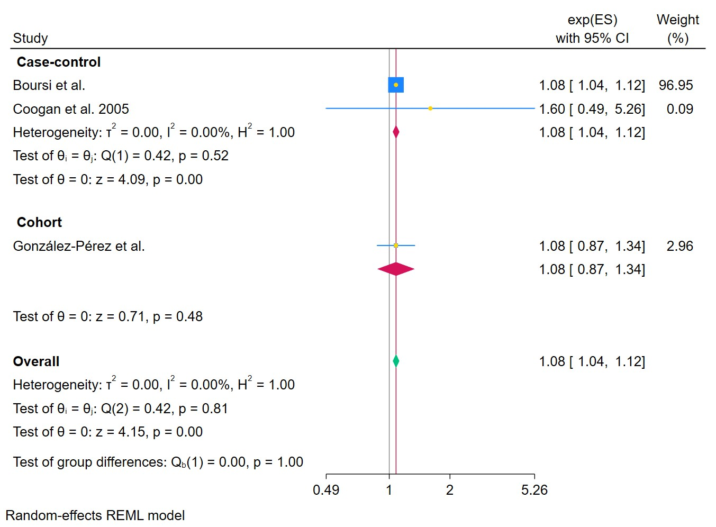
Figure 49 Forest plot -Sub-group analysis SSRIs Treatment 0-1 Year By Study Design

The area of each square is proportional to the sample size of the respective study, with horizontal lines through the squares representing the 95% confidence interval (C.I.) for that study. In the pooled analysis, the diamond symbol represents the pooled estimate, with the right and left points of the diamond indicating the 95% C.I. for the overall analysis

Sub-group analysis SSRIs Treatment 0-1 Year By Exposure Ascertainment
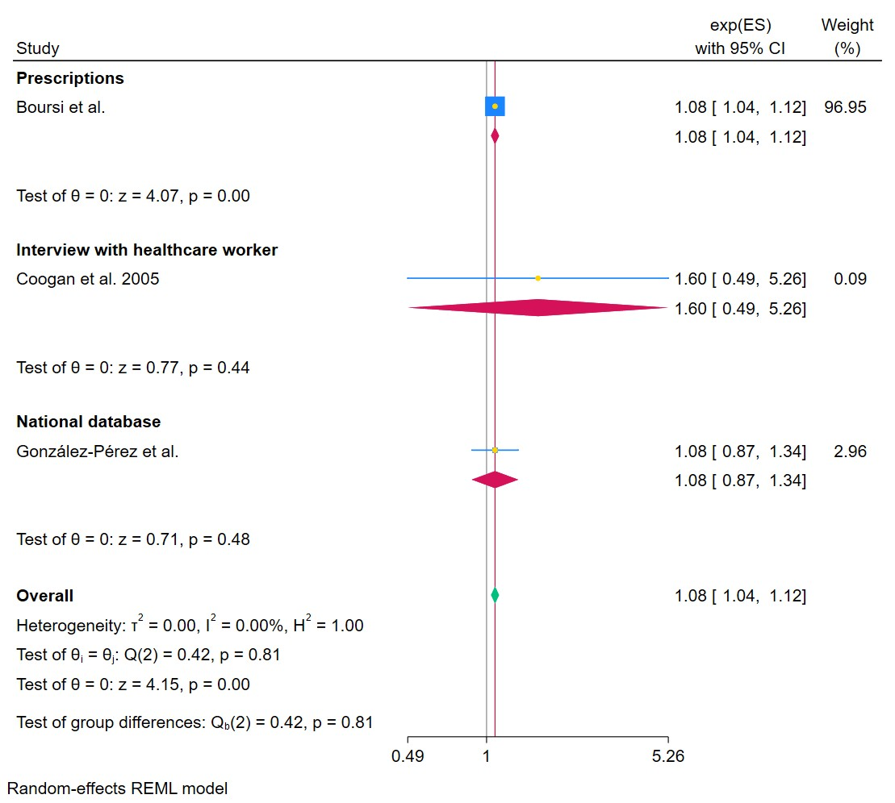
Figure 50 Forest plot - Sub-group analysis SSRIs Treatment 0-1 Year By Exposure Ascertainment

The area of each square is proportional to the sample size of the respective study, with horizontal lines through the squares representing the 95% confidence interval (C.I.) for that study. In the pooled analysis, the diamond symbol represents the pooled estimate, with the right and left points of the diamond indicating the 95% C.I. for the overall analysis

Sub-group analysis SSRIs Treatment 0-1 Year By Country

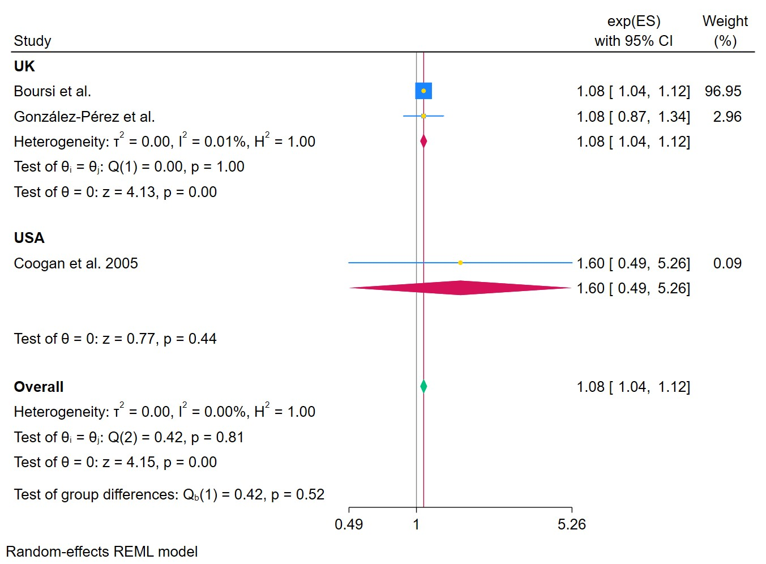
Figure 51 Forest plot - Sub-group analysis SSRIs Treatment 0-1 Year By Country
The area of each square is proportional to the sample size of the respective study, with horizontal lines through the squares representing the 95% confidence interval (C.I.) for that study. In the pooled analysis, the diamond symbol represents the pooled estimate, with the right and left points of the diamond indicating the 95% C.I. for the overall analysis

Sub-group analysis SSRIs Treatment 0-1 Year By NOS Score
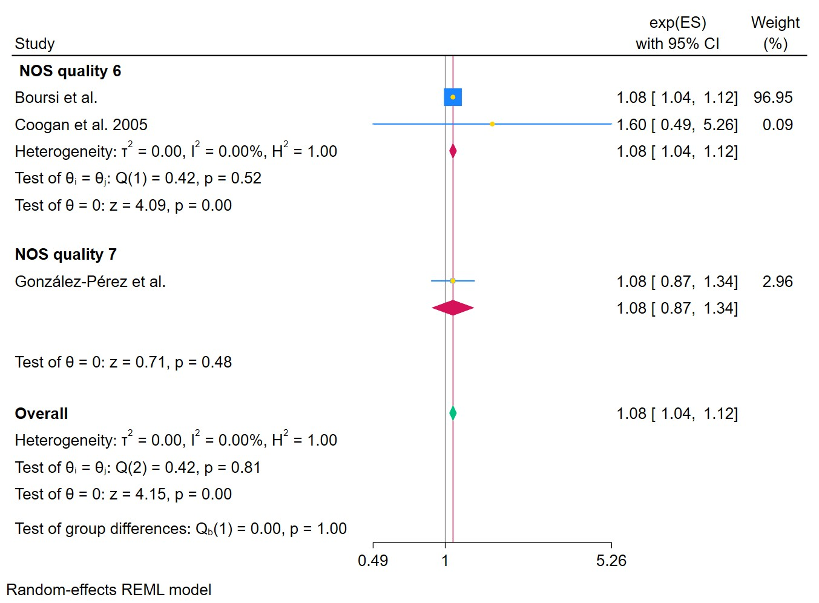
Figure 52 Forest plot -Sub-group analysis SSRIs Treatment 0-1 Year By NOS Score
The area of each square is proportional to the sample size of the respective study, with horizontal lines through the squares representing the 95% confidence interval (C.I.) for that study. In the pooled analysis, the diamond symbol represents the pooled estimate, with the right and left points of the diamond indicating the 95% C.I. for the overall analysis

Cumulative Duration SSRIs Treatment 1-3 Years
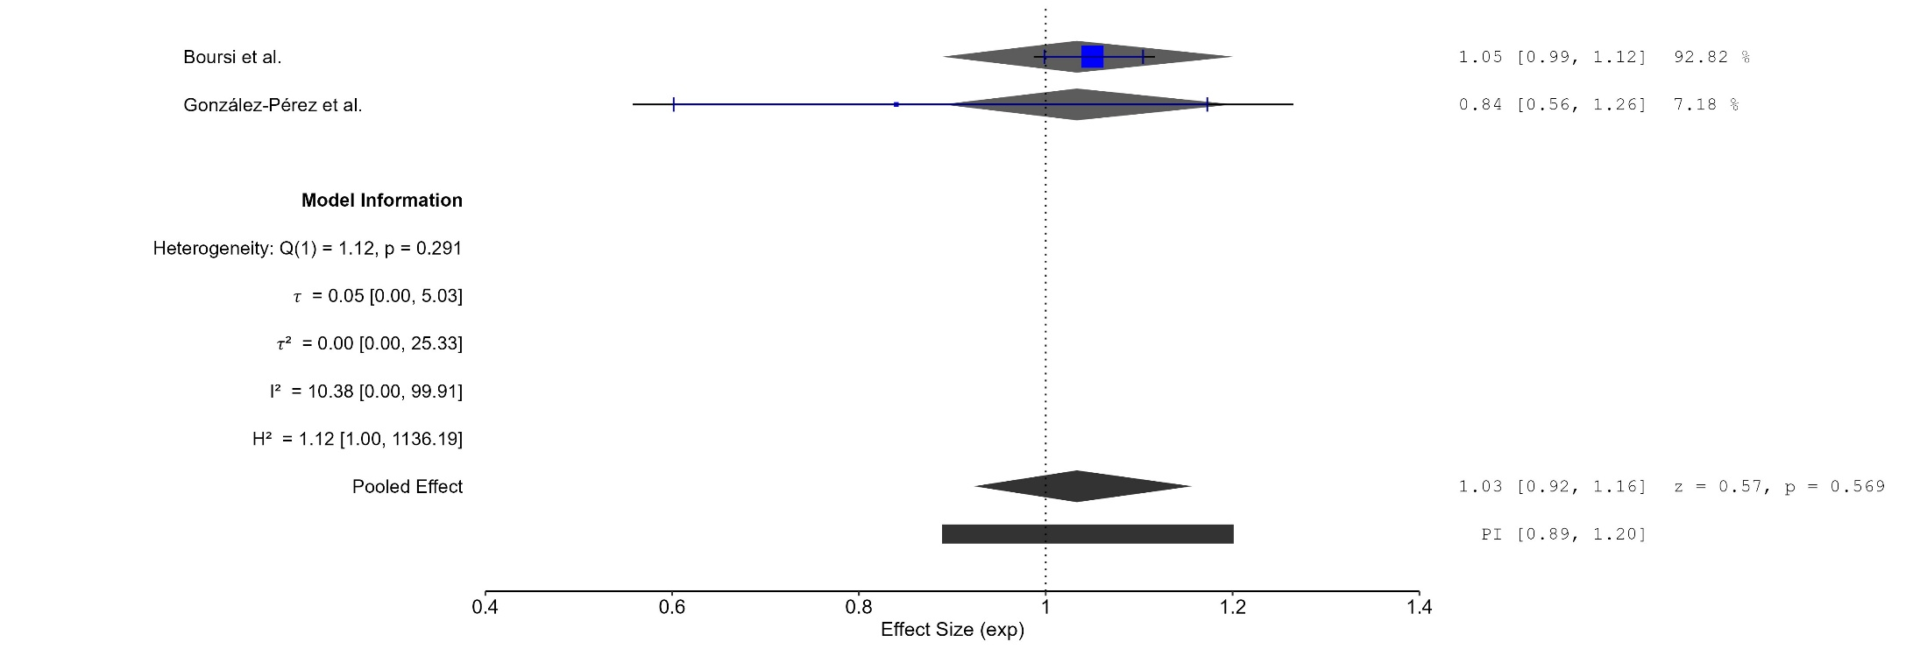
Figure 53 Forest plot - Cumulative Duration SSRIs Treatment 1-3 Years

The area of each square is proportional to the sample size of the respective study, with horizontal lines through the squares representing the 95% confidence interval (C.I.) for that study. In the pooled analysis, the diamond symbol represents the pooled estimate, with the right and left points of the diamond indicating the 95% C.I. for the overall analysis
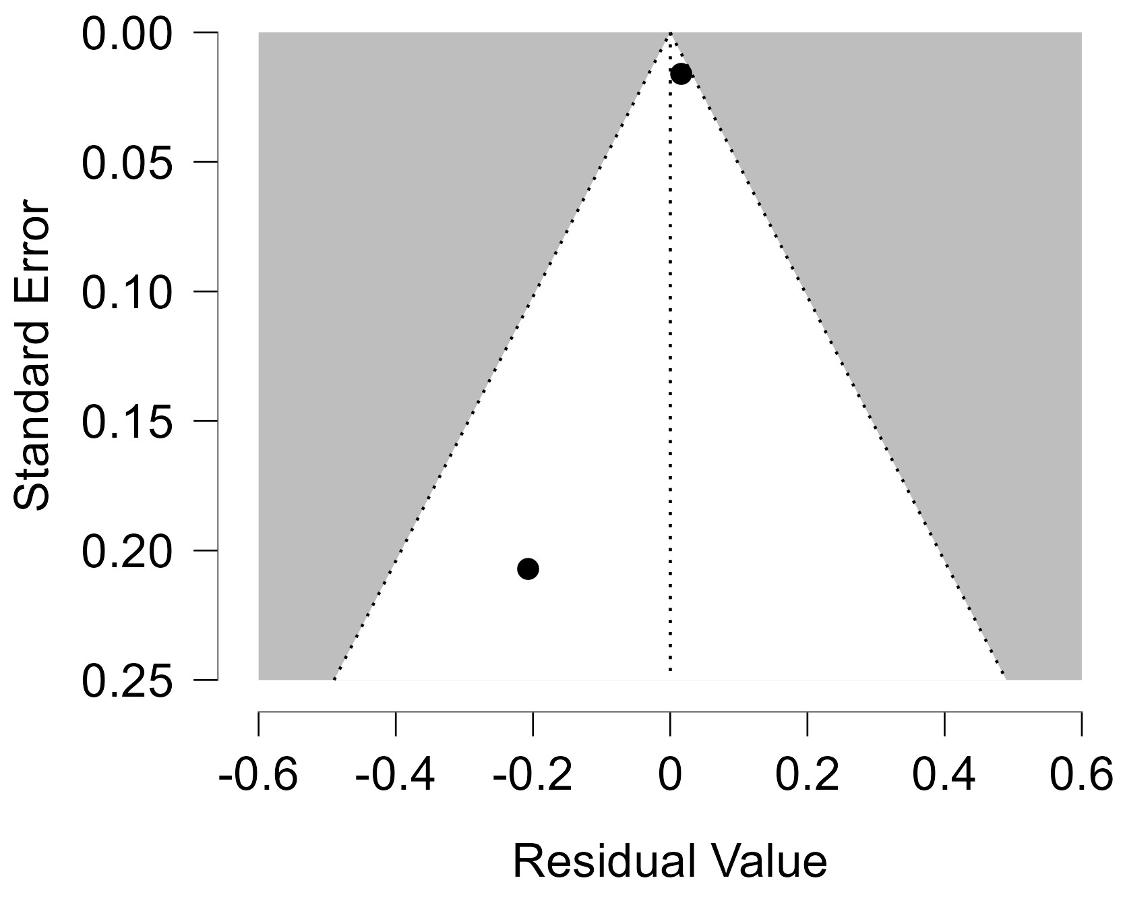
Figure 54 Funnel plot - Cumulative Duration SSRIs Treatment 1-3 Years

Each blue dot represents a single study, plotted with its effect size on the x-axis and its standard error on the y-axis. The vertical red line represents the overall effect estimate derived from the random-effects model using restricted maximum likelihood (REML). The pseudo 95% confidence interval region, shown as gray diagonal lines, outlines the expected spread of studies in the absence of bias or between-study heterogeneity.
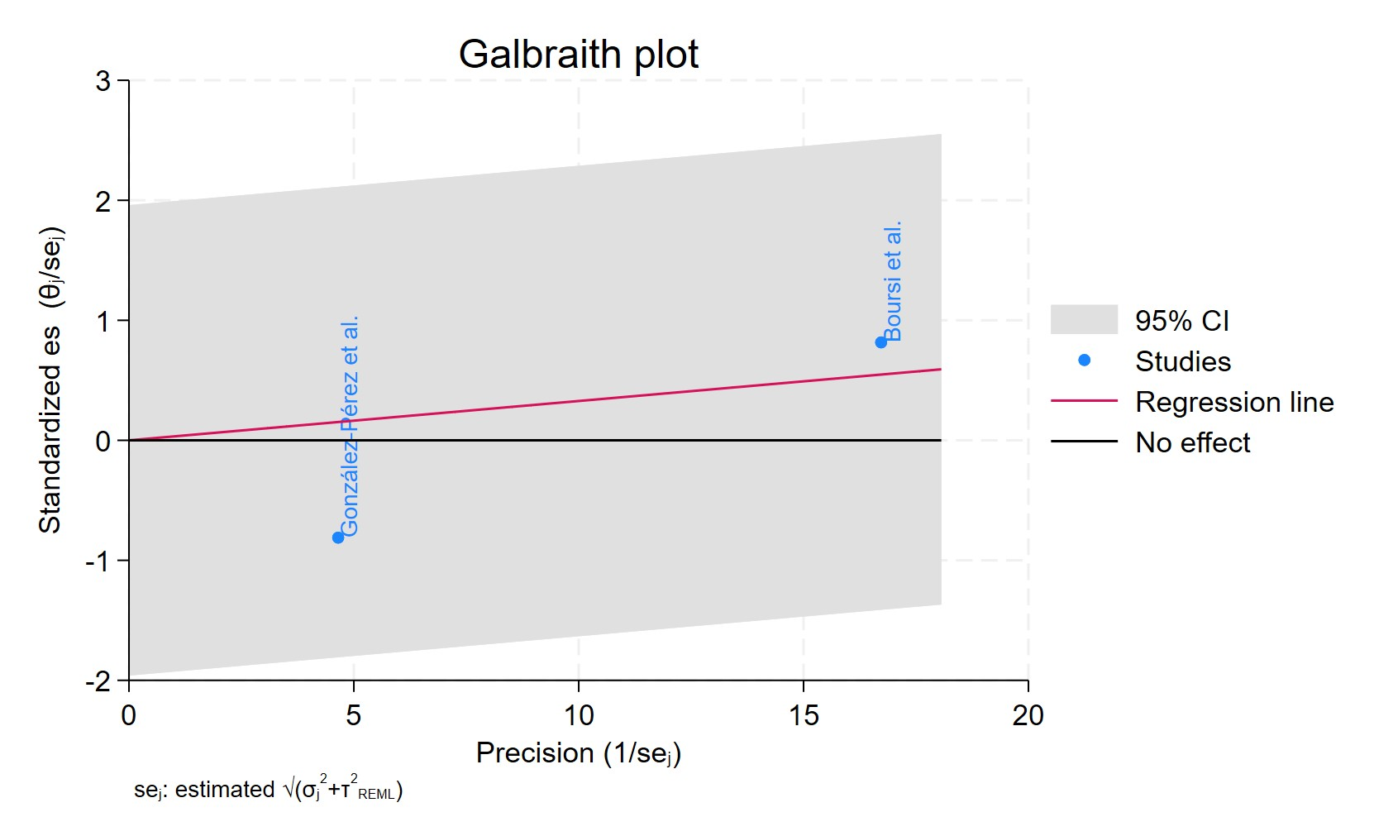
Figure 55 Galbraith plot - Cumulative Duration SSRIs Treatment 1-3 Years

Each study is represented as a point, where the x-axis denotes the precision (defined as the inverse of the standard error), and the y-axis indicates the standardized effect size. The red regression line represents the overall summary effect estimated from the random-effects model, and the gray shaded area corresponds to the confidence interval at 95% around regression line. The horizontal black ––line at y = 0 corresponds to the line of no effect, serving as a reference.
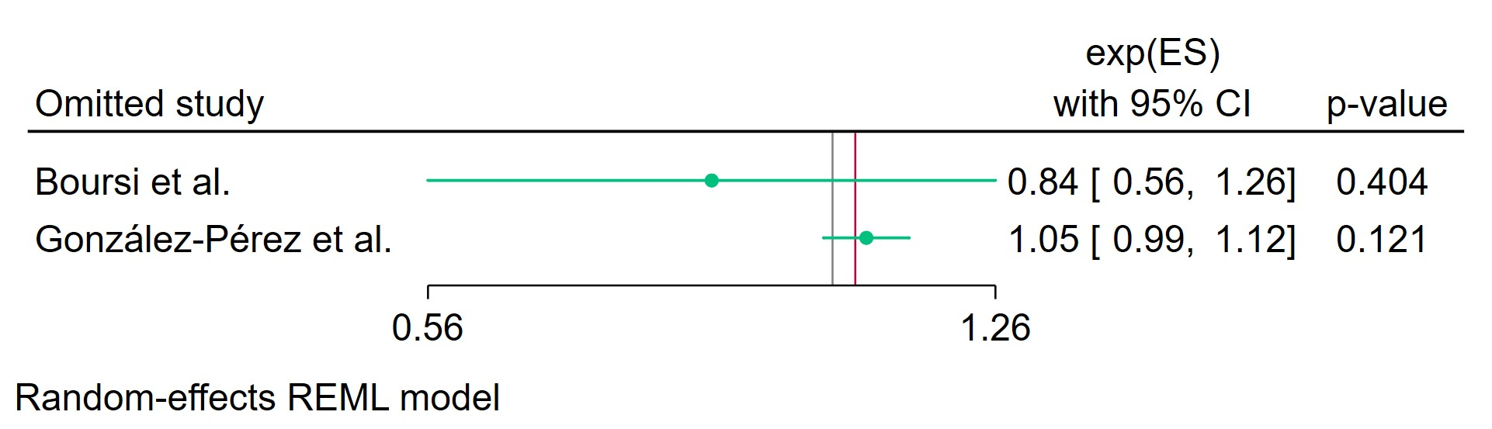
Figure 56 Leave-one-out - Cumulative Duration SSRIs Treatment 1-3 Years

Leave-one-out (LOO) analysis assesses meta-analysis robustness by iteratively excluding one study at a time and refitting the model to observe shifts in the pooled effect size, confidence interval, and heterogeneity
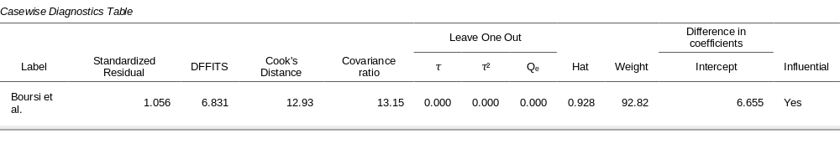
Figure 57 Casewise diagnostics - Cumulative Duration SSRIs Treatment 1-3 Years

Casewise diagnostics evaluate individual study influence in meta-analysis by computing standardized residuals, leverage (Hat values), and global influence measures like DFFITS, Cook's distance, and covariance ratios.​
Leave-one-out (LOO) analyses refit the model after sequentially omitting each study, quantifying changes in key parameters (e.g., $τ$, $τ^{2}$, $Q_{e}$, pooled effect) to assess sensitivity to individual observations.​
Studies exceeding conventional thresholds (e.g., Cook's distance >1, |DFFITS| >1, |standardized residual| >2) are flagged as influential, guiding decisions on robustness or exclusion.
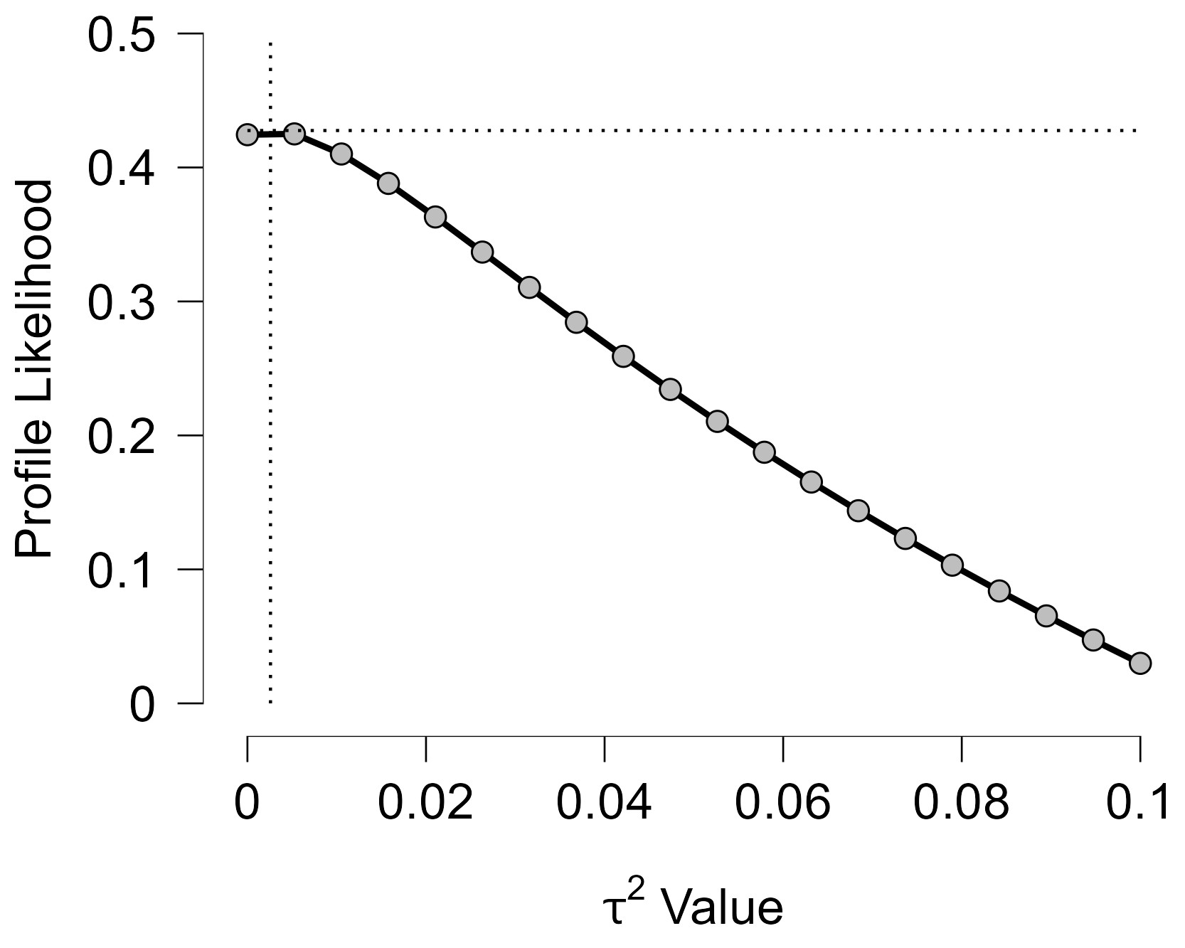
Figure 58 Profile Likelihood - Cumulative Duration SSRIs Treatment 1-3 Years
The x-axis shows candidate values of the heterogeneity variance $τ^{2}$, and the y-axis shows the corresponding standardized profile likelihood, which has been scaled so that the maximum value equals 1 at $τ^{2}=0$.
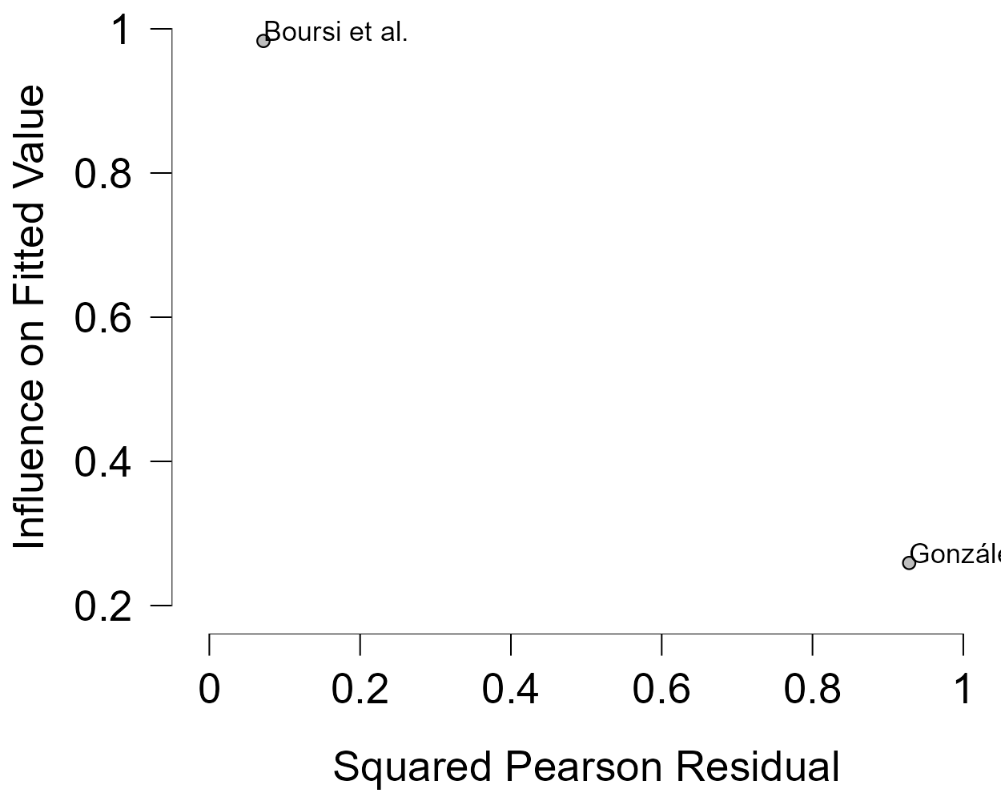
Figure 59 Baujat plot - Cumulative Duration SSRIs Treatment 1-3 Years

The Baujat plot visualises each study's contribution to the Q-statistic for heterogeneity on the x-axis (squared Pearson residual) against its influence on the pooled effect on the y-axis (standardized squared difference in fixed-effects estimates with/without the study). Studies in the top-right quadrant drive both heterogeneity and effect variation, signalling candidates for sensitivity analysis; bottom-left points have minimal impact.

Cumulative Duration SSRIs Treatment Superior To 3 Years
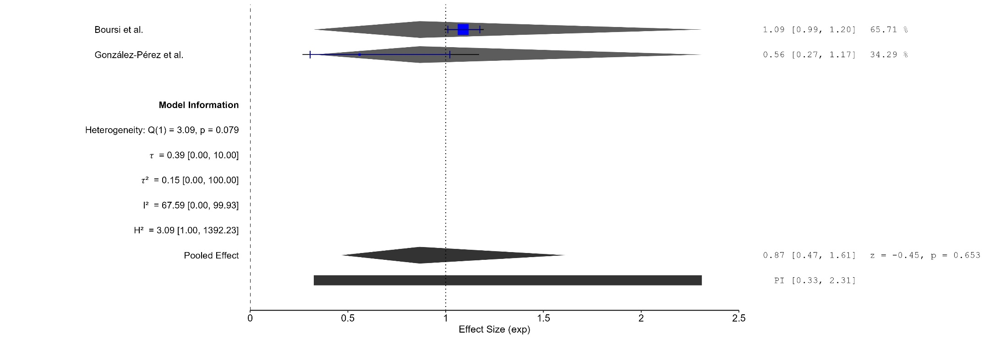
Figure 60 Forest plot - Cumulative Duration SSRIs Treatment Superior To 3 Years

The area of each square is proportional to the sample size of the respective study, with horizontal lines through the squares representing the 95% confidence interval (C.I.) for that study. In the pooled analysis, the diamond symbol represents the pooled estimate, with the right and left points of the diamond indicating the 95% C.I. for the overall analysis
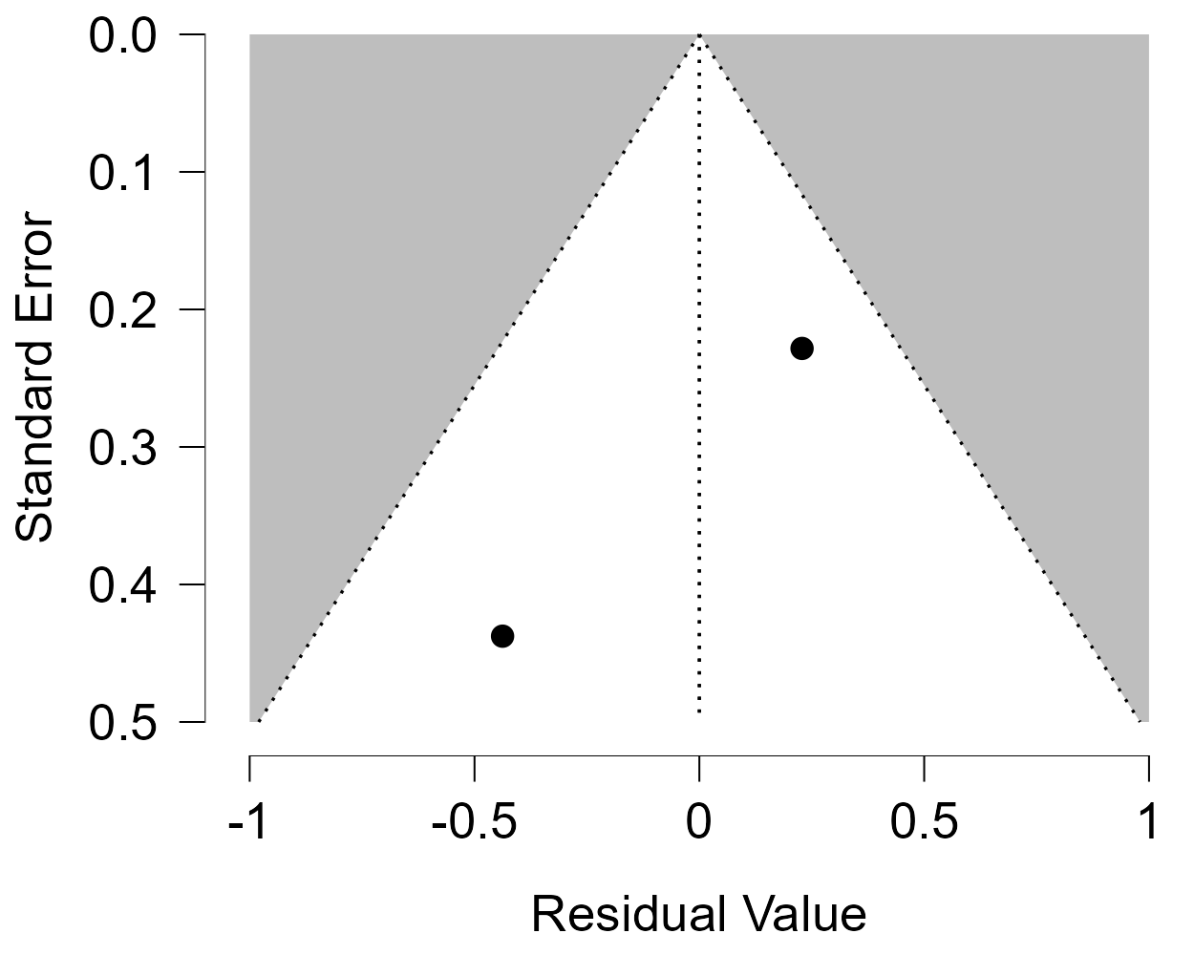
Figure 61 Funnel plot - Cumulative Duration SSRIs Treatment Superior To 3 Years

Each blue dot represents a single study, plotted with its effect size on the x-axis and its standard error on the y-axis. The vertical red line represents the overall effect estimate derived from the random-effects model using restricted maximum likelihood (REML). The pseudo 95% confidence interval region, shown as gray diagonal lines, outlines the expected spread of studies in the absence of bias or between-study heterogeneity.
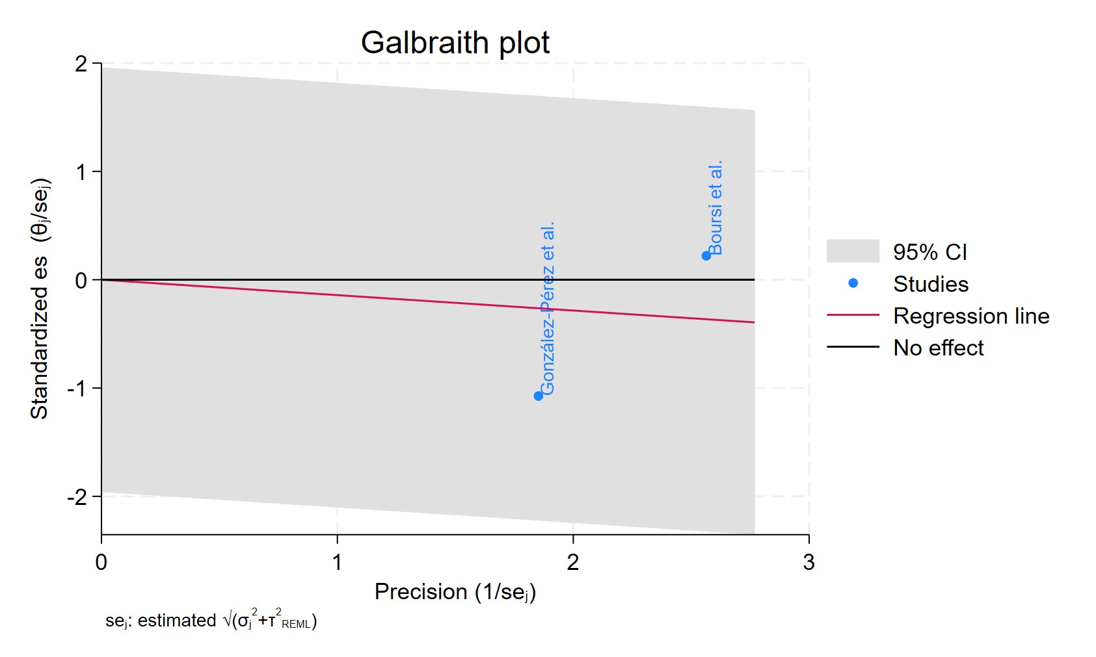
Figure 62 Galbraith plot - Cumulative Duration SSRIs Treatment Superior To 3 Years

Each study is represented as a point, where the x-axis denotes the precision (defined as the inverse of the standard error), and the y-axis indicates the standardized effect size. The red regression line represents the overall summary effect estimated from the random-effects model, and the gray shaded area corresponds to the confidence interval at 95% around regression line. The horizontal black ––line at y = 0 corresponds to the line of no effect, serving as a reference.
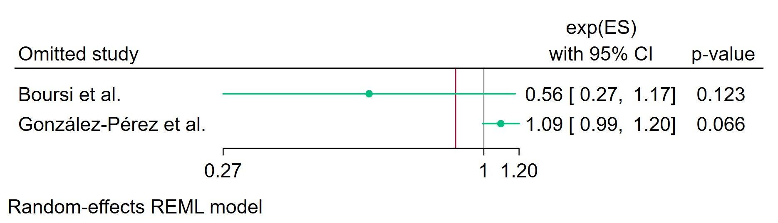
Figure 63 Leave-one-out - Cumulative Duration SSRIs Treatment Superior To 3 Years

Leave-one-out (LOO) analysis assesses meta-analysis robustness by iteratively excluding one study at a time and refitting the model to observe shifts in the pooled effect size, confidence interval, and heterogeneity
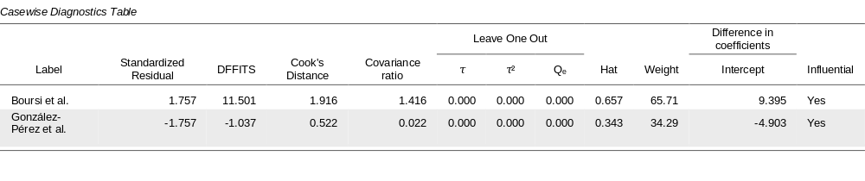
Figure 64 Casewise diagnostics- Cumulative Duration SSRIs Treatment Superior To 3 Years

Casewise diagnostics evaluate individual study influence in meta-analysis by computing standardized residuals, leverage (Hat values), and global influence measures like DFFITS, Cook's distance, and covariance ratios.​
Leave-one-out (LOO) analyses refit the model after sequentially omitting each study, quantifying changes in key parameters (e.g., $τ$, $τ^{2}$, $Q_{e}$, pooled effect) to assess sensitivity to individual observations.​
Studies exceeding conventional thresholds (e.g., Cook's distance >1, |DFFITS| >1, |standardized residual| >2) are flagged as influential, guiding decisions on robustness or exclusion.
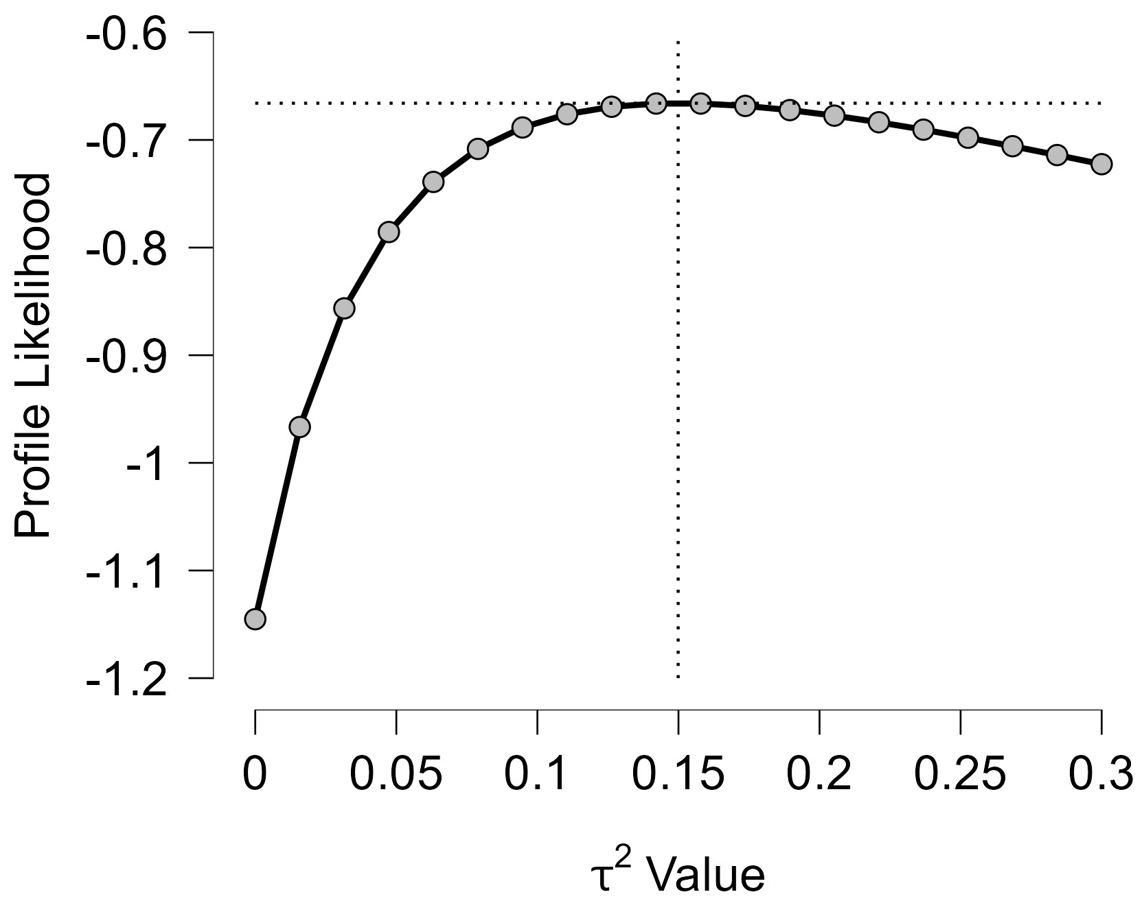
Figure 65 Profile Likelihood- Cumulative Duration SSRIs Treatment Superior To 3 Years

The x-axis shows candidate values of the heterogeneity variance $τ^{2}$, and the y-axis shows the corresponding standardized profile likelihood, which has been scaled so that the maximum value equals 1 at $τ^{2}=0$.
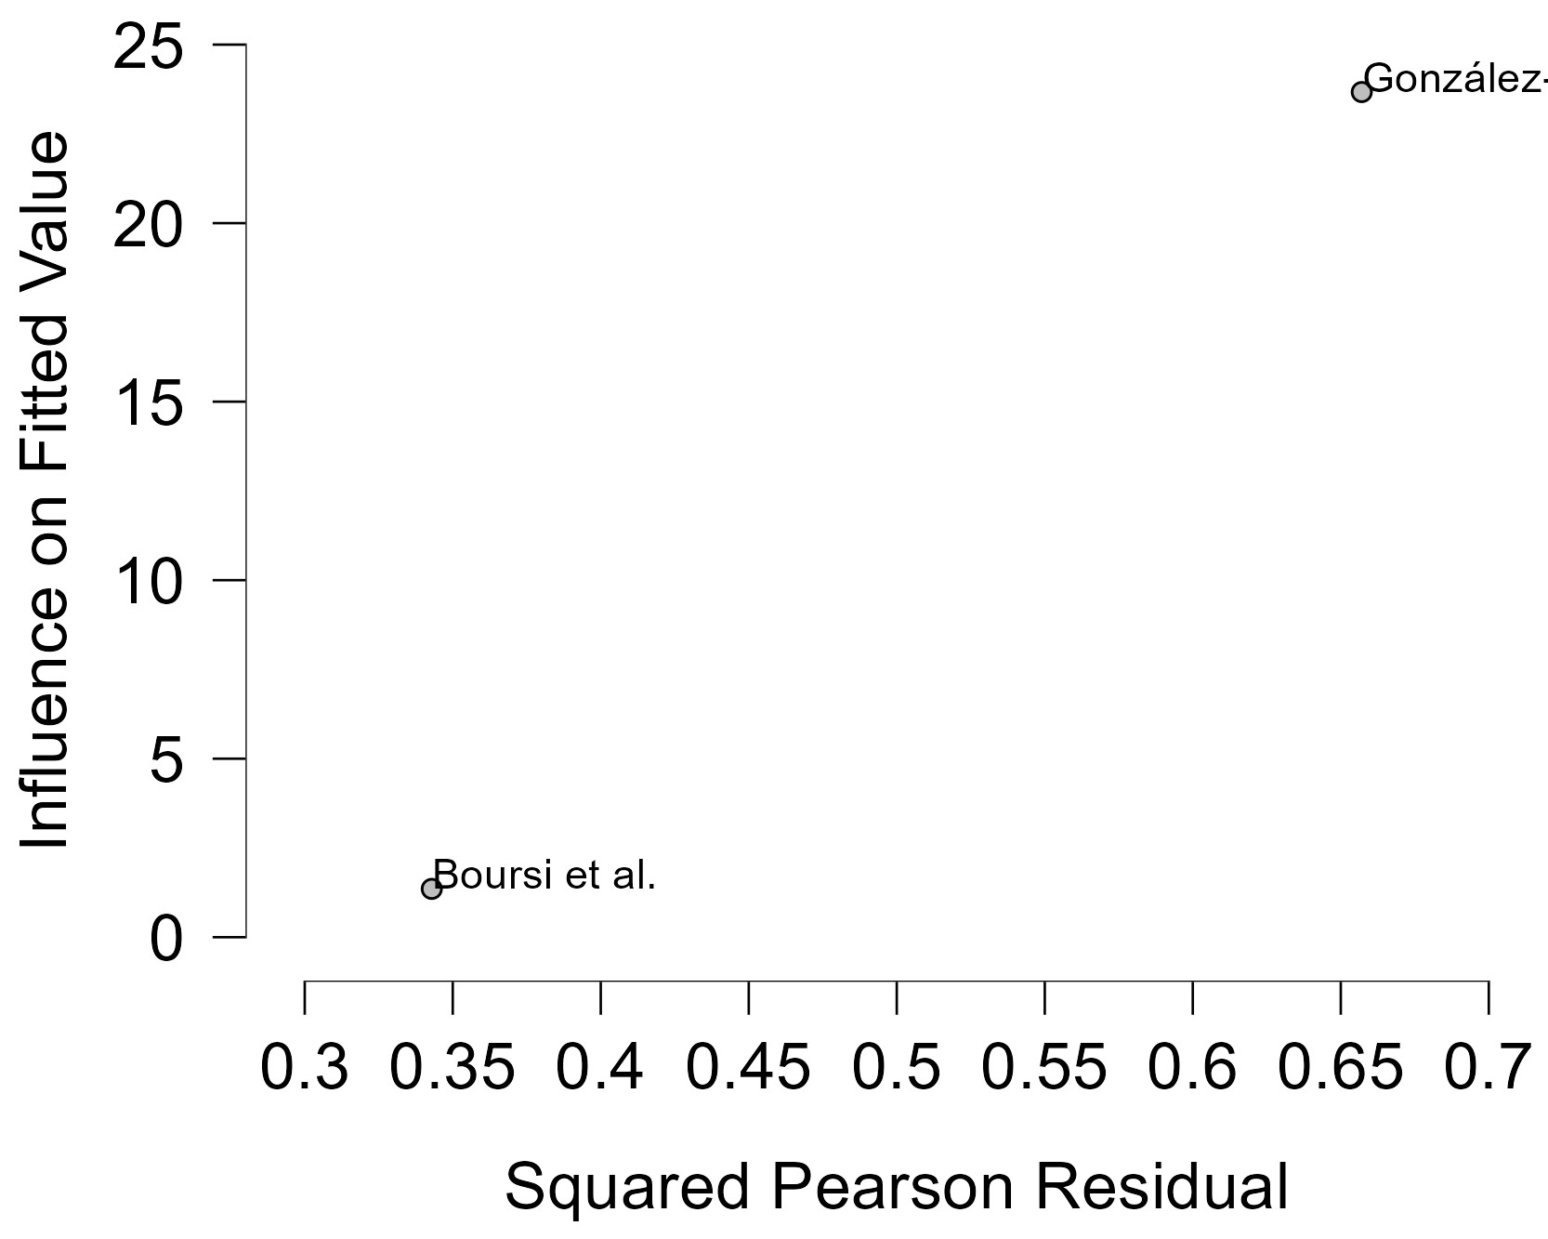
Figure 66 Baujat plot- Cumulative Duration SSRIs Treatment Superior To 3 Years

The Baujat plot visualises each study's contribution to the Q-statistic for heterogeneity on the x-axis (squared Pearson residual) against its influence on the pooled effect on the y-axis (standardized squared difference in fixed-effects estimates with/without the study). Studies in the top-right quadrant drive both heterogeneity and effect variation, signalling candidates for sensitivity analysis; bottom-left points have minimal impact.

Current TCAs Users Group 1
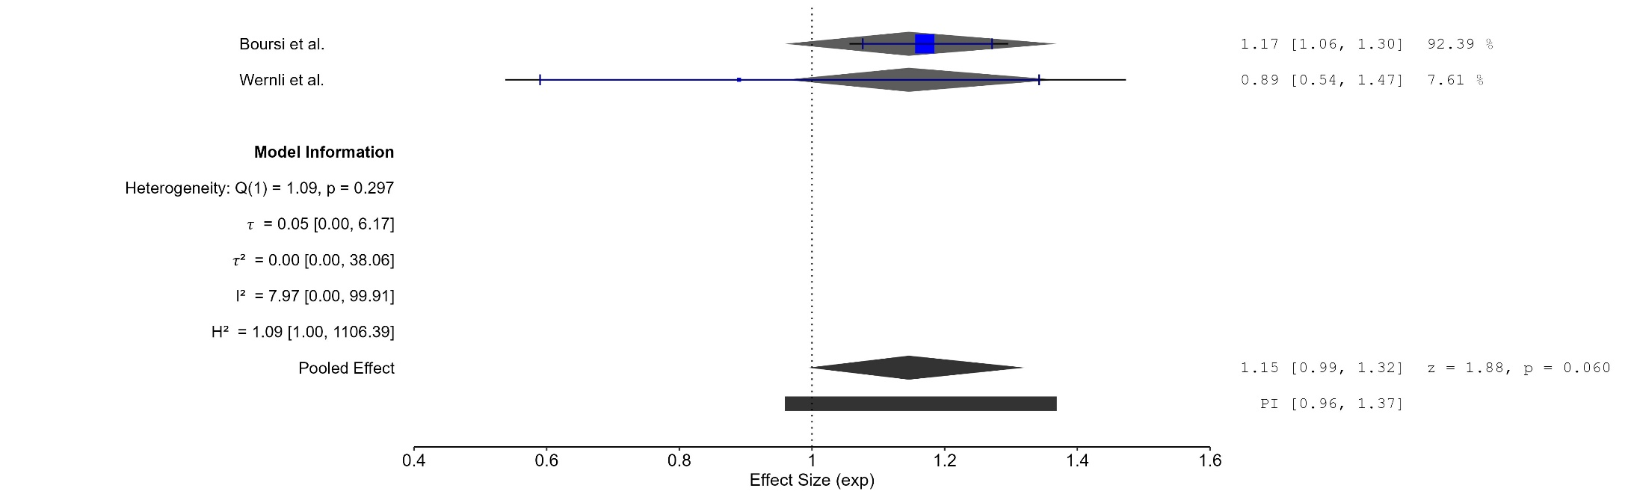
Figure 67 Forest plot -Current TCAs Users Group 1
The area of each square is proportional to the sample size of the respective study, with horizontal lines through the squares representing the 95% confidence interval (C.I.) for that study. In the pooled analysis, the diamond symbol represents the pooled estimate, with the right and left points of the diamond indicating the 95% C.I. for the overall analysis
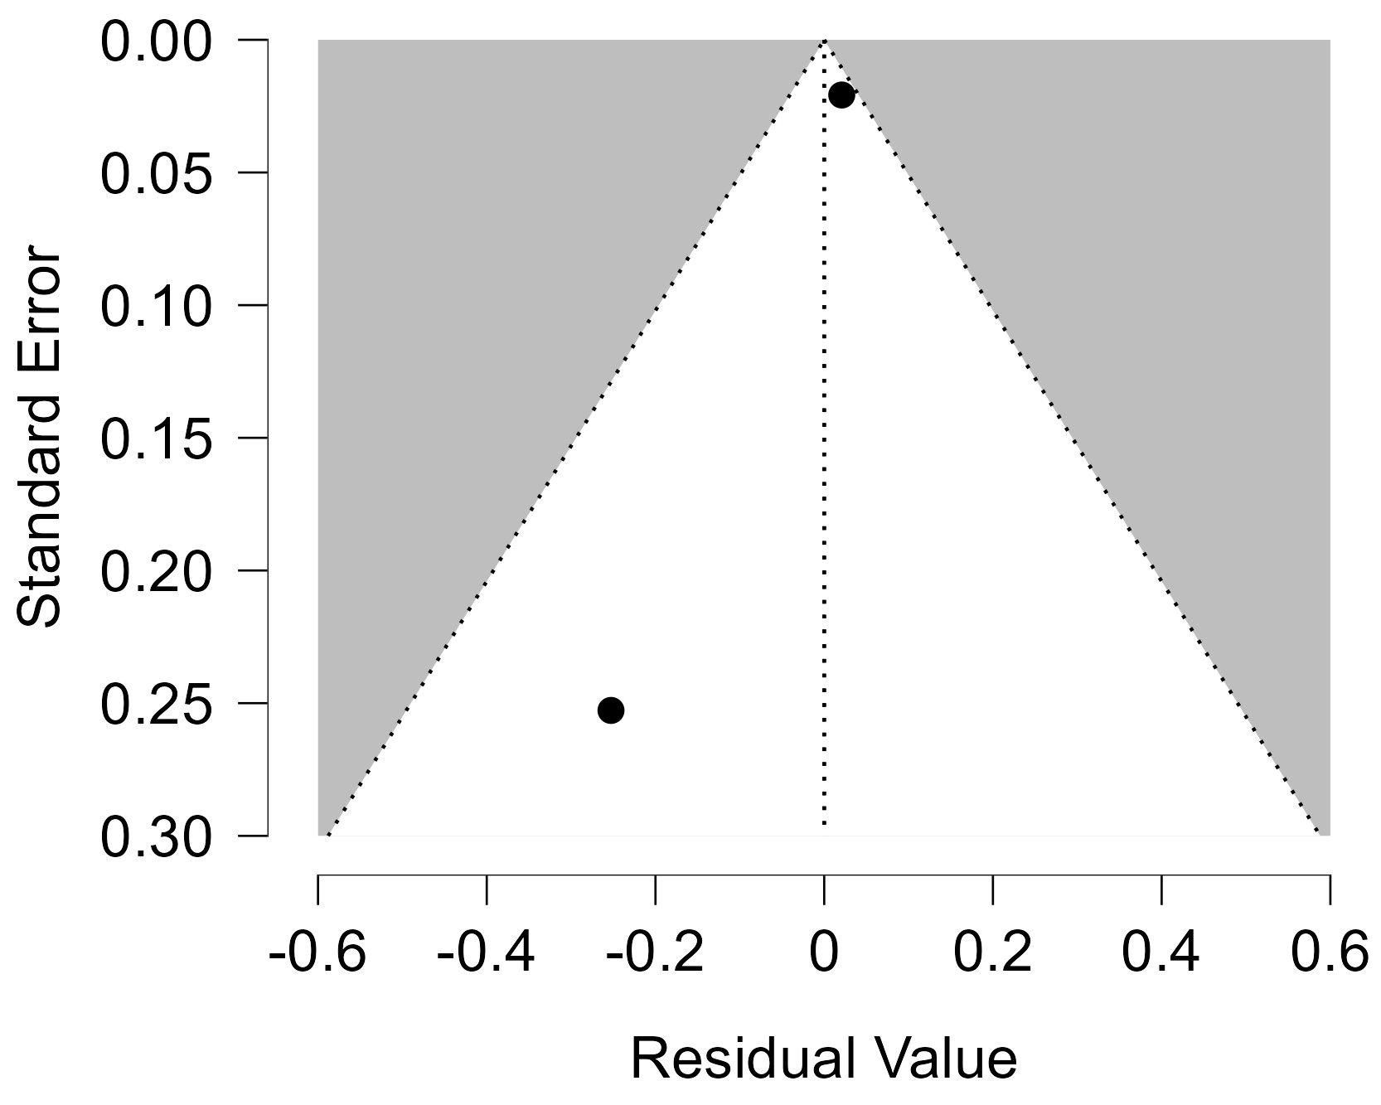
Figure 68 Funnel plot -Current TCAs Users Group 1

Each blue dot represents a single study, plotted with its effect size on the x-axis and its standard error on the y-axis. The vertical red line represents the overall effect estimate derived from the random-effects model using restricted maximum likelihood (REML). The pseudo 95% confidence interval region, shown as gray diagonal lines, outlines the expected spread of studies in the absence of bias or between-study heterogeneity.
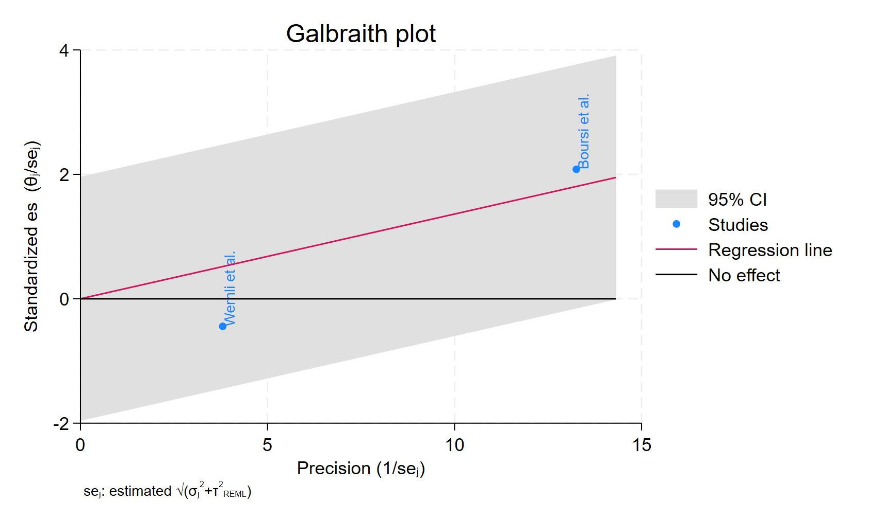
Figure 69 Galbraith plot -Current TCAs Users Group 1-Current TCAs Users Group 1

Each study is represented as a point, where the x-axis denotes the precision (defined as the inverse of the standard error), and the y-axis indicates the standardized effect size. The red regression line represents the overall summary effect estimated from the random-effects model, and the gray shaded area corresponds to the confidence interval at 95% around regression line. The horizontal black ––line at y = 0 corresponds to the line of no effect, serving as a reference.
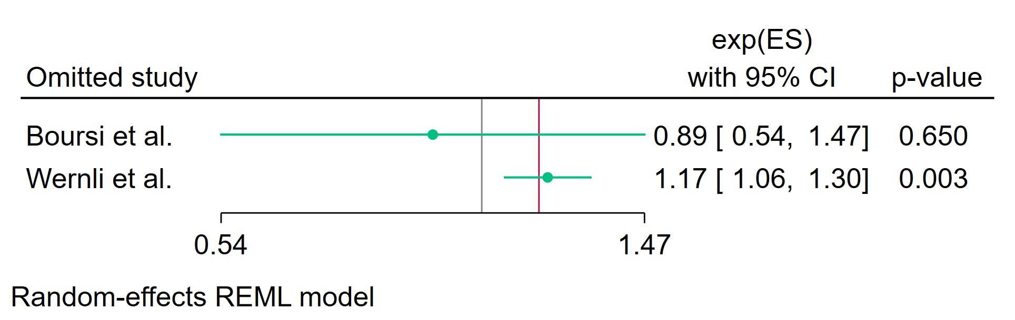
Figure 70 Leave-one-out -Current TCAs Users Group 1

Leave-one-out (LOO) analysis assesses meta-analysis robustness by iteratively excluding one study at a time and refitting the model to observe shifts in the pooled effect size, confidence interval, and heterogeneity

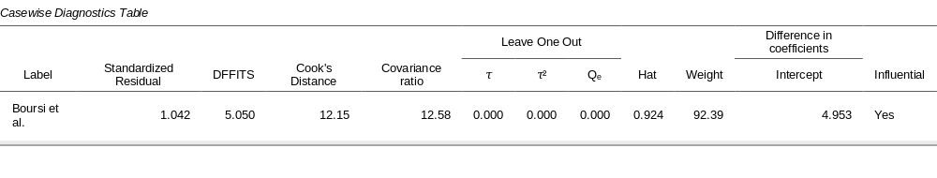
Figure 71 Casewise Diagnostics-Current TCAs Users Group 1
Casewise diagnostics evaluate individual study influence in meta-analysis by computing standardized residuals, leverage (Hat values), and global influence measures like DFFITS, Cook's distance, and covariance ratios.​
Leave-one-out (LOO) analyses refit the model after sequentially omitting each study, quantifying changes in key parameters (e.g., $τ$, $τ^{2}$, $Q_{e}$, pooled effect) to assess sensitivity to individual observations.​
Studies exceeding conventional thresholds (e.g., Cook's distance >1, |DFFITS| >1, |standardized residual| >2) are flagged as influential, guiding decisions on robustness or exclusion.
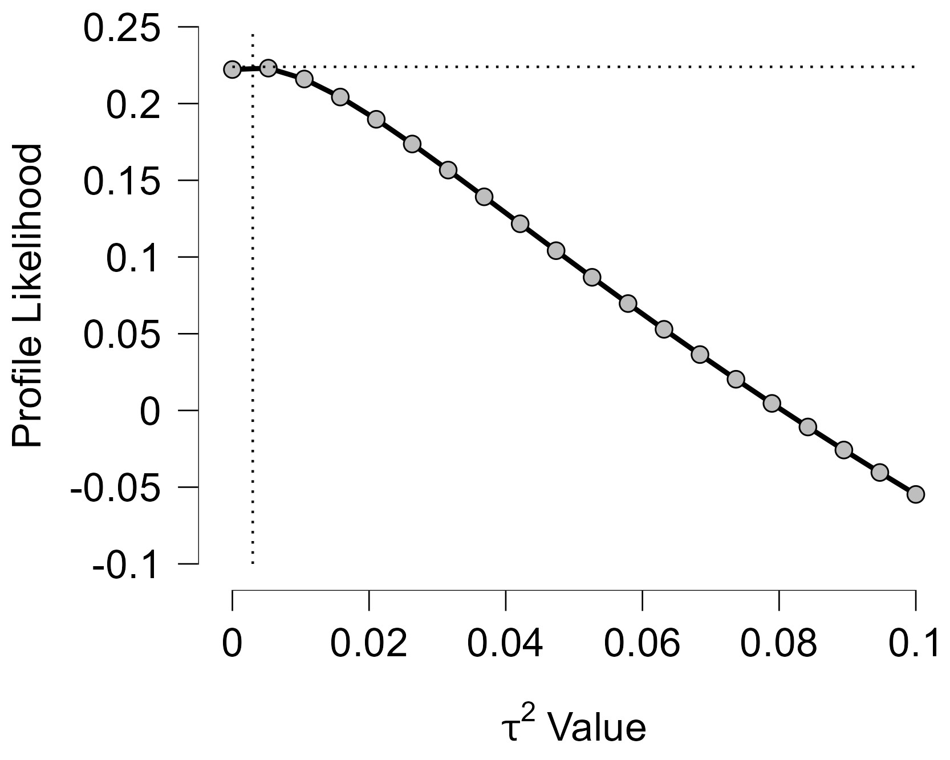
Figure 72 Profile Likelihood-Current TCAs Users Group 1

The x-axis shows candidate values of the heterogeneity variance $τ^{2}$, and the y-axis shows the corresponding standardized profile likelihood, which has been scaled so that the maximum value equals 1 at $τ^{2}=0$.
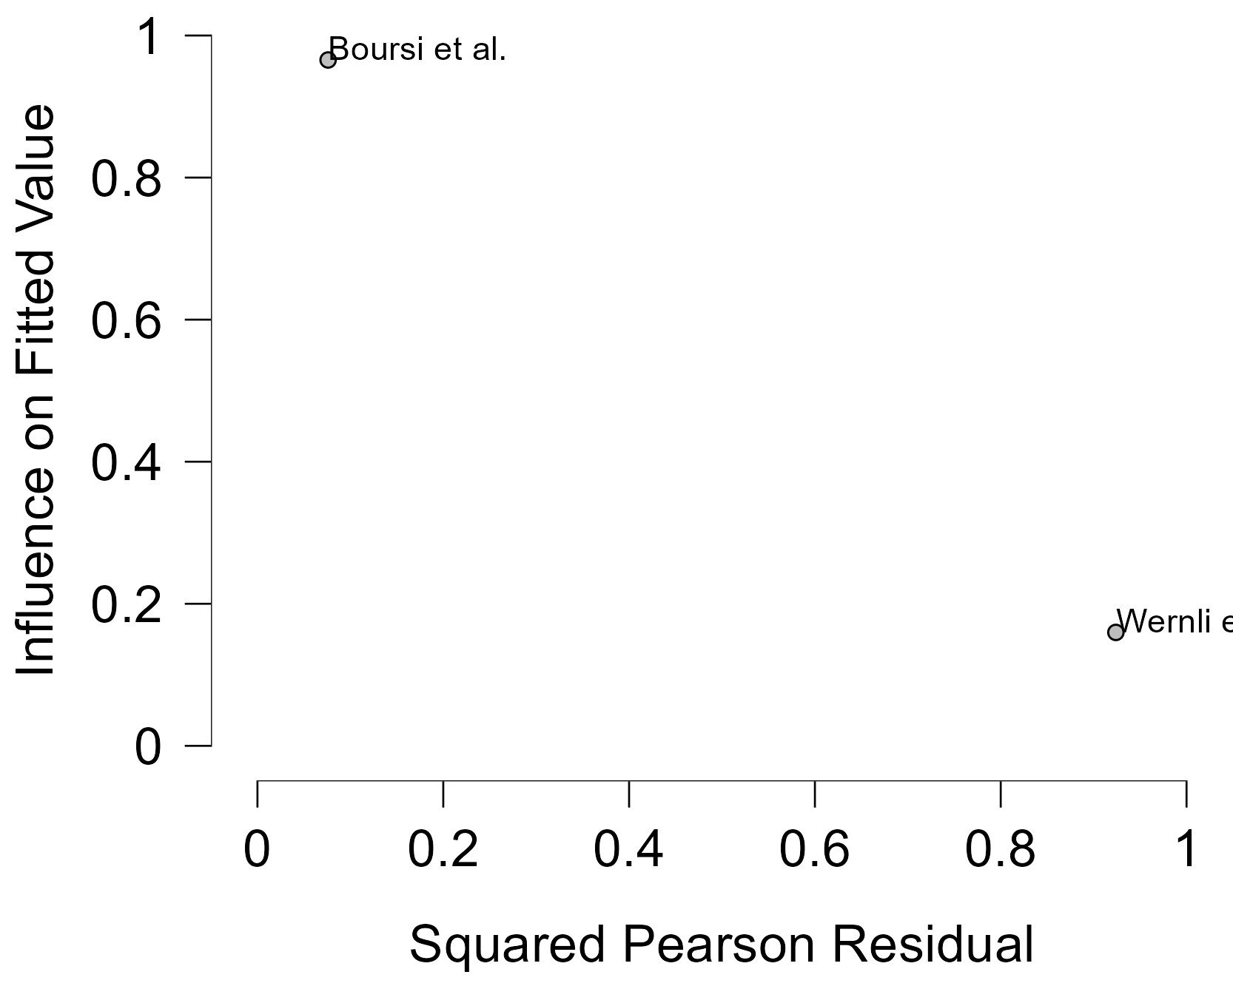
Figure 73 Baujat plot-Current TCAs Users Group 1

The Baujat plot visualises each study's contribution to the Q-statistic for heterogeneity on the x-axis (squared Pearson residual) against its influence on the pooled effect on the y-axis (standardized squared difference in fixed-effects estimates with/without the study). Studies in the top-right quadrant drive both heterogeneity and effect variation, signalling candidates for sensitivity analysis; bottom-left points have minimal impact.

Former TCAs Users Group 1
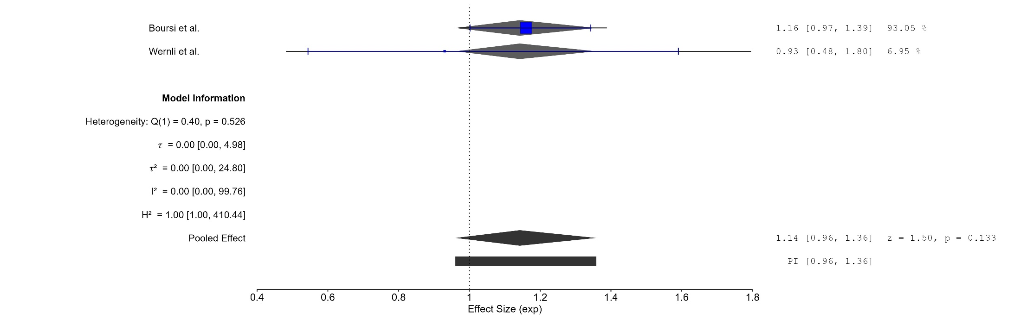
Figure 74 Forest plot- Former TCAs Users Group 1

The area of each square is proportional to the sample size of the respective study, with horizontal lines through the squares representing the 95% confidence interval (C.I.) for that study. In the pooled analysis, the diamond symbol represents the pooled estimate, with the right and left points of the diamond indicating the 95% C.I. for the overall analysis.
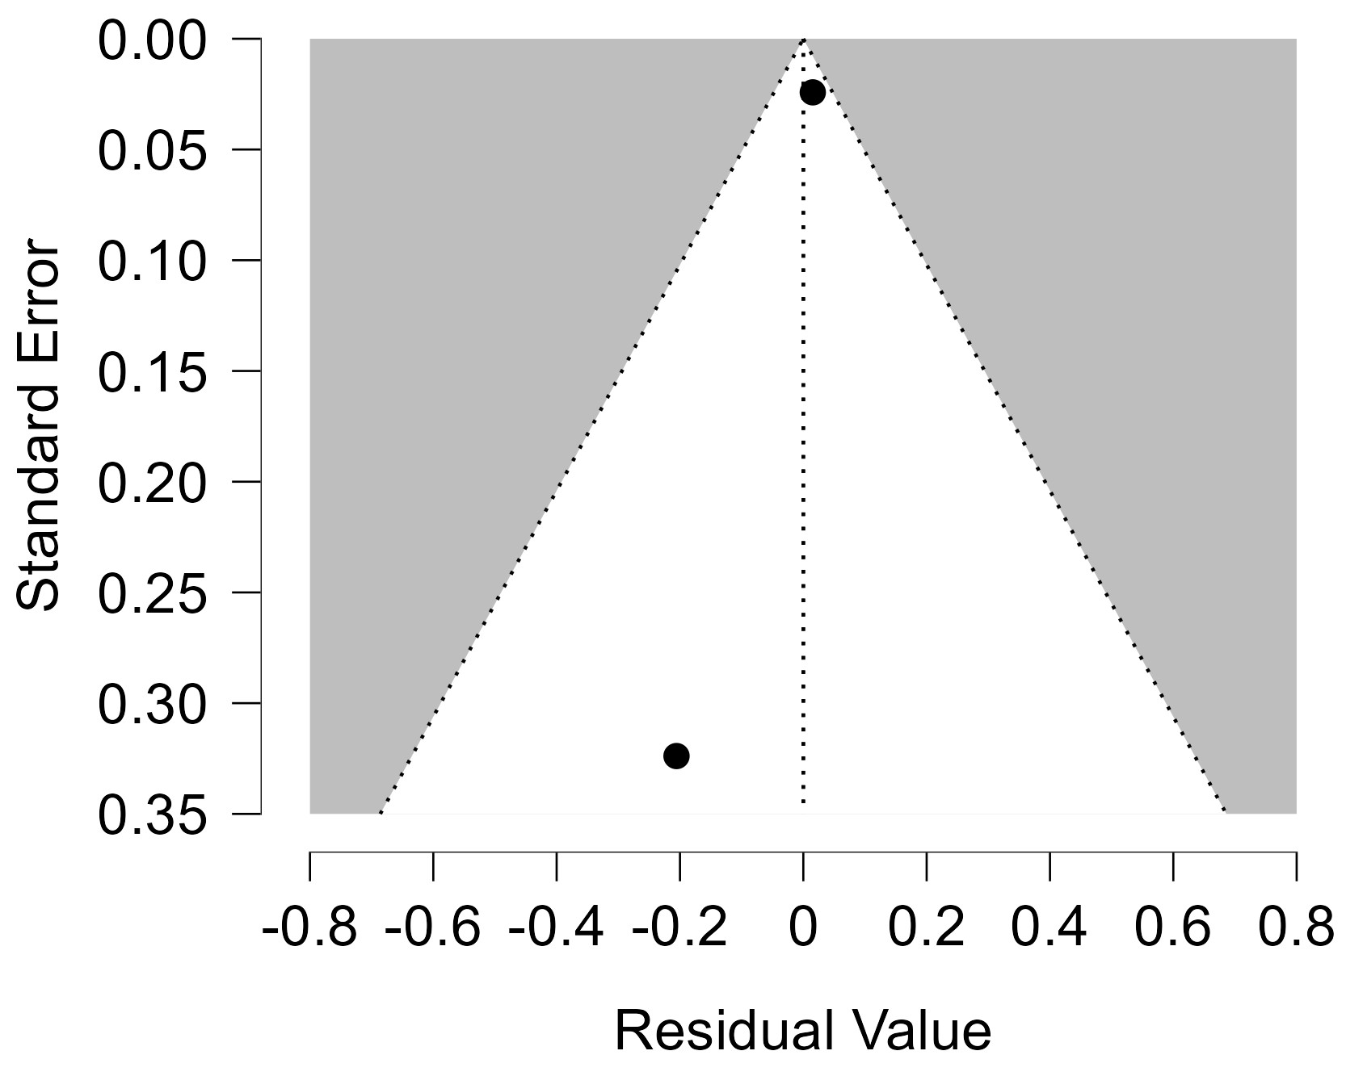
Figure 75 Funnel plot -Former TCAs Users Group 1

Each blue dot represents a single study, plotted with its effect size on the x-axis and its standard error on the y-axis. The vertical red line represents the overall effect estimate derived from the random-effects model using restricted maximum likelihood (REML). The pseudo 95% confidence interval region, shown as gray diagonal lines, outlines the expected spread of studies in the absence of bias or between-study heterogeneity.
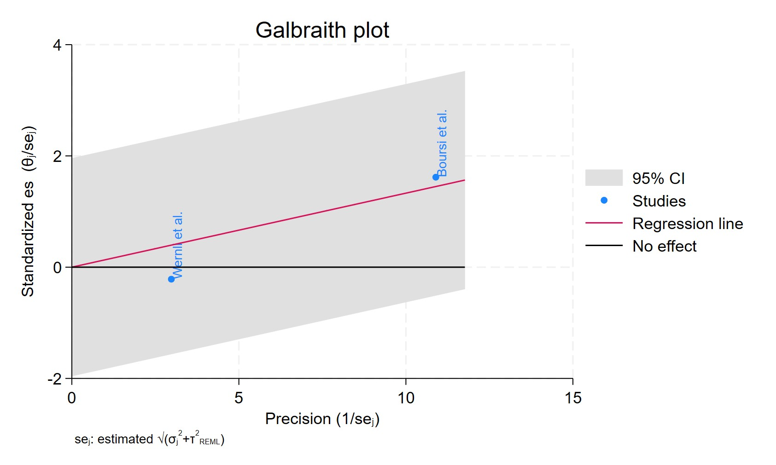
Figure 76 Galbraith plot - Former TCAs Users Group 1

Each study is represented as a point, where the x-axis denotes the precision (defined as the inverse of the standard error), and the y-axis indicates the standardized effect size. The red regression line represents the overall summary effect estimated from the random-effects model, and the gray shaded area corresponds to the confidence interval at 95% around regression line. The horizontal black ––line at y = 0 corresponds to the line of no effect, serving as a reference.
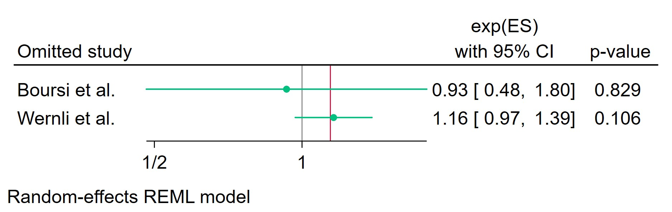
Figure 77 Leave-one-out - Former TCAs Users Group 1

Leave-one-out (LOO) analysis assesses meta-analysis robustness by iteratively excluding one study at a time and refitting the model to observe shifts in the pooled effect size, confidence interval, and heterogeneity
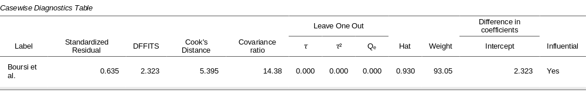
Figure 78 Casewise diagnostics - Former TCAs Users Group 1

Casewise diagnostics evaluate individual study influence in meta-analysis by computing standardized residuals, leverage (Hat values), and global influence measures like DFFITS, Cook's distance, and covariance ratios.​
Leave-one-out (LOO) analyses refit the model after sequentially omitting each study, quantifying changes in key parameters (e.g., $τ$, $τ^{2}$, $Q_{e}$, pooled effect) to assess sensitivity to individual observations.​
Studies exceeding conventional thresholds (e.g., Cook's distance >1, |DFFITS| >1, |standardized residual| >2) are flagged as influential, guiding decisions on robustness or exclusion.
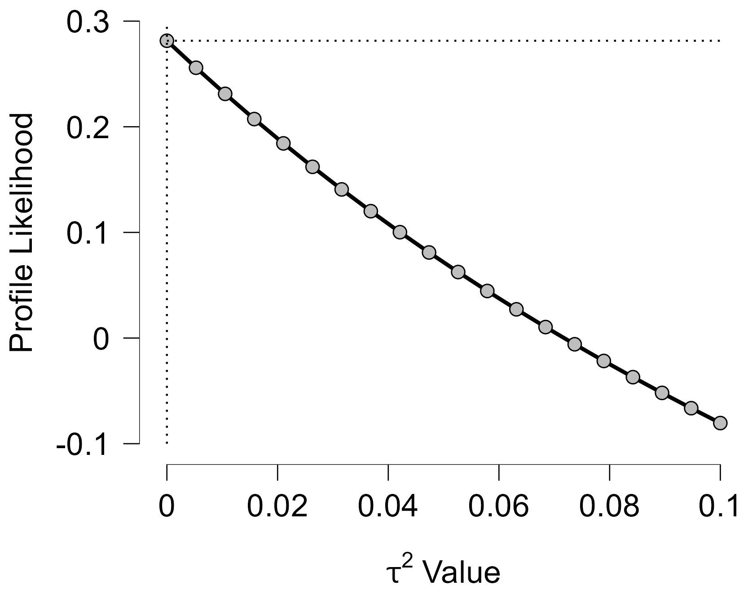
Figure 79 Profile Likelihood- Former TCAs Users Group 1

The x-axis shows candidate values of the heterogeneity variance $τ^{2}$, and the y-axis shows the corresponding standardized profile likelihood, which has been scaled so that the maximum value equals 1 at $τ^{2}=0$.
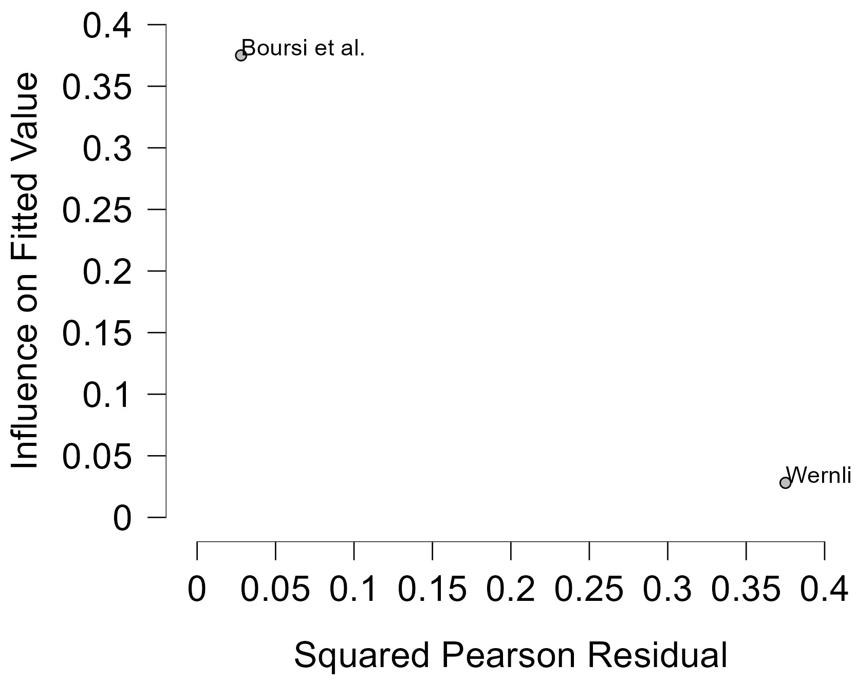
Figure 80 Baujat plot- Former TCAs Users Group 1

The Baujat plot visualises each study's contribution to the Q-statistic for heterogeneity on the x-axis (squared Pearson residual) against its influence on the pooled effect on the y-axis (standardized squared difference in fixed-effects estimates with/without the study). Studies in the top-right quadrant drive both heterogeneity and effect variation, signalling candidates for sensitivity analysis; bottom-left points have minimal impact.

Current TCAs Users Group 2
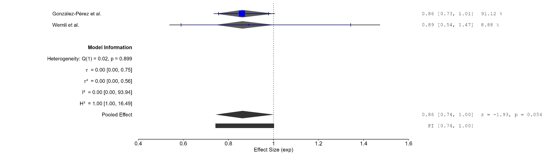
Figure 81 Forest plot - Current TCAs Users Group 2

The area of each square is proportional to the sample size of the respective study, with horizontal lines through the squares representing the 95% confidence interval (C.I.) for that study. In the pooled analysis, the diamond symbol represents the pooled estimate, with the right and left points of the diamond indicating the 95% C.I. for the overall analysis
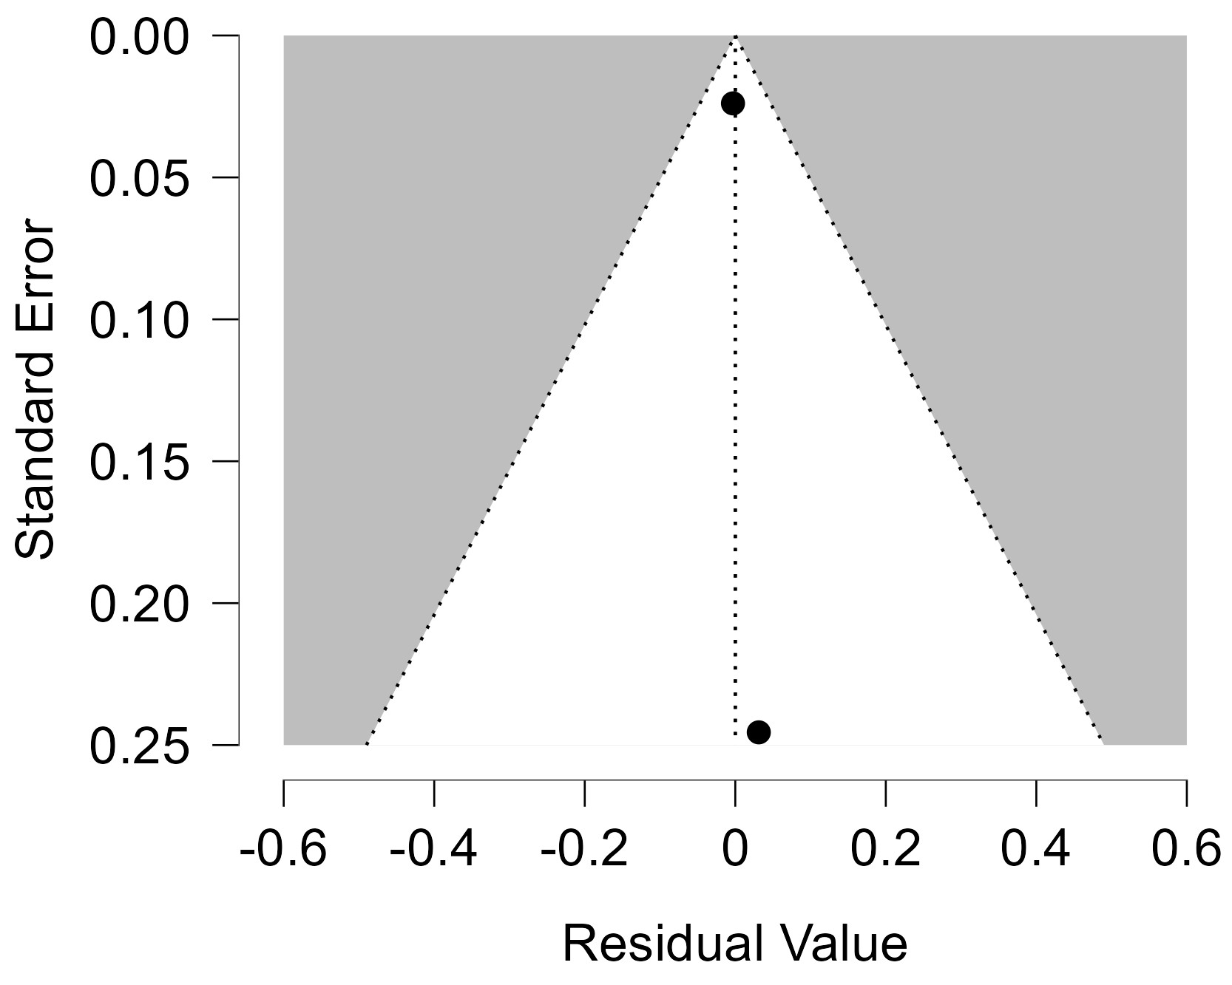
Figure 82 Funnel plot - Current TCAs Users Group 2

Each blue dot represents a single study, plotted with its effect size on the x-axis and its standard error on the y-axis. The vertical red line represents the overall effect estimate derived from the random-effects model using restricted maximum likelihood (REML). The pseudo 95% confidence interval region, shown as gray diagonal lines, outlines the expected spread of studies in the absence of bias or between-study heterogeneity.
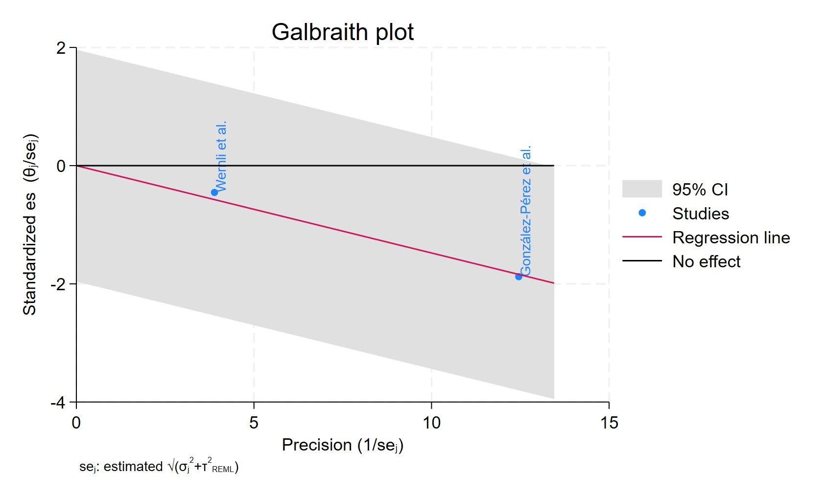
Figure 83 Galbraith plot - Current TCAs Users Group 2

Each study is represented as a point, where the x-axis denotes the precision (defined as the inverse of the standard error), and the y-axis indicates the standardized effect size. The red regression line represents the overall summary effect estimated from the random-effects model, and the gray shaded area corresponds to the confidence interval at 95% around regression line. The horizontal black ––line at y = 0 corresponds to the line of no effect, serving as a reference.
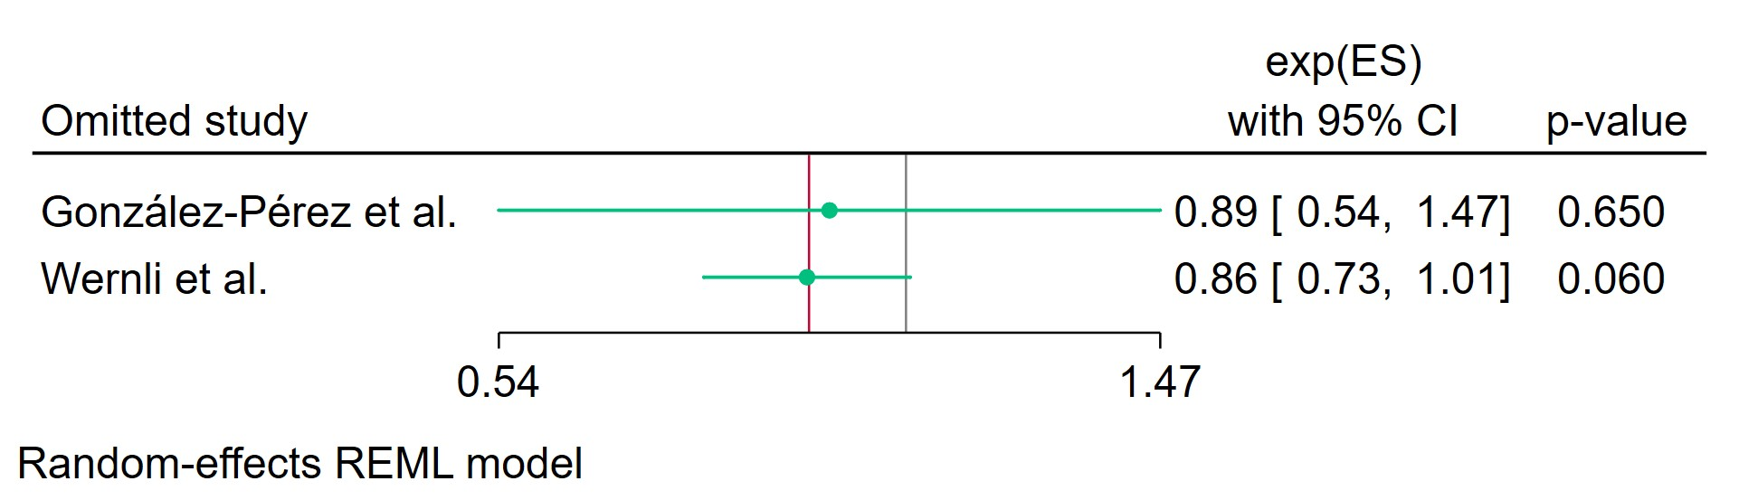
Figure 84 Leave-one-out - Current TCAs Users Group 2

Leave-one-out (LOO) analysis assesses meta-analysis robustness by iteratively excluding one study at a time and refitting the model to observe shifts in the pooled effect size, confidence interval, and heterogeneity

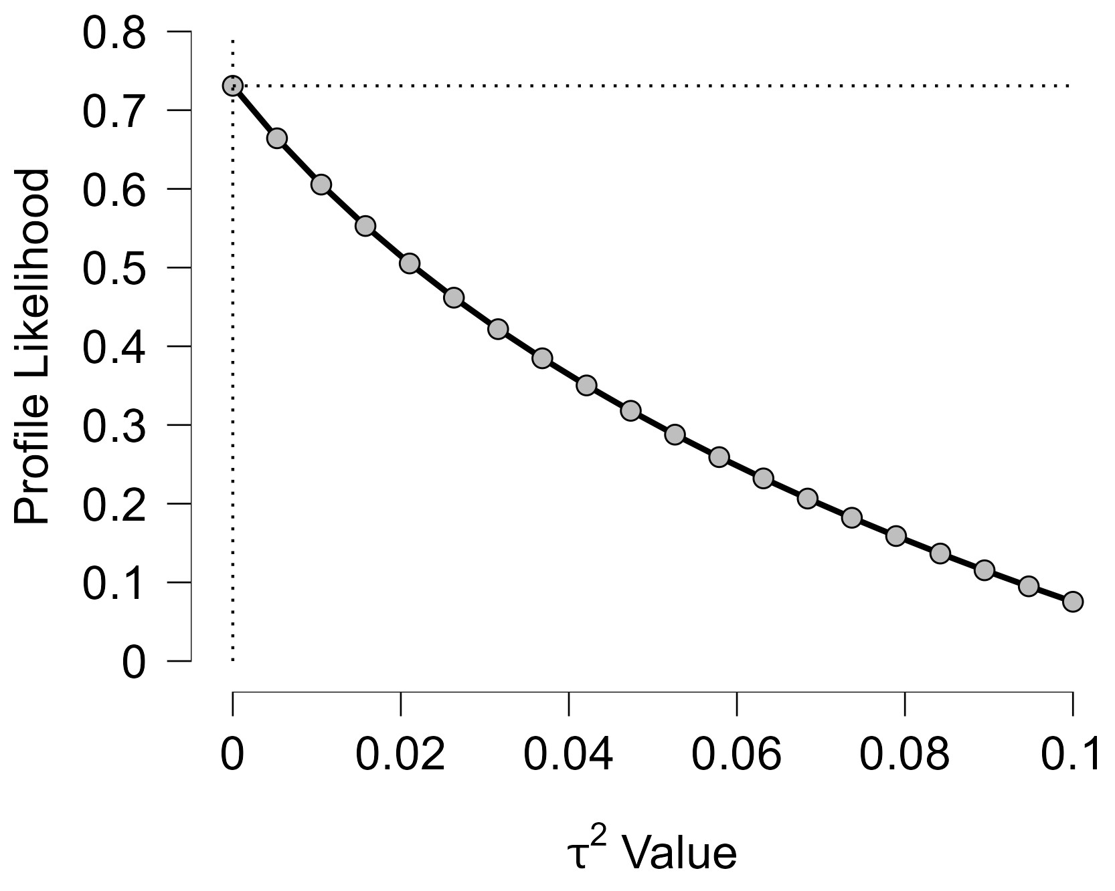
Figure 85 Profile Likelihood- Current TCAs Users Group 2

The x-axis shows candidate values of the heterogeneity variance $τ^{2}$, and the y-axis shows the corresponding standardized profile likelihood, which has been scaled so that the maximum value equals 1 at $τ^{2}=0$.
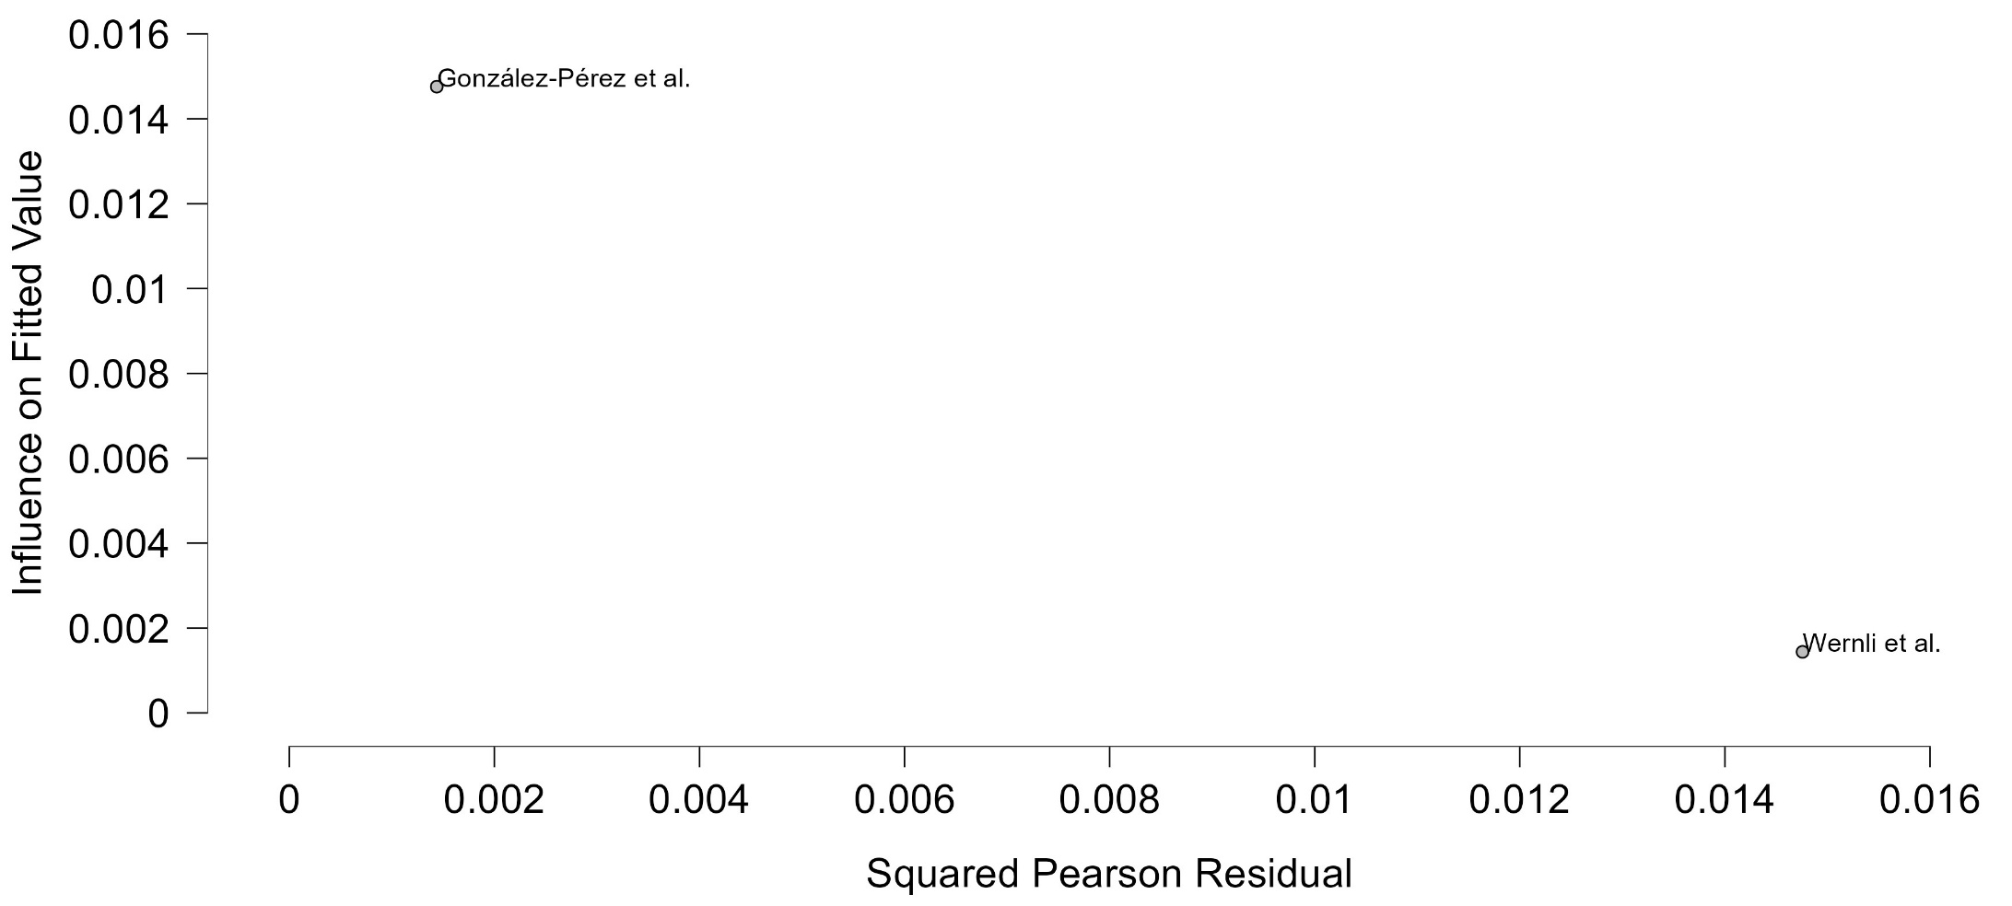
Figure 86 Baujat plot - Current TCAs Users Group 2

The Baujat plot visualises each study's contribution to the Q-statistic for heterogeneity on the x-axis (squared Pearson residual) against its influence on the pooled effect on the y-axis (standardized squared difference in fixed-effects estimates with/without the study). Studies in the top-right quadrant drive both heterogeneity and effect variation, signalling candidates for sensitivity analysis; bottom-left points have minimal impact.

Former TCAs Users Group 2
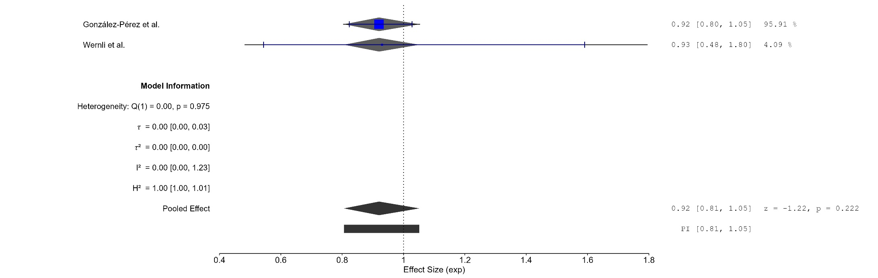
Figure 87 Forest plot - Former TCAs Users Group 2

The area of each square is proportional to the sample size of the respective study, with horizontal lines through the squares representing the 95% confidence interval (C.I.) for that study. In the pooled analysis, the diamond symbol represents the pooled estimate, with the right and left points of the diamond indicating the 95% C.I. for the overall analysis
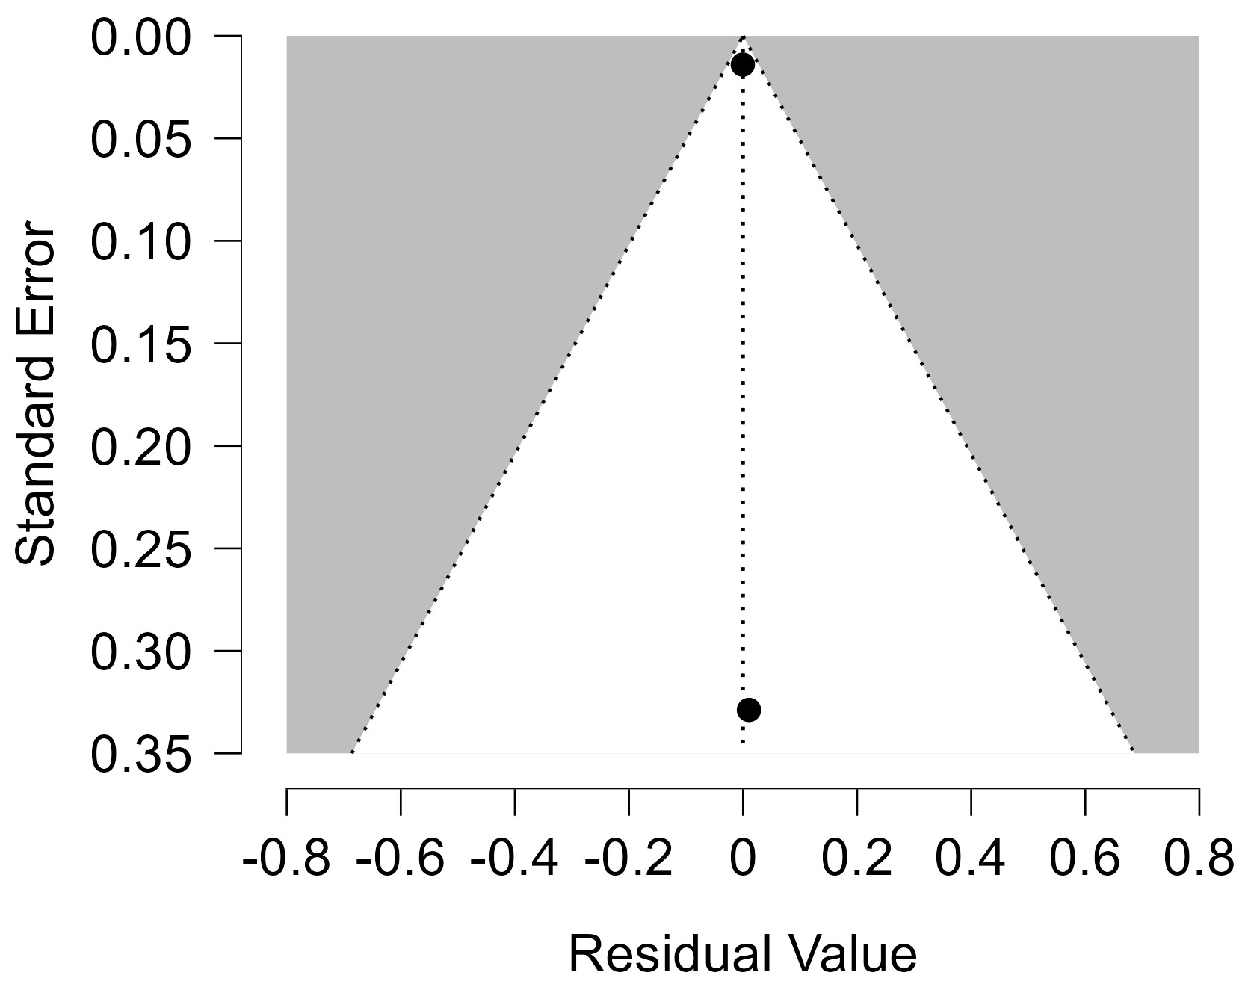
Figure 88 Funnel plot - Former TCAs Users Group 2
Each blue dot represents a single study, plotted with its effect size on the x-axis and its standard error on the y-axis. The vertical red line represents the overall effect estimate derived from the random-effects model using restricted maximum likelihood (REML). The pseudo 95% confidence interval region, shown as gray diagonal lines, outlines the expected spread of studies in the absence of bias or between-study heterogeneity.
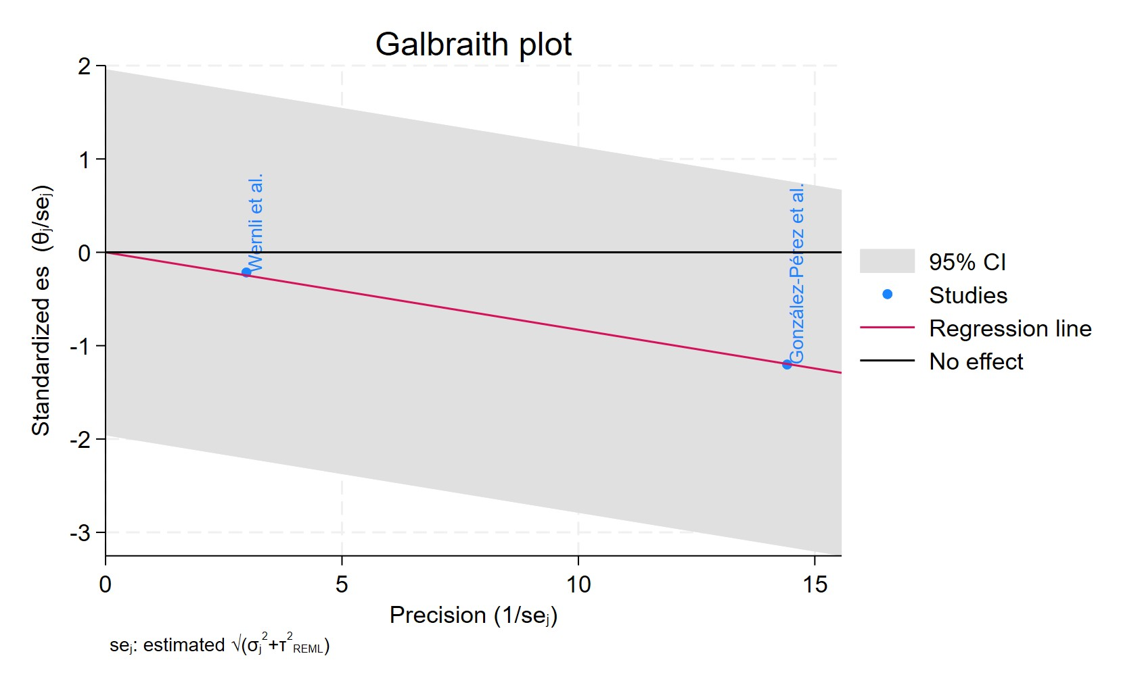
Figure 89 Galbraith plot - Former TCAs Users Group 2

Each study is represented as a point, where the x-axis denotes the precision (defined as the inverse of the standard error), and the y-axis indicates the standardized effect size. The red regression line represents the overall summary effect estimated from the random-effects model, and the gray shaded area corresponds to the confidence interval at 95% around regression line. The horizontal black ––line at y = 0 corresponds to the line of no effect, serving as a reference.
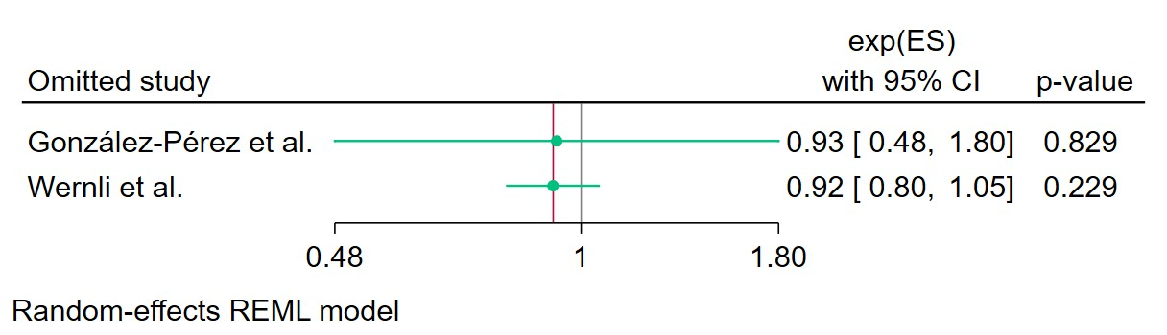
Figure 90 Leave-one-out - Former TCAs Users Group 2

Leave-one-out (LOO) analysis assesses meta-analysis robustness by iteratively excluding one study at a time and refitting the model to observe shifts in the pooled effect size, confidence interval, and heterogeneity

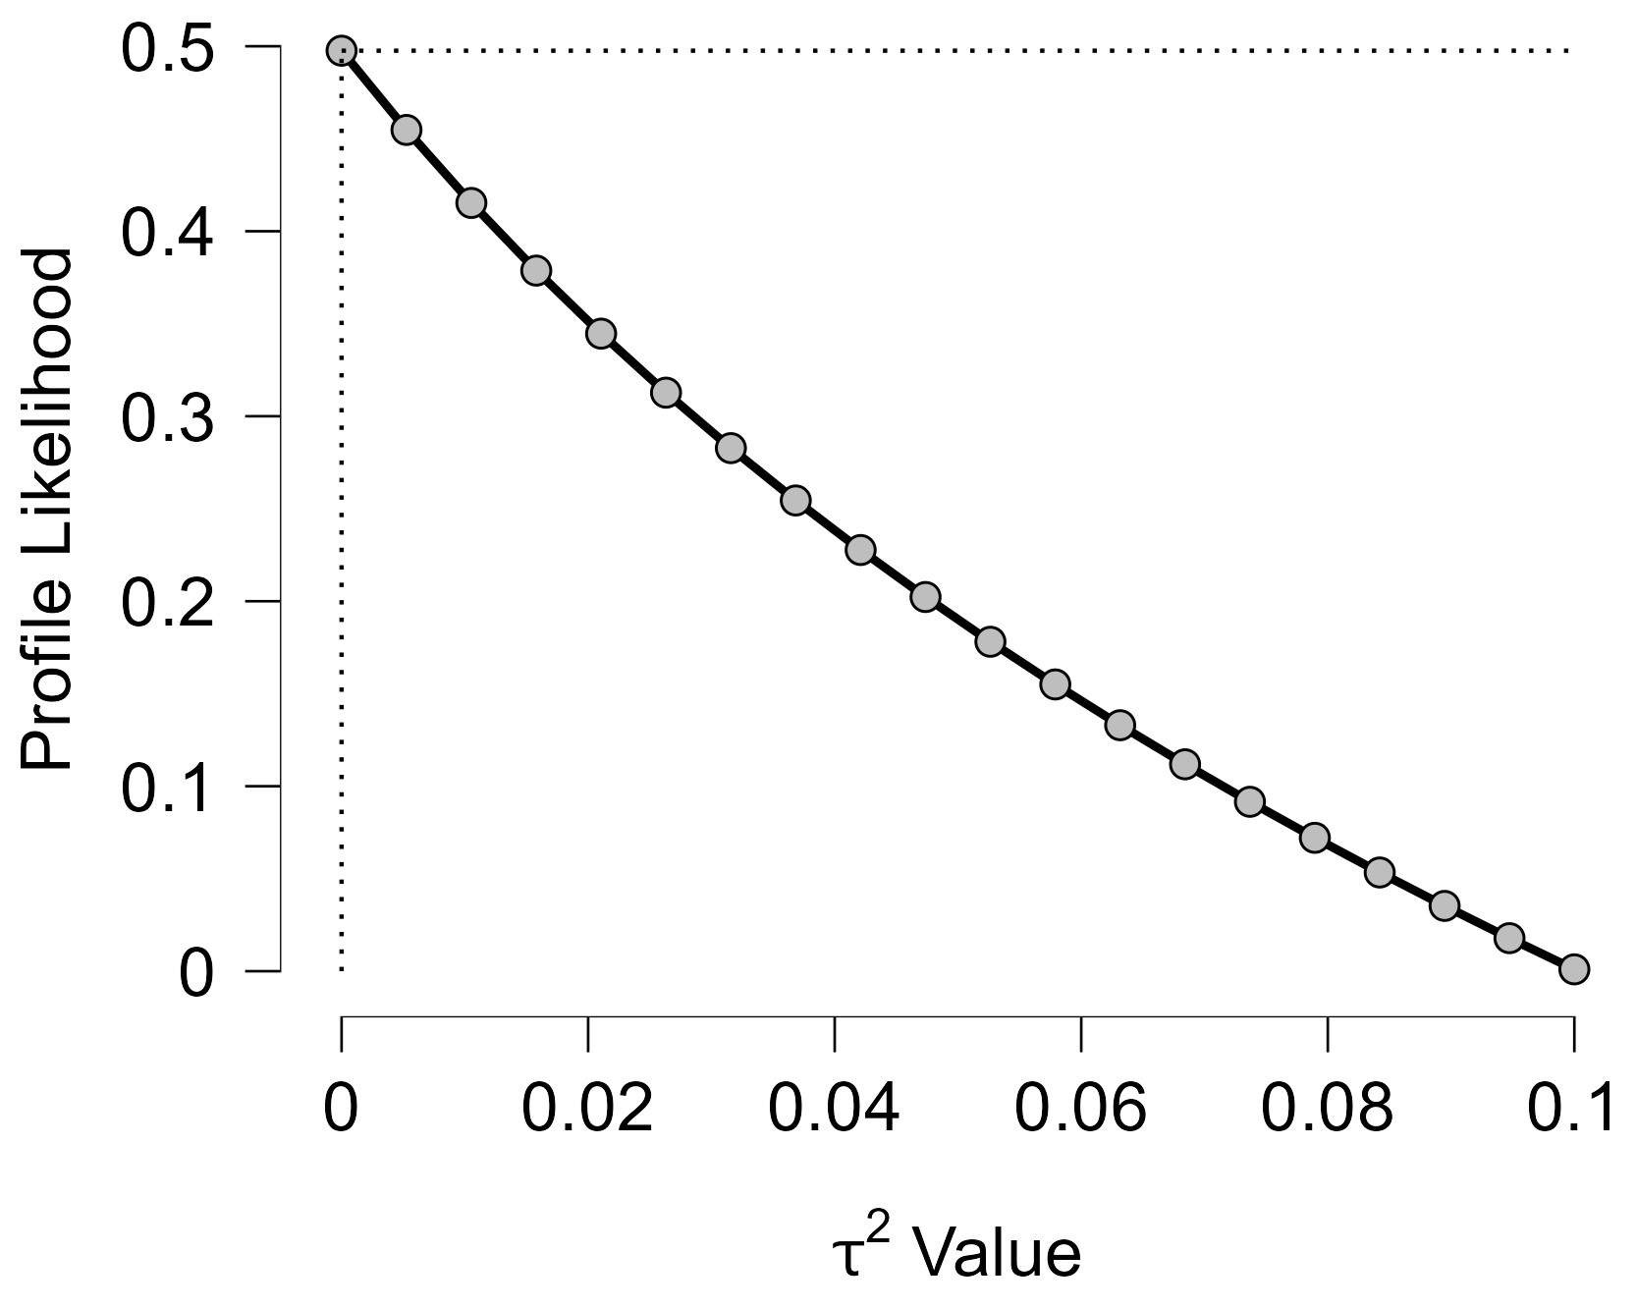
Figure 91 Profile Likelihood- Former TCAs Users Group 2

The x-axis shows candidate values of the heterogeneity variance $τ^{2}$, and the y-axis shows the corresponding standardized profile likelihood, which has been scaled so that the maximum value equals 1 at $τ^{2}=0$.
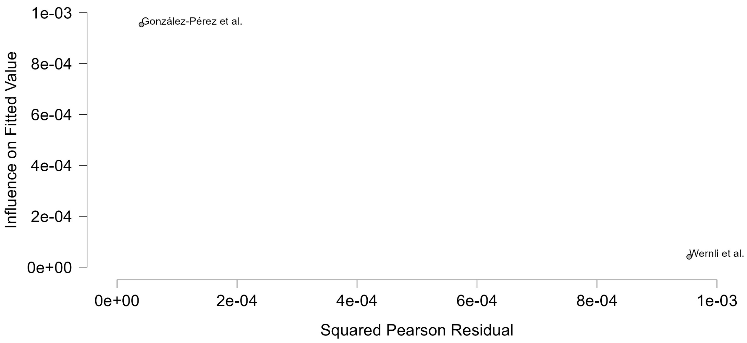
Figure 92 Baujat plot- Former TCAs Users Group 2

The Baujat plot visualises each study's contribution to the Q-statistic for heterogeneity on the x-axis (squared Pearson residual) against its influence on the pooled effect on the y-axis (standardized squared difference in fixed-effects estimates with/without the study). Studies in the top-right quadrant drive both heterogeneity and effect variation, signalling candidates for sensitivity analysis; bottom-left points have minimal impact.

Cumulative Duration TCAs Treatment Less Than 2 Years
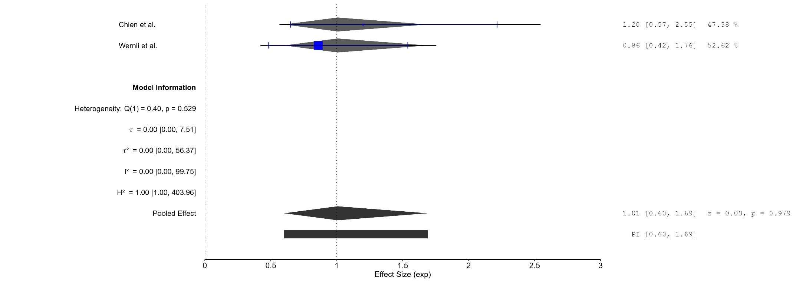
Figure 93 Forest plot - Cumulative Duration TCAs Treatment Less Than 2 Years

The area of each square is proportional to the sample size of the respective study, with horizontal lines through the squares representing the 95% confidence interval (C.I.) for that study. In the pooled analysis, the diamond symbol represents the pooled estimate, with the right and left points of the diamond indicating the 95% C.I. for the overall analysis
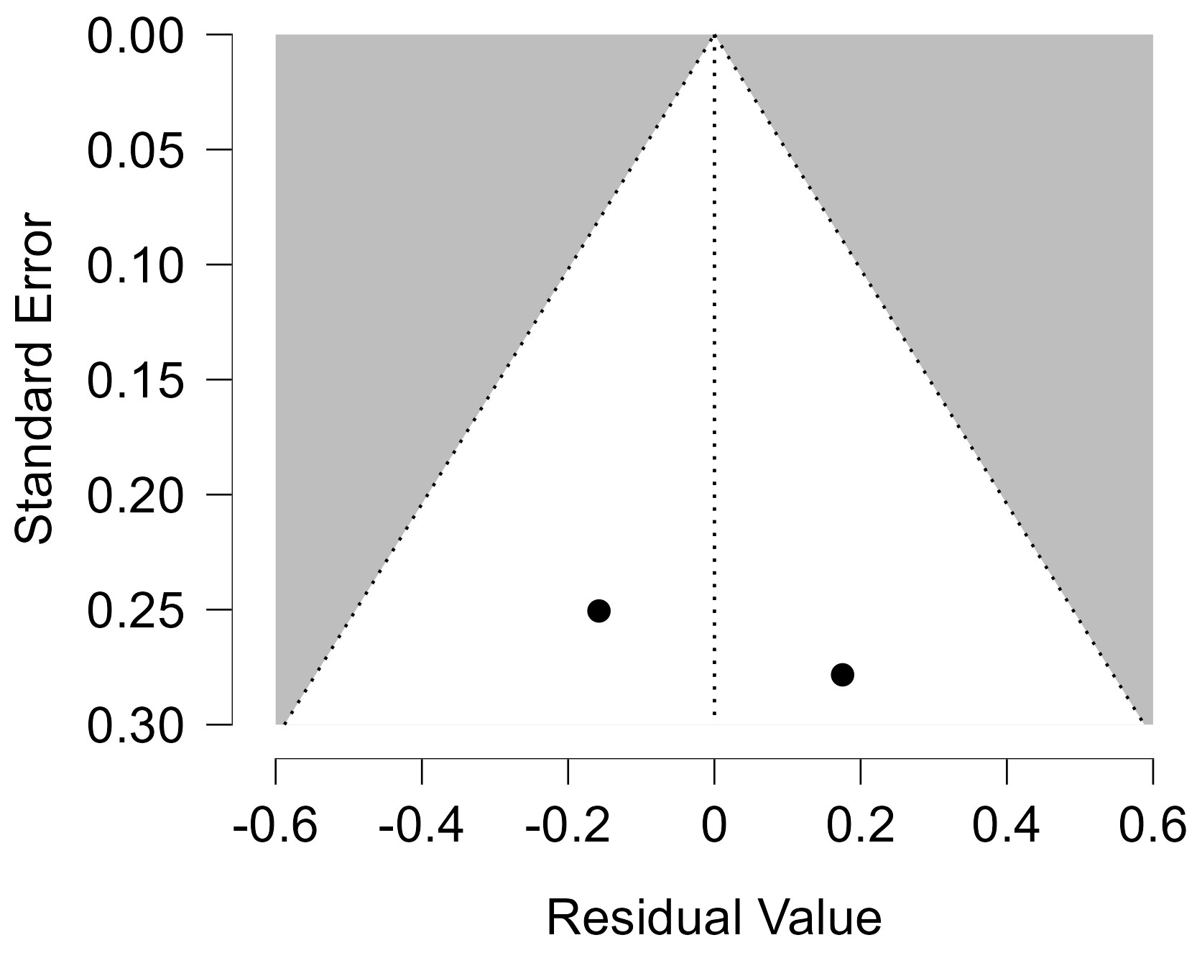
Figure 94 Funnel plot - Cumulative Duration TCAs Treatment Less Than 2 Years

Each blue dot represents a single study, plotted with its effect size on the x-axis and its standard error on the y-axis. The vertical red line represents the overall effect estimate derived from the random-effects model using restricted maximum likelihood (REML). The pseudo 95% confidence interval region, shown as gray diagonal lines, outlines the expected spread of studies in the absence of bias or between-study heterogeneity.
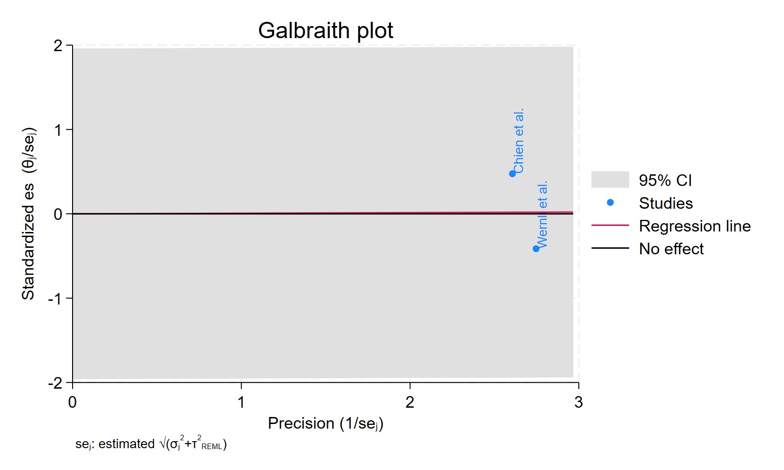
Figure 95 Galbraith plot - Cumulative Duration TCAs Treatment Less Than 2 Years

Each study is represented as a point, where the x-axis denotes the precision (defined as the inverse of the standard error), and the y-axis indicates the standardized effect size. The red regression line represents the overall summary effect estimated from the random-effects model, and the gray shaded area corresponds to the confidence interval at 95% around regression line. The horizontal black ––line at y = 0 corresponds to the line of no effect, serving as a reference.
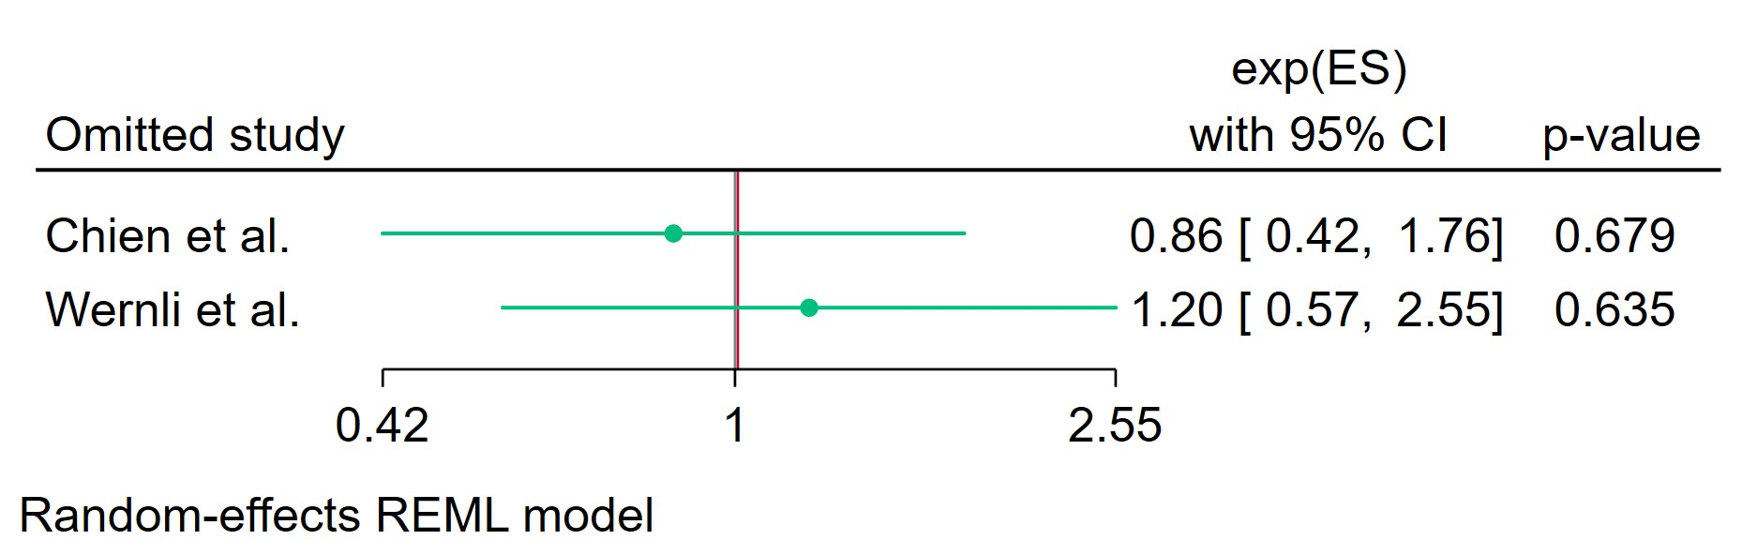
Figure 96 Leave-one-out - Cumulative Duration TCAs Treatment Less Than 2 Years
Leave-one-out (LOO) analysis assesses meta-analysis robustness by iteratively excluding one study at a time and refitting the model to observe shifts in the pooled effect size, confidence interval, and heterogeneity

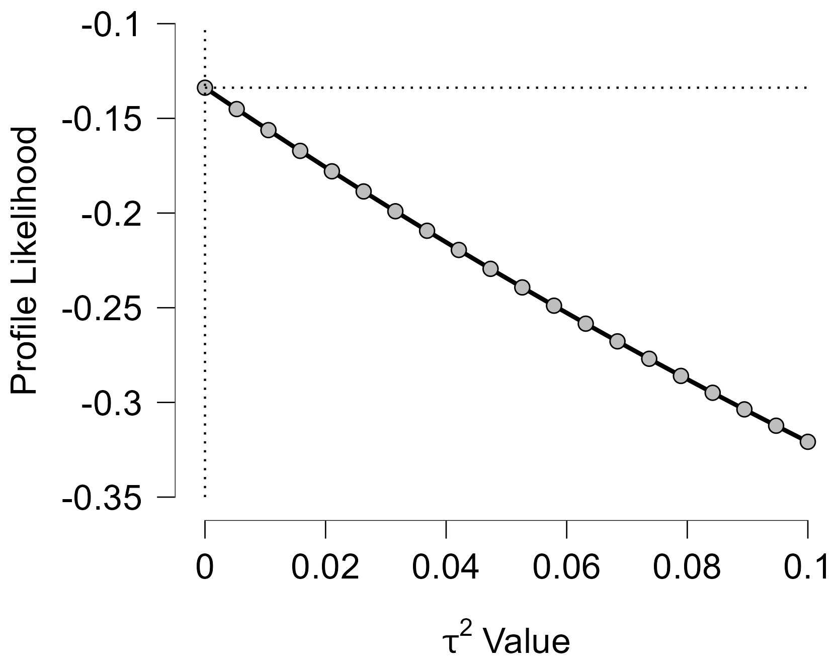
Figure 97 Profile Likelihood- Cumulative Duration TCAs Treatment Less Than 2 Years
The x-axis shows candidate values of the heterogeneity variance $τ^{2}$, and the y-axis shows the corresponding standardized profile likelihood, which has been scaled so that the maximum value equals 1 at $τ^{2}=0$.
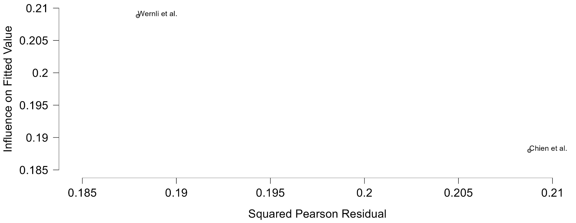
Figure 98 Baujat plot- Cumulative Duration TCAs Treatment Less Than 2 Years

The Baujat plot visualises each study's contribution to the Q-statistic for heterogeneity on the x-axis (squared Pearson residual) against its influence on the pooled effect on the y-axis (standardized squared difference in fixed-effects estimates with/without the study). Studies in the top-right quadrant drive both heterogeneity and effect variation, signalling candidates for sensitivity analysis; bottom-left points have minimal impact.

Cumulative Duration TCAs Treatment 0-1 Year
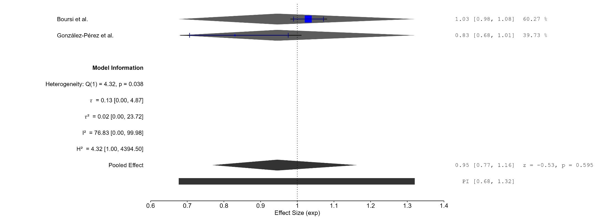
Figure 99 Forest plot - Cumulative Duration TCAs Treatment 0-1 Year

The area of each square is proportional to the sample size of the respective study, with horizontal lines through the squares representing the 95% confidence interval (C.I.) for that study. In the pooled analysis, the diamond symbol represents the pooled estimate, with the right and left points of the diamond indicating the 95% C.I. for the overall analysis
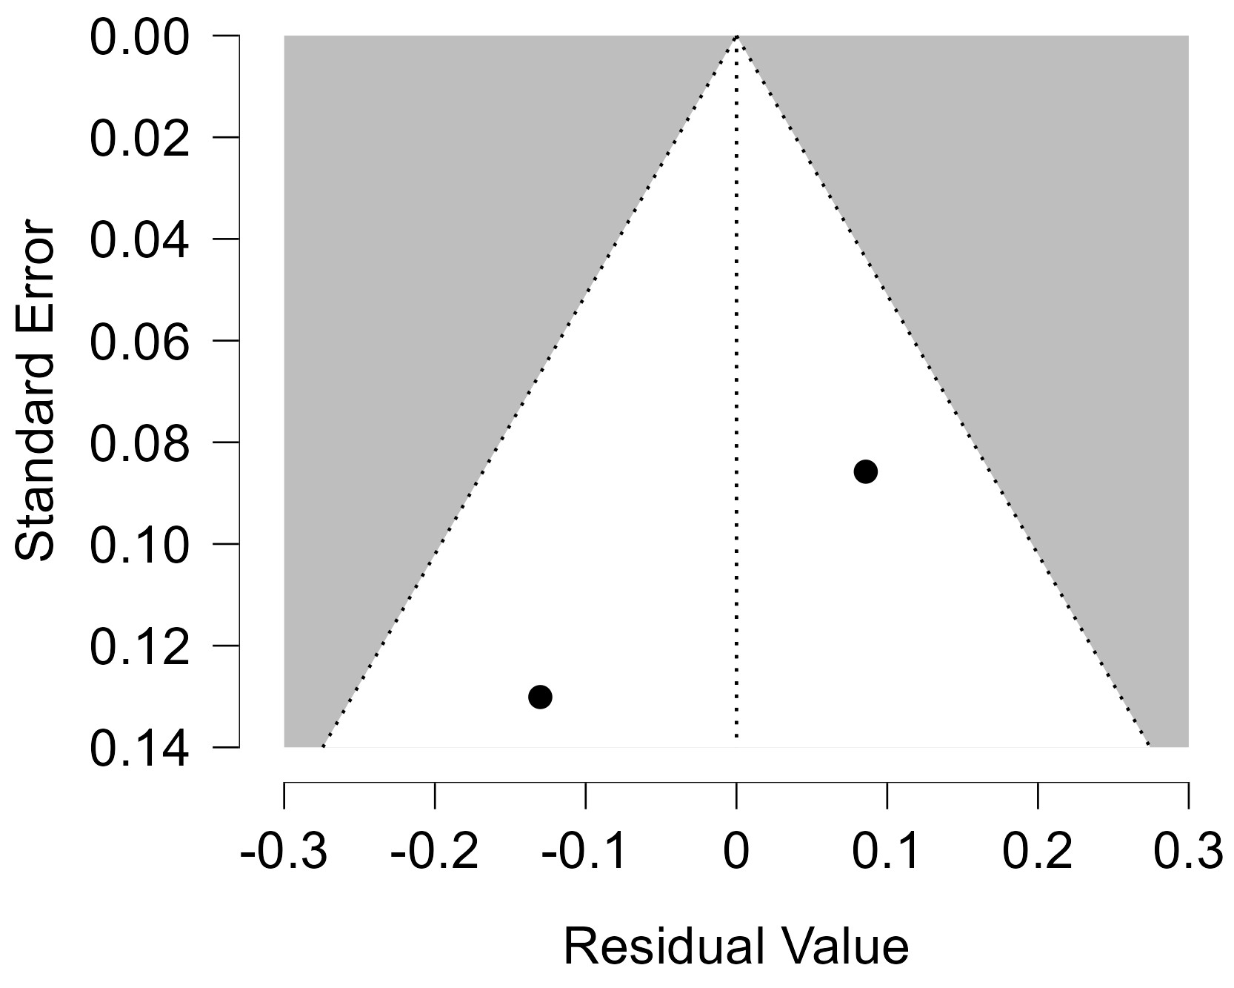
Figure 100 Funnel plot - Cumulative Duration TCAs Treatment 0-1 Year

Each blue dot represents a single study, plotted with its effect size on the x-axis and its standard error on the y-axis. The vertical red line represents the overall effect estimate derived from the random-effects model using restricted maximum likelihood (REML). The pseudo 95% confidence interval region, shown as gray diagonal lines, outlines the expected spread of studies in the absence of bias or between-study heterogeneity.
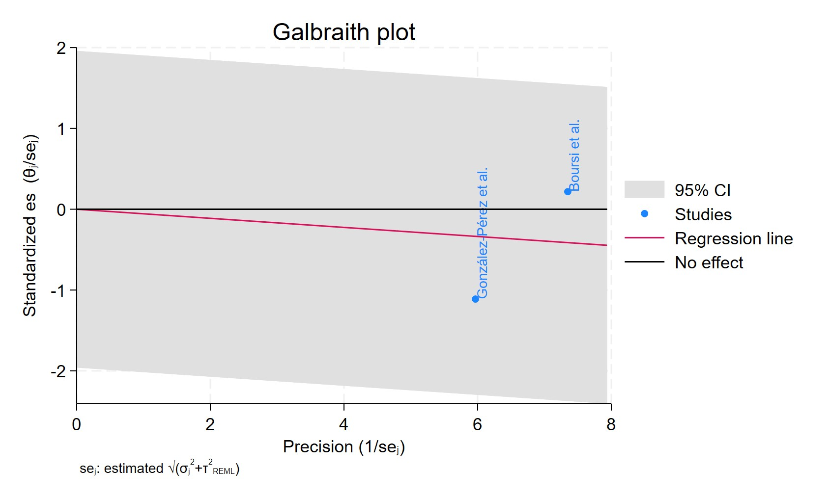
Figure 101 Galbraith plot - Cumulative Duration TCAs Treatment 0-1 Year

Each study is represented as a point, where the x-axis denotes the precision (defined as the inverse of the standard error), and the y-axis indicates the standardized effect size. The red regression line represents the overall summary effect estimated from the random-effects model, and the gray shaded area corresponds to the confidence interval at 95% around regression line. The horizontal black ––line at y = 0 corresponds to the line of no effect, serving as a reference.
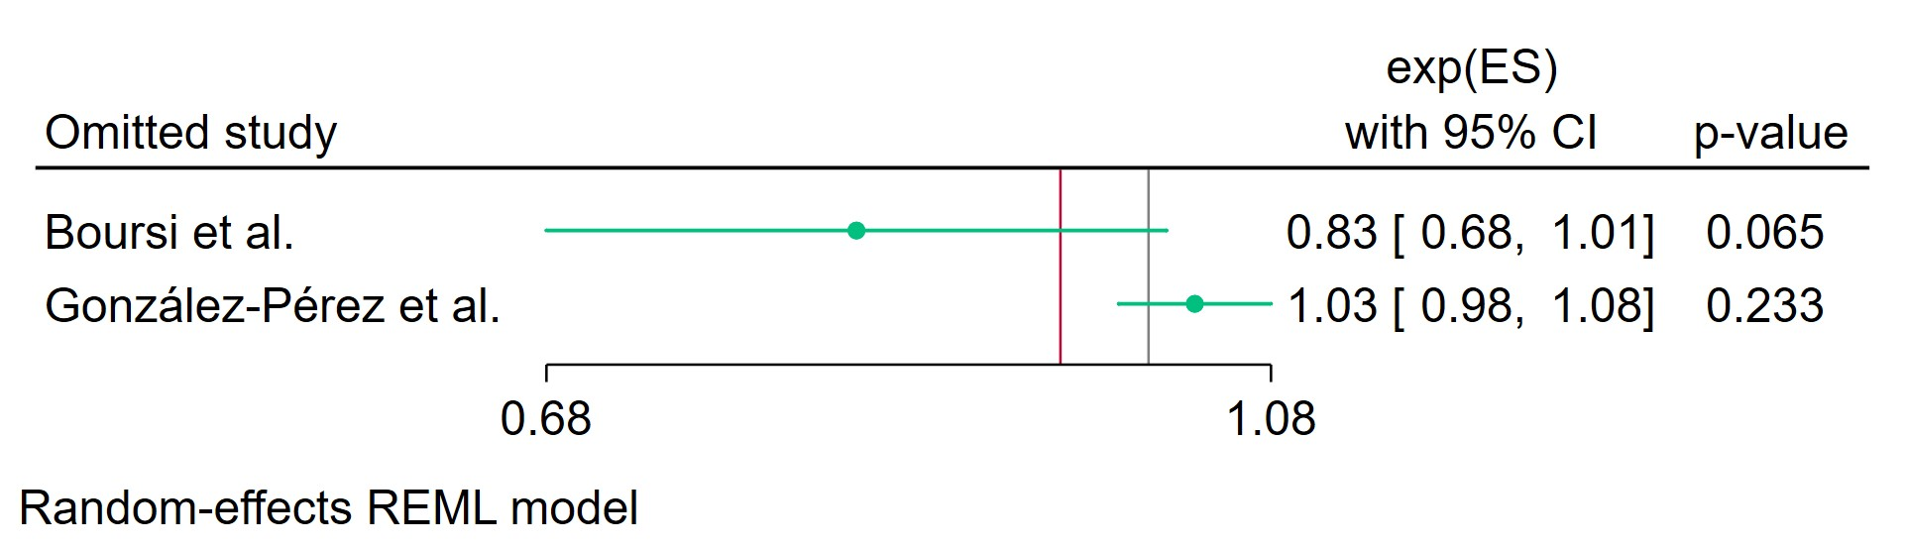
Figure 102 Leave-one-out - Cumulative Duration TCAs Treatment 0-1 Year
Leave-one-out (LOO) analysis assesses meta-analysis robustness by iteratively excluding one study at a time and refitting the model to observe shifts in the pooled effect size, confidence interval, and heterogeneity
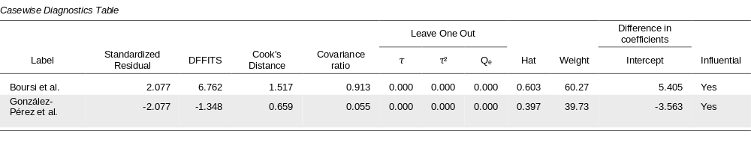
Figure 103 Casewise diagnostics- Cumulative Duration TCAs Treatment 0-1 Year

Casewise diagnostics evaluate individual study influence in meta-analysis by computing standardized residuals, leverage (Hat values), and global influence measures like DFFITS, Cook's distance, and covariance ratios.​
Leave-one-out (LOO) analyses refit the model after sequentially omitting each study, quantifying changes in key parameters (e.g., $τ$, $τ^{2}$, $Q_{e}$, pooled effect) to assess sensitivity to individual observations.​
Studies exceeding conventional thresholds (e.g., Cook's distance >1, |DFFITS| >1, |standardized residual| >2) are flagged as influential, guiding decisions on robustness or exclusion.
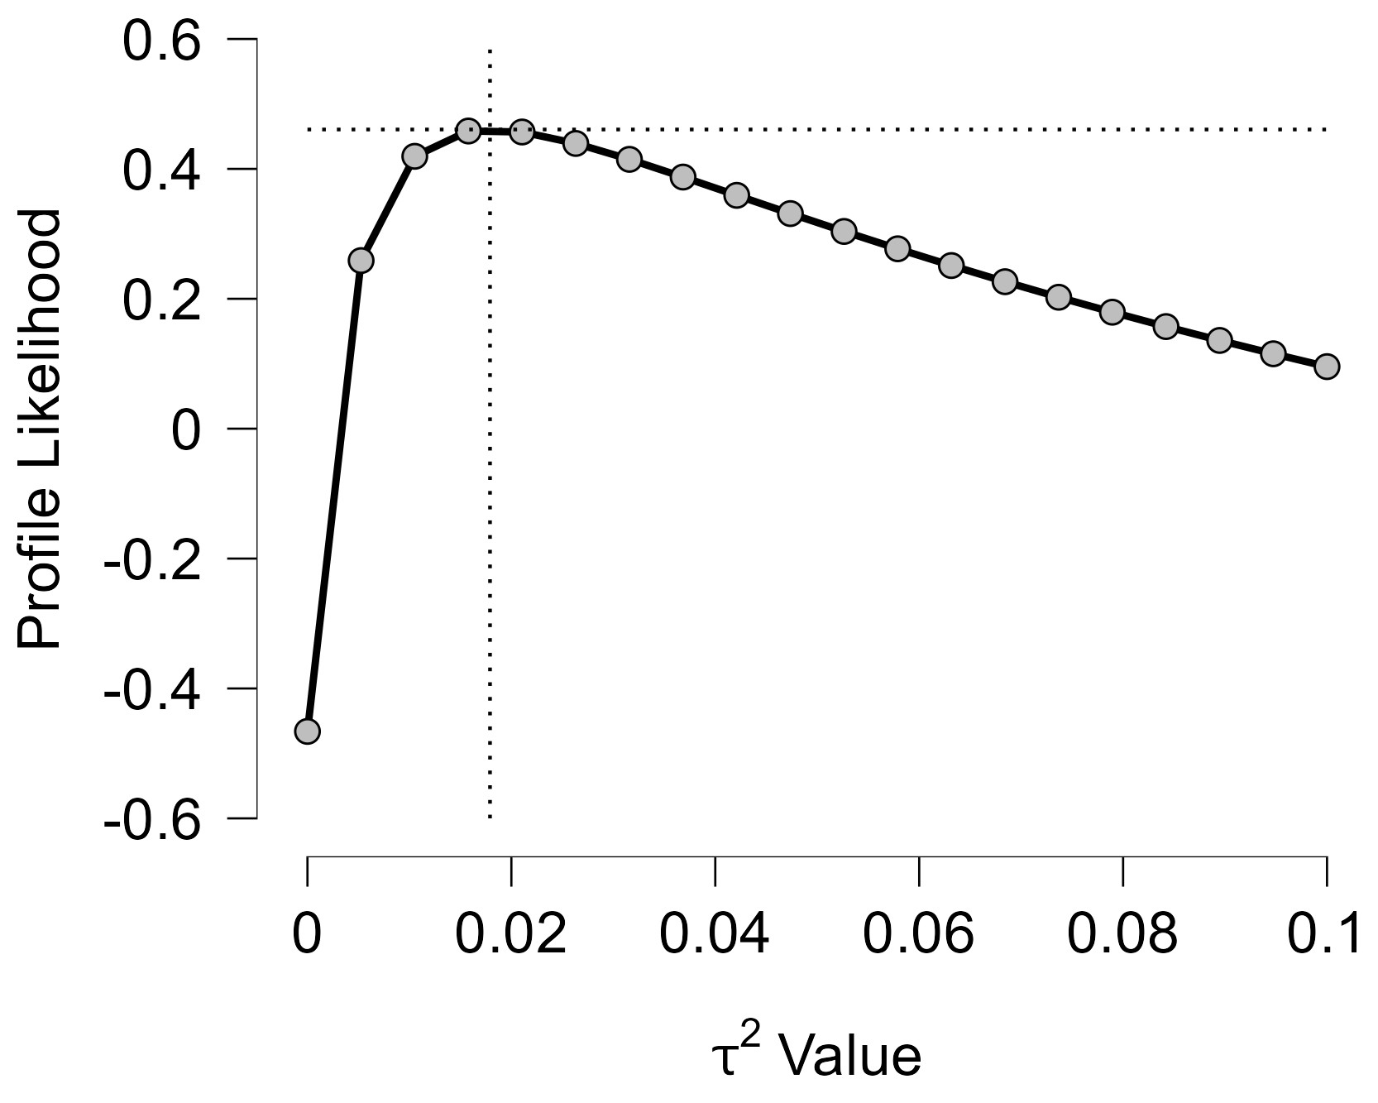
Figure 104 Profile Likelihood- Cumulative Duration TCAs Treatment 0-1 Year

The x-axis shows candidate values of the heterogeneity variance $τ^{2}$, and the y-axis shows the corresponding standardized profile likelihood, which has been scaled so that the maximum value equals 1 at $τ^{2}=0$.
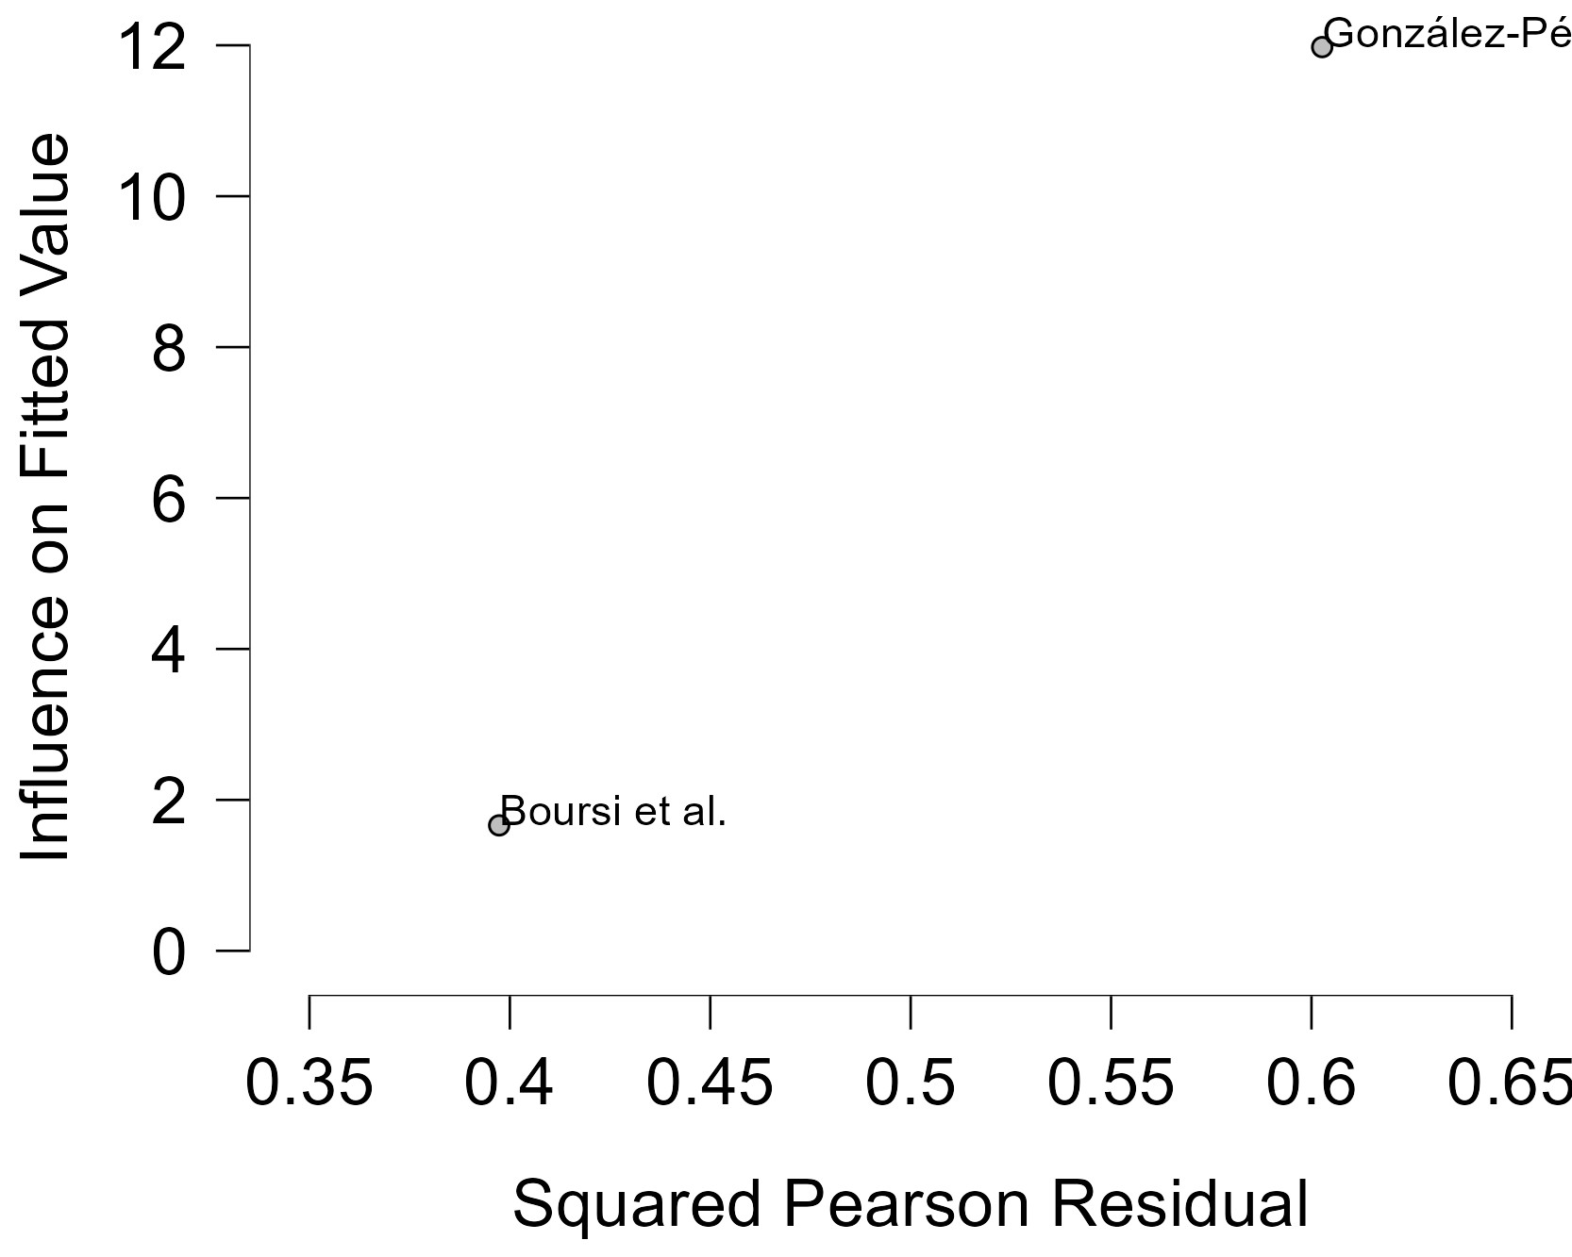
Figure 105 Baujat plot - Cumulative Duration TCAs Treatment 0-1 Year

The Baujat plot visualises each study's contribution to the Q-statistic for heterogeneity on the x-axis (squared Pearson residual) against its influence on the pooled effect on the y-axis (standardized squared difference in fixed-effects estimates with/without the study). Studies in the top-right quadrant drive both heterogeneity and effect variation, signalling candidates for sensitivity analysis; bottom-left points have minimal impact.

Cumulative Duration TCAs Treatment 1-3 Years
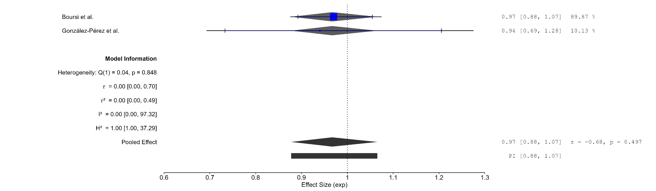
Figure 106 Forest plot - Cumulative Duration TCAs Treatment 1-3 Years

The area of each square is proportional to the sample size of the respective study, with horizontal lines through the squares representing the 95% confidence interval (C.I.) for that study. In the pooled analysis, the diamond symbol represents the pooled estimate, with the right and left points of the diamond indicating the 95% C.I. for the overall analysis
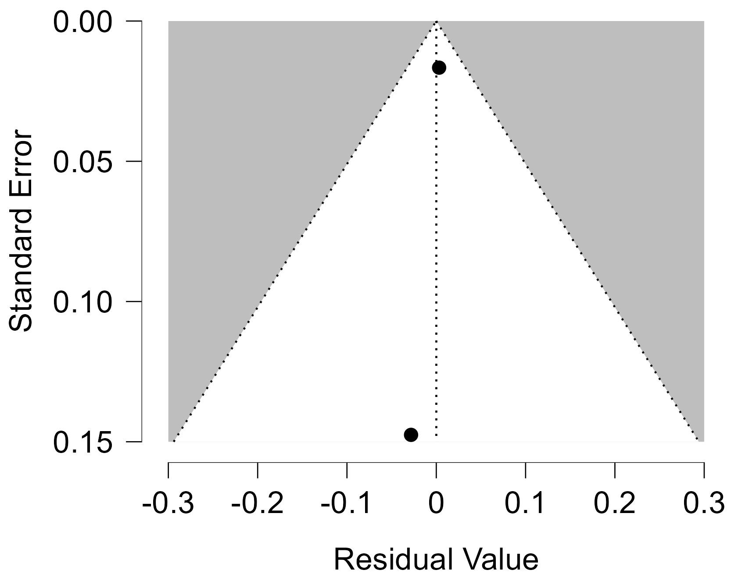
Figure 107 Funnel plot - Cumulative Duration TCAs Treatment 1-3 Years

Each blue dot represents a single study, plotted with its effect size on the x-axis and its standard error on the y-axis. The vertical red line represents the overall effect estimate derived from the random-effects model using restricted maximum likelihood (REML). The pseudo 95% confidence interval region, shown as gray diagonal lines, outlines the expected spread of studies in the absence of bias or between-study heterogeneity.
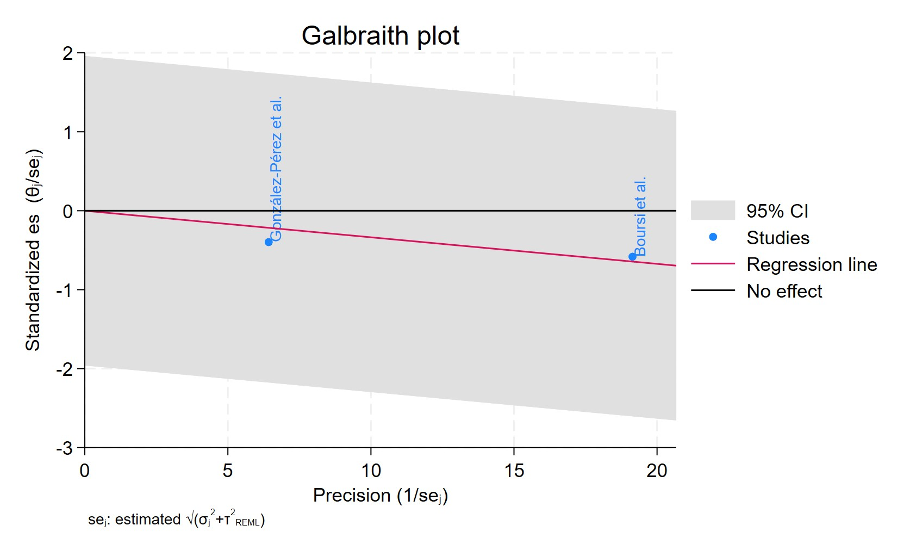
Figure 108 Galbraith plot - Cumulative Duration TCAs Treatment 1-3 Years

Each study is represented as a point, where the x-axis denotes the precision (defined as the inverse of the standard error), and the y-axis indicates the standardized effect size. The red regression line represents the overall summary effect estimated from the random-effects model, and the gray shaded area corresponds to the confidence interval at 95% around regression line. The horizontal black ––line at y = 0 corresponds to the line of no effect, serving as a reference.
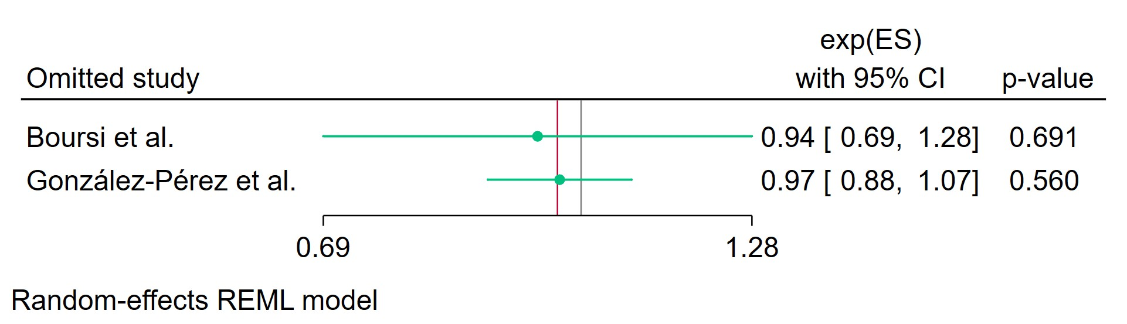
Figure 109 Leave-one-out - Cumulative Duration TCAs Treatment 1-3 Years
Leave-one-out (LOO) analysis assesses meta-analysis robustness by iteratively excluding one study at a time and refitting the model to observe shifts in the pooled effect size, confidence interval, and heterogeneity

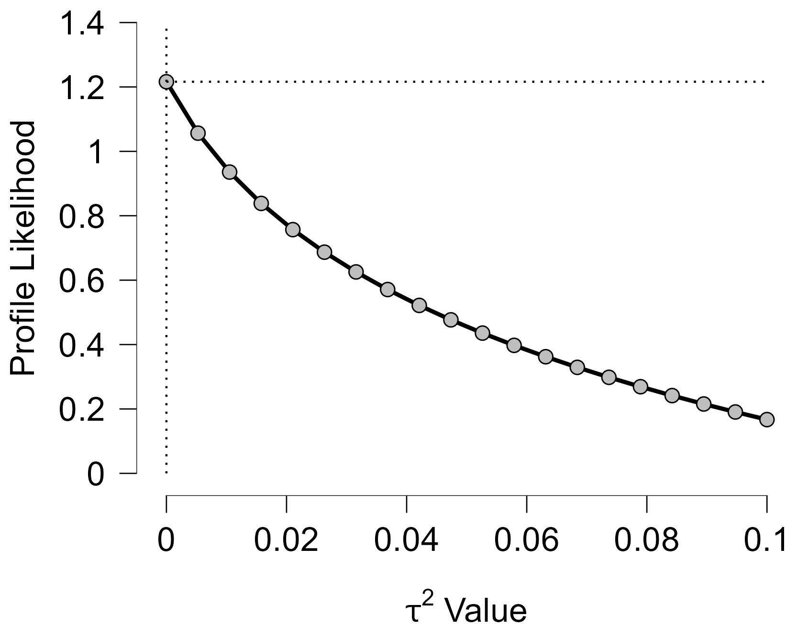
Figure 110 Profile Likelihood- Cumulative Duration TCAs Treatment 1-3 Years

The x-axis shows candidate values of the heterogeneity variance $τ^{2}$, and the y-axis shows the corresponding standardized profile likelihood, which has been scaled so that the maximum value equals 1 at $τ^{2}=0$.
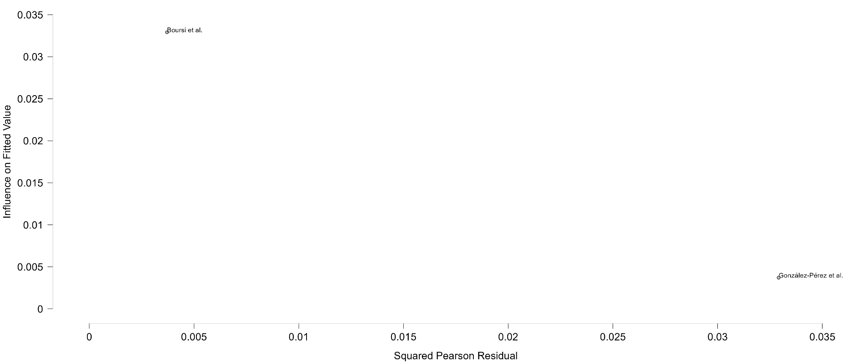
Figure 111 Baujat plot - Cumulative Duration TCAs Treatment 1-3 Years
The Baujat plot visualises each study's contribution to the Q-statistic for heterogeneity on the x-axis (squared Pearson residual) against its influence on the pooled effect on the y-axis (standardized squared difference in fixed-effects estimates with/without the study). Studies in the top-right quadrant drive both heterogeneity and effect variation, signalling candidates for sensitivity analysis; bottom-left points have minimal impact.

Cumulative Duration TCAs Treatment Superior To 3 Years
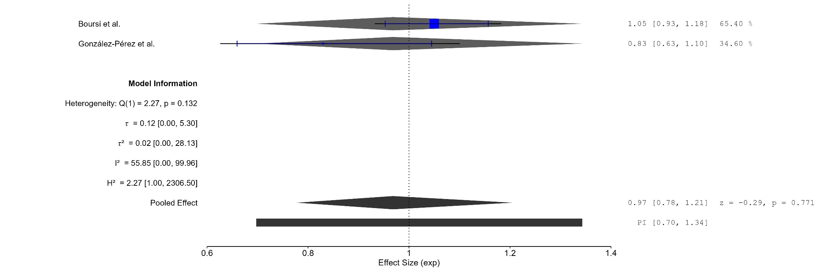
Figure 112 Forest plot - Cumulative Duration TCAs Treatment Superior To 3 Years

The area of each square is proportional to the sample size of the respective study, with horizontal lines through the squares representing the 95% confidence interval (C.I.) for that study. In the pooled analysis, the diamond symbol represents the pooled estimate, with the right and left points of the diamond indicating the 95% C.I. for the overall analysis
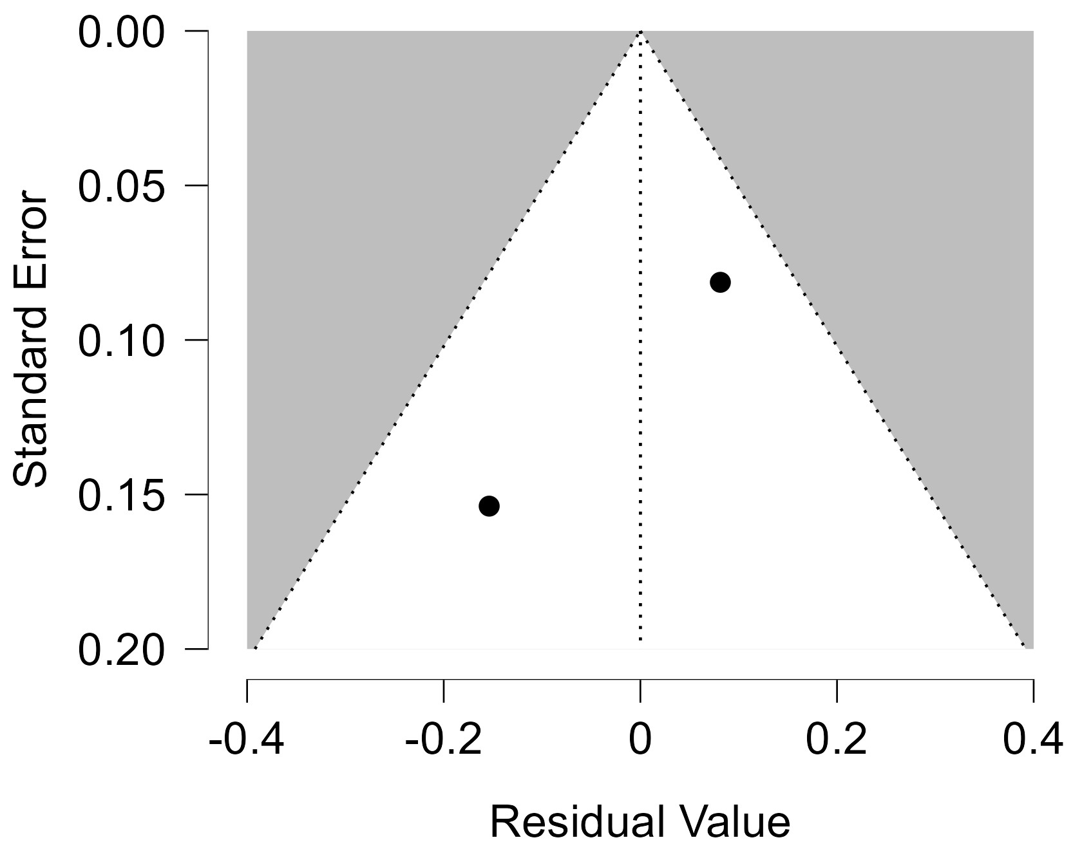
Figure 113 Funnel plot - Cumulative Duration TCAs Treatment Superior To 3 Years

Each blue dot represents a single study, plotted with its effect size on the x-axis and its standard error on the y-axis. The vertical red line represents the overall effect estimate derived from the random-effects model using restricted maximum likelihood (REML). The pseudo 95% confidence interval region, shown as gray diagonal lines, outlines the expected spread of studies in the absence of bias or between-study heterogeneity.
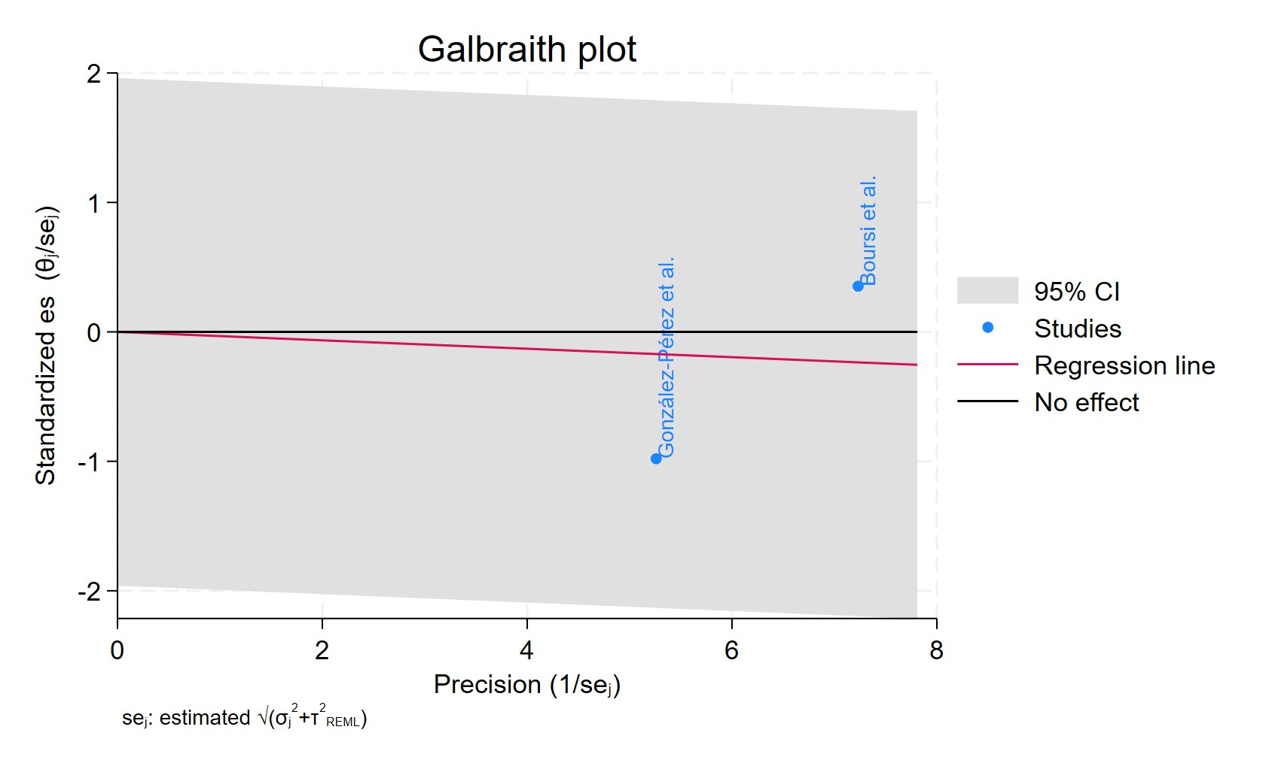
Figure 114 Galbraith plot - Cumulative Duration TCAs Treatment Superior To 3 Years

Each study is represented as a point, where the x-axis denotes the precision (defined as the inverse of the standard error), and the y-axis indicates the standardized effect size. The red regression line represents the overall summary effect estimated from the random-effects model, and the gray shaded area corresponds to the confidence interval at 95% around regression line. The horizontal black ––line at y = 0 corresponds to the line of no effect, serving as a reference.
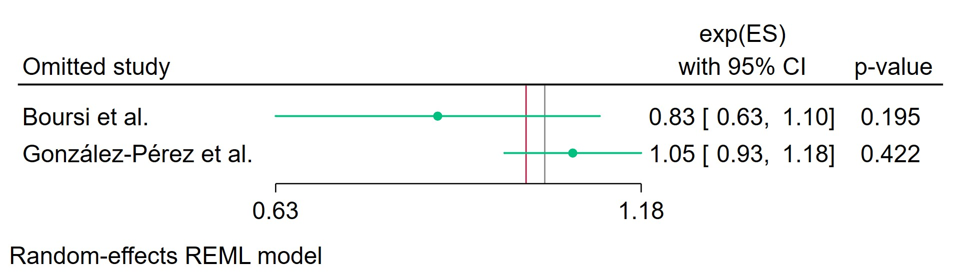
Figure 115 Leave-one-out - Cumulative Duration TCAs Treatment Superior To 3 Years

Leave-one-out (LOO) analysis assesses meta-analysis robustness by iteratively excluding one study at a time and refitting the model to observe shifts in the pooled effect size, confidence interval, and heterogeneity
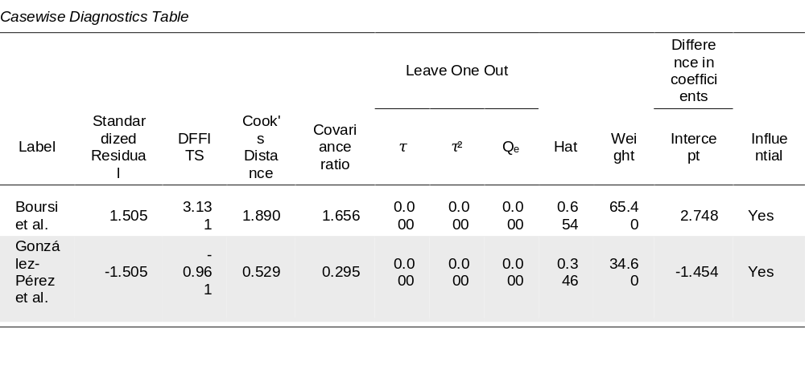
Figure 116 Casewise diagnostics- Cumulative Duration TCAs Treatment Superior To 3 Years
Casewise diagnostics evaluate individual study influence in meta-analysis by computing standardized residuals, leverage (Hat values), and global influence measures like DFFITS, Cook's distance, and covariance ratios.​
Leave-one-out (LOO) analyses refit the model after sequentially omitting each study, quantifying changes in key parameters (e.g., $τ$, $τ^{2}$, $Q_{e}$, pooled effect) to assess sensitivity to individual observations.​
Studies exceeding conventional thresholds (e.g., Cook's distance >1, |DFFITS| >1, |standardized residual| >2) are flagged as influential, guiding decisions on robustness or exclusion.
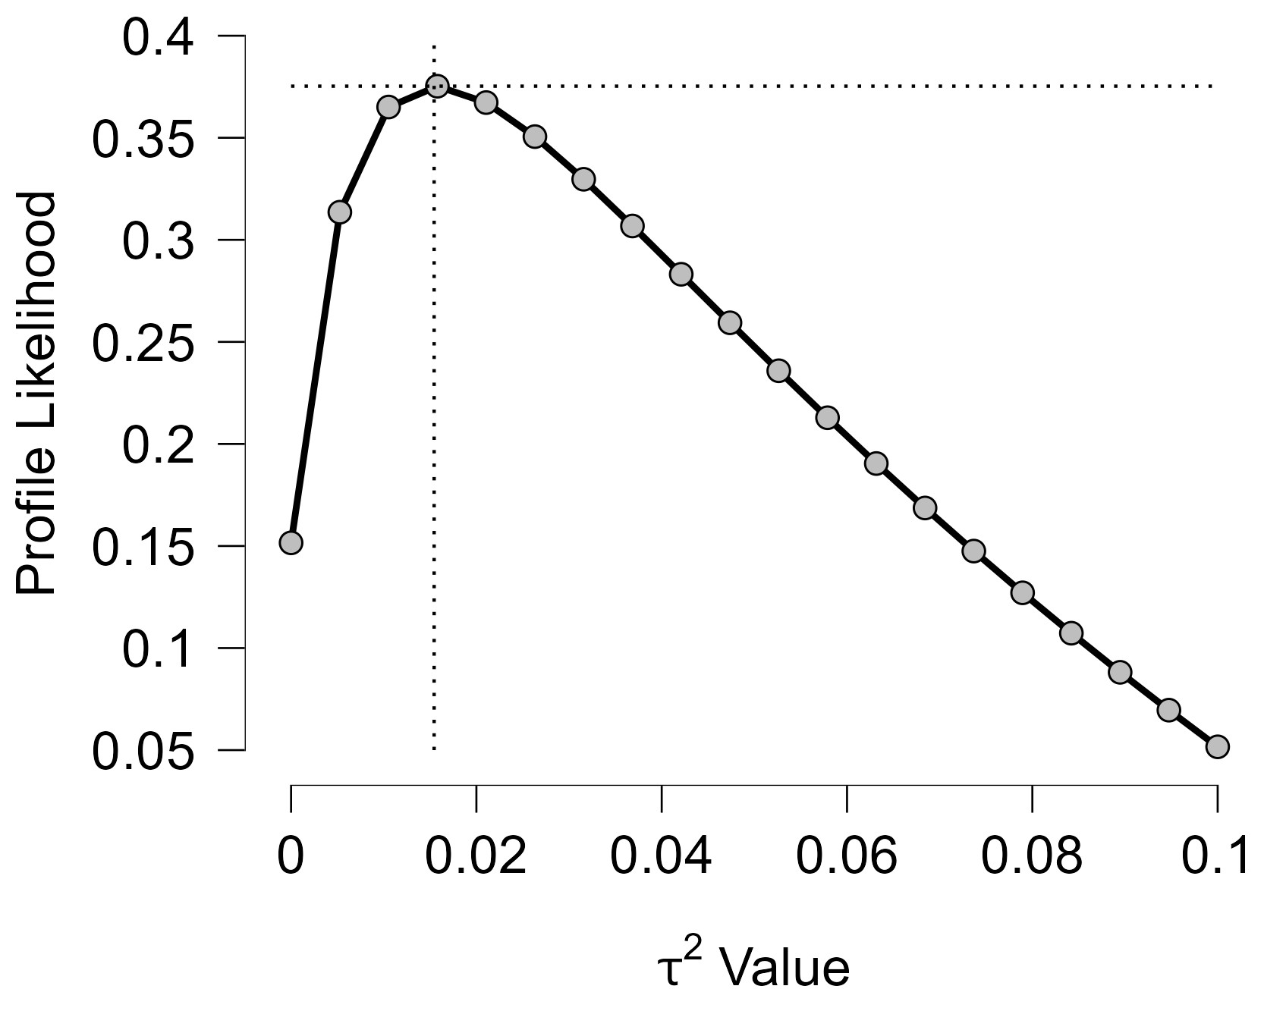
Figure 117 Profile Likelihood- Cumulative Duration TCAs Treatment Superior To 3 Years
The x-axis shows candidate values of the heterogeneity variance $τ^{2}$, and the y-axis shows the corresponding standardized profile likelihood, which has been scaled so that the maximum value equals 1 at $τ^{2}=0$.
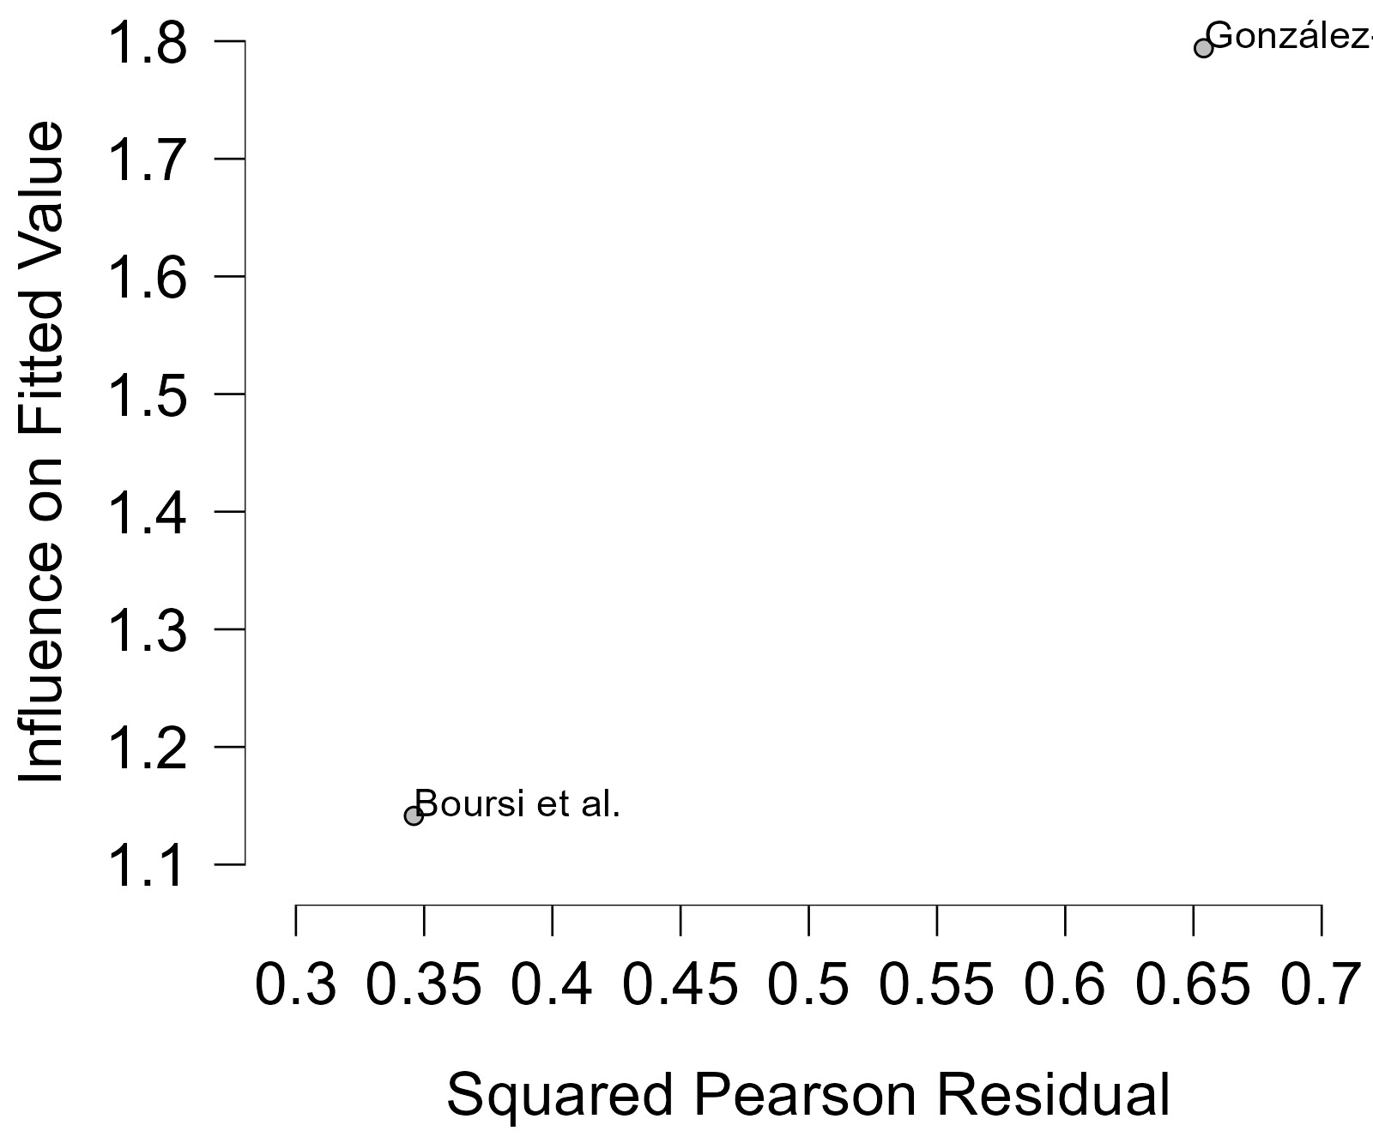
Figure 118 Baujat plot- Cumulative Duration TCAs Treatment Superior To 3 Years

The Baujat plot visualises each study's contribution to the Q-statistic for heterogeneity on the x-axis (squared Pearson residual) against its influence on the pooled effect on the y-axis (standardized squared difference in fixed-effects estimates with/without the study). Studies in the top-right quadrant drive both heterogeneity and effect variation, signalling candidates for sensitivity analysis; bottom-left points have minimal impact.

Cumulative Duration ADs Treatment Less Than 2 Years
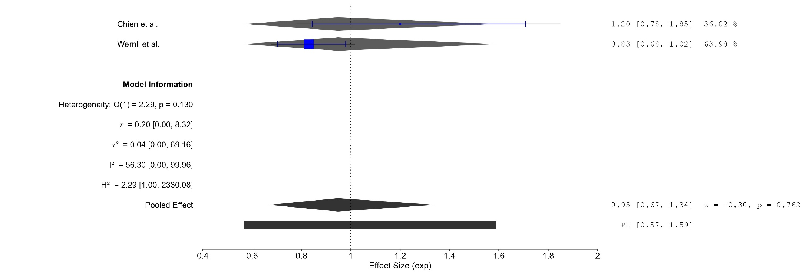
Figure 119 Forest plot - Cumulative Duration ADs Treatment Less Than 2 Years

The area of each square is proportional to the sample size of the respective study, with horizontal lines through the squares representing the 95% confidence interval (C.I.) for that study. In the pooled analysis, the diamond symbol represents the pooled estimate, with the right and left points of the diamond indicating the 95% C.I. for the overall analysis
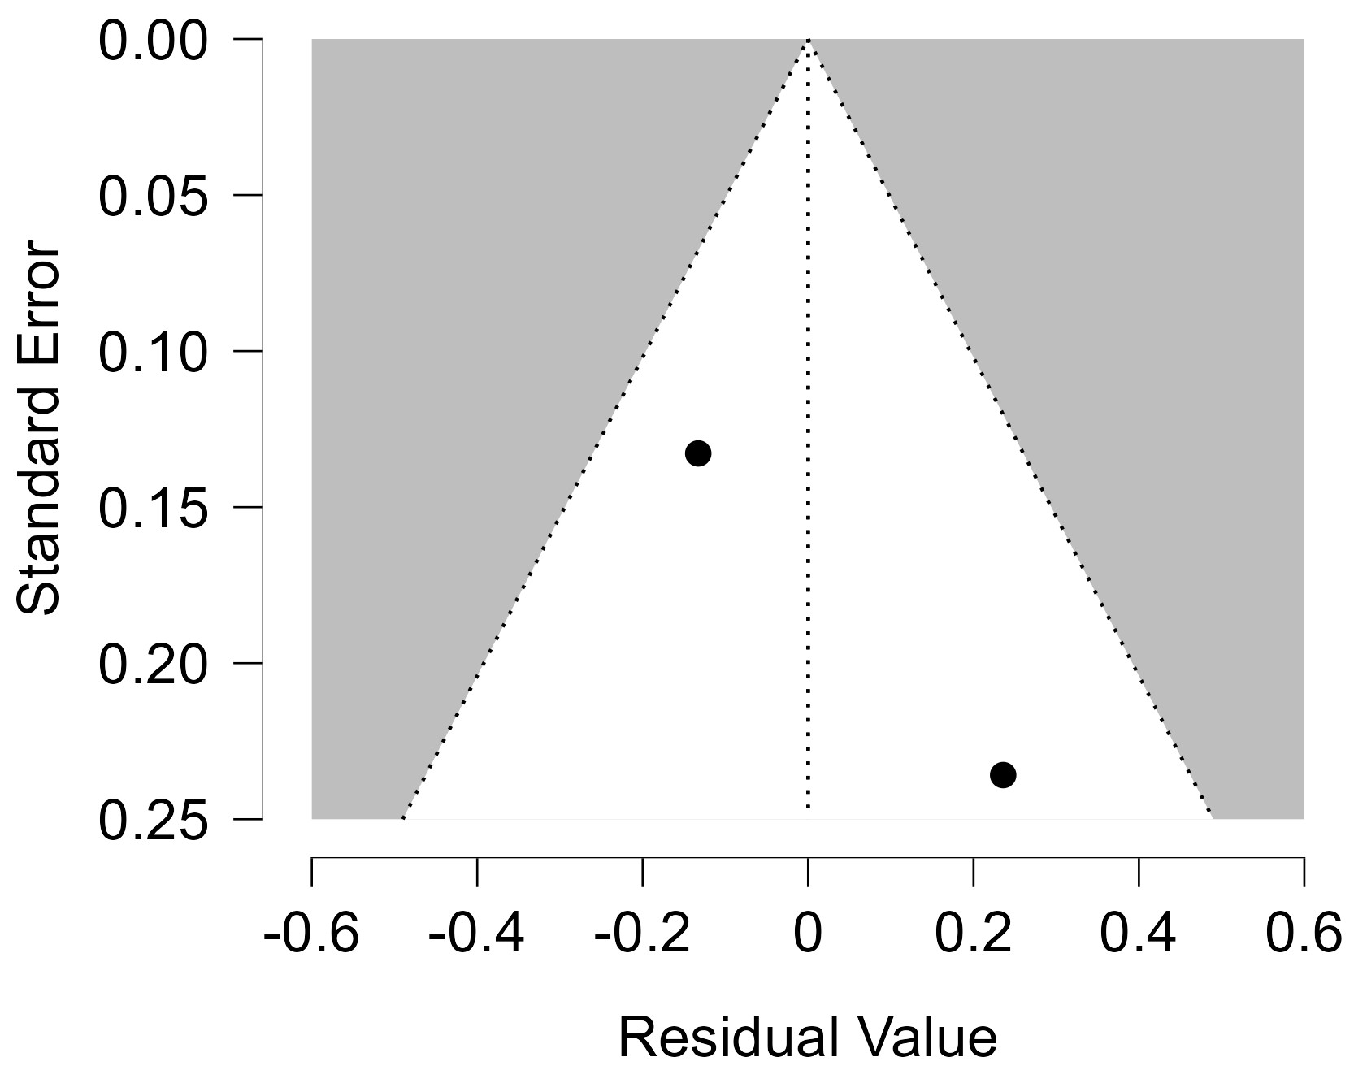
Figure 120 Funnel plot - Cumulative Duration ADs Treatment Less Than 2 Years

Each blue dot represents a single study, plotted with its effect size on the x-axis and its standard error on the y-axis. The vertical red line represents the overall effect estimate derived from the random-effects model using restricted maximum likelihood (REML). The pseudo 95% confidence interval region, shown as gray diagonal lines, outlines the expected spread of studies in the absence of bias or between-study heterogeneity.
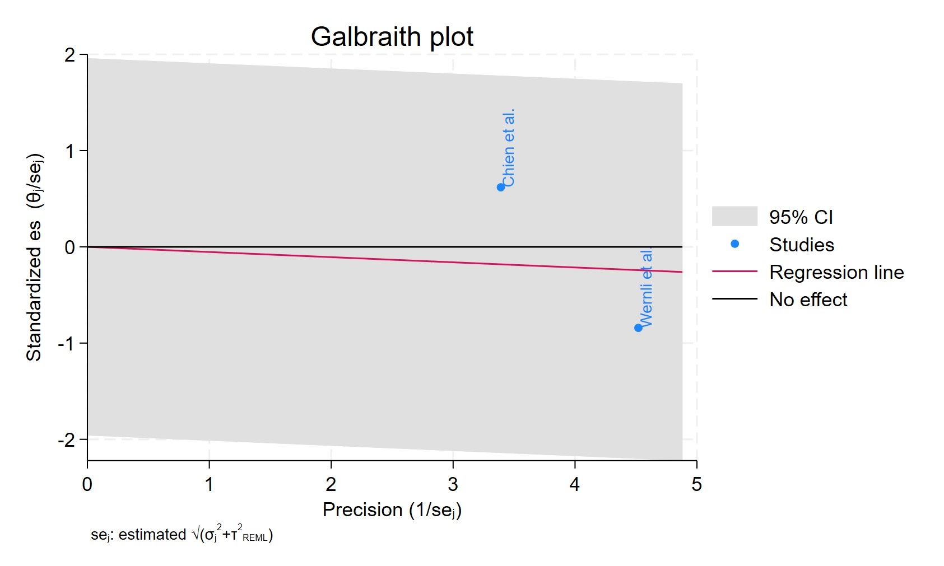
Figure 121 Galbraith plot - Cumulative Duration ADs Treatment Less Than 2 Years

Each study is represented as a point, where the x-axis denotes the precision (defined as the inverse of the standard error), and the y-axis indicates the standardized effect size. The red regression line represents the overall summary effect estimated from the random-effects model, and the gray shaded area corresponds to the confidence interval at 95% around regression line. The horizontal black ––line at y = 0 corresponds to the line of no effect, serving as a reference.
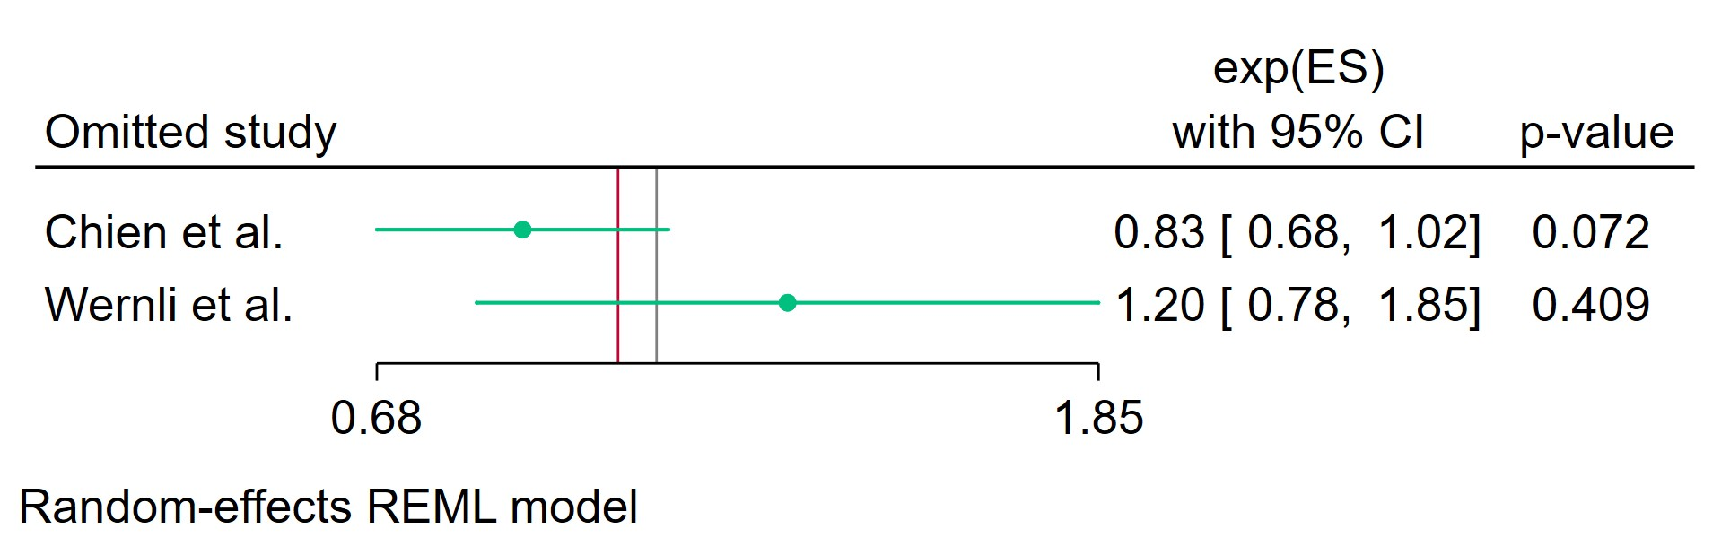
Figure 122 Leave-one-out - Cumulative Duration ADs Treatment Less Than 2 Years

Leave-one-out (LOO) analysis assesses meta-analysis robustness by iteratively excluding one study at a time and refitting the model to observe shifts in the pooled effect size, confidence interval, and heterogeneity

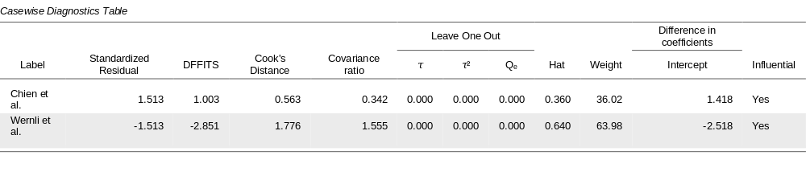
Figure 123 Casewise diagnostics- Cumulative Duration ADs Treatment Less Than 2 Years
Casewise diagnostics evaluate individual study influence in meta-analysis by computing standardized residuals, leverage (Hat values), and global influence measures like DFFITS, Cook's distance, and covariance ratios.​
Leave-one-out (LOO) analyses refit the model after sequentially omitting each study, quantifying changes in key parameters (e.g., $τ$, $τ^{2}$, $Q_{e}$, pooled effect) to assess sensitivity to individual observations.​
Studies exceeding conventional thresholds (e.g., Cook's distance >1, |DFFITS| >1, |standardized residual| >2) are flagged as influential, guiding decisions on robustness or exclusion.
Figure 124 Profile Likelihood- Cumulative Duration ADs Treatment Less Than 2 Years

The x-axis shows candidate values of the heterogeneity variance $τ^{2}$, and the y-axis shows the corresponding standardized profile likelihood, which has been scaled so that the maximum value equals 1 at $τ^{2}=0$.
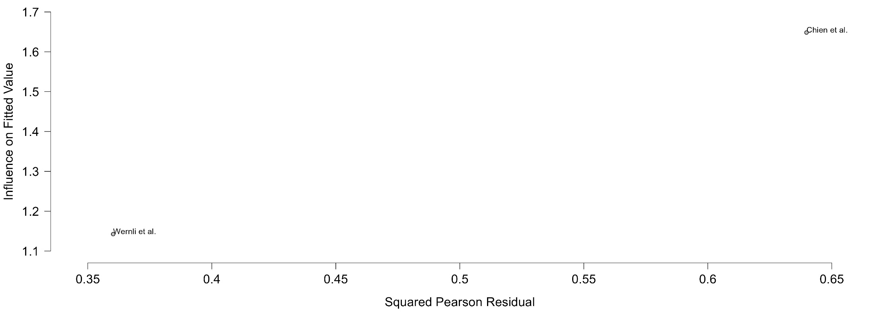
Figure 125 Baujat plot- Cumulative Duration ADs Treatment Less Than 2 Years

The Baujat plot visualises each study's contribution to the Q-statistic for heterogeneity on the x-axis (squared Pearson residual) against its influence on the pooled effect on the y-axis (standardized squared difference in fixed-effects estimates with/without the study). Studies in the top-right quadrant drive both heterogeneity and effect variation, signalling candidates for sensitivity analysis; bottom-left points have minimal impact.

Cumulative Duration Fluoxetine Treatment Less Than 2 Years
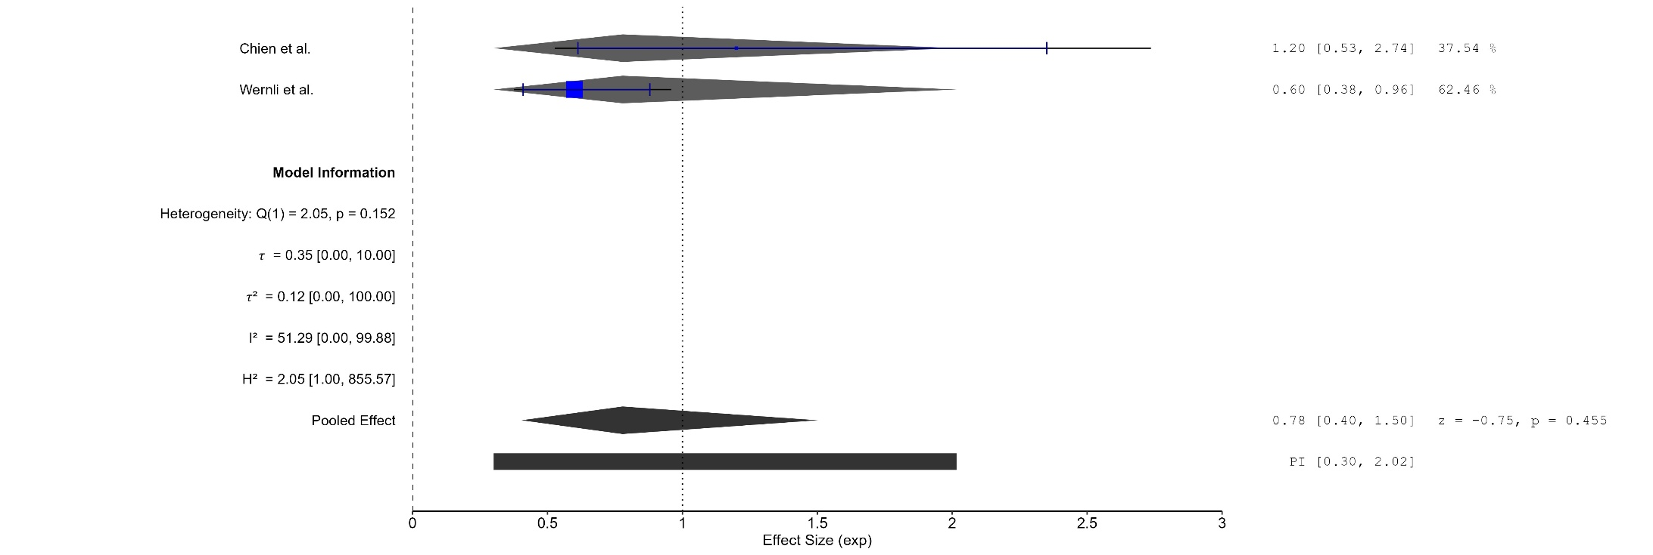
Figure 126 Forest plot - Cumulative Duration Fluoxetine Treatment Less Than 2 Years
The area of each square is proportional to the sample size of the respective study, with horizontal lines through the squares representing the 95% confidence interval (C.I.) for that study. In the pooled analysis, the diamond symbol represents the pooled estimate, with the right and left points of the diamond indicating the 95% C.I. for the overall analysis
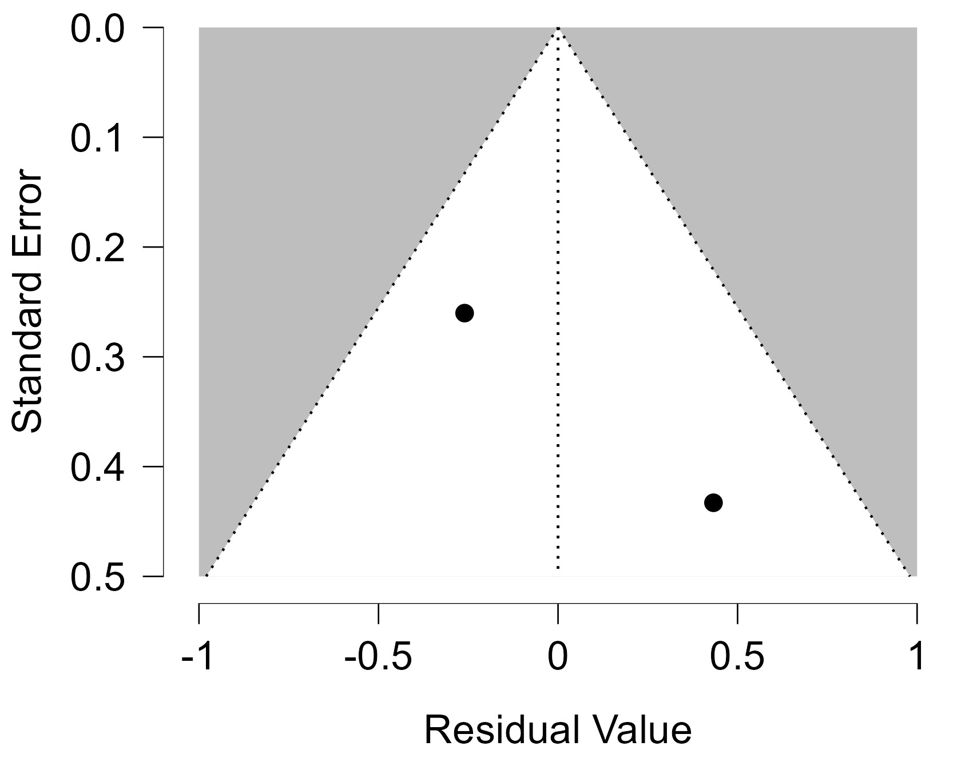
Figure 127 Funnel plot - Cumulative Duration Fluoxetine Treatment Less Than 2 Years

Each blue dot represents a single study, plotted with its effect size on the x-axis and its standard error on the y-axis. The vertical red line represents the overall effect estimate derived from the random-effects model using restricted maximum likelihood (REML). The pseudo 95% confidence interval region, shown as gray diagonal lines, outlines the expected spread of studies in the absence of bias or between-study heterogeneity.
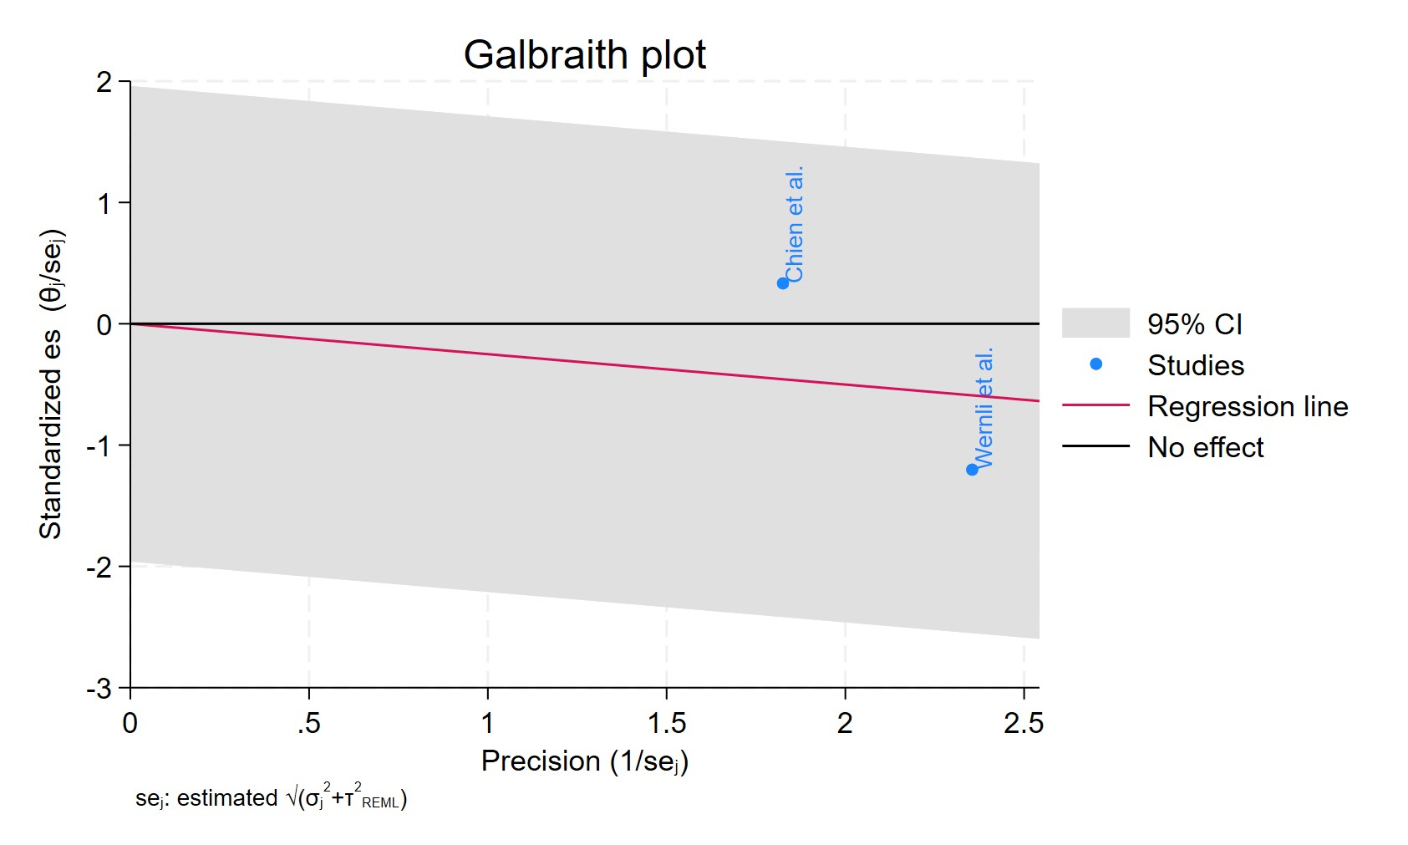
Figure 128 Galbraith plot - Cumulative Duration Fluoxetine Treatment Less Than 2 Years

Each study is represented as a point, where the x-axis denotes the precision (defined as the inverse of the standard error), and the y-axis indicates the standardized effect size. The red regression line represents the overall summary effect estimated from the random-effects model, and the gray shaded area corresponds to the confidence interval at 95% around regression line. The horizontal black ––line at y = 0 corresponds to the line of no effect, serving as a reference.
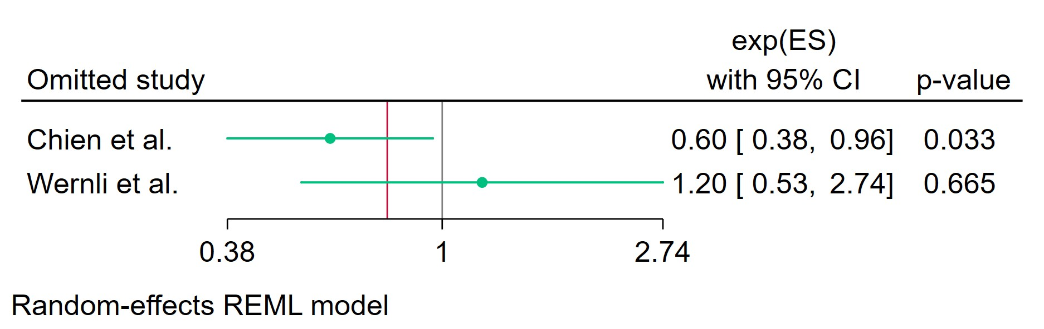
Figure 129 Leave-one-out - Cumulative Duration Fluoxetine Treatment Less Than 2 Years

Leave-one-out (LOO) analysis assesses meta-analysis robustness by iteratively excluding one study at a time and refitting the model to observe shifts in the pooled effect size, confidence interval, and heterogeneity

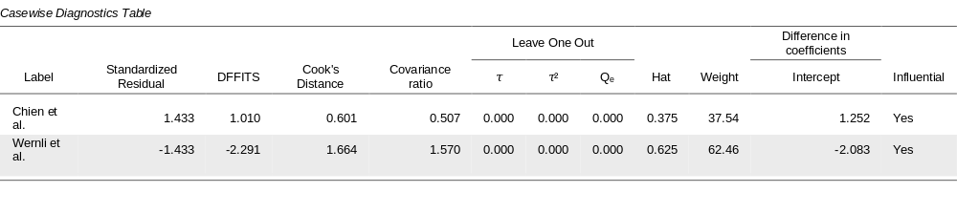
Figure 130 Casewise diagnostics- Cumulative Duration Fluoxetine Treatment Less Than 2 Years
Casewise diagnostics evaluate individual study influence in meta-analysis by computing standardized residuals, leverage (Hat values), and global influence measures like DFFITS, Cook's distance, and covariance ratios.​
Leave-one-out (LOO) analyses refit the model after sequentially omitting each study, quantifying changes in key parameters (e.g., $τ$, $τ^{2}$, $Q_{e}$, pooled effect) to assess sensitivity to individual observations.​
Studies exceeding conventional thresholds (e.g., Cook's distance >1, |DFFITS| >1, |standardized residual| >2) are flagged as influential, guiding decisions on robustness or exclusion.
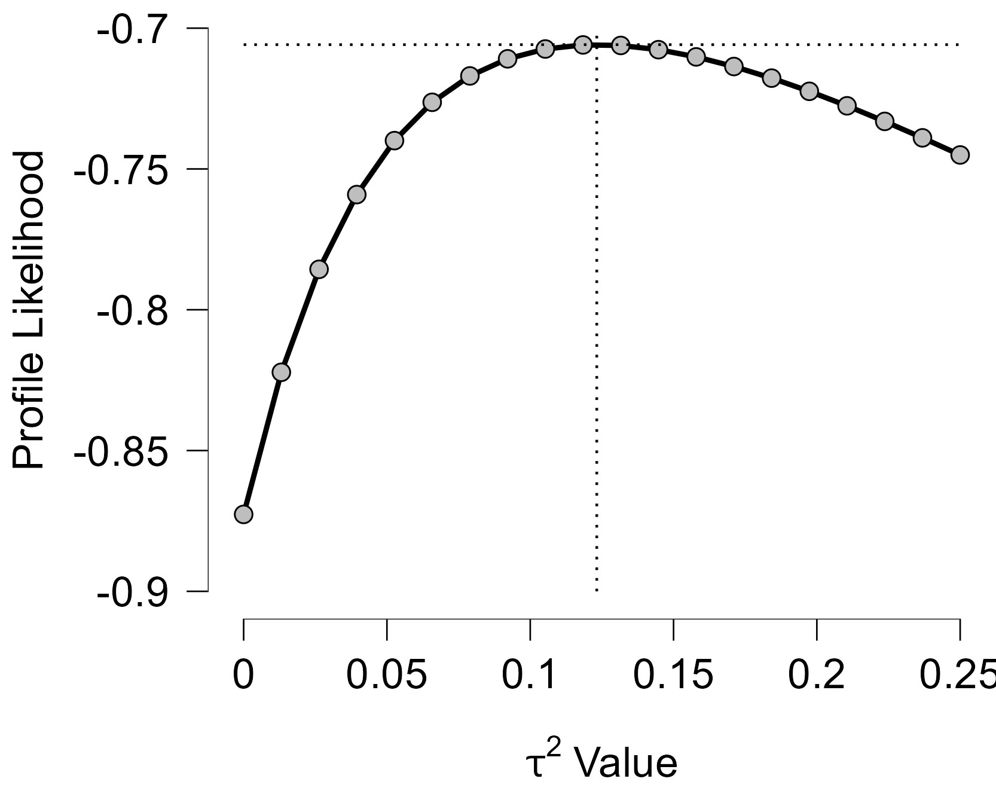
Figure 131 Profile Likelihood- Cumulative Duration Fluoxetine Treatment Less Than 2 Years

The x-axis shows candidate values of the heterogeneity variance $τ^{2}$, and the y-axis shows the corresponding standardized profile likelihood, which has been scaled so that the maximum value equals 1 at $τ^{2}=0$.
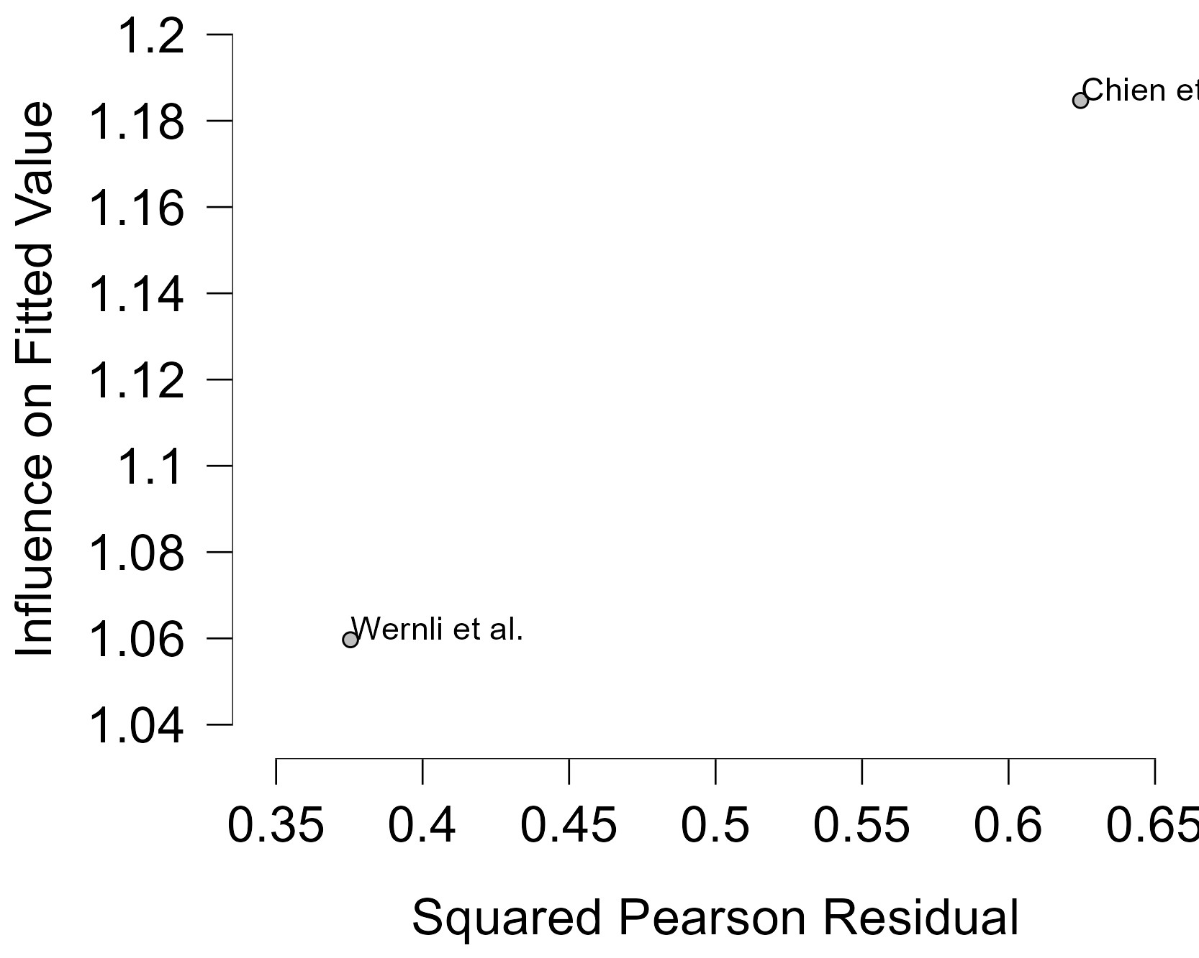
Figure 132 Baujat plot- Cumulative Duration Fluoxetine Treatment Less Than 2 Years

The Baujat plot visualises each study's contribution to the Q-statistic for heterogeneity on the x-axis (squared Pearson residual) against its influence on the pooled effect on the y-axis (standardized squared difference in fixed-effects estimates with/without the study). Studies in the top-right quadrant drive both heterogeneity and effect variation, signalling candidates for sensitivity analysis; bottom-left points have minimal impact.

Cumulative Duration Fluoxetine Treatment 2-4 Years
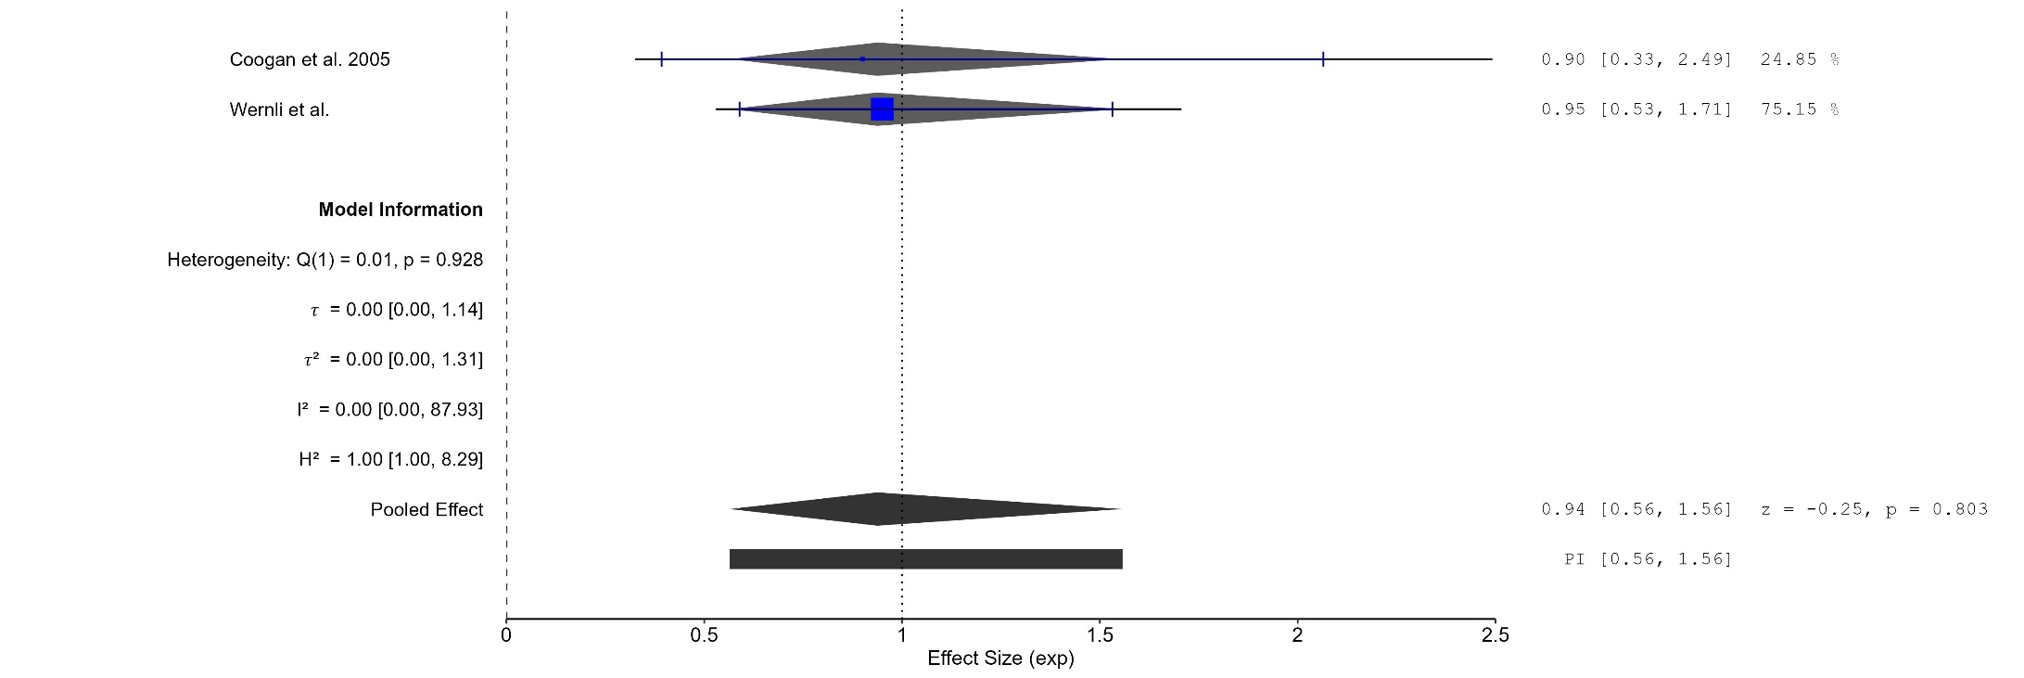
Figure 133 Forest plot - Cumulative Duration Fluoxetine Treatment 2-4 Years

The area of each square is proportional to the sample size of the respective study, with horizontal lines through the squares representing the 95% confidence interval (C.I.) for that study. In the pooled analysis, the diamond symbol represents the pooled estimate, with the right and left points of the diamond indicating the 95% C.I. for the overall analysis
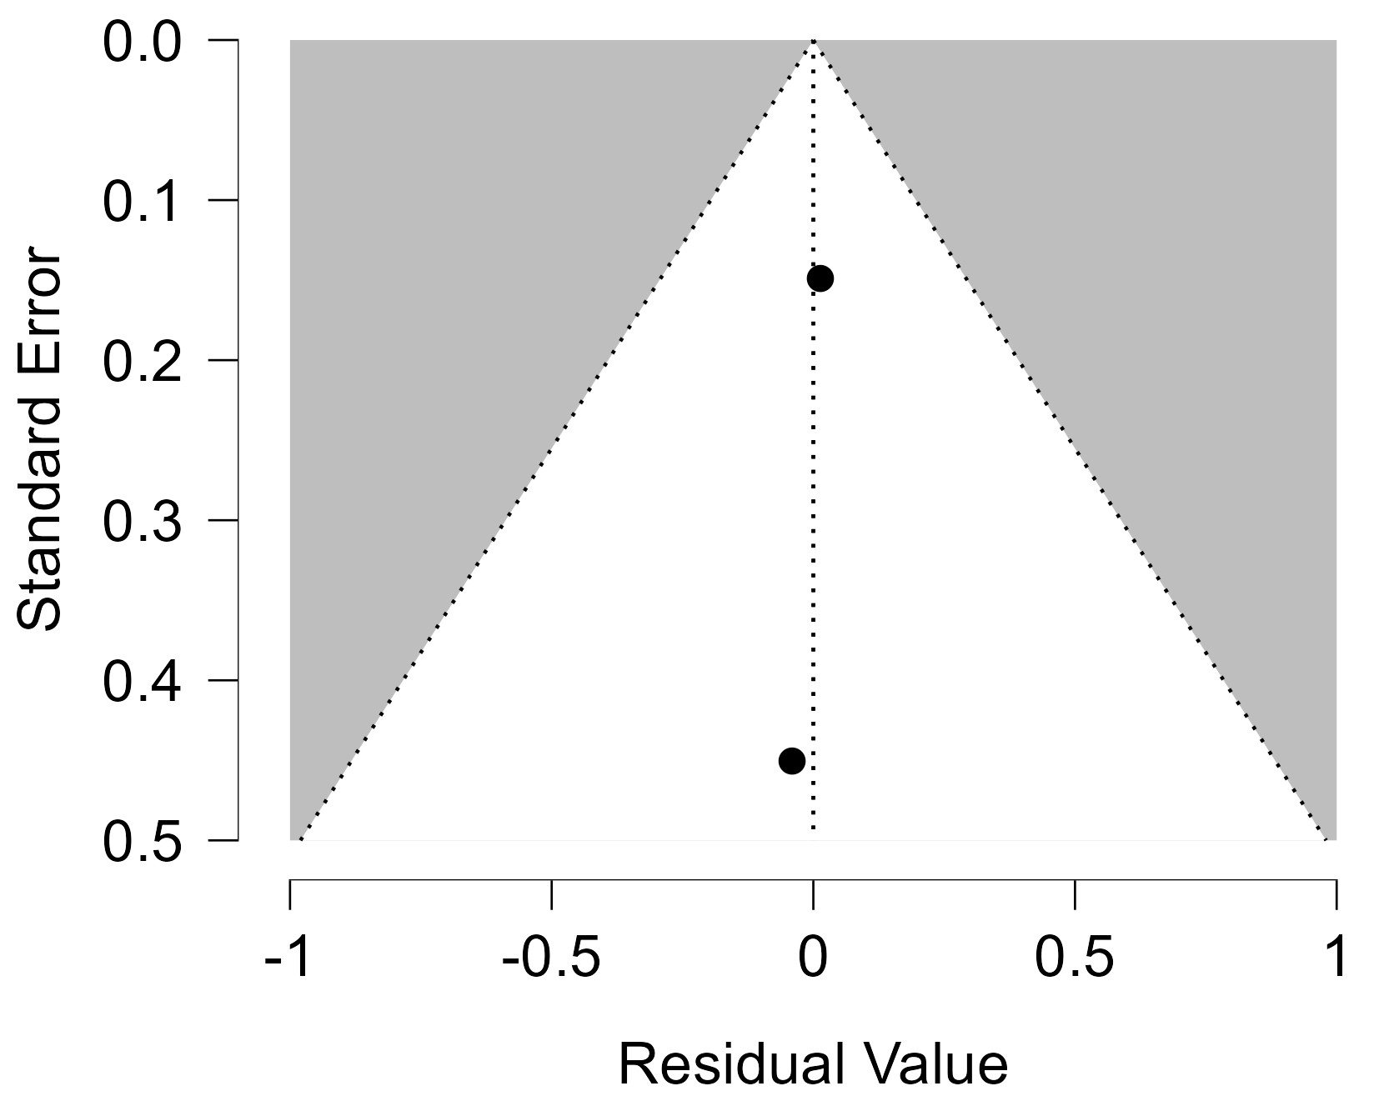
Figure 134 Funnel plot - Cumulative Duration Fluoxetine Treatment 2-4 Years

Each blue dot represents a single study, plotted with its effect size on the x-axis and its standard error on the y-axis. The vertical red line represents the overall effect estimate derived from the random-effects model using restricted maximum likelihood (REML). The pseudo 95% confidence interval region, shown as gray diagonal lines, outlines the expected spread of studies in the absence of bias or between-study heterogeneity.
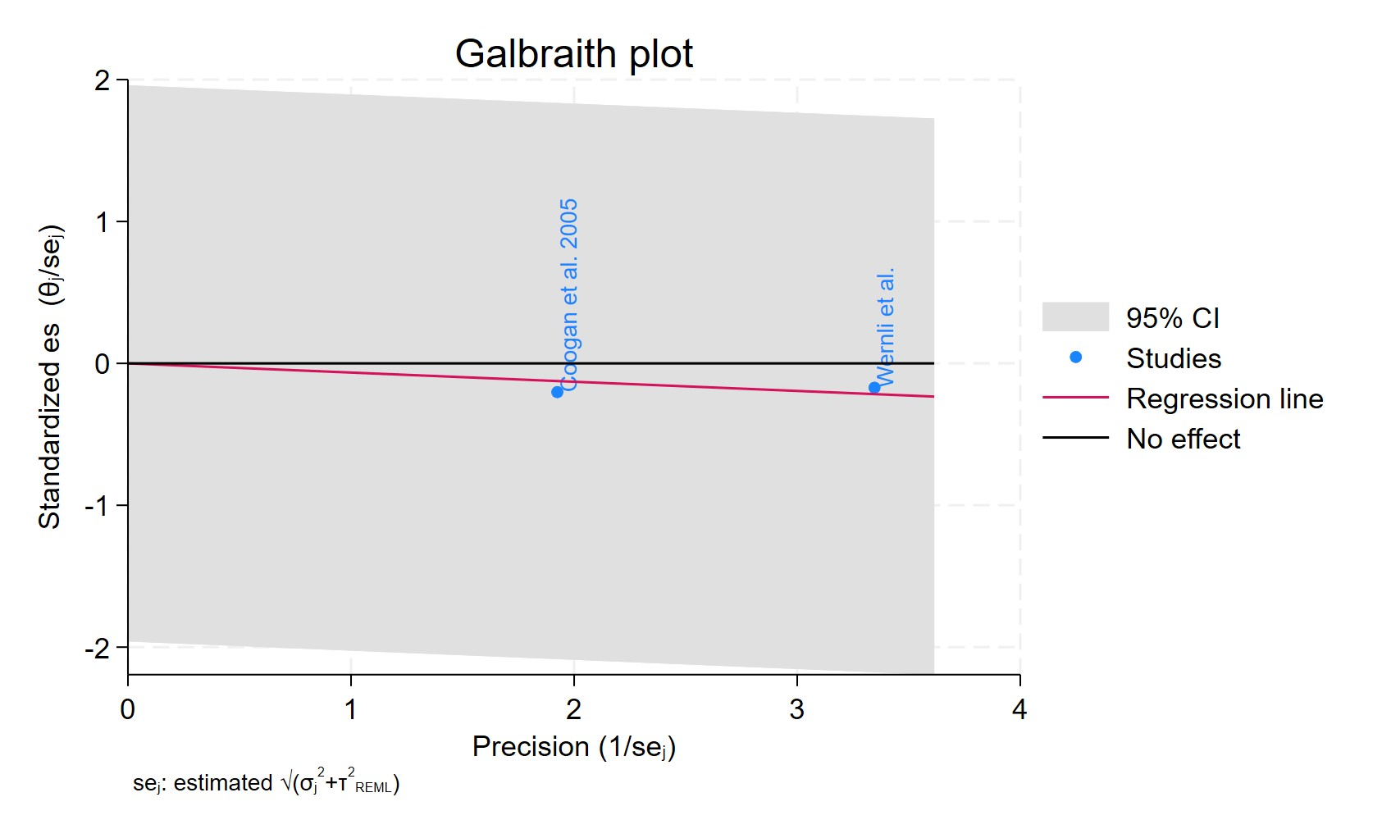
Figure 135 Galbraith plot - Cumulative Duration Fluoxetine Treatment 2-4 Years

Each study is represented as a point, where the x-axis denotes the precision (defined as the inverse of the standard error), and the y-axis indicates the standardized effect size. The red regression line represents the overall summary effect estimated from the random-effects model, and the gray shaded area corresponds to the confidence interval at 95% around regression line. The horizontal black ––line at y = 0 corresponds to the line of no effect, serving as a reference.
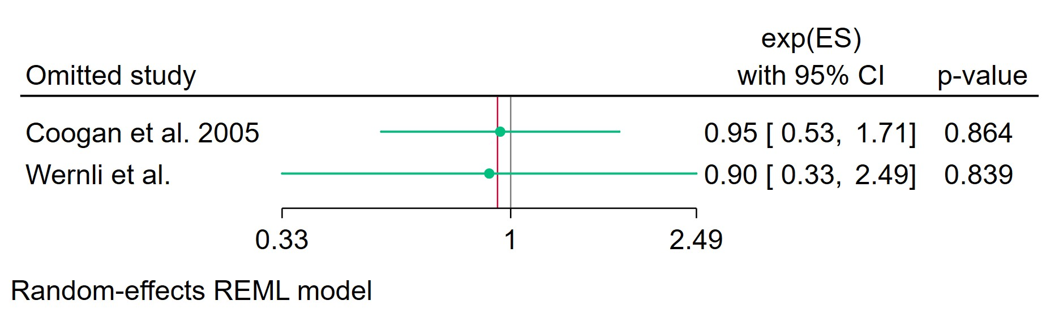
Figure 136 Leave-one-out - Cumulative Duration Fluoxetine Treatment 2-4 Years

Leave-one-out (LOO) analysis assesses meta-analysis robustness by iteratively excluding one study at a time and refitting the model to observe shifts in the pooled effect size, confidence interval, and heterogeneity

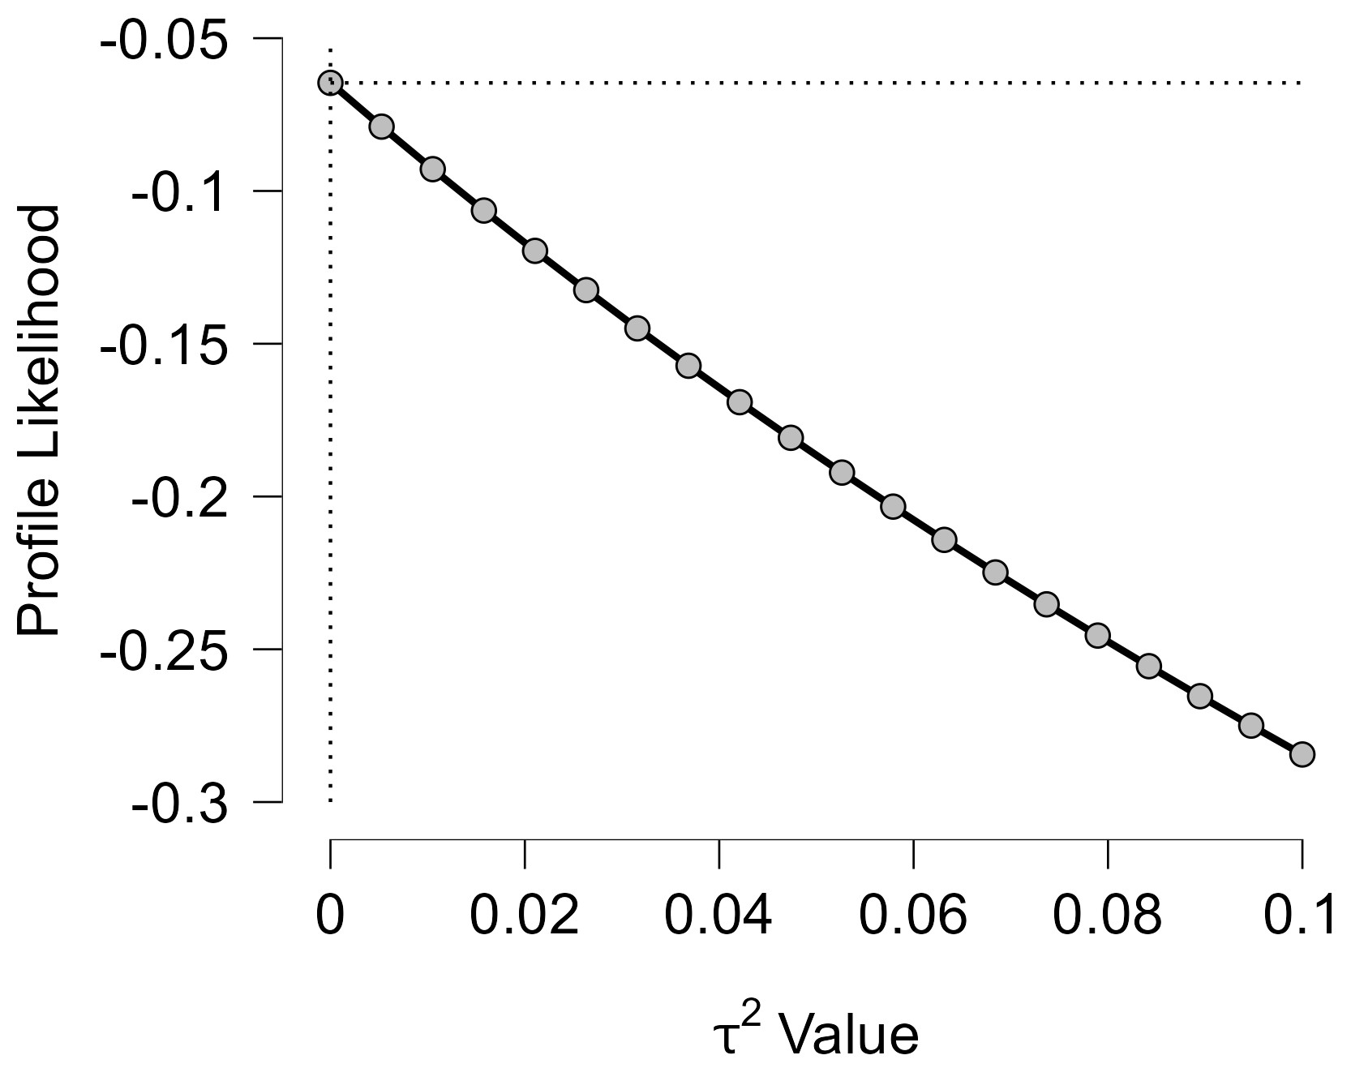
Figure 137 Profile Likelihood- Cumulative Duration Fluoxetine Treatment 2-4 Years

The x-axis shows candidate values of the heterogeneity variance $τ^{2}$, and the y-axis shows the corresponding standardized profile likelihood, which has been scaled so that the maximum value equals 1 at $τ^{2}=0$.
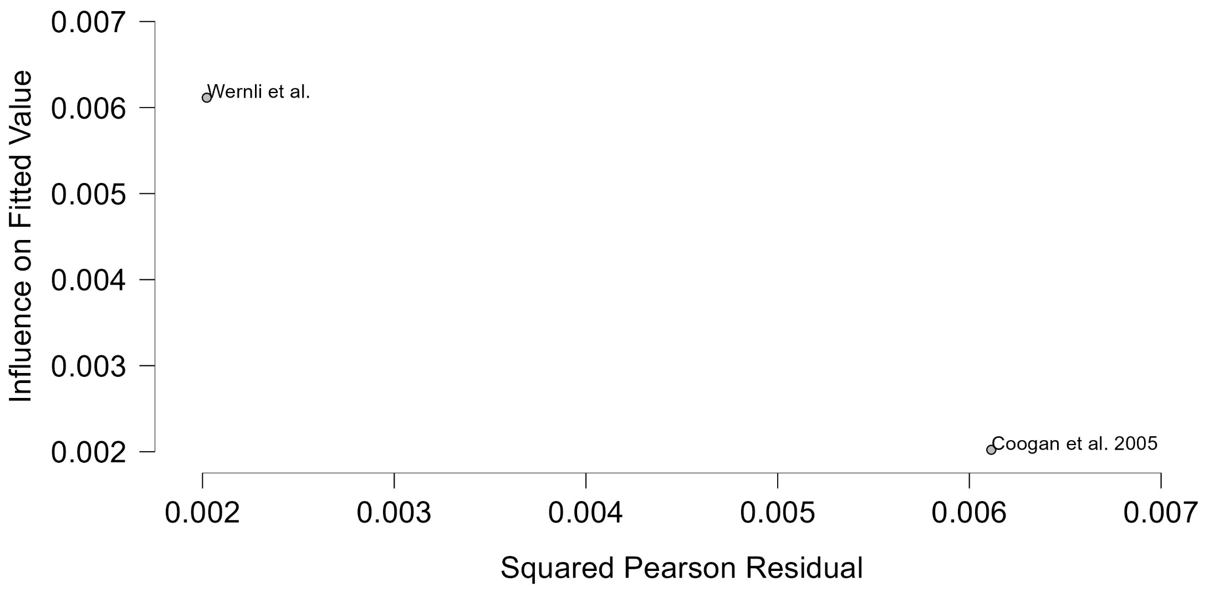
Figure 138 Baujat plot- Cumulative Duration Fluoxetine Treatment 2-4 Years

The Baujat plot visualises each study's contribution to the Q-statistic for heterogeneity on the x-axis (squared Pearson residual) against its influence on the pooled effect on the y-axis (standardized squared difference in fixed-effects estimates with/without the study). Studies in the top-right quadrant drive both heterogeneity and effect variation, signalling candidates for sensitivity analysis; bottom-left points have minimal impact.

Cumulative Duration Sertraline Treatment Less Than 2 Years
Figure 139 Forest plot - Cumulative Duration Sertraline Treatment Less Than 2 Years

The area of each square is proportional to the sample size of the respective study, with horizontal lines through the squares representing the 95% confidence interval (C.I.) for that study. In the pooled analysis, the diamond symbol represents the pooled estimate, with the right and left points of the diamond indicating the 95% C.I. for the overall analysis
Figure 140 Funnel plot - Cumulative Duration Sertraline Treatment Less Than 2 Years

Each blue dot represents a single study, plotted with its effect size on the x-axis and its standard error on the y-axis. The vertical red line represents the overall effect estimate derived from the random-effects model using restricted maximum likelihood (REML). The pseudo 95% confidence interval region, shown as gray diagonal lines, outlines the expected spread of studies in the absence of bias or between-study heterogeneity.
Figure 141 Galbraith plot - Cumulative Duration Sertraline Treatment Less Than 2 Years

Each study is represented as a point, where the x-axis denotes the precision (defined as the inverse of the standard error), and the y-axis indicates the standardized effect size. The red regression line represents the overall summary effect estimated from the random-effects model, and the gray shaded area corresponds to the confidence interval at 95% around regression line. The horizontal black ––line at y = 0 corresponds to the line of no effect, serving as a reference.
Figure 142 Leave-one-out - Cumulative Duration Sertraline Treatment Less Than 2 Years

Leave-one-out (LOO) analysis assesses meta-analysis robustness by iteratively excluding one study at a time and refitting the model to observe shifts in the pooled effect size, confidence interval, and heterogeneity

Figure 143 Profile Likelihood- Cumulative Duration Sertraline Treatment Less Than 2 Years

The x-axis shows candidate values of the heterogeneity variance $τ^{2}$, and the y-axis shows the corresponding standardized profile likelihood, which has been scaled so that the maximum value equals 1 at $τ^{2}=0$.
Figure 144 Baujat plot- Cumulative Duration Sertraline Treatment Less Than 2 Years

The Baujat plot visualises each study's contribution to the Q-statistic for heterogeneity on the x-axis (squared Pearson residual) against its influence on the pooled effect on the y-axis (standardized squared difference in fixed-effects estimates with/without the study). Studies in the top-right quadrant drive both heterogeneity and effect variation, signalling candidates for sensitivity analysis; bottom-left points have minimal impact.

Cumulative Duration Sertraline Treatment 2-4 Years
Figure 145 Forest plot - Cumulative Duration Sertraline Treatment 2-4 Years

The area of each square is proportional to the sample size of the respective study, with horizontal lines through the squares representing the 95% confidence interval (C.I.) for that study. In the pooled analysis, the diamond symbol represents the pooled estimate, with the right and left points of the diamond indicating the 95% C.I. for the overall analysis
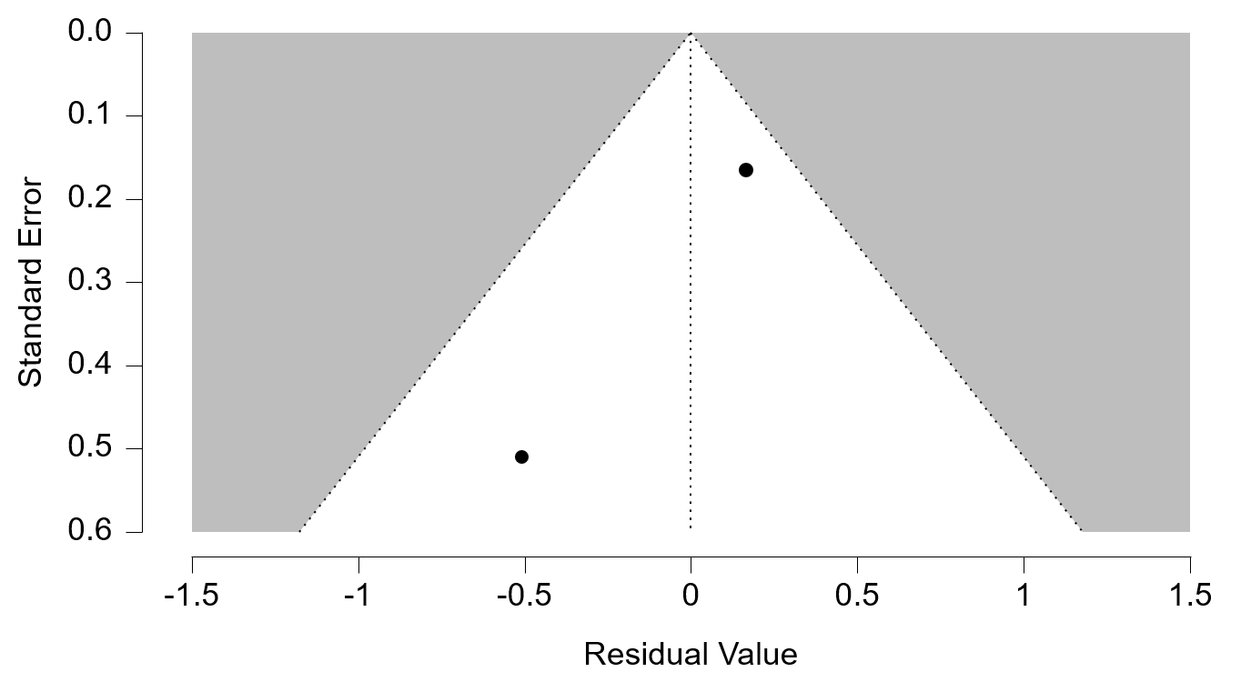
Figure 146 Funnel plot - Cumulative Duration Sertraline Treatment 2-4 Years
Each blue dot represents a single study, plotted with its effect size on the x-axis and its standard error on the y-axis. The vertical red line represents the overall effect estimate derived from the random-effects model using restricted maximum likelihood (REML). The pseudo 95% confidence interval region, shown as gray diagonal lines, outlines the expected spread of studies in the absence of bias or between-study heterogeneity.
Figure 147 Galbraith plot - Cumulative Duration Sertraline Treatment 2-4 Years

Each study is represented as a point, where the x-axis denotes the precision (defined as the inverse of the standard error), and the y-axis indicates the standardized effect size. The red regression line represents the overall summary effect estimated from the random-effects model, and the gray shaded area corresponds to the confidence interval at 95% around regression line. The horizontal black ––line at y = 0 corresponds to the line of no effect, serving as a reference.
Figure 148 Leave-one-out - Cumulative Duration Sertraline Treatment 2-4 Years
Leave-one-out (LOO) analysis assesses meta-analysis robustness by iteratively excluding one study at a time and refitting the model to observe shifts in the pooled effect size, confidence interval, and heterogeneity

Figure 149 Profile Likelihood- Cumulative Duration Sertraline Treatment 2-4 Years

The x-axis shows candidate values of the heterogeneity variance $τ^{2}$, and the y-axis shows the corresponding standardized profile likelihood, which has been scaled so that the maximum value equals 1 at $τ^{2}=0$.
Figure 150 Baujat plot- Cumulative Duration Sertraline Treatment 2-4 Years

The Baujat plot visualises each study's contribution to the Q-statistic for heterogeneity on the x-axis (squared Pearson residual) against its influence on the pooled effect on the y-axis (standardized squared difference in fixed-effects estimates with/without the study). Studies in the top-right quadrant drive both heterogeneity and effect variation, signalling candidates for sensitivity analysis; bottom-left points have minimal impact.

Cumulative Duration Paroxetine Treatment Less Than 2 Years
Figure 151 Forest plot - Cumulative Duration Paroxetine Treatment Less Than 2 Years

The area of each square is proportional to the sample size of the respective study, with horizontal lines through the squares representing the 95% confidence interval (C.I.) for that study. In the pooled analysis, the diamond symbol represents the pooled estimate, with the right and left points of the diamond indicating the 95% C.I. for the overall analysis
Figure 152 Funnel plot - Cumulative Duration Paroxetine Treatment Less Than 2 Years

Each blue dot represents a single study, plotted with its effect size on the x-axis and its standard error on the y-axis. The vertical red line represents the overall effect estimate derived from the random-effects model using restricted maximum likelihood (REML). The pseudo 95% confidence interval region, shown as gray diagonal lines, outlines the expected spread of studies in the absence of bias or between-study heterogeneity.
Figure 153 Galbraith plot - Cumulative Duration Paroxetine Treatment Less Than 2 Years

Each study is represented as a point, where the x-axis denotes the precision (defined as the inverse of the standard error), and the y-axis indicates the standardized effect size. The red regression line represents the overall summary effect estimated from the random-effects model, and the gray shaded area corresponds to the confidence interval at 95% around regression line. The horizontal black ––line at y = 0 corresponds to the line of no effect, serving as a reference.
Figure 154 Leave-one-out - Cumulative Duration Paroxetine Treatment Less Than 2 Years

Leave-one-out (LOO) analysis assesses meta-analysis robustness by iteratively excluding one study at a time and refitting the model to observe shifts in the pooled effect size, confidence interval, and heterogeneity

Figure 155 Profile Likelihood- Cumulative Duration Paroxetine Treatment Less Than 2 Years

The x-axis shows candidate values of the heterogeneity variance $τ^{2}$, and the y-axis shows the corresponding standardized profile likelihood, which has been scaled so that the maximum value equals 1 at $τ^{2}=0$.
Figure 156 Baujat plot - Cumulative Duration Paroxetine Treatment Less Than 2 Years
The Baujat plot visualises each study's contribution to the Q-statistic for heterogeneity on the x-axis (squared Pearson residual) against its influence on the pooled effect on the y-axis (standardized squared difference in fixed-effects estimates with/without the study). Studies in the top-right quadrant drive both heterogeneity and effect variation, signalling candidates for sensitivity analysis; bottom-left points have minimal impact.

