Additional File 1

Figure S1: IHCoR-Africa Study Sites 4
Figure S2: Summary of study procedures 5
Figure S3: Hypertensive diagnostic phenotypes 6
Figure S4: Bland Altman plots of level of agreement for diastolic AHBP and average 24-hour blood pressure for participants in Kenya and The Gambia 7
Table S1: Recommended blood pressure cutoffs for diagnosing hypertension 8
Table S2: Comparison of individuals included and excluded from this manuscript’s analysis 9
Table S3: Distribution of ambulatory blood pressure monitoring (ABPM) parameters 10
Table S4: Accuracy of attended and unattended AHBP measurements at the European Society of Hypertension (ESH) cutoffs 11
Table S5: McNemar’s test and Cohen’s kappa statistic comparison of attended and unattended automated blood pressure measurements conducted at home (AHBP) in Kenya 12
Table S6: McNemar’s test and Cohen’s kappa statistic comparison of attended and unattended automated blood pressure measurements conducted at home (AHBP) in The Gambia 12
Supplementary analysis of accuracy using the joint American College of Cardiology/American Heart Association (ACC/AHA) blood pressure cutoffs 13
Table S7: Hypertensive diagnostic phenotypes for attended and unattended automated blood pressure measurements conducted at home (AHBP) compared to average 24-hour blood pressure at the ACC/AHA cutoffs 13
Table S8: Accuracy of attended and unattended automated blood pressure measurements conducted at home (AHBP) compared to average 24-hour BP at the ACC/AHA cutoffs 14
Supplementary analysis of accuracy using average daytime blood pressure as the reference standard at the ESH cutoffs 15
Table S9: Hypertensive diagnostic phenotypes for attended and unattended automated blood pressure measurements conducted at home (AHBP) compared to average daytime blood pressure 15
Table S10: Accuracy of attended and unattended automated blood pressure measurements conducted at home (AHBP) compared to average daytime blood pressure 16
Supplementary analysis of accuracy of attended automated blood pressure measurement conducted at home (AHBP) stratified by age and sex at the ESH cutoffs 17
Table S11: Accuracy of attended AHBP compared to average 24-hour blood pressure stratified by sex 17
Table S12: Accuracy of attended AHBP compared to average 24-hour blood pressure stratified by age among participants in Kenya 18
Table S13: Accuracy of attended AHBP compared to average 24-hour blood pressure stratified by age among participants in The Gambia 19

Figure S1: IHCoR-Africa Study Sites
The figure below illustrates the location of IHCoR-Africa’s study sites - The Gambia in West-Africa and Kenya in East Africa.
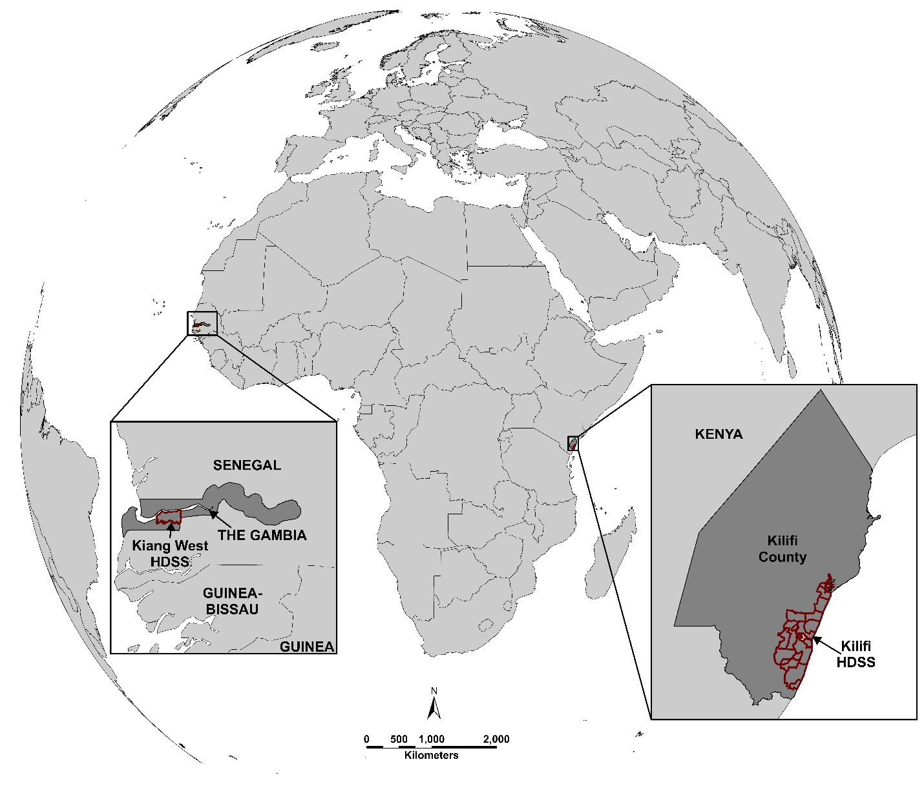

Figure S2: Summary of study procedures

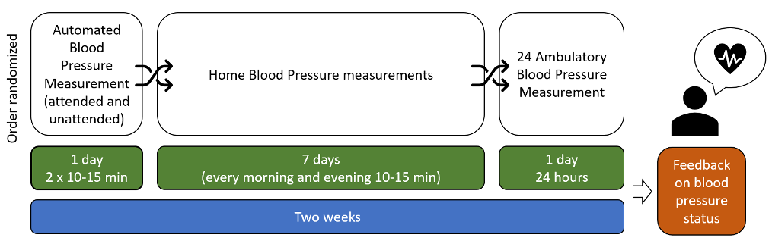
Summary of study procedures:
- Community health workers enrolled an age-stratified random sample of eligible participants from the two study sites; Kilifi Health and Demographic Surveillance System, Kenya and Kiang West Demographic Surveillance System, The Gambia
- Participants had four blood pressure measurements conducted by community health workers at home. In addition, basic sociodemographic data were collected.
- After enrollment, participants were randomly assigned a sequence for the four blood pressure measurements to be conducted within a two-week period.
- The four measurements were attended automated home blood pressure (attended AHBP), unattended automated home blood pressure (unattended AHBP), home blood pressure monitoring and 24-hour ambulatory blood pressure monitoring (ABPM). AHBP measurements were conducted on the same day 10 minutes apart.
- This manuscript’s analyses are limited to the AHBP and 24-hour ABPM measurements.

Figure S3: Hypertensive diagnostic phenotypes
 |  | Reference test
 |  | Positive | Negative
Index test | Positive | True Positive (TP)  Sustained hypertension | False Positive (FP)  Whitecoat hypertension
Index test | Negative | False Negative (FN)  Masked hypertension | True Negative (TN)  Sustained Normotension

Hypertensive diagnostic phenotypes are derived from cross-tabulations of positive and negative results on BP measurement index tests and reference tests

Figure S4: Bland Altman plots of level of agreement for diastolic AHBP and average 24-hour blood pressure for participants in Kenya and The Gambia
A. Kenya (attended) | B. The Gambia (attended)
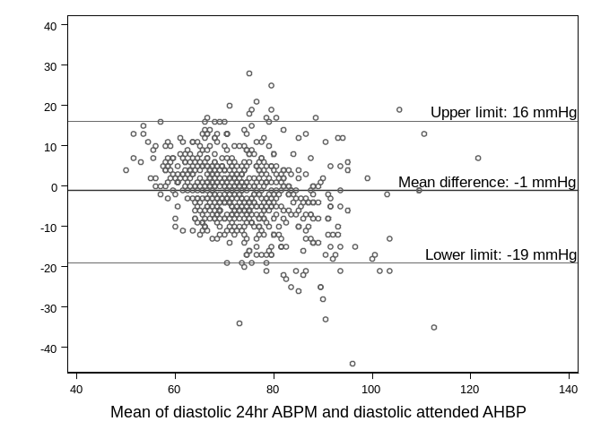 | 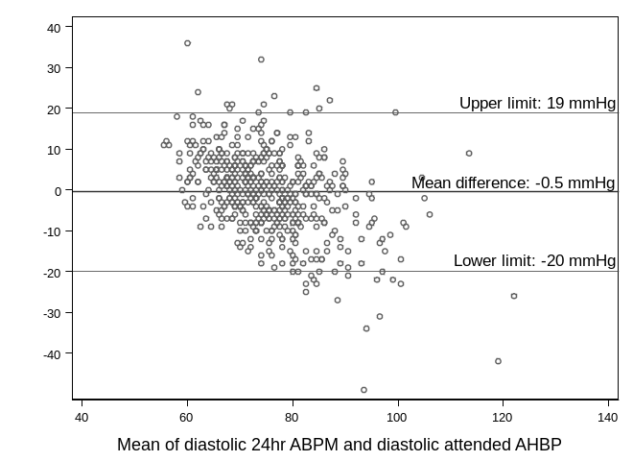
C. Kenya (unattended) | D. The Gambia (unattended)
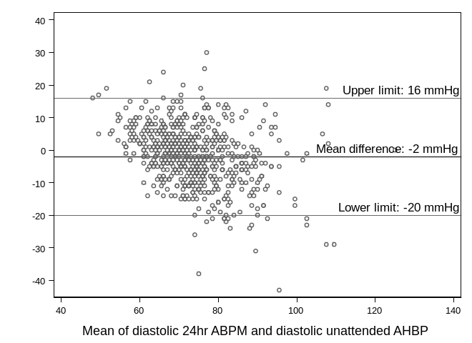 | 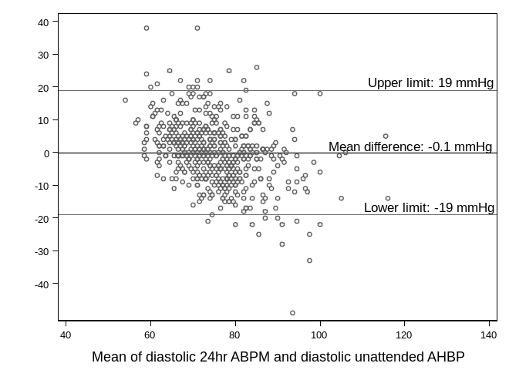
Abbreviations: ABPM – ambulatory blood pressure monitoring; AHBP – automated blood pressure measurements conducted at home; BP – blood pressure
*The correlation coefficients (Pitman test) between the difference and mean were r=-0.325 for attended diastolic measurements and r=-0.340 for unattended diastolic measurements in Kenya and r= -0.440 for attended diastolic measurements and r= -0.371 for unattended diastolic measurements in The Gambia. These suggest proportional bias for both systolic and diastolic measurements in both attended and unattended measurements.

Table S1: Recommended blood pressure cutoffs for diagnosing hypertension
This table summarizes the blood pressure (BP) cutoffs for diagnosing hypertension recommended by the European Society of Hypertension (ESH) and the joint American College of Cardiology/American Heart Association (ACC/AHA).
Guidelines | Blood pressure (BP) cutoffs
Guidelines | Automated BP measurement | Average 24-hour BP | Average awake BP | Average asleep BP
ESH guidelines | 140/90 mmHg | 130/80 mmHg | 135/85 mmHg | 120/70 mmHg
ACC/AHA guidelines | 130/80 mmHg | 125/75 mmHg | 130/80 mmHg | 110/65 mmHg
*Average 24-hour BP was used as the reference standard measurement for the main analyses in this manuscript

Table S2: Comparison of individuals included and excluded from this manuscript’s analysis

Demographic characteristic | Participants excluded in analysis  (n = 232) |  | Participants included in analysis  (n = 1220) |  | Chi square p value
 | Kenya  n (%) | The Gambia  n (%) | Kenya  n (%) | The Gambia  n (%)
Sex
Male | 52 (45.6) | 54 (45.8) | 222 (33.7) | 223 (39.8) | 0.227
Female | 62 (54.4) | 64 (54.2) | 437 (66.3) | 338 (60.3)
Age group (years)
30 – 39 | 30 (26.3) | 26 (22.0) | 127 (19.3) | 118 (21.0) | 0.056
40 – 49 | 17 (14.9) | 15 (12.7) | 132 (20.0) | 116 (20.7)
50 – 59 | 17 (14.9) | 20 (17.0) | 132 (20.0) | 113 (20.1)
60 – 69 | 16 (14.0) | 22 (18.6) | 136 (20.7) | 108 (19.3)
≥ 70 | 34 (29.8) | 35 (29.7) | 132 (20.0) | 106 (18.9)

Table S3: Distribution of ambulatory blood pressure monitoring (ABPM) parameters
Blood pressure parameters | Kenya |  | The Gambia
 | Crude | Age standardized | Crude | Age standardized
Ambulatory BP averages (SD), mmHg
Mean systolic daytime BP | 122 ± 18 | 120 ± 17 | 125 ± 17 | 123 ± 16
Mean systolic nighttime BP | 112 ± 19 | 110 ± 17 | 117 ± 20 | 115 ± 18
Mean diastolic daytime BP | 76 ± 10 | 76 ± 9 | 78 ± 9 | 78 ± 9
Mean diastolic nighttime BP | 66 ± 10 | 66 ± 10 | 69 ± 9 | 69 ± 9
Prevalence of hypertension on ambulatory BP parameters % (95% CI)
Average daytime BP | 25.0  (21.7, 28.5) | 21.8  (18.6, 24.9) | 30.8  (27.0, 34.8) | 27.0  (23.3, 30.6)
Average nighttime BP | 38.4  (34.7, 42.2) | 33.6  (29.8, 37.4) | 50.8  (46.6, 55.0) | 46.1  (41.9, 50.3)
Average 24-hour BP | 29.1  (25.7, 32.8) | 25.1  (21.7, 28.4) | 36.9  (32.9, 41.0) | 32.7  (28.8, 36.6)
Any* ABPM measure | 40.8  (37.0, 44.7) | 36.2  (32.4, 40.1) | 52.6  (48.4, 56.8) | 47.9  (43.6, 52.1)
Abbreviations: BP-blood pressure, SD-standard deviation, CI-confidence interval
*Any ABPM measurement refers to participants who were hypertensive on either average daytime BP, average nighttime BP or average 24-hour BP

Table S4: Accuracy of attended and unattended AHBP measurements at the European Society of Hypertension (ESH) cutoffs
Accuracy measure | Kenya; % (95% CI) |  | The Gambia; % (95% CI)
Accuracy measure | Crude | Age standardized | Crude | Age standardized
Attended AHBP
Sensitivity | 61.5 (54.2, 68.4) | 59.5 (52.1, 66.9) | 48.8 (41.8, 55.8) | 42.2 (34.9, 49.5)
Specificity | 90.4 (87.3, 92.9) | 92.5 (90.2, 94.7) | 92.7 (89.4, 95.1) | 93.2 (90.6, 95.9)
Positive predictive value | 72.4 (64.9, 79.1) | 72.8 (65.8, 79.9) | 79.5 (71.5, 86.2) | 74.8 (66.2, 83.4)
Negative predictive value | 85.1 (81.6, 88.1) | 87.1 (84.2, 90.0) | 75.6 (71.3, 79.5) | 77.2 (73.1, 81.3)
Likelihood Ratio positive | 6.38 (4.73, 8.60) | 7.94 (5.23, 10.6) | 6.64 (4.47, 9.87) | 6.23 (3.21, 9.25)
Likelihood Ratio negative | 0.43 (0.36, 0.51) | 0.44 (0.36, 0.52) | 0.55 (0.48, 0.63) | 0.62 (0.54, 0.70)
Diagnostic odds ratio | 15.0 (9.81, 22.8) | 18.1 (9.68, 26.6) | 12.0 (7.43, 19.4) | 10.0 (4.11, 16.0)
Area under receiver operating characteristic curve | 0.76 (0.72, 0.80) | 0.76 (0.72, 0.80) | 0.71 (0.67, 0.74) | 0.68 (0.64, 0.72)
Unattended AHBP
Sensitivity | 57.8 (50.5, 64.9) | 56.1 (48.4, 63.8) | 47.8 (40.9, 54.9) | 42.2 (35.2, 49.2)
Specificity | 91.0 (88.0, 93.4) | 92.6 (90.2, 95.0) | 92.1 (88.0, 94.7) | 93.3 (90.8, 95.9)
Positive predictive value | 72.5 (64.8, 79.4) | 71.9 (64.0, 79.8) | 78.0 (69.7, 84.8) | 75.1 (66.8, 83.4)
Negative predictive value | 84.0 (80.5, 87.1) | 86.2 (83.2, 89.2) | 75.1 (70.8, 79.1) | 77.2 (73.1, 81.3)
Likelihood Ratio positive | 6.43 (4.70, 8.79) | 7.56 (4.71, 10.4) | 6.05 (4.12, 8.87) | 6.34 (3.42, 9.26)
Likelihood Ratio negative | 0.46 (0.39, 0.55) | 0.47 (0.39, 0.56) | 0.57 (0.50, 0.65) | 0.62 (0.54, 0.70)
Diagnostic odds ratio | 13.9 (9.06, 21.2) | 16.0 (7.85, 24.1) | 10.7 (6.67, 17.1) | 10.2 (4.60, 15.9)
Area under receiver operating characteristic curve | 0.74 (0.71, 0.78) | 0.74 (0.70, 0.78) | 0.70 (0.66, 0.74) | 0.68 (0.64, 0.71)
Abbreviations: AHBP – automated blood pressure measurements conducted at home; CI – confidence interval

Table S5: McNemar’s test and Cohen’s kappa statistic comparison of attended and unattended automated blood pressure measurements conducted at home (AHBP) in Kenya
 | Hypertensive on unattended AHBP | Normotensive on unattended AHBP
Hypertensive on attended AHBP | 128 | 35
Normotensive on attended AHBP | 25 | 471
McNemar’s test:
There was no significant difference in hypertension classification between attended and unattended measurements (McNemar’s χ²(1) = 1.67, p = 0.20; exact p = 0.25). The odds of being classified hypertensive by attended versus unattended measurement were not significantly different (OR = 1.4, 95% CI: 0.81–2.44).
Cohen’s kappa statistic:
There was substantial agreement between attended and unattended measurements (observed agreement = 90.9%, expected agreement = 63.5%, Cohen’s κ = 0.75, SE = 0.04, p < 0.001)

Table S6: McNemar’s test and Cohen’s kappa statistic comparison of attended and unattended automated blood pressure measurements conducted at home (AHBP) in The Gambia
 | Hypertensive on unattended AHBP | Normotensive on unattended AHBP
Hypertensive on attended AHBP | 102 | 25
Normotensive on attended AHBP | 25 | 409
McNemar’s test:
There was no significant difference in hypertension classification between attended and unattended measurements (McNemar’s χ²(1) = 0.00, p = 1.00; exact p = 1.00). The odds of being classified hypertensive by attended versus unattended measurement were not significantly different (OR = 1.0, 95% CI: 0.55–1.81).
Cohen’s kappa statistic:
There was substantial agreement between attended and unattended measurements (observed agreement = 90.9%, expected agreement = 63.5%, Cohen’s κ = 0.75, SE = 0.04, p < 0.001)

Supplementary analysis of accuracy using the joint American College of Cardiology/American Heart Association (ACC/AHA) blood pressure cutoffs

Table S7: Hypertensive diagnostic phenotypes for attended and unattended automated blood pressure measurements conducted at home (AHBP) compared to average 24-hour blood pressure at the ACC/AHA cutoffs
Hypertensive diagnostic phenotype | Kenya; % (95% CI) |  | The Gambia; % (95% CI)
Hypertensive diagnostic phenotype | Crude | Age standardized | Crude | Age standardized
Attended AHBP
Sustained normotension | 43.9  (40.1, 47.7) | 48.1  (44.2, 52.1) | 38.3  (34.4, 42.4) | 41.8  (37.6, 46.0)
White-coat hypertension | 12.4  (10.1, 15.2) | 12.3  (9.6, 15.0) | 7.8  (5.9, 10.4) | 8.4  (5.9, 10.8)
Masked hypertension | 12.3  (10.0, 15.0) | 11.7  (9.2, 14.3) | 17.3  (14.4, 20.7) | 17.8  (14.5, 21.2)
Sustained hypertension | 31.4  (28.0, 35.1) | 28.0  (24.5, 31.5) | 36.5  (32.7, 40.6) | 32.1  (28.3, 35.9)
Unattended AHBP
Sustained normotension | 41.4  (37.7, 45.2) | 45.5  (41.5, 49.5) | 36.5  (32.7, 40.6) | 39.9  (35.6, 44.1)
White-coat hypertension | 14.9  (12.4, 17.8) | 14.9  (11.9, 17.8) | 9.6  (7.4, 12.4) | 10.3  (7.6, 13.0)
Masked hypertension | 14.0  (11.5, 16.8) | 13.3  (10.6, 16.0) | 15.0  (12.3, 18.2) | 15.5  (12.4, 18.7)
Sustained hypertension | 29.7  (26.4, 33.3) | 26.4  (23.0, 29.7) | 38.9  (34.9, 43.0) | 34.4  (30.5, 38.3)
Abbreviations: AHBP – automated blood pressure measurements conducted at home; CI – confidence interval

Table S8: Accuracy of attended and unattended automated blood pressure measurements conducted at home (AHBP) compared to average 24-hour BP at the ACC/AHA cutoffs
Accuracy measure | Kenya; % (95% CI) |  | The Gambia; % (95% CI)
Accuracy measure | Crude | Age standardized | Crude | Age standardized
Attended AHBP
Sensitivity | 71.9 (66.3, 77.0) | 70.5 (64.8, 76.2) | 67.9 (62.3, 73.1) | 63.9 (58.2, 69.6)
Specificity | 77.9 (73.3, 82.0) | 79.6 (75.4, 83.8) | 83.0 (77.9, 87.4) | 83.3 (78.6, 88.2)
Positive predictive value | 71.6 (66.1, 76.8) | 69.6 (63.8, 75.4) | 82.3 (77.0, 86.9) | 79.0 (73.4, 84.6)
Negative predictive value | 78.1 (73.5, 82.2) | 80.2 (76.2, 84.3) | 68.9 (63.5, 74.0) | 70.2 (65.0, 75.5)
Likelihood Ratio positive | 3.25 (2.65, 3.99) | 3.45 (2.66, 4.24) | 4.00 (3.02, 5.29) | 3.84 (2.63, 5.05)
Likelihood Ratio negative | 0.36 (0.30, 0.44) | 0.37 (0.30, 0.44) | 0.39 (0.33, 0.46) | 0.43 (0.36, 0.51)
Diagnostic odds ratio | 9.01 (6.32, 12.8) | 9.30 95.54, 13.1) | 10.3 (6.90, 15.5) | 8.87 (4.89, 12.9)
Area under receiver operating characteristic curve | 0.75 (0.72, 0.78) | 0.75 (0.71, 0.79) | 0.75 (0.72, 0.79) | 0.74 (0.70, 0.77)
Unattended AHBP
Sensitivity | 68.1 (62.3, 73.4) | 66.4 (60.3, 72.5) | 71.9 (66.4, 76.9) | 68.5 (62.9, 74.2)
Specificity | 73.6 (68.8, 78.0) | 75.3 (70.8, 79.7) | 79.2 (73.7, 83.9) | 79.5 (74.3, 84.7)
Positive predictive value | 66.7 (61.0, 72.0) | 64.1 (58.1, 70.0) | 80.1 (74.8, 84.7) | 76.6 (70.8, 82.3)
Negative predictive value | 74.8 (70.0, 79.2) | 77.2 (72.7, 81.6) | 70.7 (65.1, 75.9) | 72.1 (66.5, 77.6)
Likelihood Ratio positive | 2.58 (2.14, 3.11) | 2.69 (2.14, 3.24) | 3.45 (2.69, 4.41) | 3.34 (2.42, 4.27)
Likelihood Ratio negative | 0.43 (0.36, 0.52) | 0.45 (0.36, 0.53) | 0.36 (0.29, 0.43) | 0.40 (0.32, 0.47)
Diagnostic odds ratio | 5.93 (4.23, 8.32) | 6.03 (3.74, 8.31) | 9.69 (6.56, 14.3) | 8.45 (4.75, 12.2)
Area under receiver operating characteristic curve | 0.71 (0.67, 0.74) | 0.71 (0.67, 0.75) | 0.76 (0.72, 0.79) | 0.74 (0.70, 0.78)

Supplementary analysis of accuracy using average daytime blood pressure as the reference standard at the ESH cutoffs

Table S9: Hypertensive diagnostic phenotypes for attended and unattended automated blood pressure measurements conducted at home (AHBP) compared to average daytime blood pressure
Hypertensive diagnostic phenotype | Kenya; % (95% CI) |  | The Gambia; % (95% CI)
Hypertensive diagnostic phenotype | Crude | Age standardized | Crude | Age standardized
Attended AHBP
Sustained normotension | 66.3  (62.6, 69.8) | 71.3  (68.0, 74.7) | 63.3  (59.2, 67.2) | 67.5  (63.7, 71.4)
White-coat hypertension | 8.6  (6.7, 11.1) | 7.0  (5.1, 8.8) | 5.9  (4.2, 8.2) | 5.6  (3.7, 7.6)
Masked hypertension | 9.0  (7.0, 11.4) | 8.3  (6.1, 10.5) | 14.1  (11.4, 17.2) | 13.9  (11.0, 16.9)
Sustained hypertension | 16.1  (13.5, 19.1) | 13.4  (10.9, 16.0) | 16.8  (13.9, 20.1) | 13.0  (10.5, 15.6)
Unattended AHBP
Sustained normotension | 66.9  (63.2, 70.4) | 71.5  (68.1, 74.9) | 63.1  (59.0, 67.0) | 67.7  (63.9, 71.5)
White-coat hypertension | 8.0  (6.2, 10.4) | 6.9  (5.0, 8.7) | 6.1  (4.4, 8.4) | 5.4  (3.5,7.3)
Masked hypertension | 9.9  (7.8, 12.4) | 9.1  96.8, 11.3) | 14.3  (11.6, 17.4) | 13.9  (10.9, 16.8)
Sustained hypertension | 15.2  (12.6, 18.1) | 12.7  (10.2, 15.2) | 16.6  (13.7, 19.9) | 13.1  (10.5, 15.7)
Abbreviations: AHBP – automated blood pressure measurements conducted at home; CI – confidence interval

Table S10: Accuracy of attended and unattended automated blood pressure measurements conducted at home (AHBP) compared to average daytime blood pressure
Accuracy measure | Kenya; % (95% CI) |  | The Gambia; % (95% CI)
Accuracy measure | Crude | Age standardized | Crude | Age standardized
Attended AHBP
Sensitivity | 64.2 (56.4, 71.5) | 61.9 (53.9, 69.9) | 54.3 (46.6, 61.9) | 47.6 (39.8, 55.4)
Specificity | 88.5 (85.3, 91.1) | 90.9 (88.4, 93.4) | 91.5 (88.3, 94.1) | 92.4 (89.8, 95.1)
Positive predictive value | 65.0 (57.2, 72.3) | 65.7 (57.9, 73.5) | 74.0 (65.5, 81.4) | 69.4 (60.4, 78.5)
Negative predictive value | 88.1 (84.9, 90.8) | 89.5 (86.7, 92.2) | 81.8 (77.8, 85.3) | 83.0 (79.3, 86.6)
Likelihood Ratio positive | 5.57 (4.25, 7.29) | 6.83 (6.64, 9.02) | 6.39 (4.48, 9.10) | 6.28 (3.49, 9.08)
Likelihood Ratio negative | 0.40 (0.33, 0.50) | 0.42 (0.33, 0.51) | 0.50 (0.42, 0.59) | 0.57 (0.48, 0.65)
Diagnostic odds ratio | 13.8 (9.05, 21.0) | 16.3 (8.25, 24.3) | 12.8 (8.05, 20.4) | 11.1 (4.67, 17.5)
Area under receiver operating characteristic curve | 0.76 (0.72, 0.80) | 0.76 (0.72, 0.81) | 0.73 (0.69, 0.77) | 0.70 (0.66, 0.74)
Unattended AHBP
Sensitivity | 60.6 (52.7, 68.1) | 58.4 (50.3, 66.5) | 53.8 (46.0, 61.4) | 48.1 (40.1, 56.0)
Specificity | 89.3 (86.2, 91.9) | 91.1 (88.7, 93.6) | 91.2 (88.0, 93.9) | 92.7 (90.1, 95.3)
Positive predictive value | 65.4 (57.3, 72.9) | 64.9 (56.6, 73.2) | 73.2 (64.6, 80.7) | 70.4 (61.6, 79.2)
Negative predictive value | 87.2 (83.9, 89.9) | 88.7 (85.7, 91.6) | 81.6 (77.6, 85.1) | 83.2 (79.6, 86.7)
Likelihood Ratio positive | 5.65 (4.26, 7.49) | 6.60 (4.38, 8.81) | 6.13 (4.32, 8.70) | 6.58 (3.70, 9.45)
Likelihood Ratio negative | 0.44 (0.36, 0.54) | 0.46 (0.37, 0.56) | 0.51 (0.43, 0.60) | 0.56 (0.47, 0.65)
Diagnostic odds ratio | 12.8 (8.40, 19.5) | 14.5 (7.24, 21.7) | 12.1 (7.64, 19.2) | 11.7 (5.21, 18.3)
Area under receiver operating characteristic curve | 0.75 (0.71, 0.79) | 0.75 (0.71, 0.79) | 0.73 (0.69, 0.77) | 0.70 (0.66, 0.75)

Supplementary analysis of accuracy of attended automated blood pressure measurement conducted at home (AHBP) stratified by age and sex at the ESH cutoffs

Table S11: Accuracy of attended AHBP compared to average 24-hour blood pressure stratified by sex
Accuracy measure | Male; % (95% CI) |  | Female; % (95% CI)
Accuracy measure | Crude | Age standardized | Crude | Age standardized
Kenya
Prevalence | 41.0 (35.0, 48.2) | 38.4 (31.6, 45.2) | 23.0 (19.0, 27.1) | 18.6 (15.0, 22.3)
Sensitivity | 60.9 (50.1, 70.9) | 52.0 (41.3, 62.6) | 62.0 (51.7, 71.5) | 60.4 (50.0, 70.7)
Specificity | 88.5 (81.7, 93.4) | 90.1 (85.1, 95.1) | 91.1 (87.5, 93.9) | 93.5 (91.0, 96.1)
Positive predictive value | 78.9 (67.6, 87.7) | 76.5 (65.5, 87.6) | 67.4 (56.8, 76.8) | 68.2 (57.7, 78.6)
Negative predictive value | 76.2 (68.6, 82.7) | 75.0 (67.9, 82.1) | 89.0 (85.2, 92.1) | 91.2 (88.2, 94.1)
Area under receiver operating characteristic curve | 0.75 (0.69, 0.80) | 0.71 (0.65, 0.77) | 0.77 (0.72, 0.82) | 0.77 (0.72, 0.82)
The Gambia
Prevalence | 35.0 (28.0, 41.2) | 29.2 (23.2, 35.2) | 38.0 (33.0, 43.9) | 34.2 (28.9, 39.5)
Sensitivity | 53.2 (41.5, 64.7) | 40.0 (28.5, 51.5) | 46.2 (37.4, 55.1) | 43.4 (34.5, 52.3)
Specificity | 91.8 (86.1, 95.7) | 93.1 (89.1, 97.1) | 93.3 (89.0, 96.3) | 93.5 (90.1, 97.0)
Positive predictive value | 77.4 (63.8, 87.7) | 70.4 (55.6, 85.3) | 81.1 (70.3, 89.3) | 77.7 (67.0, 88.4)
Negative predictive value | 78.8 (71.9, 84.7) | 79.0 (73.1, 84.9) | 73.5 (67.7, 78.7) | 76.1 (70.4, 81.7)
Area under receiver operating characteristic curve | 0.73 (0.67, 0.79) | 66.5 (60.4, 72.6) | 0.70 (0.65,0.74) | 0.68 (0.64, 0.73)

Table S12: Accuracy of attended AHBP compared to average 24-hour blood pressure stratified by age among participants in Kenya
Age group | Measures of accuracy
Age group | Prevalence | Sensitivity | Specificity | PPV | NPV | AUROC
30 – 39 years | 12.0 (6.8, 18.7) | 46.7 (21.3, 73.4) | 97.3 (89.4, 99.4) | 70.0 (34.8, 93.3) | 93.2 (87.0, 97.0) | 0.72 (0.59, 0.85)
40 – 49 years | 23.0 (16.0, 30.8) | 53.3 (34.3, 71.7) | 95.1 (88.9, 98.4) | 76.2 (52.8, 91.8) | 87.4 (79.7, 92.9) | 0.74 (0.65, 0.84)
50 – 59 years | 30.0 (22.0, 38.1) | 56.4 (39.6, 72.2) | 87.1 (78.5, 93.2) | 64.7 (46.5, 80.3) | 82.7 (73.7, 89.6) | 0.72 (0.63, 0.80)
60 – 69 years | 39.0 (31.0, 47.7) | 58.5 (44.1, 71.9) | 86.7 (77.5, 93.2) | 73.8 (58.0, 86.1) | 76.6 (66.7, 84.7) | 0.73 (0.65, 0.80)
≥ 70 years | 42.0 (33.0, 50.6) | 63.6 (49.6, 76.2) | 85.7 (75.9, 92.6) | 76.1 (61.2, 87.4) | 76.7 (66.4, 85.2) | 0.75 (0.67, 0.82)
Abbreviations: AHBP – automated blood pressure measurement conducted at home; AUROC – area under receiver operating characteristic curve; NPV – negative predictive value; PPV – positive predictive value

Table S13: Accuracy of attended AHBP compared to average 24-hour blood pressure stratified by age among participants in The Gambia
Age group | Measures of accuracy
Age group | Prevalence | Sensitivity | Specificity | PPV | NPV | AUROC
30 – 39 years | 24.0 (16.0, 32.4) | 32.1 (15.9, 52.4) | 95.6 (89.0, 98.8) | 69.2 (38.6, 90.9) | 81.9 (73.2, 88.7) | 0.64 (0.55, 0.73)
40 – 49 years | 22.0 (14.0, 30.1) | 24.0 (19.4, 45.1) | 93.4 (86.2, 97.5) | 50.0 (21.1, 78.9) | 81.7 (72.9, 88.6) | 0.59 (0.50, 0.68)
50 – 59 years | 40.0 (31.0, 49.5) | 35.6 (21.9, 51.2) | 92.6 (83.7, 97.6) | 76.2 (52.8, 91.8) | 68.5 (58.0, 77.8) | 0.64 (0.56, 0.72)
60 – 69 years | 41.0 (31.0, 50.6) | 63.6 (47.8, 77.6) | 89.1 (78.8, 95.5) | 80.0 (63.1, 91.6) | 78.1 (66.9, 86.9) | 0.76 (0.68, 0.85)
≥ 70 years | 61.0 (51.0, 70.6) | 61.5 (48.6, 73.3) | 85.4 (70.8, 94.4) | 87.0 (73.7, 95.1) | 58.3 (44.9, 70.9) | 0.74 (0.65, 0.82)
Abbreviations: AHBP – automated blood pressure measurement conducted at home; AUROC – area under receiver operating characteristic curve; NPV – negative predictive value; PPV – positive predictive value

