Effectiveness of Structured Lactation Support and Human Donor Milk Banking in German NICUs: A Stepped-Wedge Cluster Randomized Trial
Authors: Juliane Köberlein-Neu¹, Nicola Gabriela Dymek¹, Viola Zimmer¹, Trutz Bommhardt¹, Anna Katharina Stirner², Isabella Güldenring⁴, Tim Ohnhäuser³, Daniel Wiesen²^{,5}, Till Dresbach⁶, Nadine Scholten³^{,4}; the Neo-MILK Consortium

Affiliations: ¹Centre for Health Economics and Health Services Research, University of Wuppertal, Wuppertal, Germany; ²Department of Business Administration and Health Care Management, University of Cologne, Cologne, Germany; ³Department of Health Services Research, University of Cologne, Cologne, Germany; ⁴Department for Psychosomatic Medicine and Psychotherapy, Centre for Health Services Research and Communication (CHSR), University Hospital Bonn, Bonn, Germany; ⁵Erasmus School of Health Policy & Management (ESHPM), Erasmus University Rotterdam, Rotterdam, Netherlands; ⁶Department of Neonatology, University Hospital Bonn, Bonn, Germany

Additional File 5
Secondary effectiveness outcomes

Infant outcomes
Table 1: Secondary effectiveness outcomes at the infant level: multilevel regression analyses for feeding modes, complications, HDM use, and length of stay
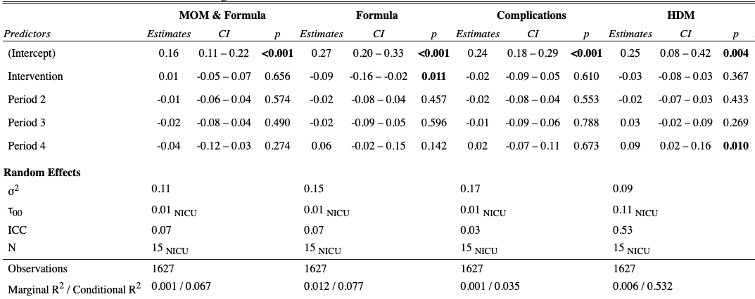
Note: MOM = Mother’s Own Milk; HDM = Human Donor Milk; CI = Confidence Interval; ICC = Intraclass Correlation Coefficient; NICU = Neonatal Intensive Care Unit; SD = Standard Deviation

Table 2: Secondary effectiveness outcomes at the infant level: multilevel regression analyses length of stay unadjusted and adjusted for gestational age
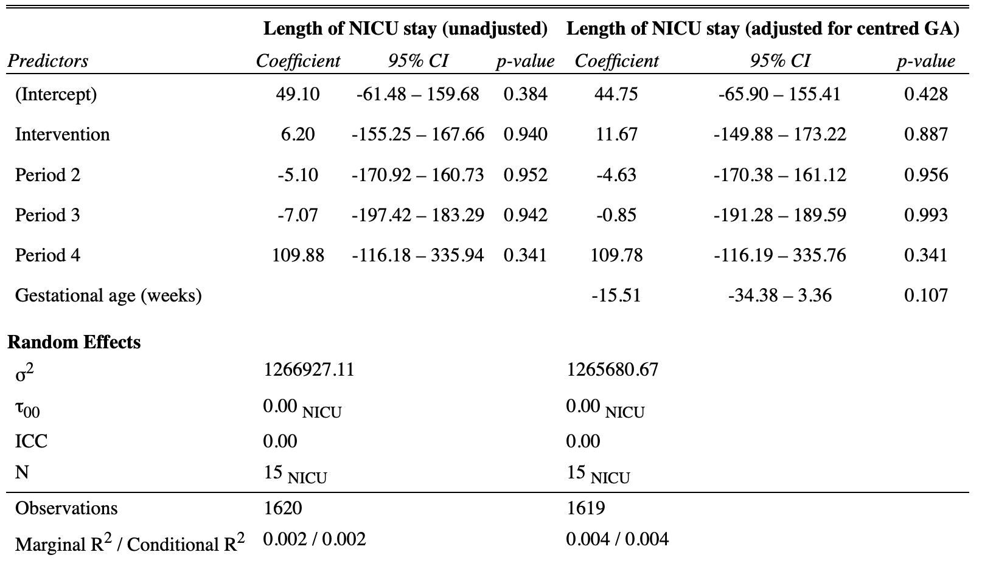
Note: CI = Confidence Interval; ICC = Intraclass Correlation Coefficient; NICU = Neonatal Intensive Care Unit; SD = Standard Deviation; GA = gestational age

Figure 1: Site-specific intervention effects on the primary endpoint

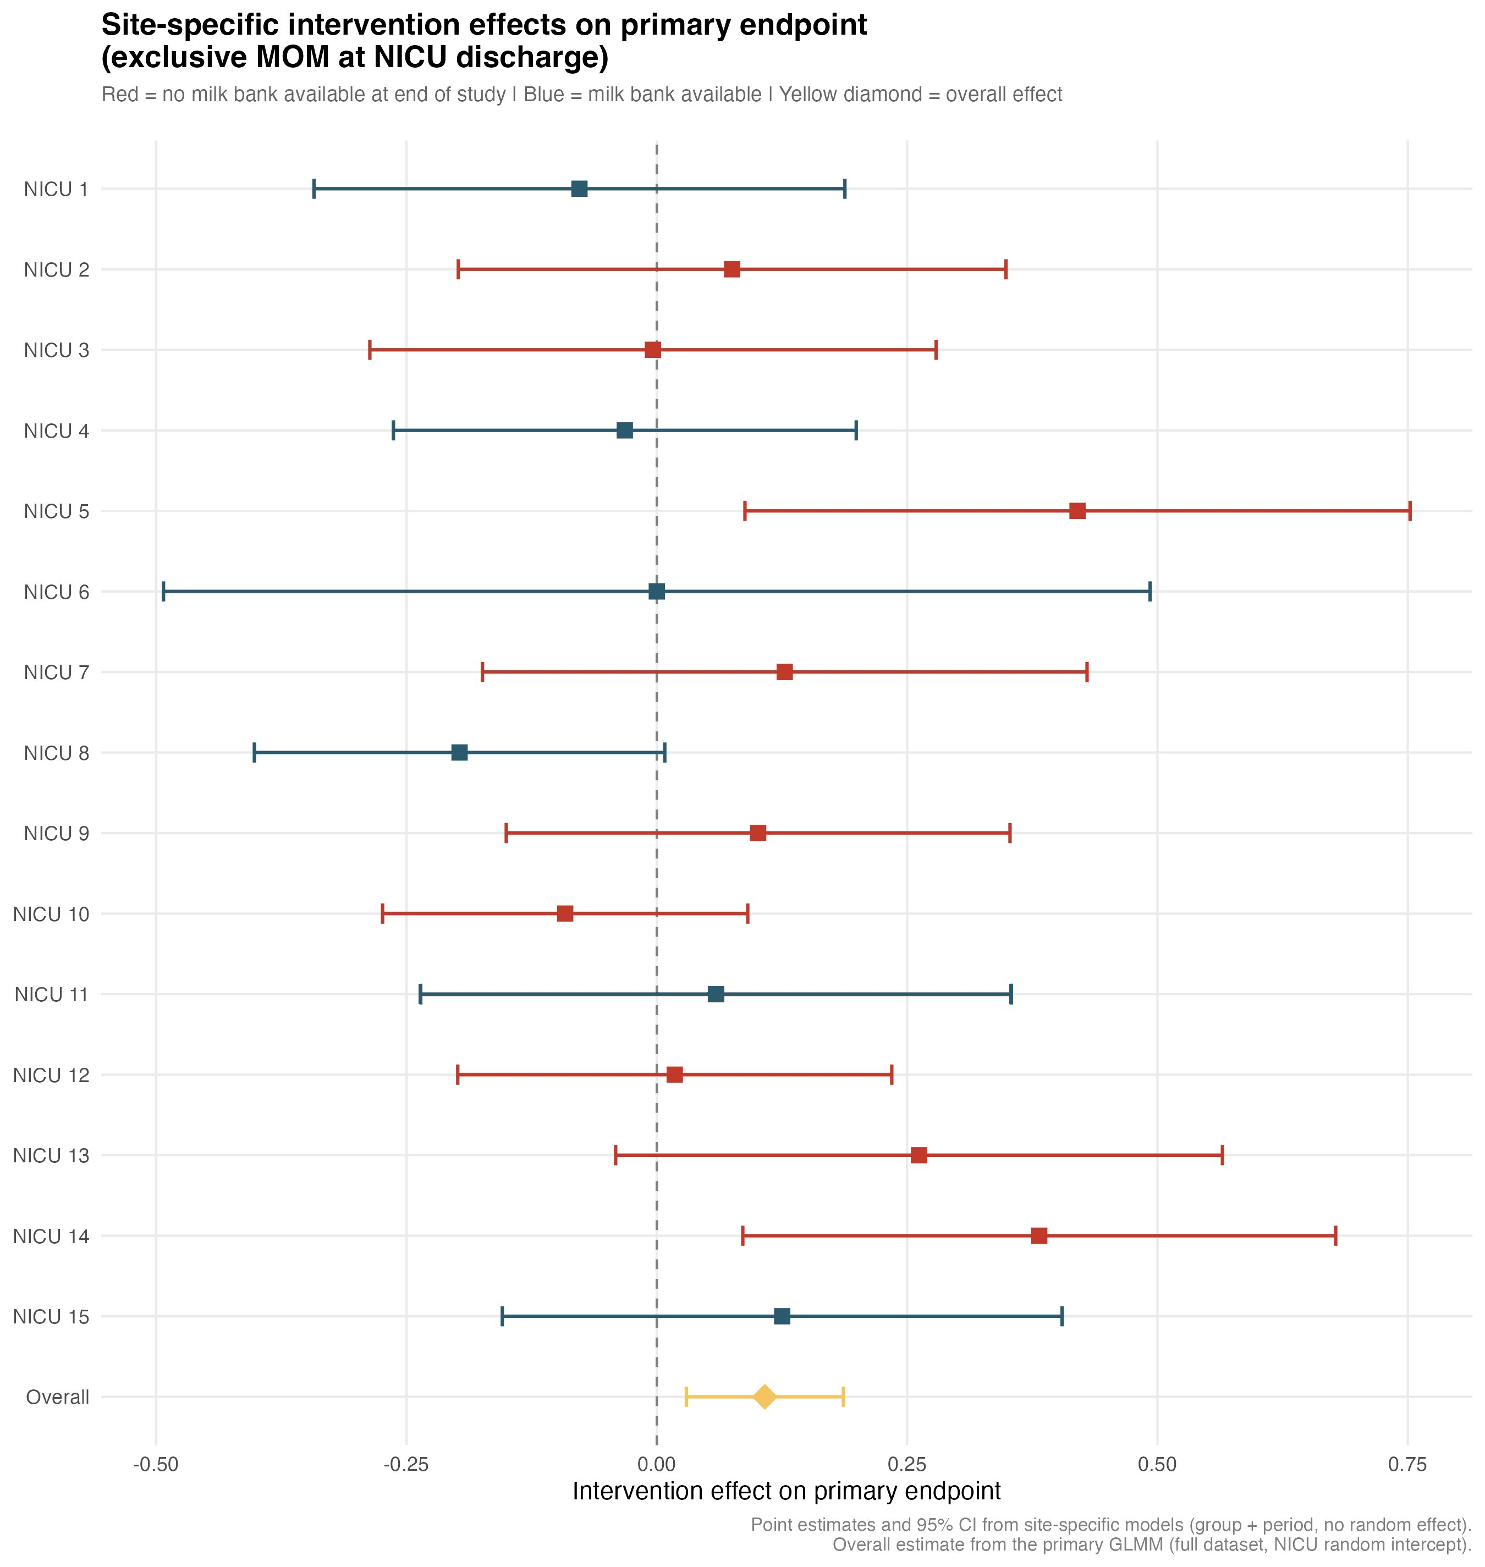

Maternal outcomes
Table 3: Regression results for maternal secondary outcomes, including lactation initiation, willingness to donate human milk, and willingness to accept human milk
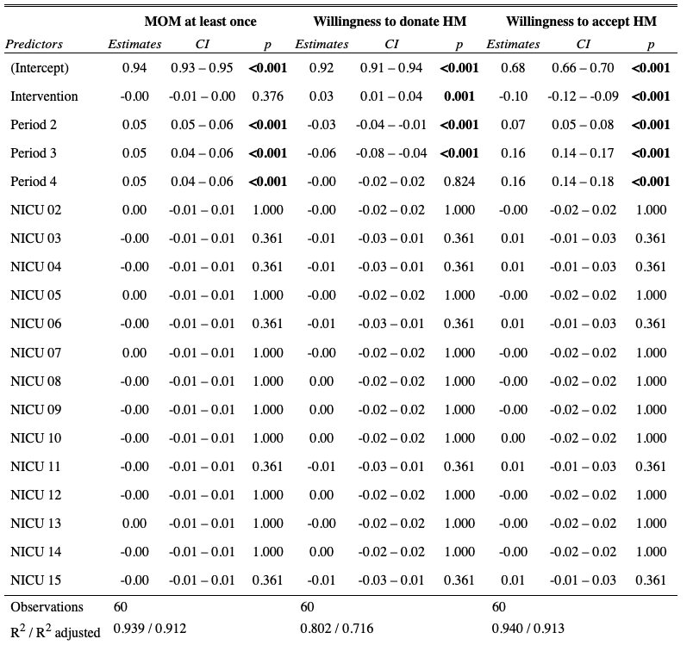

Note: MOM = Mother’s Own Milk; HDM = Human Donor Milk; CI = Confidence Interval; ICC = Intraclass Correlation Coefficient; NICU = Neonatal Intensive Care Unit; SD = Standard Deviation

Table 4: Multilevel regression analyses of two maternal secondary outcomes: breast-feeding self-efficacy and the amount of milk pumped 14 days postpartum
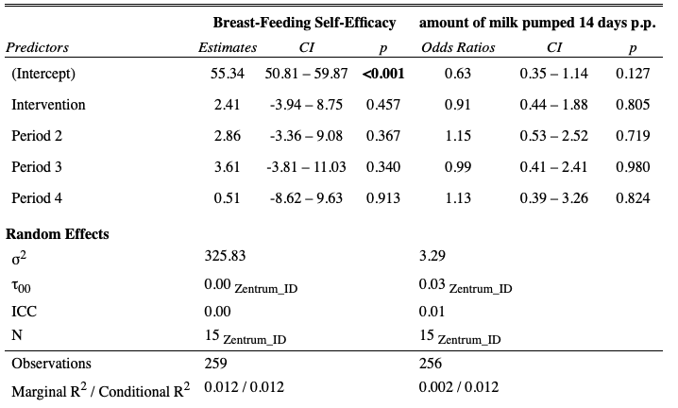

Note: CI = Confidence Interval; ICC = Intraclass Correlation Coefficient; NICU = Neonatal Intensive Care Unit; p.p = postpartum; SD = Standard Deviation

Table 5: Multilevel logistic regression analyses of the maternal secondary outcome amount of milk pumped 14 days postpartum (reaching the 500ml threshold 14d pp) and its association with birth weight
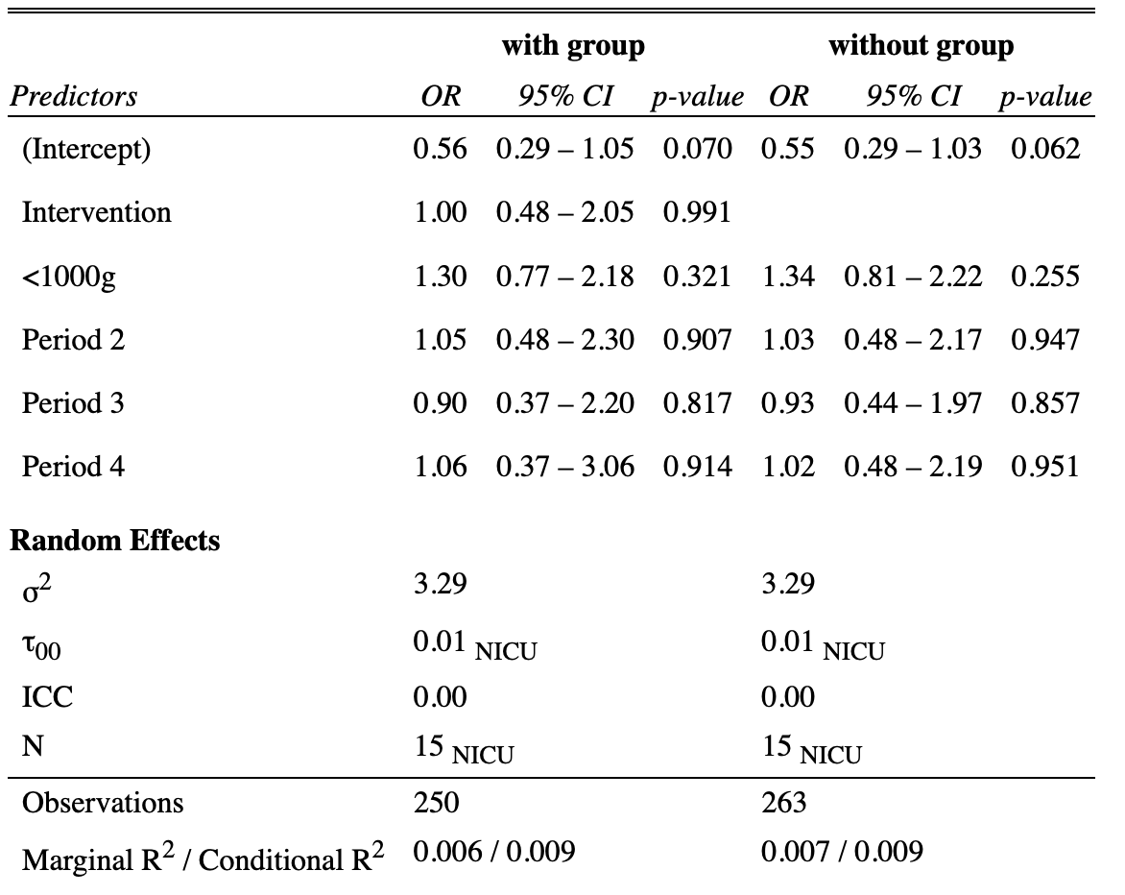
Note: CI = Confidence Interval; ICC = Intraclass Correlation Coefficient; NICU = Neonatal Intensive Care Unit; SD = Standard Deviation

