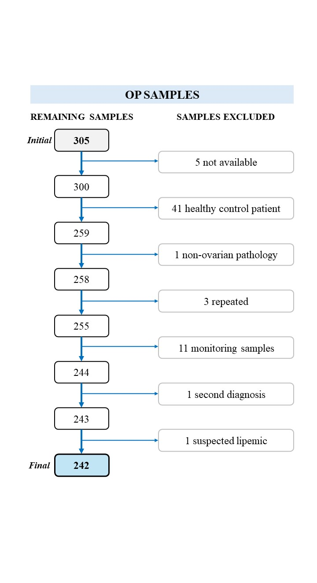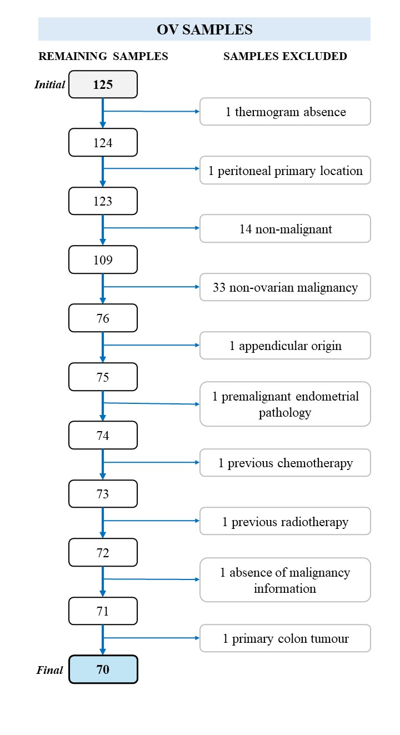
Figure S1: Sample selection flowcharts for prospective (OP) and retrospective (OV) cohorts. Flowcharts illustrate the stepwise selection process for both prospective (OP, left) and retrospective (OV, right) samples. From an initial 305 OP samples, 242 were retained after applying inclusion and exclusion criteria. In the OV cohort, 125 samples were available, of which 55 were excluded, resulting in 70 eligible samples. Reasons for exclusion and final sample counts are detailed at each step.

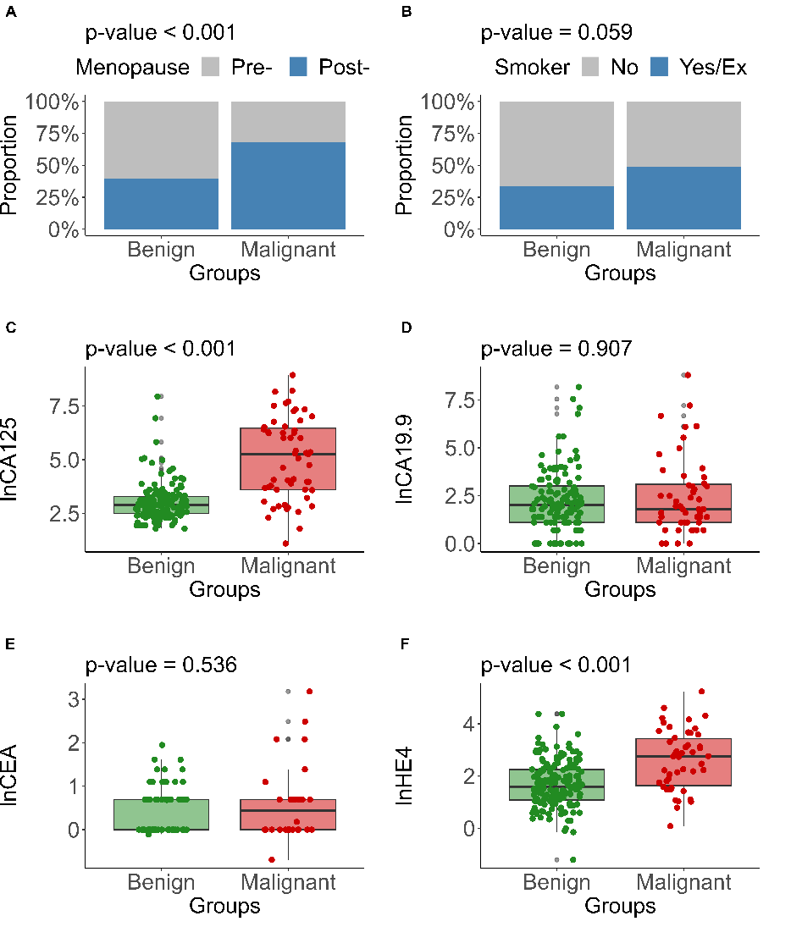
Figure S2: Bivariate analysis between tumor malignancy and different variables from the prospective study cohort. The figure shows the bivariate analysis between tumor malignancy and various variables from the prospective study cohort. Panel (A) depicts the association between menopause status and tumor malignancy (p-value < 0.001). Panel (B) shows the association between smoking status and tumor malignancy (p-value = 0.059). Panels (C), (D), (E), and (F) present box plots of ln(CA125), ln(CA19.9), ln(CEA), and ln(HE4) levels, respectively, in benign and malignant groups, with associated p-values of < 0.001, 0.907, 0.536, and < 0.001. The associated p-values were determined using the `compareGroups()´ function in R.

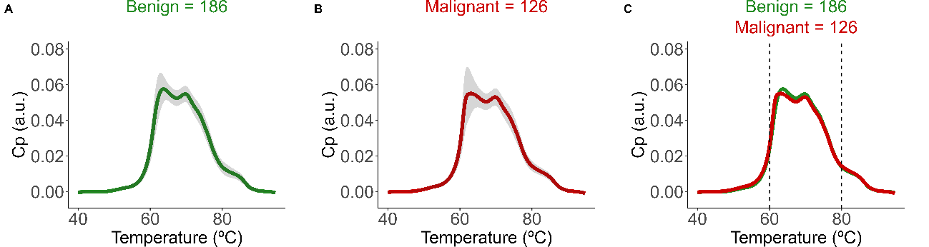

Figure S3: Mean thermograms from prospective and retrospective serum samples, with standard deviation shadow. The Y-axis represents the excess heat capacity (C_{p}) in arbitrary units (a.u.). (A) Mean thermogram in benign patients (n = 186). (B) Mean thermogram in malignant patients (n = 126). (C) Comparison of mean thermograms from benign (green, n = 186) and malignant (red, n = 126) samples.

Table S1: Final β coefficients of the variables selected for each iTLB+iClin predictive model obtained for training and validation samples with each model. The dash (–) indicates that the variable was not selected in that model.
 | MODEL 1 | MODEL 2
Predictor Variable | β Coefficient | β Coefficient
(Intercept) | 1.792 | 1.505
71 > 66 | -1.474 | –
62 > 64 | -1.387 | -0.572
lnCA125 | 1.234 | 1.323
lnHE4 | 0.649 | 0.885
67 > 66 | – | -1.449

Table S2: Results obtained for training and validation samples with each model. In bold, the highest value for each parameter. Note: Acc. = Accuracy; Sen. = Sensitivity; Spe. = Specificity; PPV = Positive Predictive Value; NPV = Negative Predictive Value; AUC = ROC AUC; OP = prospective; OV = retrospective.
MODEL |  | Acc. (%) | Sen. (%) | Spe. (%) | PPV (%) | NPV (%) | AUC
OP | iTLB+iClin 1 | 82.78 | 68.75 | 87.88 | 67.35 | 88.55 | 0.85
OP+OV | iTLB+iClin 2 | 83.40 | 78.64 | 87.12 | 82.65 | 83.94 | 0.91

Table S3: AUCs obtained for each stage with the different models. In bold, the highest value of AUC for each stage. Note: OP = prospective; OV = retrospective.
MODEL |  | AUC for early stages (I-II) | AUC for late stages (III-IV)
OP | iTLB+iClin 1 | 0.80 | 0.97
OP+OV | iTLB+iClin 2 | 0.86 | 0.97

Table S4: Success rates of the different models obtained. In bold, the highest value of success rate for each category. Note: OP = prospective; OV = retrospective.
MODEL |  | Success rate in benign (%) | Success rate in malignant (%) | Success rate in indeterminate (%)
OP | iTLB+iClin 1 | 87.88 | 68.75 | 72.22
OP+OV | iTLB+iClin 2 | 87.12 | 78.64 | 79.63

