Unequal health returns of healthy lifestyles across countries: the role of social and environmental contexts in healthy ageing
Running title: Unequal Health Returns of Healthy Lifestyles
Heng Wang¹, Yining Zhang¹, Yaqi Zhang¹, Yang Pei¹, Moluan Zhang², Jun Li¹, Koh-Hei Sonoda3, Jinghua Jiao4,*, Chingyu Cheng5,6,7,8,*, Lei Liu9,10,*, Han Zhang¹,*
1 Department of Ophthalmology, First Hospital of China Medical University, Shenyang, China.
2 School of Medicine, Gifu University, Gifu City, Japan.
3 Department of Ophthalmology, Graduate School of Medical Sciences, Kyushu University, Fukuoka, Japan.
4. Department of Anesthesiology, The Affiliated Panyu Central Hospital, Guangzhou Medical University, Guangzhou, China.
5. Singapore Eye Research Institute, Singapore National Eye Centre, Singapore.
6. Centre for Innovation and Precision Eye Health, Yong Loo Lin School of Medicine, National University of Singapore, Singapore.
7. Department of Ophthalmology, Yong Loo Lin School of Medicine, National University of Singapore, Singapore.
8. Ophthalmology & Visual Sciences Academic Clinical Program (Eye ACP), Duke-NUS Medical School, Singapore.
9. Department of Ophthalmology, Guangdong Eye Institute, Guangdong Provincial People's Hospital (Guangdong Academy of Medical Sciences), Southern Medical University, Guangzhou, China.
10. Medical Big Data Center, Guangdong Provincial People's Hospital (Guangdong Academy of Medical Sciences), Southern Medical University, Guangzhou, China.
# Correspondence to Jinghua Jiao, Department of Anesthesiology, The Affiliated Panyu Central Hospital, Guangzhou Medical University, Guangzhou, China. Email: jean0905@163.com; Chingyu Cheng, Singapore Eye Research Institute, Singapore National Eye Centre, Singapore; Centre for Innovation and Precision Eye Health, Yong Loo Lin School of Medicine, National University of Singapore, Singapore; Department of Ophthalmology, Yong Loo Lin School of Medicine, National University of Singapore, Singapore; Ophthalmology & Visual Sciences Academic Clinical Program (Eye ACP), Duke-NUS Medical School, Singapore; Email: chingyu.cheng@nus.edu.sg; Lei Liu, Medical Big Data Center, Guangdong Provincial People's Hospital (Guangdong Academy of Medical Sciences), Southern Medical University, Guangzhou, China. Email: liulei@gdph.org.cn; Han Zhang, Department of Ophthalmology, First Hospital of China Medical University, Shenyang, China. Email: hanzh@cmu.edu.cn.

Supplementary Figure S1:Cohort design and analytic time windows
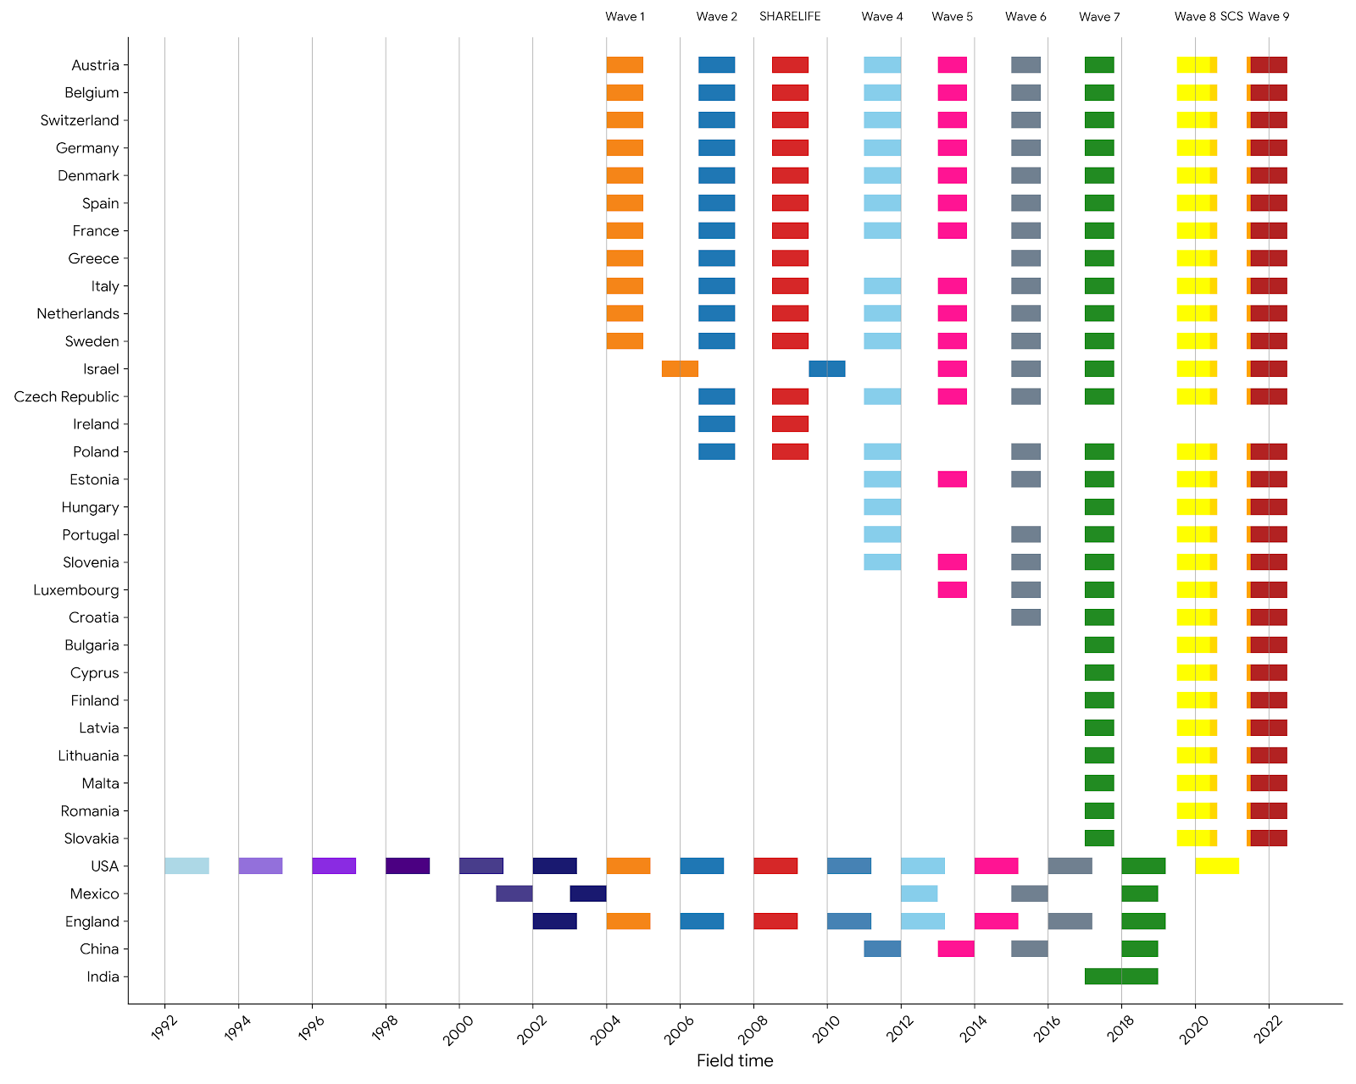

Supplementary Table S1:Ethical Approval of Cohort Studies
Cohort | Country / region | Ethics approval | Approval ID | Informed consent
CHARLS | China | Approved by the Institutional Review Board (IRB) at Peking University | IRB00001052-11015 (main survey); IRB00001052-11014 (biomarker collection) | Written informed consent; separate consents covering main interview and biomarker/blood collection and storage
ELSA | UK | Approved by the National Research Ethics Service / Research Ethics Committees (wave-specific approvals) | Wave-specific REC references (Wave 1–Wave 11 listed by ELSA,https://www.elsa-project.ac.uk/ethical-approval) | Informed consent obtained (as documented in ELSA materials/publications)
HRS | United States | Approved by the University of Michigan Health Sciences and Behavioral Sciences IRB (HSBS) | HUM00061128 (protocol; plus related protocols listed in HRS IRB document) | Written/oral consent procedures described; additional written consent for specific linkages/biomarkers as applicable
SHARE | Europe (multi-country) | Ethics approvals centrally documented; additional country-specific approvals as required | Central approvals include University of Mannheim ethics committee (waves 1–4) and Max Planck Society Ethics Council (continuation); https://share-eric.eu/fileadmin/user_upload/Ethics_Documentation | Informed consent procedures implemented across participating countries (documentation described in SHARE materials)
LASI | India | Ethical approvals were obtained from the following collaborating organizations: Indian Council of Medical Research (ICMR), Delhi; IRB, International Institute for Population Sciences (IIPS), Mumbai; IRB, Harvard T.H. Chan School of Public Health (HSPH), Boston; IRB, University of Southern California (USC), Los Angeles; IRB, ICMR-National AIDS Research Institute (NARI), Pune; and IRB, Regional Geriatric Centres (RGCs), MoHFW. | IRB/ethics details are described in the cohort’s official documentation | Household and individual informed consent forms are embedded in the LASI Wave 1 survey instrument
MHAS | Mexico | Approved by the Institutional Review Board of the University of Texas Medical Branch (UTMB); approvals in Mexico also documented | UTMB IRB Protocol #11-061 | Informed consent obtained from all subjects (as stated in a peer-reviewed MHAS-based publication)

Supplementary Table S2:Harmonised items used to derive the Healthy Ageing Index (HAI)
Item | Definition | CHARLS | ELSA | HRS | LASI | MHAS | SHARE
Memory | Self-reported ratings of memory at the time of the interview. | R3SLFMEM | R8SLFMEM | R13SLFMEM |  | R5SLFMEM | R8SLFMEM
Immediate recall | Immediate recall of common nouns from a list. | R3IMRC | R8IMRC | R13IMRC | R1IMRC | R5IMRC8 | R8IMRC
Delayed recall | Test that assesses delayed recall using the common nouns from the list previously employed for measuring Immediate recall. | R3DLRC | R8DLRC | R13DLRC | R1DLRC | R5DLRC8 | R8DLRC
Verbal fluency | Test that assesses verbal (semantic) fluency |  | R8VERBF |  |  | R5VERBF | R8VERBF
Orientation in time | Difficulties for orientation in time, evaluated by a set of questions about the date and day of the week. | R3ORIENT | R8ORIENT | R13ORIENT | R1ORIENT |  | R8ORIENT
Processing speed | Test which assesses processing speed. |  |  |  |  | R5VSCAN
Numeracy | Test that assesses numeracy. |  | R8NUMER_E |  | R1COMPU |  | R8NUMER_S
Sleeping | Sleeping problems | R3SLEEPRL | R8SLEEPR | R13SLEEPR | R1FALLSLP | R5SLEEPR | R8SLEEP
Pain | It measures if the participant experiences some degree of pain or if the participant does not present any pain at all. | DA041 | R8PAINFR | R13PAINLV | R1PAINFR | R5PAINFR | R8PAINFR
Energy | Self-reported high level of energy experienced at the time of the interview. | R3EFFORTL | R8FENERG | R13EFFORT | R1EFFORTL | R5ENERG | R8FATIG
Urine incontinence | It measures if the participant has experienced loss of urine (or has used any special device for urine leakage) | R3URINA | R8URINAI | R13URINAI | R1URINAE
Near vision | Difficulties for near vision. | DA034 | R8NSIGHT | R13NSIGHT | R1NSIGHTA |  | R8NSIGHT
Far vision | Difficulties for far vision. | DA033 | R8DSIGHT | R13DSIGHT | R1DSIGHTA |  | R8DSIGHT
Eyesight | Difficulties in eye sight using glasses or corrective lens as usual. | DA005_3_ | R8SIGHT | R13SIGHT |  | R5SIGHT
Hearing in general | It measures if the participant experiences some difficulty for hearing (i.e., hearing someone talking on the other side of the room in a normal voice) or not, using a hearing aid as usual. | DA005_4_ | R8HEARING | R13HEARING | R1HEARCNDE | R5HEARING | R8HEARING
Hearing in a conversation | It measures if the participant experiences some difficulty (including total disability) for following a conversation (i.e., if there is a background noise, or several people talking) or not, using a hearing aid as usual.
Stooping, kneeling or crouching | Difficulty for stooping, kneeling or crouching | R3STOOPA | R8STOOPA | R13STOOPA |  | R5STOOPA | R8STOOPA
Lifting or carrying weights | Difficulty for lifting or carrying weights | R3LIFTA | R8LIFTA | R13LIFTA |  | R5LIFTA | R8LIFTA
Climbing stairs | Difficulty for climbing stairs | R3CLIMSA | R8CLIM1A | R13CLIM1A |  | R5CLIMSA | R8CLIM1A
Getting up | Difficulty for getting up from sitting down | R3CHAIRA | R8CHAIRA | R13CHAIRA |  | R5CHAIRA | R8CHAIRA
Walking | Difficulty for walking by yourself and without using any special equipment | R3WALK1KMA/R3WALK100A | R8WALK100A | R13WALKSA | R1WALK100A | R5WALK1A/R5WALKSA | R8WALK100A
Pulling or pushing | Difficulty for pulling or pushing large objects |  | R8PUSHA | R13PUSHA |  | R5PUSHA | R8PUSHA
Sitting | Difficulty for sitting for long periods | DB004 | R8SITA | R13SITA |  | R5SITA | R8SITA
Reaching or extending arms | Difficulty for reaching / extending arms | R3ARMSA | R8ARMSA | R13ARMSA |  | R5ARMSA | R8ARMSA
Walking speed | It is measured assessing the time that is taken to walk a distance.
Dizziness | Dizziness problems when walking on a level surface |  |  | R13DIZZY
Picking up | Difficulty for picking up things with fingers, e.g. picking up a coin. | R3DIMEA | R8DIMEA | R13DIMEA |  | R5DIMEA | R8DIMEA
Getting in or out of bed | Difficulty for getting in or out of bed | R3BEDA | R8BEDA | R13BEDA | R1BEDA | R5BEDA | R8BEDA
Bathing or showering | Difficulties for bathing or showering | R3BATHA | R8BATHA | R13BATHA | R1BATHA | R5BATHA | R8BATHA
Getting dressed | Difficulty for getting dressed | R3DRESSA | R8DRESSA | R13DRESSA | R1DRESSA | R5DRESSA | R8DRESSA
Moving around the home | Difficulty for moving around the home |  | R8WALKRA | R13WALKRA |  | R5WALKRA | R8WALKRA
Toilet | Difficulties for using the toilet | R3TOILTA | R8TOILTA | R13TOILTA | R1TOILTA | R5TOILTA | R8TOILTA
Eating | Difficulties for eating | R3EATA | R8EATA | R13EATA | R1EATA | R5EATA | R8EATA
Housework | Difficulties for doing housework | R3HOUSEWKA | R8HOUSEWKA | R13LIMHWRK |  |  | R8HOUSEWKA
Shopping | Difficulties for shopping groceries | R3SHOPA | R8SHOPA | R13SHOPA |  | R5SHOPA | R8SHOPA
Getting out of the house | Difficulties for getting out of the house
Meals | Difficulties in preparing meals | R3MEALSA | R8MEALSA | R13MEALSA |  | R5MEALSA | R8MEALSA
Map | Difficulties for using a map |  | R8MAPA | R13MAPA |  |  | R8MAPA
Money | Difficulties for managing money, bills, or expenses | R3MONEYA | R8MONEYA | R13MONEYA |  | R5MONEYA | R8MONEYA
Medications | Difficulties for taking medications | R3MEDSA | R8MEDSA | R13MEDSA |  | R5MEDSA | R8MEDSA
Telephone | Difficulties for using telephone | R3PHONEA | R8PHONEA | R13PHONEA |  |  | R8PHONEA

Note: Leaving a blank indicates that no usable data is available in the GAD coordinated dataset, possibly due to planned missing or changes in the follow-up questionnaire.

Supplementary Methods S1:Definition of Four-component healthy lifestyle score (HLS-4)
The selection of the alcohol consumption threshold was primarily determined by the measurement methods used in the GAD harmonised datasets and the specific risks alcohol poses to the elderly. In the GAD harmonised datasets, most cohorts captured drinking frequency and quantity (typically in "glasses" via self-report) over intervals ranging from one day to one month. We standardized these measures into the number of drinks consumed per week. In the absence of specific ethanol-to-gram conversion data, this serves as the most feasible and comparable unit.

We defined high-risk or heavy drinking as consuming more than 7 drinks per week, based on the dose-response relationship between alcohol intake, all-cause mortality, and incident cardiovascular events. Research indicates that the nadir of all-cause mortality risk occurs at approximately <100 g of pure alcohol per week; risk for both mortality and cardiovascular disease begins to rise significantly beyond this point[36-38]. Given evidence that older adults may be more sensitive to alcohol, we set the high-risk threshold at 100 g/week. This equates to 14.3 g of alcohol daily, which aligns closely with the U.S. "standard drink" (e.g., 12 oz of regular beer at 5% ABV, 5 oz of wine at 12% ABV, or 1.5 oz of 40% ABV distilled spirits). While this threshold may be lower than those found in some general guidelines, we consider it appropriate given that most guidelines are developed for general adults rather than the elderly. The follow-up questionnaires typically use descriptions such as "pint of normal beer" or "glass of wine" (or common local alcoholic beverages). These descriptions generally estimate the alcohol content of a single drink to be between 12g and 16g, while a standard drink is estimated at 14g. Therefore, we consider this estimation method reasonable. In summary, thresholds were pre-defined based on data availability and professional expertise. We acknowledge potential measurement errors, which would likely bias the estimation of Δ[L4–L1] toward the null.

Referencing similar studies, we categorized the population into current smokers and non-current smokers (the latter including never-smokers and former smokers). Research shows that among participants aged 60 and older, the pooled hazard ratio (HR) is 2.07 (95% CI: 1.82–2.36) for current smokers and 1.37 (95% CI: 1.25–1.49) for former smokers compared to never-smokers. The excess risk among smokers follows a dose-response relationship with consumption, while the risk for former smokers decreases consistently with the duration of cessation[39]. The benefits of quitting are evident across all age groups, including those 80 and older[40]. Study from NEJM indicates that smoking reduces life expectancy by at least 10 years compared to never-smoking; however, quitting before age 40 reduces the excess risk of death by approximately 90%.[41]

Thresholds for physical activity (PA) were likewise determined by cross-cohort data availability and the protective effects of PA in older populations. PA levels across all cohorts were self-reported, typically as the frequency of activity per week or month (often without precise durations or Metabolic Equivalent of Task [MET] values). To ensure comparability, we defined "active" as engaging in Moderate-to-Vigorous Physical Activity (MVPA) more than once per week. MVPA was generally defined in questionnaires as activities such as brisk walking, cycling, swimming, or running, including occupational physical activity. Some cohorts did not measure light-intensity activity. Studies show a significant inverse correlation and a non-linear dose-response relationship between total PA and mortality risk in the elderly. The greatest marginal benefit often occurs during the transition from inactivity to low-level activity, suggesting that even small amounts of PA can significantly reduce all-cause mortality in older adults[42]. Among all types of exercise, MVPA has been proven to offer the greatest benefit, as light activity requires significantly longer durations to achieve similar energy expenditure. As with alcohol consumption, current definitions may involve measurement errors, likely resulting in conservative estimates of the overall association.

Regarding BMI (kg/m²), measured values were prioritized over self-reported values, with the latter used only when measurements were missing to maximize sample size. To ensure cross-cohort comparability and consistency with previous literature, we adopted the international WHO BMI classification framework. "Healthy weight" was defined as 18.5-24.9 kg/m², while deviations (underweight, overweight, and obesity) were classified as "unhealthy."
While some researchers propose the "BMI paradox"—suggesting that mild obesity (e.g., BMI = 27.0 kg/m²) may be protective for the elderly—meta-analyses have yielded inconsistent results. Specifically, meta-analyses indicate that for individuals aged 60, mortality is lowest within the 20.0–<25.0 kg/m² range[43]. Furthermore, research shows that Asian populations exhibit higher cardiovascular and metabolic risks at lower BMI levels (18.5–23.9 kg/m²) than Western populations. However, since the Western cohorts (like HRS) in this study also contain significant Asian populations, applying a lower "healthy" BMI threshold specifically for CHARLS and LASI might introduce new biases. Therefore, we maintained 18.5-24.9 kg/m² as the uniform standard. As noted previously, this definition may lead to a conservative estimation of the overall associations.

Supplementary Methods S2:ATHLOS Healthy Ageing Index: IRT model and score computation
The Healthy Ageing Index (HAI) was developed by the ATHLOS consortium to place individuals from multiple cohorts on a single, comparable “healthy ageing” latent trait scale derived from harmonised intrinsic capacity and functional ability items (K = 41; items coded as presence/absence of difficulty, with some continuous indicators dichotomised at the first quartile). HAI is based on a unidimensional two-parameter logistic item response theory model (2PL), in which the probability that person p endorses item i (response r = 0/1) is modelled as:
$$logit(P(x_{ip}=r∣a_{i},b_{i},θ_{p}))=−a_{i}(θ_{p}−b_{i}), r∈\{0,1\}.$$
, where a_i is the item discrimination (slope), b_i is the item difficulty (location), and θ_p is the individual’s latent healthy ageing level; under the unidimensionality assumption, the likelihood of an individual response pattern is the product of item probabilities
$$P(X_{p}∣a,b,θ_{p})=\prod_{i=1}^{K}{P}(x_{ip}∣a_{i},b_{i},θ_{p}).$$
. Item parameters were estimated using full-information maximum likelihood (EM with numerical quadrature), which natively accommodates missingness under standard IRT assumptions, and individual latent trait scores were obtained via expected a-posteriori (EAP) estimation using Bayes’ rule:
$$P(θ_{p}∣X_{p},a,b)=\frac{P(θ_{p}) P(X_{p}∣θ_{p},a,b)}{\int_{−∞}^{+∞}{P}(θ) P(X_{p}∣θ,a,b) dθ}.$$
, with the EAP point estimate computed as
$${\overset{̂}{θ}}_{p}^{}=\frac{\int_{−∞}^{+∞}{θ} P(θ) \prod_{i=1}^{K}{P}(x_{ip}∣a_{i},b_{i},θ) dθ}{\int_{−∞}^{+∞}{P}(θ) \prod_{i=1}^{K}{P}(x_{ip}∣a_{i},b_{i},θ) dθ}.$$
(approximated numerically). To demonstrate that the IRT model yields comparable scores across cohorts (despite cohorts having different subsets of available items), ATHLOS evaluated overall model fit and the unidimensionality/conditional-independence assumption using confirmatory factor analysis for categorical data under a limited-information estimator (diagonally weighted least squares), reporting standard fit indices (RMSEA, CFI, TLI); because categorical CFA requires complete item matrices, missing responses were imputed conditional on the fitted IRT model and preliminary θ estimates, and fit evaluation was repeated multiple times with negligible variation in indices, supporting stable global fit. Cohort-to-cohort comparability was further assessed by (i) computing intraclass correlation coefficients (ICC) between the main (global) scale scores and cohort-specific scores when the common-item parameters were fixed to the main-scale calibrations—high ICCs indicate that differences in item availability do not materially alter individuals’ relative standing—and (ii) explicitly addressing cross-study measurement non-invariance via differential item functioning (DIF) detection using an ordinal-logistic-regression IRT framework (nested models with θ, study, and θ×study terms; DIF flagged by clinically relevant changes in the θ coefficient), followed by Stocking–Lord equating to map cohort-specific metrics onto the main ATHLOS metric through a linear transformation with multiplicative and additive constants, $θ_{eq}=c_{mult}⋅θ+c_{add}$(constants reported per study), thereby aligning test characteristic curves over a θ grid and ensuring a common unit and origin. Finally, equated latent trait scores were rescaled into an interpretable T-score metric to avoid negative/decimal values: $T=θ_{eq}⋅\frac{10}{SD(θ_{eq})}+50$, where higher T-scores indicate healthier ageing. In our research, to ensure cross-cohort comparability, we applied published item parameters.

Presence or absence of difficulties | IRT parameter estimates and standard errors
Presence or absence of difficulties | Discrimination |  | Difficulty
Memory | 0.8332 | (0.0059) | -0.5914 | (0.0065)
Immediate recall | 0.6325 | (0.0049) | -0.9731 | (0.0092)
Delayed recall | 0.6714 | (0.0051) | -1.2130 | (0.0100)
Verbal fluency | 0.6080 | (0.0057) | -1.6981 | (0.0160)
Orientation in time | 0.8449 | (0.0078) | -1.7307 | (0.0155)
Processing speed | 0.5912 | (0.0144) | -1.9291 | (0.0453)
Numeracy | 1.0404 | (0.0118) | -1.9586 | (0.0203)
Sleeping | 0.8334 | (0.0052) | -0.5605 | (0.0057)
Experiences some degree of pain | 1.0616 | (0.0059) | -0.1463 | (0.0042)
Having high level of energy | 0.9119 | (0.0054) | -0.5781 | (0.0054)
Urinary incontinence | 1.0969 | (0.0111) | -2.3546 | (0.0196)
Near vision | 0.9438 | (0.0061) | -0.9104 | (0.0069)
Far vision | 1.2639 | (0.0075) | -1.1091 | (0.0062)
Eyesight using glasses or lens as usual | 0.9421 | (0.0086) | -1.5122 | (0.0126)
Hearing in general | 0.8212 | (0.0067) | -1.9818 | (0.0151)
Hearing in a conversation | 0.8426 | (0.0107) | -2.2121 | (0.0262)
Stooping,kneeling or crouching | 2.4717 | (0.0120) | -0.5059 | (0.0029)
Lifting or carrying weights | 2.7130 | (0.0134) | -0.7834 | (0.0031)
Climbing stairs | 2.7327 | (0.0137) | -0.7940 | (0.0031)
Getting up from sitting down | 2.4166 | (0.0125) | -0.8256 | (0.0035)
Walking by yourself and without any  equipment | 3.1335 | (0.0161) | -0.8763 | (0.0030)
Pulling or pushing large objects | 3.1691 | (0.0202) | -0.8848 | (0.0036)
Sitting for long periods | 2.0455 | (0.0114) | -1.1322 | (0.0047)
Reaching or extending arms | 2.1929 | (0.0129) | -1.4727 | (0.0054)
Walking speed | 0.8995 | (0.0111) | -1.6364 | (0.0160)
Dizziness when walking on a level surface | 1.3230 | (0.0128) | -1.7363 | (0.0142)
Picking up things with fingers | 2.3139 | (0.0156) | -1.8427 | (0.0068)
Getting in or out of bed | 3.4954 | (0.0239) | -1.4949 | (0.0044)
Bathing or showering | 3.5997 | (0.0253) | -1.5996 | (0.0045)
Getting dressed | 2.6935 | (0.0180) | -1.6404 | (0.0055)
Moving around the home | 3.4746 | (0.0271) | -1.6976 | (0.0053)
Using the toilet | 3.5668 | (0.0277) | -1.7960 | (0.0054)
Eating | 3.0627 | (0.0255) | -2.0989 | (0.0073)
Doing housework | 3.1663 | (0.0185) | -1.0530 | (0.0035)
Shopping for groceries | 4.3188 | (0.0376) | -1.3521 | (0.0045)
Getting out of the house | 3.4506 | (0.0377) | -1.3939 | (0.0056)
Difficulties in preparing meals | 3.8589 | (0.0360) | -1.5886 | (0.0058)
Using a map | 1.6814 | (0.0149) | -1.6329 | (0.0108)
Managing money,bills or expenses | 2.4045 | (0.0266) | -1.8498 | (0.0107)
Taking medications | 3.0022 | (0.0311) | -2.0162 | (0.0096)
Making telephone calls | 2.9271 | (0.0332) | -2.0392 | (0.0108)

Supplementary Figure S2: Sensitivity: robustness to latent-class assumptions for eHAYs
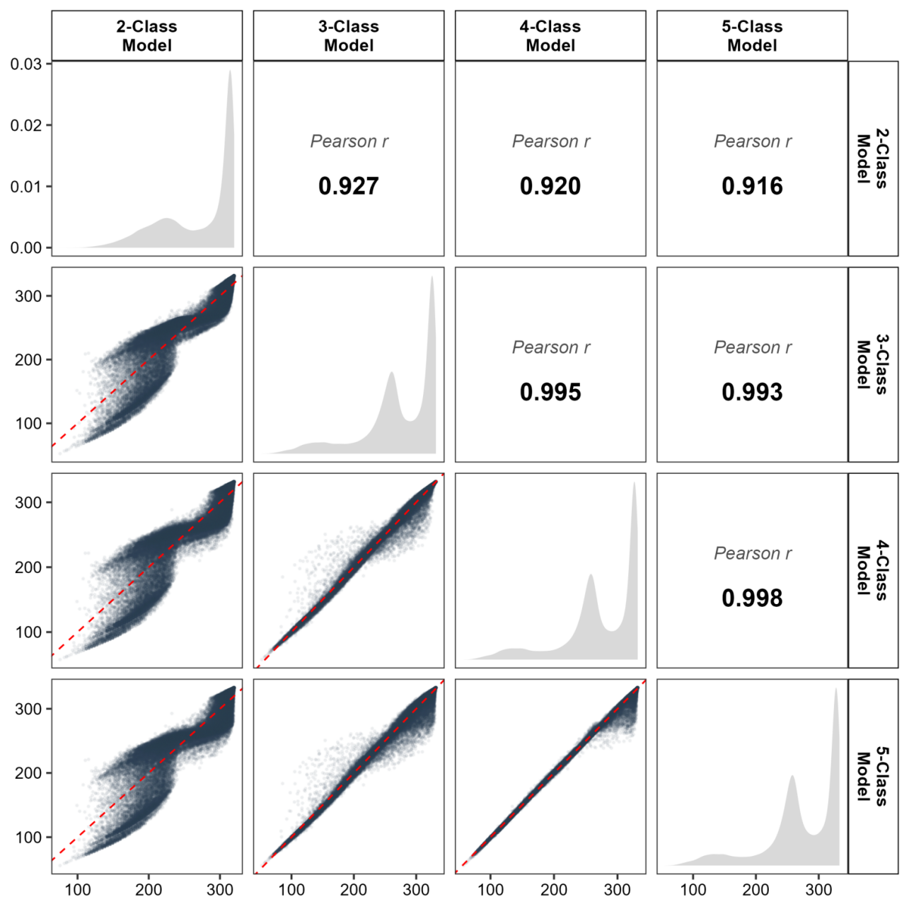
Note: The diagonal panels display the density distribution of eHAYs for each respective model. The lower triangular panels present scatter plots of individual-level eHAYs between models; the red dashed line represents the identity line. The upper triangular panels show the corresponding Pearson correlation coefficients.

Supplementary Figure S3: Directed acyclic graph
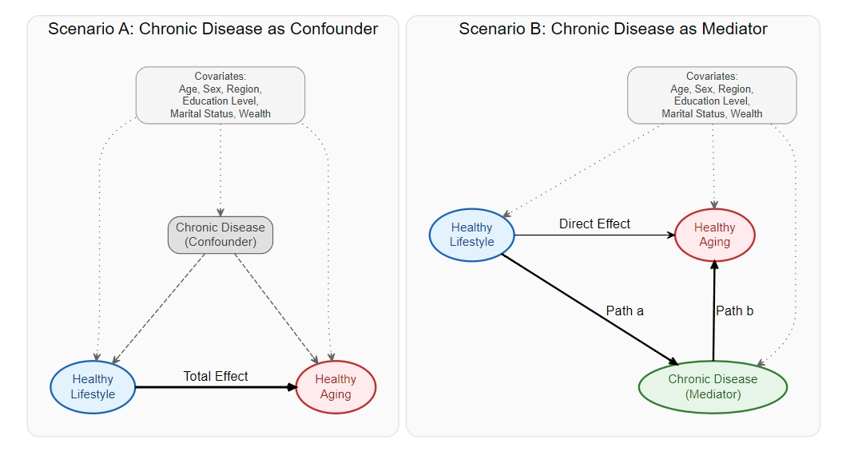
In the diagram, blue represents exposure; red represents outcome; gray represents confounding factors; and green represents mediating factors. Dashed lines represent back-door path while solid line represent front-door path.

Supplementary Figure S4: Sensitivity: Cross-sectional HAI standardized prediction marginal model (1 point: Participate in MVPA activities ≥1 per week; 0 points: Participate in MVPA activities ＜1 per week.)

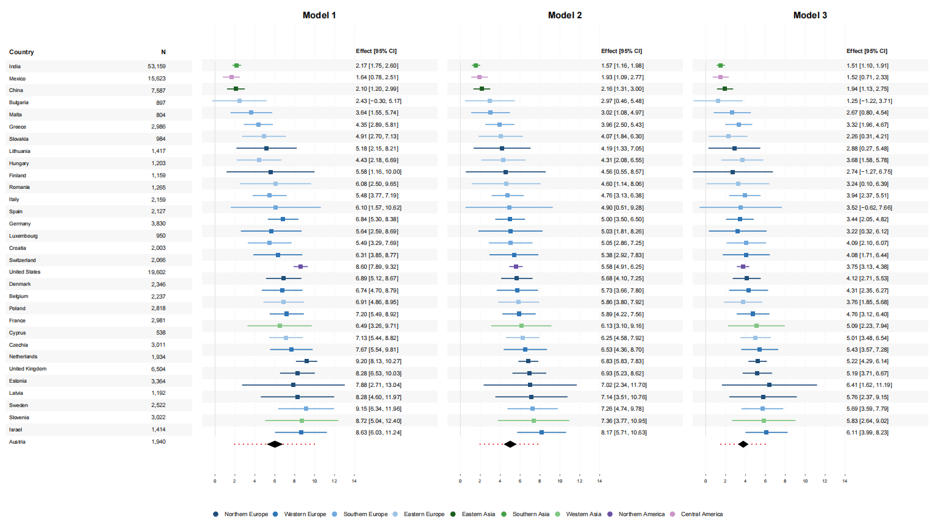

Supplementary Figure S5: Sensitivity: Cross-sectional HAI standardized prediction marginal model (1 point: Participate in MVPA activities ≥3 per week; 0 points: Participate in MVPA activities ＜3 per week.)

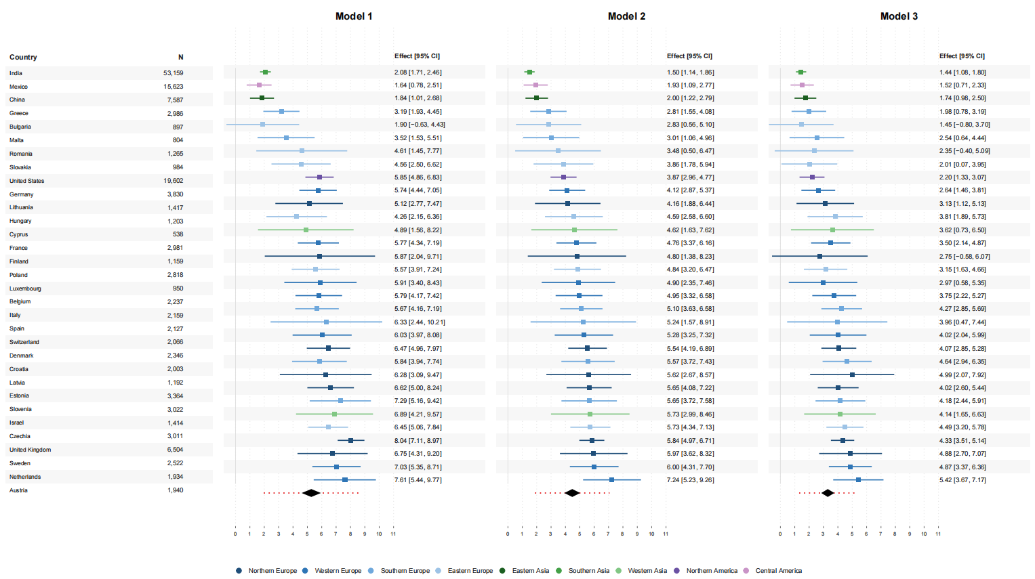

Supplementary Figure S6: Sensitivity: Standardized Marginal Prediction Model for Longitudinal eHAYs (1 point: Participate in MVPA activities ≥1 per week; 0 points: Participate in MVPA activities ＜1 per week.)
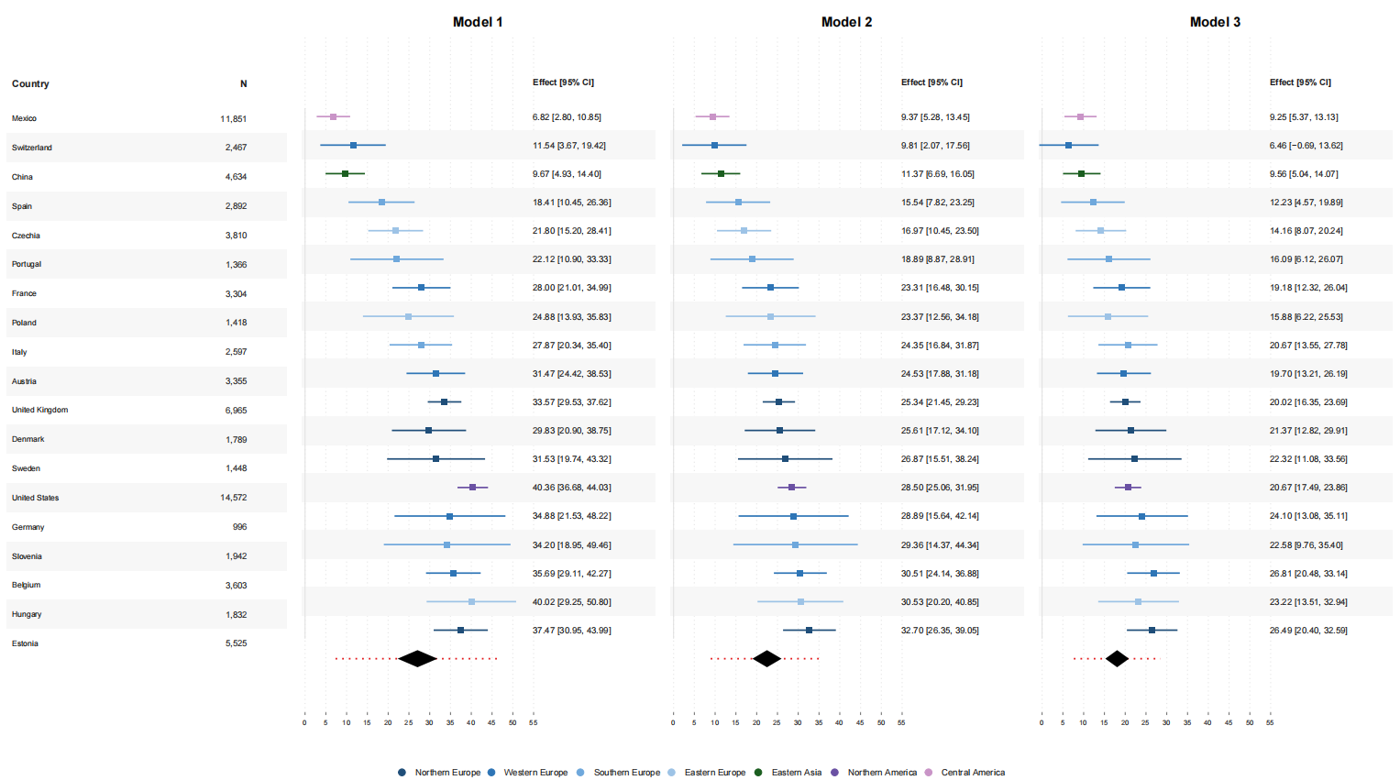

Supplementary Figure S7: Sensitivity: Standardized Marginal Prediction Model for Longitudinal eHAYs (1 point: Participate in MVPA activities ≥3 per week; 0 points: Participate in MVPA activities ＜3 per week.)
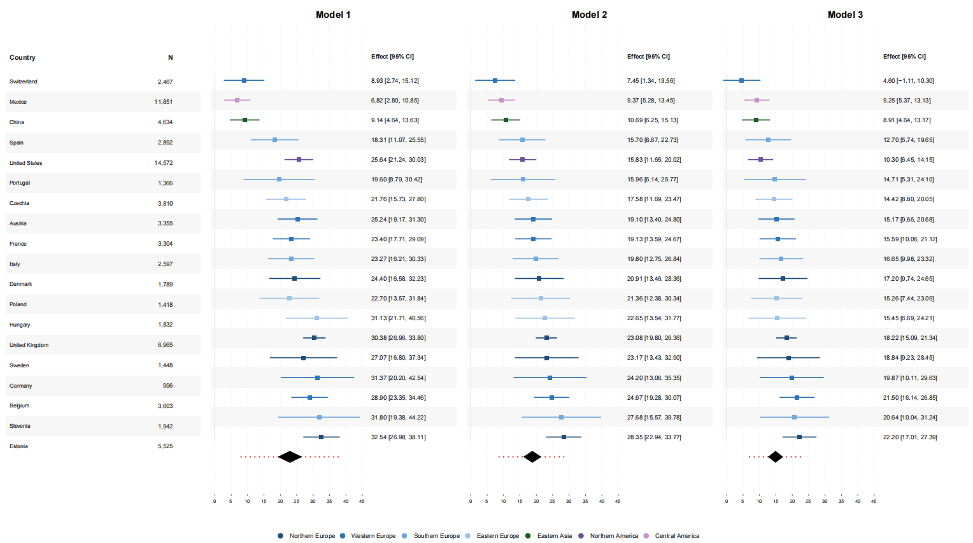

Supplementary Figure S8: Sensitivity: Cross-sectional HAI standardized prediction marginal model (using SHARE Wave 7 follow-up data)

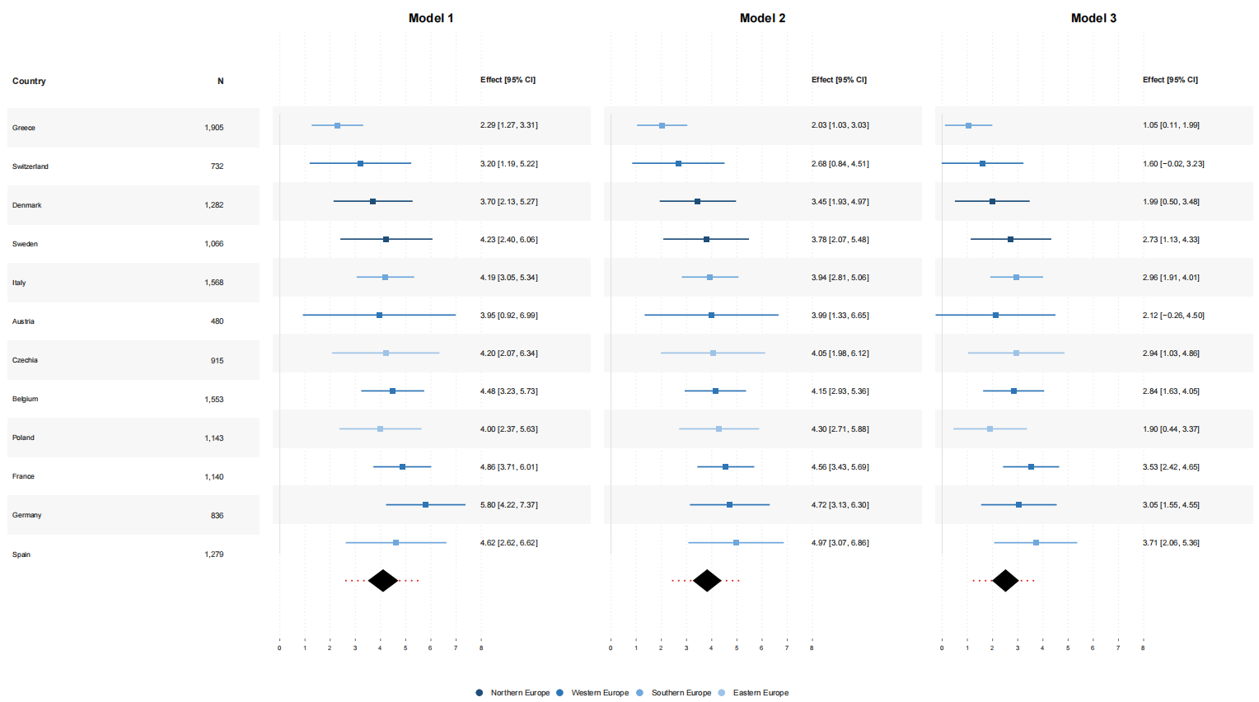

Supplementary Figure S9: Study flow diagram
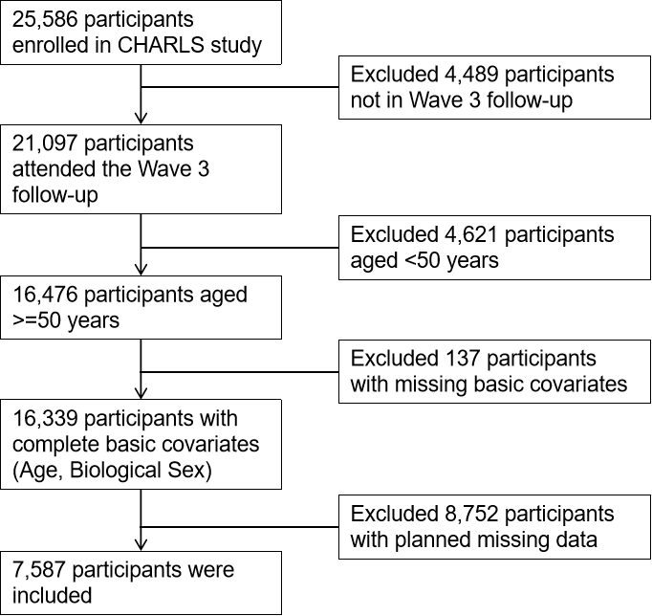
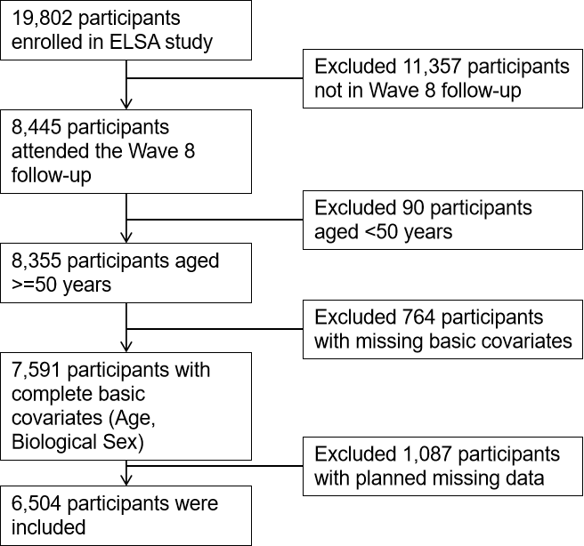
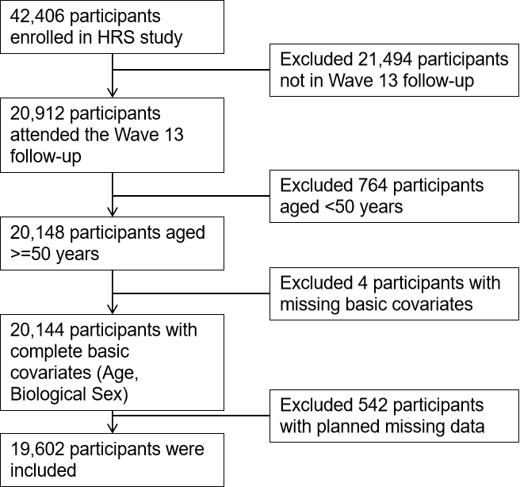
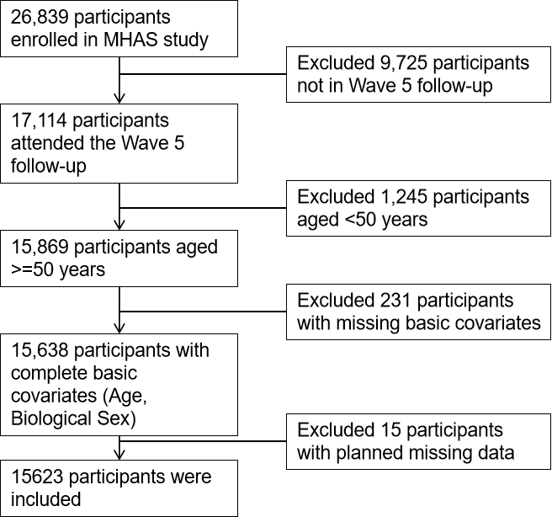
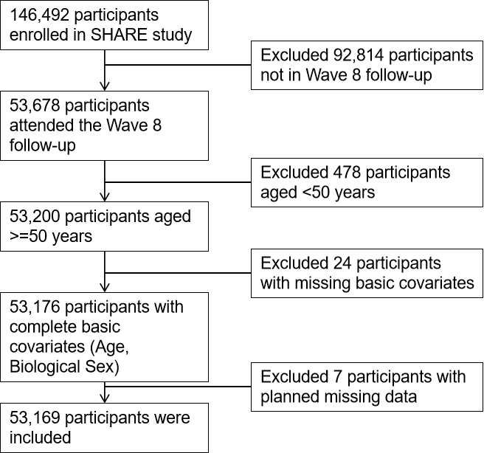
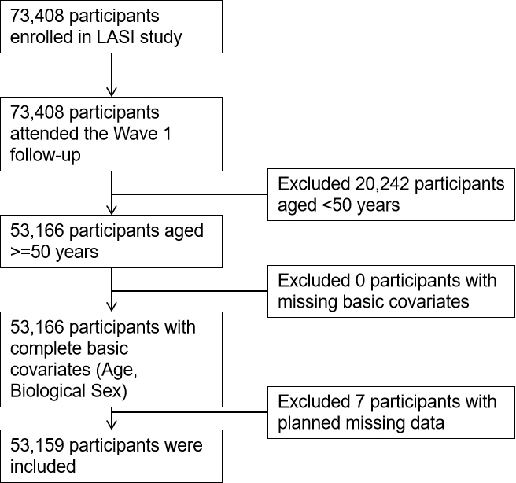

Note:Planned missing data include Split-Questionnaire Design (where researchers, during the survey design phase, intentionally allow different respondents to answer different subsets of the questionnaire based on randomization principles). Implausible values were excluded (e.g., BMI > 100); observations with zero survey weights were removed.

Supplementary Figure S10: Meta-regression results and model coefficients
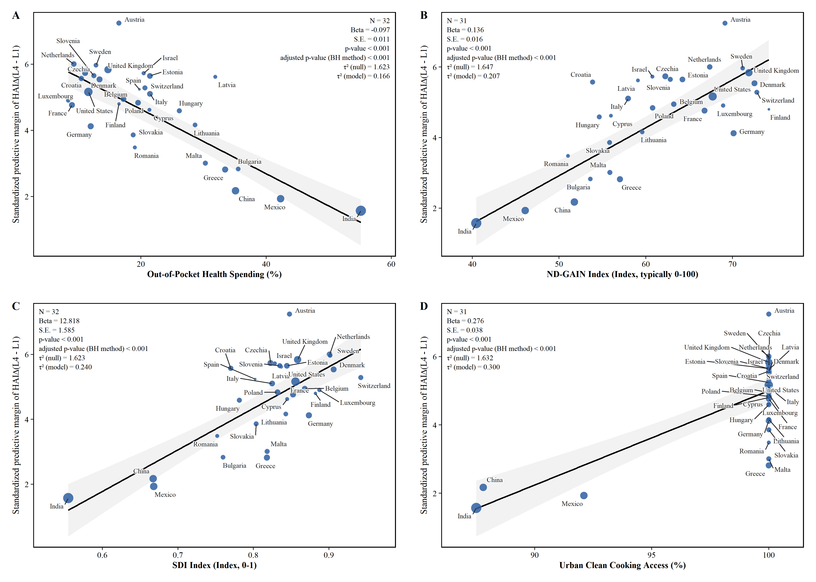
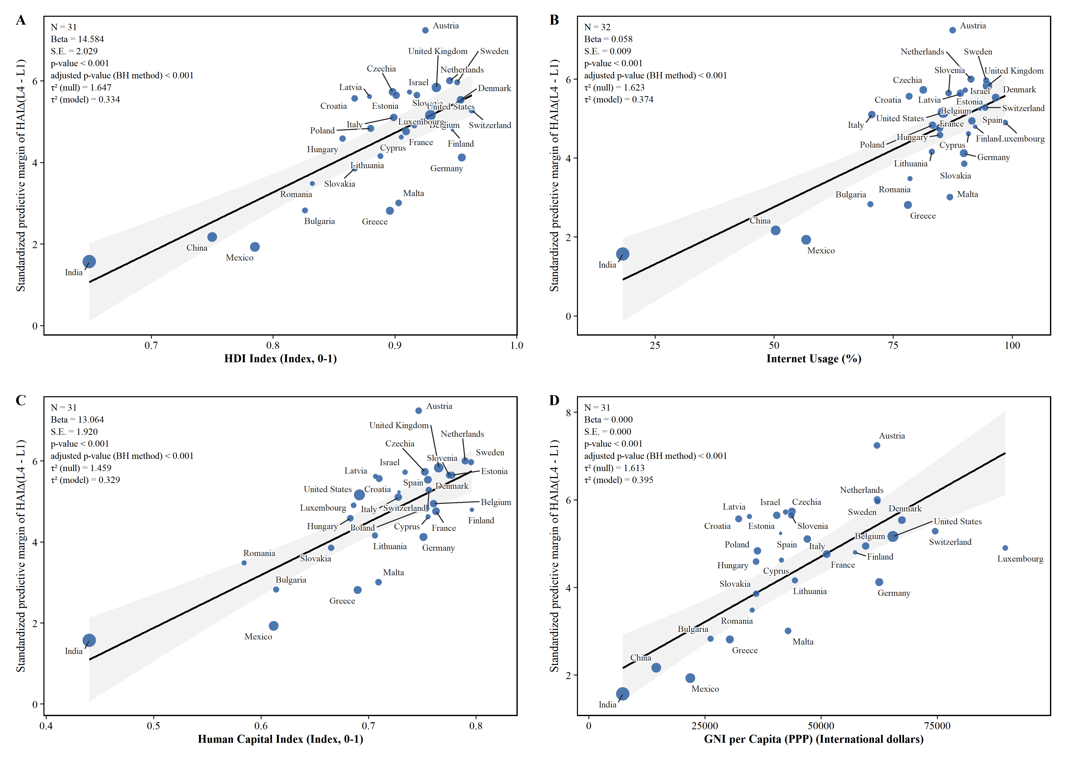
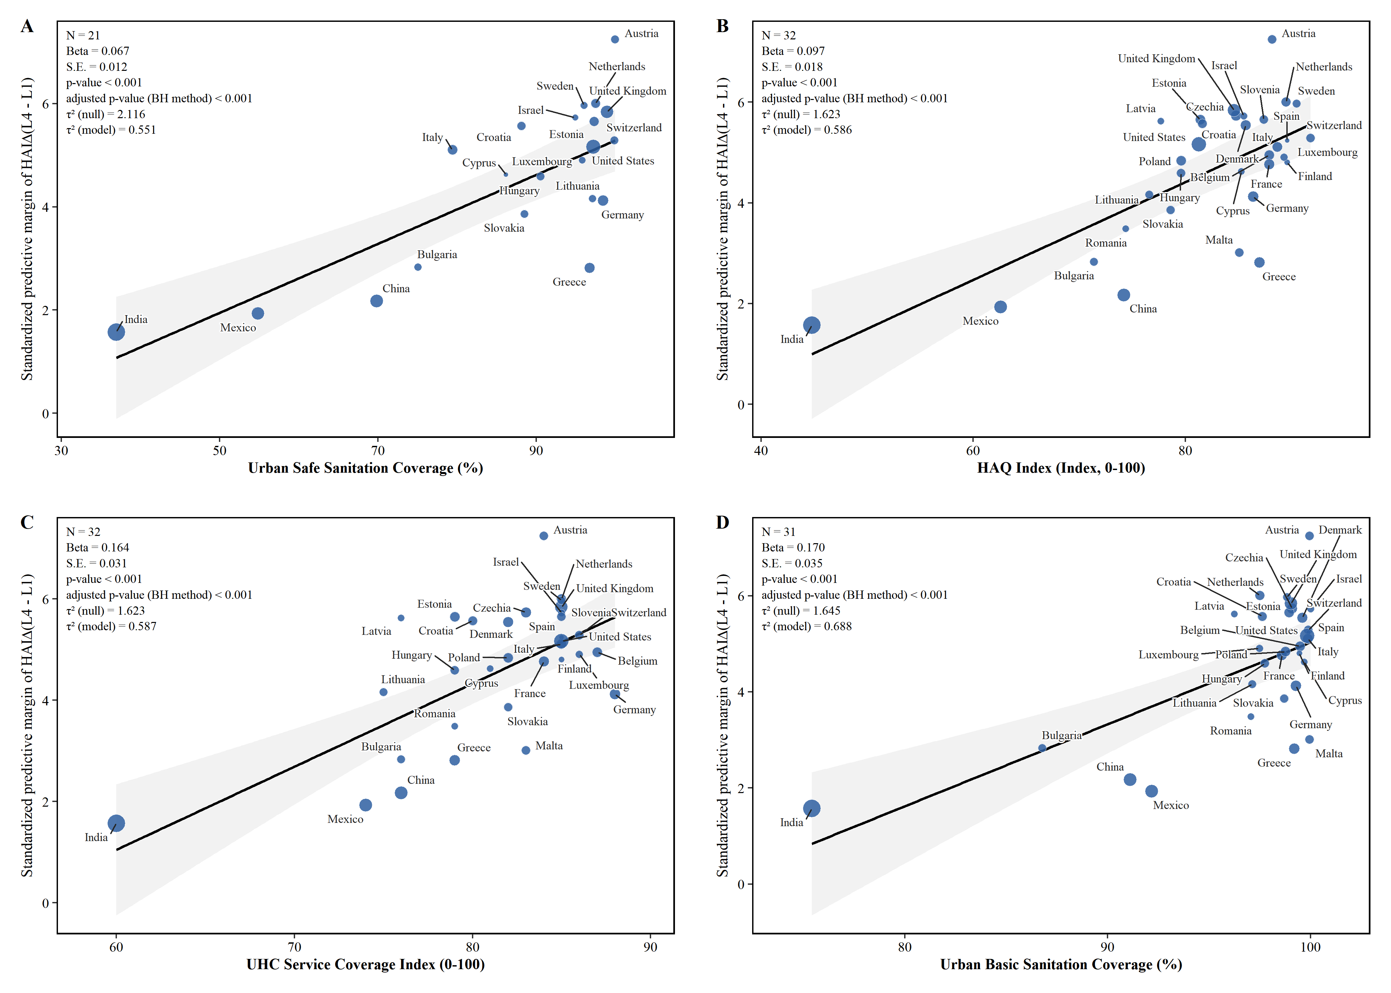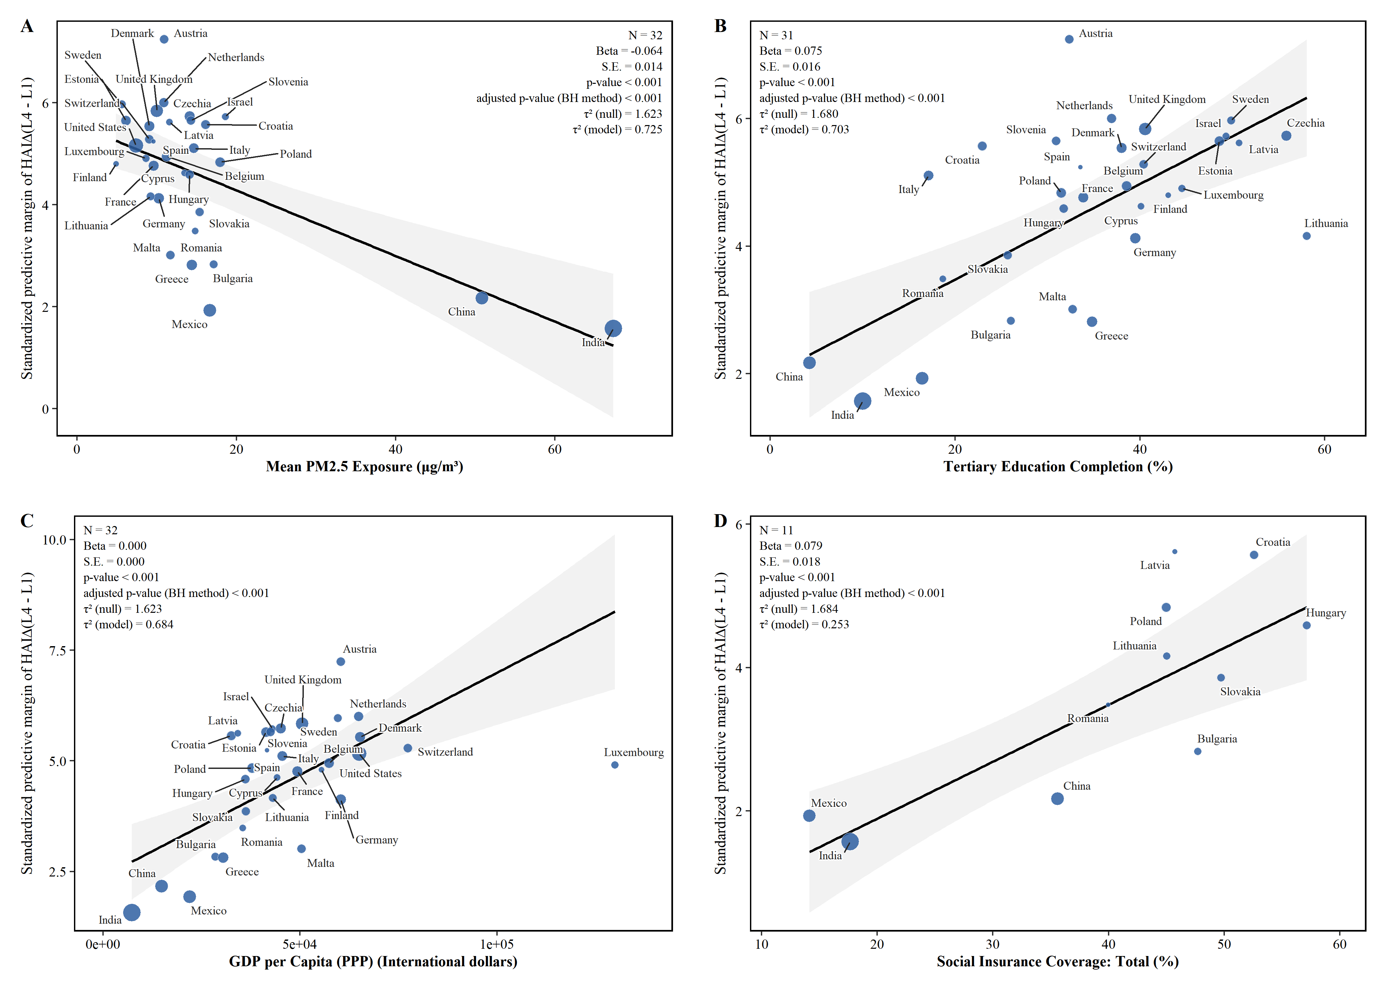
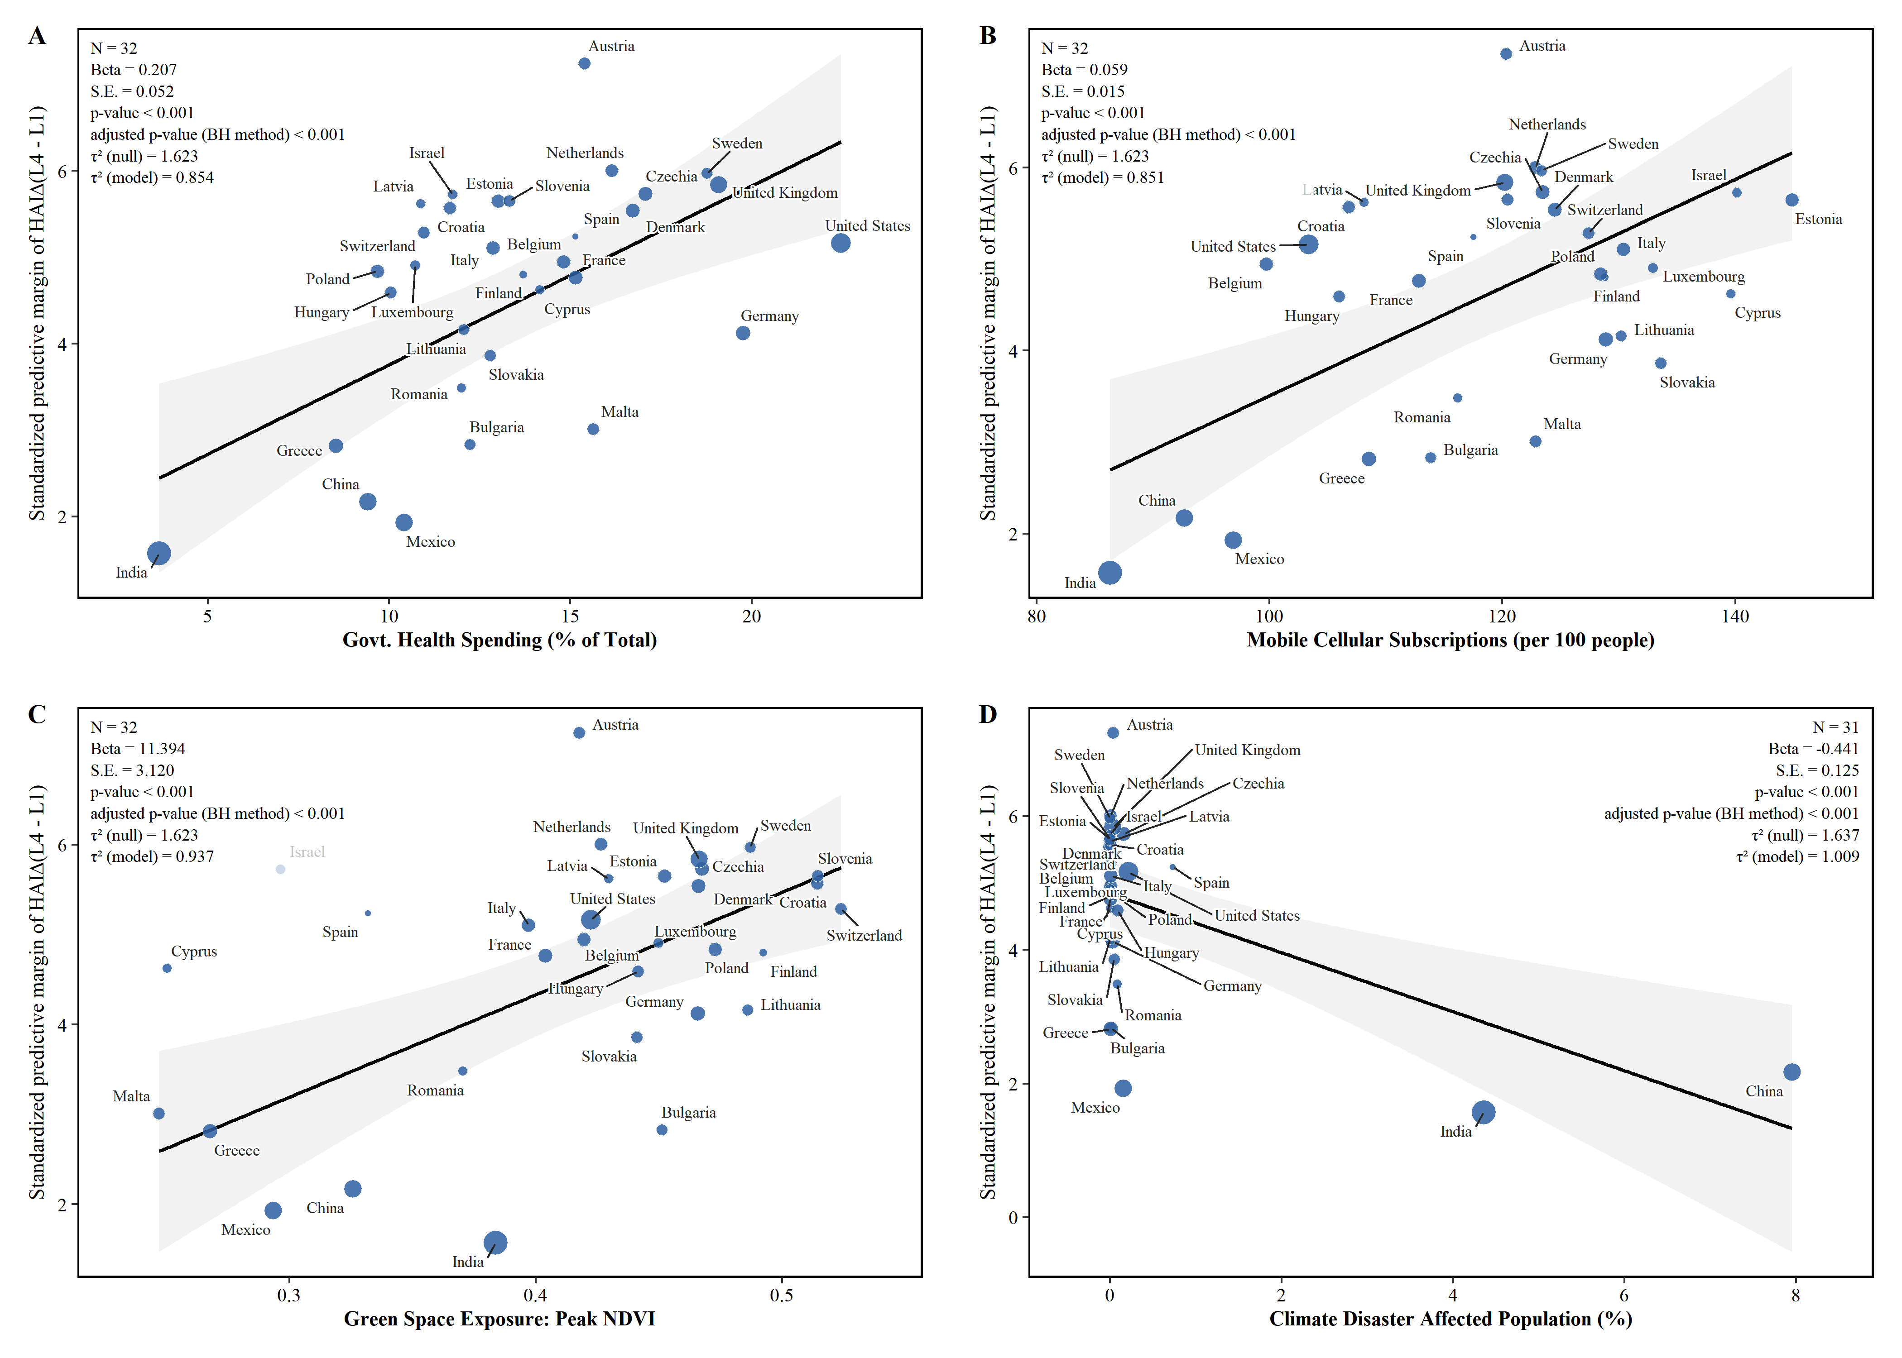
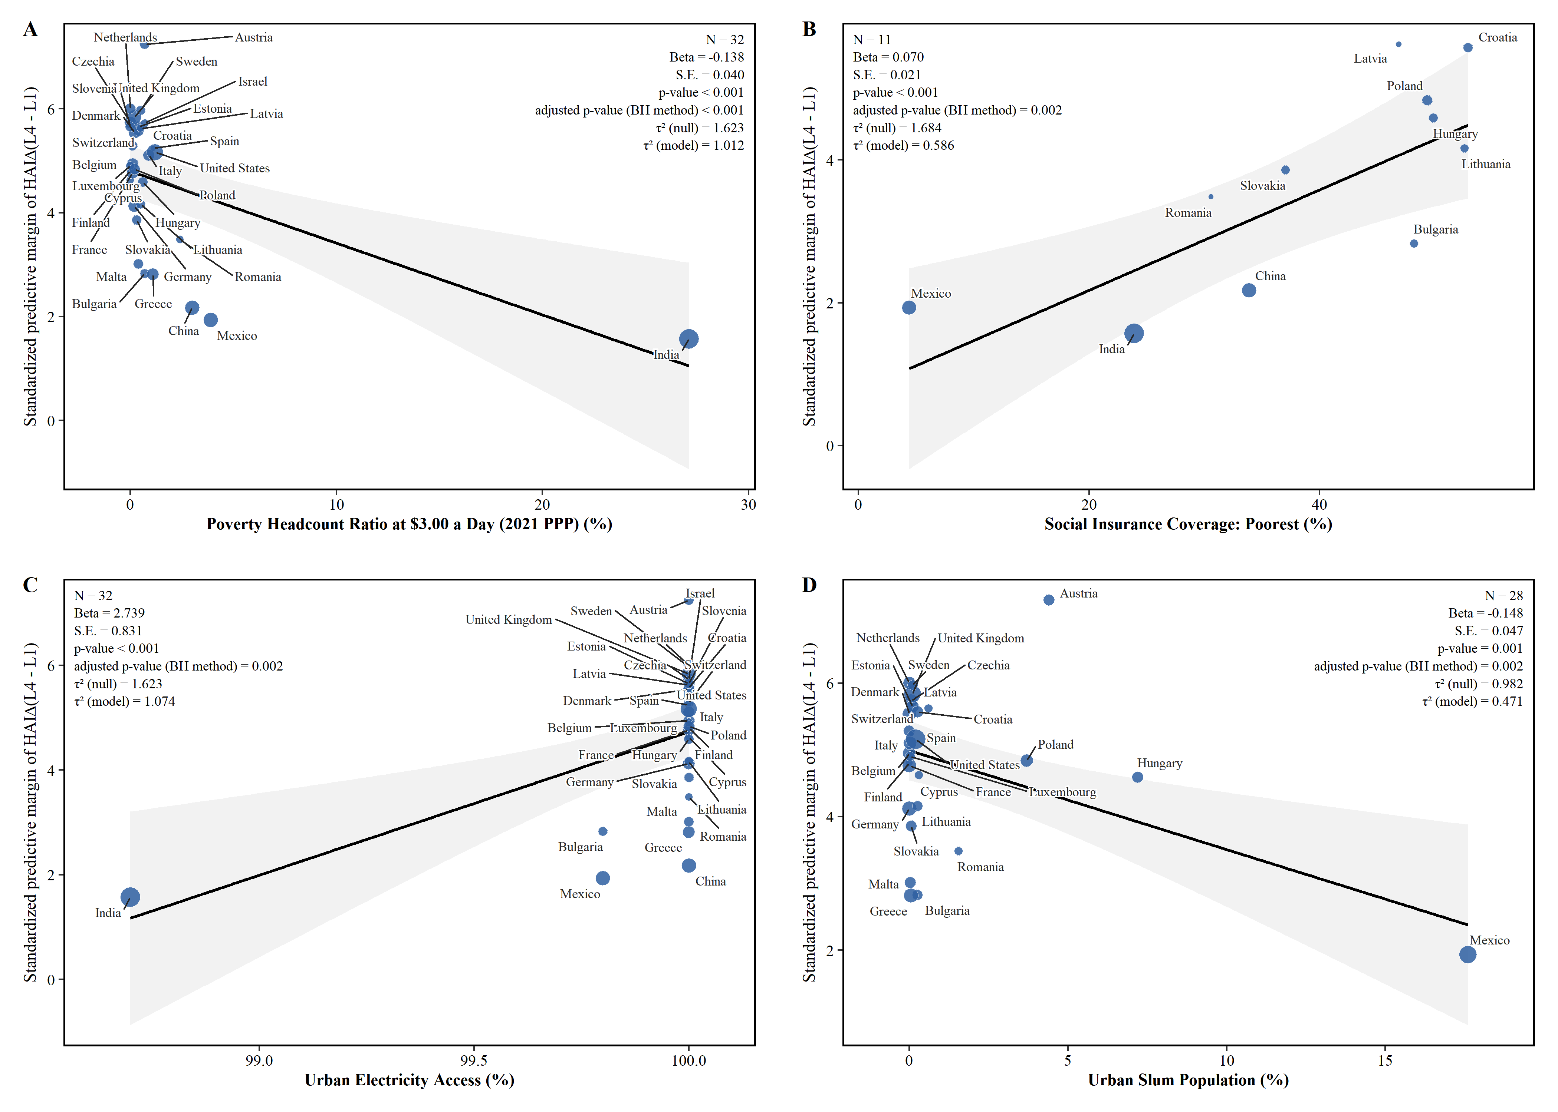
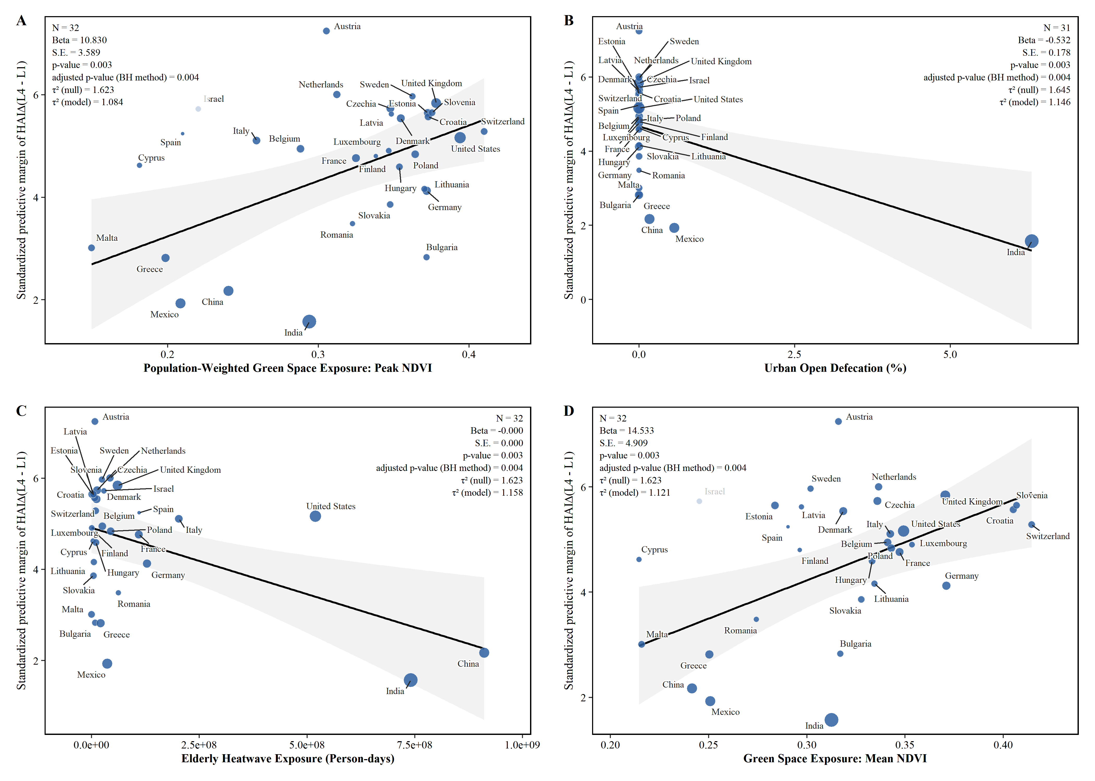
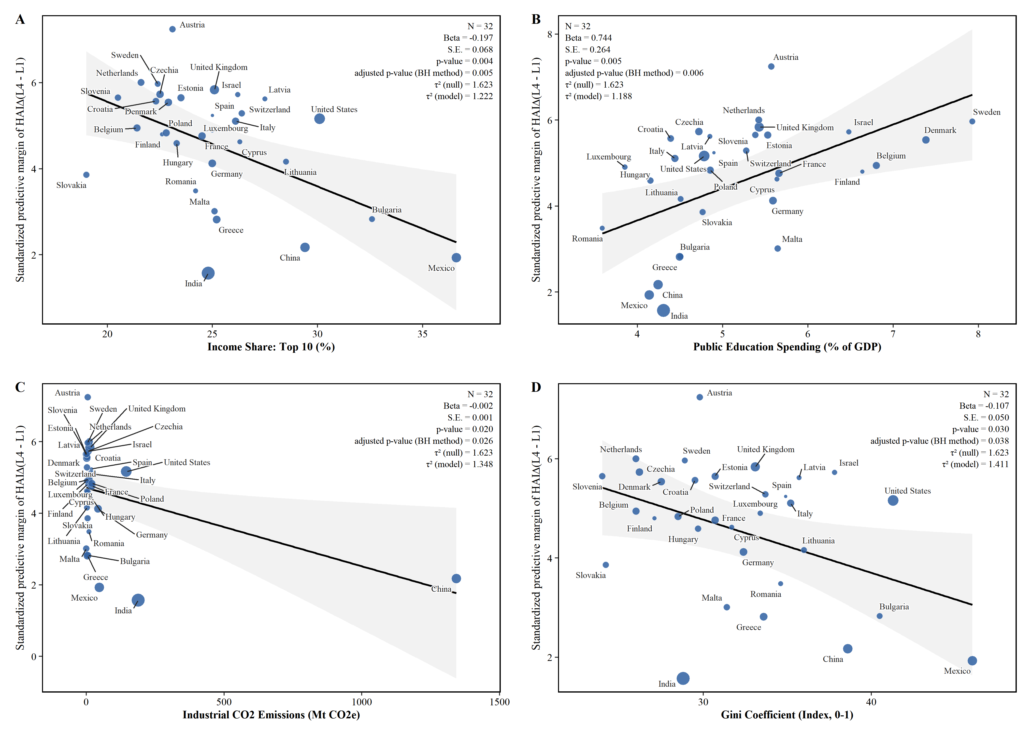
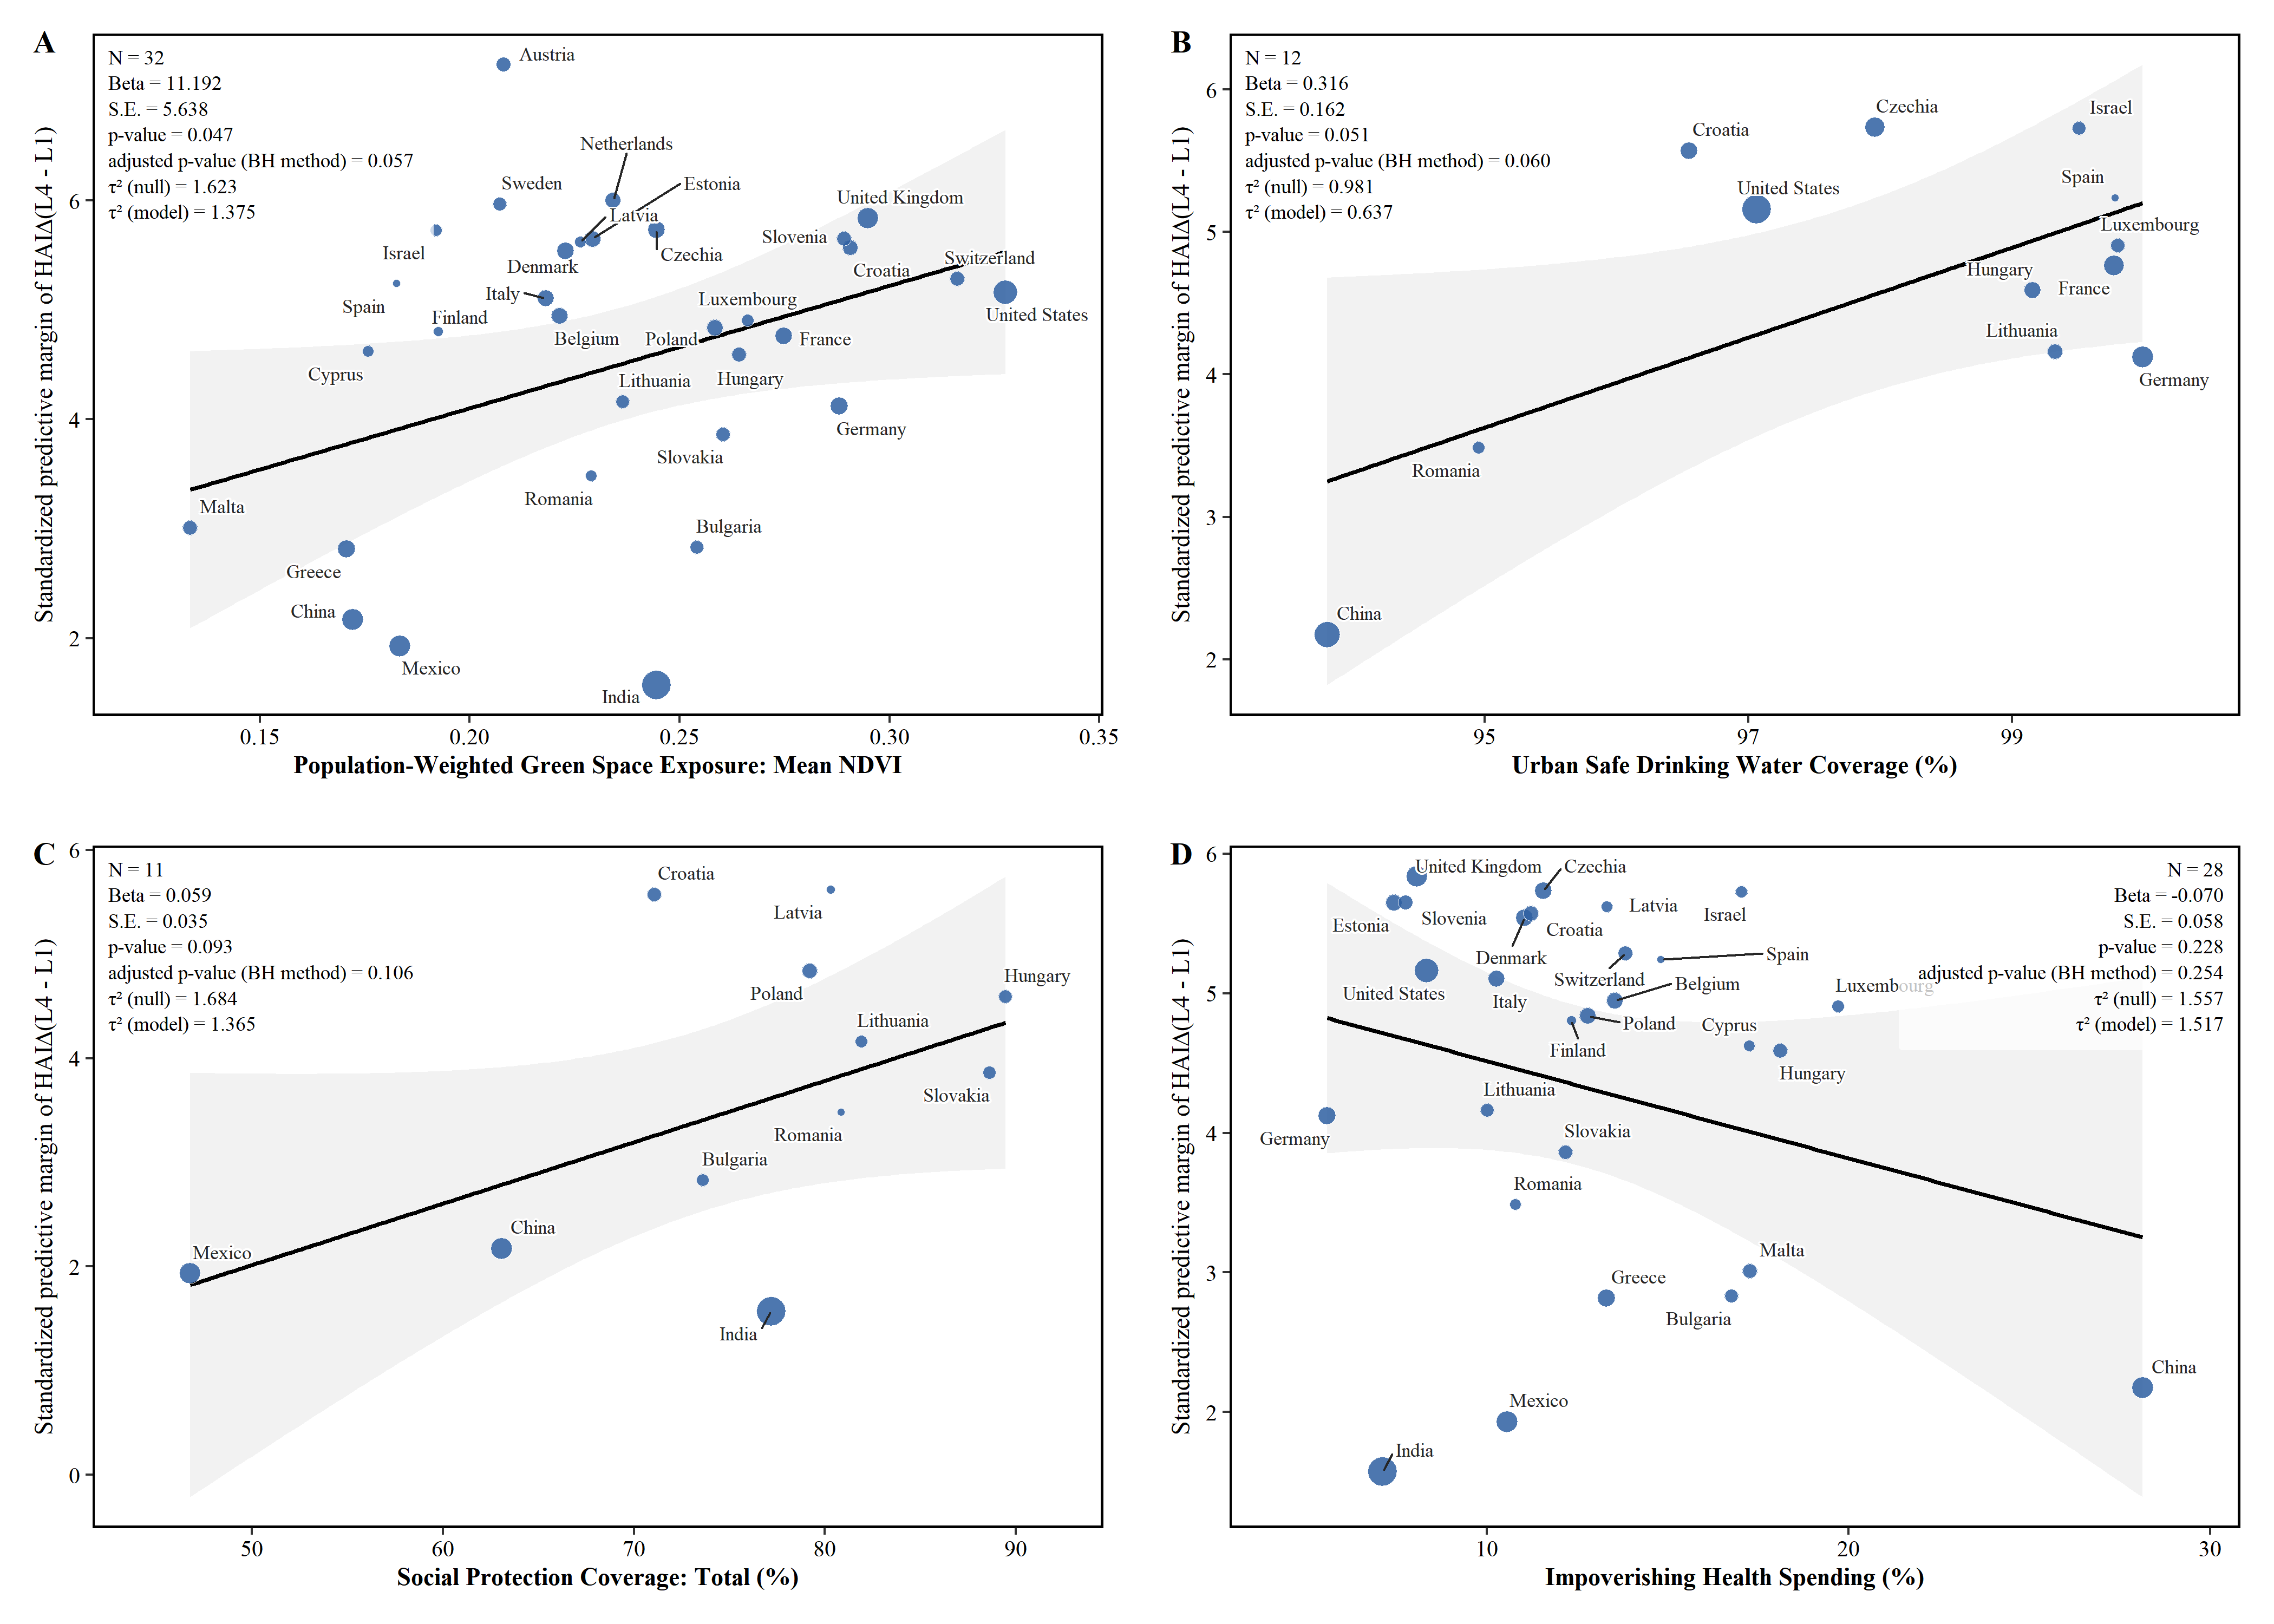
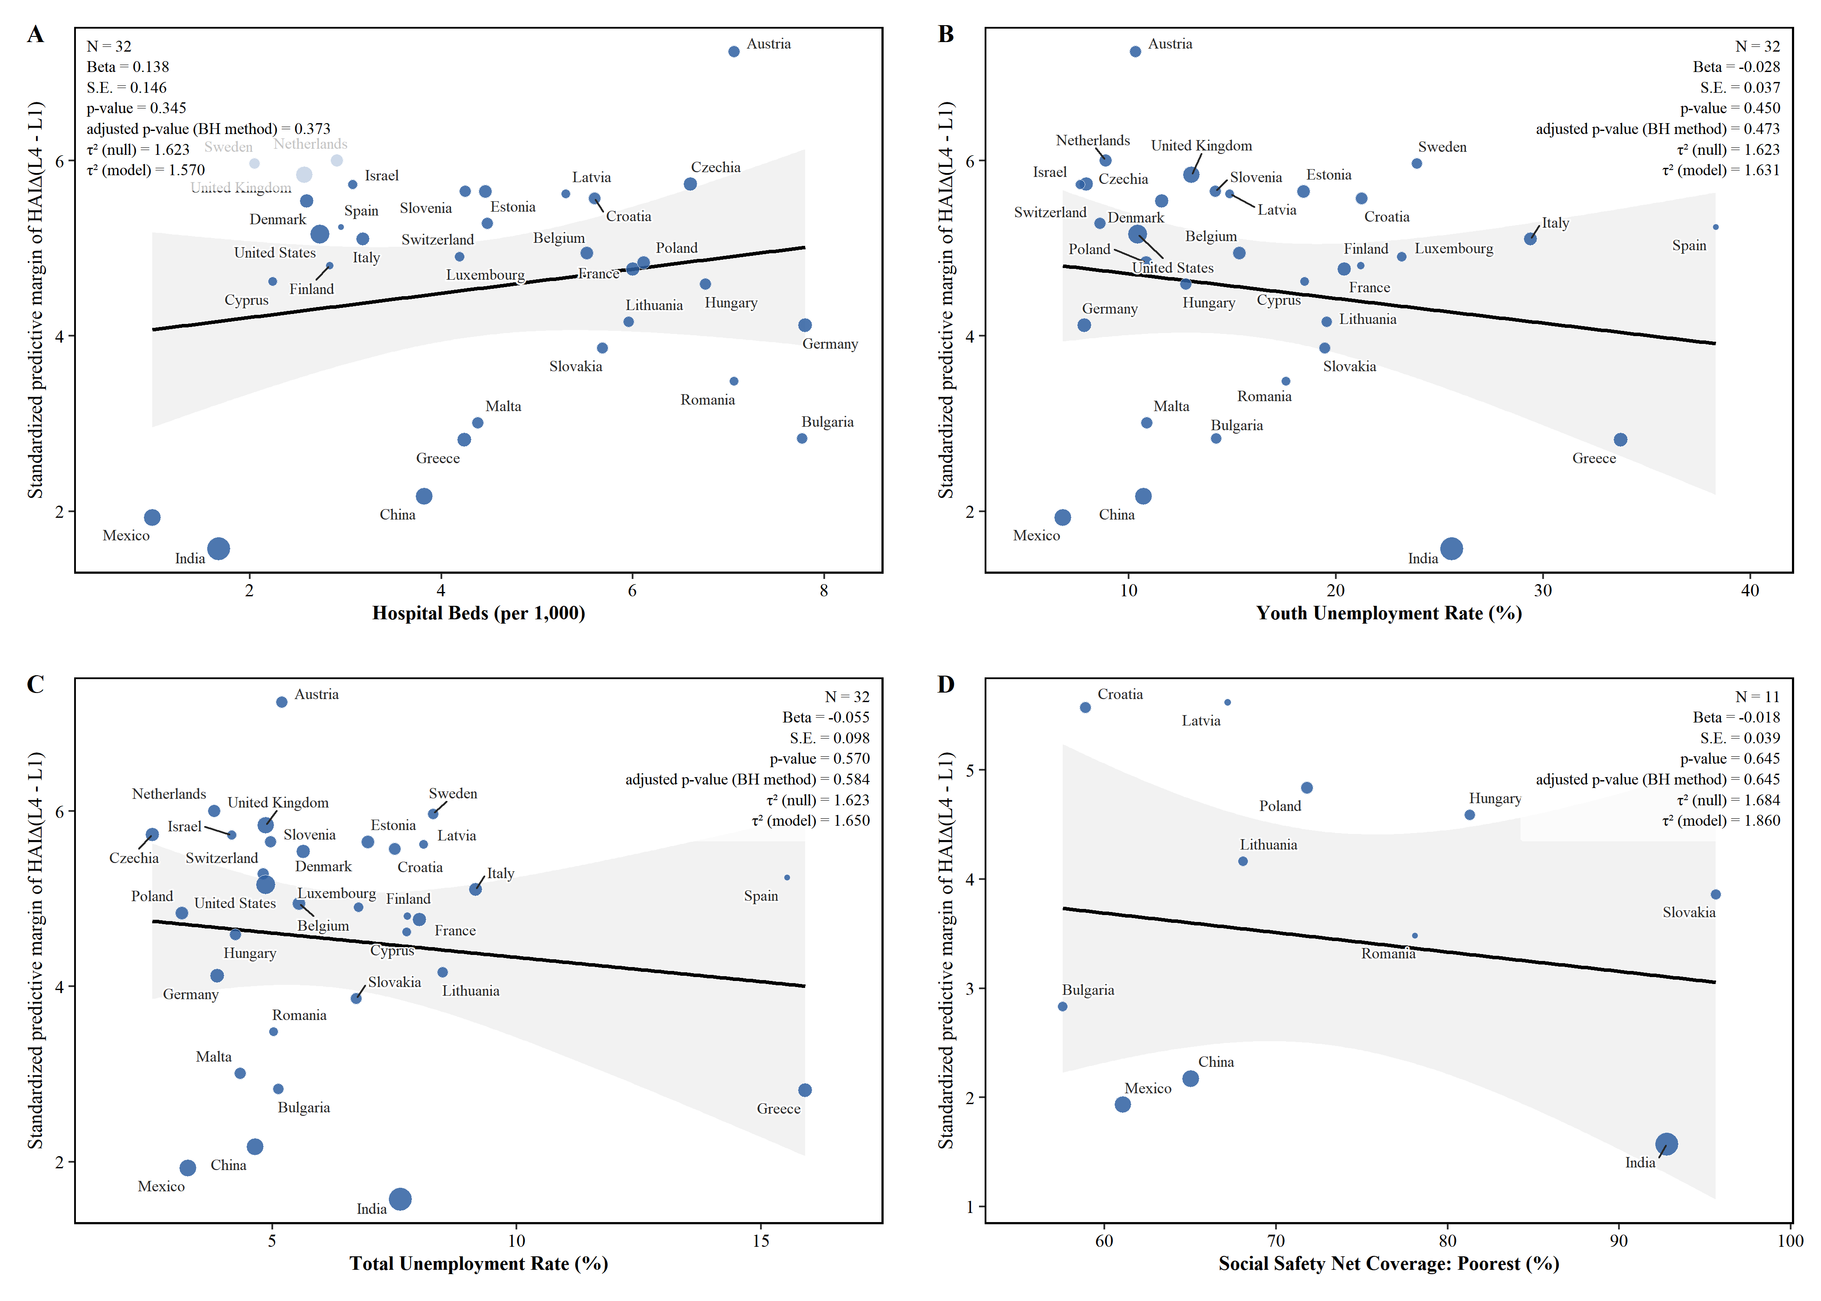

Blue bubbles represent countries, and the size of the bubble represents the weight of that country in the meta-regression (inversely proportional to the SE). The solid black line represents the fitted line of the meta-regression, and the light gray shading represents the 95% confidence interval of the fitted line. τ² (null) represents the unexplained variance among the effect sizes of different countries before this indicator is included as an explanatory variable. τ² (model) represents the unexplained variance among the effect sizes of different countries after this indicator is included as an explanatory variable.

Supplementary Figure S11: Sensitivity: agreement between model-based eHAYs and raw-data integration
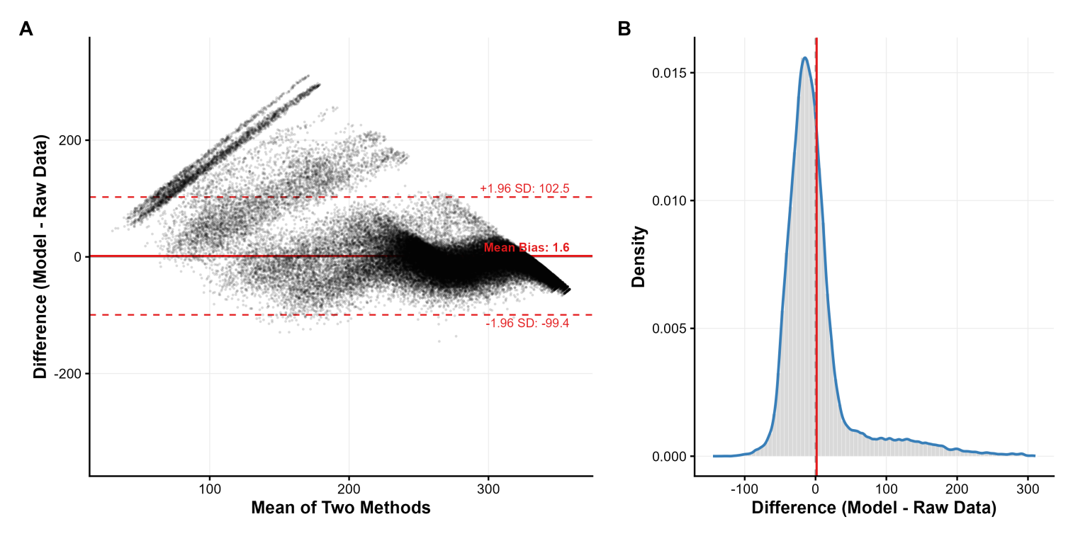

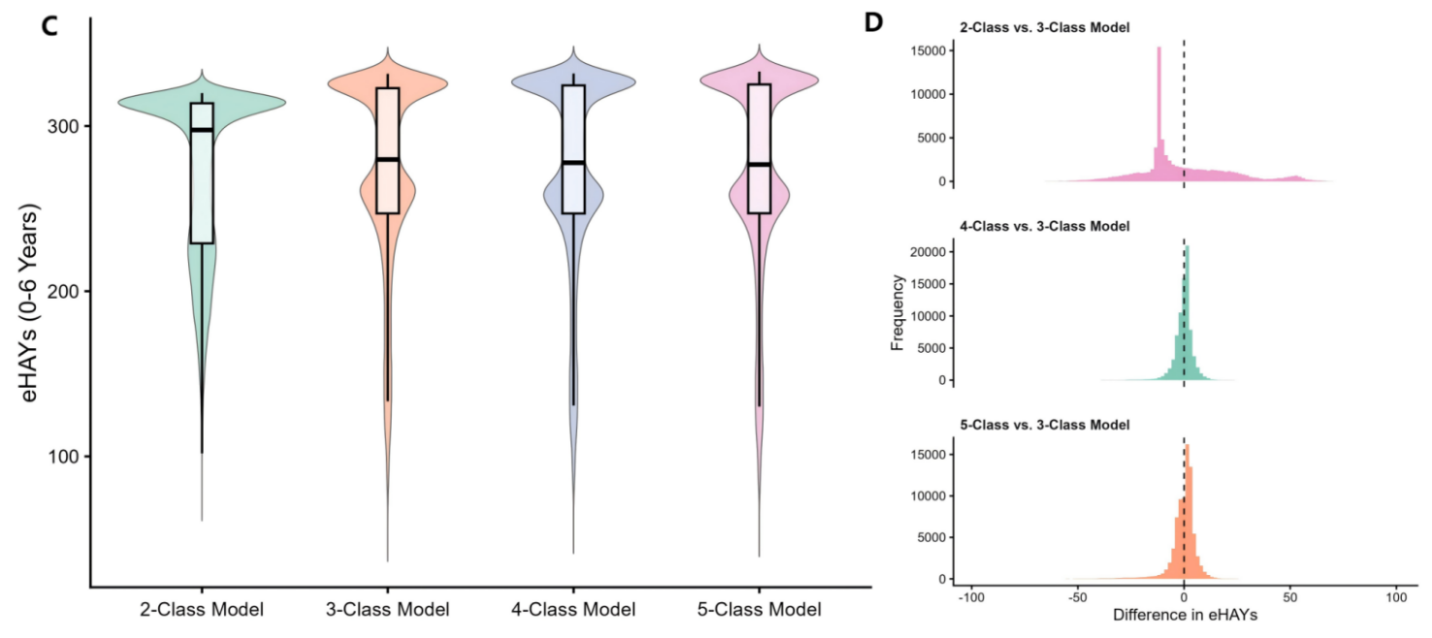
Figure A (Bland-Altman Plot): The horizontal axis represents the average of the results calculated by the two methods (the joint model predictions and the integrals of the original data). The vertical axis represents the difference between the results calculated by the two methods. The solid red line represents the average deviation; the dashed red line represents the limits of agreement. When eHAYs are below 200, the expected difference between the two models can be observed. This is mainly because low eHAYs values(<200) typically indicate a rapid decline in individual function leading to death. In this scenario, the original data integration model calculates by integrating only the available data. However, accurate estimates are often difficult to obtain in this situation because available data are either truncated upon death or marked as missing due to loss to follow-up. The longitudinal joint model, on the other hand, can generate a smooth decline curve at this stage, thus obtaining a more reasonable estimate.
Figure B (Density Plot): The blue curve represents the probability density estimation curve of the difference between the two methods. The red vertical line marks the position of the mean bias (close to 0 in the figure).
Figure C (Violin Plot): Violin Shape illustrates the kernel density distribution for different eHAYs values. The black line in the middle of the boxplot represents the median, the white rectangle represents the interquartile range (IQR), and the extending vertical lines represent the range of observations.
Figure D. Histogram of Differences: The horizontal axis represents the estimated difference between different latent class models and the baseline model (3-Class). The vertical axis represents the sample frequency.

Supplementary Figure S12: Sensitivity: Standardized Marginal Prediction Model for Longitudinal eHAYs under Different τ-year Window
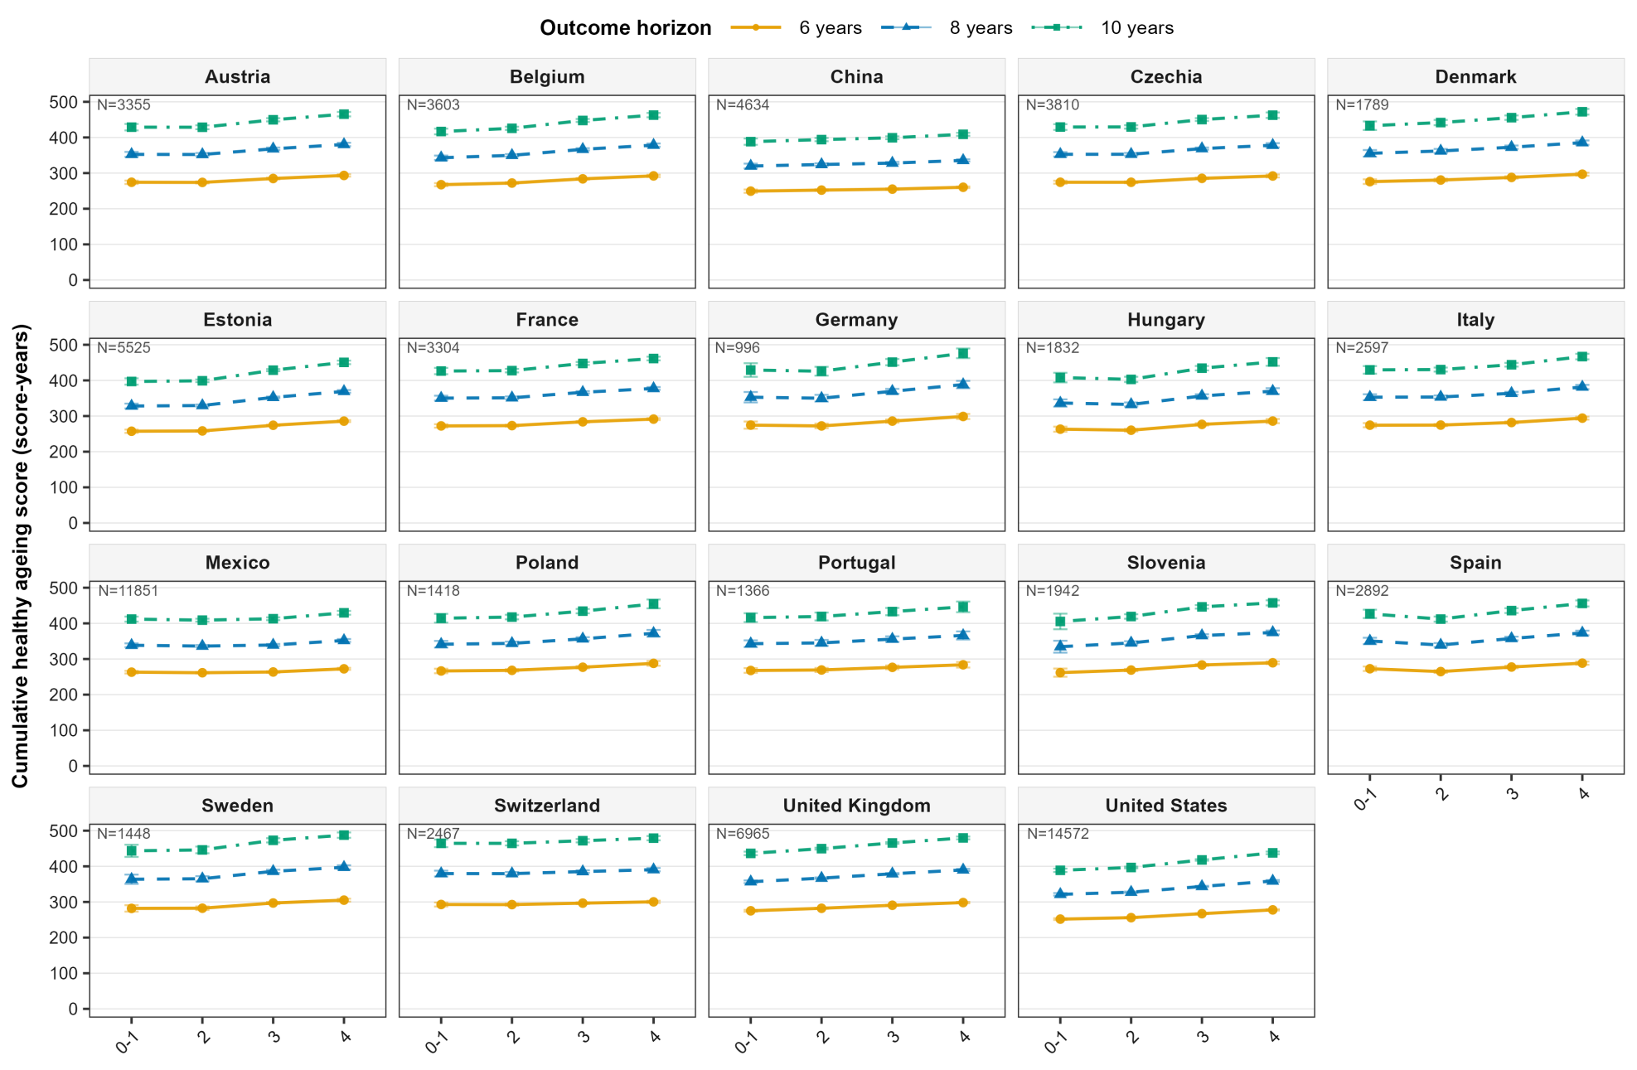

Supplementary Figure S13: Sensitivity: Cross-sectional HAI standardized prediction marginal model excluding the lowest baseline HAI
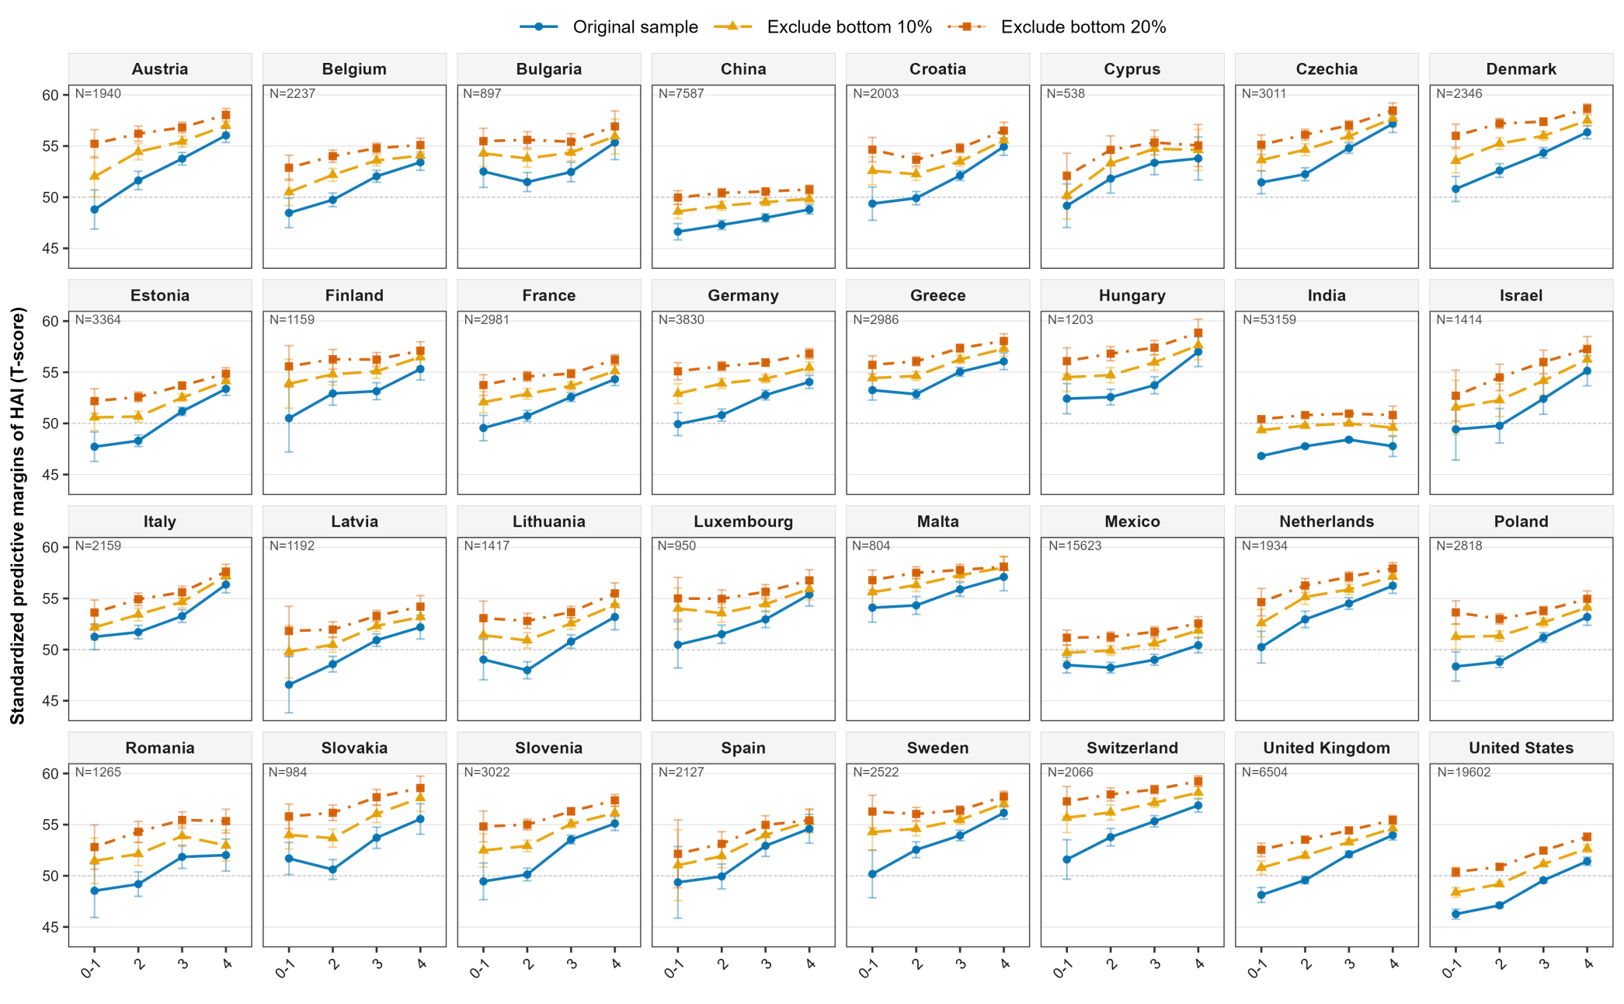

Supplementary Table S3: Sensitivity: Meta-regression results and model coefficients using the average SDOH from previous years
Domain | SDOH | Beta (per SD) [95% CI] - Most Recent Year | adjusted p-value  (Most Recent Year) | Beta (per SD) [95% CI] - Past 3-Year Average | adjusted p-value  (Past 3-Year Average) | Beta (per SD) [95% CI] - Past 5-Year Average | adjusted p-value  (Past 5-Year Average)
Environment & Climate Change | ND-GAIN Index (Index, typically 0-100) | 1.137 (0.873, 1.401) | <0.001 | 1.132 (0.865, 1.400) | <0.001 | 1.116 (0.830, 1.402) | <0.001
Environment & Climate Change | Green Space Exposure: Peak NDVI | 0.896 (0.415, 1.376) | <0.001 | 0.891 (0.416, 1.366) | <0.001 | 0.835 (0.345, 1.324) | 0.002
Environment & Climate Change | Mean PM2.5 Exposure (ug/m3) | -0.792 (-1.124, -0.461) | <0.001 | -0.786 (-1.119, -0.453) | <0.001 | -0.787 (-1.122, -0.451) | <0.001
Environment & Climate Change | Population-Weighted Green Space Exposure: Peak NDVI | 0.758 (0.266, 1.251) | 0.004 | 0.742 (0.248, 1.237) | 0.005 | 0.696 (0.192, 1.201) | 0.01
Environment & Climate Change | Green Space Exposure: Mean NDVI | 0.751 (0.254, 1.248) | 0.005 | 0.651 (0.134, 1.167) | 0.019 | 0.663 (0.147, 1.180) | 0.017
Environment & Climate Change | Climate Disaster Affected Population (%) | -0.705 (-1.097, -0.313) | <0.001 | -0.705 (-1.097, -0.313) | <0.001 | -0.705 (-1.097, -0.313) | <0.001
Environment & Climate Change | Elderly Heatwave Exposure (Person-days) | -0.626 (-1.039, -0.212) | 0.005 | -0.670 (-1.071, -0.270) | 0.002 | -0.657 (-1.062, -0.252) | 0.003
Environment & Climate Change | Industrial CO2 Emissions (Mt CO2e) | -0.521 (-0.961, -0.081) | 0.028 | -0.517 (-0.958, -0.077) | 0.03 | -0.517 (-0.957, -0.076) | 0.03
Environment & Climate Change | Population-Weighted Green Space Exposure: Mean NDVI | 0.516 (0.007, 1.026) | 0.06 | 0.441 (-0.085, 0.967) | 0.118 | 0.454 (-0.072, 0.980) | 0.11
Health System Access, Quality & Financial Protection | Out-of-Pocket Health Spending (%) | -1.050 (-1.272, -0.828) | <0.001 | -1.037 (-1.267, -0.807) | <0.001 | -1.039 (-1.276, -0.802) | <0.001
Health System Access, Quality & Financial Protection | HAQ Index (Index, 0-100) | 0.913 (0.588, 1.237) | <0.001 | 0.913 (0.588, 1.237) | <0.001 | 0.913 (0.588, 1.237) | <0.001
Health System Access, Quality & Financial Protection | UHC Service Coverage Index (0-100) | 0.894 (0.568, 1.220) | <0.001 | 0.894 (0.568, 1.220) | <0.001 | 0.890 (0.548, 1.233) | <0.001
Health System Access, Quality & Financial Protection | Govt. Health Spending (% of Total) | 0.773 (0.393, 1.154) | <0.001 | 0.803 (0.437, 1.170) | <0.001 | 0.797 (0.427, 1.168) | <0.001
Health System Access, Quality & Financial Protection | Impoverishing Health Spending (%) | -0.329 (-0.864, 0.206) | 0.256 | -0.316 (-0.852, 0.220) | 0.279 | -0.347 (-0.880, 0.187) | 0.227
Health System Access, Quality & Financial Protection | Hospital Beds (per 1,000) | 0.259 (-0.279, 0.798) | 0.378 | 0.271 (-0.266, 0.807) | 0.353 | 0.279 (-0.255, 0.814) | 0.335
Inequality & Social Protection | Social Insurance Coverage: Total (%) | 1.084 (0.601, 1.567) | <0.001 | 1.084 (0.601, 1.567) | <0.001 | 1.084 (0.601, 1.567) | <0.001
Inequality & Social Protection | Social Insurance Coverage: Poorest (%) | 1.060 (0.434, 1.687) | 0.002 | 1.060 (0.434, 1.687) | 0.002 | 1.060 (0.434, 1.687) | 0.002
Inequality & Social Protection | Social Protection Coverage: Total (%) | 0.717 (-0.120, 1.555) | 0.11 | 0.717 (-0.120, 1.555) | 0.113 | 0.717 (-0.120, 1.555) | 0.11
Inequality & Social Protection | Income Share: Top 10 (%) | -0.697 (-1.167, -0.226) | 0.006 | -0.678 (-1.145, -0.212) | 0.007 | -0.655 (-1.126, -0.185) | 0.01
Inequality & Social Protection | Poverty Headcount Ratio at $3.00 a Day (2021 PPP) (%) | -0.657 (-1.026, -0.289) | <0.001 | -0.662 (-1.029, -0.295) | <0.001 | -0.654 (-1.023, -0.284) | 0.001
Inequality & Social Protection | Gini Coefficient (Index, 0-1) | -0.552 (-1.052, -0.053) | 0.04 | -0.532 (-1.031, -0.033) | 0.048 | -0.507 (-1.008, -0.006) | 0.062
Inequality & Social Protection | Social Safety Net Coverage: Poorest (%) | -0.232 (-1.218, 0.754) | 0.645 | -0.232 (-1.218, 0.754) | 0.645 | -0.232 (-1.218, 0.754) | 0.659
Inequality & Social Protection | Youth Unemployment Rate (%) | -0.220 (-0.789, 0.350) | 0.481 | -0.266 (-0.821, 0.289) | 0.371 | -0.274 (-0.826, 0.279) | 0.354
Inequality & Social Protection | Total Unemployment Rate (%) | -0.167 (-0.744, 0.410) | 0.582 | -0.182 (-0.751, 0.388) | 0.544 | -0.195 (-0.763, 0.373) | 0.524
Socio-economic & Human Capital | GNI per Capita (PPP) (International dollars) | 1.061 (0.725, 1.396) | <0.001 | 1.074 (0.751, 1.397) | <0.001 | 1.075 (0.753, 1.396) | <0.001
Socio-economic & Human Capital | SDI Index (Index, 0-1) | 0.992 (0.751, 1.232) | <0.001 | 0.991 (0.751, 1.232) | <0.001 | 0.990 (0.749, 1.231) | <0.001
Socio-economic & Human Capital | GDP per Capita (PPP) (International dollars) | 0.990 (0.562, 1.417) | <0.001 | 1.002 (0.579, 1.424) | <0.001 | 1.008 (0.590, 1.426) | <0.001
Socio-economic & Human Capital | HDI Index (Index, 0-1) | 0.968 (0.704, 1.232) | <0.001 | 0.970 (0.706, 1.234) | <0.001 | 0.969 (0.711, 1.227) | <0.001
Socio-economic & Human Capital | Tertiary Education Completion (%) | 0.965 (0.560, 1.369) | <0.001 | 0.956 (0.554, 1.359) | <0.001 | 0.969 (0.569, 1.370) | <0.001
Socio-economic & Human Capital | Human Capital Index (Index, 0-1) | 0.963 (0.686, 1.241) | <0.001 | 0.963 (0.686, 1.241) | <0.001 | 0.963 (0.686, 1.241) | <0.001
Socio-economic & Human Capital | Public Education Spending (% of GDP) | 0.750 (0.229, 1.272) | 0.007 | 0.759 (0.236, 1.283) | 0.007 | 0.777 (0.251, 1.303) | 0.006
Urban Environment & Infrastructure | Urban Safe Sanitation Coverage (%) | 1.097 (0.716, 1.479) | <0.001 | 1.097 (0.716, 1.479) | <0.001 | 1.098 (0.717, 1.479) | <0.001
Urban Environment & Infrastructure | Internet Usage (%) | 0.923 (0.657, 1.188) | <0.001 | 0.919 (0.644, 1.195) | <0.001 | 0.917 (0.641, 1.194) | <0.001
Urban Environment & Infrastructure | Urban Clean Cooking Access (%) | 0.920 (0.675, 1.165) | <0.001 | 0.919 (0.673, 1.164) | <0.001 | 0.917 (0.672, 1.163) | <0.001
Urban Environment & Infrastructure | Urban Basic Sanitation Coverage (%) | 0.852 (0.512, 1.192) | <0.001 | 0.852 (0.512, 1.192) | <0.001 | 0.852 (0.512, 1.192) | <0.001
Urban Environment & Infrastructure | Mobile Cellular Subscriptions (per 100 people) | 0.833 (0.416, 1.250) | <0.001 | 0.827 (0.411, 1.243) | <0.001 | 0.818 (0.406, 1.231) | <0.001
Urban Environment & Infrastructure | Urban Safe Drinking Water Coverage (%) | 0.663 (-0.003, 1.329) | 0.063 | 0.664 (-0.001, 1.330) | 0.064 | 0.668 (0.003, 1.333) | 0.063
Urban Environment & Infrastructure | Urban Electricity Access (%) | 0.638 (0.258, 1.017) | 0.002 | 0.628 (0.241, 1.015) | 0.002 | 0.645 (0.259, 1.030) | 0.002
Urban Environment & Infrastructure | Urban Open Defecation (%) | -0.603 (-0.998, -0.207) | 0.005 | -0.603 (-0.998, -0.207) | 0.005 | -0.603 (-0.998, -0.207) | 0.005
Urban Environment & Infrastructure | Urban Slum Population (%) | -0.534 (-0.862, -0.205) | 0.003 | -0.534 (-0.862, -0.205) | 0.002 | -0.535 (-0.863, -0.207) | 0.002

Supplementary Table S4:Data missing characteristics before multiple imputation
 | CHARLS |  | ELSA |  | HRS |  | LASI |  | MHAS |  | SHARE
Variable | Missing Count  (N) | Missing Percent | Missing Count  (N) | Missing Percent | Missing Count  (N) | Missing Percent | Missing Count  (N) | Missing Percent | Missing Count  (N) | Missing Percent | Missing Count  (N) | Missing Percent
Age | 0 | 0.00% | 0 | 0.00% | 0 | 0.00% | 0 | 0.00% | 0 | 0.00% | 0 | 0.00%
Bathing | 19 | 0.25% | 1 | 0.01% | 47 | 0.23% | 218 | 0.41% | 103 | 0.66% | 167 | 0.31%
BirthYear | 0 | 0.00% | 0 | 0.00% | 0 | 0.00% | 0 | 0.00% | 1 | 0.01% | 0 | 0.00%
BMI_Raw | 1331 | 17.54% | 1423 | 18.75% | 307 | 1.53% | 5451 | 10.25% | 1781 | 11.40% | 1383 | 2.60%
Chronic_Arthr | 610 | 8.04% | 0 | 0.00% | 0 | 0.00% | 183 | 0.34% | 16 | 0.10% | 119 | 0.22%
Chronic_Cancr | 611 | 8.05% | 0 | 0.00% | 0 | 0.00% | 139 | 0.26% | 13 | 0.08% | 156 | 0.29%
Chronic_Diabe | 671 | 8.84% | 0 | 0.00% | 0 | 0.00% | 143 | 0.27% | 23 | 0.15% | 138 | 0.26%
Chronic_Heart | 654 | 8.62% | 0 | 0.00% | 0 | 0.00% | 138 | 0.26% | 8 | 0.05% | 140 | 0.26%
Chronic_Hibp | 631 | 8.32% | 0 | 0.00% | 0 | 0.00% | 141 | 0.27% | 13 | 0.08% | 97 | 0.18%
Chronic_Lung | 607 | 8.00% | 0 | 0.00% | 0 | 0.00% | 139 | 0.26% | 11 | 0.07% | 154 | 0.29%
Chronic_Stroke | 603 | 7.95% | 0 | 0.00% | 0 | 0.00% | 139 | 0.26% | 7 | 0.04% | 150 | 0.28%
Climbing_stairs | 96 | 1.27% | 1 | 0.01% | 322 | 1.60% | NA | NA | 1826 | 11.69% | 166 | 0.31%
Delayed_recall | 275 | 3.62% | 410 | 5.40% | 929 | 4.62% | 652 | 1.23% | 1261 | 8.07% | 1478 | 2.78%
Dressing | 12 | 0.16% | 1 | 0.01% | 57 | 0.28% | 218 | 0.41% | 1291 | 8.26% | 167 | 0.31%
Drink_Ever | 11 | 0.14% | 1211 | 15.96% | 15 | 0.07% | 436 | 0.82% | 8 | 0.05% | NA | NA
Drink_Freq | 26 | 0.34% | 1181 | 15.56% | 75 | 0.37% | 436 | 0.82% | 87 | 0.56% | 164 | 0.31%
Drink_Quant | 26 | 0.34% | 1161 | 15.30% | 81 | 0.40% | NA | NA | 78 | 0.50% | 221 | 0.42%
Eating | 12 | 0.16% | 1 | 0.01% | 55 | 0.27% | 218 | 0.41% | 108 | 0.69% | 167 | 0.31%
Edu_Raw | 0 | 0.00% | 0 | 0.00% | 0 | 0.00% | 0 | 0.00% | 0 | 0.00% | 0 | 0.00%
Energy | 145 | 1.91% | 1156 | 15.23% | 963 | 4.78% | 1513 | 2.85% | 1304 | 8.35% | 1101 | 2.07%
Eyesight | 666 | 8.78% | 6 | 0.08% | 63 | 0.31% | NA | NA | 1296 | 8.29% | NA | NA
Far_vision | 23 | 0.30% | 397 | 5.23% | 47 | 0.23% | 167 | 0.31% | NA | NA | 252 | 0.47%
Gender_Raw | 0 | 0.00% | 0 | 0.00% | 0 | 0.00% | 0 | 0.00% | 0 | 0.00% | 0 | 0.00%
Getting_in_out_bed | 12 | 0.16% | 1 | 0.01% | 70 | 0.35% | 218 | 0.41% | 105 | 0.67% | 167 | 0.31%
Getting_up | 16 | 0.21% | 1 | 0.01% | 105 | 0.52% | NA | NA | 1302 | 8.33% | 166 | 0.31%
Hearing_in_general | 882 | 11.63% | 4 | 0.05% | 26 | 0.13% | 151 | 0.28% | 1279 | 8.19% | 186 | 0.35%
Housework | 11 | 0.14% | 1 | 0.01% | 213 | 1.06% | NA | NA | NA | NA | 167 | 0.31%
Immediate_recall | 218 | 2.87% | 452 | 5.96% | 929 | 4.62% | 652 | 1.23% | 1261 | 8.07% | 1365 | 2.57%
Lifting_carrying | 34 | 0.45% | 1 | 0.01% | 301 | 1.50% | NA | NA | 1430 | 9.15% | 166 | 0.31%
Map | NA | NA | 1 | 0.01% | 1293 | 6.42% | NA | NA | NA | NA | 167 | 0.31%
Marital_Raw | 1 | 0.01% | 3 | 0.04% | 7 | 0.03% | 3 | 0.01% | 0 | 0.00% | 175 | 0.33%
Meals | 34 | 0.45% | 1 | 0.01% | 436 | 2.17% | NA | NA | 1673 | 10.71% | 167 | 0.31%
Medications | 28 | 0.37% | 1 | 0.01% | 271 | 1.35% | NA | NA | 1349 | 8.63% | 167 | 0.31%
Memory | 35 | 0.46% | 441 | 5.81% | 929 | 4.62% | NA | NA | 1349 | 8.63% | 905 | 1.70%
Money | 59 | 0.78% | 1 | 0.01% | 462 | 2.30% | NA | NA | 1322 | 8.46% | 167 | 0.31%
Moving_around | NA | NA | 1 | 0.01% | 64 | 0.32% | NA | NA | 109 | 0.70% | 167 | 0.31%
Near_vision | 31 | 0.41% | 398 | 5.24% | 40 | 0.20% | 220 | 0.41% | NA | NA | 253 | 0.48%
Numeracy | NA | NA | NA | NA | NA | NA | 652 | 1.23% | NA | NA | 36688 | 69.00%
Orientation_in_time | 603 | 7.95% | 510 | 6.72% | 6934 | 34.45% | 652 | 1.23% | NA | NA | 188 | 0.35%
PA_Light_Days | 64 | 0.84% | 2 | 0.03% | 60 | 0.30% | NA | NA | NA | NA | NA | NA
PA_Mod_Days | 73 | 0.96% | 2 | 0.03% | 82 | 0.41% | 437 | 0.82% | NA | NA | 162 | 0.30%
PA_Vig_Days | 54 | 0.71% | 2 | 0.03% | 102 | 0.51% | 448 | 0.84% | 1273 | 8.15% | 178 | 0.33%
Pain | 6 | 0.08% | 406 | 5.35% | 129 | 0.64% | 182 | 0.34% | 1268 | 8.11% | 193 | 0.36%
Picking_up | 24 | 0.32% | 1 | 0.01% | 87 | 0.43% | NA | NA | 1299 | 8.31% | 166 | 0.31%
Pulling_pushing | NA | NA | 1 | 0.01% | 443 | 2.20% | NA | NA | 1475 | 9.44% | 166 | 0.31%
Processing_speed | NA | NA | NA | NA | NA | NA | NA | NA | 1261 | 8.07% | NA | NA
Reaching_arms | 15 | 0.20% | 1 | 0.01% | 93 | 0.46% | NA | NA | 1298 | 8.31% | 166 | 0.31%
Rural_Raw | 0 | 0.00% | NA | NA | 1610 | 8.00% | 0 | 0.00% | 0 | 0.00% | 2534 | 4.77%
Shopping | 31 | 0.41% | 1 | 0.01% | 331 | 1.64% | NA | NA | 1469 | 9.40% | 167 | 0.31%
Sitting | 16 | 0.21% | 1 | 0.01% | 147 | 0.73% | NA | NA | 1304 | 8.35% | 166 | 0.31%
Sleeping | 74 | 0.98% | 443 | 5.84% | 970 | 4.82% | 175 | 0.33% | 1277 | 8.17% | 1038 | 1.95%
Smoke_Ever | 2 | 0.03% | 92 | 1.21% | 85 | 0.42% | 447 | 0.84% | 14 | 0.09% | 63 | 0.12%
Smoke_Now | 5 | 0.07% | 32 | 0.42% | 91 | 0.45% | 446 | 0.84% | 17 | 0.11% | 160 | 0.30%
Stooping | 20 | 0.26% | 1 | 0.01% | 212 | 1.05% | NA | NA | 1364 | 8.73% | 166 | 0.31%
Telephone | 377 | 4.97% | 1 | 0.01% | 81 | 0.40% | NA | NA | NA | NA | 167 | 0.31%
Toilet | 13 | 0.17% | 1 | 0.01% | 67 | 0.33% | 218 | 0.41% | 116 | 0.74% | 167 | 0.31%
Urine_incontinence | 14 | 0.18% | 1170 | 15.42% | 57 | 0.28% | 150 | 0.28% | NA | NA | NA | NA
Verbal_fluency | NA | NA | 410 | 5.40% | NA | NA | NA | NA | 1261 | 8.07% | 1470 | 2.76%
Walking_100m | 27 | 0.36% | NA | NA | NA | NA | NA | NA | 1321 | 8.45% | 166 | 0.31%
Walking_1km | 33 | 0.43% | NA | NA | 169 | 0.84% | NA | NA | 1350 | 8.64% | NA | NA
Wealth_Raw | 2914 | 38.41% | 131 | 1.73% | 0 | 0.00% | 24 | 0.05% | 19 | 0.12% | 140 | 0.26%

Note: NA indicates that data is unavailable in the GAD coordinated dataset, possibly due to planned missing or changes in the follow-up questionnaire.

Supplementary Figure S14: Sensitivity: Forest plot of cross-sectional Δ(L4−L1) for HAI using alternative smoking definition A (never smokers = 1 point, former smokers = 0.5 points, and current smokers = 0 points)
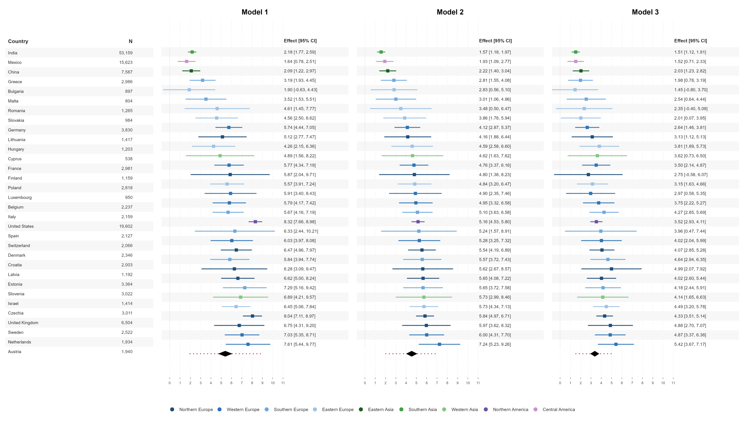

Supplementary Figure S15: Sensitivity: Forest plot of longitudinal Δ(L4−L1) for eHAYs using alternative smoking definition A (never smokers = 1 point, former smokers = 0.5 points, and current smokers = 0 points)
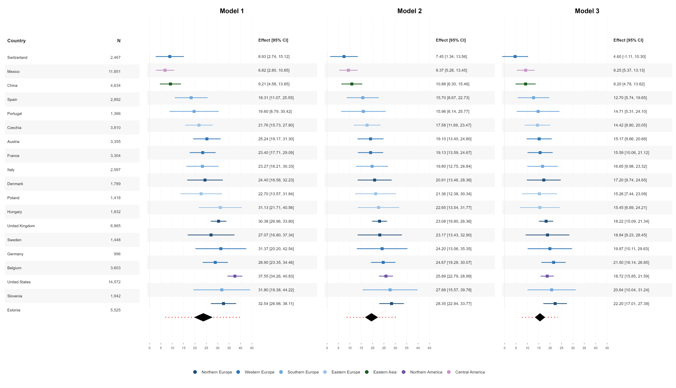

Supplementary Figure S16: Sensitivity: Forest plot of cross-sectional Δ(L4−L1) for HAI using alternative smoking definition B (never smokers = 1 point, and former or current smokers = 0 points)
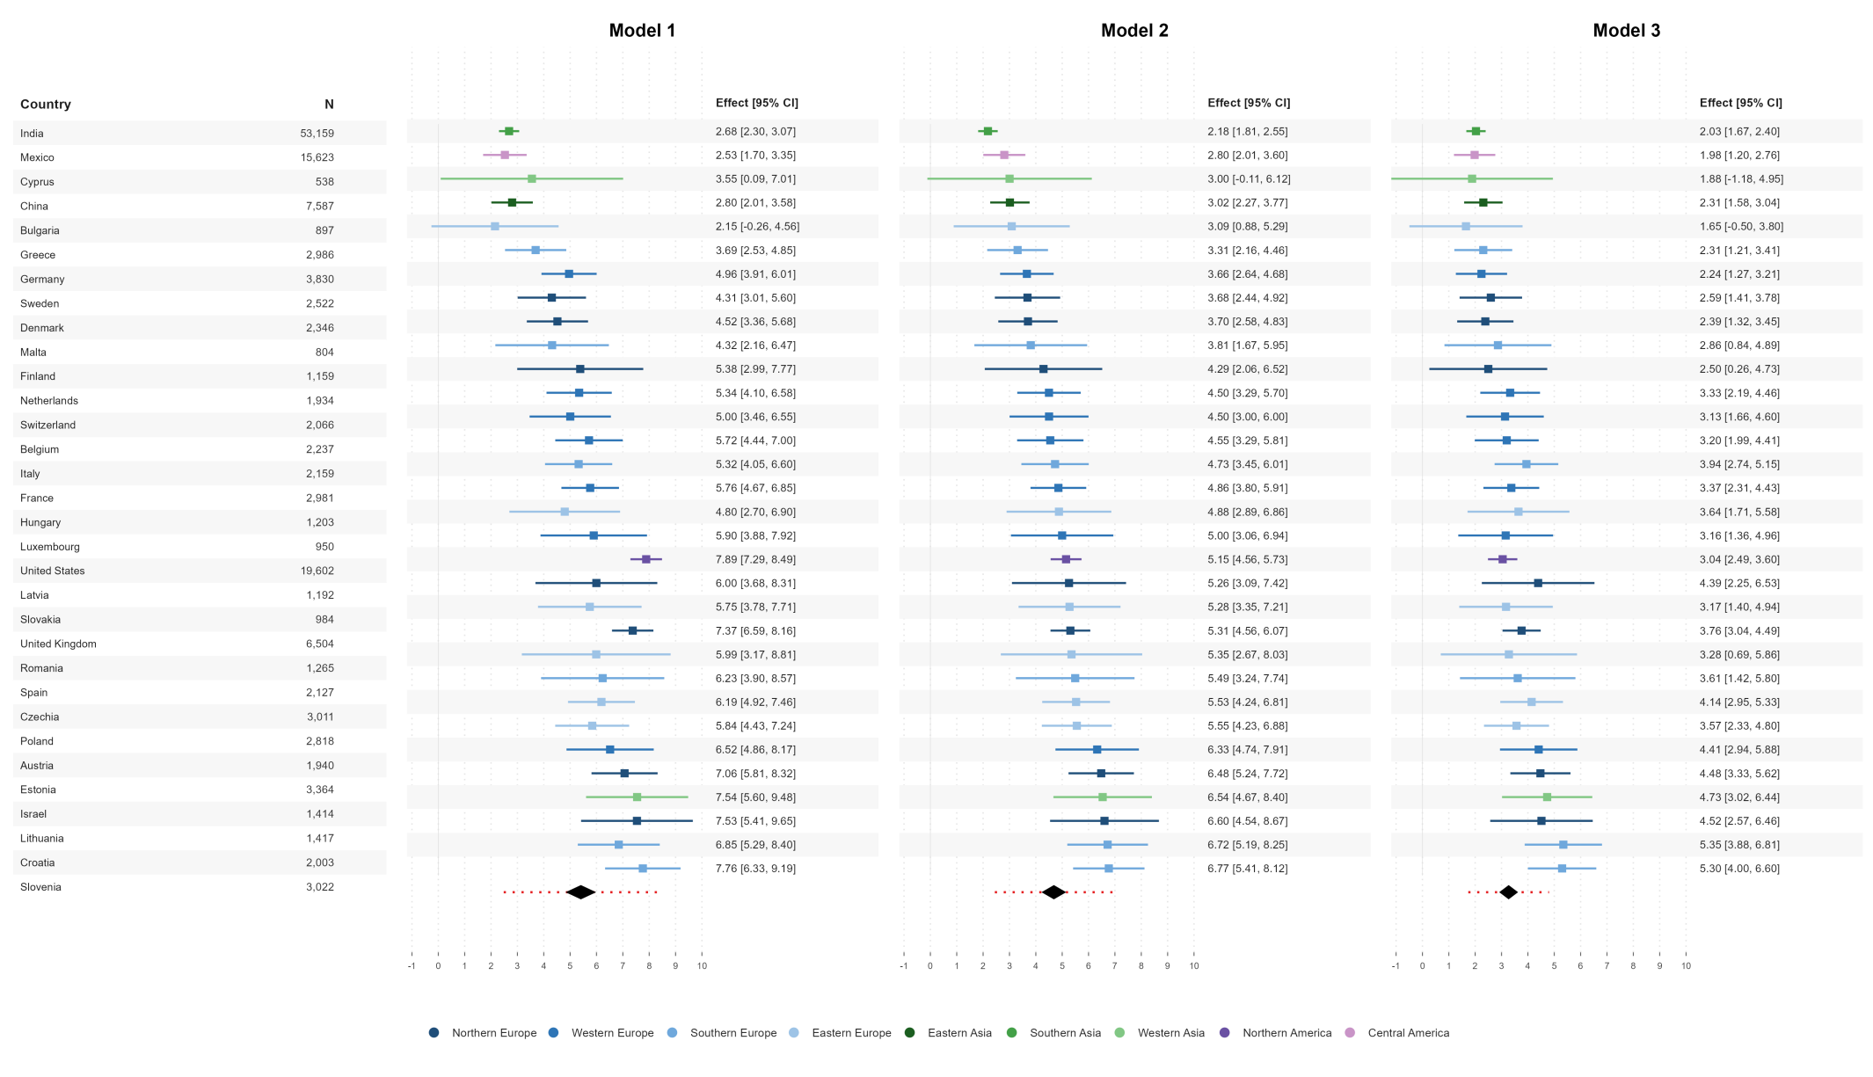

Supplementary Figure S17: Sensitivity: Forest plot of longitudinal Δ(L4−L1) for eHAYs using alternative smoking definition B (never smokers = 1 point, and former or current smokers = 0 points)
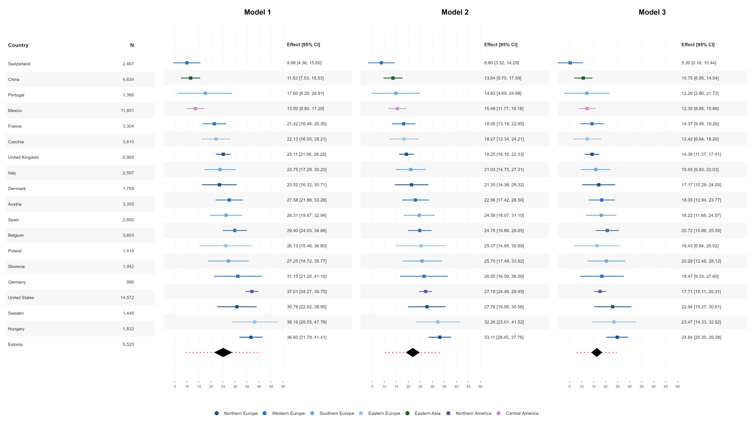

Supplementary Figure S18: Sensitivity: Forest plot of cross-sectional Δ(L4−L1) for HAI using country-specific normal BMI definition C (China: 18.5–23.9 kg/m²; India: 18.5–22.9 kg/m²; all other countries: 18.5–24.9 kg/m²)
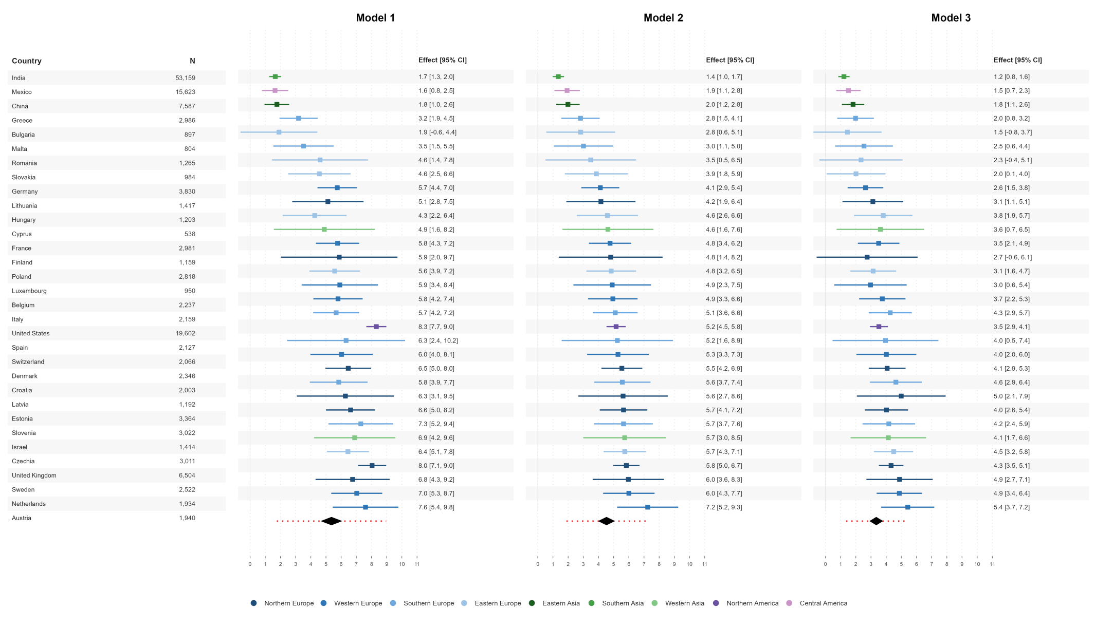

Supplementary Figure S19: Sensitivity: Forest plot of longitudinal Δ(L4−L1) for eHAYs using country-specific normal BMI (China: 18.5–23.9 kg/m²; India: 18.5–22.9 kg/m²; all other countries: 18.5–24.9 kg/m²)
