Additional file 1
Exercise-Based Management of Patients with Coronary Heart Disease: An Integrated Network Meta-Analysis and Machine Learning Exploration

Content
1. Research Process 2
1.1 Search Strategy 2
1.2 Definitions of exercise training interventions 5
1.3 Characteristics of Included Studies 7
2. Evidence Quality and Bias Assessment 46
2.1 Risk of Bias 46
2.2 RoB 2 Summary 58
2.3 The details of CINeMA 59
2.4 Sensitivity Analysis by Risk of Bias Criteria 60
2.5 Funnel Plot for the Assessment of Publication Bias 61
2.6 Power Funnel Plots for All Exercise 62
3. Model specification and validation 64
3.1 Node-Splitting Analysis 64
3.2 Prior-Posterior distributions of exercise treatment effects on VO₂peak 65
3.3 Bayes Factors of Different Exercise 66
3.4 Bayes Factors for Model Comparison 67
4. Results of the Meta-Analytic Random Forest Model 68
4.1 MetaForest Model Performance Metrics 68
4.2 Diagnostic plots for the random forest model 69
4.3 Variable Importance Metrics from Random Forest Model 70
4.4 Correlation Matrix of Variable Importance Metrics 72
4.5 Correlation Matrix of Variable Importance Rankings 74
4.6 Two-way interactions identified by the random forest model 76
4.7 Variable Importance Based on Mean SHAP Values 77
5. Moderation analysis 78
5.1 Predicted Exercise Effects on VO₂peak by Exercise Dose 78
5.2 Predicted Exercise Effects on VO₂peak by Intervention Frequency 81
5.3 Predicted Exercise Effects on VO₂peak by Intervention length 82
5.4 Predicted Exercise Effects on VO₂peak by Proportion of Women 84
5.5 Predicted Exercise Effects on VO₂peak by Mean Sample Age 85
5.6 Predicted Exercise Effects on VO₂peak by BCTs 86
5.7 Predicted Exercise Effects on VO₂peak by baseline VO₂peak 88
6. Effect modifiers of exercise on VO₂peak 90
6.1 Effect of Baseline Disease Severity on VO₂peak Compared with Control 90
6.2 Effect of Intervention Delivery Format on VO₂peak Compared with Control 91

Research Process

1.1 Search Strategy

Table S1. PubMed search strategy.
Database | Search strategy | amount
PubMed
#1 | ("Coronary Disease"[Mesh] OR "Coronary Artery Disease"[Mesh] OR "Myocardial Infarction"[Mesh] OR "Angina Pectoris"[Mesh] OR "coronary heart disease"[tiab] OR "coronary artery disease"[tiab] OR CHD[tiab] OR CAD[tiab] OR "myocardial infarction"[tiab] OR "heart attack"[tiab] OR angina[tiab]) | 853,667
#2 | ("Exercise"[Mesh] OR "Exercise Therapy"[Mesh] OR "Physical Exertion"[Mesh] OR "Resistance Training"[Mesh] OR "Motor Activity"[Mesh] OR "Walking"[Mesh] OR "Yoga"[Mesh] OR "Tai Ji"[Mesh] OR "Qigong"[Mesh] OR exercise*[tiab] OR "physical activity"[tiab] OR "physical activities"[tiab] OR "exercise training"[tiab] OR "aerobic exercise"[tiab] OR "endurance training"[tiab] OR "strength training"[tiab] OR "resistance training"[tiab] OR "weight training"[tiab] OR walking[tiab] OR yoga[tiab] OR "tai chi"[tiab] OR "tai ji"[tiab] OR qigong[tiab]) | 534,424
#3 | #1 AND #2 | 23,972
#4 | (randomized controlled trial[pt] OR controlled clinical trial[pt] OR randomized[tiab] OR randomised[tiab] OR randomly[tiab] OR trial[tiab] OR placebo[tiab]) | 42,891
#5 | #3 AND #4 | 10,359

Table S2. Embase search strategy.
Database | Search strategy | amount
Embase
#1 | ('coronary artery disease'/exp OR 'heart infarction'/exp OR 'angina pectoris'/exp OR ('coronary heart disease' OR 'coronary artery disease' OR CHD OR CAD OR 'myocardial infarction' OR 'heart attack' OR angina):ti,ab) | 531,230
#2 | ('exercise'/exp OR 'kinesiotherapy'/exp OR 'resistance training'/exp OR 'walking'/exp OR 'yoga'/exp OR 'tai chi'/exp OR 'qigong'/exp OR (exercise* OR 'physical activity' OR 'physical activities' OR 'exercise training' OR 'aerobic exercise' OR 'endurance training' OR 'strength training' OR 'resistance training' OR 'weight training' OR walking OR yoga OR 'tai chi' OR 'tai ji' OR qigong):ti,ab) | 279,958
#3 | #1 AND #2 | 5,133

Table S3. Web of Science search strategy.
Database | Search strategy | amount
Web of Science
#1 | TS=("coronary heart disease" OR "coronary artery disease" OR CHD OR CAD OR "myocardial infarction" OR "heart attack" OR angina) | 212,841
#2 | TS=(exercise* OR "physical activity" OR "physical activities" OR "exercise training" OR "aerobic exercise" OR "endurance training" OR "strength training" OR "resistance training" OR "weight training" OR walking OR yoga OR "tai chi" OR "tai ji" OR qigong) | 869,459
#3 | #1 AND #2 | 10,091

Table S4. Cochrane Library search strategy.
Database | Search strategy | amount
Cochrane
#1 | [mh "Coronary Disease"] OR [mh "Myocardial Infarction"] OR [mh "Angina Pectoris"] OR ("coronary heart disease" OR "coronary artery disease" OR CHD OR CAD OR "myocardial infarction" OR "heart attack" OR angina):ti,ab,kw | 5,005
#2 | [mh "Exercise"] OR [mh "Exercise Therapy"] OR [mh "Resistance Training"] OR [mh "Walking"] OR [mh "Yoga"] OR [mh "Tai Ji"] OR [mh "Qigong"] OR (exercise* OR "physical activity" OR "physical activities" OR "exercise training" OR "aerobic exercise" OR "endurance training" OR "strength training" OR "resistance training" OR "weight training" OR walking OR yoga OR "tai chi" OR "tai ji" OR qigong):ti,ab,kw | 4,250
#3 | #1 AND #2 | 3,343

1.2 Definitions of exercise training interventions
Table S5. Definitions of exercise training interventions.
Modality | Definition
Continuous aerobic exercise training | Continuous aerobic exercise training refers to a mode of endurance exercise performed at a sustained, constant intensity for a specified duration without planned rest intervals. This type of training is typically conducted at a submaximal level, targeting a steady-state heart rate zone, and is primarily aimed at enhancing cardiorespiratory fitness and endurance.
Resistance exercise training | Resistance exercise training, also referred to as strength training, is a form of physical activity designed to improve muscular strength and endurance. It involves muscles contracting against an external resistance. This resistance can be provided by free weights, weight machines, elastic bands, or an individual’s own body weight. The primary objectives of resistance exercise training are to induce muscular hypertrophy and increase muscular strength and power.
Interval aerobic exercise training | Interval aerobic exercise training involves alternating periods of higher-intensity exercise with periods of lower-intensity recovery or rest. A prominent form of this modality is high-intensity interval training. This method allows for the accumulation of a greater volume of higher-intensity work than would be possible with continuous exercise and is recognised for its time-efficiency in inducing physiological adaptations.
Combined aerobic and resistance exercise training | Combined aerobic and resistance exercise training, also known as concurrent training, is an exercise regimen that integrates both aerobic and resistance components into a single structured programme. Implementation may vary, with aerobic and resistance exercises performed sequentially within the same session or on alternate days. This approach aims to simultaneously improve both cardiorespiratory fitness and muscular strength.
Mind-body/flexibility exercise training | This category encompasses physical activities primarily aimed at improving joint range of motion, muscle extensibility, and postural control. It includes both targeted flexibility training, such as static or dynamic stretching routines, and more integrative mind-body modalities. These modalities, including yoga, tai chi, and Pilates, may improve flexibility while also incorporating conscious breathing and mindfulness to enhance balance, proprioception, and psychophysiological well-being.
Control | The control group in a clinical trial does not receive the experimental exercise intervention. This group serves as a comparator to isolate the effects of the intervention. Participants in the control group typically receive usual care, standard medical advice, or a sham intervention, such as non-therapeutic stretching, to account for placebo effects. This is a methodological component rather than an exercise modality.

1.3 Characteristics of Included Studies
Table S6. Characteristics of included studies.
Country | Funded | Group Exercise | Exercise Model | Time Management | n | Female percentage | Mean Age (SD/Range) | BMI (SD/Range) | supervision | Treatment | Duration (weeks) | Intensity (METs) | Outcomes
Ades2003
USA | TRUE | TRUE | Coached Community | Regular exercise | 14.0 | 1.000 | 72.3 (5.6) | NA | TRUE | Mind_body/Flexibility | 26 | 2 | VO₂peak
USA | TRUE | TRUE | Coached Community | Regular exercise | 19.0 | 1.000 | 72.3 (5.6) | NA | TRUE | Resistance | 26 | 3 | VO₂peak
Ades2005
USA | TRUE | TRUE | Coached Community | Regular exercise | 21.0 | 1.000 | 71.5 (4.8) | 30.2±5.6 | TRUE | Mind_body/Flexibility | 24 | 2 | VO₂peak
USA | TRUE | TRUE | Coached Community | Regular exercise | 21.0 | 1.000 | 72.9 (6.9) | 28.7±4.2 | TRUE | Resistance | 24 | 3 | VO₂peak
Arthur2007
Canada | TRUE | TRUE | Coached Community | Weekend warrior | 46.0 | 1.000 | NA (NA) | NA | TRUE | Continuous aerobic | 24 | 4 | VO₂peak
Canada | TRUE | TRUE | Coached Community | Weekend warrior | 46.0 | 1.000 | NA (NA) | NA | TRUE | Combined aerobic+resistance | 24 | 4 | VO₂peak
Beigienė2021
Lithuania | TRUE | FALSE | Solo exercise | NA | 19.0 | 0.210 | 75.5 (4.9) | 26.9±3.7 | TRUE | Control | NA | NA | VO₂peak
Lithuania | TRUE | TRUE | Coached Community | Regular exercise | 26.0 | 0.260 | 72.9 (4.4) | 28.7±3.5 | TRUE | Resistance | 3 | 3 | VO₂peak
Lithuania | TRUE | TRUE | Coached Community | Regular exercise | 18.0 | 0.330 | 70.1 (4) | 28.6±3.8 | TRUE | Resistance | 3 | 3 | VO₂peak
Belardinelli2001
USA | TRUE | TRUE | Solo exercise | NA | 59.0 | 0.160 | 59 (10) | NA | TRUE | Control | NA | NA | VO₂peak
USA | TRUE | TRUE | Coached Community | Regular exercise | 59.0 | 0.170 | 53 (6) | NA | TRUE | Mind_body/Flexibility | 26 | 2 | VO₂peak
Benetti2010
Brazil | TRUE | FALSE | Solo exercise | NA | 23.0 | 0.000 | 57 (6.1) | 29.67±4.10 | TRUE | Control | NA | NA | VO₂peak
Brazil | TRUE | TRUE | Coached Community | Regular exercise | 26.0 | 0.000 | 57 (6.1) | 29.80±3.97 | TRUE | Continuous aerobic | 12 | 4 | VO₂peak
Brazil | TRUE | TRUE | Coached Community | Regular exercise | 21.0 | 0.000 | 57 (6.1) | 30.03±4.09 | TRUE | Interval aerobic | 12 | 5 | VO₂peak
Berent2011
Austria | TRUE | FALSE | Personal Training | Fragmented Workout Style | 148.0 | 0.240 | 62.7 (11.7) | 28.6±5.3 | TRUE | Combined aerobic+resistance | 4 | 3 | VO₂peak
Austria | TRUE | FALSE | Personal Training | Regular exercise | 148.0 | 0.240 | 62.7 (11.7) | 28.6±5.3 | TRUE | Combined aerobic+resistance | 4 | 3 | VO₂peak
Bilinska2010
Poland | TRUE | FALSE | Solo exercise | NA | 59.0 | 0.000 | 54.1 (5.8) | 27.9±3.0 | FALSE | Control | NA | NA | VO₂peak
Poland | TRUE | FALSE | Personal Training | Regular exercise | 59.0 | 0.000 | 53.9 (5) | 27.4±2.7 | TRUE | Continuous aerobic | 6 | 6 | VO₂peak
Bilińska2013
Poland | TRUE | FALSE | Solo exercise | NA | 50.0 | 0.000 | 56.6 (6) | NA | FALSE | Control | NA | NA | VO₂peak
Poland | TRUE | FALSE | Solo Exercise | Regular exercise | 50.0 | 0.000 | 57.6 (6) | NA | FALSE | Continuous aerobic | 6 | 3 | VO₂peak
blumenthal1988
USA | TRUE | TRUE | Coached Community | Regular exercise | 23.0 | 0.000 | 51 (8) | NA | TRUE | Interval aerobic | 12 | 5 | VO₂peak
USA | TRUE | TRUE | Coached Community | Regular exercise | 23.0 | 0.000 | 51 (8) | NA | TRUE | Interval aerobic | 12 | 2 | VO₂peak
Blumenthal2005
USA | TRUE | FALSE | Solo exercise | NA | 70.0 | 0.180 | 61 (8) | NA | FALSE | Control | NA | NA | VO₂peak
USA | TRUE | TRUE | Coached Community | Regular exercise | 75.0 | 0.200 | 61 (9) | NA | TRUE | Continuous aerobic | 12 | 6 | VO₂peak
Bouri2012
Iran | FALSE | FALSE | Solo exercise | NA | 18.0 | 0.000 | 56 (7) | 27.6±3.0 | FALSE | Control | NA | NA | VO₂peak
Iran | FALSE | TRUE | Coached Community | Regular exercise | 20.0 | 0.000 | 57 (6) | 27.5±2.9 | TRUE | Continuous aerobic | 8 | 6 | VO₂peak
Iran | FALSE | TRUE | Coached Community | Regular exercise | 20.0 | 0.000 | 58 (7) | 27.8±3.1 | TRUE | Interval aerobic | 8 | 6 | VO₂peak
Brochu2002
USA | TRUE | FALSE | Solo exercise | NA | 19.0 | 1.000 | 72 (6) | 30.1±4.9 | FALSE | Control | NA | NA | VO₂peak
USA | TRUE | FALSE | Personal Training | Regular exercise | 22.0 | 1.000 | 71 (5) | 29.6±4.5 | TRUE | Resistance | 24 | 4 | VO₂peak
Busch2012
Germany | TRUE | TRUE | Solo exercise | Regular exercise | 86.0 | 0.360 | 79 (4) | 26.3±3.6 | TRUE | Control | 3 | 3 | VO₂peak
Germany | TRUE | TRUE | Coached Community | Regular exercise | 87.0 | 0.370 | 79 (3) | 26.1±3.4 | TRUE | Resistance | 3 | 4 | VO₂peak
Byrkjeland2015
Norway | TRUE | FALSE | Solo exercise | NA | 37.0 | 0.190 | 64 (7) | 30.7±4.0 | FALSE | Control | NA | NA | VO₂peak
Norway | TRUE | FALSE | Solo Exercise | Regular exercise | 37.0 | 0.150 | 63 (8) | 30.5±4.2 | FALSE | Interval aerobic | 52 | 6 | VO₂peak
Cao2020
China | TRUE | FALSE | Personal Training | Regular exercise | 24.0 | 0.210 | 59.4 (2.4) | 24±0.6 | TRUE | Continuous aerobic | 8 | 4 | VO₂peak
China | TRUE | FALSE | Personal Training | Regular exercise | 10.0 | 0.400 | 67.2 (1.9) | 25.3±1.4 | TRUE | Continuous aerobic | 8 | 2 | VO₂peak
Cardozo2015
Brazil | FALSE | FALSE | Solo exercise | NA | 24.0 | 0.180 | 64 (12) | 26.9±4.4 | FALSE | Control | NA | NA | VO₂peak
Brazil | FALSE | FALSE | Personal Training | Regular exercise | 24.0 | 0.150 | 62 (12) | 26.8±4.8 | TRUE | Continuous aerobic | 16 | 3 | VO₂peak
Brazil | FALSE | FALSE | Personal Training | Regular exercise | 23.0 | 0.150 | 56 (12) | 27.5±5.9 | TRUE | Interval aerobic | 16 | 5 | VO₂peak
Caruso2017
Brazil | TRUE | TRUE | Coached Community | Weekend warrior | 10.0 | 0.000 | 61.3 (4.4) | 27.6±4.5 | TRUE | Continuous aerobic | 8 | 4 | VO₂peak
Brazil | TRUE | TRUE | Coached Community | Weekend warrior | 10.0 | 0.000 | 62 (5.5) | 26.3 ± 1.4 | TRUE | Combined aerobic+resistance | 8 | 5 | VO₂peak
Chen2024
China | TRUE | FALSE | Personal Training | Regular exercise | 50.0 | 0.100 | 55.38 (9.15) | 26.36 ± 0.69 | TRUE | Continuous aerobic | 12 | 2 | VO₂peak
China | TRUE | FALSE | Personal Training | Regular exercise | 47.0 | 0.140 | 58.85 (9.32) | 25.64 ± 2.85 | TRUE | Interval aerobic | 12 | 2 | VO₂peak
Choi2018
Korea | FALSE | TRUE | Coached Community | Weekend warrior | 21.0 | 0.140 | 57.31 (12.62) | 26.30 ± 2.47 | TRUE | Continuous aerobic | 10 | 4 | VO₂peak
Korea | FALSE | TRUE | Coached Community | Weekend warrior | 23.0 | 0.080 | 53 (6.84) | 24.65 ± 3.36 | TRUE | Interval aerobic | 10 | 5 | VO₂peak
Clavario2021
Italy | FALSE | FALSE | Personal Training | Regular exercise | 9.0 | 0.000 | 66 (7) | 29±4 | TRUE | Combined aerobic+resistance | 12 | 5 | VO₂peak
Italy | FALSE | FALSE | Personal Training | Regular exercise | 15.0 | 0.000 | 68 (8) | 27±3.2 | TRUE | Combined aerobic+resistance | 12 | 3 | VO₂peak
Conraads2014
Belgium | FALSE | FALSE | Personal Training | Regular exercise | 100.0 | 0.100 | 56.5 (8.7) | 28±4 | TRUE | Continuous aerobic | 12 | 4 | VO₂peak
Belgium | FALSE | FALSE | Personal Training | Regular exercise | 100.0 | 0.100 | 60.3 (9.1) | 28.5±3.5 | TRUE | Continuous aerobic | 12 | 3 | VO₂peak
Currie2013
Canada | FALSE | TRUE | Coached Community | Weekend warrior | 11.0 | 0.090 | 68 (8) | 27.3±4 | TRUE | Continuous aerobic | 12 | 3 | VO₂peak
Canada | FALSE | TRUE | Coached Community | Fragmented Workout Style | 11.0 | 0.090 | 62 (11) | 27.9±5 | TRUE | Interval aerobic | 12 | 4 | VO₂peak
Currie2015
Canada | FALSE | FALSE | Personal Training | Weekend warrior | 10.0 | 0.100 | 66 (8) | 27.3±4 | TRUE | Continuous aerobic | 24 | 4 | VO₂peak
Canada | FALSE | FALSE | Personal Training | Fragmented Workout Style | 9.0 | 0.000 | 63 (8) | 27±3.2 | TRUE | Interval aerobic | 24 | 5 | VO₂peak
Desch2010
Germany | FALSE | FALSE | Solo exercise | NA | 12.0 | 0.330 | 62.3 (6.5) | 31.3±3 | FALSE | Control | NA | NA | VO₂peak
Germany | FALSE | TRUE | Coached Community | Regular exercise | 14.0 | 0.210 | 62.3 (6.2) | 29.8±5 | TRUE | Continuous aerobic | 24 | 4 | VO₂peak
Dressendorfer1995
USA | FALSE | FALSE | Solo exercise | NA | 12.0 | 0.000 | 54.8 (3.2) | 25.9±4 | TRUE | Control | NA | NA | VO₂peak
USA | FALSE | TRUE | Coached Community | Weekend warrior | 13.0 | 0.000 | 53.6 (2.6) | 26.5±4 | TRUE | Continuous aerobic | 5 | 3 | VO₂peak
USA | FALSE | TRUE | Coached Community | Weekend warrior | 13.0 | 0.000 | 55.1 (2.3) | 25.7±4.9 | TRUE | Continuous aerobic | 5 | 3 | VO₂peak
USA | FALSE | TRUE | Coached Community | Regular exercise | 13.0 | 0.000 | 55.9 (3) | 27±4 | TRUE | Continuous aerobic | 5 | 3 | VO₂peak
Dunford2021
Canada | TRUE | FALSE | Personal Training | Regular exercise | 9.0 | 0.110 | 61 (8) | 29.7 ± 4.1 | TRUE | Continuous aerobic | 12 | 4 | VO₂peak
Canada | TRUE | FALSE | Personal Training | Fragmented Workout Style | 9.0 | 0.110 | 62 (6) | 29.8 ± 3.3 | TRUE | Interval aerobic | 12 | 5 | VO₂peak
Edelmann2025
Germany | TRUE | FALSE | Solo exercise | NA | 161.0 | 0.570 | 70 (7) | 29.6 ± 5.1 | FALSE | Control | NA | NA | VO₂peak
Germany | TRUE | TRUE | Coached Community | Regular exercise | 161.0 | 0.590 | 70 (7) | 29.6 ± 5.4 | TRUE | Combined aerobic+resistance | 52 | 6 | VO₂peak
Eser2022
Switzerland | TRUE | TRUE | Coached Community | Regular exercise | 34.0 | 0.000 | 56 (10) | 26.9 ± 2.4 | TRUE | Continuous aerobic | 9 | 4 | VO₂peak
Switzerland | TRUE | TRUE | Coached Community | Regular exercise | 35.0 | 0.000 | 56 (10) | 26.6 ± 2.2 | TRUE | Interval aerobic | 9 | 5 | VO₂peak
Fletcher1994
USA | TRUE | FALSE | Solo exercise | NA | 19.0 | 0.000 | 63 (7) | NA | FALSE | Control | NA | NA | VO₂peak
USA | TRUE | FALSE | Solo Exercise | Fragmented Workout Style | 16.0 | 0.000 | 62 (7) | NA | FALSE | Continuous aerobic | 26 | 4 | VO₂peak
Fontes-Carvalho2015
Portugal | TRUE | FALSE | Solo exercise | NA | 86.0 | 0.200 | 55.9 (10.8) | NA | FALSE | Control | NA | NA | VO₂peak
Portugal | TRUE | TRUE | Coached Community | Regular exercise | 89.0 | 0.170 | 55.5 (10.5) | NA | TRUE | Combined aerobic+resistance | 8 | 6 | VO₂peak
Gayda2009
France | TRUE | TRUE | Coached Community | Regular exercise | 8.0 | 0.000 | 55 (8) | 28.7±4.2 | TRUE | Continuous aerobic | 7 | 4 | VO₂peak
France | TRUE | TRUE | Coached Community | Regular exercise | 8.0 | 0.000 | 55 (8) | 29.1±4 | TRUE | Combined aerobic+resistance | 7 | 5 | VO₂peak
Ghannem2014
France | TRUE | TRUE | Coached Community | Regular exercise | 9.0 | 0.000 | 62 (7) | 27.4±5 | TRUE | Continuous aerobic | 4 | 4 | VO₂peak
France | TRUE | TRUE | Coached Community | Regular exercise | 9.0 | 0.000 | 62 (7) | 27.4±6 | TRUE | Combined aerobic+resistance | 4 | 5 | VO₂peak
Ghroubi2013
Tunisia | TRUE | TRUE | Coached Community | Regular exercise | 16.0 | 0.000 | 59 (5.9) | 27.9±2.9 | TRUE | Continuous aerobic | 8 | 5 | VO₂peak
Tunisia | TRUE | TRUE | Coached Community | Regular exercise | 16.0 | 0.000 | 59.3 (1.7) | 27.2±1.8 | TRUE | Resistance | 8 | 4 | VO₂peak
Giallauria2006
Italy | TRUE | FALSE | Solo exercise | NA | 20.0 | 0.150 | 68.2 (2.6) | NA | FALSE | Control | NA | NA | VO₂peak
Italy | TRUE | TRUE | Coached Community | Regular exercise | 20.0 | 0.200 | 68.6 (2.3) | NA | TRUE | Continuous aerobic | 12 | 5 | VO₂peak
Giallauria2008
Italy | FALSE | FALSE | Solo exercise | NA | 31.0 | 0.290 | 55.1 (3.7) | 25.3±2.9 | FALSE | Control | NA | NA | VO₂peak
Italy | FALSE | TRUE | Coached Community | Regular exercise | 30.0 | 0.260 | 55.9 (3.1) | 25.6±2.4 | TRUE | Continuous aerobic | 24 | 3 | VO₂peak
Giallauria2011
Italy | FALSE | FALSE | Solo exercise | NA | 38.0 | 0.150 | 60 (8) | 28.2±2.8 | FALSE | Control | NA | NA | VO₂peak
Italy | FALSE | TRUE | Coached Community | Regular exercise | 37.0 | 0.240 | 61 (7) | 27.3±2.2 | TRUE | Continuous aerobic | 25 | 3 | VO₂peak
Giallauria2012
Italy | FALSE | FALSE | Solo exercise | NA | 21.0 | 0.140 | 54 (9) | 26.4±2.8 | FALSE | Control | NA | NA | VO₂peak
Italy | FALSE | TRUE | Coached Community | Regular exercise | 25.0 | 0.120 | 54 (7) | 26.9±2.6 | TRUE | Continuous aerobic | 26 | 3 | VO₂peak
Grabara2020
Poland | FALSE | FALSE | Solo exercise | NA | 35.0 | 0.000 | 49.6 (5) | 29.4±1.9 | TRUE | Control | NA | NA | VO₂peak
Poland | FALSE | TRUE | Coached Community | Regular exercise | 35.0 | 0.000 | 57.1 (5.3) | 28.2±1.7 | TRUE | Continuous aerobic | 3 | 3 | VO₂peak
Gremeaux2010
France | TRUE | TRUE | Coached Community | Regular exercise | 7.0 | 0.000 | 53 (0.7) | 27.1±4.3 | TRUE | Resistance | 5 | 4 | VO₂peak
France | TRUE | TRUE | Coached Community | Regular exercise | 7.0 | 0.000 | 45.3 (5.2) | 27.5±4 | TRUE | Resistance | 5 | 4 | VO₂peak
Haennel1991
Canada | FALSE | FALSE | Solo exercise | NA | 10.0 | 0.000 | 56 (6) | 25.9±2.5 | FALSE | Control | NA | NA | VO₂peak
Canada | FALSE | FALSE | Personal Training | Regular exercise | 10.0 | 0.000 | 55 (7) | 23.4±1.9 | TRUE | Continuous aerobic | 12 | 4 | VO₂peak
Canada | FALSE | TRUE | Coached Community | Regular exercise | 10.0 | 0.000 | 56 (6) | 22.9±1.4 | TRUE | Resistance | 12 | 4 | VO₂peak
Hambrecht2000
Germany | FALSE | FALSE | Solo exercise | NA | 9.0 | 0.000 | 61 (1) | NA | TRUE | Control | NA | NA | VO₂peak
Germany | FALSE | FALSE | Personal Training | Fragmented Workout Style | 10.0 | 0.000 | 60 (2) | NA | TRUE | Continuous aerobic | 4 | 6 | VO₂peak
Hansen2008
Belgium | FALSE | FALSE | Personal Training | Regular exercise | 67.0 | 0.190 | 63.4 (8.9) | 26.8±3.3 | TRUE | Continuous aerobic | 7 | 4 | VO₂peak
Belgium | FALSE | FALSE | Personal Training | Regular exercise | 67.0 | 0.190 | 62.9 (10.3) | 26.6±2.8 | TRUE | Continuous aerobic | 7 | 4 | VO₂peak
Hansen2011
Belgium | TRUE | TRUE | Coached Community | Regular exercise | 25.0 | 0.080 | 58.9 (7.2) | 27±3.2 | TRUE | Continuous aerobic | 6 | 5 | VO₂peak
Belgium | TRUE | TRUE | Coached Community | Regular exercise | 22.0 | 0.040 | 60.4 (8.9) | 26.6±3.1 | TRUE | Resistance | 6 | 5 | VO₂peak
He2020
China | TRUE | FALSE | Solo exercise | NA | 262.0 | 0.520 | 60.9 (12.9) | 24.5±3.7 | TRUE | Control | NA | NA | VO₂peak
China | TRUE | FALSE | Personal Training | Regular exercise | 262.0 | 0.540 | 60.6 (12.7) | 24.4±3.6 | TRUE | Continuous aerobic | 6 | 5 | VO₂peak
Heber2019
Austria | TRUE | FALSE | Personal Training | Regular exercise | 42.0 | 0.000 | 61.7 (9.8) | 28.1±3.4 | TRUE | Continuous aerobic | 12 | 5 | VO₂peak
Austria | TRUE | FALSE | Personal Training | Regular exercise | 40.0 | 0.000 | 60 (9.4) | 28.5±3.5 | TRUE | Interval aerobic | 12 | 6 | VO₂peak
Helgerud2010
Norway | FALSE | FALSE | Personal Training | Regular exercise | 8.0 | 0.250 | 61.4 (3.7) | 26.1±2.9 | TRUE | Continuous aerobic | 8 | 5 | VO₂peak
Norway | FALSE | FALSE | Personal Training | Fragmented Workout Style | 10.0 | 0.000 | 66.5 (5.5) | 26.5±3.1 | TRUE | Interval aerobic | 8 | 5 | VO₂peak
Huang2017
Taiwan | TRUE | FALSE | Personal Training | Regular exercise | 21.0 | 0.040 | 58.9 (3.1) | 25.9±0.6 | TRUE | Continuous aerobic | 4 | 6 | VO₂peak
Taiwan | TRUE | FALSE | Personal Training | Fragmented Workout Style | 19.0 | 0.050 | 57.9 (1.2) | 24.8±0.7 | TRUE | Continuous aerobic | 1 | 3 | VO₂peak
izawa2006
Japan | TRUE | FALSE | Solo Exercise | Weekend warrior | 8.0 | 0.120 | 66.8 (9.9) | 24±3.5 | FALSE | Continuous aerobic | 24 | 4 | VO₂peak
Japan | TRUE | FALSE | Solo Exercise | Weekend warrior | 10.0 | 0.100 | 65.2 (9.7) | 23.5±3.9 | FALSE | Combined aerobic+resistance | 24 | 6 | VO₂peak
Jaureguizar2016
Spain | FALSE | TRUE | Coached Community | Regular exercise | 36.0 | 0.080 | 58 (11) | 29.5 ± 4.1 | TRUE | Continuous aerobic | 8 | 4 | VO₂peak
Spain | FALSE | TRUE | Coached Community | Regular exercise | 36.0 | 0.220 | 58 (11) | 29.6 ± 4.4 | TRUE | Interval aerobic | 8 | 5 | VO₂peak
Jaureguizar2017
Spain | FALSE | TRUE | Coached Community | Regular exercise | 36.0 | 0.080 | 58 (11) | 29.5 ± 4.1 | TRUE | Continuous aerobic | 8 | 4 | VO₂peak
Spain | FALSE | TRUE | Coached Community | Regular exercise | 37.0 | 0.220 | 58 (11) | 29.6 ± 4.4 | TRUE | Interval aerobic | 8 | 5 | VO₂peak
Jaureguizar2019
Spain | FALSE | TRUE | Coached Community | Regular exercise | 53.0 | 0.210 | 58.3 (9.5) | 27.8 ± 3.7 | TRUE | Continuous aerobic | 8 | 4 | VO₂peak
Spain | FALSE | TRUE | Coached Community | Regular exercise | 57.0 | 0.120 | 57.6 (9.8) | 29.1 ± 3.9 | TRUE | Interval aerobic | 8 | 5 | VO₂peak
Jayo-montoya2020
Spain | FALSE | FALSE | Solo exercise | NA | 14.0 | 0.140 | 56 (7.5) | 29.6 ± 8.3 | TRUE | Control | NA | NA | VO₂peak
Spain | FALSE | TRUE | Coached Community | Weekend warrior | 28.0 | 0.180 | 58.9 (8) | 30.9 ± 9.2 | TRUE | Interval aerobic | 16 | 5 | VO₂peak
Jiang2024
China | TRUE | TRUE | Coached Community | Regular exercise | 33.0 | 0.300 | 59 (9) | NA | TRUE | Continuous aerobic | 12 | 4 | VO₂peak
China | TRUE | TRUE | Coached Community | Regular exercise | 27.0 | 0.000 | 51 (8) | NA | TRUE | Interval aerobic | 12 | 5 | VO₂peak
Kaltsatou2014
Greece | FALSE | FALSE | Solo exercise | NA | 17.0 | 0.000 | 67.2 (5) | 28.4 ± 2.0 | FALSE | Control | NA | NA | VO₂peak
Greece | FALSE | TRUE | Coached Community | Regular exercise | 18.0 | 0.000 | 67.2 (4.2) | 28.8 ± 2.7 | TRUE | Continuous aerobic | 32 | 5 | VO₂peak
Greece | FALSE | TRUE | Coached Community | Regular exercise | 16.0 | 0.000 | 67.1 (7.2) | 28.4 ± 2.0 | TRUE | Combined aerobic+resistance | 32 | 4 | VO₂peak
keteyian2014
USA | FALSE | TRUE | Coached Community | Regular exercise | 13.0 | 0.080 | 58 (9) | 30.6 ± 6.2 | TRUE | Continuous aerobic | 10 | 4 | VO₂peak
USA | FALSE | TRUE | Coached Community | Regular exercise | 15.0 | 0.270 | 60 (7) | 30.4 ± 5.6 | TRUE | Interval aerobic | 10 | 5 | VO₂peak
Khalid2019
Pakistan | FALSE | FALSE | Personal Training | Regular exercise | 13.0 | 0.380 | 57.23 (9.76) | NA | TRUE | Combined aerobic+resistance | 6 | 6 | VO₂peak
Pakistan | FALSE | FALSE | Personal Training | Regular exercise | 13.0 | 0.380 | 55.77 (10.46) | NA | TRUE | Interval aerobic | 6 | 4 | VO₂peak
Kim2015
South Korea | FALSE | FALSE | Personal Training | Regular exercise | 14.0 | 0.290 | 60.2 (13.64) | 24.64 ± 3.56 | TRUE | Continuous aerobic | 6 | 4 | VO₂peak
South Korea | FALSE | FALSE | Personal Training | Regular exercise | 14.0 | 0.140 | 57 (11.58) | 24.28 ± 2.93 | TRUE | Interval aerobic | 6 | 5 | VO₂peak
Kristiansen2022
Faroe | FALSE | FALSE | Solo exercise | NA | 78.0 | 0.180 | 66.4 (9.3) | 29.7 ± 4.8 | FALSE | Control | NA | NA | VO₂peak
Faroe | FALSE | TRUE | Coached Community | Regular exercise | 64.0 | 0.160 | 67 (9.5) | 29.2 ± 4.9 | TRUE | Interval aerobic | 12 | 5 | VO₂peak
Ksela2024
Slovenia | FALSE | FALSE | Solo exercise | NA | 14.0 | 0.210 | 66.5 (6.9) | 27.4±4 | FALSE | Control | NA | NA | VO₂peak
Slovenia | FALSE | TRUE | Coached Community | Regular exercise | 20.0 | 0.400 | 66 (6) | 28.7±5 | TRUE | Continuous aerobic | 2 | 4 | VO₂peak
Slovenia | FALSE | TRUE | Coached Community | Regular exercise | 11.0 | 0.180 | 65 (8.1) | 31.5±5 | TRUE | Continuous aerobic | 2 | 5 | VO₂peak
Kumer2024
Slovenia | FALSE | FALSE | Solo exercise | NA | 14.0 | 0.210 | 66.5 (6) | 27.4±5 | FALSE | Control | NA | NA | VO₂peak
Slovenia | FALSE | TRUE | Coached Community | Regular exercise | 11.0 | 0.180 | 65 (6) | 31.5±5 | TRUE | Continuous aerobic | 2 | 5 | VO₂peak
Slovenia | FALSE | TRUE | Coached Community | Regular exercise | 20.0 | 0.400 | 66 (6) | 28.7±4.2 | TRUE | Combined aerobic+resistance | 2 | 5 | VO₂peak
Laurent2009
France | TRUE | TRUE | Coached Community | Regular exercise | 12.0 | 0.000 | 54 (3) | 27.9 ± 0.8 | TRUE | Continuous aerobic | 3 | 4 | VO₂peak
France | TRUE | TRUE | Coached Community | Regular exercise | 12.0 | 0.000 | 53 (3) | 25.1 ± 1.3 | TRUE | Resistance | 3 | 5 | VO₂peak
Lee2001
USA | TRUE | TRUE | Coached Community | Regular exercise | 10.0 | 0.350 | 62 (10) | 28±4 | TRUE | Continuous aerobic | 24 | 4 | VO₂peak
USA | TRUE | TRUE | Coached Community | Regular exercise | 10.0 | 0.350 | 61 (10) | 28.5±4 | TRUE | Combined aerobic+resistance | 24 | 5 | VO₂peak
Lee2008
Taiwan | TRUE | FALSE | Personal Training | Fragmented Workout Style | 20.0 | 0.000 | 52 (9) | 26.1±4 | TRUE | Continuous aerobic | 12 | 5 | VO₂peak
Taiwan | TRUE | FALSE | Personal Training | Fragmented Workout Style | 20.0 | 0.000 | 52 (7) | 26.5±5 | TRUE | Continuous aerobic | 12 | 5 | VO₂peak
Lee2017
Korea | FALSE | FALSE | Solo exercise | NA | 19.0 | 0.260 | 72.9 (4.7) | 25.5±5 | TRUE | Control | NA | NA | VO₂peak
Korea | FALSE | TRUE | Coached Community | Regular exercise | 21.0 | 0.295 | 72.2 (4.5) | 26.1±5 | TRUE | Continuous aerobic | 24 | 3 | VO₂peak
Korea | FALSE | TRUE | Coached Community | Regular exercise | 21.0 | 0.295 | 73.2 (4.3) | 26.5±5 | TRUE | Continuous aerobic | 24 | 3 | VO₂peak
Lee2019
Canada | FALSE | TRUE | Coached Community | Regular exercise | 14.0 | 1.000 | 69.6 (5.9) | 28.0 ± 5.7 | TRUE | Continuous aerobic | 24 | 4 | VO₂peak
Canada | FALSE | TRUE | Coached Community | Regular exercise | 17.0 | 1.000 | 69.3 (9.9) | 26.6 ± 4.2 | TRUE | Interval aerobic | 24 | 5 | VO₂peak
Legramante2007
Italy | FALSE | TRUE | Coached Community | Weekend warrior | 43.0 | 0.000 | 59.6 (8.6) | NA | TRUE | Continuous aerobic | 2 | 4 | VO₂peak
Italy | FALSE | FALSE | Personal Training | Weekend warrior | 39.0 | 0.000 | 58 (7.5) | NA | TRUE | Continuous aerobic | 2 | 3 | VO₂peak
Lehti2020
Finland | FALSE | FALSE | Solo exercise | NA | 11.0 | 0.180 | 63.3 (6.1) | 27.9 ± 4.2 | TRUE | Control | NA | NA | VO₂peak
Finland | FALSE | TRUE | Coached Community | Weekend warrior | 12.0 | 0.080 | 58.6 (8.5) | 27.1 ± 3.0 | TRUE | Combined aerobic+resistance | 21 | 6 | VO₂peak
Leprêtre2016
France | FALSE | TRUE | Coached Community | Weekend warrior | 16.0 | 0.000 | 63.8 (8) | 28.3±3.1 | TRUE | Continuous aerobic | 4 | 5 | VO₂peak
France | FALSE | TRUE | Coached Community | Weekend warrior | 16.0 | 0.000 | 63.8 (8) | 28.3±5.5 | TRUE | Combined aerobic+resistance | 4 | 6 | VO₂peak
Li2024
China | TRUE | TRUE | Coached Community | Regular exercise | 55.0 | 0.220 | 60.68 (9.7) | 25.99 ± 3.35 | TRUE | Continuous aerobic | 12 | 4 | VO₂peak
China | TRUE | TRUE | Coached Community | Regular exercise | 54.0 | 0.160 | 60.33 (8.78) | 24.80 ± 2.86 | TRUE | Mind_body/Flexibility | 12 | 3 | VO₂peak
Liang2019
China | TRUE | TRUE | Solo exercise | NA | 39.0 | 0.560 | 59.59 (6.4) | 24.30 ± 2.28 | TRUE | Control | NA | NA | VO₂peak
China | TRUE | TRUE | Coached Community | Regular exercise | 36.0 | 0.560 | 61.86 (4.98) | 22.96 ± 3.47 | TRUE | Combined aerobic+resistance | 12 | 6 | VO₂peak
China | TRUE | TRUE | Coached Community | Regular exercise | 37.0 | 0.620 | 60.57 (5.71) | 23.61 ± 2.37 | TRUE | Mind_body/Flexibility | 12 | 3 | VO₂peak
Madssen2014
Norway | TRUE | TRUE | Coached Community | Regular exercise | 21.0 | 0.290 | 60.5 (6) | 26.3±3.6 | TRUE | Continuous aerobic | 12 | 4 | VO₂peak
Norway | TRUE | TRUE | Coached Community | Regular exercise | 15.0 | 0.070 | 55.5 (5.9) | 27.3±2.2 | TRUE | Interval aerobic | 12 | 5 | VO₂peak
Mameletzi2011
Greece | FALSE | FALSE | Solo exercise | NA | 10.0 | 0.000 | 69.1 (6.8) | 28.4±4 | TRUE | Control | NA | NA | VO₂peak
Greece | FALSE | TRUE | Coached Community | Regular exercise | 10.0 | 0.000 | 71.1 (6) | 28.9±4 | TRUE | Continuous aerobic | 28 | 5 | VO₂peak
Marzolini2008
Canada | TRUE | TRUE | Coached Community | Regular exercise | 16.0 | 0.120 | 57.9 (2.6) | 26.8±4.8 | TRUE | Continuous aerobic | 29 | 6 | VO₂peak
Canada | TRUE | TRUE | Coached Community | Regular exercise | 19.0 | 0.110 | 60.9 (2.3) | 27.6±4.5 | TRUE | Combined aerobic+resistance | 29 | 6 | VO₂peak
Canada | TRUE | TRUE | Coached Community | Regular exercise | 19.0 | 0.110 | 62.7 (2.7) | 25.7±4.9 | TRUE | Combined aerobic+resistance | 29 | 6 | VO₂peak
Mendelson2016
Canada | TRUE | FALSE | Solo exercise | NA | 17.0 | 0.120 | 59.6 (11.8) | 26.2 ± 3.9 | FALSE | Control | NA | NA | VO₂peak
Canada | TRUE | TRUE | Coached Community | Regular exercise | 17.0 | 0.060 | 63.8 (8) | 28.6 ± 4.5 | TRUE | Continuous aerobic | 4 | 4 | VO₂peak
Miozzo2018
Brazil | TRUE | TRUE | Coached Community | Regular exercise | 9.0 | 0.000 | 57.4 (8.5) | 28.1 ± 2.8 | TRUE | Continuous aerobic | 12 | 5 | VO₂peak
Brazil | TRUE | TRUE | Coached Community | Regular exercise | 9.0 | 0.000 | 57.6 (7.9) | 25.4 ± 3.0 | TRUE | Interval aerobic | 12 | 5 | VO₂peak
Moholdt2009
Norway | TRUE | TRUE | Coached Community | Regular exercise | 31.0 | 0.230 | 62 (7.6) | 28.1 ± 3.5 | TRUE | Continuous aerobic | 4 | 6 | VO₂peak
Norway | TRUE | TRUE | Coached Community | Regular exercise | 28.0 | 0.140 | 60.2 (6.9) | 26.0 ± 6.2 | TRUE | Interval aerobic | 4 | 6 | VO₂peak
Moholdt2012
Norway | TRUE | TRUE | Solo exercise | NA | 59.0 | 0.170 | 57.7 (9.3) | 27.2 ± 4.1 | TRUE | Control | NA | NA | VO₂peak
Norway | TRUE | FALSE | Personal Training | Regular exercise | 30.0 | 0.170 | 56.7 (10.4) | 26.8 ± 3.0 | TRUE | Interval aerobic | 12 | 5 | VO₂peak
Mueller2025
Germany | TRUE | FALSE | Personal Training | Regular exercise | 45.0 | 0.600 | 69 (8) | 30.8 ± 6.6 | TRUE | Continuous aerobic | 12 | 4 | VO₂peak
Germany | TRUE | FALSE | Personal Training | Weekend warrior | 46.0 | 0.740 | 69 (7) | 29.5 ± 5.4 | TRUE | Interval aerobic | 12 | 5 | VO₂peak
Munk2009
Norway | TRUE | FALSE | Solo exercise | NA | 20.0 | 0.200 | 61 (10) | 27.7 ± 4.5 | FALSE | Control | NA | NA | VO₂peak
Norway | TRUE | TRUE | Coached Community | Regular exercise | 20.0 | 0.150 | 57 (14) | 27.1 ± 5.2 | TRUE | Interval aerobic | 24 | 5 | VO₂peak
Myers2000
Switzerland | TRUE | FALSE | Solo exercise | NA | 13.0 | 0.000 | 55 (7) | 24.9±5 | FALSE | Control | NA | NA | VO₂peak
Switzerland | TRUE | TRUE | Coached Community | Regular exercise | 12.0 | 0.000 | 56 (5) | 25.7±6 | TRUE | Interval aerobic | 8 | 5 | VO₂peak
Möbius-Winkler2016
Germany | FALSE | FALSE | Solo exercise | NA | 20.0 | 0.250 | 64 (8) | 29±5 | FALSE | Control | NA | NA | VO₂peak
Germany | FALSE | TRUE | Coached Community | Fragmented Workout Style | 20.0 | 0.250 | 64 (8) | 29±5 | TRUE | Continuous aerobic | 4 | 6 | VO₂peak
Germany | FALSE | TRUE | Coached Community | Weekend warrior | 20.0 | 0.250 | 64 (8) | 29±5 | TRUE | Interval aerobic | 4 | 6 | VO₂peak
Nery2015
Brazil | TRUE | TRUE | Coached Community | Regular exercise | 31.0 | 0.200 | 56 (9) | 27.7 ± 3.4 | TRUE | Mind_body/Flexibility | 12 | 4 | VO₂peak
Brazil | TRUE | TRUE | Coached Community | Regular exercise | 30.0 | 0.370 | 60 (9) | 27.0 ± 3.5 | TRUE | Mind_body/Flexibility | 12 | 2 | VO₂peak
Neumann2006
USA | TRUE | FALSE | Solo exercise | NA | 11.0 | 0.270 | 63 (7) | 27 ± 1 | FALSE | Control | NA | NA | VO₂peak
USA | TRUE | FALSE | Personal Training | Regular exercise | 14.0 | 0.290 | 71 (6) | 27 ± 1 | TRUE | Continuous aerobic | 24 | 4 | VO₂peak
Obaya2023
Egypt | FALSE | FALSE | Personal Training | Fragmented Workout Style | 20.0 | 0.000 | 54.3 (2.8) | NA | TRUE | Continuous aerobic | 12 | 4 | VO₂peak
Egypt | FALSE | FALSE | Personal Training | Fragmented Workout Style | 20.0 | 0.000 | 55 (2.1) | NA | TRUE | Resistance | 12 | 4 | VO₂peak
Oldridge1989
Canada | TRUE | FALSE | Solo exercise | NA | 10.0 | 0.000 | NA (NA) | NA | TRUE | Control | NA | NA | VO₂peak
Canada | TRUE | FALSE | Personal Training | Regular exercise | 12.0 | 0.000 | NA (NA) | NA | TRUE | Continuous aerobic | 12 | 4 | VO₂peak
Oldridge1991
Canada | TRUE | FALSE | Solo exercise | NA | 79.0 | 0.110 | 53 (9.5) | NA | FALSE | Control | NA | NA | VO₂peak
Canada | TRUE | TRUE | Coached Community | Weekend warrior | 76.0 | 0.120 | 53 (9.5) | NA | TRUE | Continuous aerobic | 8 | 4 | VO₂peak
Oliveira2014
Portugal | TRUE | FALSE | Solo exercise | NA | 45.0 | 0.180 | 58.6 (10.7) | 27.5 ± 3.3 | FALSE | Control | NA | NA | VO₂peak
Portugal | TRUE | TRUE | Coached Community | Regular exercise | 47.0 | 0.150 | 54.8 (10.6) | 27.0 ± 3.6 | TRUE | Continuous aerobic | 8 | 5 | VO₂peak
Oliveira2015
Portugal | TRUE | FALSE | Solo exercise | NA | 44.0 | 0.640 | 57.5 (10.7) | NA | FALSE | Control | NA | NA | VO₂peak
Portugal | TRUE | FALSE | Personal Training | Regular exercise | 44.0 | 0.620 | 55.7 (10.7) | NA | TRUE | Continuous aerobic | 8 | 4 | VO₂peak
Pedersen2014
Denmark | TRUE | FALSE | Solo exercise | NA | 29.0 | 0.280 | 63.6 (6.8) | 31.1±5 | TRUE | Control | NA | NA | VO₂peak
Denmark | TRUE | TRUE | Coached Community | Regular exercise | 26.0 | 0.150 | 62.3 (5.7) | 31.6±6 | TRUE | Interval aerobic | 12 | 4 | VO₂peak
Pinto2021
Portugal | TRUE | TRUE | Coached Community | Regular exercise | 25.0 | 0.200 | 60.4 (11.2) | 27.5±5.9 | TRUE | Continuous aerobic | 48 | 5 | VO₂peak
Portugal | TRUE | TRUE | Coached Community | Regular exercise | 25.0 | 0.200 | 60.3 (8.6) | 27±5 | TRUE | Resistance | 48 | 4 | VO₂peak
Prado2016
Brazil | FALSE | TRUE | Coached Community | Regular exercise | 18.0 | 0.220 | 61.3 (6) | 28±6 | TRUE | Continuous aerobic | 12 | 4 | VO₂peak
Brazil | FALSE | TRUE | Coached Community | Regular exercise | 17.0 | 0.180 | 56.5 (7) | 28.5±5 | TRUE | Interval aerobic | 12 | 5 | VO₂peak
Renwick2024
UK | TRUE | FALSE | Personal Training | Fragmented Workout Style | 8.0 | 0.380 | 22 (2) | 23.7±5 | TRUE | Resistance | 1 | 4 | VO₂peak
UK | TRUE | FALSE | Personal Training | Fragmented Workout Style | 8.0 | 0.380 | 22 (2) | 23.7±6 | TRUE | Resistance | 1 | 4 | VO₂peak
Ribeiro2012
Portugal | TRUE | FALSE | Solo exercise | NA | 18.0 | 0.280 | 57 (7.6) | 26.6±6 | FALSE | Control | NA | NA | VO₂peak
Portugal | TRUE | TRUE | Coached Community | Regular exercise | 20.0 | 0.100 | 54.3 (10.8) | 28.4±6 | TRUE | Continuous aerobic | 8 | 6 | VO₂peak
Rocco2012
Brazil | FALSE | TRUE | Coached Community | Regular exercise | 20.0 | 0.250 | 62.5 (6) | 28.1±3.4 | TRUE | Continuous aerobic | 12 | 6 | VO₂peak
Brazil | FALSE | TRUE | Coached Community | Regular exercise | 17.0 | 0.180 | 56.5 (7) | 28.5±5 | TRUE | Interval aerobic | 12 | 6 | VO₂peak
Rognmo2004
Norway | FALSE | FALSE | Personal Training | Regular exercise | 9.0 | 0.110 | 61.2 (7.3) | 26.9±6 | TRUE | Continuous aerobic | 10 | 4 | VO₂peak
Norway | FALSE | FALSE | Personal Training | Regular exercise | 8.0 | 0.250 | 62.9 (11.2) | 26.7±6 | TRUE | Interval aerobic | 10 | 5 | VO₂peak
Salmoirago-Blotcher2017
USA | TRUE | TRUE | Coached Community | Regular exercise | 16.0 | 0.270 | 65.2 (10.5) | 28.3±4 | TRUE | Mind_body/Flexibility | 24 | 3 | VO₂peak
USA | TRUE | TRUE | Coached Community | Weekend warrior | 16.0 | 0.270 | 70.1 (9.9) | 32.2±5 | TRUE | Mind_body/Flexibility | 12 | 3 | VO₂peak
Santi2018
Brazil | FALSE | FALSE | Solo exercise | NA | 10.0 | NA | 55.1 (8.9) | NA | FALSE | Control | NA | NA | VO₂peak
Brazil | FALSE | FALSE | Personal Training | Regular exercise | 10.0 | NA | 55.1 (8.9) | NA | TRUE | Continuous aerobic | 12 | 4 | VO₂peak
Brazil | FALSE | FALSE | Personal Training | Regular exercise | 10.0 | NA | 55.1 (8.9) | NA | TRUE | Interval aerobic | 12 | 5 | VO₂peak
Schmid2008
Switzerland | FALSE | FALSE | Personal Training | Regular exercise | 21.0 | 0.190 | 57 (9.6) | NA | TRUE | Continuous aerobic | 12 | 5 | VO₂peak
Switzerland | FALSE | FALSE | Personal Training | Regular exercise | 17.0 | 0.120 | 54.7 (9.4) | NA | TRUE | Combined aerobic+resistance | 12 | 5 | VO₂peak
Seki2003
Japan | FALSE | FALSE | Solo exercise | NA | 18.0 | 0.000 | 70.1 (3.7) | 23.7±6 | FALSE | Control | NA | NA | VO₂peak
Japan | FALSE | TRUE | Coached Community | Regular exercise | 20.0 | 0.000 | 69.3 (2.9) | 23.7±5 | TRUE | Combined aerobic+resistance | 24 | 5 | VO₂peak
Seki2008
Japan | TRUE | FALSE | Solo exercise | NA | 16.0 | 0.000 | 70 (4) | 23.5 ± 3.1 | FALSE | Control | NA | NA | VO₂peak
Japan | TRUE | TRUE | Coached Community | Regular exercise | 18.0 | 0.000 | 69 (3) | 23.4 ± 2.6 | TRUE | Continuous aerobic | 24 | 5 | VO₂peak
Steinmetz2020
Germany | TRUE | FALSE | Solo exercise | NA | 115.0 | 0.100 | 67.9 (7.9) | 28.5 ± 4.2 | FALSE | Control | NA | NA | VO₂peak
Germany | TRUE | FALSE | Personal Training | Regular exercise | 88.0 | 0.100 | 66.1 (9) | 29.1 ± 4.7 | TRUE | Continuous aerobic | 2 | 3 | VO₂peak
Stewart1998
USA | FALSE | TRUE | Coached Community | Regular exercise | 11.0 | 0.000 | NA (NA) | NA | TRUE | Continuous aerobic | 10 | 5 | VO₂peak
USA | FALSE | TRUE | Coached Community | Regular exercise | 12.0 | 0.000 | NA (NA) | NA | TRUE | Combined aerobic+resistance | 10 | 5 | VO₂peak
Su2011
Taiwan | TRUE | FALSE | Solo exercise | NA | 12.0 | 0.000 | 52 (8) | 26 ± 4 | FALSE | Control | NA | NA | VO₂peak
Taiwan | TRUE | FALSE | Personal Training | Regular exercise | 17.0 | 0.000 | 52 (9) | 26 ± 3 | TRUE | Continuous aerobic | 12 | 5 | VO₂peak
Suskin2007
Canada | TRUE | FALSE | Solo exercise | NA | 26.0 | 0.080 | 66.1 (5.7) | NA | FALSE | Control | NA | NA | VO₂peak
Canada | TRUE | TRUE | Coached Community | Regular exercise | 29.0 | 0.100 | 65.5 (7) | NA | TRUE | Continuous aerobic | 12 | 5 | VO₂peak
Tagashira2021
Japan | FALSE | TRUE | Coached Community | Regular exercise | 25.0 | 0.280 | 63.4 (2.4) | 22.4 ± 3.1 | TRUE | Continuous aerobic | 16 | 4 | VO₂peak
Japan | FALSE | TRUE | Coached Community | Regular exercise | 32.0 | 0.310 | 62.8 (2.9) | 23.6 ± 4.3 | TRUE | Resistance | 16 | 4 | VO₂peak
Takeyama2000
Japan | TRUE | FALSE | Solo exercise | NA | 12.0 | 0.250 | 61 (7) | NA | FALSE | Control | NA | NA | VO₂peak
Japan | TRUE | FALSE | Personal Training | Regular exercise | 12.0 | 0.250 | 62 (8) | NA | TRUE | Continuous aerobic | 2 | 4 | VO₂peak
Tamburús2016
Brazil | FALSE | FALSE | Solo exercise | NA | 17.0 | 0.000 | NA (NA) | 29 ± 4 | TRUE | Control | NA | NA | VO₂peak
Brazil | FALSE | TRUE | Coached Community | Regular exercise | 15.0 | 0.000 | NA (NA) | 29 ± 4 | TRUE | Interval aerobic | 16 | 4 | VO₂peak
Taylor2020
Australia | FALSE | TRUE | Coached Community | Regular exercise | 47.0 | 0.170 | 65 (8) | 28.5 ± 4.2 | TRUE | Continuous aerobic | 52 | 4 | VO₂peak
Australia | FALSE | TRUE | Coached Community | Regular exercise | 46.0 | 0.160 | 65 (7) | 28.2 ± 4.2 | TRUE | Interval aerobic | 52 | 5 | VO₂peak
Teffaha2011
France | TRUE | TRUE | Coached Community | Regular exercise | 12.0 | 0.000 | 53.3 (4.2) | 26.4 ±0.8 | TRUE | Continuous aerobic | 3 | 4 | VO₂peak
France | TRUE | TRUE | Coached Community | Regular exercise | 12.0 | 0.000 | 51.7 (3.6) | 25.6 ±0.8 | TRUE | Continuous aerobic | 3 | 4 | VO₂peak
Tillin 2019
UK | FALSE | TRUE | Solo exercise | NA | 35.0 | 0.320 | 60 (10) | NA | TRUE | Control | NA | NA | VO₂peak
UK | FALSE | TRUE | Coached Community | Weekend warrior | 25.0 | 0.320 | 60 (10) | NA | TRUE | Mind_body/Flexibility | 12 | 3 | VO₂peak
Tofas2021
Cyprus | FALSE | TRUE | Solo exercise | NA | 15.0 | 0.000 | 64 (8) | 30±4 | TRUE | Control | NA | NA | VO₂peak
Cyprus | FALSE | TRUE | Coached Community | Regular exercise | 15.0 | NA | 61 (7) | 31±4 | TRUE | Continuous aerobic | 32 | 4 | VO₂peak
Cyprus | FALSE | TRUE | Coached Community | Regular exercise | 16.0 | NA | 64 (6) | 30±5 | TRUE | Combined aerobic+resistance | 32 | 5 | VO₂peak
Cyprus | FALSE | TRUE | Coached Community | Regular exercise | 11.0 | NA | 62 (8) | 31±4 | TRUE | Resistance | 32 | 4 | VO₂peak
Tokmakidis2003
Greece | FALSE | TRUE | Solo exercise | NA | 13.0 | 0.000 | 56.9 (12.3) | 27.3 ± 2.7 | TRUE | Control | NA | NA | VO₂peak
Greece | FALSE | TRUE | Coached Community | Regular exercise | 14.0 | 0.000 | 56.2 (8.6) | 28.2 ± 3.6 | TRUE | Combined aerobic+resistance | 32 | 5 | VO₂peak
Tokmakidis2008
Greece | FALSE | TRUE | Solo exercise | NA | 10.0 | 0.000 | 50.8 (9.4) | 27.0 ± 3.5 | TRUE | Control | NA | NA | VO₂peak
Greece | FALSE | TRUE | Coached Community | Regular exercise | 11.0 | 0.000 | 52.4 (11.8) | 28.0 ± 5.7 | TRUE | Continuous aerobic | 16 | 5 | VO₂peak
Trachsel2019
Canada | TRUE | TRUE | Solo exercise | NA | 10.0 | 0.000 | 60 (9) | NA | TRUE | Control | NA | NA | VO₂peak
Canada | TRUE | TRUE | Coached Community | Weekend warrior | 9.0 | 0.000 | 58 (10) | NA | TRUE | Interval aerobic | 12 | 5 | VO₂peak
Trachsel2020
Canada | TRUE | TRUE | Solo exercise | NA | 9.0 | 0.220 | 58 (10) | 28±4 | TRUE | Control | NA | NA | VO₂peak
Canada | TRUE | TRUE | Coached Community | Weekend warrior | 18.0 | 0.220 | 59 (11) | 28±5 | TRUE | Continuous aerobic | 12 | 4 | VO₂peak
Canada | TRUE | TRUE | Coached Community | Weekend warrior | 23.0 | 0.260 | 58 (10) | 28±5 | TRUE | Interval aerobic | 12 | 5 | VO₂peak
Tsai2006
Taiwan | TRUE | TRUE | Solo exercise | NA | 42.0 | 0.000 | 57 (9.3) | NA | TRUE | Control | NA | NA | VO₂peak
Taiwan | TRUE | TRUE | Coached Community | Weekend warrior | 42.0 | 0.000 | 57 (9.3) | NA | TRUE | Continuous aerobic | 8 | 5 | VO₂peak
Vasic2019
Slovenia | FALSE | TRUE | Solo exercise | NA | 29.0 | 0.220 | 60 (8.2) | NA | TRUE | Control | NA | NA | VO₂peak
Slovenia | FALSE | TRUE | Coached Community | Regular exercise | 30.0 | 0.220 | 60 (8.2) | NA | TRUE | Continuous aerobic | 2 | 6 | VO₂peak
Vesterbekkmo2022
Norway | FALSE | TRUE | Solo exercise | NA | 29.0 | NA | 63 (NA) | 28±6 | TRUE | Control | NA | NA | VO₂peak
Norway | FALSE | TRUE | Coached Community | Weekend warrior | 20.0 | NA | 63 (NA) | 28±5 | TRUE | Interval aerobic | 24 | 5 | VO₂peak
Volaklis2006
Greece | TRUE | TRUE | Solo exercise | NA | 14.0 | 0.000 | 56.9 (12.3) | NA | TRUE | Control | NA | NA | VO₂peak
Greece | TRUE | TRUE | Coached Community | Regular exercise | 16.0 | 0.000 | 56.2 (8.6) | NA | TRUE | Continuous aerobic | 32 | 5 | VO₂peak
Vona2009
Switzerland | FALSE | TRUE | Solo exercise | NA | 4.3 | 0.570 | 57 (7) | NA | TRUE | Control | NA | NA | VO₂peak
Switzerland | FALSE | TRUE | Coached Community | Regular exercise | 52.0 | 0.570 | 57 (6) | NA | TRUE | Continuous aerobic | 4 | 3 | VO₂peak
Switzerland | FALSE | TRUE | Coached Community | Regular exercise | 4.4 | 0.570 | 57 (9) | NA | TRUE | Combined aerobic+resistance | 3 | 5 | VO₂peak
Switzerland | FALSE | TRUE | Coached Community | Regular exercise | 4.0 | 0.570 | 57 (8) | NA | TRUE | Resistance | 3 | 4 | VO₂peak
Wake1991
USA | TRUE | FALSE | Personal Training | Regular exercise | 13.0 | 0.000 | 61 (7) | NA | TRUE | Combined aerobic+resistance | 12 | 4 | VO₂peak
USA | TRUE | FALSE | Personal Training | Regular exercise | 14.0 | 0.000 | 61 (7) | NA | TRUE | Resistance | 12 | 6 | VO₂peak
USA | TRUE | FALSE | Personal Training | Regular exercise | 13.0 | 0.000 | 61 (7) | NA | TRUE | Resistance | 12 | 4 | VO₂peak
Walsh2003
Australia | TRUE | FALSE | Solo exercise | NA | 10.0 | 0.000 | 55 (2) | 28.8±5 | FALSE | Control | NA | NA | VO₂peak
Australia | TRUE | TRUE | Coached Community | Fragmented Workout Style | 10.0 | 0.000 | 55 (2) | 28.8±4 | TRUE | Combined aerobic+resistance | 8 | 6 | VO₂peak
Warburton2005
Canada | TRUE | TRUE | Coached Community | Regular exercise | 7.0 | 0.000 | 57 (8) | 28.7±5 | TRUE | Continuous aerobic | 16 | 4 | VO₂peak
Canada | TRUE | TRUE | Coached Community | Regular exercise | 7.0 | 0.000 | 55 (7) | 26.1±5 | TRUE | Interval aerobic | 16 | 5 | VO₂peak
Wu2006
Taiwan | FALSE | FALSE | Solo exercise | NA | 18.0 | 0.000 | 62.2 (9.6) | 25.2±5 | FALSE | Control | NA | NA | VO₂peak
Taiwan | FALSE | TRUE | Coached Community | Regular exercise | 18.0 | 0.000 | 62.8 (6.9) | 26.4±5 | TRUE | Continuous aerobic | 12 | 4 | VO₂peak
Taiwan | FALSE | FALSE | Solo Exercise | Regular exercise | 18.0 | 0.000 | 60.9 (7.6) | 26±5 | FALSE | Continuous aerobic | 12 | 3 | VO₂peak
Yamasaki1999
Japan | FALSE | FALSE | Solo exercise | NA | 17.0 | NA | 73 (5.8) | NA | FALSE | Control | NA | NA | VO₂peak
Japan | FALSE | TRUE | Coached Community | Regular exercise | 18.0 | NA | 73 (5.8) | NA | TRUE | Continuous aerobic | 8 | 5 | VO₂peak
Zhao2018
China | FALSE | FALSE | Solo exercise | NA | 29.0 | NA | NA (NA) | NA | FALSE | Control | NA | NA | VO₂peak
China | FALSE | TRUE | Coached Community | Regular exercise | 30.0 | NA | NA (NA) | NA | TRUE | Mind_body/Flexibility | 12 | 4 | VO₂peak
Zheng2008
China | FALSE | FALSE | Solo exercise | NA | 30.0 | NA | NA (NA) | NA | FALSE | Control | NA | NA | VO₂peak
China | FALSE | FALSE | Personal Training | Regular exercise | 27.0 | NA | NA (NA) | NA | TRUE | Continuous aerobic | 24 | 3 | VO₂peak
Zhou2025
China | FALSE | FALSE | Solo exercise | NA | 43.0 | 0.530 | 57.51 (8.13) | NA | FALSE | Control | NA | NA | VO₂peak
China | FALSE | FALSE | Personal Training | Regular exercise | 34.0 | 0.560 | 56.15 (6.12) | NA | TRUE | Interval aerobic | 12 | 5 | VO₂peak
China | FALSE | FALSE | Personal Training | Regular exercise | 35.0 | 0.540 | 57.69 (6.6) | NA | TRUE | Resistance | 12 | 4 | VO₂peak

Abbreviations: BMI, body mass index; METs, metabolic equivalents; n, number of participants; NA, not applicable or not available; SD, standard deviation; VO₂peak, peak oxygen uptake.

2. Evidence Quality and Bias Assessment

2.1 Risk of Bias
Table S7. Risk-of-bias assessment.
Author, Year | Randomization process | Deviations from intended interventions | Missing outcome data | Measurement of the outcome | Selection of the reported result | Overall bias
Ades2003 | Low risk | Some concerns | Some concerns | Some concerns | Some concerns | Some concerns
Ades2005 | Low risk | Low risk | Low risk | Low risk | Low risk | Some concerns
Arthur2007 | Some concerns | Low risk | Some concerns | Some concerns | Some concerns | Some concerns
Arthur2008 | Some concerns | Low risk | Some concerns | Some concerns | Some concerns | Some concerns
Beigienė2021 | Some concerns | Low risk | Some concerns | Low risk | Some concerns | Some concerns
Belardinelli2001 | Some concerns | Low risk | Some concerns | Low risk | Some concerns | Some concerns
Benetti2010 | Low risk | Some concerns | Low risk | Some concerns | Some concerns | Some concerns
Berent2011 | Low risk | Some concerns | Low risk | Low risk | Some concerns | Some concerns
Bilinska2010 | Low risk | Some concerns | Low risk | Low risk | Some concerns | Some concerns
Bilińska2013 | Some concerns | High risk | Some concerns | Low risk | High risk | High risk
blumenthal1988 | Some concerns | Low risk | Some concerns | Some concerns | Some concerns | Some concerns
Blumenthal2005 | Some concerns | Low risk | Some concerns | Low risk | Some concerns | Some concerns
Bouri2012 | Some concerns | Low risk | Some concerns | Low risk | Some concerns | Some concerns
Brochu2002 | Low risk | Some concerns | Low risk | Some concerns | Some concerns | Some concerns
Busch2012 | Low risk | Some concerns | Low risk | Some concerns | Some concerns | Some concerns
Byrkjeland2015 | Low risk | Low risk | Low risk | Low risk | Low risk | Some concerns
Cao2020 | Low risk | Low risk | Low risk | Low risk | Low risk | High risk
Cardozo2015 | Low risk | Low risk | Low risk | Low risk | Low risk | Some concerns
Caruso2017 | Low risk | Some concerns | Some concerns | Some concerns | Some concerns | Some concerns
Chen2024 | Some concerns | Low risk | Low risk | Low risk | Some concerns | Some concerns
Choi2018 | Some concerns | Low risk | Some concerns | Some concerns | Some concerns | Some concerns
Clavario2021 | Some concerns | Low risk | Some concerns | Low risk | Some concerns | Some concerns
Conraads2014 | Low risk | Low risk | Low risk | Low risk | Low risk | Low risk
Currie2013 | Some concerns | Low risk | Some concerns | Some concerns | Some concerns | Some concerns
Currie2015 | Some concerns | Low risk | Some concerns | Low risk | Some concerns | Some concerns
Desch2010 | Low risk | Low risk | Low risk | Low risk | Low risk | Low risk
Dressendorfer1995 | Some concerns | Low risk | Some concerns | Low risk | Some concerns | Some concerns
Dunford2021 | Low risk | Some concerns | Some concerns | Some concerns | Some concerns | Some concerns
Edelmann2025 | Low risk | Some concerns | Some concerns | Some concerns | Some concerns | Some concerns
Eser2022 | Low risk | Some concerns | Some concerns | Some concerns | Some concerns | Some concerns
Fletcher1994 | Some concerns | Some concerns | Some concerns | Some concerns | Some concerns | Some concerns
Fontes-Carvalho2015 | Low risk | Some concerns | Some concerns | Some concerns | Some concerns | Some concerns
Gayda2009 | Some concerns | Some concerns | Some concerns | Some concerns | Some concerns | Some concerns
Ghannem2014 | Low risk | Some concerns | Some concerns | Some concerns | Some concerns | Some concerns
Ghroubi2013 | Low risk | Low risk | Low risk | Low risk | Low risk | Some concerns
Giallauria2006 | Some concerns | Low risk | Some concerns | Some concerns | Some concerns | Some concerns
Giallauria2008 | Low risk | Some concerns | Some concerns | Some concerns | Some concerns | Some concerns
Giallauria2011 | Some concerns | Low risk | Low risk | Low risk | Low risk | Some concerns
Giallauria2012 | Some concerns | Low risk | Some concerns | Some concerns | Some concerns | Some concerns
Grabara2020 | Some concerns | Low risk | Some concerns | Low risk | Some concerns | Some concerns
Gremeaux2010 | Low risk | Low risk | Low risk | Low risk | Low risk | Low risk
Haennel1991 | Some concerns | Low risk | Some concerns | Low risk | Some concerns | Some concerns
Hambrecht2000 | Some concerns | Low risk | Some concerns | Low risk | Some concerns | Some concerns
Hansen2008 | Low risk | Low risk | Low risk | Low risk | Low risk | Low risk
Hansen2011 | Some concerns | Low risk | Some concerns | Low risk | Some concerns | Some concerns
He2020 | Some concerns | Low risk | Some concerns | Low risk | Some concerns | Some concerns
Heber2019 | Some concerns | Low risk | Some concerns | Low risk | Some concerns | Some concerns
Helgerud2010 | Some concerns | Some concerns | Some concerns | Some concerns | Some concerns | Some concerns
Huang2017 | Low risk | Some concerns | Some concerns | Some concerns | Some concerns | Some concerns
izawa2006 | Low risk | Some concerns | Some concerns | Some concerns | Some concerns | Some concerns
Jaureguizar2016 | Some concerns | Some concerns | Some concerns | Some concerns | Some concerns | Some concerns
Jaureguizar2017 | Low risk | Some concerns | Some concerns | Some concerns | Some concerns | Some concerns
Jaureguizar2019 | Some concerns | Low risk | Some concerns | Low risk | Some concerns | Some concerns
Jayo-montoya2020 | Low risk | Low risk | Low risk | Low risk | Low risk | Low risk
Jiang2024 | Some concerns | Low risk | Some concerns | Low risk | Some concerns | Some concerns
Kaltsatou2014 | Some concerns | Low risk | Some concerns | Low risk | Some concerns | Some concerns
keteyian2014 | Some concerns | Some concerns | Some concerns | Some concerns | Some concerns | Some concerns
Khalid2019 | Low risk | Some concerns | Some concerns | Some concerns | Some concerns | Some concerns
Kim2015 | Some concerns | Low risk | Some concerns | Low risk | Some concerns | Some concerns
Kristiansen2022 | Low risk | Low risk | Low risk | Low risk | Low risk | Low risk
Ksela2024 | Some concerns | Low risk | Some concerns | Low risk | Some concerns | Some concerns
Kumer2024 | Low risk | Low risk | Low risk | Low risk | Low risk | Low risk
Laurent2009 | Some concerns | Low risk | Some concerns | Some concerns | Some concerns | Some concerns
Lee2001 | Some concerns | Low risk | Some concerns | Low risk | Some concerns | Some concerns
Lee2008 | Low risk | Low risk | Low risk | Low risk | Low risk | Low risk
Lee2017 | Some concerns | Low risk | Some concerns | Low risk | Some concerns | Some concerns
Lee2019 | Low risk | Low risk | Low risk | Low risk | Low risk | Some concerns
Legramante2007 | Some concerns | Some concerns | Some concerns | Low risk | Some concerns | Some concerns
Lehti2020 | Low risk | Some concerns | Some concerns | Low risk | Some concerns | Some concerns
Leprêtre2016 | Low risk | Low risk | Low risk | Low risk | Low risk | Some concerns
Li2024 | Low risk | Low risk | Low risk | Low risk | Low risk | Low risk
Liang2019 | Some concerns | Low risk | Some concerns | Low risk | Some concerns | Some concerns
Madssen2014 | Some concerns | High risk | Some concerns | Low risk | High risk | High risk
Mameletzi2011 | Low risk | Some concerns | Low risk | Low risk | Some concerns | Some concerns
Marzolini2008 | Some concerns | Low risk | Some concerns | Some concerns | Some concerns | Some concerns
Mendelson2016 | Some concerns | Low risk | Some concerns | Low risk | Some concerns | Some concerns
Miozzo2018 | Some concerns | High risk | Some concerns | Low risk | High risk | High risk
Moholdt2009 | Some concerns | Low risk | Some concerns | Some concerns | Some concerns | Some concerns
Moholdt2012 | Some concerns | Low risk | Some concerns | Low risk | Some concerns | Some concerns
Mueller2025 | Some concerns | High risk | Some concerns | Low risk | High risk | High risk
Munk2009 | Some concerns | Low risk | Some concerns | Some concerns | Some concerns | Some concerns
Myers2000 | Some concerns | Low risk | Some concerns | Low risk | Some concerns | Some concerns
Möbius-Winkler2016 | Low risk | Low risk | Low risk | Low risk | Low risk | Some concerns
Nery2015 | Some concerns | Some concerns | Some concerns | Some concerns | Some concerns | High risk
Neumann2006 | Some concerns | Low risk | Some concerns | Some concerns | Some concerns | Some concerns
Obaya2023 | Some concerns | Low risk | Some concerns | Low risk | Some concerns | Some concerns
Oldridge1989 | Some concerns | Low risk | Some concerns | Low risk | Some concerns | Some concerns
Oldridge1991 | Low risk | Low risk | Low risk | Low risk | Low risk | High risk
Oliveira2014 | Low risk | Low risk | Low risk | Low risk | Low risk | Some concerns
Oliveira2015 | Some concerns | Low risk | Some concerns | Low risk | Some concerns | Some concerns
Pedersen2014 | Some concerns | High risk | Some concerns | Low risk | High risk | High risk
Pinto2021 | Some concerns | Low risk | Some concerns | Low risk | Some concerns | Some concerns
Prado2016 | Some concerns | Low risk | Some concerns | Low risk | Some concerns | Some concerns
Renwick2024 | Some concerns | Low risk | Some concerns | Low risk | Some concerns | High risk
Ribeiro2012 | Some concerns | Low risk | Some concerns | Some concerns | Some concerns | Some concerns
Rocco2012 | Some concerns | Low risk | Some concerns | Low risk | Some concerns | Some concerns
Rognmo2004 | Low risk | Low risk | Low risk | Low risk | Low risk | Low risk
Salmoirago-Blotcher2017 | Low risk | Low risk | Low risk | Low risk | Low risk | Some concerns
Santi2018 | Low risk | Low risk | Low risk | Low risk | Low risk | Some concerns
Schmid2008 | Low risk | Low risk | Low risk | Low risk | Low risk | Low risk
Seki2003 | Low risk | Low risk | Low risk | Low risk | Low risk | Low risk
Seki2008 | Some concerns | Low risk | Some concerns | Some concerns | Some concerns | Some concerns
Steinmetz2020 | Some concerns | Low risk | Some concerns | Low risk | Some concerns | Some concerns
Stewart1998 | Low risk | Low risk | Low risk | Low risk | Low risk | Low risk
Su2011 | Low risk | Low risk | Low risk | Low risk | Low risk | Some concerns
Suskin2007 | Some concerns | Low risk | Some concerns | Low risk | Some concerns | Some concerns
Tagashira2021 | Low risk | Low risk | Low risk | Low risk | Low risk | Low risk
Takeyama2000 | Some concerns | Low risk | Some concerns | Some concerns | Some concerns | Some concerns
Tamburús2016 | Low risk | Low risk | Low risk | Low risk | Low risk | Some concerns
Taylor2020 | Some concerns | Low risk | Some concerns | Low risk | Some concerns | Some concerns
Teffaha2011 | Low risk | Low risk | Low risk | Low risk | Low risk | Low risk
Tillin 2019 | Low risk | Low risk | Low risk | Low risk | Low risk | Some concerns
Tofas2021 | Some concerns | Low risk | Some concerns | Low risk | Some concerns | Some concerns
Tokmakidis2003 | Low risk | Low risk | Low risk | Low risk | Low risk | Some concerns
Tokmakidis2008 | Some concerns | Low risk | Some concerns | Low risk | Some concerns | Some concerns
Trachsel2019 | Low risk | Low risk | Low risk | Low risk | Low risk | Low risk
Trachsel2020 | Some concerns | Low risk | Some concerns | Low risk | Some concerns | Some concerns
Tsai2006 | Low risk | Low risk | Low risk | Low risk | Low risk | Low risk
Vasic2019 | Some concerns | Low risk | Some concerns | Low risk | Some concerns | Some concerns
Vesterbekkmo2022 | Some concerns | Low risk | Some concerns | Low risk | Some concerns | Some concerns
Volaklis2006 | Low risk | Low risk | Low risk | Low risk | Low risk | Low risk
Vona2009 | Some concerns | Low risk | Some concerns | Low risk | Some concerns | Some concerns
Wake1991 | Some concerns | Low risk | Some concerns | Some concerns | Some concerns | Some concerns
Walsh2003 | Some concerns | Low risk | Some concerns | Low risk | Some concerns | Some concerns
Warburton2005 | Low risk | Low risk | Low risk | Low risk | Low risk | Some concerns
Wu2006 | Some concerns | Low risk | Some concerns | Low risk | Some concerns | Some concerns
Yamasaki1999 | Some concerns | Low risk | Some concerns | Some concerns | Some concerns | Some concerns
Zhao2018 | Some concerns | Low risk | Some concerns | Some concerns | Some concerns | Some concerns
Zheng2008 | Some concerns | Low risk | Some concerns | Low risk | Some concerns | Some concerns
Zhou2025 | Low risk | Low risk | Low risk | Low risk | Low risk | Low risk

2.2 RoB 2 Summary

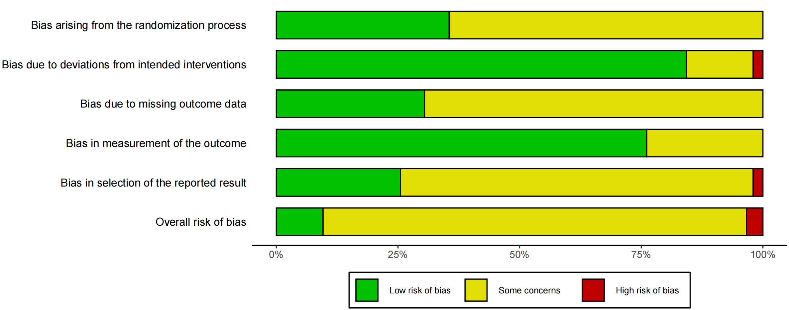
Fig. S1. RoB 2 summary.

2.3 The details of CINeMA
Table S8. CINeMA assessment details.
Control group versus | Direct  comparisons (k) | Within  study bias | Reporting  bias | Indirectness | Imprecision | Heterogeneity | Incoherence | Confidence  rating
Continuous aerobic exercise training | 102 | ● | ● | ● | ● | ● | ● | Low
Combined aerobic and resistance exercise training | 27 | ● | ● | ● | ● | ● | ● | Very low
Interval aerobic exercise training | 44 | ● | ● | ● | ● | ● | ● | Low
Mind-body/flexibility exercise training | 11 | ● | ● | ● | ● | ● | ● | Very low
Resistance exercise training | 21 | ● | ● | ● | ● | ● | ● | Very low
● Major concerns or high ● Some concerns or unclear ● No concerns or low

2.4 Sensitivity Analysis by Risk of Bias Criteria
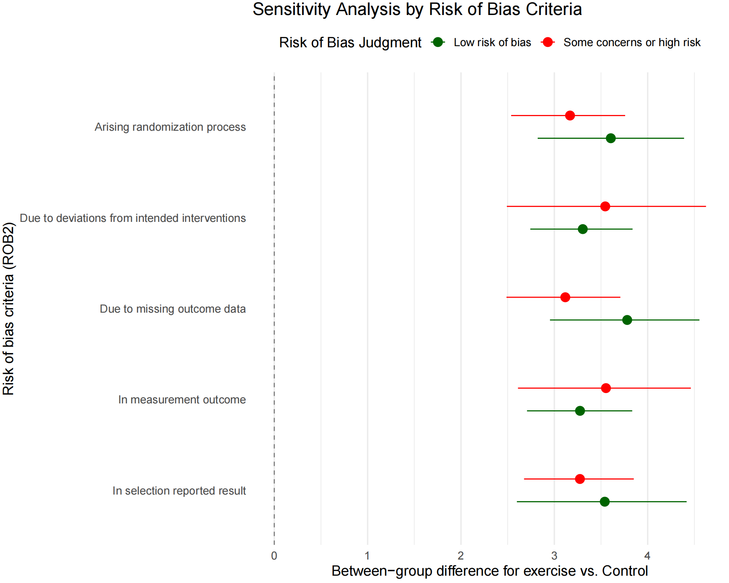
Fig. S2. Sensitivity analysis by risk-of-bias criteria.

2.5 Funnel Plot for the Assessment of Publication Bias
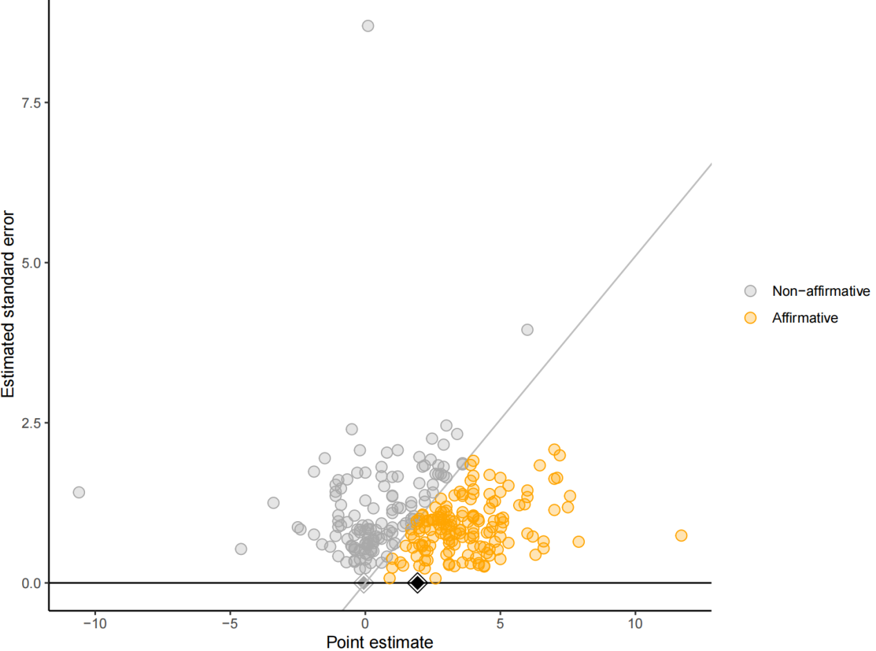Fig. S3. Funnel plot for the assessment of publication bias.

2.6 Power Funnel Plots for All Exercise
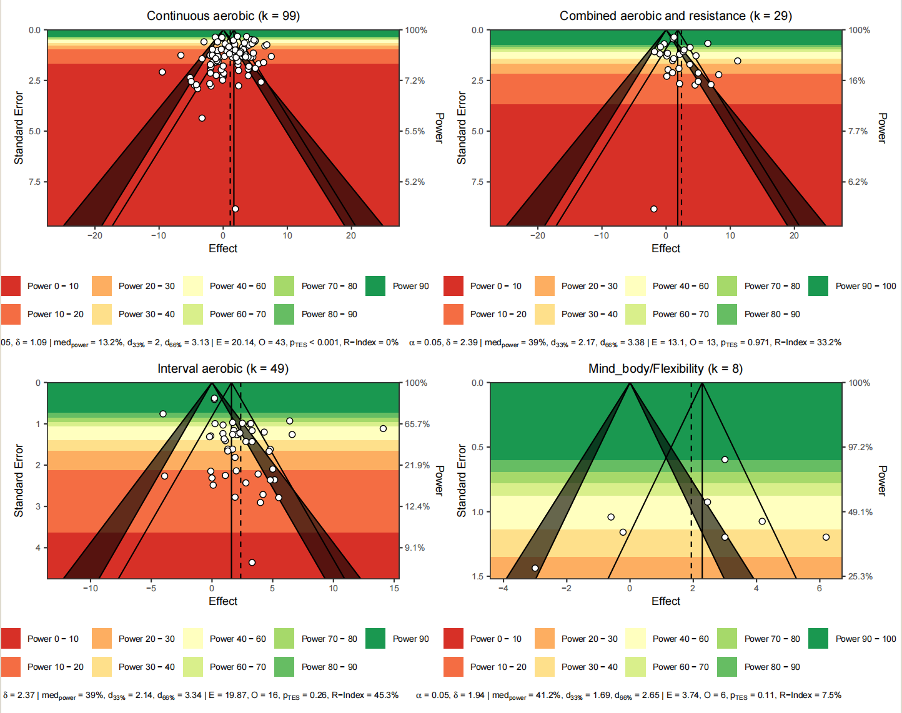
Fig. S4. Power-enhanced funnel plots for continuous aerobic, resistance, interval aerobic, and combined aerobic-resistance exercise.

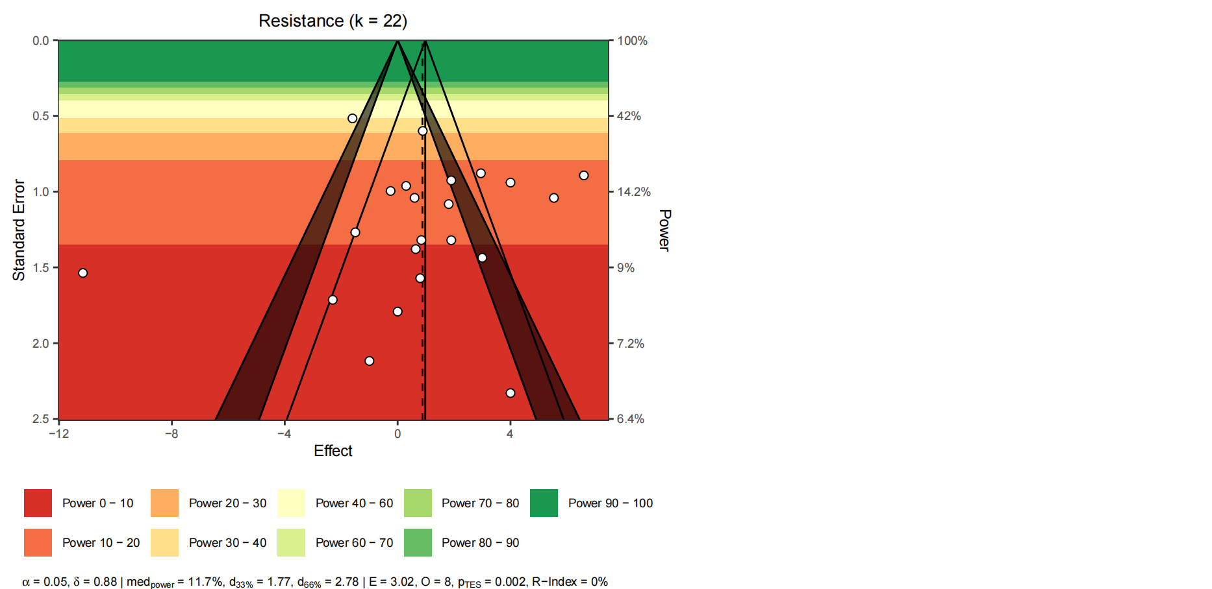
Fig. S5. Power-enhanced funnel plot for mind-body/flexibility exercise.

3. Model specification and validation

3.1 Node-Splitting Analysis
Table S9. Node-splitting analysis.
Comparison | k | prop | nma | direct | indir | Diff | z | p-value
Continuous aerobic : Combined aerobic+resistance | 13 | 0.54 | -1.1126 | -0.7944 | -1.4917 | 0.6973 | 0.70 | 0.4814
Continuous aerobic : Control | 46 | 0.78 | 3.2549 | 3.2807 | 3.1620 | 0.1188 | 0.18 | 0.8578
Continuous aerobic : Interval aerobic | 30 | 0.72 | -1.1355 | -1.2571 | -0.8178 | -0.4393 | -0.54 | 0.5874
Continuous aerobic : Mind_body/Flexibility | 1 | 0.18 | -0.5512 | -3.0000 | 0.0036 | -3.0036 | -1.49 | 0.1369
Continuous aerobic : Resistance | 9 | 0.55 | -0.0061 | 0.2034 | -0.2650 | 0.4684 | 0.44 | 0.6564
Combined aerobic+resistance : Control | 11 | 0.57 | 4.3675 | 3.8900 | 5.0023 | -1.1123 | -1.11 | 0.2649
Combined aerobic+resistance : Interval aerobic | 1 | 0.07 | -0.0228 | 0.1000 | -0.0324 | 0.1324 | 0.06 | 0.9528
Combined aerobic+resistance : Mind_body/Flexibility | 1 | 0.18 | 0.5614 | 0.2200 | 0.6345 | -0.4145 | -0.18 | 0.8562
Combined aerobic+resistance : Resistance | 3 | 0.25 | 1.1065 | 3.1761 | 0.4308 | 2.7453 | 1.79 | 0.0736
Interval aerobic : Control | 17 | 0.50 | 4.3904 | 4.4612 | 4.3206 | 0.1406 | 0.18 | 0.8572
Mind_body/Flexibility : Control | 4 | 0.57 | 3.8061 | 3.9073 | 3.6738 | 0.2335 | 0.15 | 0.8804
Resistance : Control | 7 | 0.46 | 3.2610 | 3.8744 | 2.7404 | 1.1341 | 1.07 | 0.2866
Interval aerobic : Resistance | 1 | 0.09 | 1.1294 | 0.2500 | 1.2199 | -0.9699 | -0.46 | 0.6425
Mind_body/Flexibility : Resistance | 2 | 0.32 | 0.5451 | -1.6705 | 1.5708 | -3.2413 | -1.79 | 0.0736

3.2 Prior-Posterior distributions of exercise treatment effects on VO₂peak
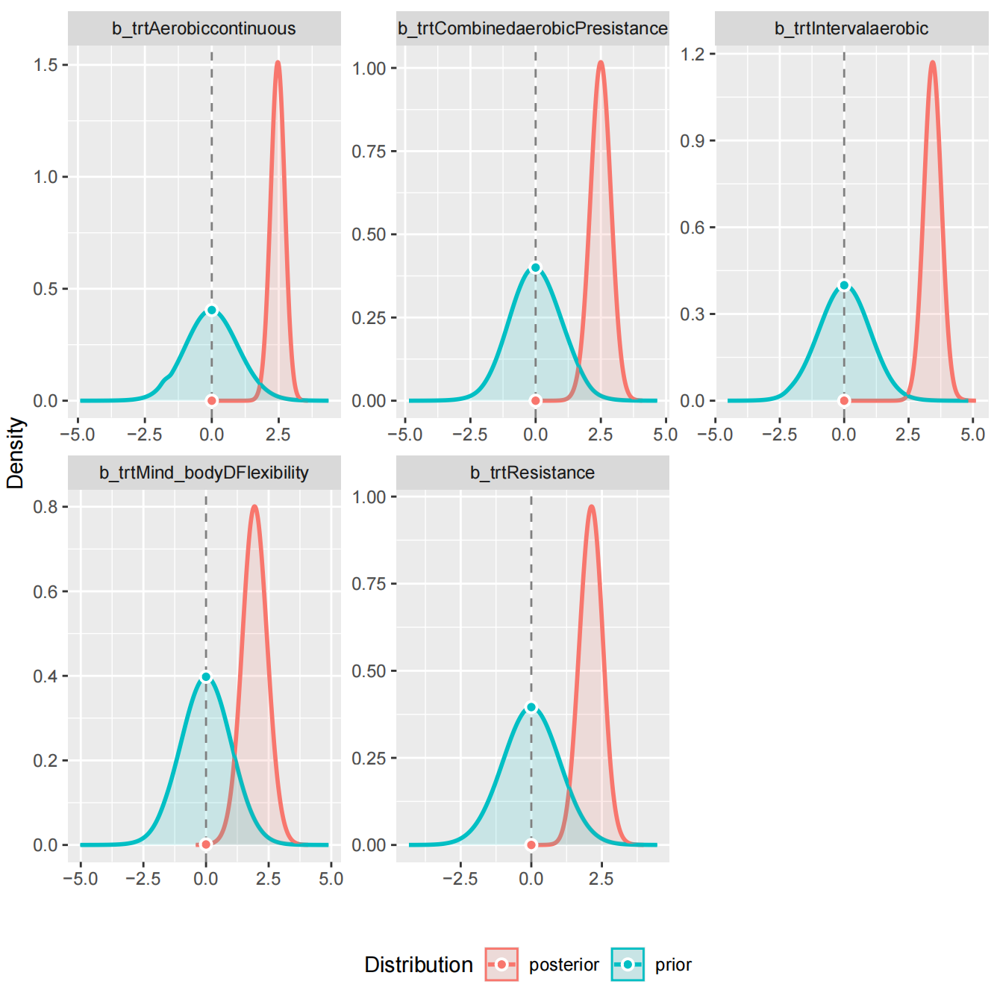
Fig. S6. Prior and posterior distributions of exercise treatment effects on VO₂peak.
The figure compares the prior and posterior probability distributions for each treatment-effect parameter. The wider teal curves represent the prior distributions, whereas the narrower red curves represent the posterior distributions after incorporating the observed data. Across the five exercise modalities, the posterior distributions were more concentrated and centred on positive effect estimates. These distributions illustrate how the observed data updated the prior information and should be interpreted together with the corresponding credible intervals and Bayes factors.

3.3 Bayes Factors of Different Exercise
Table S10. Bayes factors of different exercise modalities.
Bayes Factor (Savage-Dickey density ratio)
Parameter | BF
(Intercept) | 0.321
trtAerobiccontinuous | 4.34e+09
trtCombinedaerobicPresistance | 6.05e+05
trtIntervalaerobic | 8.21e+10
trtMind_bodyDFlexibility | 319.59
trtResistance | 7.24e+04
* Evidence Against The Null: 0

3.4 Bayes Factors for Model Comparison
Table S11. Bayes factors for model comparison.
Model | Formula | Description | Bayes Factor (BF)
Full Model | 1 + trt + (1|arm_number:studyID) + (1|studyID) | A model including a fixed effect for treatment (trt) and random effects for both study and study arm. | 2.63e+21
Null Model | 1 + (1|arm_number:studyID) + (1|studyID) | A model with only random effects for study and study arm (no treatment effect). | (Reference Model)
This table compares the Full Model, which includes the treatment effect, with the Null Model, which does not. The Bayes factor of 2.63 × 10²¹ provides very strong evidence in favour of the Full Model, supporting inclusion of the treatment effect in the model.

4. Results of the Meta-Analytic Random Forest Model

4.1 MetaForest Model Performance Metrics
Table S12. MetaForest model performance metrics.
best_mtry | oob_R² | tau²_residual | best_cv_R²
2 | 0.086 | 3.025 | 0.142
This table displays key tuning parameters and performance metrics for a MetaForest model, which is a type of random forest algorithm adapted for use in meta-analysis. best_mtry: In a random forest model, mtry is a tuning parameter that specifies the number of variables randomly sampled as candidates at each split in the decision trees. The value of 2 is the mtry that yielded the best model performance, likely determined through a cross-validation process.
oob_R2 Out-of-Bag R-squared: This is an R-squared value calculated using the model's out-of-bag OOB predictions, which serves as an internal cross-validation. It measures the proportion of variance explained by the model on data not seen during the training of individual trees. A value of 0.086 indicates that the model explains approximately 8.6 percent of the variance in the outcome.
tau2_residual Residual Heterogeneity: In meta-analysis, residual heterogeneity τ²_residual represents the amount of between-study variance that remains unexplained by the moderators included in the model. In this analysis, the τ²_residual is 3.025. This non-zero value indicates that after accounting for the moderators in the MetaForest model, there is still a portion of the between-study heterogeneity left unexplained. While the model has explained some of the variance, this residual value of 3.025 suggests that other unmeasured factors also contribute to the systematic differences observed across the studies.
best_cv_R2 Best Cross-Validated R-squared: This is the R-squared value obtained from the formal cross-validation procedure used to tune the model's parameters like mtry. It represents the proportion of variance the model explains in held-out data. A value of 0.142 indicates that the tuned model explains about 14.2 % of the variance in unseen data, which is a robust measure of its predictive performance.

4.2 Diagnostic plots for the random forest model
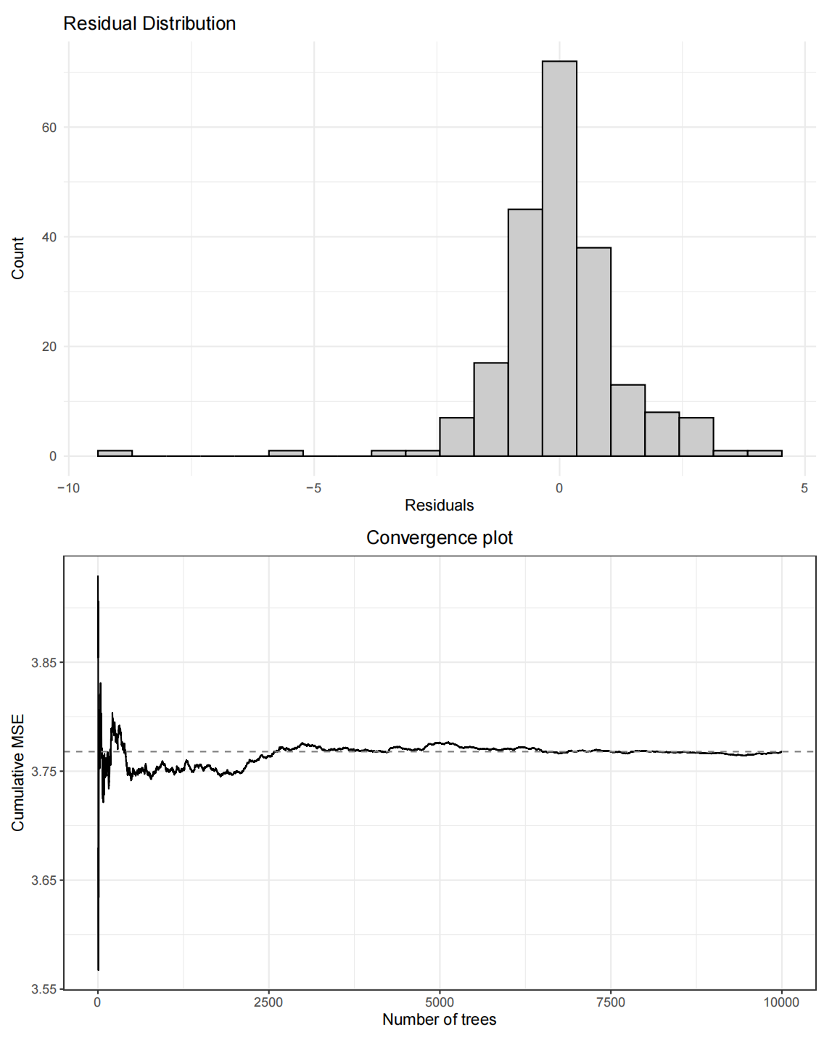
Fig. S7. Diagnostic plots for the MetaForest model.
Diagnostic plots for the random forest model. Panel (1) displays a histogram of the model residuals. The distribution is centered near zero, indicating an absence of systematic bias in the model's predictions. Panel (2) shows the model's convergence plot. The cumulative mean squared error (MSE) stabilizes as the number of trees in the forest increases, indicating that the model's performance has converged after approximately 2,000 trees and remains stable up to the final model size of 10,000 trees.

4.3 Variable Importance Metrics from Random Forest Model
Table S13. Variable importance metrics from the random forest model.
variable | mean_min_depth | no_of_nodes | permutation | no_of_trees | times_a_root | p_value
baseline_severity | 4.23971228843265 | 41018 | 0.223504115681149 | 9879 | 283 | 6.03630212993451e-33
bct_total_count | 3.53624869303956 | 56573 | 0.171148462711272 | 9949 | 548 | 0
concomitant_medications | 6.22532414621933 | 5732 | 0.13913065652402 | 5267 | 694 | 1
country | 3.55249402103155 | 54214 | 0.282420569412947 | 9941 | 566 | 0
funded | 4.22214465698548 | 23302 | 0.29577424422034 | 9723 | 817 | 1
group_exercise | 5.09329017526289 | 14154 | 0.138041120127948 | 7733 | 853 | 1
intensity_met | 3.40988370555834 | 47729 | 0.202291360336294 | 9911 | 826 | 0
intervention_model | 4.43131256885328 | 18398 | 0.195444301202896 | 8605 | 979 | 1
mean_sample_age | 2.51877816725088 | 69985 | 0.172700770419798 | 9985 | 1322 | 0
Risk | 5.46886990485729 | 24114 | 0.0965956898378212 | 9430 | 155 | 1
Pc_female | 2.83527507260891 | 62472 | 0.152191102945686 | 9967 | 1168 | 0
session_duration | 3.85531172759139 | 48207 | 0.12876097392553 | 9912 | 486 | 0
time_management | 4.9749331997997 | 24901 | 0.0758082220629631 | 9395 | 287 | 1
Exercise_modality | 3.8164162643966 | 39928 | 0.149162792157568 | 9888 | 576 | 2.14627537751178e-10
Intervention_ length | 3.7588064897346 | 50298 | 0.425909678427801 | 9916 | 440 | 0

This table ranks the importance of different variables from a random forest model, which was used to predict treatment outcomes.
Variable: The predictor variable being assessed.
Permutation Importance: The primary metric for ranking. It measures how much the model's prediction accuracy decreases when the values of that single variable are randomly shuffled. A higher value indicates greater importance. The table is sorted by this column.
Mean Minimum Depth: The average depth at which a variable first appears as a splitting rule in the decision trees. Variables with a lower value are considered more important as they separate the data more effectively early on.
Times as Root: The number of times a variable was used as the very first split (the root) in a tree across the entire forest.
p-value: The p-value from a statistical test assessing the significance of the variable's importance. A low p-value (e.g., < 0.05) suggests the variable's importance is statistically significant.

4.4 Correlation Matrix of Variable Importance Metrics
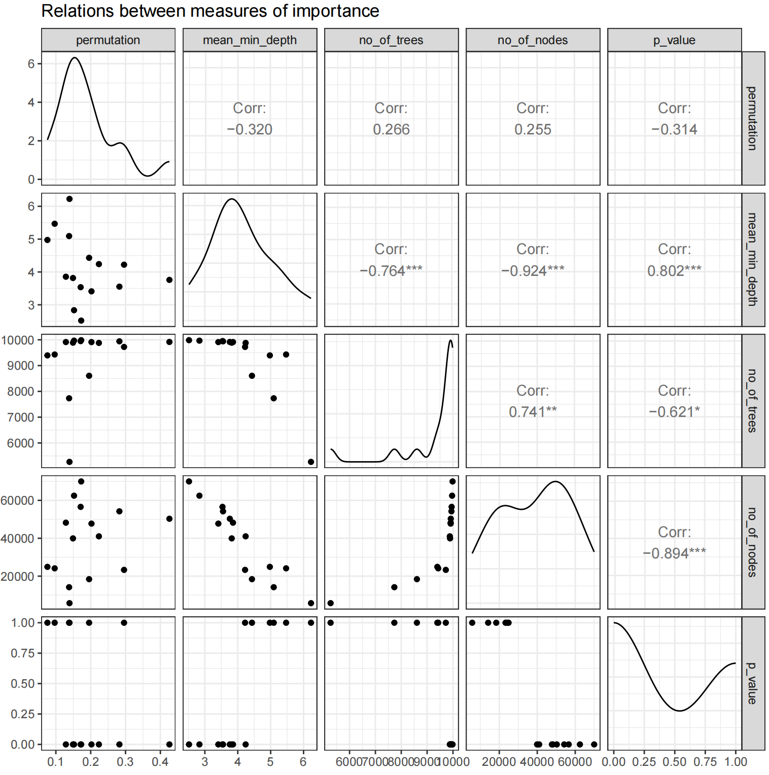
Fig. S8. Correlation matrix of variable importance metrics.
This figure presents a pairs plot illustrating the relationships between five different metrics of variable importance derived from the random forest model: permutation, mean_min_depth, no_of_trees, no_of_nodes, and p_value. The correlation matrix reveals distinct patterns in the relationships between different variable importance measures. Permutation importance shows relatively weak correlations with other metrics (r < 0.32), suggesting it captures a unique aspect of variable importance. In contrast, the tree-based measures are highly interconnected: mean minimum depth demonstrates strong negative correlations with both the number of trees (r = -0.764***) and number of nodes (r = -0.924***), while positively correlating with p-values (r = 0.802***), indicating that variables positioned closer to the tree root appear more frequently across trees and nodes with higher statistical significance. The number of trees and nodes are positively correlated with each other (r = 0.741**) but negatively correlated with p-values (r = -0.621* and -0.894***, respectively), confirming that more frequently used variables tend to be more statistically significant. These findings suggest that while most tree-based importance measures converge on similar rankings, permutation importance provides complementary information, and researchers should consider multiple metrics for a comprehensive assessment of variable importance in random forest models.

4.5 Correlation Matrix of Variable Importance Rankings
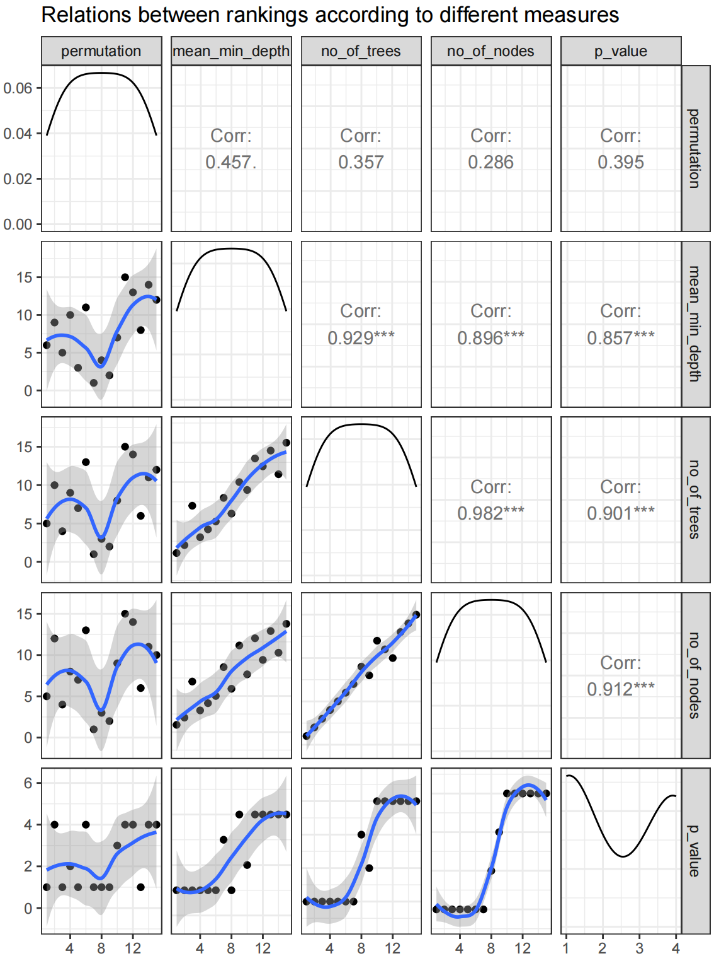
Fig. S9. Correlation matrix of variable importance rankings.
The correlation analysis of rankings from five different variable importance measures reveals two distinct patterns. The tree-based measures (mean_min_depth, no_of_trees, no_of_nodes, and p_value) demonstrate remarkably strong positive correlations with each other, ranging from 0.857 to 0.982, with the highest correlation observed between no_of_trees and no_of_nodes (r=0.982***). This high degree of agreement suggests that these tree-structure-based methods consistently identify similar variables as important. In contrast, permutation importance shows only moderate to weak correlations with the other measures (r=0.286 to 0.457), indicating that it captures a fundamentally different aspect of variable importance that may not be reflected in tree-based metrics. This divergence highlights the complementary nature of permutation importance, which evaluates variable contributions through prediction accuracy rather than tree structure. The findings suggest that while tree-based measures tend to converge on similar variable rankings, incorporating permutation importance in the analysis provides a more comprehensive assessment of variable importance by offering an independent perspective that may reveal important predictors overlooked by structural measures alone.

4.6 Two-way interactions identified by the random forest model
Table S14. Two-way interactions identified by the random forest model.
variable | root_variable | mean_min_depth | occurrences | interaction | uncond_mean_min_depth
mean_age | mean_age | 2.25253731343284 | 6700 | mean_age:mean_age | 2.51877816725088
mean_age | pc_female | 2.18898059117476 | 6583 | pc_female:mean_age | 2.51877816725088
pc_female | mean_age | 2.70805600938722 | 6438 | mean_age:pc_female | 2.83527507260891
bct_total_count | mean_age | 3.02592126996465 | 6425 | mean_age:bct_total_count | 3.53624869303956
pc_female | pc_female | 2.61499898920168 | 6384 | pc_female:pc_female | 2.83527507260891
country | pc_female | 3.00181838874255 | 6315 | pc_female:country | 3.55249402103155

4.7 Variable Importance Based on Mean SHAP Values
Table S15. Variable importance based on mean SHAP values.
variable | mean_abs_SHAP | sd_abs_SHAP
funded | 0.221652632793146 | 0.0827691033625049
intervention_model | 0.164370029330768 | 0.092115579378715
intensity_met | 0.139025429386544 | 0.112716081899147
group_exercise | 0.136366870395647 | 0.073313580263514
trt | 0.132652601007965 | 0.0861314399209435
weeks | 0.107046961054771 | 0.111846787822958
bct_total_count | 0.10080333876235 | 0.109399535729546
country | 0.100162170771282 | 0.0865902002779251
mean_sample_age | 0.0955516338658493 | 0.0717927523348333
baseline_severity | 0.0746426608474344 | 0.059832499414341
session_duration | 0.0641100771082811 | 0.0548058735283172
Pc_Female | 0.0567050908275746 | 0.0641234871777146
concomitant_medications | 0.0456392045557941 | 0.170420298974394
time_management | 0.0369322996136081 | 0.0448844587782264
overall | 0.0277995959162683 | 0.0368169064687666
This table summarises the global importance of each feature in the predictive model, calculated using SHAP (SHapley Additive exPlanations) values.
1)SHAP values quantify the contribution of each feature to the model’s prediction for an individual observation.
2)Mean Absolute SHAP: This is the primary metric for importance. It represents the average impact a feature has on the magnitude of the model's output across all data points. The table is ranked by this value, with higher values indicating greater predictive importance.
3)Standard Deviation of Absolute SHAP: This measures the variability of a feature's importance across the dataset. A high value suggests that the feature's impact is highly context-dependent, varying significantly from one prediction to another.
Based on this analysis, Mean Age, Intervention Flexibility, and Country are the most influential predictors in the model.

5. Moderation analysis

5.1 Predicted Exercise Effects on VO₂peak by Exercise Dose
Table S16. Predicted exercise effects on VO₂peak by weekly exercise dose.
weekly_exercise dose | pred | se | lower | upper
80 | 0.93157 | 0.30321 | 0.3373 | 1.52584
124 | 1.14853 | 0.28192 | 0.59598 | 1.70108
191 | 1.36549 | 0.26194 | 0.85209 | 1.87889
258 | 1.58245 | 0.24361 | 1.10499 | 2.05992
325 | 1.79942 | 0.22731 | 1.3539 | 2.24493
392 | 2.01638 | 0.21351 | 1.59791 | 2.43485
459 | 2.23334 | 0.20272 | 1.83601 | 2.63067
526 | 2.4503 | 0.19545 | 2.06723 | 2.83338
593 | 2.66727 | 0.19209 | 2.29078 | 3.04375
660 | 2.88423 | 0.19284 | 2.50626 | 3.26219
727 | 3.10119 | 0.19767 | 2.71377 | 3.48861
794 | 3.31815 | 0.20627 | 2.91386 | 3.72244
861 | 3.53512 | 0.21822 | 3.10742 | 3.96282
928 | 3.75208 | 0.23299 | 3.29543 | 4.20872
995 | 3.96904 | 0.25008 | 3.4789 | 4.45919
1062 | 4.186 | 0.26905 | 3.65867 | 4.71334
1129 | 4.40297 | 0.28954 | 3.83548 | 4.97045
1196 | 4.61993 | 0.31124 | 4.00991 | 5.22994
1263 | 4.83689 | 0.33392 | 4.18243 | 5.49135
1330 | 5.05385 | 0.35738 | 4.35339 | 5.75431
1397 | 5.27081 | 0.3815 | 4.5231 | 6.01853
1464 | 5.48778 | 0.40614 | 4.69176 | 6.2838
1531 | 5.70474 | 0.43122 | 4.85956 | 6.54992
1598 | 5.9217 | 0.45667 | 5.02664 | 6.81676
1665 | 6.13866 | 0.48243 | 5.19312 | 7.08421
1732 | 6.35563 | 0.50845 | 5.35908 | 7.35217
1799 | 6.57259 | 0.53469 | 5.52461 | 7.62057
1866 | 6.78955 | 0.56113 | 5.68976 | 7.88935
1933 | 7.00651 | 0.58773 | 5.85458 | 8.15845
2000 | 7.22348 | 0.61448 | 6.01912 | 8.42783

Table S17. Predicted exercise effects on VO₂peak by per-session exercise dose.
per-session exercise_dose | pred | se | lower | upper
50 | -0.17138 | 0.28781 | -0.73548 | 0.39273
60 | 0.12905 | 0.272 | -0.40407 | 0.66216
70 | 0.429 | 0.25738 | -0.07544 | 0.93345
80 | 0.7274 | 0.24416 | 0.24886 | 1.20594
90 | 1.0227 | 0.23256 | 0.56689 | 1.4785
100 | 1.31308 | 0.22273 | 0.87653 | 1.74962
110 | 1.5966 | 0.21476 | 1.17569 | 2.01752
120 | 1.87129 | 0.2086 | 1.46243 | 2.28014
130 | 2.13517 | 0.20413 | 1.73509 | 2.53526
140 | 2.38637 | 0.2011 | 1.99223 | 2.78051
150 | 2.62307 | 0.19921 | 2.23262 | 3.01351
160 | 2.84362 | 0.19815 | 2.45525 | 3.23199
170 | 3.04658 | 0.19763 | 2.65922 | 3.43394
180 | 3.2307 | 0.19743 | 2.84374 | 3.61765
190 | 3.39502 | 0.19742 | 3.00809 | 3.78194
200 | 3.53896 | 0.19759 | 3.15169 | 3.92623
210 | 3.66228 | 0.1981 | 3.27402 | 4.05054
220 | 3.76489 | 0.19919 | 3.37448 | 4.1553
230 | 3.84684 | 0.20126 | 3.45238 | 4.2413
240 | 3.90829 | 0.20476 | 3.50698 | 4.30961
250 | 3.94969 | 0.21021 | 3.53768 | 4.36171
260 | 3.97169 | 0.21814 | 3.54415 | 4.39923
270 | 3.97515 | 0.22895 | 3.52642 | 4.42388
280 | 3.96104 | 0.24295 | 3.48488 | 4.43721
290 | 3.93048 | 0.26025 | 3.42039 | 4.44056
300 | 3.88465 | 0.28084 | 3.33421 | 4.4351
310 | 3.8248 | 0.30458 | 3.22784 | 4.42177
320 | 3.75222 | 0.33123 | 3.10303 | 4.40142
330 | 3.66824 | 0.36051 | 2.96165 | 4.37484
340 | 3.57422 | 0.39214 | 2.80564 | 4.3428
350 | 3.47157 | 0.4258 | 2.63702 | 4.30613
360 | 3.36168 | 0.46121 | 2.45773 | 4.26562
370 | 3.2459 | 0.49807 | 2.2697 | 4.2221
380 | 3.12552 | 0.53614 | 2.07471 | 4.17633
390 | 3.00171 | 0.57517 | 1.87439 | 4.12903
400 | 2.87554 | 0.61497 | 1.67021 | 4.08086
410 | 2.748 | 0.65535 | 1.46354 | 4.03245
420 | 2.61981 | 0.69615 | 1.25539 | 3.98423
430 | 2.49152 | 0.73726 | 1.04652 | 3.93651
440 | 2.36322 | 0.77862 | 0.83716 | 3.88928
450 | 2.23493 | 0.82019 | 0.62739 | 3.84247
460 | 2.10663 | 0.86194 | 0.41726 | 3.79601
470 | 1.97834 | 0.90386 | 0.20682 | 3.74986
480 | 1.85005 | 0.9459 | -0.00389 | 3.70398
490 | 1.72175 | 0.98807 | -0.21483 | 3.65833
500 | 1.59346 | 1.03034 | -0.42597 | 3.61289

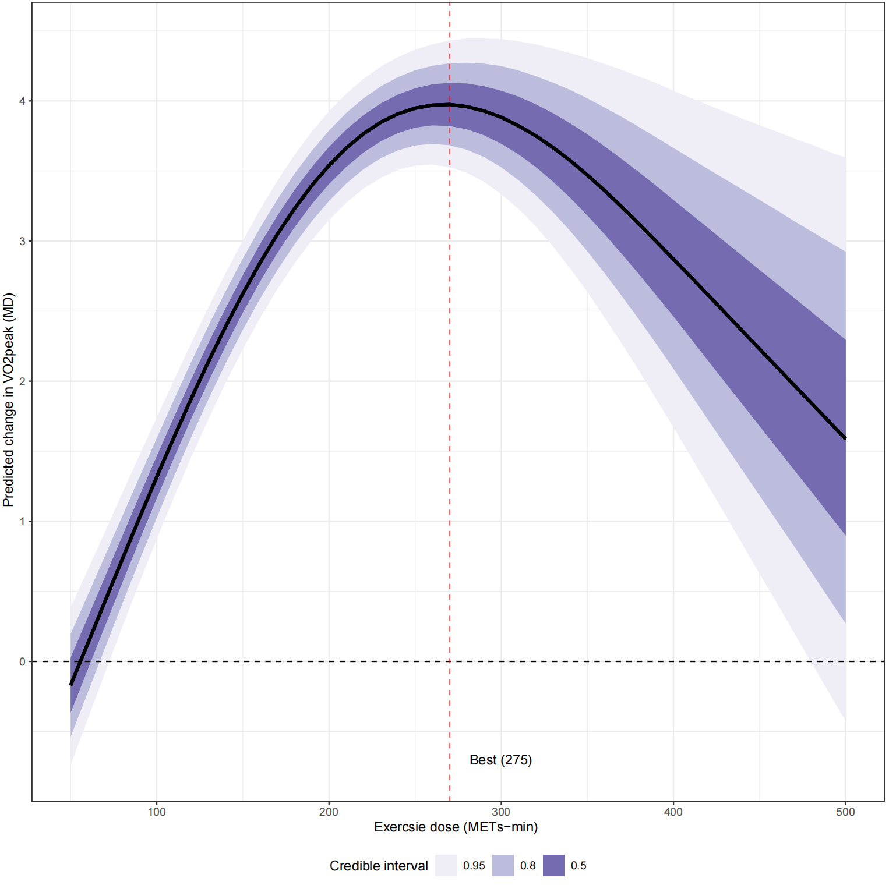
Fig. S10. Predicted exercise effects on VO₂peak by per-session exercise dose.

5.2 Predicted Exercise Effects on VO₂peak by Intervention Frequency
Table S18. Predicted exercise effects on VO₂peak by intervention frequency.
sessions | pred | se | lower | upper
1 | 2.47137 | 0.34734 | 1.7906 | 3.15214
2 | 2.59489 | 0.2288 | 2.14646 | 3.04333
3 | 2.69952 | 0.17286 | 2.36072 | 3.03832
4 | 2.77008 | 0.19063 | 2.39645 | 3.14371
5 | 2.80087 | 0.28205 | 2.24806 | 3.35368
6 | 2.79759 | 0.45179 | 1.9121 | 3.68307
7 | 2.7754 | 0.67413 | 1.45414 | 4.09667
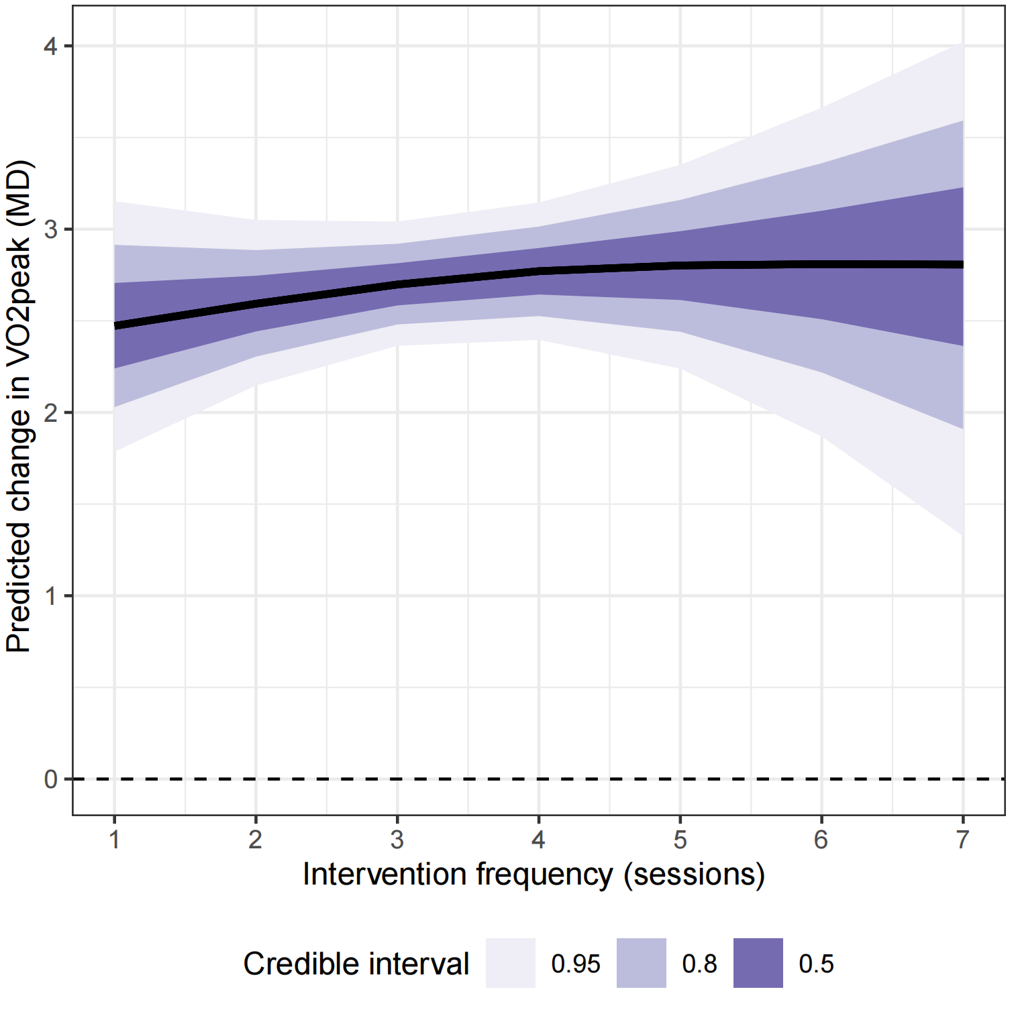
Fig. S11. Predicted exercise effects on VO₂peak by intervention frequency.

5.3 Predicted Exercise Effects on VO₂peak by Intervention length
Table S19. Predicted exercise effects on VO₂peak by intervention length.
Week_length | pred | se | lower | upper
2 | 2.58718 | 0.24921 | 2.09873 | 3.07563
6 | 2.6267 | 0.2062 | 2.22256 | 3.03083
10 | 2.66622 | 0.17591 | 2.32143 | 3.011
14 | 2.70574 | 0.16551 | 2.38135 | 3.03013
18 | 2.74526 | 0.17849 | 2.39542 | 3.09509
22 | 2.78477 | 0.21058 | 2.37204 | 3.1975
26 | 2.82429 | 0.25465 | 2.32518 | 3.3234
30 | 2.86381 | 0.30556 | 2.26492 | 3.46271
34 | 2.90333 | 0.36043 | 2.1969 | 3.60976
38 | 2.94285 | 0.4177 | 2.12418 | 3.76152
42 | 2.98237 | 0.4765 | 2.04845 | 3.91628
46 | 3.02189 | 0.53633 | 1.97071 | 4.07307
50 | 3.06141 | 0.59688 | 1.89155 | 4.23126

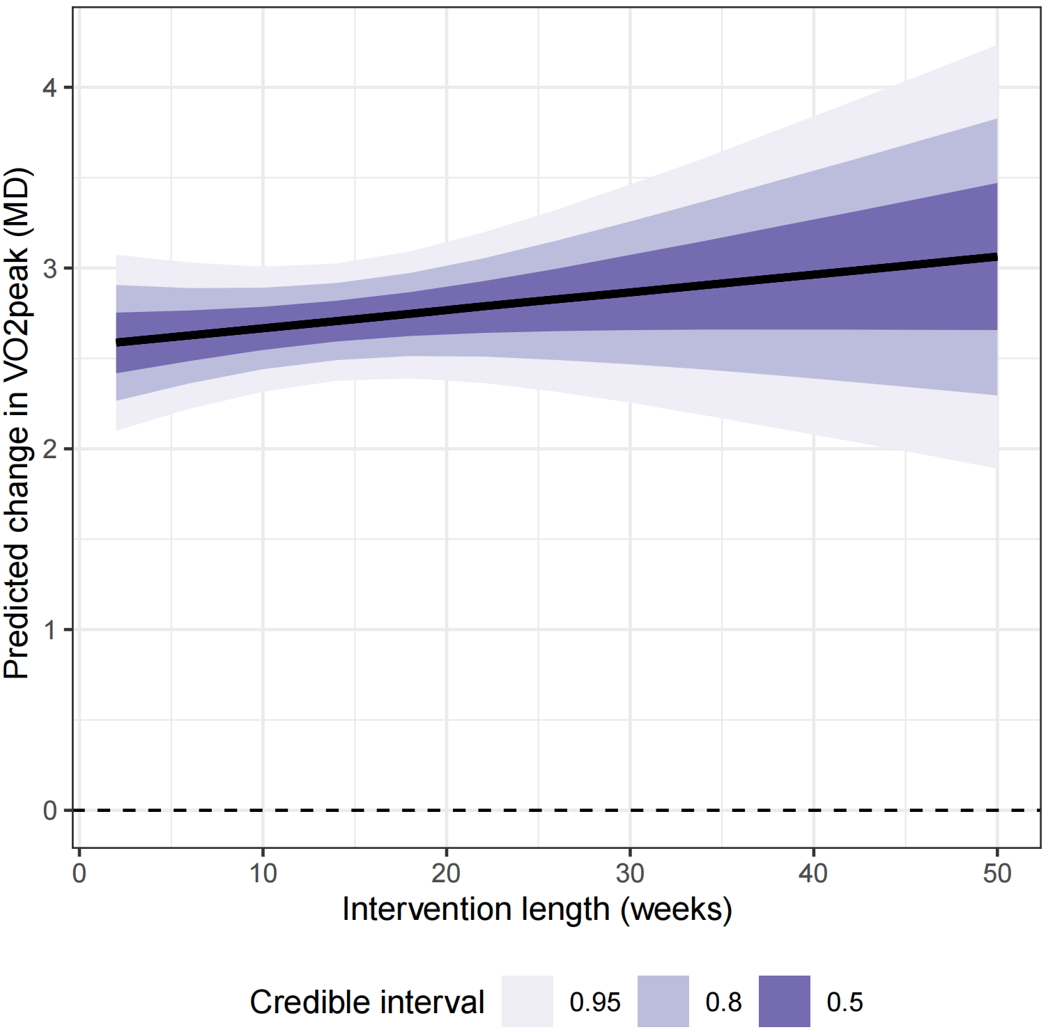Fig. S12. Predicted exercise effects on VO₂peak by intervention length.

5.4 Predicted Exercise Effects on VO₂peak by Proportion of Women
Table S20. Predicted exercise effects on VO₂peak by proportion of women.
pc_female | pred | se | lower | upper
0 | 2.87509 | 0.20282 | 2.47756 | 3.27261
0.1 | 2.77575 | 0.18052 | 2.42192 | 3.12957
0.2 | 2.6764 | 0.17304 | 2.33725 | 3.01555
0.3 | 2.57706 | 0.1822 | 2.21996 | 2.93417
0.4 | 2.47772 | 0.20579 | 2.07437 | 2.88107
0.5 | 2.37838 | 0.2396 | 1.90877 | 2.84798
0.6 | 2.27903 | 0.27994 | 1.73037 | 2.8277
0.7 | 2.17969 | 0.32438 | 1.54392 | 2.81547
0.8 | 2.08035 | 0.37146 | 1.35231 | 2.80839
0.9 | 1.98101 | 0.42029 | 1.15726 | 2.80475
1 | 1.88167 | 0.47032 | 0.95985 | 2.80348

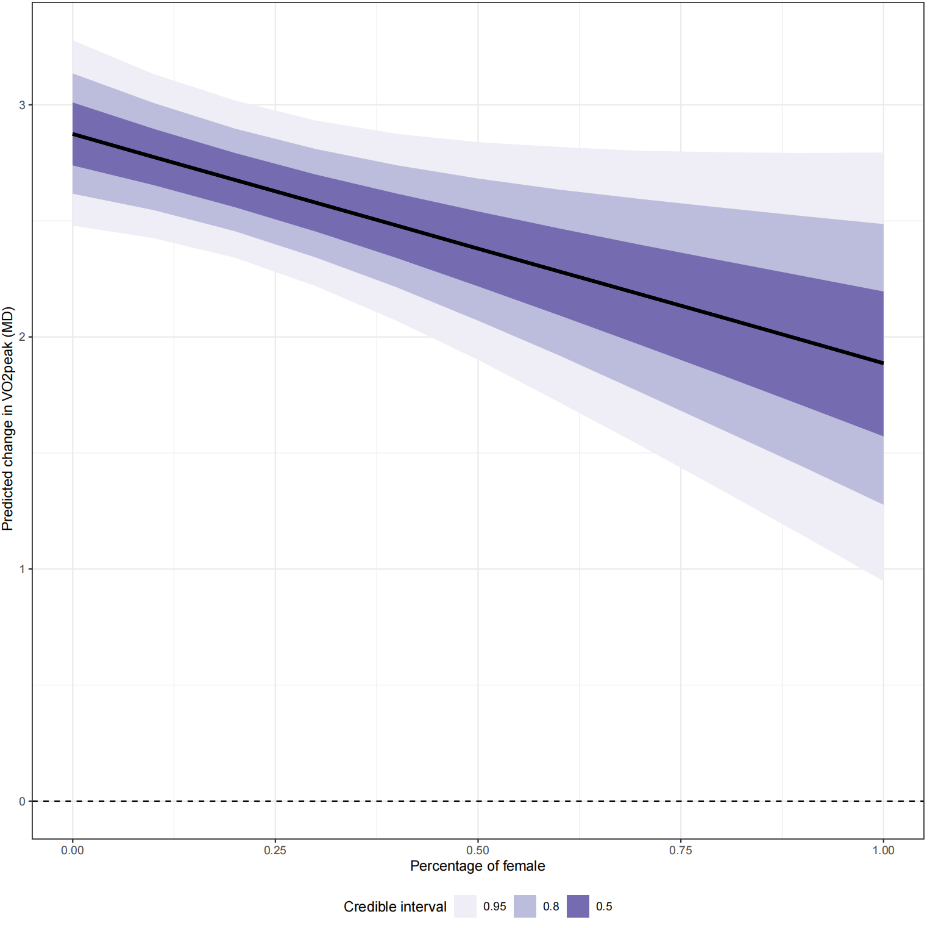Fig. S13. Predicted exercise effects on VO₂peak by proportion of women.

5.5 Predicted Exercise Effects on VO₂peak by Mean Sample Age
Table S21. Predicted exercise effects on VO₂peak by mean sample age.
mean_age | pred | se | lower | upper
20 | -0.03655 | 0.88937 | -1.77969 | 1.70659
30 | 0.63615 | 0.67996 | -0.69655 | 1.96885
40 | 1.30884 | 0.47594 | 0.37602 | 2.24166
50 | 1.98153 | 0.28893 | 1.41523 | 2.54783
60 | 2.65423 | 0.18236 | 2.29681 | 3.01164
70 | 3.32692 | 0.27537 | 2.78721 | 3.86663
80 | 3.99961 | 0.45957 | 3.09888 | 4.90035

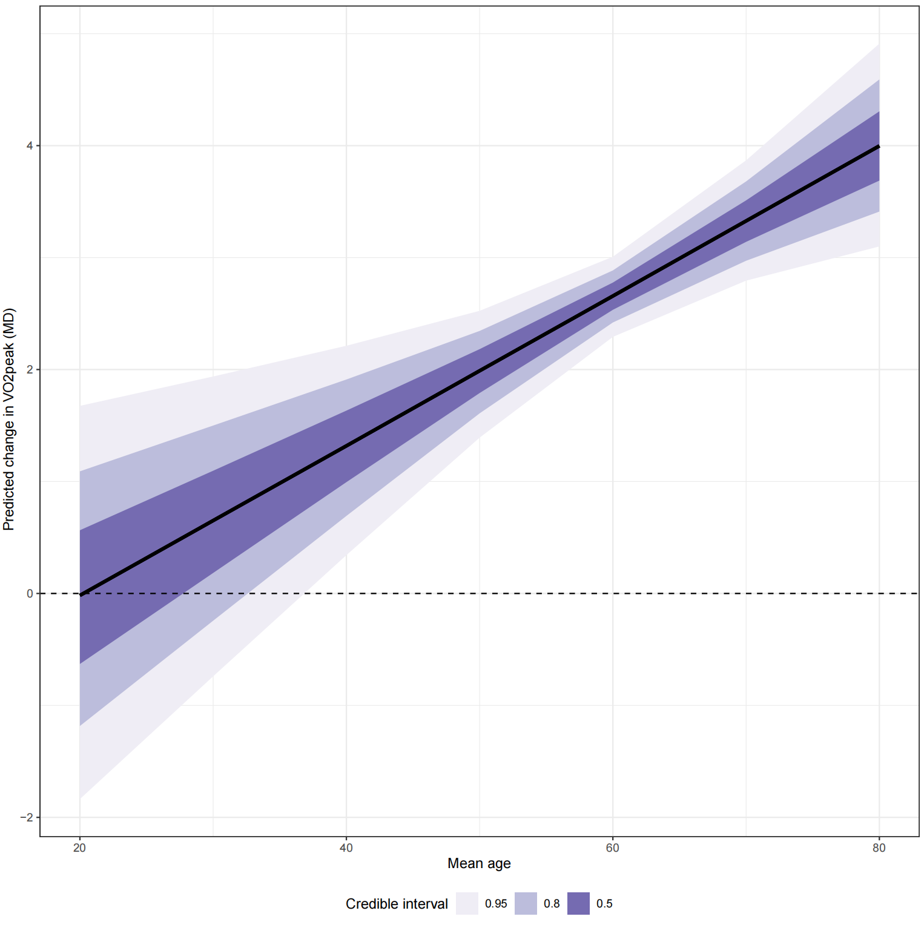Fig. S14. Predicted exercise effects on VO₂peak by mean sample age.

5.6 Predicted Exercise Effects on VO₂peak by BCTs
Table S22. Predicted exercise effects on VO₂peak by behavior change technique count.
bct_total_count | pred | se | lower | upper
0 | 2.66996 | 0.45343 | 1.78126 | 3.55865
3 | 2.674 | 0.39111 | 1.90745 | 3.44056
6 | 2.67805 | 0.33091 | 2.02948 | 3.32662
9 | 2.6821 | 0.27424 | 2.1446 | 3.2196
12 | 2.68622 | 0.22384 | 2.2475 | 3.12493
15 | 2.6906 | 0.18487 | 2.32826 | 3.05293
18 | 2.69549 | 0.16517 | 2.37176 | 3.01921
21 | 2.70116 | 0.17063 | 2.36673 | 3.03559
24 | 2.70789 | 0.19813 | 2.31955 | 3.09622
27 | 2.71589 | 0.23926 | 2.24695 | 3.18483
30 | 2.72531 | 0.28754 | 2.16175 | 3.28887
33 | 2.73623 | 0.33956 | 2.0707 | 3.40176
36 | 2.74862 | 0.39379 | 1.9768 | 3.52044
39 | 2.7624 | 0.44957 | 1.88125 | 3.64354
42 | 2.77748 | 0.50665 | 1.78447 | 3.77049
45 | 2.79379 | 0.56496 | 1.68648 | 3.90109
48 | 2.81124 | 0.62452 | 1.5872 | 4.03527
51 | 2.82975 | 0.68537 | 1.48645 | 4.17305
54 | 2.84924 | 0.74755 | 1.38407 | 4.31442
57 | 2.86963 | 0.8111 | 1.27991 | 4.45935
60 | 2.89084 | 0.87602 | 1.17388 | 4.6078
63 | 2.91278 | 0.9423 | 1.06591 | 4.75965
66 | 2.93538 | 1.0099 | 0.956 | 4.91476
69 | 2.95855 | 1.07878 | 0.84418 | 5.07292
72 | 2.98221 | 1.14884 | 0.73052 | 5.23389
75 | 3.00627 | 1.22 | 0.61512 | 5.39742
78 | 3.03066 | 1.29213 | 0.49813 | 5.5632
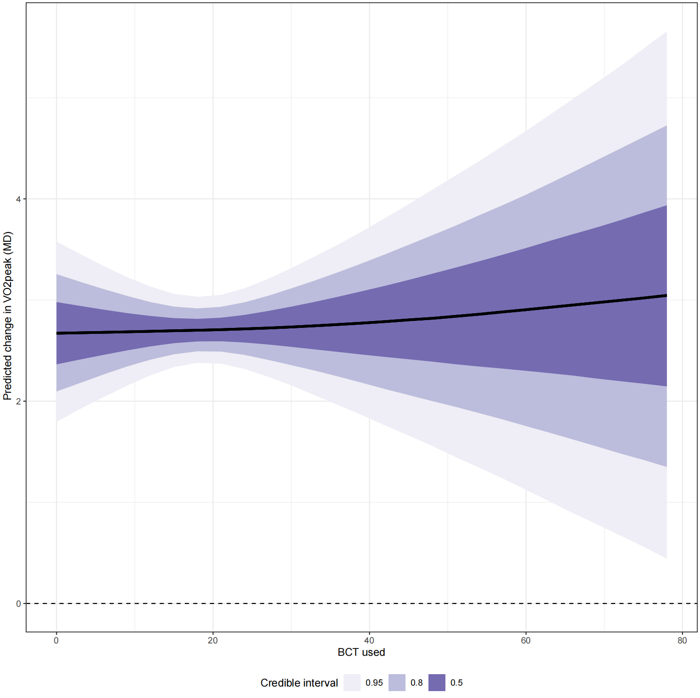
Fig. S15. Predicted exercise effects on VO₂peak by behavior change technique count.

5.7 Predicted Exercise Effects on VO₂peak by baseline VO₂peak
Table S23. Predicted exercise effects on VO₂peak by baseline VO₂peak.
Baseline_VO₂peak | pred | se | lower | upper
12 | 1.29513 | 0.29398 | 0.71894 | 1.87133
13 | 1.24618 | 0.28904 | 0.67966 | 1.8127
14 | 1.19723 | 0.28461 | 0.63941 | 1.75505
15 | 1.14828 | 0.2807 | 0.59812 | 1.69843
16 | 1.09932 | 0.27734 | 0.55576 | 1.64289
17 | 1.05037 | 0.27454 | 0.51228 | 1.58846
18 | 1.00142 | 0.27233 | 0.46765 | 1.53518
19 | 0.95246 | 0.27073 | 0.42185 | 1.48308
20 | 0.90351 | 0.26973 | 0.37485 | 1.43218
21 | 0.85456 | 0.26936 | 0.32663 | 1.38249
22 | 0.80561 | 0.2696 | 0.2772 | 1.33401
23 | 0.75665 | 0.27046 | 0.22656 | 1.28675
24 | 0.7077 | 0.27194 | 0.17472 | 1.24069
25 | 0.65875 | 0.27401 | 0.12169 | 1.19581
26 | 0.6098 | 0.27668 | 0.06751 | 1.15208
27 | 0.56084 | 0.27992 | 0.01221 | 1.10948
28 | 0.51189 | 0.28372 | -0.04418 | 1.06796
29 | 0.46294 | 0.28804 | -0.10161 | 1.02749
30 | 0.41399 | 0.29287 | -0.16004 | 0.98801
31 | 0.36503 | 0.29819 | -0.21941 | 0.94947
32 | 0.31608 | 0.30396 | -0.27968 | 0.91183
33 | 0.26713 | 0.31017 | -0.34079 | 0.87504
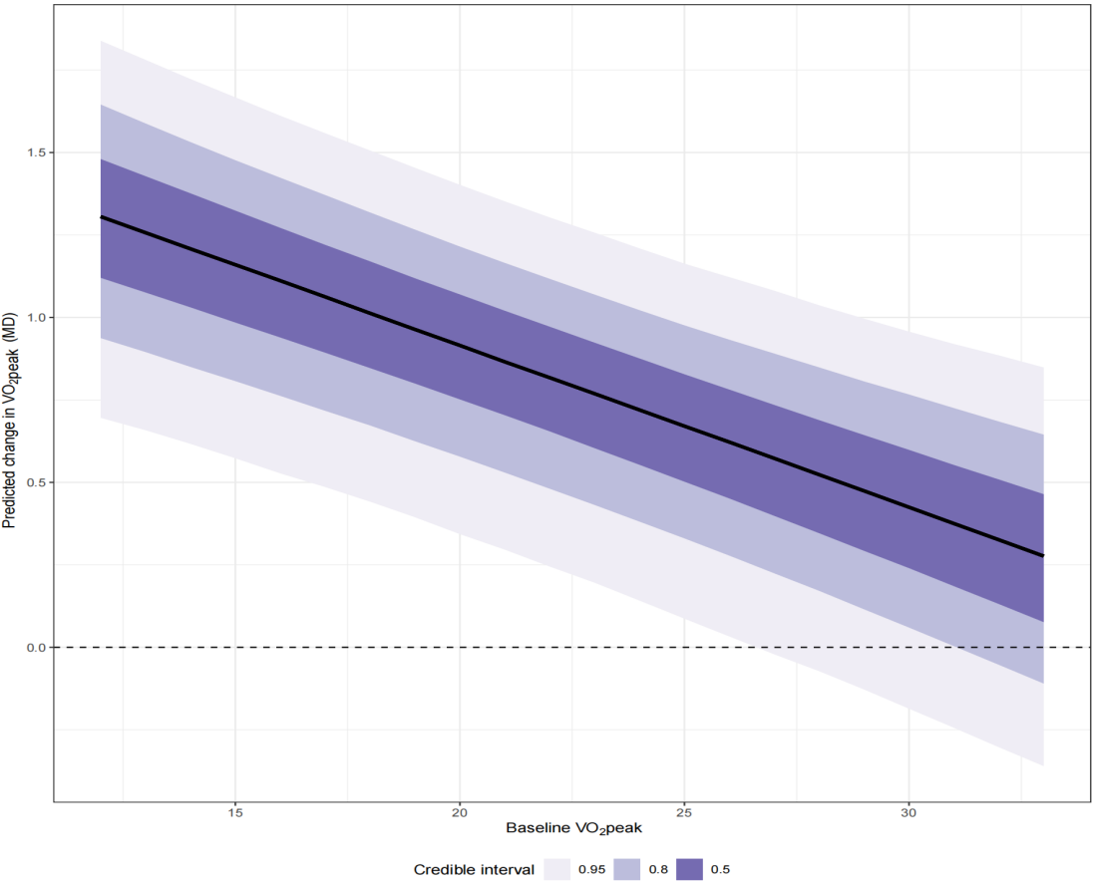
Fig. S16. Predicted exercise effects on VO₂peak by baseline VO₂peak.

6. Effect modifiers of exercise on VO₂peak

6.1 Effect of Baseline Disease Severity on VO₂peak Compared with Control
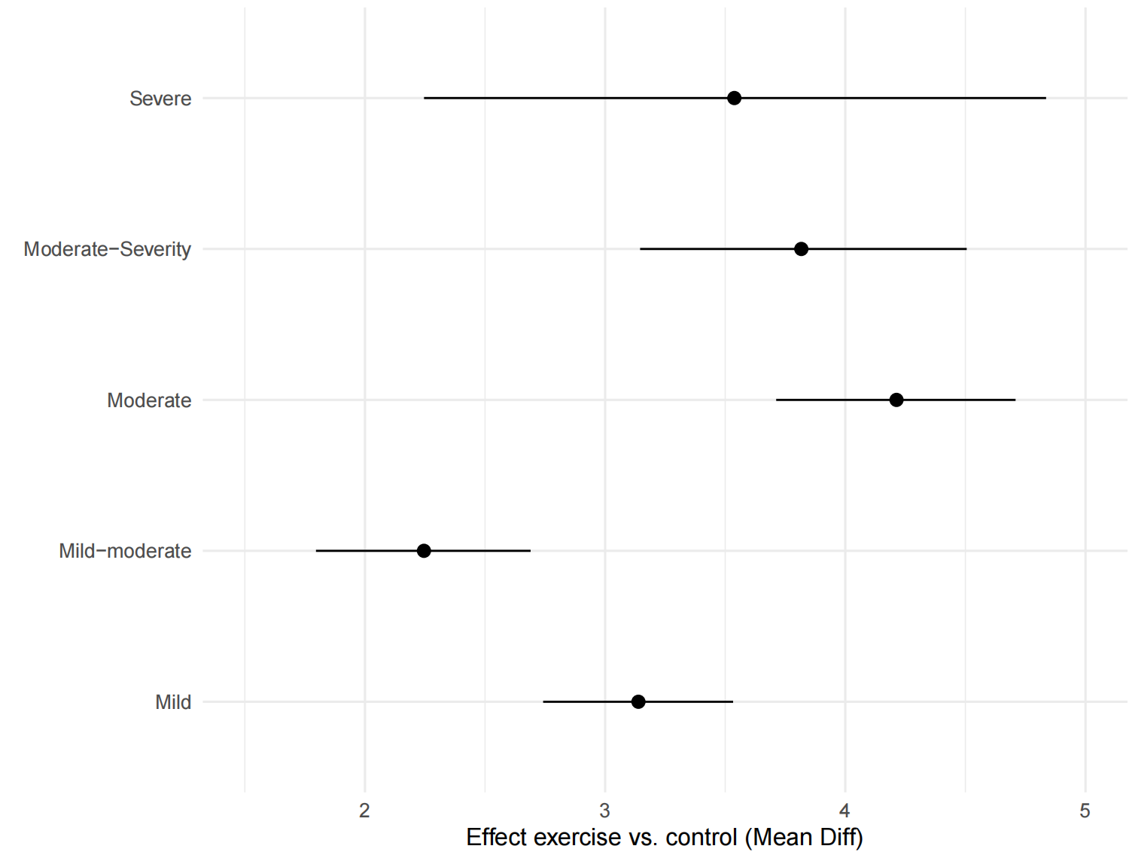
Fig. S17. Effect of baseline disease severity on VO₂peak compared with control.

6.2 Effect of Intervention Delivery Format on VO₂peak Compared with Control
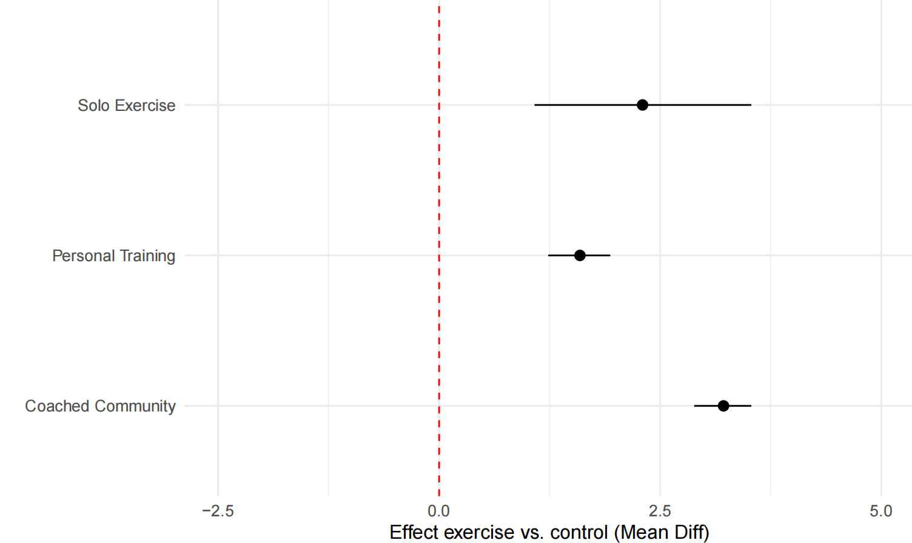
Fig. S18. Effect of intervention delivery format on VO₂peak compared with control.

