Additional file 1
Material S1. Glossary of Network Analysis Terms
Table S1. Disease Weights of the Charlson Comorbidity Index

Material S2. Regression Modeling Framework

Material S3. Outcome-Specific Model Specification

Material S4. Attribution Analysis
Figure S1. Study Flow Diagram
Figure S2. Rectangular tree diagram of disease distribution among inpatients
Table S2. Classification of Disease Patterns Using Louvain Community Detection Algorithm
Table S3. Main Structural Characteristics of Male and Female Networks
Table S4. Hub Diseases in Male and Female Networks
Table S5. Main Structural Characteristics of Networks by Age Group
Table S6. Hub Diseases by Age Group
Table S7. Effect of Covariates on Total Hospitalization Costs
Table S8. Community 30-Day Readmission Risk and PAF Ranking
Table S9. Community Prolonged Length of Stay Risk and PAMF Ranking
Table S10. Community Cost Ratio and PAMF Ranking

Material S1. Glossary of Network Analysis Terms
Term | Plain-language definition | Interpretation in this study
Node | An individual element in a network. | Each node represents a distinct disease (defined by three-character ICD-10 codes).
Edge | A connection between two nodes. | An edge indicates a statistically significant positive co-occurrence association between two diseases within the same hospitalization.
Edge weight | A numerical value assigned to an edge, representing the strength of the connection. | The edge weight is the geometric mean of the adjusted odds ratios from pairwise logistic regression, reflecting the strength of co-occurrence.
Node degree | The number of edges connected to a node | A high node degree indicates that a disease has many or strong co-occurrence associations, positioning it as a central condition in the multimorbidity network.
Node degree centrality | A measure that uses node degree to assess the importance of a node in the network. Higher values indicate that the disease is more central in the multimorbidity network. | We ranked diseases by degree centrality to identify hub diseases (top 10 nodes with the highest degree).
Community detection | An algorithmic process that partitions a network into groups where nodes within the same group are more densely connected to each other than to nodes in other groups. | We used the Louvain modularity optimization algorithm to identify disease communities. Each community represents a data-driven multimorbidity pattern.
Modularity | A measure of the quality of a network partition into communities. | Modularity was optimized to identify the most meaningful partition of diseases into multimorbidity patterns.
Louvain algorithm | A widely used algorithm for community detection that optimizes modularity. | Implemented using the igraph package in R to detect disease communities.
Network density | The proportion of all possible edges that are actually present. | Higher density indicates more widespread inter-disease connections.
Clustering coefficient | A measure of how much nodes tend to cluster together. | Higher clustering coefficient indicates tightly connected disease groups.
Mean degree | The average degree centrality across all nodes. | Higher mean degree indicates that, on average, each disease is associated with more comorbid conditions.

Table S1. Disease Weights of the Charlson Comorbidity Index

Disease | ICD-10 Code | Weight
Myocardial Infarction | I21, I22, I25 | 1
Congestive Heart-Failure | I50, I11, I13 | 1
Peripheral Vascular Disease | I70, I71, I73, I74, I77, R02, Z95 | 1
Cerebrovascular | I60-I69, G45 | 1
Dementia | F00-F03, G30-G31 | 1
Chronic Pulmonary Disease | J40-J47, J60-J67, J84 | 1
Rheumatic Disease | M05, M06, M32, M34, M35, M36 | 1
Peptic Ulcer Disease | K25-K28 | 1
Mild Liver Disease | K70, K73, K74, B18 | 1
Paralysis | G81-G82 | 2
Moderate to Severe Renal Disease | I12-I13, N18-N19, N25 | 2
Diabetes with Complications | E10.2-E14.2, E10.3-E14.3 | 2
Solid Tumour (without metastasis) | C00-C26,C30-C39,C40-C41, C43-C49, C50-C58, C60-C69, C70-C76 | 2
Leukaemia/Lymphoma | C81-C96 | 2
Severe Liver Disease | K72, K76, B15, B16, B17, B19 | 3
Metastatic Solid Tumour | C77-C79, C80，Z85 | 6
AIDS | B20-B24 | 6

Material S2. Regression Modeling Framework
To evaluate the incremental prognostic value of multimorbidity patterns beyond multimorbidity burden, we specified a set of prespecified nested regression models for each outcome. Let $\text{i}$index individuals and $\text{d}$index districts. Let ${\text{X}}_{\text{i}}$denote a vector of baseline covariates (age, sex, marital status, insurance type), ${\text{α}}_{\text{d}}$denote district fixed effects, ${\text{ACCI}}_{\text{i}}$denote the age-adjusted Charlson Comorbidity Index, and ${\text{C}}_{\text{i}}$denote a categorical variable indicating comorbidity pattern (disease cluster/community). We estimated the following models:
Model 1 (Base Model):
$$\text{g}\left(\text{E}\text{[}{\text{Y}}_{\text{i}}\text{∣}{\text{X}}_{\text{i}}\text{]}\right)\text{=}{\text{β}}_{\text{0}}\text{+}{\text{X}}_{\text{i}}^{\text{⊤}}\text{β}\text{+}{\text{α}}_{\text{d}}$$
Model 2 (Comorbidity Burden Model):
$$\text{g}\left(\text{E}\text{[}{\text{Y}}_{\text{i}}\text{∣}{\text{X}}_{\text{i}}\text{,}{\text{ACCI}}_{\text{i}}\text{]}\right)\text{=}{\text{β}}_{\text{0}}\text{+}{\text{X}}_{\text{i}}^{\text{⊤}}\text{β}\text{+}\text{γ} {\text{ACCI}}_{\text{i}}\text{+}{\text{α}}_{\text{d}}$$
Model 3 (Comorbidity Pattern Model):
$$\text{g}\left(\text{E}\text{[}{\text{Y}}_{\text{i}}\text{∣}{\text{X}}_{\text{i}}\text{,}{\text{ACCI}}_{\text{i}}\text{,}{\text{C}}_{\text{i}}\text{]}\right)\text{=}{\text{β}}_{\text{0}}\text{+}{\text{X}}_{\text{i}}^{\text{⊤}}\text{β}\text{+}\text{γ} {\text{ACCI}}_{\text{i}}\text{+}{\text{δ}}^{\text{⊤}}{\text{C}}_{\text{i}}\text{+}{\text{α}}_{\text{d}}$$
Where $\text{g}\text{(}\text{⋅)}$is the outcome-specific link function (specified below). Model 3 nests Model 2, allowing a formal likelihood-based comparison of the incremental contribution of comorbidity patterns beyond overall burden.

Material S3. Outcome-Specific Model Specification

(1) Total Hospitalization Cost
Since hospitalization cost exhibited a right-skewed distribution, we modeled the natural logarithm of cost using a linear fixed-effects model:
$$\text{log⁡(}{\text{Cost}}_{\text{i}}\text{)=}{\text{β}}_{\text{0}}\text{+}{\text{X}}_{\text{i}}^{\text{⊤}}\text{β}\text{+}\text{γ} {\text{ACCI}}_{\text{i}}\text{+}{\text{δ}}^{\text{⊤}}{\text{C}}_{\text{i}}\text{+}{\text{α}}_{\text{d}}\text{+}{\text{ε}}_{\text{i}}$$
where ${\text{ε}}_{\text{i}}$denotes the idiosyncratic error term. To account for within-district correlation, cluster-robust standard errors at the district level were applied. Exponentiated coefficients can be interpreted as relative changes in cost.
(2) Length of Stay (LOS)
Length of stay was treated as overdispersed count data and modeled using a negative binomial regression:
$${\text{LOS}}_{\text{i}}\text{∼}\text{NegBin}\text{(}{\text{μ}}_{\text{i}}\text{,}\text{θ}\text{)} \\ \text{log⁡(}{\text{μ}}_{\text{i}}\text{)=}{\text{β}}_{\text{0}}\text{+}{\text{X}}_{\text{i}}^{\text{⊤}}\text{β}\text{+}\text{γ} {\text{ACCI}}_{\text{i}}\text{+}{\text{δ}}^{\text{⊤}}{\text{C}}_{\text{i}}\text{+}{\text{α}}_{\text{d}}$$
where $\text{θ}$is the dispersion parameter. Regression coefficients are interpreted as log rate ratios for expected LOS.
(3) 30-Day Readmission
Thirty-day readmission was modeled as a binary outcome using logistic regression:
$$\text{Pr⁡(}{\text{Y}}_{\text{i}}\text{=1)=}{\text{logit}}^{\text{-1}}\left({\text{β}}_{\text{0}} + {\text{X}}_{\text{i}}^{\text{⊤}}\text{β} + \text{γ} {\text{ACCI}}_{\text{i}} + {\text{δ}}^{\text{⊤}}{\text{C}}_{\text{i}} + {\text{α}}_{\text{d}}\right)$$
Results are reported as odds ratios (ORs) with 95% confidence intervals.

Incremental Value of Comorbidity Patterns
The added prognostic value of comorbidity patterns was evaluated by comparing Model 2 and Model 3, which differ only by the inclusion of ${\text{C}}_{\text{i}}$. Since the models are nested, improvement in fit was assessed using the likelihood ratio test (LRT):
$${\text{χ}}^{\text{2}}\text{=-2}\left({\text{l}}_{\text{Model 2}} − {\text{l}}_{\text{Model 3}}\right)$$
where $\text{l}$ denotes the log-likelihood. For the binary readmission outcome, changes in discrimination were further quantified by comparing the area under the receiver operating characteristic curve (AUC).

Material S4. Attribution Analysis
To quantify the impact of comorbidity on healthcare burden at the population level and compare the relative importance of different comorbidity patterns, two types of attribution analyses were conducted.
(1) Population-Level Attribution of Comorbidity Burden
This study calculated the population attributable fraction (PAF) for readmission and the population attributable mean fraction (PAMF) for length of stay (LOS) and hospitalization cost. The goal was to estimate, under a theoretical scenario, the proportion of avoidable readmissions or reduced healthcare resource consumption if the comorbidity burden were eliminated (i.e., if the age-adjusted Charlson Comorbidity Index [ACCI] were reduced to 0) for all patients.
Calculation Method:
This analysis was based on the final "comorbidity pattern model" (Model 3). First, the predicted outcomes for each individual were calculated under the actual conditions. Then, under the counterfactual scenario, each individual's ACCI value was set to 0 while keeping the comorbidity patterns and other covariates unchanged, and their predicted outcomes were recalculated.
30-Day Readmission (Binary Outcome):
The population attributable fraction (PAF) was calculated as:
$$\text{PAF=}\frac{\text{Observed Event Rate-Counterfactual Event Rate}}{\text{Observed Event Rate}}$$
Length of Stay and Hospitalization Cost (Continuous Outcomes):
The population attributable mean fraction (PAMF) was calculated as:
$$\text{PAMF=}\frac{\text{Observed Mean-Counterfactual Mean}}{\text{Observed Mean}}$$
Uncertainty for the PAF/PAMF estimates was quantified using a nonparametric bootstrap method with 5,000 resamples. The 95% confidence intervals for PAF/PAMF were derived from the distribution of the bootstrap resamples.
(2) Attribution Contribution of Comorbidity Patterns
To compare the relative impact of the nine data-driven comorbidity patterns on healthcare outcomes, we calculated the attribution fraction for each pattern. The goal was to quantify the "net contribution" of the presence of each specific comorbidity pattern to the overall healthcare burden at the population level.
Calculation Method:
This analysis was also based on Model 3. Counterfactual scenarios were constructed for each comorbidity pattern (Community).
Real Scenario:
The predicted values were calculated using the model's original parameters and comorbidity patterns.
Counterfactual Scenario:
In the counterfactual scenario, we assumed that none of the individuals in the cohort had the diseases represented by the comorbidity pattern in question. For example, when calculating the attribution fraction for Community 1, the comorbidity pattern variable for all individuals identified as belonging to Community 1 was recoded as “missing” or “reference group,” while keeping their ACCI scores and other covariates unchanged. The predicted values were recalculated under this modified scenario.
The attribution fraction for a specific comorbidity pattern (e.g., Community 1) was calculated as:
$\text{Attribution Fraction=}\frac{\text{Predicted Mean in Real Scenario-Predicted Mean in Counterfactual Scenario (Removing Community 1)}}{\text{Predicted Mean in Real Scenario}}$
A positive attribution fraction indicates that the comorbidity pattern contributes to a worse outcome (i.e., increasing the burden), while a negative attribution fraction indicates a protective effect (i.e., reducing the burden).
The sum of the attribution fractions for all patterns should theoretically be close to the overall PAF/PAMF for ACCI.

Figure S1. Study Flow Diagram

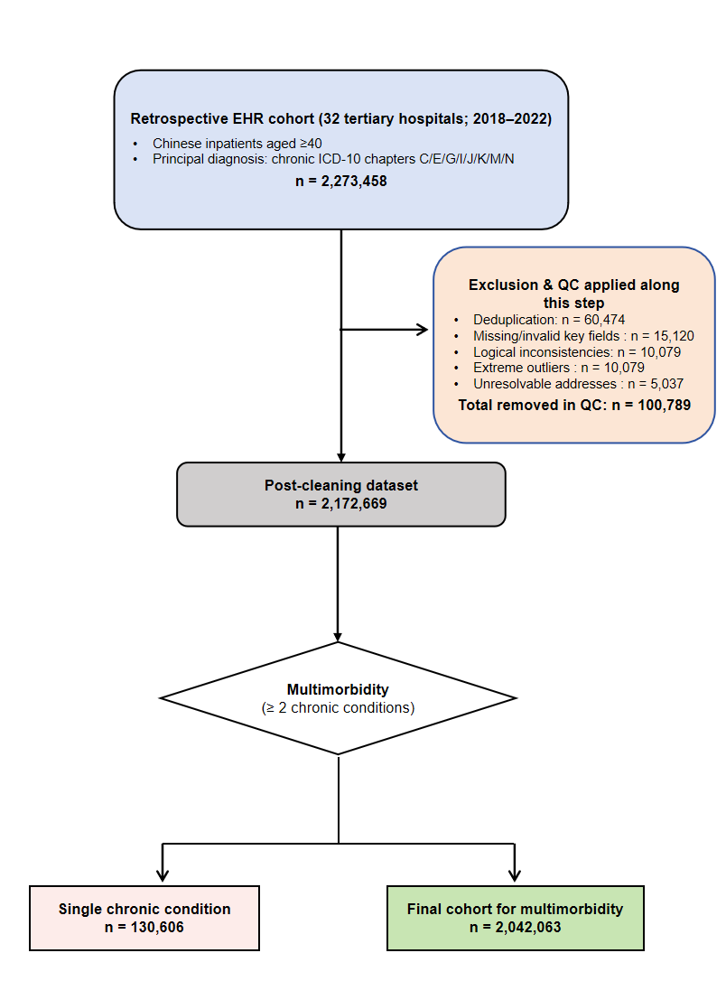

Figure S2. Rectangular tree diagram of disease distribution among inpatients

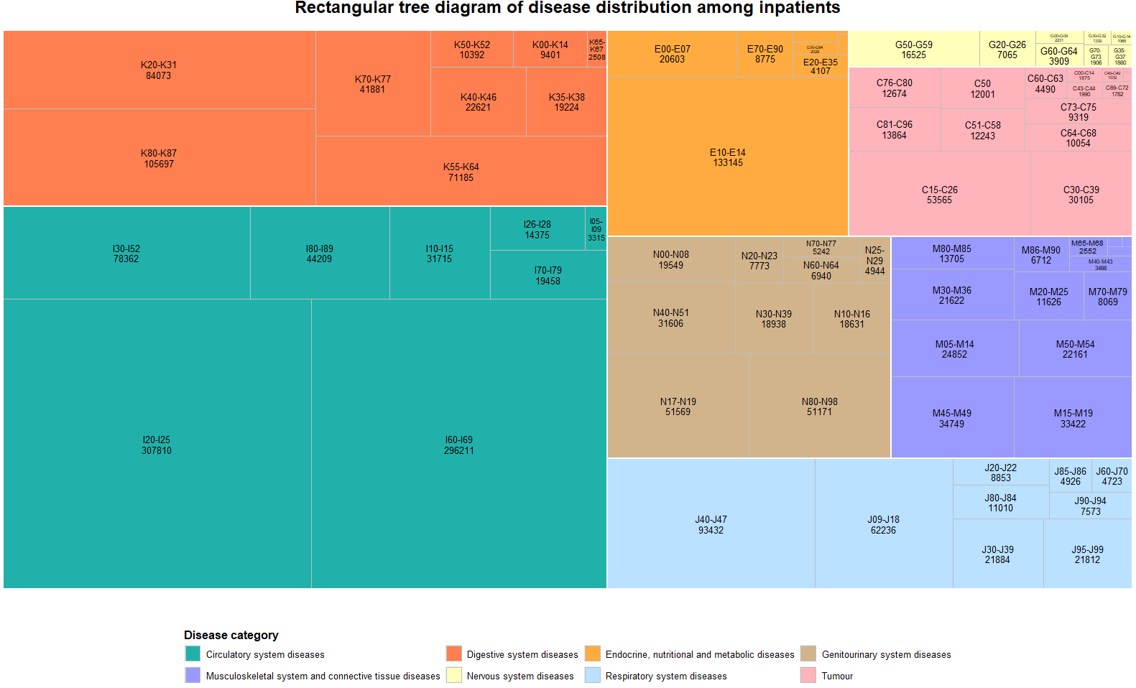
Table S2. Classification of Disease Patterns Using Louvain Community Detection Algorithm
Category | Disease
Community1 | A41、B90、C15、C34、I26、I27、I31、I80、I82、I83、I87、J15、J18、J20、J42、J43、J44、J45、J46、J47、J60、J62、J84、J85、J86、J93、J94、J96、J98、M33、R09、R57、R59、R91、R04、D86、A16、J92
Community2 | A49、B18、B49、C16、C18、C20、C22、C24、C25、C50、C56、C77、C78、C79、C80、D12、D18、D62、D68、D73、E46、E77、I84、J40、K20、K21、K22、K25、K26、K29、K31、K35、K36、K44、K51、K52、K55、K56、K57、K59、K60、K62、K63、K65、K70、K72、K74、K75、K76、K80、K81、K82、K83、K85、K86、K92、M13、N60、R16、R18、R93、R94、Z51、Z85、Z90、Z98、Z53、B16、N63、Z22、N94、T81
Community3 | B34、C53、C54、D25、D50、D64、D69、D70、K66、N70、N71、N72、N73、N80、N81、N83、N84、N85、N87、N93、N95、Z87、N76、Z92
Community4 | C61、C64、C67、I86、K40、N13、N17、N19、N20、N21、N28、N30、N31、N32、N35、N39、N40、N41、N43、N45、N50、R33、R77、Z93
Community5 | C73、E03、E04、E05、E06、E07、G56、G62、M05、M06、M15、M17、M19、M21、M23、M25、M35、M41、M43、M47、M48、M50、M51、M54、M65、M75、M79、M80、M81、M84、S22、E55、M71、M24、T91、S32
Community6 | C90、C92、D61、E10、E11、E21、E23、E27、E83、E87、E88、H35、I15、J06、K71、L08、M31、M32、M87、N03、N04、N05、N10、N18、N25、Z49、Z96、M89、B02、E02、E13、H26、Z54
Community7 | D35、E14、E16、E53、E72、E78、E79、F06、F41、F45、G20、G24、G31、G37、G40、G45、G47、G50、G51、G81、G91、G93、H81  I10、I12、I60、I61、I62、I63、I65、I66、I67、I69、I70、I71、I72、I74、I77、J69、K27、M10、M45、R47、R73、R90、Z86、F32
Community8 | I05、I08、I09、I11、I20、I21、I24、I25、I34、I35、I38、I42、I44、  I45、I46、I47、I48、I49、I50、I51、Q21、Q24、R00、Z95
Community9 | J30、J31、J32、J33、J34、J38

Table S3. Main Structural Characteristics of Male and Female Networks

Network Metric | Female | Male
Number of Nodes | 157 | 152  (2 isolated nodes removed)
Number of Edges | 613 | 419
Average Degree | 7.81 | 5.44
Network Density | 0.0501 | 0.0356
Clustering Coefficient | 0.215 | 0.282

Table S4. Hub Diseases in Male and Female Networks

Sex | Hub Diseases
Male | I10, I50, I63, E11, K29, K76, K80, J43, N40, I61
Female | I10, I50, E11, E87, K80, K29, K76, E87, I06, I25

Table S5. Main Structural Characteristics of Networks by Age Group

Network Metric | 40 - 49 | 50 - 59 | 60 - 69 | ≥70
Number of Nodes | 154 | 150 | 148 | 143
Number of Edges | 378 | 348 | 376 | 423
Average Degree | 0.279 | 0.254 | 0.288 | 0.312
Network Density | 0.032 | 0.031 | 0.035 | 0.042
Clustering Coefficient | 4.91 | 4.64 | 5.08 | 5.91

TableS6. Hub Diseases by Age Group

Age Group | Hub Diseases
40-49 | I10, E11, N18, I63, I50, K29, K76, E87, Z98, M17
50-59 | I10, E11, N18, I61, I25, K29, K74, K76, E78, D64
60-69 | I10, E11, N18, I63, K29, K76, K80, E78, M17, N28
≥70 | I10, E11, N18, I63, I61, I50, K80, E87, N40, E77

Table S7. Effect of Covariates on outcomes

variable | Model1 |  | Model 2 |  | Model 3
variable | OR(95%CI) | P value | OR(95%CI) | P value | OR(95%CI) | P value
Total hospitalization cost​
age | 1 (1 - 1) | < 0.001 | 1 (1 - 1) | < 0.001 | 1 (1 - 1) | < 0.001
gender_female | 0.9 (0.9 - 0.9) | < 0.001 | 0.91 (0.9 - 0.91) | < 0.001 | 0.91 (0.91 - 0.92) | < 0.001
Urban Residents | 1.16 (1.15 - 1.16) | < 0.001 | 1.15 (1.15 - 1.16) | < 0.001 | 1.16 (1.15 - 1.16) | < 0.001
Urban Employees | 1.1 (1.1 - 1.1) | < 0.001 | 1.1 (1.09 - 1.1) | < 0.001 | 1.11 (1.11 - 1.12) | < 0.001
New Rural Cooperative Medical Scheme | 1.29 (1.28 - 1.3) | < 0.001 | 1.29 (1.28 - 1.29) | < 0.001 | 1.29 (1.28 - 1.29) | < 0.001
marriage_Divorce | 1.12 (1.11 - 1.13) | < 0.001 | 1.12 (1.1 - 1.13) | < 0.001 | 1.13 (1.11 - 1.14) | < 0.001
marriage_Others | 0.84 (0.84 - 0.85) | < 0.001 | 0.84 (0.84 - 0.85) | < 0.001 | 0.85 (0.84 - 0.85) | < 0.001
marriage_Unmarried | 1.02 (1 - 1.03) | 0.026 | 1.02 (1 - 1.03) | 0.029 | 1.02 (1 - 1.03) | 0.026
marriage_Married | 1 (0.99 - 1) | 0.75 | 1 (0.99 - 1) | 0.483 | 0.99 (0.99 - 1) | 0.057
Length of stay (days)
age | 1 (1 - 1) | < 0.001 | 1 (1 - 1) | < 0.001 | 1 (1 - 1) | 0.041
gender_female | 0.94 (0.94 - 0.95) | < 0.001 | 0.95 (0.95 - 0.95) | < 0.001 | 0.96 (0.96 - 0.96) | < 0.001
Urban Residents | 0.96 (0.96 - 0.97) | < 0.001 | 0.96 (0.95 - 0.96) | < 0.001 | 0.96 (0.96 - 0.97) | < 0.001
Urban Employees | 0.97 (0.96 - 0.97) | < 0.001 | 0.96 (0.96 - 0.97) | < 0.001 | 0.97 (0.97 - 0.97) | < 0.001
New Rural Cooperative Medical Scheme | 1.04 (1.04 - 1.05) | < 0.001 | 1.04 (1.03 - 1.04) | < 0.001 | 1.04 (1.03 - 1.04) | < 0.001
marriage_Divorce | 1.08 (1.07 - 1.09) | < 0.001 | 1.08 (1.07 - 1.09) | < 0.001 | 1.07 (1.06 - 1.08) | < 0.001
marriage_Others | 1 (0.99 - 1) | 0.288 | 1 (0.99 - 1) | 0.175 | 1.01 (1 - 1.01) | 0.068
marriage_Unmarried | 1.13 (1.12 - 1.14) | < 0.001 | 1.13 (1.12 - 1.14) | < 0.001 | 1.12 (1.11 - 1.13) | < 0.001
marriage_Married | 0.99 (0.99 - 1) | < 0.001 | 0.99 (0.99 - 0.99) | < 0.001 | 1 (1 - 1) | 0.633
30-day readmission
age | 1.01 (1.01 - 1.01) | < 0.001 | 1 (1 - 1) | 0.437 | 1 (1 - 1) | 0.009
gender_female | 0.83 (0.82 - 0.84) | < 0.001 | 0.84 (0.83 - 0.86) | < 0.001 | 0.82 (0.81 - 0.83) | < 0.001
Urban Residents | 0.95 (0.93 - 0.97) | < 0.001 | 0.94 (0.92 - 0.96) | < 0.001 | 0.94 (0.92 - 0.96) | < 0.001
Urban Employees | 0.93 (0.91 - 0.95) | < 0.001 | 0.92 (0.9 - 0.94) | < 0.001 | 0.91 (0.89 - 0.92) | < 0.001
New Rural Cooperative Medical Scheme | 0.7 (0.68 - 0.72) | < 0.001 | 0.69 (0.67 - 0.71) | < 0.001 | 0.7 (0.68 - 0.72) | < 0.001
marriage_Divorce | 0.7 (0.66 - 0.74) | < 0.001 | 0.7 (0.66 - 0.74) | < 0.001 | 0.69 (0.65 - 0.73) | < 0.001
marriage_Others | 0.77 (0.74 - 0.8) | < 0.001 | 0.77 (0.74 - 0.8) | < 0.001 | 0.77 (0.74 - 0.8) | < 0.001
marriage_Unmarried | 0.68 (0.64 - 0.72) | < 0.001 | 0.68 (0.63 - 0.72) | < 0.001 | 0.67 (0.63 - 0.72) | < 0.001
marriage_Married | 0.58 (0.56 - 0.59) | < 0.001 | 0.57 (0.56 - 0.59) | < 0.001 | 0.57 (0.56 - 0.59) | < 0.001

Table S8. Community 30-Day Readmission Risk and PAF Ranking
Community | OR（vs community1） | OR Rank (1 = highest risk) | PAF（%） | PAF Rank (1 = largest burden)
community6 | 1.59 | 1 | +8.22 | 1
community3 | 1.08 | 2 | +0.22 | 4
community5 | 1.08 | 2 | +0.59 | 3
community1 | 1.00 | 4 | +2.51 | 2
community2 | 0.82 | 5 | -1.73 | 7
community4 | 0.88 | 6 | -0.04 | 5
community7 | 0.80 | 7 | -4.29 | 8
community8 | 0.68 | 8 | -6.19 | 9
community9 | 0.48 | 9 | -0.27 | 6

Table S9. Community Prolonged Length of Stay Risk and PAMF Ranking
Community | IRR（vs community1） | IRR Rank (1 = longest stay) | PAMF（%） | PAMF Rank (1 = greatest prolongation)
community6 | 1.028 | 1 | +1.56 | 2
community7 | 1.019 | 2 | +2.65 | 1
community1 | 1.000 | 5 | +1.61 | 3
community5 | 0.996 | 6 | +0.74 | 4
community2 | 0.900 | 7 | -0.39 | 6
community4 | 0.932 | 8 | +0.09 | 5
community9 | 0.765 | 9 | -0.12 | 7
community3 | 0.768 | 3* | -0.46 | 8
community8 | 0.691 | 4* | -5.85 | 9

Table S10. Community Cost Ratio and PAMF Ranking

Community | Cost Ratio (vs. Community 1) | IRR Rank (1 = highest cost) | PAMF (%) | PAMF Rank (1 = largest burden)
community5 | 1.184 | 1 | +1.67 | 2
community8 | 1.074 | 2 | +2.69 | 1
community1 | 1.000 | 3 | +0.70 | 3
community2 | 0.966 | 4 | -0.11 | 6
community4 | 0.962 | 5 | -0.12 | 7
community7 | 0.983 | 6 | +0.39 | 4
community9 | 0.853 | 7 | -0.09 | 5
community3 | 0.792 | 8 | -0.51 | 8
community6 | 0.708 | 9 | -3.41 | 9

