Additional file 1: Supplementary materials
Supplementary Methods
Table S1 Food items considered as ultra-processed food according to the NOVA-classification
Table S2 Proportion of missingness for each covariate
Table S3 Descriptive characteristics of participants enrolled in the study and non-response analyses in GECKO cohort
Table S4 Descriptive characteristics of participants enrolled in the study and non-response analyses in Lifelines cohort
Table S5 Baseline demographic characteristics of participants across sex-specific quartiles of ultra-processed food consumption in GECKO cohort
Table S6 Baseline demographic characteristics of participants across sex-specific quartiles of ultra-processed food consumption in Lifelines cohort
Table S7 Dietary characteristics of food intake according to NOVA classification
Table S8 Baseline dietary characteristics of participants across sex-specific quartiles of ultra-processed food consumption in GECKO cohort
Table S9 Baseline dietary characteristics of participants across sex-specific quartiles of ultra-processed food consumption in Lifelines cohort
Table S10 Interaction between child sex and sex-specific quartiles of ultra-processed food consumption (by weight ratio) in relation to anthropometric measures
Table S11 Association between sex-specific quartiles of ultra-processed food consumption (by weight ratio) and anthropometric measures stratified by child sex
Table S12 Interaction between maternal education level and sex-specific quartiles of ultra-processed food consumption (by weight ratio) in relation to anthropometric measures
Table S13 Association between sex-specific quartiles of ultra-processed food consumption (by weight ratio) and anthropometric measures stratified by maternal education level
Table S14 Interaction between child sex and sex-specific quartiles of ultra-processed food consumption (by weight ratio) in relation to overweight or obesity status
Table S15 Association between sex-specific quartiles of ultra-processed food consumption (by weight ratio) and overweight or obesity status stratified by child sex
Table S16 Interaction between maternal education level and sex-specific quartiles of ultra-processed food consumption (by weight ratio) in relation to overweight or obesity status
Table S17 Association between sex-specific quartiles of ultra-processed food consumption (by weight ratio) and overweight or obesity status stratified by maternal education level
Fig. S1 Flowchart of the study participants included in the analysis
Fig. S2 Association between sex-specific quartiles of ultra-processed food consumption (by energy ratio) and anthropometric measures
Fig. S3 Association between sex-specific quartiles of ultra-processed food consumption (by weight ratio) and anthropometric measures in complete case analysis
Fig. S4 Association between sex-specific quartiles of ultra-processed food consumption (by energy ratio) and overweight or obesity status
Fig. S5 Association between sex-specific quartiles of ultra-processed food consumption (by weight ratio) and overweight or obesity status in complete case analysis
Fig. S6 Cross-lagged analysis of the ultra-processed food consumption (by weight ratio) and BMI z-score in the complete case analyses.
Supplementary Methods
Ultra-processed foods categorization
Group 1 includes unprocessed or minimally processed foods such as fruits, vegetables, milk, meat, and legumes that are fresh, frozen, ground, pasteurized, or fermented. Group 2 comprises processed culinary ingredients derived from group 1 foods and used in cooking and seasoning (e.g., table salt, sugar, vegetable oils, butter). Group 3 consists of processed foods produced by adding salt, sugar, or other group 2 ingredients to group 1 foods (e.g., canned vegetables, canned fish, breads, cheeses). Group 4 includes ultra-processed foods (UPFs), defined as industrial formulations containing multiple ingredients, often with substances of exclusive industrial use (e.g., high-fructose corn syrup), produced through complex processes (e.g., hydrogenation) and typically containing cosmetic additives (e.g., colors, flavors, emulsifiers) (10). Examples of UPFs include packaged snacks, sugar-sweetened beverages, candy, industrial breads and breakfast cereals, ready-to-heat meals such as pasta dishes and pizza, and reconstituted meat products.
All FFQ food items were independently classified by two trained coders according to the NOVA framework. Where brand or product information was available, classifications were verified using ingredient lists and nutrition labels to identify ingredients, additives, and processing characteristics relevant to NOVA classification. When product-specific information was unavailable, conservative classifications were assigned based on the typical formulation of comparable products available in the Dutch retail market. For food items for which NOVA classification was potentially uncertain, including breakfast cereals, flavored dairy products, composite dishes, and potato products, predefined decision rules were applied. For example, commercially available white, wheat, and wholegrain breads, as well as gingerbread, were classified as NOVA group 4 because these products in the Dutch retail market are typically industrially manufactured and commonly contain additives (e.g., emulsifiers and preservatives) characteristic of ultra-processed foods. In contrast, pancakes were classified as NOVA group 3 because they are predominantly prepared at home in the Netherlands. Each FFQ food item was assigned to a single NOVA category.

Table S1 Food items considered as ultra-processed food according to the NOVA-classification
Ultra-processed food groups | Food products
Sugary beverages | Sugary beverages, lemonade with sugar, juice
Sugary dairy | Chocolate milk, yogurt drinks, ready-to-eat porridge, whipped cream, ice-cream, quark and fruit quark, fruit yogurt, full-fat custard, other types of flavored dairy products
Carbohydrate-rich staple food | Sliced bread, rusk, crisp bread, croissants, fries, muesli, granola, cereals for the preparation of porridges
Sweets | Small cookies/biscuits, cakes, pastries, pies, breakfast biscuits, cookie bars, nutritional biscuits, candy bars, chocolates, candies
Processed meat and fish | Luncheon meat, smoked sausages, deli meat, bacon slices, ham sausages, deep-fried whiting in dough, other types of processed meat
Fast food | Meals from fast-food restaurants, pizza
Ready meals | Chinese/Indonesian dishes, other types of ready-to-eat meals, pre-packed soup
Spreadable butter | Spreadable butter, margarine, low fat margarine
Savory spreads | Salad (spreads) on bread/baguettes, sandwich spreads, other kind of savory spreads on bread/baguettes, gravy, pasta sauce, mushroom sauce, sate sauce, sauce for fries, regular mayonnaise, low-fat mayonnaise, salad dressing, other non-red sauces
Savory snack | Croquettes, minced meat hotdogs, sausage rolls, potato chips, salty biscuits, other types of warm savory snacks
Sweet spreads | Peanut butter, chocolate spreads, other types of sweet spreads
Other solid foods | Veggie meat, tofu
Cheese | Spreadable cheese, snack cheese, cheese with warm meals, foreign cheese, cream cheese
Other liquid foods | Breakfast drink, light soft drinks, lemonade without sugar

Table S2 Proportion of missingness for each covariate
Variable, n(%) | GECKO cohort (n=1091) | Lifelines cohort (n=2970)
Child characteristics
Age at outcome measurement | 0 (0) | 0 (0)
Gender | 0 (0) | 0 (0)
Total energy intake | 0 (0) | 0 (0)
Maternal characteristics
Age at childbirth | 1 (0.1%) | 169 (5.7%)
BMI | 13 (1.2%) | 169 (5.7%)
Education level | 10 (0.9%) | 123 (4.1%)
Smoking status | 17 (1.6%) | 47 (1.6%)
BMI, body mass index.
Table S3 Descriptive characteristics of participants enrolled in the study and non-response analyses in GECKO cohort
 | Children enrolled in GECKO (n=2842) |  |  | Children measured diet at 3y in GECKO (n=1258)
 | Included (n=1091) | Excluded (n=1751) | P value | Included (n=1091) | Excluded (n=167) | P value
Child characteristics
Gender, n(%) |  |  | 0.91 |  |  | 0.06
Male | 548 (50.2%) | 883 (50.5%) |  | 548 (50.2%) | 97 (58.1%)
Female | 543 (49.8%) | 867 (49.5%) |  | 543 (49.8%) | 70 (41.9%)
Age, mean±SD, years
1st assessment | 3.1 ± 0.2 | 3.1 ± 0.2 | 0.34 | 3.1 ± 0.2 | 3.1 ± 0.2 | 0.48
2nd assessment | 10.6 ± 0.4 | 10.6 ± 0.4 | <0.01 | 10.6 ± 0.4 | 10.7 ± 0.3 | 0.03
BMI z-score, mean±SD
1st assessment | 0.1 ± 0.9 | 0.1 ± 1.0 | 0.94 | 0.1 ± 0.9 | 0.0 ± 1.1 | 0.51
2nd assessment | 0.2 ± 1.0 | 0.3 ± 1.1 | 0.02 | 0.2 ± 1.0 | n.a. | n.a.
Physical status at 1st assessment, n(%) |  |  | 0.03 |  |  | 0.34
No overweight | 864 (91.9%) | 648 (88.2%) |  | 864 (91.9%) | 110 (88.7%)
Overweight | 65 (6.9%) | 72 (9.8%) |  | 65 (6.9%) | 13 (10.5%)
Obesity | 11 (1.2%) | 15 (2.0%) |  | 11 (1.2%) | 1 (0.8%)
Physical status at 2nd assessment, n(%) |  |  | 0.33 |  |  | n.a.
No overweight | 914 (83.8%) | 901 (81.4%) |  | 914 (83.8%) | n.a.
Overweight | 142 (13.0%) | 164 (14.8%) |  | 142 (13.0%) | n.a.
Obesity | 35 (3.2%) | 42 (3.8%) |  | 35 (3.2%) | n.a.
Maternal characteristics
Age, mean±SD, years | 31.7 ± 4.1 | 30.9 ± 4.6 | <0.01 | 31.7 ± 4.1 | 31.4 ± 4.5 | 0.33
BMI, Median[IQR], kg/m² | 23.7[21.6-26.5] | 23.8[21.4-26.9] | 0.99 | 23.7 [21.6-26.6] | 24.4[21.8-28.1] | 0.11
Education level, n(%) |  |  | <0.01 |  |  | <0.01
Low | 268 (24.8%) | 674 (43.3%) |  | 268 (24.8%) | 74 (46.0%)
Medium | 369 (34.1%) | 382 (24.6%) |  | 369 (34.1%) | 42 (26.1%)
High | 444 (41.1%) | 499 (32.1%) |  | 444 (41.1%) | 45 (28.0%)
Smoking status, n(%) |  |  | <0.01 |  |  | 0.65
No | 965 (89.9%) | 1264(82.4%) |  | 965 (89.9%) | 141 (88.7%)
Yes | 109 (10.1%) | 270 (17.6%) |  | 109 (10.1%) | 18 (11.3%)
BMI, body mass index. Differences were assessed using one-way ANOVA for normally distributed variables, the Mann–Whitney U test for non-normally distributed variables, and the chi-square test for categorical variables.
Table S4 Descriptive characteristics of participants enrolled in the study and non-response analyses in Lifelines cohort
 | Children measured BMI data at 8-12 y in Lifelines (n=5630) |  |  | Children measured diet at 8-12y in Lifelines (n=4038)
 | Included (n=4038) | Excluded(n=1592) | P value | Included (n=2970) | Excluded (n=1068) | P value
Child characteristics
Gender, n(%) |  |  | 0.75 |  |  | 0.14
Male | 1996 (49.4%) | 777 (48.8%) |  | 1484 (50.0%) | 512 (47.9%)
Female | 2041 (50.5%) | 815 (51.2%) |  | 1486 (50.0%) | 556 (52.1%)
Age, mean±SD, years
1st assessment | 10.0 ± 1.4 | 9.9 ± 1.4 | 0.63 | 9.9 ± 1.4 | 10.0 ± 1.4 | 0.13
2nd assessment | 12.8 ± 1.6 | 13.6 ±1.7 | <0.01 | n.a. | n.a. | n.a.
BMI z-score, mean±SD
1st assessment | 0.2 ± 1.0 | 0.2 ± 1.0 | 0.71 | 0.2 ± 1.0 | 0.3 ± 1.0 | 0.02
2nd assessment | 0.1 ± 1.1 | 0.1 ± 1.0 | 0.96 | n.a. | n.a. | n.a.
Physical status at 1st assessment, n(%) |  |  | 0.04 |  |  | 0.05
No overweight | 3424 (84.8%) | 1445 (90.8%) |  | 2539 (85.5%) | 885 (82.9%)
Overweight | 510 (12.6%) | 134 (8.4%) |  | 363 (12.2%) | 147 (13.8%)
Obesity | 103 (2.6%) | 13 (0.8%) |  | 67 (2.3%) | 36 (3.4%)
Physical status at 2nd assessment, n(%) |  |  | 0.89 |  |  | n.a.
No overweight | 2526 (85.1%) | 924 (85.6%) |  | 2526 (85.1%) | n.a.
Overweight | 379 (12.8%) | 133 (12.3) |  | 379 (12.8%) | n.a.
Obesity | 65 (2.2%) | 22 (2.0%) |  | 65 (2.2%) | n.a.
Maternal characteristics
Age, mean±SD, years | 30.3 ±4.2 | 29.4 ± 4.2 | <0.01 | 30.5 ± 4.1 | 29.8 ± 4.2 | 0.00
BMI, Median [IQR] , kg/m² | 24.7 [22.4- 27.8] | 24.6 [22.2-28.1] | 1.00 | 24.6 [22.5-27.3] | 24.9 [22.3-28.1] | 0.26
Education level, n(%) |  |  | 0.16 |  |  | 0.00
Low | 630 (16.4%) | 230 (15.2%) |  | 426 (15.0%) | 204 (20.3%)
Medium | 1782 (46.3%) | 731 (48.3%) |  | 1331 (46.8%) | 451 (45.0%)
High | 1438 (37.4%) | 551 (36.4%) |  | 1090 (38.3%) | 348 (34.7%)
Smoking status, n(%) |  |  | 0.01 |  |  | 0.09
No | 3531 (88.4%) | 1328 (86.6%) |  | 2618 (89.6%) | 913 (88.0%)
Yes | 430 (10.9%) | 205 (13.4%) |  | 305 (10.4%) | 125 (12.0%)
BMI, body mass index. Differences were assessed using one-way ANOVA for normally distributed variables, the Mann–Whitney U test for non-normally distributed variables, and the chi-square test for categorical variables.
Table S5 Baseline demographic characteristics of participants across sex-specific quartiles of ultra-processed food consumption (by weight ratio) in GECKO cohort
 | First | Second | Third | Forth | P value
Child characteristics
Gender, n(%) |  |  |  |  | 0.983
Male | 138(50.2%) | 141(50.9%) | 138(50.5%) | 131(49.2%)
Female | 137(49.8%) | 136(49.1%) | 135(49.5%) | 135(50.8%)
Age, mean±SD, years
1st assessment | 3.1 ± 0.2 | 3.1 ± 0.2 | 3.1 ± 0.2 | 3.1 ± 0.2 | 0.359
2nd assessment | 10.5 ± 0.4 | 10.6 ± 0.5 | 10.6 ± 0.5 | 10.6 ± 0.5 | 0.418
BMI z-score, mean±SD
1st assessment | 0.2 ± 0.9 | 0.1 ± 0.9 | 0.0 ± 0.9 | 0.0 ± 0.9 | 0.312
2nd assessment | 0.2 ± 1.0 | 0.1 ± 1.1 | 0.2 ± 1.0 | 0.3 ± 1.0 | 0.156
Physical status at 1st assessment, n(%) |  |  |  |  | 0.092
No overweight | 211(92.1%) | 212(87.6%) | 218(93.2%) | 223(94.9%)
Overweight | 15(6.6%) | 27(11.2%) | 14(6.0%) | 9(3.8%)
Obesity | 3(1.3%) | 3(1.2%) | 2(0.9%) | 3(1.3%)
Physical status at 2nd assessment, n(%) |  |  |  |  | 0.779
No overweight | 233(84.7%) | 234(84.5%) | 232(85.0%) | 215(80.8%)
Overweight | 35(12.7%) | 34(12.3%) | 31(11.4%) | 42(15.8%)
Obesity | 7(2.5%) | 9(3.2%) | 10(3.7%) | 9(3.4%)
Maternal characteristics
Age, mean±SD, years | 32.0 ± 3.9 | 31.8 ± 4.2 | 31.8 ± 4.2 | 31.2 ± 4.2 | 0.171
BMI, Median[IQR], kg/m² | 23.5 [21.3-26.0] | 23.2 [21.2-26.4] | 23.7 [21.5-26.4] | 24.5 [22.0-27.8] | 0.002
Education level, n(%) |  |  |  |  | 0.000
Low | 52(19.2%) | 62(22.4%) | 65(24.3%) | 89(33.6%)
Medium | 86(31.7%) | 92(33.2%) | 100(37.3%) | 91(34.3%)
High | 133(49.1%) | 123(44.4%) | 103(38.4%) | 85(32.1%)
Smoking status, n(%) |  |  |  |  | 0.010
Yes | 250(92.6%) | 253(92.3%) | 238(89.5%) | 224(84.8%)
No | 20(7.4%) | 21(7.7%) | 28(10.5%) | 40(15.2%)
BMI, body mass index. Differences were assessed using one-way ANOVA for normally distributed variables, the Mann–Whitney U test for non-normally distributed variables, and the chi-square test for categorical variables.
Table S6 Baseline demographic characteristics of participants across sex-specific quartiles of ultra-processed food consumption (by weight ratio) in Lifelines
 | First | Second | Third | Forth | P value
Child characteristics
Gender, n(%) |  |  |  |  | 0.666
Male | 374(49.5%) | 384(50.7%) | 357(48.3%) | 369(51.3%)
Female | 381(50.5%) | 373(49.3%) | 382(51.7%) | 350(48.7%)
Age, mean±SD, years
1st assessment | 10.1 ± 1.4 | 9.8 ± 1.4 | 9.9 ± 1.4 | 9.9 ± 1.4 | 0.007
2nd assessment | 13.0 ± 1.6 | 12.7 ± 1.6 | 12.7 ± 1.6 | 12.8 ± 1.6 | 0.004
BMI z-score, mean±SD
1st assessment | 0.3 ± 1.0 | 0.1 ± 1.0 | 0.1 ± 1.0 | 0.2 ± 1.0 | 0.013
2nd assessment | 0.2 ± 1.1 | 0.1 ± 1.0 | 0.1 ± 1.1 | 0.2 ± 1.1 | 0.034
Physical status at 1st assessment, n(%) |  |  |  |  | 0.228
No overweight | 629(83.3%) | 658(87.0%) | 640(86.6%) | 612(85.1%)
Overweight | 105(13.9%) | 88(11.6%) | 80(10.8%) | 90(12.5%)
Obesity | 21(2.8%) | 10(1.3%) | 19(2.6%) | 17(2.4%)
Physical status at 2nd assessment, n(%) |  |  |  |  | 0.334
No overweight | 631(83.6%) | 650(85.9%) | 643(87.0%) | 602(83.7%)
Overweight | 107(14.2%) | 91(12.0%) | 78(10.6%) | 103(14.3%)
Obesity | 17(2.3%) | 16(2.1%) | 18(2.4%) | 14(1.9%)
Maternal characteristics
Age, mean±SD, years | 30.6 ± 4.1 | 30.5 ± 3.9 | 30.3 ± 4.2 | 29.8 ± 4.0 | 0.003
BMI, Median[IQR], kg/m² | 24.3 [21.9-27.5] | 24.5 [22.4-27.1] | 24.6 [22.3-27.8] | 24.9 [22.8-27.9] | 0.023
Education level, n(%) |  |  |  |  | 0.000
Low | 83(11.5%) | 96(13.2%) | 112(15.8%) | 135(19.6%)
Medium | 294(40.8%) | 342(46.9%) | 322(45.5%) | 373(54.1%)
High | 344(47.7%) | 291(39.9%) | 274(38.7%) | 181(26.3%)
Smoking status, n(%) |  |  |  |  | 0.002
Yes | 685(92.6%) | 679(90.5%) | 634(87.6%) | 620(87.4%)
No | 55(7.4%) | 71(9.5%) | 90(12.4%) | 89(12.6%)
BMI, body mass index. Differences were assessed using one-way ANOVA for normally distributed variables, the Mann–Whitney U test for non-normally distributed variables, and the chi-square test for categorical variables.
Table S7. Dietary characteristics of food intake according to NOVA classification
 | GECKO (3y, n=1258) | GECKO (10/11y, n=869) | Lifelines (8-12y, n=4038)
NOVA classification, Median [IQR]
Total weight intake, g/d | 1464 [1244-1741] | 1880 [1538-2279] | 1865 [1560-2226]
Group 1, Unprocessed or minimally processed foods, g/day | 597 [408-811] | 861 [599-1229] | 777 [526-1081]
Proportion of Group 1 in the diet, % of g/day | 42 [31-53] | 49 [37-60] | 43 [32-53]
Group 2, Processed culinary ingredients, g/day | 2 [0-12] | 7 [3-16] | 8 [3-19]
Proportion of Group 2 in the diet, % of g/day | 0 [0-1] | 0 [0-1] | 0 [0-1]
Group 3, Processed foods, g/day | 60 [42-81] | 102 [74-139] | 96 [69-131]
Proportion of Group 3 in the diet, % of g/day | 4 [3-6] | 5 [4-7] | 5 [4-7]
Group 4, Ultra-processed foods, g/day | 744 [567-961] | 828 [579-1054] | 908 [719-1166]
Proportion of Group 4 in the diet, % of g/day | 52 [42-63] | 44 [33-56] | 50 [40-61]
Group 4, Ultra-processed foods, kcal/day | 853 [703, 1025] | 1197 [1000, 1429] | 1269 [1042, 1458]
Proportion of Group 4 in the diet, % of kcal/day | 64 [57, 71] | 68 [62, 74] | 68 [62, 74]
Subgroups of Group 4, Ultra-processed foods, Median [IQR]
Liquid UPF, g/day | 511 [352-724] | 455 [238-686] | 564 [389-809]
Solid UPF, g/day | 222 [184-265] | 344 [293-404] | 338 [284-395]
Sugary beverages, g/day | 334 [193-474] | 289 [97-480] | 371 [211-547]
Sugary dairy, g/day | 143 [79-247] | 144 [69-246] | 180 [97-293]
Carbohydrate-rich staple food, g/day | 90 [73-113] | 139 [111-175] | 135 [106-169]
Sweets, g/day | 34 [23-50] | 51 [35-73] | 53 [37-72]
Processed meat and fish, g/day | 29 [19-44] | 47 [31-66] | 42 [26-59]
Fast food, g/day | 6 [0-9] | 24 [12-24] | 17 [8-22]
Ready meals, g/day | 9 [4-17] | 17 [9-26] | 16 [9-26]
Spreadable butter, g/day | 11 [11-17] | 15 [4-22] | 14 [9-20]
Savory spreads, g/day | 10 [6-15] | 12 [7-19] | 0 [0-0]
Savory snack, g/day | 4 [3-6] | 7 [5-11] | 18 [9-24]
Sweet spreads, g/day | 3 [0-7] | 5 [0-11] | 7 [5-11]
Other solid, g/day | 2 [0-5] | 1 [0-10] | 2 [0-10]
Cheese, g/day | 0 [0-3] | 0 [0-0] | 5 [0-11]
Other liquid, g/day | 0 [0-0] | 0 [0-0] | 0 [0-0]

Table S8 Baseline dietary characteristics of participants across sex-specific quartiles of ultra-processed food consumption (by weight ratio) in GECKO cohort
 | First | Second | Third | Forth | P value
NOVA classification, Median [IQR]
Total weight intake, g/day | 1502 [1304-1766] | 1462 [1223-1741] | 1435 [1186-1677] | 1453 [1243-1751] | 0.036
Group 1, Unprocessed or minimally processed foods, g/day | 914 [759-1114] | 680 [577-831] | 516 [431-629] | 343 [253-421] | 0.000
Proportion of Group 1 in the diet, % of g/day | 60 [56-65] | 47 [44-50] | 37 [33-40] | 24 [19-28] | 0.000
Group 2, Processed culinary ingredients, g/day | 3 [1-12] | 2 [0-10] | 2 [1-14] | 1 [0 -11] | 0.146
Proportion of Group 2 in the diet, % of g/day | 0 [0-1] | 0 [0-1] | 0 [0-1] | 0 [0-1] | 0.126
Group 3, Processed foods, g/day | 64 [47-87] | 63 [48-83] | 58 [43-83] | 51 [34-71] | 0.000
Proportion of Group 3 in the diet, % of g/day | 4 [3-6] | 5 [3-6] | 4 [3-6] | 4 [2-5] | 0.000
Group 4, Ultra-processed foods, g/day | 509 [414-603] | 712 [567-810] | 814 [673-984] | 1034 [866-1233] | 0.000
Proportion of Group 4 in the diet, % of g/day | 35 [30-38] | 47 [45-50] | 58 [55-60] | 70 [66-75] | 0.000
Subgroups of Group 4, Ultra-processed foods, Median [IQR]
Sugary beverages, g/day | 172 [109-279] | 311 [217-418] | 371 [257-467] | 496 [339-714] | 0.000
Sugary dairy, g/day | 82 [44-130] | 121 [77-194] | 189 [108-275] | 261 [139-392] | 0.000
Carbohydrate-rich staple food, g/day | 88 [74-109] | 97 [76-117] | 93 [74-116] | 84 [68-106] | 0.000
Sweets, g/day | 32 [20-44] | 32 [23-47] | 36 [24-50] | 41 [26 -59] | 0.000
Processed meat and fish, g/day | 25 [15-39] | 28 [19-41] | 32 [21-48] | 34 [21-48] | 0.000
Fast food, g/day | 3 [0-9] | 6 [0-12] | 6 [0-9] | 3 [0-9] | 0.044
Ready meals, g/day | 9 [4-16] | 9 [4-16] | 9 [4-17] | 8 [3-17] | 0.418
Savory spreads, g/day | 10 [6-15] | 10 [6-15] | 10 [7-15] | 8 [5-13] | 0.004
Spreadable butter, g/day | 11 [11-17] | 11 [11-17] | 11 [11-17] | 11 [8-17] | 0.043
Savory snack, g/day | 3 [2-5] | 4 [3-6] | 4 [3-6] | 5 [3-7] | 0.000
Sweet spreads, g/day | 3 [0-5] | 3 [0-6] | 3 [0-7] | 3 [0-7] | 0.866
Other solid, g/day | 2 [0-6] | 2 [0-9] | 1 [0-5] | 1 [0 -5] | 0.014
Cheese, g/day | 0 [0-3] | 0 [0-5] | 0 [0-3] | 0 [0-3] | 0.042
Other liquid, g/day | 0 [0-0] | 0 [0 -0] | 0 [0-0] | 0 [0-0] | 0.395
Differences were assessed using the Mann–Whitney U test.
Table S9 Baseline dietary characteristics of participants across sex-specific quartiles of ultra-processed food consumption (by weight ratio) in Lifelines cohort
 | First | Second | Third | Forth | P value
NOVA classification
Total weight intake, g/day | 2035 [1731-2419] | 1901 [1614-2238] | 1787 [1497-2130] | 1755 [1480-2058] | 0.000
Group 1, Unprocessed or minimally processed foods, g/day | 1223 [1011-1507] | 916 [747-1103] | 671 [545-820] | 408 [298-532] | 0.000
Proportion of Group 1 in the diet, % of g/day | 59 [56-65] | 48 [45-51] | 38 [34-41] | 24 [19-29] | 0.000
Group 2, Processed culinary ingredients, g/day | 11 [5-21] | 8 [4-20] | 7 [3-20] | 4 [2-15] | 0.000
Proportion of Group 2 in the diet, % of g/day | 0 [0 -1] | 0 [0-1] | 0 [0-1] | 0 [0-1] | 0.000
Group 3, Processed foods, g/day | 105 [76-142] | 99 [71-133] | 94 [69-128] | 88 [61-121] | 0.000
Proportion of Group 3 in the diet, % of g/day | 5 [4-7] | 5 [4-7] | 5 [4-7] | 5 [4-7] | 0.003
Group 4, Ultra-processed foods, g/day | 667 [538-813] | 864 [725-1018] | 987 [820-1188] | 1225[1003-1452] | 0.000
Proportion of Group 4 in the diet, % of g/day | 34 [29-38] | 46 [43-48] | 55 [52-58] | 69 [65-75] | 0.000
Subgroups of Group 4, Ultra-processed foods, Median [IQR]
Sugary beverages, g/day | 196 [92-322] | 343 [214-460] | 418 [285-563] | 546 [386-765] | 0.000
Sugary dairy, g/day | 111 [55-178] | 163 [95-240] | 206 [128-306] | 316 [191-447] | 0.000
Carbohydrate-rich staple food, g/day | 143 [112-179] | 140 [110-174] | 134 [104-167] | 126 [100-156] | 0.000
Sweets, g/day | 47 [33-64] | 52 [36-72] | 55 [40-77] | 58 [42-78] | 0.000
Processed meat and fish, g/day | 36 [23-53] | 40 [26-54] | 42 [26-59] | 46 [30-66] | 0.000
Fast food, g/day | 18 [9-24] | 18 [9-24] | 18 [12-24] | 18 [9-24] | 0.299
Ready meals, g/day | 16 [9-26] | 17 [9-27] | 18 [9-28] | 14 [6-26] | 0.000
Savory spreads, g/day | 13 [8-17] | 14 [9-21] | 14 [9-20] | 14 [9-20] | 0.129
Spreadable butter, g/day | 16.7 [6-22] | 17 [8-22] | 17 [8-22] | 17 [7-22] | 0.074
Savory snack, g/day | 6 [4-9] | 7 [5-10] | 7 [5-11] | 8 [5-12] | 0.000
Sweet spreads, g/day | 5 [0-12] | 5 [0-12] | 5 [0-11] | 4 [0-11] | 0.003
Other solid, g/day | 5 [0-12] | 5 [0-11] | 1 [0-9] | 1 [0-5] | 0.000
Cheese, g/day | 0 [0-0] | 0 [0-0] | 0 [0-0] | 0 [0-0] | 0.227
Other liquid, g/day | 0 [0-0] | 0 [0-0] | 0 [0-0] | 0 [0-0] | 0.678
Differences were assessed using the Mann–Whitney U test.

Table S10 Interaction between child sex and sex-specific quartiles of ultra-processed food consumption (by weight ratio) in relation to anthropometric measures
Interaction terms | β (95%CI) | ΔR² | F (df1, df2) | Overall interaction P value | Term P value
GECKO cohort
BMI z-score at ages 10/11 years
Interaction model (overall) | — | 0.000 | 0.084 (3, 1076) | 0.969 | —
UPF Q2 × girl | 0.003 (-0.321, 0.326) | — | — | — | 0.987
UPF Q3 × girl | -0.070 (-0.394, 0.254) | — | — | — | 0.671
UPF Q4 × girl | -0.023 (-0.347, 0.301) | — | — | — | 0.889
BMI z-score increase from 3 to 10/11 years
Interaction model (overall) | — | 0.002 | 0.772 (3, 925) | 0.510 | —
UPF_Q2 × girl | 0.065 (-0.232, 0.363) | — | — | — | 0.667
UPF_Q3 × girl | 0.073 (-0.227, 0.373) | — | — | — | 0.634
UPF_Q4 × girl | 0.222 (-0.076, 0.519) | — | — | — | 0.144
Lifelines cohort
BMI z-score at ages 9-17 years
Interaction model (overall) | — | 0.001 | 1.167 (3, 2955) | 0.321 | —
UPF Q2 × girl | -0.058 (-0.210, 0.093) | — | — | — | 0.452
UPF Q3 × girl | 0.065 (-0.093, 0.223) | — | — | — | 0.421
UPF Q4 × girl | 0.071 (-0.099, 0.241) | — | — | — | 0.413
BMI z-score increase from 8-12 to 9-17 years
Interaction model (overall) | — | 0.000 | 0.396 (3, 2954) | 0.756 | —
UPF Q2 × girl | 0.010 (-0.092, 0.113) | — | — | — | 0.844
UPF Q3 × girl | -0.034 (-0.141, 0.073) | — | — | — | 0.537
UPF Q4 × girl | -0.041 (-0.156, 0.075) | — | — | — | 0.490
BMI, body mass index; UPF, ultra-processed food. Linear regression analyses examined associations between sex-specific quartiles of UPF intake (by weight ratio) at age 3 years in the GECKO cohort and at ages 8–12 years in the Lifelines cohort, with anthropometric indicators including BMI z-scores at ages 10/11 years and 9–17 years, respectively, and changes in BMI z-scores over time.
Interaction terms between UPF intake (with Q1 as the reference group) and child sex (with boys as the reference group) were included to assess effect modification. Interaction coefficients (β) estimate the difference in the association between each UPF quartile and the outcome in girls relative to boys. The overall interaction P value reflects a partial F-test comparing nested models with and without interaction terms, assessing whether the interaction terms jointly improved model fit. The term P value represents the significance of each individual interaction coefficient. Models were adjusted for child age at outcome measurement, total energy intake, maternal BMI, maternal education, maternal smoking during pregnancy, and maternal age at birth.
Table S11 Association between sex-specific quartiles of ultra-processed food consumption (by weight ratio) and anthropometric measures stratified by child sex
 | First | Second | Third | Forth
GECKO cohort
BMI z-score at ages 10/11 years
Male (n=548) | Ref | -0.04 (-0.26, 0.18) | 0.04 (-0.18, 0.27) | 0.04 (-0.19, 0.27)
Female (n=543) | Ref | -0.00 (-0.24, 0.23) | -0.03 (-0.26, 0.20) | 0.05 (-0.19, 0.28)
BMI z-score increase from 3 to 10/11 years
Male (n=474) | Ref | -0.02 (-0.23, 0.20) | 0.11 (-0.11, 0.33) | 0.11 (-0.11, 0.33)
Female (n=466) | Ref | 0.05 (-0.16, 0.26) | 0.16 (-0.05, 0.37) | 0.34 (0.13, 0.55)
Lifelines cohort
BMI z-score at ages 9-17 years
Male (N=1484) | Ref | -0.08 (-0.23, 0.07) | -0.13 (-0.28, 0.02) | -0.12 (-0.27, 0.03)
Female (n=1486) | Ref | -0.16 (-0.30, -0.02) | -0.26 (-0.40, -0.12) | -0.14 (-0.29, 0.00)
BMI z-score increase from 8-12 to 9-17 years
Male (n=1484) | Ref | 0.00 (-0.10, 0.10) | 0.03 (-0.06, 0.13) | 0.04 (-0.06, 0.14)
Female (n=1485) | Ref | 0.04 (-0.06, 0.14) | -0.02 (-0.11, 0.08) | 0.01 (-0.09, 0.11)
BMI, body mass index. Data was shown in β coefficient (95%CI). Linear regression analyses were applied to examine associations between sex-specific quartiles of UPF intake (by weight ratio) at age 3 years in the GECKO cohort and at ages 8–12 years in the Lifelines cohort, with anthropometric indicators including BMI z-scores at ages 10/11 years and 9–17 years, respectively, and changes in BMI z-scores over time. Analyses were stratified by child sex. Model was adjusted for child age at outcome measurement, total energy intake, maternal BMI, maternal education, maternal smoking during pregnancy, and maternal age at birth.

Table S12-1 Interaction between maternal education level and sex-specific quartiles of ultra-processed food consumption (by weight ratio) in relation to anthropometric measures in GECKO cohort
 | β (95%CI) | ΔR² | F (df1, df2) | Overall interaction P value | Term P value
BMI z-score at ages 10/11 years
Interaction model (overall) | — | 0.002 | 0.409 (6, 1073) | 0.874 | —
UPF Q2 × medium | -0.089 (−0.456, 0.278) | — | — | — | 0.634
UPF Q3 × medium | 0.095 (−0.277, 0.467) | — | — | — | 0.617
UPF Q4 × medium | -0.178 (−0.560, 0.203) | — | — | — | 0.360
UPF Q2 × high | -0.085 (−0.517, 0.347) | — | — | — | 0.700
UPF Q3 × high | 0.059 (−0.371, 0.489) | — | — | — | 0.788
UPF Q4 × high | -0.028 (−0.449, 0.392) | — | — | — | 0.895
BMI z-score increase from 3 to 10/11 years
Interaction model (overall) | — | 0.004 | 0.614 (6, 922) | 0.719 | —
UPF Q2 × medium | -0.091 (−0.430, 0.248) | — | — | — | 0.598
UPF Q3 × medium | -0.022 (−0.368, 0.324) | — | — | — | 0.900
UPF Q4 × medium | -0.260 (−0.608, 0.088) | — | — | — | 0.143
UPF Q2 × high | 0.070 (−0.326, 0.465) | — | — | — | 0.729
UPF Q3 × high | 0.051 (−0.347, 0.448) | — | — | — | 0.802
UPF Q4 × high | 0.057 (−0.330, 0.443) | — | — | — | 0.774
BMI, body mass index; UPF, ultra-processed food. Linear regression analyses examined associations between sex-specific quartiles of UPF intake (by weight ratio) at age 3 years in the GECKO cohort and at ages 8–12 years in the Lifelines cohort, with anthropometric indicators including BMI z-scores at ages 10/11 years and 9–17 years, respectively, and changes in BMI z-scores over time.
Interaction terms between UPF intake (with Q1 as the reference group) and maternal education level (with low education level as the reference group) were included to assess effect modification. Interaction coefficients (β) represent the difference in the association between each UPF quartile and the outcome across maternal education levels. The overall interaction P value was obtained using a partial F-test comparing nested models with and without interaction terms, assessing whether the interaction terms jointly improved model fit. The term P value represents the significance of each individual interaction coefficient. Models were adjusted for child age at outcome measurement, total energy intake, maternal BMI, maternal education, maternal smoking during pregnancy, and maternal age at birth.
Table S12-2 Interaction between maternal education level and sex-specific quartiles of ultra-processed food consumption (by weight ratio) in relation to anthropometric measures in Lifelines cohort
 | β (95%CI) | ΔR² | F (df1, df2) | Overall interaction P value | Term P value
BMI z-score at ages 9-17 years
Interaction model (overall) | — | 0.005 | 2.891 (6, 2952) | 0.008 | —
UPF Q2 × medium | -0.040 (-0.199, 0.120) | — | — | — | 0.628
UPF Q3 × medium | 0.031 (-0.136, 0.198) | — | — | — | 0.717
UPF Q4 × medium | 0.157 (-0.027, 0.340) | — | — | — | 0.094
UPF Q2 × high | 0.090 (-0.076, 0.256) | — | — | — | 0.288
UPF Q3 × high | 0.232 (0.049, 0.415) | — | — | — | 0.013
UPF Q4 × high | 0.373 (0.165, 0.580) | — | — | — | 0.000
BMI z-score increase from 8-12 to 9-17 years
Interaction model (overall) | — | 0.002 | 1.056 (6, 2951) | 0.387 | —
UPF Q2 × medium | 0.078 (-0.030, 0.186) | — | — | — | 0.158
UPF Q3 × medium | -0.022 (-0.136, 0.091) | — | — | — | 0.698
UPF Q4 × medium | -0.041 (-0.165, 0.083) | — | — | — | 0.515
UPF Q2 × high | -0.040 (-0.152, 0.073) | — | — | — | 0.488
UPF Q3 × high | -0.053 (-0.177, 0.071) | — | — | — | 0.400
UPF Q4 × high | -0.028 (-0.168, 0.113) | — | — | — | 0.698
BMI, body mass index; UPF, ultra-processed food. Linear regression analyses examined associations between sex-specific quartiles of UPF intake (by weight ratio) at age 3 years in the GECKO cohort and at ages 8–12 years in the Lifelines cohort, with anthropometric indicators including BMI z-scores at ages 10/11 years and 9–17 years, respectively, and changes in BMI z-scores over time.
Interaction terms between UPF intake (with Q1 as the reference group) and maternal education level (with low education level as the reference group) were included to assess effect modification. Interaction coefficients (β) represent the difference in the association between each UPF quartile and the outcome across maternal education levels. The overall interaction P value was obtained using a partial F-test comparing nested models with and without interaction terms, assessing whether the interaction terms jointly improved model fit. The term P value represents the significance of each individual interaction coefficient. Models were adjusted for child age at outcome measurement, total energy intake, maternal BMI, maternal education, maternal smoking during pregnancy, and maternal age at birth.
Table S13 Association between sex-specific quartiles of ultra-processed food consumption (by weight ratio) and anthropometric measures stratified by maternal education level
 | First | Second | Third | Forth
GECKO cohort
BMI z-score at ages 10/11 years
Low maternal education (n=268) | Ref | -0.03 (-0.40, 0.33) | 0.05 (-0.31, 0.42) | 0.12 (-0.22, 0.47)
Medium maternal education (n=369) | Ref | -0.11 (-0.40, 0.17) | -0.09 (-0.38, 0.19) | -0.10 (-0.38, 0.19)
High maternal education (n=444) | Ref | 0.01 (-0.22, 0.24) | -0.03 (-0.27, 0.21) | 0.07 (-0.18, 0.32)
Missing (n=10) | n.a. | n.a. | n.a. | n.a.
BMI z-score increase from 3 to 10/11 years
Low maternal education (n=230) | Ref | 0.15 (-0.19, 0.48) | 0.21 (-0.12, 0.55) | 0.38 (0.06, 0.70)
Medium maternal education (n=311) | Ref | -0.06 (-0.33, 0.21) | 0.07 (-0.20, 0.34) | 0.06 (-0.21, 0.33)
High maternal education (n=390) | Ref | 0.02 (-0.20, 0.23) | 0.13 (-0.10, 0.35) | 0.28 (0.04, 0.51)
Missing (n=9) | n.a. | n.a. | n.a. | n.a.
Lifelines cohort
BMI z-score at ages 9-17 years
Low maternal education (n=426) | Ref | -0.22 (-0.54, 0.10) | -0.32 (-0.63, -0.01) | -0.31 (-0.61, -0.01)
Medium maternal education (n=1331) | Ref | -0.12 (-0.28, 0.04) | -0.22 (-0.38, -0.06) | -0.17 (-0.33, -0.02)
High maternal education (n=1090) | Ref | -0.11 (-0.27, 0.04) | -0.14 (-0.29, 0.02) | 0.01 (-0.17, 0.18)
Missing (n=123) | n.a. | n.a. | n.a. | n.a.
BMI z-score increase from 8-12 to 9-17 years
Low maternal education (n=426) | Ref | 0.05 (-0.18, 0.27) | 0.14 (-0.08, 0.36) | 0.15 (-0.06, 0.35)
Medium maternal education (n=1331) | Ref | 0.03 (-0.08, 0.14) | -0.02 (-0.13, 0.09) | -0.01 (-0.11, 0.10)
High maternal education (n=1089) | Ref | 0.00 (-0.10, 0.11) | -0.00 (-0.11, 0.10) | 0.03 (-0.09, 0.14)
Missing (n=123) | n.a. | n.a. | n.a. | n.a.
Data was shown in β coefficient (95%CI). Linear regression analyses were applied to examine associations between sex-specific quartiles of UPF intake (by weight ratio) at age 3 years in the GECKO cohort and at ages 8–12 years in the Lifelines cohort, with anthropometric indicators including BMI z-scores at ages 10/11 years and 9–17 years, respectively, and changes in BMI z-scores over time. Analyses were stratified by maternal education level. Model was adjusted for child age at outcome measurement, total energy intake, maternal BMI, maternal education, maternal smoking during pregnancy, and maternal age at birth.

Table S14 Interaction between child sex and sex-specific quartiles of ultra-processed food consumption (by weight ratio) in relation to overweight or obesity status
 | OR (95%CI) | chi² | df | Overall interaction P value | Term P value
GECKO cohort
Interaction model (overall) | — | 0.801 | 3 | 0.849 | —
UPF Q2 × girl | 0.636 (0.229, 1.768) | — | — | — | 0.386
UPF Q3 × girl | 0.845 (0.299, 2.389) | — | — | — | 0.751
UPF Q4 × girl | 0.783 (0.292, 2.104) | — | — | — | 0.628
Lifelines cohort
Interaction model (overall) | — | 2.710 | 3 | 0.439 | —
UPF Q2 × girl | 1.794 (0.870, 3.697) | — | — | — | 0.113
UPF Q3 × girl | 1.581 (0.730, 3.425) | — | — | — | 0.246
UPF Q4 × girl | 1.421 (0.602, 3.352) | — | — | — | 0.423
UPF, ultra-processed food. Logistic regression analyses examined associations between sex-specific quartiles of UPF intake (by weight ratio) at age 3 years in the GECKO cohort and at ages 8–12 years in the Lifelines cohort, with overweight or obesity status at ages 10/11 years and 9–17 years, respectively.
Interaction terms between UPF intake (with Q1 as the reference group) and child sex (with boys as the reference group) were included to assess effect modification. Interaction coefficients (OR) represent the difference in the association between each UPF quartile and overweight or obesity status in girls relative to boys. The overall interaction P value was obtained using a likelihood ratio test comparing nested models with and without interaction terms, assessing whether the interaction terms jointly improved model fit. The term P value represents the significance of each individual interaction coefficient. Models were adjusted for child age at outcome measurement, total energy intake, maternal BMI, maternal education, maternal smoking during pregnancy, and maternal age at birth.
Table S15 Association between sex-specific quartiles of ultra-processed food consumption (by weight ratio) and overweight or obesity status stratified by child sex
 | First | Second | Third | Forth
GECKO cohort
Male (n=532) | Ref | 1.32 (0.64, 2.76) | 1.04 (0.49, 2.18) | 1.19 (0.57, 2.50)
Female (n=528) | Ref | 0.87 (0.42, 1.78) | 0.78 (0.38, 1.62) | 0.91 (0.46, 1.80)
Lifelines cohort
Male (N=1258) | Ref | 0.86 (0.44, 1.69) | 0.78 (0.39, 1.56) | 0.83 (0.42, 1.64)
Female (n=1282) | Ref | 1.08 (0.57, 2.05) | 0.41 (0.18, 0.92) | 0.74 (0.36, 1.50)
Data was shown in OR (95%CI). Logistic regression analyses were applied to examine associations between sex-specific quartiles of UPF intake (by weight ratio) at age 3 years in the GECKO cohort and at ages 8–12 years in the Lifelines cohort, with overweight or obesity status at ages 10/11 years and 9–17 years, respectively. Analyses were stratified by child sex. Model was adjusted for child age at outcome measurement, total energy intake, maternal BMI, maternal education, maternal smoking during pregnancy, and maternal age at birth.
Table S16 Interaction between maternal education level and sex-specific quartiles of ultra-processed food consumption (by weight ratio) in relation to overweight or obesity status
 | OR (95%CI) | chi² | df | Overall interaction P value | Term P value
GECKO cohort
Interaction model (overall) | — | 3.272 | 6 | 0.774 | —
UPF Q2 × medium | 0.704 (0.214, 2.311) | — | — | — | 0.562
UPF Q3 × medium | 1.524 (0.435, 5.344) | — | — | — | 0.511
UPF Q4 × medium | 0.595 (0.184, 1.922) | — | — | — | 0.386
UPF Q2 × high | 0.933 (0.257, 3.394) | — | — | — | 0.916
UPF Q3 × high | 1.838 (0.469, 7.195) | — | — | — | 0.382
UPF Q4 × high | 0.726 (0.208, 2.535) | — | — | — | 0.616
Lifelines cohort
Interaction model (overall) | — | 1.403 | 6 | 0.966 | —
UPF Q2 × medium | 0.784 (0.388, 1.583) | — | — | — | 0.497
UPF Q3 × medium | 0.867 (0.417, 1.803) | — | — | — | 0.702
UPF Q4 × medium | 0.675 (0.284, 1.605) | — | — | — | 0.374
UPF Q2 × high | 1.087 (0.486, 2.429) | — | — | — | 0.840
UPF Q3 × high | 0.785 (0.291, 2.121) | — | — | — | 0.633
UPF Q4 × high | 1.005 (0.349, 2.894) | — | — | — | 0.992
UPF, ultra-processed food. Logistic regression analyses examined associations between sex-specific quartiles of UPF intake (by weight ratio) at age 3 years in the GECKO cohort and at ages 8–12 years in the Lifelines cohort, with overweight or obesity status at ages 10/11 years and 9–17 years, respectively.
Interaction terms between UPF intake (with Q1 as the reference group) and maternal education level (with low education level as the reference group) were included to assess effect modification. Interaction coefficients (OR) represent the difference in the association between each UPF quartile and overweight or obesity status across maternal education levels. The overall interaction P value was obtained using a likelihood ratio test comparing nested models with and without interaction terms, assessing whether the interaction terms jointly improved model fit. The term P value represents the significance of each individual interaction coefficient. Models were adjusted for child age at outcome measurement, total energy intake, maternal BMI, maternal education, maternal smoking during pregnancy, and maternal age at birth.

Table S17 Association between sex-specific quartiles of ultra-processed food consumption (by weight ratio) and overweight or obesity status stratified by maternal education level
 | First | Second | Third | Forth
GECKO cohort
Low maternal education (n=260) | Ref | 1.17 (0.44, 3.12) | 1.40 (0.52, 3.71) | 1.01 (0.40, 2.57)
Medium maternal education (n=357) | Ref | 0.87 (0.36, 2.11) | 0.66 (0.27, 1.62) | 0.86 (0.37, 2.01)
High maternal education (n=433) | Ref | 1.19 (0.50, 2.82) | 0.54 (0.20, 1.48) | 1.23 (0.50, 3.00)
Missing (n=10) | n.a. | n.a. | n.a. | n.a.
Lifelines cohort
Low maternal education (n=332) | Ref | 0.78 (0.23, 2.63) | 0.66 (0.20, 2.19) | 0.70 (0.22, 2.16)
Medium maternal education (n=1128) | Ref | 1.13 (0.57, 2.22) | 0.45 (0.19, 1.03) | 0.75 (0.37, 1.50)
High maternal education (n=977) | Ref | 0.81 (0.36, 1.82) | 0.73 (0.31, 1.71) | 0.73 (0.28, 1.95)
Missing (n=103) | n.a. | n.a. | n.a. | n.a.
Data was shown in OR (95%CI). Logistic regression analyses were applied to examine associations between sex-specific quartiles of UPF intake (by weight ratio) at age 3 years in the GECKO cohort and at ages 8–12 years in the Lifelines cohort, with overweight or obesity status at ages 10/11 years and 9–17 years, respectively. Analyses were stratified by maternal education level. Model was adjusted for child age at outcome measurement, total energy intake, maternal BMI, maternal education, maternal smoking during pregnancy, and maternal age at birth.

Fig. S1. Flowchart of the study participants included in the analysis
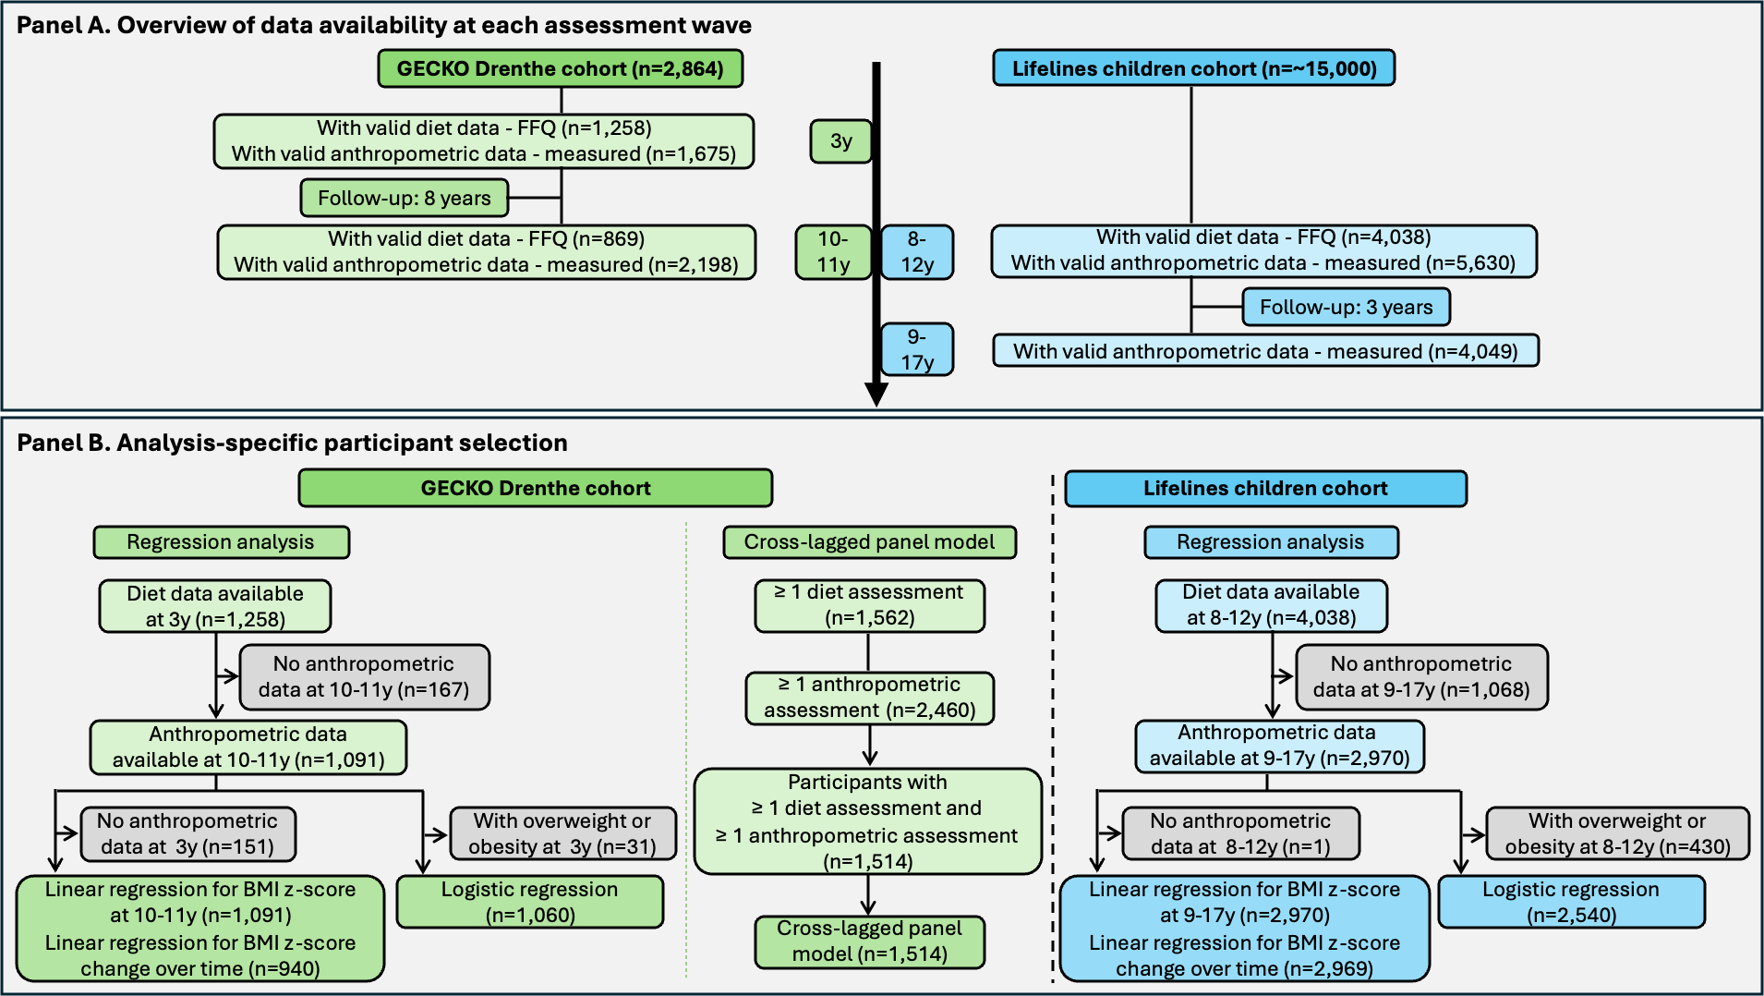
FFQ, food frequency questionnaire; BMI, body mass index.
Fig. S2 Association between sex-specific quartiles of ultra-processed food consumption (by energy ratio) and anthropometric measures
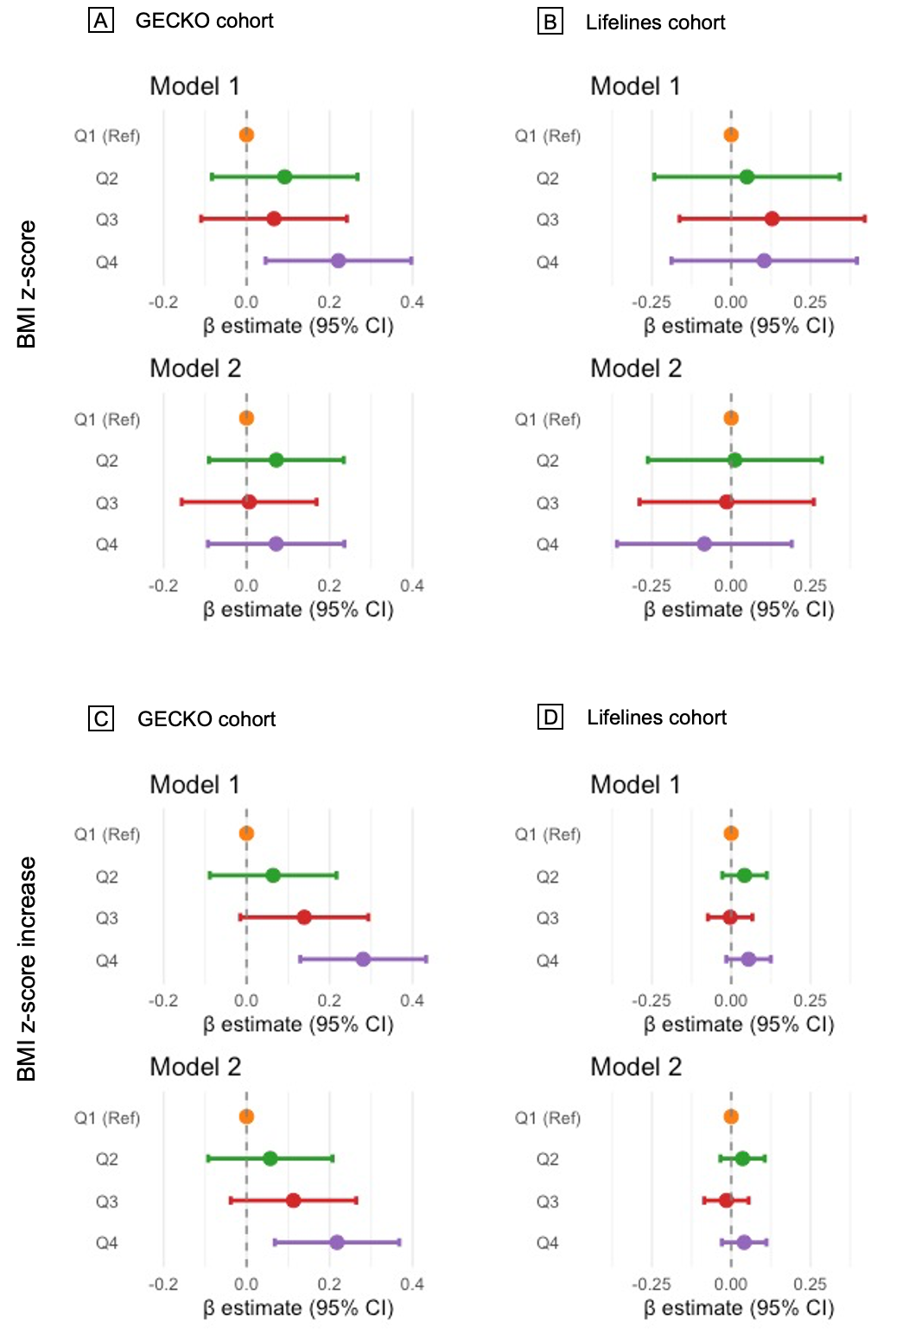
BMI, body mass index. Linear regression analyses were applied to examine associations between sex-specific quartiles of UPF intake (by energy ratio) at age 3 years in the GECKO cohort and at ages 8–12 years in the Lifelines cohort, with anthropometric indicators including BMI z-scores at ages 10/11 years and 9–17 years, respectively, and changes in BMI z-scores over time. Model 1 was adjusted for child sex and age at outcome measurement, and total energy intake, while Model 2 was further adjusted for maternal BMI, maternal education, maternal smoking during pregnancy, and maternal age at birth.
Fig. S3 Association between sex-specific quartiles of ultra-processed food consumption (by weight ratio) and anthropometric measures in complete case analysis
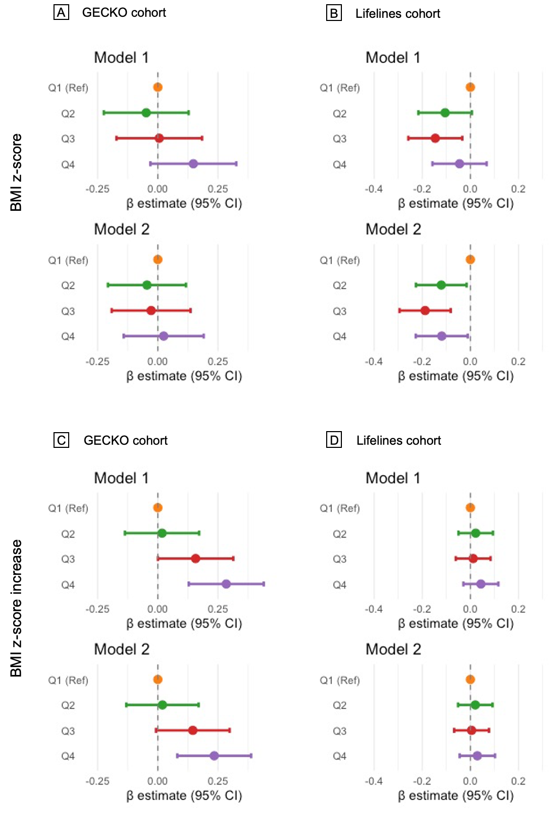
BMI, body mass index. Linear regression analyses were applied to examine associations between sex-specific quartiles of UPF intake (by weight ratio) at age 3 years in the GECKO cohort and at ages 8–12 years in the Lifelines cohort, with anthropometric indicators including BMI z-scores at ages 10/11 years and 9–17 years, respectively, and changes in BMI z-scores over time. Model 1 was adjusted for child sex and age at outcome measurement, and total energy intake, while Model 2 was further adjusted for maternal BMI, maternal education, maternal smoking during pregnancy, and maternal age at birth.
Fig. S4 Association between sex-specific quartiles of ultra-processed food consumption (by energy ratio) and overweight or obesity status
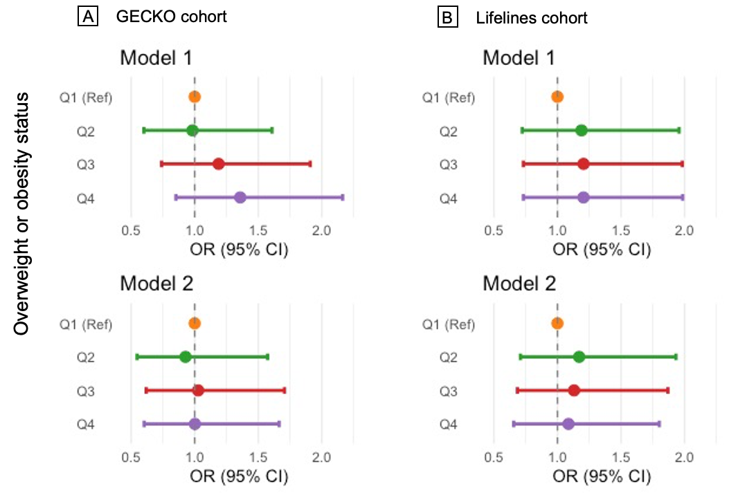
Logistic regression analyses were applied to examine associations between sex-specific quartiles of UPF intake (by energy ratio) at age 3 years in the GECKO cohort and at ages 8–12 years in the Lifelines cohort, with overweight or obesity status at ages 10/11 years and 9–17 years, respectively. Model 1 was adjusted for child sex and age at outcome measurement, and total energy intake, while Model 2 was further adjusted for maternal BMI, maternal education, maternal smoking during pregnancy, and maternal age at birth.

Fig. S5 Association between sex-specific quartiles of ultra-processed food consumption (by weight ratio) and overweight or obesity status in complete case analysis
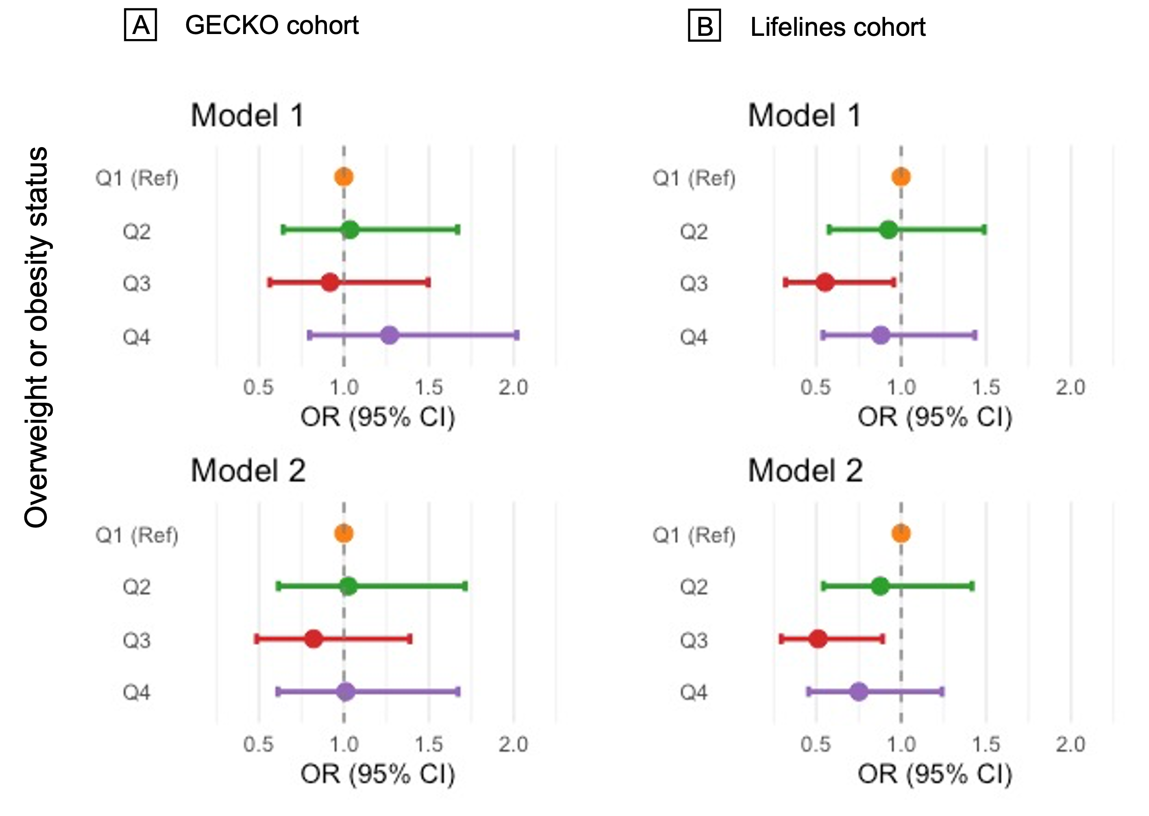
Logistic regression analyses were applied to examine associations between sex-specific quartiles of UPF intake (by weight ratio) at age 3 years in the GECKO cohort and at ages 8–12 years in the Lifelines cohort, with overweight or obesity status at ages 10/11 years and 9–17 years, respectively. Model 1 was adjusted for child sex and age at outcome measurement, and total energy intake, while Model 2 was further adjusted for maternal BMI, maternal education, maternal smoking during pregnancy, and maternal age at birth.

Fig. S6. Cross-lagged analysis of the ultra-processed food consumption (by weight ratio) and BMI z-score in the complete case analyses (n=470).
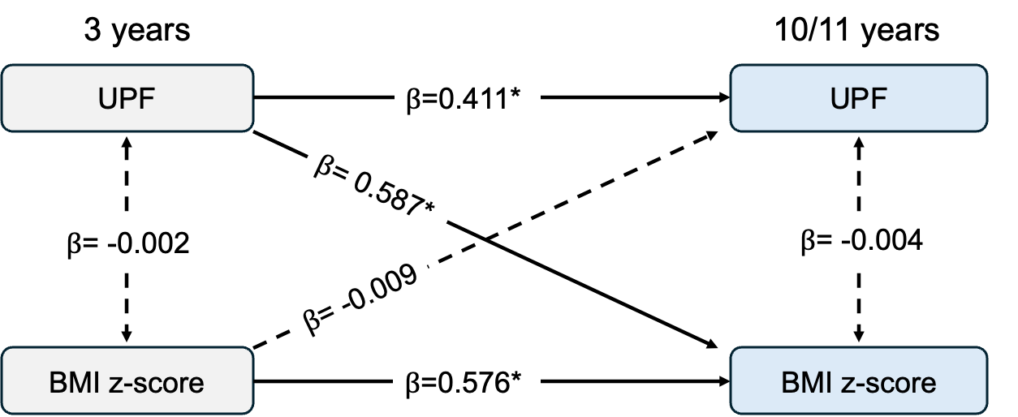
UPF, ultra-processed foods. BMI, body mass index. “10/11 years” denotes the second follow-up assessment (anthropometric measurements: mean age 10.6 years; dietary assessment: mean age 11.0 years). Model was adjusted for child age and sex, total energy intake, maternal BMI, maternal education level, maternal smoking during pregnancy, and maternal age at birth.

