Additional file 1
We performed three sensitivity analyses. In all three sensitivity analyses, we redrew the associated plots to evaluate whether the observed patterns and associations remained consistent.
- Sensitivity analysis after excluding participants with chronic diseases
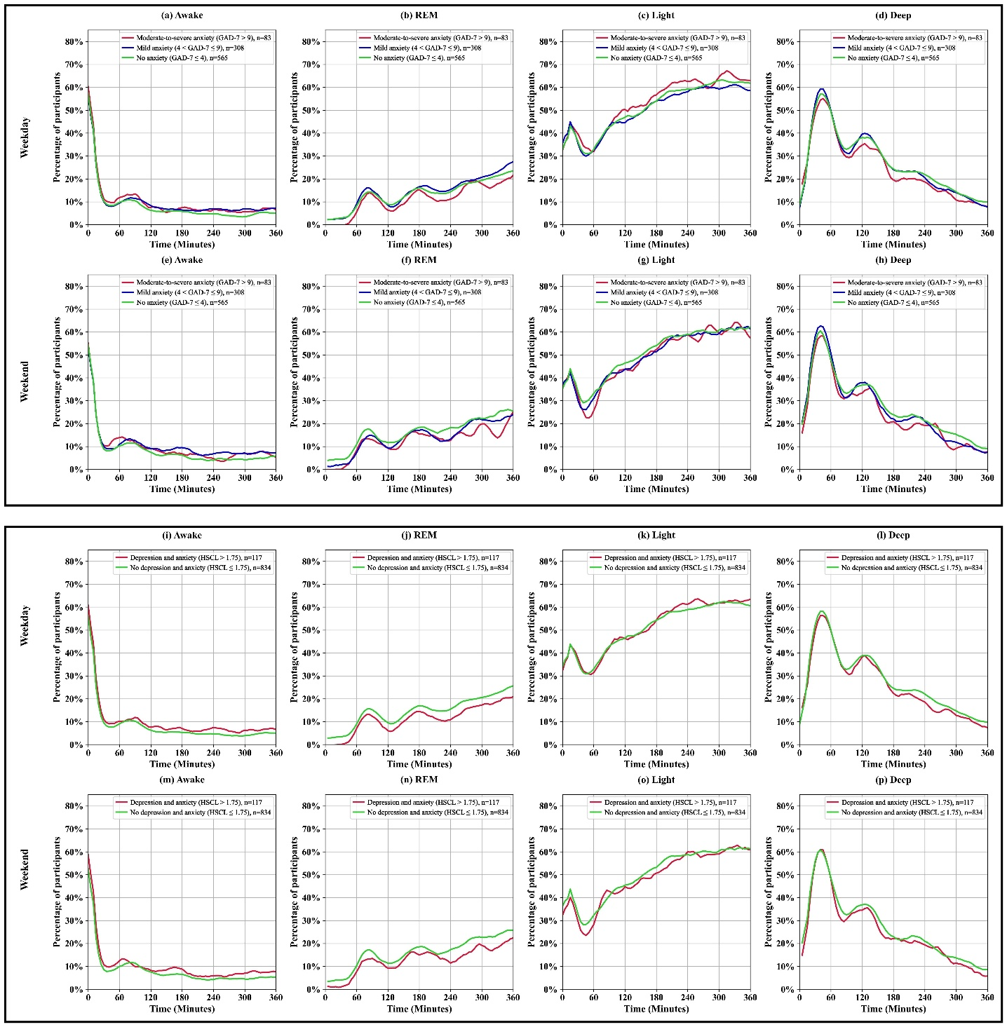
Figure S1: Percentage of participants in each sleep stage (Awake, Light, Deep, and REM) over time during detected sleep period on weekdays and weekend days, stratified by anxiety and depression symptoms levels. Panels (a–h) represent comparisons based on anxiety severity measured using the GAD-7 score, categorized as no anxiety, mild anxiety, and moderate-to-severe anxiety. Panels (i–p) represent comparisons based on the presence or absence of depression and anxiety symptoms measured by the HSCL-25. The top rows (a–d, i–l) show sleep stage percentages for weekdays, and the bottom rows (e–h, m–p) show percentages for weekend days. The y-axis indicates the percentage of participants, and the x-axis represents time (minutes) over the sleep period. The number of participants in each group is indicated by $n$ in the panel legends.
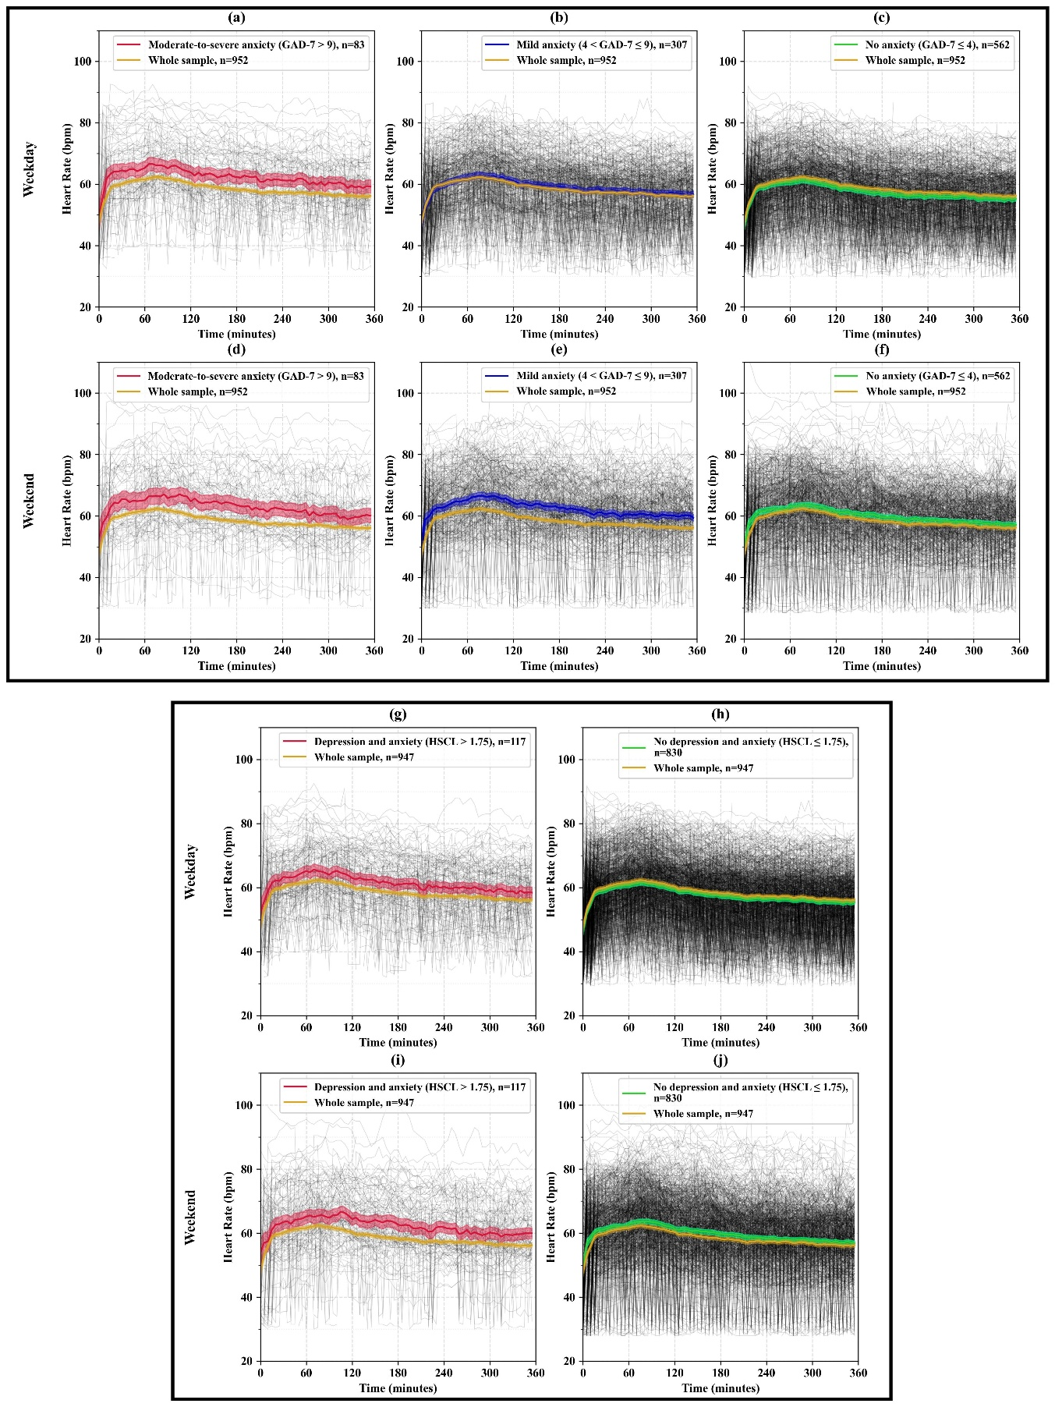
Figure S2: Mean HR (beats/minute) during detected sleep period on weekdays and weekend days. Panels (a–f) show the results based on anxiety severity measured by the GAD-7 scores, categorized as no anxiety, mild anxiety, and moderate-to-severe anxiety. Panels (g–j) show the results based on the no depression and anxiety and depression and anxiety symptoms measured by the HSCL-25. The number of participants in each category is indicated by $n$ in the panel legends. The gray lines represent individual HR trajectories, while the colored lines indicate the mean HR for each group. The y-axis shows HR (bpm), and the x-axis represents time (minutes) over the sleep period.
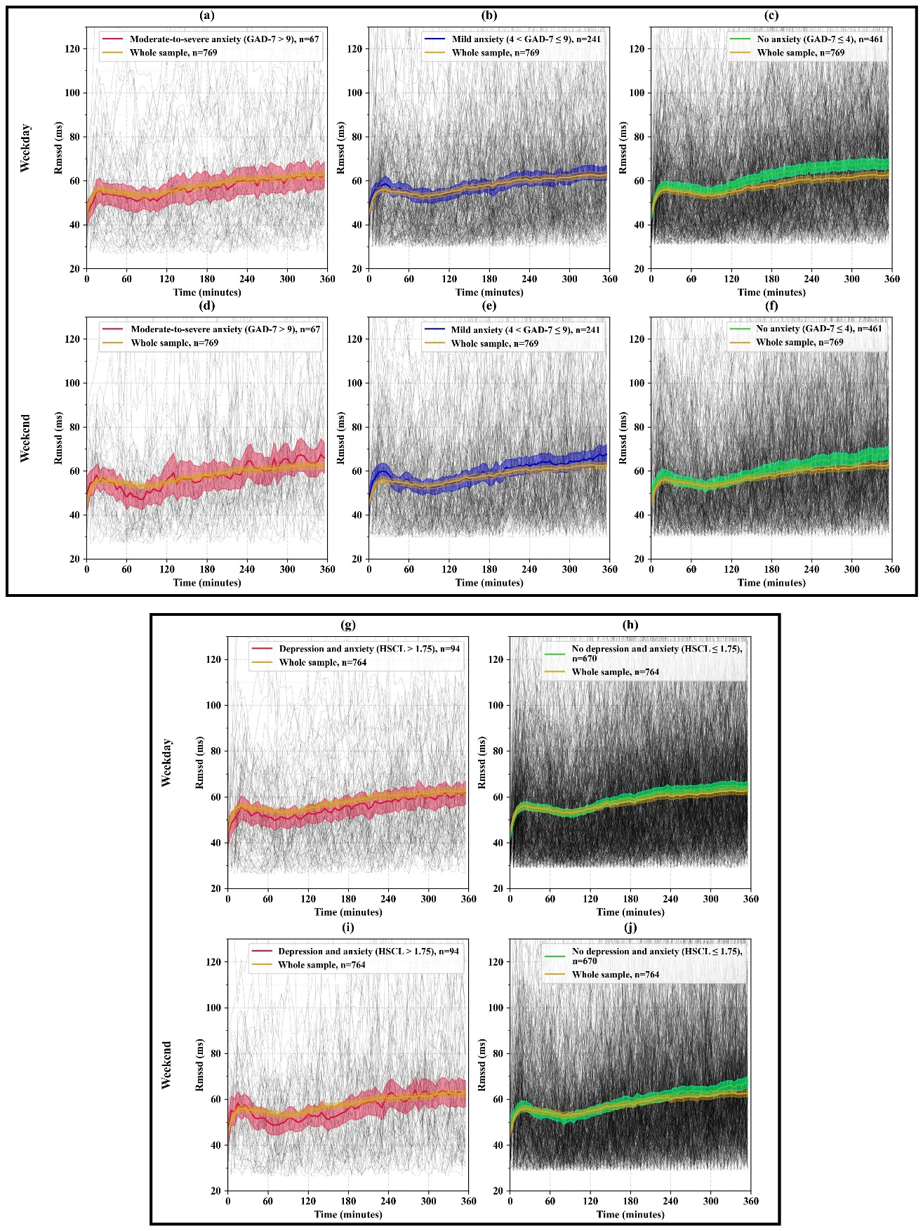
Figure S3: Mean RMSSD (milliseconds) during detected sleep period on weekdays and weekend days. Panels (a–f) show the results based on anxiety severity measured by the GAD-7 scores, categorized as no anxiety, mild anxiety, and moderate-to-severe anxiety. Panels (g–j) show the results based on the no depression and anxiety and depression and anxiety symptoms measured by the HSCL-25. The number of participants in each category is indicated by $n$ in the panel legends. The gray lines represent individual RMSSD trajectories, while the colored lines indicate the RMSSD for each group. The y-axis shows RMSSD (ms), and the x-axis represents time (minutes) over the sleep period.
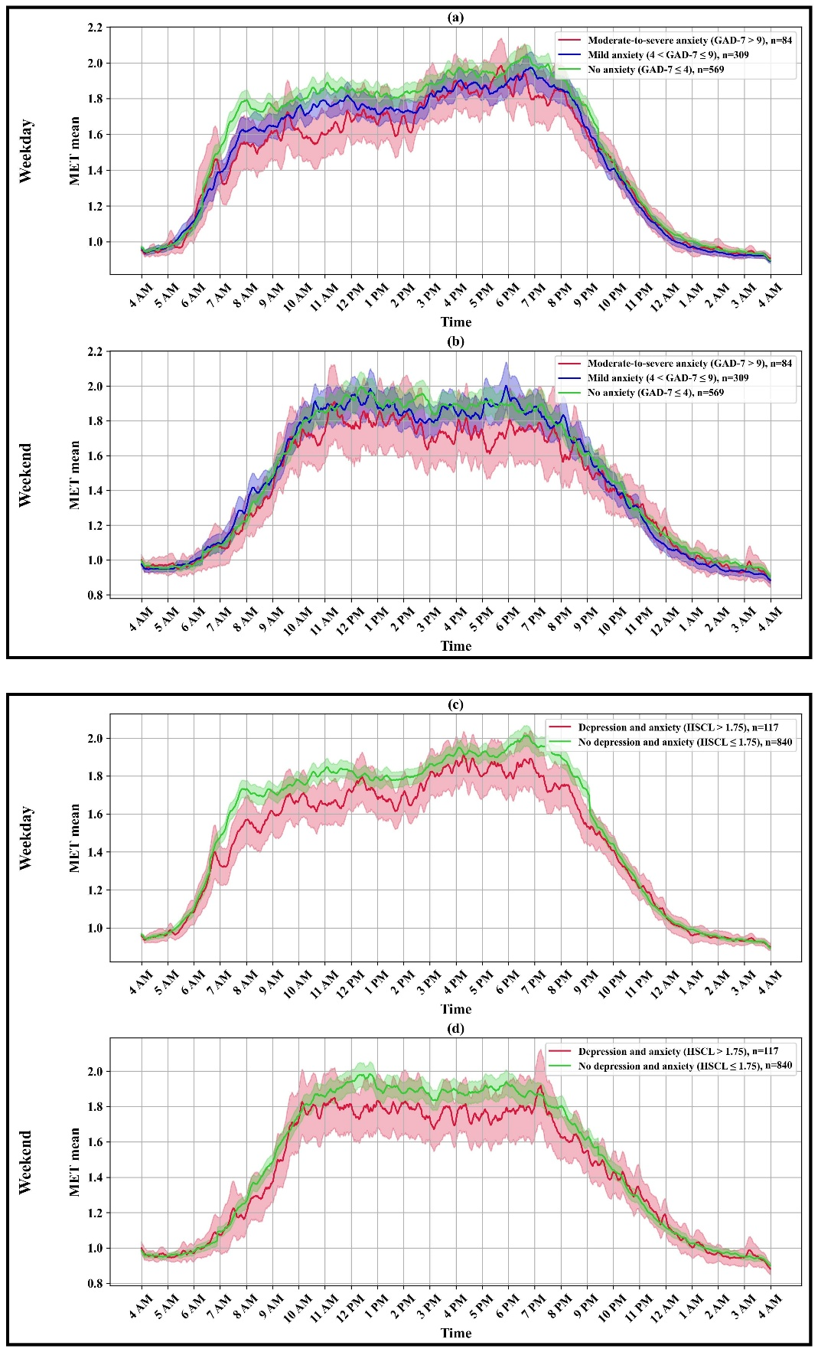
Figure S4: Mean MET values across 24 hours on weekdays and weekend days. Panels (a–b) show the results based on anxiety severity measured by the GAD-7 scores, categorized as no anxiety, mild anxiety, and moderate-to-severe anxiety. Panels (c–d) show the results based on the presence or absence of depression and anxiety symptoms measured by the HSCL-25. The number of participants in each category is indicated by $n$ in the panel legends. The colored lines represent the mean MET values for each group, and the shaded areas indicate the 95% confidence intervals. The y-axis shows the mean MET values, and the x-axis represents time of day (hours).
Table S1: Characteristics of participants who had sufficient Oura Ring data and valid GAD-7 and HSCL-25 scores after excluding those with chronic diseases.
Variables |  | Whole sample  $$(n=962)$$ | GAD-7 groups |  |  | HSCL-25 groups
 |  | Whole sample  $$(n=962)$$ | No anxiety  (n=569) | Mild anxiety  ($n=309$) | Moderate-to-severe anxiety  ($n=84$) | No depression and anxiety  ($n=845$) | Depression and anxiety  ($n=117$)
Demographics
Age, yr |  | 33.8 (0.6) | 33.8 (0.6) | 33.9 (0.6) | 33.9 (0.5) | 33.8 (0.6) | 33.8 (0.6)
Sex
Female |  | 586 (60.9%) | 316 (55.5%) | 210 (68.0%) | 60 (71.4%) | 501 (59.3%) | 85 (72.6%)
Education
Comprehensive school |  | 75 (7.8%) | 39 (6.9%) | 27 (8.8%) | 9 (10.7%) | 56 (6.6%) | 19 (16.2%)
Vocational/college level |  | 316 (32.8%) | 181 (31.8%) | 103 (33.3%) | 32 (38.1%) | 271 (32.1%) | 45 (38.5%)
Polytechnic/university degree |  | 571 (59.4%) | 349 (61.3%) | 179 (57.9%) | 43 (51.2%) | 518 (61.3%) | 53 (45.3%)
Employment status
Employed |  | 791 (82.2%) | 485 (85.2%) | 244 (79.0%) | 62 (73.8%) | 710 (84.0%) | 81 (69.2%)
Unemployed |  | 50 (5.2%) | 23 (4.0%) | 18 (5.8%) | 9 (10.7%) | 37 (4.4%) | 13 (11.1%)
Other (e.g., student, homemaker) |  | 121 (12.6%) | 61 (10.8%) | 47 (15.2%) | 13 (15.5%) | 98 (11.6%) | 23 (19.7%)
Marital status
Married/cohabiting |  | 756 (78.6%) | 446 (78.4%) | 250 (80.9%) | 60 (71.4%) | 676 (80.0%) | 80 (68.4%)
Divorced/widowed |  | 36 (3.7%) | 17 (3.0%) | 13 (4.2%) | 6 (7.1%) | 28 (3.3%) | 8 (6.8%)
Unmarried |  | 170 (17.7%) | 106 (18.6%) | 46 (14.9%) | 18 (21.5%) | 141 (16.7%) | 29 (24.8%)
Household income (€ per year)
≤50,000 |  | 367 (38.1%) | 208 (36.6%) | 120 (38.8%) | 39 (46.4%) | 303 (35.9%) | 64 (54.7%)
50,001 to 100,000 |  | 524 (54.5%) | 315 (55.4%) | 170 (55.0%) | 39 (46.4%) | 477 (56.4%) | 47 (40.2%)
>100,000 |  | 71 (7.4%) | 46 (8.1%) | 19 (6.1%) | 6 (7.1%) | 65 (7.7%) | 6 (5.1%)
Lifestyle factors
Alcohol consumption, g·d−1 |  | 3.0 (3.7) | 3.0 (3.7) | 2.7 (3.3) | 3.8 (4.6) | 2.9 (3.5) | 3.9 (4.8)
Smoking status
Nonsmoker |  | 311 (32.4%) | 187 (32.9%) | 97 (31.3%) | 27 (32.1%) | 273 (32.3%) | 38 (32.5%)
Former smoker |  | 466 (48.4%) | 267 (46.9%) | 163 (52.8%) | 36 (42.9%) | 413 (48.9%) | 53 (45.3%)
Current smoker |  | 185 (19.2%) | 115 (20.2%) | 49 (15.9%) | 21 (25.0%) | 159 (18.8%) | 26 (22.2%)
Cardiometabolic biomarkers
Fasting glucose, mmol·L−1 |  | 5.0 (0.4) | 5.0 (0.4) | 4.9 (0.4) | 5.0 (0.5) | 5.0 (0.4) | 5.0 (0.5)
Triglycerides, mmol·L−1 |  | 0.9 (0.6) | 0.9 (0.7) | 0.9 (0.4) | 0.9 (0.5) | 0.9 (0.6) | 0.9 (0.4)
Total/HDL cholesterol ratio |  | 3.2 (0.9) | 3.2 (0.9) | 3.2 (0.9) | 3.2 (0.8) | 3.2 (0.9) | 3.2 (0.8)
LDL/HDL cholesterol ratio |  | 1.9 (0.8) | 1.9 (0.8) | 1.9 (0.8) | 1.9 (0.7) | 1.9 (0.8) | 1.9 (0.8)
Adiposity measures
BMI, kg·m−2 |  | 25.6 (4.7) | 25.7 (4.5) | 25.6 (5.0) | 25.6 (5.0) | 25.6 (4.6) | 26.1 (5.5)
Waist circumference, cm |  | 87.2 (12.8) | 87.4 (12.3) | 87.1 (13.6) | 86.2 (12.9) | 87.2 (12.6) | 87.4 (14.0)
Data are mean (SD) or count (%)

- Sensitivity analysis using different sleep-period windows (i.e., 8 hours)
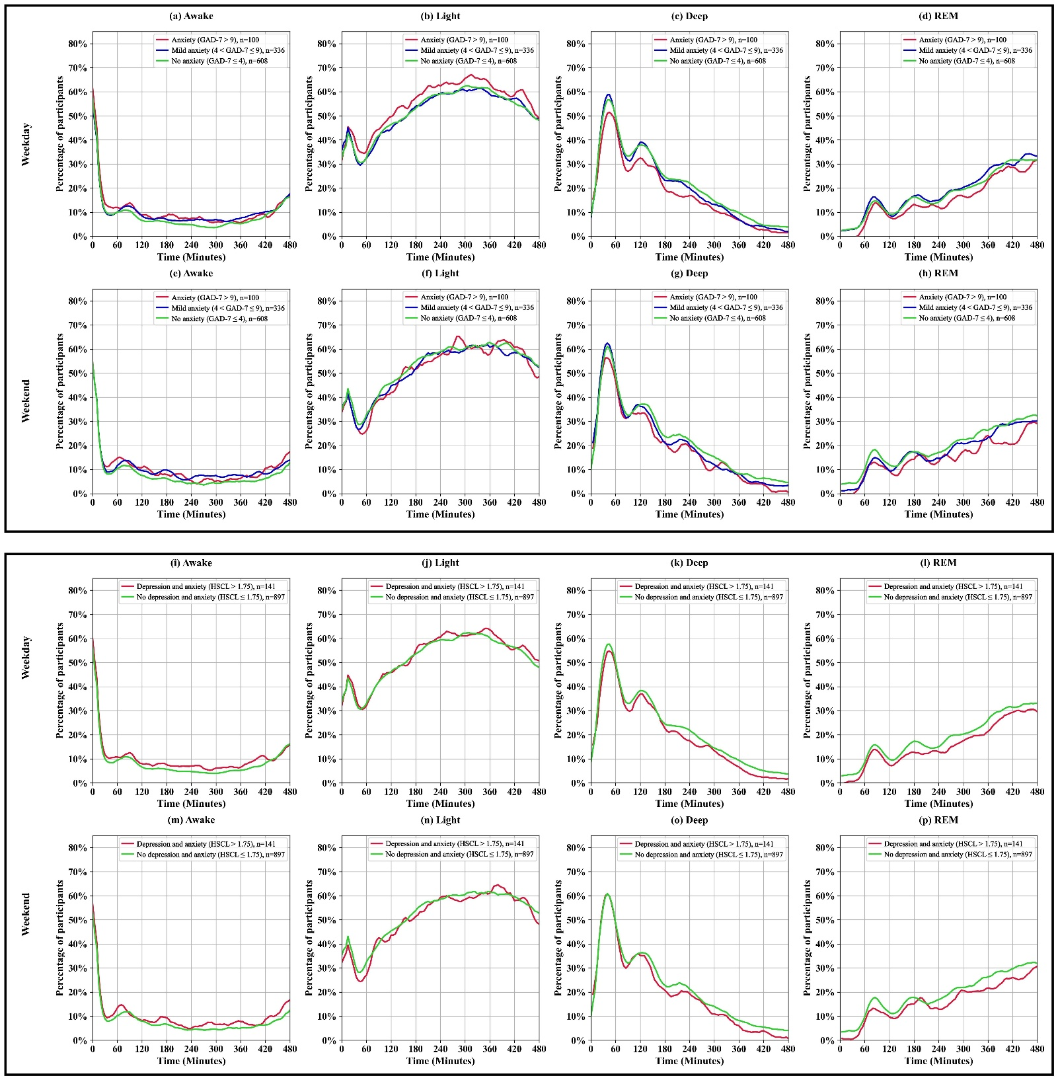
Figure S5: Percentage of participants in each sleep stage (Awake, Light, Deep, and REM) over time during detected sleep period (8 hours) on weekdays and weekend days, stratified by anxiety and depression symptoms levels. Panels (a–h) represent comparisons based on anxiety severity measured using the GAD-7 score, categorized as no anxiety, mild anxiety, and moderate-to-severe anxiety. Panels (i–p) represent comparisons based on the presence or absence of depression and anxiety symptoms measured by the HSCL-25. The top rows (a–d, i–l) show sleep stage percentages for weekdays, and the bottom rows (e–h, m–p) show percentages for weekend days. The y-axis indicates the percentage of participants, and the x-axis represents time (minutes) over the sleep period. The number of participants in each group is indicated by $n$ in the panel legends.

Table S2: Characteristics of participants who had sufficient Oura Ring data and valid GAD-7 and HSCL-25 scores after excluding those with lower than 8 hours sleep period.
Variables | Whole sample  $$(n=1,044)$$ | GAD-7 groups |  |  | HSCL-25 groups
Variables | Whole sample  $$(n=1,044)$$ | No anxiety  $$(n=608)$$ | Mild anxiety  $$(n=336)$$ | Moderate-to-severe anxiety  $$(n=100)$$ | No depression and anxiety  $$(n=903)$$ | Depression and anxiety  $$(n=141)$$
Demographics
Age, yr | 33.8 (0.6) | 33.8 (0.6) | 33.8 (0.6) | 33.9 (0.6) | 33.8 (0.6) | 33.8 (0.5)
Sex
Female | 675 (64.7%) | 361 (59.4%) | 242 (72.0%) | 72 (72.0%) | 566 (62.7%) | 109 (77.3%)
Education
Comprehensive school | 78 (7.5%) | 40 (6.5%) | 29 (8.7%) | 9 (9.0%) | 58 (6.4%) | 20 (14.2%)
Vocational/college level | 360 (34.5%) | 201 (33.1%) | 112 (33.3%) | 47 (47.0%) | 298 (33.0%) | 62 (44.0%)
Polytechnic/university degree | 606 (58.0%) | 367 (60.4%) | 195 (58.0%) | 44 (44.0%) | 547 (60.6%) | 59 (41.8%)
Employment status
Employed | 842 (80.7%) | 517 (85.0%) | 253 (75.3%) | 72 (72.0%) | 749 (82.9%) | 93 (66.0%)
Unemployed | 61 (5.8%) | 23 (3.8%) | 23 (6.8%) | 15 (15.0%) | 40 (4.4%) | 21 (14.9%)
Other (e.g., student, homemaker) | 141 (13.5%) | 68 (11.2%) | 60 (17.9%) | 13 (13.0%) | 114 (12.6%) | 27 (19.1%)
Marital status
Married/cohabiting | 824 (78.9%) | 472 (77.6%) | 272 (81.0%) | 80 (80.0%) | 719 (79.6%) | 105 (74.5%)
Divorced/widowed | 39 (3.7%) | 20 (3.3%) | 14 (4.2%) | 5 (5.0%) | 32 (3.5%) | 7 (5.0%)
Unmarried | 181 (17.4%) | 116 (19.1%) | 50 (14.8%) | 15 (15.0%) | 152 (16.9%) | 29 (20.6%)
Household income (€ per year)
≤50,000 | 410 (39.3%) | 230 (37.8%) | 135 (40.2%) | 45 (45.0%) | 337 (37.3%) | 73 (51.8%)
50,001 to 100,000 | 562 (53.8%) | 331 (54.4%) | 181 (53.9%) | 50 (50.0%) | 501 (55.5%) | 61 (43.3%)
>100,000 | 72 (6.9%) | 47 (7.7%) | 20 (6.0%) | 5 (5.0%) | 65 (7.2%) | 7 (5.0%)
Lifestyle factors
Alcohol consumption, g·d−1 | 2.9 (3.5) | 2.8 (3.4) | 2.6 (3.3) | 3.7 (4.6) | 2.8 (3.3) | 3.5 (4.5)
Smoking status
Nonsmoker | 342 (32.8%) | 209 (34.3%) | 103 (30.4%) | 30 (30.0%) | 301 (33.3%) | 41 (29.1%)
Former smoker | 512 (49.0%) | 288 (47.4%) | 179 (53.3%) | 45 (45.0%) | 443 (49.1%) | 69 (48.9%)
Current smoker | 190 (18.2%) | 111 (18.3%) | 54 (16.1%) | 25 (25.0%) | 159 (17.6%) | 31 (22.0%)
Chronic disease
Hypertension | 22 (2.1%) | 9 (1.5%) | 10 (3.0%) | 3 (3.0%) | 29 (3.2%) | 5 (3.5%)
Congenital heart disease | 21 (2.0%) | 11 (1.8%) | 8 (2.4%) | 2 (2.0%) | 28 (3.1%) | 5 (3.5%)
Type 2 diabetes | 9 (0.9%) | 2 (0.3%) | 6 (1.8%) | 1 (1.0%) | 18 (2.0%) | 3 (2.1%)
Cardiometabolic biomarkers
Fasting glucose, mmol·L−1 | 5.0 (0.7) | 5.0 (0.8) | 5.0 (0.4) | 5.0 (0.5) | 5.0 (0.6) | 5.1 (0.9)
Triglycerides, mmol·L−1 | 0.9 (0.6) | 1.0 (0.7) | 0.9 (0.6) | 0.9 (0.5) | 0.9 (0.6) | 0.9 (0.5)
Total/HDL cholesterol ratio | 3.3 (0.9) | 3.3 (0.9) | 3.2 (0.9) | 3.3 (0.9) | 3.3 (0.9) | 3.2 (0.9)
LDL/HDL cholesterol ratio | 2.0 (0.8) | 2.0 (0.8) | 1.9 (0.8) | 2.0 (0.8) | 2.0 (0.8) | 1.9 (0.8)
Adiposity measures
BMI, kg·m−2 | 26.0 (5.0) | 26.1 (4.8) | 25.9 (5.2) | 26.1 (5.5) | 26.0 (4.9) | 26.3 (5.8)
Waist circumference, cm | 87.8 (13.1) | 88.2 (12.6) | 87.4 (13.7) | 87.0 (13.7) | 87.9 (12.9) | 87.5 (14.4)
Data are mean (SD) or count (%)

- Sensitivity analysis for different cutoff points for GAD-7 scores
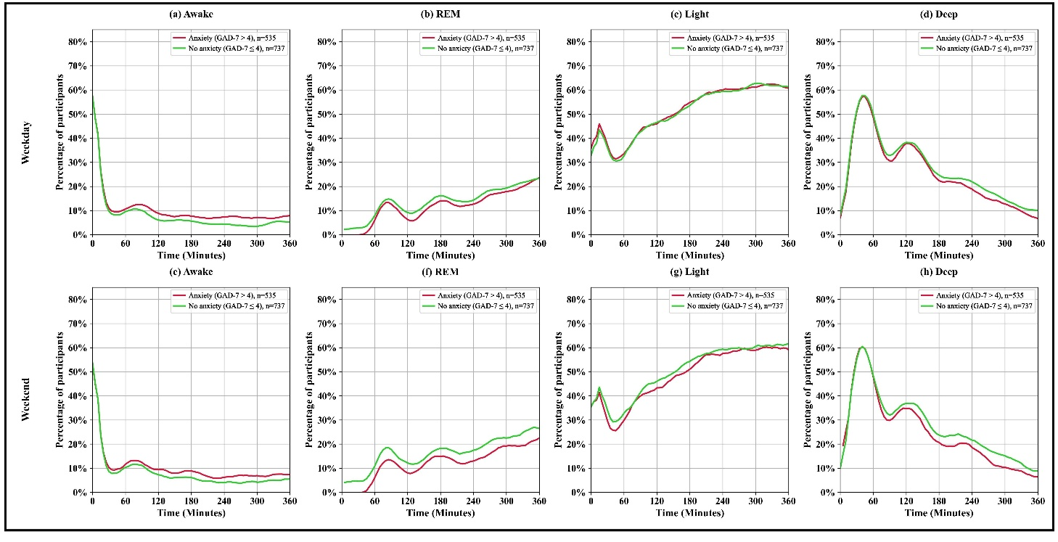
Figure S6: Percentage of participants in each sleep stage (Awake, Light, Deep, and REM) over time during detected sleep period on weekdays and weekend days, stratified by anxiety and depression symptoms levels. Panels (a–h) represent comparisons based on anxiety severity measured using the GAD-7 score, categorized as no anxiety: GAD-7 score ≤ 4 and anxiety: GAD-7 score > 4. The y-axis indicates the percentage of participants, and the x-axis represents time (minutes) over the sleep period. The number of participants in each group is indicated by $n$ in the panel legends.
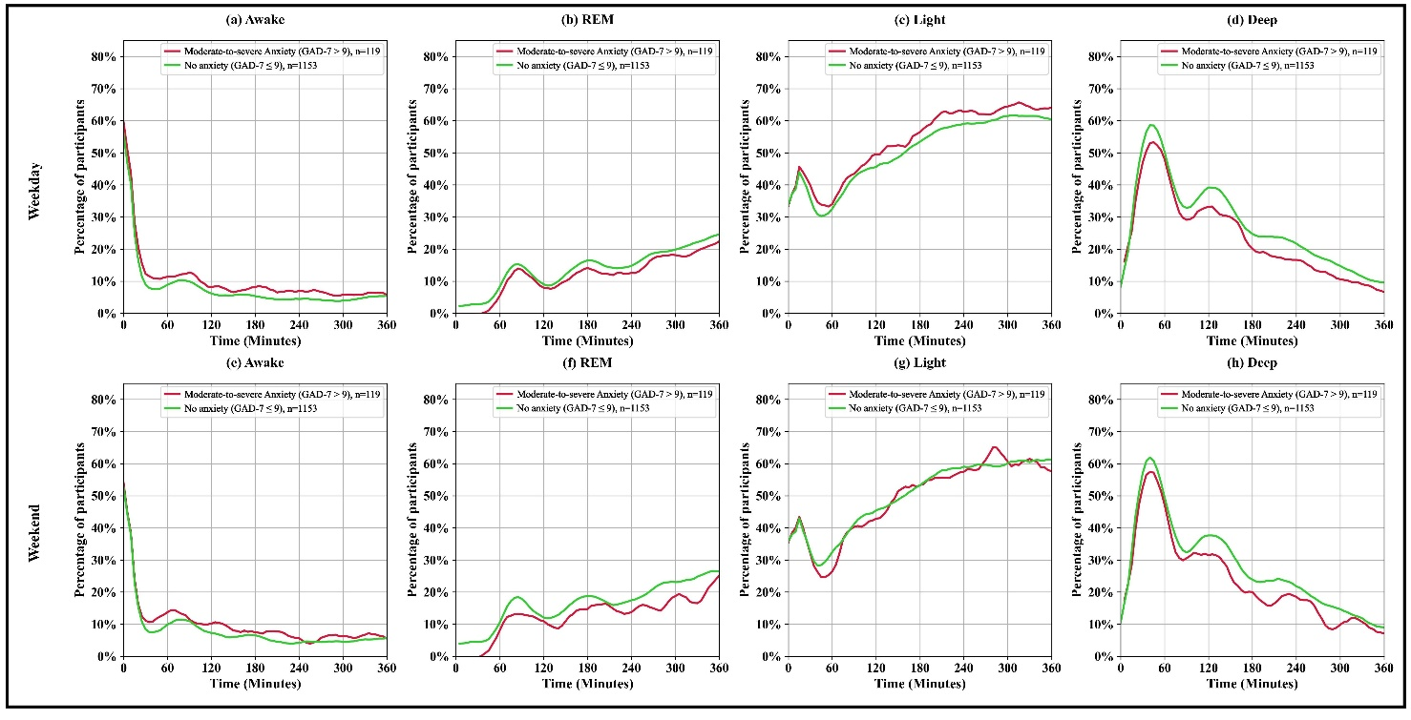
Figure S7: Percentage of participants in each sleep stage (Awake, Light, Deep, and REM) over time during detected sleep period on weekdays and weekend days, stratified by anxiety and depression symptoms levels. Panels (a–h) represent comparisons based on anxiety severity measured using the GAD-7 score, categorized as no anxiety: GAD-7 score ≤ 9 and moderate-to-severe anxiety: GAD-7 score > 9. The y-axis indicates the percentage of participants, and the x-axis represents time (minutes) over the sleep period. The number of participants in each group is indicated by $n$ in the panel legends.
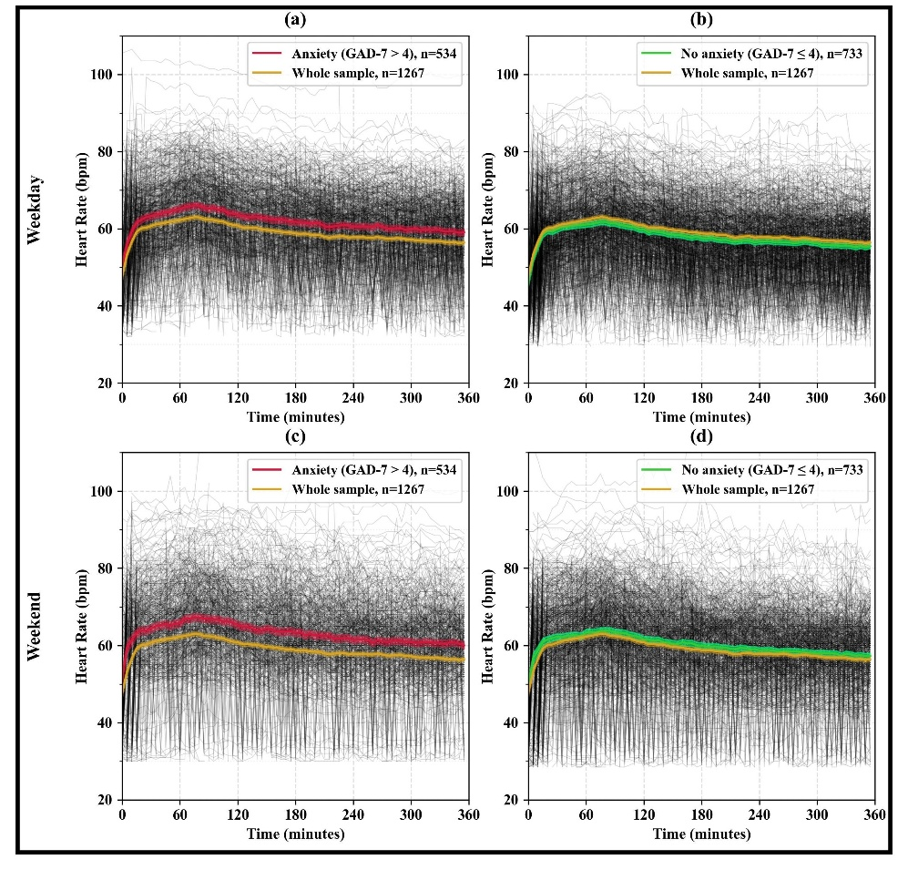
Figure S8: Mean HR (beats/minute) during detected sleep period on weekdays and weekend days. Panels (a–f) show the results based on anxiety severity measured by the GAD-7 scores, categorized as no anxiety: GAD-7 score ≤ 4 and anxiety: GAD-7 score > 4. The number of participants in each category is indicated by $n$ in the panel legends. The gray lines represent individual HR trajectories, while the colored lines indicate the mean HR for each group. The y-axis shows HR (bpm), and the x-axis represents time (minutes) over the sleep period.

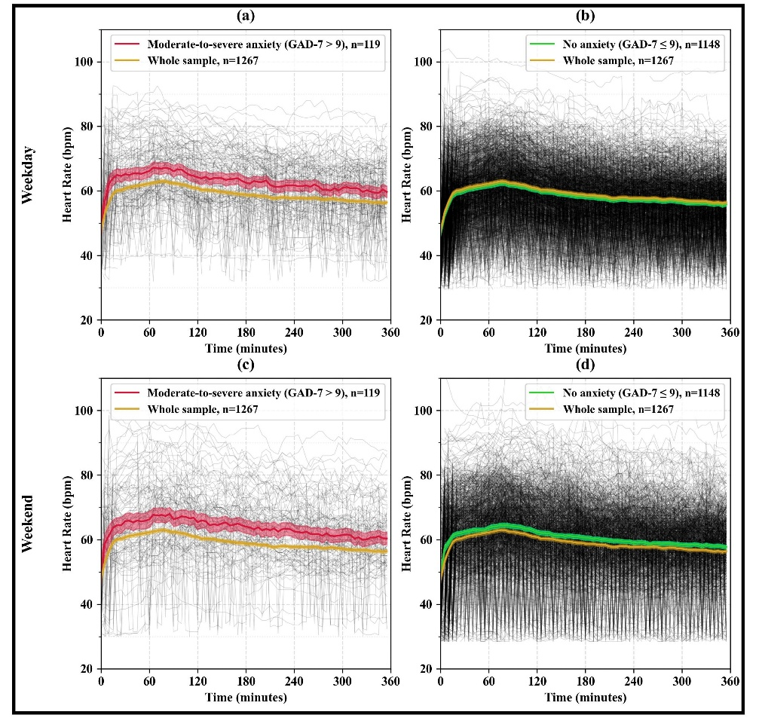
Figure S9: Mean HR (beats/minute) during detected sleep period on weekdays and weekend days. Panels (a–f) show the results based on anxiety severity measured by the GAD-7 scores, categorized as no anxiety: GAD-7 score ≤ 9 and moderate-to-severe anxiety: GAD-7 score > 9. The number of participants in each category is indicated by $n$ in the panel legends. The gray lines represent individual HR trajectories, while the colored lines indicate the mean HR for each group. The y-axis shows HR (bpm), and the x-axis represents time (minutes) over the sleep period.

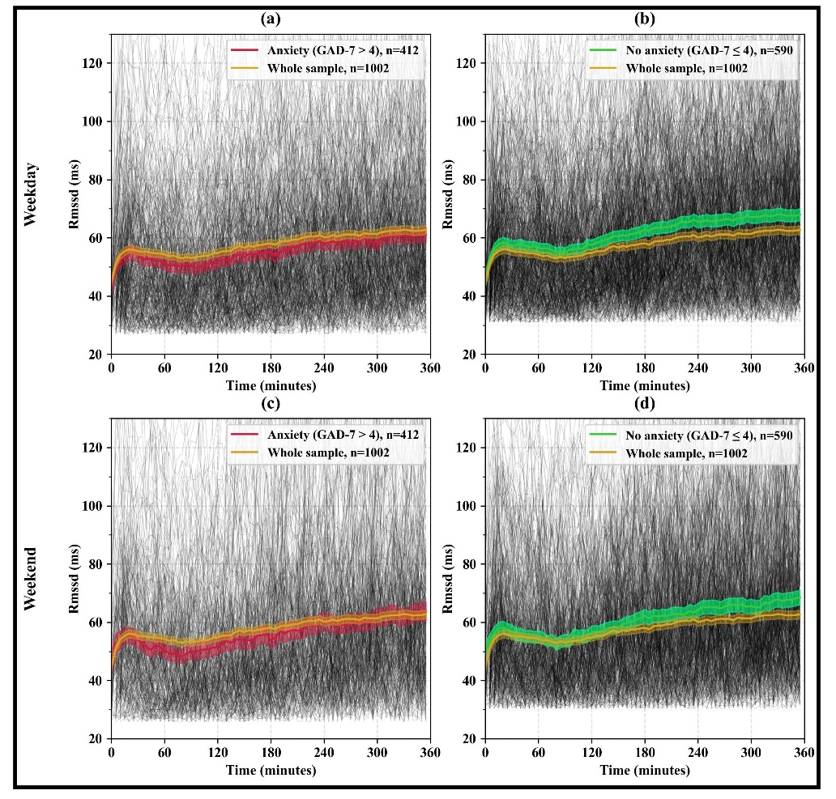
Figure S10: Mean RMSSD (milliseconds) during detected sleep period on weekdays and weekend days. Panels (a–f) show the results based on anxiety severity measured by the GAD-7 scores, categorized as no anxiety: GAD-7 score ≤ 4 and anxiety: GAD-7 score > 4. The number of participants in each category is indicated by $n$ in the panel legends. The gray lines represent individual RMSSD trajectories, while the colored lines indicate the RMSSD for each group. The y-axis shows RMSSD (ms), and the x-axis represents time (minutes) over the sleep period.

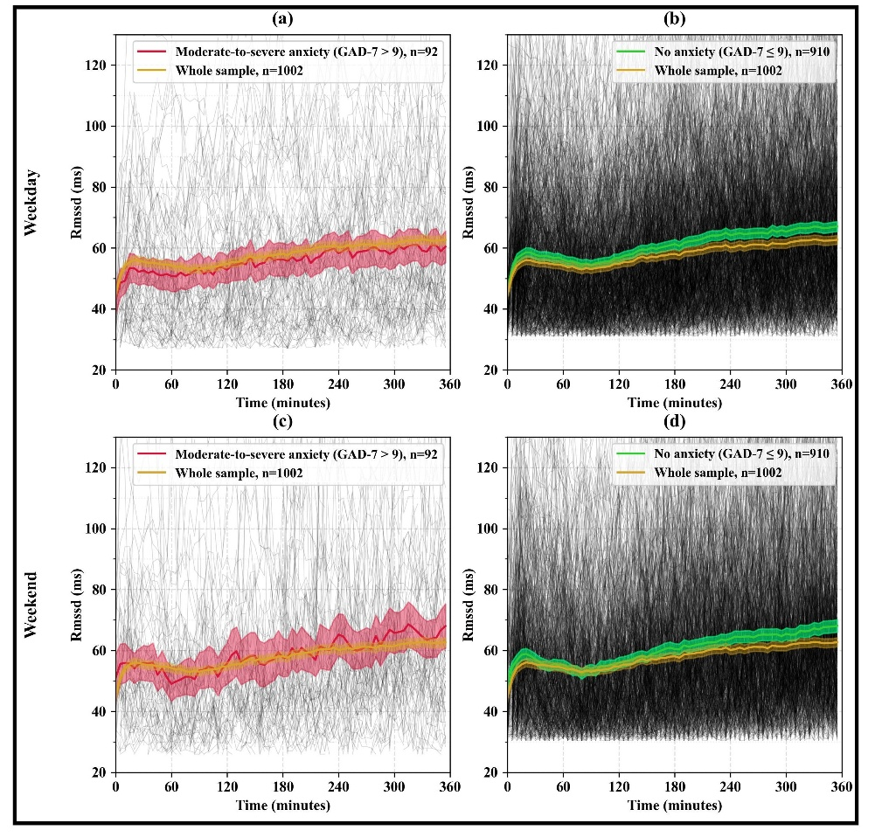
Figure S11: Mean RMSSD (milliseconds) during detected sleep period on weekdays and weekend days. Panels (a–f) show the results based on anxiety severity measured by the GAD-7 scores, categorized as no anxiety: GAD-7 score ≤ 9 and moderate-to-severe anxiety: GAD-7 score > 9. The number of participants in each category is indicated by $n$ in the panel legends. The gray lines represent individual RMSSD trajectories, while the colored lines indicate the RMSSD for each group. The y-axis shows RMSSD (ms), and the x-axis represents time (minutes) over the sleep period.

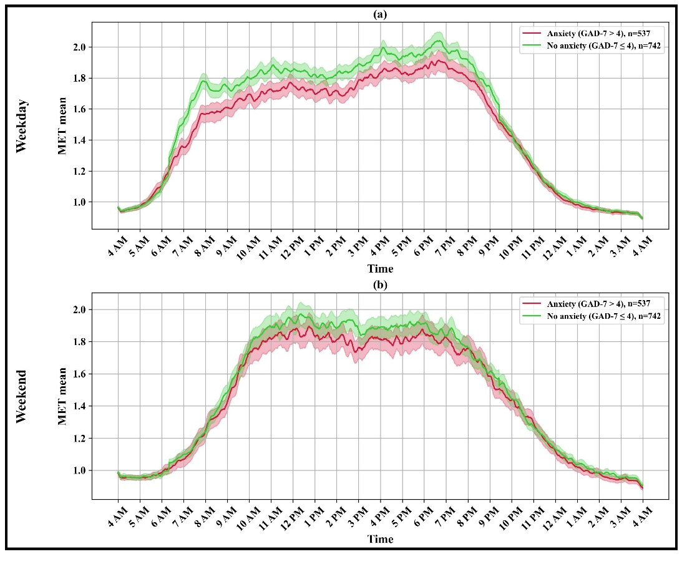
Figure S12: Mean MET values across 24 hours on weekdays and weekend days. Panels (a–b) show the results based on anxiety severity measured by the GAD-7 scores, categorized as no anxiety: GAD-7 score ≤ 4 and anxiety: GAD-7 score > 4. The number of participants in each category is indicated by $n$ in the panel legends. The colored lines represent the mean MET values for each group, and the shaded areas indicate the 95% confidence intervals. The y-axis shows the mean MET values, and the x-axis represents time of day (hours).

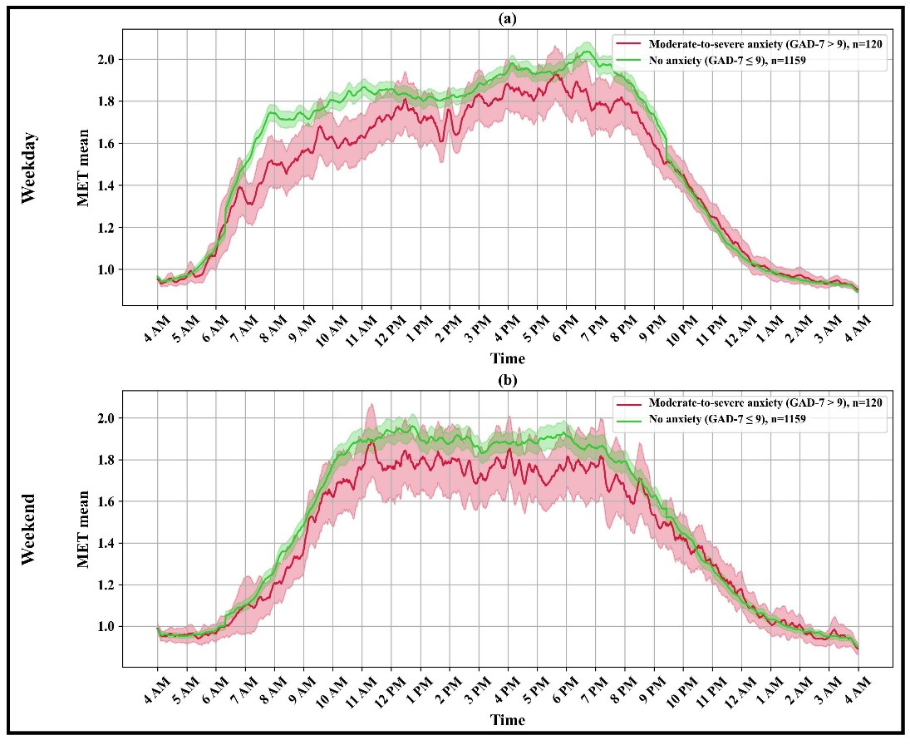
Figure S13: Mean MET values across 24 hours on weekdays and weekend days. Panels (a–b) show the results based on anxiety severity measured by the GAD-7 scores, categorized as no anxiety: GAD-7 score ≤ 9 and moderate-to-severe anxiety: GAD-7 score > 9. The number of participants in each category is indicated by $n$ in the panel legends. The colored lines represent the mean MET values for each group, and the shaded areas indicate the 95% confidence intervals. The y-axis shows the mean MET values, and the x-axis represents time of day (hours).

