Additional file 4: Figures S1–S2
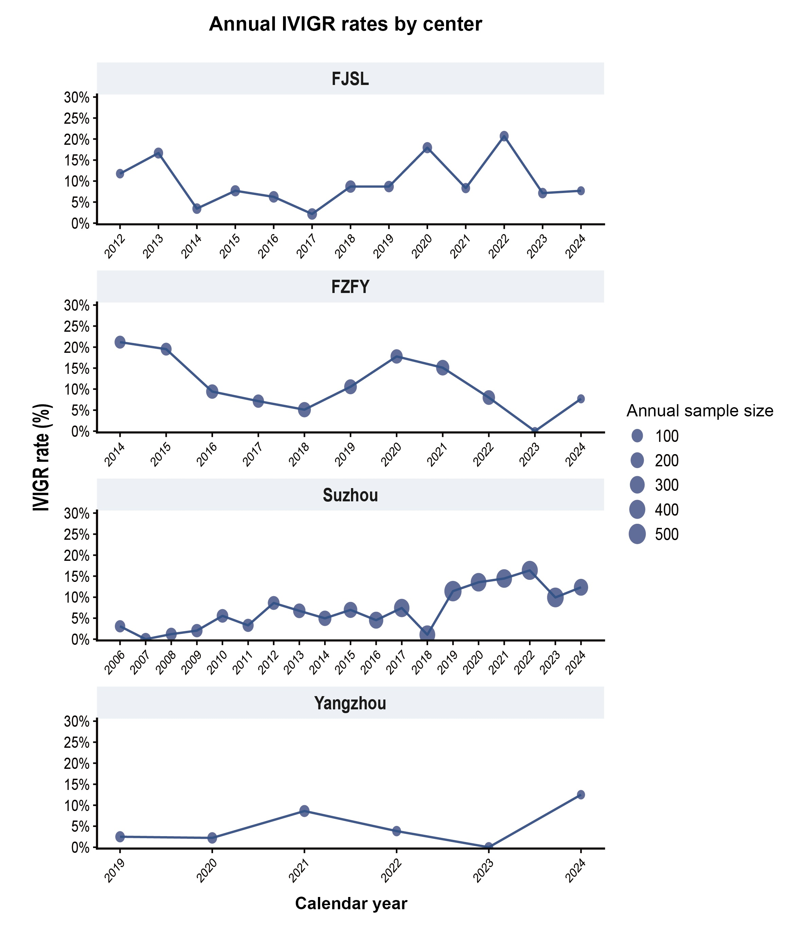
Fig. S1. Annual IVIGR rates by center. Annual IVIG resistance (IVIGR) rates are shown for each participating center across the calendar years for which data were available. Point size is proportional to the annual number of eligible patients. FJSL, Fuzhou University Affiliated Provincial Hospital; FZFY, Fujian Provincial Maternal and Child Health Hospital; Suzhou, Children’s Hospital of Soochow University; Yangzhou, The Affiliated Hospital of Yangzhou University. IVIGR, intravenous immunoglobulin resistance.

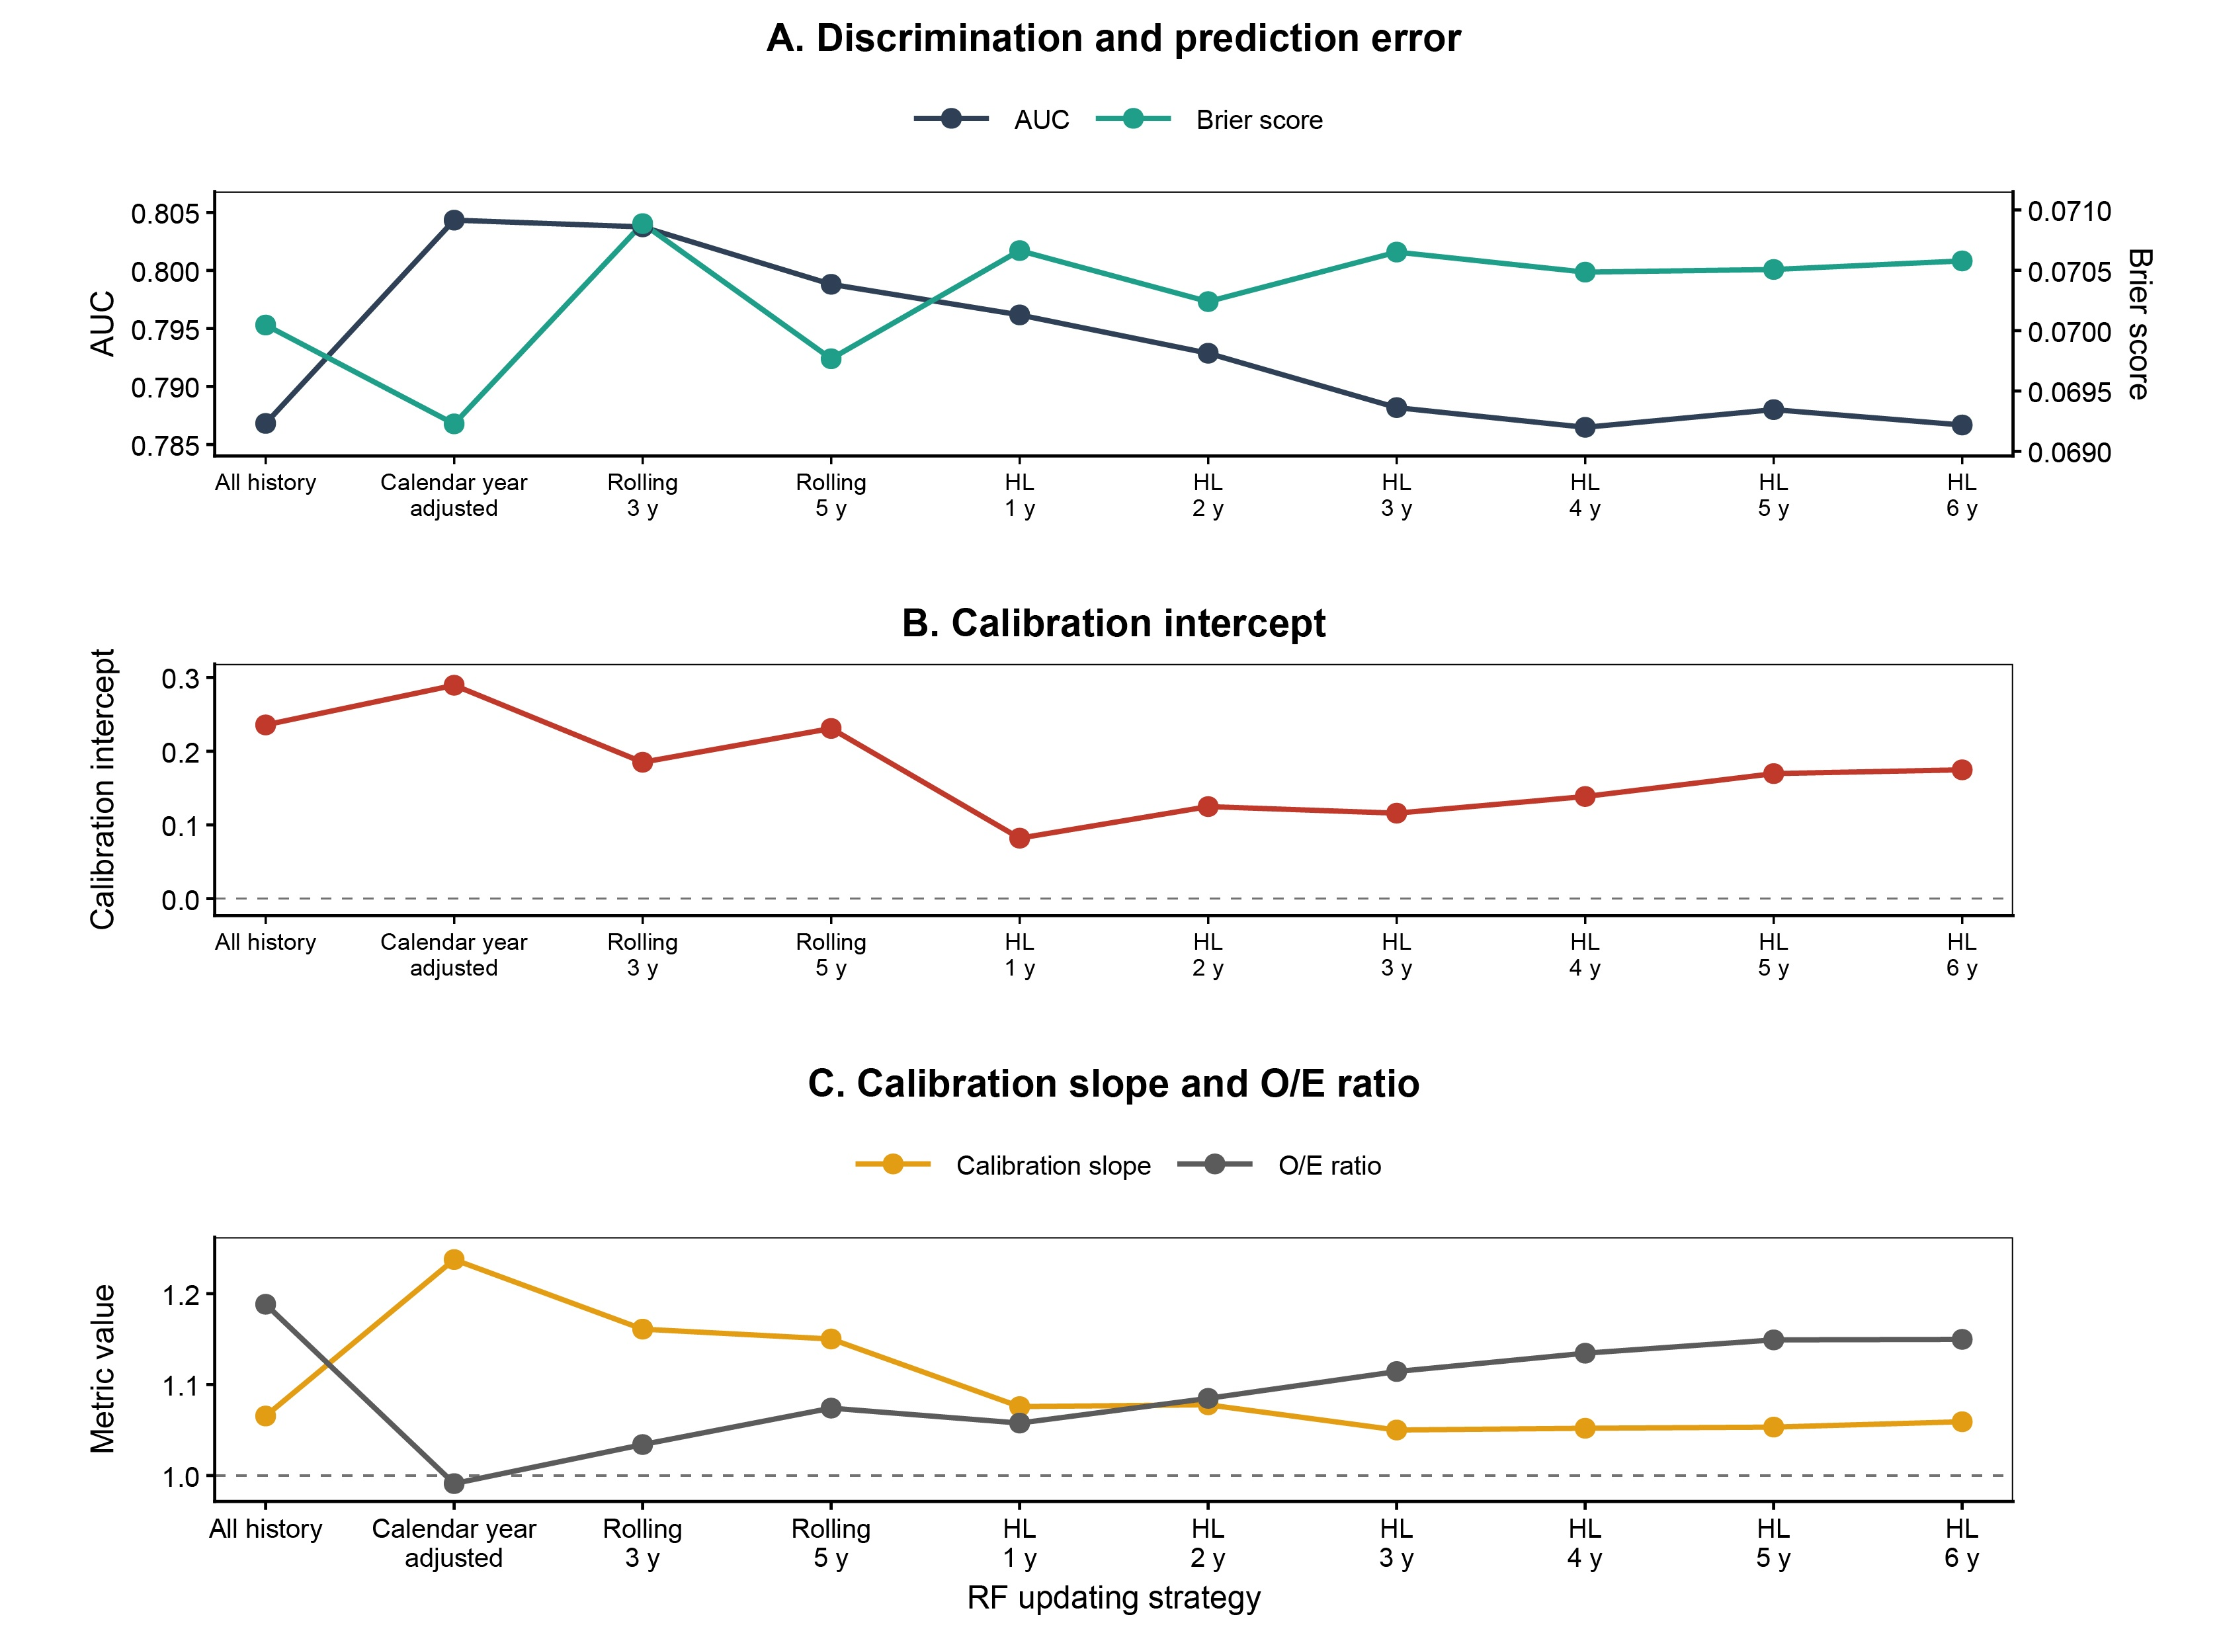
Fig. S2. Discrimination, prediction error, and calibration of RF updating strategies. (A) Mean annual AUC and Brier score, (B) calibration intercept, and (C) calibration slope and O/E ratio for all history RF, calendar year adjusted RF, rolling window RF with 3 and 5 year windows, and half-life weighted RF with half-lives of 1 to 6 years. Estimates were averaged across the 2015–2024 target years and the 10 multiply imputed datasets. Dashed horizontal lines indicate the ideal values of 0 for the calibration intercept and 1 for the calibration slope and O/E ratio. AUC, area under the receiver operating characteristic curve; HL, half-life weighted RF; O/E, observed to expected ratio; RF, random forest.

