Additional file1

Table S1. The LIP score system for sepsis screening. 1
Table S2. The performance of different LIP score thresholds in the screening of sepsis. 2
Table S3. Early warning efficacy of LIP scores* (when any two of the three items ≥1 point) 3
Table S4. Diagnostic performance of the LIP score for sepsis screening: overall cohort vs. cohort excluding patients with a single 2-point item. 4
Table S5. Prognostic performance of different LIP scores in predicting mortality. 5
Table S6. Microbiological prediction by LIP score thresholds. 6
Table S7. Comparative evaluation of screening tools for predicting microbial positivity. 7
Figure S1. Illustrating the exclusion dilemma for patients with unclear baseline SOFA scores. 8
Figure S2. Distribution of SOFA, NEWS, qSOFA, SIRS, and LIP scores among all patients. 9
Figure S3. Distribution of the five scoring systems (SOFA/NEWS/qSOFA/SIRS/LIP) in ICU and Non-ICU patients. 10
Figure S4. Distribution of SOFA scores across participating centers. 11
Figure S5. Distribution of NEWS scores across participating centers. 12
Figure S6. Distribution of qSOFA scores across participating centers. 13
Figure S7. Distribution of SIRS scores across participating centers. 14
Figure S8. Distribution of LIP scores across participating centers. 15
Figure S9. Sankey diagram visualizes the relationship between different scoring tools and the SOFA score. 16
Figure S10. Distribution of pulmonary and non-pulmonary infections cases under the screening thresholds of different scoring tools. 17
Figure S11. Distribution of sepsis and non-sepsis cases under the screening thresholds of different scoring tools. 18
Figure S12. The performance of Lym, INR and PCT in screening for sepsis. 19
Figure S13. Diagnostic performance of biomarkers and scoring systems for sepsis in pulmonary vs. non-pulmonary infections. 20
Figure S14. Analysis of calibration of the LIP score and its Diagnostic efficacy for sepsis in ICU patients and Out of ICU patients. 21
Figure S15. Performance metrics (sensitivity, specificity, PPV, NPV) of screening tools at established diagnostic thresholds. 22
Figure S16. Sensitivity and specificity of LIP thresholds for sepsis screening. 23
Figure S17. SHAP feature importance ranking of mortality prognostic biomarkers in sepsis. 24
Figure S18. Prognostic performance of biomarkers and scoring systems for sepsis in pulmonary vs. non-pulmonary infections. 25
Figure S19. Sepsis mortality and ICU length of stay at different LIP scores 26
Figure S20. Predictive performance of various scoring systems for microbiological positivity in pulmonary and non-pulmonary infections. 27
Figure S21. Performance of PCT for sepsis screening and comparison with the LIP score. 28

Table S1. The LIP score system for sepsis screening.
Items | Score*
Items | 0 | 1 | 2
Lymphocyte count (*10^9/L) | ＞1.0 | 0.7~1.0 | ＜0.7
International normalized ratio (INR) | ＜1.2 | 1.2~1.4 | ＞1.4
Procalcitonin (PCT, ng/ml) | ＜0.5 | 0.5~2.0 | ＞2.0
* Sepsis should be considered, when the LIP score is greater than or equal to 3 points. LIP, Lymphocyte, INR, and Procalcitonin-based Sepsis Screening Score.

Table S2. The performance of different LIP score thresholds in the screening of sepsis.
All patients
Score | Sen, 95% CI | Spe, 95% CI | +LR, 95% CI | -LR, 95% CI | PPV | NPV
0 | 100(99.5-100.0) | 0(0.0-0.8) | 1(1.0-1.0) | N/A | 61.40 | 0
1 | 97.7(96.3-98.7) | 37.5(33.1-42.1) | 1.56(1.5-1.7) | 0.061(0.04-0.10) | 71.32 | 91.10
2 | 94.58(92.7-96.1) | 62.72(58.1-67.1) | 2.54(2.3-2.9) | 0.086(0.06-0.1) | 80.14 | 87.92
3 | 85.37(82.6-87.8) | 94.83(92.4-96.7) | 16.5(11.2-24.4) | 0.15(0.1-0.2) | 96.33 | 80.29
4 | 61.52(57.9-65.0) | 97.41(95.5-98.7) | 23.79(13.6-41.7) | 0.4(0.4-0.4) | 97.42 | 61.41
5 | 32.38(29.0-35.9) | 99.57(98.5-99.9) | 75.13(18.8-300.7) | 0.68(0.6-0.7) | 99.17 | 48.07
6 | 14.36(11.9-17.1) | 99.78(98.8-100.0) | 66.64(9.3-475.9) | 0.86(0.8-0.9) | 99.07 | 42.28
Pulmonary infection subgroup
Score | Sen, 95% CI | Spe, 95% CI | +LR, 95% CI | -LR, 95% CI | PPV | NPV
0 | 100(99.0-100.0) | 0(0.0-1.8) | 1(1.0-1.0) | N/A | 64.10 | 0
1 | 97.54(95.4-98.9) | 32.2(25.9-39.1) | 1.44(1.3-1.6) | 0.076(0.04-0.2) | 71.98 | 88.00
2 | 93.17(90.1-95.5) | 57.56(50.5-64.4) | 2.2(1.9-2.6) | 0.12(0.08-0.2) | 79.67 | 82.52
3 | 81.15(76.8-85.0) | 96.1(92.5-98.3) | 20.79(10.5-41.1) | 0.2(0.2-0.2) | 97.38 | 74.06
4 | 55.74(50.5-60.9) | 98.05(95.1-99.5) | 28.57(10.8-75.7) | 0.45(0.4-0.5) | 98.08 | 55.37
5 | 25.41(21.0-30.2) | 99.51(97.3-100.0) | 52.09(7.3-370.9) | 0.75(0.7-0.8) | 98.94 | 42.77
6 | 10.93(7.9-14.6) | 100(98.2-100.0) | N/A | 0.89(0.9-0.9) | 0 | 35.90
Non-pulmonary infection subgroup
Score | Sen, 95% CI | Spe, 95% CI | +LR, 95% CI | -LR, 95% CI | PPV | NPV
0 | 100(99.0-100.0) | 0(0.0-1.4) | 1(1.0-1.0) | N/A | 58.95 | 0
1 | 97.85(95.8-99.1) | 41.7(35.6-48.0) | 1.68(1.5-1.9) | 0.052(0.03-0.1) | 70.68 | 93.10
2 | 95.97(93.4-97.7) | 66.8(60.7-72.5) | 2.89(2.4-3.4) | 0.06(0.04-0.10) | 80.59 | 92.02
3 | 89.52(85.9-92.4) | 93.82(90.2-96.4) | 14.49(9.0-23.3) | 0.11(0.08-0.2) | 95.42 | 86.17
4 | 67.2(62.2-72.0) | 96.91(94.0-98.7) | 21.76(11.0-43.2) | 0.34(0.3-0.4) | 95.51 | 55.41
5 | 39.25(34.3-44.4) | 99.61(97.9-100.0) | 101.65(14.3-721.9) | 0.61(0.6-0.7) | N/A | N/A
6 | 17.74(14.0-22.0) | 99.61(97.9-100.0) | 45.95(6.4-329.0) | 0.83(0.8-0.9) | 0 | 41.05
Sen, Sensitivity; Spe, Specificity; + LR, Positive likelihood ratio; - LR, Negative likelihood ratio; 95% CI, 95% Confidence Interval; PPV, Positive predictive value; NPV, Negative predictive value.

Table S3. Early warning efficacy of LIP scores* (when any two of the three items ≥1 point)
Item | Sen, 95%CI | Spe, 95%CI | +LR, 95%CI | -LR, 95%CI | PPV (%) | NPV (%)
0 | 100(99.5-100.0) | 0(0.0-1.0) | 1(1.0-1.0) | N/A | 66.38 | N/A
1 | 97.54(96.1-98.6) | 49.71(44.4-55.1) | 1.94(1.7-2.2) | 0.05(0.03-0.08) | 79.29 | 91.10
2 | 94.21(92.2-95.8) | 83.14(78.8-86.9) | 5.59(4.4-7.1) | 0.07(0.05-0.09) | 91.69 | 87.92
3 | 91.17(88.8-93.2) | 93.14(90.0-95.6) | 13.30(9.0-19.6) | 0.10(0.07-0.1) | 96.33 | 84.24
4 | 65.70(62.0-69.2) | 96.57(94.1-98.2) | 19.16(11.0-33.5) | 0.36(0.3-0.4) | 95.18 | 42.68
5 | 34.59(31.0-38.3) | 99.43(98.0-99.9) | 60.53(15.1-242.0) | 0.66(0.6-0.7) | 99.17 | 43.50
6 | 15.34(12.7-18.2) | 99.71(98.4-100.0) | 53.69(7.5-381.1) | 0.85(0.8-0.9) | 99.07 | 37.37
LIP score*: Evaluating the sepsis warning efficacy of the LIP score in a new subgroup, which was formed by excluding patients who were rated as 2 points in only any single item from the overall patients.. Thus here, LIP ≥2 means total score ≥2 points plus ≥1 point in ≥2 biomarkers, means any two of the three items ≥1 point. Sen, Sensitivity; Spe, Specificity; + LR, Positive likelihood ratio; - LR, Negative likelihood ratio; 95% CI, 95% Confidence Interval; PPV, Positive predictive value; NPV, Negative predictive value. LIP, Lymphocyte, INR, and Procalcitonin-based Sepsis Screening Score.

Table S4. Diagnostic performance of the LIP score for sepsis screening: overall cohort vs. cohort excluding patients with a single 2-point item.
LIP | All patients |  | Subgroup of patients*
Score | Sen, 95% CI | Spe, 95% CI | Sen, 95% CI | Spe, 95% CI
0 | 100(99.5-100.0) | 0(0.0-0.8) | 100(99.5-100.0) | 0(0.0-1.0)
1 | 97.7(96.3-98.7) | 37.5(33.1-42.1) | 97.54(96.1-98.6) | 49.71(44.4-55.1)
2 | 94.58(92.7-96.1) | 62.72(58.1-67.1) | 94.21(92.2-95.8) | 83.14(78.8-86.9)
3 | 85.37(82.6-87.8) | 94.83(92.4-96.7) | 91.17(88.8-93.2) | 93.14(90.0-95.6)
4 | 61.52(57.9-65.0) | 97.41(95.5-98.7) | 65.70(62.0-69.2) | 96.57(94.1-98.2)
5 | 32.38(29.0-35.9) | 99.57(98.5-99.9) | 34.59(31.0-38.3) | 99.43(98.0-99.9)
6 | 14.36(11.9-17.1) | 99.78(98.8-100.0) | 15.34(12.7-18.2) | 99.71(98.4-100.0)
95% CI, 95% Confidence Interval; Sen, sensitivity; Spe, Specificity. Subgroupt of patients*: this new patient subgroup was formed by excluding patients who were rated as 2 points in only any single item from the overall patients. LIP, Lymphocyte, INR, and Procalcitonin-based Sepsis Screening Score.

Table S5. Prognostic performance of different LIP scores in predicting mortality.
All patients
Item | Sen, 95% CI | Spe, 95% CI | +LR, 95% CI | -LR, 95% CI
0 | 100(97.2-100.0) | 0(0.0-0.3) | 1(1.0-1.0) | N/A
1 | 96.9(92.3-99.1) | 17.43(15.2-19.8) | 1.17(1.1-1.2) | 0.18(0.07-0.5)
2 | 95.35(90.2-98.3) | 30.29(27.6-33.1) | 1.37(1.3-1.4) | 0.15(0.07-0.3)
3 | 82.95(75.3-89.0) | 49.02(46.0-52.1) | 1.63(1.5-1.8) | 0.35(0.2-0.5)
4 | 62.79(53.8-71.1) | 64.12(61.2-67.0) | 1.75(1.5-2.0) | 0.58(0.5-0.7)
5 | 33.33(25.3-42.2) | 81.55(79.1-83.8) | 1.81(1.4-2.4) | 0.82(0.7-0.9)
6 | 14.73(9.1-22.0) | 91.8(90.0-93.4) | 1.8(1.1-2.8) | 0.93(0.9-1.0)
Pulmonary infection subgroup
Item | Sen, 95% CI | Spe, 95% CI | +LR, 95% CI | -LR, 95% CI
0 | 100(96.2-100.0) | 0(0.0-0.8) | 1(1.0-1.0) | N/A
1 | 96.81(91.0-99.3) | 15.09(12.0-18.6) | 1.14(1.1-1.2) | 0.21(0.07-0.7)
2 | 94.68(88.0-98.3) | 28.93(24.9-33.2) | 1.33(1.2-1.4) | 0.18(0.08-0.4)
3 | 81.91(72.6-89.1) | 52.2(47.6-56.8) | 1.71(1.5-2.0) | 0.35(0.2-0.5)
4 | 57.45(46.8-67.6) | 67.71(63.3-71.9) | 1.78(1.4-2.2) | 0.63(0.5-0.8)
5 | 28.72(19.9-39.0) | 85.95(82.5-88.9) | 2.04(1.4-3.0) | 0.83(0.7-0.9)
6 | 13.83(7.6-22.5) | 94.34(91.9-96.2) | 2.44(1.3-4.6) | 0.91(0.8-1.0)
Non-pulmonary infection subgroup
Item | Sen, 95% CI | Spe, 95% CI | +LR, 95% CI | -LR, 95% CI
0 | 100(90.0-100.0) | 0(0.0-0.6) | 1(1.0-1.0) | N/A
1 | 97.14(85.1-99.9) | 19.3(16.2-22.7) | 1.2(1.1-1.3) | 0.15(0.02-1.0)
2 | 97.14(85.1-99.9) | 31.38(27.7-35.3) | 1.42(1.3-1.5) | 0.091(0.01-0.6)
3 | 85.71(69.7-95.2) | 46.48(42.4-50.6) | 1.6(1.4-1.9) | 0.31(0.1-0.7)
4 | 77.14(59.9-89.6) | 61.24(57.2-65.2) | 1.99(1.6-2.4) | 0.37(0.2-0.7)
5 | 45.71(28.8-63.4) | 78.02(74.5-81.3) | 2.08(1.4-3.1) | 0.7(0.5-0.9)
6 | 17.14(6.6-33.6) | 89.77(87.0-92.1) | 1.67(0.8-3.6) | 0.92(0.8-1.1)
95% CI, 95% Confidence Interval; Sen, sensitivity; Spe, Specificity; +LR, Positive likelihood ratio; - LR, Negative likelihood ratio; PPV, Positive predictive value; NPV, Negative predictive value. LIP, Lymphocyte, INR, and Procalcitonin-based Sepsis Screening Score. LIP, Lymphocyte, INR, and Procalcitonin-based Sepsis Screening Score.

Table S6. Microbiological prediction by LIP score thresholds.
All patients
Item | Sen, 95% CI | Spe, 95% CI | +LR, 95% CI | -LR, 95% CI
0 | 100(99.2-100.0) | 0(0.0-0.5) | 1(1.0-1.0) | NA
1 | 90.05(86.9-92.7) | 19.34(16.6-22.3) | 1.12(1.1-1.2) | 0.51(0.4-0.7)
2 | 84.16(80.4-87.4) | 34.34(31.0-37.8) | 1.28(1.2-1.4) | 0.46(0.4-0.6)
3 | 69.68(65.2-73.9) | 54.47(50.9-58.1) | 1.53(1.4-1.7) | 0.56(0.5-0.7)
4 | 50.9(46.1-55.7) | 68.29(64.8-71.6) | 1.61(1.4-1.8) | 0.72(0.6-0.8)
5 | 27.15(23.1-31.6) | 84.08(81.3-86.6) | 1.71(1.4-2.1) | 0.87(0.8-0.9)
6 | 9.73(7.1-12.9) | 91.58(89.4-93.5) | 1.16(0.8-1.7) | 0.99(0.9-1.0)
Pulmonary infection subgroup
Item | Sen, 95% CI | Spe, 95% CI | +LR, 95% CI | -LR, 95% CI
0 | 100(98.5-100.0) | 0(0.0-1.1) | 1(1.0-1.0) | NA
1 | 89.03(84.3-92.7) | 14.67(11.1-18.9) | 1.04(1.0-1.1) | 0.75(0.5-1.2)
2 | 83.54(78.2-88.0) | 31.14(26.2-36.4) | 1.21(1.1-1.3) | 0.53(0.4-0.7)
3 | 64.56(58.1-70.6) | 54.49(49.0-59.9) | 1.42(1.2-1.6) | 0.65(0.5-0.8)
4 | 44.3(37.9-50.9) | 69.16(63.9-74.1) | 1.44(1.2-1.8) | 0.81(0.7-0.9)
5 | 22.36(17.2-28.2) | 87.72(83.7-91.0) | 1.82(1.3-2.6) | 0.89(0.8-1.0)
6 | 7.59(4.6-11.7) | 93.41(90.2-95.8) | 1.15(0.6-2.1) | 0.99(0.9-1.0)
Non-pulmonary infection subgroup
Item | Sen, 95% CI | Spe, 95% CI | +LR, 95% CI | -LR, 95% CI
0 | 100(98.2-100.0) | 0(0.0-0.9) | 1(1.0-1.0) | NA
1 | 91.22(86.5-94.7) | 23(19.1-27.3) | 1.18(1.1-1.3) | 0.38(0.2-0.6)
2 | 84.88(79.2-89.5) | 36.85(32.3-41.6) | 1.34(1.2-1.5) | 0.41(0.3-0.6)
3 | 75.61(69.1-81.3) | 54.46(49.6-59.3) | 1.66(1.5-1.9) | 0.45(0.3-0.6)
4 | 58.54(51.5-65.4) | 67.61(62.9-72.0) | 1.81(1.5-2.2) | 0.61(0.5-0.7)
5 | 32.68(26.3-39.6) | 81.22(77.2-84.8) | 1.74(1.3-2.3) | 0.83(0.7-0.9)
6 | 12.2(8.0-17.5) | 90.14(86.9-92.8) | 1.24(0.8-2.0) | 0.97(0.9-1.0)
95% CI, 95% Confidence Interval; Sen, sensitivity; Spe, Specificity; +LR, Positive likelihood ratio; - LR, Negative likelihood ratio. LIP, Lymphocyte, INR, and Procalcitonin-based Sepsis Screening Score. LIP, Lymphocyte, INR, and Procalcitonin-based Sepsis Screening Score.

Table S7. Comparative evaluation of screening tools for predicting microbial positivity.
Item | All patients |  | Pulmonary infection |  | Non-pulmonary infection
Item | AUROC (95% CI) | P | AUROC (95% CI) | P | AUROC (95% CI) | P
LIP | 0.632(0.604-0.659) | NA | 0.606(0.565-0.647) | NA | 0.659(0.621-0.696) | NA
NEWS | 0.650(0.622-0.677) | 0.3095 | 0.649(0.608-0.688) | 0.098 | 0.637(0.598-0.675) | 0.310
qSOFA | 0.638(0.610-0.665) | 0.7393 | 0.642(0.601-0.681) | 0.188 | 0.618(0.578-0.656) | 0.080
SIRS | 0.577(0.549-0.605) | 0.0047 | 0.549(0.508-0.591) | 0.056 | 0.596(0.557-0.635) | 0.014
SOFA | 0.660(0.632-0.686) | 0.0389 | 0.663(0.623-0.702) | 0.003 | 0.649(0.611-0.687) | 0.578
APACHE-II | 0.640(0.612-0.667) | 0.6542 | 0.599(0.557-0.639) | 0.758 | 0.669(0.631-0.706) | 0.686
AUROC, Area under the receiver operating characteristic curve; 95% CI, 95% Confidence Interval. LIP, Lymphocyte, INR, and Procalcitonin-based Sepsis Screening Score; NEWS, National Early Warning Score; qSOFA, Quick Sequential Organ Failure Assessment; SIRS, Systemic Inflammatory Response Syndrome; APACHE-II, Acute Physiology and Chronic Health Evaluation II.

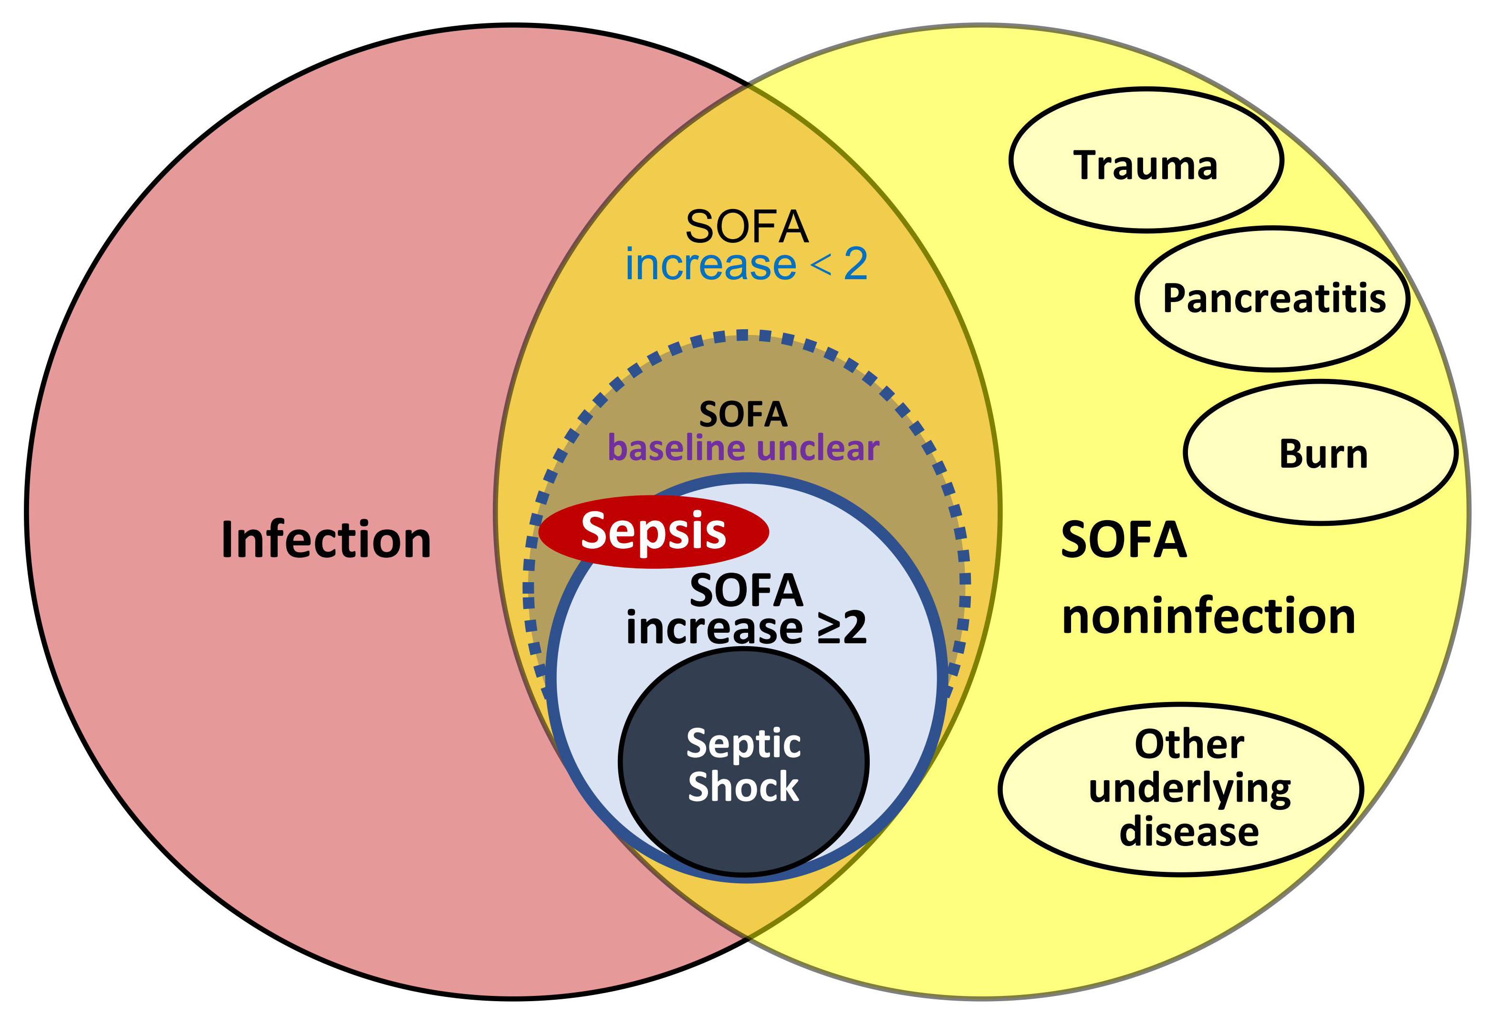

Figure S1. Illustrating the exclusion dilemma for patients with unclear baseline SOFA scores.
This figure illustrates the methodological dilemma encountered in applying the Sepsis-3 criteria: patients with suspected infection but an unclear baseline SOFA score cannot be classified as having sepsis. To avoid confounding the primary outcome, inclusion of these patients is not feasible, and their exclusion is necessitated by the study design.
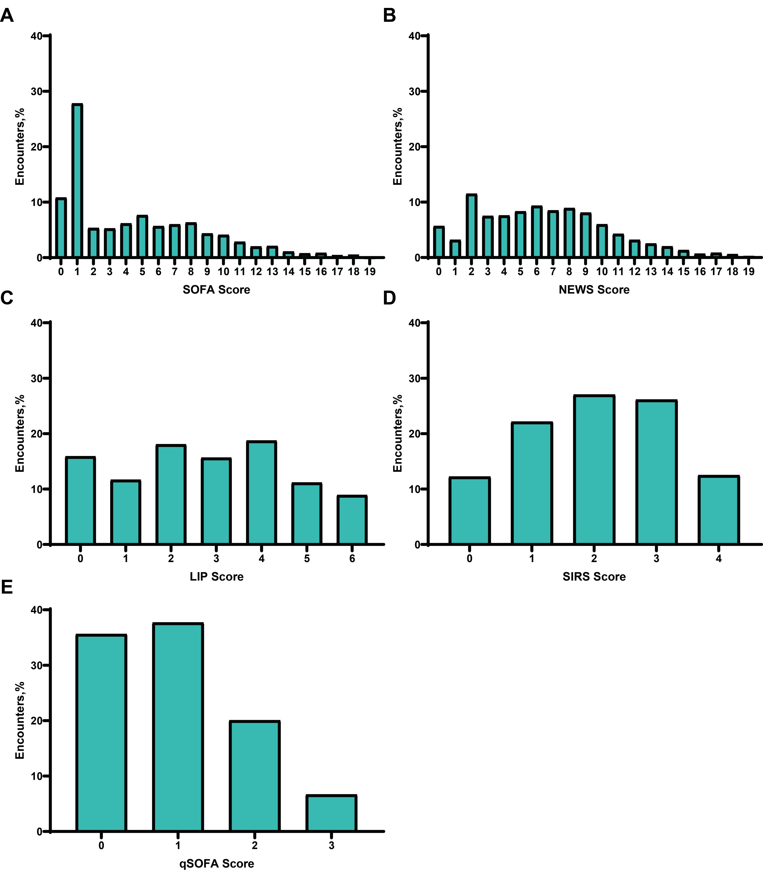

Figure S2. Distribution of SOFA, NEWS, qSOFA, SIRS, and LIP scores among all patients.
(A) SOFA Score; (B) NEWS Score; (C) LIP Score; (D) SIRS Score; (E) qSOFA Score. LIP, Lymphocyte, INR, and Procalcitonin-based Sepsis Screening Score; NEWS, National Early Warning Score; qSOFA, Quick Sequential Organ Failure Assessment; SIRS, Systemic Inflammatory Response Syndrome; APACHE-II, Acute Physiology and Chronic Health Evaluation II.

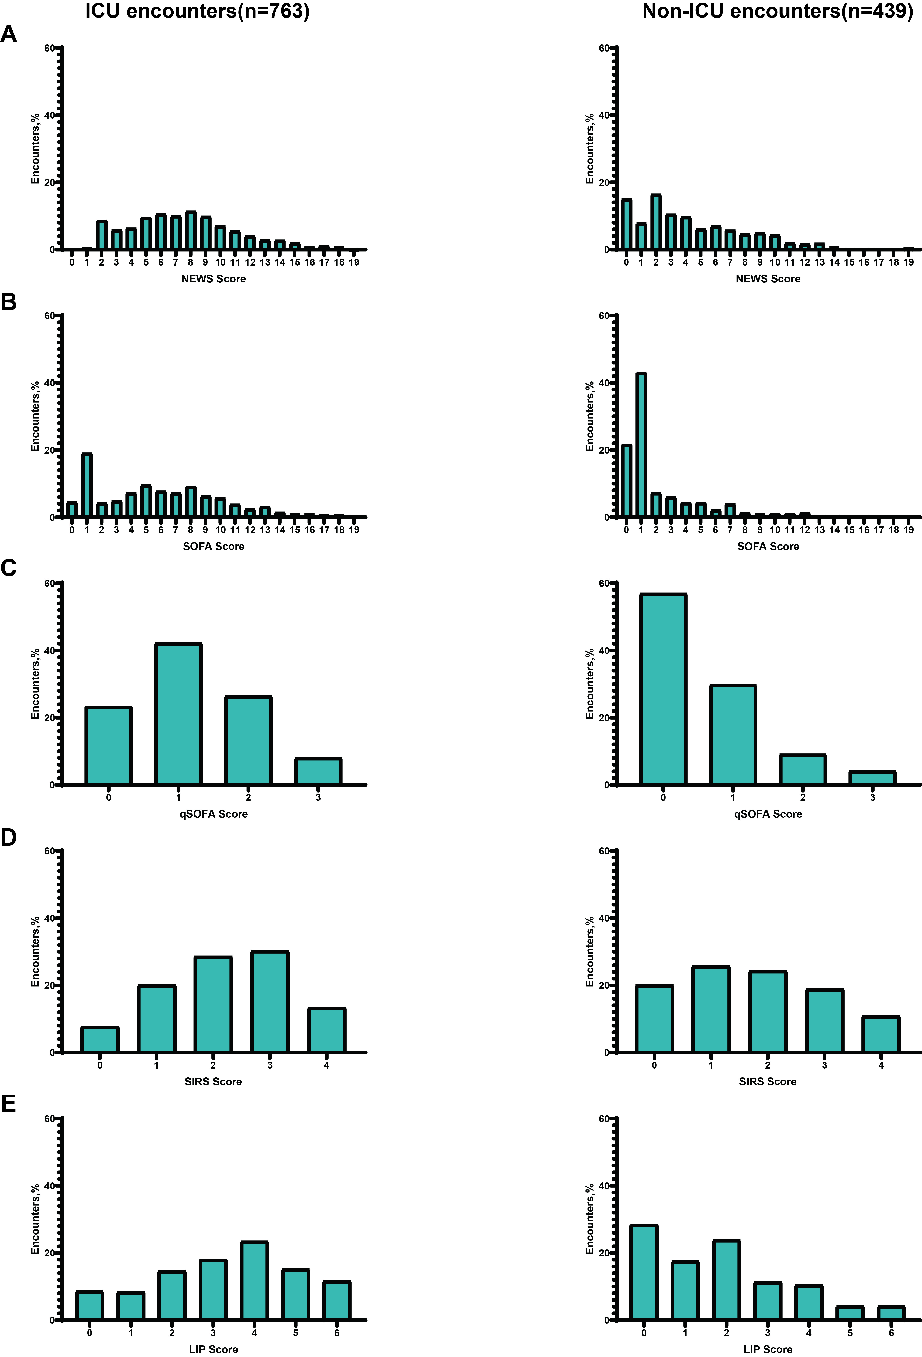

Figure S3. Distribution of the five scoring systems (SOFA/NEWS/qSOFA/SIRS/LIP) in ICU and Non-ICU patients.
(A)NEWS Score; (B)SOFA Score; (C)qSOFA Score; (D) SIRS Score; (E) LIP Score. LIP, Lymphocyte, INR, and Procalcitonin-based Sepsis Screening Score; NEWS, National Early Warning Score; qSOFA, Quick Sequential Organ Failure Assessment; SIRS, Systemic Inflammatory Response Syndrome; APACHE-II, Acute Physiology and Chronic Health Evaluation II.

Figure S4. Distribution of SOFA scores across participating centers.
(A) CQUCH, Chongqing University Central Hospital; (B)CQRCH, Chongqing Red Cross Hospital; (C)CQYBDPH, Chongqing Yubei District People's Hospital; (D)CQPH, Chongqing General Hospital; (E) QLHSDU, Qilu Hospital of ShanDong University; (F) SCPPH, Sichuan Provincial People's Hospital; (G) SAHCQMU, The Second Affiliated Hospital of Chongqing Medical University; (H) CDSPH, Chengdu Second People's Hospital; (I) TAHCQMU, The Third Affiliated Hospital of Chongqing Medical University; (J)WCHSCU, Westchina Hospital of Sichuan University. qSOFA, Quick Sequential Organ Failure Assessment.

Figure S5. Distribution of NEWS scores across participating centers.
(A) CQUCH, Chongqing University Central Hospital; (B)CQRCH, Chongqing Red Cross Hospital; (C)CQYBDPH, Chongqing Yubei District People's Hospital; (D)CQPH, Chongqing General Hospital; (E) QLHSDU, Qilu Hospital of ShanDong University; (F) SCPPH, Sichuan Provincial People's Hospital; (G) SAHCQMU, The Second Affiliated Hospital of Chongqing Medical University; (H) CDSPH, Chengdu Second People's Hospital; (I) TAHCQMU, The Third Affiliated Hospital of Chongqing Medical University; (J)WCHSCU, Westchina Hospital of Sichuan University. NEWS, National Early Warning Score.

Figure S6. Distribution of qSOFA scores across participating centers.
(A) CQUCH, Chongqing University Central Hospital; (B)CQRCH, Chongqing Red Cross Hospital; (C)CQYBDPH, Chongqing Yubei District People's Hospital; (D)CQPH, Chongqing General Hospital; (E) QLHSDU, Qilu Hospital of ShanDong University; (F) SCPPH, Sichuan Provincial People's Hospital; (G) SAHCQMU, The Second Affiliated Hospital of Chongqing Medical University; (H) CDSPH, Chengdu Second People's Hospital; (I) TAHCQMU, The Third Affiliated Hospital of Chongqing Medical University; (J)WCHSCU, Westchina Hospital of Sichuan University. qSOFA, Quick Sequential Organ Failure Assessment.

Figure S7. Distribution of SIRS scores across participating centers.
(A) CQUCH, Chongqing University Central Hospital; (B)CQRCH, Chongqing Red Cross Hospital; (C)CQYBDPH, Chongqing Yubei District People's Hospital; (D)CQPH, Chongqing General Hospital; (E) QLHSDU, Qilu Hospital of ShanDong University; (F) SCPPH, Sichuan Provincial People's Hospital; (G) SAHCQMU, The Second Affiliated Hospital of Chongqing Medical University; (H) CDSPH, Chengdu Second People's Hospital; (I) TAHCQMU, The Third Affiliated Hospital of Chongqing Medical University; (J)WCHSCU, Westchina Hospital of Sichuan University. SIRS, Systemic Inflammatory Response Syndrome.

Figure S8. Distribution of LIP scores across participating centers.
(A) CQUCH, Chongqing University Central Hospital; (B)CQRCH, Chongqing Red Cross Hospital; (C)CQYBDPH, Chongqing Yubei District People's Hospital; (D)CQPH, Chongqing General Hospital; (E) QLHSDU, Qilu Hospital of ShanDong University; (F) SCPPH, Sichuan Provincial People's Hospital; (G) SAHCQMU, The Second Affiliated Hospital of Chongqing Medical University; (H) CDSPH, Chengdu Second People's Hospital; (I) TAHCQMU, The Third Affiliated Hospital of Chongqing Medical University; (J)WCHSCU, Westchina Hospital of Sichuan University. LIP, Lymphocyte, INR, and Procalcitonin-based Sepsis Screening Score.
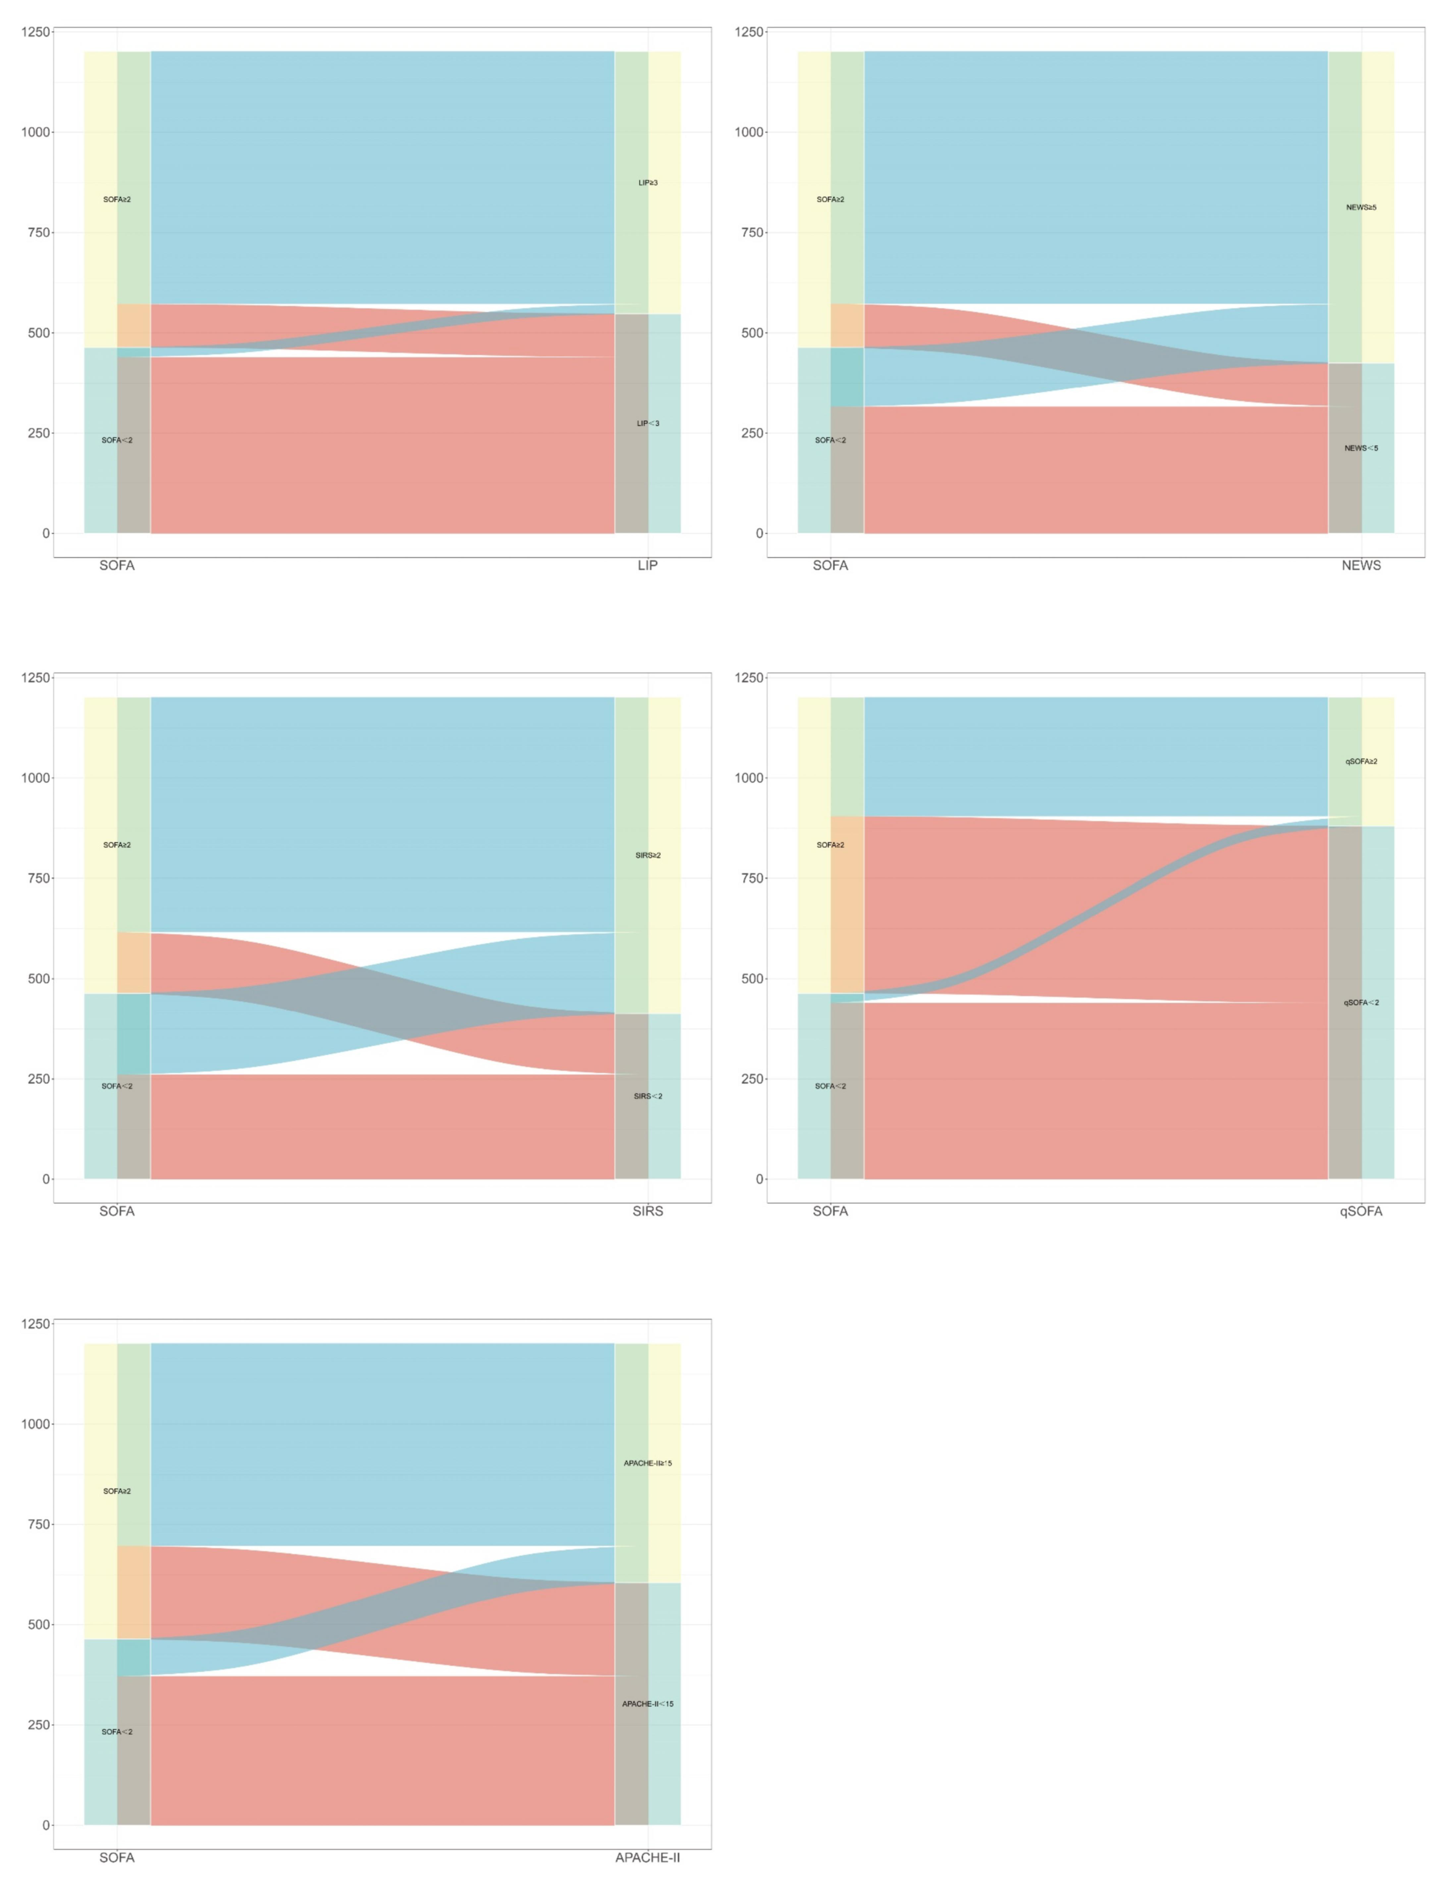

Figure S9. Sankey diagram visualizes the relationship between different scoring tools and the SOFA score.
LIP, Lymphocyte, INR, and Procalcitonin-based Sepsis Screening Score; NEWS, National Early Warning Score; qSOFA, Quick Sequential Organ Failure Assessment; SIRS, Systemic Inflammatory Response Syndrome; APACHE-II, Acute Physiology and Chronic Health Evaluation II.

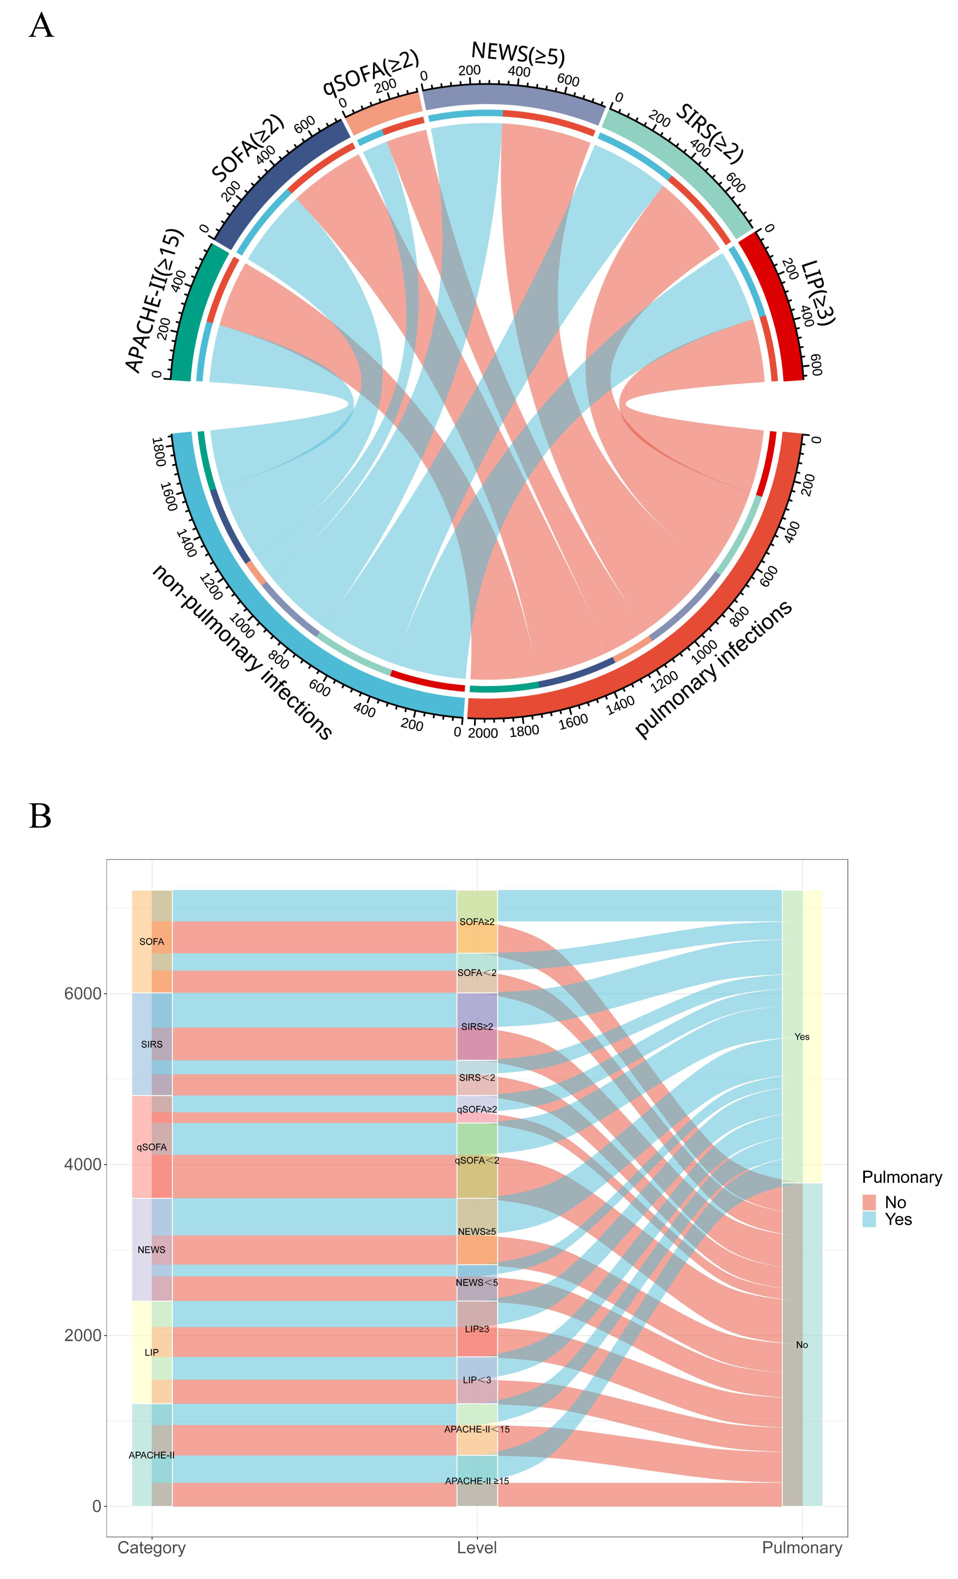

Figure S10. Distribution of pulmonary and non-pulmonary infections cases under the screening thresholds of different scoring tools.
(A) The chord diagrams visualizations of distribution of pulmonary versus non-pulmonary infections when different screening tools meet diagnostic criteria; (B) The sankey diagrams visualizations of distribution of pulmonary versus non-pulmonary infections in different screening tools. LIP, Lymphocyte, INR, and Procalcitonin-based Sepsis Screening Score; NEWS National Early Warning Score; qSOFA Quick Sequential Organ Failure Assessment; SIRS Systemic Inflammatory Response Syndrome; APACHE-II Acute Physiology and Chronic Health Evaluation II.

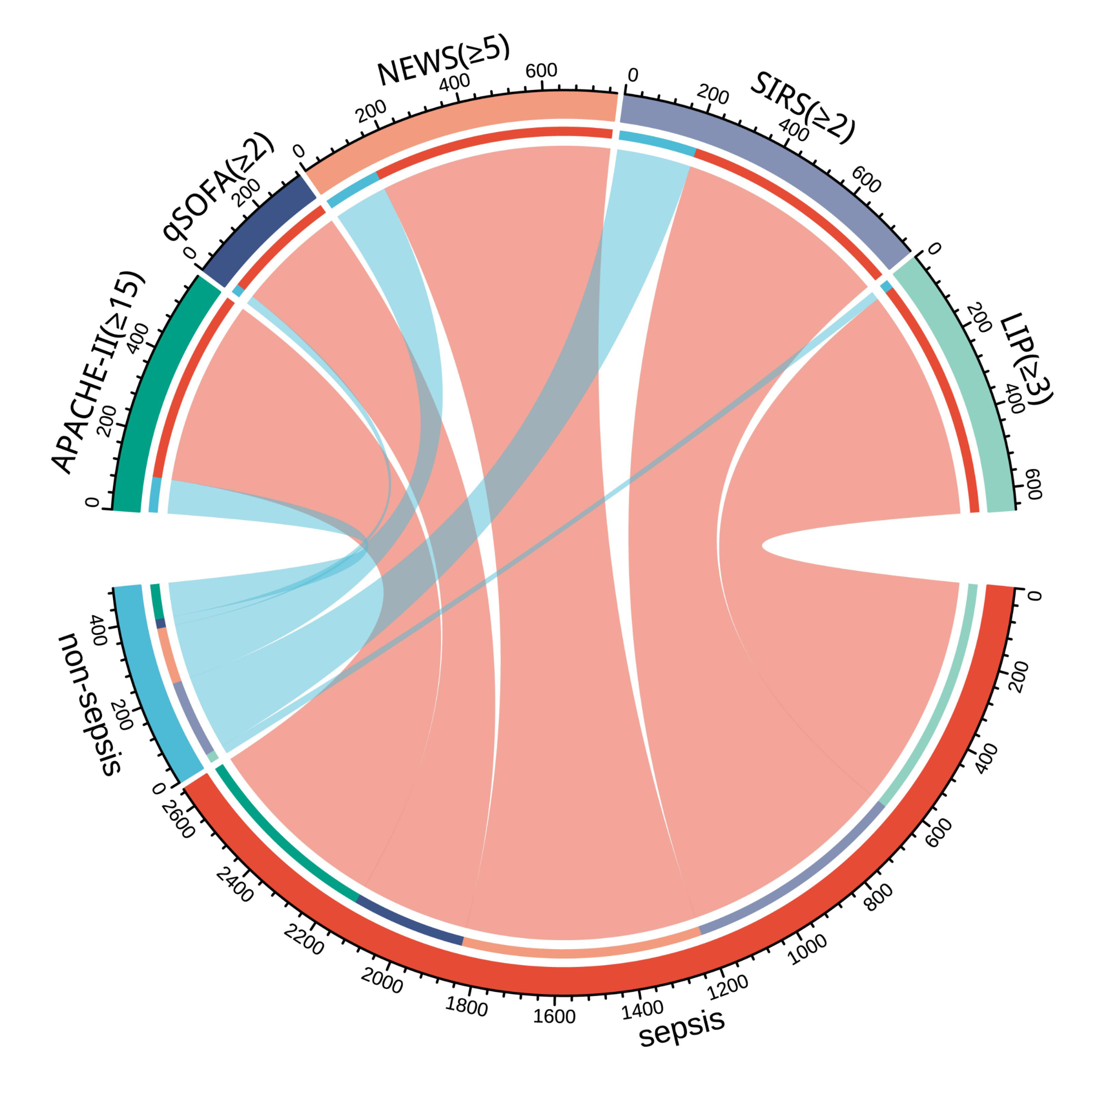

Figure S11. Distribution of sepsis and non-sepsis cases under the screening thresholds of different scoring tools.
LIP, Lymphocyte, INR, and Procalcitonin-based Sepsis Screening Score; NEWS National Early Warning Score; qSOFA Quick Sequential Organ Failure Assessment; SIRS Systemic Inflammatory Response Syndrome; APACHE-II Acute Physiology and Chronic Health Evaluation II.

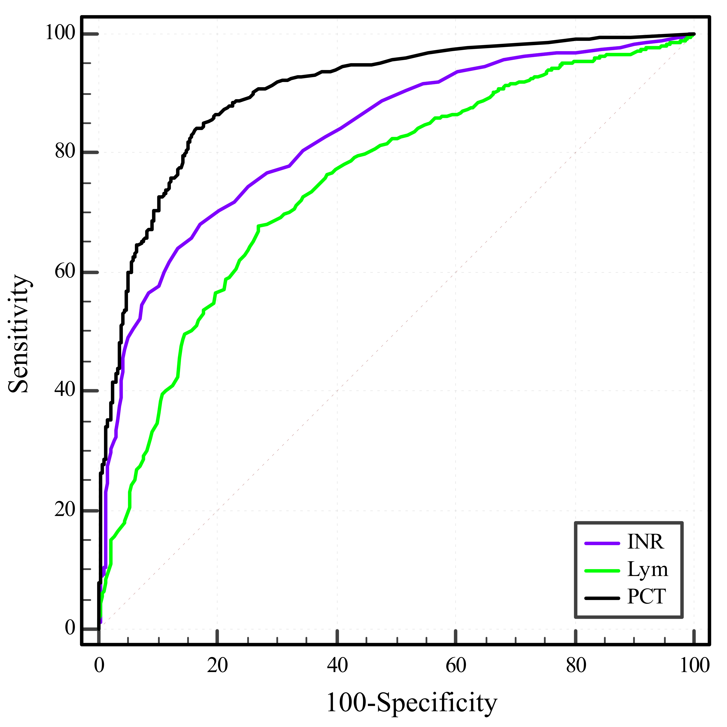

Figure S12. The performance of Lym, INR and PCT in screening for sepsis.
ROC curve analysis was conducted to evaluate the performance of Lym, INR, and PCT in independently screening for sepsis. The AUROC (95% CI) values were 0.747 (0.721 to 0.771), 0.828 (0.805 to 0.849), and 0.902 (0.884 to 0.918), respectively. PCT Procalcitonin; Lym Lymphocyte; INR International Normalized Ratio.

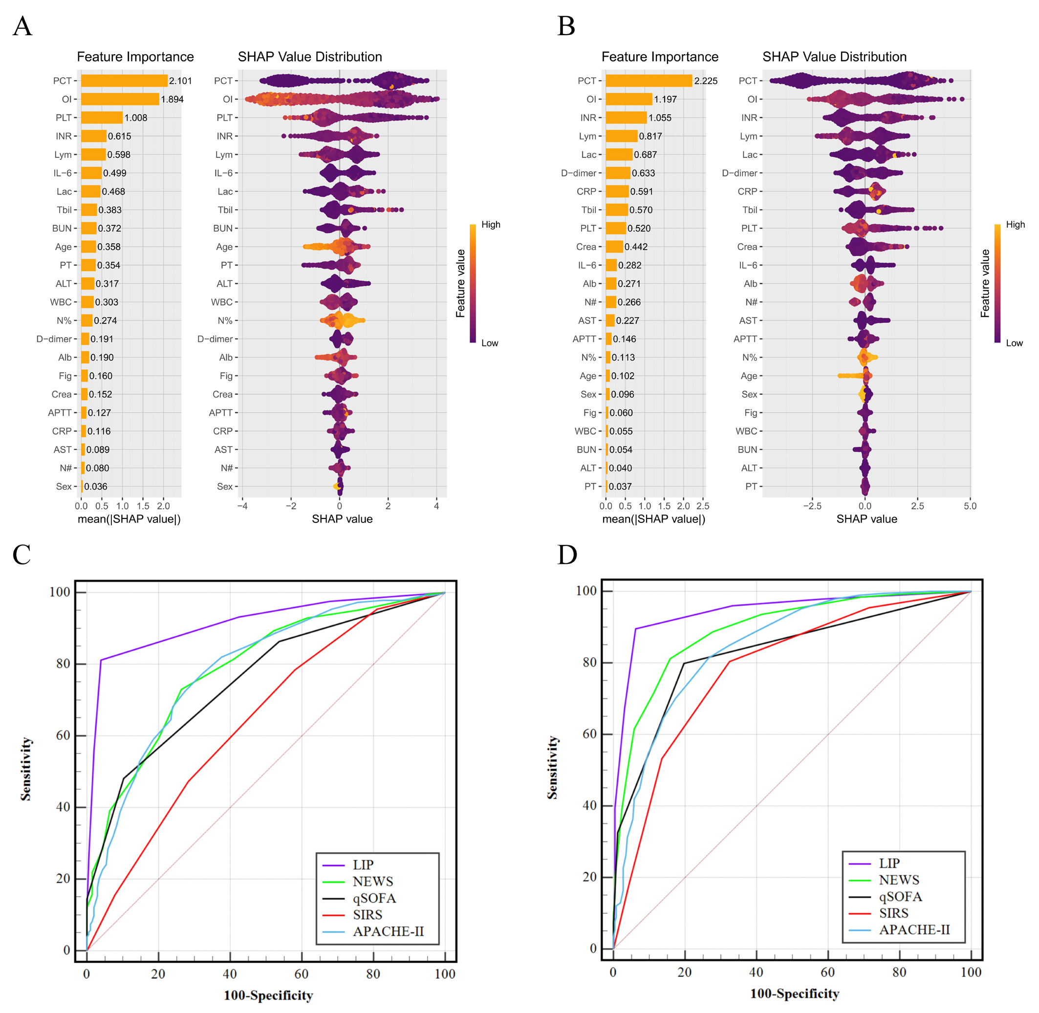

Figure S13. Diagnostic performance of biomarkers and scoring systems for sepsis in pulmonary vs. non-pulmonary infections.
(A) SHAP feature importance ranking of diagnostic biomarkers in pulmonary sepsis; (B) SHAP feature importance ranking of diagnostic biomarkers in non-pulmonary sepsis; (C) Screening tool efficacy for pulmonary sepsis diagnosis (AUROC: LIP 0.916, NEWS 0.789, qSOFA 0.756, SIRS 0.642, APACHE II 0.786); (D) Screening tool efficacy for non-pulmonary sepsis diagnosis (AUROC: LIP 0.945, NEWS 0.893, qSOFA 0.829, SIRS 0.785, APACHE II 0.849). PCT Procalcitonin; OI Oxygenation Index; PLT Platelet; Lym Lymphocyte; INR International Normalized Ratio; PA Prealbumin; TBil Total Bilirubin; Lac Lactate; PT Prothrombin time; CRP C-Reactive Protein; BUN Blood Urea Nitrogen; ALT Alanine Transaminase; N% Neutrophil Ratio; IL-6 Interleukin-6; WBC White Blood Cell; Alb Albumin; Crea Creatinine; APTT Activated partial thromboplastin time; AST Aspartate Transaminase; N# Neutrophil count. LIP, Lymphocyte, INR, and Procalcitonin-based Sepsis Screening Score; NEWS National Early Warning Score; qSOFA Quick Sequential Organ Failure Assessment; SIRS Systemic Inflammatory Response Syndrome; APACHE-II Acute Physiology and Chronic Health Evaluation II.

Figure S14. Analysis of calibration of the LIP score and its Diagnostic efficacy for sepsis in ICU patients and Out of ICU patients.
(A) Calibration assessment has been carried out using the Hosmer- Lemeshow goodness- of- fit test for the logistic regression model underlying the LIP score (cutoff ≥3 for sepsis diagnosis). The test yielded a χ² = 8.54 and P = 0.476, indicating no significant difference between predicted and observed sepsis events. This supports that the LIP score is well calibrated. (B) Diagnostic efficacy of the LIP score for sepsis in ICU patients. In ICU patients, the AUROC of the LIP score for diagnosing sepsis was 0.927(95%CI:0.906-0.944). (C) Diagnostic efficacy of the LIP score for sepsis in Out of ICU patients. In Out of ICU patients, the AUROC of the LIP score for diagnosing sepsis was 0.917(95%CI:0.887-0.941). Both are excellent and statistically non- inferior to each other (P = 0.5711), confirming that the LIP score works equally well for sepsis screening inside and outside the intensive care unit (e.g., emergency departments, general wards) .

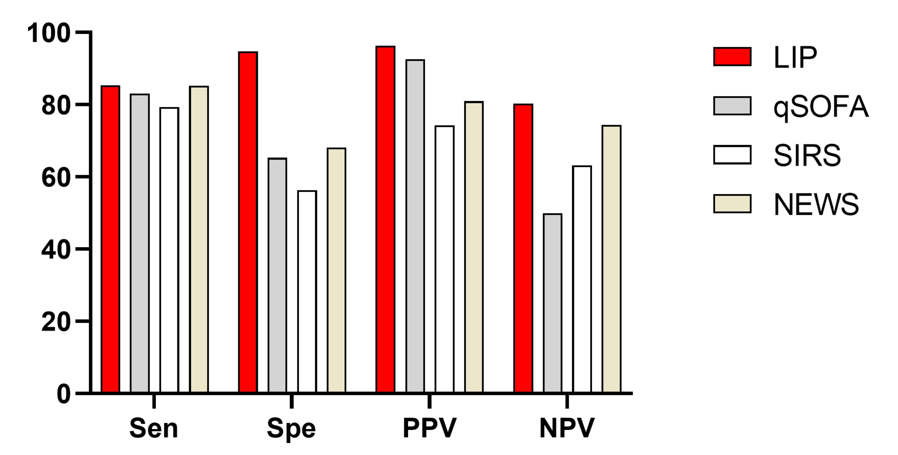

Figure S15. Performance metrics (sensitivity, specificity, PPV, NPV) of screening tools at established diagnostic thresholds.
LIP (≥3): Sen 85.37%, Spec 94.83%, PPV 96.33%, NPV 80.29%; qSOFA (≥2): Sen 83.06%, Spec 65.30%, PPV 92.52%, NPV 49.94%; SIRS (≥2): Sen 79.40%, Spec 56.25%, PPV 74.27%, NPV 63.20%; NEWS (≥5): Sen 85.23%, Spec 68.10%, PPV 80.95%, NPV 74.35%. LIP, Lymphocyte, INR, and Procalcitonin-based Sepsis Screening Score; qSOFA Quick Sequential Organ Failure Assessment; SIRS Systemic Inflammatory Response Syndrome; NEWS National Early Warning Score; APACHE-II Acute Physiology and Chronic Health Evaluation II. Sen, Sensitivity; Spe, Specificity; PPV, Positive predictive value; NPV, Negative predictive value.

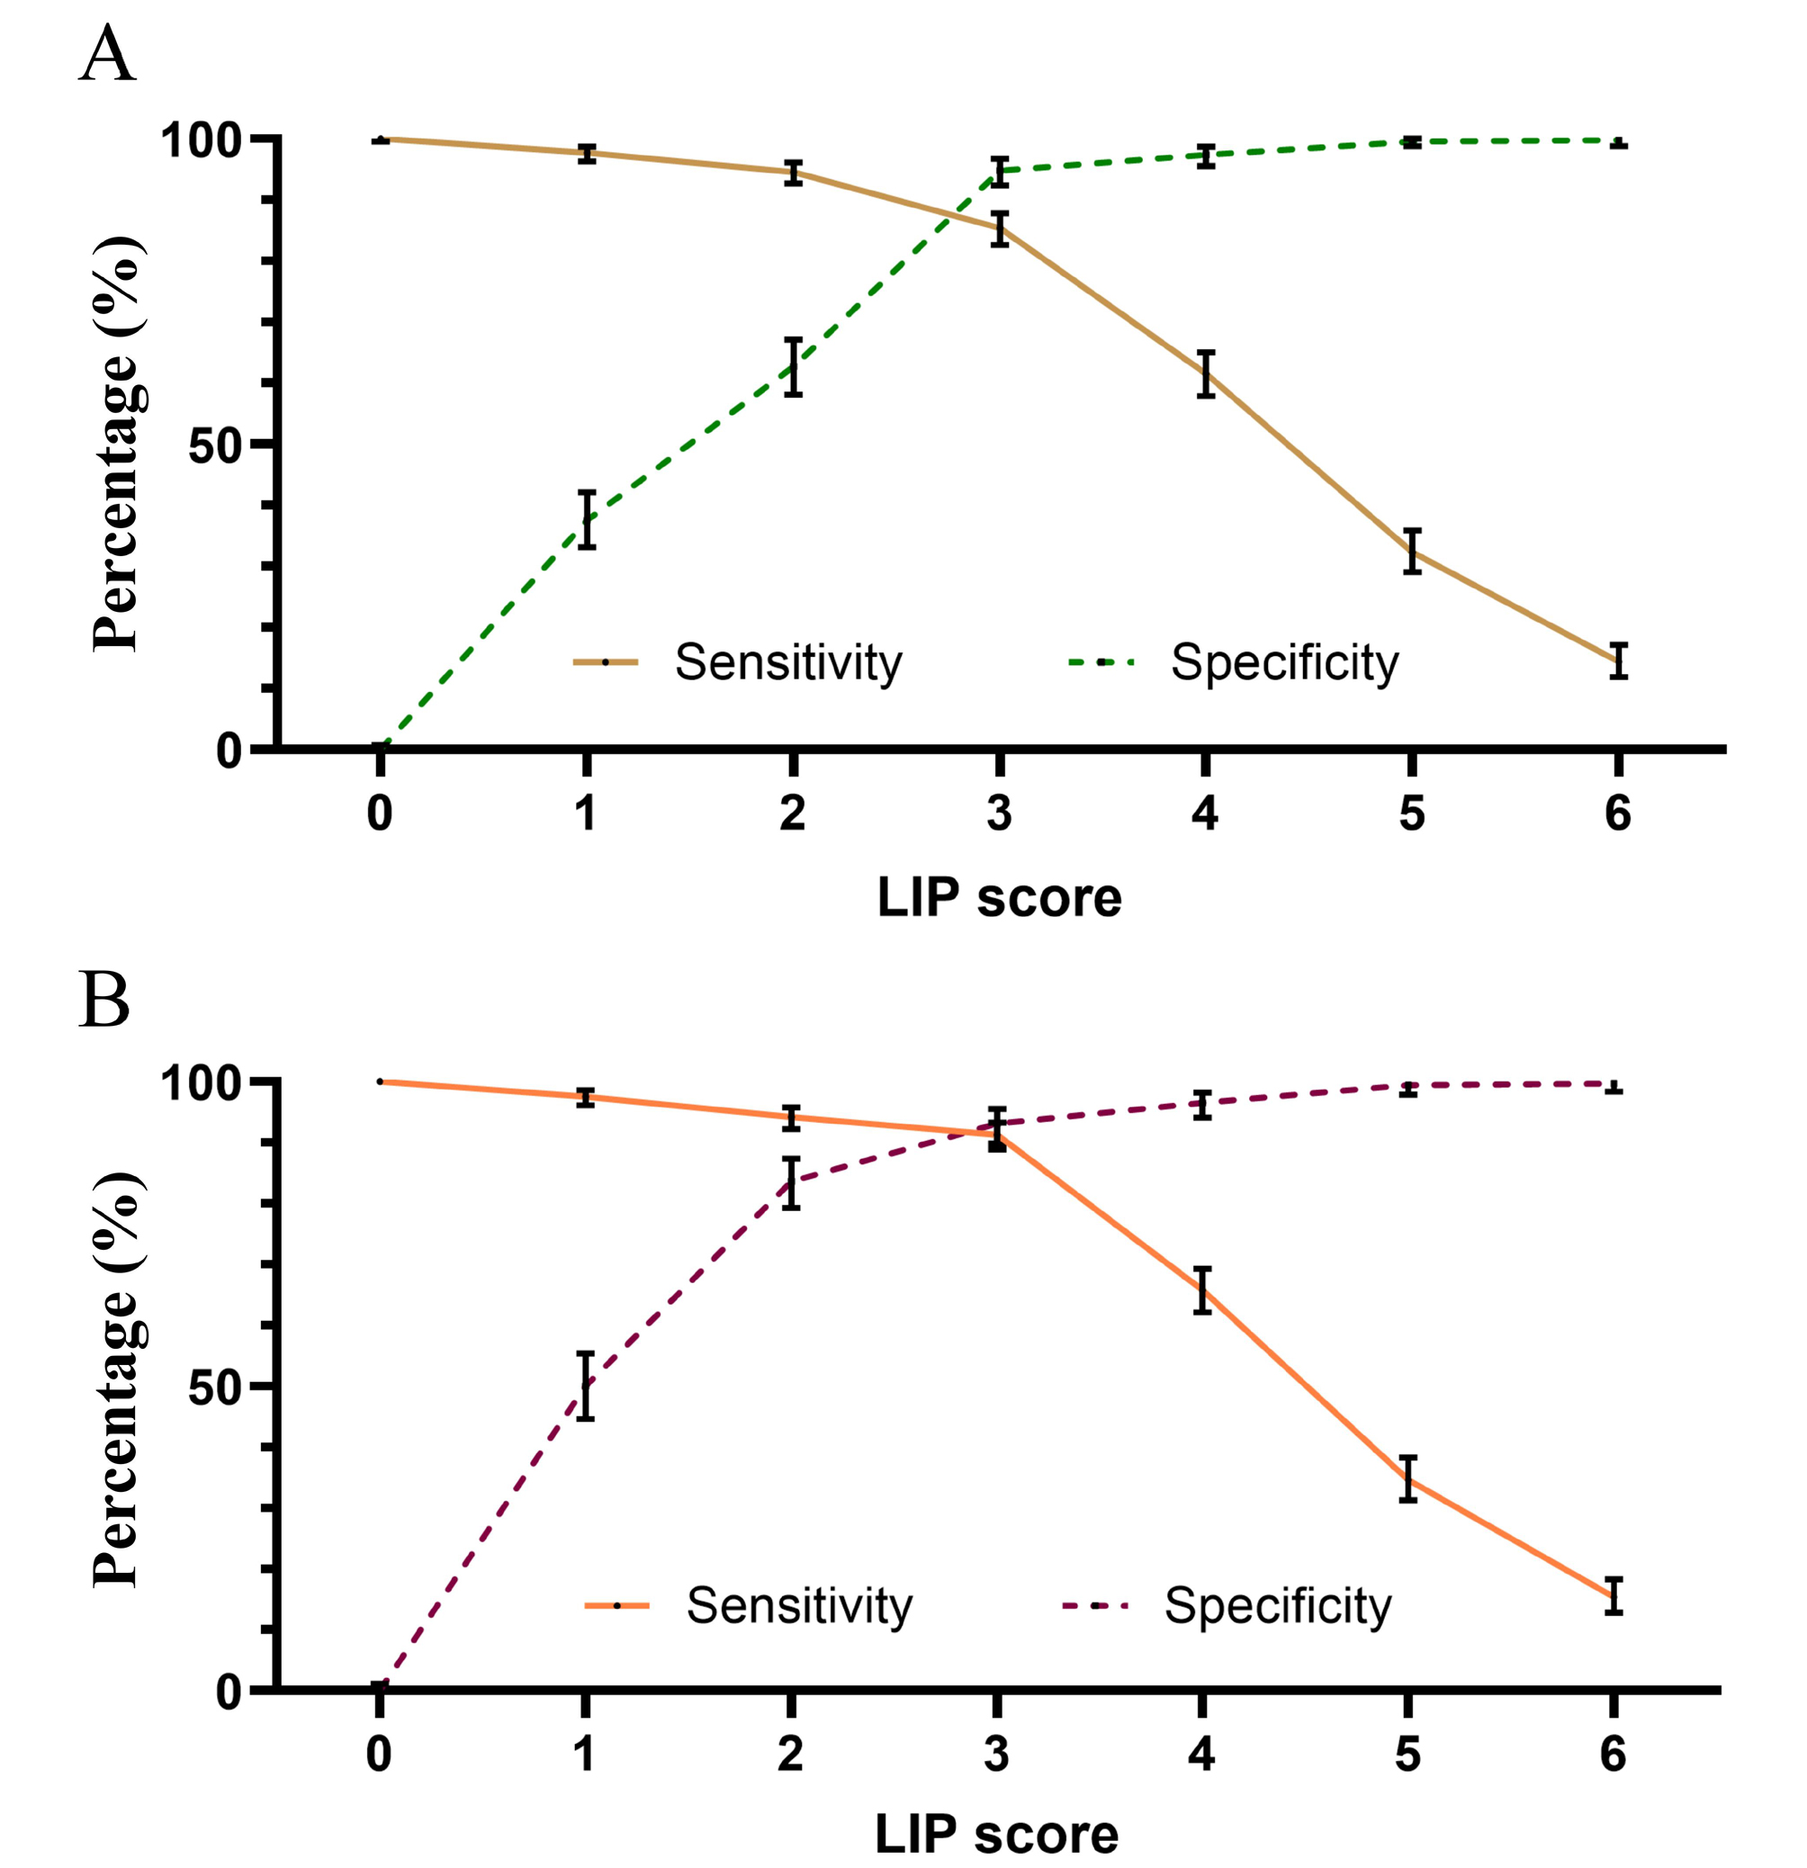

Figure S16. Sensitivity and specificity of LIP thresholds for sepsis screening.
(A) Performance trends across LIP thresholds in suspected infection patients (all patients). (B) Performance trends across LIP thresholds in a subgroup of suspected infection patients excluding patients with any single LIP item score=2.

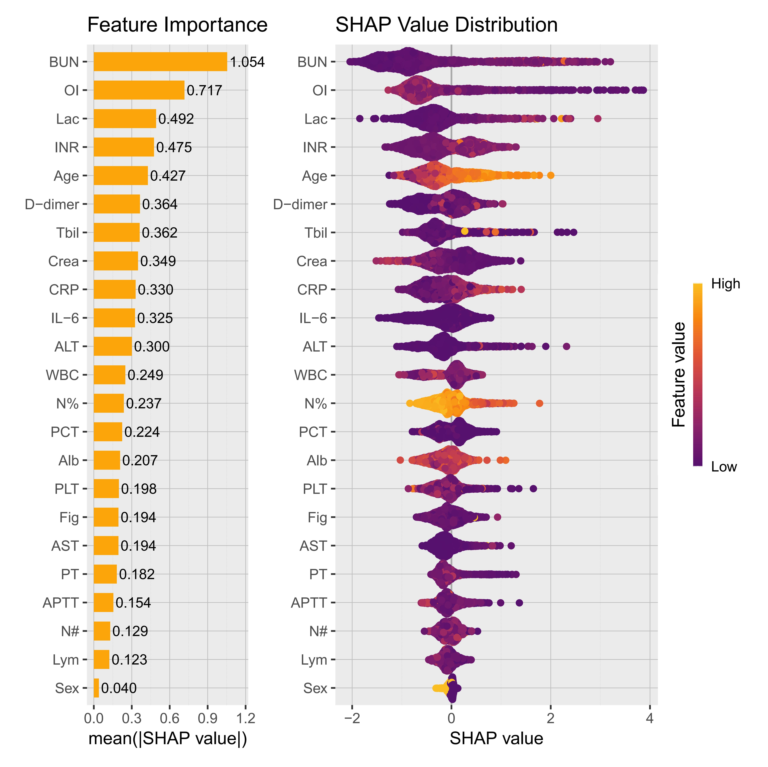

Figure S17. SHAP feature importance ranking of mortality prognostic biomarkers in sepsis.
As shown in the figure, INR ranks third. BUN Blood Urea Nitrogen; OI Oxygenation Index; INR International Normalized Ratio; Lac Lactate; PA Prealbumin; Crea Creatinine; ALT Alanine Transaminase; Alb Albumin; TBil Total Bilirubin; CRP C-Reactive Protein; IL-6 Interleukin-6; AST Aspartate Transaminase; WBC White Blood Cell; N% Neutrophil Ratio; APTT Activated partial thromboplastin time; PT Prothrombin time; PLT Platelet; PCT Procalcitonin; Lym Lymphocyte; N# Neutrophil count.

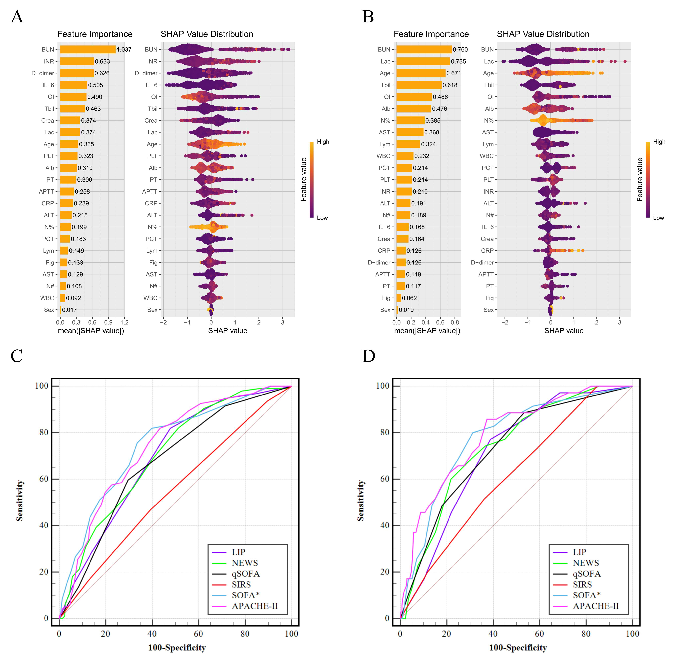

Figure S18. Prognostic performance of biomarkers and scoring systems for sepsis in pulmonary vs. non-pulmonary infections.
(A) SHAP feature importance ranking of mortality prognostic biomarkers in pulmonary sepsis; (B) SHAP feature importance ranking of mortality prognostic biomarkers in non-pulmonary sepsis; (C) Screening tool efficacy for pulmonary sepsis mortality prognosis (AUROC: LIP 0.695, NEWS 0.704, qSOFA 0.674, SIRS 0.549, SOFA 0.741, APACHE-II 0.749); (D) Screening tool efficacy for non-pulmonary sepsis mortality prognosis (AUROC: LIP 0.715, NEWS 0.740, qSOFA 0.727, SIRS 0.617, SOFA 0.790, APACHE-II 0.778). BUN Blood Urea Nitrogen; INR International Normalized Ratio; PA Prealbumin; OI Oxygenation Index; IL-6 Interleukin-6; Crea Creatinine; TBil Total Bilirubin; Lac Lactate; PLT Platelet; ALT Alanine Transaminase; Alb Albumin; PT Prothrombin time; CRP C-Reactive Protein; N% Neutrophil Ratio; APTT Activated partial thromboplastin time; PCT Procalcitonin; AST Aspartate Transaminase; WBC White Blood Cell; N# Neutrophil count; Lym Lymphocyte; LIP, Lymphocyte, INR, and Procalcitonin-based Sepsis Screening Score; NEWS National Early Warning Score; qSOFA Quick Sequential Organ Failure Assessment; SIRS Systemic Inflammatory Response Syndrome; SOFA*, indicates a SOFA score increase caused by infection; APACHE-II Acute Physiology and Chronic Health Evaluation II.

Figure S19. Sepsis mortality and ICU length of stay at different LIP scores
(A) When the LIP scores are 0, 1, 2, 3, 4, 5, and 6, the corresponding mortality rates of sepsis patients are 2.09%, 1.43%, 7.37%, 13.83%, 16.89%, 17.91%, and 17.77%, respectively. (B, C) The relationship between ICU length of stay and different LIP scores in the deceased and survived subgroups was analyzed by restricted cubic spline (RCS). The results showed that in the deceased group, after the LIP score was 3-4, the higher the score, the shorter the ICU stay (associated with an increased mortality rate); while in the survived group, the RCS curve indicated that the ICU length of stay gradually increased with the higher LIP score. Therefore, the deceased patients did indeed show a competing event with ICU length of stay. LIP, Lymphocyte, INR, and Procalcitonin-based Sepsis Screening Score.

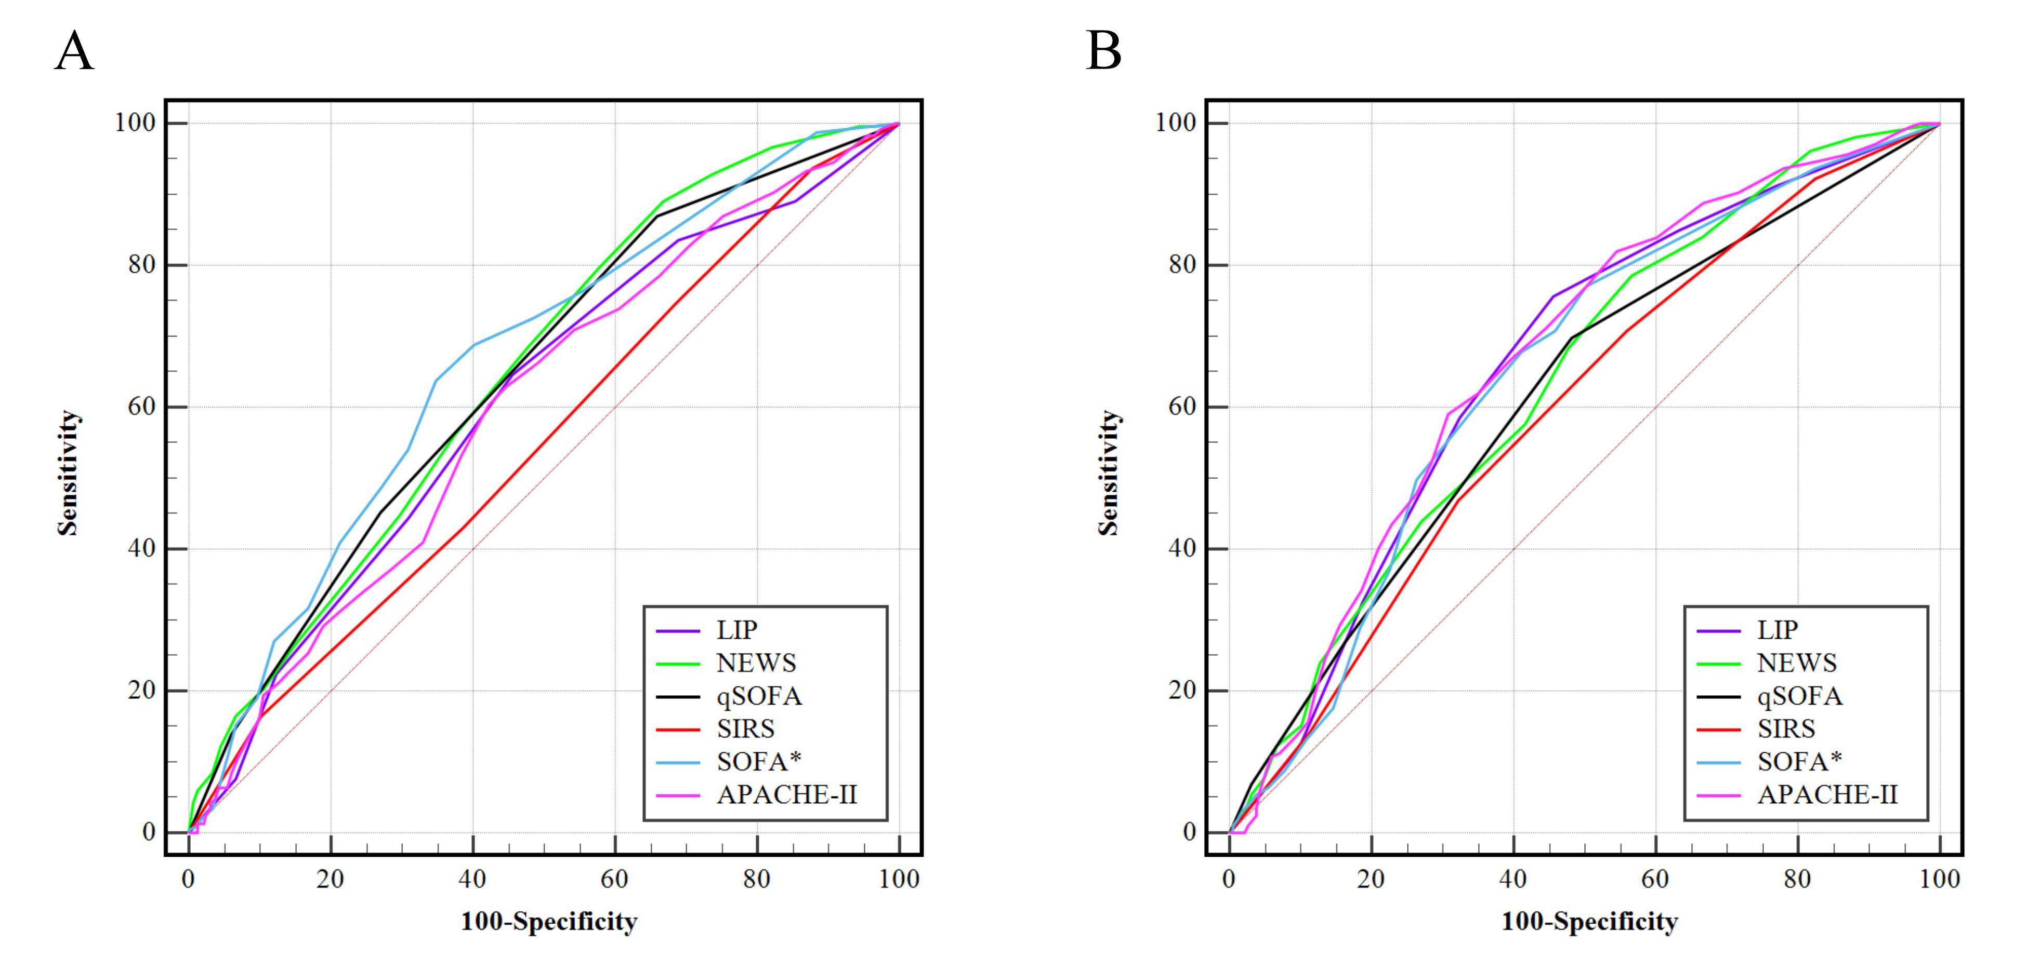

Figure S20. Predictive performance of various scoring systems for microbiological positivity in pulmonary and non-pulmonary infections.
(A) The efficacy of different screening tools for predicting positive microbiology in pulmonary infection (the AUROC of the LIP score was 0.606, and the detail can be found in Table E2); (B) The efficacy of different screening tools for predicting positive microbiology in Non-pulmonary infection (the AUROC of the LIP score was 0.659, and the detail can be found in Table E2). LIP, Lymphocyte, INR, and Procalcitonin-based Sepsis Screening Score; NEWS National Early Warning Score; qSOFA Quick Sequential Organ Failure Assessment; SIRS Systemic Inflammatory Response Syndrome; SOFA*, indicates a SOFA score increase caused by infection; APACHE-II Acute Physiology and Chronic Health Evaluation II.

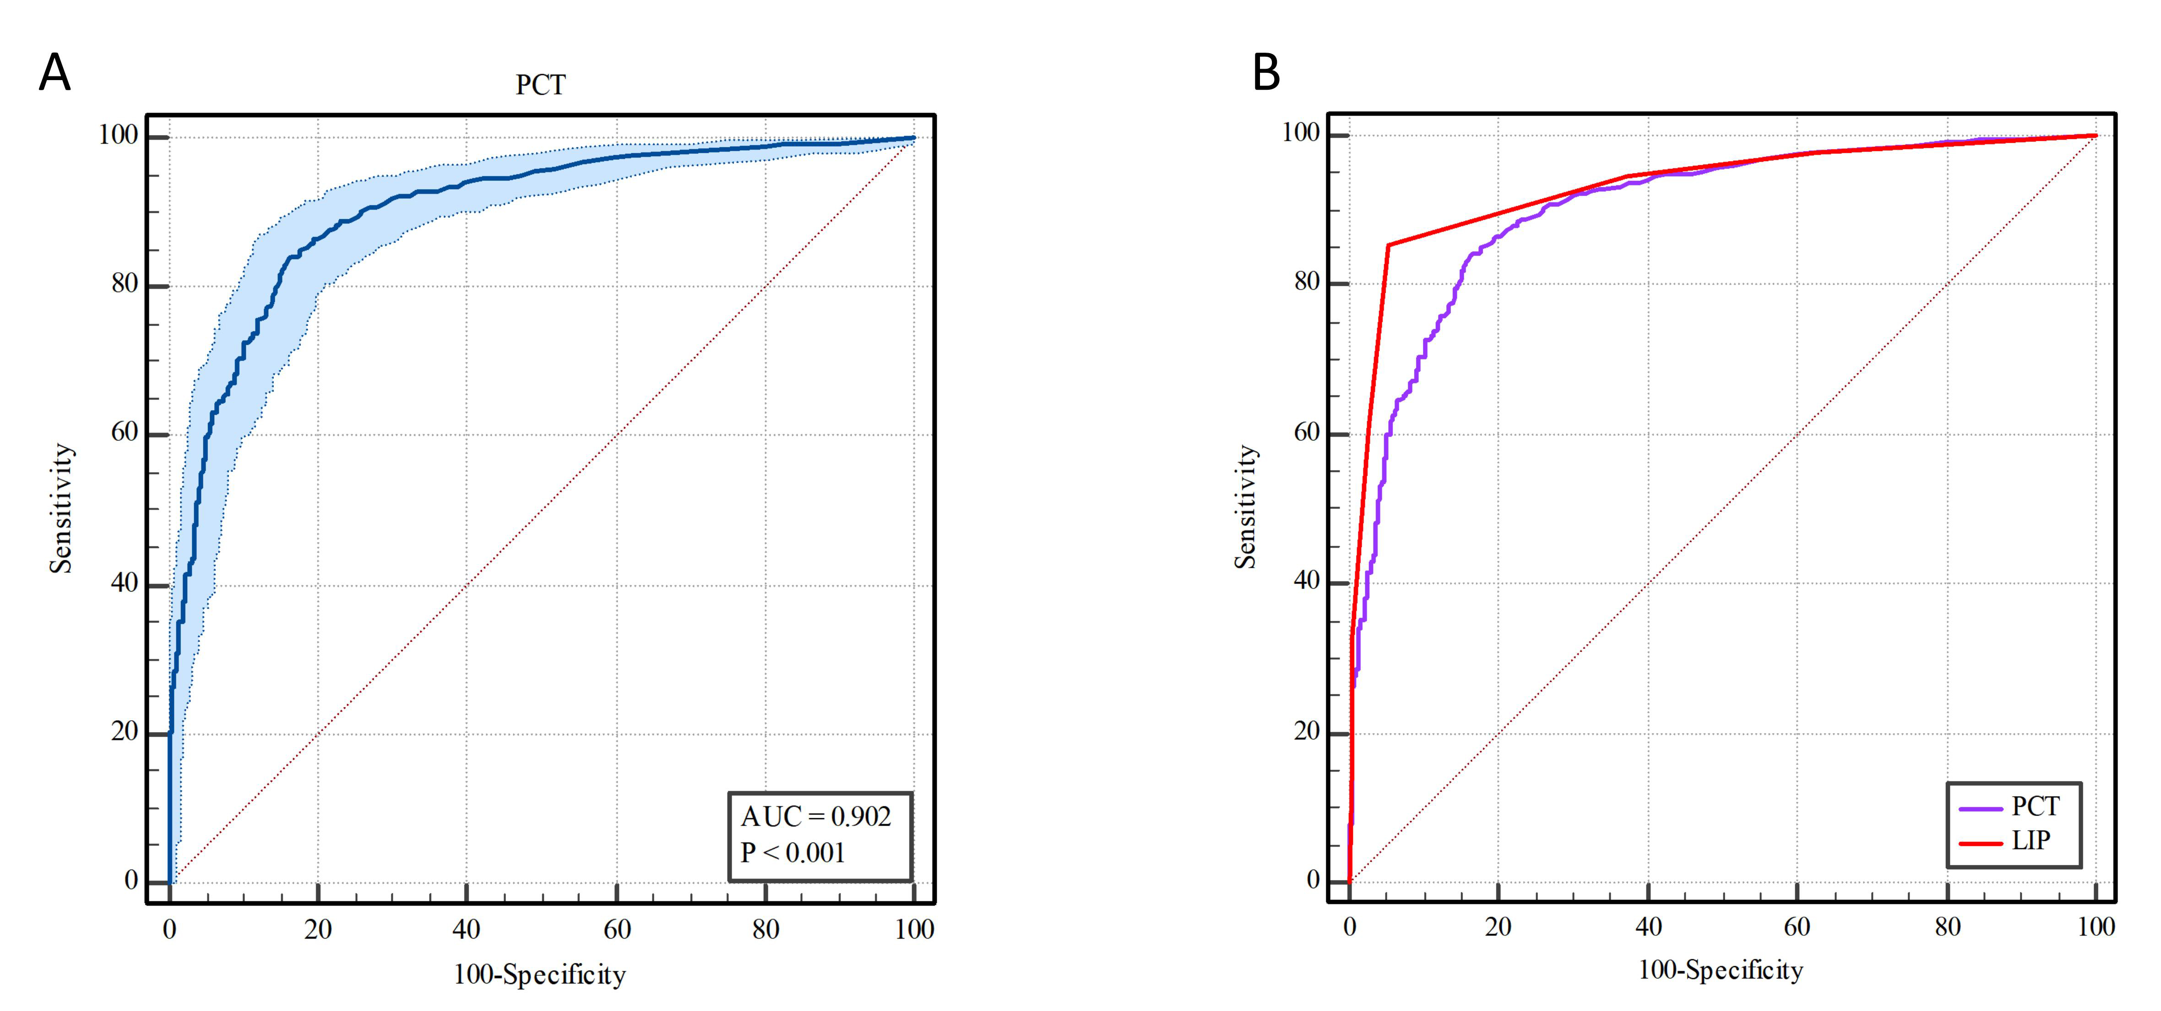

Figure S21. Performance of PCT for sepsis screening and comparison with the LIP score.
(A) ROC analysis of PCT alone for sepsis screening, with an AUC of 0.902 (95% CI: 0.884–0.918). At a cutoff of 0.5 ng/mL, sensitivity (95% CI), specificity (95% CI), PPV, NPV, +LR (95% CI), and –LR (95% CI) were 85.64% (82.9–88.1%), 81.03% (77.2–84.5%), 87.64%, 77.80%, 4.52 (3.7–5.5), and 0.18 (0.1–0.2), respectively. At a cutoff of 0.2 ng/mL, the corresponding values were 63.14% (59.5–66.6%), 93.97% (91.4–96.0%), 93.94%, 61.39%, 10.46 (7.3–15.0), and 0.39 (0.4–0.4). (B) Comparison of PCT and the LIP score for sepsis screening: AUCs were 0.902 (0.884–0.918) for PCT and 0.932 (0.916–0.945) for LIP, demonstrating that the LIP score significantly improved not only the AUC but also the overall sensitivity and specificity. PCT, procalcitonin; PPV, positive predictive value; NPV, negative predictive value; +LR, positive likelihood ratio; -LR, negative likelihood ratio.

