Additional file 1

eMethod 1. Search Strategy
eMethod 2. List of included studies.
eTable 1. Study-level characteristics of included trials.
eTable 2. Sensitivity analysis using restricted maximum likelihood estimation.
eTable 3. Sensitivity analysis using fixed-effects meta-regression.
eTable 4. Sensitivity analysis using planned total contact hours.
eTable 5. Sensitivity analysis restricted to comparisons reporting actual delivered contact hours.
eTable 6. Sensitivity analysis restricted to comparisons using BMI z score as the selected outcome.
eFigure 1. Study selection flow diagram.
eFigure 2. Risk of bias summary across included studies.
eFigure 3. Study-level risk-of-bias judgments for individual included studies.
eFigure 4. Forest plot of behavioral intervention effects on weight-related outcomes in children and adolescents with obesity.
eFigure 5. Funnel plot of standard error by Hedges’s g.

eMethod 1. Search Strategy
1. MEDLINE through Ovid
ID Search Hits
1 obesity.ab,kf,ti. 356331
2 obese.ab,kf,ti. 160457
3 overweight.ab,kf,ti. 97130
4 over weight.ab,kf,ti. 586
5 weight control.ab,kf,ti. 7813
6 weight loss.ab,kf,ti. 119612
7 weight management.ab,kf,ti. 10114
8 (obesity or Obesity, Morbid or Obesity, Abdominal or Overweight).sh. 275308
9 1 or 2 or 3 or 4 or 5 or 6 or 7 or 8 570345
10 (pediatric* or paediatric* or child* or teen* or adolescen* or youth* or young people or young adult* or schoolchildren or school children or preschool* or pre school* or toddler*).ab,kf,ti. 2385171
11 (Young Adult or Adolescent or child or Child, Preschool).sh. 3991164
12 10 or 11 4737662
13 9 and 12 139766
14 (Behavior Therap* or Cognitive Behavior Therap* or Cognitive Therap* or Behavior Modifi* or behavior chang* or Lifestyle Chang* or School Counsel* or Psychotherap* or Group Counsel* or Motivational Interview* or Health Education or Health Promot* or Family Intervention or Family Therap*).ab,kf,ti. 211581
15 ((psychological or behavio*) adj (therap* or modif* or chang* or intervention*)).ab,kf,ti. 118786
16 (lifestyle chang* or lifestyle intervention or lifestyle modifi* or self regulat* or parent behavi* or parent educat*).ab,kf,ti. 48968
17 14 or 15 or 16 323603
18 (diet* adj (modif* or therap* or intervention*)).ab,kf,ti. 25887
19 (calori* control or healthy eating or low calorie or Eating Behavior).ab,kf,ti. 23436
20 18 or 19 48492
21 (Physical Activity or Exercise or aerobic exercise or physical training or sedentary behavio*).ab,kf,ti. 480987
22 17 or 20 or 21 806368
23 13 and 22 32166
24 randomized controlled trial.pt. 628601
25 randomized controlled trial.mp. [mp=title, book title, abstract, original title, name of substance word, subject heading word, floating sub-heading word, keyword heading word, organism supplementary concept word, protocol supplementary concept word, rare disease supplementary concept word, unique identifier, synonyms, population supplementary concept word, anatomy supplementary concept word] 681645
26 24 or 25 681645
27 23 and 26 3861

2. PsycINFO via EBSCOhost
ID Search Hits
S1 obesity 52,655
S2 TX obesity 52,887
S3 TX overweight 19,410
S4 TX weight control 10,947
S5 TX weight loss 15,817
S6 MA obesity OR MA Obesity, Morbid OR MA Obesity, Abdominal OR MA Overweight 19,773
S7 TI obesity OR AB obesity OR KW obesity 43,315
S8 TI obese OR AB obese OR KW obese 18,065
S9 TI overweight OR AB overweight OR KW overweight 18,467
S10 TI over weight OR AB over weight OR KW over weight 2,585
S11 TI weight control OR AB weight control OR KW weight control 6,821
S12 TI weight management OR AB weight management OR KW weight management 3,545
S13 S1 OR S2 OR S3 OR S4 OR S5 OR S6 OR S7 OR S8 OR S9 OR S10 OR S11 OR S12 72,000
S14 " TI (child* or teen or teens or teenage* or adolescen* or youth or youths or young people or young adult* or
pediatric* or paediatric* or schoolchildren or school children or preschool* or pre school* or toddler*) OR AB
(child* or teen or teens or teenage* or adolescen* or youth or youths or young people or young adult* or
pediatric* or paediatric* or schoolchildren or school children or preschool* or pre school* or toddler*) OR KW
(child* or teen or teens or teenage* or adolescen* or youth or youths or young people or young adult* or
pediatric* or paediatric* or schoolchildren or school children or preschool* or pre school* or toddler*)" 1 , 117 ,079
S15 S13 AND S14 22,853
S16 TI Behavior Therapy OR AB Behavior Therapy OR KW Behavior Therapy 23,809
S17 TI Cognitive Behavior Therapy OR AB cognitive behavior therapy OR KW Cognitive Behavior Therapy 10,869
S18 TI Cognitive Therapy OR AB Cognitive Therapy OR KW Cognitive Therapy 45,470
S19 TI Behavior Modification OR AB Behavior Modification OR KW Behavior Modification 7,612
S20 TI behavior change OR AB behavior change OR KW Behavior Change 51,050
S21 TI Lifestyle Changes OR AB Lifestyle Changes OR KW Lifestyle Changes 0
S22 TI Lifestyle OR AB Lifestyle OR KW Lifestyle 37,795
S23 TI School Counseling OR AB School Counseling OR KW School Counseling 5,647
S24 " TI Psychotherapeutic Counseling OR AB Psychotherapeutic Counseling OR KW Psychotherapeutic
Counseling" 317
S25 TI Group Counseling OR AB Group Counseling OR KW Group Counseling 7,277
S26 TI Motivational Interview* OR AB Motivational Interview* OR KW Motivational Interview* 5,072
S27 TI Feedback OR AB Feedback OR KW Feedback 84,899
S28 TI Health Education OR AB health education OR KW health education 32,949
S29 TI Health Promotion OR AB Health Promotion OR KW Health Promotion 25,830
S30 TI Intervention OR AB Intervention OR KW Intervention 513,965
S31 TI School Based Intervention OR AB School Based Intervention OR KW School Based Intervention 7,491
S32 TI Family Intervention OR AB Family Intervention OR KW Family Intervention 20,250
S33 TI Family Therapy OR AB Family Therapy OR KW Family Therapy 23,749
S34 " TI ( ((psychological or behavio*) adj (therap* or modif* or chang* or intervention*)) ) OR AB ( ((psychological
or behavio*) adj (therap* or modif* or chang* or intervention*)) ) OR KW ( ((psychological or behavio*) adj
(therap* or modif* or chang* or intervention*)) )" 0
S35 " TI ( ((psychological or behavio*) adj (therap* or modif* or chang* or intervention*)) ) OR AB ( ((psychological
or behavio*) adj (therap* or modif* or chang* or intervention*)) ) OR KW ( ((psychological or behavio*) adj
(therap* or modif* or chang* or intervention*)) )" 0
S36 " TI ( ((psychological or behavio*) adj2 (therap* or modif* or chang* or intervention*)) ) OR AB ( ((psychological
or behavio*) adj2 (therap* or modif* or chang* or intervention*)) ) OR KW ( ((psychological or behavio*) adj2
(therap* or modif* or chang* or intervention*)) )" 0
S37 TI psychological therap* OR AB psychological therap* OR KW psychological therap* 9,413
S38 TI Behav* therap* OR AB Behav* therap* OR KW Behav* therap* 59,008
S39 TI Behav* modif* OR AB Behav* modif* OR KW Behav* modif* 16,489
S40 TI psychological modif* OR AB psychological modif* OR KW psychological modif* 1,020
S41 TI psychological intervention OR AB psychological intervention OR KW psychological intervention 16,115
S42 TI behavio* intervention OR AB behavio* intervention OR KW behavio* intervention 44,534
S43 TI lifestyle chang* OR AB lifestyle chang* OR KW lifestyle chang* 5,098
S44 TI lifestyle intervention OR AB lifestyle intervention OR KW lifestyle intervention 3,415
S45 TI lifestyle modifi* OR AB lifestyle modifi* OR KW lifestyle modifi* 1,619
S46 TI self regulat* OR AB self regulat* OR KW self regulat* 33,536
S47 TI parent behavi* OR AB parent behavi* OR KW parent behavi* 23,232
S48 TI parent educat* OR AB parent educat* OR KW parent educat* 20,190
S49 TI ( modif* or therap* or intervention* ) OR AB ( modif* or therap* or intervention* ) OR KW ( modif* ortherap* or intervention* ) 1 ,024 ,378
S50 TI diet* OR KW diet* 21,512
S51 S49 AND S50 6,720
S52 TI calori* control OR AB calori* control OR KW calori* control 395
S53 TI healthy eating OR AB healthy eating OR KW healthy eating 5,129
S54 TI low calorie OR AB low calorie OR KW low calorie 794
S55 TI Eating Behavior OR AB Eating Behavior OR KW Eating Behavior 16,418
S56 TI Physical Activity OR AB Physical Activity OR KW Physical Activity 53,470
S57 TI Exercise OR AB Exercise OR KW Exercise 79,076
S58 TI aerobic exercise OR AB aerobic exercise OR KW aerobic exercise 3,424
S59 TI physical training OR AB physical training OR KW physical training 3,562
S60 TI sedentary behavio* OR AB sedentary behavio* OR KW sedentary behavio* 4,361
S61 " S16 OR S17 OR S18 OR S19 OR S20 OR S21 OR S22 OR S23 OR S24 OR S25 OR S26 OR S27 OR S28
OR S29 OR S30 OR S31 OR S32 OR S33 OR S37 OR S38 OR S39 OR S40 OR S41 OR S42 OR S43 OR
S44 OR S45 OR S46 OR S47 OR S48 OR S51 OR S52 OR S53 OR S54 OR S55 OR S56 OR S57 OR S58
OR S59 OR S60" 905,321
S62 " (S16 OR S17 OR S18 OR S19 OR S20 OR S21 OR S22 OR S23 OR S24 OR S25 OR S26 OR S27 OR S28
OR S29 OR S30 OR S31 OR S32 OR S33 OR S37 OR S38 OR S39 OR S40 OR S41 OR S42 OR S43 OR
S44 OR S45 OR S46 OR S47 OR S48 OR S51 OR S52 OR S53 OR S54 OR S55 OR S56 OR S57 OR S58
OR S59 OR S60) AND (S15 AND S61)" 13,355
S63 random* OR random* OR random* 268,094
S64 control OR control OR control 717,066
S65 S63 OR S64 904,836
S66 S62 AND S65 4,738

3. Cochrane library
ID Search Hits
#1 (obesity):ti,ab,kw 52503
#2 (obese):ti,ab,kw 28389
#3 (overweight):ti,ab,kw 23449
#4 (over weight):ti,ab,kw 35038
#5 (weight control):ti,ab,kw 62501
#6 (weight loss):ti,ab,kw 34296
#7 (weight management):ti,ab,kw 14984
#8 MeSH descriptor: [Obesity] explode all trees 22058
#9 MeSH descriptor: [Obesity, Morbid] explode all trees 2067
#10 MeSH descriptor: [Obesity, Abdominal] explode all trees 596
#11 MeSH descriptor: [Overweight] explode all trees 25843
#12 #1 or #2 or #3 or #4 or #5 or #6 or #7 or #8 or #9 or #10 or #11 137290
#13 (pediatric* or paediatric* or child* or teen* or adolescen* or youth* or young people or young adult* or schoolchildren or school children or preschool* or pre school* or toddler*):ti,ab,kw 416570
#14 MeSH descriptor: [Young Adult] explode all trees 99997
#15 MeSH descriptor: [Adolescent] explode all trees 139416
#16 MeSH descriptor: [Child] explode all trees 83722
#17 MeSH descriptor: [Child, Preschool] explode all trees 40382
#18 #13 or #14 or #15 or #16 or #17 416570
#19 #12 and #18 35487
#20 (Behavior Therap* or Cognitive Behavior Therap* or Cognitive Therap* or Behavior Modifi* or behavior chang* or Lifestyle Chang* or School Counsel* or Psychotherap* or Group Counsel* or Motivational Interview* or Health Education or Health Promot* or Family Intervention or Family Therap*):ti,ab,kw 229376
#21 ((psychological or behavio*) adj (therap* or modif* or chang* or intervention*)):ti,ab,kw 48
#22 (lifestyle chang* or lifestyle intervention or lifestyle modifi* or self regulat* or parent behavi* or parent educat*):ti,ab,kw 45946
#23 #20 or #21 or #22 243495
#24 ((diet*) adj ((modif*) or (therap*) or (intervention*))):ti,ab,kw 32
#25 (calori* control or healthy eating or low calorie or Eating Behavior):ti,ab,kw 21220
#26 #24 or #25 21250
#27 (Physical Activity or Exercise or aerobic exercise or physical training or sedentary behavio*):ti,ab,kw 184010
#28 #23 or #26 or #27 388460
#29 #19 and #28 16862
#30 (random*):ti,ab,kw 1395178
#31 (control*):ti,ab,kw 1387250
#32 #30 or #31 1685265
#33 #29 and #32 15669

eMethod 2. List of included studies.
1. Alustiza et al. [15]
2. Anderson et al. [16]
3. Arauz et al. [17]
4. Boodai et al. [18]
5. Boutelle et al. [19]
6. Broccoli et al. [20]
7. Bryant et al. [21]
8. Christie et al. [22]
9. Coppins et al. [23]
10. Crespo et al. [24]
11. Croker et al. [25]
12. Daley et al. [26]
13. DeBar et al. [27]
14. Derwig et al. [28]
15. Epstein et al. [29]
16. Esfarjani et al. [30]
17. Figueroa-Colon et al. [31]
18. Gerards et al. [32]
19. Gillis et al. [33]
20. Golley et al. [34]
21. Gourlan et al. [35]
22. Gunnarsdottir et al. [36]
23. Ho et al. [37]
24. Hofsteenge et al. [38]
25. Kahhan et al. [39]
26. Kalarchian et al. [40]
27. Kalavainen et al. [41]
28. Kong et al. [42]
29. Kose et al. [43]
30. Lochrie et al. [44]
31. Looney et al. [45]
32. Love-Osborne et al. [46]
33. Mårild et al. [47]
34. Markert et al. [48]
35. McCallum et al. [49]
36. Miri et al. [50]
37. Nemet et al. [51]
38. Newsome et al. [52]
39. Norman et al. [53]
40. Nourian et al. [54]
41. Ojeda-Rodriguez et al. [55]
42. Pakpour et al. [56]
43. Patrick et al. [57]
44. Pbert et al. [58]
45. Reinehr et al. [59]
46. Resnicow et al. [60]
47. Resnicow et al. [61]
48. Sacher et al. [62]
49. Saelens et al. [63]
50. Sauder et al. [64]
51. Savoye et al. [65]
52. Savoye et al. [66]
53. Sherwood et al. [67]
54. Smith et al. [68]
55. Stark et al. [69]
56. Stark et al. [70]
57. Stark et al. [71]
58. Stettler et al. [72]
59. Tanofsky-Kraff et al. [73]
60. Tanofsky-Kraff et al. [74]
61. Taveras et al. [75]
62. Taveras et al. [76]
63. Taveras et al. [77]
64. Taylor et al. [78]
65. Thoren et al. [79]
66. Tyler et al. [80]
67. van Grieken et al. [81]
68. Vos et al. [82]
69. Wake et al. [83]
70. Wake et al. [84]
71. Weigel et al. [85]
72. Yackobovitch-Gavan et al. [86]
73. Kamil et al. [87]
74. Lu et al. [88]
75. Lancaster et al. [89]
76. Zin et al. [90]
77. Zhang et al. [91]
78. Monserrat-Mesquida et al. [92]

eTable 1.Study-level characteristics of included trials.

Study | Country | Recruitment setting | Pediatric participants | N randomized | Intervention | Intervention participants | Session structure | Comparator category | Weight-related outcomes
Alustiza 2021 | Spain | Primary care | 12-14 years; overweight/obesity | 92 | Behavioral/cognitive-behavioral | Child + parent/caregiver | Group | Usual/routine care | BMI z score
Anderson 2017 | New Zealand | Primary care | 5-16 years; overweight/obesity | 203 | Multicomponent lifestyle | Child + parent/caregiver | Mixed | Minimal active comparator | BMI z score
Arauz Boudreau 2013 | US | Mixed healthcare/community | 9-12 years; elevated BMI | 41 | Multicomponent lifestyle | Child + parent/caregiver | Mixed | Waitlist | BMI z score
Boodai 2014 | Kuwait | Primary care | 10-14 years; elevated BMI | 82 | Multicomponent lifestyle | Child + parent/caregiver | Group | Standard/enhanced care | BMI z score
Boutelle 2014 | US | Mixed healthcare/community | children; overweight | 44 | Behavioral/cognitive-behavioral | Child + parent/caregiver | Group | Waitlist | BMI z score; BMI
Broccoli 2016 | Italy | Primary care | children; overweight | 372 | Family-based multicomponent lifestyle | Child + parent/caregiver | Individual | Usual/routine care | BMI z score; BMI; Weight; Percent overweight
Bryant 2011 | UK | Mixed healthcare/community | children/adolescents; overweight/obesity | 70 | Multicomponent lifestyle | Child + parent/caregiver | Mixed | Waitlist | BMI z score
Christie 2017 | UK | Mixed healthcare/community | 13-17 years; overweight/obesity | 174 | Motivational interviewing/counseling | Child + parent/caregiver | Group | Standard/enhanced care | BMI z score; BMI; Weight
Coppins 2011 | UK | Healthcare-linked mixed/other | 6-14 years; overweight/obesity | 65 | Family-based multicomponent lifestyle | Child + parent/caregiver | Group | Waitlist | BMI z score
Crespo 2018 | US | Primary care | 5-10 years; overweight | 297 | Family-based multicomponent lifestyle | Child + parent/caregiver | Mixed | Usual/routine care | BMI z score; BMI; Weight; Percent overweight
Croker 2012 | UK | Community/school | children; overweight/obesity | 72 | Family-based behavioral treatment | Child + parent/caregiver | Group | Waitlist | BMI z score; BMI; Weight; Percent overweight
Daley 2006 | UK | Hospital/specialty care | 11-16 years; elevated BMI | 81 | Multicomponent lifestyle | Child only | Individual | Usual/routine care | BMI z score
DeBar 2012 | US | Primary care | adolescents; elevated BMI | 208 | Multicomponent lifestyle | Child + parent/caregiver | Group | Usual/routine care | BMI z score; Weight; Percent overweight
Derwig 2022 | Sweden | Primary care | 4 years; overweight/obesity | 490 | Motivational interviewing/counseling | Child + parent/caregiver | Individual | Usual/routine care | BMI z score; BMI
Epstein 2023 | US | Primary care | children; overweight/obesity | 452 | Family-based behavioral treatment | Child + parent/caregiver | Individual | Usual/routine care | Weight; Percent overweight
Esfarjani 2013 | Iran | Primary care | 7 years; overweight/obesity | 156 | Family-based multicomponent lifestyle | Parent/caregiver only | Group | Usual/routine care | BMI; Weight
Figueroa-Colon 1996 | US | Community/school | children; overweight/obesity | 19 | Multicomponent lifestyle | Child + parent/caregiver | Group | Usual/routine care | BMI
Gerards 2015 | Netherlands | Mixed healthcare/community | children; overweight/obesity | 86 | Multicomponent lifestyle | Parent/caregiver only | Group | Minimal active comparator | BMI z score
Gillis 2007 | Israel | Primary care | 7-16 years; elevated BMI | 27 | Behavioral/cognitive-behavioral | Child only | Individual | Usual/routine care | BMI z score
Golley 2007 | Australia | Mixed healthcare/community | children; overweight/obesity | 111 | IG1: Family-based multicomponent lifestyle;  IG2: Family-based multicomponent lifestyle | IG1: Child + parent/caregiver;  IG2: Parent/caregiver only | Mixed | Waitlist | BMI z score
Gourlan 2013 | France | Hospital/specialty care | 11-18 years; obesity | 62 | Motivational interviewing/counseling | Child only | Group | Standard/enhanced care | BMI
Gunnarsdottir 2011 | Iceland | Hospital/specialty care | 8-12 yearss; elevated BMI | 16 | Family-based behavioral treatment | Child + parent/caregiver | Mixed | Usual/routine care | BMI z score
Ho 2016 | Canada | Mixed healthcare/community | children/adolescents; overweight/obesity | 99 | Motivational interviewing/counseling | Child + parent/caregiver | Individual | Standard/enhanced care | BMI z score; BMI; Weight
Hofsteenge 2014 | Netherlands | Mixed healthcare/community | children/adolescents; overweight/obesity | 122 | Multicomponent lifestyle | Child + parent/caregiver | Group | Usual/routine care | BMI z score; BMI; Weight
Kahhan 2021 | US | Mixed healthcare/community | 8-11 years; elevated BMI | 130 | Family-based multicomponent lifestyle | Child + parent/caregiver | Group | Usual/routine care | BMI z score; Weight; Percent overweight
Kalarchian 2009 | US | Healthcare-linked mixed/other | children; overweight/obesity | 192 | Family-based multicomponent lifestyle | Child + parent/caregiver | Mixed | Usual/routine care | BMI; Weight
Kalavainen 2007 | Finland | Community/school | children; overweight/obesity | 70 | Family-based multicomponent lifestyle | Child + parent/caregiver | Group | Usual/routine care | BMI z score; BMI; Weight
Kamil 2025 | Malaysia | Community/school | adolescents; overweight/obesity | 1041 | Multicomponent lifestyle | Child only | Group | Usual/routine care | BMI z score
Kong 2013 | US | Mixed healthcare/community | adolescents; overweight/obesity | 60 | Multicomponent lifestyle | Child + parent/caregiver | Individual | Minimal active comparator | Weight; Percent overweight
Köse 2021 | Turkey | Mixed healthcare/community | adolescents; overweight/obesity | 80 | Motivational interviewing/counseling | Child + parent/caregiver | Individual | Usual/routine care | BMI; Weight
Lancaster 2026 | US | Primary care | children; overweight/obesity | 104 | Digital/remote-supported lifestyle | Parent/caregiver only | Mixed | Minimal active comparator | BMI z score; BMI
Lochrie 2013 | US | Mixed healthcare/community | children; elevated BMI | 130 | Multicomponent lifestyle | Child + parent/caregiver | Group | Usual/routine care | BMI z score
Looney 2014 | US | Primary care | children; overweight/obesity | 22 | IG1: Motivational interviewing/counseling;  IG2: Multicomponent lifestyle | IG1: Child + parent/caregiver;  IG2: Child + parent/caregiver | Individual | Minimal active comparator | BMI z score
Love-Osborne 2014 | US | Mixed healthcare/community | adolescents; overweight/obesity | 165 | Multicomponent lifestyle | Child only | Individual | Usual/routine care | BMI z score
Lu 2025 | US | Hospital/specialty care | 8-12 years; elevated BMI | 135 | Multicomponent lifestyle | Child only | Individual | Waitlist | Weight; Percent overweight
Mårild 2013 | Sweden | Mixed healthcare/community | 8-12 yearss; obesity | 64 | IG1: Multicomponent lifestyle;  IG2: Multicomponent lifestyle | IG1: Child + parent/caregiver;  IG2: Child + parent/caregiver | Individual | Usual/routine care | BMI z score
Markert 2014 | Germany | Healthcare-linked mixed/other | children/adolescents; overweight | 289 | Multicomponent lifestyle | Parent/caregiver only | Individual | No intervention | BMI z score
McCallum 2007 | Australia | Primary care | children; overweight/obesity | 163 | Multicomponent lifestyle | Parent/caregiver only | Individual | Usual/routine care | BMI z score; BMI
Miri 2019 | Iran | Hospital/specialty care | 13-18 years; overweight/obesity | 110 | Behavioral/cognitive-behavioral | Child + parent/caregiver | Group | Usual/routine care | BMI z score
Monserrat-Mesquida 2025 | Spain | Community/school | children; overweight/obesity | 90 | Family-based multicomponent lifestyle | Parent/caregiver only | Mixed | Standard/enhanced care | BMI z score; BMI; Weight
Nemet 2005 | Israel | Hospital/specialty care | children/adolescents; obesity | 54 | Multicomponent lifestyle | Child + parent/caregiver | Mixed | Usual/routine care | BMI; Weight; Percent overweight
Newsome 2022 | US | Mixed healthcare/community | adolescents; overweight/obesity | 40 | Behavioral/cognitive-behavioral | Child + parent/caregiver | Group | Standard/enhanced care | BMI z score; Weight
Norman 2016 | US | Primary care | children/adolescents; elevated BMI | 106 | Multicomponent lifestyle | Child + parent/caregiver | Individual | Usual/routine care | BMI z score; BMI
Nourian 2016 | Iran | Hospital/specialty care | 12-18 years; overweight | 100 | Diet/physical activity-focused | Child only | Group | Usual/routine care | BMI z score; Weight
Ojeda-Rodríguez 2020 | Spain | Hospital/specialty care | 7-16 years; obesity | 121 | Family-based multicomponent lifestyle | Child + parent/caregiver | Mixed | Usual/routine care | BMI z score; Weight
Pakpour 2015 | Iran | Hospital/specialty care | adolescents; obesity | 357 | IG1: Motivational interviewing/counseling;  IG2: Motivational interviewing/counseling | IG1: Child + parent/caregiver;  IG2: Child only | Group | No intervention | BMI z score; BMI
Patrick 2013 | US | Community/school | children/adolescents; overweight | 101 | IG1: Digital/remote-supported lifestyle;  IG2: Digital/remote-supported lifestyle;  IG3: Digital/remote-supported lifestyle | IG1: Child + parent/caregiver;  IG2: Child only;  IG3: Child only | Mixed | Usual/routine care | BMI z score; Weight; Percent overweight
Pbert 2024 | US | Primary care | children; overweight/obesity | 501 | Multicomponent lifestyle | Parent/caregiver only | Individual | Minimal active comparator | BMI z score
Reinehr 2010 | Germany | Mixed healthcare/community | children/adolescents; overweight/obesity | 71 | Multicomponent lifestyle | Child + parent/caregiver | Mixed | Waitlist | BMI z score; BMI
Resnicow 2015 | US | Primary care | children; overweight/obesity | 645 | IG1: Motivational interviewing/counseling;  IG2: Motivational interviewing/counseling | IG1:Parent/caregiver only;  IG2:Parent/caregiver only | Individual | Usual/routine care | Weight; Percent overweight
Resnicow 2024 | US | Primary care | children; overweight/obesity | 1120 | Motivational interviewing/counseling | Parent/caregiver only | Individual | Usual/routine care | BMI
Sacher 2010 | UK | Healthcare-linked mixed/other | children; overweight/obesity | 116 | Multicomponent lifestyle | Child + parent/caregiver | Group | Waitlist | BMI z score; BMI; Weight
Saelens 2002 | US | Primary care | adolescents; elevated BMI | 44 | Multicomponent lifestyle | Child + parent/caregiver | Individual | Usual/routine care | BMI z score; BMI; Weight
Sauder 2018 | US | Mixed healthcare/community | 7-10 years; overweight/obesity | 62 | Multicomponent lifestyle | Child + parent/caregiver | Group | Minimal active comparator | BMI z score
Savoye 2007 | US | Hospital/specialty care | children/adolescents; overweight/obesity | 209 | Family-based multicomponent lifestyle | Child + parent/caregiver | Group | Usual/routine care | BMI; Weight
Savoye 2014 | US | Hospital/specialty care | children/adolescents; overweight/obesity | 75 | Behavioral/cognitive-behavioral | Child + parent/caregiver | Group | Usual/routine care | BMI z score; BMI; Weight
Sherwood 2019 | US | Primary care | children; overweight/obesity | 421 | Digital/remote-supported lifestyle | Child + parent/caregiver | Mixed | Minimal active comparator | BMI z score; Weight; Percent overweight
Smith 2021 | US | Primary care | children; overweight/obesity | 240 | Multicomponent lifestyle | Child + parent/caregiver | Individual | Usual/routine care | BMI z score
Stark 2011 | US | Primary care | children; overweight/obesity | 18 | Multicomponent lifestyle | Child + parent/caregiver | Mixed | Standard/enhanced care | BMI z score; Weight; Percent overweight
Stark 2014 | US | Primary care | children; overweight/obesity | 42 | IG1: Multicomponent lifestyle;  IG2: Multicomponent lifestyle | IG1:Child + parent/caregiver;  IG2:Child + parent/caregiver | Mixed | Standard/enhanced care | BMI z score; Weight; Percent overweight
Stark 2018 | US | Primary care | children; overweight/obesity | 167 | IG1: Multicomponent lifestyle;  IG2: Motivational interviewing/counseling | IG1:Child + parent/caregiver;  IG2:Parent/caregiver only | Mixed | Standard/enhanced care | BMI z score; Weight; Percent overweight
Stettler 2015 | US | Primary care | children; overweight/obesity | 173 | IG1: Multicomponent lifestyle;  IG2: Multicomponent lifestyle | IG1:Parent/caregiver only;  IG2:Parent/caregiver only | Individual | Minimal active comparator | BMI z score; BMI; Weight
Tanofsky-Kraff 2010 | US | Healthcare-linked mixed/other | 12-17 years; overweight/obesity | 38 | Multicomponent lifestyle | Child only | Mixed | Minimal active comparator | BMI z score; BMI; Weight; Percent overweight
Tanofsky-Kraff 2014 | US | Mixed healthcare/community | adolescents; overweight/obesity | 116 | Multicomponent lifestyle | Child only | Mixed | Minimal active comparator | BMI z score; Weight; Percent overweight
Taveras 2011 | US | Primary care | children; overweight/obesity | 475 | Motivational interviewing/counseling | Parent/caregiver only | Individual | Usual/routine care | BMI
Taveras 2017 | US | Primary care | children; overweight/obesity | 721 | Multicomponent lifestyle | Child + parent/caregiver | Individual | Standard/enhanced care | BMI z score
Taveras, 2015 | US | Primary care | children; overweight/obesity | 549 | IG1: Multicomponent lifestyle;  IG2: Multicomponent lifestyle | IG1:Parent/caregiver only;  IG2:Parent/caregiver only | Individual | Usual/routine care | BMI z score; BMI
Taylor 2015 | New Zealand | Mixed healthcare/community | children; overweight/obesity | 206 | Family-based multicomponent lifestyle | Parent/caregiver only | Individual | Usual/routine care | BMI z score; BMI; Weight
Thorén 2023 | Sweden | Mixed healthcare/community | children; elevated BMI | 95 | Multicomponent lifestyle | Child + parent/caregiver | Group | Usual/routine care | BMI z score
Tyler 2016 | US | Mixed healthcare/community | children; overweight/obesity | 80 | Motivational interviewing/counseling | Child + parent/caregiver | Individual | Usual/routine care | BMI z score
Van Grieken 2013 | Netherlands | Primary care | children; overweight/obesity | 637 | Motivational interviewing/counseling | Parent/caregiver only | Individual | Usual/routine care | BMI
Vos 2011 | Netherlands | Mixed healthcare/community | children/adolescents; obesity | 81 | Family-based behavioral treatment | Child + parent/caregiver | Mixed | Standard/enhanced care | BMI z score
Wake 2009 | Australia | Primary care | children; overweight/obesity | 258 | Multicomponent lifestyle | Parent/caregiver only | Individual | Usual/routine care | BMI
Wake 2013 | Australia | Primary care | children; overweight/obesity | 118 | Multicomponent lifestyle | Parent/caregiver only | Individual | Usual/routine care | BMI z score; BMI
Weigel 2008 | Germany | Healthcare-linked mixed/other | children/adolescents; overweight/obesity | 73 | Multicomponent lifestyle | Child + parent/caregiver | Group | Usual/routine care | BMI z score; BMI
Yackobovitch-Gavan 2018 | Israel | Community/school | 5-11 years; overweight/obesity | 270 | IG1: Family-based behavioral treatment;  IG2: Family-based behavioral treatment | IG1: Child + parent/caregiver;  IG2:Parent/caregiver only | Group | No intervention | BMI z score
Zhang 2026 | China | Community/school | 8-10 years; overweight/obesity | 331 | Digital/remote-supported lifestyle | Child only | Group | Usual/routine care | BMI z score; BMI
Zin 2025 | Malaysia | Community/school | children; overweight/obesity | 1397 | Multicomponent lifestyle | Child only | Group | Usual/routine care | BMI z score

eTable 2. Sensitivity analysis using restricted maximum likelihood estimation.

Covariate | Coefficient | 95% CI | P value
Intercept | -21.513 | -55.792 to 12.766 | 0.215
Duration | -0.013 | -0.035 to 0.009 | 0.256
Number of sessions | 0.004 | -0.001 to 0.010 | 0.109
Total contact hours | -0.017 | -0.028 to -0.005 | 0.005*
Publication year | 0.011 | -0.006 to 0.028 | 0.212
Baseline weight status |  |  | 0.862
Overweight | Reference | - | -
Obesity | 0.064 | -0.195 to 0.323 | 0.623
Mixed | 0.017 | -0.221 to 0.255 | 0.887
Age |  |  | 0.657
2-12 years | Reference | - | -
12-18 years | -0.095 | -0.351 to 0.160 | 0.461
Mixed | -0.085 | -0.310 to 0.140 | 0.452
Session format |  |  | 0.354
Individual | Reference | - | -
Group | -0.033 | -0.269 to 0.204 | 0.785
Mixed | 0.151 | -0.111 to 0.412 | 0.256
Session participants |  |  | 0.037
Children only | Reference | - | -
Parents or other caregivers only | -0.048 | -0.408 to 0.312 | 0.792
Mixed | -0.28 | -0.551 to -0.010 | 0.042*
Intention-to-treat analysis
No | Reference | - | -
Yes | 0.088 | -0.103 to 0.278 | 0.362
* Asterisks indicate statistical significance (P < 0.05).
CI, confidence interval.
Negative coefficients indicate larger intervention effects on weight-related outcomes favoring the intervention group.
eTable 3. Sensitivity analysis using fixed-effects meta-regression.
Covariate | Coefficient | 95% CI | P value
Intercept | -28.834 | -44.924 to -12.744 | <0.001
Duration | -0.007 | -0.016 to 0.003 | 0.176
Number of sessions | 0.003 | 0.001 to 0.005 | 0.004*
Total contact hours | -0.012 | -0.018 to -0.005 | <0.001*
Publication year | 0.014 | 0.006 to 0.022 | <0.001*
Baseline weight status
Overweight | Reference | - | -
Obesity | 0.084 | -0.028 to 0.195 | 0.140
Mixed | 0.044 | -0.057 to 0.144 | 0.395
Age
2-12 years | Reference | - | -
12-18 years | 0.052 | -0.051 to 0.155 | 0.321
Mixed | -0.077 | -0.194 to 0.040 | 0.195
Session format
Individual | Reference | - | -
Group | -0.112 | -0.225 to 0.001 | 0.052
Mixed | 0.163 | 0.037 to 0.288 | 0.011*
Session participants
Children only | Reference | - | -
Parents or other caregivers only | 0.015 | -0.137 to 0.168 | 0.846
Mixed | -0.180 | -0.296 to -0.065 | 0.002*
Intention-to-treat analysis
No | Reference | - | -
Yes | 0.069 | -0.032 to 0.169 | 0.180
* Asterisks indicate statistical significance (P < 0.05).
CI, confidence interval.
Negative coefficients indicate larger intervention effects on weight-related outcomes favoring the intervention group.
eTable 4. Sensitivity analysis using planned total contact hours.
Covariate | Coefficient | 95% CI | P value
Intercept | -31.142 | -65.214 to 2.931 | 0.073
Duration | -0.005 | -0.025 to 0.015 | 0.624
Number of sessions | 0.001 | -0.004 to 0.005 | 0.718
Planed total contact hours | -0.003 | -0.006 to -0.000 | 0.027*
Publication year | 0.015 | -0.001 to 0.032 | 0.073
Baseline weight status
Overweight | Reference | - | -
Obesity | 0.056 | -0.195 to 0.308 | 0.657
Mixed | 0.055 | -0.179 to 0.289 | 0.641
Age
2-12 years | Reference | - | -
12-18 years | -0.048 | -0.296 to 0.201 | 0.703
Mixed | -0.042 | -0.263 to 0.179 | 0.705
Session format
Individual | Reference | - | -
Group | -0.091 | -0.317 to 0.134 | 0.421
Mixed | 0.101 | -0.152 to 0.354 | 0.429
Session participants
Children only | Reference | - | -
Parents or other caregivers only | 0.012 | -0.348 to 0.372 | 0.946
Mixed | -0.268 | -0.534 to -0.002 | 0.049*
Intention-to-treat analysis
No | Reference | - | -
Yes | 0.072 | -0.120 to 0.265 | 0.457
* Asterisks indicate statistical significance (P < 0.05).
CI, confidence interval.
Negative coefficients indicate larger intervention effects on weight-related outcomes favoring the intervention group.
eTable 5. Sensitivity analysis restricted to comparisons reporting actual delivered contact hours.
Covariate | Coefficient | 95% CI | P value
Intercept | -0.399 | -0.973 to 0.175 | 0.166
Duration | 0.001 | -0.019 to 0.021 | 0.945
Number of sessions | 0.001 | -0.011 to 0.013 | 0.912
Actual contact hour | -0.012 | -0.022 to -0.002 | 0.021*
Baseline weight status
Overweight | Reference | - | -
Obesity | 0.200 | -0.136 to 0.535 | 0.234
Mixed | 0.059 | -0.198 to 0.316 | 0.642
Age
2-12 years | Reference | - | -
12-18 years | 0.077 | -0.242 to 0.396 | 0.626
Mixed | -0.024 | -0.407 to 0.358 | 0.897
Session format
Individual | Reference | - | -
Group | 0.229 | -0.133 to 0.592 | 0.206
Mixed | 0.464 | 0.101 to 0.827 | 0.014*
Session participants
Children only | Reference | - | -
Parents or other caregivers only | 0.268 | -0.331 to 0.867 | 0.368
Mixed | -0.002 | -0.565 to 0.562 | 0.996
Intention-to-treat analysis
No | Reference | - | -
Yes | 0.012 | -0.226 to 0.251 | 0.916
* Asterisks indicate statistical significance (P < 0.05).
CI, confidence interval.
Negative coefficients indicate larger intervention effects on weight-related outcomes favoring the intervention group.
eTable 6. Sensitivity analysis restricted to comparisons using BMI z score as the selected outcome.
Covariate | Coefficient | 95% CI | P value
Intercept | -17.457 | -56.815 to 21.901 | 0.379
Duration | -0.009 | -0.028 to 0.011 | 0.382
Number of sessions | 0.005 | -0.000 to 0.011 | 0.066
Total contact hours | -0.013 | -0.022 to -0.004 | 0.005*
Publication year | 0.009 | -0.011 to 0.028 | 0.379
Baseline weight status |  |  | 0.908
Overweight | Reference | - | -
Obesity | 0.047 | -0.217 to 0.312 | 0.722
Mixed | 0.005 | -0.249 to 0.260 | 0.968
Age |  |  | 0.800
2-12 years | Reference | - | -
12-18 years | 0.080 | -0.183 to 0.343 | 0.544
Mixed | -0.011 | -0.240 to 0.218 | 0.922
Session format |  |  | 0.339
Individual | Reference | - | -
Group | -0.103 | -0.370 to 0.164 | 0.444
Mixed | 0.105 | -0.172 to 0.381 | 0.452
Session participants |  |  | 0.343
Children only | Reference | - | -
Parents or other caregivers only | -0.005 | -0.410 to 0.400 | 0.981
Mixed | -0.161 | -0.435 to 0.113 | 0.244
Intention-to-treat analysis
No | Reference | - | -
Yes | 0.180 | -0.018 to 0.378 | 0.075
* Asterisks indicate statistical significance (P < 0.05).
CI, confidence interval.
Negative coefficients indicate larger intervention effects on weight-related outcomes favoring the intervention group.

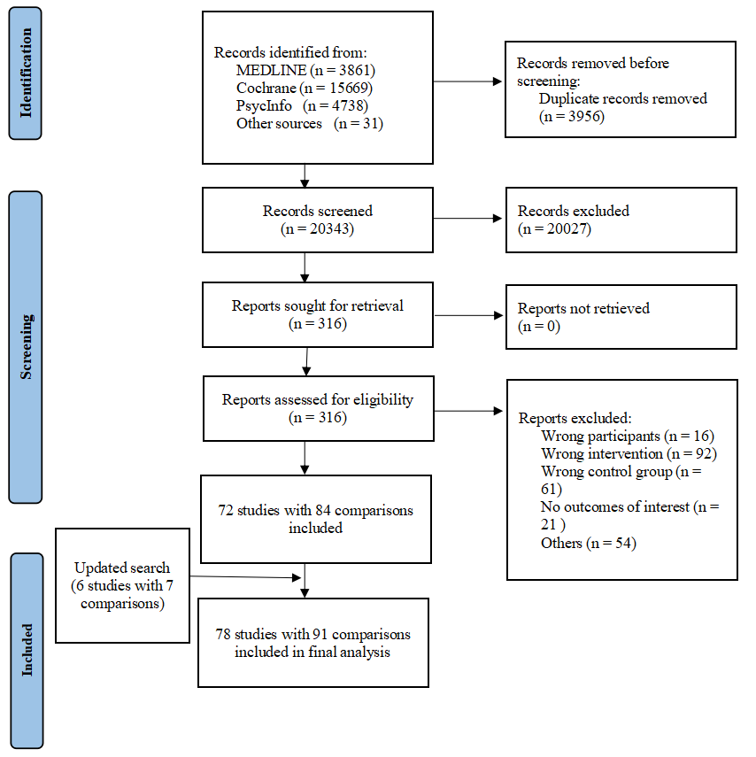
eFigure 1. Study selection flow diagram. “Other sources” refers to records identified through manual screening of reference lists from included trials and relevant prior systematic reviews. The updated search conducted in April 2026 identified 6 additional trials and 7 additional comparisons

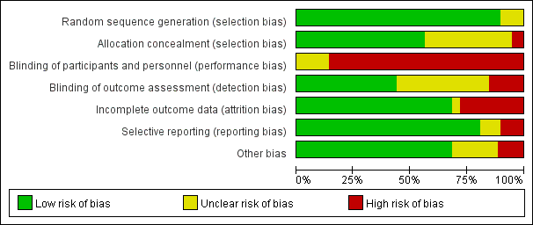
eFigure 2. Risk of bias summary across included studies. “Other bias” included potential baseline imbalance, contamination or co-intervention, deviations from the intended intervention, or other study-specific methodological concerns. Overall, no study was judged to be at low risk of bias; 14.1% were judged to have unclear risk and 85.9% high risk.

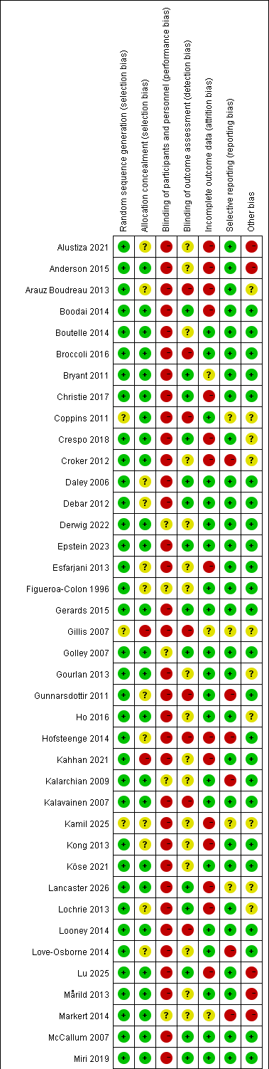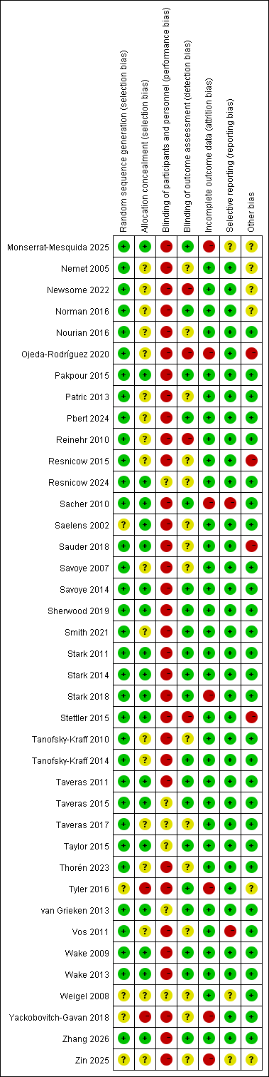
eFigure 3. Study-level risk-of-bias judgments for individual included studies. “Other bias” refers to baseline imbalance, contamination, deviations from the intended intervention, or other study-specific concerns. Green indicates low risk of bias, yellow unclear risk, and red high risk. Overall risk of bias was judged as high if any domain was high risk, low if all domains were low risk, and unclear otherwise.
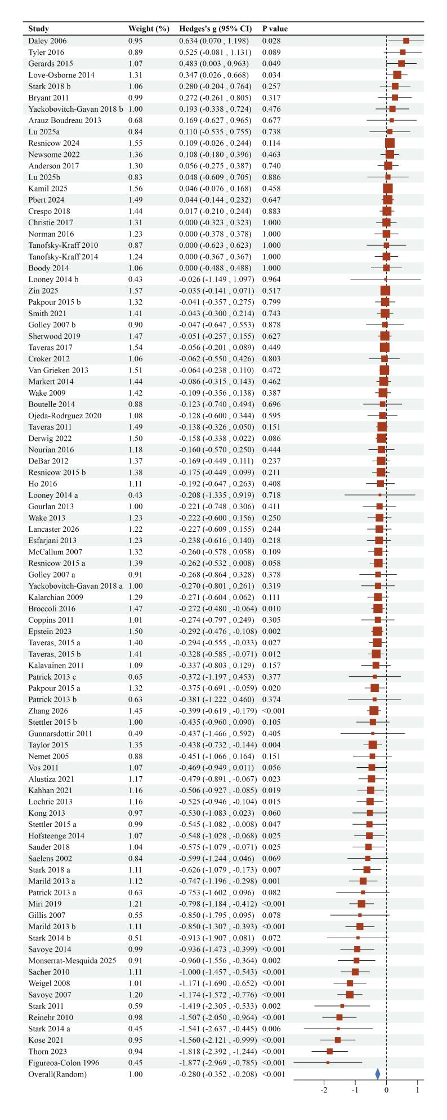
eFigure 4. Forest plot of behavioral intervention effects on weight-related outcomes in children and adolescents with obesity.

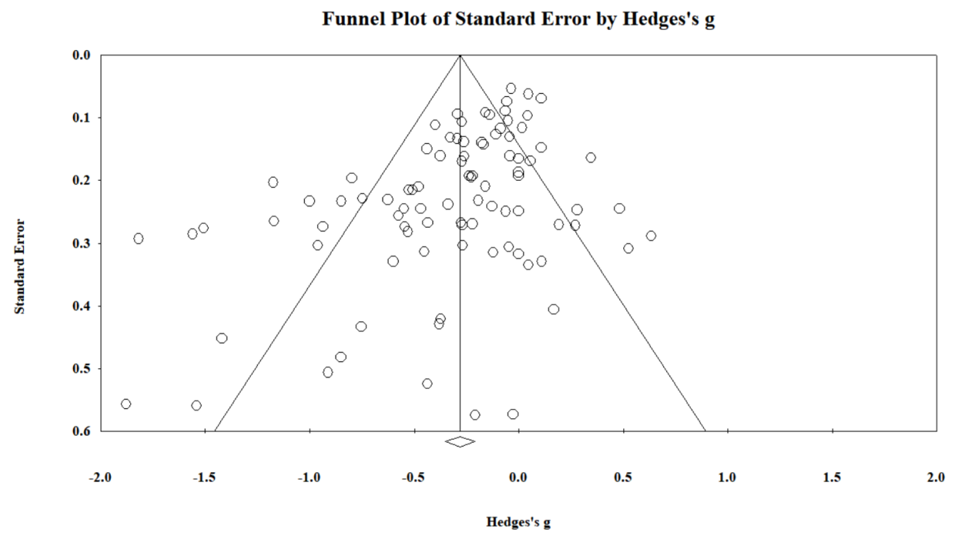
eFigure 5. Funnel plot of standard error by Hedges’ g.

