Additional file 4 The amplification dynamic curve of RT-qPCR of standard plasmid
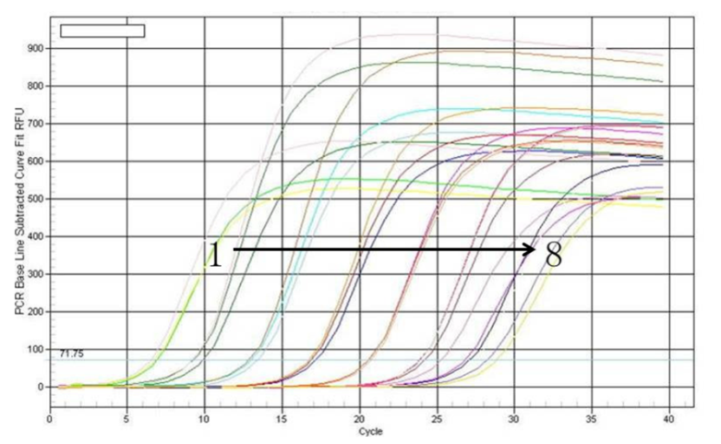
1-8, amplification curves of standard plasmid template with 3.74×10⁸, 3.74×10⁷, 3.74×10⁶, 3.74×10⁵, 3.74×10⁴, 3.74×10³, 3.74×10² and 3.74×10¹ copies/µL，respectively.

