Additional file 5 The melting curve of RT-qPCR of standard plasmid
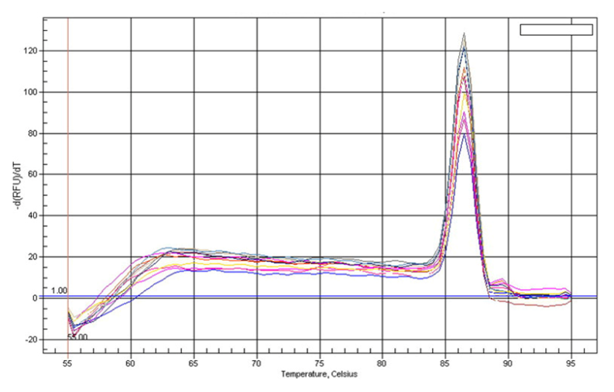
This figure provides only Tm of 86.6°C of the amplified template.

