Chart S1
Owner Questionnaire Provided at Each Visit

On a scale of 1-5 please answer the following questions:

- How well does your dog like his or her current diet?
(1 = very much, 5 = needs significant coaxing)

1 2 3 4 5

- How athletic is your dog?
(1 = very athletic, 5 = goes outside for voiding purposes only)

1 2 3 4 5

- How would you rate your dog’s body condition score based on the document provided?

1 2 3 4 5

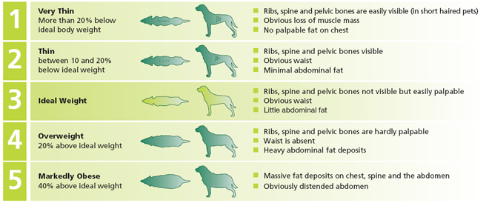

- How would you rate your dog’s coat condition?
(1 = shiny and excellent, 5 = dry and dull)

1 2 3 4 5

