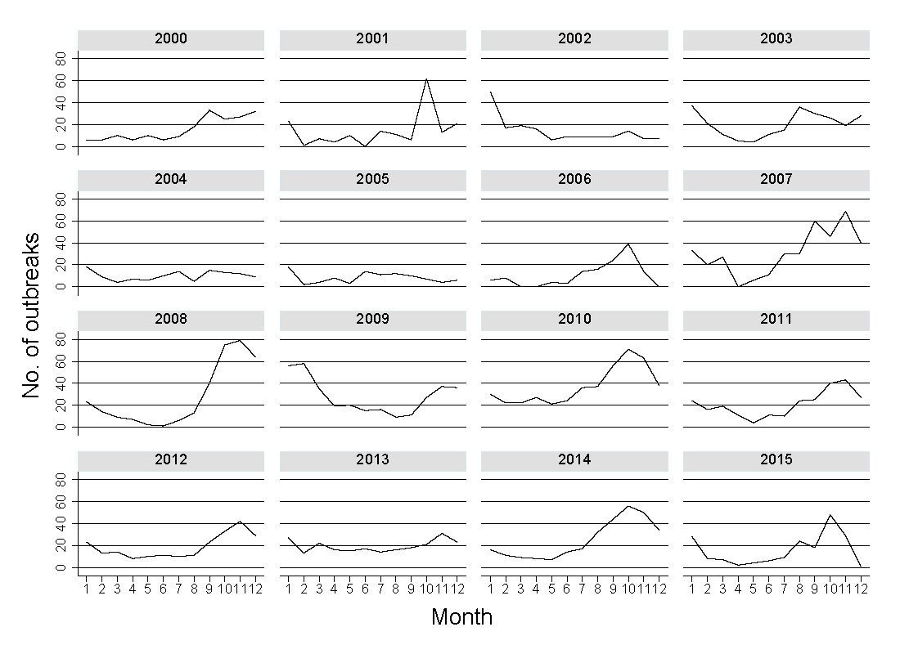
Figure S3. Annual course of LSD outbreaks in Ethiopia, 2000-2015.

