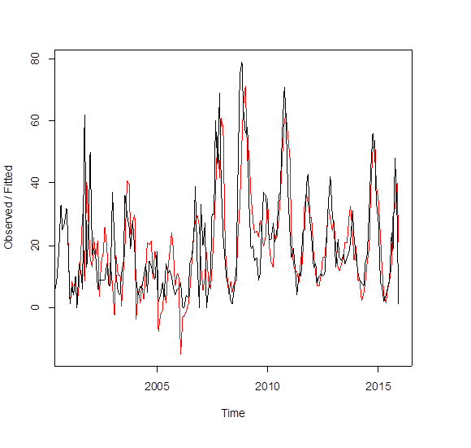
Figure S4. The original LSD outbreak time series (black) and the predicted values (red) using Holt-Winters filtering.

