Additional file 1 Original western blotting band pictures

p65

pp65

IL-1β
mTOR
αS1-casein
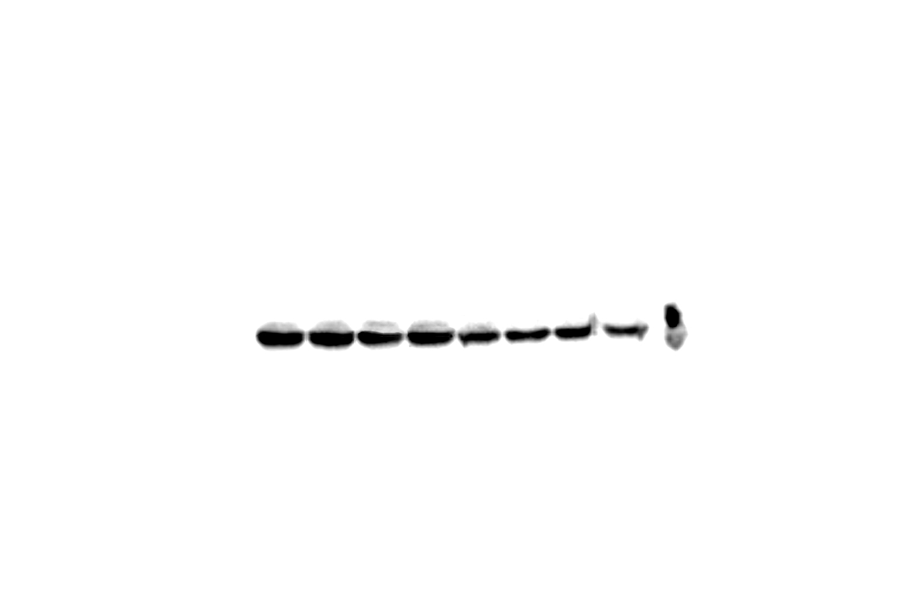
pmTOR

P70S6K

pP70S6K
GAPDH

