Alignment results of the seven viruses’ primers.
- Alignment result of FAdV F primer.
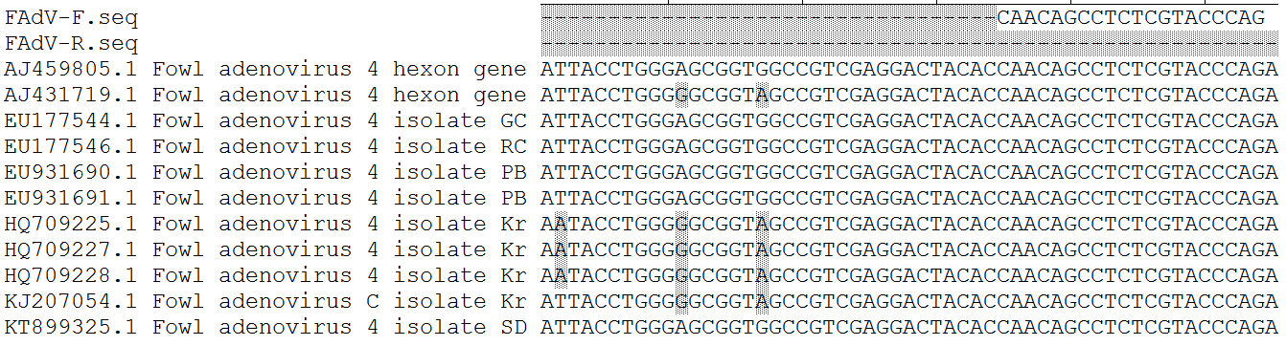
Alignment result of FAdV R primer. (Reverse complementary sequence)
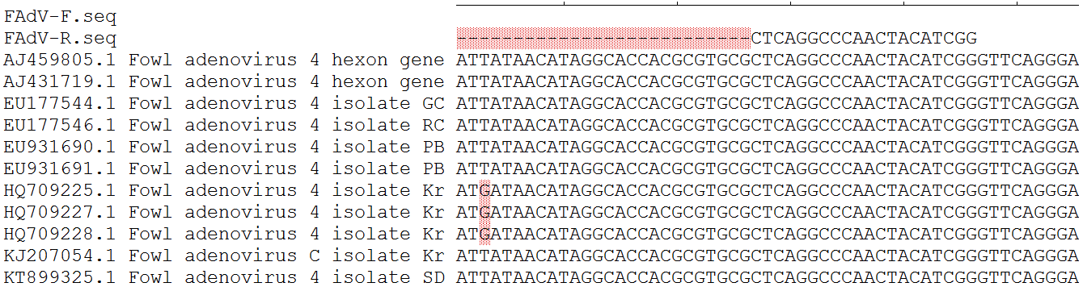

- Alignment result of DHAV F primer.
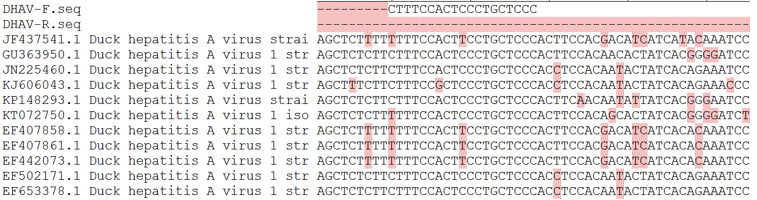
Alignment result of DHAV R primer. (Reverse complementary sequence)
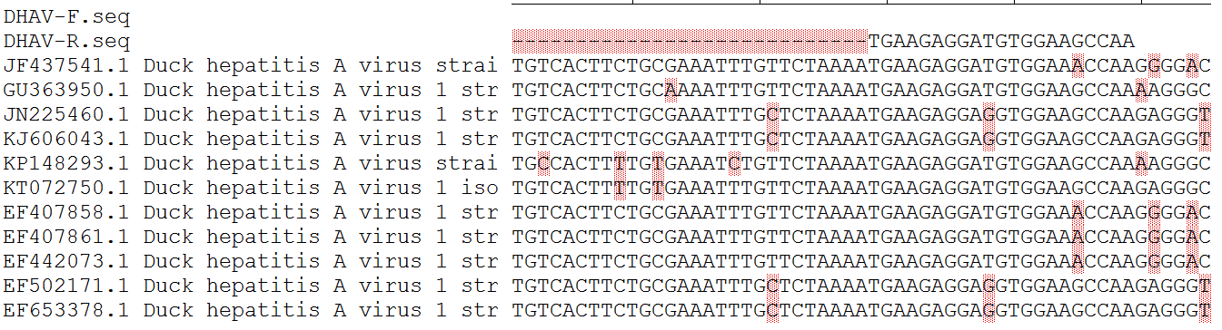
- Alignment result of DEV F primer.
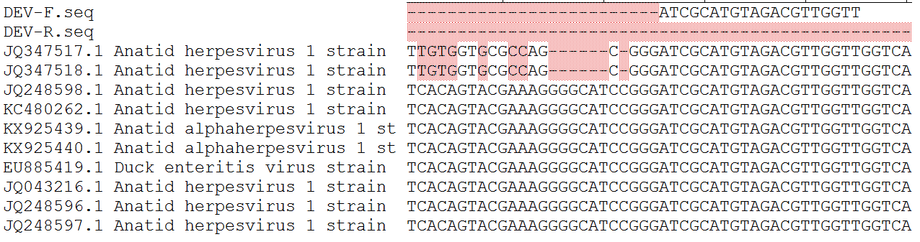
Alignment result of DEV R primer. (Reverse complementary sequence)
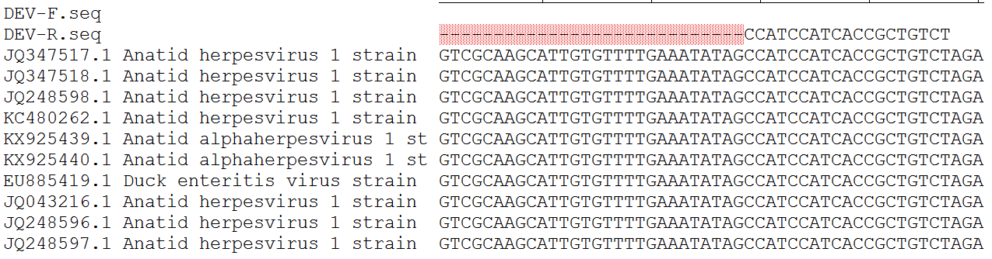

- Alignment result of DTMUV F primer.
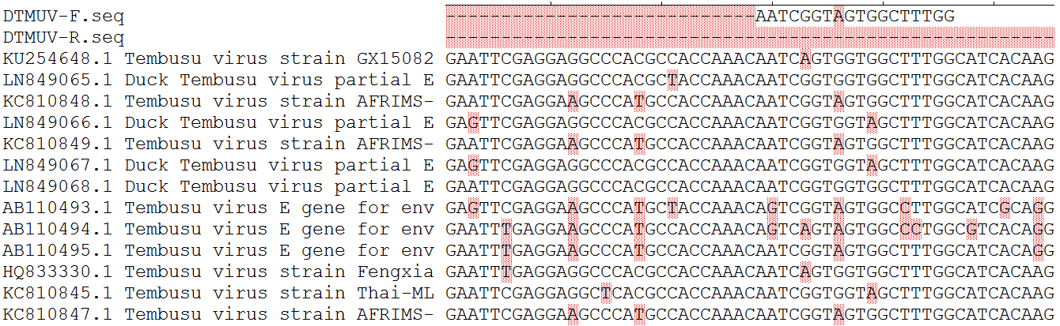
Alignment result of DTMUV R primer. (Reverse complementary sequence)
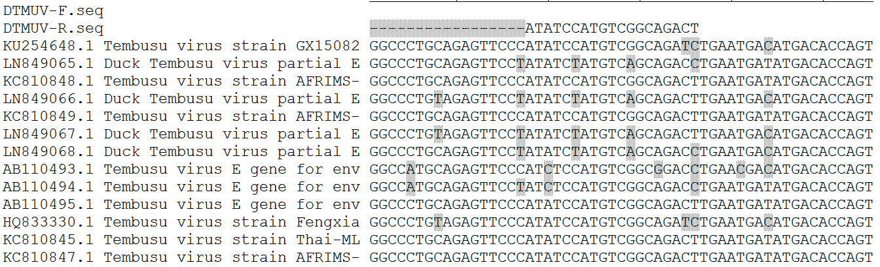
- Alignment result of NDV F primer.
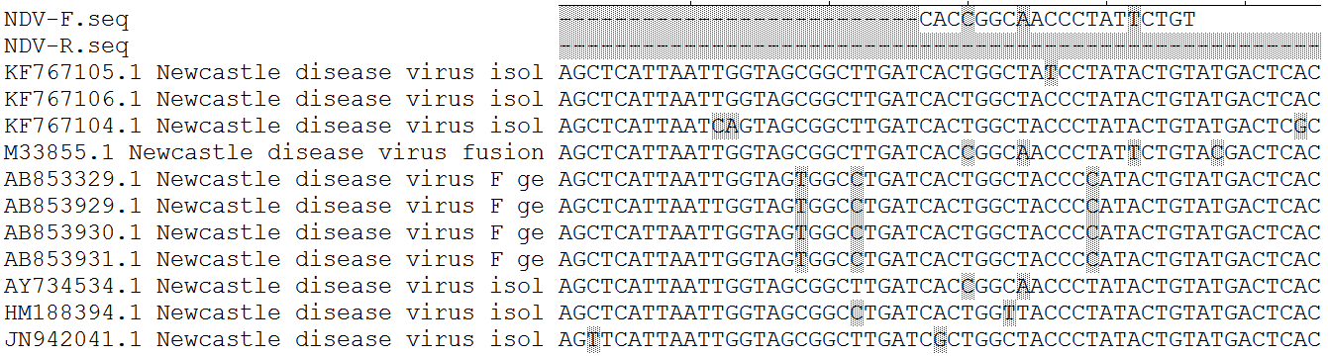
Alignment result of NDV R primer. (Reverse complementary sequence)
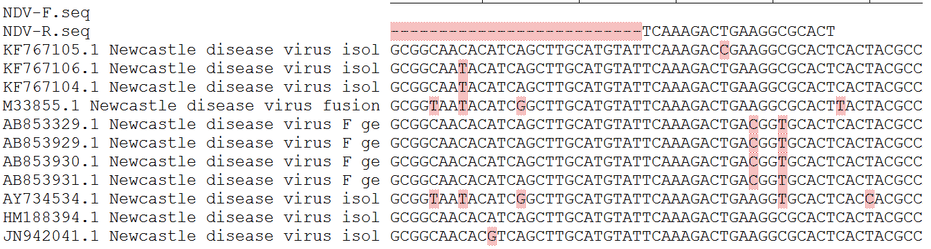

- Alignment result of AIV F primer.
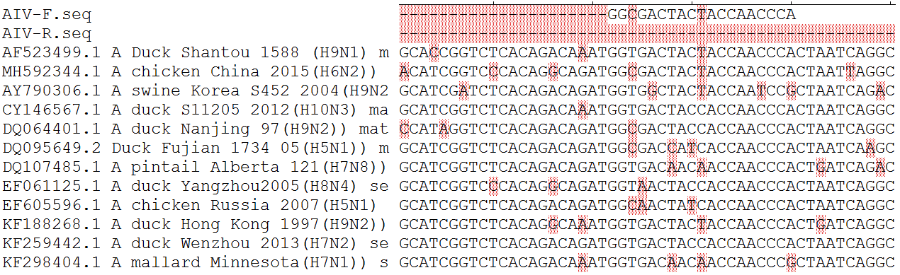
Alignment result of AIV R primer. (Reverse complementary sequence)
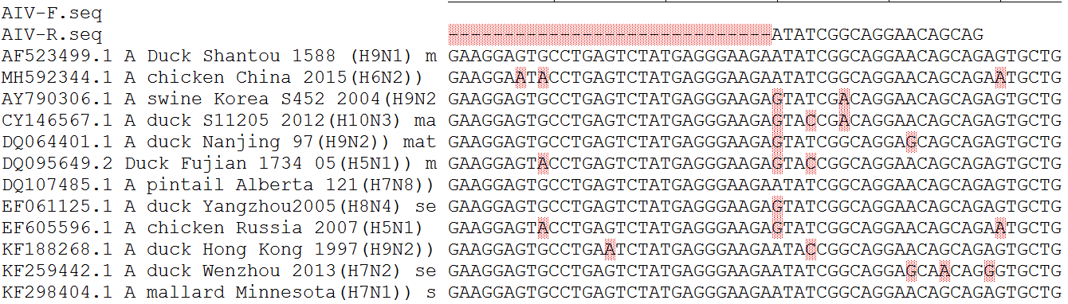

- Alignment result of NDPV F primer.
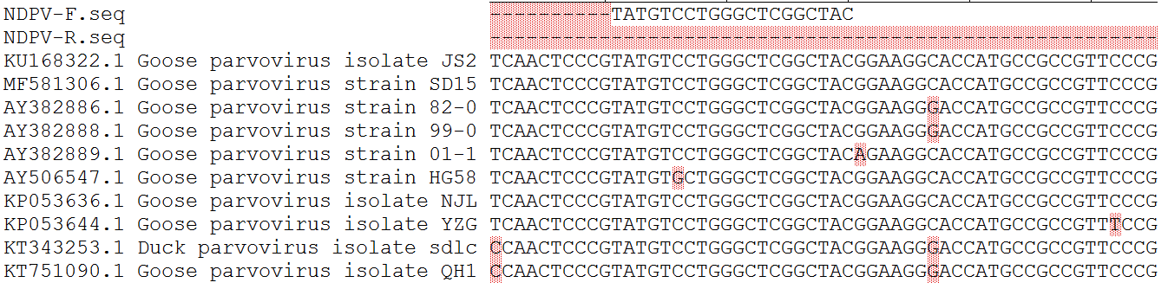
Alignment result of NDPV R primer. (Reverse complementary sequence)
