Dermatological evaluation
Please provide a clinical assessment for each of the numbered sites, using the lesion images and using the following scoring system: 0 = None, 1 = Very Mild, 2 = Mild, 3 = Moderate, 4 = Severe
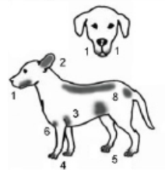  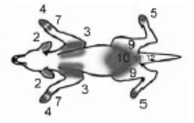 | Erythema | Lichenification | Excoriations | Alopecia
 | 0-4 | 0-4 | 0-4 | 0-4
1. Chin, Lips & Face (left and right combined)
2. Medial Pinnae (concave pinnae)
3. Axillae
4. Front Paws (dorsal and palmar sides combined)
5. Hind Paws (dorsal and plantar sides combined)
6. Cubital Flexor (elbow folds)
7. Palmar Metacarpal (from carpal to metacarpal pads)
8. Dorsum, Flanks & Tail Base
9. Inguinal Areas (groin)
10. Abdomen
11. Perineum (from vulva/scrotum to anus)
12. Ventral Tail (proximal)

