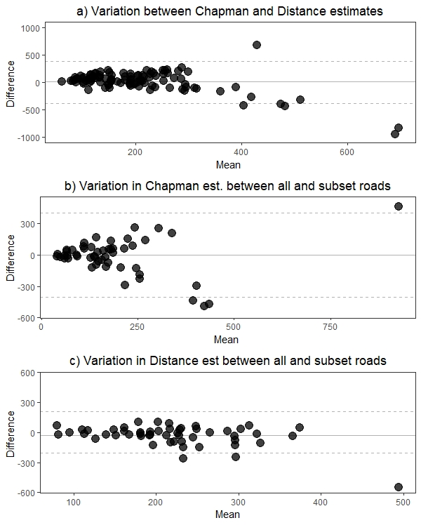Additional Figure 1: Bland-Altman plots are given for the a) difference between Chapman and distance-method estimates, b) and c) difference between estimates for all roads and subset of roads. The mean of the estimates (x-axis) are plotted against the difference between estimates (y-axis). The mean of the difference is shown by the horizontal solid grey line and 2*SD given by the dashed lines.

