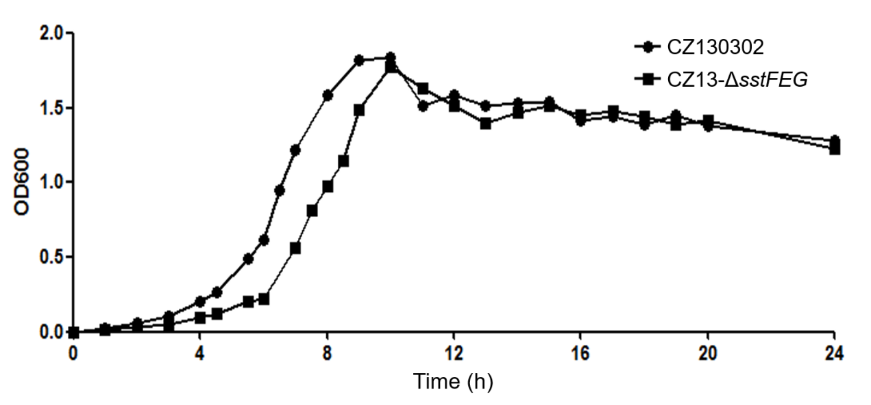

Additional file 2: Comparison of growth curves between wild-type CZ130302 and mutant strain CZ13-△sstEFG. Growth rates were monitored at each time point under the same conditions in vitro. Except for a slight difference during the log phase, the trend and the highest points of the two curves were essentially the same.

