Supplementary Material

Duck enteritis virus UL21 is a late gene and encodes a protein that interacts with pUL16
Linjiang Yang ^{1,2,3¶}, Mingshu Wang^{1,2,3¶}, Chunhui Zeng^{1,2}, Yong Shi, Anchun Cheng^{1,2,3*}, Mafeng Liu^{1,2,3}, Dekang Zhu^{2,3}, Shun Chen^{1,2,3}, Renyong Jia^{1,2,3}, Qiao Yang^{1,2,3}, Ying Wu^{1,2,3}, Shaqiu Zhang^{1,2,3},Xin-Xin Zhao^{1,2,3}, Yunya Liu^{1,2,3}, Yanling Yu^{1,2,3}, Ling Zhang^{1,2,3} , Bin Tian^{1,3},Leichang Pan^{1,3}, Mujeeb Ur Rehman^{1,3}, Xiaoyue Chen^{1,2,3}, Juan Huang^{1,2,3}
* Correspondence: Anchun Cheng: chenganchun@vip.163.com

Supplementary Figures and Tables

Table 1. Sequence and characteristics of RT-qPCR primers.
Primer | Primer sequence (5’-3’) | Gene | Product size (bp)
P1 | TACGCCAACACGGTGCTG | β-actin | 178
P2 | GATTCATCATACTCCTGCTTGCT | β-actin
P3 | GCCCAGGAACACCAGTCT | DEV UL21 | 106
P4 | CAGTGCGTATTGCCGTCT | DEV UL21
P5 | GCCACCAACCCTACCAAG | DEV UL13 | 131
P6 | GTCGTCAGCCCATCACCA | DEV UL13
P7 | AGACGGTTCCGA-AAGTACAG | DEV US2 | 111
P8 | TCGGCAGCACCAATAATCC | DEV US2
P9 | GAACAACCGCCGAACAC | DEV UL54 | 127
P10 | TCAAACATCCGCCTCAA | DEV UL54

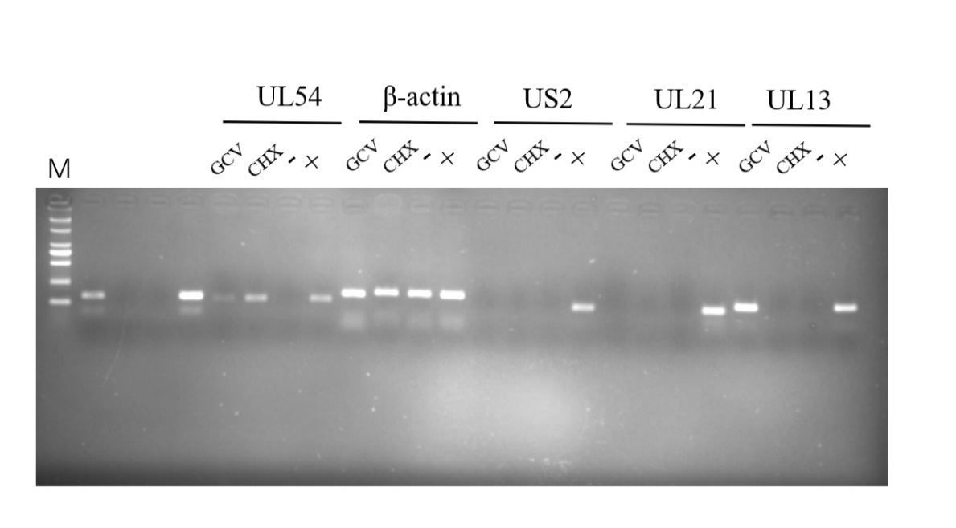
Figure 1. Complete image of UL21 genotype identification. GCV represents DEV-infected cells adding ganciclovir and CHX is adding cycloheximide. The (-) represents negative control and (+) were positive control.

