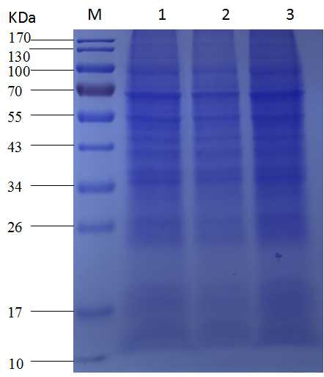
Original image of Fig 5A. SDS-PAGE analysis of VP2 expression in different virus-infected Sf9 cells at 96 hours post infection. M: PageRuler™ Prestained Protein Ladder, 10 to 170 kDa; 1: recombinant baculovirus Ac-IM-p10-VP2; 2: recombinant baculovirus Ac-IM-ph-VP2; 3: recombinant baculovirus Ac-IM-ph-VP2+p10-VP2.
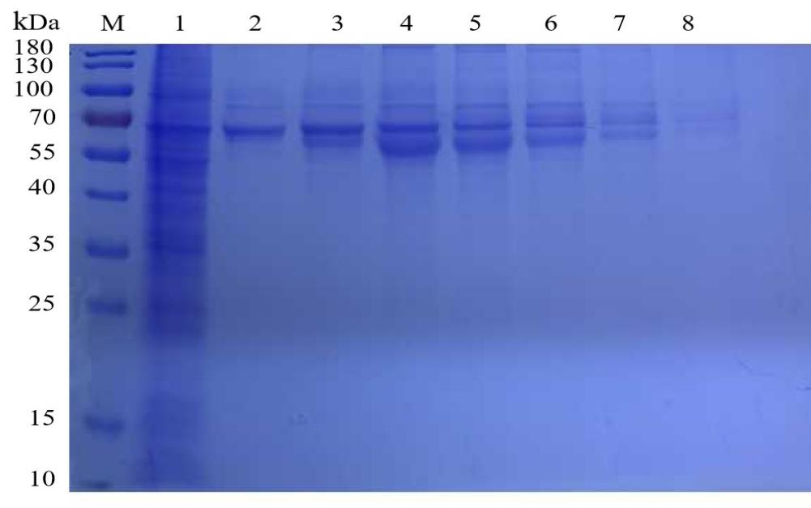
Original image of Fig 6A. The SDS-PAGE analysis of purified recombinant VP2 protein. M: PageRuler™ Prestained Protein Ladder, 10 to 180 kDa; 1: ultrasound supernatant of the recombinant baculovirus Ac-IM-ph-VP2+p10-VP2 infected Sf9 cells; 2: 200 mM Imidazole eluent; 3: 300 mM Imidazole eluent; 4: 500 mM Imidazole eluent; 5: First eluent of 500 mM Imidazole; 6: Second eluent of 500 mM Imidazole; 7: Third eluent of 500 mM Imidazole; 8: Fourth eluent of 500 mM Imidazole.

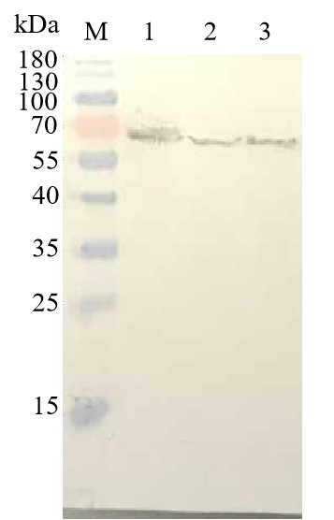

Original image of Fig 6B. Western blot analysis of purified VP2 protein with Mouse anti-His monoclonal antibodies. M: PageRuler™ Prestained Protein Ladder, 10 to 180 kDa; 1: First eluent of 200 mM Imidazole; 2: Second eluent of 200 mM Imidazole; 3: Third eluent of 200 mM Imidazole.

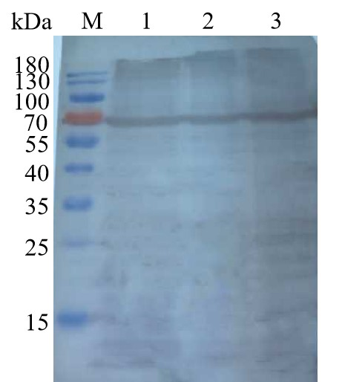
Original image of Fig 6C. Western blot analysis of purified VP2 protein with Rabbit anti-VP2 polyclonal antibodies. M: PageRuler™ Prestained Protein Ladder, 10 to 180 kDa; 1: First eluent of 200 mM Imidazole; 2: Second eluent of 200 mM Imidazole; 3: Third eluent of 200 mM Imidazole.

